Logbook science fair 2020:
By Nolan Howard

Nolan - I’ve looked through the various pages within this folder and I can’t see any actual trials that you carried out on the prototype. How are you going to create a graph if there hasn’t been any test/trials completed? Maybe I just missed it - please let me know. MT/01/13

November 2 2020
Today I ran through a few ideas but am not positive about what to do
My main idea so far is making a heating tube to put on storm drains to heat them up and unclog them. It could also be used to unfreeze pipes too for plumbers, but I will think it over.
Other ideas might be waterproof seals that can be applied like glue,
Pencils that are like mechanical pencils but don't break as easily,
Easy pack/set up tent, an outlet that can rotate 360 degrees.
Those are some I could think of off the top of my head.

November 7 2020
Started my paragraph on my project and I have an basic understanding of what I want to do:
A self rolling sleeping bag.
1206 - I would also add that you would need to ask about various types of materials to use, noise of rolling this out/together, warranties, and possible price points?
November 9 2020
Materials I am considering are
- Cardboard
- Measuring tape
- Glue
- Duct tape
For a prototype I am considering using a pillowcase as a demonstration of my project.
(I might compare the weight of a pillow case compared to the weight of a sleeping bag)
Have you drawn this out yet? Have you made a prototype yet? Have you completed any tests/trials regarding this idea yet? You don’t have to cut up/destroy a working sleeping bag to get this going. Please let me know your progress. 1206

I have a prototype laid out and I am planning to add it in later. Great - I’m looking forward to
seeing this prototype in action.12/26

November 21 2020
I have all the materials for my project and am planning on making the slap bands today.
Today also is a day where I will question my expert while He watches me go through the processes of making my design.
The questions I ask are on the final design, and some on the prototype.
Questions like
- Who is the target audience
- What changes would you make to the design
- What if I stacked the bands, would it be able to lift and roll more weight
The answers I have recorded on a notepad.

Nov 30th
I have made blueprints and other designs for my project and they should work
One of the blue prints is a test copy to see in a frame made from slap bands and sticks held together can roll up a similar item to a sleeping bag (pillow case) in retrospect a pillow case is quite light so I will have to estimate how many more slap bands are needed to roll a pillow case.
I have also thought of a good name for my project “the quick pack sleep pack.” and would like your opinion on it Ms Turner.

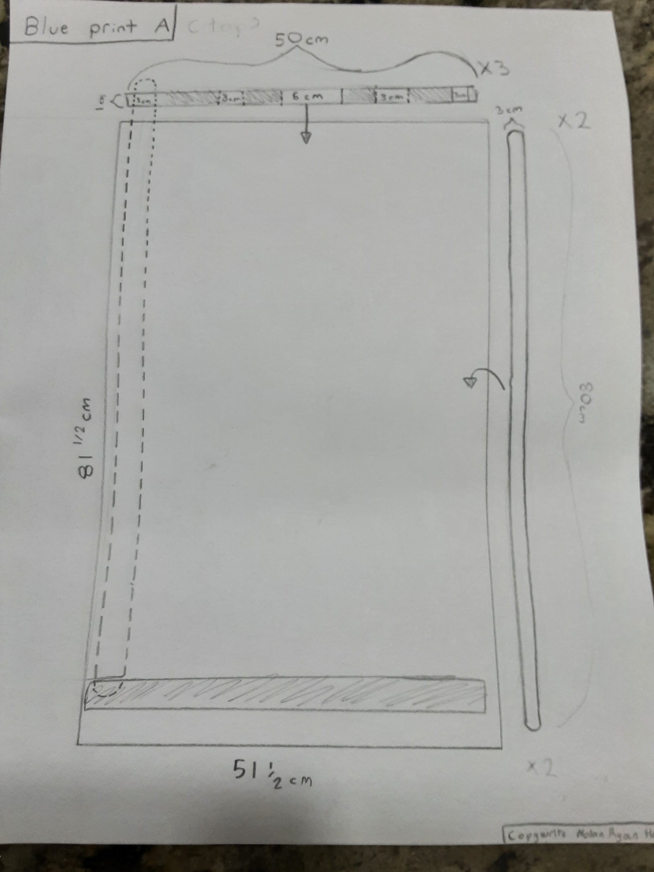This is the prototype blueprint.

December 4 2020
I have tested the prototype and I can say it was a success.
I have started to gather the materials needed for my final design which will be shown in the following image:
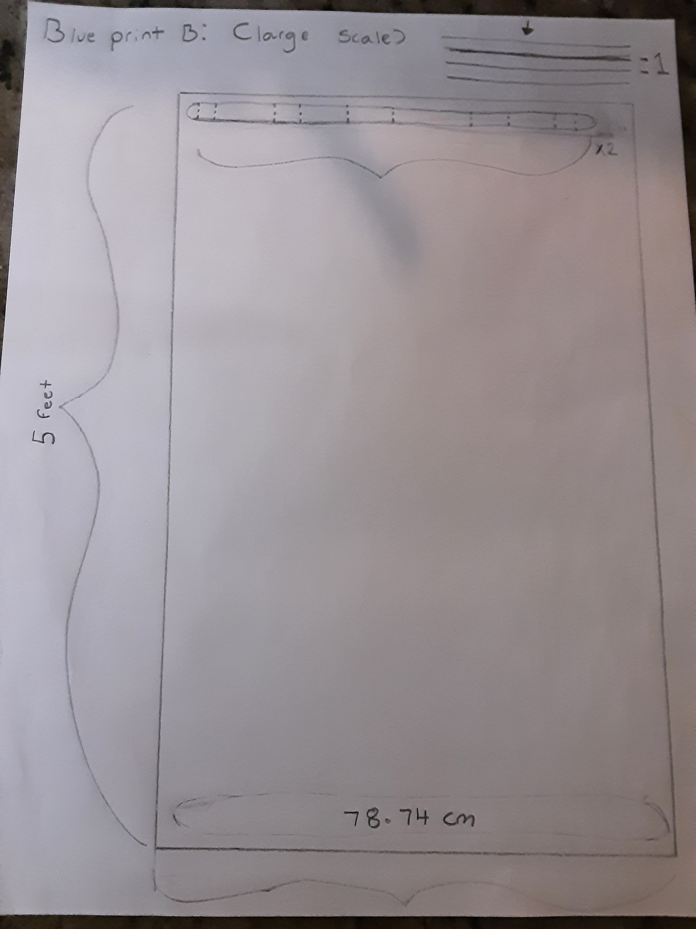
I will record the results of the prototypes testing in a graph.

Dec 20th

I have contacted my expert a second time he is a product development engineer and was a student at the university of Calgary
His job is to run through designs and improve and fix them so that they are safer and better for the people using them

For interview questions I asked
- What are some changes you would make to the design
- What market do you think this would be targeting
- As a product do you consider this to be useful
- What are some cons about this product
- What are some cons about this product

I will ask more questions because my dad knows him well and I can easily make contact with him. I will be contacting the person in person and writing down his responses on a notepad.

December 27 2020
I have gained all the materials needed for my final design
I plan to create the design ASAP.
I will also consult my expert one more time for advice on my final design.
I will record the questions on a notepad and ask in person.
He will be there to see the process to create my final design.

January 5 2021
I have contacted the expert twice and am planning to contact him one last time to ask some more questions about the design to make sure there are no flaws to the design and if there are to make the changes so it turns out all right.
I plan to ask him
- Where he thinks that I should put the frame (top,bottom,inside) to lift and roll an entire sleeping bag
- When I stack them how many should be put for watch layer
- If he recommends me not to stack them and to put them side by side ( and if so I will ask how far apart.)
- How he can estimate this turning out
If there are any questions you think I should add you can tell me below.

Nolan - consider asking the expert about marketing ideas as well. Who would be the typical consumer that would purchase this product? What kind of packaging would you need to hold it in place? Price point? MT 01/13

January 6 2021

Thank you ms Turner for your advice

The expert said

- that smaller children (around age 7) would use this product. (kids who would go out with their parents for camping and need help packing up.)
- The packaging could be inside a bag or box.( you would just have to roll it and it will do the rest, and you can put it in a package however you want, eg rolled up, stretched out, standing up standing on its side. It would not change anything about it.)

Thank you for your questions. Now I can update my work.

Sinceriously,

Nolan Howard.

January 8 2021
The final design has had an issue: the slap bands fought each other and caused the bands to not be able to stay stretched out and has warped them.
I will look more into this problem in my reflection.
Both graphs have been made (one showing the time without the time it takes to put in the frame and the other with.)
Below I will show the conflict between the slap bands;
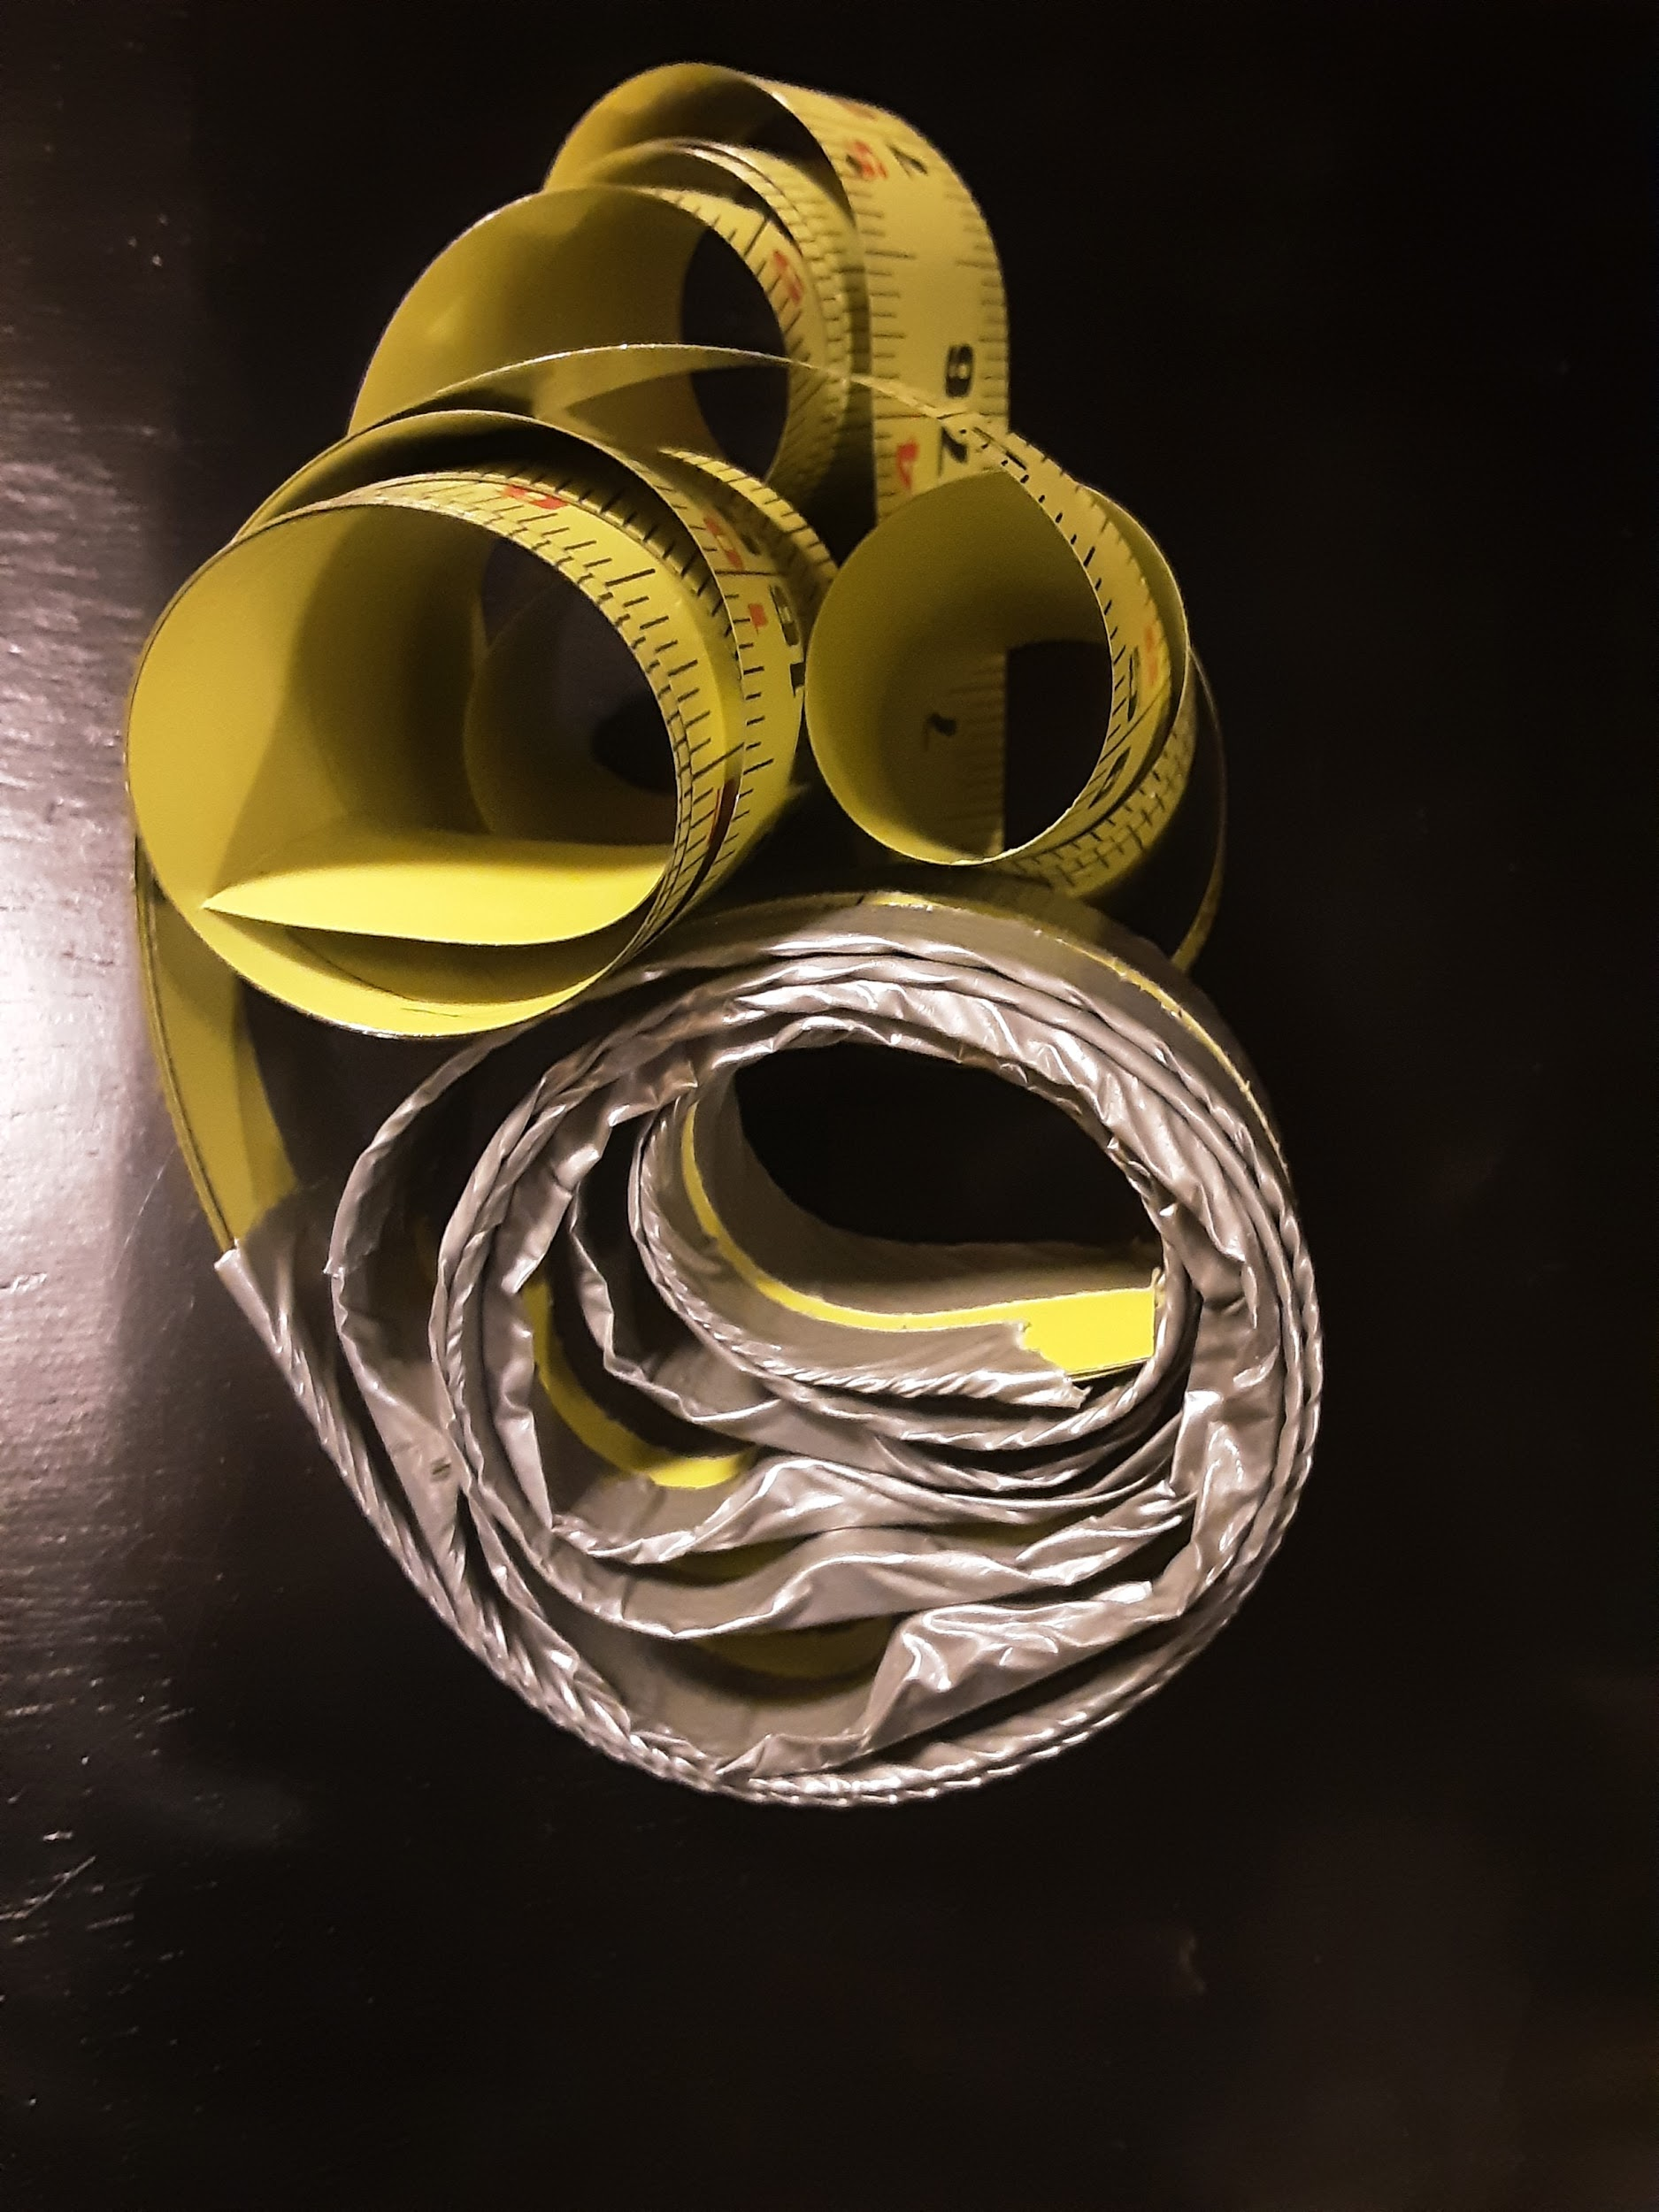
February 21 2021
For the past week I have been working on the feedback I got from the CYSF judges and have completed all of it.
I have:
Fixed and practiced my speech,
Estimated how much one slap band could lift on its own,
Added all the entries into my logbook.
Today I finished all of those tasks for the next two weeks. I will practice and improve my speech and slide show.
I plan to create my video for CYSF judging in one week for practice and so I have one more week to touch it up and if I need more practice, make another video.
(end of entry)

