CYSF LOGBOOK — Sophia Chan (Tom Baines School)
Project: Can a Cabinet Garden Grow Edible Vegetables Indoors During Calgary’s Winter and Help Reduce Grocery Costs?
Year: 2026
Grade: 9

1. Timetable
- Jan 1–3: Topic selection, background research
- Jan 4: First planting
- Jan 4–31: Daily monitoring, replanting, troubleshooting
- Jan 28: Lighting increased to 16 hrs/day
- Jan 31: Airflow adjustment, pea shoot failure, green onion regrowth started
- Feb 1–14: Continued monitoring, spacing adjustments, energy tracking
- Feb 15: Project report writing + presentation video recording
- Feb 16: Begin tri-fold poster construction
- Feb 17–Fair Day: Light updates only; continue plant growth but no major edits
- Feb 25: Last Logbook update for online submission

2. Choosing a Topic
- Interested in indoor gardening and sustainability
- Calgary winters prevent outdoor gardening for months
- Wanted to test whether a cabinet garden could grow real vegetables indoors
- Also wanted to see if this setup could reduce grocery costs
- Topic chosen because it combines engineering, biology, and practical usefulness

3. Background Research
From the project report:
“LED grow lights provide the full spectrum of light needed for photosynthesis, while airflow helps prevent mold and disease.”
Key research points:
- Calgary’s climate limits outdoor gardening
- LED grow lights can mimic sunlight
- Airflow reduces mold and improves plant health
- Cabinet gardens are compact and customizable
- Success depends on environmental control and cost efficiency
Sources:
- Indoor gardening websites
- LED manufacturer documentation
- YouTube cabinet garden builds
- Articles on airflow and humidity
- Grocery store pricing for comparison

4. Testable Question / Purpose
Purpose:
“To determine whether a cabinet garden can successfully grow edible vegetables indoors during Calgary’s winter and whether it can help reduce grocery costs over time.”

5. Hypothesis
“If a cabinet garden is equipped with proper lighting and airflow, then it can grow edible vegetables indoors during Calgary’s winter and potentially reduce grocery expenses through homegrown produce.”

6. Materials
- Indoor Gardening Cabinet (2-level)
- QuickGrow LED Grow Lights ×5 – $400
- 120mm PC Fans ×2 – $53
- Fan mounts ×2 – $78
- Power strip – $15
- Timer – $20
- Time-lapse camera
- Containers: bubble tea cups, 2L bottles, small pots, tray with plastic screen
- Potting soil
- Seeds: Han Yu radish, choy sum, green onion roots
- Power energy monitor
- Total setup cost: $566 CAD

7. Procedure
- Assemble cabinet and divide into two growing levels
- Install LED lights and timer
- Install PC fans for airflow
- Mount time-lapse camera
- Plant radish, choy sum, green onion
- Plant pea shoots on plastic screen
- Set lights to 12 hrs/day
- Water every 2 days
- Monitor growth and reorganize as needed
- Increase lights to 16 hrs/day (Jan 28)
- Increase fan speed slightly (Jan 31)
- Track energy use with monitor

8. Variables
Independent Variables
- Lighting duration (12 → 16 hrs/day)
- Airflow (fan speed increase)
- Container size (cups vs. 2L bottles)
- Plant spacing (Feb 14 rearrangement)
Dependent Variables
- Plant growth (height, health, survival)
- Energy consumption (kWh, cost)
- Crop success/failure
Controlled Variables
- Cabinet environment
- Soil type
- Watering schedule
- Seed source
- Indoor temperature/location

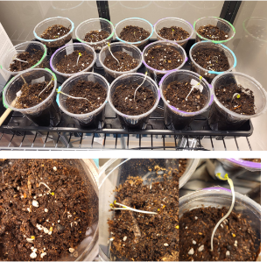
9. Daily Notes & Observations
Jan 4
- Planted first batch of radish, choy sum, green onion
- Lights set to 12 hrs/day
- Fans running continuously
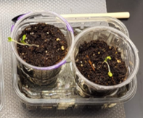
Jan 7
- Seedlings leggy
- Suspected low light and overwatering
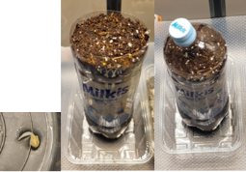
Jan 9
- Planted radish in 2L bottle
- Replaced 4 choy sum seedlings
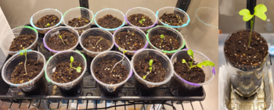
Jan 12
- Replaced 2 failed radish seedlings with choy sum
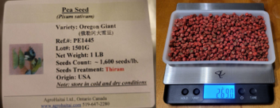
Jan 16
- Planted pea shoots on plastic screen
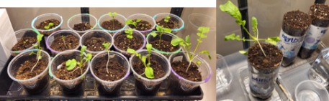
Jan 21
- Planted 2 more radish in 2L bottles
Jan 28 — Major Change
- Increased lighting from 12 → 16 hrs/day
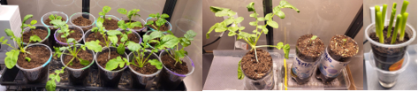
Jan 31 — Multiple Events
- Pea shoots failed (mold, sogginess)
- Increased fan speed slightly
- Started regrowing green onion from grocery scraps
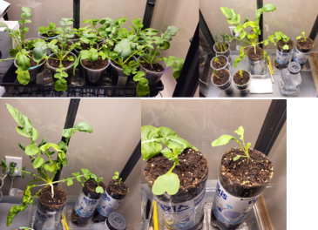
Feb 1–10
- Choy sum recovering from legginess
- Radish in bottles growing 6–10 cm
- Cup radish still stunted
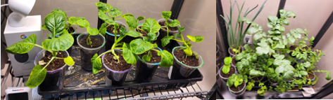
Feb 14
- Rearranged plants to improve spacing and airflow

Revised Final Phase Timeline (Integrated)
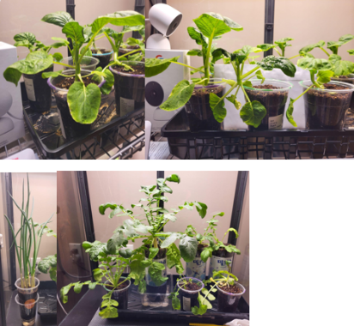
Feb 15 — Report Writing + Presentation Video Recording
- Compiled all results and tables
- Wrote full project report
- Recorded presentation video
- Selected photos and diagrams for poster
- Logged that experiment continues but major edits are frozen
Feb 16 — Begin Tri-Fold Poster Construction
- Planned poster layout
- Printed charts, tables, and diagram placeholders
- Mounted sections onto tri-fold
- Added captions
- Left space for small data updates if needed
Feb 17–Fair Day — Light Updates Only
- Continued watering and monitoring
- Added minor logbook notes only
- Final quality check on poster and presentation materials
- Ensured consistency across report, poster, and logbook
Feb 25 – Final photos capture for online submission
- The radish in a 2L bottle has root thickening progress well
- Choy Sums are doing well
- Green onion regrowth is strong and has been ready for harvest
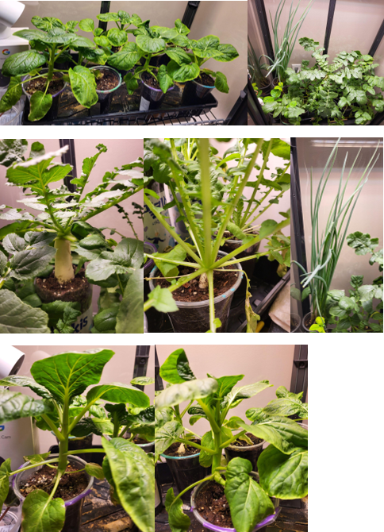

10. Data (Raw Measurements)
Energy Usage Log
Date | Energy Used (kWh) | Cost  (@ 0.07 $/kWh) | Notes
03 Jan 2026 | N/A | N/A | Transplant seedlings.  Began greenhouse cabinet operations.
04 Jan 2026 | N/A | N/A
05 Jan 2026 | N/A | N/A
06 Jan 2026 | N/A | N/A
07 Jan 2026 | N/A | N/A | Began seedlings' health recovery.
08 Jan 2026 | N/A | N/A
09 Jan 2026 | 1.546 | $0.108 | Added energy monitor.  Began energy monitoring.  Planted 4 Choy Sum seeds to replace 4 dead seedlings
10 Jan 2026 | 1.517 | $0.106
11 Jan 2026 | 1.522 | $0.107 | Added two monitoring cameras.
12 Jan 2026 | 1.537 | $0.108 | Planted 2 Choy Sum seeds to replace 2 dead seedlings.
13 Jan 2026 | 1.544 | $0.108
14 Jan 2026 | 1.544 | $0.108
15 Jan 2026 | 1.537 | $0.108
16 Jan 2026 | 1.537 | $0.108 | Started to plant bean shoots in tray on plastic screen
17 Jan 2026 | 1.532 | $0.107
18 Jan 2026 | 1.537 | $0.108
19 Jan 2026 | 1.544 | $0.108
20 Jan 2026 | 1.537 | $0.108
21 Jan 2026 | 1.532 | $0.107 | Planted 2 more Korean radish in 2-liter bottles
22 Jan 2026 | 1.635 | $0.114
23 Jan 2026 | 1.631 | $0.114
24 Jan 2026 | 1.532 | $0.107
25 Jan 2026 | 1.533 | $0.107
26 Jan 2026 | 1.536 | $0.108
27 Jan 2026 | 1.762 | $0.123
28 Jan 2026 | 2.069 | $0.145 | Change lighting from 12 hours to 16 hours
29 Jan 2026 | 2.085 | $0.146
30 Jan 2026 | 2.079 | $0.146
31 JaN 2026 | 2.081 | $0.146 | Bean shoot failure due to sogginess and mold  Started regrowing green onion from grocery store roots
1 Feb 2026 | 2.084 | $0.146
2 Feb 2026 | 2.089 | $0.146
3 Feb 2026 | 2.085 | $0.146
4 Feb 2026 | 2.085 | $0.146
5 Feb 2026 | 2.083 | $0.146
6 Feb 2026 | 2.09 | $0.146
7 Feb 2026 | 2.098 | $0.147
8 Feb 2026 | 2.091 | $0.146
9 Feb 2026 | 2.096 | $0.147
10 Feb 2026 | 2.091 | $0.146
11 Feb 2026 | 2.09 | $0.146
12 Feb 2026 | 2.091 | $0.146
13 Feb 2026 | 2.096 | $0.147
14 Feb 2026 | 2.092 | $0.145 | Rearranged plants to give choy sum more space between plants
15 Feb 2026 | 2.103 | $0.147 | Write CYSF project report and presentation based on observations up to this point.
16 Feb 2026 | 2.076 | $0.145
17 Feb 2026 | 2.077 | $0.145
18 Feb 2026 | 2.083 | $0.146
19 Feb 2026 | 2.088 | $0.146
20 Feb 2026 | 2.084 | $0.146
21 Feb 2026 | 2.084 | $0.146
22 Feb 2026 | 2.083 | $0.146
23 Feb 2026 | 2.088 | $0.146
24 Feb 2026 | 2.083 | $0.146 | Added fertilizer.  Attach this logbook for online submission
Han Yu Radish
- Batch 1 (Jan 4): 3–5 cm, stunted
- Batch 2 (Jan 9, 21): 6–10 cm, healthy in 2L bottles
Choy Sum
- Batch 1 (Jan 4): 8–10 cm, recovered from legginess
- Batch 2 (Jan 9, 12): 4–6 cm, healthy but slower
Green Onion
- Started Jan 31
- Regrowing; multiple harvests possible
Pea Shoots
- Planted Jan 16
- Failed Jan 31
Energy Use
- Jan 9–27: ~1.54 kWh/day
- Jan 28–Feb 13: ~2.09 kWh/day
- Total: 81.91 kWh
- Cost: $5.73 CAD

11. Results Summary
- Lighting increase improved growth
- Airflow increase reduced mold risk
- Larger containers improved radish growth
- Pea shoots failed due to poor drainage
- Green onions regrew successfully
- No harvest by deadline, but strong early growth

12. Conclusion
From the report:
“This project demonstrated that a cabinet garden can support the early growth of edible vegetables indoors during Calgary’s winter.”
Key points:
- Hypothesis supported
- Lighting and airflow were critical
- Manual watering worked but could be improved
- System shows long-term potential for reducing grocery costs

13. Recommendations / Future Improvements
- Add automated watering or moisture sensors
- Improve drainage for microgreens
- Use deeper containers for root vegetables
- Add humidity control
- Extend experiment to full harvest cycles
- Track grocery savings over several months

