# **Science Fair LogBook 2025**

By: Annika Saini

**August 19, 2024**

Today, I came up with the idea to create a cost-effective unmanned aerial vehicle (UAV) or drone to detect poaching. However, there are many UAVs that are being used in today's world, there are many existing problems that affect the usage and efficiency of these UAVs for poaching detection.

* **Existing anti-poaching drones face several challenges that limit their effectiveness. Their short flight time and range leave large areas unmonitored, reducing surveillance efficiency. Additionally, advanced drones capable of effective monitoring are costly, with prices ranging from $50,000 to $250,000, making them unaffordable for many conservation groups, especially in developing regions. Harsh weather conditions like strong winds, rain, and extreme temperatures can further compromise their reliability.**
* **Other limitations include the need for frequent recharging, which is difficult in remote areas with limited infrastructure, leading to downtime. Poachers may also use jamming devices to disrupt drone signals, rendering them ineffective. Lastly, drones can only cover small areas at a time, limiting their surveillance capabilities compared to ground patrols or satellite imagery. These challenges highlight the need for more cost-effective, durable, and long-lasting surveillance solutions.**

**Resources:**

* [**https://www.worldwildlife.org/stories/how-drones-are-helping-save-rhinos**](https://www.worldwildlife.org/stories/how-drones-are-helping-save-rhinos)
* [**https://www.droneii.com/**](https://www.droneii.com/)
* [**https://www.frontiersin.org/articles/10.3389/fevo.2020.563998/full**](https://www.frontiersin.org/articles/10.3389/fevo.2020.563998/full)
* [**https://www.nasa.gov/aeroresearch/weather-impacts-on-uavs/**](https://www.nasa.gov/aeroresearch/weather-impacts-on-uavs/)
* [**https://www.sciencedirect.com/topics/computer-science/gps-jamming**](https://www.sciencedirect.com/topics/computer-science/gps-jamming)

**December 22, 2024**

Creating a drone for this purpose would be out of my reach/skillset. So, i'm planning on creating something like a wearable for endangered animals with a GPS, cameras, and some other kind of add-on that can help detect poachers, and alert rangers on their live locations while providing live video/audio feed.

**December 23, 2024**

**It will be more cost-effective rather than having a drone.**

**December 31, 2024**

[**Rainforest Connection - Phones Turned to Forest Guardians by Topher White — Kickstarter**](https://www.kickstarter.com/projects/topherwhite/rainforest-connection-phones-turned-to-forest-guar?ref=discovery&term=stop%20poaching&total_hits=4&category_id=16)

**January 2, 2025**

[**How To Stop Poaching: 9 Ways To Protect Wildlife From Trafficking - Forestry.com**](https://forestry.com/wildlife-management/how-to-stop-poaching/)[**What are LoRa and LoRaWAN? | The Things Network**](https://www.thethingsnetwork.org/docs/lorawan/what-is-lorawan/)

[**7 High-Tech Tools to Combat Poaching**](https://www.treehugger.com/high-tech-tools-to-make-poaching-extinct-4863255)

[**Rhino conservation: AI collars & drones to the rescue | anti-poaching; rhino conservation; AI; technology; ankle collar; drone; drones; south africa**](https://www.wildwonderfulworld.com/post/rhino-conservation-ai-collars-drones-to-the-rescue)

* **Mobility**
* **Visuals**
* **Missing sound?**
* **Drones are hard to implement, privacy concerns**

**January 3, 2025**

**Somejot notes from my planning:**

* Infrared For Night
* Heat Powered
* Drone + Collar/Wearable duo?
* Physio Sensors?
* Acoustics?
* Which Animal?
* Testing?
* AI For Human Detection
* Send drone to check up, but alert rangers of potential threats and provide specific location
* Sturdy Material for Harsh Environments
* Sharks, turtles,

[Thanda Safari recruits AI technology to combat rhino poaching](https://www.getaway.co.za/travel-news/thanda-safari-recruits-ai-technology-to-combat-rhino-poaching/)

[WWF introduces innovative technologies to combat poaching in Kenya | Magazine Articles | WWF](https://www.worldwildlife.org/magazine/issues/fall-2016/articles/wwf-introduces-innovative-technologies-to-combat-poaching-in-kenya)

After more research I found that Poaching detection collars, typically used in wildlife conservation efforts to track and monitor animals, face several challenges that can undermine their effectiveness. Here are some common problems:

Poaching detection collars, while useful in wildlife conservation, face several limitations that reduce their effectiveness. Battery life is a major issue, as many collars stop transmitting after a few months or years, leaving animals untracked. Signal interference, wear and tear, and harsh environmental conditions can also cause malfunctions, making tracking unreliable. Additionally, ethical concerns arise regarding animal welfare, as improperly fitted collars may cause injury or discomfort, and some animals may alter their behavior due to the presence of a collar.

Poachers, aware of these tracking systems, have developed means to bypass such security devices by using jamming signals or removing collars. High costs and limited accessibility further restrict widespread implementation, particularly in developing regions. Moreover, managing large amounts of tracking data can be overwhelming, leading to false positives or negatives. While poaching detection collars are a valuable tool, their effectiveness is limited against sophisticated poaching networks, and human error can further weaken their impact, **emphasizing the need for improved, cost-effective solutions.**

I'm not 100% sure if having a wearable for this effort is a good idea, but I will continue to research and learn more about this.

[5 of the Most Commonly Poached Animals](https://artdaily.com/news/144253/5-of-the-Most-Commonly-Poached-Animals)

[The Top Five Animals That Poachers Are Hunting Into Extinction](https://www.globalcitizen.org/en/content/most-poached-animals-world-environment-day/)

[Saving Sea Turtles | People not poaching](https://www.peoplenotpoaching.org/saving-sea-turtles)

[Satellites 'See' Sea Turtles, Ocean Threats | NASA Spinoff](https://spinoff.nasa.gov/Satellites_See_Sea_Turtles_Ocean_Threats)

[Frontiers | Warm beach, warmer turtles: Using drone-mounted thermal infrared sensors to monitor sea turtle nesting activity](https://www.frontiersin.org/journals/conservation-science/articles/10.3389/fcosc.2022.954791/full)

[Tracking endangered sea turtles with hardware the size of a pound coin | University of Oxford](https://www.ox.ac.uk/news/features/tracking-endangered-sea-turtles-hardware-size-pound-coin)

[Heat-sensing drone cameras spy threats to sea turtle nests](https://news.mongabay.com/2022/10/heat-sensing-drone-cameras-spy-threats-to-sea-turtle-nests/)

January 24, 2025

Wildlife poaching in Canada poses significant threats to biodiversity, targeting species such as polar bears and black bears. Between 2002 and 2021, over 4,000 polar bear hides were exported from Canada, with annual exports peaking at approximately 300-400 in 2012-2013 and averaging 150 hides from 2015 to 2021 (The Guardian, 2025). In 2019, Canada participated in Operation Thunderball, a global enforcement effort involving 109 countries, which led to the interception of items like pangolin carcasses and black bear parts within Canada (Government of Canada, 2019). These incidents highlight the ongoing challenges in combating wildlife crime and the necessity for continued vigilance and international collaboration to protect Canada's wildlife.

The illegal wildlife trade is a significant global issue, ranking as the fourth-largest criminal enterprise worldwide, with an estimated annual value of $175 billion (Canadian Geographic, 2022). Canada plays a notable role in this trade, both as an importer and exporter. Between 2014 and 2019, the country imported at least 1.8 million wild animals, with less than 8% subjected to permits from agencies like the Canadian Food Inspection Agency (CFIA) or the Convention on International Trade in Endangered Species of Wild Fauna and Flora (CITES) (World Animal Protection Canada, 2021). Notably, in 2019, approximately 80% of the 320,000 wild animals imported were destined for the exotic pet trade (World Animal Protection Canada, 2021). This extensive trade not only threatens global biodiversity but also raises concerns about biosecurity and the potential spread of zoonotic diseases within Canada.

**Sources Where Information Was Found:**

<https://www.theguardian.com/environment/2025/feb/15/wwf-helping-facilitate-trade-in-polar-bear-fur-investigation-reveals>

<https://www.canada.ca/en/environment-climate-change/news/2019/07/canada-participates-in-largest-ever-international-enforcement-operation-to-crack-down-on-wildlife-crime.html>

<https://canadiangeographic.ca/articles/the-illegal-wildlife-trade-is-a-biodiversity-apocalypse>

<https://www.worldanimalprotection.ca/our-work/wildlife/trading-animals-and-diseases-canadas-role-in-the-global-commercial-wildlife-trade>

[What are zoonotic diseases - and how dangerous are they?](https://www.gavi.org/vaccineswork/what-are-zoonotic-diseases-and-how-dangerous-are-they#:~:text=1%20A%20zoonosis%20is%20any%20disease%20or%20infection,contributing%20to%20a%20higher%20risk%20of%20zoonotic%20diseases.)

**Feb 18, 2025**

I realized that this entire time, I failed to look at what needed to be done. Instead of improving on wearables or drones, I had to find the weaknesses of each of these security devices, and use those weaknesses as my main design goal.

I was able to identify the weaknesses of each existing device:

### **While surveillance cameras include infrared and motion-activated cameras, and are widely used in conservation, they have several limitations:**

* Cameras are expensive to install and maintain, particularly in remote areas.
* They are prone to failure due to environmental conditions (e.g., harsh weather, animal interference).
* Surveillance footage often requires time-consuming human review, which leads to delayed responses.
* Coverage is often limited to specific, fixed locations rather than offering real-time updates across large areas.
* **Drones:** Drones are increasingly used in wildlife conservation for aerial surveillance, especially in large or difficult-to-reach areas. They can monitor vast areas in real time, detect movement, and send alerts. Drones offer many benefits, including the ability to cover large areas and collect real-time data.

**Radio Collar/Tracking Technology:** Some wildlife organizations have used GPS collars or radio transmitters to track endangered species. While these devices provide real-time location data, they are typically used for monitoring animal movements rather than detecting poaching. They can help researchers locate animals, but they do not actively respond to or detect poaching events. Moreover, such devices are vulnerable to tampering or removal by poachers.

**SO the main 3 issues I identified in each of these devices overall were efficiency, high prices, and the device being too large or discreet.**

### **February 21, 2025**

#### **I decided I wanted to make some kind of cost-effective, AI-powered surveillance system using object detection to detect and alert authorities about suspicious poaching activities in wildlife areas.**

But…I DON'T HAVE MUCH EXPIERIENCE IN CODING!!!

I will have to learn to apply some of the basic skills I know in order to make this into reality.

First, let me talk more in depth about how the device/prototype should be like:

* A small camera trap with motion sensors (infrared, PIR, etc.) can monitor high-risk poaching areas like animal habitats, waterholes, or known poaching routes. When movement is detected, the camera captures a snapshot or short video and sends a real-time alert to rangers, allowing them to quickly verify the threat and respond accordingly. If possible, integrating GPS into the camera or linking it to a ranger’s phone can provide precise location data, improving response times and overall effectiveness in combating poaching.
* **PIR (Passive Infrared) Motion Sensor**: To detect movement of animals or humans.
* **Camera Module**: A low-cost, reliable camera like the **ESP32-CAM** or an off-the-shelf **motion-sensing camera trap** (around $50-100).
* **Microcontroller**: A **Raspberry Pi Zero** or **Arduino** to control the camera and motion sensor.
* **Communication Module**: Wi-Fi or **LoRa/GSM** for sending alerts and images to the ranger. For Wi-Fi, possibly could use an **ESP32** or **Raspberry Pi**.
* **Casing**: Weatherproof case to protect the electronics in outdoor conditions, and camouflaging the exterior to make it undetectable to the eye.

#### **Extra Features:**

* **Motion Detection (maybe)**: To trigger the camera when movement is detected.
* **Image/Video Capture**: Capture a snapshot or short video whenever suspicious movement occurs.
* **Alert System**: Send an SMS or email with the captured image/video to the ranger or monitoring station.
* **GPS Location**: Optionally add a **GPS module** to the camera to send location coordinates along with the alert, so rangers can locate the poaching activity.

### **February 19, 2025:**

Some other resources I read/looked at:

* [Poaching Detection Technologies—A Survey - PMC](https://pmc.ncbi.nlm.nih.gov/articles/PMC5982520/)
* <https://pmc.ncbi.nlm.nih.gov/articles/PMC8232034/>
* [Poaching numbers | Conservation | Save the Rhino International](https://www.savetherhino.org/rhino-info/poaching-stats/)
* [Poaching Statistics & Facts In 2024](https://worldanimalfoundation.org/advocate/poaching-statistics/)
* [Poaching by Country 2025](https://worldpopulationreview.com/country-rankings/poaching-by-country)
* [Many Senegalese seek to tap the power of animals by wearing them. Lions pay a heavy price | AP News](https://apnews.com/article/senegal-niokolokoba-lions-leopards-poaching-africa-4a238577a3f6b91044a76386d1fece73)

### **February 25, 2025**

I was just browsing today to see where I could buy some materials for my prototype from:

### **1. Microcontroller**

### **ESP32** is affordable and versatile, and it supports both Wi-Fi and Bluetooth.

* **Raspberry Pi Zero** is another option, pretty good for linux.

**Where to potentially buy**:

* **ESP32**:
  + [Amazon Canada](https://www.amazon.ca/s?k=esp32) **Price**: $12 - $20 CAD
  + [RobotShop Canada](https://www.robotshop.com/ca/en/esp32.html) **Price**: $12 - $17 CAD
* **Raspberry Pi Zero W** (with Wi-Fi):
  + [The Pi Hut](https://thepihut.com/collections/raspberry-pi-zero) **Price**: $16 - $20 CAD
  + [Amazon Canada](https://www.amazon.ca/s?k=raspberry+pi+zero+w) **Price**: $18 - $30 CAD

### **2. GPS Module:**

### GPS modules like the **Neo-6M GPS** works well for outdoor tracking.

**Where to buy**:

* **RobotShop Canada**: [Ublox NEO-6M GPS Module](https://www.robotshop.com/ca/en/ublox-neo-6m-gps-module.html) **Price**: ~ $15 - $30 CAD
* **Amazon Canada**: [Neo-6M GPS Module](https://www.amazon.ca/s?k=neo-6m+gps+module) **Price**: ~ $10 - $25 CAD

### **3. Low-Power Camera (Ideally ESP32-CAM or similar)**

* The **ESP32-CAM** module has a small camera, built-in Wi-Fi, and can be used for capturing images or video.

**Where to buy**:

* **Amazon Canada**: [ESP32-CAM](https://www.amazon.ca/s?k=ESP32-CAM) **Price**: $10 - $15 CAD
* **RobotShop Canada**: [ESP32-CAM Module](https://www.robotshop.com/ca/en/esp32-cam-module.html) **Price**: $10 - $12 CAD

### **4. Communication Module (LoRa or GSM)**

* **LoRa** is great for long-range communication, and **GSM** can work for areas with mobile coverage.
  + **LoRa Module** (ex model: SX1278)
  + **GSM Module** (ex model: SIM800L)

**Where to buy**:

* **LoRa Module**:
  + **Amazon Canada**: [LoRa SX1278 Module](https://www.amazon.ca/s?k=LoRa+SX1278) **Price**: $10 - $15 CAD
  + **RobotShop Canada**: [LoRa SX1278 Module](https://www.robotshop.com/ca/en/lora-sx1278-radio-module.html) **Price**: ~$10 - $15 CAD
* **GSM Module**:
  + **Amazon Canada**: [SIM800L GSM Module](https://www.amazon.ca/s?k=SIM800L+GSM+module) **Price**: $5 - $15 CAD

### **5. Power Supply (Rechargeable LiPo Battery + Solar Panel)**

* A **LiPo battery** with **solar charging** would provide continuous power for outdoor use.

**Where to buy**:

* **LiPo Battery**:
  + **Amazon Canada**: [LiPo Battery](https://www.amazon.ca/s?k=lipo+battery) **Price**: $8 - $15 CAD
* **Solar Panel** (for outdoor charging):
  + **Amazon Canada**: [Solar Charging Panel](https://www.amazon.ca/s?k=solar+panel+for+lipo+battery) **Price**: $10 - $25 CAD
* **RobotShop Canada**: [LiPo Battery and Solar Charger Kit](https://www.robotshop.com/ca/en/lipo-battery.html) **Price**: $15 - $25 CAD

### **6. Weatherproof Enclosure (for Electronics If Needed)**

* A **small waterproof case** for housing the components is necessary for outdoor durability.

**Where to buy**:

* **Amazon Canada**: [Weatherproof Enclosure](https://www.amazon.ca/s?k=weatherproof+electronic+enclosure) **Price**: $8 - $15 CAD

### 

### **Estimated Total Cost:**

Here’s a rough estimate of the total cost of materials, based on the components mentioned:

* **Microcontroller** (ESP32 or Raspberry Pi Zero): $12 - $30
* **GPS Module**: $10 - $30
* **Low-Power Camera**: $10 - $15
* **Communication Module (LoRa/GSM)**: $10 - $15
* **Power Supply (LiPo or Solar Panel)**: $15 - $40
* **Weatherproof Enclosure**: $8 - $15

**Total Estimated Cost**: **$65 - $155 CAD**

**February 28, 2025**

Some things to keep in mind when testing the quality of device:

Before full deployment, it is essential to test the device's ability to withstand environmental conditions such as rain, heat, dust, and sun exposure. This can be done by setting up controlled experiments that simulate harsh weather conditions. A water spray or mist test can help assess the waterproofing of the device, ensuring it remains functional in wet environments. Additionally, temperature testing using heat lamps or freezers can determine how well the battery and electronics perform in extreme heat or cold.

Durability testing is also crucial to evaluate the device's ability to endure rough conditions in the wild. This includes shaking, dropping, or applying impact to simulate physical stress from animal movements or environmental obstacles. The primary goals of these tests are to confirm that the device is weather-resistant, assess how well the battery holds up in different conditions (such as solar charging in sunlight or functioning in low temperatures), and ensure the overall durability and reliability of the system in real-world scenarios.

March 1, 2025

Let's move onto trying to make the poacher detection YOLO model, for the camera.

I started off by trying to watch multiple videos on how object detection could be done. There were methods like **YOLO (You Only Look Once)** and many other ways to train the model. By exploring these different techniques, I gained a better understanding of how object detection could be implemented for my project. Since I was new to this field, I decided to choose to use YOLO, as there were many tutorials, and open source resources I could utilize in my project.

Some videos I watched:

* [YOLOv8: How to Train for Object Detection on a Custom Dataset - YouTube](https://www.youtube.com/watch?v=wuZtUMEiKWY&t=950s)
* [How to Train YOLO Object Detection Models in Google Colab (YOLO11, YOLOv8, YOLOv5) - YouTube](https://www.youtube.com/watch?v=r0RspiLG260&t=465s)
* [Training Custom Dataset Yolo v8 Segmentation | Roboflow | Google Colaboratory - YouTube](https://www.youtube.com/watch?v=laEfscBc48o&t=745s)
* [How to train YOLOv8 Object Detection on Custom Dataset | step by step Tutorial | Google Colab - YouTube](https://www.youtube.com/watch?v=ZzC3SJJifMg&t=442s)
* [Train Yolov8 custom dataset on Google Colab | Object detection | Computer vision tutorial](https://www.youtube.com/watch?v=bx52WmQvbaE&t=209s)
* [Roboflow Dataset How to use for Yolo| Yolov8| Tutorial |Google Colab Train](https://www.youtube.com/watch?v=CKEmdgTkIBQ)
* [Computer Vision - YOLOV5 Model Object Detection Basic Tutorial on Google Colab - Vehicles and People](https://www.youtube.com/watch?v=m_gxEiamhHY)
* [YOLO11: Train on Custom Dataset on Google Colab for Free](https://www.youtube.com/watch?v=TXA68JJsenI&t=16s)
* [Yolov8 object tracking 100% native | Object detection with Python | Computer vision tutorial](https://www.youtube.com/watch?v=uMzOcCNKr5A&t=4s)
* [Object Detection in 10 minutes with YOLOv5 & Python!](https://www.youtube.com/watch?v=fu2tfOV9vbY&t=46s)
* [QuickStart Guide Ultralytics YOLO | Episode 15](https://www.youtube.com/watch?v=_a7cVL9hqnk)

March 8, 2025

Attempt 1:

**In my project, I will be using YOLOv11 to detect humans which could potentially be poachers and cause harm to animals.**

To start with, I had to find/collect images of people, specifically in a wildlife environment. I collected images with people in the daytime and nighttime. I chose to do this as most poaching and illegal activity tends to happen at night, where visibility is lower, which is why it was important to train my model based off of such images that would replicate real life scenarios. I used open source images and datasets from roboflow universe.

Then, I created a folder called “yolo”



Within this folder I created a subfolder named “human_images” for storing all the open source images of humans I found. There are approx. 200 images only.

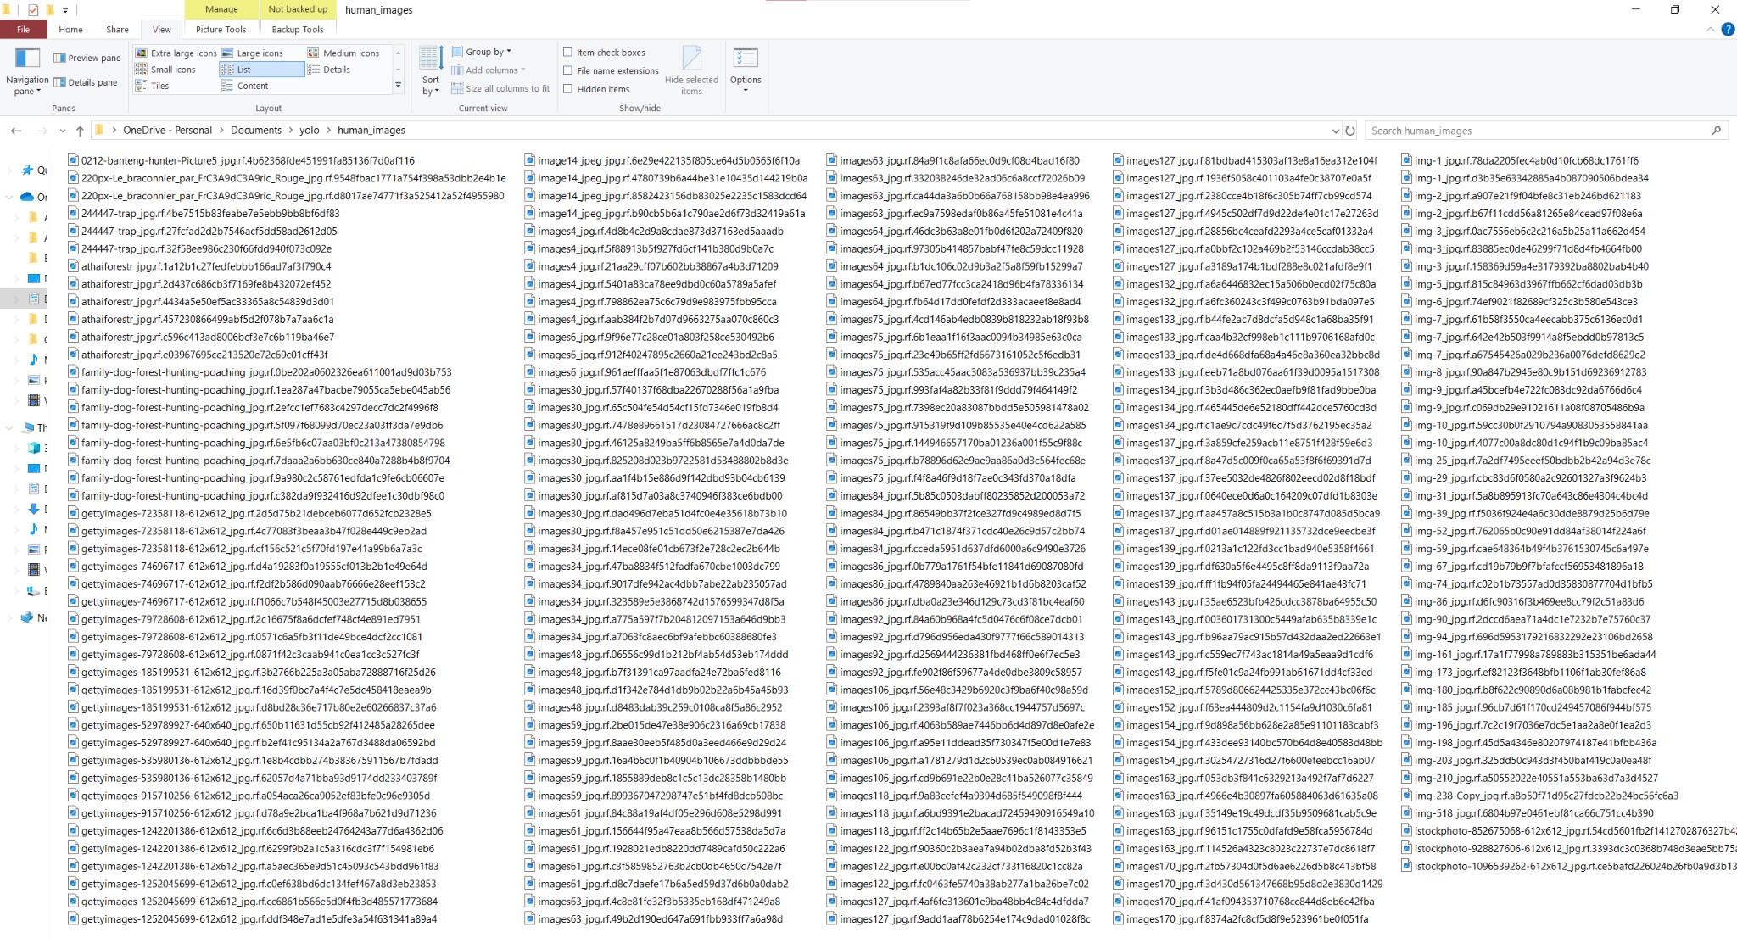

This is just a preview of some of the initial images I saved under here.

Now I needed to move on to annotate my dataset.

**Annotating a dataset** is basically the process of labeling data (such as images, videos, or text) with relevant information to train machine learning models. In computer vision, this typically involves drawing bounding boxes, polygons, or segmentation masks around objects in images and assigning them category labels (e.g "elephant," "human," "vehicle").

These annotations help the model learn to recognize and differentiate objects during training. High-quality annotations are crucial for accurate object detection, classification, and segmentation in AI applications like YOLO-based poacher detection systems.

In my case, I will be labelling my data using Label Studio, which is an open source labelling tool for this purpose. In order to use this platform, i will need to install Anaconda, a tool for creating and managing python environments. It is important to download this software based off of what OS your using. In my scenario, i'm using windows, so I opted for that option.

Now, I had to open the Anaconda Prompt, and setup the python environment for installing Label Studio, and other libraries for running YOLO models.

Step By Step, Ill Show You How It Was Setup:

1. In prompt, type in: conda create --name yolo-env1 python=3.12

This will enable the environment I'm looking for.

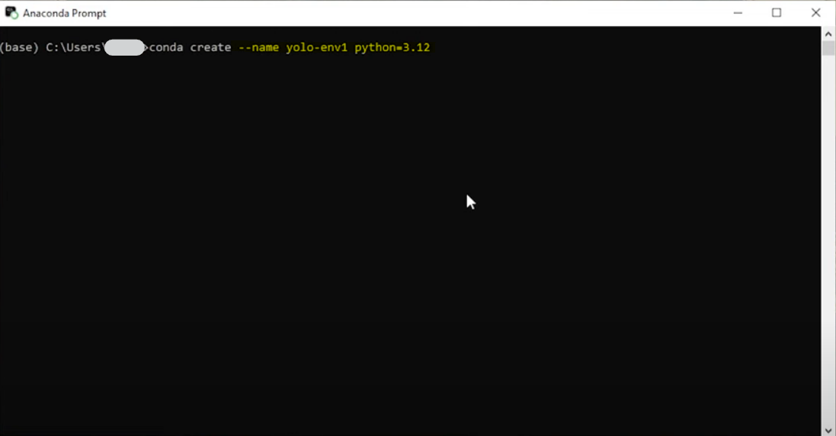

2. Now that the environment is created, I need to activate it, and install Label Studio:

3. Now I Have To Start Label Studio:

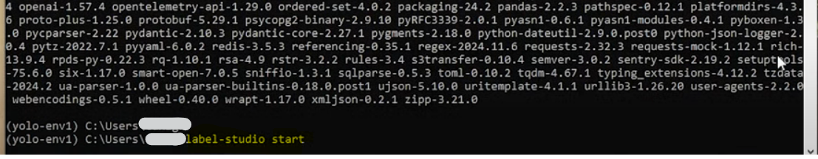

Annotating The Data:

After I set up Label Studio, and inserted my dataset, I had to choose which method of labeling I wanted to use. As mentioned earlier, I will be using bounding boxes.



After selecting this setup mode, I have to manually draw bounding boxes around what I want the model to identify. In this case, I want it to recognize humans, since that's my only object class for the model to identify. The photo below is an example of an image from the dataset with a bounding box.

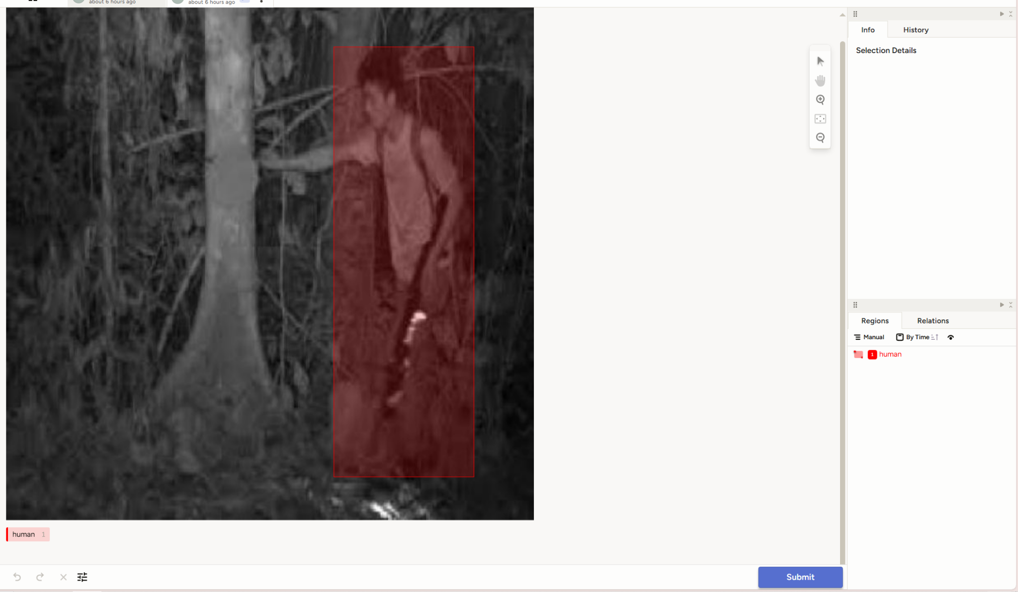

Then I exported data into a zip folder and used this specific google collab notebook to train my model: [Train_YOLO_Models.ipynb - Colab](https://colab.research.google.com/github/EdjeElectronics/Train-and-Deploy-YOLO-Models/blob/main/Train_YOLO_Models.ipynb#scrollTo=zEEObQqoiGrs)

I ran the first model training with the parameters of 25 epochs.

**March 20, 2025**

**I also exported the charts (see below/next page):**

**These were the results:**

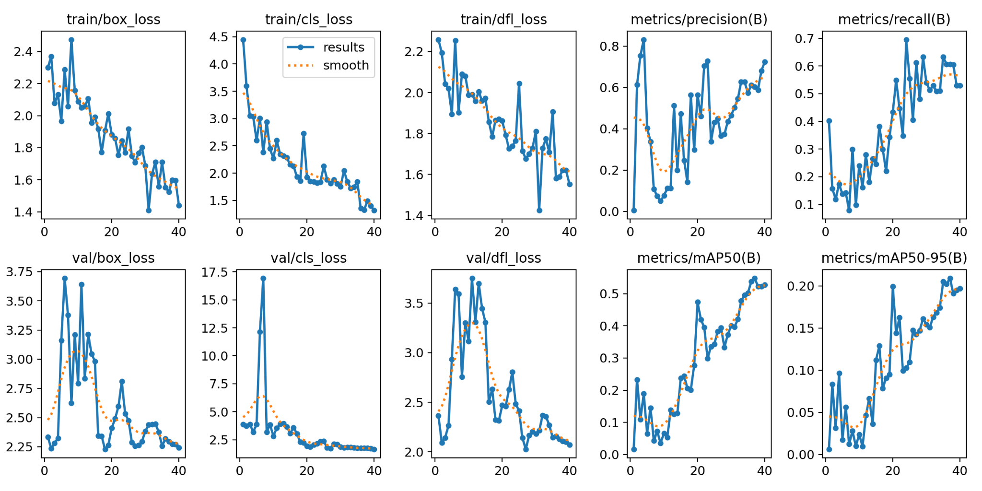

**Multiple Metric Chart Of Performance**

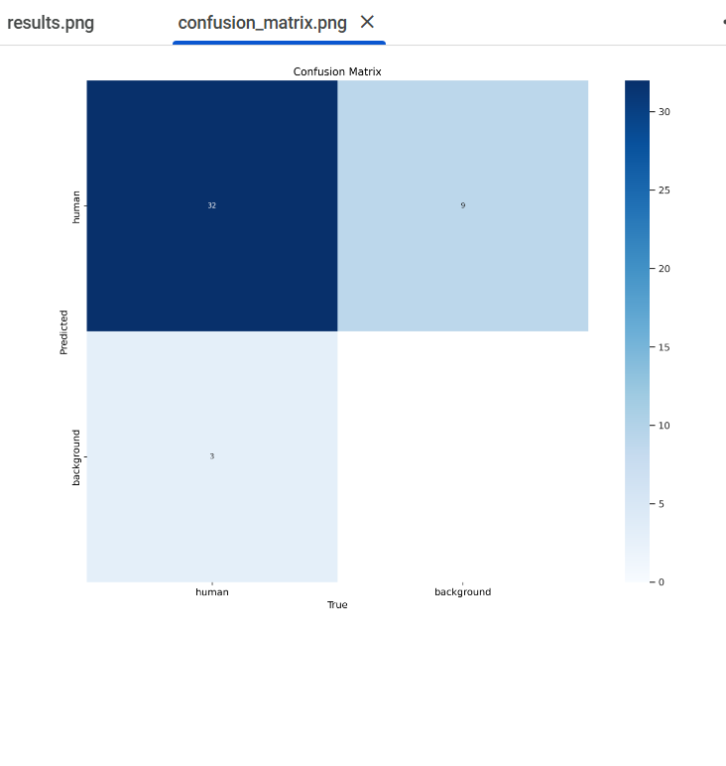

**Confusion Matrix**

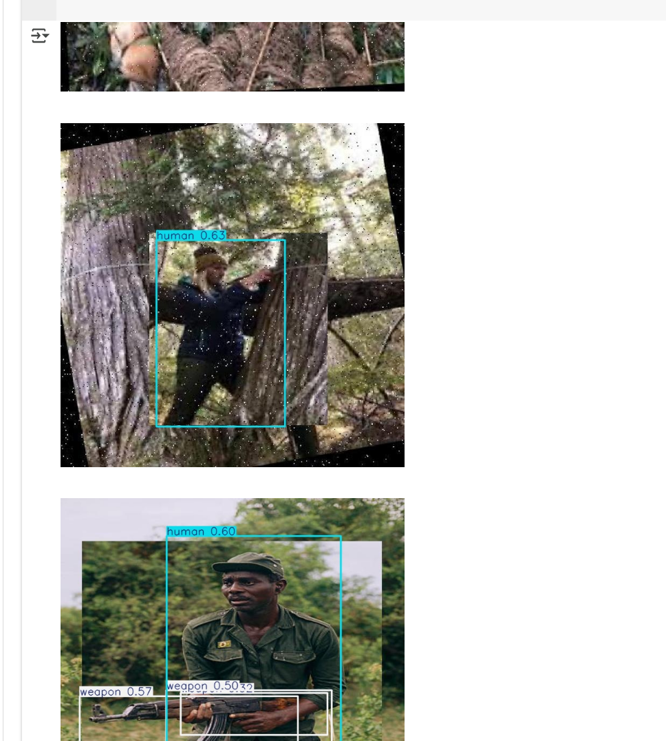

**Examples Of Test/Valid Testing**

Analyzing the Performance:

For the train/dfl loss and val/dfl loss:

**train/dfl loss** and **val/dfl loss**: Measures the loss related to *Distribution Focal Loss*, which helps in focusing on difficult-to-classify objects.

Trends for all losses should generally decrease steadily. In my graph, you can see that the graphs for these losses do decrease, however not continually or steadily. This could be because during training, the model might face fluctuations due to the learning rate or optimizer. A high learning rate can cause the model's weights to update too aggressively, leading to some instability in the loss and metric curves (spiking up and down). Early in training, the model may overfit to the training data, which can cause the metrics to spike because the model is learning very quickly but might not generalize well. This also applies to the precision, recall, mAP50, and mAP50-95 charts. Instead of decreasing in slope however, these classes(precision, recall, mAP50, and mAP50-95), should gradually increase which would indicate good performance of model. In this case, the same fluctuations could be caused by the reasons explained above.

**Confusion Matrix:**

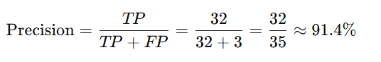

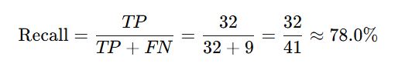

**The data from the confusion matrix never included any of the TN (True Negatives, meaning I could not calculate the accuracy based off of the confusion matrix, but the other pieces of data provided should give us a general idea of how well this performed.**

**SO, the results are good, but why does the valid/train set of images that the model had never seen before perform so poorly/not with high confidence? The reason why all lies in the dataset I used.**

**How my dataset was like (Issue To Improve On):**

**Included only 200 images, all way too specific, and did not have any pre-processing or augmentations applied to improve efficiency. Humans are directional, and if I dont flip/add different directions humans could face, then the model would not be able to identify if the class is human due to the way it faced. The dataset also had a ton of repeated images, as well as most images were set in one particular place, and barely any variations in terms of settings, or lighting. Mainly, the issue was that the dataset was not large, or diverse enough (As a beginner, I did not realize this).**

**Second Attempt Charts:**

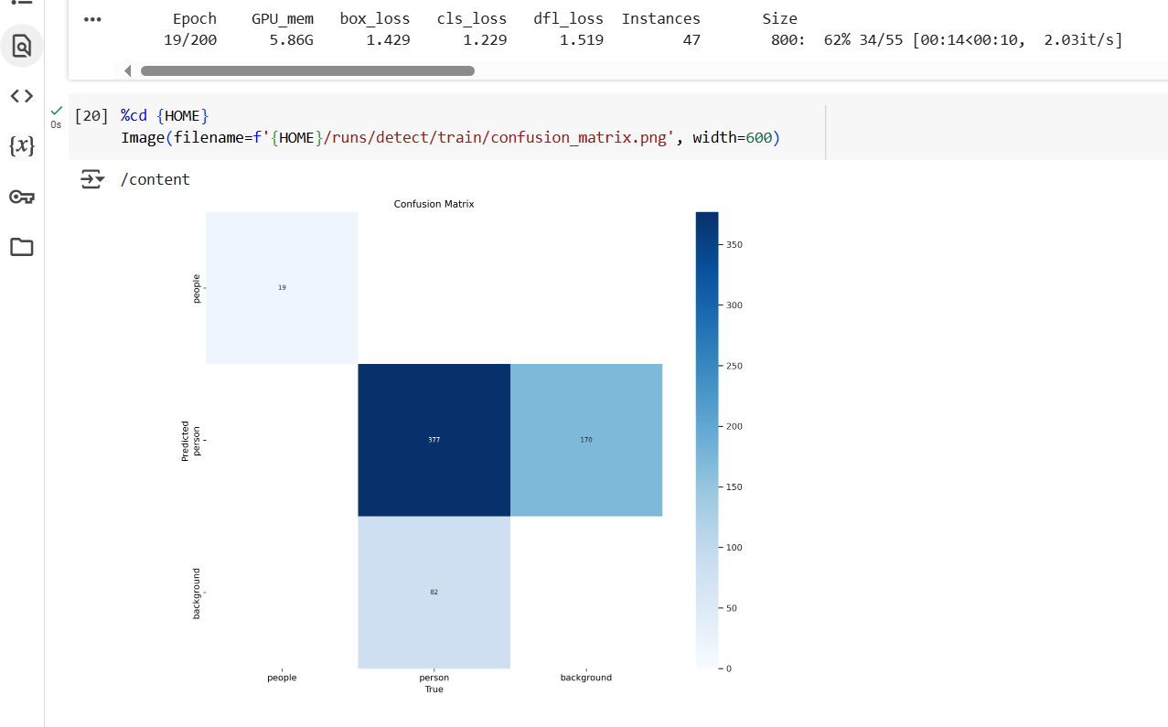

**Confusion Matrix Chart:**

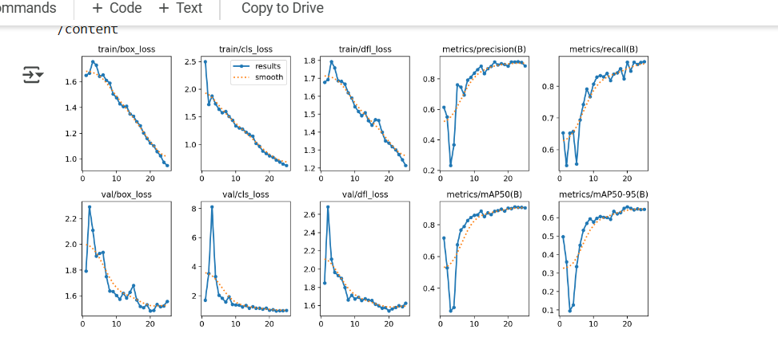

mULTI-mETRICS Charts:

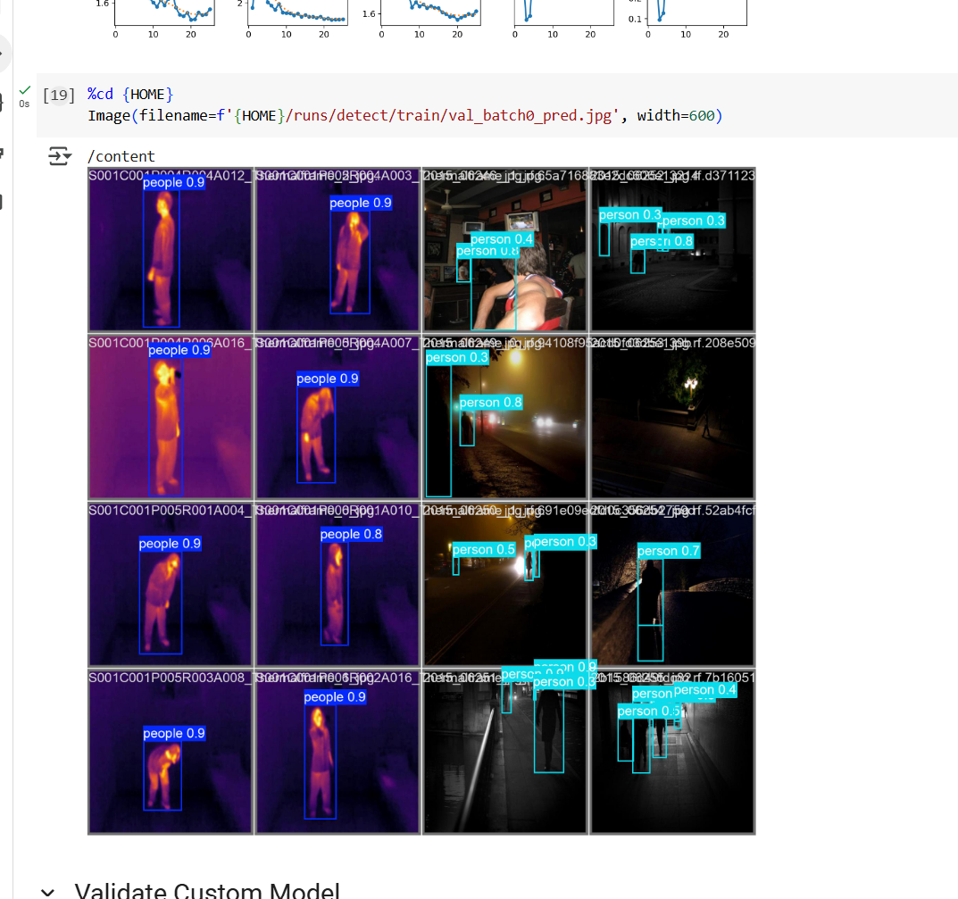

**Train/Valid Test Images Set and Model Confidence On Unseen Images:**

Originally, I attempted to train my model based off of images of only people/rangers during the daytime but **I decided to generate and label a dataset of humans, in mainly night settings. Images I used were once again not as diverse as it should have been (another mistake I repeated AGAIN).**

**Analyzing The Information:**

**Multi Metrics Charts: Chart trends are followed, kind of gradually increase, and decrease when needed. Refer to previous multi metrics graph analysis to learn more about how this would be analyzed.**

**Confusion Matrix (No TN):**

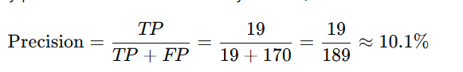

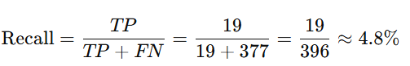

**Identified Issue:**

**The model was confusing the background as people since in some of the images, people were blended in with background shadows, and once again the dataset was not as diverse as it was supposed to be. Also around 200-300 images. Also, only augmentation and pre-processing applied was a horizontal flip, and stretch to 640x640 option. Please refer to the method section to learn more about terminology if unsure what is meant.**

**Attempt 3 (Much Better, but Unfortunately, No Multi-Metric Graph Was Exported):**

**After running into such bad performance, I decided to gather a much larger dataset, apply much more preprocessing and augmentations to the dataset.**

**The Options Selected:**

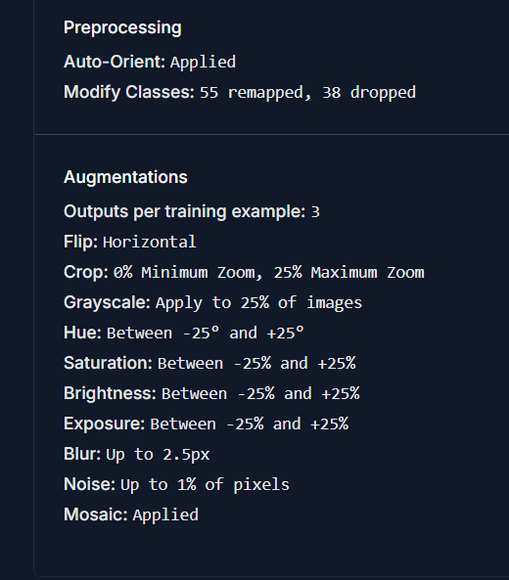

**Validation and Performance Charts:**

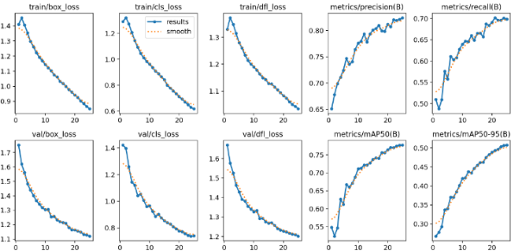

**NOW, Let's take a look at the Confusion Matrix After The Training (No TN):**

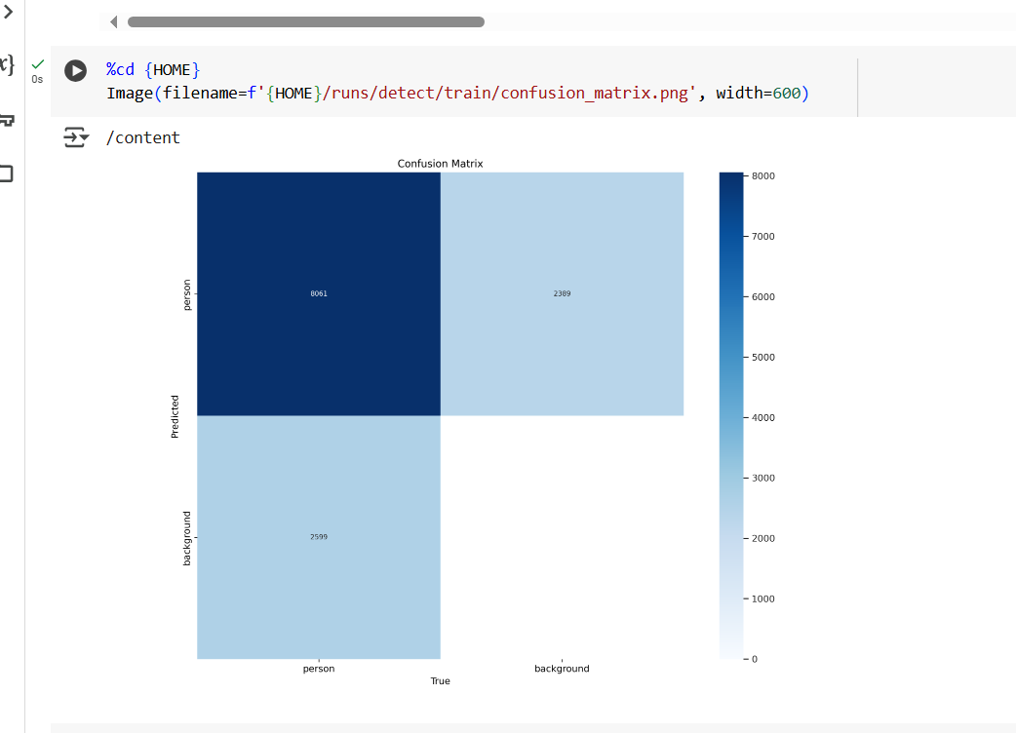

***Confusion Matrix from Attempt 3***

**Analyzing The Chart:**

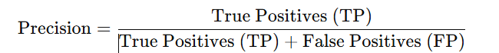

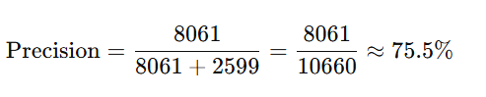

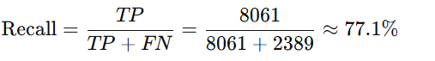

**Overall, this model's recall and precision dramatically increased when compared to attempt 2. This is probably because the dataset I used was very large, and had pre-processing and augmentation applied. This dataset was so much more diverse and mixed, compared to the other datasets and attempts that were used.**

**Comparing Attempt 2 and 3:**

**Attempt 3, with a precision of 75.5% and recall of 77.1%, is significantly better than Attempt 2, which has precision of 10.1% and recall of 4.8%. Attempt 3 is quite accurate when predicting "human," with a good balance between precision and recall. It correctly predicts 75.5% of the time when it says "human," and it successfully identifies 77.1% of actual humans. In contrast, Attempt 2 struggles greatly, in correctly identifying humans only 10.1% of the time and missing 95.2% of the humans it should detect.**

**Overall, Attempt 3 performs much better in both detecting humans and making accurate predictions. Attempt 2 is underperforming severely, with low precision and recall, making it ineffective for its intended task.**

**Comparing Attempt 3 and 1:**

**So, according to the confusion matrix, attempt 1 performed “better”, however it only did due to the very specialized, and in-diverse range of dataset images used. This is proved when we look at the train/valid set of images, images the model has never seen, and its low confidence rates.**

**Now, I'm not saying attempt 3 is the best performing model, I will still need to try and bring the precision and recall value higher. For now though, as a beginner, and with the limited help/guidance and resources I have had for this project, I would say this is a solid model for predicting humans.**

**What I will Complete Before In-Person Fair:**

* **Building and testing the physical device**
  + **Testing of the device could include testing durability, and ability to withstand weather conditions, and many other aspects needed in order to have a good device.**

**- Gathering More Data and Graphs, Also Re-Training Models**

**- Coding In The Notification Trigger (What I am Currently Doing)**

**Future Improvements:**

* **If selected for CWSF 2025, I will try my best to find the guidance needed in training a more efficient model, and in overall just testing different aspects of my project.**
* **Interview real park rangers about their experience and difficulties with dealing with poachers.**
  + **Ask them to give me some feedback on my design of the anti-poacher system.**
* **The Device may not be cost effective at first, but my main goal is to first work on bringing up the efficiency and performance as high as possible, and then see if I am able to cut down on prices.**

### **Also, I have not included all training sessions, as some were failures due to software disconnecting and not saving, meaning I had to restart the session from scratch. The attempts below were the 3 main training sessions I would like to share.**

Extra data:

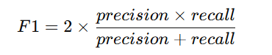

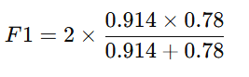

F1 Score is approx. 0.842 (but remember, dataset wasnt diverse, and this is not an accurate score given that if this were to be deployed in the wild, it would be ineffective).

F1 Score of 1.0 is a “perfect model”, and F1 Score of 0.0 is worst possible model

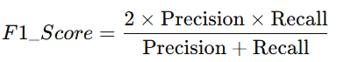

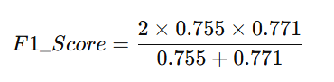

F1 Score is approx. 0.763

F1 Score of 1.0 is a “perfect model”, and F1 Score of 0.0 is worst possible model

### 

### 

### **In conclusion, in my project I worked on creating a new, innovative poaching detection system using AI-powered surveillance that was specially designed to address the major issues all current poaching detection devices have. I trained a YOLO-based model to detect “poachers” in wildlife areas, refining it through multiple attempts, while also adding a trigger notification alarm to alert authorities about suspicious activity related to poaching, while taking the proper action needed to address the issue. I used open-source tools and datasets, as well as trained the model on Google Collab. I enhanced the dataset with more variations, evaluated and fine-tuned the model. Additionally, I plan to collaborate with experts in wildlife conservation and AI to improve my system's/physical device effectiveness (when built).**

### 

### 

### 

### 

### 