Science Fair Plan

Science Fair 2025-2026 Plan
Idea:
- This project examines how students of various age groups spend money by collecting and analyzing financial data through surveys. Based on the findings, it proposes a customized budgeting app designed to help each age group manage their finances more effectively.

Research Question:
- How do students/teenagers view money, and how do their emotions and financial literacy impact that? How are their financial habits and literacy influenced by their home situation?

Proposed deadlines:
- September 29, 2025: Decide on project plan and assemble a control group.
- October 8, 2025: Have a control group decided and begin the experiment.
- November 6, 2025: Attempt to finish researching and organize collected data.
- December 6, 2025: Finish research and data collection, analyze research and begin making a budgeting app/understanding how to code
- January 21, 2025: Finish creating the budgeting application and test and debug.
- February 2026: Final project done and ready to present.

The steps:
- Research survey bias and prepare a survey to receive data
- We need a control group that will send us receipts and fill out a short survey for every purchase
- We will have to research financial literacy and financial management among teenagers
- We have to collect the data and organize it to analyze patterns in our control group
- We have to use that data and research to create a report
- We have to make a user-friendly application that can help people budget using the data.

Why is this a good idea:
- Topic: Nobody usually takes topics like finance/economics into consideration in a “science fair, so it brings a new twist that distinguishes you from the others. It is a refreshing idea, and the psychological aspect can easily explain why it is a scientific project.
- Research: Since this is a research project too, you will be able to learn a lot more about psychology and can develop good research habits.
- Innovation: Through this project, you learn how to make applications that are helpful for our day-to-day life, and you can be creative with how you deliver the project.

Next week: research survey bias
Establish research groups
26th:
- Create a contract (like thing) so ensure they agree for us to use their data (recipes) in our research – they will remain anonymous (aside from their grade/age)
- Create the actual survey
  - Mood - effect of the money on how they think/use the money
  - How do they feel the money limit changes their daily lives
  - Receipts of their spending
- End of week reflection
  - How do they feel about their spending habits this week
- Figure out people
  - 2 people per control group (no limit, except themselves)
    - Grades: 12, 11, 10, 9 (maybe 7 & 8)
  - 2 people in each group for the experiment
  - Total: 16, 20, or 24 people
- While collecting data:
  - Research on financial literacy and financial management among teenagers
  - Analyze their data
  - Make graphs according to the data
  - Find patterns in their spending habits
  - Finalize all graphs, data, and patterns
  - Start creating a report of this research project
- Make a report
- Plan a website or app
- Make the app/website

Next time plan:
- Create survey
  - How to format
- Figure out each group – control, experiment

Logs:
Sept 10:
- Organize thoughts
- Created Plan [above]
Sept 15:
- Researched survey bias
Sept 17:
- Create contract – approved by Mr. Finley
Sept 22:
- Start creating the survey
- Figuring out people for the survey/experiment
Sept 25:
- Continue setting up the survey
- Started organizing the data sheet
Sept 29
- Continue setting up the survey
- Draft email
Oct 2
- Create an intro survey
Nov 20
- Filled in the data sheet with new information
- Found 12 new links to research
- Started learning Python on freecodecamp.org

Scientific Method

Project Overview
Project Title
Wallets & Weaknesses – The Teen Psychology of Spending
Team Members
- Likhita
- Gwyneth
Short Summary.
This project examines teenagers’ spending habits and the psychological factors that influence them. Through an experiment and supporting research, we plan to better understand how teens make financial decisions. Based on our findings, we plan to design an app that helps teens manage their money more effectively.
Summary:
Our project explored the spending habits of teenagers ages 13 to 17 and the psychological factors that shape the way they make financial decisions. By combining an experiment with supporting research, we aim to understand both what teens spend their money on and why they make these decisions, including how emotions, social influence and stress affect their behaviour. We will analyze patterns in spending and decision-making to identify common challenges teens face when managing money. Using the insights of our findings, we plan to design a website that will track their spending and help teens make more thoughtful financial choices.
Primary Research Question
What psychological factors influence spending habits in teenagers?
Secondary Questions
- How are teens’ spending habits affected by their environment and external influences?
- How are teens’ spending habits connected to their background and experiences?
Objectives:
The purpose of this experiment is to examine how students from different age groups spend money and how their decisions are influenced by emotions and external factors.

Hypothesis :
We hypothesize that most teenage spending will be directed towards food and transportation, as these are essential items often purchased daily. Spending will also probably increase when the environment is ranked high, and items are cheap, resulting in lower emotional levels and a tendency to purchase. This combination of good purchasing factors can result in a low-risk comfort zone where a majority of the participants will purchase from. We also expect that spending decisions will be strongly influenced by peers and social environments, causing teens to make purchases based on social pressures and trends. This will likely also drive more people to spend during the holiday season (December) on gifts or in late October for Halloween. Additionally, having a set budget is expected to encourage participants to think more carefully about the difference between wants and needs, leading to more intentional and responsible spending choices.

Research Design

Study Type and Rationale
Study type (e.g., survey, experimental, mixed methods)
- Experimental (using surveys)
Rationale for chosen design
We chose an experimental design supported by surveys to better understand real spending habits and attitudes. This approach allows us to identify common financial challenges faced by teens around us and develop solutions based on their needs.

Population and Sampling
Target population
Teenagers (ages 15-18)
Inclusion criteria
- Students at our school
- Signed consent form
- Willingness to participate
Exclusion criteria
- Lack of parental consent

Sampling method
Participants will be given different budget limits (under $20, $50, or $100) based on the typical spending ranges of our participants to observe how budget size affects spending behaviour.
Sample size target
Approximately one-third of our population

Variables and Measures
Independent variables
- Budget limit (under $20, $50, or $100)
- External influences (peer pressure, advertisement, social media)
- Emotional state (stress, excitement, boredom)
Dependent variables
- Amount of money spent
- Type of purchases made (needs vs wants)
- Spending decisions (impulsive vs. planned)
Control variables
- Age range
- Time allowed to complete the surveys
Operational definitions
- Variable 1: Budget Limit
  - The budget limit is the fixed amount of money assigned to each participant in the spending scenario ($20, $50, or $100), which determines the maximum amount they are allowed to spend during the experiment.
- Variable 2: Spending Behaviour
  - Spending behaviour is measured through participants’ survey responses, including how much of the budget they choose to spend, the types of items selected (e.g., food, transportation, entertainment), and whether the purchase is influenced by others or a want/need.

Instruments and scales
- Survey items:
  - Date of purchase
  - Proof of purchase
    - Picture of receipt (optional)
    - Price and item name
  - Emotions/Feelings upon purchasing the item(s)/product(s)
    - Scale (Thrilled - regretful) and explanation
  - Describe your surrounding environment
    - Scale (opposing - supportive) and explanation
  - What influenced you to purchase this item/product?
  - (Phase 2) How did having a limit affect your financial choices?
- Validated scales:
  - Likert scale (1-10)
    - Measures participants’ emotional state of the purchase and their surrounding environment

Data Collection

Procedures
Recruitment plan
Participants will be recruited from Grades 10-12 within the school. Students who are willing to participate will be informed about the study
Consent process
All interested participants will be provided with a printed consent form approved by the principal. The form will include an overview of the study and require a parent or guardian’s signature, as well as a preferred email address for communication.
Data collection steps
- Participants will receive an email containing instructions and a link to a Google survey
- Each time participants make a purchase, they will complete a short form describing the purchase
Receipt or transaction logging protocol (if applicable)
Participants will be asked to provide proof of purchase by uploading a photo of their receipt in each Google Form submission
Data storage and security
All collected data will be stored in a Google Spreadsheet, with participants identified only by assigned code numbers. Data will not be shared with others, and any reported results will be anonymous

Quality Control and Bias Mitigation
Steps to reduce bias
- To minimize survey bias, questions will be carefully designed based on prior research and reviewed to ensure clarity and neutrality
Attention checks and validation
- Weekly emails will be sent to participants containing new Google Forms or reminders to complete previously sent forms, helping to ensure consistent participation and accurate data collection.
Missing data handling plan
All data will be collected directly from participants. If participants have questions or concerns, email communication will remain open. Missing data will be defined as unsubmitted purchase forms and will not be included in the final analysis. This may limit the accuracy of results; however, secondary research data will be used to help support and contextualize findings.

Timeline and Resources

Milestones and Deadlines
- Milestone 1: Consent Forms Signed — Date: October 9, 2025
- Milestone 2: Phase 1 Complete — Date: November 10, 2025
- Milestone 3: Phase 2 Complete — Date: December 8, 2025
- Final presentation: Date: February 6, 2026

Ethics Risk Management and Appendices

Ethics and Consent
Ethics approval required:
Yes
Consent form summary
- Participants will provide consent for their data to be collected and used for this study. All data will remain confidential and will only be shared in anonymized form
Anonymization plan
- Each participant will be assigned a unique code number. Any data used in analysis or reporting will reference these code numbers rather than participant names.

Risks and Contingencies
Potential risks
- Loss of data due to technical issues
- Insufficient data caused by low participation or incomplete submissions
Mitigation strategies
- Careful use of software to ensure all data is properly saved and stored
- Regular monitoring of data collection to identify issues early
Backup plans
- If insufficient data is collected, the project will rely more heavily on secondary research to support and contextualize findings.

Scientific Method 2
Our project explored the spending habits of teenagers ages 13 to 17 and the psychological factors that shape the way they make financial decisions. By combining an experiment with supporting research, we aim to understand both what teens spend their money on and why they make these decisions, including how emotions, social influence and stress affect their behaviour. We will analyze patterns in spending and decision-making to identify common challenges teens face when managing money. Using the insights of our findings, we plan to design a website that will track their spending and help teens make more thoughtful financial choices.
Primary Research Question
What psychological factors influence spending habits in teenagers?
Secondary Questions
- How are teens’ spending habits affected by their environment and external influences?
- How are teens’ spending habits connected to their background and experiences?
Objectives:
The purpose of this experiment is to examine how students from different age groups spend money and how their decisions are influenced by emotions and external factors.

We hypothesize that most teenage spending will be directed towards food and transportation, as these are essential items often purchased daily. Spending will also probably increase when the environment is ranked high, and items are cheap, resulting in lower emotional levels and a tendency to purchase. This combination of good purchasing factors can result in a low-risk comfort zone where a majority of the participants will purchase from. We also expect that spending decisions will be strongly influenced by peers and social environments, causing teens to make purchases based on social pressures and trends. This will likely also drive more people to spend during the holiday season (December) on gifts or in late October for Halloween. Additionally, having a set budget is expected to encourage participants to think more carefully about the difference between wants and needs, leading to more intentional and responsible spending choices.

Research Design

Study Type and Rationale
Study type (e.g., survey, experimental, mixed methods)
- Experimental (using surveys)
Rationale for chosen design
We chose an experimental design supported by surveys to better understand real spending habits and attitudes. This approach allows us to identify common financial challenges faced by teens around us and develop solutions based on their needs.

Population and Sampling
Target population
Teenagers (ages 15-18)
Inclusion criteria
- Students at our school
- Signed consent form
- Willingness to participate
Exclusion criteria
- Lack of parental consent

Sampling method
Participants will be given different budget limits (under $20, $50, or $100) based on the typical spending ranges of our participants to observe how budget size affects spending behaviour.
Sample size target
Approximately one-third of our population

Variables and Measures
Independent variables
- Budget limit (under $20, $50, or $100)
- External influences (peer pressure, advertisement, social media)
- Emotional state (stress, excitement, boredom)
Dependent variables
- Amount of money spent
- Type of purchases made (needs vs wants)
- Spending decisions (impulsive vs. planned)
Control variables
- Age range
- Time allowed to complete the surveys
Operational definitions
- Variable 1: Budget Limit
  - The budget limit is the fixed amount of money assigned to each participant in the spending scenario ($20, $50, or $100), which determines the maximum amount they are allowed to spend during the experiment.
- Variable 2: Spending Behaviour
  - Spending behaviour is measured through participants’ survey responses, including how much of the budget they choose to spend, the types of items selected (e.g., food, transportation, entertainment), and whether the purchase is influenced by others or a want/need.

Instruments and scales
- Survey items:
  - Date of purchase
  - Proof of purchase
    - Picture of receipt (optional)
    - Price and item name
  - Emotions/Feelings upon purchasing the item(s)/product(s)
    - Scale (Thrilled - regretful) and explanation
  - Describe your surrounding environment
    - Scale (opposing - supportive) and explanation
  - What influenced you to purchase this item/product?
  - (Phase 2) How did having a limit affect your financial choices?
- Validated scales:
  - Likert scale (1-10)
    - Measures participants’ emotional state of the purchase and their surrounding environment

Data Collection

Procedures
Recruitment plan
Participants will be recruited from Grades 10-12 within the school. Students who are willing to participate will be informed about the study
Consent process
All interested participants will be provided with a printed consent form approved by the principal. The form will include an overview of the study and require a parent or guardian’s signature, as well as a preferred email address for communication.
Data collection steps
- Participants will receive an email containing instructions and a link to a Google survey
- Each time participants make a purchase, they will complete a short form describing the purchase
Receipt or transaction logging protocol (if applicable)
Participants will be asked to provide proof of purchase by uploading a photo of their receipt in each Google Form submission
Data storage and security
All collected data will be stored in a Google Spreadsheet, with participants identified only by assigned code numbers. Data will not be shared with others, and any reported results will be anonymous

Quality Control and Bias Mitigation
Steps to reduce bias
- To minimize survey bias, questions will be carefully designed based on prior research and reviewed to ensure clarity and neutrality
Attention checks and validation
- Weekly emails will be sent to participants containing new Google Forms or reminders to complete previously sent forms, helping to ensure consistent participation and accurate data collection.
Missing data handling plan
All data will be collected directly from participants. If participants have questions or concerns, email communication will remain open. Missing data will be defined as unsubmitted purchase forms and will not be included in the final analysis. This may limit the accuracy of results; however, secondary research data will be used to help support and contextualize findings.

Timeline and Resources

Milestones and Deadlines
- Milestone 1: Consent Forms Signed — Date: October 9, 2025
- Milestone 2: Phase 1 Complete — Date: November 10, 2025
- Milestone 3: Phase 2 Complete — Date: December 8, 2025
- Final presentation: Date: February 6, 2026

Ethics Risk Management and Appendices

Ethics and Consent
Ethics approval required:
Yes
Consent form summary
- Participants will provide consent for their data to be collected and used for this study. All data will remain confidential and will only be shared in anonymized form
Anonymization plan
- Each participant will be assigned a unique code number. Any data used in analysis or reporting will reference these code numbers rather than participant names.

Risks and Contingencies
Potential risks
- Loss of data due to technical issues
- Insufficient data caused by low participation or incomplete submissions
Mitigation strategies
- Careful use of software to ensure all data is properly saved and stored
- Regular monitoring of data collection to identify issues early
Backup plans
- If insufficient data is collected, the project will rely more heavily on secondary research to support and contextualize findings.

09/15/2025 Survey Bias Research
Survey bias types that researchers need to know about
by qualtrics

- Survey bias:
  - A systemic error that causes results to be inaccurate or unrepresentative
  - It occurs when the design, wording or method of survey influences participants’ responses
  - Bias reduces the validity and reliability of an experiment
- Bias is in every survey
  - Impossible to have no bias – opinion is subjective
    - Includes the researcher (thinks of questions and plans the research) and the participants (answers questions)
- Several ways of survey bias:
  - Selection: survey variety (is it broad enough?)
  - Response: answers swayed by factors from the interviewer?
  - Interviewer: Are they biased? Asking questions that are or asked in a way that might create bias
- Selection Bias:
  - Happens when the people chosen for the survey do not represent the target population
    - sample too narrow – doesn’t provide the necessary data
  - Results become skewed because certain groups are overrepresented or missing
- Non-response bias
  - Occurs when people who choose not to respond are different from those who do
  - Leads to incomplete or misleading data
- Survivorship bias
  - Only the “remaining” or long-term participants are measured, while those who dropped out are ignored
  - This can make results seem more positive than they truly are
- Response Bias
  - Happens when participants answer in a way that is not truthful or accurate, often due to pressure or confusion
  - Acquiescence bias:
    - Participants tend to agree with statements even if they don’t truly feel that way
    - easier to agree — to please a researcher or complete a survey — than to disagreeable
  - Demand characteristic bias
    - Participants change their behaviour because they think they know the purpose of the study
  - Question order bias
    - Related questions are placed in a certain order – participants feel the need to follow up based on previous questions
    - Participants’ desire to be consistent with their answers
  - Reporting bias (Social desirability bias or conformity bias)
    - People selectively report information, leaving out things that make them look bad
      - Survey takers may want to appear more socially desirable or attractive to the interviewer
      - respondents answering uncharacteristically or lying to appear in a positive light.
  - Extreme response bias
    - Participants only choose the most extreme options on a scale
  - Neutral response bias
    - Questions are not specific enough → don’t evoke a strong enough response for respondents to pick an extreme either way.
    - Participants overuse the middle option to avoid making a real choice
- Interviewer bias
  - Survey bias is created by the actions of the interviewer
    - The way that a question is asked, or the way the interviewer makes a participant feel in the survey
  - Demand characteristic bias
    - Participant acts differently knowing they are in an interview setting – pressure
  - Reporting bias:
    - The research team decides on the publication of the research based on the positive or negative outcome from the analysis of the data.

The 7 types of sampling and response bias to avoid in customer surveys
by Lucia Chung

- Selection bias
  - Add “don’t know” or “not applicable” options so people don’t guess
  - Use a random and up-to-date participant list
  - Follow up with non-respondents to reduce missing data
  - Choose the best way to reach target audience
  - Prevent survivorship bias by including newer and less active participants
- Response bias
  - Avoid emotional or leading language
  - Write neutral questions that don’t suggest a “right” answer
  - Use scales or multiple choice instead of yes/no
  - Ask someone else to review the survey for bias
  - Provide incentives so participants stay focused
  - Ask one question at a time
  - Mix up topics to prevent question order bias
  - Avoid emotionally charged words
  - Use balanced answer scales to reduce acquiescence bias
  - Offer anonymous feedback if people feel uncomfortable
- Interviewer bias
  - Stay neutral and professional
  - Be polite and supportive so participants feel comfortable

09/15/2025 Survey Bias Research 2
Survey Bias (Qualtrics)
- What is survey bias?
  - A systematic error that makes survey results inaccurate or unrepresentative.
  - It occurs when the survey design, wording, or method influences responses.
  - Bias reduces the validity and reliability of results.
  - Bias is unavoidable because opinions are subjective.
  - Both researchers (question design) and participants (answers) contribute to bias.
- Main Types of Survey Bias
  - Selection Bias
    - Occurs when the sample does not represent the target population.
Results become skewed because certain groups are missing or overrepresented
    - Examples:
      - Non-response bias: People who don’t answer differ from those who do.
      - Survivorship bias: Only long-term or “successful” participants are counted.
- Response Bias
  - Occurs when participants give inaccurate or influenced answers.
    - Types:
      - Acquiescence bias: Tendency to agree with statements.
      - Demand characteristic bias: Changing answers based on what they think the study is about.
      - Question order bias: Earlier questions influence later ones.
      - Social desirability bias: Responding to look good or avoid judgment.
      - Extreme response bias: Only choosing extreme options.
      - Neutral response bias: Always choosing the middle option.
- Interviewer Bias
  - Occurs when the interviewer’s tone, wording, or behaviour influences answers.
How to Reduce Bias (Lucia Chung)
- Prevent Selection Bias
  - Use random and up-to-date samples
  - Follow up with non-respondents
  - Include “not applicable” options
  - Reach participants through the right platform
- Prevent Response Bias
  - Use neutral wording
  - Avoid emotional or leading questions
  - Ask one question at a time
  - Use balanced answer scales
  - Mix up question order
  - Allow anonymous responses
- Prevent Interviewer Bias
  - Stay neutral and professional
  - Create a comfortable, non-judgmental environment

Survey bias affects every study, but careful design and neutral questioning can reduce its impact.

Surveys
Intro Survey:
https://docs.google.com/forms/d/1KrUCPmpiT7tiSY5lrFcfUn2l-gdOsXmXvOCBm-201Zk/edit?ts=68cb84ec

Week 1 Survey:
https://docs.google.com/forms/d/1KrUCPmpiT7tiSY5lrFcfUn2l-gdOsXmXvOCBm-201Zk/edit?ts=68cb84ec

Week 2-4 Survey:
https://docs.google.com/forms/d/16HwCWkCQtKzpzEvDNwEQMwjpRQjcmNHlwqxih_dd7ko/edit?ts=68f70231

Final Survey:
https://docs.google.com/forms/d/1OG6bhQM4t0K89dQ039DCmw_Y3I_8K3HMwOkpIHOEgmY/edit?ts=6937b192

Contract
USE OF FINANCIAL DATA AGREEMENT
1, Purpose
The volunteer consents to share particular personal data with the Collaborators for use in a behavioural finance–focused science fair project. The Collaborators will be analyzing and reporting this data anonymously for financial and behavioural insights. This data collection model will be entirely anonymous and will not require the volunteer to disclose their identity aside from their age. Conducted as part of a high school science fair, the project aims to explore and understand individual spending behaviours in mid-high school students.

2. Scope of Data Collection
The Collaborators may collect, store, and use the following types of data:
- Financial Data (Records of purchase, receipts, proof)
- Behavioural Data (Emotions and feelings)
3. Data Protection & Privacy
The Collaborators agree to:
- Protect the Participant’s data using reasonable security measures
- Not sell, rent, or disclose personally identifiable information to third parties without explicit consent
- Maintain anonymity when using the Participant’s data
4. Retention of Data
The Collaborators will retain the data received until the end of June 2026, unless otherwise requested by the Volunteer to delete their data.

5. Liability
The Collaborators shall not be liable for any unintended consequences resulting from the use of anonymized data.

6. Consent to Use Data
By signing this Agreement, the Participant grants the Collaborators the right to:
- Collect, process, and analyze the data described in Section 2
- Use the data in this year’s Science Fair Project in the form of reports and experimental results data
- Share anonymized data with Westmount Charter School administration

________________________________ ________________________________
Participant Signature Parent/Guardian Signature

Emails:

Intro Email
Hey everyone,

Thank you for filling out the contract and deciding to participate in our science fair experiment. To clarify any confusion, this experiment is looking at your psychological responses to spending money (thoughts, emotions, etc) and spending habits.

For the next 2 months, from October 15 to December 15, we will be sending you weekly emails on Monday with a purchase survey for you to fill out every day of the week. The survey will only take 5-10 minutes maximum. We would greatly appreciate it if you could complete the survey on the day of, but we understand if it takes longer because we all have our own lives. However, please understand that the survey will be based on your emotions during your purchases and may become more inaccurate the longer you wait. The “deadline” for the purchase surveys will be 11:59 p.m. Sunday.

To start this experiment, please fill out this introductory survey. Please complete this by 11:59 pm Tuesday. The first purchase survey will be sent out on Wednesday, if all goes according to plan.
https://docs.google.com/forms/d/e/1FAIpQLSdqkh9ewRGBqR667Qfo1xyjK585Kq51miOPjQdIwup6yYT_xQ/viewform?usp=sharing&ouid=115314540344905627763

Draft email for the first survey:
Subject: Wallets & Weaknesses – First Official Survey (Oct 15 - Oct 19)

Hey everyone,

Thank you for filling out the introductory survey! Starting next week, surveys will be sent out every Monday for you to complete based on the items you buy that week.

Please be honest when filling them out. The information is used only for educational purposes and will remain completely anonymous in our data, so there’s really no reason not to be! We understand you might forget sometimes, which can lead to small inaccuracies, but please try your best — something is always better than nothing.

Please complete all surveys for this week by Sunday, October 19, at 11:59 p.m. Each one should take you no more than 5-10 minutes.

[survey link]

Thanks,
— The Wallets & Weaknesses Team
Likhita and Gwyneth

Week 2 Email
Wallets & Weaknesses – Phase 1 (Oct 20 - Nov 9)

$20
Hey everyone,
For this next phase, we’ll be making a few small changes to the experiment. You will now have a weekly spending maximum of $20.

Please do your best to stay within that limit. Of course, if there’s an emergency, it’s completely fine to go over. If you feel that your maximum is unreasonable, please email us to explain why and suggest a more suitable amount.

Friendly reminder: please make sure to read the emails and complete the forms — they really don’t take long, and the emails will get even shorter once we’re all in a routine. The due date for this phase’s forms is Sunday, November 9, at 11:59 p.m., though we encourage you to complete them weekly. Again, please be honest when completing the forms.

Thanks,
— The Wallets & Weaknesses Team
Likhita and Gwyneth

$50

Hey everyone,
For this next phase, we’ll be making a few small changes to the experiment. You will now have a weekly spending maximum of $50.

Please do your best to stay within that limit. Of course, if there’s an emergency, it’s completely fine to go over. If you feel that your maximum is unreasonable, please email us to explain why and suggest a more suitable amount.

Friendly reminder: please make sure to read the emails and complete the forms — they really don’t take long, and the emails will get even shorter once we’re all in a routine. The due date for this phase’s forms is Sunday, November 9, at 11:59 p.m., though we encourage you to complete them weekly.

Thanks,
— The Wallets & Weaknesses Team
Likhita and Gwyneth

$100

Hey everyone,
For this next phase, we’ll be making a few small changes to the experiment. You will now have a weekly spending maximum of $100.

Please do your best to stay within that limit. Of course, if there’s an emergency, it’s completely fine to go over. If you feel that your maximum is unreasonable, please email us to explain why and suggest a more suitable amount.

Friendly reminder: please make sure to read the emails and complete the forms — they really don’t take long, and the emails will get even shorter once we’re all in a routine. The due date for this phase’s forms is Sunday, November 9, at 11:59 p.m., though we encourage you to complete them weekly.

Thanks,
— The Wallets & Weaknesses Team
Likhita and Gwyneth

10/27 Reminder Email
Wallets & Weaknesses – Weekly Form Reminder
Hi everyone,
For this week, the experiment will remain the same as last week; we’re still in Phase 1. This email is just a reminder to please complete your weekly forms.
We understand that everyone is busy, but these forms take no longer than five minutes to fill out. In fact, the longer you wait to submit them, the more time it’ll take to catch up later. Our expectations aren’t high; even one-sentence responses are perfectly fine!
This may not apply to everyone, especially if you haven’t made any purchases recently. However, we do know that several participants have spent money but haven’t yet submitted their forms, so please make sure to do so as soon as possible.
If you have any concerns about your price range, expectations, or any other questions, please email karwad.li@wcs-g.com and cc. gao.gw@wcs-g.com.

Thanks,
— The Wallets & Weaknesses Team
Likhita and Gwyneth

Week 3 & 4 Email
Wallets & Weaknesses – Phase 1, Weekly Form Reminder
Hey everyone,
This is the 3rd week of phase 1. The experiment is the same as before: stay within the budget, and fill out the purchase surveys. To review your weekly budget, check the last email you received from us.

Just a reminder: since we go to the same school, we’ve noticed that some of you have been making purchases but haven’t filled out the form yet. Please take a moment to complete it when you can. We really appreciate your help. Remember, this is due on Sunday, November 9th, at 11:59 pm.

The link to the form you should complete

If you have any concerns about your price range, expectations, or any other questions, please email karwad.li@wcs-g.com and cc. gao.gw@wcs-g.com.

Thanks,
— The Wallets & Weaknesses Team
Likhita and Gwyneth

Hey everyone,
Our next phase for this experiment will be postponed due to the lack of responses, so for the next 2 weeks, the experiment will still be the exact same as before: Stay within the limit of our experiment and log your purchases.

Reminder: READ our emails and COMPLETE the forms — again, they will not take long. 5 minutes maximum. This is not a difficult task to do. Please finish them weekly, and be honest.

[survey link]

Thanks,
— The Wallets & Weaknesses Team
Likhita and Gwyneth

Final Email
Hey everyone,
This is our final week of this experiment! I hope everyone enjoyed it, and please complete your last week of Google Forms! The process and form are the same, except for our final question! Please take some time this week to fill it out!

Purchase Survey:
Final Survey:

Thanks,
— The Wallets & Weaknesses Team
Likhita and Gwyneth

Research:
The Psychology of Spending: Understanding Your Money Mindset
- Beliefs guide our financial decisions
- Money mindset – how you view finance
  - Finance is full of opportunities, vs a “long journey with caution signs”
  - Mix of your beliefs, financial knowledge, and emotions
- Spending habits are highly influenced by our money mindset
- Shaped by experiences, values, and beliefs
  - Growing up constantly struggling with finances, → scarcity mindset, feel anxious about spending money, even on necessary expenses
  - Growing up where money was abundant and freely spent → more relaxed attitude towards spending; challenging to save for the future.
- Spending is influenced by: Emotions, Impulses, & Beliefs
- Psychological Factors:
  - Emotions:
    - Stress, anxiety, fear, happiness, etc., influence financial decisions
      - Ex. more impulsive when stressed, more willing to take risks when happy
  - Impulses:
    - Override rational thinking about money
- Spending Behaviours:
  - Emotional spending:
    - Ex. Might be connected to finding comfort through purchases
  - Values-based spending:
    - Ex. belief that like is about making memories → spend more on experiences
  - Security-driven Spending:
    - Ex. financial stability driven → only spend on essential items

What is unhappy spending? How to teach teens to get smart about money
- Teenagers have fewer physical interactions with money, creating a more distant impression of it
  - Doesn’t feel like you actually have the money
- Teens adopt a wants-based, YOLO mentality
- Unhappy spending
  - Emotional return on investment
  - Mindfully choosing where you're spending money so you get the most joy
  - Enjoy the spending so you don’t resent the savings
- Fear of loans – secondary school
- Practice the habits that you need → confidence moves up and anxiety goes down.

10/16: The Psychology of Spending
The Psychology of Spending: Understanding Your Money Mindset
by Remynt

- Money mindset (how it explains financial success or struggle)
  - People differ in money skills because of spending habits and psychology
  - Money mindset = deep beliefs that guide financial decisions
  - It is about how people think about money, not just how much they have
- Money mindset as a “lens.”
  - Mindset acts like glasses for viewing money
    - Some see money as an opportunity; others see danger and stress
  - Understanding this helps people reach goals more effectively
- How the money mindset is formed
  - Shaped by experiences, values, and beliefs
  - Growing up with financial stress → scarcity mindset, anxiety about spending
  - Growing up with financial abundance → relaxed spending, difficulty saving
- Inner psychology that controls spending
  - Emotions:
    - Retail therapy = spending to cope with (bad) emotions
  - Impulses
    - Desire for new items overrides logic
  - Beliefs
    - Fear of money “running out” leads to herding or reckless spending
  - Money mindset is a mix of beliefs, emotions, and financial logic
    - Together, these affect how people handle money
- Psychological factors
  - Emotions:
    - Stress → impulsive buying
    - Happiness → risk-taking
    - Fear/anxiety → overspending or avoidance
  - Impulses
    - Immediate wants override rational thought
- Types of spending behaviours
  - Emotional spending
    - Buying for comfort or stress relief
  - Values-based spending
    - Spending on experiences instead of possessions
  - Security-driven spending
    - Focused on saving and essential purchases
- Why mindset matters
  - Financial decisions are driven by thoughts and emotions
  - Self-reflection helps people understand why they spend the way they do

10/23: What is Unhappy Spending?
What is unhappy spending? How to teach teens to get smart about money
by Marcus Medford-Kerr

- Teen money challenges
  - Teens face different financial struggles than adults
  - Many teens rarely use cash because of digital payments
    - Without physical money, spending feels
      - Less real
      - Less earned
      - Less “spent”
  - This makes money feel abstract, leading to careless spending
- Emotional and social pressures
  - Global issues (climate crisis, job insecurity) make teens adopt a:
    - “You only live once.”
    - Want-based mindset
  - Some teens feel hopeless about the future and spend for short-term comfort
- Teaching budget awareness
  - Simmons tells teens to:
    - Separate allowance from spending accounts
    - Pretend savings are “not yours.”
    - Spend only within set limits
  - If budgeting fails:
    - Troubleshoot instead of feeling like a failure
  - Parents may pass down financial trauma, which affects teens’ money attitudes
- Unhappy spending
  - Spending should be judged by emotional return on investment
    - Teens rate purchases from one to five
      - 5/5: brings joy, connection or meaning
      - ⅕: regret, forgettable, or unnecessary
    - Example:
      - Starbucks with friends = 5/5 (on the emotional scale) because of social value
- Shame vs mindful spending
  - Parents calling purchases “wasteful” creates shame
  - Teens should learn to:
    - Say no to impulse buys
    - Save for things that truly matter
  - Mindful spending:
    - Allows enjoyment
    - Prevents resentment towards saving
- Money anxiety & the future
  - Teens worry about:
    - Student debt
    - Employment
    - Living at home after graduation
  - Simmons reframes education as:
    - An investment in future income
  - Future income = the biggest asset
- Confidence through saving
  - Many teens feel:
    - “Why should I try? The future doesn’t matter.”
  - Simmons encourages:
    - Building saving habits
    - Preacticing money management
  - Results:
    - More confidence
    - Less anxiety
    - Feeling in control
- Money is a tool, not a source of shame
- Smart habits and awareness = emotional and financial well-being
- Saving isn’t about the amount – it’s about control and confidence

11/18: Anthony's Input
Student Input:
by Anthony Popa-Urria

- okay sorry this took so long and *is* so long

- so, i think a good way to evaluate this is in comparison to grade 10 when i was a lot more frivolous with my spending, i didnt have an allowance per-se but i was able to ask my parents for minute amounts of cash to work on projects or get the occasional snack for myself, and the moment i got it that money was gone, i immediately spent it on whatever it was i needed, it was a very impulse heavy spending habit, and while i think i made good use out of the money at the time, i can admit to the fact that the recreational things i spend that money on, primarily video games but other gadgets and fun things too, were sorta hit-or-miss on whether or not they brought me joy for prolonged periods of time any sort of material good i have acquired that is tech related, if i received it around this time in grade 10 or even 11, i have only really gotten 6 months usage out of it compare that to my frugal penny-pinching attitude today now that im actually aware of the value of cash and whatnot, i would say there is an interesting difference, i will preface this with the fact that my family is upper-middle class so money has never really been that big of an issue, but an example that comes to mind was when my dad took me and my 2 siblings out to a fast food chain and our meals cost $20 each, and i felt kinda sucky for contributing to such a what i think is such a large amount for a burger and fries i think the turning point for this, albeit very slowly and gradually, was when i met my jahatma sensei (its an arbitrary title) in grade 10, who came from a family that for the most part, was kinda strapped for cash, and it never really occurred to me how privileged i was until then, and over time, i kept seeing the steps they would take to minimize their spending and sorta mimicked that i think a big part of this comes from a personal philosophy i developed from my jahatma sensei of "i dont feel good spending money that i dont have to that isnt mine because it feels kind of like a drain", and despite this, i have spent money on other people out of kindness or friendliness or whatever and ill feel good about it, and i dont think i adopt this mentality for anything else, i dont have problems asking for things when it comes to anything that isnt monetary, or atleast has enough layers away from it to the point where i detach it from monetary concepts, e.g. "can i have your eraser permanently", "can you do this for me", "can you split this lunch food you packed with me" but on tuesday, i was out for the first time in a while with friends who go out to tims all the time, and theres this, what they call, "sugar daddy" of the group, and he offered to buy me something, anything i wanted and i immediately was like "oh no what you dont have to do that" and it was the first time in so long that i had someone pay for me other than my dad back in grades 7 and 8 i would leech off of my friends all the time, i would constantly ask for a donut or a slurpee or whatever they could cover and they would be nice like "oh you dont have to pay it back" and so i didnt, and i didnt feel bad about it at all, but cut to now, that this person is offering it sorta feels like im in that same position of leeching off of their personal money, especially now that there is a much higher chance that they worked for it (im pretty sure my friends worked for it in grade 7 and 8 as well), i asked for a small, they said "okay ill get you a medium" and i was so grateful and a little bit ashamed that i got it, i enjoyed the drink, and i think that they could pick up on the fact that i was sorta iffy about it and i appreciate that they tried to insist it wasnt an issue, but i wouldve been just fine without that drink, it was an act of gratuity, and it meant a lot nowadays ill pirate games, ill torrent things, ill go on streaming sites, because i view them as the baseline option to consume content, i dont have to pay for it, so i wont, however i will still go out of my way to support indie developers because ive been in that game development industry (albeit at a much lesser magnitude than even indie), my personal views on gratuity for people outshine the desire to penny-pinch wherever i can, because im in a position where if i want to, i absolutely would pay for things, but i dont feel like it because that costs money if that makes sense, im having trouble pinpointing it exactly my laptop broke a couple weeks ago and ive been putting it off for so long because ive been spending a lot of time finding a laptop that has an extremely good price to performance ratio, ideally i want it to last for 3 years into university, but those laptops for the most part start at 1k, ive seen friends get new laptops for around that price and i think its ludicrous, one of my friends got a gaming laptop for 3k, and i think that is absolutely ludicrous, no sane person should spend that kind of money on a laptop, especially with the added consideration that if it breaks, thats so much money to reapir ive been waiting until black friday and cyber monday to get it, and ill probably end up getting a refurbished laptop, and ill settle for that because it is enough for what i need and id feel bad for spending any more ive been anxious to apply for universities because thats $100 each, which is insane for the net that im throwing out, its around 1k, so ive been using the platforms at my disposal to try and acquire cash, im an animator and graphic designer, and so for the next public projects im working on, ive been considering adding a segment at the end of my things that is like "please support me and my education" because that is going to suckkkk financially, and its my parents who are paying, not me so that double sucks even though they want to support me the only thing i have considered spending money on recreationally as of recent is to self-host a website for $20 yearly, ive gotten into that sorta space and ive been seeing some of my friends and my jahatma sensei work on it like a kind of art and thats because it is, i think programming as an art form is an art form i excel in, and im on the fence on if im gonna spend money to support that, especially because i dont need to self-host whatsoever in terms of art, i used to be a roblox developer,,,, and that platform provided you with a lot of tools to help you get the result you wanted, but then it started sucking hard with all of its controversies, im not sure if youve heard of any as of recent but my point is, the platform sucked so bad it sort of instilled this preference against similar game engines at that level, and this combined with a couple of other factors, those being at this time i was seeing other people who were extremely talented make software where they cobbled together things without any external dependencies, just completely building things like a graphics engine from the ground up, and i thought that was really cool, combined with combined with also, my preference for a challenge that sorta boiled together into this habit of expressing myself programming wise by trying to adhere to that, and my love for this hobby is genuinely getting me to consider spending that money again when i could just set up free services but then turn my back on the things i value. overall, ive sorta been worried more about spending, and ive definitely gotten a lot more mindful about it, but thats where i stand experience wise

Notes:
- Background:
  - This student compares their current spending habits to Grade 10
  - Comes from an upper-middle-class family, so money was never a major concern growing up
  - Did not have a formal allowance, but could ask parents for small amounts of money
- Past spending habits:
  - Money was spent immediately after receiving it
  - Spending was:
    - Impulse-driven
    - Focused on recreational items (video games, gadgets, tech)
  - Many purchases were “hit or miss” in long-term enjoyment
  - Most tech items only felt useful for about six months
  - Felt no guilt when friends paid for him in Grades 7-8
  - Did not feel bad about “leeching” off friends at the time
- Turning point
  - Met a person (“jahatma sensei”) from a family with financial struggles
  - Realized his own financial privilege
  - Began observing and copying their frugal habits
  - Developed a personal belief:
    - “I don’t feel good spending money I don’t have to that isn’t mine.”
- Current mindset:
  - Much more frugal and mindful
  - Feels guilty and uncomfortable when others pay him
  - Now associates are spending with:
    - “Drain”
    - Responsibility
    - Emotional weight
  - Feels okay asking for non-monetary things, but not money-based items
  - Enjoys spending on others, because it feels meaningful
- Digital consumption and ethics
  - Often:
    - Pirates games
    - Torrents content
    - Uses free platforms
  - View free access as the “baseline.”
  - Still choose to support indie developers
  - Personal values > saving money when it comes to creators
- Major financial anxiety:
  - Laptop broke – delayed replacement because:
    - Wants best price-to-performance
    - Avoids high-cost devices
    - Views $1k-$3k laptops as “ludicrous”
  - Plans to:
    - Wait for sales
    - Buy refurbished
  - University applications feel stressful due to high fees (~$1000 total)
  - Feels worse because parents are paying, not him
- Income attempts
  - Animator and graphic designer
  - Considering adding donation requests to project to help fund education
  - Trying to earn rather than rely on parents
- Values-based spending
  - Only recreational spending considered recently: self-hosting a website ($20/year)
  - Sees:
    - Programming
    - Software creation as art and self-expression
  - Torn between:
    - Using free tools
    - Paying to support what he values
  - His boddy motivates him to reconsider spending when it aligns with personal values
- Overall he feels more mindful and responsible (and anxious)
- Shift from impulse spending to value based, emotional, and ethical decision-making

Connection [DONT PRINT]
Our experiment is designed to examine how psychological factors influence teenagers’ spending habits, particularly emotions, impulses, values, and external influences. This student’s reflection directly supports the ideas behind our research questions and hypotheses.

1. Emotional Influence on Spending
The student describes feeling:
- guilt
- anxiety
- shame
- gratitude
when spending or when others spend on him.
This connects to our experiment because we are measuring how emotions change spending decisions, especially when teens reflect on whether a purchase feels “worth it.” His discomfort when friends buy him things shows that emotions can stop or reshape spending behavior.

2. Impulse vs. Mindful Spending
In Grade 10, he:
- spent money immediately
- made impulse purchases
- didn’t think long-term
Now he:
- delays purchases
- waits for sales
- evaluates value
- avoids unnecessary spending
This directly supports our hypothesis that having a budget or financial awareness makes teens think more carefully about wants vs. needs.

3. Background and Social Environment
He explains that:
- growing up upper-middle class made money feel less “real”
- meeting someone from a low-income background changed his mindset
- friends’ behaviors influence how he feels about spending
This connects to our secondary question:
How are teens’ spending habits connected to their background and experiences?
It also connects to:
How are teens influenced by their environment and peers?

4. Values-Based Spending
He is willing to spend money only when:
- it supports creators
- it aligns with his values (art, programming, education)
This reflects the values-based spending type found in our research and shows that teens do not just spend for fun — they spend based on meaning and personal beliefs.

5. Supports Our Main Research Question
Primary Question:
What psychological factors influence spending habits in teenagers?
This student demonstrates that spending is influenced by:
- emotions (guilt, fear, gratitude)
- impulses (past behavior)
- beliefs (money as a “drain”)
- values (supporting creators, education)
- social influence (friends, family, mentor)

Conclusion Connection
This source strengthens our experiment by showing that:
- Teen spending is not random
- It changes with experience
- It is deeply connected to psychology, identity, and emotion
His story supports the purpose of our project and helps justify why studying teen money psychology is important.

11/27: Financial Tips for Teenagers
Financial Tips for Teenagers: 15 Experts Share Their Best Advice
by: Steve Rogers

- Financial literacy gap
  - Rand Corporation (2018)
    - Only 28% of college students could answer 2 basic finance questions
    - Only 23% of high school graduates answered correctly
    - Lower-income students performed worse → those who need financial knowledge have the least
  - National Financial Educators Council
    - Only 23% of teens frequently talk to parents about money
  - Financial illiteracy is a systemic issue, not teens’ fault
  - Schools and homes rarely teach money management
- Common themes from the financial experts:
  - Wants vs needs (Sebastien Brault)
    - Teens must:
      - Identify what is a want vs a need
      - Understand why they want something
    - Ads push impulse spending
    - Goal-based spending reduces regret
  - Strategic Debt (Brooklyn Lowery)
    - Not all debt is bad – only planned debt is acceptable
    - Avoid social comparison (“keeping up with others”)
    - Live within a budget
    - Save for major goals instead of impulse buying
  - Saving habits and Money Scripts (Tolen Teigen)
    - Start saving early
    - If you don't learn now, you’ll spend everything later
    - Money beliefs come from family and culture
    - Teens should question inherited money attitudes
  - Time > Money (Mitchel Harad)
    - Teens overvalue money, undervalue time
    - Use time to:
      - Earn interest
      - Build skills
      - Create income from hobbies
    - Money should work for you, not the other way around
  - Live Within Your Means (Louisa Sanghera, Matt Schulz, Mankut Tsang)
    - Overspending destroys future security
    - Lower-income people can still thrive with smart habits
    - Living beneath your means builds freedom
    - Small habits → big impact
  - Financial Education (Harry N. Stout)
    - Only 20 US states require financial education
    - Teens should:
      - Spend 2 hours/week learning about money
      - Use podcasts, videos, and books
    - Knowledge builds independence
  - Avoid Impulse Credit (Bill Hardekopf)
    - Never buy something you can’t pay off immediately
    - Parents taught kids through:
      - Chores → allowance
      - Credit card training
      - Daily money limits on trips
    - Hands-on practice builds responsibility
  - Long-Term Investing (Urban Adams, Michael Edesess)
    - Early investing has the most growth power
    - Diversified long-term investing > constant trading
    - Time is the strongest factor in wealth growth
  - Pay Your Future Self First (Joshua Gerstler)
    - Save before spending
    - Automate savings
    - Spending first = no savings later
  - Social Pressure and Happiness (Troy Williams)
    - Social media creates fake standards
    - Don’t spend to impress others
    - Spend on what makes you happy
  - Appreciating Assets (Dr. Adrian Raftery)
    - Save ⅓ of income
    - Buy assets that grow in value
    - Avoid credit and “buy now, pay later.”
  - Practical Living Advice (Moswan James)
    - Live at home after graduation to save
    - Avoid debt early
    - Get ahead financially
- Summary:
  - Teens lack financial education
  - Spending is influenced by:
    - Emotions
    - Social pressure
    - Family beliefs
    - Lack of knowledge
  - Experts stress:
    - Budgeting
    - Saving early
    - Avoiding impulse
    - Values-based spending
    - Long-term thinking

11/27: Budgeting guide for teens
A Teen’s Guide to Budgeting for Financial Independence
by: MyCanadaPayday

- Main idea:
  - Budgeting helps teens control their money instead of wondering where it went
  - Learning to budget early builds lifelong financial habits and independence
- Why budgeting matters
  - Budgeting is like planting a tree: small actions now grow into long term benefits
  - Helps teens:
    - Save for school supplies, cars, trips and college
    - Build discipline and responsibility
    - Focus on needs before wants
  - Small savings grow over time due to compounding interest
- Core budgeting skills
  - Track income and expenses
  - Set clear financial goals
  - Plan monthly spending
  - Adjust when needed
- Steps to start a budget
  - Track all income
    - Include allowance, part-time jobs, babysitting, yard work, etc.
    - Know your total monthly money
  - Separate Needs vs Wants
    - Needs: gas, school supplies, phone bill, etc.
    - Wants: snacks, clothes, games, subscriptions
  - Set a savings goal
    - Save for a car, laptop, or college
    - Aim for at least 10% of income
  - Use budgeting tools
    - Apps or paper worksheets help track spending
  - Create spending categories
    - Ex. entertainment, clothing, transport, savings, school
  - Track spending daily
    - Small purchases add up quickly
    - Logging helps spot bad habits
  - Plan for monthly bills
    - Phone plans, subscriptions, insurance, etc.
  - Prepare for unexpected costs
    - Emergency fund for lost books, repairs, and school fees
  - Celebrate progress
    - Reward yourself for meeting savings goals
  - Review weekly
    - Adjust your budget based on new income or spending
- Key budgeting concepts
  - Variable expenses: change monthly (gas, supplies)
  - Fixed expenses: regular monthly bills
  - Emergency fund prevents financial stress
  - Credit awareness is important for future loans and cards
- Overall:
  - Budgeting gives teens freedom, confidence and control
  - The earlier teens learn, the better prepared they are for adulthood

11/27: Envision Financial Tips
How to Teach Teenagers Good Money Habits
by: envisionfinancial

- Importance of financial habits
  - Teen years are a key stage for developing life skills, including money management
  - Good financial habits help teens achieve their goals (trips, car, etc.) and build independence
- Starting money conversation
  - Connect finances to teen goals and ambitions
  - Emphasize “habits” to show money management is a routine, valuable skill
- Focus on the basics
  - Opening a bank account
    - The first bank account is a major step toward independence
    - Debit card teaches teens to monitor money online; money becomes less tangible
    - Involve teens in choosing the account: discuss benefits (security, growth) and risks (fees)
    - Start with a no-fee account
  - Paying yourself first
    - Teach automatic saving (“pay yourself first”)
    - Focus on short-term goals (first car, concert tickets, clothes) for relatability
    - Automatic saving makes reaching goals easier and encourages budgeting
  - Create a basic budget
    - Budgeting = tracking income and expenses + ensuring savings for goals
    - Work with teens to make a simple budget spreadsheet or use apps/online planners
    - Helps teens understand spending limits and plan for their needs
  - Ongoing conversations
    - Introduce complex topics (taxes, investing, risk, debt) gradually
    - Encourage multiple conversations over time to build understanding
- Key Takeaways
  - Financial skills are learned gradually, starting with simple habits like saving, budgeting, and managing a bank account
  - Teens benefit from hands-on involvement and seeing the connection between money management and their goals

11/27: Teens and Finances: What They Need to Know
Teens and Finances: What They Need to Know
by: David Schwartz

- Teens financial awareness is limited
  - Many teens underestimate financial responsibilities
  - Example: Teens may think minimum wage is sufficient without considering taxes, rent, utilities, food, etc.
  - Teens often lack discussions with parents about real-life costs
- Parent-teen conversations are critical
  - Parents may avoid money talks to shield teens from stress
  - Talking about finances gives teens perspectives on budgeting, saving, and planning
  - Helps teens understand the link between education, skills, and future earning potential
- Early awareness shapes habits
  - Real-life exposure to financial struggles early can motivate teens toward financial responsibility
  - Example: childhood awareness of family rent struggles lead to a desire for sulf-sufficiency and financial stability
- Developing marketable skills is essential
  - Teens should cultivate at least one skill or expertise to increase earning potential
  - College or vocational training can provide this expertise
  - Understanding the value of skills can change how teens approach school and career planning
- Financial education benefits future decision-making
  - Teens who understand money are more likely to make informed choices about jobs, education, and lifestyle
  - Awareness prevents unrealistic expectations and poor financial decisions in adulthood
- Overall:
  - Teens are not at fault for lack of financial knowledge; gaps are due to limited exposure and discussion
  - Early conversations, awareness of expenses and skill development are key to fostering financial responsibility

12/1: Teen Survey
Fall 2025 Teen Survey
by: Pipersandler
- Spending Categories and priorities
  - Beauty and self-care: high priority for teens; shows interest in self-expression and trends
  - Clothing and footwear: brand-conscious, often influenced by social media, celebrities, or peers
  - Food and drinks: regular discretionary spending; convenience and popular culture drive choices
  - Technology and media: daily video streaming and social media usage → impacts purchasing decisions and exposure to advertising
- Influences on spending
  - Celebrities and influencers: strong role in shaing teen interests and “wants” vs. “needs”
  - Trends and brand awareness: teens are highly responsive to popular brands in beauty, fashion and tech
- Teen spending behaviour
  - Average annual spending: $2,213 → teens have some financial independence but may overspend or lack savings habits
  - Core beauty wallet: $336 → shows discretionary spending is significant even within a category
  - Majority perceive economic trends as worsening → awareness of economic environment but may not fully understand financial management
- Media consumption and social patterns
  - Platforms like TikTok, Instagram, YouTube → primary channels for products influence and peer comparison
  - Media exposure likely affects wants, tends, and impulse purchases
- Key Takeaways:
  - Teens are forming financial habits influenced by media, peers, and family context
  - Tehy manage small sums independently but may lack structured budgeting or savings strategies
  - Preferences reveal priorities: social, aesthetic, and entertainment needs outweigh long-term savings habits
  - Financial literacy or guidance could help them balance wants vs. needs and plan for future expenses

https://www.pipersandler.com/sites/default/files/document/TS_Fall25_Infographic.pdf

Fall 2025:
- 10,969 teens surveyed with an average yearly household income of $69,527 (middle class)
- Survey participants had an average age of 15.7 years, with just a little more than 50% of them being male (55% to 44% to 1%)
- 33% of the teenagers are part-time employed
- Beauty Shops:
  - Top destinations:
    - Sephora (40%)
    - Ulta (26%)
    - Target (7%)
  - Top Cosmetic Brands
    - Elf
    - Rare Beauty
    - Maybelline
  - Top Fragrance Brands
    - Bath & Body Works
    - Sol de Janeiro
    - Victoria's Secret
  - Top Skincare Brands
    - CeraVe
    - The Ordinary
    - La Roche-Posay
  - Top Haircare Brands
    - Not Your Mother's
    - Amika
    - L'Oreal
- Clothing and Footwear
  - Top Shopping Websites
    - Amazon
    - Nike
    - Shien
  - Top Clothing Brands
    - Nike
    - Hollister
    - Brandy Melville
  - Top Footwear Brands
    - Nike
    - Adidas
    - New Balance
  - Top Handbag Brands
    - Coach
    - Louis Vuitton
    - Lululemon
- Food
  - Top Chain Restaurants
    - Chick-Fil-A
    - McDonald’s
    - Chipotle
  - Top Snacks
    - Lays
    - Goldfish
    - Cheez-Its
  - Top Energy Drinks
    - Red Bull
    - Monster
    - Alani Nu
  - Top Beverage Brands
    - Dr Pepper
    - Coca-Cola
    - Gatorade
- Technology
  - Daily Video Consumption
    - Netflix
    - Youtube
    - Disney+
  - Top Social Media Platforms
    - TikTok
    - Instagram
    - SnapChat
- Key Takeaways
  - Teen self-reported spending
    - $2,213 (-6% Y/Y)
  - Core beauty wallet
    - $336 (-2% Y/Y)
  - Teen outlook on economic trends
    - Majority thought it was worse
- Influences
  - Celebrities
    - Adam Sandler
    - LeBron James
    - Drake
    - Taylor Swift
    - Ryan Reynolds
  - Influencers
    - MrBeast
    - LeBron James
    - Alix Earle
    - Joe Bartolozzi
    - CoryxKenshin

12/08: Consumptive Behaviour in Adolescents
Consumptive Behavior in Adolescents and Its Impact on Financial Management: Case Studies and Practical Implications
by: Priyo Sasmito, Fazrian Thursina, Ari Riswanto, Fitriana Kusuma

- Purpose of the study:
  - Examine adolescent consumptive behaviour and its impact on financial management
  - Identify factors influencing adolescents consumption
  - Analyze short-term and long-term effects of consumptive behaviour
- Factors influencing consumptive behaviour
  - Social factors:
    - Peer pressure and social media influence consumption trends
    - Family influences values and attitudes toward money
  - Psychological factors:
    - Impulsivity, low self-control, desire for social acceptance
    - Emotional needs or lack of self-confidence drive shopping behaviour
  - Economic factors:
    - Access to money, pricing strategies, discounts and promotions encourage spending
  - Cultural/Environmental factors
    - Societal values emphasixing material ownership
    - Availability of shopping centers, recreational spaces, online stores
- Adolescent consumptive behaviour patterns
  - Impulse purchases and overspending are common
  - Motivated by social competition, trends and emotional satisfaction
  - Often purcahse non-essential items or use credit without planning
- Impact on financial management
  - Short-term effects:
    - Difficultly managing expenses and prioritizing needs
    - Minimal saving habits
    - Vulnerability to financial mistakes and poor decision-making
  - Long-term effects:
    - Potential financial instability (debt, lack of preparedness for emergencies)
    - Lack of financial literacy and management skills (budgeting, saving, investing)
    - Increased risk of stress and poor financial outcomes in adulthood
  - Psychological effects:
    - Stress, dissatisfactions, or inferiority when unable to meet consumption desires
    - Shopping as a coping mechanism can lead to emotional dependency or compulsive buying
- Theoretical frameworks referenced
  - Shopping dependence theory: shopping as psychological/emotional dependence
  - Social adjustment theory: social environment and peer comparison influence consumption
  - Consumer satisfaction concept: fulfillmenr of desires effects satisfaction levels
  - Cognitive development theory: adolescents’ decision-making is still developing; impulsive behaviour common
- Recommendations:
  - Improve financial literacy through:
    - Education in schools (budgeting, saving, incestment basics)
    - Parental guidance and family involvement
    - Social campaigns and interventions from financial institutions
  - Awareness of negative impacts of consumptive behaviour should be praised
  - Programs should address both financial and psychological aspects of adolescent consumption
- Overall:
  - Adolescents exhibit significant consumptive behaviours driven by social, psychological, and economic factors
  - Consumptive behaviour negatively affects financial management skills, saving habits, and financial preparedness
  - Interventions targeting financial education and awareness are essential for sustainable financial habits

12/23: The Psychology of Overspending
The Psychology of Overspending
by: Securian Financial

- People often use money to try to feel happy or fix emotional problems
  - Money because unhealthy when it is used to fill emotional needs instead of practical ones
  - Overspending is usually emotional and psycholoical, not logical
- Human relationship with money
  - Moeny is necessary to survive, but it can become a crutch
  - People often believe bing things will make them happy, but the feeling is usually short-lived
  - Financial stress is very common:
    - Finances are the #1 cause of stress
    - 77% of American households have debt
  - Stress, shame, and fear aare closely connected to money behaviour
- What are money disorders?
  - Money disorders are unhealthy financial behaviours caused by stress
  - They negatively affect:
    - Mental health
    - Emotional well-being
    - Family relationships
- The three main money disorders
  - Money avoidance
    - Peole deny or avoid thinking about money
    - May believe:
      - Money is bad
      - They don’t deserve it
      - It’s risky to manage
    - Often ignore financial problems instead of solving them
  - Relational money disorders
    - Money problems connected to relationships
    - Includes:
      - Financial infidelity: hiding spending
      - Financial enabling: letting others avoid responsibility
      - Financial dependence: relying on others to fix money problems
    - Diven by fear of rejection and shame
  - Money worship
    - People believe money = happiness or security
    - Often linked to:
      - Compulsive buying
      - Overspending
      - Hoarding
      - Risk-taking
    - Used to fill emotional emptiness or stress

- Effects of money disorders
  - Financial strain
  - Emotional stress and anxiety
  - Family conflict
  - Development of unhealthy coping habits
- Treatment and solutions
  - Finacial therapy combines emotional and financial support
  - Focuses on:
    - Feelings about money
    - Beliefs
    - Spending habits
  - Reflecting on why you spend can reduce impulse buying
  - Healthy money habits require:
    - Self-awareness
    - Open communication
    - Goal setting
- Key takeaways:
  - Money does not create happiness
  - A person’s mindset about money shapes their financial behaviour
  - Changing thoughts about money can improve decision-making

01/05: Gen Z Money Moves
Gen Z Money Moves: How Teens Are Spending, Saving, and Investing in 2025
by: Msjag

- Teens are majour economic participants:
  - Teens spent $2 billion in 2024
  - They are not just casual spenders
    - Their choices shape real economic trends
  - Money is connected to mental wellness, stress and self-care, not just purchases
- Where teens spend most
  - Online shopping: Amazon is the top platform
  - Food: DoorDash, Starbucks, McDonald’s, Chick-fil-A, Chipotle
  - Beauty: Sephora (average $38 per visit)
  - Fashion: Shein, Nike, Hollister, PacSun
  - Entertainment and tech: Apple, PlayStation, Xbox, Steam, gaming platforms
- Emotional reasons for spending
  - Teens use spending as a way to reduce stress and feel beter
  - Shopping, food, gaming, and concerts act as emotional escapes
  - Pruchases are often connected to instant gratification
- Experiences matter
  - Nearly $1 million spent on concerts and events
  - Teens value memories, entertainment, and social connection
- Saving and investing habits
  - Teen increased savings by $259 million
  - Common goals: college, cars, vacations
  - Investing doubled (stocks, crypto, fractional shares)
  - Saving reduces stress and increases independence
- How teens earn money
  - Teens completed 66 million chores in 2024
  - Average allowance: $13.42
  - Many teens work part-time or run side hustles (babysitting, reselling, online content.)
- Giving and values
  - Teens donated $8 million to charities
  - Spending reflects personal values like community, animals, and climate causes
- Overall
  - Teen finances are tied to emotions, identity, stress and self-care
  - Teens are learning to balance
    - Impulse spending
    - Saving for the future
    - Emotional needs

Research Links
Research Links:

Financial Tips for Teenagers: 15 Experts Share Their Best Advice
Budgeting for Teens: Financial Freedom In Your Future
How to Teach Teenagers Good Money Habits | Envision Financial
Teens and Finances: What They Need to Know | Psychology Today
(PDF) Consumptive Behavior in Adolescents and Its Impact on Financial Management: Case Studies and Practical Implications
Adolescent Spending: How to Control Teen Money Habits - Psychepedia
The Psychology of Money: How Our Minds Influence Spending and Saving
Teen Spending Habits and How to Guide Them Wisely - Covision Training
European Proceedings | Advanced search
Adolescence and the matter with money. | Psychology Today
What Are Microtransactions? (How They Affect Teen Mental Health)
58 Common Teenage Expenses (Plus Free Printable PDF)
20+ Latest Teen Spending Statistics 2025 • HeadphonesAddict
Gen Z Money Moves: How Teens Are Spending, Saving, and Investing in 2025 | by Msjag | Medium
Chart: Where Young Generations Rule the Spending Class | Statista
Teen Survey - Presentation Request | Piper Sandler
TS_Fall25_Infographic.pdf
Household spending by age of reference person
85+ Stats on Gen Z Spending and Buying Habits (2025)
Mydoh 2023 Young Money Teen Survey | RBCx
Teen Saving Statistics [2025 Study] - Kids' Money

Citations
Works Cited
Chung, Lucia. “The 7 Types of Sampling and Response Bias to Avoid in Customer Surveys.” Delighted, 30 May 2024, delighted.com/blog/avoid-7-types-sampling-response-survey-bias.
“How to Teach Teenagers Good Money Habits .” How to Teach Teenagers Good Money Habits | Envision Financial, www.envisionfinancial.ca/simple-advice/money/how-to-teach-your-teenager-about-money. Accessed Feb. 2025.
Howarth, Josh. “85+ Stats on Gen Z Spending and Buying Habits (2025).” Exploding Topics, Exploding Topics, 5 June 2025, explodingtopics.com/blog/gen-z-spending.
Medford-Kerr, Marcus. “What Is Unhappy Spending? How to Teach Teens to Get Smart about Money | CBC Radio.” CBCnews, CBC/Radio Canada, 19 Sept. 2025, www.cbc.ca/radio/thecurrent/unhappy-spending-teaching-teens-how-to-use-money-smarter-1.7621413.
Msjag. “Gen Z Money Moves: How Teens Are Spending, Saving, and Investing in 2025.” Medium, 24 Feb. 2025, medium.com/@msjag416/tracking-teen-finances-where-the-money-goes-in-2025-28d962ee1bee.
“The Psychology of Overspending.” Securian Financial, www.securian.com/insights-tools/articles/psychology-of-overspending.html. Accessed Feb. 2025.
“The Psychology of Spending: Understanding Your Money Mindset.” REMYNT, getremynt.com/blog/the-psychology-of-spending-understanding-your-money-mindset/. Accessed Feb. 2025.
Rogers, Steve. “Financial Tips for Teenagers: 15 Experts Share Their Best Advice.” FinMasters, 23 June 2025, finmasters.com/financial-tips-for-teenagers/.
Sasmito, Priyo, et al. “(PDF) Consumptive Behavior in Adolescents and Its Impact on Financial Management: Case Studies and Practical Implications.” ResearchGate, May 2023, www.researchgate.net/publication/371272164_Consumptive_Behavior_in_Adolescents_and_Its_Impact_on_Financial_Management_Case_Studies_and_Practical_Implications.
Schwartz, David. “Teens and Finances: What They Need to Know.” Psychology, Sussex Publishers, 6 Oct. 2025, www.psychologytoday.com/us/blog/adolescents-explained/202510/teens-and-finances-what-they-need-to-know?msockid=3e306cdb787a64b1347f7af979fe6562.
“Survey Bias Types That Researchers Need to Know About.” Qualtrics, 25 Oct. 2021, www.qualtrics.com/experience-management/research/survey-bias/.
“A Teen’s Guide to Budgeting for Financial Independence.” Budgeting for Teens: Financial Freedom in Your Future, www.mycanadapayday.com/educate/budgeting/budgeting-for-teens. Accessed Feb. 2025.

Compiled Research
The Psychology of Spending:

- Money mindset
  - A mix of beliefs, financial knowledge, and emotions that affect how one handles money
  - Can see money as opportunity or risk/stress
“For some people, finance is like a playground full of opportunities, while for others, it is a long journey with caution signs at every turn”
  - Influenced by spending habits
    - Shaped by experiences, values, beliefs, and upbringing
- Spending influences
  - Emotions: Stress → impulsive buying; happiness → risk-taking
  - Impulses: immediate desires can override logic
  - Beliefs: fear of running out of money → overspending
- Types of Spending
  - Emotional: comfort/stress relief
  - Values-based: experiences > possessions
  - Security-driven: saving and essentials
- Mindset drives financial decisions
- Awareness helps reduce impulsive/unhappy spending
- Guides spending aligned with goals and values

What is Unhappy Spending

- Teen Money Challenges
  - Teens rarely handle physical money → spending feels abstract, less “earned,” less “spent.”
  - Global issues (climate crises, job insecurity) encourages a YOLO, want-based mindset
  - Parents’ messages about “wasteful” spending can create shame
- Unhappy Spending and Mindfulness
  - Evaluate purchases by emotional return on investment (joy, connection, meaning vs regret)
  - Mindful spending prevents resentment towards saving
  - Teens should set limits, separate allowances, and focus on meaningful purchases
- Money and the Future
  - Fear of student loans, unstable jobs, and uncertain futures increases anxiety
  - Education seen as an investment → future income is the biggest asset
  - Practice saving builds confidence, control and reduces anxiety

Student Input (Anthony):

- Past Habits:
  - Grew up in an upper-middle-class family → money wasn’t a concern
  - Spent impulsive on recreational items (games, tech)
  - Felt no guilt when friends paid
- Turning Point:
  - Met a mentor (“jahatma sensei”) from a family with financial struggles
  - Realized personal privilege → adopted frugal habits
  - Developed belief: “I don’t feel good spending money I don’t have”
- Current Mindset
  - Much more frugal and mindful
  - Experiences guilt when parents pay or friends cover costs
  - Enjoys spending on others meaningfully
  - Makes ethical and value-based decisions (ex. Supporting creators, chooing purposeful purchases)
  - Manages majoy expenses carefully (ex. Laptops, university fees)
  - Shift from impulse to conscious, responsible spending
- Mindful spending combines emotional, ethical, and financial awareness
- Personal values guide spending more than convenience or habit

Financial Tips for Teenagers

- The Problem:
  - Only 23–28% of teens/college students answer basic finance questions correctly
  - Lower-income students have the least financial knowledge
  - Teens rarely discuss money at home or school → systemic gap
  - Spending influenced by emotions, social pressure, and inherited beliefs
- Spending Challenges:
  - Impulse buying driven by ads and social comparison
  - Teens struggle to distinguish wants vs needs
  - Digital payments make money feel less real → easier to overspend
  - Social media can encourage “keeping up” spending
- Smart Habits:
  - Start saving early → build long-term security
  - Budget and track spending → focus on needs first
  - Pay your “future self” first → automate savings
  - Invest for growth → long-term thinking beats quick gains
  - Spend in line with personal values → happiness > appearances
  - Practice financial responsibility → chores, allowances, controlled spending
- Key Takeaways:
  - Financial literacy + mindful habits = control, confidence, and security
  - Teens benefit from reflection, planning, and values-based spending
Budgeting for Teens: Financial Freedom In Your Future
- Why Budgeting Matters:
  - Keeps track of where money goes
  - Builds financial habits, discipline, and independence
  - Helps save for short-term & long-term goals (school, car, trips, college)
- Core Skills:
  - Track income & expenses
  - Separate needs vs wants
  - Set a clear savings goal
  - Review & adjust budget regularly
- Steps to Start a Simple Budget:
  - Track Income – allowance, part-time jobs, odd jobs
  - Separate Needs & Wants – cover essentials first
  - Set Savings Goal – even small amounts help
  - Use Tools – apps or worksheets to categorize expenses
  - Track Spending Daily – notice habits & patterns
  - Plan for Bills & Emergencies – phone, subscriptions, school costs
  - Review & Adjust – weekly check-ins keep budget realistic
- Key Concepts:
  - Fixed vs variable expenses
  - Emergency fund = financial safety
  - Early budgeting = more freedom and confidence later
How to Teach Teenagers Good Money Habits | Envision Financial

- Why It Matters:
  - Teen years = key stage for developing life skills
  - Strong financial habits build independence and help achieve goals
- Starting Money Conversations:
  - Connect money to teen goals (trips, car, hobbies)
  - Emphasize “habits” to show money management is routine
- Focus on the Basics:
  - Open a bank account – first step toward independence
  - Teach monitoring money online (debit card = less tangible)
  - Discuss benefits, safety, growth, fees; choose a no-fee account
- Pay Yourself First:
  - Automate savings for short-term goals (car, clothes, concert tickets)
  - Encourages budgeting and financial discipline
- Create a Simple Budget:
  - Track income & expenses
  - Ensure enough savings for goals
  - Use apps, spreadsheets, or online planners
- Ongoing Education:
  - Introduce complex topics gradually (taxes, investing, debt)
  - Financial discussions should happen multiple times over teen years
- Start simple, build habits gradually
- Hands-on involvement helps teens see value of money management

Teens and Finances: What They Need to Know

- Key Points:
  - Many teens underestimate real-life costs (rent, taxes, bills)
  - Lack of parent discussions limits financial understanding
  - Early exposure to family financial struggles builds responsibility
- Skill Development:
  - Cultivate marketable skills to increase earning potential
  - Education and training affect future financial choices
- Benefits of Financial Awareness:
  - Helps teens make informed decisions about jobs, education, and lifestyle
  - Shapes habits for independence and self-sufficiency
- Takeaway:
  - Gaps in teen financial knowledge are due to limited exposure, not fault
  - Early conversations, skill development, and real-world awareness foster financial responsibility
Fall 2025 Teen Survey

- What Teens Spend On:
  - Beauty & self-care (self-expression, trends)
  - Clothing & footwear (brand-conscious, social media influence)
  - Food & drinks (convenience & culture)
  - Technology & media (streaming, apps, social media)
- Influences on Spending:
  - Social media, celebrities, and influencers shape “wants vs. needs”
  - Trends and peer pressure encourage YOLO or impulse purchases
  - Only 33% have part-time jobs → much money isn’t earned firsthand
- Behavior Patterns:
  - Emotion- and identity-driven spending
  - Impulsive & convenience-based
  - Awareness of economic challenges may reduce spending slightly
  - Limited understanding of effort behind money → increases impulsivity
- Takeaway:
  - Teens manage small sums but lack structured budgeting
  - Media, peers, and family shape priorities
  - Financial guidance could help balance wants vs. needs

Consumptive Behavior in Adolescents and Its Impact on Financial Management: Case Studies and Practical Implications
- Teens often spend impulsively due to social, emotional and environmental influences
- Can affect both short-term money management and long-term financial stability
- Factors Influencing Consumptive Behaviour
  - Social:
    - Peer pressure and social media strongly shape spending trends
    - Family attitudes toward money influence teens’ values and habits
  - Psychological
    - Impulsivity and low self-control
    - Desire for acceptance
    - Emotional spending for comfort
  - Economic Factors
    - Easy access to money, sales, and promotions increase spending
  - Cultural and Environmental Factors
    - Materialism = success
    - Easy access to online stores and malls
- Common Spending Patterns
  - Impulse buying
  - Overspending
  - Teens commonly buy non-essential items for emotional satisfaction
- Impact on Financial Management
  - Short-Term Effects
    - Trouble choosing needs over wants
    - Little savings
    - Increased financial mistakes
  - Long-Term Effects
    - Risk of debt
    - Poor emergencies readiness
    - Weak budgeting and financial skills
  - Psychological Effects
    - Stress, dissatisfaction, and feeling of inferiority
    - Shopping may become a coping mechanism
- Recommendations:
  - Improve financial literacy through education
  - Raise awareness of the emotional and financial risks of impulsive spending
- Teens need both money skills and emotional awareness to build healthy financial habits

The Psychology of Overspending
- Money does not creating lasting happiness
- Using money to cope with emotions often leads to stress and unhealthy habits
- Emotional Spending
  - People buy things expecting happiness
  - The feeling fades quickly
  - Overspending is often emotional, not logical
- Money and Stress
  - Finances are the #1 cause of stress
  - 77% of households are in debt
  - Stress, shame, and fear, strongly affect money behaviour
- Money Disorders
  - Money Avoidance
    - Avoid thinking or talking about money
    - Believe money is bad or stressful
  - Relational Money Disorders
    - Hiding spending
    - Depending on others financially
    - Driven by fear or shame
  - Money Worshipping
    - Believes money = happiness
    - Leads to compulsive buying and overspending
- Effects:
  - Financial strain
  - Anxiety
  - Family conflicts
- Solutions:
  - Self-reflection reduces impulsive spending
  - Financial therapy helps connect emotions and money habits
  - Set clear goals and talk opening about money
- Mindset about money shapes your well-being and spending

Gen Z Money Moves: How Teens Are Spending, Saving, and Investing in 2025 | by Msjag | Medium

- Teens spent $2 billion in 2024
- Their money choices shape the economy and are linked to mental health, stress and self-care
- Where Teens Spend the Most
  - Online and retail: Amazon, Target, Walmart
  - Food and Drink: DoorDash, Starbucks, McDonald’s
  - Beauty and Fashion: Sephora, Shein, Nike, Hollister
  - Entertainment and Tech: Apple, PlayStation, Xbox, Steam
  - Experiences and Entertainment: Concerts, amusement parks, cinemas
    - Gaming and digital platforms help teens cope with stress and anxiety
- Saving and Investing
  - Teens savings increased by $259 million
  - Common goals: cars, college, travel
  - Teen investments doubled
  - Money apps help teens budget and invest
- How teens earn money
  - 66 million chores completed in 2024
  - Average allowance: $13.42
  - Increase in part-time jobs and side hustles
- Giving and Values
  - Teens donated $8 million to charities in 2024
  - Causes include climate action, animal rescue, and food banks
- Teen money habits are tied to emotions, independence, and future goals

Ethics Due Care
Purpose of experiment or research:
- To examine how students of different age groups spend money and how it is influenced by external influences and emotions.

Description of experiment or research study
- Our experiment will collect data on students’ spending through Google Forms using their receipts as proof. Throughout the experiment, all Google Forms will be sent through email, with questions on what they spent money on, their emotions during this purchase, external influences and their impact on their decision making. Our experiment will also have 2 phases, one where the participants will be free to spend as much as they want, and two where they will be required to stay within a budget that will be determined based on their typical spending amounts and will not limit any emergency expenses. During the second phase, an additional question will be added to the Google Forms: how did a budget limit affect their spending? All data that is recorded for specific participants is recorded under code numbers.

What will Participants be asked to do?
Participants will be asked to submit a Google Form for every purchase made using their own money (or money provided to them). The participants will be asked to state the date, proof (receipts), emotions, and external influences of the purchase.

The participants will be asked to state their date of purchase, proof of purchase (receipts), emotions during the purchase, and external influences.

Recruiting:
Every participant in our experiment will be recruited from the school if they express interest in participating. The inclusion criteria to participate in our study are that they must have parental consent if they are under the age of 18, and they must complete the experiment surveys. The exclusion criteria include children or vulnerable individuals who cannot show proof of consent and will not commit to completing the surveys. We have followed all school board guidelines during recruitment, and we have gotten explicit permission from the principal and our advisors. In order to keep the experiment fair, we will not offer compensation to the participants so their contribution remains voluntary.

Every participant will be recruited from the school if they express interest in participating. The inclusion criteria are that they must have parental consent if they are under the age of 18, and must complete the experiment surveys. The exclusion criteria include children or vulnerable individuals who cannot show proof of consent and will not commit to completing the surveys. We have followed all school board guidelines during recruitment, and we have gotten explicit permission from the principal and our advisors.

What are the potential risks? A complete and clear description of all known or anticipated risks of participation, whether physiological, psychological, economic and/or social in nature must be provided. Indicate how risk will be minimized to the extent reasonably possible. In cases of tasks involving psychological risk, indicate preparations to deal with any negative impact attributable to participation in the study.

Psychological: assess your emotions, reflect and think about purchases
Economic: data privacy,
Social: habits, survey bias, peer influence

Our study on teen spending habits may pose psychological risks from self-reflection, economic risks from data leaks, and social risks from peer judgment. To minimize these, we ensure anonymity, allow voluntary participation, and provide supportive debriefing.
Potential risks in our experiment include psychological risks from self-reflection, economic risks from data leaks, & social risks from peers. To reduce these risks, we keep participants anonymous, have consent forms, & keep the study confidential.

What are the potential benefits?
All studies must have some benefit in order to justify their conduct. Thus, a description of known and/or potential benefits to the participants and/or society is required.

The study could help participants gain a better understanding of themselves, including their habits, relationships, and spending patterns. It may also increase participants’ knowledge of financial literacy and aid in their economic decision-making.

Informed Consent:
How will Informed Consent be obtained? Attach a copy of a sample Letters of Information and your Informed Consent form
When recruiting participants, consent forms will be handed out to anyone interested. If they are able to acquire parental consent, the consent forms will be collected, and they will then be chosen as a part of the experiment.

Anonymity
Describe how the data will be kept secure, so that participants cannot afterwards be identified. Explain how you will present your findings at the Science Fair without revealing who participated in your research.

- Anonymous storage
- Confidential viewing of data
- Private access to files
- Delete google forms
- Emailed on bcc instead of to

All data will be stored anonymously with confidential viewing and private file access. Google Forms will be deleted after collection, and any updates shared via email will use BCC. Science Fair results will be presented in aggregate, never identifying individuals.

All data received through the surveys will be studied privately & recorded anonymously. Files will remain private, & Google Forms will be deleted post-experiment. We will email updates using BCC & our final presentation will only have the results.

Feedback to participants
- Feedback of the findings to the participants, their parents and/or teachers should be part of the plan. If deception is used, provide details about the nature of the deception and why it was needed. Participants in such a study must receive adequate and immediate debriefing at the end of their participation. This debriefing, provided orally and as a written handout, should explain why the deception was required, offer the opportunity to answer any questions and then seek their written consent to use all information obtained from them.

At the end of our experiment, we will send all our participants an email with our findings. There will not be any deceptions aside from anonymizing participants.

Coding, real world

Coding, Putting this project together for the real world

Goal:
This application will:
- Assess the purchase
- Track the users' habits
- Refer to the experiment data
- See if it's worth it
- Reduce impulse purchases
- Help increase budgeting habits

Target Audience:
The target audience is:
- Teenagers
- Budgeting against impulse
- Emotions away from money
- Surroundings impact emotions
- Personalized for teenage data
- Gifted and neurodivergent
- No financial data needed
- Safer due to lack of information

Inputs:
The input material:
- Price of the item
- Emotion related to the item
- Surrounding level
- Monthly budget
- Item categories

Outputs:
The output reply:
- Not/Worth it
- Fits in your budget
- Records show
- Value to reward
- Surrounding bias
- Score for expense?
- Impact on budget(%)
- Emotion warning

Core logic:
The beginning logic:
- Item price > budget, not worth it
- Emotions ≥ 2 & price > 40, emotional spending
- Surroundings ≥ 9 & price > 50, impulsive buy
- Price < 15, low risk purchase, but more likely
- Transportation price > 15, not worth it for one time
- Combinations < 30, more emotionally worth it
- Snacks > 8, worth it, if snack < 10% budget
- Price > 100, satisfaction trends downwards, beware
- 20 < meal price > 10, worth it, if meal price < 20% budget
- Clothes emotion ≥ 2, you may continue your retail therapy
- Budget ≤ 10, proceed with caution, meals & snacks approved if < 70%
- School surroundings < 8.5, why are you buying something from here
- Snacks surroundings < 10, maybe think before you buy
- Beverages > 15% budget, unless it's a Venti Iced Matcha Tea Latte
- Meal surroundings < 7, not worth it
- If emotions = 1 and < 35% of the budget, you can splurge it on yourself

Variables:
- High spending = price > 45
- Low spending = price < 5
- Emotional variables:
  - High = emotions > 8
  - Medium = 7 < emotions > 4
  - Low = emotions < 3
- Surroundings:
  - High = surroundings > 8
  - Medium = 7 < surroundings > 4
  - Low = surroundings < 3
- Budget percent = budget/price x 1o0

Basic stats:
- Average price: 29.25
- Median price: 13
- Highest price: 136, 97.51
- Lowest price: 2.32
- Average emotions: 3
- Lowest emotion: 0
- Highest emotion: 9
- Average surroundings: 8.1
- Lowest surroundings: 0
- Highest surroundings: 10
- High spend events: 8
- Low spend events: 5

Patterns:
- High spend happens in surroundings 8-10 in person
- High spend events have emotions between 2-5
- Beverages and snacks are the most impulsive purchases
- Snacks, clothes, and beverages tend to have the highest surroundings rating
- Big purchases are usually on a weekend or Friday
- Transportation tends to be a more regretted purchase
- Usually, when the surroundings are 10, more items are purchased
- Smaller purchases occur during weekdays and school hours’

Rules:
- If surroundings > 8, and price > 45 high spend
- If emotion > 2, and price < 15, worth it
- If category = beverages and snacks, and emotion > 2, slightly impulsive
- If surroundings > 9, and category = snacks, clothes, beverages, think about it
- If date = weekend and price > 45, high spend alert
- If category = transportation and price > 20, just run
- If surroundings = 10, watch out for impulsive buys
- If weekday and category = meals, snacks, beverages, and price < 35, go ahead

Score system:
- Budget percent = price/budget x 100
- Price = price input
- Emotions = emotion x 10
- Surroundings = surroundings x 10
- Category = 10 x category value:
  - Meals - 8
  - Beverages - 9
  - Transportation - 6
  - School - 7
  - Clothes - 6
  - Combinations - 7
  - Snacks - 9
  - Other - 7
- Score value = (Budget percent x 0.15) + (Price x 0.30) + (Emotions x 0.20) + (Surroundings x 0.20) + (Category x 0.15)
- Score explanation:
  - 0-40 worth it
  - 41-70 consider it some more
  - 70-100 not worth it unless necessary

Analysis

Analysis of the Experimental Data

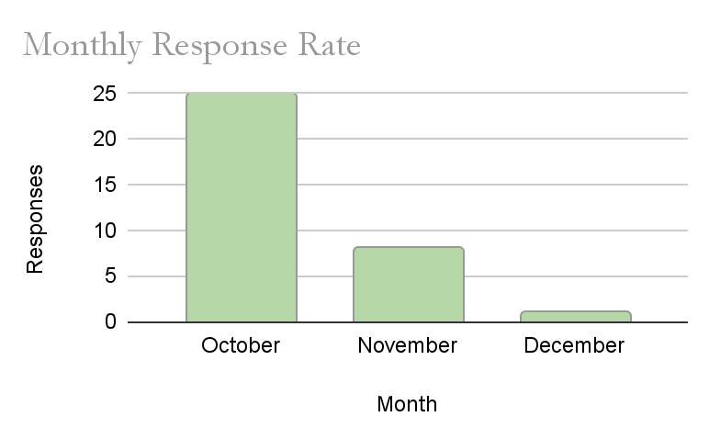
This graph is a representation of the number of responses compared to the month. We have used a bar graph because we are comparing the quantity of responses for each month. The independent variable is the month: October, November, and December. The Dependent Variable is the number of responses received each month. October has the most responses, with 25 total, and December has the fewest, with 1 per month. From October to November, the response rate fell 68%, and from November to December, the response rate fell 87.5%. This equates to a drop of 17 responses in the second month and 7 in the third month. Our project was dependent on teenagers providing us with data so we could analyze and use their data. This graph shows that many responses were collected in October, indicating that most of our data was collected in that month, with some additional responses in November. We received more responses in October due to the motivation of the survey being a new and exciting concept. After a while, the students became less motivated due to increased school activities and a possible loss of interest. The sample size from October is the greatest, because it has the largest number of responses. The November sample size is the smallest, but it still has a range of responses. December is the worst sample size because it only has one response, making it unreliable. Since this graph only covers 3 months, we can’t tell anything about future involvement and engagement trends. There is also bias for certain grades, as they have a higher response percentage compared to other grades. This graph shows how the participants had a lack of interest as the experiment progressed, providing us with less data than anticipated. We will use most of our October data, as that contains the most diverse and plentiful data. In a future study, we would send more consistent reminders and make sure that the responses don’t have such a large difference. We could also split it up into weekly collections, making it easier to find the external cause of fewer responses.

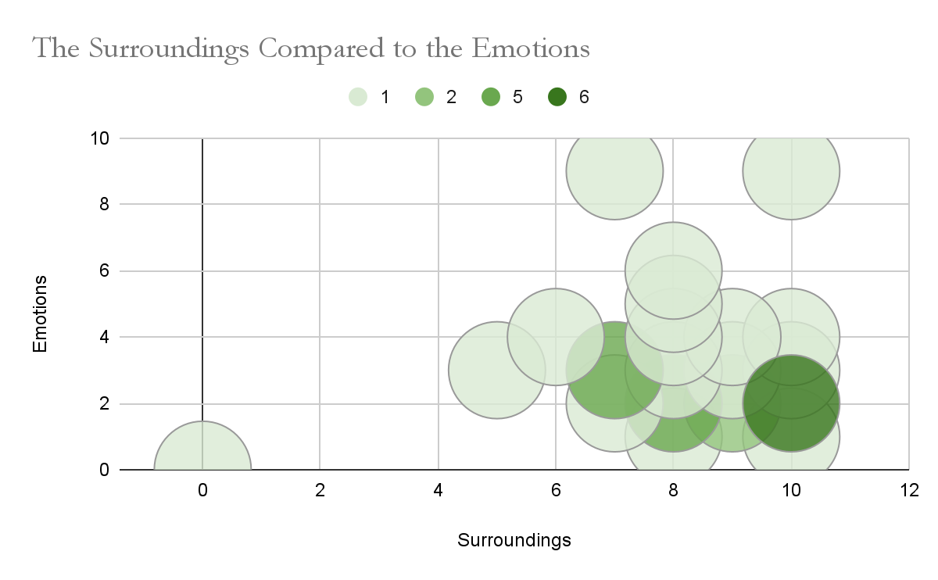
The graph represents how the surrounding environment affects the purchaser's emotions. We used a bubble graph to represent the frequency of each combination of the surroundings and emotions. The independent variable is the surrounding environment, because an individual's emotions are heavily reliant on their external environment, which causes the emotions to be the dependent variable. The pattern in this graph is the great clustering effect occurring at the bottom right side of the graph. This represents the comfort zone, an area where individuals often perceive themselves before making any purchase. This zone has a pattern where higher surroundings equate to lower emotional levels. The densest bubble is (10,2), which follows the trend mentioned above of the comfort zone. The biggest outlier is in the bottom left corner, marking 0 emotions and 0 surroundings. This outlier is very far from the central cluster of data, so it is not significant for our final data analysis. There are 2 more outliers present at the top right of the graph. These bubbles represent how higher surroundings do not always equal a positive emotional experience, giving us an insight into unfavourable purchases. The greatest density is 6 responses at (10,2), followed by 5 at (7,3) and (8,2), 2 at (9,2), and 1 for everything else. In the hypothesis, we discussed how there would be greater responses in the zone of higher surroundings and lower emotions. This graph highlights the accuracy of our hypothesis and also shows the outliers we overlooked when forming it. This trend occurs due to the comfort zone created mentally by teenagers; this area on the graph symbolizes a safe and low-risk purchase. This is a good example of emotional control displayed by the teenage individuals. This data is gathered from each survey entry filled out by the participants. This is genuine data because it was extracted from the confidential survey we used. This graph shows the comfort cluster, but it doens’t mention price or the item. Due to this, we cannot claim that the individuals are financially responsible, but we have figured out their emotional reasoning when approaching a purchase. This graph supports our hypothesis because it outlines how most of the purchases fall into a common comfort category for the majority. Next time, while conducting this experiment, we would include a scale with decimals, allowing the individual to input their exact emotions and surroundings in that moment.
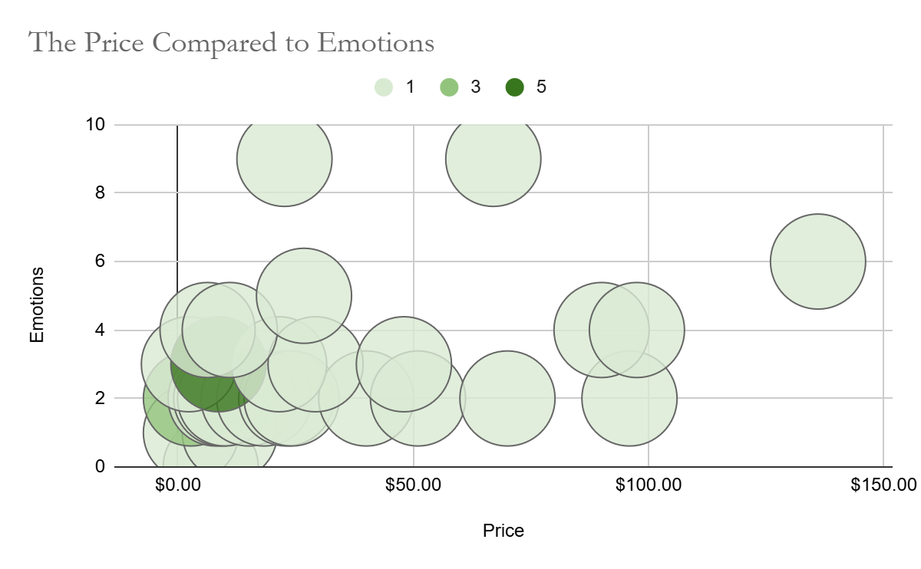
This graph illustrates the comparison between the purchase price and emotions. We used a bubble graph to display this data because it shows the frequency of certain responses, and it displays the cluster of comfort clearly. The independent variable is price, as the price differs for each purchase and affects the participant's emotions. The dependent variable is the emotions because the participants' emotions change depending on the price of the purchase. The comfort cluster is in the bottom left corner of this graph, symbolizing that most purchases are made with high emotions and low prices. The most common outliers occur when emotions or prices are comparatively higher and farther from the cluster of common responses. The two biggest outliers have a high emotional level or a high cost, differentiating them from every other purchase. These gaps are notable because they tend to have a higher emotion linked to them, creating a sense of regret or nervousness regarding the purchase. The price compared to the emotions relates to our hypothesis because it covers the frugal mentality, and how people react positively to a discount, deal, or lower price. We expected many of the responses to be very much on the lower side of prices, but there was a significant number that went above our hypothesized budget range. In the research articles we read, many teenagers paid attention to the price when purchasing something, and they often looked for a discount. This proves that teenagers are financially responsible, with the exception of the outlier purchases. The data is gathered from the students who participated in our survey, and the prices are taken from a proof of purchase, such as a receipt. The emotions could vary due to the time difference between when the purchase was made and when the survey was filled out. While these can be an important factor, we tried our best to encourage the participants to fill out the survey on time before a change occurs in their emotional state. Due to the uncontrollability of the response time, there are certain limitations to this data. Furthermore, the lack of participation later on during the experiment could have impacted the participants' emotions. Next time, we would consider making the survey more accessible through other tools and making sure that the results would not be affected by a difference in time or participation.

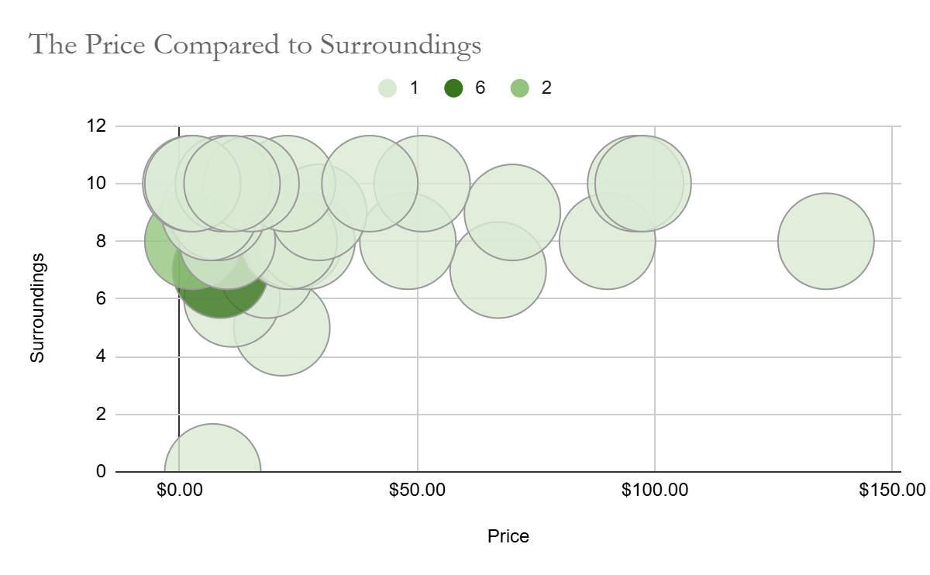
The price compared to the surroundings graph is a representation of how the price of a place could impact the surrounding environment and vice versa. We have demonstrated this through a bubble graph because it shows the average cluster where many people's responses and views collide, showing a visible trend that everyone subconsciously follows. The common trend is the cluster of bubbles at the top left of the graph, highlighting the specific surroundings in which most teens tend to purchase something. While this graph has the same prices as the price compared to the emotions graph, there are only two outliers, and every other bubble flows into the main cluster. Our hypothesis mentioned how higher surroundings would generate greater purchases, which was proven true through this graph. This is because a higher surrounding rating is usually created by having a supportive atmosphere, such as encouraging friends or a cafe with a friendly vibe. The data was obtained through the experiment survey, but there could be issues with the responses due to the difference in time. The surrounding environment is what the environment seems like before and during the purchase, but many of the responses were filled out after the purchase. This could impact the results because the quality of the product purchased could raise or lower the surroundings rating. The graph represents numbers, which limit our understanding of the environments and reasons why anything was purchased. It also limits our ability to understand when the survey was completed and how the question was interpreted. This graph supports our hypothesis of a more supportive and positive environment driving purchase decisions. If we could fix anything, we would make the graph bubbles smaller, because they overlap and hide each other.

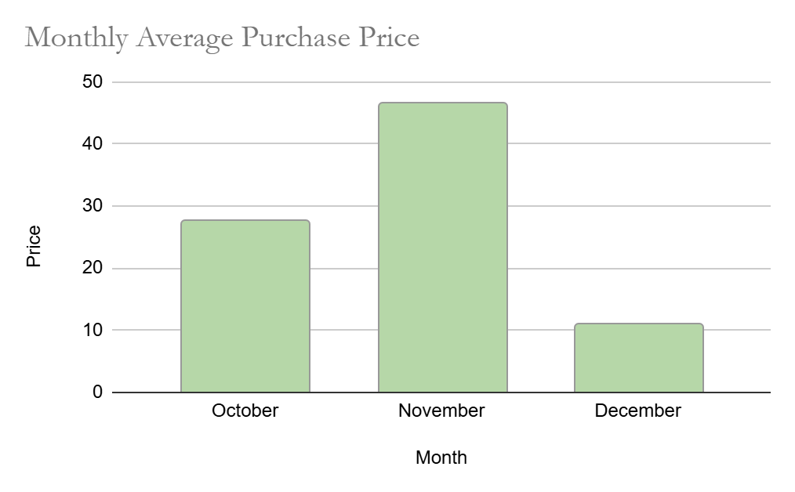

This graph shows the relationship between every month and the average price purchased each month. The independent variable is the month, as it was fixed for the whole experiment, and the dependent variable is the price because it changed throughout the experimental timeframe. This graph contains data from the responses submitted by the students, meaning a difference in response rate can significantly alter this data. From this data, we can infer that during November, the participants spent the most money, coming in at around 46 dollars. After that, it is October with an average purchase price of 28 dollars. In October, we had the highest participation rate, yet it didn’t have the highest average purchase price. This graph can represent a trend of more important purchases being reported or show how the most expensive purchases are made outside of festive seasons. Between the first and second months, there is a 16-dollar difference for the average purchase price, and between the last two months, there is a 35-dollar difference. In percentages, there is a 34% increase between the first and second months, and a 78% decrease between the second and third months. In our hypothesis, we believed that the most expensive purchases would occur during the holiday season, due to discounts and gift-giving. This graph opposes our hypothesis because it demonstrates how the most expensive purchases occurred in the middle month, where they were least expected to happen. This may be due to seasonal sales as stores clear out their Halloween items and fall collections for a Christmas and winter collection. During December, students face more academic pressure, driving their focus and energy into academics over product consumption. In the month of Novemeber there were 3 purchases that raised the overall average purchase price by a lot, which could affect the quality of the data. We went back and double-checked all the data, and it isn’t that big of a discrepancy, making it usable and reliable data. Something we could improve is asking why they bought that product during that month, which would help us better understand the psychology behind spending money on higher-value goods.

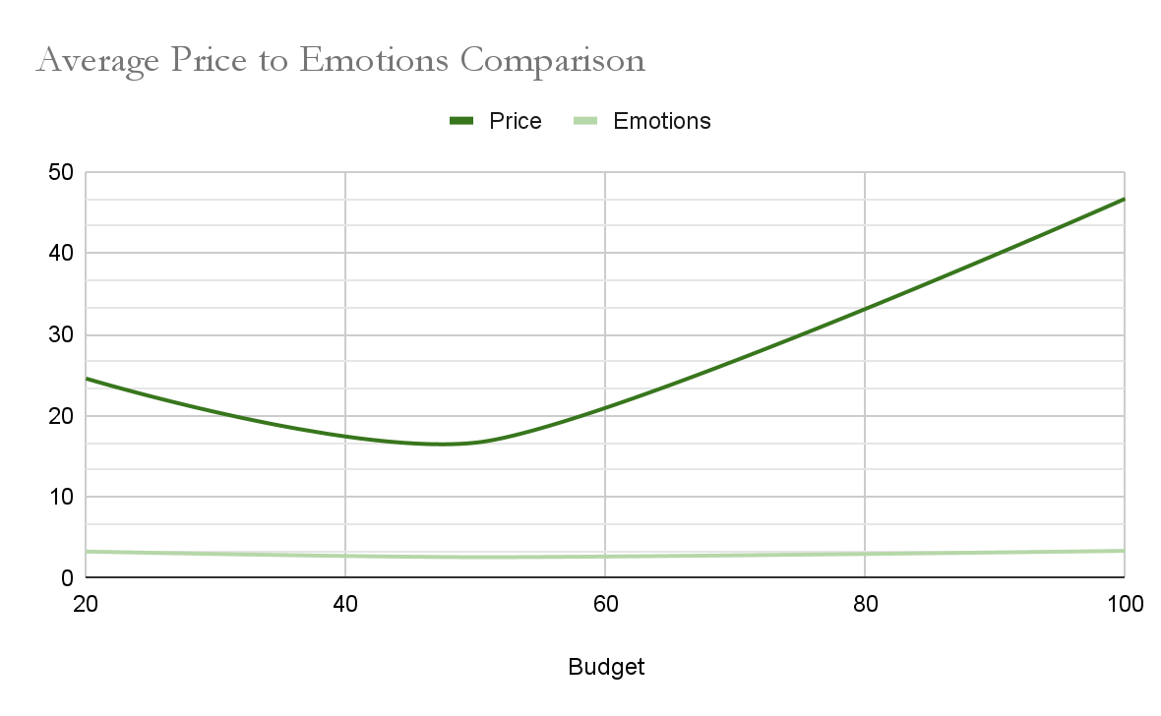
This graph exhibits a comparison between the price and emotions when on a budget. We used a line graph for this graph because we wanted to clearly demonstrate the comparison and relationship between emotions and price when on a budget. The independent variable is the budget, as it influences both the emotional levels and price point when making a financial decision. The dependent variables are the price and emotions associated with each purchase, as they change when people have a set budget. In our experiment, we had 3 budget groups that we sorted students into. Group one was the 20-dollar budget, which is the left side margin of the graph. The trend for this group is that their average price was 24 dollars, which went over their budget, proving that 20 dollars isn’t a sustainable budget for a teenager. The average emotions on this graph are an average of 3, indicating that this group of participants didn’t make purchases based on their emotions, and that they remained calm even during impulsive periods. In the second budget group, all the participants got a budget of 50 dollars per week. Their results were a little shocking as the average purchase price was around 18 dollars, more than half their set budget. The emotions for this group were also a little lower, showing signs of more emotional purchases and possibly impulsive behaviour. The last group had a budget of 100 dollars, which was the biggest budget of the entire experiment. The average purchase price for the participants from this budget group is 47 dollars, which is 62% higher than the previous budget group. The average emotional level was 3.3 for each purchase, demonstrating responsible emotional purchases and considerably less impulsive decisions. The difference in price between each group of participants in the set budgets in percentages is a 25% decline between the first two groups, and a 62% increase between the next budget groups. The emotions are in a very similar range, with minimal differences between each budget group's results. This data is all from the surveys we collected, but the participation could create bias or tendencies towards a certain budget. The average price of the 20 budget groups is higher because they had more responses, and the participants tended to spend higher amounts. While the number of responses may differ, therefore affecting the overall average of our results, this data is credible, and we made sure that every group had a minimum number of responses.
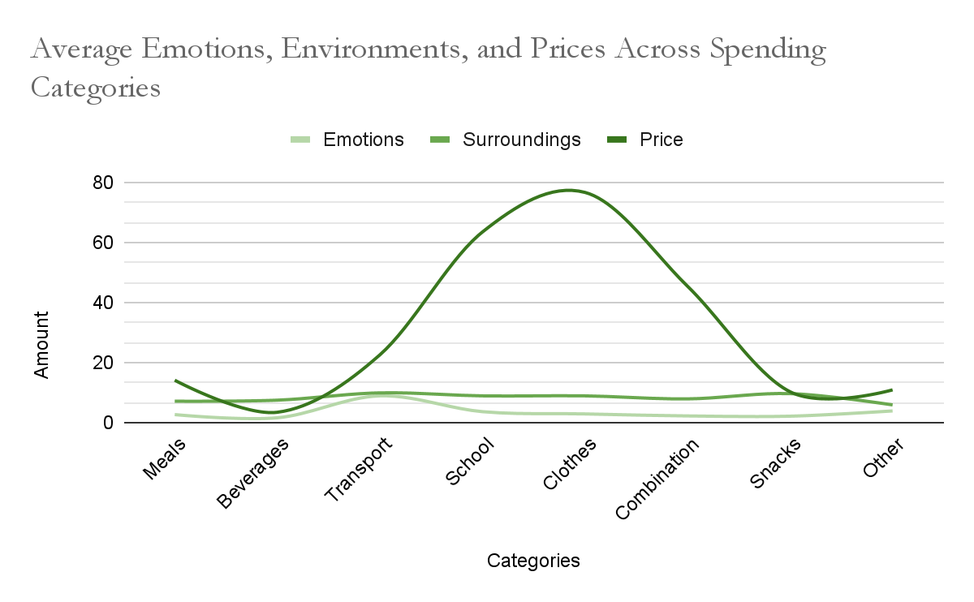
This line graph demonstrates the comparison of the average price, emotional level, and surroundings across several defined spending categories. We made these categories after analyzing the data and realizing that every purchase falls into one of these categories: meals, beverages, transportation, school, clothes, combination, snacks, and other. The dependent variables of this graph are the categories, as they remain constant throughout, and the dependent variable responds to them. This graph has 3 dependent variables: the average emotional level of the purchaser, the average surroundings of the environment where the purchase occurs, and the average price of a product purchased in that category. The most visible trend is how the price rises steeply from beverages to school and clothes. The most expensive categories are school, clothes, and combinations, as presented on the graph. The cheapest categories to purchase are beverages, snacks, and other items, as the average price amounts to 12 dollars or less. The most impulsive purchases occur when the emotional level is the lowest, and the average price is above 20 dollars, and the most prominent example is the combination category. Beverages can also be considered an impulsive risk, but since the average purchase price is lower, they are considered a low-risk purchase. The majority of the categories have an average surrounding rating of 8 or more. This is because they often go with friends or spend money during a sale or with a discount. Some participants also measured their surroundings in vibes, causing cafes and malls to earn high surrounding ratings. The graph connects to our hypothesis because the participants purchased goods in the categories we mentioned, but we had to define more categories to clearly analyze the trends of teen spending. They purchased goods in these specific categories because they are affordable, accessible, and trendy. This was analyzed through all purchase responses the participants submitted, and carefully organized and calculated into data sets. This graph shows a big overview of the factors that go into making a financial decision, and it breaks down the score of each category. This graph reflects some of our hypotheses, but it also displays the data on a deeper level with more specific categories catered towards the final data we received.

Analysis 2.0

Analysis of the Experimental Data

This graph represents the monthly response rate, and it is demonstrated in a bar graph to emphasize the gaps between the response rates per month. The independent variable is the Month, and the dependent variable is the number of responses received that month. The response rate dropped 68% from October to November, and another 87.5% from November to December. The data from October is the most reliable because it has the highest number of responses, therefore providing us with more data to analyze. The decline in responses could be due to increasing academic pressure, vacation, and a lack of interest.

The graph represents how the surrounding environment compares to the purchaser's emotions. We used a bubble chart to represent the variety of responses we received and the frequency of each one. In the bottom right corner, the bubbles form a cluster, which is the cluster of comfort. It is a zone where a teen is able to purchase something because the factors are positive. This supports the comfort cluster mentioned in the hypothesis because it follows the same idea represented through this trend. We can’t call these financially responsible actions; we can call them emotional control and being less impulsive.

The Price compared to emotions graph is another bubble graph we have used to represent our findings. The independent variable is the price of each purchase, and the dependent variable is the emotional level of each purchase. In this graph, there is another notable cluster at the bottom left, where the comfort zone is defined as low cost and low emotions. This is an implies that most teens tend to spend when they are happier and it is well within their budget, just like our hypothesis. There were some outliers where it was not an emotionally rewarding process, and another one where it was outside of the budget. These outliers are common with unpredictable spending habits, but the vast majority of participants tend to stick to the zone of comfort.

This bubble graph represents the price compared to the surrounding environment, with the colored bubbles representing the frequency of each response. The independent variable is the price of each purchase, and the dependent variable is the environment in which it was purchased. The cluster of comfort is in the top left corner, emphasizing the appeal for high surroundings and low prices. There are 2 outliers, and most data points cluster around the comfort zone. This supports our hypothesis, where we mentioned that positive environments would drive purchases. The limitations of this data are that we don’t have the exact surroundings before purchasing, which could affect our final data.

In the month vs average price graph, we compared the average price spent in that specific month across all 3 months. The independent variable was the month, and the dependent variable was the average purchase price in that month. November had the highest average price with $46, and December had the lowest with $11. The difference between the average price in the first two months was an increase of 34%, and the difference between the last two months was a 78% decrease. This opposed our hypothesis’s idea of increased spending during the seasonal months, with the results showing the complete opposite of what we expected. The most probable causes for this spending pattern is end of holiday sales and stores shifting from fall collections to winter collections. Due to our data collection method, we weren't able to find the exact reasons for the expenditure, giving us room to improve in the future.

The following graph represents the average price and emotions per group. The independent variables are the individual budget groups, and the dependent variables are the average price and emotions. The $20 group had an average price of around $24, which opposed our hypothesis of sticking to the provided budget. The $50 budget group had an average price of $18, which was very unexpected and supported our experimental hypothesis. The $100 budget group had an average price of $47, aligning with the hypothesis we theorized. The emotional level for all 3 budget groups was around level 3, except for the $50 budget group, which had a slightly lower emotional level. Through this graph, we recognized that the price of a purchase impacts the budget more than the emotions. There could be a slight discrepancy between the average amounts due to an unequal response rate, but after careful analysis, it wasn’t big enough to be unreliable.

The last graph is the spending categories graph, where we analyzed all of the purchase factors across 8 categories. The independent variables were the 8 distinct categories we derived, and the dependent variables were the average price, emotional level, and surrounding environment. The 3 categories with the highest average purchase price were school, clothes, and combinations. The 3 categories with the lowest prices were beverages, snacks, and other. The average surrounding rating for each category was above 8.5, which indicated that most surroundings were positive purchase factors. The emotional range showed a little more variety, with cheaper and more satisfying buys resulting in lower ratings. This supports our hypothesis that teenagers spend money in specified categories, but we had to elaborate and deepen our understanding of their purchasing psychology.

In our experiment, we had three main types of variables: controlled, manipulated, and responsive. The controlled variables were the survey formats, the scale values, data collection method, the assigned budget groups, the age range, time required to complete the survey, and the weekly survey. The manipulated variables were the phases, because at the start the participants didn’t have an budget but later on in phase one they were assigned a budget. Our responding variables were the purchase prices, the emotional rating of each purchase, the surrounding environment rating of each purchase, and how the budget affected their financial choices.

Graphs

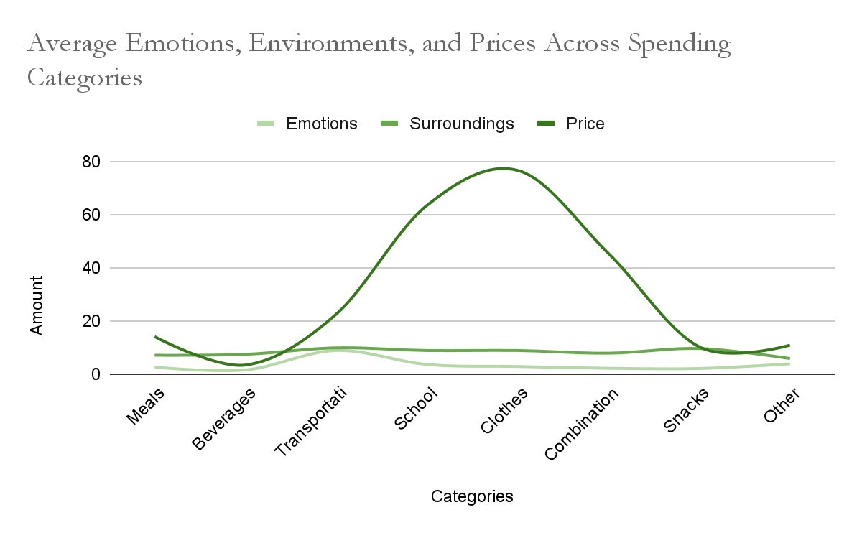
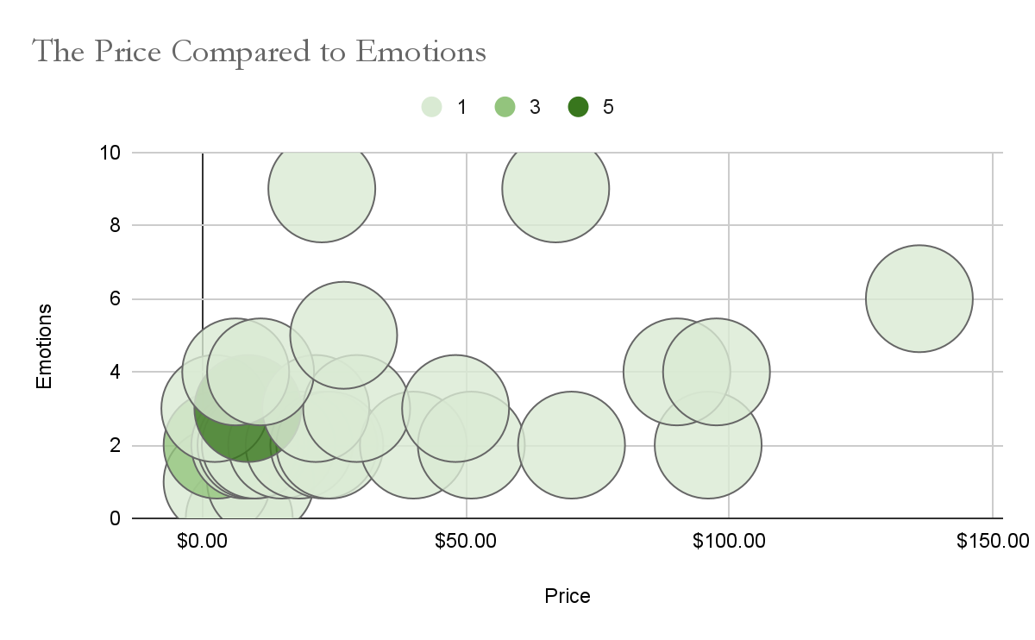
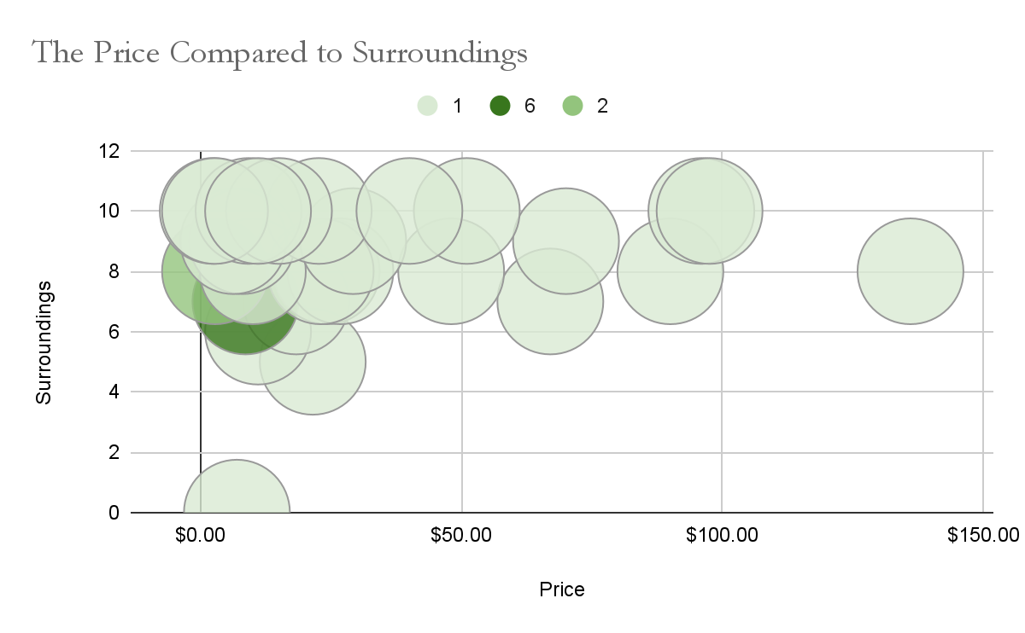

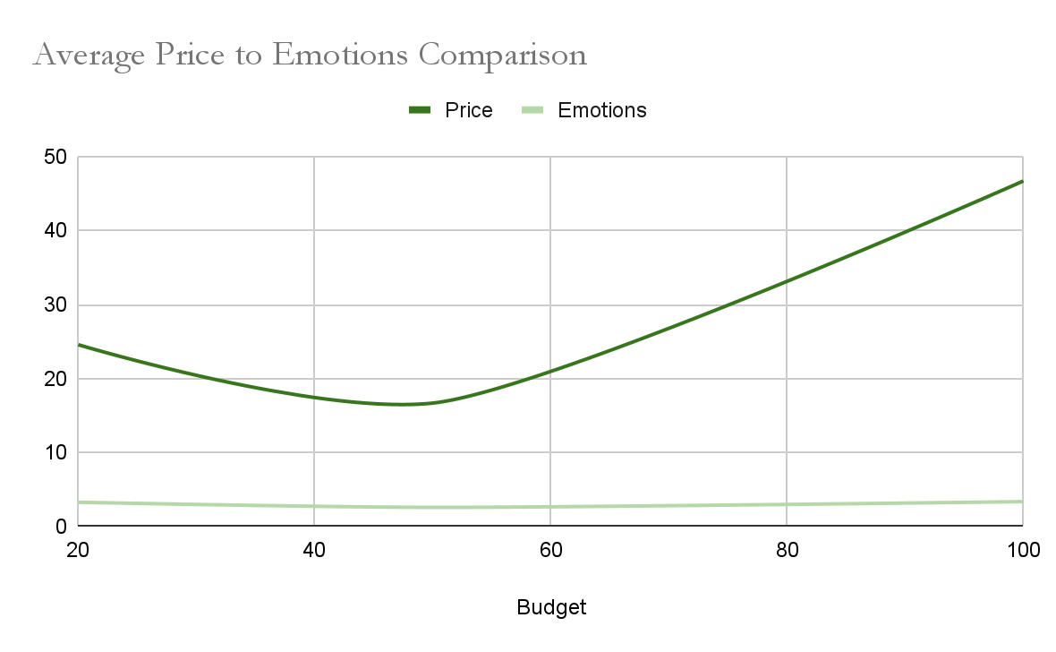
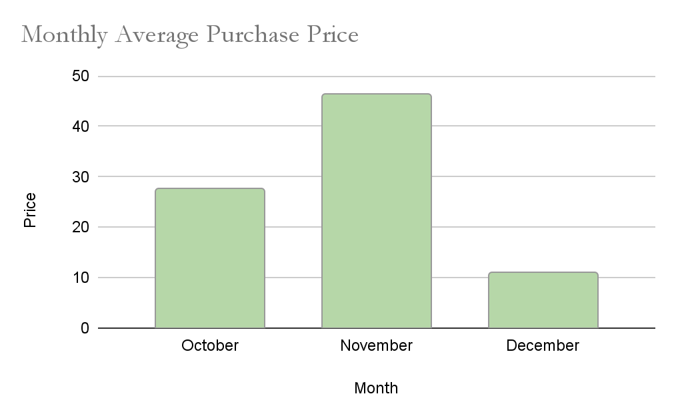
56

CODE

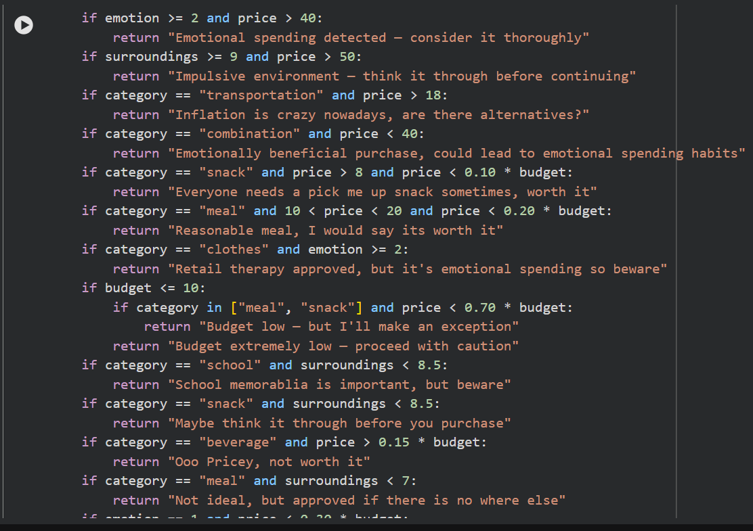
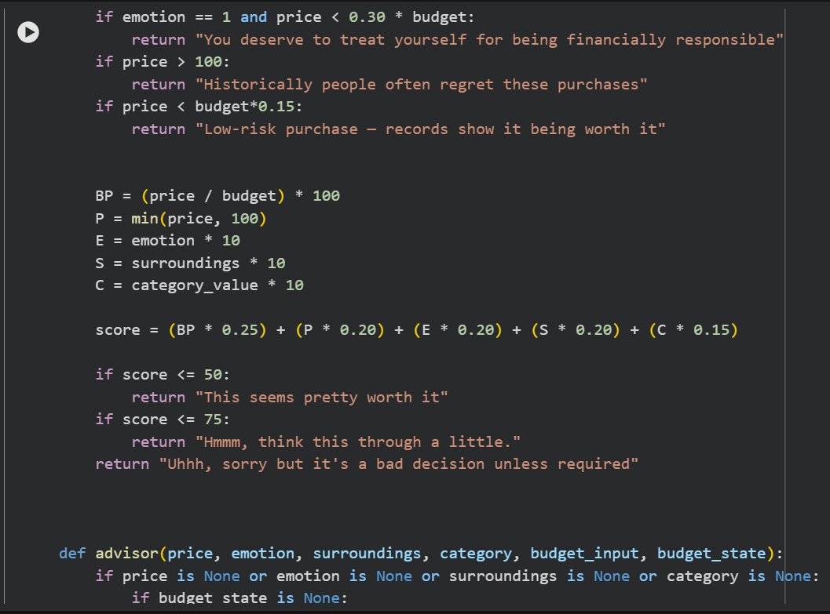
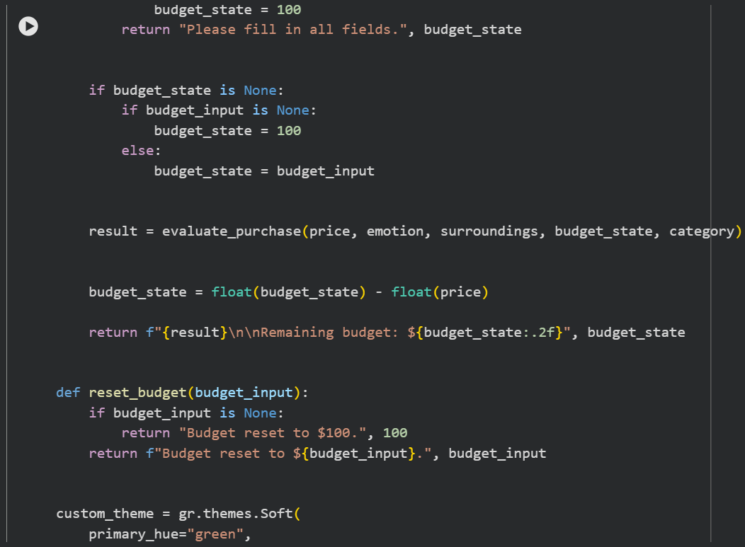
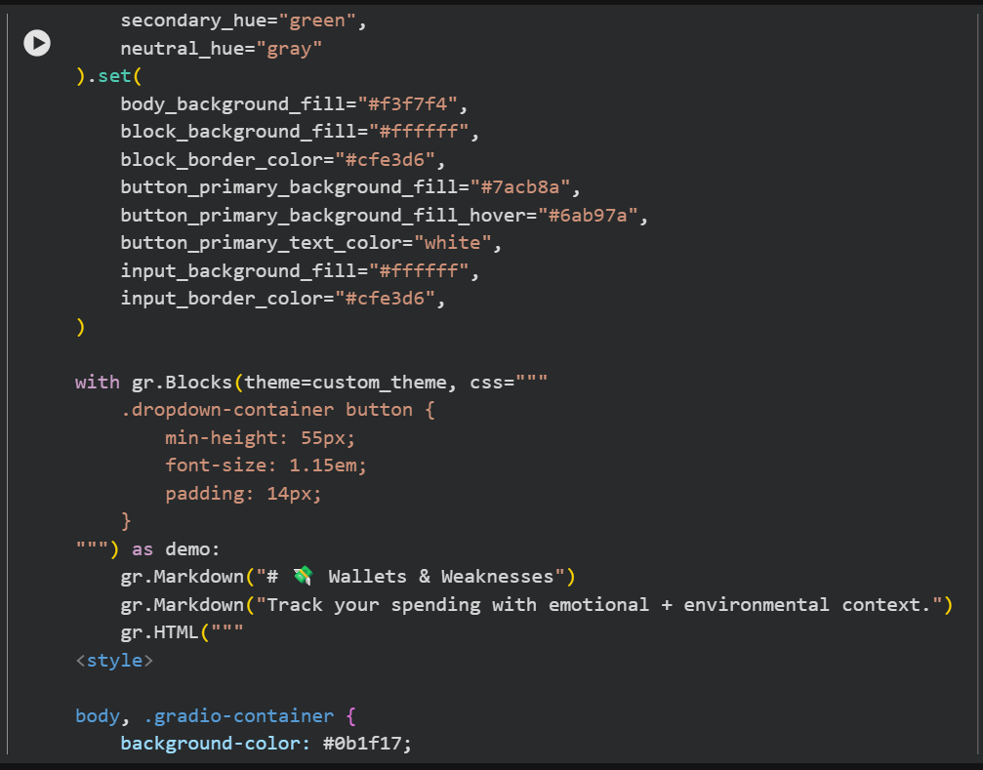
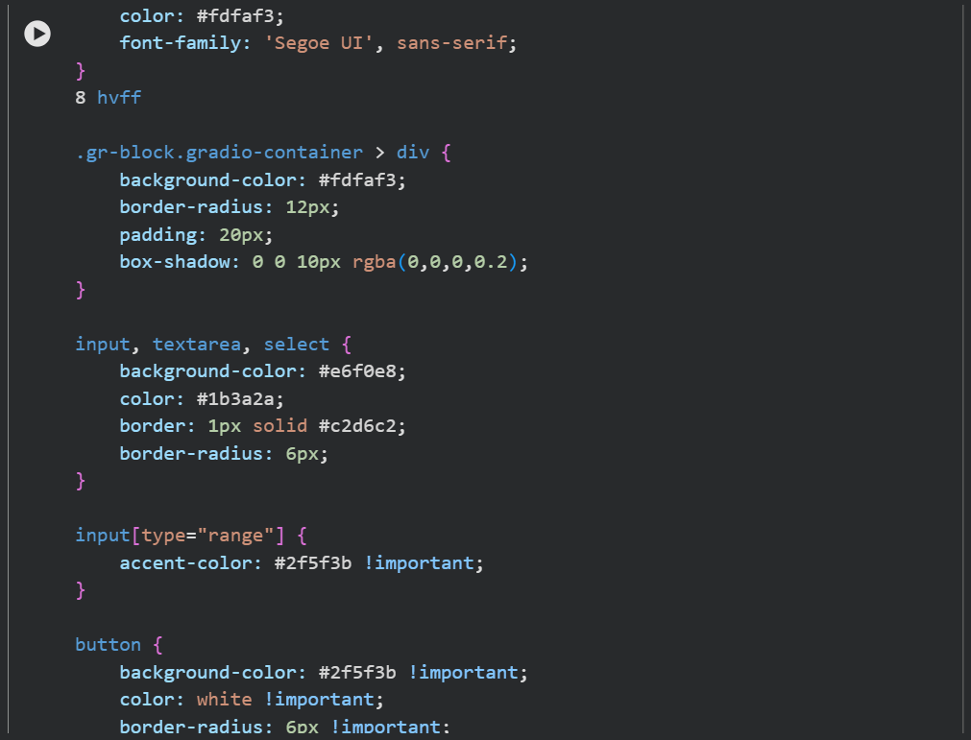
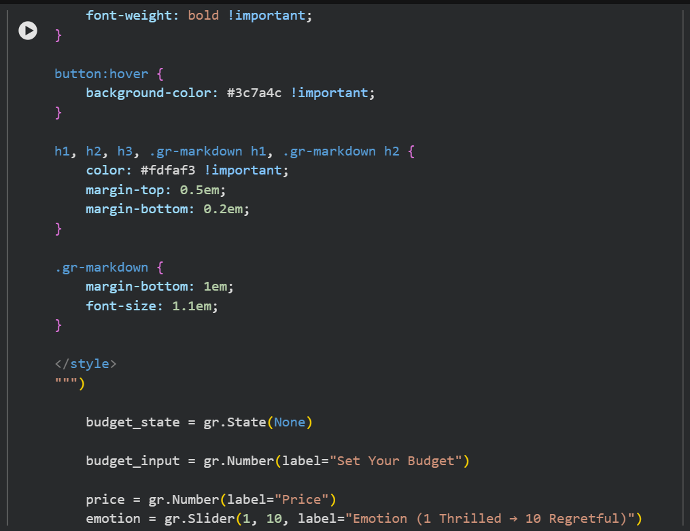
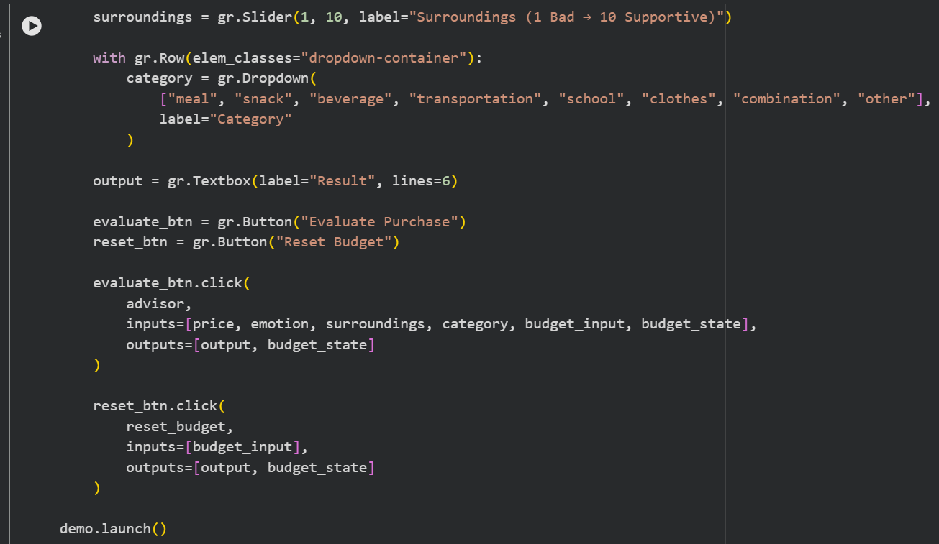

Images
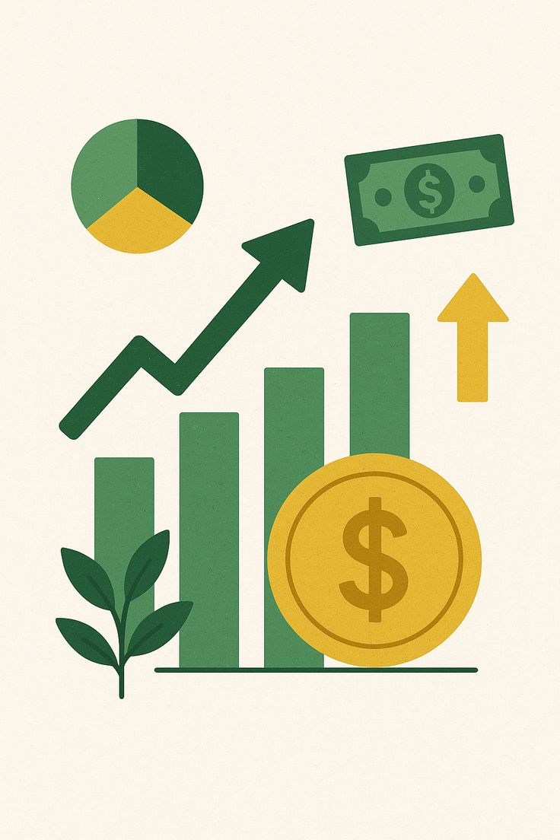
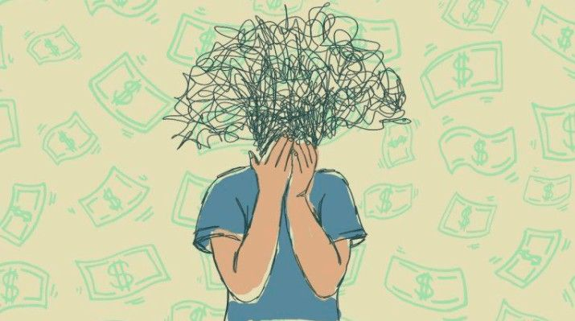
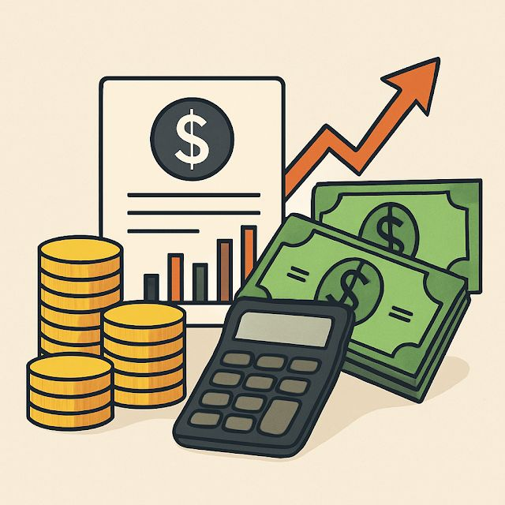
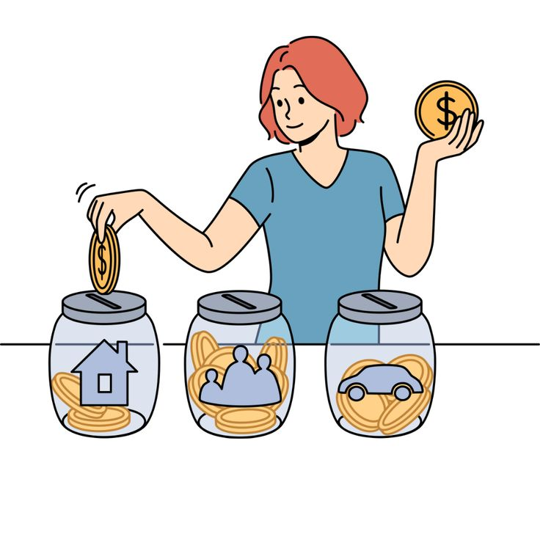
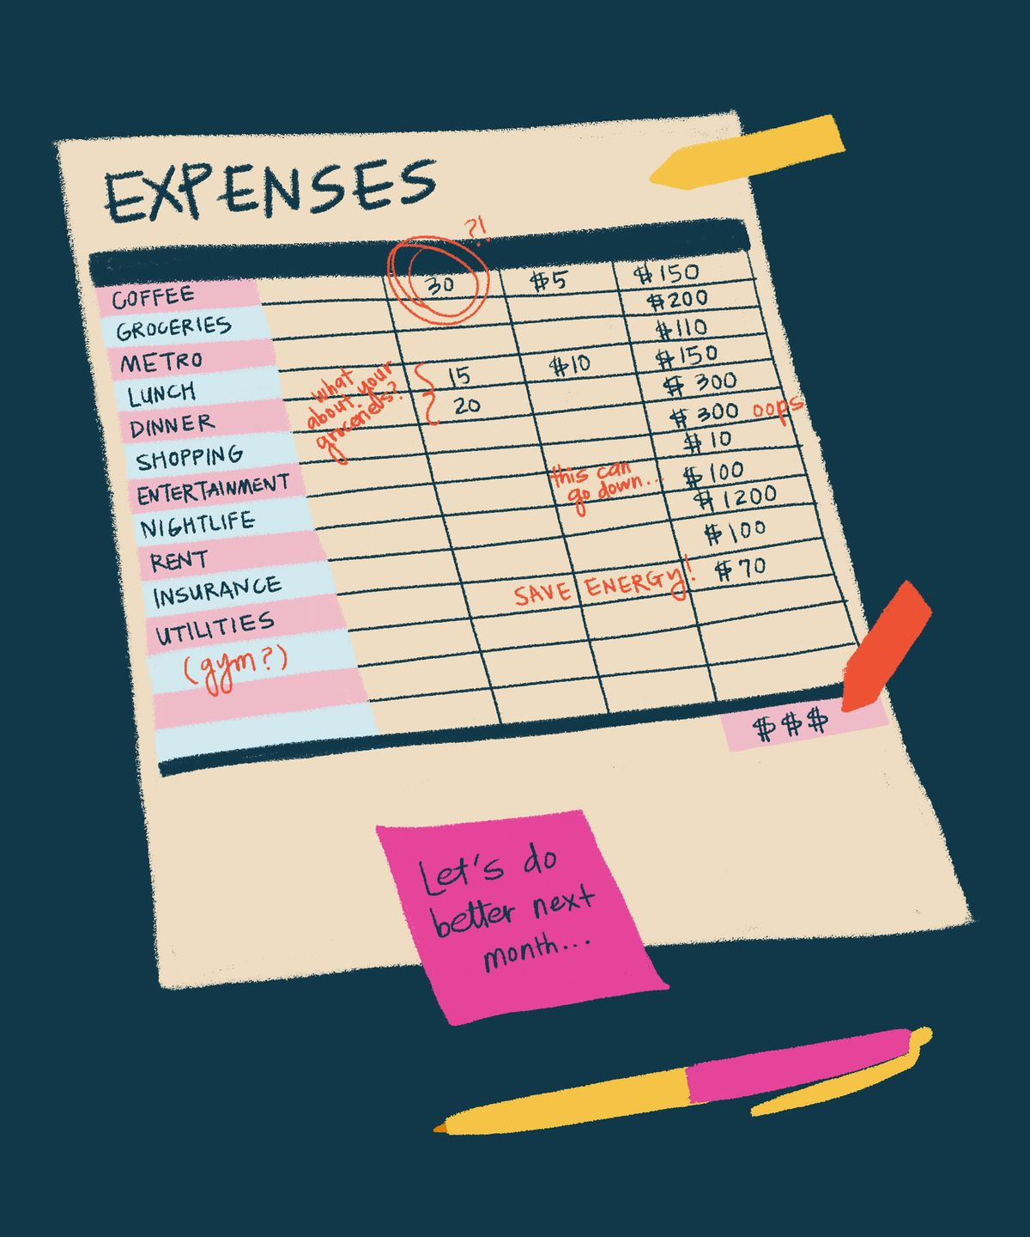

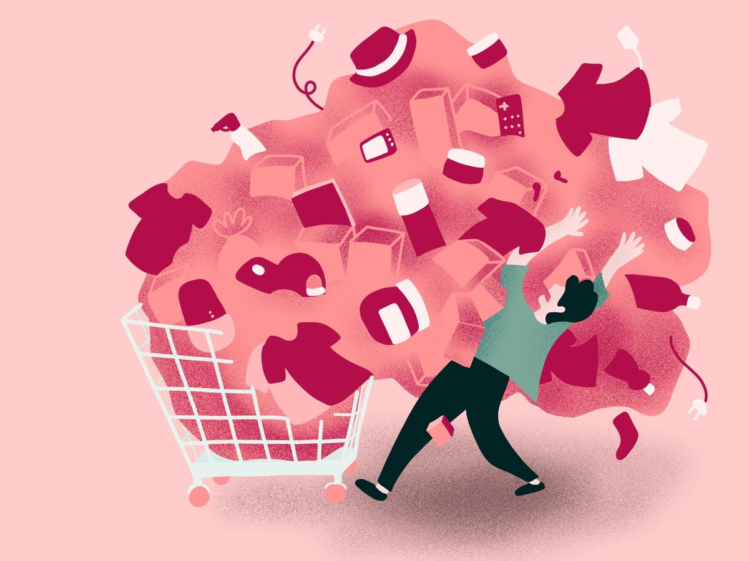


Todo by tonight:

- Write the code annotations

- Fill out the CYSF info like 60%

Data
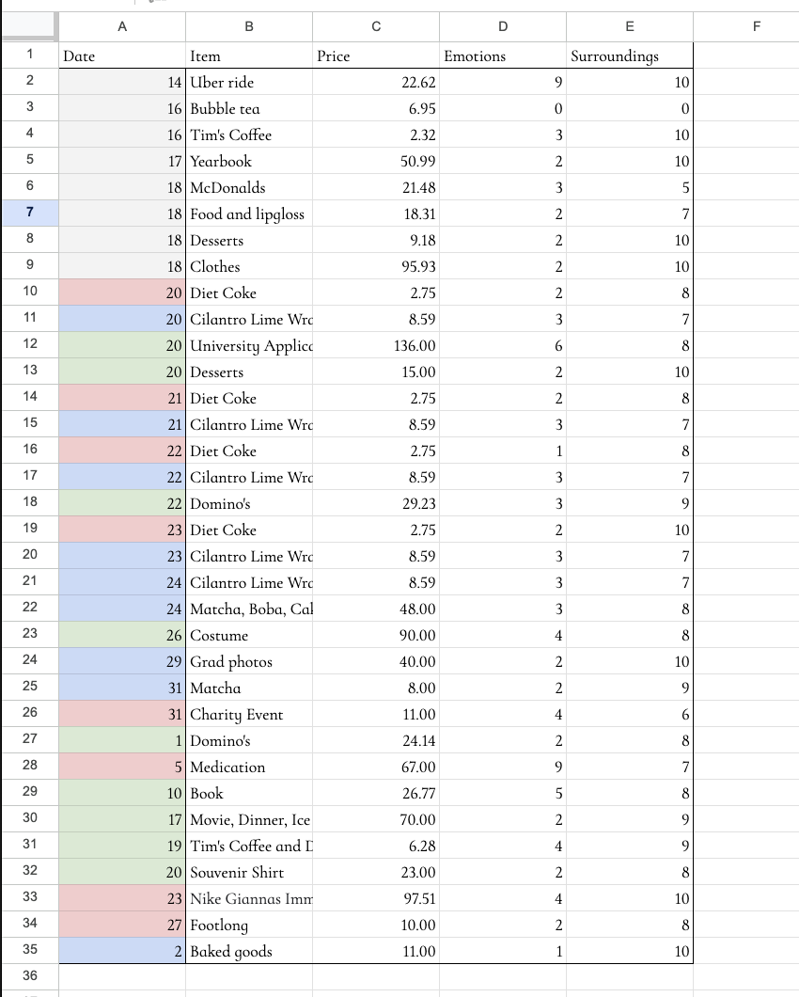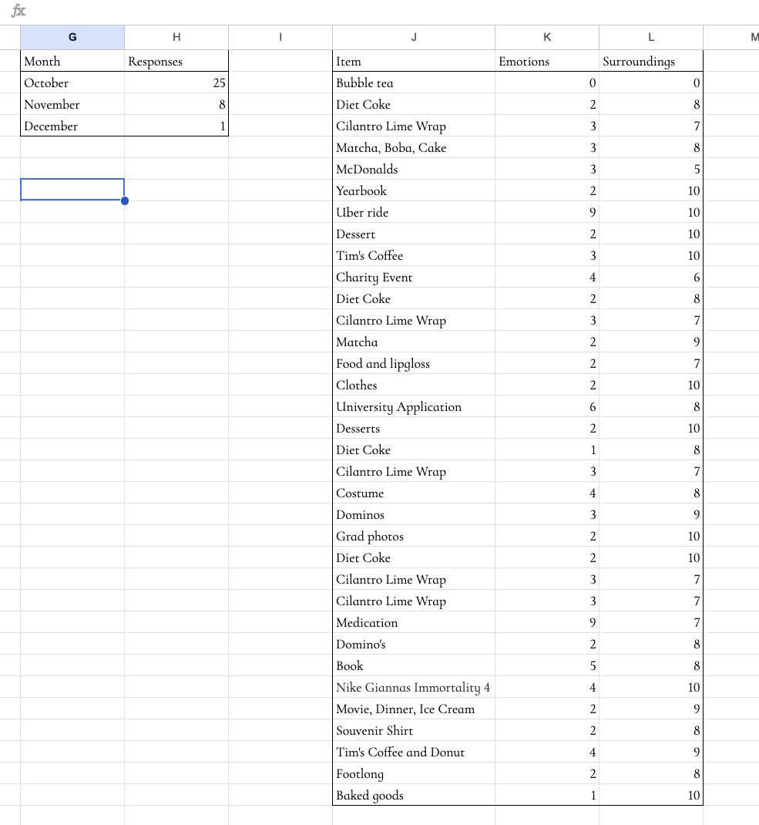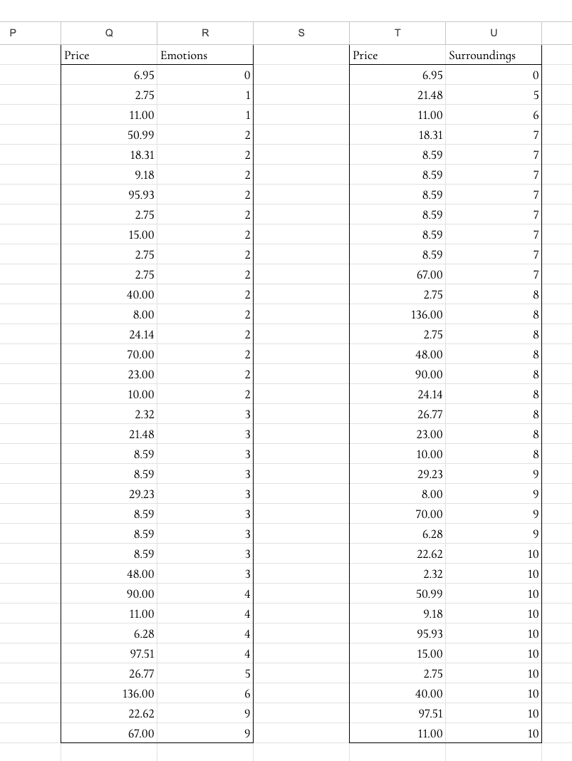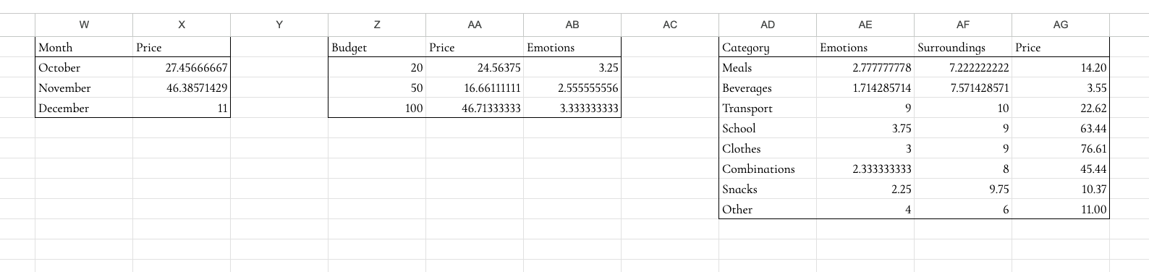
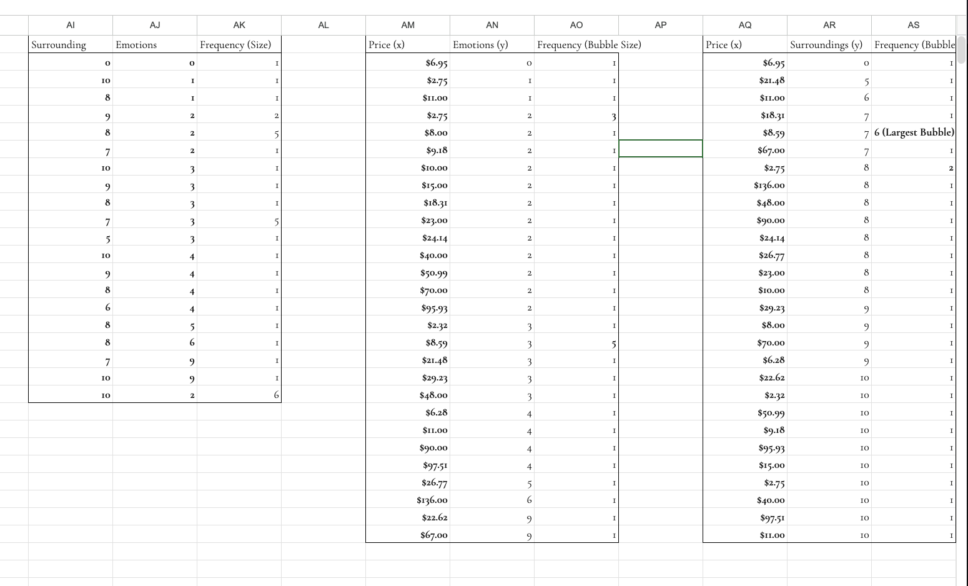

Conclusion

Hypothesis Match

Overall, our results partially support our hypothesis. We predicted that most teenage spending would go toward food and transportation, and this was supported, as these categories were purchased many times throughout all groups, especially in November. We also expected that more supportive environments and lower prices would increase spending by creating a low-risk “comfort zone,” and this was supported: participants were more likely to buy items when their surroundings were positive, and prices were low. However, our prediction that spending would decrease with a budget was only supported in certain groups. The $50 group showed the strongest support, becoming more mindful and wanting to spend less when purchasing. The $100 group showed moderate support with our hypothesis, where many spent similar amounts to before, but due to a large variation in emotional range, they did not entirely support our hypothesis. The $20 group did not support this part of the hypothesis, as many participants actually went over the budget and were more impulsive with their purchases. We also predicted lower spending in November, as it is between the holidays, but instead, overall spending increased. There were also outliers in every data set, which showcases how each participant has their own comfort zone.

Key Findings
We observed some common spending patterns throughout the different phases of our experiment. In Phase 1, there was no budget for the student’s spending, and the average purchase price was 29.50 dollars. In Phase 2, we assigned each student a budget that incorporated their normal spending, and the average purchase price was 29.50 dollars. The emotional range varied very slightly from Phases 1 & 2, with the averages being 2.875 and 3.038, respectively. The surrounding environment rating had a bigger difference, with the Phase 1 average being 7.75 and the Phase 2 average being 8.23.

We had 3 different budget groups during our experiment, with budgets ranging from $20 to $100. The $20 budget group had an average purchase price of 24.56 dollars, which means they went over their budget by around $4. The $50 budget group had an average purchase price of $18, which was highly unexpected and amounts to a little more than half their original budget. The $100 budget group’s performance supported our hypothesis, as their average purchase price was $45, which we expected. The most common expenses were food and beverages, with the occasional entertainment purchase.

In the Fall 2025 Piper Sandler Survey, the highest expense category was beauty and self-care, followed by clothing and footwear. In our survey, the most expensive category was clothing and footwear, and food and drinks were the most common category. While the food and beverage category is relatively more affordable, expenses can compound quickly, causing long-term financial impacts. These are often bought because of online trends and influences, as well as peer pressure.

Emotions & Surroundings
In our analysis, we observed a comfort cluster, which we defined as a low-risk zone where most teens would purchase a product. These clusters usually occur around high and low points on the graph. In our surroundings versus emotions graph, they were in the top left corner, signifying that most students would purchase an item if it had a high enough surroundings rating and low emotional level. This trend also occurs in the surroundings versus price and emotions and price versus surroundings graphs.
The comfort cluster is created by everyone's conscious money mindset, which is how they view money. The average teen views money as either a risk or an opportunity, and they tend to purchase goods in their comfort zone to have a smaller risk margin. One of the biggest influences is how success is associated with materialistic values, causing teenagers to spend more money to display success. In the data we collected, there were some outliers, which indicated rare occasions of lower satisfaction levels and emotional spending decisions, such as retail therapy.

Influences & Monthly Trends
While there weren’t any major purchases influencing social media trends during our experiment, there is always pressure from friends, family, and the school community. In October, there was high spending and involvement with the survey, more holiday-related expenses, and results similar to our hypothesis. During November, the average purchase price increased by 34%, which was unexpectedly high. The possible causes for these purchases could have been seasonal and festive collection sales, creating comfortable, low-risk financial situations. In December, we had the lowest number of responses and purchases, with the average purchase price dropping by 78%. There were very few holiday-related purchases, but many participants were on vacation and break, making budgeting more complex.

In the study about consumptive behaviour in teenagers, they mentioned a YOLO mindset, which can lead to irresponsible financial habits and future mental disorders. In a you only live once mentality, many individuals focus on a joyous and enjoyable life. Teenagers in this mindset don’t realize the consequences of not understanding their finances and how education is an investment.

Budget Impact (Phase 2 Specific)
Many students reported no direct effect of the budget on their mindset, but some participants mentioned being more money-smart and cautious. Many participants also said, “I feel more aware and attentive,” signalling that budgets reduce impulsive spending habits. The $20 budget group went over budget with their average purchase price, and they had a scattered emotional range. The $50 budget group had a smaller average purchase price, but they had a lower emotional range, implying more emotional purchases. The $100 budget group had the highest emotional range, signalling stability, but they also had the highest average purchase price.

Budgeting has been proven to help build discipline and good financial habits, helping with financial independence and goal accomplishment. Learning how to budget from early on will enhance your freedom, confidence, and discipline in the future.

Research Connections

Money Mindset & Emotions

A money mindset is a mix of beliefs, financial knowledge, and emotions that affect how one handles money. When people spend money based on impulse or emotion, they tend to think about the ROI, which is the return on investment. They consider any purchase as an investment, and the satisfaction or joy they get from it as the return. This can encourage unhealthy spending behaviour and habits, and can be used as a coping behaviour in some scenarios. To prevent this, individuals should set limits, learn and implement from their mistakes, and track and manage their expenses.

In our student input, Anthony said that he faced a lot of influence from his friends, family, and social media. When he encountered someone he would consider a mentor, his mindset shifted from having to please his impulses to living a more frugal and grateful life. He had a self-sustaining mindset and made more ethical and value-based decisions while enhancing his money management skills. The Piper Sandler survey also suggested that awareness of economic issues can cause teenagers to spend less and be more wary of their purchases. Since our experiment was conducted in an era where many economists warned of a recession, many teens could be affected by a saving mindset and social media warnings.

Real-World Application: Coding Solution

The App’s Purpose & Audience

We created a website with a goal to assess purchases, manage emotional spending, and give outputs based on our experimental data. Through this website, any individual would be able to input the 3 factors of a purchase and receive a response that has been interpreted through the experiment data. The target is teenagers because we used their emotional, financial, and habitual data. We are also more centred around gifted kids as they have more awareness and can reconsider a decision when hinted at. The inputs we need to properly run this are the price, emotion, surroundings, budget, and product category.

Key Patterns Coded From The Data

We coded the main trends and patterns from our data into if statements to evaluate each purchase through our website. When the price is greater than 45, and the surroundings are high, it signals a slightly impulsive and regrettable purchase according to our past purchase data. If the emotions are between the range of 2 and 5 during any purchase, it means that the individual is emotionally stable and in the right headspace to make this financial decision. We also sorted the data out into categories, letting us decide the lowest-risk and highest impulse categories, such as snacks, beverages, and meals. We also identified that transportation purchases greater than $20 are often regretted, and made that a condition in our purchase evaluation website.

Exception Decision Rules

We also had some exception rules placed to make sure that there would be no wrong advice from the evaluator. If the price was greater than the remaining budget, it would not be worth it, as it would amount to debt, not a financial purchase. An emotional spending warning is issued when the price and emotions are at a higher level, because in our past data, it has been a common trend. We also have category-specific thresholds, because each category has different limits and price points that we need to take into account.

Scoring System

As a final backup assessment system, we decided to implement a point scoring system that would give each purchase factor, as well as the budget percentage and category weight. The category weight is how much each category contributes to the result of the final purchase, which we calculated manually by looking at the most common and low-risk categories. The formula we used is: Budget Percentage (15%) + Price (30%) + Emotions×10 (20%) + Surroundings×10 (20%) + Category weightx10 (15%).

Overall Statistics

The total average purchase price throughout the experiment was $29.25, with a median price of $13. We didn’t use these prices as a benchmark because we had some high spend events and some low spend events, and we had to consider those due to the wide range of purchase prices. We did the same for the average emotional rate of 3 and the average surroundings rate of 8.1.

Limitations

Our experiment was well conducted, but we experienced some data limitations. The biggest limitation was the survey responses; the response rate was uneven, and the questions were a bit open-ended. There was also a time limitation, as we never knew when the participants would fill out the survey and how the time difference would change their results. Our scope limits were that we only had high school students from one school of gifted students, and that everyone in that school environment had similar ideologies. As the experiment continued, the engagement percentage dropped significantly, because finance is seen as a boring subject, but we need to learn more about it earlier on to be more successful later.

Future Work
If we were able to do this project again in the future, we would like to reconduct this experiment to include a larger population, with more schools and longer phases for more diverse results and data. We would also add some questions into our survey, including when they had purchased the items and whether the participants thought if it was a want or need purchase. Additionally, we think it would also be interesting to take in account the specific trends that are going on during the experimental phases and analyze how they might have affected spending habits. To continue on with this project, we would like to create and test an actual app that teens can actually use to help with their budgeting and even integrating collected data to create more tailored advice for the specific user, rather than the demo website we have created right now.

