Project Logbook- Homeopathy in Surgeries
Umar Arain 8A – Akram Jumma CIS

October 15 - I looked at the news related to healthcare and very often I came across news where the healthcare was delayed to patients because of overloaded healthcare system that made me curious about what are the other possible options of managing patients in the community without needing hospitalization.

October 20 - How I got my research question
Considering the overburdened healthcare system, I have been thinking about doing some research on Homeopathy as it makes me curious about why its not been used as much in the healthcare system as I could benefit. During my last summer vacation, I did some volunteer work at my grandfather Homeopath clinic for 4 weeks. My grandfather is a homeopathy physician and has been running a clinic in Ontario for more than 20 years. For that reason, most of my family members using homeopathic for medicine as the main source of treatment for any kind of illnesses. Therefore, I decided to work on a case study as an example and compared it with the traditional health care system of medicine to see what knowledge I can add through this scientific project to benefit my society.
November 10 - How I came up with my research question
After reviewing multiple cases with my grandfather, I noticed that patients who have conditions which usually require surgery have been cured completely using homeopathy medicine. That made me curious further to specifically focus on how homeopathy can treat those conditions which usually require surgery in a standard medical treatment system.
- November 14 - I had limited data available about homeopath medicine, and which was due to very small number of research studies conducted about homeopath medicine. There could be several reasons for the limited literature such as lack of interest of researchers and healthcare providers to explore further about homeopathy. In addition, most of the research trials on drugs are designed in a way that are not applicable to test on homeopath medicine.

November 20 - My Research Question
This is the main key research question I came up with. “How Can Homeopathy Medicine Be An Alternative To Surgery?”

December 20- January 5, 2026 - What I researched in Background
I started literature search on Homeopathy and particularly focused on PubMed (Medline) database and Google Scholar to look for relevant articles. I looked at the background literature on Homeopathy as well as some latest research to find any clinical trials on Homeopathic medication.
I researched about how homeopathy has been developed by Samuel Hahnemann. It has been developed by using some herbs which caused a set of symptoms in human so when he diluted the same substance, it helped curing the similar set of symptoms in human which come form a disease. Basically the whole thing is based on the principle of “like cures like”. The more diluted the substance is the higher the potency the homeopath remedy is for example one part of medicine is diluted with 99 percent of alcohol it gives the potency of 1x. I have also researched the differences of allopathic medicine (traditional medical system) and homeopathy. Allopathic medicine usually focuses on the disease itself by using drugs radiation or surgery to treat or suppress a disease condition. While homeopathy medicine focuses on the patient as a whole by stimulating the self healing process using diluted substances that mimic the symptoms which is usually gentler on the patient. I have also learned about vital force and how it works. The vital force is considered the life energy in a human that sustains the body and mind and enables self healing. When the vital force is strong and balanced, the body will be able to recover quickly from illness. A disease is seen as a disturbance in the vital force, leading to symptoms that reflect the body’s attempt to restore balance. There is no surgery that is 100 percent free from any risk so any surgical procedure involves some kind of risk which could vary from the type of disease and type of surgical procedures so if there is any other alternative therapy system that could reduce the need for surgery it should always be explored and considered the risks and benefits of using the alternative therapy’s. so far Ontario is the only province that has regulated homeopath medicine.



January 5-16, 2026 - Case Study
January 5
I came across several cases where Homeopathic treatment cures the patient who needed surgery such as Gall Bladder stone, lipoma (fat deposition), enlarged glands, and others. I particularly included two cases here for this research (case 1 with Chalazion and case 2 with kidney stone) to demonstrate as example of how these confirmed cases who were scheduled for a surgery were cured by Homeopathic Treatment.

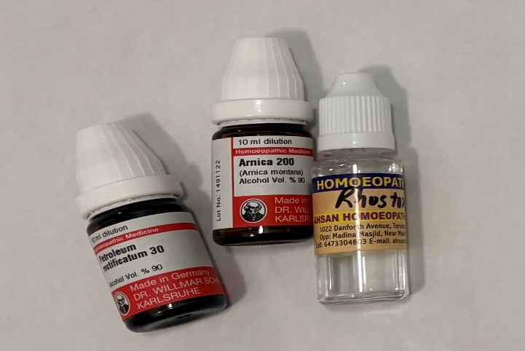
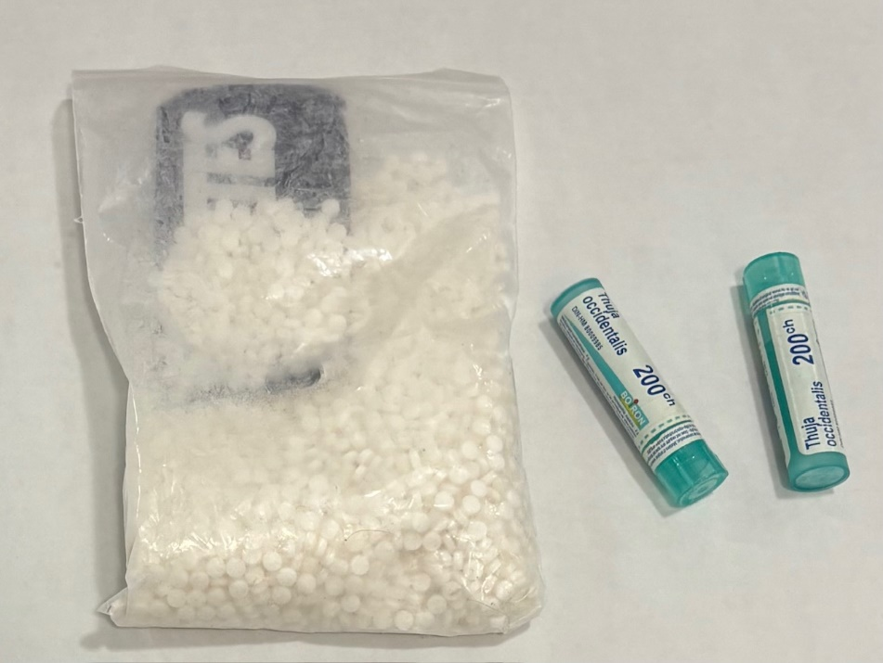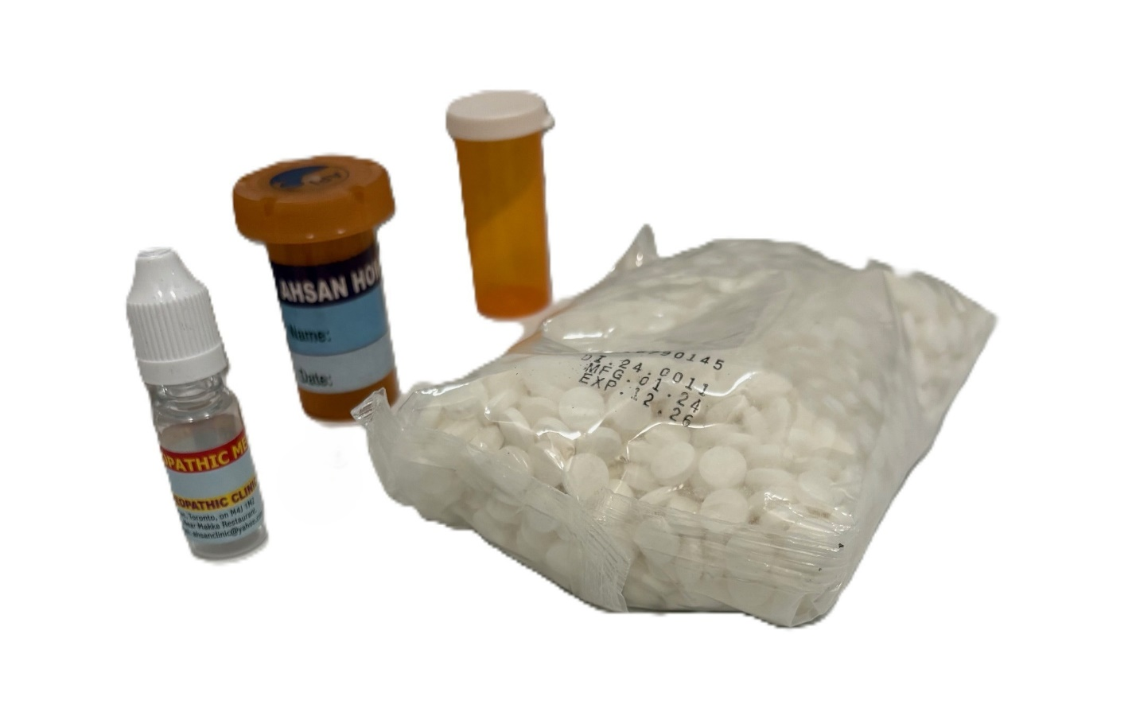

January 16
Case # 1 I discussed this confirmed case that needed surgery (chalazion) but has been cured with homeopathy medicine. Chalazion is a painless firm lump on the eyelid caused by a blocked oil gland, which needs to be drained surgically. When the patient first presented to the eye hospital with the complain of a lump on his eye the healthcare provider informed him that the only available cure is a surgical process to drain the blockage and was given an appointment for performing the surgical process. The patient was a young man and did not have any surgical process in the past so there was a lot of anxiety to get a surgery done on him, so he started looking to explore other options not available in the standard healthcare system. One of the options he considered was consulting a homeopath practitioner and discussed his medical issue in detail the homeopath practitioner informed that the homeopath system of cure is a complimenting medicine which may not be able to fully replace the standard healthcare system but there are good chances that the patient condition could be cured with a few days of medication without needing surgery. After the consent process the patient agreed to try homeopathic treatment plan which was provided for four weeks. There was certain dietary restriction during homeopathic treatment such as avoiding coffee, sour foods and foods that are really spicy. The patient started noticing decrease in the lump size after fifteen days and it completely disappeared in about twenty days. The patient followed up with the practitioner over the phone who advised him to stop the medication as the general rule is no homeopath remedy is required after the disease is cured.

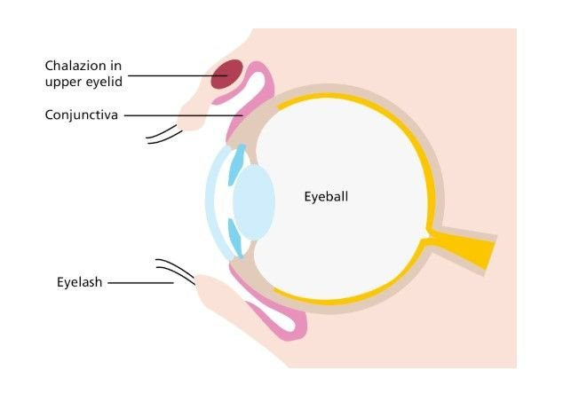
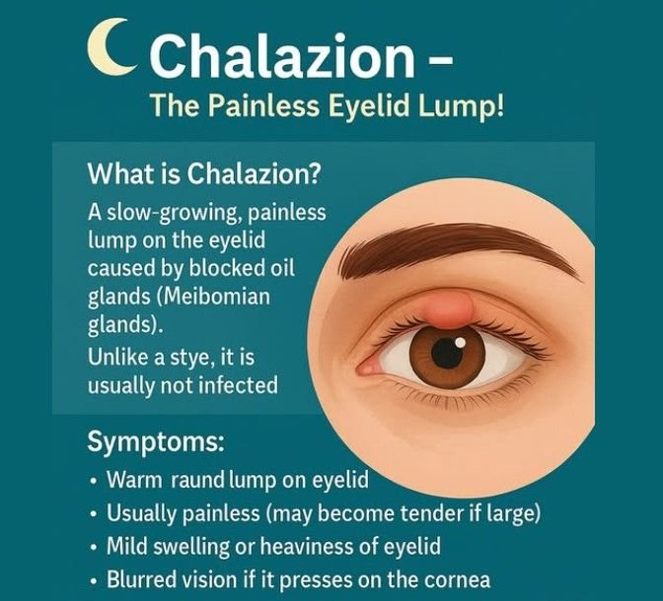

Case Study # 2
Another case of a patient with a large kidney stone who needed surgery was successfully treated with homeopathic medicines without needing surgery.
A female patient 17 years old started severe pain around her left side of the abdomen. The pain was very sharp and only relieved temporarily after taking pain killers. The patient also felt changes in her urine colour and frequency. Patient presented to a primary care physician who referred for a number of diagnostic tests such as abdomen ultrasound, followed by a CT scan. Other basic tests include urine analyses, and blood some blood tests. There was no past history of any chronic disease or surgery in this patient. After the imaging and laboratory findings, it was the presence of a large stone around the edge of the kidney was diagnosed. The stone was significantly large that the only possible cure suggested was an elective open surgery of kidney to remove the stone. And the patient was given the date for the elective surgery to remove the kidney stone. Meanwhile a family friend of the patient introduced her about homeopath medication and suggested to see a homeopath practitioner for a possible cure without needing a surgery. She visited the homeopath practitioner and provided the necessary details about her disease condition the homeopath practitioner inquired her about the overall patient habits, physical activity, sleep details, along with the information about the nature of the pain. This is because homeopath way of treatment is different and it focuses on overall human body rather than only looking at one specific disease condition in the body. Thus, two patients with the same disease might receive different homeopath medicine based on their overall nature (sometimes referred to as aura in homeopathy). To work perfectly, homeopathic medicine must be chosen to match how an individual’s system works, how it reacts to stress and illness. Different people with the same illness can react differently to remedies.
After taking complete history of this patient the homeopath practitioner provided medication and asked for excessive water intake; it was also suggested to keep using pain killers as per need while the stone was still causing irritation. The homeopathic medication was initially suggested to take four times a day and the practitioner asked to call if anything changes in terms of her symptoms. After initiating the homeopath medication, the patient noticed the expulsion of her kidney stone on the third day of starting the medication. This all happened just four days before her elective surgery was scheduled. The patient went back to the primary care physician and informed about the expulsion of the stone and immediate relief of pain and other associated symptoms which was surprising for the physician as well. The diagnostic investigation tests were quickly performed again to ensure there was no stone that remained in the area. The elective surgery was cancelled after confirming the patient was cured without needing a surgery.
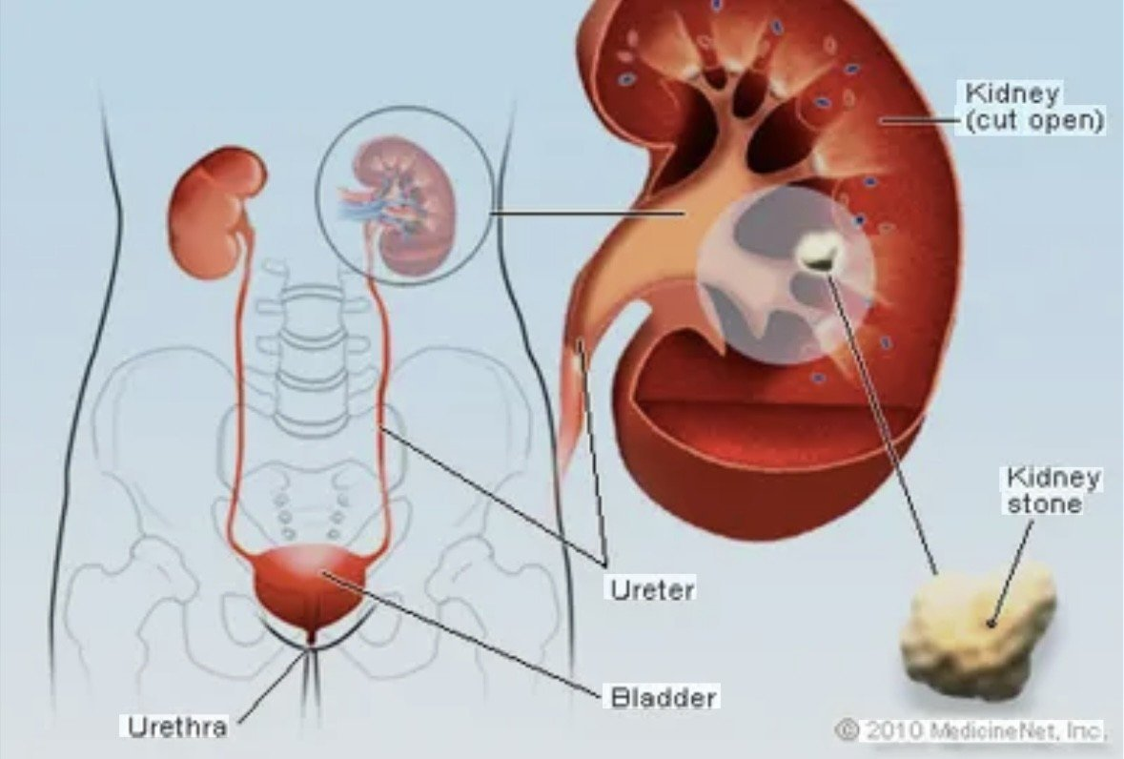

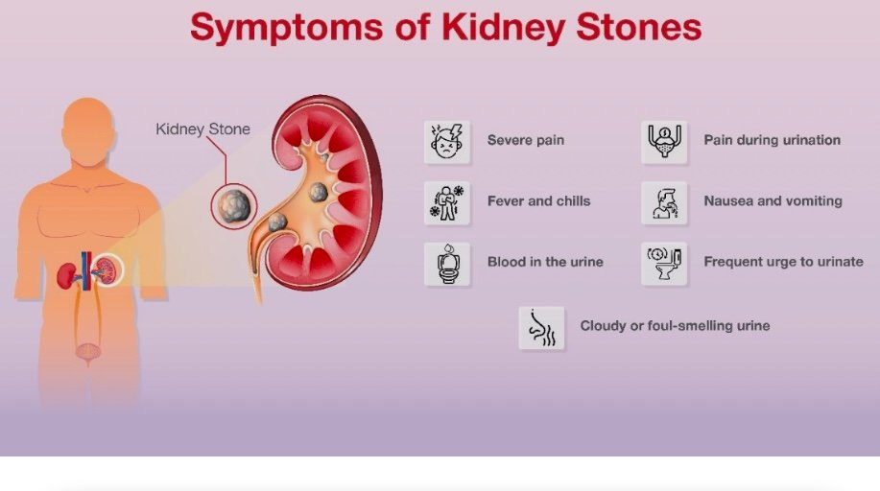
January 15 -17 - Differences Between Allopathic And Homeopathic Medicine
On this date my whole focus was to search and look for some key differences between Allopath and Homeopath

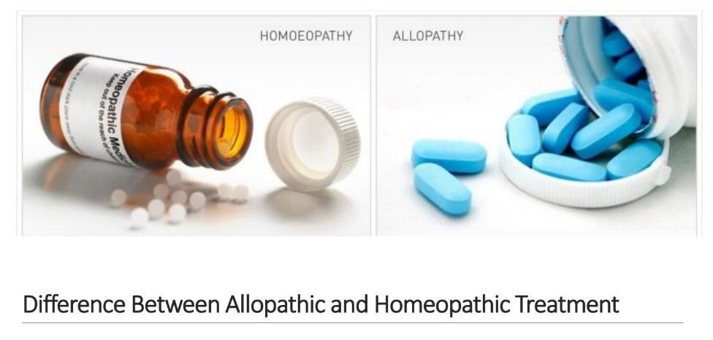

Allopathic Medication | Homeopathic Medication
Disease specific medication doses based on age, weight, and severity of disease. All patients with the same disease would get the same medication, the dosage may vary. | person specific medication the doses and medication are specifically tailored to the individual. Two patients with the same disease might receive different medication based on the individual body type and response to diseases.
Compliance with Allopath medicine can be an issue sometimes, particularly with children because of taste and size of pills and mode of administration like injectables. | Compliance is usually high because of easily dissolvable pills without needing any injectables.
In several cases surgical intervention is required to cure the disease. | Medication aims to use internal body force to cure several cases which otherwise would need a surgical procedure such as gallstone, kidney stone, and chalazion.

January 26 – Why don’t people use homeopath medicine?
- Lack of awareness most people don’t know what homeopath medicine is
- Fear of unintended consequences there isn’t a lot of research of homeopath medicine so people are afraid that it might cause unintended consequences
- Lack of interest from healthcare authorities to explore the benefits of homeopathy in complementing disease care

January 25-28 - Misconceptions Of Homeopathy
- One of the most common misconceptions is that homeopathy is only a placebo effect. However, there is little justification is how the placebo effect could cure infants and young children who are unaware of which medicine they are taking

January 26 - To explore this further I spoke with a few physicians in Calgary to discuss the possible ways to integrate homeopath medicine in the current health system they told me the main obstacle is that there are so many misconceptions of homeopathy so its not well recognized however they agreed that the current healthcare system is over capacity and needed solutions to address how the timely healthcare services can be provided to all citizens.

February 5-8 - Conclusion
To come up with a final conclusion based on the work I did on this project, I realised there is a small number of research done on homeopathy medicine, and there is a need to do more clinical trials. Also, my focus on the conclusion is more towards how to best utilize homeopathy along with the current healthcare system and to determine if it can fill in the gaps in the current healthcare system. Homeopath medicine is NOT meant to fully replace the standard healthcare system, it is rather a support system for out already overloaded healthcare delivery system. For example, if there’s 5 to 10 percent of cases than can be dealt with homeopath system it’s a big pressure relief to the existing healthcare system.

Feb 10th
Recommendations
Based on the conclusions, I came up with some key recommendations for the leaders. Surgical wait times are above 12 months for certain surgeries in Alberta as well as some other provinces in Canada. If that overload healthcare system can get a little bit relief using complementary medicine such as Homeopathy. If patients are not getting any treatment for up to 12 months while waiting for surgeries, is there any harm in trying an alternative therapy which could potentially reduce the need for surgery

Feb 15
I thought that this platform of the science fair could be my first step of creating the awareness of homeopathy among academics. I would like to take it further to the other levels of health care authorities in the future to demonstrate the examples of case studies that were cured by homeopathy without needing any surgeries.


References
I searched the literature throughout my project and learned how to cite in APA style. These were some of the key references I used to prepare the back, methods as well as some of the comparisons and misconceptions about Homeopathy.
Dezső Csupor, Klára Boros, and Judit Hohmann. Low Potency Homeopathic Remedies and Allopathic Herbal Medicines: Is There an Overlap? PLoS One. 2013; 8(9): e74181.
Kayne SB (2006) Homeopathic pharmacy : Theory and practice. Edinburgh; New York: Elsevier Churchill Livingstone. 386 p
Linde K, Clausius N, Ramirez G, Melchart D, Eitel F, Hedges LV, Jonas WB. Are the clinical effects of homeopathy placebo effects? A meta-analysis of placebo-controlled trials. Lancet. 1997 Sep 20;350(9081):834-43.
Mercer SW, Reilly D. A qualitative study of patient's views on the consultation at the Glasgow Homoeopathic Hospital, an NHS integrative complementary and orthodox medical care unit. Patient Educ Couns. 2004 Apr;53(1):13-8.
Samuel Hahnemann. Sixth Edition of Organon of the Medical Art, Aphorism 11, p.66.
Schmidt JM. Believing in order to understand: Hahnemann’s hierarchisation of values. Homeopathy. 2008 Jul;97(3):156-60.
Shang A, Huwiler-Müntener K, Nartey L, Juni P, Dorig S, Sterne JA, et al. Are the clinical effects of homoeopathy placebo effects? Comparative study of placebo-controlled trials of homoeopathy and allopathy

Acknowledgements
I highly acknowledge my grandfather Muhammad Aslam who is a licensed homeopath practitioner in Ontario. The case examples presented in this research are based on his over 50 years of clinical practice. I also acknowledge support of my class teacher (Jyothi Nambiar) and my parents.

