LOGBOOK

Feb 5th: We came up with our project topic today. Our science fair project is about preventing biofilm. The objective of our project is to understand the harms of biofilm and why the importance of preventing it. Through this we want to learn the relationship of biofilm with public transportation, specifically with Transit. We will create an analogue experiment

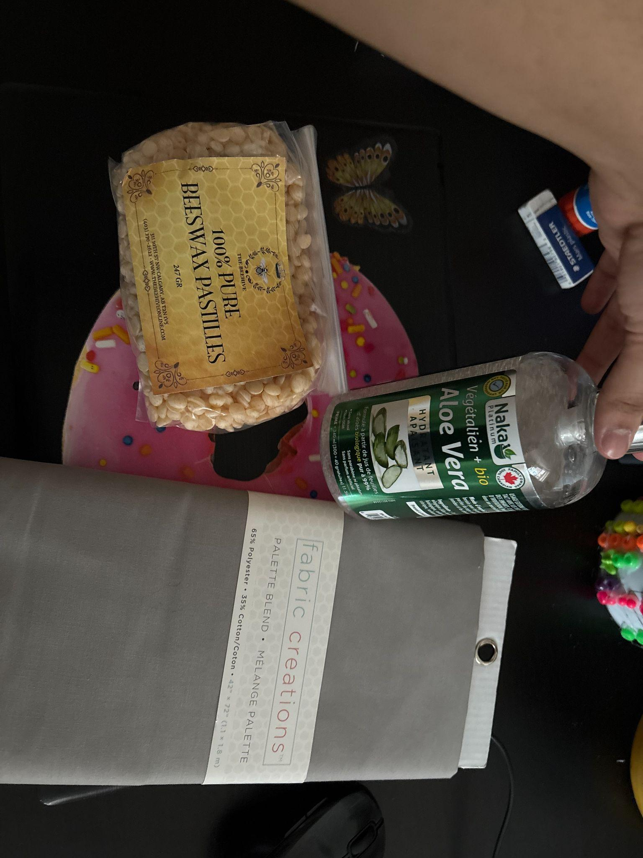
Feb 27th 2026: Today we worked on the literature review for our project. Through researching we learned how biofilm forms and how it can harm the human body. We learned that around 60-80% biofilm is responsible for infections. Jaya and I discussed buying materials for this project, starting from the materials for our experiment to buying the trifold.

Feb 28th 2026: (Raameen) I worked on the procedure for our experiment, while finishing up my side of the research. I also went outside to buy some of the materials. I bought Beeswax, fabric, and aloe vera gel

Mar 3rd 2026:(Jaya) I bought the agar plates which included a kit of 20 plates with the sterilized swabs.

Mar 3rd 2026: (Raameen) I continued with our research. Looking at the articles, one of them is called “Thor”. I learned about the impact biofilm has on infrastructure industries.

Mar 4th 2026: (Raameen) I worked on the CYSF platform, filling up the variables and procedure section. The CYSF platform is due today.

Mar 4th 2026: (Jaya) I worked on the CYFS platform filling up the remaining sections with information, and planning how we are going to set up the trifold and how we are going to do the experiments. The platform is due today so we're finishing everything up before it locks us out. We still need to conduct the experiments so we have specified that we will unfortunately not be able to input the data on the platform.

Mar 4th 2026: (Jaya) I called the trifold place, and placed an order for one.

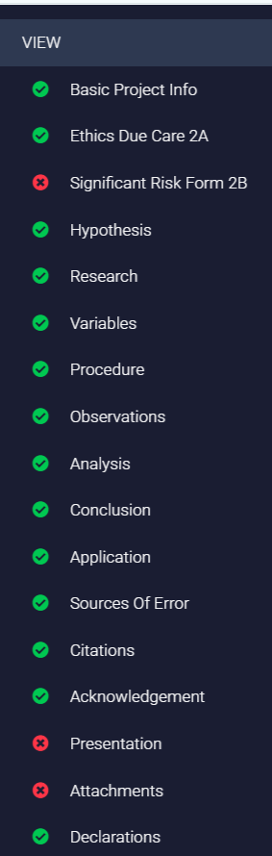
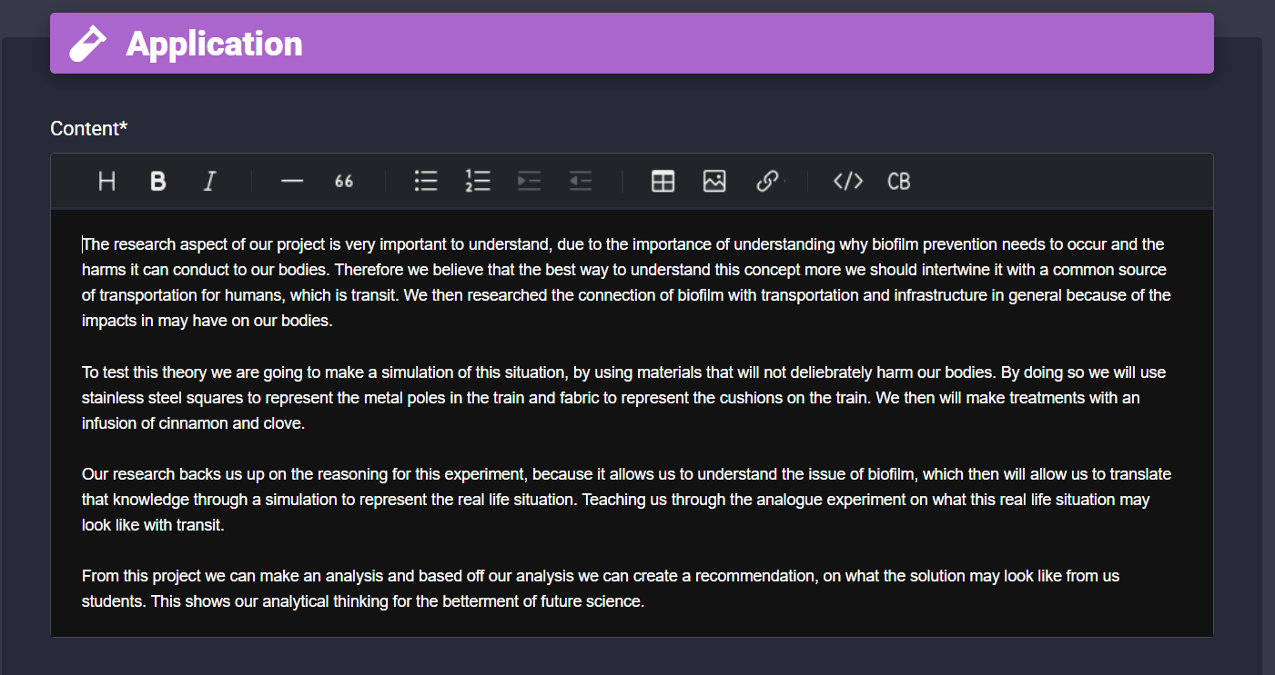
Mar 4th 2026: (Raameen), I’m working on finishing up the “Application” on the platform and adding the attachments. Jaya and I are planning to do more research and then add this onto the platform. We finished the CYSF platform for what we needed to do, just needed to attach the logbook.

