The Future of Physics – Particle Accelerators
Anaya Satavalekar
2021 Science Fair Research Report

Note: All the pictures throughout this paper are drawn by me, except for the ones that include citations underneath them

Abstract
There are constant problems regarding cancer, wars, and radiation in this world. We repetitively have problems that are unresolved, and scientists, physicists and researchers incline to look at the greater picture, how these systems work, to help understand these problems. What is necessary, is to comprehend the inner workings of everything, smaller than even the subatomic level; this is where we get introduced to a smaller scale; smaller than molecules; smaller than the fundamental building blocks of matter, atoms. This is where we get introduced to the quantum level/scale. This quantum scale/level will be visited again later through this paper, in deeper and more thorough explanations.
Molecules are the smallest unit of chemical compounds. Atoms are the smallest unit of any element. But these are not the smallest unit of matter. The atom is made up of electrons, protons, and neutrons. Electrons are a fragment of the smallest building blocks of matter, but protons and neutrons are made up of even smaller particles called quarks. This falls under quantum physics or the quantum scale, a level even smaller than the subatomic level. The new and emerging field, quantum physics, has so many mysteries that can solve an infinite number of problems in our world, and one of the leading technologies used in this field, are particle accelerators. This paper focuses on how particle accelerators can be used in our world to help us appreciate and understand this quantum realm, which will help us solve many, real life problems. This paper will visit all the aspects of particle accelerators, from the mechanics of how it works to the chemistry behind the effect of the particles colliding. This paper will also go through all the particles in our Standard Model of Elementary Particles Model. Nuclear physics, medicine and health, Einstein’s famous equation (E=mc²), The standard model of elementary particles, will all be visited during the research of how this fascinating piece of technology works. This report is an extension and a thorough/complete overview of the research conducted through the duration of this project.
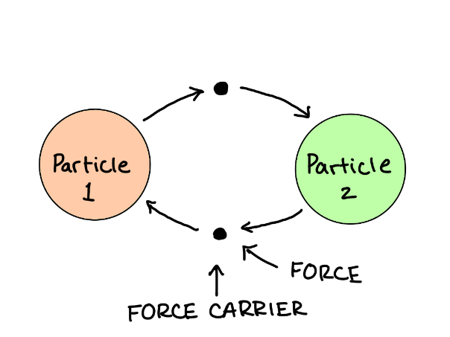
The Four Fundamental Forces
Understanding the physics behind the uses and how particle accelerators work, first requires us to understand the fundamental forces and the elementary particles that are commonly studied and researched through the use of particle accelerators. Throughout years of school and further studies we are gradually introduced to forces that are present in our universe. These forces include: The Gravitational force, The Electromagnetic force, The Weak force, and The Strong force. These forces are very communal conversations in our grade three science class and our university physics class. In younger classes, we are taught that forces are an invisible attraction or repulsion that results in some kind of movement or change in the environment around us, but as we go deeper into how forces work, we realize that forces are present because of exchange in particles between two objects. These exchanged particles are called “Force Carriers” and as the name implies, they carry the four fundamental forces.

Gravitational Force
Gravity. One of the most common of the four forces, is also the weakest of the four forces. When we talk about gravity, we usually refer to planets, orbits, the rotation of the moon and tides. Clearly, gravity is a very significant force on the macroscale which is why it is also very insignificant on the subatomic level or the quantum level.
Gravity usually has a larger effect on large concentrations of mass, and it is usually highly focused in densely packed areas and less likely to influence other areas even though gravity acts on every object with a physical mass.
Gravity is the only force without a discovered force carrier. Scientists are predicting a particle called he “graviton” that will mediate the gravitational force, but we have found no traces of this particle. Experiments at the LHC (Large Hadron Collider) are continuously being carried out to find even a small trace that a graviton exists. Unlike the electromagnetic force, gravity has only an attractive force, meaning it will never repel two objects. Gravity is one of the forces out of the 4 fundamental forces which has an infinite range and can act throughout galaxy if the mass is large and concentrated enough.

The universal law of gravitation states the force of gravity acting on two objects is proportional to the product of the masses. This proves that the larger the masses are (the more concentrated they are) the
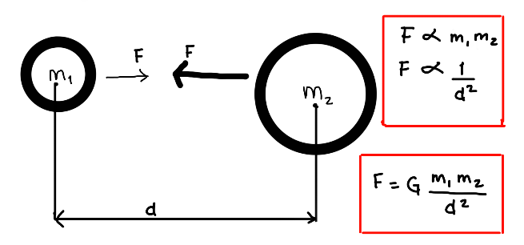
stronger the gravitational pull, which is the reason we talk about large objects like planets and celestial bodies when referring to gravity.
Another vital theory that helps us understand how gravity works is the general theory of relativity, commonly referred to as the “theory of relativity”. This theory states gravity is the consequence of the curvature or deformation of the spacetime continuum that is created by the presence of some kind of mass. This theory also contains the world’s most famous equation, E = mc². Simply stated, this equation means that mass and energy are interchangeable and are different forms of the same thing. We will revisit this vital equation when we talk about the high energy apparent in a particle accelerator.
Electromagnetic Force
The electromagnetic force is another one of the four fundamental forces that are apparent in our universe. This force is much stronger than gravity, nearly 10³⁶ times stronger than gravity, which makes it the second-strongest force after the “strong force”.
When we think of electromagnetism, we usually picture a magnet with a battery or a spinning coil, but the electromagnetic force acts way beyond our imagination both ways. Electromagnetism acts on the subatomic/quantum scale and in infinite distances which makes it the only force able to interact on both levels of the spectrum. Gravity acts on concentrations of mass and Electromagnetism acts on concentrations of charge. Since there aren’t usually very large concentrations of charge (coulombs) because they tend to neutralize fast, we don’t see concentrated electromagnetism like we do gravity, but if necessary, electromagnetism can act on infinite distances.
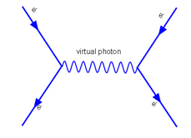
Since this project/paper is dedicated to the quantum level, we won’t visit the effect of the electromagnetic force on macroscales but this force in specific is very important in the subatomic and atomic level.
When we start learning about atoms, we learn that electrons “orbit” the nucleus but as we learn farther, we understand that they really just vibrate and bounce around the nucleus. As known, an electron has a negative 1 charge and a proton has a positive 1 charge. Like charges repel and different charges attract, so if we were to have 2 electrons side to side, they would repel due to the exchange of a “light photon” or “virtual photon”. The photon is the force carrier for the electromagnetic force and the interactions between charged particles occur when the exchange of a virtual photon is conducted.
https://www.google.com/search?q=virtual+photon&client=firefox-b-d&sxsrf=ALeKk008VBQpgHLazbmyysV-X1G8dyd3ew:1615525085908&source=lnms&tbm=isch&sa=X&ved=2ahUKEwjB3vv2-6nvAhXJrJ4KHZWPBXgQ_AUoAXoECBgQAw&biw=1843&bih=868#imgrc=r78WJ6ZTiLuWcM

Strong Force
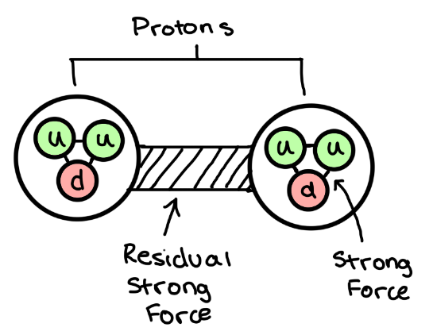
As the name states, the strong force is the most powerful/strongest force out of all the four fundamental forces which is 10³⁸ times stronger than gravity.
This force only acts in very small distances, approximately the distance of the diameter of an atomic nucleus (10⁻¹⁵ m)
Ever wondered: if like charges repel, why do protons stick together in a nucleus? The strong force is a force that is so strong, that it can even overcome the electromagnetic force so it can be able to keep like charges together, but this force I only present in distances up to 3fm. If you look at this picture to the right, you see 2 protons. These protons are made up of even smaller, elementary particles called quarks, that will be visited further in this report, but the primary strong force acts on keeping the quarks together. The residue of the strong force acting on the quarks also called the residual strong force, acts on the proton as a whole, which is what keeps the protons together. Now, this force isn’t only accessible to protons or electrons, but it acts on all hadrons which are particles mad up of further elementary quarks.
The force carriers for the strong force are gluons and they can only be transmitted through small distances, which is why the strong force only affects very small distances. The further the particles become, the less significant the force becomes, and more gluons are lost through the process of transmitting them.
Weak Force
Don’t get fooled by the name because the weak force is much stronger than gravity, 10²⁵ times. It’s weaker than the other forces but it also works only on very tiny distances. The weak force acts on distances that are 10⁻¹⁸m which is even smaller than the strong force. This force is found withing the neutrons and atoms instead of outside them like the strong force.
This force is responsible for keeping the number of neutrons and protons somewhat similar. The weak force is very special because it is the only interaction where the quarks can change types or flavours (quarks will be visited further in this report).
This force is very important in protons and neutrons because it leads to a unique interaction that cause the majority of the phenomenon we see today. Let’s take the Nuclear fission reaction in which 2 hydrogen nuclei fuse to create a deuterium nucleus which fuse to create alpha particles and so on to create heavier elements. All the heavier elements that are present in the periodic table are due to this nuclear fission reaction which builds up smaller particles to create heavier particles, but it would not be possible without the weak force. A proton is made up of 2 up quarks and 1 down quark while a neutron is made up of 2 down quarks and 1 up quark. In the case, where 2 protons fuse, it will be a pair of proton-neutron (picture to the left). But in the process, we have a positron and a neutrino emitted. As you can see, one of the protons converted into a neutron which means one up quark in the proton converted into a down quark. The weak force is responsible for this reaction. You will notice that every element has a similar number on protons and neutrons. If the number of protons greatly exceeds the number of neutrons, some protons will convert to a neutron to stabilize the nucleus, and vice versa (neutrons to protons).
The force carriers for the weak force include 2 types of bosons, the W boson, and the Z boson. The reaction mentioned above (proton converting to neutron) is controlled by the W boson which is responsible for changing an up quark to a down quark and is responsible for the radioactive decay. The Z boson is responsible for/mediates the neutrino reaction.
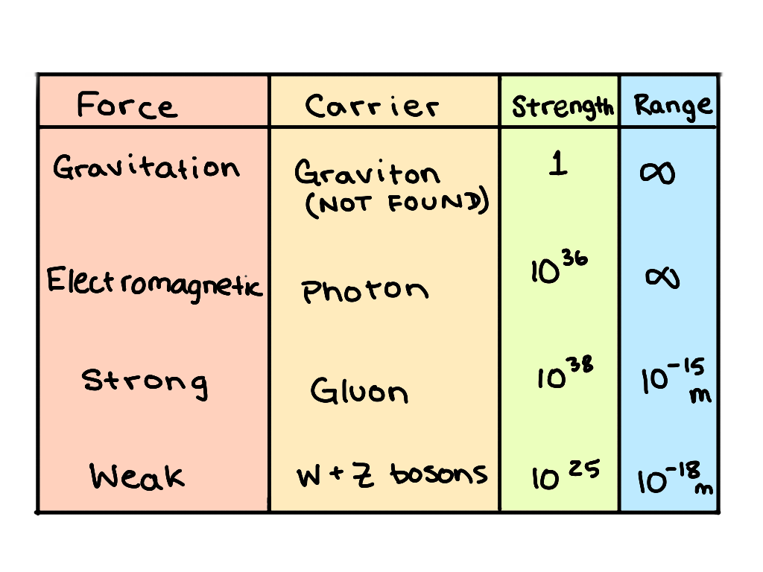

This graph to the right sums up all the fundamental forces, their mediator(carier), range, and the strength. Lets move on to the standard model of elementary particles.

Standard Model Of Elementary Particles
Now that we have understood all the interactions that particles undergo, let’s understand the particles themselves and how they work.
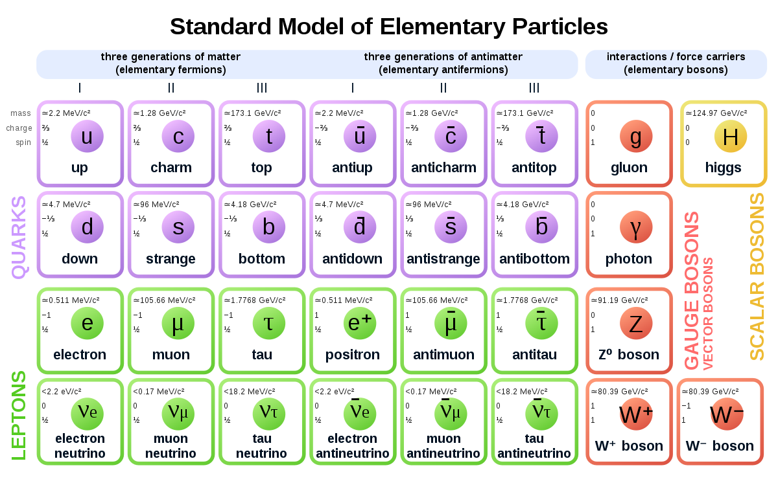
https://upload.wikimedia.org/wikipedia/commons/thumb/a/a3/Standard_Model_of_Elementary_Particles_Anti.svg/1200px-Standard_Model_of_Elementary_Particles_Anti.svg.png

Similar to the periodic table of elements, the standard model of elementary particles shows us all the very fundamental building blocks of the universe, smaller than even protons and neutrons. As you can see in the above picture, all the purple colored particles are called quarks, which are always in groups to create larger, more significant particles. The green particles are called leptons which are much larger than quarks but are fundamental and cannot be broken down into smaller particles. The red particles are the Gauge or Vector bosons and they are all the force carriers we visited above, and the mediate all the four fundamental forces. Finally, the yellow particle, the Higgs Boson, has just recently been discovered at the LHC (large hadron collider) during a collision of particles.
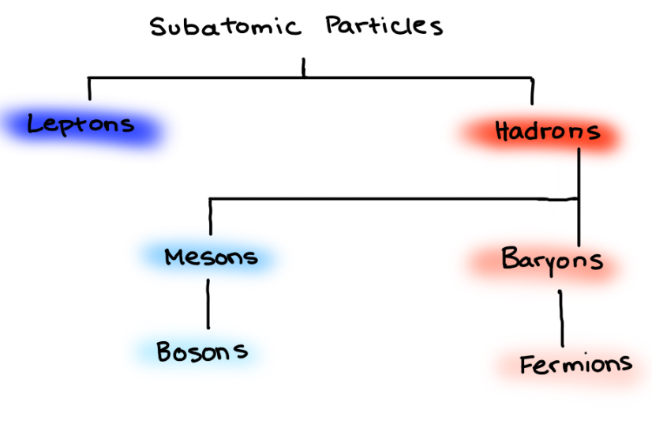
This flowchart to the right, classifies the subatomic particles present in our universe. They each have their own role in keeping balanced quantum fields. This chart will be described further in detail, but to be concise, Leptons are not affected by the strong interaction and they are larger but cannot be broken down into further particles. Hadrons, on the other hand, are affected by the strong force and they can be broken down into further elementary particles. These 2 sections can then be broken down into further categories such as mesons, bosons, fermions, and baryons that will be visited throughout this report/research paper.

Quarks
The term “quarks” was mentioned quite a bit when we were talking about the four fundamental forces, and now we can toughly understand how quarks work and how they interact with other particles.
If you see the picture on the left, you will notice that there was a similar picture when we were visiting the strong force. As you can tell, the proton and neutron aren’t fundamental particles, and can be broken down into even por basic particles called quarks. A proton is made up of 2 up quarks and 1 down quark, while a neutron is made up of one up quark and 2 down quarks. Up, down, top bottom, strange, and charm are all flavours or types of quarks and they each have different properties such as charge, spin, and mass.
We know that protons have a +1 charge and neutrons have a 0 charge. These charges come from the charges of the quarks. An up quark has +2/3 charge and a down quark has a -1/3 charge so if you were to do the math, you would see that a proton has a total of +1 charge and a neutron has a total of 0 charge. The charges of any hadrons are dependant on the total charges of the quarks or particles they are made up of.
The quark model states that each baryon is made up of 3 quarks and meson particles are mad up of a quark, anti-quark pairs. (anti-particles will be discussed further)
Quarks interact with each other via the strong force and they all have fractional charges which is why the hadrons usually have integer charges (because hadrons are made up of quarks).
Quarks have many properties, but in this report, we will describe three main properties: quark color, quark flavour, and quark confinement. Another property that I will quickly discuss is spin. Not just quarks, but many other particles have a “spin” property.
The spin property is a number that describes the speed and angular momentum of the rotation of a particle. All fermions have a spin of ½ which includes particles such as electrons.
Quarks don’t actually have color; scientists use colors to help visualize stable and unstable particles. Taught in elementary school, mixing certain colors, gets us other colors. In quarks, we have labeled them as 6 different colors, green, blue and red. Then there are the anti quarks which have anti colors that include, anti-red, anti-green, and anti-blue. These colors are not the actual property, but merely an analogy or naming convention to help scientist sort the quarks. These quarks could have also been named as x, y, and z but we specifically used colors because, it helps in understanding the combinations quarks are put together in. When we have the three colors in light; green, blue, and red, and these three colors are mixed/come together, we get white light. Now, this analogy is used in hadrons saying, “all hadrons are colorless” so when quarks come together, they do so in a way that the “colors” mixed, will become white.
So, using this analogy, I mentioned before, that baryon particles are made up of 3 quarks and meson particles are made up of a quark, ani-quark pair. Baryons will always have a green blue and red quark in they same proportion with all of them making 1/3 of the particle which results in a colorless particle. And since mesons are made up of a quark, ani-quark which also results in a colorless particle. This color property is only relevant with quarks and nothing beyond that because all larger particles are colorless so there are no more color properties past the quarks. These quark colors or this analogy is called Quantum Chromodynamics.
Quantum chromodynamics also explains why particles of specific quarks are not found such as a hadron particle with 4 quarks. In this case we cannot have any combinations which will result in a colorless particle, which means if this combination were to actually be present, it will be too unstable to last in our universe.
The strong force also plays a big role in the creation of hadrons as mentioned before. Because of the strong force, the quarks are attracted to each other because of the strong force, and similar to the fact that the electromagnetic force needs charges to have an interaction, the strong force needs these quarks to have an interaction which is why, the strong force is also called the color force.
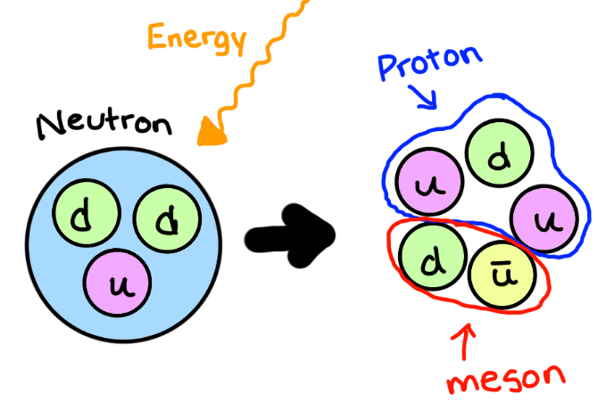
Now, let’s move on the quark flavour. Similar to ice cream flavours, there are different “flavours” or types of quarks as mentioned before. These flavours include: up, down, and strange, but there are another three flavours that were discovered later on, but they are not that common because they are found in heavier particles that are only created in high energy collisions or extreme energy. These quarks include top, bottom, and charm quarks. There isn’t much to elaborate on flavours of quarks other than to know there are 6 different quarks that have different properties, and some are more commonly found (inside protons and neutrons) and some are only found in places of high energy and are impossible to come across in our regular life because they decay into smaller particles very fast.
Quark confinement is a theory to explain why quarks are never actually found alone and you can never isolate one single quark. If we were to take some hadron and apply an external energy, or force to break apart the 3 quarks. The energy would be used to create another quark which would lead to the creation of a meson (quark, anti-quark pair) and a hadron. In the picture to the right, you can see that the energy was used and it was turned into an up quark and an anti-up quark pair, which will now reshuffle to create a proton and another meson (a pi-meson for this specific case).
Leptons
If you recall the flow chart that is located on page 5 of this repot you can see that Leptons are one of the 2 types of subatomic particles. There aren’t any more “types” of leptons as there are hadrons. Leptons are special because they are part of the standard model of elementary particles, but are much bigger than the quarks. Leptons cannot be brocken down into further quarks or any further particles, and they are in the most simplest form already why is why they are on the standard model.
Leptons are also not affected by the strong force. If you can recall, the primary strong force acts on quarks, and the resdual strong force acts on the hadrons that are made up of the quarks. Because leptons are in the most simplst form possible, there are no quarks inside which means the strong interaction is absent in leptons. So these are the two main points that make leptons different from hadrons: They are not affected by the strong interaction and they cannot be broken down into further elementary particles.
There are three main leptons. The Electron, the Tau and the Muon. The electron, as we know, are really common in our universe found in every atom that makes up matter. But the other two heavier particles in Its family, te tau and muon are only found in extremely high energy areas such as a particle accelerator or within stars. The tau and muon, if not in a high energy/collision environmnet, decay almost instantly into smaller, lighter, more stable partilcles such as hadrons.The tau, the heaviest of all the leptons, decays 2.903 x 10⁻¹³seconds and the muon decays in 2.2x 10 ⁻⁶ seconds. We will talk about decay modes later in this report.
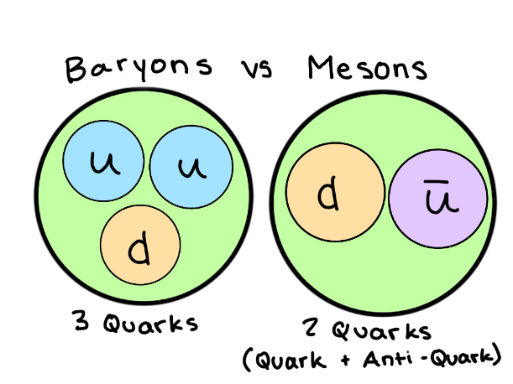
Hadrons
We already talked about hadrons a lot in the “Quarks” section but unlike leptons, hadrons do experience the strong force and are made of further elementary particles called quarks. Hardrons are also further split into/ seperated into two categories: mesons and baryons. Mesons and bosons are the same thing, while baryons and fermions are the same thing.
The difference between mesons and baryons are that mesons contain 2 quarks while baryons have 3, and they follow different principles, statistics, laws and equations. Mesons follow the Bose-Einstein statistics (these statistics explain the statistics of a system where you can’t differentiate between any of the particles). Baryons follow the Fermi-Diarc statistics and the Pauli Exclusion principle (describe the large scale state of a system which is made of many of the same particles or fermions. None of the particles can have more than one particle (which is the Pauli- Exclusion principle).
Some of the common mesons include:
Meson Types
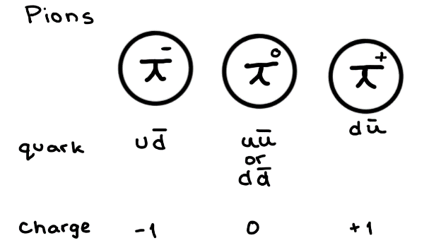
There are many mesons that are made up of 2 quarks, a quark, anti-quark pair, but just as an example here are 2 types of common mesons.
Pions or Pi-Mesons
A type of meson that are made up of up and down quarks and anti-quarks. There are 3 types, -,+, and 0. These mesons have no spin.
Kaons
Kaons, another type of mesons also have no spin but they are made up of all three main quarks and anti quarks in different combinations: up, strange and down.
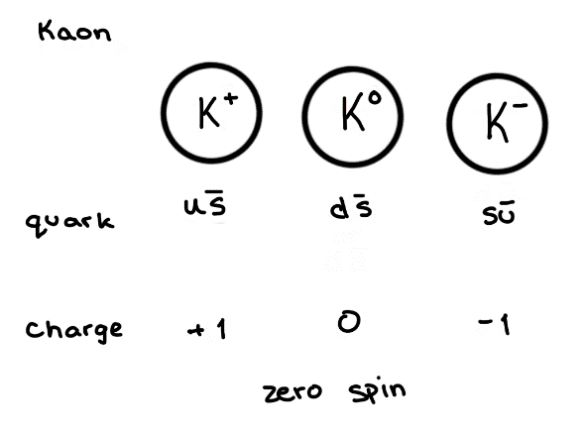
Baryon Types
Similar to the Mesons, there are many types Baryons that are made of 3 quarks but as an example, I will show 6 of the most common baryons that are studied, researched, and are part of conversation.
Proton
We have discussed the proton quite a lot throught the length of this paper and it is a baryon or a hadron as mentioned before, made up of 3 quarks. It is also the most stable hadron
Neutron
Similar to proton, neutrons are a very stable hadron but they have a charge of 0 and their combination of quarks are different.
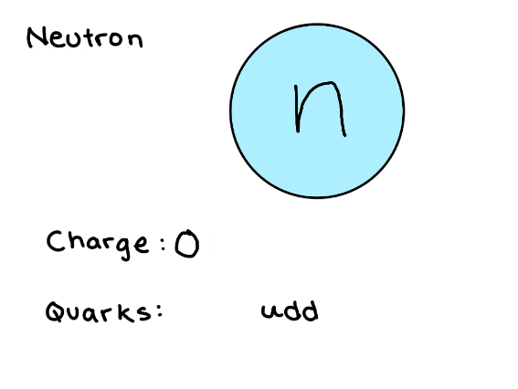
All 6 of these baryons are very common and we have heard of most of them in our life.
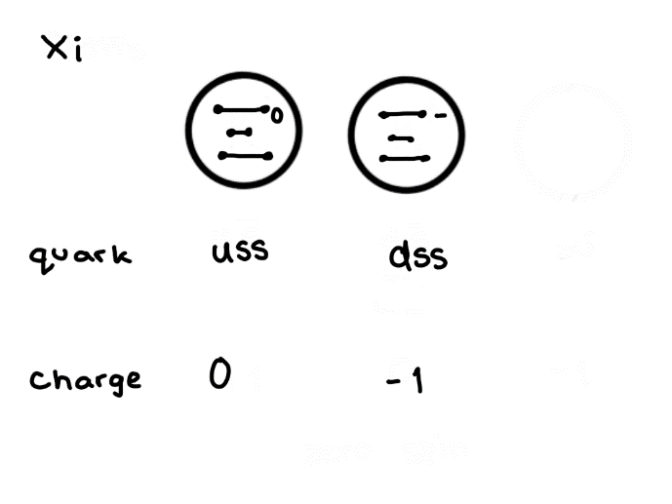
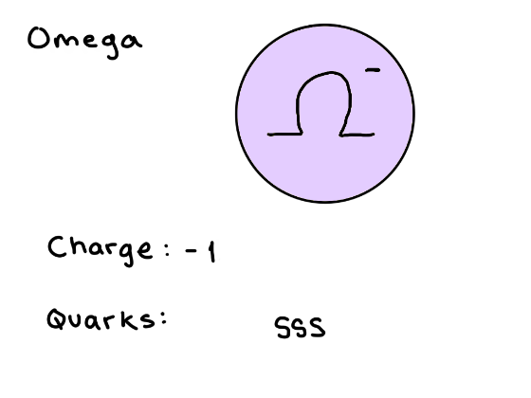
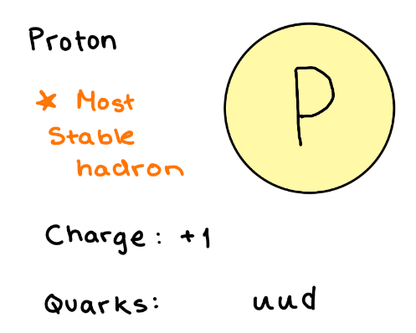
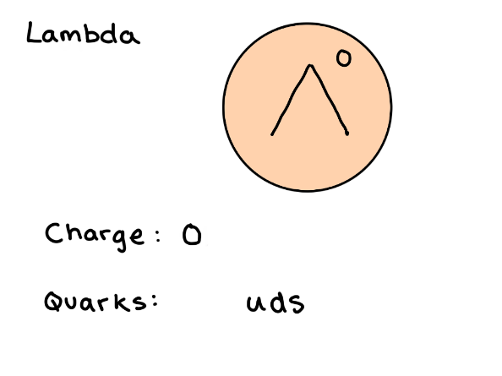
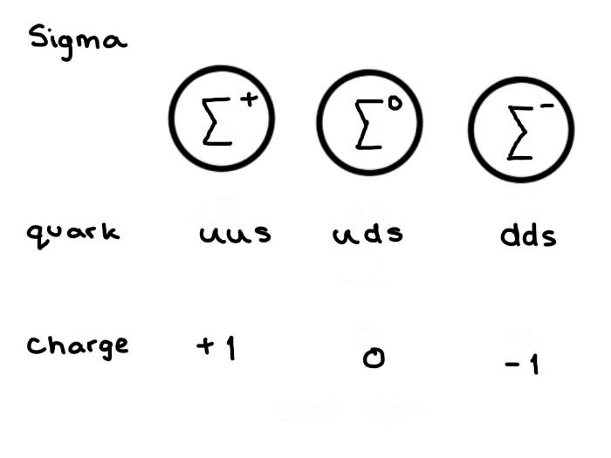
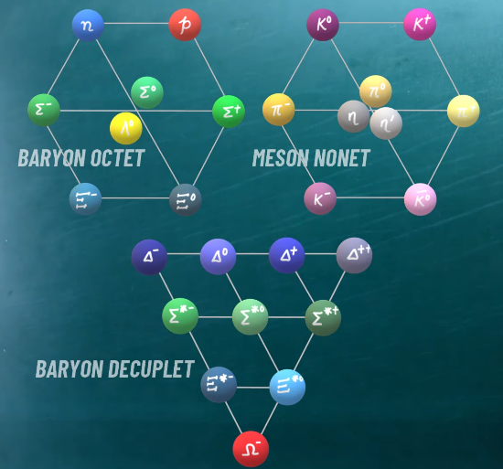
The EightFold Way
All The pictures on this page are screenshot photos taken from a video, that is citation [56] because they conveyed exactly what I wanted to show for the eightfold way, so I give credit to their original owner who is Dibyajyoti Das, a physics professor
We have all these particles, meseons, hardon, and scientists have come up with ways like images, nets and webs to sort these partices into groups simiilar to the periodic table. The eightfold way was first proposed by 2 scientists: Murray GellMann and Yuval Ne’eman
There are 3 main ways we can sort baryons and mesons: the baryon octet, the meson nonet, and the baryon decuplet. (image to the right).
All of these different arrangements are sorted by different properties. If you can see the 3 indifidual pictures below, you can see that every particle in each of the baryon decuplet, meson nonet, and baryon octet consisit of the same ttypes of particle, either all baryons, or mesons.
Baryon Octet
The baryon octec constsis of the lightest baryon particles that all have a spin of 1/2. If you can see, The baryon octet is made up of 3 horizontal lines and three diagonal line (disculding the sides). Every “layer” or every horizontal line has different properties associated with the particles on that line. Strangeness, another property of quark and particles can be sorted according to this property. The first horizontal layer contains allthe particles with a strangeness of 0, the second alyer has a strangeness of -1, and the 3rd layer has a srangesness of -2. The diagonal lines, are to sort the particles according to their electrical charge. The first or most bottom diagonal layer has a charge of -1, the middle has a charge of 0, and the top has a chrage of +1.
Meson Nonet
The meson nonet is another way to arrange particles, but instead of baryons (like the baryon octet) it sorts mesons(recall, mesons contain only 2 quarks). The spin for this arrangement is 0 for all the particles. The charge is sorted the excatc same way as the baryon octet with the three diagonals being the same values, but the strangeness (horizontal) values are different. The top is a strangeness of +1, middle is 0 and bottom is -1.
Baryon Decuplet
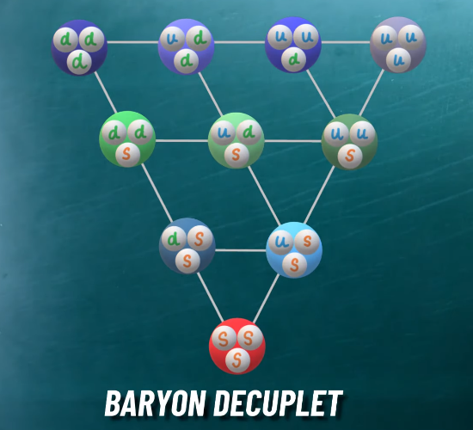
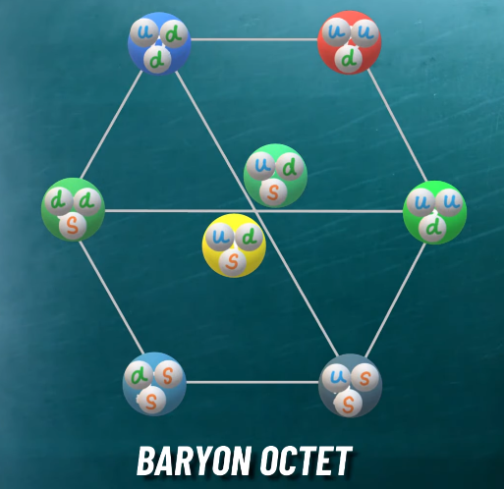
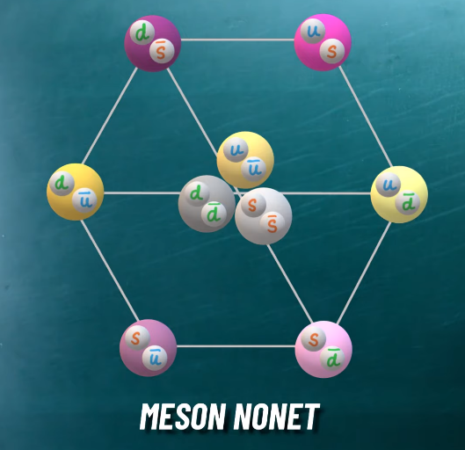
Instead of a hexagon, this time it’s a triangle. The bayron decuplet has 10 particles that are all baryons just like the baryon octet and the spin of all the particles is 3/2. The strangeness (horizontal lines) are 0, -1, -2, -3 (from top to bottom) and the charges are +2, +1, 0, -1 (from top to bottom for the diagonal lines).
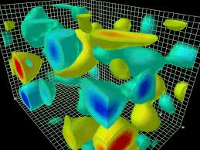
Quantum Fields
All these particles do different things, but the world is so much more complicated. The world is not made up of particles, rather, the universe is made up of quantum fields. Particles are just a phenomenon that emerges from quantum fields. The universe is a collection of these quantum fields, and for each particle in the standard model, there is an associated quantum field. Like for the photon, there is the electromagnetic quantum field.
https://www.google.com/search?q=quantum+field&safe=strict&rlz=1C1CHBD_enCA918CA919&sxsrf=ALeKk03fFs9gQEkqd_D27UeBrPXx0NUq2g:1615747089713&source=lnms&tbm=isch&biw=1821&bih=882#imgrc=LJ8yptwhwIUDnM

A field is an imaginary plane, that has a value at every point in space, if we take the example of the electromagnetic field, there is a “number value” in every point is space, and when its corresponding particle (photon) travels through that field or through space, the value of the field changes. But the value only changes where the photon is travelling. The fields measure energy, for every particle. When it’s corresponding particles travels through space, the energy of that particle will change the “value” in its associated field.
Even if there is no photon traveling through the field, there is still a number value for the electromagnetic field, which would be 0, which means the quantum field exists even if there are no particles in it, “Similar to how oceans would exist, even if there are no waves in it” [55].
This theory also explains that particles are not absolute, they can appear to one observer and not to another because they are observing through different reference frames. It is similar to the idea of time dilation, where if someone is moving really fast, close to the speed of light, their clock will actually tick slower, than that of a person standing still (explained in the theory of relativity).
So, this all indicates that the fields are fundamental and not the particles, now as I will explain in more detail when we talk about particle accelerators, these fields can interact with each other, so when we use a particle accelerator to smash 2 particles together, they create disturbances in the quantum fields and the energy of one field transfers to another and soon to all the fields, which activates values an all the fields.
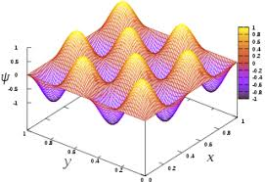
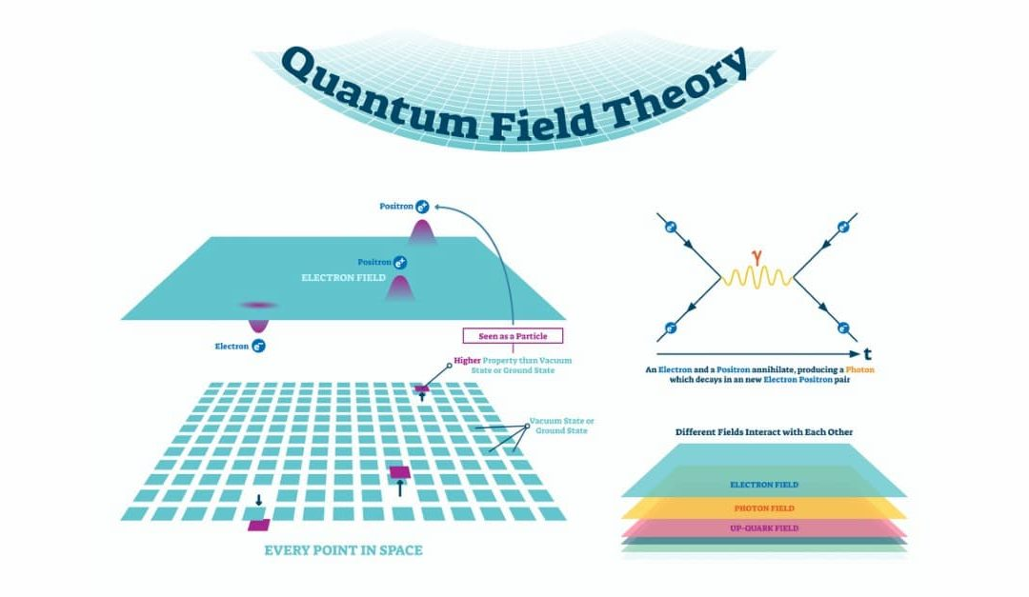
I will explain this next concept a little bit deeper when we visit particle decay modes and the Higgs boson (another fundamental particle) but when a particle accelerator collides 2 particles to create new particles, we can’t actually directly observe the particles, so scientist have to track the decay processes of these new particles and exactly where the different parts of the particle fly off.
https://www.google.com/search?q=quantum+fields&client=firefox-b-d&sxsrf=ALeKk03okIJdTf7xcBzFCcs6MKoMUVe2Ig:1615747905714&source=lnms&tbm=isch&biw=1843&bih=868#imgrc=RJZqxsJQdgqbCM

https://www.google.com/search?q=quantum+fields&client=firefox-b-d&sxsrf=ALeKk03okIJdTf7xcBzFCcs6MKoMUVe2Ig:1615747905714&source=lnms&tbm=isch&biw=1843&bih=868#imgrc=13fsKtMvezuSSM

Particle Decay and Decay Modes
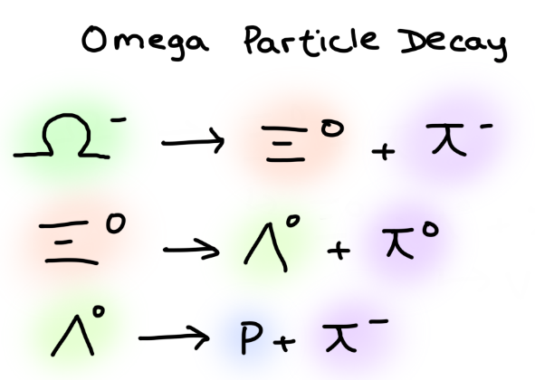
As we talked about before, there are some very heavy particles that have a very short life and can only be created in high energy areas such as a particle accelerator or inside a star. When a large (heavy) particle “exits” or leaves the high energy areas, they will immediately convert into smaller, lighter particles such as a hadron, or electrons. This “converting” is called decay. All the heavier leptons will decay into smaller particles. Some very large and heavy particles will decay into smaller larger particles, that will decay into even smaller particles, all in the duration of less than a microsecond.

For example, the omega negative particle will decay first into a pi-meson (negative charge) and a Xi particle (zero charge). Then the Xi zero charge particle will decay into a will decay into a lambda zero charge and a pi-meson zero charge, and finally, the lambda zero charge will decay into a proton and a pi-meson negative charge. Sometimes for even heavier particles, the chain can go on forever, with particles decaying tens of times.
Anti-Particles
Every particle has different “versions” of itself, with properties that could be similar or opposite but there are these special versions called anti-particle or neutrino. When describing mesons, I constantly stated a meson is made up of a “quark, anti-quark” pair. When we described quantum chromodynamics, it was said, that a colorless particle could be made up of a “red, anti-green” or any other color with an anti color pair. Anti-particles are particles with the same mass but opposite charge. An electron has a -1 charge, while an anti-electron (more commonly known as a positron) will have a +1 charge. Particles like the proton that have 2 up and 1 down quark can also have infinite pairs of quark, anti-quark pairs (same flavour) along with the 3 main quarks.
If a particle and its corresponding anti-particle were to come together, they would both be destroyed, leaving gamma photons to be emitted. If we take an example, if an electron and a positron were to collide or come together, they would both be destroyed, leaving 2 gamma photons. There would be 2 photons to keep the linear momentum balanced (there was a 0 linear momentum before the collision, and if there was only 1 photon emitted, there would be uneven, unbalanced linear momentum,
which is why 2 gamma photons would be emitted.) to follow the conservation of linear momentum law.
If we revisit this collision we will also see that the anti-electron will have to have an opposite charge or +1 charge because photons have 0 (neutral) charge so if a -1 charge and a +1 charge combine, we will get a 0 charge as per the reaction. These reactions also conserve many laws such as: conservation of charge, conservation of linear momentum, conservation of energy, conservation of angular momentum, conservation of lepton quantity number etc.
So anti-particles have the same mass, and same spin, but have opposite charge, opposite magnetic moment, and opposite lepton number. Every quark flavour has an anti-quark so if we have an anti-neutron, instead of the neutron being made up of one up quark and 2 down quarks, it will be mad up of one anti-up quark and 2 anti-down quarks.
Anti-matter is a very commonly said word when talking about cool astrophysics and dark matter, but really, antimatter is just matter that is made up of all anti-particles. Our normal matter is made up of for example protons, neutrons, and electrons while anti-matter is made up of anti-protons, anti-neutrons, and anti-electrons. Which means that is it possible for anti-protons and anti-electrons to create “anti-elements” such as an “anti-helium” atom, consisting of 2 anti-protons, 2 anti-neutrons, and 2 anti-electrons. But anti-matter is not very common in our daily universe, it is only found in nuclear reactions or cosmic ray interactions etc.
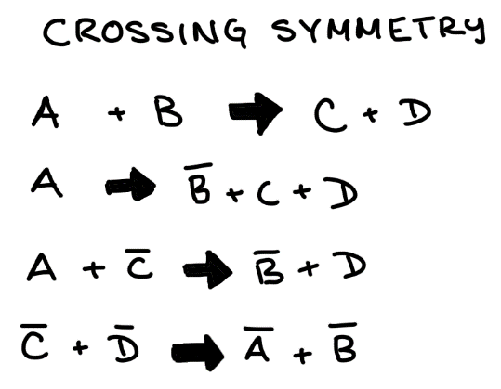
There is also a unique property called crossing symmetry, which is very similar to the algebra we learn in grade 5. In the picture to the left, if you have A + B = C + D you can “isolate” the variable “A” by adding an “anti-B particle to both sides, and on the right, the B and the “anti B” cancel each other out very similar to simple algebra. And soon if you keep going, you can find that you can completely flip the equation and have anti-particles for all the variables, which is another prof to show that every antiparticle has the same “value” as the particle. This phenomenon is called crossing symmetry. [49]
This picture, I drew but was an equation taken from citation [49]

Neutrinos
As you can see in the standard model of elementary particles, there are 6 neutrino particles in the very last row that are considered leptons. Neutrinos are also called “ghost particles” because they are so small, and their mass is s minimal that it still hasn’t been measured by scientists. The properties of these neutrinos include extremely tiny, interact via the weak force only, fermions, and have a neutral (0) charge.
A neutrino is so small and massless, it can “travel through millions of light years of dense lead material without being detected” [50]. Overall, neutrinos are a very complex topic and scientist are constantly looking for more information on these special particles and there is nothing yet confirmed about these particles which is why we will now move on to the final topic of particle accelerators.
Particle Accelerators
Everything that we visited before this point was to help us understand the fundamental particles, forces and properties that are constantly being researched with the help of particle accelerators. Now that we have thoroughly understood the basics, we can understand what exactly goes on inside a particle accelerator.
The largest Particle accelerator in the world is the Large Hadron Collider (LHC) and it is located in Geneva, 100m underground owned by a company called CERN. Throughout the next part of this paper, we will visit: what is a particle accelerator, how does it do what it does (mechanics), what new innovations has it created (uses), what fields can it be helpful for, and what is the future of particle accelerators.
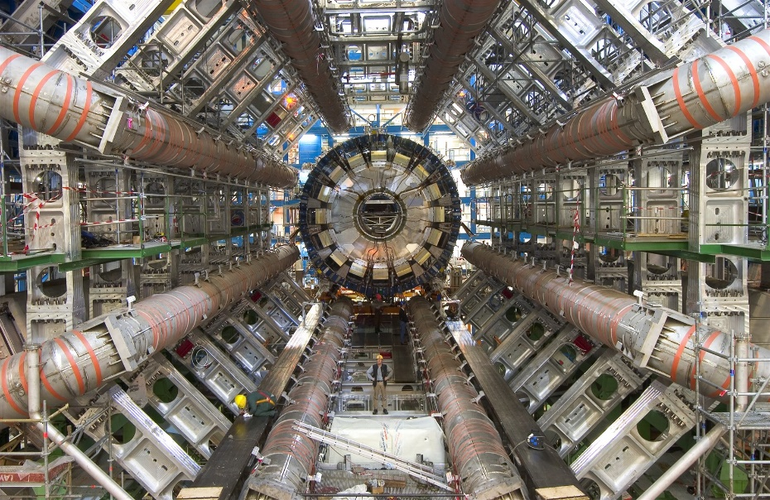
Basics of a Particle Accelerator
You see this very cool but complex machine on the right? That is a particle accelerator, the only piece of technology that can make something travel at nearly the speed of light.
A particle accelerator propels high-energy beams of particles nearly to the speed of light before they collide. A particle accelerator is in a ring shaped or a circle, so the particle beams have to be guided around the circular pipe before their collision with the other particle beam.
Particle accelerators are used for a variety of researches such as finding new particles like the graviton or another force/force carrier particle. Our knowledge in this quantum field is very minimal and particle accelerators are currently the leading technologies for new discoveries for quantum science/engineering. These collisions can tell us a lot of the properties of particle accelerators, the data can also give us hints, and clues or a detection of any other existing particles or forces that are yet to be found.
https://en.wikiversity.org/wiki/Radiation_astronomy/Hadrons

Mechanics behind a Particle Accelerator
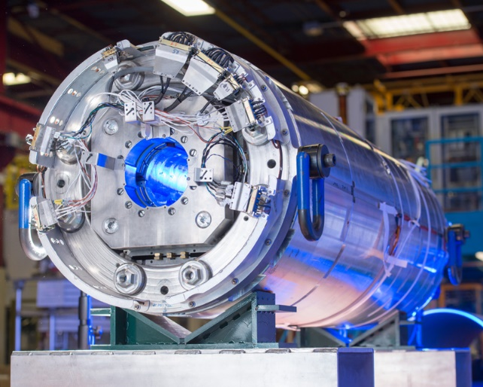
There are 2 beams of protons that travel in opposite direction in separate “pipes” called beam pipes, so they don’t collide early. These tubes must be kept in a very strong vacuum, so the protons do not collide with gas particles as they are moving. To be extra-sure, the beams are kept in an ultrahigh vacuum. Since the particle accelerator is a round ring (very long and large) the particles have to be guided along the ring. This is where the electromagnetic force comes in, the beams of particles are guided along the ring by a very strong magnetic field that is made with superconducting electromagnets.
The electromagnets are very powerful and are made of coils from a special cable that can be a superconductor that produces energy very efficiently, losing minimal energy with a nearly 0 resistance. To keep the coils in this superconducting state, the magnets need to be cooled to a temperature near to absolute 0. The magnets need to be cooled to a temperature of -271.3 degrees C. To cool the magnets, scientists at CERN use liquid helium which cools not only the magnets, but many other supply services inside an accelerator for the most efficient outcome.
You probably wondered what magnets were being used for the accelerator. There are may different magnets inside a particle accelerator to help control and steer the beams of particles. There are magnets such as dipole magnets used to bend the beams so they can travel in the circular pattern. There are also quadrupole magnets that focus the beams, so they collide.
https://newscenter.lbl.gov/2018/06/15/cern-ceremony-marks-groundbreaking-for-accelerator-upgrade-involving-u-s-national-labs/

The quadrupole magnets are also very important because the beams we are trying to collide, are so tiny, that it is near to impossible to get 2 such a small surface area at such a speed, to collide head on for the proper results and data. The beams inside the collider collide at four places around the accelerator circle, where there are also particle detectors that collect and gather data.
Extracting the Protons for Collisions
The high energy particle beams in an accelerator are beams of protons and the particle accelerator must separate the protons from its original nucleus or atom. The accelerator has a part with an electric field that uses the electromagnetic force to take hydrogen atoms and isolate the proton by using the electric field and different frequencies to remove the electrons from the atom, leaving just the proton that could be accelerated and collided. CERN scientists can control the frequencies and make sure that the particles aren’t in a “single file” line and more in bunches to make the chances of collisions higher and increase the surface area for better results.
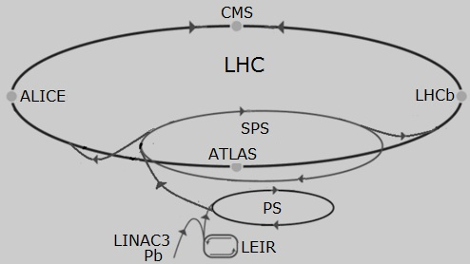
Moving the Particles at a High Speed
There are these special chambers that vibrate/resonate at different frequencies allowing waves to interact with the particle beam. The energy from the wave is transferred to the beam and their speed increases, slowly after multiple rounds of the particle accelerator the particles have gained enough speed to be collided into each other. So, as you can see in the picture to the right, there are multiple smaller rings other than the LHC. The hydrogen atoms first travel through the LINAC3 without gaining much speed or absorbing a lot of energy, but the LINAC3 strips most of the electrons before sending the particles to the LEIR (Low Energy Ion ring) as the atoms are moving through LIER, PS (proton synchrotron), and SPS (super proton synchrotron), they are gaining more and more speed and losing all of their remaining electrons. By the end of the SPS, the protons are traveling at a speed of 177 GeV when they are sent into the final LHC9Large Hadron Collider. Usually, both neutrons and protons take part un a particle accelerator so scientists can see the difference between the reactions of different ions and charge. Once in the LHC, the electromagnets will accelerate the particles to a speed of 1.38TeV and brought to collide at four different particle detectors placed around the LHC. These particle detectors are named as follows: ALICE, ATLAS, CMS, and LHCb.
https://www.lhc closer.es/taking_a_closer_look_at_lhc/0.lhc_pb_collisions

Types of Particle Accelerators
There are 8 main types of particle accelerators and they all essentially do the same thing in different patterns and different ways, for example, the LINAC or linear accelerator accelerates particles in a straight line. The 8 main types are: The Cockcroft-Walton and Van de Graaff Accelerators, the linear accelerator, the cyclotron, the betatron, the microtron, the synchrocyclotron, the synchrotron, and the storage ring collider
Uses of Particle Accelerators
Particle accelerators sound and seem like a very cool and complex piece of technology, they sow up in many tv shows and movies and they are related to dark matter etc. but if we think about it, what really are the uses of particle accelerators in our real world?
When we were discussing the basics of the forces and different types of particles, we talked a lot about some of the heavier particles only appearing in high energy places or inside nuclear reactions. A particle accelerator can create those high energy collisions to create those heavier particles that can’t be studied otherwise. A particle accelerator has given us many new discoveries and it helps us understand and study particles that are not seen in our regular universe such as the heavier leptons like tau and muon. If you noticed, I talked about every single particle on the standard model of elementary particles except for one, the Higgs Boson. This is a very heavy and unique particle that was first discovered inside LHC at CREN. The Higgs Boson is a very special particle which is why I left it to visit when we are explaining particle accelerators. We came to know about the heavier particles because of the particle accelerator’s high energy collisions and we wouldn’t have known that such heavy particles like the tau and muon existed. But the uses of particle accelerators go way beyond just “new science”, particle accelerators can be used in numerous ways for the medical field and particle accelerators, can be suer helpful in nuclear weaponry and many other fields that we will visit in the next couple sections.
Particle Accelerators in Medicine
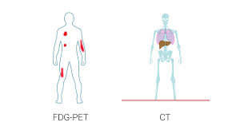
You’re probably wondering, how in the world can we use super fast particles, in a hospital? There are so many ways particle accelerators help doctors and medical practitioners. Did you know that today, there are over 30,000 particle accelerators out of which over 70% are in hospitals?
There is a radioactive form of glucose called FDG that can be injected into a patient, and after a PET scan (positron emission tomography), the doctor will know if the patient has any disease or any type of cancer. The FDG will be attracted by any tumour or cancer cells, and if the patient has a tumour, it will take up a large amount of the FDG and will act as a signal or beacon for the scanner. FDG is called a PET tracer, and there are mano other types which are very useful for medical diagnosis. Every PET tracer is created inside a particle accelerator, and here’s how. The particle accelerators in hospitals are cyclotrons, so there is this special type of water that contains a very heavy form of oxygen, Oxygen-18. A proton is accelerated in the cyclotron and once it reaches a fast-enough speed, it is shot at the O-18. The proton attaches itself to the atom and kicks a neutron out of the atom which turns the oxygen-18 into a fluorine-18, which is a very radioactive isotope of fluorine that can be detected through a PET scanner. This fluorine must be used quickly because in 2 hours, nearly half the solution will be gone because of radioactive decay. That’s not it. The particle accelerator will take the folurine-18 ad connect it to other molecules, creating different radiotracers. FDG is a common tracer because the rate at which cells consume glucose, can signal doctors, and tell the that there is the presence of cancer, the location of an infection, or dementia.
https://www.google.com/search?q=FDG&tbm=isch&ved=2ahUKEwjnsZK_167vAhVjIzQIHZKiDPEQ2-cCegQIABAA&oq=FDG&gs_lcp=CgNpbWcQAzIECCMQJzIECAAQQzIECAAQQzICCAAyAggAMgIIADICCAAyAggAMgIIADICCAA6BQgAELEDUOYwWNs8YPQ-aAJwAHgAgAFhiAGVApIBATOYAQCgAQGqAQtnd3Mtd2l6LWltZ8ABAQ&sclient=img&ei=v21NYKfWM-PG0PEPksWyiA8&bih=937&biw=1920&rlz=1C1CHBD_enCA924CA924&safe=strict#imgrc=whpkU0T15sgFdM

Not only can particle accelerators be used to detect diseases such as cancer, but they can be used to treat and help cure cancer and other diseases. Treating cancer comes in 3 forms. surgery, radiotherapy, and chemotherapy. Treatments using particle accelerators fall under the category of radiotherapy.
X-Ray Therapy
X-ray therapy is the most communal type of radiotherapy. High energy X-rays which are produced by firing electrons at a material like tungsten are focussed into a tumour or cancer. The radiation destroys the DNA of the cancerous cells which destroys the cells. A high dose in the tumour is needed to cure cancer through radiation. Regrettably, the X-ray radiation also harms healthy cells at positions in the patient’s body that cannot be avoided by the X-ray radiation.
Electron beam therapy
This method also uses the same type of accelerator that is used to produce X-rays, but the X-ray creating target is detached so that the electrons are fired straight into the tumour. Electron beam therapy is beneficial for treating tumours at the surface of or on the skin because electrons rapidly lose energy when they meet atoms in the body. Electron beam therapy causes much less harm to healthy tissue in the body because the beam does not pass all the way through the body, but it is only useful for skin cancer or diseases that are near the surface.
Hydrogels
Changing bandages daily, can be painful, and can damage newly grown skin which is why hydrogels are a much better replacement. This alternate type of covering is created using particle accelerators. hydrogels have a consistency like contact lens, its like a jelly that can be applied to open wounds. Hydrogels are made by dissolving certain polymers in small parts with water and then treating them with an electron beam using a particle accelerator. This interlaces the inward structure of the hydrogel into a molecular net, permitting it to grasp moisture while recollecting its shape.
These are just a few of the uses of particle accelerators in medicine and there are so many other ways particle accelerators are used in hospitals and doctor’s offices.
Particle Accelerators in Nuclear Physics
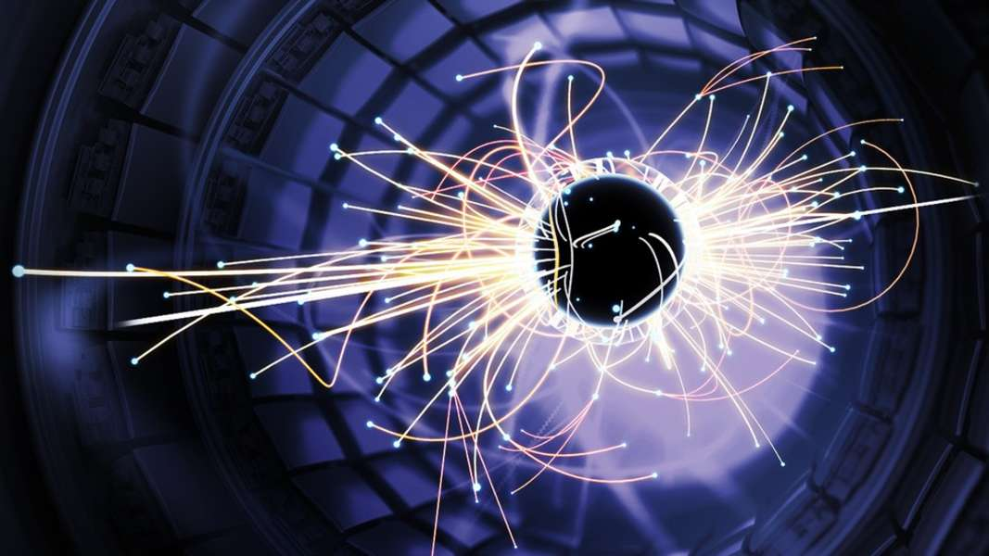
Particle accelerators play an important role in national security. We could take the high energy particle beams and compress them inside a bomb to create extremely dangerous nuclear bombs. Miniature particle accelerators could be inside weapons for an extra fast bullet speed or more energy confined for a more explosive blow.
As mentioned in medicine, particle accelerators can also be used for detection when shipping cargo, instead of x-rays, particle accelerators can create an even stronger beam to help see through an type of material, as mentioned when talking about neutrinos, they can travel through any material without being detected.
https://www.google.com/search?q=particle+accelerators+inside+nuclear+bombs&safe=strict&rlz=1C1CHBD_enCA924CA924&sxsrf=ALeKk00NXNa-
We8Cy7_HmcXicHZAyBKRJQ:1615687410770&source=lnms&tbm=isch&biw=1920&bih=937#imgrc=f0ZA55G6Yq_NtM
Laser technology could be improved using particle accelerators to create a stronger beam and a beam that could have extremely high energy to be used for satellite communications and military telecommunications. They can also be used to send signals or create secret channels for special communications.
All these examples just prove, how many different places particle accelerators can be used and all the different benefits they give us other than new particles and more scientific knowledge. These were just a very small fraction out of the infinite uses for this piece of technology.
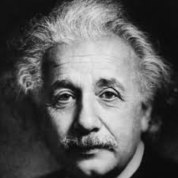
E=mc² and Particle Accelerators
One of the world’s most famous equations, E = mc², simply stated, means that mass and energy are interchangeable, they are the same thing in different forms. How does this relate to particle accelerators? When the particles are extremely energetic (like inside a particle accelerator), a phenomenon that proves this equation happens. The excess energy turns into new particles, and because the environment is like how it would be inside a star or nuclear fusion, we get these massive particles that are created because of the excess energy. This phenomenon is described by Einstein’s famous equation E=mc², according to which matter is a concentrated form of energy, and the two are interchangeable.
The LHC which is the most powerful accelerator in the world, speeds particles, such as protons, to a speed close to that of light, they collide with other protons. These collisions produce colossal particles, such as the Higgs boson or the top quark. Everything about the collisions are measured, how the quarks separate after collision. And with this data, scientists can grow our understanding of matter and find new particles and forces. These massive particles only for fractions of seconds and cannot be observed directly. Almost immediately they transform (or decay) into lighter particles, which in turn also decay and written in the particle decay and decay modes topic. And even these decays are detected, and data is collected to make sure that new particles aren’t discovered during the decay process.
https://www.biography.com/scientist/albert-einstein

Basically, if you transfer enough energy to a field, you will get a particle that corresponds to that field.
The Higgs Boson
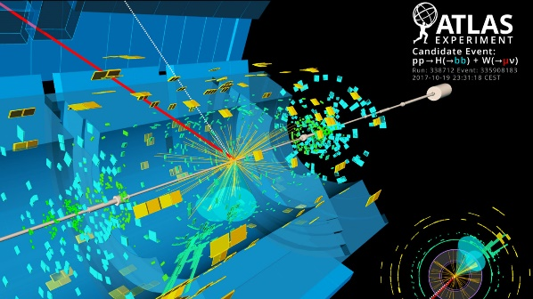
I have already mentioned this many times before, but let’s recap, if we were to collide particles at a very fast speed you would expect a huge mess of gluons and quarks to go flying everywhere, but instead, we get newer different particles with the excess energy absorbed by the particles. And remember, these experiments are carried hundreds of times at different frequencies before they get a result or a new particle. Sometimes the particles aren’t focused enough and miss the collision completely. to detect the Higgs boson, which has a life span of only 10⁻²² seconds as mentioned before, physicists at CERN had to increase the energy to 8 TeV, a record level
https://www.google.com/search?q=particles+collision+detection&tbm=isch&ved=2ahUKEwiuwpKcu7DvAhWTqp4KHcOyDDwQ2-cCegQIABAA&oq=particles+collision+detection&gs_lcp=CgNpbWcQAzoECAAQHjoGCAAQBRAeOgYIABAIEB46BAgAEBhQ6H5Y5JUBYKmXAWgBcAB4AIABTogByQWSAQIxMZgBAKABAaoBC2d3cy13aXotaW1nwAEB&sclient=img&ei=iVxOYO7ZLJPV-gTD5bLgAw&bih=868&biw=1843&client=firefox-b-d#imgrc=D4YyRrOA32hQKM

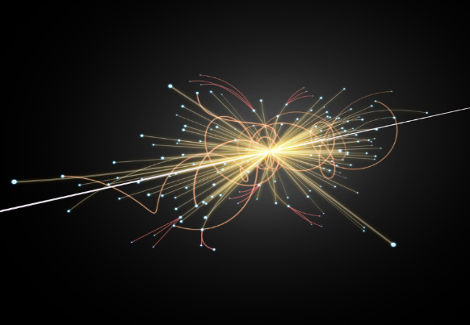
Similarly, at the LHC, when they were conducting a particle accelerator collision, expecting a mess of quarks and gluons like the other hundred times they did the experiment, all of a sudden, they get data and traces of a completely different particles with different properties, but this particle was so heavy it decayed in 1.56x10⁻²² seconds which is faster than any of the other heavier particles. This particle is the Higgs boson. After conducting the same experiment at the exact same frequency, a couple more hundred times, and confirming the existence of this new particle, they start to focus on the different properties of this particle.
I mentioned before, that the particle detectors, cant actually observe the new particles such as the Higgs boson directly, but as you can see in the pictures, we can collect data from every single particle that flies off and every particle that decays from the collision. But, “the decay products from the Higgs decay, are fundamentally indistinguishable from the decay of other particles” says Dr. Andres G. Delannoy, a physicist at CERN. So instead they will look at the decay patterns to see if they can find any hints or clues at all, so it shows how hard it is to distinguish the Higgs or any new particle from regular heavier particles.
https://www.google.com/search?q=particles+collision+&tbm=isch&ved=2ahUKEwiKjuilu7DvAhUUmJ4KHWTBDS8Q2-cCegQIABAA&oq=particles+collision+&gs_lcp=CgNpbWcQAzIECCMQJzIECAAQHjIGCAAQBRAeMgYIABAIEB4yBggAEAgQHjIGCAAQCBAeMgYIABAIEB4yBggAEAgQHjIECAAQGDIECAAQGFDx2ARY2eEEYODlBGgAcAB4AIABcIgBxwWSAQM3LjKYAQCgAQGqAQtnd3Mtd2l6LWltZ8ABAQ&sclient=img&ei=nlxOYIpHlLD6BOSCt_gC&bih=868&biw=1843&client=firefox-b-d#imgrc=p79-2cJAwmbYQM&imgdii=Ol8fBSE326jexM

Now back to what is the Higgs boson. As mentioned previously, the Higgs boson is a particle that is created when the Higgs field is excited, and it is the second-heaviest particle in the standard model, after the top quark. In the 1970’s scientist found out that there was a very close tie between the electromagnetic and weak forces, and the two of the forces can be described and explained by the same theory.
But the crazy concept is that every singly particle must have no mass, and we know this stays true for the photon, but the W and Z bosons have a huge mass, nearly 100 times that of a proton. Luckily, theorists Robert Brout, François Englert and Peter Higgs made a suggestion to help understand this “glitch”. The Higgs field is what gives the mass to the W and Z when they interact with the “Higgs field”, which exists after discovery in the universe.
When the Big Bang happened, the Higgs field had an overall value of 0, but as the universe got colder and lost all the energy that was trapped, the temperature dropped significantly and the field values increased so that any particle relating with the Higgs field gained mass. The more a particle interacts with this field, the heavier it is and the more the weight increases (mass). Particles like the photon do not interact with the field have no mass. So, the Higgs boson and field are truly a revolutionary discovery in physics.
The Future of Particle Accelerators
I believe that particle accelerators are going to hold a very fulfilling future for every field we currently study in. Not only will scientists find a way to increase the speed of the particles more efficiently, but we will also expand our standard model because of the even heavier particles that will be discovered, we just need even more excess energy to create those massive particles.
This is a very bizarre concept, but if we could speed up particles so fast, that they are travelling at the speed of light, we could generate completely abstract and particles that are currently nothing but theoretical. We could discover particles such as tachyons, and who knows what else.
We could also finally be able to detect those neutrinos commonly called as “ghost particles” and we could more thoroughly study the Higgs boson if we were to upgrade the particle detectors. It is also possible that even quarks are made up of smaller, more fundamental building blocks. We can also find newer fields and forces to go along with the new articles.
But that is just the cool physics advancements, the advancements that could be used I the medicine field are infinite. Last year, my science fair topic was on nanotechnology, and if we were to use particle accelerators to enhance the precision of leaser therapy, or femtosecond laser optical surgery.
You never know, but particle accelerators could be used as a renewable source of energy, to power our homes (although unlikely, but possible), because of the huge amount of energy they generate because of the speed.
Physicists believe that there is a lot yet to accomplish, not just with particle accelerators but also in quantum physics and engineering. Quantum is just a new and emerging field and there are so many more discoveries yet to be mad, the standard model could extend to the point where it is as large as our periodic table because even the periodic table of elements started of with very minimal elements.
Miniature particle accelerators can also be created that don’t use as much energy for medical healing purposes or just a simple weapon when you go hiking in the forests. It’s like holding your cancer treatment in the palm of your hand! Scientists are also trying to generate autonomous particle that run themselves and keep track of the data and will alert scientists if new particles or forces are detected.
The future of particle accelerators has great potential for new discoveries
- Anaya Satavalekar Grade 9
Resources Used
Four Fundamental Forces
- https://www.britannica.com/science/fundamental-interaction
- https://www.space.com/four-fundamental-forces.html
- http://hyperphysics.phy-astr.gsu.edu/hbase/Forces/funfor.html
- https://www.sciencealert.com/four-forces
- https://www.clearias.com/four-fundamental-forces-of-nature/
- https://home.cern/science/physics/standard-model
- https://courses.lumenlearning.com/physics/chapter/4-8-extended-topic-the-four-basic-forces-an-introduction/

Standard Model of Elementary Particles
- https://www.quantamagazine.org/a-new-map-of-the-standard-model-of-particle-physics-20201022/
- https://www.energy.gov/science/doe-explainsthe-standard-model-particle-physics
- https://physics.info/standard/
- https://www.iop.org/explore-physics/physics-stepping-stones/standard-model#gref
Quarks
- https://www.popularmechanics.com/science/a29429636/quarks-particle-physics-matter/
- https://www.britannica.com/science/quark
- https://scitechdaily.com/science-made-simple-what-are-quarks-and-gluons/
- http://hepoutreach.syr.edu/HEP_Tour/std_model/quarks.html
- https://www.sciencealert.com/watch-what-are-quarks
Particle Decay
- https://courses.lumenlearning.com/introchem/chapter/modes-of-radioactive-decay/
- https://www.intechopen.com/books/use-of-gamma-radiation-techniques-in-peaceful-applications/basic-modes-of-radioactive-decay
- https://www.sciencedirect.com/topics/physics-and-astronomy/particle-decay
Anti-Particles
- https://www.britannica.com/science/antiparticle
- https://www.forbes.com/sites/startswithabang/2021/12/29/not-all-particles-and-antiparticles-are-either-matter-or-antimatter/?sh=2042a77178af
- https://home.cern/science/physics/antimatter
- https://www.sciencedirect.com/topics/physics-and-astronomy/antiparticles
- https://www.scientificamerican.com/article/what-is-antimatter-2002-01-24/
LHC
- https://home.cern/science/accelerators/large-hadron-collider
- https://newscenter.lbl.gov/2018/06/15/cern-ceremony-marks-groundbreaking-for-accelerator-upgrade-involving-u-s-national-labs/
- https://home.cern/resources/video/cern/cern-overview-animation
- https://home.cern/resources/faqs/facts-and-figures-about-lhc
- https://home.cern/science/accelerators/proton-synchrotron
- https://home.cern/science/accelerators/proton-synchrotron-booster
- https://www.lhc-closer.es/taking_a_closer_look_at_lhc/0.lhc_pb_collisions
Particle Accelerator Uses
- https://www.symmetrymagazine.org/article/october-2010/accelerator-apps
- https://www.google.com/search?q=pet+scanner&rlz=1C1CHBD_enCA924CA924&oq=PET+scanner&aqs=chrome.0.0j0i20i263j0l8.2007j0j7&sourceid=chrome&ie=UTF-8
- https://www.energy.gov/articles/how-particle-accelerators-work#:~:text=There%20are%20two%20basic%20types,particles%20around%20a%20circular%20track.
- http://www.accelerators-for-society.org/about-accelerators/index.php?id=21
- http://www.accelerators-for-society.org/health/index.php?id=7#:~:text=One%20of%20the%20most%20important,in%20the%20treatment%20of%20cancer.&text=chemotherapy%2C%20where%20powerful%20cancer%2Dkilling,by%20energy%20deposited%20by%20radiation.
- https://www.energy.gov/articles/how-particle-accelerators-work
- https://www.symmetrymagazine.org/article/the-future-of-particle-accelerators-may-be-autonomous#:~:text=Particle%20accelerators%20are%20some%20of%20the%20most%20complicated%20machines%20in%20science.&text=Scientists%20are%20using%20machine%20learning,they%20need%20in%20real%2Dtime.
- http://thehappyneuron.com/2020/01/the-future-of-particle-accelerators-beyond-the-standard-model/
- https://physicstoday.scitation.org/doi/10.1063/1.1349610
The Higgs Boson
- https://home.cern/science/physics/higgs-boson
- https://www.scientificamerican.com/article/what-exactly-is-the-higgs/
- https://atlas.cern/updates/feature/higgs-boson
- https://www.exploratorium.edu/origins/cern/ideas/higgs.html
- https://www.britannica.com/science/E-mc2-equation
- https://www.scientificamerican.com/article/was-einstein-the-first-to-invent-e-mc2/
Videos Watched
- https://www.youtube.com/playlist?list=PLRN3HroZGu2lkRDsRxzqy_WU8NRk6evbD
- https://www.youtube.com/watch?v=n-WTovOT4Lw&list=PLRN3HroZGu2lkRDsRxzqy_WU8NRk6evbD&index=1&t=2208s
- https://www.youtube.com/watch?v=IexNXyyYfYk&list=PLRN3HroZGu2lkRDsRxzqy_WU8NRk6evbD&index=2&t=348s – Crossing symmetry
- https://www.youtube.com/watch?v=Ukop9e8dAuI&list=PLRN3HroZGu2lkRDsRxzqy_WU8NRk6evbD&index=3&t=1005s - Neutrinos
- https://www.youtube.com/watch?v=XltiIJYRWFQ&list=PLRN3HroZGu2lkRDsRxzqy_WU8NRk6evbD&index=7&t=1291s
- https://www.youtube.com/watch?v=fWPvhFcDjEs&list=PLRN3HroZGu2lkRDsRxzqy_WU8NRk6evbD&index=10
- https://www.khanacademy.org/science/cosmology-and-astronomy/universe-scale-topic/light-fundamental-forces/v/four-fundamental-forces
- https://www.youtube.com/watch?v=KXzONBPcPIk
- https://www.youtube.com/watch?v=nrXhK3Gh5EE&t=641s
- https://www.youtube.com/watch?v=9hsabeoi4U8&list=PLRN3HroZGu2lkRDsRxzqy_WU8NRk6evbD&index=9
Scientific Papers Read
- https://arxiv.org/ftp/arxiv/papers/1007/1007.3268.pdf

