Science Fair Log Book
By Max McGivern and Alex Vazquez Meza

We have always been taught that plants need 3 things to grow, water, air and sunlight. But is it possible to use various liquids other than water to successfully grow seeds?

Liquids: Tap Water, Distilled Water, Mouthwash, Orange Fanta, Tomato Juice, Sparkling water, Gatorade, Pedialyte.

What plant to choose?: Researched various types of seeds to plant. We decided on a pinto bean due to its fast growth cycle. We’ll begin by soaking the beans overnight to boost the germination process, then soaking a paper towel and placing the seeds inside so that we know they have all germinated. Then we’ll plant them in pots and start watering them all with a different liquid.

Supplies: Plant pots, soil, paper towel, measuring cup, liquids, pinto beans, ruler.

Jan 23, 2026
Pre germination process/soaking. We put 10 pinto beans in a bowl of water and let it sit overnight to soak them. We soaked 10 because some might not germinate.
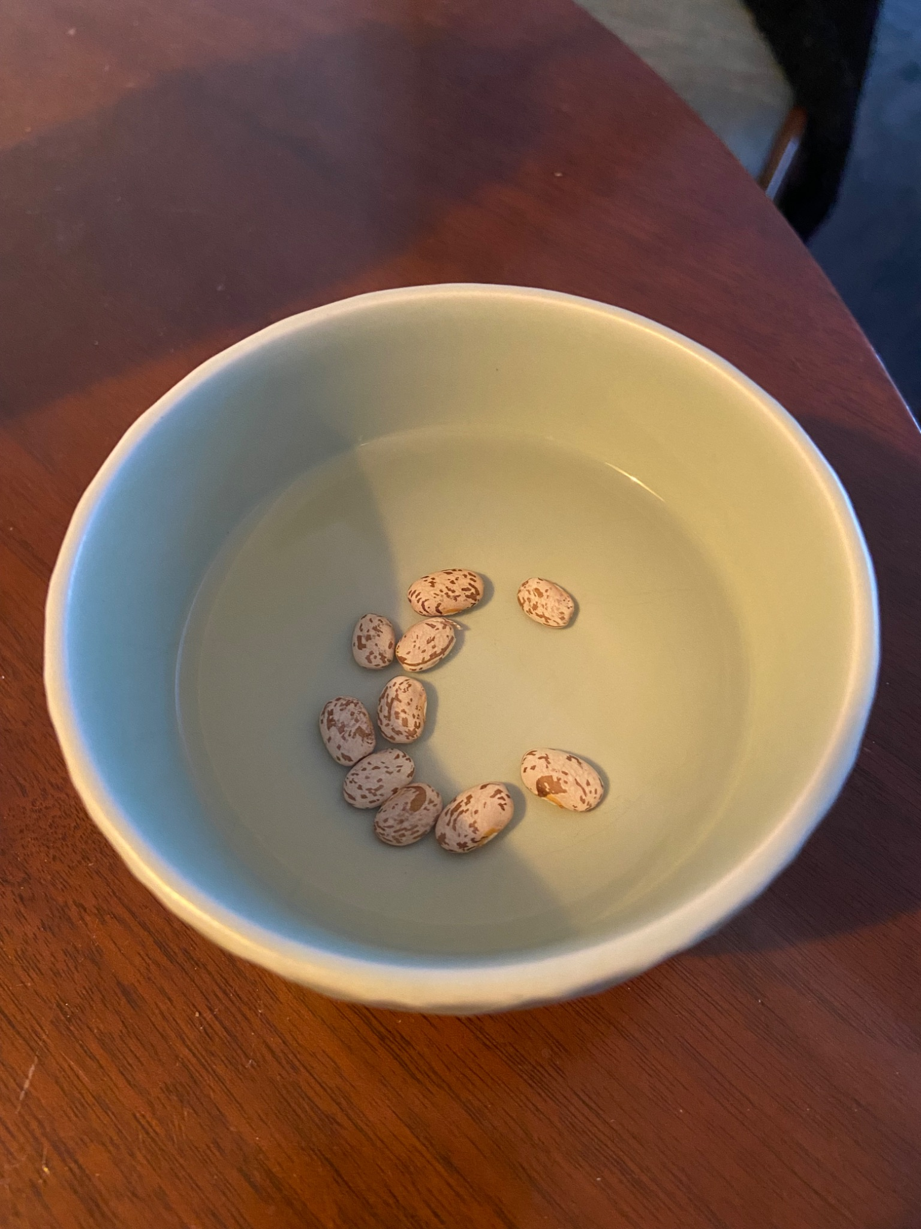

Jan 24, 2026
Germination process. We took the beans out of the water and placed them in a bag between pieces of wet paper towel. We will wait 2-4 days to allow them to germinate.
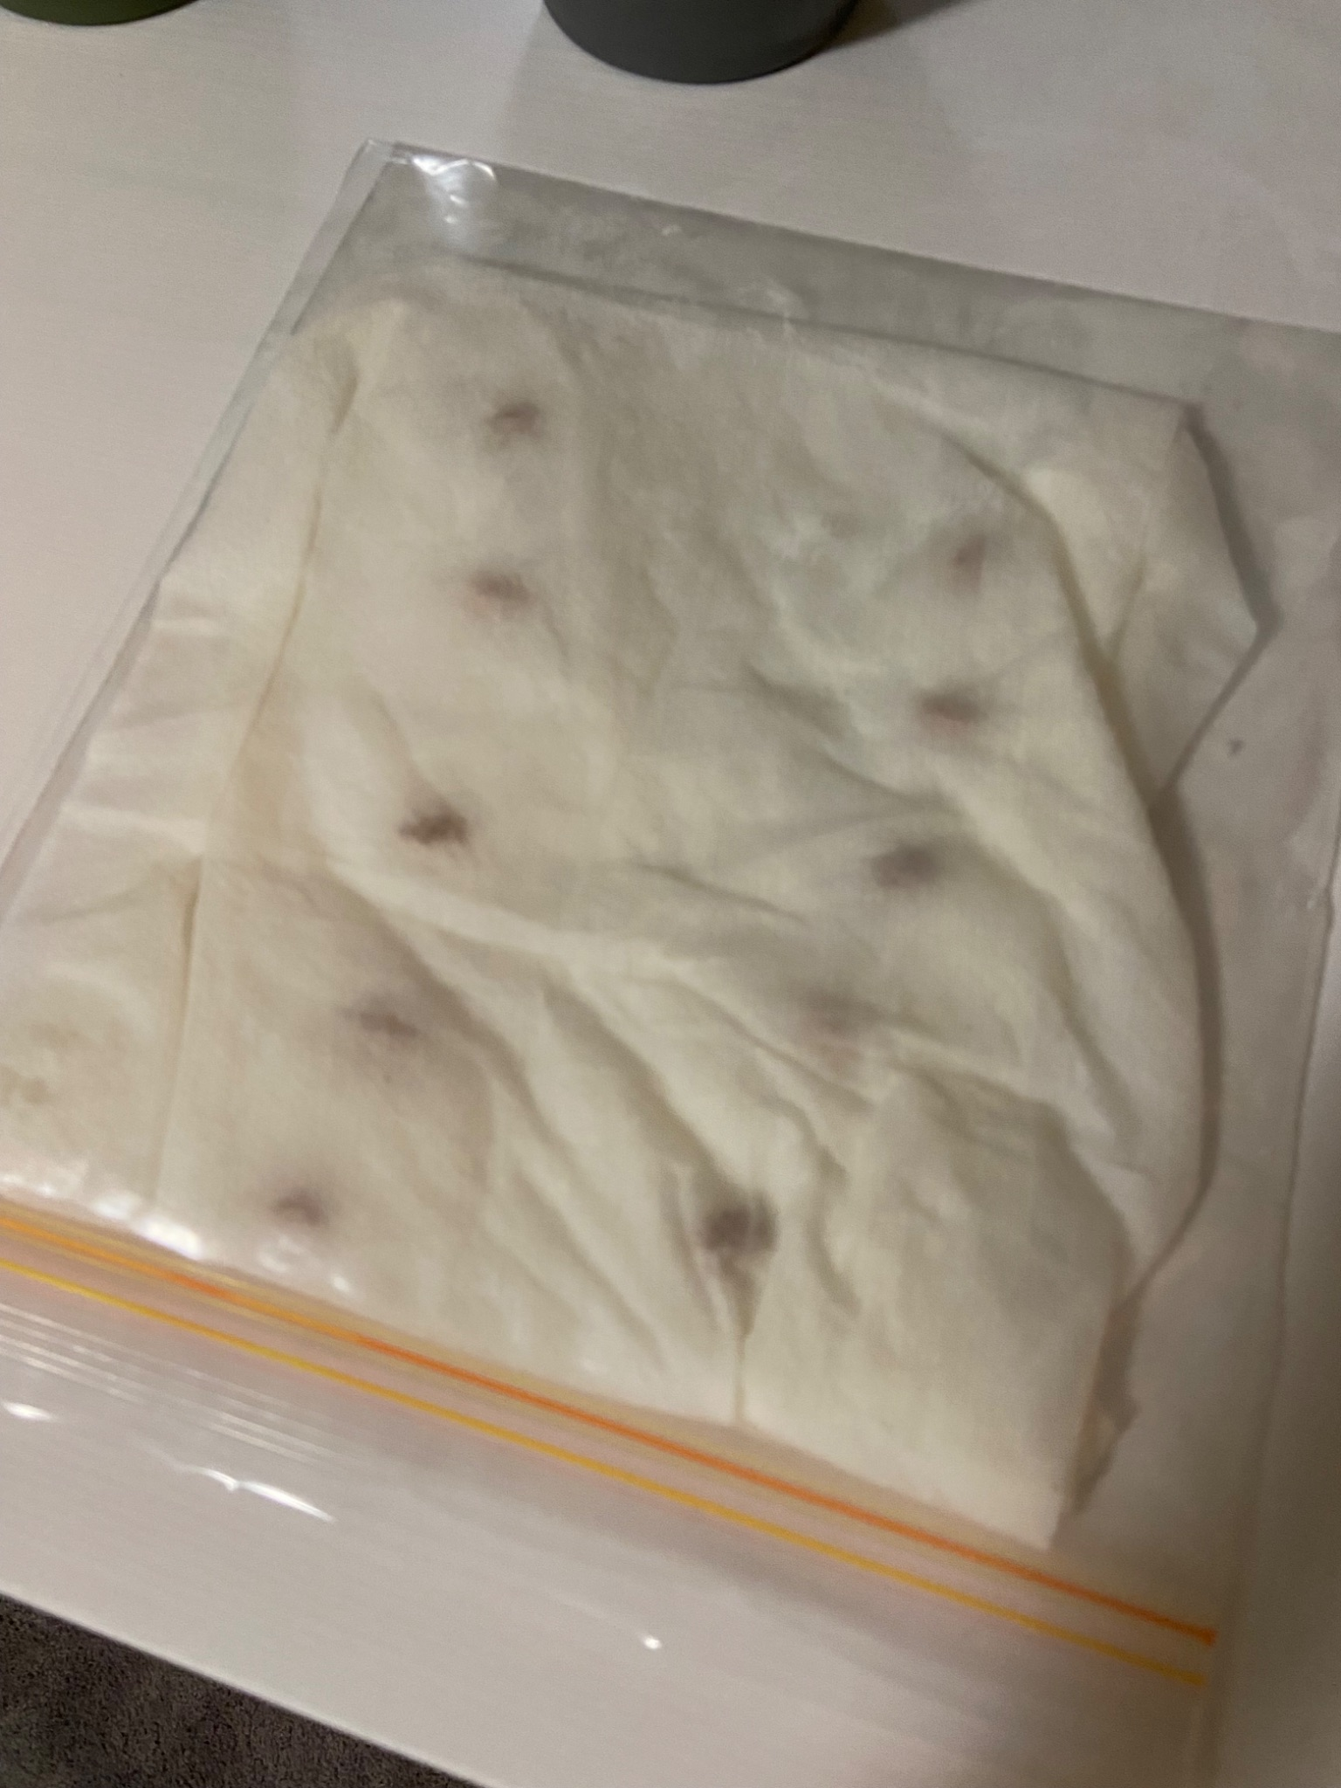

Jan 27, 2026 We took the pinto beans out of the germinating bag and chose the best ones to plant. After we planted them all in the pots we watered them all 3/4s of a cup with a different liquid.

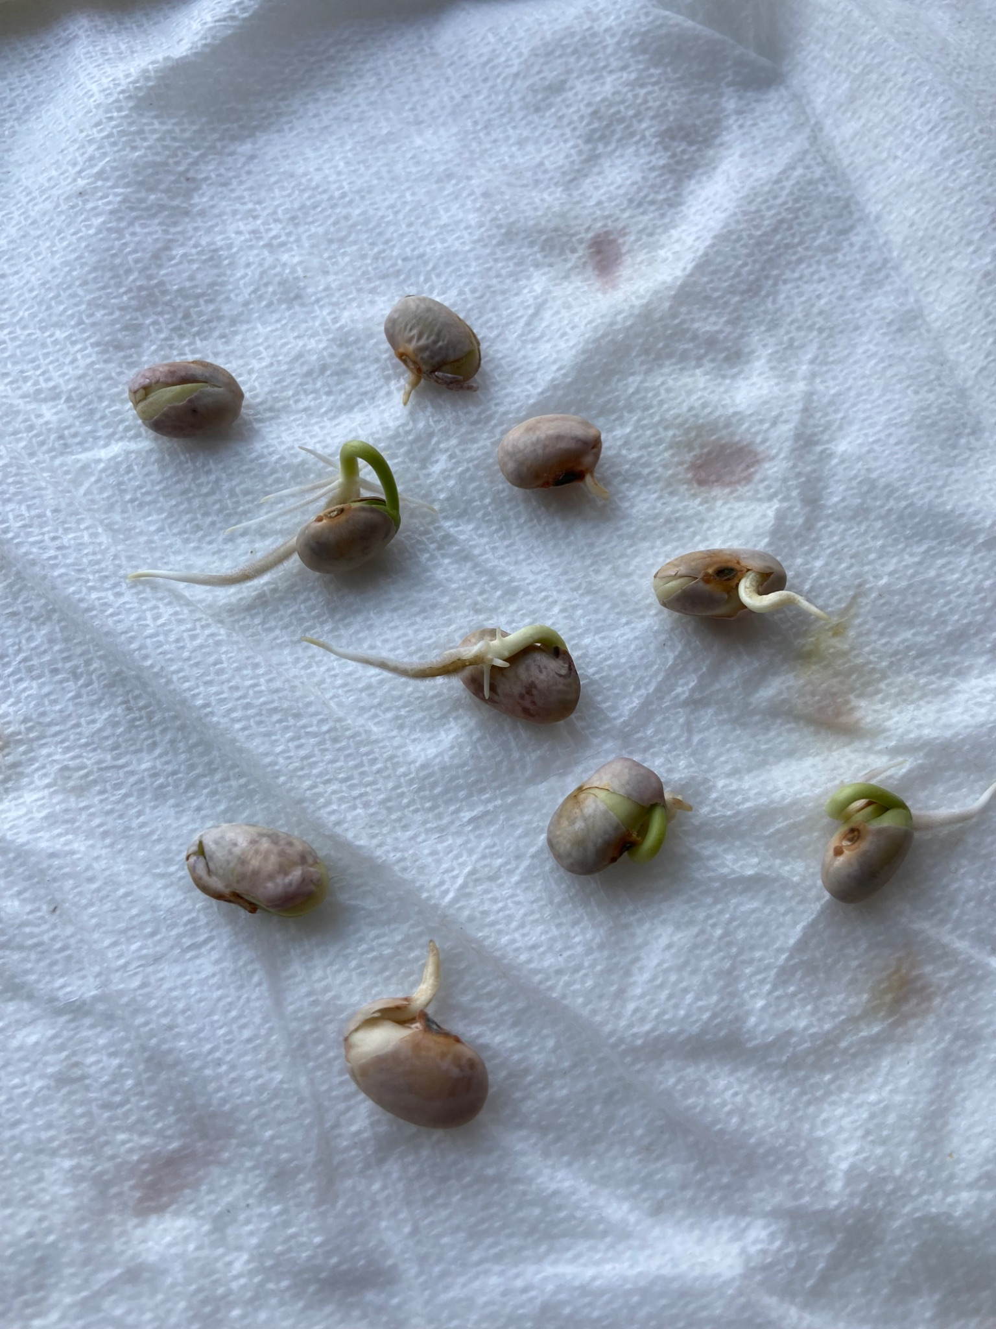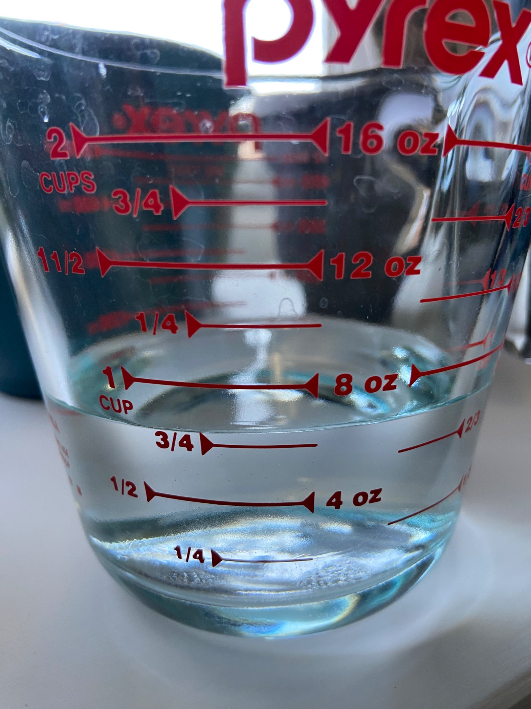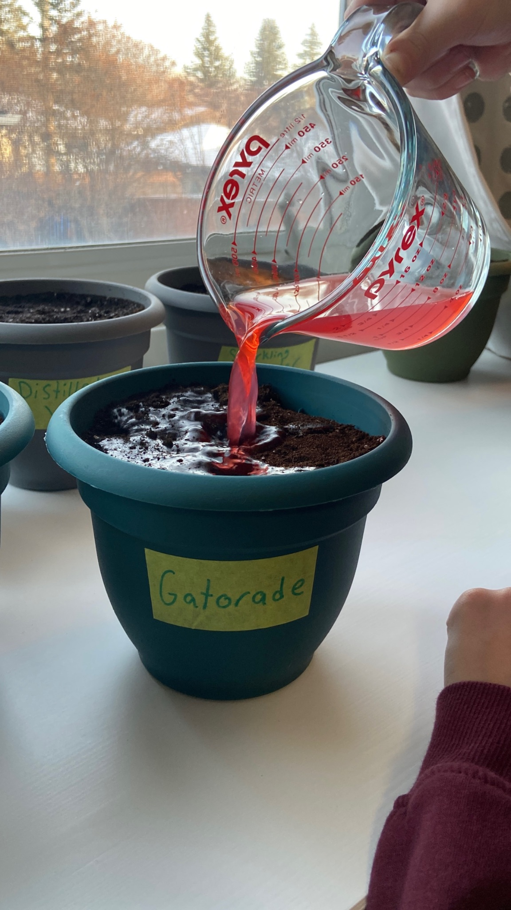

Jan 29, 2026
2 days later we watered the plants again with half a cup of each liquid.

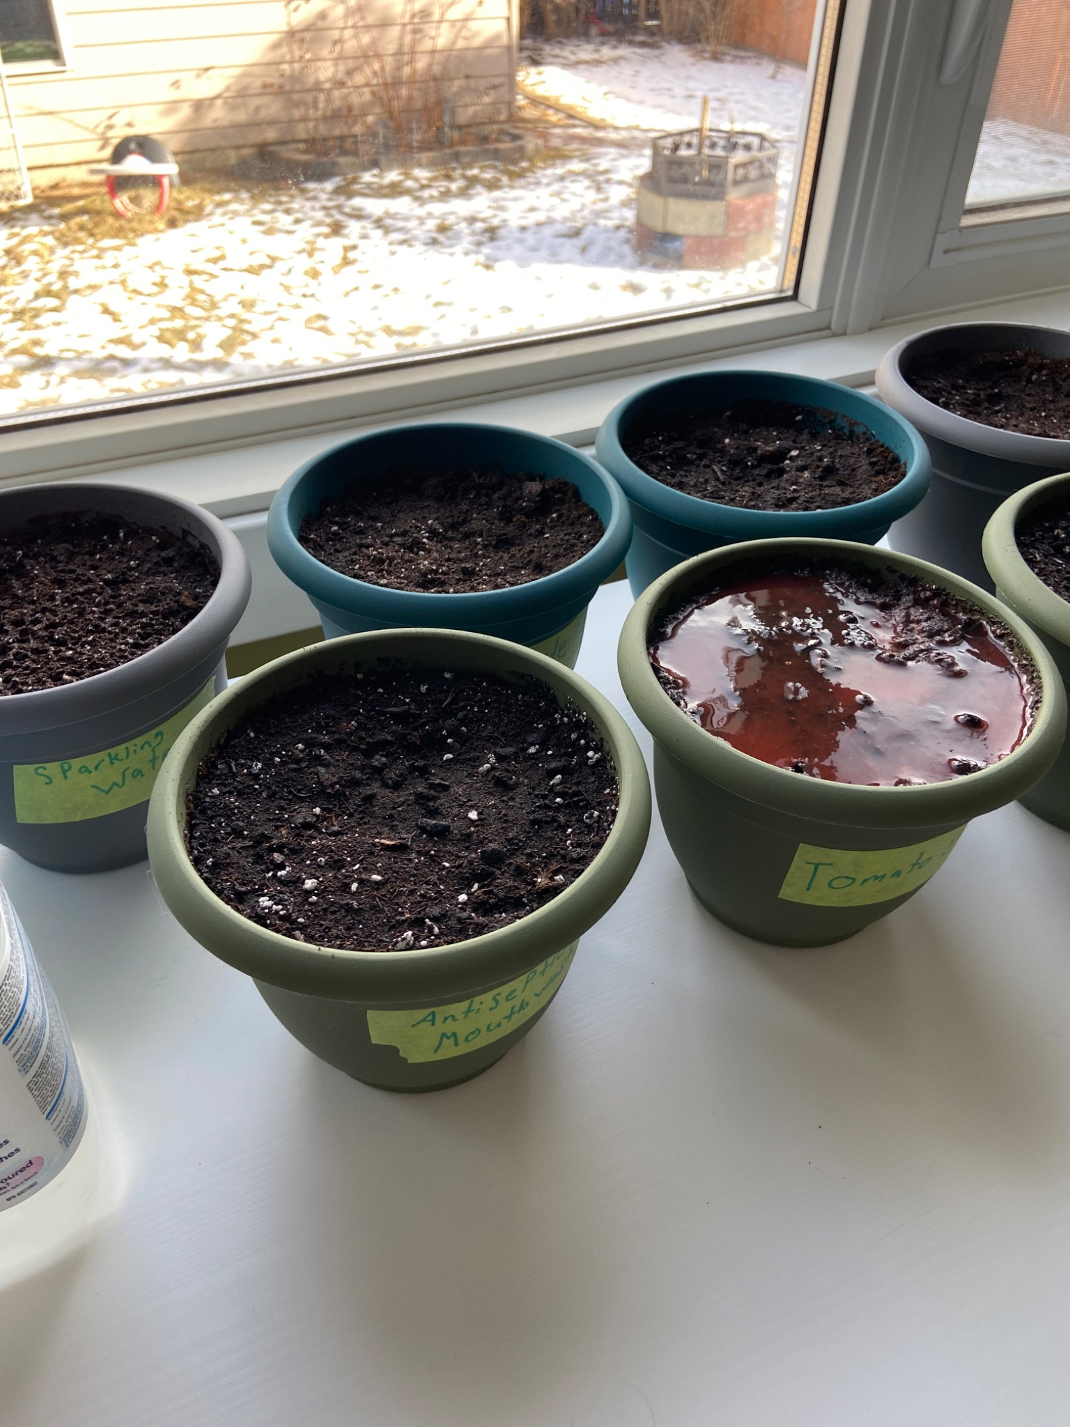

Jan 30, 2026
We noticed the first sprouts, from tap water and distilled water, and measured their length.

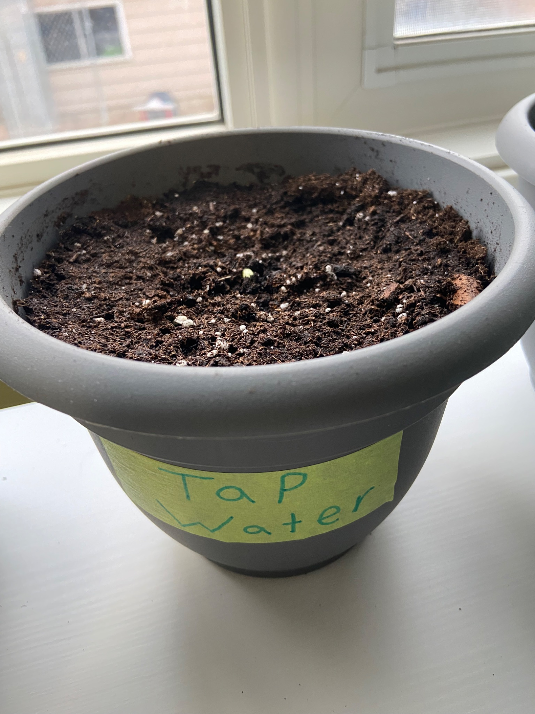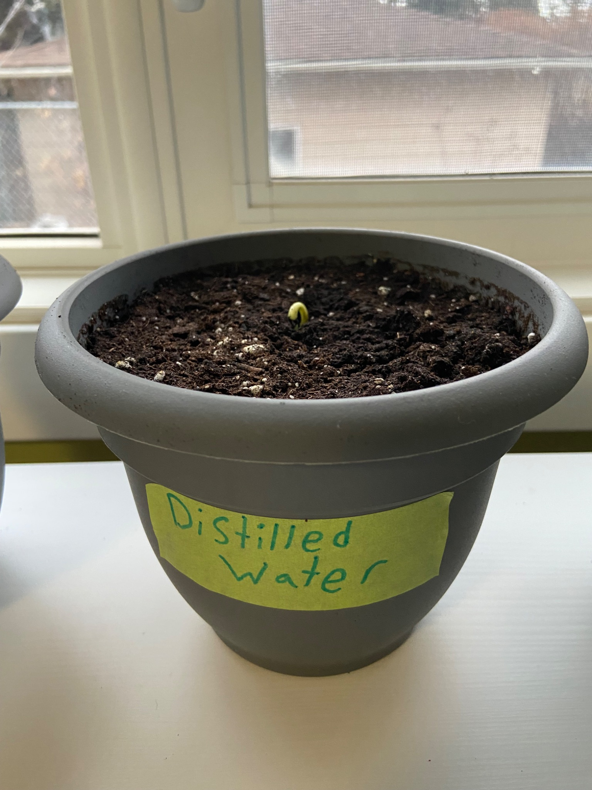

By 4:30 in the afternoon tap water had grown about an inch. We will continue to measure every day and record our observations.
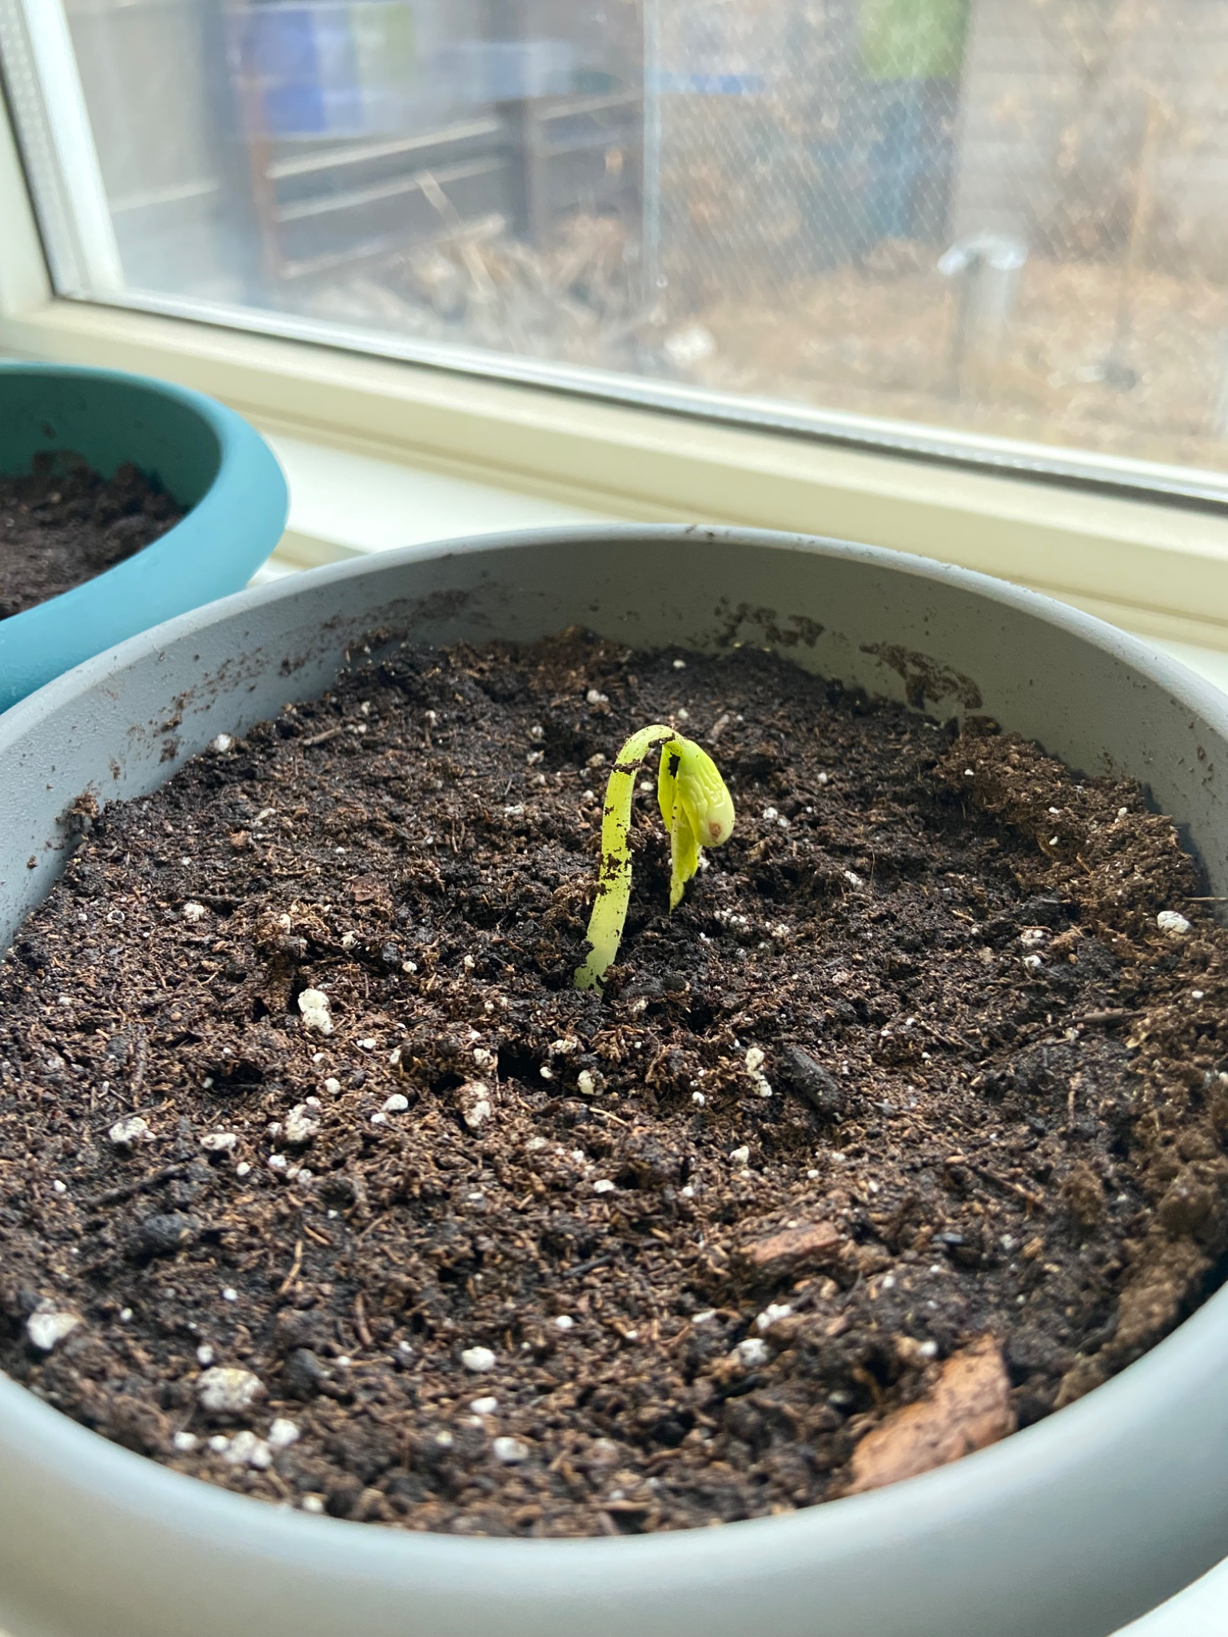

Feb 2, 2026
We watered all the plants again with 1/3 of a cup with their designated liquids. On this day the tomato juice plant sprouted, and tap and distilled water had grown about 5 inches.

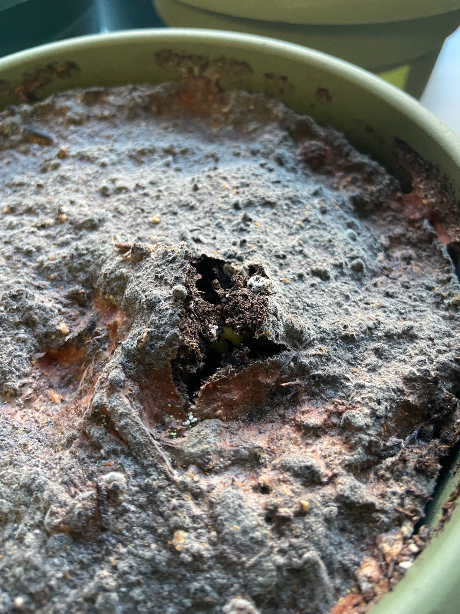

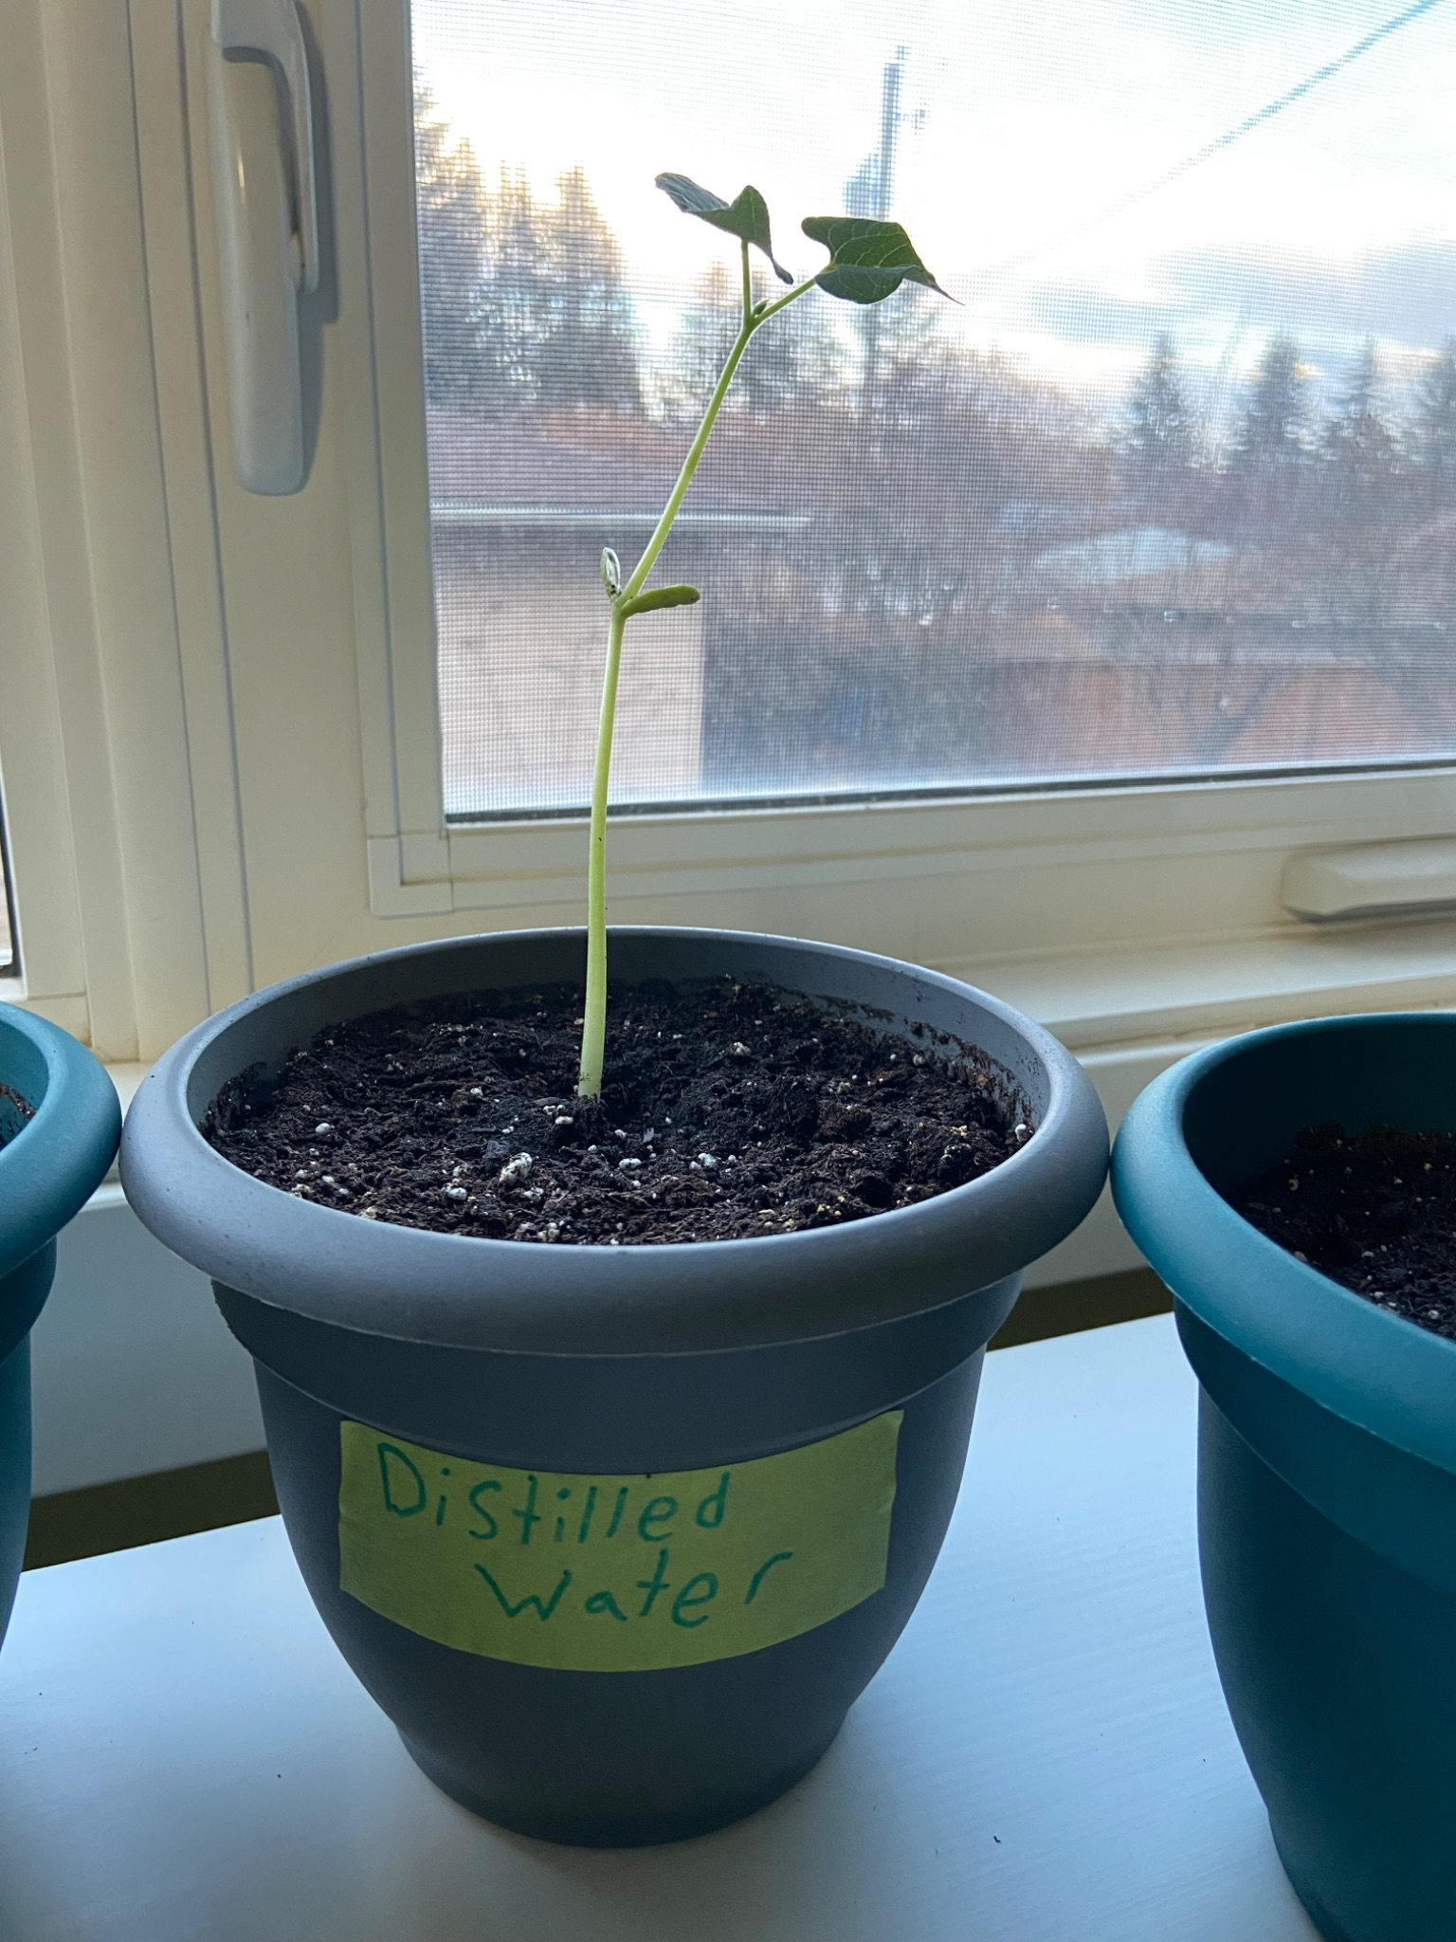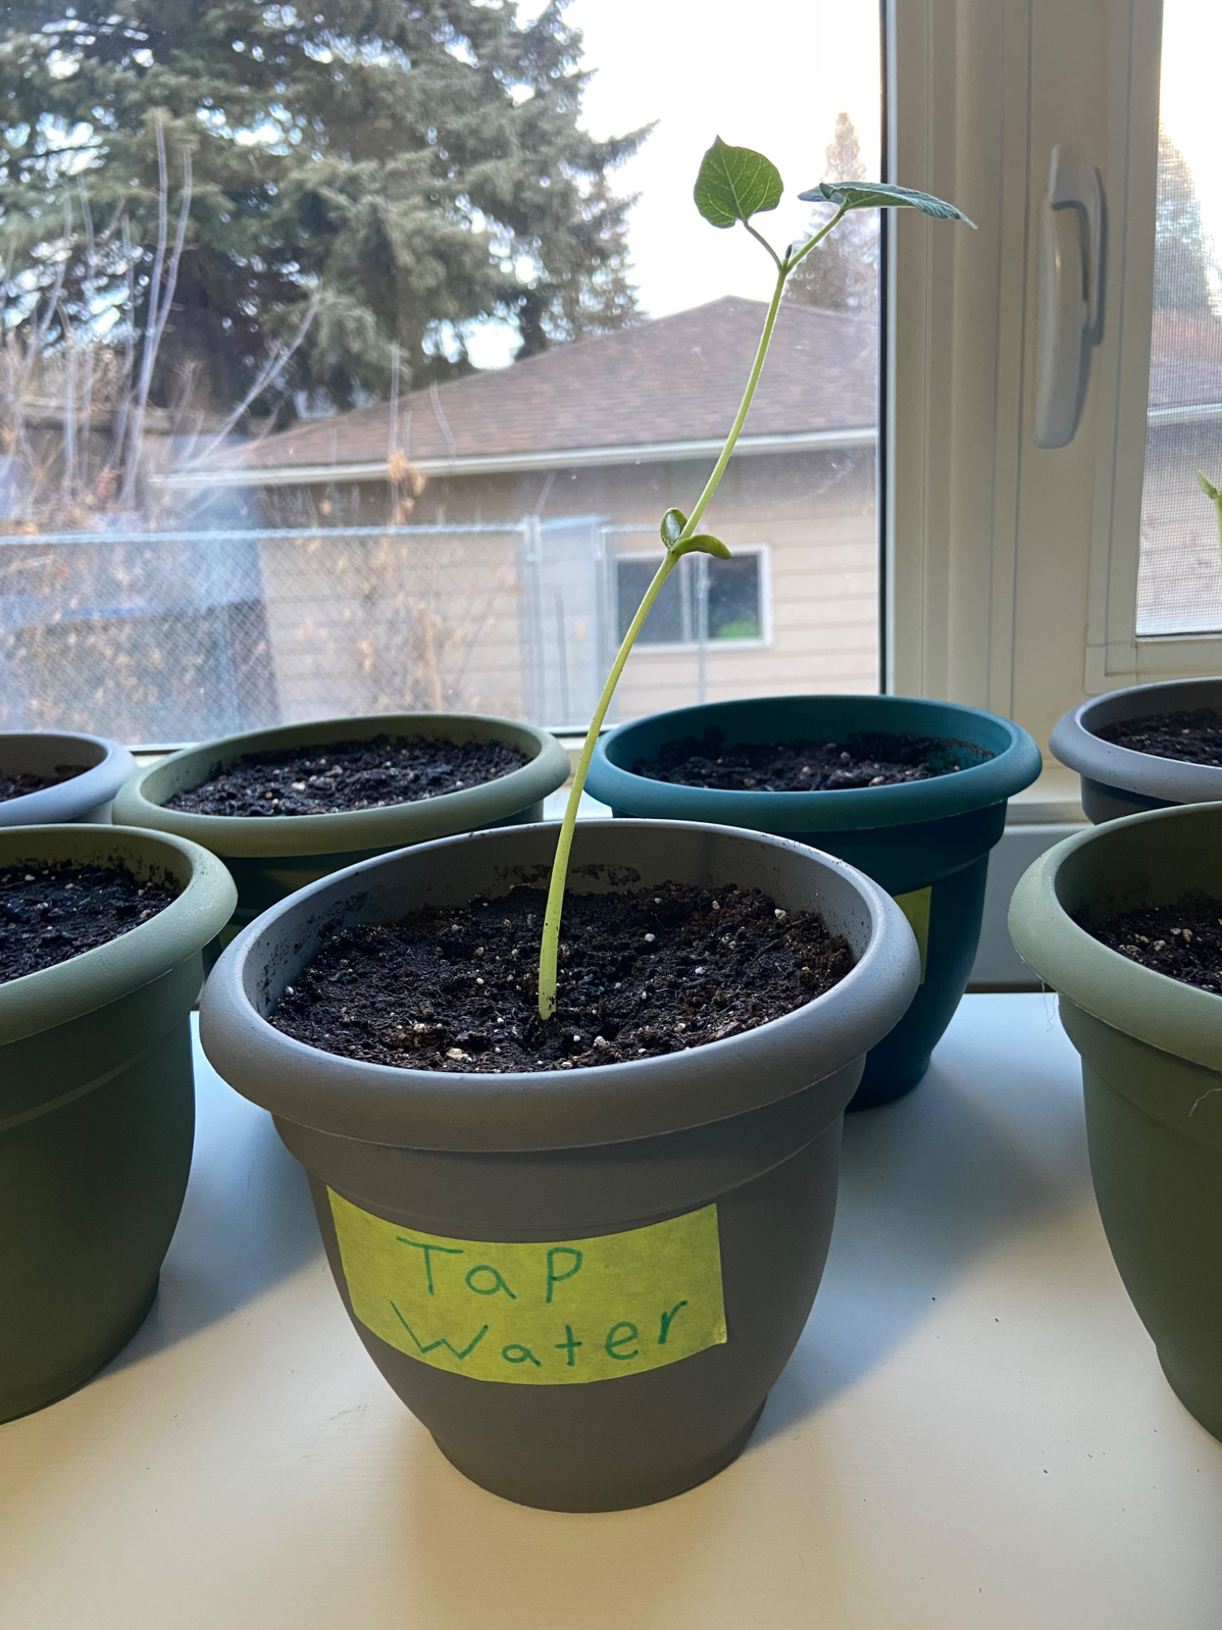

Feb 3, 2026
The Orange pop plant sprouted and by the next day, tomato juice and orange pop grew about an inch. 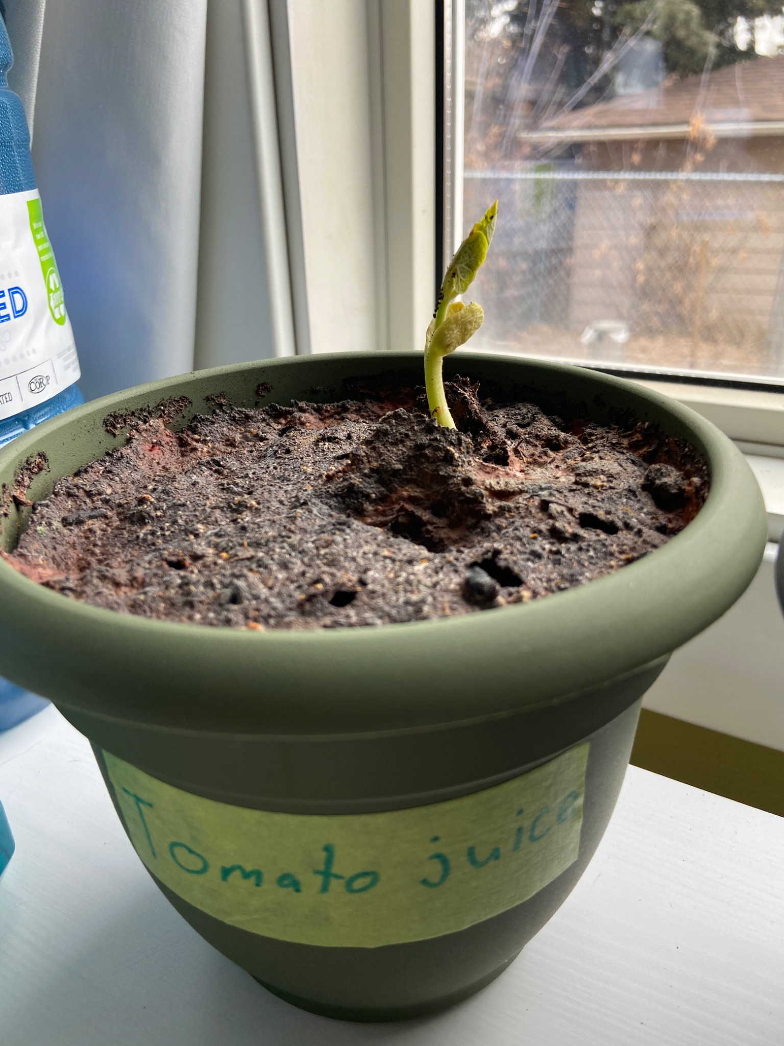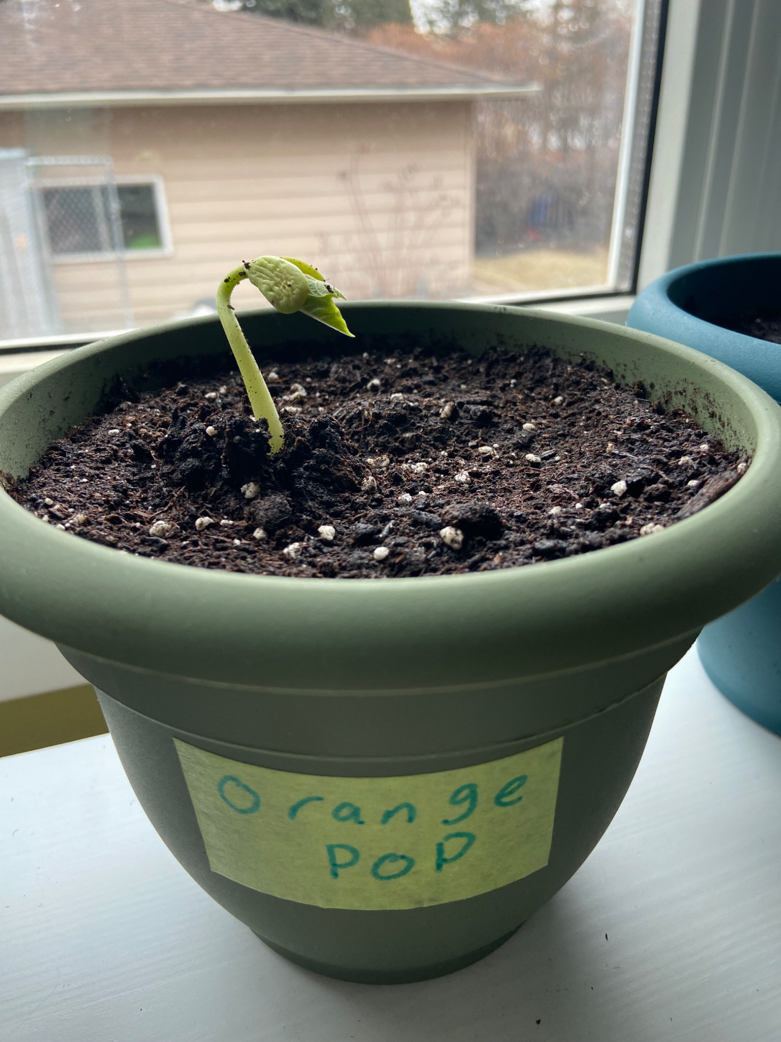

Feb 6, 2026
This evening we started part 2 of the experiment where we soaked new pinto beans in their designated liquid overnight.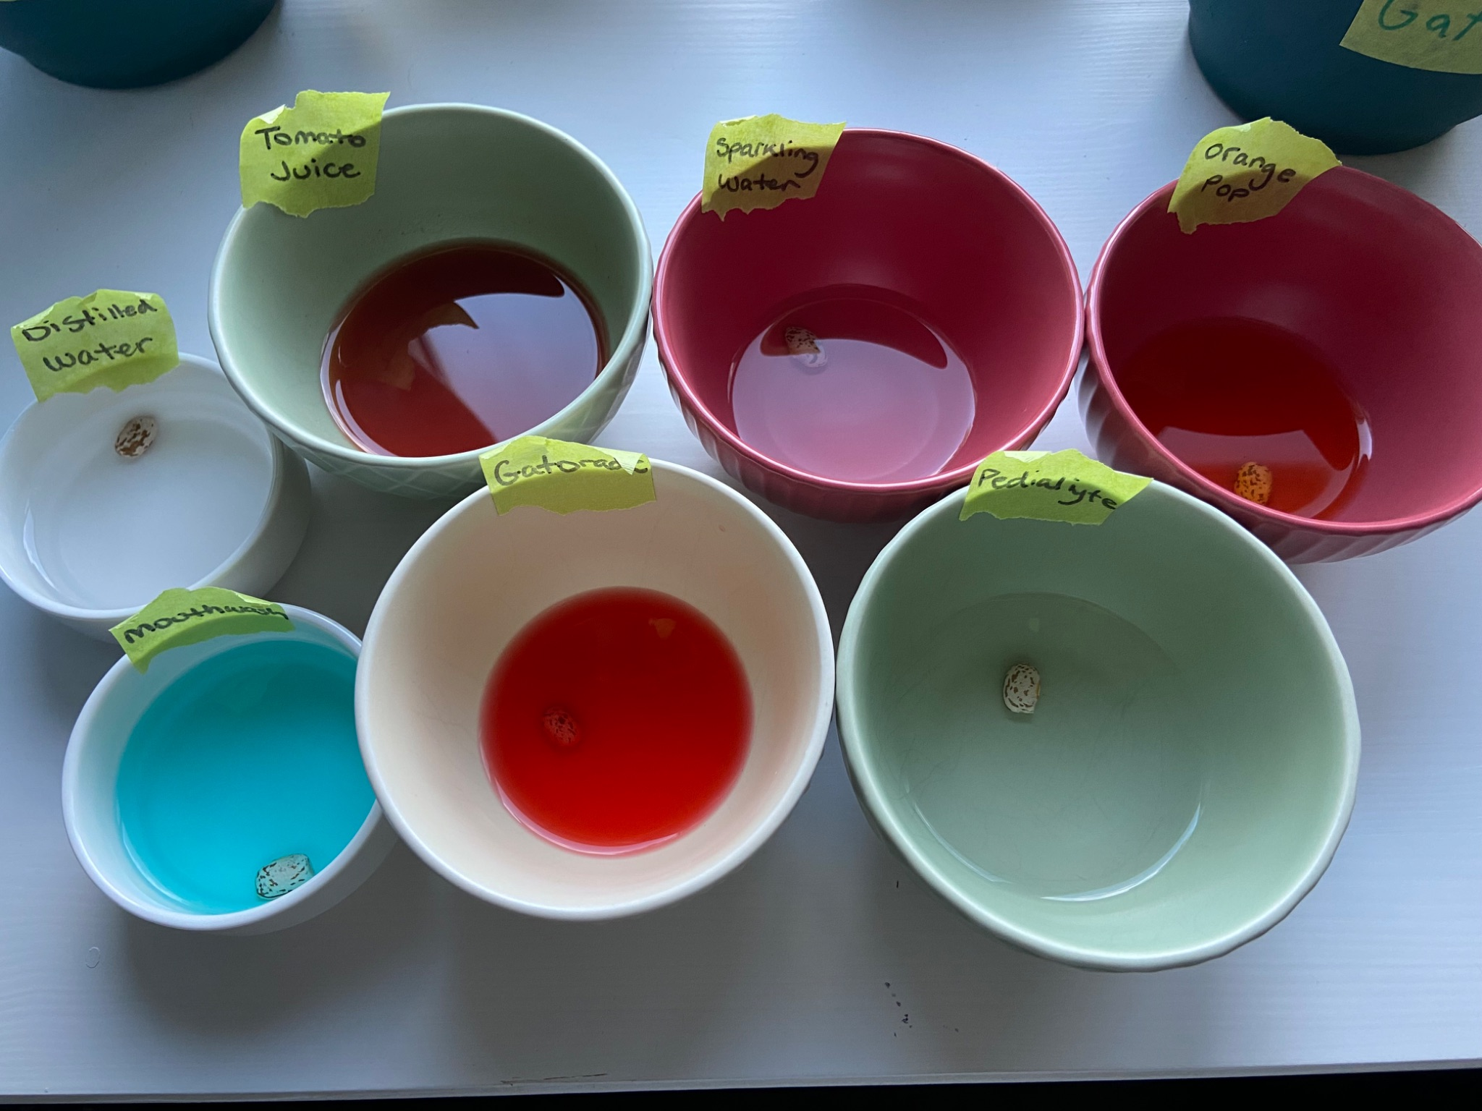

Feb 7, 2026
For part 2 of the experiment, we put the soaked beans into damp paper towels and put them in a freezer bag to germinate.
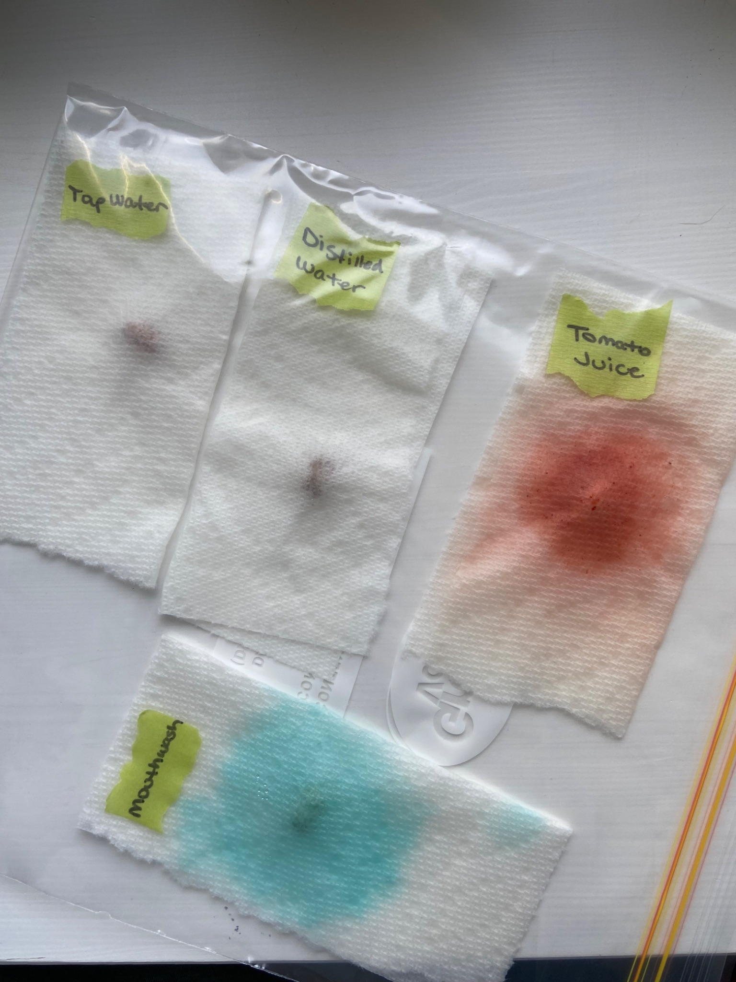

We also watered all part 1 plants again with ½ a cup of their liquids.

Feb 10, 2026
For part 2 of the experiment we noticed that the Tomato juice, Pedialyte, and gatorade grew mold so we changed their paper towels to prevent bacteria growth.

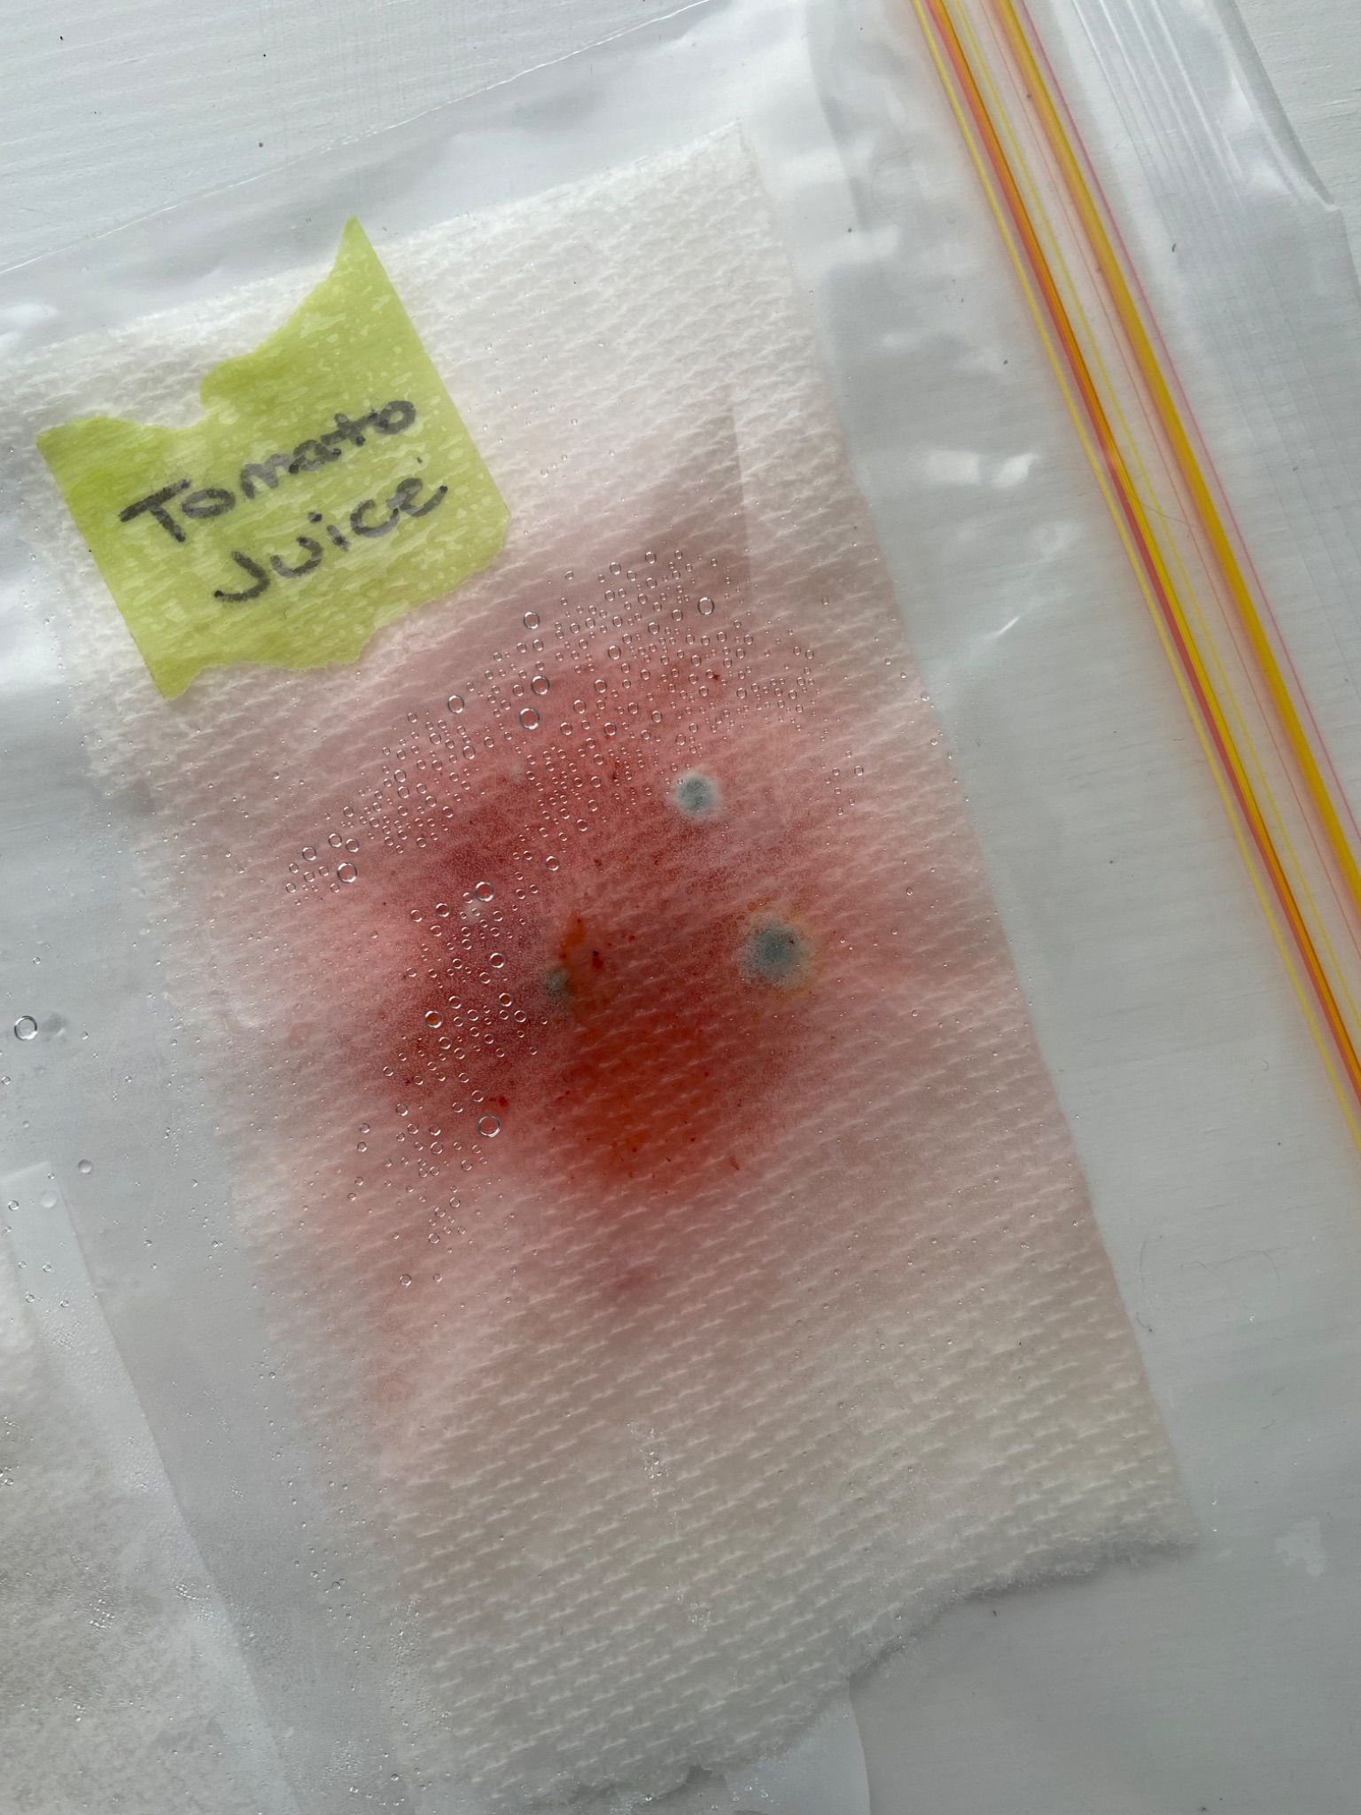

Feb 12, 2026
Watered all part 1 plants with ½ a cup of their liquids.

Feb 13, 2026
For part 2 of the experiment we took each seed out of their paper towel and planted all of the seeds that germinated, Pedialyte, Sparkling water, Distilled water, and tap water, as well as gatorade just to see what would happen. The tomato juice seed was very moldy and started to turn black, the orange pop seed just turned orange and did not sprout, the mouth wash seed turned blue and looked dried out.

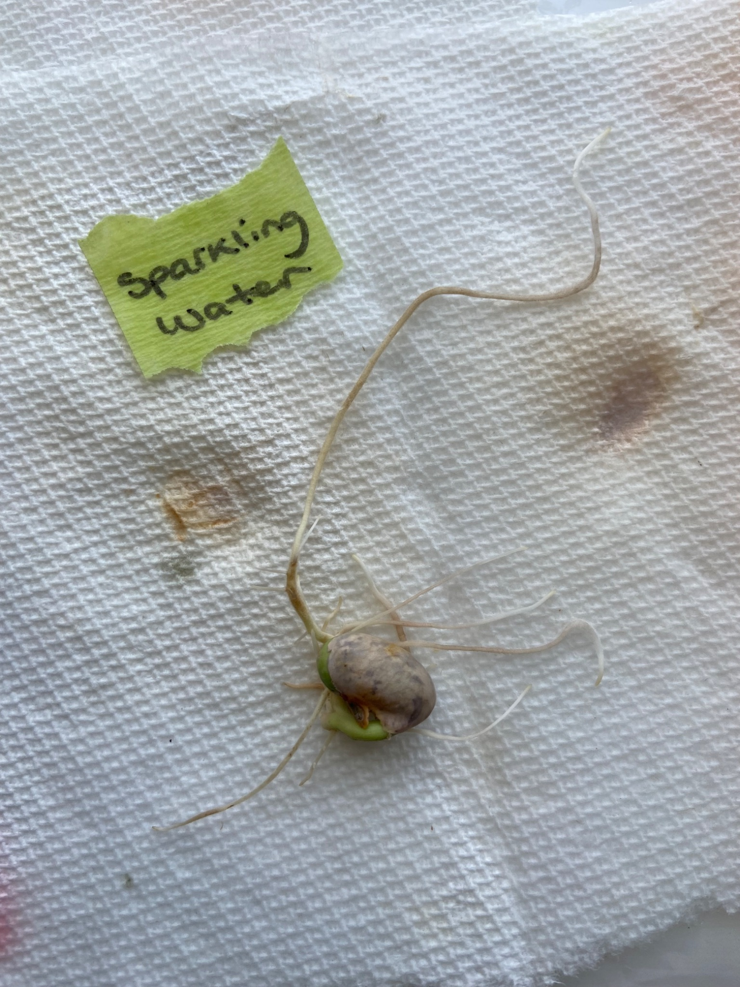

Feb 15, 2026
Watered all the part 2 plants with ½ a cup of their liquids.

Feb 16, 2026
Part 2 tap water plant sprouted.
We watered all part 1 plants with ½ a cup of their liquids.

Feb 17, 2026
Part 2 sparkling water plant sprouted.

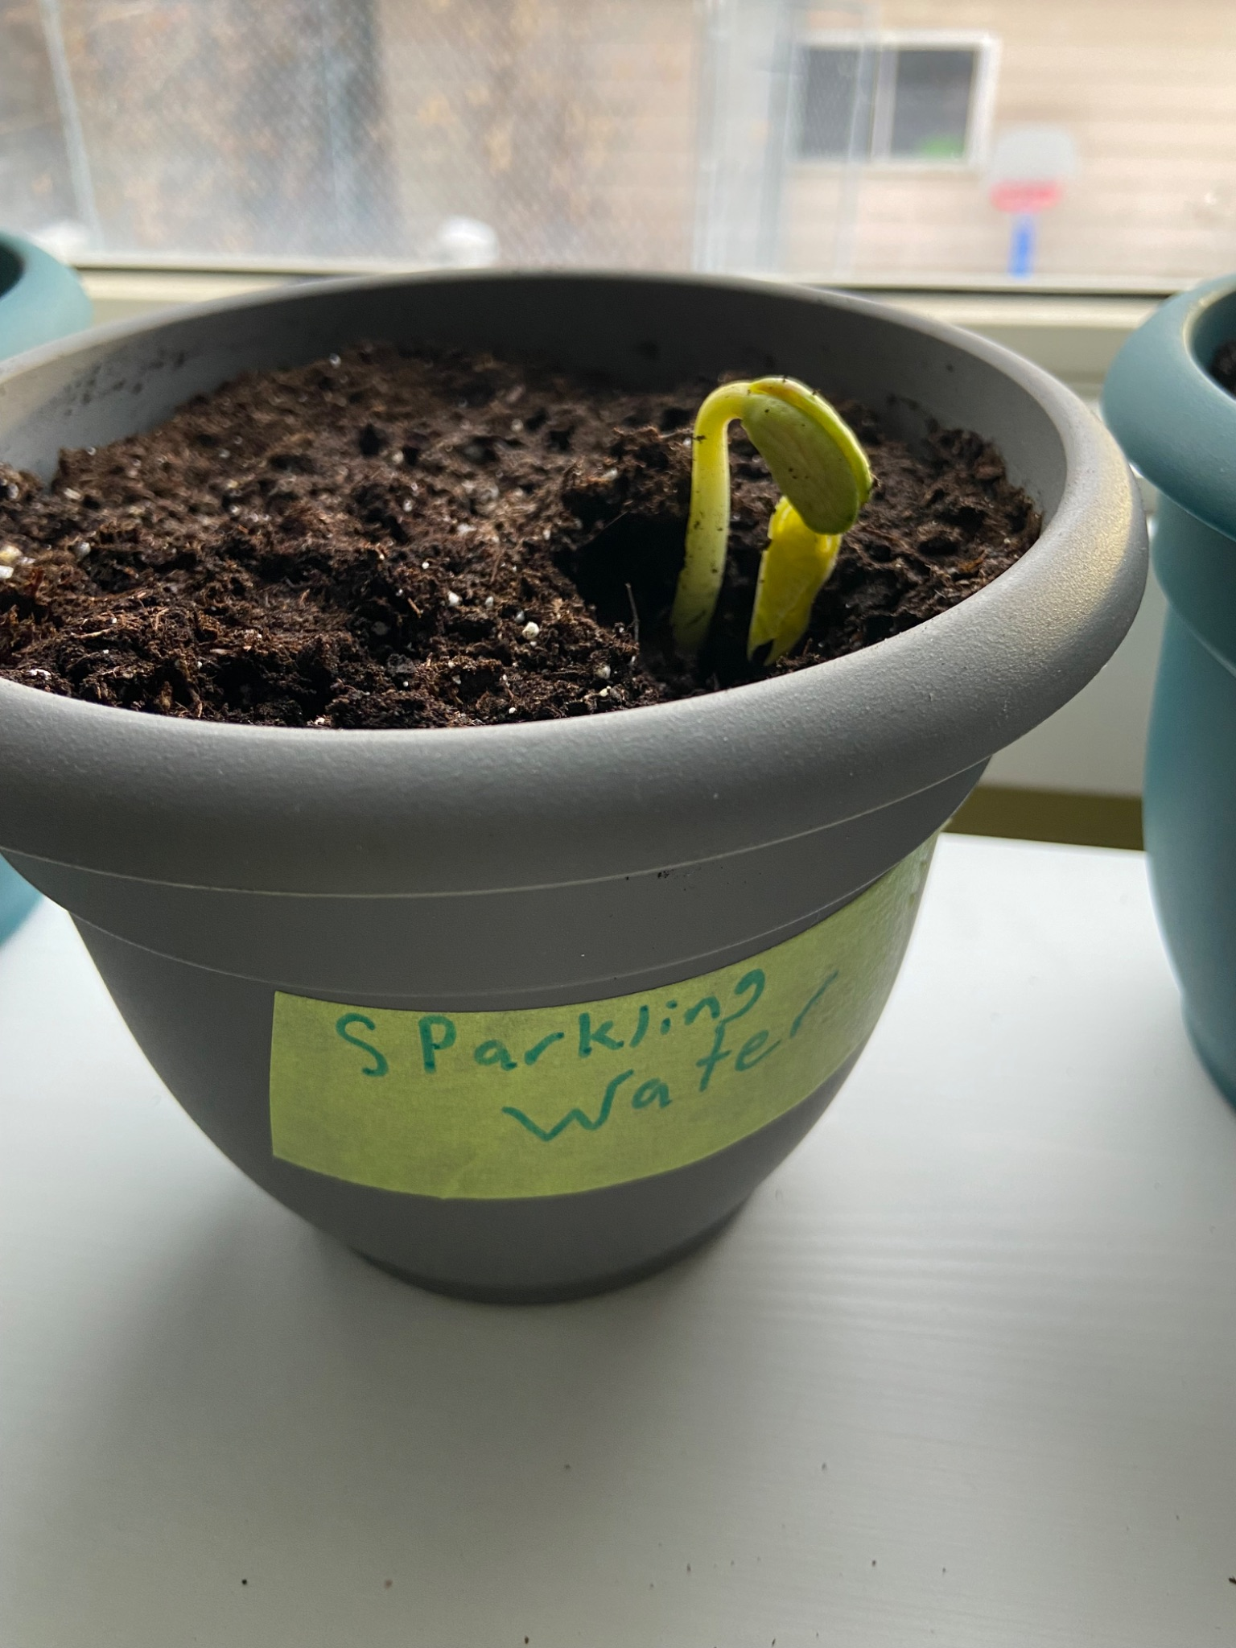

Feb 18, 2026
Watered all part 2 plants with ⅓ a cup of their liquids.

Feb 21, 2026
Today we determined that it was unlikely to see any more of the part 1 plants sprout since they had not grown already, so we dug up the seeds to observe what had happened to them. These seeds were sparkling water, gatorade, mouthwash, and Pedialyte. The only seeds we could find were the gatorade, mouthwash and sparkling water seeds. We determined the others must have decomposed.
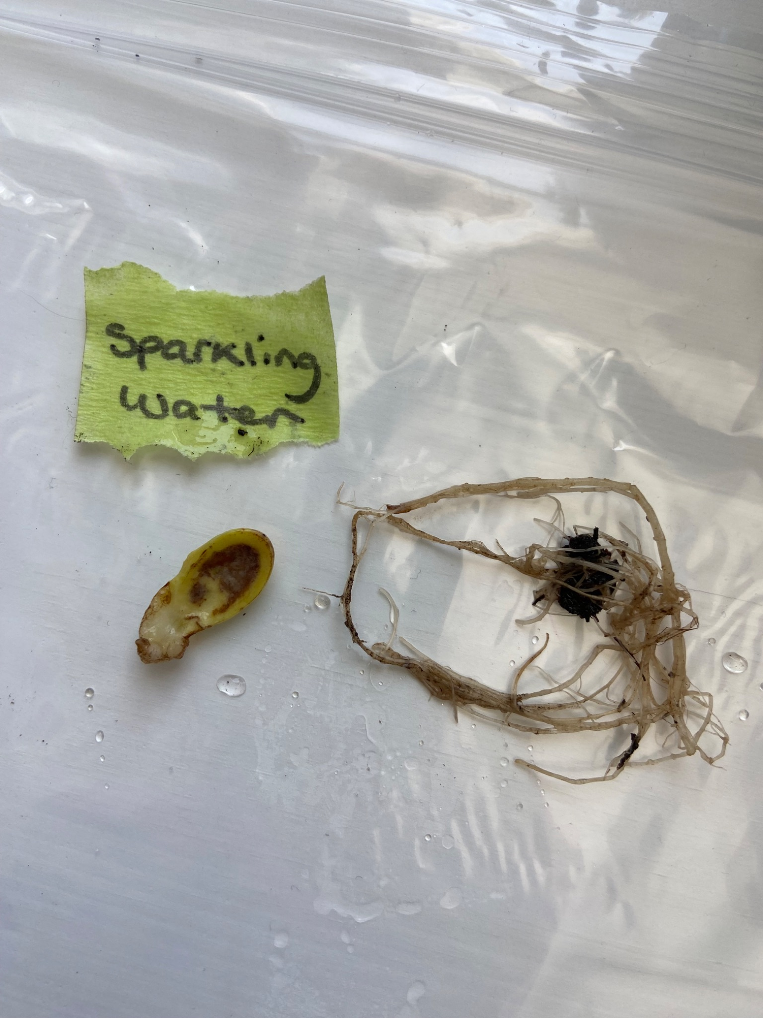
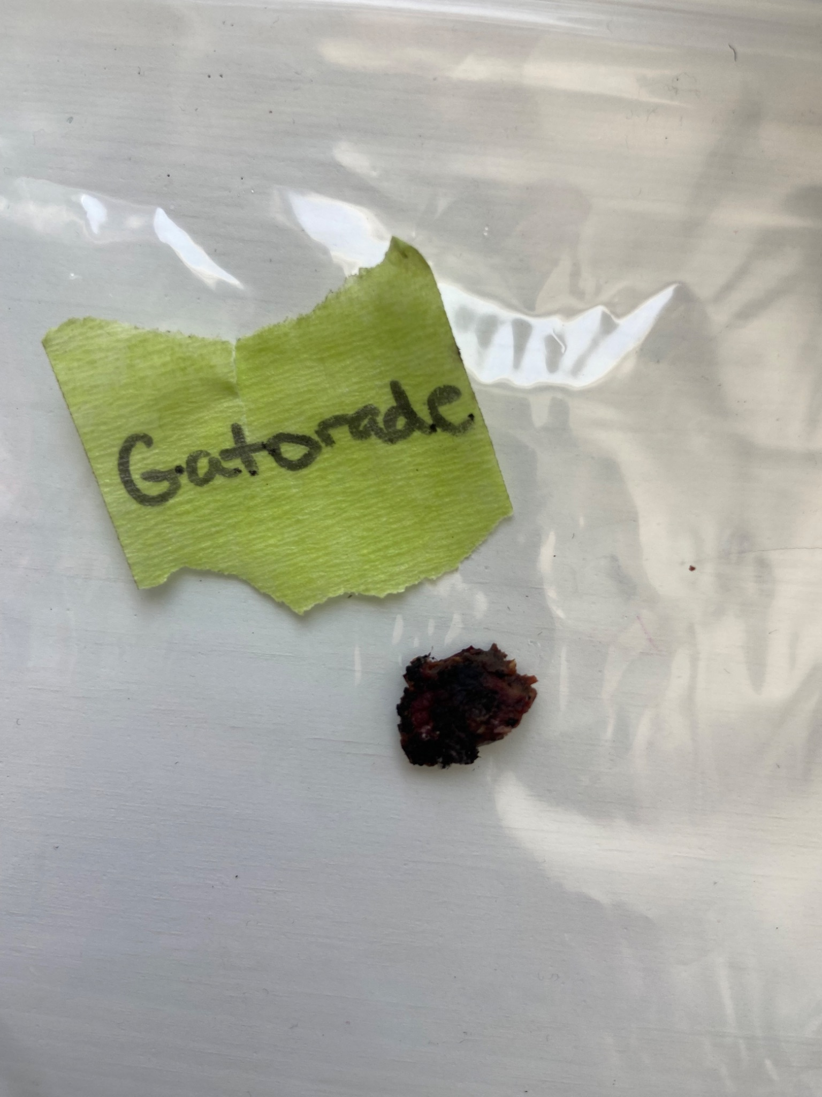

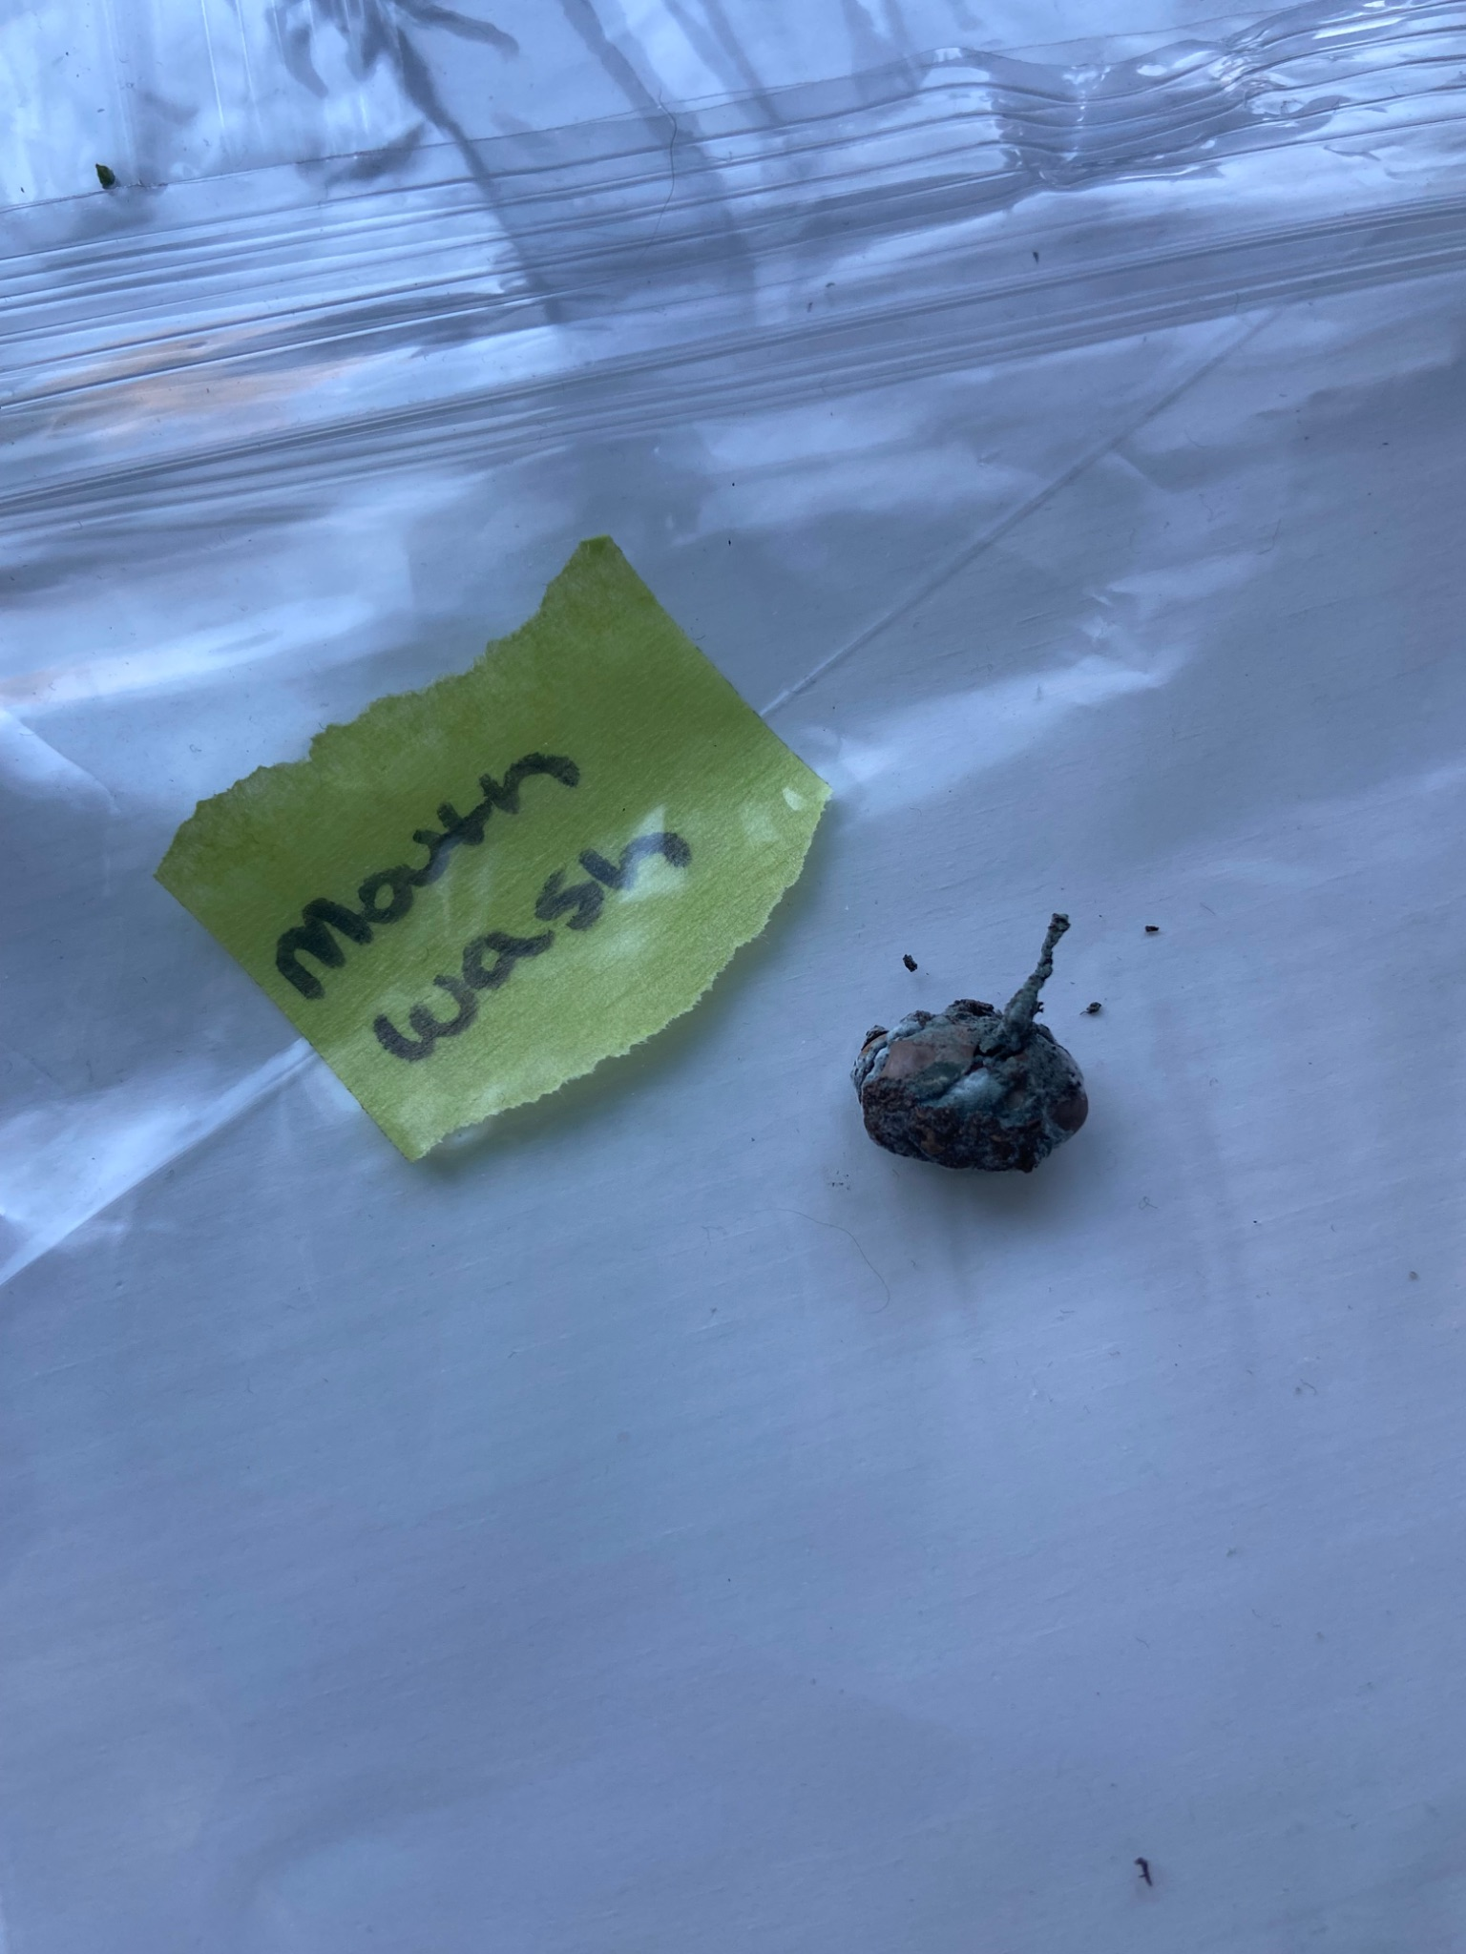
Feb 24, 2026
We measured our part 1 plants one final time and wrapped up our observations.

Feb 26, 2026
We found that despite watering the orange pop plant frequently, it was completely dead.

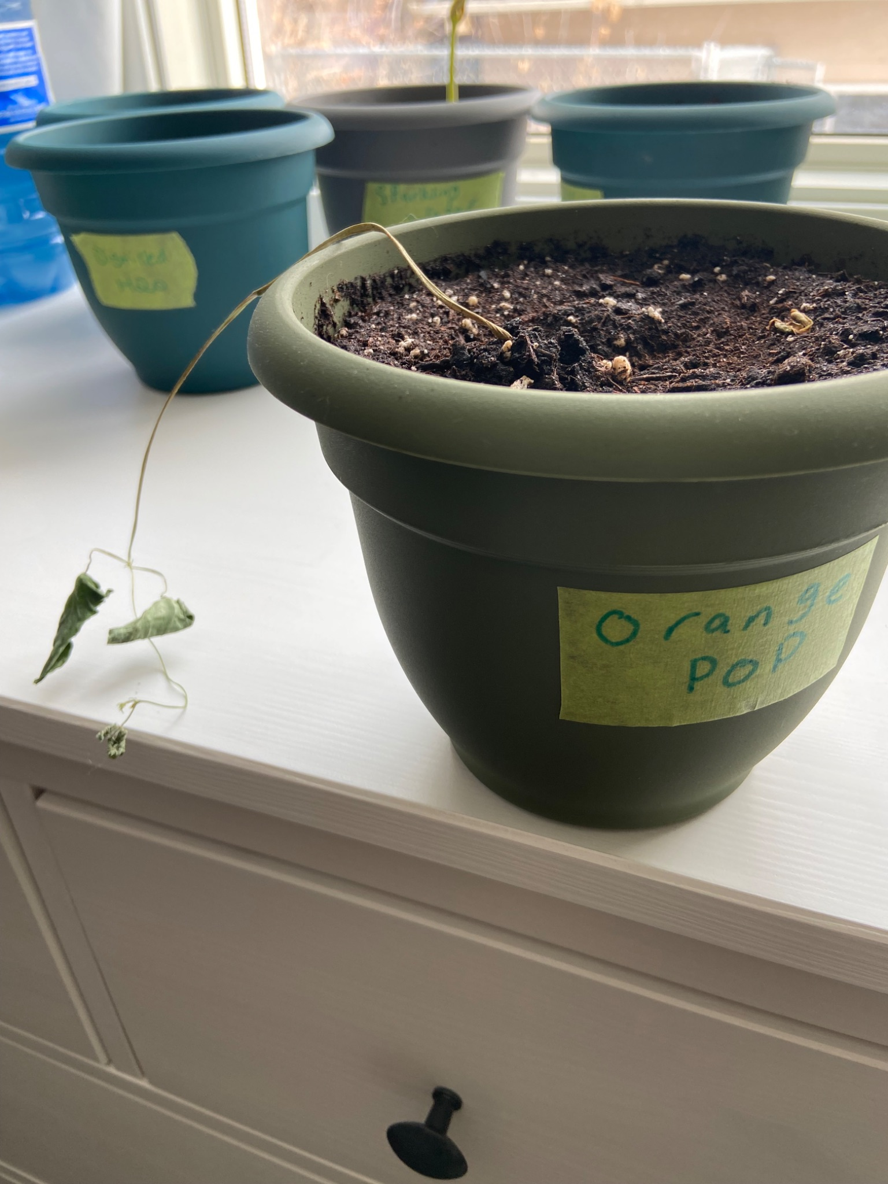

Feb 27, 2026
We measured our part 2 plants for the last time and made our observations. We dug up the remaining seeds that did not sprout after two weeks.
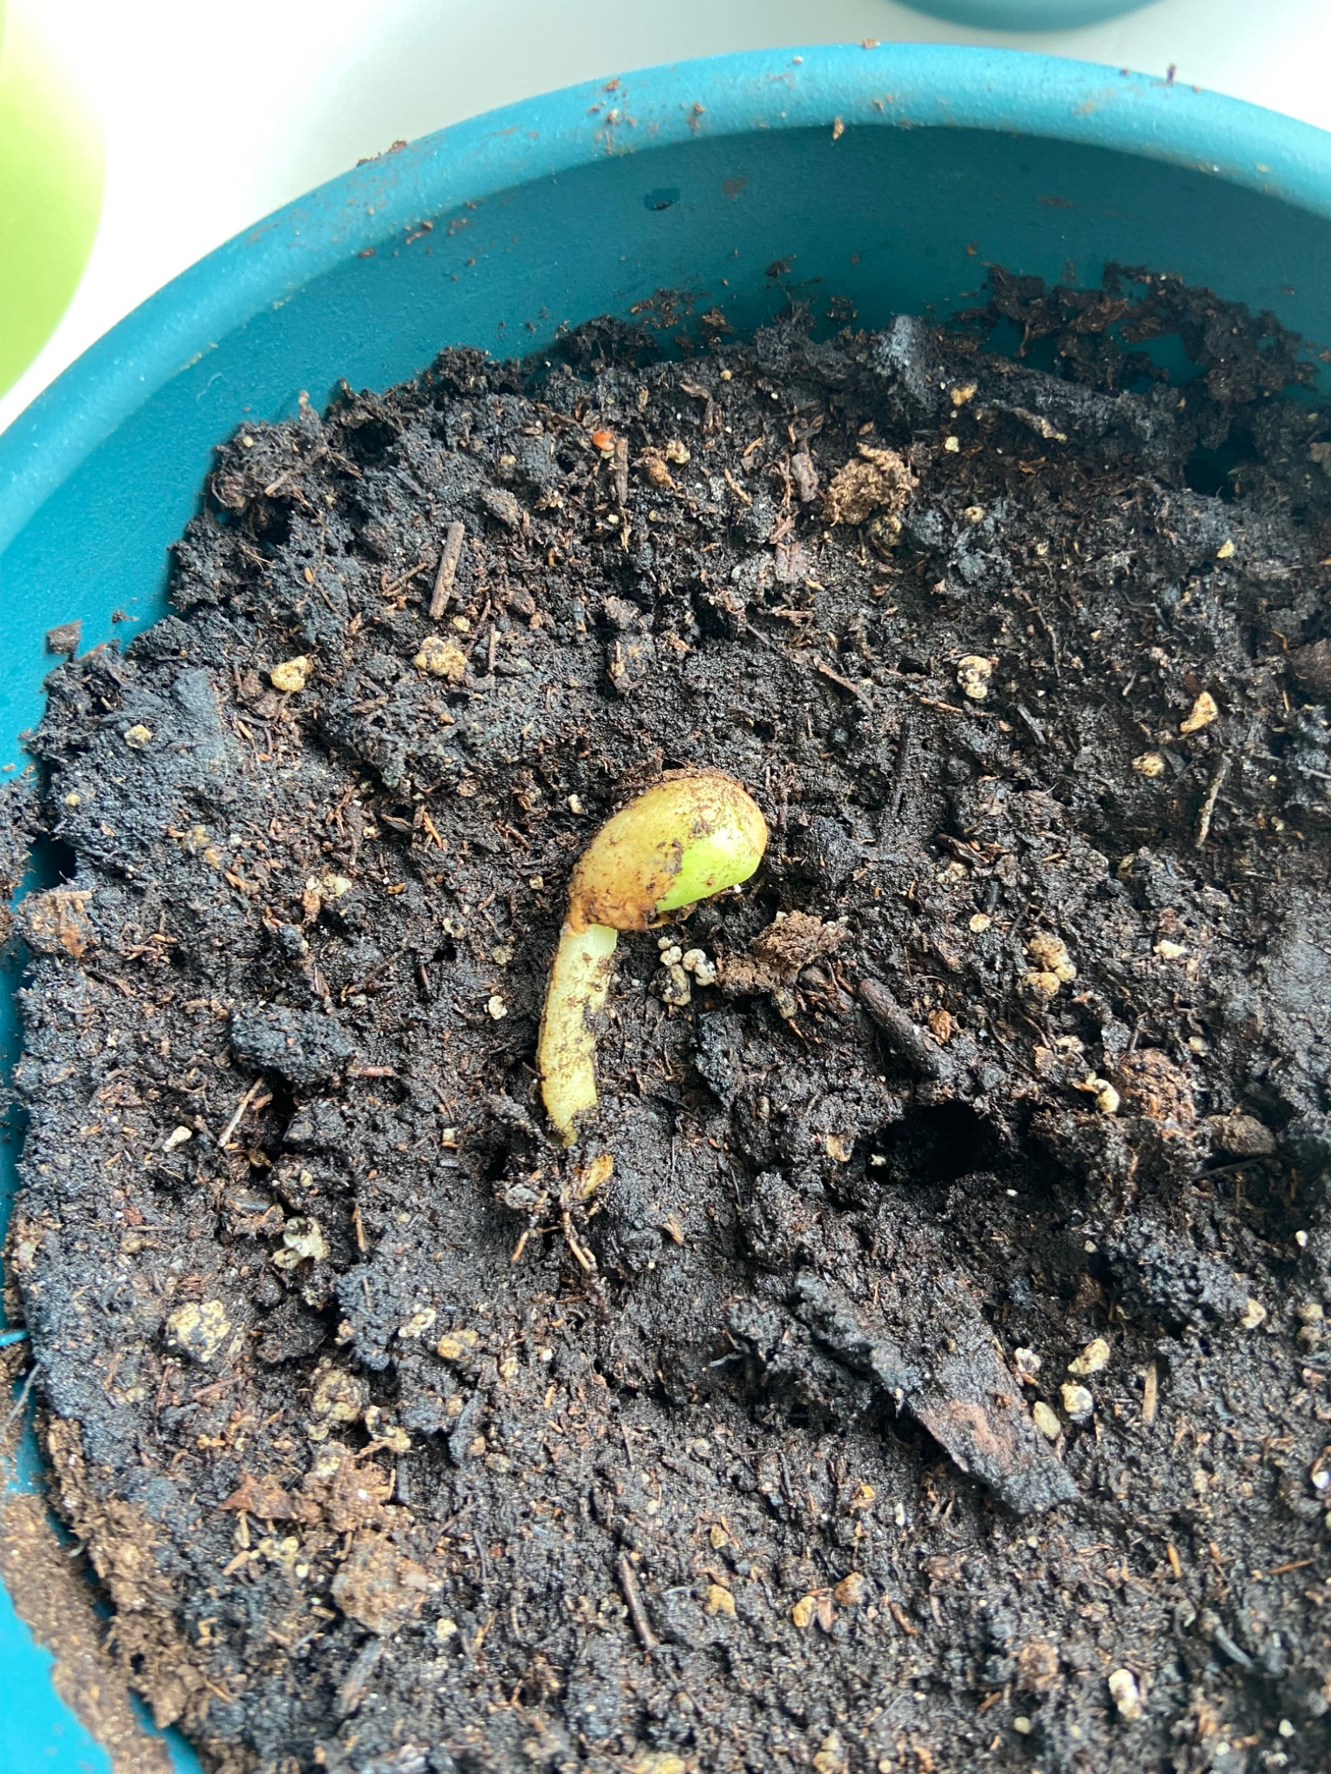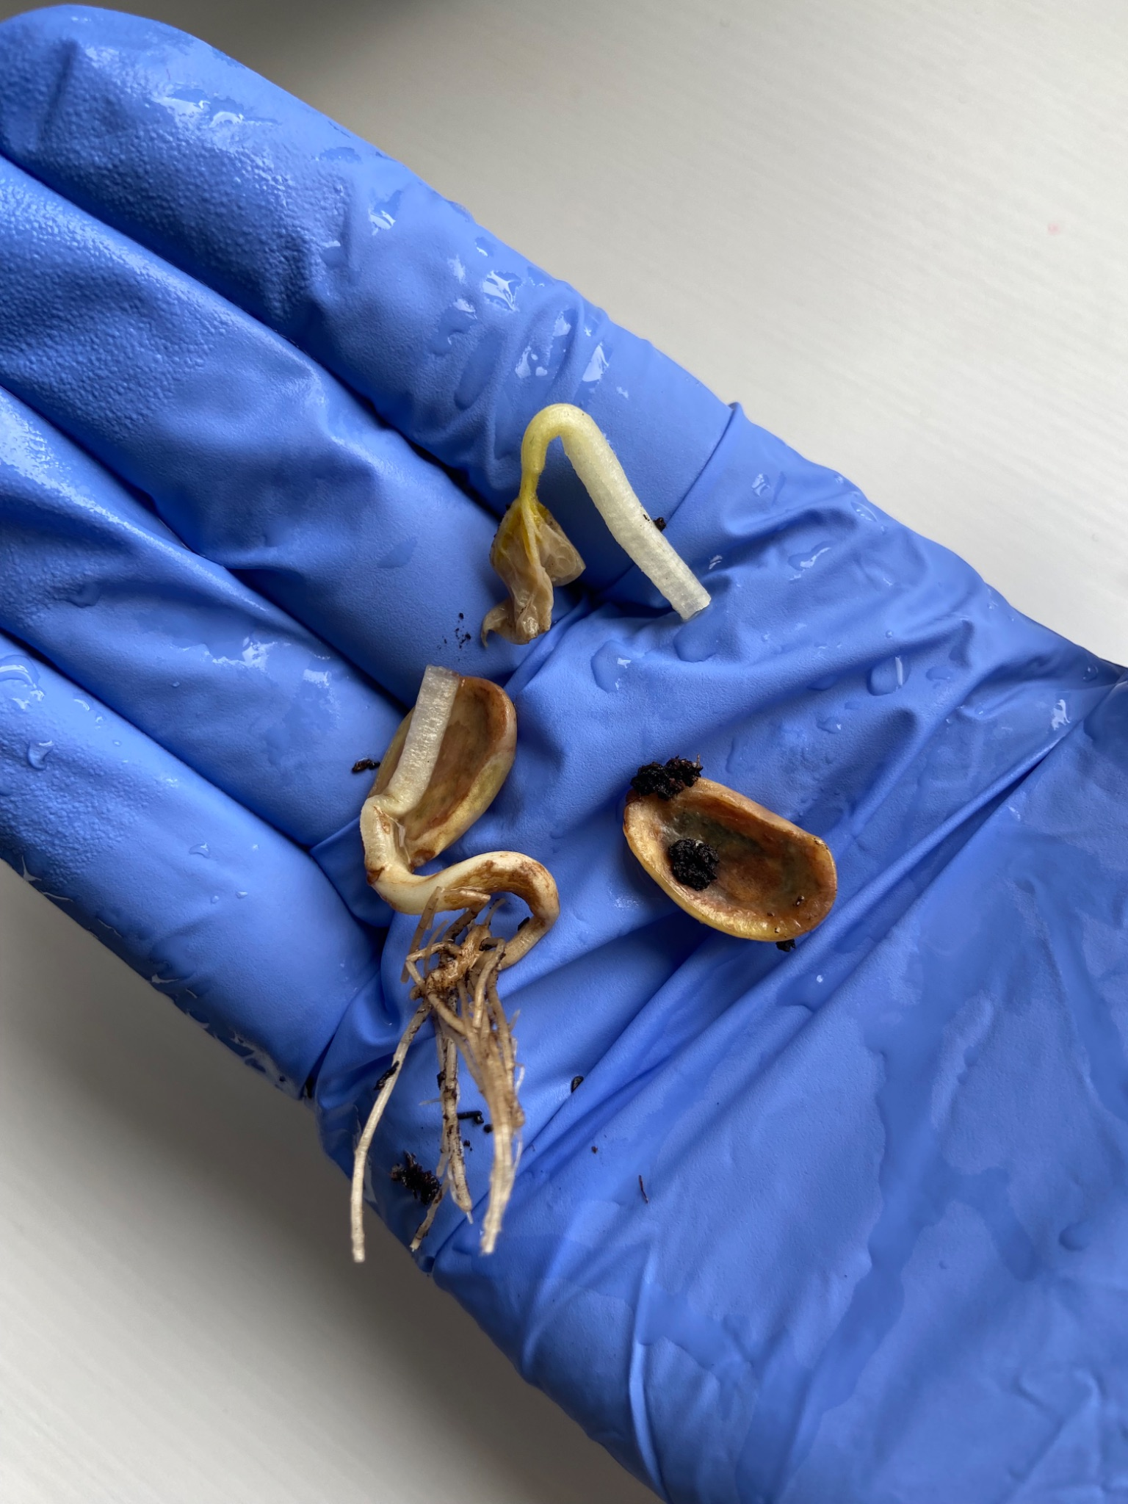

On Mar 1, 2026 we wrapped everything up. With tomato juice still thriving, we decided it is the winning plant for part 1 of the experiment and the sparkling water plant as the winner for part 2. We even discovered the tomato juice plant growing its own bean pod!

