SCIENCE FAIR LOG BOOK:

The Art Of Filtering

~Alkhalil Jadalowen~

Jan 17

Brainstorm Ideas for Science projects
- How to clean water
- Evolution of electronics
- The 5 second rule
- Which water is the cleanest?
- Paper airplanes: Best design
- Rusting nails in metals + Aluminum
- Can light color effect plant growth
- Do plants have feelings
- What distracts people from pain the most
- Dos gender effect reaction time?
- What melts ice the fastest
- Does the shape of an ice cube affect the time of its melting

So many options, but I’m really interested in water. After watching cool videos, I think I’d like to do something that involves water. This limits me to a few options;
- How to clean water
- Which water is the cleanest?
- Do plants have feelings
- What melts ice the fastest
- Does the shape of an ice cube affect the time of its melting?

Jan 22

I’ve decided to go with a project the compares a few elements that I’ve seen videos and diagrams reuse a lot.
- Sand
- Soil
- Carbon
- Activated Carbon
- Different types of sand
- Grass
- Pebbles
- Gravel

The highlighted are my planned independent variables. I’ll probably add pebbles and gravel as a top layer to make the actual elements work better.

Image Inspo

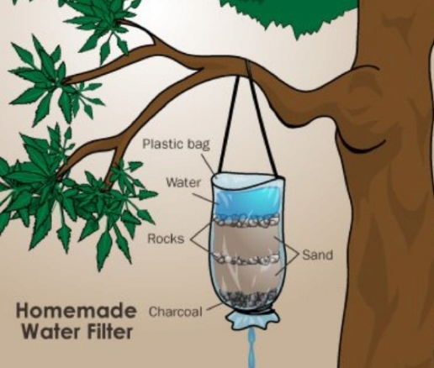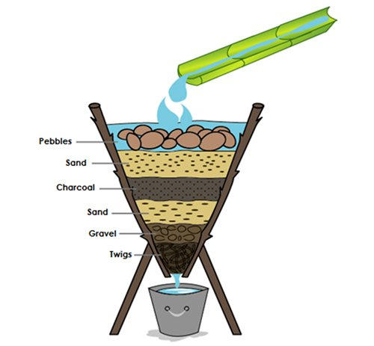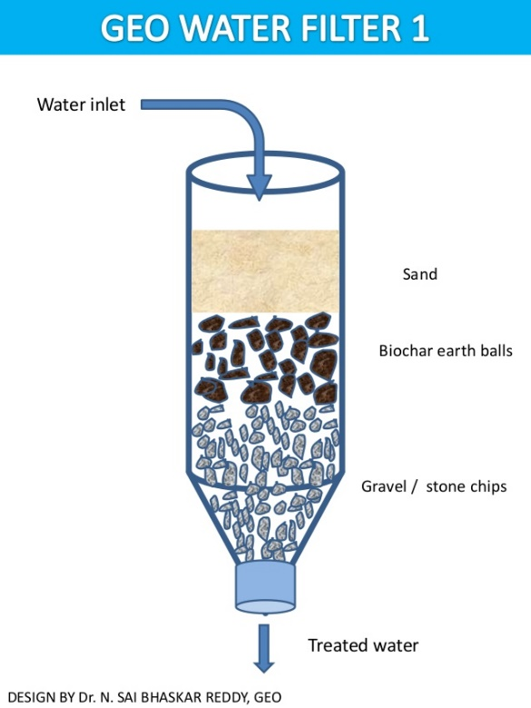

- https://familyprotectionassociation.com/survival-water-filter/
- https://www.slideshare.net/saibhaskar/geo-water-filters
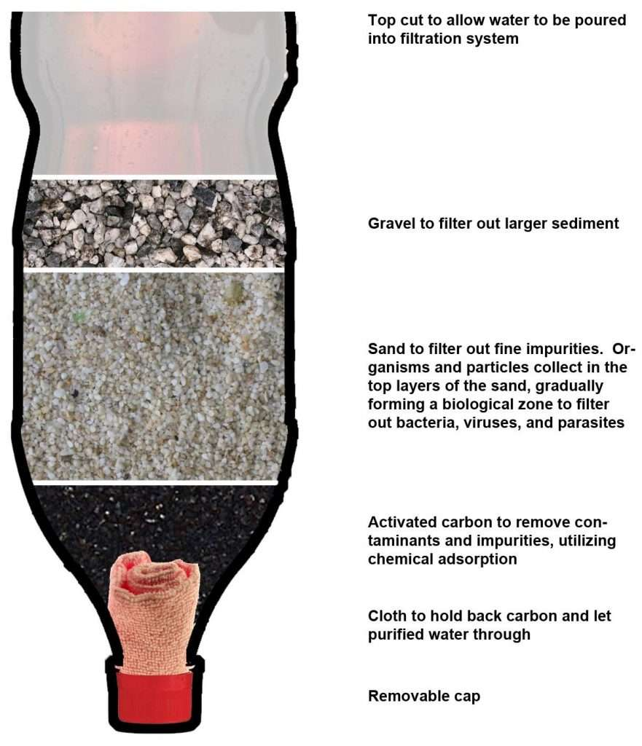
- https://www.blogarama.com/health-and-fitness-blogs/779127-geek-like-clean-water-write-blog/23258689-why-you-must-know-but-never-make-diy-filter

How Does Activated Carbon Work in Water Purification?
By Anna A. MadsenPublished On June 11, 2020
https://earthandhuman.org/how-does-activated-carbon-work-in-water-purification/
January 25- Feb 10
Random Background research + cites
How does sand work in water filtration?
https://homeguides.sfgate.com/types-soil-would-likely-drain-readily-95566.html
Buy Activated Carbon from Amazon:
https://www.amazon.ca/Fluval-C2-Carbon-3-Pack/dp/B003SJTM8Q/ref=sr_1_6?crid=2R6EGPQXMP7RT&dchild=1&keywords=activated+carbon&qid=1612496273&sprefix=activated+ca%2Caps%2C792&sr=8-6
Why is earth good for filtering? http://www.wildwoodsurvival.com/survival/water/purification.html

Build you own water filter: https://www.youtube.com/watch?v=-_w50k6U2AQ
Sand filters: W5 https://en.wikipedia.org/wiki/Sand_filter
Distilled water system: https://www.askaprepper.com/make-distiller-home-filter-desalinate-water/

Testable Question:
Can Activated Carbon filter water better than other materials?
Intro
21.1 billion people drink water in a day. In my opinion water is the most important liquid on this earth and people are dying because of not having enough water or not having clean water with minerals to drink. So I think this is something important for this universe. People have to drink water as the type you see in the image here. This is why I made these two recyclable water filters.

How Many People Do Not Have Access To Clean Drinking Water?
Of the less than 1% of the available water for drinking, most of the third world countries do not have the needed resource to provide safe and clean drinkable water to its people. According to 2008 WHO report on Drinkable Water and Sanitation, about 885 million people, translating to an eighth of the world’s population, have no access to safe water. About 3.6 million people die annually from diseases resulting from unsafe drinking water.
- Of the waters occupying 70% of the earth’s surface, only 3% is considered fresh water. Furthermore, about 2.6% of this freshwater is inaccessible for humans. They’re either locked up in polar ice caps and glaciers, stored in the atmosphere or soil, are highly polluted, or are too far underneath the earth’s surface to be extracted.

https://www.worldatlas.com/articles/what-percentage-of-the-earth-s-water-is-drinkable.html

Freshwater Crisis

There is the same amount of freshwater on earth as there always has been, but the population has exploded, leaving the world's water resources in crisis.

A Clean Water Crisis
The water you drink today has likely been around in one form or another since dinosaurs roamed the Earth, hundreds of millions of years ago.
Water scarcity is an abstract concept to many and a stark reality for others. It is the result of myriad environmental, political, economic, and social forces.
Fresh water available:Freshwater makes up a very small fraction of all water on the planet. While nearly 70 percent of the world is covered by water, only 2.5 percent of it is fresh. The rest is saline and ocean-based. Even then, just 1 percent of our freshwater is easily accessible, with much of it trapped in glaciers and snowfields. In essence, only 0.007 percent of the planet's water is available to fuel and feed its 6.8 billion people.
Due to geography, climate, engineering, regulation, and competition for resources, some regions seem relatively flush with freshwater, while others face drought and debilitating pollution. In much of the developing world, clean water is either hard to come by or a commodity that requires laborious work or significant currency to obtain.

Water Is Life
Wherever they are, people need water to survive. Not only is the human body 60 percent water, the resource is also essential for producing food, clothing, and computers, moving our waste stream, and keeping us and the environment healthy.
Unfortunately, humans have proved to be inefficient water users. (The average hamburger takes 2,400 liters, or 630 gallons, of water to produce.
According to the United Nations, water use has grown at more than twice the rate of population increase in the last century. By 2025, an estimated 1.8 billion people will live in areas plagued by water scarcity, with two-thirds of the world's population living in water-stressed regions as a result of use, growth, and climate change. The challenge we now face as we head into the future is how to effectively conserve, manage, and distribute the water we have.
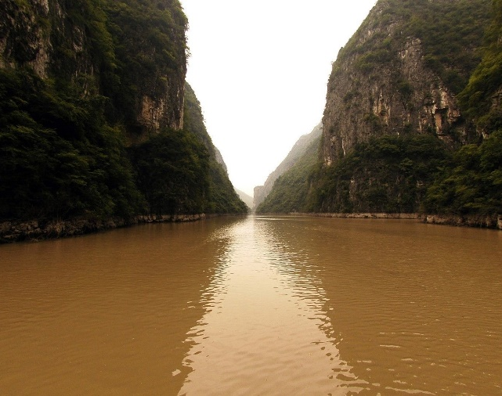

TYPES OF FILTERATING METHODS: https://www.thoughtco.com/filtration-definition-4144961
- General Filtration: The most basic form of filtration is using gravity to filter a mixture. The mixture is poured from above onto a filter medium (e.g., filter paper) and gravity pulls the liquid down. The solid is left on the filter, while the liquid flows below it.
- Vacuum Filtration: A Büchner flask and hose are used to create a vacuum to suck the fluid through the filter (usually with the aid of gravity). This greatly speeds the separation and can be used to dry the solid. A related technique uses a pump to form a pressure difference on both sides of the filter. Pump filters do not need to be vertical because gravity is not the source of the pressure difference on the sides of the filter.
- Cold Filtration: Cold filtration is used to quickly cool a solution, prompting the formation of small crystals. This is a method used when the solid is initially dissolved. A common method is to place the container with the solution in an ice bath prior to filtration.
- Hot Filtration: In hot filtration, the solution, filter, and funnel are heated to minimize crystal formation during filtration. Stemless funnels are useful because there is less surface area for crystal growth. This method is used when crystals would clog the funnel or prevent crystallization of the second component in a mixture.

ELEMENTS
- General Filtration: The most basic form of filtration is using gravity to filter a mixture.
ACTIVATED CHARCOAL: https://juicing-for-health.com/10-activated-charcoal-uses-benefits#:~:text=Activated%20charcoal%20works%20by%20trapping%20toxins%20and%20chemicals,it%20works%20through%20the%20chemical%20process%20of%20adsorption.
The difference between activated carbon and charcoal
https://www.differencebetween.com/difference-between-activated-carbon-and-vs-charcoal/#:~:text=%20Difference%20Between%20Activated%20Carbon%20and%20Charcoal%20,is%20more%20useful%20as%20a%20fuel.%20More%20
Activated Carbon
- Increases the porosity. Because of this, activated carbon will have a large surface area, which can adsorb substances effectively. This primarily increases its effectiveness as a filter. Therefore, activated carbon is mainly used in water filters, in chemical purification process, and in medicine. As we use them, the impurities tend to accumulate in the carbon surfaces. So the disadvantage of using this is that they become less effective as we use them.
Charcoal
- Charcoal consists of the element carbon. Carbonic compounds are abundant in plants, animals and other living organisms. Therefore, as they die, these carbonic compounds are ultimately converted to other carbonic compounds. Charcoal is one of those products. When water and other volatile substances are removed from the carbonic compounds, the resulting product is charcoal. Charcoal is in the solid form, and it has a dark grey color. It contains ash; therefore, charcoal doesn’t have carbon in its pure form. Charcoal is mainly produced by pyrolysis. This is a method, where organic materials are decomposed at high temperatures in the absence of oxygen. Therefore, the chemical compositions and the physical phase of the matter will change very fast. For example, by heating wood we can obtain charcoal. There are few types of charcoal. They are as follows.
Feb 15
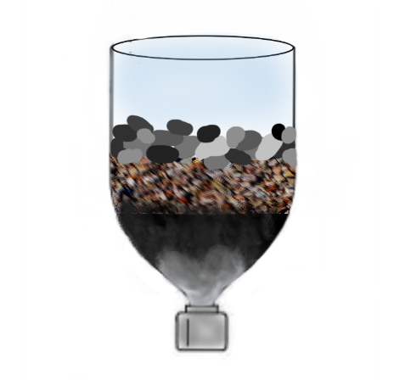
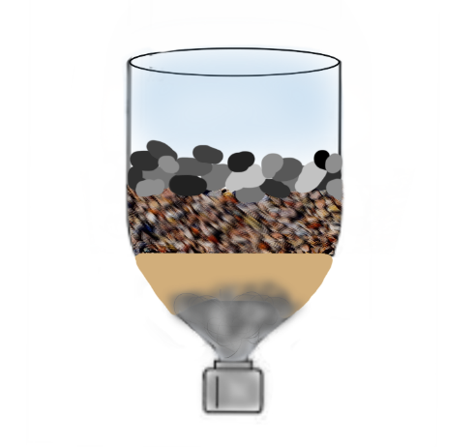
I planned and drew out my filter experiment.
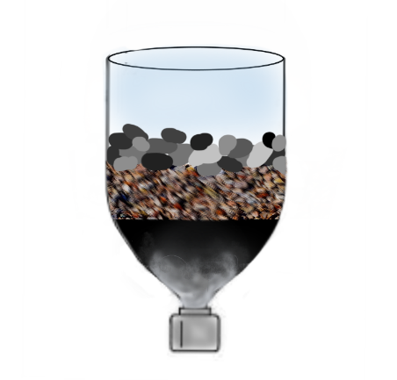
Pebbles Pebbles Pebbles
Gravel Gravel Gravel
Sand Charcoal Activated Carbon
Feb 20
I assembled the materials together and made my 3 filters. My dad helped me cut the plastic bottles with a hot knife. Then I began to pour each element in order, just as I planned.
Challenge: Finding dirty water to filter in the middle of Canadian winter. I had to create my own dirty water by stirring random dust, soil and crushed leaves I found around the background and garage.

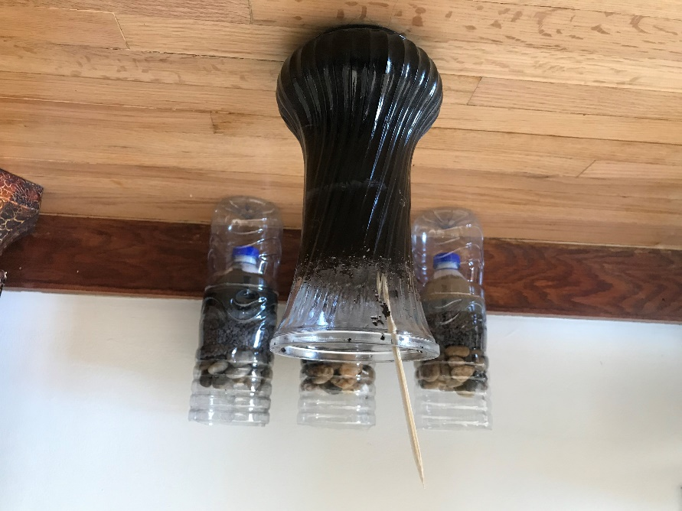

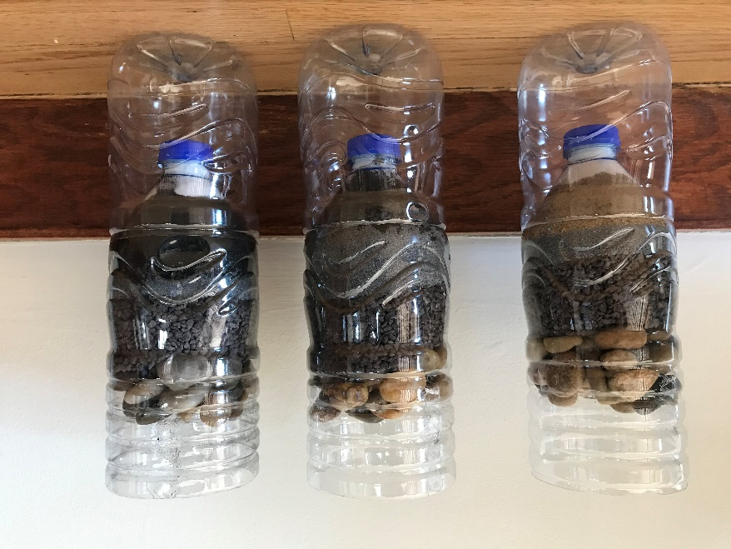
Feb 21
Carbon is everywhere. There are millions of compounds, which are made with carbon. We can say that, carbon is the framework for our bodies, plants and micro-organisms. Further, they are in nature, in several forms, as graphite, diamond, charcoal etc.
SIDE RESEARH

In the absence of oxygen

Treated with oxygen
- Charcoal consists of the element carbon. Carbonic compounds die, they are ultimately converted to other carbonic compounds. Charcoal is one of those products. When water and other volatile substances are removed from the carbonic compounds, the resulting product is charcoal.
- Charcoal is in the solid form, and it has a dark grey color. It contains ash; therefore, charcoal doesn’t have carbon in its pure form.
- Pyrolysis: Process where organic materials are decomposed at high temperatures in the absence of oxygen. Therefore, the chemical compositions and the physical phase of the matter will change very fast. For example, by heating wood we can obtain charcoal.
- Increases the porosity. -+Activated carbon will have a large surface area, which can adsorb substances effectively.
- Micro-porosity>larger surface area> Binds with toxins easier.
- Activated carbon is mainly used in water filters, in chemical purification process, and in medicine.
CON: As we use them, the impurities tend to accumulate in the carbon surfaces. They become less effective as we use them.
- Charcoal consists of the element carbon. Carbonic compounds die, they are ultimately converted to other carbonic compounds. Charcoal is one of those products. When water and other volatile substances are removed from the carbonic compounds, the resulting product is charcoal.
- Charcoal is in the solid form, and it has a dark grey color. It contains ash; therefore, charcoal doesn’t have carbon in its pure form.
- Pyrolysis: Process where organic materials are decomposed at high temperatures in the absence of oxygen. Therefore, the chemical compositions and the physical phase of the matter will change very fast. For example, by heating wood we can obtain charcoal.
In the absence of oxygen
Treated with oxygen

Feb 22
I poured the dirty water in.
Quick note observations
Activated Carbon | Carbon | Sand
- The activated carbon was slow  - Took 10 minutes for all water to go through | - Water went through fast  - The cotton ball I placed in the bottom fell. *Use a coffee filter or of some sort next time* | - Water went through really quick  - Water is very yellow. Yellowist of all 3 filters.
- The pebbles and gravel did what I put them there for. They seem to stop any physical clumps and impurities from the water before it reaches the independent variable.

- The pebbles held up chunks of soil, and big chunks of leaves.

- The activated carbon water is the least yellow. ON the camera they all look the same though.

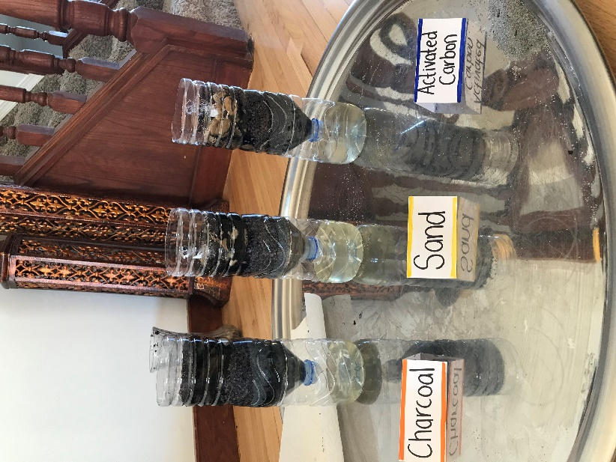

Feb 25
Final Observations Rating:
1st) Activated Carbon cleaned the water the most, because to the eye, it is the least yellow, and has the least floating objects in it. I could drink it maybe.
2nd place) Carbon. Because its yellowness in in between the activated carbon and the sand filters. A few floating objects.
3rd place) Sand. Definitely did not do a well job. The water went straight threw it. It did not do a well job at chemically cleaning it because of the yellowness. A lot of floating objects.

Thanks to: My dad, and My older sister. They’ve helped me in small things here and there, which made my project what it is.

