December 21, 2025

Today I completed all my research questions, finished the preparations for my experiment and I also created this logbook.There will be three different concentrations, two different plastics and two plants and one control for each plant. I will do each combination twice which is 28 pots in total. I filled all the pots with soil and gave them each a specific amount of microplastics. The pots are each labeled with the type of plant, radish or peas, the type of plastic, PVC or ABS, the concentration of plastic, high, medium or low. High is 15g of shaved PVC or ABS per 680g of soil, medium is 8g of microplastic, low is 2g of microplastic. Afterward, each pot receives three seeds, either peas or radishes. Finally each pot receives 80ml of water.

December 22, 2025

I did not observe anything happening to the plants, nothing else happened.

December 22, 2025-Later

I watered the plants with approximately 20ml of water each. I used a syringe-like object to measure the water making the process a bit faster. I would also poke the tip into the dirt a tiny bit before injecting the water. I have also decided to scrap the water retention test.

December 23, 2025

I moved the plants down to my basement where they will be out of the way. I also added a timed LED light set to 12 hours a day to give them light when they sprout. The light is a regular white light and is not a light optimized for plant growth.

December 24, 2025

The room I originally stored the plants in was too cold for them to grow so I moved the setup to the guest room. There may be a bit of interference with the project because sometimes my parents use the guest room to exercise.

December 24, 2025-Later

I watered the plants with about 20ml of water each, I noticed that the pots with higher microplastic contamination had a harder time absorbing the water. It was gathering in pools at the surface and slowly sinking down, however it also resulted in an even watering (at least on the surface). The control was absorbing water quickly however it resulted in an uneven spread. The medium and low contamination absorbed the water at a medium pace.

December 25, 2025

Merry Christmas!
December 25, 2025-Later

I noticed that 5 of the plants had finally sprouted. They were all radishes except for one and none of them looked healthier or weaker than the others. One control radish sprouted, one with a high concentration of PVC, one with a medium concentration of PVC and one with a high concentration of ABS. The single pea that sprouted was in a pot with a high concentration of ABS. I also created a chart that I will leave downstairs to keep track of which ones have sprouted.

December 26, 2025

I have made an online chart which will be far more detailed than the one on paper. I will keep all my observations there. I will measure the colour of the plant, the height of the plant and the number of leaves.

December 26, 2025-Later

I watered the plants once more with the usual 20ml. While watering, I noticed that because of the uneven lighting, the pots in the center, closer to the light, tended to be drier. The radishes were all sprouting at a rapid pace while the peas were lagging behind. I believe that this is because the peas were generally buried a bit deeper than the radishes and their seeds are larger with a harder shell. I also realized that I have not yet come up with a hypothesis so I will also pay attention to that. Once the plants have grown and have noticeable changes, I will start filling in the chart. To keep track at first, I will highlight the seed number that has sprouted so I will not be confused by which have sprouted and which haven’t.

December 27, 2025

I noticed that many of the plants have already sprouted and are already growing. The ones that have sprouted are mostly radishes, every pot in the radish section has at least one seed that has sprouted. I may have put too many radish seeds in one of the ABS medium pots because I noticed that there were two stems instead of one coming out of the ground. The peas only have two sprouts so far and one of them is green and healthy but the other one is white and could be dead.

December 28, 2025

The radishes are growing nicely and each pot has at least two seeds that have sprouted. I estimate that the tallest is around 3.5 cm, it is in a PVC medium pot. The peas have started to sprout but all the ones that have sprouted are in the pots contaminated by ABS microplastics. I also finished my hypothesis on which combination of plastic and concentration would harm the plant the most.

December 28, 2025-Later

I watered the plants again and one of the control radishes was having a hard time absorbing water. I am not sure why this is, but it could have been due to the soil being too dry and unable to absorb water too quickly. It could also be because the soil was already moist.

December 29, 2025

Almost all the radish plants have grown and there are three more peas that have also sprouted. At the tip, the pea plants seem to branch off into multiple strands. I am not sure if this is normal or unhealthy for the plant. Many of the plants that have sprouted are leaning towards the middle where there is the most light. This could be an issue in the future when the plant grows bigger.

December 30, 2025

When I watered the plants this afternoon, I saw that every pot had at least one sprout. To avoid confusion, I labeled every sprout with a number from 1-6 in its category. For example, radish plants with a high contamination of ABS is one category, every category has six seeds in it. Even though it is still early, I am not noticing any differences in the plants with more plastic contamination and they don’t seem to be unhealthier either. They may have not absorbed enough microplastics but it could also be because the microplastics are not small enough.

January 1, 2026

I was not able to make an entry for December 31, 2025 because there were too many things happening. What I did yesterday was label a new bean plant that had sprouted and I also predicted that no other radishes will sprout because it has already been 6 days since the first radishes sprouted. The remaining seeds are most likely dead, the peas however are likely to have many more sprouts coming up. I have also decided to start filling out my chart to keep track of the plants growth everytime I water the plants.

January 1, 2026-Later

I watered all the plants again and filled out my first observation sheet. I have also decided to only fill the sheet out every four days. Here are the results:

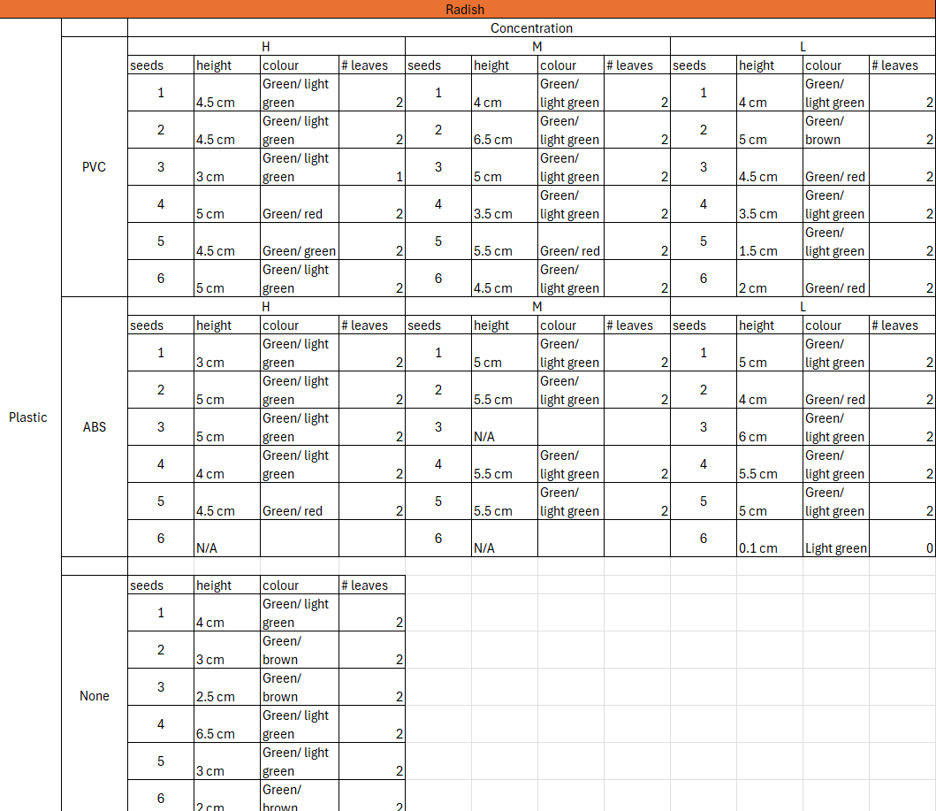
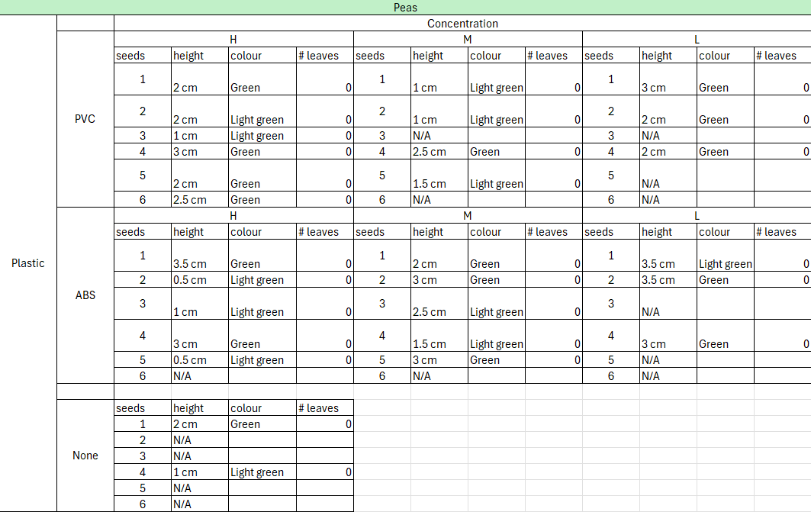

In the colour section, the first colour is the colour of the leaves unless there are no leaves in which case it is the colour of the stem. However if there are leaves, the second colour is the colour of the stem. If the height says N/A, it means the plant has not yet grown.

January 3, 2026

Today, I labeled a new bean sprout. I also watered the plants and attempted to see a difference in health between the different concentrations of plastic but ultimately failed. I am starting to worry that the plastic is still too big for the plant to absorb.

January 4, 2026

I started making a list of all the materials used in my experiment. I also started on my procedure for my experiment.

January 5, 2026

When I was watering my plants, I noticed that many of the pots were still moist, even with the plant absorbing water. Before the plants grew, the pots were always dry when I watered them, so why did it change? I also finished my materials list and got around halfway through my procedure. Here are my observations today:

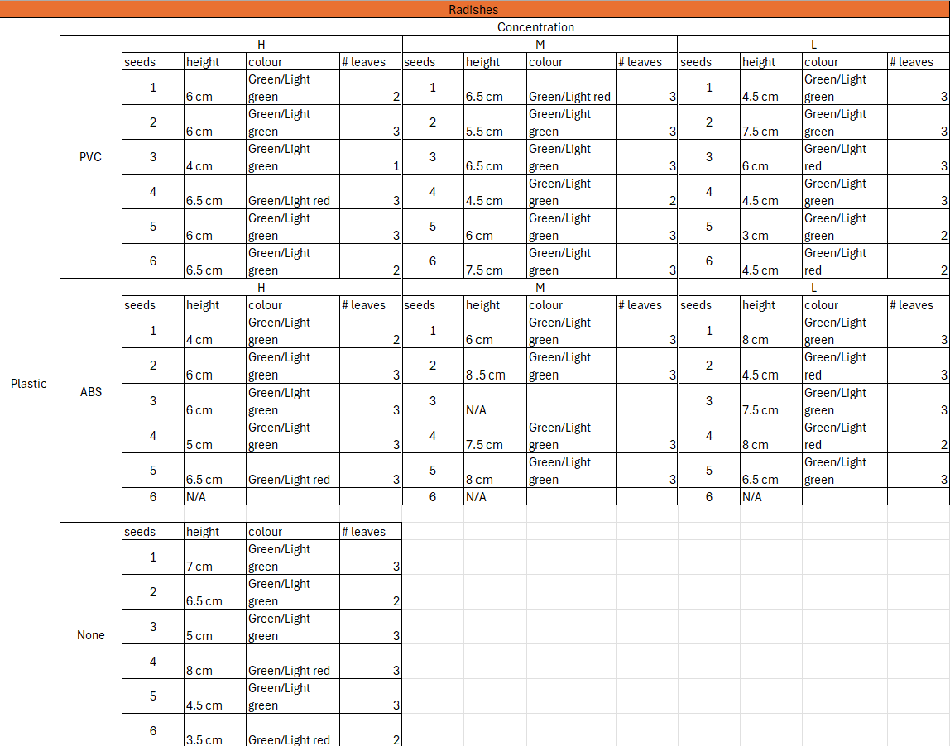
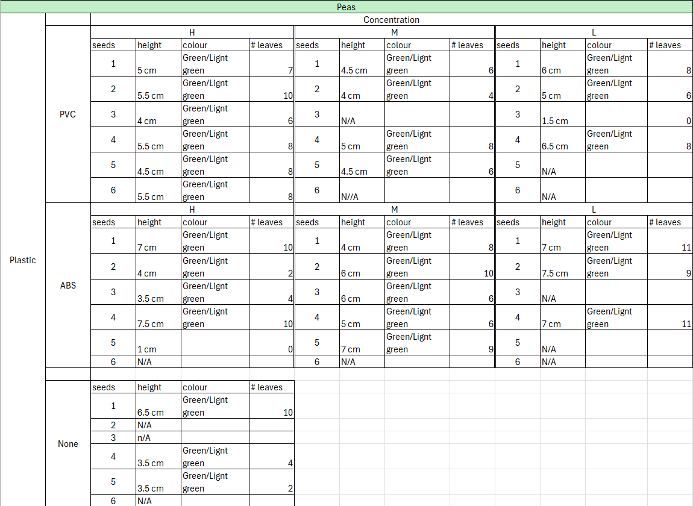

January 7, 2025

When I watered the plants today, I noticed that many of the taller radishes were leaning over the side of the pot. All of the plants doing so had microplastics in the pot they were growing in. The control pot had a fairly tall plant but it was not leaning over as much as the other ones were. I also listed all of the variables in my experiment and finished my procedure and put them all into a google slides presentation.

January 9, 2026

I took my third set of observations today and most of the radish plants were all bent over the side of the pot. There is only one tall plant left standing and the rest of them are short. Here are the observations (for some I had to hold the plant up against the ruler):

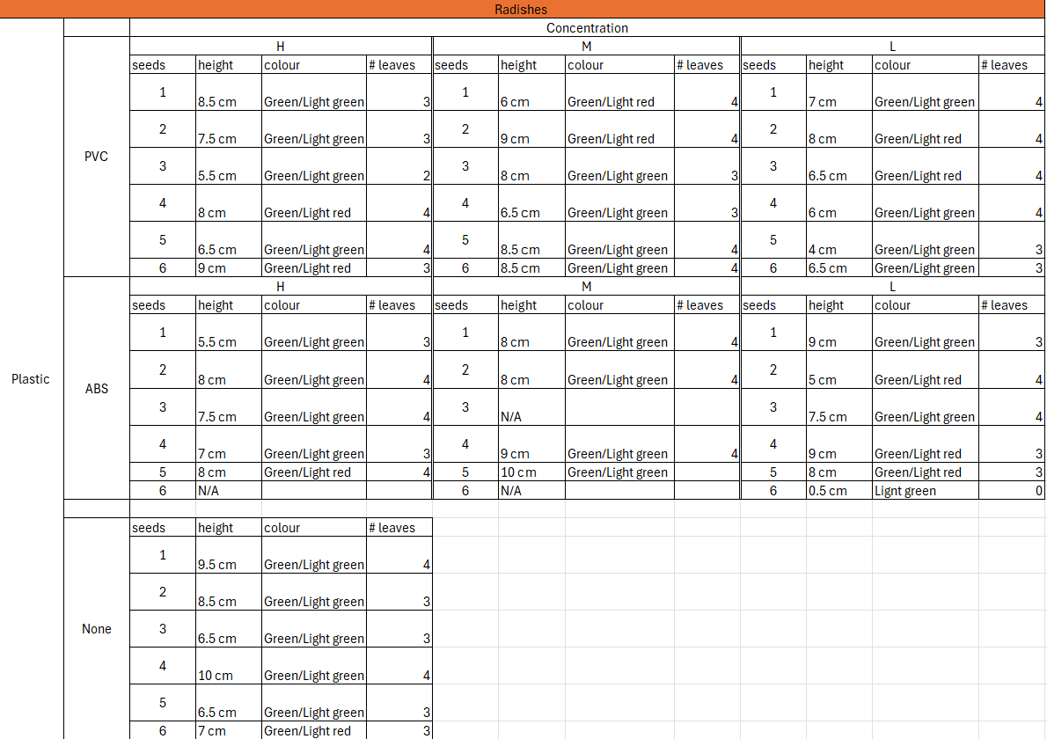
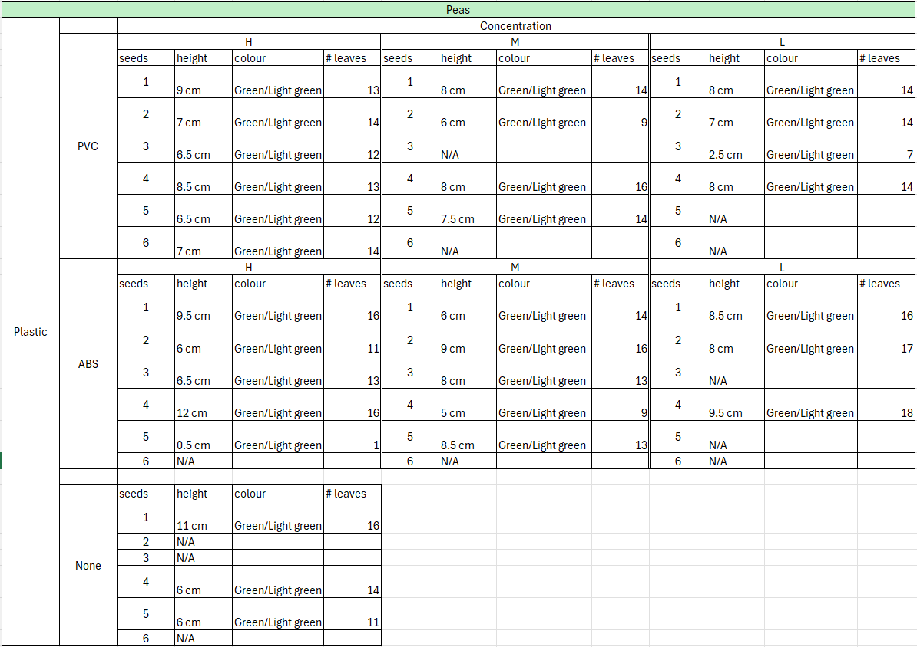

January 11, 2026

When I watered the plants, I saw that many of the radish plants were attempting to get back up. Many of them were failing but they still reached out with the top of the plant towards the light making a “C” shape.

January 13, 2026

This will be the last time I will be taking observations. Here they are:

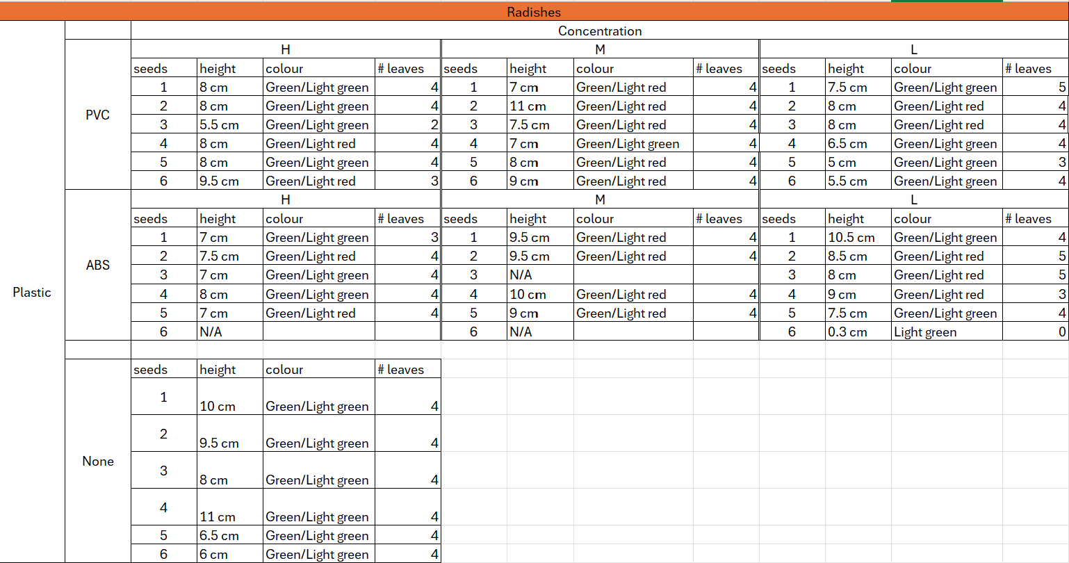
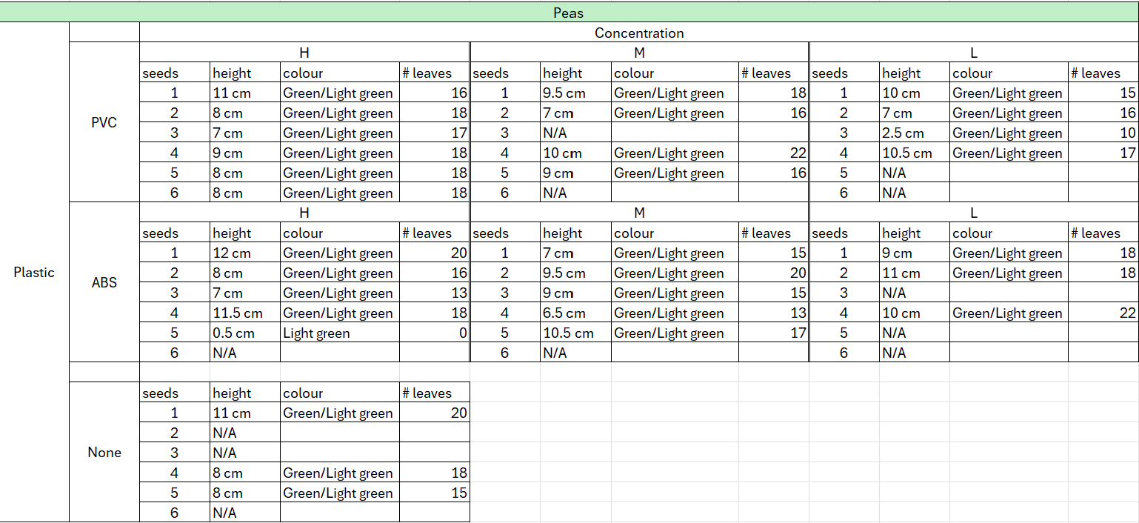

January 19, 2026

I was busy for the last few days so I was unable to do much. Today I processed all of my information on the plants. The three factors I will be judging on are height, growth and number of leaves. I also worked on my slideshow.

January 20, 2026

I worked on my slideshow and got my trifold today.

January 27, 2026

I finished my slideshow and started working on my trifold today. I also revised my script and presented it to my teachers. For the results, I calculated the average for each of the concentrations and types of microplastics; however, I was unsure if it is correct to add the plants that did not grow in the calculations.

February 14, 2026

I got accepted into CYSF today and decided to redo my experiment. This time I will only use PVC for a larger sample size and more results. I labeled all my pots and put in coffee filters. I bought a new brand of dirt for my experiment because I was almost out. I had to mix the new dirt and the old dirt.

February 14, 2026-Later

I finished watering the plants with 120 ml of water and moved them down into my basement. This time the high concentration was 38 grams of shaved PVC in 1360 grams of soil, the medium was 19 grams and the low was 7 grams.

February 16, 2026

I watered all the plants with 60 ml of water and noticed that the soil was so loose that wherever I poured water, it made a huge dent.

February 18, 2026

I watered all the plants with 20 ml of water and started uploading my variables and procedure to the CYSF platform.

February 21, 2026

I watered the plants with 20 ml of water and started to record information on the plants. 32 of the 84 plants have already sprouted and the tallest one is currently 6 cm. Overall, the radishes are doing much better than the peas. There is no visible difference between pots that have microplastics and pots that don’t.

