Science Fair Logbook

Project Title: CRISPR: Hit or Miss?

Student Name: Twishaa Kartik
Grade: 7
School: Westmount Charter School
Calgary Youth Science Fair 2026

TABLE OF CONTENTS

Pages

Title Page 0
Table of Contents 1
Ideas and Background Research 2-7
Scientific Question and Purpose 7
Hypothesis and Variables 8
Experimental Design 9-10
Observations 10-11
Managed Data 12
Results and Conclusions 13
Improvements, Further Questions, and New Problems 13
Sources and References 14-15

Section 1- Background Research

What are Genes?
Genes are specific, functional segments of DNA found in chromosomes.
- DNA (deoxyribonucleic acid) is a double-stranded molecule that is arranged in a double helix
- Its a fundamental molecule that carries genetic instructions for the development, formation, growth and reproduction of organisms
- DNA is made up of repeating units called nucleotides
- Each nucleotide has:
- A phosphate group
- A sugar (deoxyribose in DNA)
- A nitrogenous base (A, T, C, G)

- Base pairing rules:
- Adenine (A) always pairs with Thymine (T)
- Cytosine (C) always pairs with Guanine (G)

What is Gene-Editing?
Gene-editing is the deliberate/intentional alteration of DNA sequences within living cells.

Gene-editing allows for scientists to:
- Knock out genes (disable function)
- Repair mutations
- Insert new genetic material

Gene-editing can occur in:
- Somatic cells (mutation are not inherited; they only affect the individual)
- e.g., most cancers, aging
- Germline cells (mutations are passed to offspring and future generations, becoming hereditary)
- e.g., cystic fibrosis, Huntington’s
Common gene-editing goals include:
- Understanding gene function
- Treating inherited diseases
- Improving agricultural traits
- Engineering microbes for industrial and biotechnological use cases

**Gene editing requires highly accurate DNA targeting, controlled DNA cutting, and predictable repair

Errors in gene-editing could result in:
- Off target mutations
- Disruptions of essential genes
- Unintentional biological consequences

This makes targeting specificity a major concern in gene-editing technologies, especially in therapeutical applications.

Gene-Editing Technologies Prior to CRISPR
Before CRISPR, scientists used other tools to edit genes by cutting DNA at specific locations. These cuts trigger the cell’s natural repair systems, letting genes be disrupted or changed.

Zinc Finger Nucleases (ZFNs)
- ZFNs are engineered proteins that bind to specific DNA sequences and cut the DNA.
- Effective but difficult and expensive to design
- Limited flexibility for new targets

TALENs
- TALENs use customizable protein domains to recognize DNA and cut it.
- More flexible than ZFNs
- Large size makes delivery into cells challenging

Meganucleases
- Meganucleases are naturally occurring enzymes that cut very specific DNA sequences.
- Highly precise
- Hard to program for different genes

These earlier methods show and prove that gene-editing was possible, but required complex protein engineering which led to the development of CRISPR- a faster, flexible system that uses RNA to guide and assist DNA cutting.

Discovery of CRISPR
CRISPR-Cas9 wasn't “invented” by humans in the conventional way, but rather discovered as a natural system used by bacteria to survive. Scientists later realized that they could adapt this system into a revolutionary gene editing tool.

Historical Context
- In 1987, Japanese researchers studying E. coli noticed strange DNA sequences with repeating patterns [CRISPR] that were separated by unique spacer sequences [spacers]. At the time, scientists were not aware of these sequences’ functions, purpose or significance in a cell, and were simply labeled as unusual and mysterious repeats.

- In the late 1990s-early 2000s, researchers analyzing these sequences made a surprising discovery that many spacer sequences matched DNA from viruses that infect bacteria [bacteriophages].
This suggested that:
- Bacteria were capturing fragments of viral DNA
- These fragments were being stored in the bacterial genome, acting like a “genetic record” of previous infections

- In 2012, Jennifer Doudna and Emmanuelle Charpentier made a key breakthrough. They discovered that the CRISPR-Cas9 system could be simplified and the two separate RNA molecules [tracrRNA and crRNA] used by bacteria could be artificially combined into a single, synthetic RNA molecule [sgRNA]. This [sgRNA] could be programmed to target any DNA sequence- CRISPR is more than a bacterial immune system, it is a programmable genetic/molecular tool!

How CRISPR Functions in the Bacterial Adaptive Immune System
In prokaryotes, CRISPR is part of an adaptive immune system that protects bacteria from viruses known as bacteriophages.

How it works (natural system)-

- Viral Infection (invasion)
- A bacteriophage infects the prokaryotic cell by injecting its viral DNA

- Memory formation
- Once the viral DNA is inside the cell, a short section of it can be incorporated into the bacterial genome. This DNA fragment is then inserted between repeating palindromic sequences. These pieces are called spacers and along with the repeats, they form a CRISPR array. This step allows the cell to create a “genetic memory” of the infection, not immediate protection.

- Transcription of the CRISPR array
- The CRISPR array can undergo transcription to form CRISPR RNA (crRNA). Each crRNA contains a sequence complementary to the viral DNA from the original disease.

- Forming the CRISPR-Cas Complex
- Then, the protein Cas9 gets involved. Cas refers to CRISPR-associated proteins, and Cas proteins are nucleases- enzymes that are capable of cleaving/cutting DNA, kind of like a pair of genetic scissors. Along with Cas9, molecules of tracrRNA are also present. TracrRNA is complementary to the palindromic repeat sequences and can anneal (bind) to them. Together, the crRNA and tracrRNA guide Cas9 to its target.

- Destruction of the viral DNA
- The cell is now prepared to defend itself against the invader whose genome created the crRNA. If this (Cas9-crRNA-tracrRNA) complex encounters a section of viral DNA that has a sequence which is complementary to this crRNA, Cas9 will do a double-strand break of the viral DNA. This inactivates the virus and prevents it from replicating, effectively providing the cell with immunity against future infections from the same virus.

CRISPR as a Gene-Editing Tool in Eukaryotes
In eukaryotic organisms, CRISPR is a gene-editing editing technology adapted from the prokaryotic immune system to cut or modify specific DNA sequences in the genome.
How it works (engineered system)-

Designing the guideRNA
- Scientists identify a target gene that they want to edit. A single guide RNA (sgRNA) is designed with a complementary sequence to the sgRNA. The sgRNA is an artificial molecule, generated by fusing together tracrRNA and crRNA.

Introduction of CRISPR-Cas9 into the cell
- The Cas9 protein and th sgRNA are introduced into the cell using methods such as viral vectors or plasmids. Together, Cas9 and sgRNA form a CRISPR-Cas9 complex, essentially a two component system that can cleave DNA, just like the three part system in bacteria.

Target recognition and the Binding process
- The CRISPR-Cas9 complex moves through the cell and scans the DNA
- Cas9 first recognizes a PAM (Protospacer Adjacent Motif) sequence
- If the PAM is there, the sgRNA checks if the adjacent DNA sequence is complementary
- If they match, the sgRNA binds to the target DNA

DNA Cleavage
- Once bound, Cas9 cleaves both strands of DNA, creating a double-stranded break at precisely the desired location

DNA Repair Mechanisms After CRISPR Cleavage
After the incision is made, the cell attempts to repair the double-stranded break by enacting its natural DNA repair mechanisms:

- Non-homologous end joining (NHEJ) - fast, error-prone, gene knockout
- NHEJ is the default and most common DNA repair pathway in eukaryotic cells
- The broken DNA ends are directly rejoined without a template
- This process is error-prone and often results in insertions or deletions (indels) of nucleotides
- NHEJ produces DNA strands that are not uniform in size

- Homology-directed repair (HDR) - slow, precise, gene insertion or correction
- HDR is commonly found in archaeal and bacterial cells
- It is a high-fidelity repair path, but does not occur as frequently as NHEJ
- Lowers the possibility of errors, no indels of nucleotides, maintains uniform DNA size
- The cell repairs the break by using a homologous DNA template– this template has homology to the surrounding sequences near the cut site

- In the context of CRISPR gene editing (HDR continued)-
- Scientists provide a synthetic template DNA
- This template contains: the required DNA sequence and flanking regions homologous to the cleavage site
- The cell copies the sequence from the template into its genome

Applications of CRISPR
CRISPR applications fall into two major categories:

Gene-Editing and Gene Therapy:
- Editing disease-causing gens in human cells
- Treating genetic disorders through:
- Gene corrections
- Gene knockouts
- Designing plants for:
- Increasing crop resistance to diseases/pests
- Enhancing their tolerance towards environmental stresses
- Building microbes for:
- Increased efficiency in production of biofuels, bioplastics, and enzymes

Genetic Detection and Diagnostic Purposes:
- Cas12 systems → detect DNA
- Cas13 systems → detect RNA

- CRISPR-based diagnostics can:
- Locate/detect viral and bacterial infections
- Find/identify genetic mutations
- Monitor environment and detect pathogens

Risks and Concerns Associated with CRISPR Technology

Off-Target Effects (Limitations with Precision)
- CRISPR may cleave DNA at unintended sites
- Similar DNA sequences could be targeted mistakenly
- Off-target edits can cause mutations, disrupt essential genes, or activate cancer-related genes

Ethical Concerns include
- Germline editing can affect future generations
- Lack of consent from descendants
- Potential for misuse and genetic inequality- “designer babies?”
- Blurs the line between treatment and enhancement

Section 2- Scientific Question and Purpose

Scientific/Research Question
How does mismatch tolerance influence CRISPR’s ability to identify target DNA?

Reason for Choosing this Project
While exploring CRISPR and deep diving into the gene-editing world, I became interested in how CRISPR is able to locate specific DNA sequences among millions of base pairs. Its truly fascinating! Something that stood out to me is that CRISPR doesn’t always require a perfectly matching DNA sequence in order to bind and cut. This raised questions about how strict CRISPR targeting rules should be and how these rules impact performances in different applications.

This is a vital point because CRISPR is being used in both diagnostics (where missing a potential target could be dangerous) and gene therapy (where cutting the wrong gene could have catastrophic repercussions). This highlights that understanding how mismatch tolerance influences CRISPR accuracy is important to ensure this technology is utilised both safely and effectively.

Section 3- Hypothesis and Variables

Hypothesis:

My prediction is that as mismatch tolerance increases, CRISPR will detect more DNA sequences overall, but its accuracy will decrease. In other words:
- Stricter rules (low mismatch tolerance, rules 0-1): have almost no false alarms (FP low), but miss many real targets (FN high)
- Looser rules (high mismatch tolerance, rules 3-4): catch almost all targets (FN low), but create more false alarms (FP high)

So, to summarize:
Allowing more mismatches between the gRNA and DNA will increase detection of true targets but also increase off-target binding, while stricter mismatch rules will reduce off-target errors but miss some real targets.

Variables:

Manipulated Variables (what I change):
- Mismatch tolerance level (rule strictness)- the maximum number of allowed differenced between the guide RNA and the DNA sequence before there is “no bind”
- Example: If best mismatches ≤ rule number = match

Responding Variables (what I measure):
- CRISPR accuracy- measured as:
- Number of true positives → said match and target was present
- Number of false positives → said match and target was not present
- Number of true negatives → said no match and target was not present
- Number of false negatives → said no match and target was present

Control Variables (what stays the same):
- Same sequence length
- Same gRNA strip
- Same scoring methods
- Same dataset of paper strips

Section 4- Experimental Design

Overview of the Experiment:
My experiment is a paper-based simulation, designed to model and demonstrate how CRISPR locates and binds to a target DNA sequence. Rather than using real DNA or laboratory equipment, I used printed sequences to represent a gRNA (guide RNA) and DNA strands. By manually comparing sequences, this experiment simulates how CRISPR scans DNA and tolerates mismatches when attempting to identify a target.

The focus of my experiment is mismatch tolerance. By repeatedly applying different matching rules with varying degrees of strictness, my project examines how allowing more/less mismatches affects CRISPR accuracy and impacts its tendency to produce false positives and false negatives.

Materials:
- Printed copy of the guide RNA sequence
- Printed DNA strips
- Graph paper/Google Sheets for recording results
- Truth key to indicate which DNA strips include the target sequence

Data set I used:
- Guide sequence
- 12 letters long
- Represents the CRISPR targeting sequence (gRNA)
- DNA strips
- 20 total strips
- Each strip is 30 letters long
- Each strip may or may not contain a target section similar to the guide sequence
- Truth key
- Identifies which DNA sequences actually have the true target sequence

Step-by-Step Process

Step 1- Setting the 5 rules (strictness levels)
- Rule 0: only 0 mismatches allowed (strictest)
- Rule 1: up to 1 mismatch allowed
- Rule 2: up to 2 mismatches allowed
- Rule 3: up to 3 mismatches allowed
- Rule 4: up to 4 mismatches allowed (loosest)

Step 2- Finding the “best mismatch score” for each strip
- For each 30 letter DNA strip, I slid the gRNA across it, creating 19 possible 12-letter windows (30-12+1=19)
- For each window, I compared it to the guide and count how many letters differ
- The best mismatch score for the strip is the lower number of mismatches found among all 19 windows

Step 3- Deciding match/no match for each rule
Once I had the best mismatch score:
- For each rule (0-4):
- If the best mismatch score is equal to or less than the rule number = match
- If the best mismatch score is greater than the rule number = no match
- I repeated this process for:
- Every rule
- Every DNA strip

Step 4- Revealing truth and label FP/FN
After completing all 20 strips, I compared answers with the truth key
- TP (True Positive): predicted match and target was present
- FP (False Positive): predicted match and target was not present
- TN (True Negative): predicted no match and target was not present
- FN (False Negative): predicted no match and target was present

Quick note: This process was supposed to closely simulate how CRISPR searches for DNA without using live organisms or extensive procedures, therefore complying with ethical and safety guidelines.

Section 5- Observations and Data Tables

After completing the matching process for all 20 DNA strips, I collected data separately for each rule (Rule 0 through Rule 4). For every rule, each DNA strip was noted as either a match or no match based on its best mismatch score. These predictions were then compared to the truth key to figure out whether each result was a true positive, false positive, true negative, or false negative. The repeated data collection was in the same way for every rule to ensure consistency when comparing strictness levels.

Raw DNA Strip Matching Results for Every Rule

Strip ID | Best Mismatch | Rule 0 | Rule 1 | Rule 2 | Rule 3 | Rule 4 | Truth
S01 | 1 | Yes | Yes | Yes | Yes | Yes | Target Present
S02 | 1 | No | Yes | Yes | Yes | Yes | Target Present
S03 | 1 | No | Yes | Yes | Yes | Yes | Target Present
S04 | 2 | No | No | Yes | Yes | Yes | Target Present
S05 | 2 | No | No | Yes | Yes | Yes | Target Present
S06 | 3 | No | No | No | Yes | Yes | Target Present
S07 | 3 | No | No | No | Yes | Yes | Target Present
S08 | 4 | No | No | No | No | Yes | Target Present
S09 | 0 | Yes | Yes | Yes | Yes | Yes | Target Present
S10 | 2 | No | No | Yes | Yes | Yes | Target Present
S11 | 5 | No | No | No | No | No | No Target
S12 | 5 | No | No | No | No | No | No Target
S13 | 5 | No | No | No | No | No | No Target
S14 | 5 | No | No | No | No | No | No Target
S15 | 5 | No | No | No | No | No | No Target
S16 | 6 | No | No | No | No | No | No Target
S17 | 2 | No | No | Yes | Yes | Yes | No Target
S18 | 3 | No | No | No | Yes | Yes | No Target
S19 | 3 | No | No | No | Yes | Yes | No Target
S20 | 2 | No | No | Yes | Yes | Yes | No Target

Summary of Outcomes (TP, FP, TN, FN) for Each Rule

Rules | TP | FP | TN | FN
Rule 0 | 2 | 0 | 10 | 8
Rule 1 | 4 | 0 | 10 | 6
Rule 2 | 7 | 2 | 8 | 3
Rule 3 | 9 | 4 | 6 | 1
Rule 4 | 10 | 4 | 6 | 0

Section 6- Managed Data and Graphs

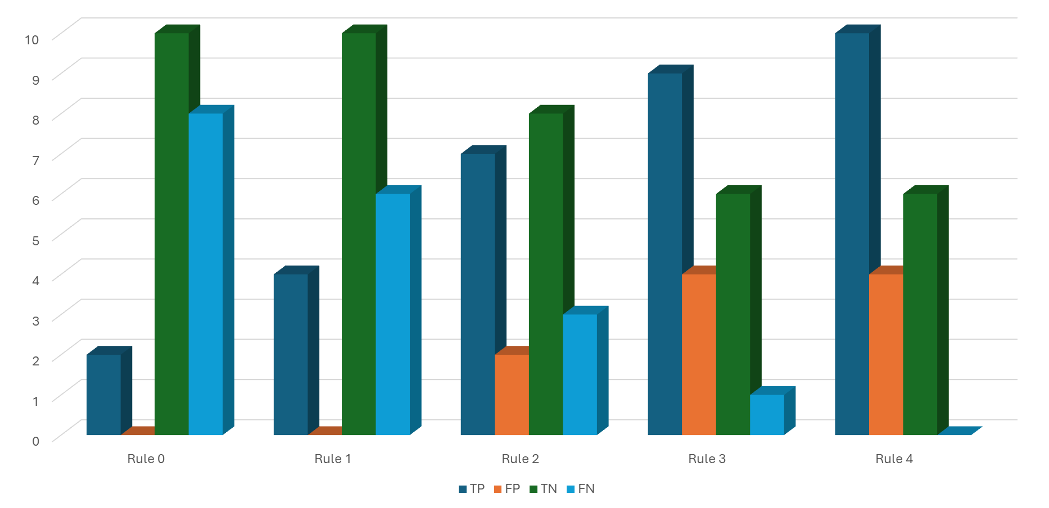

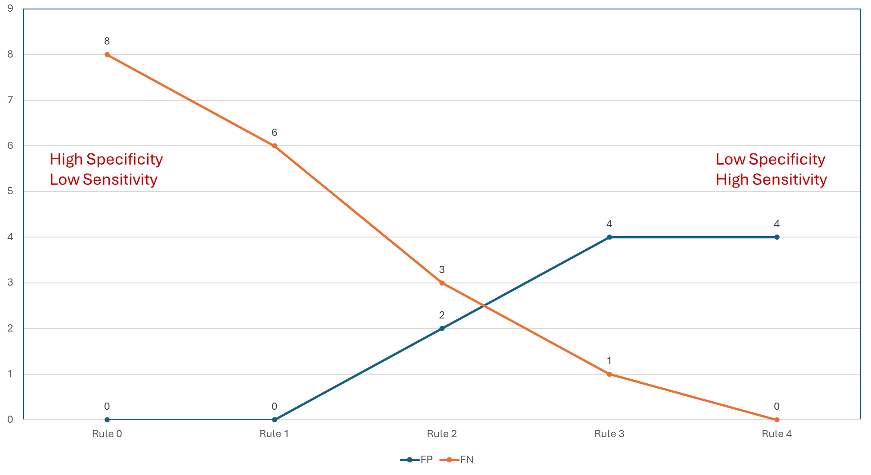

Section 7- Results and Conclusions

Results
After analyzing the data from all 5 mismatch rules, clear patterns began to emerge in relation to how CRISPR accuracy changes as strictness levels increase or decrease.
- Under strict rules (Rules 0-1), there were very few false positives (FP low), meaning it was extremely rare that DNA was identified as a target when it was not. However, these strict rules also resulted in many false negatives, as several real targets were missed (FN high).
- Under looser rules (Rules 3-4), almost all real targets sequences were detected, and as a result, there were very few false negatives. On the other hand, this created many false positives as the level of accuracy reduced

The results of the experiment support my hypothesis that increasing mismatch tolerance improves CRISPR’s sensitivity but reduces its specificity. While strict mismatch rules minimize off-target effects, they fail to detect many actual targets, while looser rules say “yes” to most targets at the cost of increased false positives.
This demonstrates that CRISPR accuracy exists as a trade-off, where ideal outcomes depends on the application. Diagnostic tools would benefit from higher mismatch tolerance, while therapeutic gene editing requires stricter rules to prevent harmful off-target mutations.

Section 8- Improvements, Further Questions, and New Problems

Limitations with my Project
- Paper model oversimplifies real CRISPR biology (binding relies on more factors than just mismatch count)

Improvements for the Future
- Increase the number of strips (larger dataset)
- Test longer sequences and different gRNA lengths
- Have the location of the mismatch play a role (e.g., mismatches close to PAM sites count more)

Further Questions
- How does the position of a mismatch affect CRISPR binding/cutting efficiency?
- How would different Cas proteins affect and change mismatch tolerance and overall accuracy?

New Problems
As CRISPR technology becomes more advanced and spreads across the world, some challenges and obstacles emerge, including:
- How can we regulate and control germline editing in an ethical fashion?
- How can we predict and prevent off-target effects?
AI Use Statement:
Artificial intelligence was utilised in both a limited as well as a responsible way to help simplify complex concepts during some parts of my background research and to generate random letter sequences for the paper DNA strips used in the model/simulation.

Section 9- References and Sources
APA 7th Edition Format

Anderson, E. M., Haupt, A., Schiel, J. A., Chou, E., Machado, H. B.,
Strezoska, Ž., Lenger, S., McClelland, S., Birmingham, A.,
Vermeulen, A., & Smith, A.V (2015). Systematic analysis of
CRISPR-Cas9 mismatch tolerance reveals low levels of off-target
activity. Journal of biotechnology, 211, 56–65.
https://doi.org/10.1016/j.jbiotec.2015.06.427

Ansori, A. N., Antonius, Y., Susilo, R. J., Hayaza, S., Kharisma, V.
D., Parikesit, A. A., Zainul, R., Jakhmola, V., Saklani, T.,
Rebezov, M., Ullah, M. E., Maksimiuk, N., Derkho, M., & Burkov,
P. (2023). Application of CRISPR-Cas9 genome editing technology
in various fields: A review. Narra J, 3(2), e184.
https://doi.org/10.52225/narra.v3i2.184

Azizoglu R. O., CRISPR-Cas systems in diagnostics: A comprehensive
assessment of Cas effectors and biosensors, Gene and Genome
Editing, Volumes 3–4, 2022, 100019, ISSN 2666-3880,
https://doi.org/10.1016/j.ggedit.2022.100019.

Davis, D. J., & Yeddula, S. G. R. (2024). CRISPR Advancements for
Human Health. Missouri medicine, 121(2), 170–176.
https://pmc.ncbi.nlm.nih.gov/articles/PMC11057861/

Gaj, T., Gersbach, C. A., & Barbas, C. F., 3rd (2013). ZFN, TALEN, and
CRISPR/Cas-based methods for genome engineering. Trends in
biotechnology, 31(7), 397–405.
https://doi.org/10.1016/j.tibtech.2013.04.004

Gostimskaya I. (2022). CRISPR-Cas9: A History of Its Discovery and
Ethical Considerations of Its Use in Genome Editing.
Biochemistry. Biokhimiia, 87(8), 777–788.
https://doi.org/10.1134/S0006297922080090

Iorio, F., Behan, F.M., Gonçalves, E. et al. Unsupervised correction
of gene-independent cell responses to CRISPR-Cas9 targeting. BMC Genomics 19, 604 (2018). https://doi.org/10.1186/s12864-018-4989-y
Rojahn, S. Y. (2014, February 11). Genome surgery. MIT TechnologyReview. https://web.archive.org/web/20160112051853/http://www.technologyreview.com/review/524451/genome-surgery/

What is CRISPR: Your Ultimate Guide | Synthego. (2025, December 1).
Synthego.https://www.synthego.com/learn/crispr/

Jolany Vangah, S., Katalani, C., Boone, H.A. et al. CRISPR-Based
Diagnosis of Infectious and Noninfectious Diseases. Biol Proced
Online 22, 22 (2020). https://doi.org/10.1186/s12575-020-00135-3

