Science Fair Logbook 2025-2026

Table of Contents

Timeline
Daily Entries
Abstract
Considered Ideas
Testable Question
Hypothesis
Background research
Experimental Design
Experimental Procedure and Results
Experimental Observations, Analysis and Conclusion
Applications
Next Steps
Sources of Error
Acknowledgments
Citations
Images

Timeline

No daily entries were recorded throughout the Sep 17, 2025 and January 29, 2026 area of this project. Though this was the case, the following timeline was implemented-

Sep 17 - Oct 1- This was the ideation period in which various ideas and experiments were looked into and analyzed for their feasibility and originality. The numerous ideas that were assessed and a brief gist of them is provided in the Considered Ideas section of the logbook. The idea for the project was finalized during this period of time.

Oct 1 - Oct 22 - It was during this period of time that an amount of research was conducted and the materials, as well as variables for the experiment were finalized. The materials were acquired during this phase and the area for the conduction of the experiment was readied.

Oct 22 - Oct 29 - It was during this period of time that the experiment was conducted and the data was collected. I was able to conduct the trials for only the control, sand, manure, and gypsum sample sets as biochar and coconut cor were unavailable to me at the time.

Oct 30 - Jan 1 - This was the research period of the experiment and research was conducted, but not on a regular basis. There was not a large amount of progress during this phase other than that of background research.

Jan 1 - Jan 22 - The research was extended and the biochar and coconut coir trials for the experiment were conducted. The data was analyzed and a conclusion was derived. The observations were compiled and written altogether. The entirety of the practical and written portion of the project was completed during this phase.

Jan 23 - Jan 29 - The tri fold board was prepared and a presentation was readied. My sources were cited and the school science fair occurred during this period.

Daily Entries

Feb 1, 2026

Today I made no progress on my project.

Feb 2, 2026

Today I registered on the CYSF platform and completed the Basic Project Information and Ethics and Due Care 2A.

Feb 3, 2026

The areas that I had filled out the previous day had been approved and I had gained access to the various areas of my project that I could begin filling in. I entirely completed the easier and straightforward sections, including those of the variables, declarations, acknowledgments and hypothesis.

Feb 4, 2026

Today I made no progress on my project.

February 5, 2026

I increased my understanding of the platform and how it works through watching videos about formatting one’s information on the platform that were provided on the Calgary Youth Science Fair website. I thought of ways through which my experiment can be modified for redoing it prior to the fair, and found various other ways through which I could quantify the qualitative data through the usage of scientific tools and instruments that are available at my school.

February 6, 2026

Today I analyzed the feedback from judges at the school fair with my teacher and discussed various ways through which the entirety of the project could be improved.

February 7, 2026

Today I made no progress on my project.

February 8, 2026

Today I made no progress on my project.

February 9, 2026

Today I began formatting my background research on the platform and discussed my project and its improvements with my teacher.

February 10, 2026

Today I edited my limitations and finalized the experiment itself so that I could conduct my experiment once more over the course of the upcoming week. I took all of the images that were required for the presentation area of the platform.

Feb 11, 2026

Today I formatted my procedure and got it onto the platform. It is not at all finalized and edits will be made to it as the experiment is completed once more. Feedback from my teacher and science fair coordinator is required.

Feb 12, 2026

Today I made no progress on my project.

Feb 13, 2026

Today I formatted my research on the platform and found there were a few issues on the platform that I was having trouble with. I will ask my teacher about those. I got my sources of error, limitations, and applications onto the platform as well. Finalization pending.

Feb 14, 2026

Today I made no progress on my project.

Feb 15, 2026

Today I finalized the formatting of the research on the platform from my side. I finalized various other aspects from my side as well, including those of applications, sources of error, limitations, hypothesis, variables, procedure, and acknowledgements. I did the day 1 setup for the first half of my trials.

Feb 16, 2026

Today I measured my results for the first trial, and poured the water for the second trial. Halfway through this I realized that redoing the experiment was not at all worth it and it was a waste of time as all I was doing was complicating things and I had run into a bounty of new issues. I realized my previous experiment was accurate and I should present those results in the best way possible.I made progress on my observations, presentation video powerpoint, and citations.

Feb 17, 2026

Today I made no progress on my project.

Feb 18, 2026

Today I discussed improvements on my data with my science fair coordinator, Mr. Bykovski.

Feb 19, 2026

Today I worked on my data through adding figure captions to the graphs and tables. I added images to my background research.

Feb 20, 2026

Today I worked on crunching the numbers in my data and calculating the averages of various measurements and converting my ppm measurements to EC in the tables and graphs I had previously created.

Feb 21, 2026

Today I worked on crunching the numbers in my data and calculating the averages of various measurements and converting my ppm measurements to EC in the tables and graphs I had previously created.

Feb 22, 2026

Today I discussed how to write a discussion with my science fair coordinator.

Feb 23, 2026

Today I made no progress on my project.

Feb 24, 2026

Today I made no progress on my project.

Feb 25, 2026

Today I worked on finalizing various aspects of my project and citing the remainder of my sources. I began work on the discussion and slides for the presentation video.

Feb 26, 2026

Today I worked on the discussion and slides for the presentation video.

Feb 27, 2026

Today I worked on the discussion and slides for the presentation video.

Feb 28, 2026

Today I finished the discussion and the slides for the presentation video.

March 1, 2026

Today I recorded the presentation video.

March 2, 2026

Today I finalized the entirety of my project with my science fair coordinator.

March 3, 2026

Today I made no progress on my project.

March 4, 2026

Today I made no progress on my project.

Abstract

Soil salinity and sodicity are extensive issues with numerous negative implications that threaten global food security, infrastructural stability, and the availability of freshwater worldwide. Soil salinity occurs when there is an increased concentration of water soluble salts in the soil through general accumulation, while sodicity is the occurrence of sodium dominated soils. These salts are essentially composed of chlorides, sulfates and carbonates and when dominated by sodium, can lead to sodicity. This high concentration of salts has a variety of negative implications in the soil.
The aim of my experiment was to envision a cost effective and realistic solution to the issue of soil salinity and sodicity. This solution would be natural and independent, thereby requiring minimal human interference. This remedy was that of natural amendments. Amendments are materials that are added to the soil to improve its chemical, biological and physical properties, thereby contributing to the growth of plants and the health of the soil. The aspects of natural amendments are that they are primarily self reliant, realistic, natural, and cost effective.
Self reliance- Natural amendments require minimal human intervention as after they are integrated into the soil physically, they react with and benefit the soil independently. These aspects of amendments are what make them a low effort and less time consuming remedy for the issues of soil salinity and sodicity.
Cost effectiveness- Natural amendments have an extensive price range, however their effectiveness over a long period of time is what makes them a more reasonable option over synthetic fertilizers, which degrade the quality of soil over time.
Realistic- Natural amendments are a long term and realistic solution to the issues of soil salinity and sodicity as a lot of naturally acquired amendments are renewable resources.
Natural- They are naturally occurring or are created from natural materials through various processes.
The amendments chosen for this experiment are biochar, gypsum, sand, coconut coir, and manure. These amendments were chosen for their wide range of qualities and properties. To illustrate a couple of the varying properties, two of the amendments chosen are non renewable, while the rest are renewable, and each of them have a unique way of reacting either physically or chemically with the soil into which they are integrated. This provides us with an ample scope for exploration and research on the topic of soil remediation by using natural amendments. Furthermore, an in depth analysis of the similarities and differences of the chosen amendments are expressed below. It was these differing and similar qualities that led to these 5 amendments being implemented and tested in my experiment.

Biochar- It has quite a high initial cost, but it does require reapplication and can remain in the soil for an extensive period of time after being integrated into the soil once. It is not as widely available and its access is limited to the areas that have the ability to manufacture through the presence of pyrolysis plants and large amounts of forestry residue or other kinds of organic waste. It is quite lightweight and easy, yet high cost to ship and transport from one area to another. It is an unregulated amendment and does not have many requirements for storage. It does not require inoculation, but it is advisable. I did not inoculate the biochar for my experiment as inoculation is mainly directed towards improved plant growth, which held no significance in my experiment. Biochar’s prices are rising as its demand increases alongside.

Gypsum- It has quite a low cost and dissolves over the course of 1-3 years and reapplication is advisable if salt related issues persist in the soil. It is found in abundance and is obtained through mining or as a byproduct of other processes. Though this is the case, it has a high shipping cost due to its high weight. Additionally, it has no storage requirements other than the fact that it should be kept dry. It has a stable market cost and it is ready to implement into the soil without any previous additions to the amendment itself.

Coconut Coir- It has a moderate cost that is similar to that of peat moss, but more than that of local compost. It lasts for approximately 3-5 years in the soil, but requires periodic topping up throughout. It is produced mainly in the tropical regions and shipped as a compressed brick. It requires photosanitary certs and one of its storage risks is that of rotting. It requires hydration before implementation and its costs are tied to shipping.

Sand- It has quite a low cost and can remain in the soil for an extended amount of time due to its geological lifespan, which does not allow it to decompose or dissolve in the soil. It is widely available at local quarries and landscaping yards and has low storage requirements. Though this is the case, it is quite a heavy material and its transportation costs often exceed the cost of the sand itself. It is ready for usage once obtained and its prices fluctuate based on the shipping cost at that respective time.

Manure- It has a low cost and is often free, though it must be integrated into the soil annually as it decomposes over time. It is ubiquitously available wherever livestock is raised and has quite a high weight, thereby making transport difficult. Therefore, its prices are tied to those of fuel and labour as a lot of fuel is required to transport it and labour is needed to spread and load it. It has strict legal regulations as its runoff can pollute water bodies as it has a large amount of nutrients. Its storage requirements are quite high as to control its runoff and it requires composting before usage.

Though this is the case, there are numerous nuances of these amendments that differ from what is known at the surface level, including the following-

An exemplification of these nuances is that though manure is often free, it has to be integrated into the soil year after year and if the objective of the amendment usage is that of adding carbon to the soil, biochar is the reasonable alternative. This is due to the fact that one application of biochar can add as much carbon to the soil that 20 years of consecutive manure application would. Though the initial cost of biochar is quite high, it can remain in the soil for an extended period of time and the seasonal cost of intensive labor and machinery are averted.

Another aspect of these nuances is that though sand is a low cost amendment, it is one of the most geographically locked in the sense that its cost effectiveness depends a lot on the location of the individual. This is due to the fact that sand has high shipping and transportation costs, leading to the final cost being higher than the value of the sand itself if it is acquired from far away. On the other hand, coconut coir is not as cheap and is produced in designated regions around the globe, but as it is sold in a compressed brick, one pallet of these bricks can be enough to cover an acre of land, while that much sand would have sky high transportation costs.

Another aspect is the handling requirements of the various amendments. Biochar requires chagrin through its soaking in nutrient rich material before implementation, while sand and gypsum are ready to be integrated without any preliminary actions required. Manure requires a storage space that is free of pests, while coconut coir needs to be hydrated, which can prove it to be an unreasonable choice in drought prone regions.

There areas of the current economy (2026) that are affecting these amendment prices as well, including the following-

Biochar- Its prices are heavily tied to those of carbon, and if carbon prices rise, biochar will become more available as the plants will receive subsidies for its production. This is due to the fact that biochar is a form of carbon sequestration.

Coconut Coir- It is dependent on transportation rates and the monsoon seasons in the tropical areas of countries like Indian and Sri Lanka. Therefore, its prices can fluctuate severely on the basis of international trade.

Gypsum- It is associated with the construction industry (drywall manufacturing) and the industry of coal power. Therefore the availability of synthetic gypsum decreases with the usage of coal, thereby leading to a higher dependency on mining to acquire gypsum.

Considered Ideas

One of the vital project considerations was that of Mycelium Rafts for Microplastic Remediation. The objective for this experiment was to grow mushrooms on a raft that would be on water that had been polluted with microplastics. The mushroom hyphae would trap the microplastics as the water flowed in slow convection current. The amount of microplastics collected by this raft would be observed under a microscope at designated time intervals for the data collection. This was a natural solution, but there were numerous reason for why it was rejected, including the following-
Applicability- It was realized that this solution was not realistic and effective on a large scale. This is due to the fact that though it could possibly treat ponds and small lakes, it would not be realistic to use in the oceans and other larger bodies of water, which is where microplastic pollution is a prominent issue.
Acquiring of Materials and Experiment Timing- It was not known how we were going to acquire microplastics for this experiment as they are extremely small and it would be extremely hard to get a ratio of a certain amount of microplastics into the water and severely controlled conditions would be required for clean and error free results. Furthermore, growing reliable oyster mushrooms for the experiment was a difficult task on its own. Though mushrooms are fungi and they are extremely resilient, I was unsure if I would be able to handle them properly and in a way where there was no contamination. This project was brought to a point where the materials were almost ordered before the above aspects were realized and it was decided that this would not be our idea.

Another project that was considered was found before the microplastics one, but it still dealt with the issue of water pollution. This project was that of a water filter that would filter water through moringa seeds, biochar, sand and gravel. We would measure a variety of the results that would come up. Examples of such results included the water turbidity, the filter’s durability and lifetime, and the pH of the water. This project was rejected primarily because of its lack of originality as filters are commonly made and mashing together a variety of single stage filters to make a multiple stage one was not original enough.

Various other project ideas were looked at but not chosen, including the following-

Greywater recycling
Biofilms to Catch Microplastics
Sound Waves to Congregate Microplastics
Microplastics Detecting Dye
Numerous others were also considered and looked at.

Testable Question

Which soil remediating amendment integrated into the soil increases the salt content in the leachate the most effectively ?

Hypothesis

If I integrate a variety of amendments into certain amounts of soil to determine which amendment will release the highest amount of salt from the soil, then gypsum will increase the sodium content of the leachate the most effectively. This is due to the fact that there are sodium ions bonded to clay particles, which deteriorates soil structure. Calcium sulfate releases these sodium ions , thereby replacing them with calcium ions. These freely moving sodium ions can eventually be leached from the soil through irrigation and rainfall, reducing sodicity. The addition of gypsum can cause the soil to flocculate, creating passages for water, aeration, drainage, and root penetration.

Background research

Other Solutions

There are numerous ways of mitigating soil salinity and sodicity that can be explored in the time ahead. The characteristics of these ideas range from physical interference to enduring biological techniques. They include the following-
The appropriate usage and implementation of water and irrigation techniques can reduce salinity in an area of soil. One of these techniques is the intermittent leaching of the soil. This occurs when a large amount of water is integrated into the soil over designated intervals of time as this water will flush the accumulated salts out of the soil. This technique is considered better than continuous flooding as flooding allows the water to percolate through primarily the macropores in the soil, and not as much through the micropores, where the dissolved salt ions are also found and are not entirely flushed out through continuous flooding. Intermittent leaching, on the other hand, allows time for those dissolved salt ions to diffuse out of the micropores and into the main channels, and they are washed out in the next round of leaching.
Furthermore, irrigation techniques that reduce salinity include the following-
Drip Irrigation- In this technique, water is delivered directly to the root zone of the plants, reducing the accumulation of salts in the root zone itself.
Sprinkler Irrigation- Water is applied uniformly onto the surface of the soil. This aids in the leaching of salts, while it is important to heed that saline water is not to be utilized on sensitive crops as this can cause leaf burns on the foliage when the water evaporates.
Bubbler Irrigation- This irrigation technique utilizes streams of water that are delivered to basins around the roots of the plant. This is found primarily in tree agriculture, where fruits, nuts, and other kinds of produce are grown. This technique allows for the leaching of salts directly in the root zone and the entire field is not dampened, reducing weed growth and evaporation.

Pitcher Irrigation- This is a traditional technique that can be utilized in smaller scale agriculture. In this approach, an unglazed clay pot is buried at a short distance from the roots of the various plants. The porous surface of the clay pot allows for the water to enter soil only if the surrounding soil is dry. This is an ingenious technique of irrigating vegetative growth, but is realistic only on an exceedingly small scale.
Another technique that can be implemented is that of improving the drainage systems on land affected by this issue as it ensures that the saline water is removed entirely. An exemplification of this is subsurface tile drainage, which consists of perforated plastic pipes buried 3 to 4 feet under a designated area. These pipes were earlier composed of clay tiles and they act as engineered low tide lines, which extract water from the soil once the water table has risen to an appropriate level. This excess water is then transferred into an area where it is collected. This hinders the process of saline water coming to the surface of the soil and evaporating, thereby not leaving a white crust. Other drainage technique improvements include dry and bio drainage.
Dry drainage occurs when an inconsiderable area of land is sacrificed and left uncultivated or fallow for the accumulation of salts from the rest of the area. This is due to the fact that excess water and salts from the surrounding area will be transferred onto this tract of land. This technique is cost effective as it does not require expensive pipe installations. Bio drainage can be implemented through the planting of trees that require a lot of water for survival, such as eucalyptus and certain acacias. They can be planted in designated sets and rows across the cultivated land. These trees use and transpire excess water from the soil into the air, thereby keeping groundwater levels deep enough so that salts do not rise upward through capillary action.

Another idea is that of magnetized water treatment, in which water is traversed through a magnetic field prior to its usage for irrigation. According to research, this lowers the viscosity and surface tension of the water and this water can easily infiltrate deeper into the soil and increase the solubility of the salts. Though this is the case, scientific information on this idea remains indeterminate and results of its implementation can vary.
Soil salinity can be addressed biologically and an idea is that of the planting of salt resistant crops as certain crops have a higher tolerance rate for salinity than others and the sowing of crops with a high salt tolerance can combat the numerous issues of saline soil. A few examples of common crops and their tolerance rates are indicated below.
High tolerance- Barley, Asparagus, Sugar Beets, Tall Wheatgrass, Date Palm
Average tolerance- Sunflowers, Sorghum, Wheat, Tomato, Alfalfa
Low Tolerance- Avocados, Strawberries, Peas, Radishes, Lettuce, Flax
Another biological idea for reducing soil salinity is that of phytoremediation. This can be implemented through the cultivating of salt aggregating halophytes, including Atriplex or Sueda species. They extract salt from the soil and transfer it into their above ground biomass. This biomass which has accumulated salts in it is then removed.
Another idea is that the application of mulch or straw onto the area can remediate the soil as it reduces surface evaporation, thereby reducing the amount of salt drawn upward to the surface of the soil via capillary action.
An aspect to temporarily resolving the issue of soil salinity is scraping, in which the white crust formed by the salt’s transfer to the surface is scraped off. This is often exhaustive work and it requires labour or appropriate machinery. Furthermore, it is not the most effective solution as it does not combat the issue of root zone salinity, which is the dominant issue. The soil can be tilled thoroughly to increase the soil’s porosity and absorbency. This will thereby better the water infiltration of the soil and facilitate the leaching of salts.
Another idea is that of electromagnetic remediation, in which electrodes are used to migrate saline ions out of the soil, but this is used primarily in limited, high-risk areas, and it is not a reasonable solution in broad agriculture.

Issues of Salinity and Sodicity

Soil salinity has numerous issues and negative implications on plant and soil health, soil structure, and infrastructural stability. These issues include the following-
A high concentration of accumulated salt in the soil increases the osmotic potential of the soil, thereby affecting the vegetation in obstructive ways. This high concentration of salts impedes the plant’s ability to extract water out of the soil even if an adequate amount of moisture is present and water can flow out of the roots if the concentration gradient is high enough. This leads to the occurrences of symptoms that would otherwise occur in a drought, including wilting, discoloration, and stunting of growth. This is known as physiological drought.
Therefore, plants end up squandering their energy in adjusting their salt balances internally, or implementing osmotic adjustment. This usage takes away from the execution of life processes, including photosynthesis and growth.
The high accumulation of salts in the soil can lead to the accretion of toxic ions in the soil. Due to this, plants can absorb large amounts of unneeded ions. In saline soils, these include sodium and chloride, with each of them having their own negative implications.
Chloride infiltrates into the leaves of the plant. This can cause leaf tip, marginal burn, and premature leaf fall, as well as the death of buds and branches in woody plants. Sodium on the other hand is directly toxic and it leads to complications in the cell organelles. Additionally, these sodium and chloride ions compete with essential plant nutrients, including potassium, calcium, and magnesium. They interfere in the absorption of nitrate, which can thereby lead to consequential nutrient deficiencies.
These issues reduce the plant’s biological and physiological efficiencies, which can lead to less seed germination, lowered crop yields, stunted crop growth, and low-quality produce. The above issues indicate that farmers will have to increase their inputs to produce as much crop yield out of saline soil as they would in healthy soil. An example of this is that when the crop suffers from the results of physiological drought, a farmer would have to irrigate the soil more to compete with the high salt concentration.
Another issue related to soil salinity is that when sodium ions dominate the exchange sites between clay particles in the soil, the clay particles repel and disperse. These dispersed particles then clog the pores in the soil, reducing the water infiltration. High salt concentration in the soil can chemically change the environment of the soil. This can create anaerobic conditions in the soil, killing numerous kinds of beneficial bacteria and microbes. This will impede the decomposition of organic matter in the soil, and it is one of the contributors in the formation of black alkali soils. The formation of such alkali soils is also dependent on the pH and Exchangeable Sodium Percentage (ESP) of the soil. When this soil dries, it becomes hard and compact with a dry crust with no structure whatsoever. It can be termed as gumbo soil.
Soil salinity can have an impact on infrastructural and urban stability as the saline water that is leached from the soil is transferred into the freshwater bodies and aquifers, increasing their overall salt concentration. Chloride can affect the taste of the water while the sodium and magnesium have a laxative effect, thereby characterizing the water as unfit for human consumption without undergoing expensive forms of treatment. This leads to less amounts of water being available for urban, industrial, and agricultural purposes.
Furthermore, capillary action conducts saline water closer to the surface of the soil. This thereby leads to the corrosion and chemical degradation of numerous forms of infrastructure, including roads, buildings, and more. This leads to an increase in maintenance cost for these structures. In addition, soil salinity has been found to increase the risk of flooding and other natural disasters in urban areas. This is due to the fact that salinity kills the vegetative growth of an area, leaving the soil prone to erosion as there are no roots to hold it together. This soil does not have an appreciable water absorption capacity, and if rainfall is not absorbed, the risk of flash flooding increases, as well as that of other natural disasters which can be caused through soil erosion.

Soil salinity is one of the aspects of the larger global issues that plague our world today, including those of food security, freshwater pollution, climate change and infrastructural stability.

Soil salinity contributes to the issue of food security in numerous ways, with one of the crucial ones being that of making otherwise arable land infertile. This is due to the fact that the high amounts of salt found in saline soils often turn fertile and cultivable land fallow as vegetative growth is inconceivable. This can affect the economy of agrarian regions around the globe, including the Central Valley in California, and the Nile Delta in Egypt. It is due to salinity that the world has incurred a loss of approximately 1 billion hectares of land. This indicates that there is less land for agricultural purposes to feed a growing population. It is known that approximately 20% of the irrigated land worldwide is salinity affected, and the global economy loses 27 billion USD to soil salinity. Furthermore, it worsens the yield gap.

Additionally, soil salinity plays a role in the worsening of the impacts of climate change. It is a constituent of the negative feedback loop and is destructive in coastal and arid regions in the following ways-
Arid regions- Climate change is a fundamental reason for the occurrences of numerous droughts and high temperature in arid regions. These high temperatures lead to higher rates of evaporation, thereby accumulating salts in the soil there for a long period of time.
Coastal Regions- Another aspect of climate change is the rising mean sea level (MSL). These increased sea levels lead to saltwater entering freshwater bodies, increasing their salt concentration and making these bodies of water unsuitable for agricultural purposes. This is an issue in numerous coastal agricultural regions around the world, including the Ganges Brahmaputra and Nile River areas.

Soil salinity can be the cause of humanitarian crises worldwide as farmers can lose their livelihoods to the occurrences of saline soil that is no longer cultivable. This loss can induce large migration into cities and urban areas, thereby causing sociopolitical stress. ‘
In addition to this, soil salinity is one of numerous barriers for the various goals established by the United Nations (UN), including those included in SDG 2, 6, and 15. These are those of zero hunger, clean water and sanitation, and life on land, respectively. Furthermore, soil salinity worsens the issue of freshwater pollution as leached salts from the soil find their way into freshwater bodies and underground aquifers. This phenomenon is termed as Freshwater Salinization Syndrome. This transfer can mobilize harmful substances, including lead and radionuclides. This leads to the formation of chemical cocktails in water, which are extremely difficult to filter. This affects the quality of drinking water. Additionally, to recommence the entirety of this cycle, farmers use larger amounts of water to combat the issues of osmotic stress on their crops. This lowers water levels in the freshwater bodies and underground aquifers, causing seawater to flow in, thereby forming an eternal cycle.
In addition to all this, soil salinity threatens biodiversity and can lead to ecosystem degradation as salinity affected soil in numerous natural areas will be unable to perform life processes, including carbon sequestration and the natural filtration of pollutants. This can interfere with the nitrogen and hydrological cycles, leading to the degradation of an ecosystem and the damaging of the biodiversity of that area. Salinity acts as a catalyst for the process of desertification and leads to the formation of dry soils.

Yield Gap

The yield gap can be defined as the difference between the potential yield of a crop and the actual yield of the crop. The potential yield of the crop is considered to be the yield the farmer would acquire under ideal conditions with flawless management, unlimited nutrition and water availability, as well as the presence of no pests. This yield is calculated solely through the genetic characteristics of the crop and climatic conditions of where it is being cultivated. Though this is the case, ideal conditions are often achievable and this is why the attainable yield is calculated. It can be termed as the amount of yield a farm that has access to all resources and technology could attain and it is approximately 80% of the potential yield. Furthermore, the actual yield is the yield obtained by the farmer in reality in a designated area and under certain climatic conditions.
The yield gap exists for numerous reasons, including those fostered by biophysical and socioeconomic factors, as well as those of logistics. Biophysical factors that affect the yield gap include lack of water or soil fertility, or the invasion of pests and other unwanted organisms while the socioeconomic factors relate to an agricultural practitioner’s lack of access to resources or lack of knowledge about modern farming techniques. Logistics issues include poor transportation routes, as well as substandard storage.
The reduction of the yield gap is one of the essential aims for improving food security around the globe. This is due to the fact that making immediate farms more productive will improve food security without fostering the need of cutting down natural areas to create more farmland. An example of how significant of an impact the yield gap can have can be seen in Sub Saharan Africa, where the gap occupies approximately 80% of the yield in designated areas and regions. This indicates that there is a lot of room for improvement and that the yield gap is indeed a crucial issue.

Cation Exchange Capacity (CEC)

It can be termed as a representation of the soil’s total capacity to hold and exchange positively charged ions or cations. The cation exchange capacity of a designated amount of soil can be represented in centimoles (cmol(+)/kg) or charge per kilogram of soil.
It is quite dynamic and can be influenced by the pH, texture, amount of organic matter, the type of clay in the soil and numerous other characteristics. It has been found that the amount of clay and the type of clay in a designated amount of soil is vital to forming a larger number of exchange sites, or increasing the cation exchange capacity. This is due to the fact that clay particles are microscopic and negatively charged. Their addition can increase the amount of exchange sites in the soil, while it is important to note that expanding clays like Smectite have a larger cation exchange capacity than non expanding clays like Kaolinite. Another aspect of the soil that affects the number of exchange sites is that of the amount of organic matter found in the soil as organic matter is rich in humus, which has a higher cation exchange capacity than a lot of clays. Therefore, adding organic matter to the soil can increase the cation exchange capacity. Furthermore, it has been found that increasing the pH of a designated amount of soil unfurls more nutrient exchange sites in the soil, thereby increasing the cation exchange capacity. This is why liming acidic soils is beneficial for the health and nutrient storage capacity of the soil.
Additionally, it is known that humus and the organic matter found in the soil have a negative charge, and as opposites attract, they hold onto numerous essential and electropositive nutrients, including potassium, calcium, and magnesium. Additionally soils that have a high cation exchange capacity are able to retain a higher amount of nutrients than those soils that have a lower cation exchange capacity as a considerable amount of essential plant nutrients are electropositive. Furthermore, these soils require less fertilizers, while those with a lower representation become bereft of nutrients faster and they require fertilizers more often. An exemplification of this is that of soils that have a large amount of sand. As sand particles are predominantly large in comparison to other particles and they have a low surface area. These characteristics disallow them from retaining a large amount of nutrients and their low cation exchange capacity is what fosters their need for frequent fertilization. A higher cation exchange capacity is beneficial for the soil as it assists the soil in holding nutrients and thereby prevents them from washing away in rainfall.
The cation exchange capacity of a designated amount of soil is essential for opposing salinity as in saline soil, sodium ions dominate the numerous exchange sites. Sodium is termed as a junk ion as it has little to no nutritional value to the soil or to the plant itself. The quantification of the cation exchange capacity in soil can assist agricultural practitioners in determining how much of a certain soil amendment is required to recapture these exchange sites.
The cation exchange capacity of the soil is what keeps the soil cultivable and fertile as otherwise beneficial nutrients would be washed away from the soil constantly whenever rainfall occurred and this would nurture a sterile environment that would not support plant growth.

Absorption and Adsorption

Absorption-
This is termed as a bulk phenomenon in which the absorbate is taken into the entire volume of the absorbent. It causes the absorbate to become a constituent of the internal solution of the absorbent, thereby making each substance harder to separate and extract from one another. An exemplification of this in soil is that of when water or dissolved nutrients move into the pores of the organic matter and designate expanding clay layers found in the soil. This is a process considered to be fueled by the concept of diffusion, which is the movement of the particles of a substance from an area of higher concentration to an area of lower concentration, and the concentration gradient. It is predominantly exemplified as the storage of water or bulk chemicals.

Adsorption
It is rigidly a surface phenomenon and it consists of the adhesion of the adsorbate ions to the outer surface of the adsorbent’s particles. It often occurs as an exothermic process and is due to the surface energy and electrostatic attraction of the particle. An exemplification of this is when soil particles absorb nutrients or other ions from their surroundings, and a thin film is formed on the surface of the soil particles. Soil particles have a high surface area in relation with their weight and adsorption is their primary way of holding onto nutrients from the soil. The concept of adsorption is considered to be critical in the area of plant nutrition as soil particles have the ability to absorb nutrients to an extent where they are not washed away through rainfall, but a plant can obtain them with ease.

Water table

There are three essential layers of the underground in which the water table is established.
Unsaturated zone- This is the zone that is directly under vegetative growth on land and a large amount of the pores in its soil are filled with air and water.
Capillary Fringe- This layer exists above the water table, and it acts as an area from which water begins to conduct itself upward against the force of gravity. The water in the pores here is held there through surface tension.
Saturated Zone- This is the area where groundwater exists and it is found underneath the water table.
Therefore, this indicates that the water table is a division that lies between the saturated zone and capillary fringe. Though this is the case, the water table is not a stable and indefinite establishment and its location varies greatly on numerous factors, including the topography of the area as the table is found to be higher under elevation and lower under depressions. Additionally, its level can increase and decrease based on the amount of water in that designated area. An exemplification of this is if a large amount of snow and water melts in an area, water is absorbed into the ground. This increases the level of the water table while if there is a drought and the area does not have as much water, the water table will be found to be lower.

Soil Composition

There exists a 4-phase system to understand the various components of soil. This system is expressed below-
It is known that highly cultivable and ideal soils, including the virgin silt loam, are composed through a ratio of solid material and empty pores spaces in a designated amount of soil. This ratio is 45:5:25:25. The division of this ratio is expressed below in depth-
Solid Fraction
The solid phase of the soil is what is known to dispense a form of structural support and area of chemical nutrient storage for plants. This solid fragment of the soil can be divided into the following two constituents-
The Mineral Fraction
This amount of the soil consists of inorganic rock that has been weathering for thousands of years and its constituents are classified on the basis of their particle size and other characteristics. They include the following-
Sand- Sand particles are the largest kind of soil separate and their size can range from approximately 2.0mm to 0.05mm. Their composition is essentially inert and it is highly constituted by the presence of quartz. These particles form the frame of the soil and have a considerable water retention capacity and have numerous pores spaces. These designated characteristics allow for drainage and airflow through the soil.
Silt- Silt particles are the second largest kind of soil separate and their size can range from approximately 0.005mm to 0.002mm. and they have a larger average surface area when compared to sand. Though this is the case, silt lacks the stickiness of clay particles.
Clay- Clay particles are the smallest soil separate particles and they are considered to be an essential mineral compound. This is due to the fact that a large amount of all soil chemistry happens on the surface of these clay particles and they have an extensive surface area. To exemplify this, if all of the clay particles in a tablespoon of soil were to be to their surface area, they would envelop the entirety of a football field.
The Organic Fraction
This constitutes approximately 5% of a designated amount of soil, and though this amount can seem inadequate, its absence would not classify the soil as a collection of weathered rocks. This organic matter concentration in the soil can be referred to as Soil Organic Matter or SOM. This SOM can be divided into three of the following categories-
Humus- Humus is a dark stable component of the organic matter content of the soil and it is formed through the decomposition of organic matter over lengths of time. This is such a material that resists further decomposition or degradation and it can remain in the soil for hundreds of years.
Active Fraction- These are the recently decaying kinds of organic matter in the soil, including leaves, roots, and microbes. They are currently being cycled.
Biological Glue- Biological glue is essentially composed of the secretions of bacteria and fungi, such as glomalin. These secretions are what hold the numerous soil particles together.
Pore Spaces and the Circulatory System
This contributes approximately 50% of the soil is just as essential as the solid fraction through its own beneficial properties. It can be divided into the following two categories-
The Liquid Phase
This comprises approximately 25% of a designated amount of soil and it does not consist of pure water, but a chemical solution that is composed of dissolved ions, organic acids, and gases. The chemistry and composition of this liquid phase is what determines whether the plant will effortlessly grow, or die of osmotic thirst.
The Gaseous Phase-
This comprises approximately 25% of a designated amount of soil and it is quite dissimilar from the air found in our average atmosphere. This is due to the fact that soil microbes and plant roots are constantly respiring and therefore there is a large amount of Carbon Dioxide found in this area of the soil, and not as much oxygen. It is known that in healthy soil, there is adequate aeration for air to exchange with the atmosphere at times and this is why when soil is water logged, anaerobic conditions are created, disallowing much of plant growth.
Another aspect of soil composition is that of the chemical composition and to understand this portion of the soil well, we must look at soil colloids. A colloid is a particle so small that its physical behaviour of its surroundings is determined by its surface electrical charges and not by gravity. The aspects of this include the following-
Cation Exchange Capacity of the Soil
It has been found that numerous soil colloids bear a negative electrical charge and this enables them to attract positively charged ions or cations. Numerous kinds of nutrients are positively charged, including Magnesium, Potassium, and Calcium. This cation exchange capacity is what helps the soil hold onto its nutrients and not let them be leached away through the occurrence of rainfall.
Another interesting aspect is the technique through which plants are able to absorb their nutrients for their usage. The roots of the plant release hydrogen ion, thereby bumping the nutrients off the clay particles that had adsorbed them and the nutrients get integrated into the water in the soil, which the plant then takes up ordinarily.
pH of the Soil
It is through this that the chemical composition of the soil is determined and the pH can also be termed as the concentration of hydrogen ions in the soil. It has been found that-
Acidic Soils (pH < 5.5) - They have toxic levels of manganese. These elements lock up the phosphorus away from the plant.
Approximately Neutral Soils (pH 6.5 - 7.0) - It is at this level where microbial activity is at its highest and approximately all nutrients are soluble.
Alkaline Soils (pH > 8.0) - It is often these soils that are saline and with a high pH, nutrients like Boron and Iron become insoluble in the soil, thereby leading to nutrient deficiencies in the plant.
The biological composition of the soil is another essential aspect of soil composition that needs to be understood.
One gram of healthy soil can contain more microorganisms than people on the planet. These organisms are composed of the following-
Micro flora- These are essentially bacteria and fungi which are the primary decomposers in the soil. The bacteria have the ability to break down simple sugars, while the fungi can break down hard woody material known as lignin through their hyphae.
Mycorrhizae- They are a specialized kind of fungi which can form a symbiotic relationship with the plant root, thereby physically grown into the roots themselves and extending for miles underground in search of phosphorus and water. They act as a kind of secondary root system.
Macro fauna- They are essentially constructed of earthworms and beetles. Earthworms turn the soil for proper aeration and water infiltration through a process known as pedoturbation. Their castings are a kind of concentrated fertilizer.
Another aspect of soil composition is that of its stratigraphy and this can be understood through the concept of soil horizons, which are expressed below-
O Horizon
This is the topmost layer in the soil profile and it is termed as the organic layer of the soil. It is essentially composed of leaves, needles, twigs, and animal and plant remains, which are also known as detritus. The essential role of this layer is to retain moisture and prevent the erosion of the soil. Furthermore, it is the layer where the process of humification begins, in which the decomposition of organic matter into rich and dark humus occurs. This area is found to be thick in forests and other naturally vegetated habitats, but it is thin or not found in deserts and plowed areas of land.
A Horizon
This layer is the most essential layer for agricultural purposes and it is the most biologically active. This layer is termed as the topsoil and it is dark in color due to the fact that it is abundant in the presence of organic matter and contains numerous amounts of mineral particles. These minerals include those of sand, silt, and clay. Its role can be identified as the nursery for all the vegetative growth that develops here as seed germination, a large amount of root activity, and nutrient cycling occur in this designated horizon of the soil. Additionally, it has a high cation exchange capacity, indicating that it has considerable aptitude for the retainment of essential nutrients like potassium and calcium.
E Horizon
This is termed as the eluviated or leached layer of the soil. This is due to the fact that rainfall thrusts a large amount of the minerals, clays, and organic acids deeper into the soil profile. Moreover, this layer is not always found in the soil, but when it is, it is essentially found between the topsoil and subsoil. It is commonly found in older and acidic forest soils.
B Horizon
This layer is termed as the accumulation zone and this is owing to the fact that when the numerous substances get eluviated from the above E horizon of the soil, they all get deposited in this layer. They essentially consist of iron oxides, aluminums and clays. The color of this layer is lighter than that of topsoil and has a reddish or yellowish hue, but it is a lot denser. Another aspect of this designated horizon is the fact that the high clay content can lead to it having a prismatic or blocky structure. It acts as a second reservoir for water and deep reaching roots.
C Horizon
This is known as the parent material of the soil and it essentially consists of partially weathered rocks and geological deposits. There is almost no occurrence of biological ability or presence of organic matter in this layer, and this adds to the fact that its composition of weathered rocks is not enough for it to be termed as soil. It is through this layer that the geological history of that designated land can be discovered. Exemplifications of such histories include if the land was formed by an ancient glacier, river, or the weathering of the bedrock.
R Horizon
The R in this layer represent rock or regolith and it is the layer of the soil which eventually becomes a constituent of the C horizon through the process of weathering and the breaking down of its large amount of rock. There is absolutely no soil found in this layer of the soil and it consists of solid bedrock, including those of basalt, granite, or limestone. This layer is what feeds all of the soil horizons from the bottom up.
The final aspect of soil composition, and the one the most contextually relevant is that of how salinity or sodicity can affect the soil composition. It can affect it in essentially 3 ways, including the following-
It is known that calcium is what creates bridges between clay particles in healthy soil to perform aggregation. Sodium is a large and weak ion that breaks these bridges, thereby releasing all of the clay particles. These clay particles then repel and eventually clog the various pores in the soil that allow for aeration and water infiltration. This can reduce the hydraulic conductivity of the soil significantly, thereby turning the soil into a waterproof and airless block.
Another way through which salinity and sodicity affect the composition of the soil is through osmotic stress on the plant. High levels of salt can decrease the water potential of the soil. The salt holds onto the water to such an extent that the plant is unable to extract water from the soil, even in soils that contain adequate moisture, leading to the death of the plant.
The final aspect of this is when the environment in the soil extremifies to the extent where bacterial and fungal cells in the soil deplasmolyze, causing nutrient cycling in the soil to ground to a halt.

Integration of Salts Into Soil
There are numerous ways through which salts enter the soil, including those of geologic processes and human anthropogenic activities and agricultural techniques. Though this is the case, it is important to note that the accumulation of salts in soil to a designated degree in the soil is healthy, but it is the rapid buildup and accumulation due to humans that causes the main issue.
Natural Ways-
One of the aspects of salts entering the soil naturally is that of mineral weathering. It is known that rocks are composed of minerals like feldspar and mica. When acidic rainwater comes in contact with these minerals, mineral weathering occurs, thereby breaking the crystalline bonds in these minerals and liberating them. This releases sodium, chloride, and magnesium ions into the soil and in well drained areas, they often wash away but accumulate over years in arid regions, thereby causing salinity.
Another aspect of salts entering the soil naturally is that of atmospheric deposition. This occurs when waves that crash against shores create a fine mist. The water content of this mist evaporates, thereby leaving the salt particles suspended in the air. These salt particles can then be carried anywhere by wind or get integrated into the soil through the occurrence of rain. It proves difficult for them to be washed out of the soil in dry regions, and they accumulate in the A horizon over time and cause salinity.
The final cause of natural occurrences of salinity involves fossils. This is due to the fact that many present day land masses used to be underwater during the Mesozoic Era. When the oceans receded, they left massive evaporite deposits in the land, which remained stable until something like a rising water table brought them to the surface.
Human Induced Ways
One of the ways through which humans cause salinity is through that of irrigation. This is a matter of evapotranspiration in which all the water that is irrigated onto the soil by a farmer is either transpired by the plants, or it is evaporated by the sun. Plants transpire pure H2O and the sun evaporates this as well. No salt is taken away from the soil in either of these occurrences. Therefore, over time, the amount of salt in the soil increases to the point where it crystallizes and forms a crust at the surface.
Another way through which humans cause salinity is through land clearing. When large native trees are removed from an area to create farmland, this causes the groundwater to rise. This is because a tree’s roots can extend up to 20 to 30 feet underground and they keep the groundwater below. When they are removed and replaced by shallow rooted crops, the groundwater rises. It dissolves salts in the soil and carries them to the surface.
The third way that humans cause salinity is through applying salt to roads and sidewalks in wintertime. These salts do not linger on the road and they eventually turn into brine. When this brine enters the soil, the sodium ions kick the calcium ions off the clay particles and cause them to disperse. They clog the pores and make it difficult for water to drain through the soil.

Salinity Issue Major Locations
It has been found that soil salinity is a major issue in numerous areas around the globe, essentially in arid and semi arid regions, affecting approximately 20 to 33% of the world’s irrigated land. These areas including the following
One of these areas is that of central and south Asia which comprises Pakistan, India, and Uzbekistan. This high amount of salinity is due to the fact that there is a flat landscape and the practice of ancient irrigation practices can lead to the accumulation of salts over time. The Aral Sea basin can therefore be classified as a man-made salinity disaster and this area is known as the Salt Belt.
Another area with a prominent amount of salinity is that of the Middle East or North Africa, known as MENA. This is a large issue in especially the Nile Delta, Iraq, and Iran. This is due to their dependence on essentially river water for irrigation and the high temperatures there often create a high evaporation rate, leading to the accumulation of salts.
This is an issue in Australia as well, especially in the Murray Darling Basin. Australia experiences something known as dryland salinity which occurs when native deeply rooted vegetation is removed from the area, causing groundwater and underground saltwater to rise and spread across vast areas of farmland.
Soil salinity has also been found to be an issue in the Western region of the United States of America, especially in the San Joaquin Valley in California and the Colorado River Basin. Though this area has a large amount of agriculture occurring, the water used for irrigation is often mineral rich and drainage in the soils is poor.
The Yellow River Basin and the Northern Plains in China are other areas for salinity due to the large number of agricultural activities there over a long period of time and the rising water tables.

Differentiation Between Gradual and Sudden Salt Exposure
The exposure of salts to the soil can affect the plant based on the concept of acclimation. Sudden exposure is considered to be more dangerous for the health of plants when compared to the exposure of the same amount of salt over an extended period of time.
If the plant is exposed to the salts over an extended period of time through irrigation practices or other techniques, the plant can respond in the following ways-
The plant will experience salt stress and it will begin to adjust its internal chemistry and will release compatible solutes, including proline and sugars. These substances increase the plant’s ability to extract water from the soil to a designated extent, thereby combatting the osmotic stress caused through salinity. Another way the plant could respond to this gradual exposure of salts is through releasing sodium ions into the soil, or storing them in old leaves, which will eventually drop, but the growing portion of the plant will remain protected. Though this is the case, all of these activities will reduce the plant's energy that it requires for growth, thereby resulting in smaller leaves, stems, and decreased crop yields. Though this is the case, the plant will remain alive.
If sudden exposure occurs due to an immense irrigation error, pipe burst or other reasons, the plant can respond in the following ways-
The plant will experience the phenomenon of osmotic shock, in which instant dehydration will occur. This is due to the fact that the sudden exposure will increase the concentration gradients of salt in the soil to an extent where water will be transferred out of the plant roots through osmosis and plasmolysis. Another aspect of this is that the plant did not have any time to adjust its internal chemistry as it would if it were gradually exposed to salt. In these circumstances, the plant cells lose turgor pressure, which can lead to the wilting and browning of leaves in a span of hours. Furthermore, the plant can occlude its stomatal pores to minimize water loss. This halts the process of photosynthesis, and non halophytes or those plants that are not salinity resistant will die.

Halophytes and Non-Halophytes
Plants can be designated on the basis of how they react to a large concentration of salt around them. These classifications are those of halophytes and non halophytes. Their properties and techniques of handling salt are expressed below respectively-
Halophytes-
This term has its origins in the Greek word halo, meaning salt and phyto, meaning plant. They are deemed as rare kinds of specialists that comprise approximately 2% of all plant species and this is due to the fact that they have the ability to withstand an environment that has such a high salt concentration that it would have created difficulties for any other plants that would have to endure these surroundings. They have numerous techniques and biological properties that assist them in achieving this, including the following-
Their roots possess filters that have the ability to filter the water that they are extracting and absorb the water and not its excessive salt content. Furthermore, halophytes have secretory glands that secrete salts out of them and the salt can be observed on the surface of the leaf at times.
It is known that if salts do enter the internal area of a halophyte, then it can keep this excessive salt content in the vacuoles of their cells, thereby not letting it interfere with the internal biological processes of the plant itself. Another property that these halophytes retain is that of succulence, which is defined as them having large fleshy leaves that can store a considerable amount of water to dilute the salt in their system.
It is important to understand that the above properties and techniques are not retained and practiced by every halophyte, and rather designated plants could have their designated assortment of various properties and techniques of dealing with salt.
Examples of halophytes include those of mangroves, salicornia, saltbush, and date palms. Mangroves are found in tidal regions and their roots are submerged underwater, while salicornia is often found in salt marshes and is edible, with a salty and crunchy taste. They can be termed as sea beans or glasswort. The saltbush is a hardy shrub used in Australia and the Western Region of the United States to extract salts from degraded soils. Date palms on the other hand are not extensive halophytes like the above examples, but they are essentially more salt tolerant than other fruit trees.
Non-Halophytes
Non halophytes constitute a large number of plants that humans require for their nourishment. These plants evolved in freshwater and have little to no defence against high concentrations of salt in their environment.
These plants struggle against salinity due to numerous reasons, including the following-
They suffer from osmotic shock, as through the process of osmosis they lose water to the soil as the salt concentration increases. They can end up absorbing an excessive amount of salt instead of nutrients, which can lead to malnutrition in the plant. Another aspect of this is that of ion toxicity in which excessive sodium and chloride ions in their internal system can damage the plant.
Examples of non halophytes include those of a majority of grains, including rice, wheat and corn. It is known that rice is especially non tolerant during its flowering stage. Other examples include those of legumes, including those of beans, peas and soybeans. Fruits and vegetables are quite non tolerant, including those of citrus fruits, avocados and garden vegetables like lettuce, tomatoes, and onions.

Evaporite Minerals
Evaporite minerals are water soluble sediments that are elicited when the water from the body of water evaporates. This body of water can be anything, including, a lake, puddle, pond, or other water body. These minerals are what create salt crusts on the surface of the soil in agriculture, unusually in arid and semi arid regions.
These minerals follow a specific precipitation sequence which begins with Calcite (Calcium Carbonate), Gypsum (Calcium Sulfate), Halite (Common table salt), and then Sylvite (Potassium Chloride).
Another aspect of evaporite minerals is that their presence in agrarian regions is often a sign of secondary or human induced salinization. This is due to the fact that the groundwater in the soil is rising and when it evaporates from the surface of the soil, it leaves behind these evaporite minerals which can accumulate to the extent where they resemble snow.
Though this is the case, there are numerous beneficial evaporite minerals, with one of them being that of Potash. Potash is a large source of fertilizer but its natural accumulation in the soil can be detrimental as it increases the osmotic potential of the soil, making it difficult for plants to extract water from it.
The ideal way to combat the accumulation of evaporite minerals in that soil is through leaching, which requires an adequate amount of freshwater being poured into the soil. This drives the salts into the subsoil, thereby preventing the evaporite minerals from staying on the surface and turning otherwise fertile land into a barren flat.

Hydraulic Conductivity
Hydraulic conductivity is defined as a measure of how easily water can navigate through a porous medium, like soil or rock. It is one of the essential ways that soil is able to drain properly and have adequate aeration, or the soil would otherwise turn into an anaerobic environment. It depends on essentially 2 main aspects, the architecture of the soil, and the fluid properties. The architecture of the soil comprises the size and connectivity of the pores in the soil, while the properties of the fluid include how viscous the fluid is, as well as others.
An aspect of hydraulic conductivity found in agriculture is that of saturated hydraulic conductivity. This is the flow rate of the water through the porous medium, when every single pore is already filled with water. This is essential for designing the irrigation characteristics and drainage systems for that area of soil.
It has been found that sodicity is extremely detrimental for the hydraulic conductivity of soil as the clay particles in the soil repel and clog the numerous pores. This is one of the causes for waterlogging and lasting puddles or slick spots in the soil and it can lower the hydraulic conductivity value by a large margin. An example of a medium with a high hydraulic conductivity is that of gravel, while one of low hydraulic conductivity is that of heavy clayey soils.
It is the hydraulic conductivity of the soil that allows it to breathe and have adequate water infiltration, thereby preventing it from turning into an anaerobic environment that is unsuitable for plant growth.

Units of Measurement in Salinity
There are various units of measurements used in the science of soil salinity, but there are essentially 3 common and widely used ones that are found in almost all measuring devices. They are Electrical Conductivity, Total Dissolved Solids, and Parts Per Million. A brief description of each is given below-
Electrical Conductivity (EC)
Freshwater is a poor conductor of electricity and for water to conduct it, salts need to be dissolved in the water, including those of Sodium, Calcium, and Chloride.
The way through which the EC of the soil is measured is through putting two electrodes in the water and then quantifying how well the electricity is able to conduct between the two of them. The more easily the electrodes conduct, the higher the electrical conductivity, and the lower the electrodes conduct, the lower the electrical conductivity.
The units for this are deciSiemens per meter or milliSiemens per centimetre. Both the units hold the same value numerically but are not identical units.
Total Dissolved Solids (TDS)
It is the quantification of all the salt, minerals, or metals dissolved in the water and does not just measure only the electrical charge.
Ppm is a unit and it can be defined as 1 ppm is equivalent to a milligram of salt in a whole litre of water. The interesting thing is that metres do not measure the ppm directly, they measure the EC and estimate it on the basis of that. The measurement value of TDS is often expressed in ppm.

Capillary Action
Capillary action is defined as the process through which water moves upward against the force of gravity. It occurs due to two distinct forces, adhesion and cohesion. Adhesion is considered to be the force of attraction between water and other substances, while cohesion is the attraction between water with itself. In the context of soil science, water particles adhere to soil particles through adhesions, and when they do this, they often bring other water molecules along with them due to cohesion.
An aspect that capillary action is affected by is the porosity of the soil, where it is known that soil with larger pores and smaller pores will have different kinds of capillary action occurring. In soils with larger or macro pores, like sandy soil, the water is not able to go as high as the force of gravity is stronger in these large pores in comparison to the forces of adhesion and cohesion. On the other hand, soils with microscopic or micro pores, like clayey soils will have the water is higher due to the fact that the surface area of the clay particles is huge in comparison to that of the water molecules.
Salinity and sodicity are 2 different soil conditions that are often confused with one another. Their differences and various characteristics are listed below respectively-

Differentiation of Salinity and Sodicity

Salinity-
This is essentially an issue in which the entire concentration of dissolved salt in the soil is too high and it involves various ions including chloride, sulfate, calcium, and magnesium. It can be measured through the EC or Electrical Conductivity of the soil as it is known that saltwater conducts better electricity in comparison to freshwater.
Furthermore, one of the hidden beneficial characteristics is that saline non-sodic soil is quite porous and drains easily due to the fact that the high concentration of ions causes the clay particles to flocculate. This keeps the clay particles in the soil clumped together in crumbs or peds, which are essential for facilitating drainage and water infiltration in the soil.
A visual indicator of it is that of a white crust forming on the surface of the soil as water evaporates.
Sodicity-
Sodicity addresses the issue of the presence of an excessive amount of sodium in the soil in comparison to other numerous nutrients and is defined as when the sodium ions take over the exchange sites in the soils.
It is measured through the Sodium Adsorption Ratio or the Exchangeable Sodium Percentage. It compares the amount of sodium in the soil to the amount of calcium or magnesium.
One of the dominant issues with sodicity is the fact that after the sodium ions take over the exchange sites in the soil, they form a hydration shell around them. Clay particles in the soil are negatively charged, indicating that they would like to repel from one another. This does not usually occur as there is often another ion that holds these clay particles together, with one of them being calcium. Sodium is another positive ion, but it is a poor ion for holding the clay particles together. An aspect of this is that water sticks to sodium, and this forms a hydration shell around the sodium particles, thereby forcing the clay particles apart as now there is a wall of sorts between the sodium ions and the clay particles. These clay particles break free and block the pores in the soil, reducing water infiltration and aeration. This can lead to Hypoxia in the plants and the lack of availability of oxygen to the roots can be detrimental for the plant. Another aspect of this is the fact that sodic soils have a high pH (often higher than 8.5) and this locks away essential nutrients like iron and phosphorus.
A visual indicator of salinity is the presence of black alkali as the structure of the soil has melted and the organic matter rises to the top. Additionally, water will puddle on the surface of the soil as the soil is unable to absorb it.
One of the ways to combat sodicity is through the addition of Gypsum as it will replace the sodium ions in the soil with calcium ones and bring the clay particles back together. Adding water to the soil is not a great solution due to the fact that integrating water will not be enough to wash these sodium ions out of the soil.

Biochar

It is defined as a specialized form of charcoal used for agricultural purposes and it is a horticultural product. It is carbon rich, stable, porous, and not very dense. It is formed through the technique of pyrolysis, which is defined as the process of heating organic materials to exceedingly high temperatures in an oxygen depleted environment.
Pyrolysis, in its rudimentary form involves the following stages-
Collection of the organic material- Numerous kinds of organic material or waste can be utilized in the production of biochar. They include wood, leaves, agricultural and animal waste, as well as forestry residues.
Heating- This organic material is then heated at high temperatures of 350 and 850 degrees Celsius in an enclosed environment or chamber. This is done in an oxygen depleted environment to prevent the combustion of the material and to avoid combustion at such high temperatures.
Biochar has porous structure and it has a high specific surface area. Another aspect of this is that due to biochar being less dense itself, it reduces the soil’s overall density, thereby improving aeration and water infiltration. This facilitates leaching in the soil and betters the structure as well. Furthermore, it improves the water retention capacity of the soil, especially in sandy soils. Biochar has highly alkaline pH due to the high ash content in it and has a high cation exchange capacity, thereby allowing it to hold on to essential nutrients like potassium and calcium. This improves the nutrient retention of the soil. It is through these improvements in soil structure and ion retention that biochar can aid the soil in salinity management.
It is through all of these benefits that biochar improves soil structure and assists the plant in subsisting against the adverse effects of soil salinity.

Sand

Sand is often utilized as an amendment to loosen up heavily compacted soils and it is a naturally occurring substance that, when needed for agricultural purposes, is minted from quarries or riverbeds. It is then processed for a uniform particle size and the removal of any impurities.
It has the largest particle size ( 0.05 to 2.0 mm in diameter ) of all 3 of the soil separates, including sand, silt and clay. It is essentially composed of weathered rock fragments and has a large amount of quartz. It forms when rocks naturally weather over large periods of time to the extent where they form particles of the size that sand is composed of. Due to this large particle size, sand forms macropores in the soil, which allow for an increase in water infiltration.
These particles have a low specific surface area and a low cation exchange capacity, which does not assist it in improving the nutrient retention of the soil. It is quite chemically inert due to its high quartz content and does not add organic matter, nutrients, or other aspects to the soil as its role is essentially the physical improvement of the soil and its structure. Its improved drainage does improve the leaching of salts from the soil and though this is the case, it is important to note that high quality agricultural sand should be used as low quality sand can contain salts to begin with.

Manure

Manure is a soil amendment that has the ability to alter the properties of the soil into which it is integrated and it is an important aspect of sustainable agriculture. It is essentially composed of decomposed animal waste and often has straw, sawdust, or woodshavings in it as well. It is a byproduct of livestock farming and it is advisable that it is aged before its usage. This is due to the fact that aging the manure reduces the amount of weed seeds, removes any harmful pathogens, decreases the volume, and stabilizes nutrients. If it is applied fresh, it is known as raw manure.
Manure has numerous beneficial characteristics for the soil with one of them being the fact that it decomposes into humus, which thereby aggregates the soil particles and improves soil structure. It prevents erosion, forms macropores, thereby bettering the water infiltration aeration in the soil. The high content of organic matter helps with water retention in sandy soils and manure has various chemical benefits as well. It provides a variety of micronutrients and macronutrients to the soil and it has a high cation exchange capacity, thereby improving the nutrient retention of the soil. Furthermore, it provides stability in the soil and reduces the buffering of the pH. These improvements indirectly assist in the leaching of salt from the soil. Though this is the case, it is important to note that manure can contain its own salts at times.

Gypsum

Gypsum is a common and naturally occurring soil amendment that is known as Calcium Sulfate Dihydrate and can be obtained through underground mining or on the surface as an evaporite mineral. It is then crushed and processed for its utilization in agricultural purposes. Though it is the case, it can be obtained as a byproduct in the production of other substances, including Phosphogypsum and Flue Gas Desulfurization. Phosphogypsum is a co-product of the processing of phosphate rock into phosphoric acid, while Flue Gas Desulfurization is the scrubbing of sulfur from the exhaust gases of fossil fuel power stations.
It is moderately soluble in water and this is important due to the fact that it is imperative for it to dissolve to release its beneficial ions into the soil. It is considered to be a neutral amendment, but it can lower the pH of high pH soils due to its high sulfate content, but it has no effect on neutral soils.
It has numerous benefits in sodic soils, with one of them being that it replaces the sodium ions at the exchange sites with calcium ions, thereby causing the clay particles to flocculate, thereby improving the permeability and water infiltration of the soil, as well as reducing soil crusting. This is the essential effect of gypsum on the soil as calcium has a higher affinity on the negative exchange sites and displaces the sodium effectively. These sodium ions are then released into the soil and are bound together through the sulfate that gypsum releases, forming a salt complex. This soluble sodium salt is then leached out of the root zone and deeper into the soil. Gypsum has no direct impact on the pH of the soil, but it can lower the pH of high pH soils due to its high sulfate content.
As observed above, gypsum does have a highly chemical effect on the salt content of the soil.

Coconut Coir

Coconut Coir is a widespread amendment that is made from the husk of a coconut and is a sustainable alternative to peat moss. Coir is the fibrous material that is found between the hard internal shell and the outermost layer of the coconut. Coco dust or the pith is the powder that is separated from the long strand of fibre.
Coconut Coir is produced through separating the husk from the coconut and soaking it in water. After this, the long strands of fibre are separated, thereby leaving the pith. This pith is then washed with freshwater and on certain occasions, chemically buffered to reduce its naturally high salt content, before it is compressed and packaged, usually into bricks.
Coir has the ability to hold 10 times its dry weight, a beneficial quality for the water retention capacity of the soil. The material itself is quite porous,allowing for aeration and it can be used as a long term soil conditioner. This is due to the fact that it has high lignin content, thereby slowing its rate of decomposition and degradation in the soil.
It has a pH that is acceptable for a large amount of plants as it ranges from slightly acidic to neutral ( 5.8 to 6.8 ). It has a high cation exchange capacity, allowing it to hold onto essential nutrients. Though this is the case, it can hold onto potassium more strongly and interfere with the availability of other nutrients in the soil, including calcium and magnesium.
One of the essential aspects to note though is the fact that unwashed coir naturally contains high concentrations of sodium, potassium, and chloride in it as it could have been processed in saline water. To combat this, it is often a reasonable decision to wash or the coir before usage. This will reduce its salt content. Coir’s role in reducing salinity is dominantly physical as its integration betters the water infiltration and permeability of the soil, allowing for the washing out of excess salts over time.

This project distinguishes between both salinity which is the cause of general salt accumulation, and sodicity, which is the the scenario of sodium dominated soils and how each of these conditions can affect the soil chemistry, structure, water movement, and agricultural productivity of the soil.

Experimental Design

Variables

Controlled Variables- Amount of soil per trial, Salt percentage in water, Bottle consistency , Measurement method, Temperature, Interval between trials, Kind of water poured, Soil Consistency
Manipulated Variables- Soil Amendments ie Biochar, Gypsum, Coconut Coir, Sand, Manure, Control
Responding Variable– ml, Parts per Million, Soil Condition, Drainage Rate, Clarity, Odour,and Drainage Rate in the leachate

Materials

Numerous materials were vital for the completion of this experiment, each of them contributing in their own way. The materials used for this experiment are listed below, along with their respective roles.

EC/TDS Meter- This was required for the measurement of PPM from the leachate.
Soil- It was filled in the bottles and had amendments and salt integrated into it. It was the base of the experiment.

Granular Gypsum- This was one of the amendments in the experiment and was mixed into 3 of the 18 bottles.

Coconut Coir- This was one of the amendments in the experiment and was mixed into 3 of the 18 bottles.

Sand- This was one of the amendments in the experiment and was mixed into 3 of the 18 bottles.

Composted Cow Manure- This was one of the amendments in the experiment and was mixed into 3 of the 18 bottles.

Biochar- This was one of the amendments in the experiment and was mixed into 3 of the 18 bottles.

Distilled Water- It was used to leach the salts from the soil.

Salt- It was integrated into the soil and was leached through. Its measurement was essential.

Kitchen Scale- It was used for the measurements of the various materials used, ie salt, soil, and the numerous amendments.

2 litre bottles (18)- They were used for the filling of the soil as well as the amendments and salts. They were the most crucial apparatus for the experiment.

Jars (18)- They were used for the collection of the leachate under the bottle.

Lab Notebook- This was used to record the results from the experiment roughly.

Experimental Procedure and Results

Procedure

Day 1
Experimental Arrangement
- Acquire 18, 2 litre bottles and using a permanent marker, draw a circular line around each of the bottles at the halfway point.
- Cut along these lines using a craft knife, splitting each of the bottles into two equal parts.
Note- If experiencing difficulty in cutting the bottles, light a small wax candle and heat the cutter at the tip before cutting for a smoother and more easily obtained result. Adult supervision is compulsory for this stage and the usage of gloves to avoid cuts is advisable.
- Take the 18 upper bottle halves and set them aside for the time being. Discard the lower halves.
How to Soak Coconut Coir Prior to Usage
- Place the coconut coir brick in a large bucket and fill it up with water to an extent that the entirety of the brick is submerged. It is important to note that only the amount of coir that is needed should be broken apart off the brick and soaked. This is due to the fact that if the entire brick is soaked unnecessarily, this hydrated coir will be difficult to store if not used soon.
- After this, leave the coir submerged for approximately 3 to 4 hours. After this duration, use a strainer to strain out the excess water and take care not to squeeze the coir, but let it drain naturally.
- Let it settle in a dust free environment and cover with a cloth if needed, but aeration is advisable. The coir is now ready for implementation.
Control Bottles
- Take out the kitchen scale and measure out 500 g of soil. Spread it out on a tray.
- Measure out 5 g of salt and 100 ml of water.
- Pour the water and then the salt on the tray with the soil on it and mix well.
- Fill this mixture into one of the upper bottle halves and set the bottle onto one of the cups in a vertical orientation. It is crucial to note that the soil should not be compressed while being filled into the bottles.
- Repeat steps 4 through 7 two more times.
Integrated Amendment Bottles
Biochar Bottles
- For 3 bottles, measure out 500 g of soil and spread it out on a tray.
- Measure out 5 g of salt, 100 ml of water, and 75 g of biochar.
- Pour the water and then the salt on the tray with the soil on it and mix well. Integrate the biochar into this mixture.
- Fill this mixture into one of the upper bottle halves and set the bottle onto one of the cups in a vertical orientation.
- Repeat steps 9 through 12 replacing the biochar with the respective amendment.
Measurements of the Amendments-
Biochar- 75g
Manure- 50g
Coconut Coir- 150g
Sand- 75g
Gypsum- 75g
Notes-
Ppm will be quantified through the implementation of the EC/TDS meter.
Volume will be calculated on a kitchen scale through weighing the leachate as 1 ml of water is equivalent to 1g.
Odour and Clarity will be quantified on a qualitative scale of 1 to 10 in which 1 will be the lowest and 10 the highest. For example, a 5 clarity is average, and a 2 odour is quite low and barely noticeable.
Drainage Rate Sample Calculation- It is through the following calculation that all the numerics for drainage rate will be obtained throughout this experiment.
Drainage Rate = Volume of Leachate (mL) ÷ Time Interval (hr)​
And in our case the time taken will always be 24 hours. Therefore the formula comes out to be
Drainage Rate = Volume of Leachate (mL) ÷ 24
Units will be ml/hr.
Sample Calculation- Example in which let us assume for amendment X-
Volume- 240 ml
TIme Interval- 24 hours
Applying the formula
Volume of Leachate (mL) ÷ Time Interval (hr)​
240 ÷ 24 = 10
10 ml/hr is the drainage rate for amendment X in that trial.

Total Dissolved Solids Sample Calculation- It is through the following calculation that all the numerics for the total dissolved solids will be obtained throughout this experiment. It is important to note that this will be calculated after the experiment in the data and will not be a direct measurement during the experiment itself.
Total Dissolved Solids = Volume of Leachate (mL) ÷ 1000 x Parts Per Million (ppm)​
Units will be mg or milligrams.
Sample Calculation- Example in which let us assume for amendment X-
Volume- 240 ml
Parts Per Million- 5000
Applying the formula
Volume of Leachate (mL) ÷ 1000 x Parts Per Million (ppm)​
240 ÷ 1000 x 5000 = 1200
Therefore there are 1200 mg of dissolved solids in that designated volume of leachate.

Experimental Procedure
Day 2
- Measure out 300 ml of water and pour it through each of the bottles.
- Let the bottles sit for 24 hours.

Day 3
- Slide each of the cups out from under the bottles and take their measurements of ml, ppm, clarity, odour, and drainage rate. The volume of the leachate can be measured using the kitchen scale as 1 ml is equivalent to 1 gram while the ppm can be measured through the usage of the EC/TDS meter. Make sure to calibrate the meter before every measurement. Drainage rate will be measured through the ratio of the volume of the leachate upon time taken to drain which was 24 hours. Clarity and odour will be quantified through a qualitative scale of 1 to 10, with 10 being the highest and 1 being the lowest.
- Empty each of the glasses out and clean them prior to placing them back under their respective bottles.
- Pour 300ml of water into each of the bottles.
- Let the bottles sit for 24 hours, letting the water drain out into the cups.

Day 4
- Slide each of the cups out from under the bottles and take their measurements of ml, ppm, clarity, odour, and drainage rate.
- Empty each of the glasses out and clean them prior to placing them back under their respective bottles.
- Pour 300ml of water into each of the bottles.
- Let the bottles sit for 24 hours, letting the water drain out into the cups.

Day 5
- Slide each of the cups out from under the bottles and take their measurements of ml, ppm, clarity, odour, and drainage rate.
- Dispose of the bottles and other disposable materials appropriately. Ensure that all data has been acquired.

Trials Timeline
Day 1 Set up all of the bottles using the above steps and let them settle for 24 hours.
Day 2 This is Trial 1. Perform the Experimental Procedure expressed above.
Day 3 This is Trial 2. Perform the Experimental Procedure expressed above.
Day 4 This is the Trial 3. Perform the Experimental Procedure expressed above.
Day 5 This is the last day of the experiment. Take the final measurements and clean up the experimental area.

Results

Figure 1

Bottle # | Amendment | mL | Parts Per Million (ppm) | Clarity | Odour | Drainage Rate ml/hr | Dissolved Solids Mass mg
1 | Control | 193 | 3367 | 3.5 | 1 | 8.041 | 649.831
2 | Control | 210 | 4293 | 3 | 1 | 8.75 | 901.53
3 | Control | 174 | 6600 | 3 | 1 | 7.25 | 1148.4
1 | Sand | 217 | 8528 | 5 | 1 | 9.041 | 1850.576
2 | Sand | 272 | 9678 | 6 | 1 | 11.333 | 2632.416
3 | Sand | 280 | 5210 | 5.5 | 1 | 11.667 | 1458.8
1 | Manure | 241 | 6612 | 8.5 | 1 | 10.041 | 1593.492
2 | Manure | 253 | 5666 | 8.5 | 1 | 10.541 | 1433.498
3 | Manure | 253 | 5207 | 8.5 | 1 | 10.541 | 1317.371
1 | Gypsum | 257 | 6603 | 4.7 | 7 | 10.708 | 1696.971
2 | Gypsum | 268 | 6880 | 4.5 | 7 | 11.167 | 1843.84
3 | Gypsum | 269 | 5911 | 5 | 7 | 11.208 | 1590.059
1 | Biochar | 202 | 9999 | 4 | 1 | 8.416 | 2019.798
2 | Biochar | 257 | 8472 | 6.5 | 1 | 10.708 | 2177.304
3 | Biochar | 234 | 9099 | 7.5 | 1 | 9.75 | 2129.166
1 | Coconut Coir | 256 | 9999 | 8 | 1 | 10.667 | 2559.744
2 | Coconut Coir | 284 | 6552 | 9 | 1 | 11.833 | 1860.768
3 | Coconut Coir | 249 | 9999 | 9 | 1 | 10.375 | 2489.751

Figure 1 - These are the results obtained from Trial One and it displays the various values of the volume of the leachate required for the respective samples, their ppm values, and the drainage rate quantitatively. The values of odour and clarity are qualitative and on a 1 to 10 scale with 1 being the lowest and 10 being the highest.

Figure 2

Bottle # | Amendment | mL | Parts Per Million (ppm) | Clarity | Odour | Drainage Rate ml/hr | Dissolved Solids Mass  mg
1 | Control | 225 | 8986 | 6.5 | 1 | 9.375 | 2021.85
2 | Control | 243 | 8986 | 7 | 1 | 10.125 | 2183.598
3 | Control | 225 | 9678 | 7 | 1 | 9.375 | 2177.55
1 | Sand | 258 | 9999 | 6 | 1 | 10.75 | 2579.742
2 | Sand | 278 | 6366 | 6 | 1 | 11.583 | 1769.748
3 | Sand | 274 | 4456 | 6 | 3 | 11.416 | 1220.944
1 | Manure | 205 | 6237 | 5 | 4 | 8.541 | 1278.585
2 | Manure | 190 | 5933 | 5 | 4 | 7.916 | 1127.27
3 | Manure | 266 | 4554 | 5 | 4 | 11.083 | 1211.364
1 | Gypsum | 280 | 5681 | 4.5 | 5 | 11.667 | 1590.68
2 | Gypsum | 280 | 3832 | 4 | 6 | 11.667 | 1072.96
3 | Gypsum | 281 | 4620 | 4.5 | 5 | 11.708 | 1298.22
1 | Biochar | 310 | 9999 | 9.5 | 1 | 12.916 | 3099.69
2 | Biochar | 257 | 7809 | 9.5 | 1 | 10.708 | 2006.913
3 | Biochar | 274 | 7809 | 8 | 1 | 11.416 | 2139.666
1 | Coconut Coir | 277 | 7178 | 7.5 | 1 | 11.541 | 1988.306
2 | Coconut Coir | 261 | 7769 | 7 | 1 | 10.875 | 2027.709
3 | Coconut Coir | 245 | 8360 | 7 | 1 | 10.208 | 2048.2

Figure 2 - These are the results obtained from Trial Two and it displays the various values of the volume of the leachate required for the respective samples, their ppm values, and the drainage rate quantitatively. The values of odour and clarity are qualitative and on a 1 to 10 scale with 1 being the lowest and 10 being the highest.

Figure 3

Bottle # | Amendment | mL | Parts Per Million (ppm) | Clarity | Odour | Drainage Rate ml/hr | Dissolved Solids Mass mg
1 | Control | 235 | 4858 | 7 | 1 | 9.791 | 1141.63
2 | Control | 256 | 5206 | 7 | 2 | 10.667 | 1332.736
3 | Control | 269 | 3817 | 7 | 1 | 11.208 | 1026.773
1 | Sand | 269 | 4281 | 7 | 3 | 11.208 | 1151.589
2 | Sand | 245 | 4620 | 6.2 | 1 | 10.208 | 1131.9
3 | Sand | 254 | 3587 | 7 | 1 | 10.583 | 911.098
1 | Manure | 276 | 4620 | 6.5 | 1 | 11.5 | 1275.12
2 | Manure | 286 | 5207 | 7 | 1 | 11.916 | 1489.202
3 | Manure | 284 | 2900 | 6.5 | 1 | 11.833 | 823.6
1 | Gypsum | 278 | 3825 | 4 | 3.5 | 11.583 | 1063.35
2 | Gypsum | 282 | 2900 | 4.5 | 3.5 | 11.75 | 817.8
3 | Gypsum | 282 | 2900 | 4 | 4 | 11.75 | 817.8
1 | Biochar | 287 | 7180 | 8.5 | 1 | 11.958 | 2060.66
2 | Biochar | 271 | 4655 | 9 | 1 | 11.291 | 1261.505
3 | Biochar | 281 | 5440 | 9 | 1 | 11.708 | 1528.64
1 | Coconut Coir | 265 | 5287 | 7.5 | 1 | 11.041 | 1401.055
2 | Coconut Coir | 281 | 9752 | 7.5 | 1 | 11.708 | 2740.312
3 | Coconut Coir | 179 | 1523 | 5 | 1 | 7.458 | 272.617

Figure 3 - These are the results obtained from Trial Three and it displays the various values of the volume of the leachate required for the respective samples, their ppm values, and the drainage rate quantitatively. The values of odour and clarity are qualitative and on a 1 to 10 scale with 1 being the lowest and 10 being the highest.

For these results, the values of the leachate volume and ppm measurement for Coconut Coir 2 in Trial 3 were averaged through the other trials as it was observed that the values of ml and ppm for respective amendments in their designated trial were quite similar. This was the reason through which these values were estimated realistically.

Figure 4-

Amendment | Parts Per Million (ppm) | Volume | Drainage Rate  ml/hr | Dissolved Solids Mass mg
Biochar | 9190 | 231 | 9.624 | 2108.756
Gypsum | 6464.6 | 264.6 | 11.027 | 1710.467
Coconut Coir | 8850 | 263 | 10.958 | 2303.421
Sand | 7805.3 | 256.3 | 10.680 | 1980.597
Manure | 5828.3 | 249 | 10.374 | 1448.120
Control | 4753.3 | 192.3 | 8.013 | 899.920

Figure 4 - These are the averages of each of the results obtained from Trial One and it displays the various values of the volume of the leachate acquired for the respective samples, their ppm values, and the drainage rate quantitatively.

Figure 5-

Amendment | Parts Per Million (ppm) | Volume | Drainage Rate  ml/hr | Dissolved Solids Mass mg
Biochar | 8539 | 280.3 | 11.680 | 2415.423
Gypsum | 4711 | 280.3 | 11.680 | 1320.62
Coconut Coir | 7769 | 261 | 10.874 | 2021.405
Sand | 6940.6 | 270 | 11.249 | 1856.811
Manure | 5574.6 | 220.3 | 9.180 | 1205.739
Control | 9216.6 | 231 | 9.625 | 2127.666

Figure 5 - These are the averages of each of the results obtained from Trial Two and it displays the various values of the volume of the leachate acquired for the respective samples, their ppm values, and the drainage rate quantitatively.

Figure 6-

Amendment | Parts Per Million (ppm) | Volume | Drainage Rate | Dissolved Solids Mass mg
Biochar | 5758.3 | 279.6 | 11.652 | 1616.935
Gypsum | 3208.3 | 280.6 | 11.694 | 899.65
Coconut Coir | 5520.6 | 241.6 | 10.069 | 1471.328
Sand | 4162.6 | 256 | 10.666 | 1064.862
Manure | 4242.3 | 282 | 11.749 | 1195.974
Control | 4627 | 253.3 | 10.555 | 1167.046

Figure 6 - These are the averages of each of the results obtained from Trial Three and it displays the various values of the volume of the leachate acquired for the respective samples, their ppm values, and the drainage rate quantitatively.

Figure 7-

Amendment | Parts Per Million (ppm) | Volume | Drainage Rate | Dissolved Solids Mass mg
Biochar | 7829.1 | 263.67 | 10.985 | 2047.038
Gypsum | 4624.44 | 275.22 | 11.467 | 1310.245
Manure | 5215.11 | 250.44 | 10.434 | 1283.277
Coconut Coir | 7379.33 | 255.33 | 10.633 | 1932.051
Control | 6109 | 225.56 | 9.397 | 1398.210
Sand | 6280.67 | 263 | 10.865 | 1634.09

Figure 7 - These are the averages of each of the results obtained across all the trials and they displays the various values of the volume of the leachate acquired for the respective samples, their ppm values, and the drainage rate quantitatively.

Figure 8-
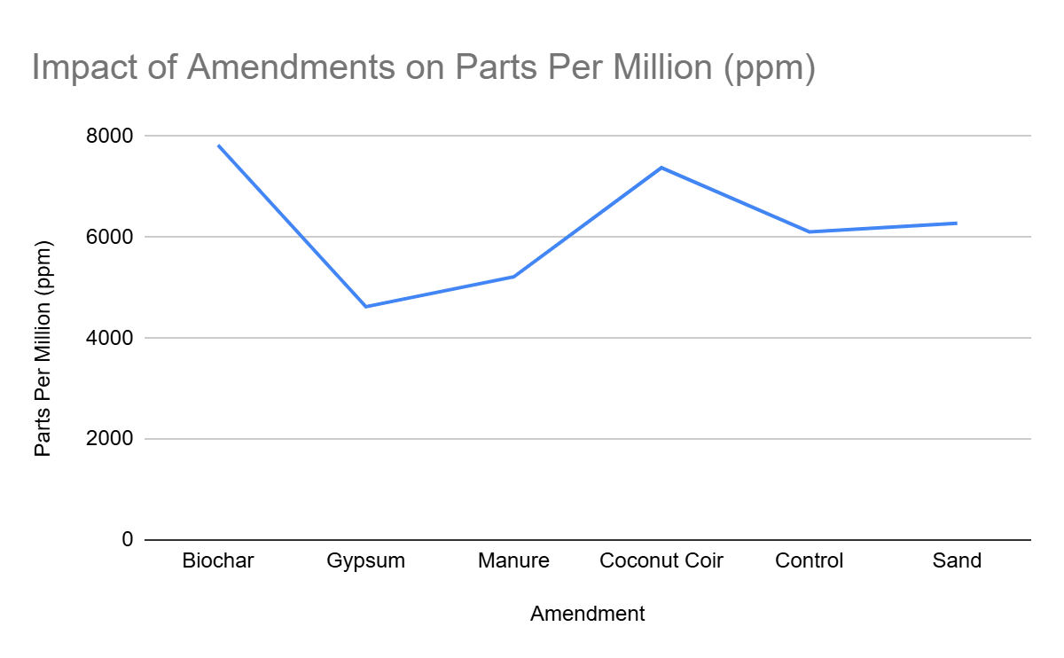

Figure 8- This graph displays the averages for the electrical conductivity of the leachate from the various amendments across all of the trials.

Figure 9-

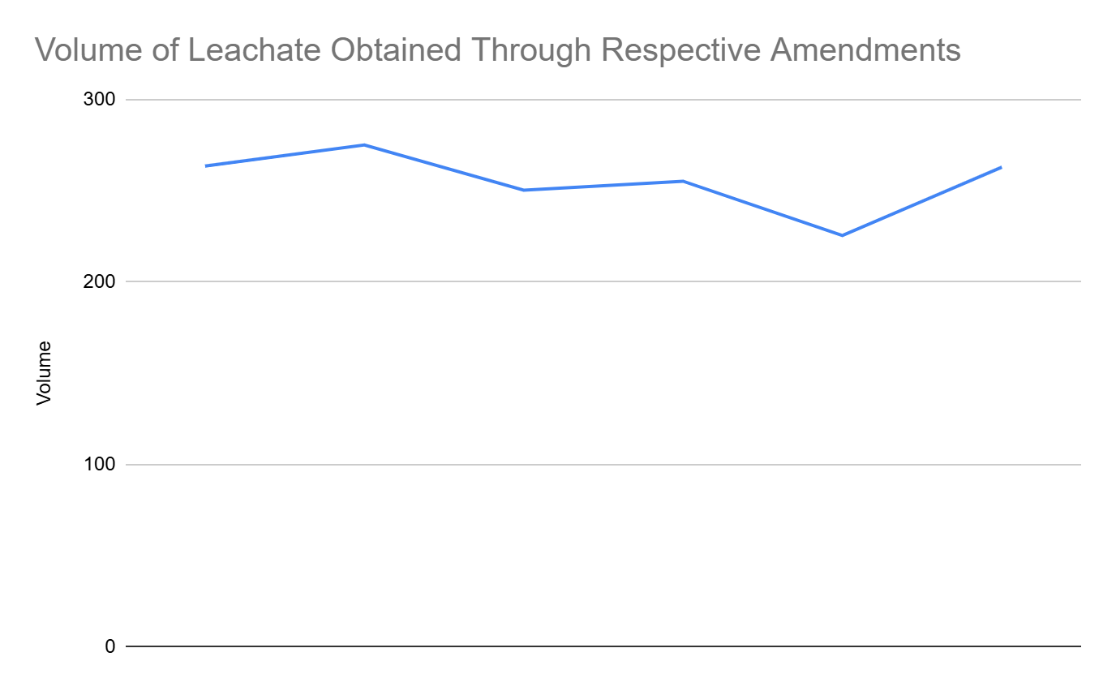
Figure 9- This graph displays the averages for the volume of the leachate from the various amendments across all of the trials.

Figure 10-

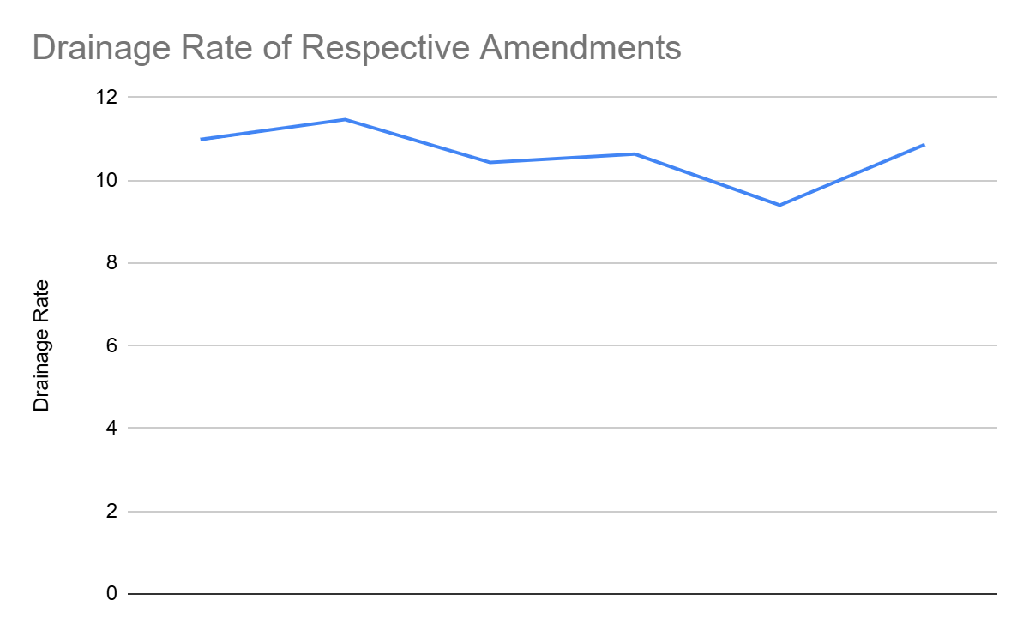

Figure 10- This graph displays the averages for the drainage rate of the leachate from the various amendments across all of the trials.

Figure 11-

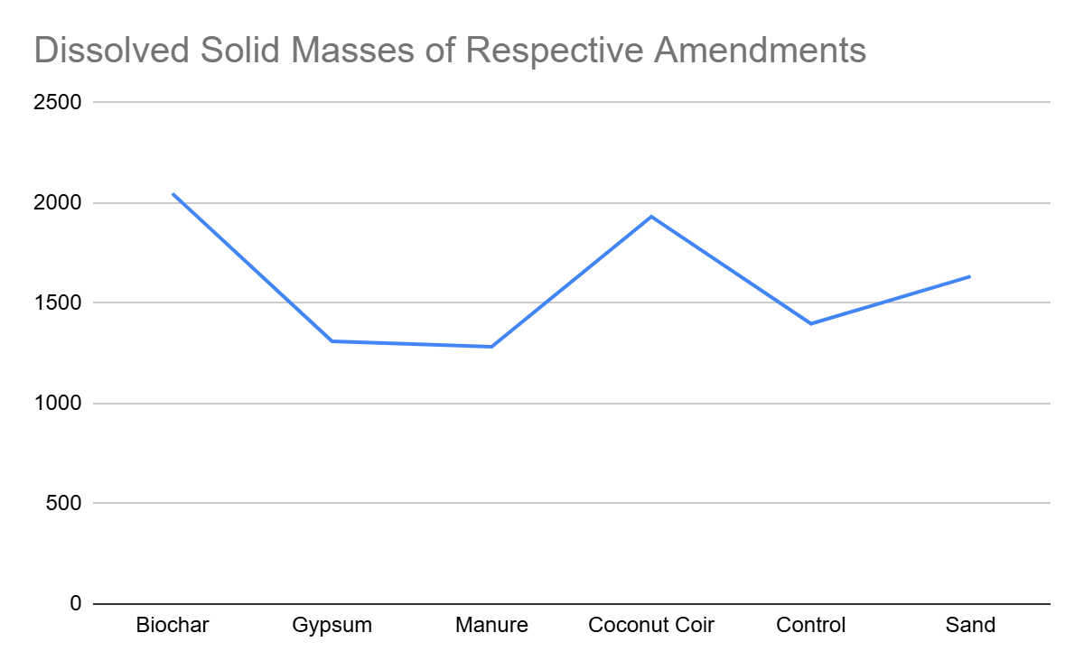

Figure 11- This graph displays the averages for the total dissolved solids of the leachate from the various amendments across all of the trials.

Experimental Observations, Analysis and Conclusion

Observations

Throughout the duration of the trials, numerous aspects of the soil, the amendments, and the water flow were observed as the distilled water was being poured onto the surface of the soil. Nonspecific observations were made, as well as those interconnected with their sole amendments. These two classifications are expressed below-
Nonspecific Observations
These are the observations that were notes for all of the trials and amendments. They include the following-
One of them was the fact that when the water was poured onto the surface of the soil, there was a formation of bubbles on the surface.
Another nonspecific observation was that the large dents formed on the surface of the soil after the first 1 or 2 trials.
Another observation was quite conspicuous and it was that the soil got saturated over each of the trials as it was observed that the water drained the best during the first trial, but after this, it became saturated to the extent where it had the ability to absorb more water, but it took a while to do so. An example of this was when I poured the water on the initial day of the trials and it was being absorbed in real time, yet on the day of the following trial, it took approximately 12 hours for the water poured that day to completely disappear from the surface of the soil. The soil was excessively damp and was understandably compact after the initial or especially the following trials.
Furthermore, it was observed that it took a longer period of time for the water to permeate through a soil surface which was compact and had no gaps through which the soil could slip through, while though surfaces of the soil that a crumblier texture to them were accessible to larger extent ot the water due to the fact that this looseness and lack of compactness created paths for the water to flow through.
The endmost nonspecific observation was that of the white lines formed on the surface of the soil during approximately all the trials as after the water was absorbed.

Distinct Observations

These observations are those that do not apply to all of the trials and they include the following-

One of these observations was the fact that the leachate from designated bottles had quite a range of colors. An exemplification of this was that the control, manure, and biochar leachate collections would often contain a larger amount of soil than the leachate found in coconut coir. Therefore, the color of the leachate in the control, manure, and biochar trials would often have a darkish brown hue to it, even after staring, while the coconut coir had a golden brown color to it and it had a larger amount of clarity.
Another distinct observation was that of the odor as it was distinguished that the odor in the trials involving any amendment or control other than gypsum was quite low, while the odor of gypsum was easily notable.
The following include some observations distinguished characteristically for each of the amendments
Control- There was a formation of bubbles and the drainage rate was quite unhurried, thereby almost causing the water to overflow over the brim of the bottle. Additionally, there was the formation of white lines in the bottles.
Sand- It had a drainage rate that was less rapid when differentiated from gypsum and manure, and the water easily congregates at the surface of the soil with this amendment.
Manure- It had an approximately comparable drainage rate to that of gypsum and there was a formation of bubbles at the surface of the soil.
Gypsum- It explicitly had the fastest drainage rate out of all of the trials and there were no bubbles formed. Furthermore, there were numerous cracks formed in the soil.
Biochar- There was a large amount of soil found in the leachate of these trials and their drainage rate was not as rapid as I had anticipated.
Coconut Coir- These trials had a golden brown leachate and amongst them, one of the coir bottles appeared to have an extensively sluggish drainage rate and this was in all likelihood due to the fact that there was a clog in the bottle. Eliminating this clog was attempted through churning the soil to a designated extent, but no difference was made. Another aspect of the coir was the fact that it had already been damp at the time when it was integrated into the soil. This could be one of the aspects that led it to have a less rapid drainage rate when distinguished from the other amendments.

Analysis

The explanation for the occurrence of the formation of bubbles on the surface of the soil during the pouring of the distilled water onto the soil. This was due to the fact that the air pockets or pores in the soil were flooded with water, thereby causing the escape of air onto the surface of the soil itself.

Furthermore, the formation of dents in the soil can be explained through the pressure that the water exerted on the soil surface, which is quite unsurprising to say the least.

Another aspect was the formation of white lines on the soil surface and this was in all likelihood due to the fact that salt crusts were being formed. They occur when salt water moves upward against gravity in the soil due to capillary action and then evaporates, but the salts are left behind, thereby creating these salt crusts. These crusts are indicators of saline soil and are not as commonly found in sodic soils, but their appearance is not impossible in sodic soils and can come when soluble salts are existing, which they were in this experiment.

Let us now analyze each of the trials and their respective results through their calculated averages, as shown in the earlier sections-

Before any of this, it is important to understand how all of the data is interconnected throughout the experimental results. One of them is the drainage rate and the volume of the leachate. As discussed in the procedure, drainage rate is a quantification of the volume of the leachate acquired divided by the time period taken, which was a controlled interval of 24 hours. Performing such a calculation for each of the amendments and their respective volume of leachate is the technique through which the drainage was quantified and therefore in a way, is an interpretation of the volume of the leachate for the respective amendments.

Another exemplification through which the data is linked is that of the dissolved solid mass, volume, and ppm measurements. It is important to note that ppm is parts per million, and it represents one unit of that substance for every one million units in the solution. For example, if a designated solution has a ppm measurement of 8000, then there are 8000 mg of dissolved solids in a litre of that solution. Another aspect of this is that ppm only measures dissolved substances. This is quite beneficial in this experiment as the salt that we integrated into the bottles was dissolved and there was no interference of undissolved soil particles in the results.

Therefore, as discussed in the procedure, converting the ml values to litres and then multiplying by the ppm will give us the mg of dissolved solids the amount of leachate that was acquired. Therefore, the dissolved solid mass is a representation or interpretation of the ppm and volume measurements. It is the principle outcome of the experiment as it tells us what the mass of the dissolved solids is, through which we can determine which amendment released the largest amount of salt out of the soil.

Though these dissolved solids can include salts and other soluble substances, it can safely be assumed that the majority of them are indeed salts. This is due to the fact that the soil was previously enriched with 5 grams of salt for each sample, as mentioned in the procedure, therefore increasing the salinity of the soil significantly. Therefore, it is reasonable to assume that a large amount of the dissolved solids mass came from these added salts.

The data supports this in the following way-

Let us take the example of the sample Gypsum 1. Throughout the trials, the dissolved solids mass was as follows-

Trial 1- 1696.971 Trial 2- 1590.68 Trial 3- 1063.35

If we add all of these values together, we obtain 4351.001. This is less than 5 grams, and therefore it can reasonably be assumed that the majority of these dissolved solids were those of the salts that were integrated into the soil. Though for other bottles, such as Biochar 1, this amount is greater than 5 grams, but biochar releases other soluble substances into the leachate as well, which can contribute to this.
Therefore, it can be said that the dissolved solids mass is an accurate representation of the amount of salts leached from the soil.

Trial 1-

It was found that sand, gypsum, coconut coir, and manure had quite a similar drainage rate, while the drainage rates for biochar and the control were quite lower than this. This could have been due to a variety of aspects.

The explanation for the drainage rates of coconut coir, sand, gypsum and manure being quite similar was that gypsum causes the soil to flocculate and creates channels in the soil through which water can traverse easily. Coconut coir has a high water retention capacity and can retain an amount of water that is 10x its weight. Though this is the case, this characteristic could have been affected through the soaking of the coconut coir prior to its integration into the soil. This led to the coir already being saturated to an extent before it was implemented into the soil, which could have reduced its ability to retain water, thereby increasing the drainage rate as it was able to retain less water. To mitigate this aspect, the coconut coir had been left to settle in an open air and dust free environment for 3 to 5 hours before usage to reduce an excessive amount of saturation. Furthermore, manure had a high drainage rate as it improves soil structure and retains water to some extent, but a lot of it drains through as well, while sand retains very little water as its main role in the soil is to improve drainage.

On the other hand, biochar and control had lower drainage rates as biochar retains water in its numerous pores, thereby slowing the speed of water flow while the control samples had not been enriched with any amendment, the soil in them was quite dense, thereby lowering drainage rate.

Those were some of the ways through which the varying drainage rates can be interpreted but the differences in the values are quite minor and a larger amount of data and information is required to explain these tiny differences with certainty. Though this is the case, these results were analyzed to the highest extent possible with the given data, tools and information access.

In this trial it was found that the highest dissolved solid mass was that coconut coir and this was due to the fact that it is quite porous and though it retains water to a large extent, it was partially saturated prior to its implementation as soaking it as required. This would have decreased water retention and increased the flow of water through the soil, thereby allowing a larger amount of salts to be leached out of the soil through this larger amount of water flow. Biochar on the other hand has numerous pores in which it has the ability to retain water and solutes. This is quite interesting as to how biochar has a higher dissolved solid mass, but a low drainage rate, but one possible way to explain this is that the slowly moving water traversed through various pores and carried a larger amount of dissolved solids with it in comparison to water that moved exceedingly fast and was only able to acquire salts from certain areas throughout the soil profile.

Sand is quite chemically inert and its high drainage rate carried an amount of salts from certain areas in the soil and sand itself did not contribute any ions, thereby lowering the dissolved solid mass. Gypsum’s dissolved solid mass was quite similar to that of sand, yet lower. This is quite interesting as it would have been more reasonable for it to be higher as gypsum contributes more ions and has a considerable drainage rate due to flocculation. Though this is the case, the difference in dissolved solid mass between gypsum and sand is quite minor and can be negligible for this experiment. Manure had quite a reasonable drainage rate similar to that of sand and other amendments as discussed before and has quite low dissolved solid mass, though manure does contribute nutrient ions as well. This aspect is quite interesting, but a larger amount of information and data is required to explain it with certainty.

In this trial it is important to realize that the drainage rate is the speed of the flow of water, while the dissolved solid mass is all the dissolved solids that were leached out of the soil. Therefore, a high drainage rate, but a low amount of dissolved solids is not a contradiction as the speed of the water could have been higher but it did not carry as many dissolved solids with it, while a slower drainage rate could have traversed more entirely throughout the soil and carried a large amount of dissolved solids with it.

Another observation in the results of this trial was that of the values of drainage rate and dissolved solid mass for the control samples being the lowest out of all the amendments. This could have been due to the fact that these samples did not have any amendment integrated into them and had no improved soil structure or characteristics in general. Therefore, the soil had a poor structure and a higher bulk density in comparison to the soils that had been enriched through amendments, thereby leading to lower drainage rate and dissolved solid mass.

Odour and clarity were aspects of the data as well though they were not as important or essential to the results of the experiment as the other data points of drainage rate, volume, ppm, and dissolved solid mass were. They were qualitative observations and odour was observed essentially only in gypsum and did not hold much value to the experiment itself.

In this trial it was found that there was quite a vast range for the amount of leachate that was created. This range was between the values of 170 to 285 ml.

Trial 2-

In this trial, it was observed that biochar experienced an increase in dissolved solid mass and this could have been for a variety of reasons. It is important to understand that, as discussed above, all of the data is interconnected and designated values can be used to explain others. In this case, biochar was found to have an increase in its volume of leachate and drainage rate with a low ppm difference. This increased leachate volume and similar ppm value are what led to biochar having an increased dissolved solid mass, and this is an occurrence that is consistent with the behaviour of porous amendments like that of biochar. This pattern is such that biochar retained salts in the first trial through its porous structure tendency to adsorb various substances which were then flushed out of the soil in the following trial.

Though this is the case, it is important to understand that though this was a feasible observation for biochar, there was a decreasing trend within the other amendments. This is due to their designated properties and characteristics. An exemplification of this is that of gypsum, which when integrated into the soil, displaces sodium ions off the clay particles and causes the soil to flocculate, thereby mobilizing the sodium ions into the soil. This process occurred during the interval between the set up of the bottles and the first round of leaching, as discussed in the procedure. Therefore, during the first trial, these mobilized sodium ions were flushed out of the soil, thereby leaving not a large amount of salts to be leached in the subsequent trials. Sand improves drainage and therefore the salts deplete over the trials and a similar trend is found throughout coconut coir and manure. Essentially, a large amount of salts are leached in the first trials, leading to a steady decrease in dissolved solid mass in the following trials.

There was a significant increase in all values for the control samples. This is in all likelihood an outlier. It will be discussed more in the following trial analysis.

The drainage rate remained similar throughout the first and second trials, with the small differences being negligible for the purposes of the experiment.

The volume of the leachate decreased for certain amendments, while it increased for others. An example of this is that of an increase in gypsum with a decrease in manure. This can be analyzed in the following way-

Biochar had an increase in volume as it improved drainage though its pores may have held water in trial one, but it was drained in trial 2, leading to the increase. Gypsum experienced an increase as well as it improves structure and drainage over time. Sand has a large particle size and could have created improved drainage pathways over the course of the two trials. Manure has organic matter, thereby retaining water over time, thereby decreasing leachate volume. Coconut coir on the other hand had a similar volume of leachate due to the reasoning analyzed in the first trial above.

This sharp increase for the control samples can be interpreted as an outlier as it returned to similar values in Trial 3 as it was in Trial 1. Therefore, this spike is likely a form of experimental variability or measurement error, though the latter is unlikely.

Trial 3-

In this trial, a similar trend was observed as in the second trial with a decrease in ppm and dissolved solid mass with negligible differences in the drainage rates, and variable increased and decreasing volumes of the leachate. Control was quantified with similar values as in trial one, thereby supporting the conclusion that its extreme measurements in trial 2 were outliers and a large amount of information, data, and tools is required to understand the rationale behind those unexpected results.

I found a trend during this experiment and it is that of the decreasing ppm values throughout the course of the trials. This is an explainable trend that suggests that the salts were being leached out of the soil over the course of the trials, thereby lowering the ppm values.

In this experiment it is important to note that the results can be analyzed in various ways and there are numerous perspectives and scientific angles. This is due to the fact that soil is extremely complex and how it reacts and performs is reliant on a variety of factors and aspects.

It is important to note that these conceptions are being derived from the calculated averages, which are considered to be an accurate representation of the individual trials themselves.

.

Conclusion

From this experiment, my initial hypothesis has been disproven and this is for the following reasons-

One of them is the aspect of amendments interacting differently with salts and drainage throughout the course of the three trials. This was due to the fact that, as discussed in depth in the analysis, that the amendments underwent various processes over the trials, thereby resulting in quite interesting outcomes.

Though this was the case, there was an amendment that increased the salt content in the leachate to the largest extent throughout the entirety of the trials and that amendment was biochar. This was due to the fact that it combined a high volume of leachate with a high ppm value. It improved the structure and overall porosity of the soil and led to higher amounts of leachate being formed along with a large amount of salts being flushed out of the soil profile. Though gypsum mobilizes salts and improves structure to the extent of soil flocculation ,biochar combines both physical and chemical efficiency in the leaching of salts in such a way that it releases more salts from the soil than gypsum.

Though this is the case, it is important to note that biochar releases other soluble substances into the soil as well, which could have increased the ppm, but adding 5 g of salts to 500 g of soil is a larger soluble input than the amount of soluble substances that biochar commonly releases.

Applications

Soil salinity is a notable issue with numerous negative implications and affects. The solution that was proposed throughout my experiment was that of amendments. Amendments have innumerable benefits as they are essentially self reliant, cost effective, natural, and realistic. This solution involving amendments could benefit numerous organizations and global aspects. If salinity is reduced in areas worldwide, global soil health could increase, resulting in a variety of benefits.
Soil is often represented as the skin of the earth and it is a vital component of the global food supply chain as 95% of the world’s food comes directly or indirectly from soil. Furthermore, plants are reliant on the soil for 15 of the 18 essential nutrients that are crucial for growth, including nitrogen, phosphorus and potassium. It is important to note that without the requisite biological processes that occur in the soil, crops would be unable to grow as these processes are what break down organic matter to release nutrients. Without these biological processes, the nutrients would remain embedded and would not be able to be used by plants.
Soil is the source of numerous medicines that we use today as it is brimming with biodiversity. A healthy teaspoon of soil contains more organisms such as bacteria, fungi, and nematodes, than people in the world. Innumerable medicines that we use today were discovered in biodiverse soil, including penicillin and streptomycin.
Soil is an essential carbon reservoir and the second largest carbon sink in the world, after the ocean. It stores three times as much carbon as the atmosphere, and twice as much as all the vegetative growth globally. This is due to the fact that when plants take in carbon dioxide from the atmosphere to execute photosynthesis, they make carbon sugars that are then pumped down through the roots to feed the soil microbes. These microbes then store this carbon in the soil and healthy soil can lock carbon away for centuries.
Soil can act as a water filtration system as when rainwater is absorbed by the soil, it is purified before reaching groundwater aquifers as numerous pollutants in the water get trapped throughout the soil profile. This prevents flash floods and keeps various large and metropolitan areas safe from natural disasters.
Numerous building materials that are used globally are also derived from the soil, including sand and clay.

Soil salinity is an extensive issue as solid degradation is escalating. We are destroying soil 100 times faster than it can be replenished as it takes a 1000 years to make 2-3 centimeters of topsoil. There various reasons why this is happening, including the following-
Soil erosion- This is a whole other spectrum of the topic of soil degradation, and it is being accelerated by climate change. This is due to the fact that climate change leads to extreme weather conditions which cause the topsoil to erode. This erosion then releases the stored carbon into the atmosphere, in turn accelerating climate change.
Agriculture- Many farmers around the world follow various practices which deplete soil nutrients, and degrade the soil quality in the long run. Such practices include monocropping, which is the planting of a single type of crop on a tract of land year after year. This rids the soils of certain nutrients, and degrades its health. These soils with less nutrients produce crops that are not as high in nutrients as they could have been if they were grown in healthy soil. This is why vegetables grown 100 years ago were more nutritious than they are today. Lots of industrial machinery also drives over the soil, and this squeezes air out of the pores in the soil and compacts it. This does not allow the roots of the crops to grow deep.
Salinization is another aspect of soil degradation and it occurs in dry regions through improper irrigation. When water that contains salts is used to irrigate farmland, the water eventually evaporates but leaves the salts behind. Over time, these salts accumulate and degrade the soil.

The aim of this project was to come up with a reasonable and realistic solution for soil salinity. The solution found was that of amendments. These amendments can be of assistance to farmers and gardeners around the globe. This is due to the fact that many farmers and gardeners struggle with soil salinity, and amendments can help solve this issue. Farmers can utilize these amendments on a large scale and observe an improvement in various areas in their field, including crop yield, soil health, and the local biodiversity. Gardeners on the other hand, will have a similar experience, though on a smaller scale. Another aspect of this solution is that of its base for new advancements in the field of agriculture and soil conservation. Research on solutions to issues that relate to soil can be conducted, which can improve various current issues, including the yield gap, degrading soil heath, and others. Natural amendments that positively affect the soil can be discovered and implemented, improving soil health. It is known that soil salinity occurs primarily in dryer regions, which are prominent in many developing countries. This indicates that cost effectiveness is an important aspect to the residents there. They want their nation to advance in an environmentally friendly, and yet realistic way. The solution explored in this project will fulfill their requirements effectively as the amendments described in this project are cost effective and commonly found. These are essential factors for the farmers there who want to improve their crop yield in a cost effective manner.
Furthermore, soil salinity influences various global issues, including food security, freshwater availability, and infrastructural stability. Though it does not affect them on an extremely large scale, it does play a role in the broader scope of things. Improvements made in the soil salinization area will affect these issues in one way or another. The interconnections between these global issues and soil salinity include the following-
Soil salinity is intertwined with global food security as large amounts of otherwise cultivable and fertile land are transformed into fallow and uncultivable land. This indicates that there is less land for agricultural purposes to feed a growing population. Soil salinity leads to the worsening of the yield gap, and it negatively affects the economies of numerous agrarian regions around the globe. Furthermore, this issue has been found to worsen the impacts of climate change as due to the change in climate, the mean sea level is rising. This indicates that seawater from these rising sea levels will find its way into fresh bodies of water and underground aquifers. Due to this, this water is considered unsuitable for irrigation as its use will only worsen salinity. Climate change is known to increase evaporation rates from their usual high selves in arid regions, making the accumulation of salts there inevitable. Additionally, soil salinity can cause humanitarian crises as the loss of arable land on various farms can lead to farmers and other agricultural practitioners to lose their livelihoods. In search of a new profession, this can cause mass migrations into cities and urban areas and create sociopolitical stress. In addition to this, soil salinity is one of the leading causes for freshwater pollution worldwide and it threatens biodiversity and can lead to ecosystem degradation. This is through the fact that when the salt concentration in the soil becomes higher than its need, the soil is unable to perform various processes, including those of natural pollutant filtration and carbon sequestration. This interferes with the nitrogen, carbon, and hydrological cycles, thereby affecting biodiversity of that designated area in the process.
From the above information, it is reasonable to conclude that a solution to this issue is the need of the moment and amendments are one of the ways that these various problems can be improved.

Next Steps

A numerous number of next steps can be taken in the future to further improve this experiment, as well as the other aspects of this project. These include the following-
iVariation of Manipulated Variables- This implies that a larger number of amendments can be tested throughout the trials in this project. This would have given us a wider range of results, giving us a considerable perspective on the idea of using amendments as a way to battle soil salinity. Examples of other amendments that can possibly be tested in this experiment include mulch, vermicompost, peat moss, and ash. To manipulate these amendments to a larger extent, we can mix different amounts of them into the same amount of soil. For example, we could mix 25g of biochar into 500g of soil, and mix 75g of biochar into another 500g of soil. This would have also told us how a given amount of each amendment affects a given quantity of soil.
It is also known that a few of our results are thoroughly qualitative, but some of them can be made quantitative through the use of other tools. An example of this is to measure clarity with a Secchi disk instead of measuring out results related to clarity in an entirely qualitative manner. We can measure the drainage rate through a stopwatch to see how fast the water was absorbed into the soil. These quantitative observations can give us raw and reliable data to work with.
We can also test different volumes of water on different soils to differentiate between the effectiveness of amendments in areas that receive a considerable amount of rainfall each year against those that do not.
Scale- This experiment can be taken to a larger scale by taking and testing larger quantities of soil. This would give us an idea of the scalability of the solution, as well as a glimpse of the bigger picture if this is going to be a reliable solution for addressing soil salinity.
Modifications- There are numerous ways to modify this experiment in the future through using a larger amount of sample sets and measuring all kinds of different aspects instead of solely the mL and ppm of the leachate. An exemplification of this is that I could have a new sample set for each trial, thereby avoiding how the saturation negatively affected the soil over the trials.
In the future, I can connect with those who have expertise in the field of soil as online research would be unmatched to the amount of insight that a true expert could provide. They could widen my scope on testability, quantification, and other aspects.
These changes, as well as having access to infinite cups and other resources can improve my experiment if I were to do it in the future.
These were some of the endeavors I could implement if I were to do this experiment in the future.

Limitations

There were a few limitations that were related to this experiment and they are expressed below-
Lack of Cups- One of the limitations for this experiment was the lack of cups, and though this in all likelihood did not affect the results of my experiment, it can definitely be termed as limitation. This was why we had to rinse the cups during the measuring and other times when they were needed. Though this was the case, it was ensured that no dirty cups were used in the experiment for purposes that related to our controlled environment and results.
Cup size- During the experiment, it was found that the cups being used to collect the leachate from the soil did not have enough capacity to hold the amount of leachate that was being obtained. Therefore, every 12 hours or halfway through the experiment in each trial, the full cups with the leachate would be removed and labeled and the bottles would be given empty fresh cups for leachate collection for the remaining 12 hours in the trial. For the measurement aspect, both the cups would be mixed to obtain a clean measurement. Though it is quite unlikely that this affected my results, it was a hurdle that came up during the experiment.
Soil consistency- The consistency of the soil was an uncontrollable area of my experiment. This is due the fact that non-uniform soil could have clumps and stones in areas that would not allow for a controlled trial for each sample set. Though this was the case, there was no way of determining whether the soil being used was completely consistent or not. Though this did affect the controlled area of the experiment, it reflected real life soil conditions which would not be entirely consistent. Though this was the case, I did my utmost to ensure that the soil was consistent. I laid it out on a tarp and took out any large clumps of hardened soil or rock to obtain a soil mixture that looked consistent to the eye. Furthermore, I let the soil sit in a room temperature environment for approximately a few days before usage to let the soil completely settle down.

Concentration and total salt content- This was one of the dominant limiting factors for the conduction of this experiment. It was the fact that though the objective of the experiment itself was to measure the total salt content, the leachate contained all other kinds of dissolved substances and ions other than those of sodium chloride ,thereby influencing the ppm value. It was determined that the ppm value measured the concentration of salts in the leachate as the leachate volumes differed as well. This was a limitation in this experiment and can be looked into in the future through different measurement tools and apparatus that were not available during the experiment.

Access to Scientific Instruments and Tools- This was a major limitation throughout the experiment as the measurements that were taken were quantified through the tools available. It was indicated that ppm does not quantify the total amount of salt in a designated amount of leachate, but it can provide an extensively reasonable estimate of this value. Though this is the case, there are elaborate tools that could be used to obtain an exact value, but these were unavailable to me during the time of the experiment. Furthermore, there are other scientific instruments for the quantification of clarity and drainage rate, but the measurements in the experiment were taken through those instruments and tools available to me at the time at my scientific level.

Sources of Error

There were a number of aspects in the experiment that may or may not have affected my results -

Measurement errors- This is highly unlikely but there could have been a smidge of measurement errors in the experiment. It was ensured that there was no error in measurement for the weighing of the amount of salt, water, soil and amendments. These errors, if there are any, most likely occurred during the ppm measurement of the leachate. This is due to the fact that ppm is an extremely precise measurement and can fluctuate greatly based on small factors. To address this issue, I did my utmost to make sure that the meter was calibrated during each and every measurement. Though this was the case, there was a chance that those smidges of measurement errors could have gotten through.

Water Pouring- After the first trial of my experiment, the soil in each of the bottles had become extremely saturated, and it was difficult for more water to percolate through its pores. This was why it was impossible to pour the water into each of the bottles in such a way that the next pour only started after the last one had been fully absorbed. This is the reason why I then instead poured all the water at once into the bottles and let it absorb in its own time. This would not have had a large effect on the results of my experiment as the same amount of water was poured onto the soil nonetheless.

Timing- One of the other aspects that had an extensively minute effect on my results was the timing of the experiment. As there were a large amount of samples, it became quite difficult to manage them in the space where the experiment was being conducted. Therefore the entire experiment was conducted in two halves in which 9 of 18 samples would be tested on the first 3 days and the other 9 samples in the following 3 days in the same location. This would not have had a significant effect on the results as the area of the experiment is regulated through a thermostat and no considerable changes occurred in the experimental environment itself, thereby keeping it a controlled variable.
Clogging- One of the coir bottles was clogged and it produced results but not to the extent it could have if it was not clogged. The water essentially sat on the surface and a minimal amount was absorbed and turned into leachate in this trial. This affected my results.
Missing Numerics- The final source of error was that the data for Trial Coconut Coir Bottle Number Two was not able to be obtained. Though this was the case, the values of the leachate volume and ppm measurement for Coconut Coir 2 in Trial 3 were averaged through the other trials as it was observed that the values of ml and ppm for respective amendments in their designated trial were quite similar. This was the reason through which these values were estimated realistically.
Another aspect of my measurements that is not necessarily a source of error that I would like to address is the qualitative observations. It is to be noted that all the measurements of clarity and odour are merely observational and are not quantitative numerics.

Acknowledgements

I would like to acknowledge the numerous individuals and institutions who have encouraged and assisted me throughout the completion of this project. Needless to say, my family has been a continuous source of encouragement and motivation for me. Furthermore, I would like to acknowledge my teachers, Ms. Beatty and Mr. Barg, who have constantly provided guidance throughout the duration of this project. I would also like to acknowledge my local community clubhouse for providing me with one of the essential materials for my experiment, which was sand. Mr. Bykovskikh, our school science fair coordinator, has rectified and revised my project with regard to the high standards that are required at a city level science fair. Lastly, I would like to express gratitude to my school, R.T. Alderman and the CYSF community for providing me with the opportunity to showcase my work in the best possible way. Thank you to all of these individuals and institutions who have contributed to this unforgettable experience.

Citations

Tilley, N. (2021, June 1). The benefits of manure compost in your garden. Gardening Know How. https://www.gardeningknowhow.com/composting/manures/the-benefits-of-manure-in-your-garden.htm
Nima Shokri, A. H. (2024a, October 21). Soil salinization: A rising threat to ecosystems and Global Food Security. Eos. https://eos.org/editors-vox/soil-salinization-a-rising-threat-to-ecosystems-and-global-food-security
N;, H. A. A. (n.d.). Global predictions of primary soil salinization under changing climate in the 21st Century. Nature communications. https://pubmed.ncbi.nlm.nih.gov/34795219/
PhycoTerra®. (2025a, June 6). What is soil salinity? causes, affects, mitigation, and more. https://phycoterra.com/blog/soil-salinity-causes-affects-mitigation/
Fao.org. Soil salinity | Global Soil Partnership | Food and Agriculture Organization of the United Nations. (n.d.). https://www.fao.org/global-soil-partnership/areas-of-work/soil-salinity/en/
Fao.org. Soil salinization as a global major challenge | ITPS soil letter #3 | Global Soil Partnership | Food and Agriculture Organization of the United Nations. (n.d.-a). https://www.fao.org/global-soil-partnership/resources/highlights/detail/en/c/1412475/
Fao.org. Soil salinization as a global major challenge | ITPS soil letter #3 | Global Soil Partnership | Food and Agriculture Organization of the United Nations. (n.d.-b). https://www.fao.org/global-soil-partnership/resources/highlights/detail/en/c/1412475/
Environmental Protection Agency. (n.d.). EPA. https://www.epa.gov/sciencematters/epa-researching-impacts-freshwater-salinization-syndrome
(PDF) soil salinity: A global threat to sustainable development. (n.d.-aj). https://www.researchgate.net/publication/355487013_Soil_salinity_A_global_threat_to_sustainable_development
Food security and socio-economic impacts of soil ... (n.d.-x). https://jagroforenviron.com/wp-content/uploads/2018/09/25.-Food-security-and-socio-economic-impacts-of-soil-salinization-in-the-central-dry-zone-of-Myanmar-a-case-study-Aung-Naing-Oo.pdf
Nima Shokri, A. H. (2024b, October 21). Soil salinization: A rising threat to ecosystems and Global Food Security. Eos. https://eos.org/editors-vox/soil-salinization-a-rising-threat-to-ecosystems-and-global-food-security
Ullah, A., Bano, A., & Khan, N. (2026, February 25). Climate change and salinity effects on crops and chemical communication between plants and plant growth-promoting microorganisms under stress. Frontiers. https://www.frontiersin.org/journals/sustainable-food-systems/articles/10.3389/fsufs.2021.618092/full
Fred Pearce • May 10, Fred Pearce, Fred Pearce, The Mekong Delta is under a chemical threat arguably more deadly for the long term than the Agent Orange deployed across it during the Vietnam War half a century ago. By the middle of this century, Fred Pearce was a freelance author and journalist based in the U.K. He is a contributing writer for Yale Environment 360 and is the author of numerous books, Pearce →, M. about F., Struzik, E., Struzik, E., Pearce, F., Pearce, F., Jones, N., & Jones, N. (n.d.-a). Salt scourge: The dual threat of warming and rising salinity. Yale E360. https://e360.yale.edu/features/salt-scourge-the-dual-threat-of-warming-and-rising-salinity
Dasgupta, S., Hossain, M. M., Huq, M., & Wheeler, D. (2015, December). Climate change and soil salinity: The case of coastal Bangladesh. Ambio. https://pmc.ncbi.nlm.nih.gov/articles/PMC4646857/
Fred Pearce • May 10, Fred Pearce, Fred Pearce, The Mekong Delta is under a chemical threat arguably more deadly for the long term than the Agent Orange deployed across it during the Vietnam War half a century ago. By the middle of this century, Fred Pearce was a freelance author and journalist based in the U.K. He is a contributing writer for Yale Environment 360 and is the author of numerous books, Pearce →, M. about F., Struzik, E., Struzik, E., Pearce, F., Pearce, F., Jones, N., & Jones, N. (n.d.-b). Salt scourge: The dual threat of warming and rising salinity. Yale E360. https://e360.yale.edu/features/salt-scourge-the-dual-threat-of-warming-and-rising-salinity
R;, S. P. (n.d.). Soil Salinity: A serious environmental issue and plant growth promoting bacteria as one of the tools for its alleviation. Saudi journal of biological sciences. https://pubmed.ncbi.nlm.nih.gov/25737642/
(PDF) soil salinity: A global threat to sustainable development. (n.d.-ak). https://www.researchgate.net/publication/355487013_Soil_salinity_A_global_threat_to_sustainable_development
Soil Salinity: A threat to Global Food Security | request PDF. (n.d.-bh). https://www.researchgate.net/publication/310621326_Soil_Salinity_A_Threat_to_Global_Food_Security
Fao.org. Soil salinization as a global major challenge | ITPS soil letter #3 | Global Soil Partnership | Food and Agriculture Organization of the United Nations. (n.d.-c). https://www.fao.org/global-soil-partnership/resources/highlights/detail/en/c/1412475/
Managing salinity | Murray–darling basin authority. (n.d.-ad). https://www.mdba.gov.au/climate-and-river-health/water-quality/salinity/managing-salinity
PhycoTerra®. (2025b, June 6). What is soil salinity? causes, affects, mitigation, and more. https://phycoterra.com/blog/soil-salinity-causes-affects-mitigation/
Stavi, I., Thevs, N., & Priori, S. (2026b, February 23). Soil salinity and Sodicity in drylands: A review of causes, effects, monitoring, and restoration measures. Frontiers. https://www.frontiersin.org/journals/environmental-science/articles/10.3389/fenvs.2021.712831/full
Basics of salinity and sodicity effects on soil physical properties. Basics of Salinity and Sodicity Effects on Soil Physical Properties - MSU Extension Water Quality | Montana State University. (n.d.-a). https://waterquality.montana.edu/energy/cbm/background/soil-prop.html
Nima Shokri, A. H. (2024c, October 21). Soil salinization: A rising threat to ecosystems and Global Food Security. Eos. https://eos.org/editors-vox/soil-salinization-a-rising-threat-to-ecosystems-and-global-food-security
Canada, A. and A.-F. (2022, May 16). Government of Canada. Agriculture and Agri-Food Canada. https://agriculture.canada.ca/en/agricultural-production/soil-and-land/soil-salinization-indicator
Soil salinization: How to prevent and manage its effects. EOS Data Analytics. (2025a, September 2). https://eos.com/blog/soil-salinization/
Stavi, I., Thevs, N., & Priori, S. (2026c, February 23). Soil salinity and Sodicity in drylands: A review of causes, effects, monitoring, and restoration measures. Frontiers. https://www.frontiersin.org/journals/environmental-science/articles/10.3389/fenvs.2021.712831/full
Queensland;, c=AU; o=The S. of. (2013, October 1). Impacts of salinity. Environment, land and water | Queensland Government. https://www.qld.gov.au/environment/land/management/soil/salinity/impacts
González, Y., Miranda-Cantillo, C., Quintero-Torres, J., Rhenals-Julio, J. D., Jaramillo, A. F., & Cabello-Eras, J. J. (2024, September 26). Substitution of sand in concrete blocks with coconut fiber and cattle manure: Effects on compressive strength and thermal conductivity. MDPI. https://www.mdpi.com/2075-5309/14/10/3092
Chapter 6 soil amendments - ardcorp. (n.d.-l). http://ardcorp.ca/wp-content/uploads/2017/11/EFP-Reference-Guide-Chapter-6.pdf
The Business Research Company. (2026, February 1). Biochar fertilizer market report 2026, size and growth analysis. https://www.thebusinessresearchcompany.com/report/biochar-fertilizer-global-market-report
Soil amendments. CALS. (n.d.). https://cals.cornell.edu/national-good-agricultural-practices-program/resources/educational-materials/decision-trees/soil-amendments
Soil amendments : Food safety resources : Center for agriculture, food, and the Environment (CAFE) at UMass Amherst. Center for Agriculture, Food, and the Environment at UMass Amherst. (2024, November 19). https://www.umass.edu/agriculture-food-environment/resources/food-safety/for-farmers/general-food-safety-information/soil-amendments
(PDF) the role of biochar and biochar-compost in improving soil quality and crop performance: A Review. (n.d.-am). https://www.researchgate.net/publication/318054137_The_role_of_biochar_and_biochar-compost_in_improving_soil_quality_and_crop_performance_A_review
Coconut coir compost, coconut coir soil: 7 top benefits. Farmonaut®. (2025a, September 17). https://farmonaut.com/blogs/coconut-coir-compost-coconut-coir-soil-7-top-benefits
Soil Amendment and fertilizer comparison. (n.d.-ba). https://www2.gov.bc.ca/assets/gov/environment/waste-management/organic-waste/biosolids/biosolids-manure-comparison.pdf
The 5 best biochar carbon credit and offset projects of 2026. Regreener. (n.d.). https://www.regreener.earth/blog/the-5-best-biochar-carbon-credit-and-offset-projects-of-2026
Zaman, M., Shahid, S. A., & Heng, L. (1970a, January 1). Irrigation Systems and zones of salinity development. SpringerLink. https://link.springer.com/chapter/10.1007/978-3-319-96190-3_4
Platt, J. (2023, November 30). Humour me: What exactly is humus?. Zylem. https://zylemsa.co.za/blog/humour-me-what-exactly-is-humus/
ltd, R. and M. (n.d.). Soil amendments market size, competitors & forecast to 2032. Soil Amendments Market Size, Competitors & Forecast to 2032. https://www.researchandmarkets.com/report/soil-amendment
Seacliff Organics. (1970, April 14). The living soil: Bacteria. https://seaclifforganics.nz/blogs/news/the-living-soil-bacteria?srsltid=AfmBOorJKIavy9mntlVG_7wbNEetSuA0u6dKALpLwaEf1GtuWezxWSdx
Simurgh.media. (n.d.). Usage areas of tractors in agriculture and construction sectors. HARS. https://www.hars.com.tr/en/usage-areas-of-tractors-in-agriculture-and-construction-sectors
Barley | description, nutrition, uses, & facts | britannica. (n.d.-e). https://www.britannica.com/plant/barley-cereal
TWL Irrigation, & Ware, T. (2023, June 6). How do lawn sprinklers work?. TWL Irrigation. https://www.twl-irrigation.com/how-do-lawn-sprinklers-work/
Kohfeld, M. (2025, August 8). Demystifying a drip irrigation system. Seattle’s Favorite Garden Store Since 1924 - Swansons Nursery. https://www.swansonsnursery.com/blog/drip-irrigation-system
Fao.org. Soil infographics | Global Soil Partnership | Food and Agriculture Organization of the United Nations. (n.d.). https://www.fao.org/global-soil-partnership/resources/news/presentations-gsb23/en/c/284443/
Google. (n.d.-a). Google search. https://www.google.com/search?q=https%3A%2F%2Fwww.researchgate.net%2Fpublication%2F343248386_The_Role_of_Organic_and_Inorganic_Amendments_in_Reducing_Salinity_Stress_and_Enhancing_Crop_Production_in_Salt-Affected_Soils&safe=active&ssui=on
Megandickerson. (2025, January 27). 3 raised bed soil mixes compared. The Beginner’s Garden. https://journeywithjill.net/gardening/2020/03/09/3-raised-bed-soil-mixes-compared/
Bootstrap Farmer. (2025, March 10). A beginner’s guide to the best soil amendments for Healthier Gardens. https://www.bootstrapfarmer.com/blogs/homesteading/beginners-guide-to-the-best-soil-amendments
Royal Horticultural Society. (2025, December 19). Green manures. RHS Advice. https://www.rhs.org.uk/soil-composts-mulches/green-manures
Collie, S. (2023, March 13). 12 miracle soil amendments to set your garden up for Success. Seeds ’n Such. https://seedsnsuch.com/blogs/gardeners-greenroom/12-miracle-soil-amendments-to-set-your-garden-up-for-success
Hassani, N. (2024, August 5). Guide to soil amendments: What they are and how to use them. The Spruce. https://www.thespruce.com/guide-to-soil-amendments-7095754
Projar, S., Dooley, T., Cimaglio, C., staff, G. G., & Sparks, B. D. (2020, October 30). Why plants prefer coir, and growers as well. Greenhouse Grower. https://www.greenhousegrower.com/sponsor/projar-group/why-plants-prefer-coir-and-growers-as-well/
Abad, M., & Puchades, R. (2025, May 10). Physico-Chemical and chemical properties of some coconut coir dusts for use as a peat substitute for containerised ornamental plants. Bioresource Technology. https://www.academia.edu/14371788/Physico_chemical_and_chemical_properties_of_some_coconut_coir_dusts_for_use_as_a_peat_substitute_for_containerised_ornamental_plants
Coconut Coir: The new gardening superstar. Humboldts Secret Supplies. (n.d.). https://humboldtssecretsupplies.com/blogs/articles/coconut-coir-the-new-gardening-superstar
Iannotti, M. (2024, September 18). How do you use coir in the garden?. The Spruce. https://www.thespruce.com/what-is-coir-1403141
Boeckmann, C. (2026, January 16). How to prepare your garden soil for planting. Almanac.com. https://www.almanac.com/soil-preparation-how-do-you-prepare-garden-soil-planting
Physical and chemical properties of coir waste and their relation to plant growth. ishs. (n.d.). https://ishs.org/ishs-article/450_45/
We apologize for the inconvenience... Radware Captcha Page. (n.d.). https://stormwater.pca.state.mn.us/?title=Coir_and_applications_of_coir_in_stormwater_management
Basics of salinity and sodicity effects on soil physical properties. Basics of Salinity and Sodicity Effects on Soil Physical Properties - MSU Extension Water Quality | Montana State University. (n.d.-b). https://waterquality.montana.edu/energy/cbm/background/soil-prop.html
Effect of crop rotation and fertilization on the quantitative relationship between spring wheat yield and moisture use in southwestern Saskatchewan. (n.d.-q). https://cdnsciencepub.com/doi/10.4141/cjss88-001
Soil thermal properties: Influence of no-till cover crops. (n.d.-bj). https://cdnsciencepub.com/doi/full/10.1139/cjss-2023-0095
Google. (n.d.-b). Google search. https://www.google.com/search?q=https%3A%2F%2Fextension.usu.edu%2Fyardandgarden%2Fresearch%2Fgardening-in-sand-soils&safe=active&ssui=on
CLARK, W. by C. A. (n.d.). The important role of soil texture on water. Crops and Soils. https://cropsandsoils.extension.wisc.edu/articles/the-important-role-of-soil-texture-on-water/
Gypsum - nature’s Way Resources. Natures Way Resources. (2024, July 16). https://www.natureswayresources.com/gypsum/
Basics of salinity and sodicity effects on soil physical properties. Basics of Salinity and Sodicity Effects on Soil Physical Properties - MSU Extension Water Quality | Montana State University. (n.d.-c). https://waterquality.montana.edu/energy/cbm/background/soil-prop.html
Brillante, L., Singh, K., & Singh, L. B. and K. (2023, January 23). Use of gypsum to reclaim salt problems in soils. Progressive Crop Consultant. https://progressivecrop.com/2022/01/24/use-of-gypsum-to-reclaim-salt-problems-in-soils/
Cabi Digital Library - Home. (n.d.-g). https://www.cabidigitallibrary.org/
Google. (n.d.-c). Google search. https://www.google.com/search?q=https%3A%2F%2Fextension.usu.edu%2Fyardandgarden%2Fresearch%2Fgardening-in-sand-soils&safe=active&ssui=on
Bello, S. K., Alayafi, A. H., AL-Solaimani, S. G., & Abo-Elyousr, K. A. M. (2021, August 29). Mitigating soil salinity stress with gypsum and Bio-Organic Amendments: A Review. MDPI. https://www.mdpi.com/2073-4395/11/9/1735
Wikimedia Foundation. (2026b, February 7). Gypsum. Wikipedia. https://en.wikipedia.org/wiki/Gypsum
Gypsum. Mosaic Crop Nutrition. (2023, July 11). https://www.cropnutrition.com/resource-library/gypsum/
El-sayed, M. E. A., Hazman, M., Abd El-Rady, A. G., Almas, L., McFarland, M., Shams El Din, A., & Burian, S. (2021, November 9). Biochar reduces the adverse effect of saline water on soil properties and wheat production profitability. MDPI. https://www.mdpi.com/2077-0472/11/11/1112
Biochar effects on salt-affected soil properties and plant productivity: A global meta-analysis - sciencedirect. (n.d.-f). https://www.sciencedirect.com/science/article/abs/pii/S0301479724016396
Premalatha, R. P., Bindu, J. P., Nivetha, E., Malarvizhi, P., Manorama, K., Parameswari, E., & Davamani, V. (2026, February 20). A review on biochar’s effect on soil properties and crop growth. Frontiers. https://www.frontiersin.org/journals/energy-research/articles/10.3389/fenrg.2023.1092637/full
Khan, S., Irshad, S., Mehmood, K., Hasnain, Z., Nawaz, M., Rais, A., Gul, S., Wahid, M. A., Hashem, A., Abd Allah, E. F., & Ibrar, D. (2024a, January 8). Biochar production and characteristics, its impacts on soil health, crop production, and Yield Enhancement: A Review. Plants (Basel, Switzerland). https://pmc.ncbi.nlm.nih.gov/articles/PMC10821463/
Zhu, Z., Zhang, Y., Tao, W., Zhang, X., Xu, Z., & Xu, C. (2025, March 4). The biological effects of biochar on Soil’s physical and Chemical Characteristics: A Review. MDPI. https://www.mdpi.com/2071-1050/17/5/2214
Khan, S., Irshad, S., Mehmood, K., Hasnain, Z., Nawaz, M., Rais, A., Gul, S., Wahid, M. A., Hashem, A., Abd Allah, E. F., & Ibrar, D. (2024b, January 8). Biochar production and characteristics, its impacts on soil health, crop production, and Yield Enhancement: A Review. Plants (Basel, Switzerland). https://pmc.ncbi.nlm.nih.gov/articles/PMC10821463/
Soil sodicity - an overview | sciencedirect topics. (n.d.-bi). https://www.sciencedirect.com/topics/agricultural-and-biological-sciences/soil-sodicity
Google. (n.d.-d). Google search. https://www.google.com/search?q=https%3A%2F%2Fwww.nrcs.usda.gov%2Fsites%2Fdefault%2Ffiles%2F2022-10%2FSalinity-and-Sodicity.pdf&safe=active&ssui=on
Capillary action and water. USGS. (n.d.-a). https://www.usgs.gov/water-science-school/science/capillary-action-and-water
Google. (n.d.-e). Google search. https://www.google.com/search?q=https%3A%2F%2Fwww.nature.com%2Fscitable%2Fknowledge%2Flibrary%2Fwater-movement-in-soil-13235184%2F&safe=active&ssui=on
Google. (n.d.-f). Google search. https://www.google.com/search?q=https%3A%2F%2Fwater.unl.edu%2Farticle%2Fagricultural-water-management%2Fsoil-water-basics&safe=active&ssui=on
Google. (n.d.-g). Google search. https://www.google.com/search?q=https%3A%2F%2Fwww.frontiersin.org%2Farticles%2F10.3389%2Ffpls.2020.574186%2Ffull&safe=active&ssui=on
3. saline soils and their management. (n.d.-a). https://www.fao.org/4/x5871e/x5871e04.htm
Halophyte - an overview | sciencedirect topics. (n.d.-y). https://www.sciencedirect.com/topics/agricultural-and-biological-sciences/halophyte
Google. (n.d.-h). Google search. https://www.google.com/search?q=https%3A%2F%2Fwww.nrcs.usda.gov%2Fsites%2Fdefault%2Ffiles%2F2022-10%2FSalinity-and-Sodicity.pdf&safe=active&ssui=on
Saline and sodic soils. NDSU Agriculture. (2021, July 23). https://www.ndsu.edu/agriculture/ag-hub/ag-topics/crop-production/soil-health/saline-and-sodic-soils
Google. (n.d.-i). Google search. https://www.google.com/search?q=https%3A%2F%2Flawr.ucdavis.edu%2Fcooperative-extension%2Firrigation%2Fsalinity&safe=active&ssui=on
Google. (n.d.-j). Google search. https://www.google.com/search?q=https%3A%2F%2Fextension.arizona.edu%2Fpubs%2Fmanaging-sodic-soils-southwest&safe=active&ssui=on
Google. (n.d.-k). Google search. https://www.google.com/search?q=https%3A%2F%2Fwww.fao.org%2F3%2Fi3805e%2Fi3805e.pdf&safe=active&ssui=on
Soil Horizon - an overview | sciencedirect topics. (n.d.-bc). https://www.sciencedirect.com/topics/agricultural-and-biological-sciences/soil-horizon
Google. (n.d.-l). Google search. https://www.google.com/search?q=https%3A%2F%2Fwww.fao.org%2F3%2Fi3805e%2Fi3805e.pdf&safe=active&ssui=on
Google. (n.d.-m). Google search. https://www.google.com/search?q=https%3A%2F%2Feducation.nationalgeographic.org%2Fresource%2Fsoil-horizon&safe=active&ssui=on
Google. (n.d.-n). Google search. https://www.google.com/search?q=https%3A%2F%2Fwww.nrcs.usda.gov%2Fsites%2Fdefault%2Ffiles%2F2022-09%2FSoil-Physical-Properties.pdf&safe=active&ssui=on
Google. (n.d.-o). Google search. https://www.google.com/search?q=https%3A%2F%2Fwww.csiro.au%2Fen%2Fresearch%2Fnatural-resources%2Fsoil%2Fsoil-salinity&safe=active&ssui=on
Google. (n.d.-p). Google search. https://www.google.com/search?q=https%3A%2F%2Fwww.sciencedirect.com%2Fscience%2Farticle%2Fpii%2FS266601642100010X&safe=active&ssui=on
3. saline soils and their management. (n.d.-b). https://www.fao.org/4/x5871e/x5871e04.htm
Humic substance - an overview | sciencedirect topics. (n.d.-z). https://www.sciencedirect.com/topics/agricultural-and-biological-sciences/humic-substance
Google. (n.d.-q). Google search. https://www.google.com/search?q=https%3A%2F%2Fextension.umn.edu%2Fsoil-management-and-health%2Forganic-matter-management&safe=active&ssui=on
Google. (n.d.-r). Google search. https://www.google.com/search?q=https%3A%2F%2Fwww.nrcs.usda.gov%2Fsites%2Fdefault%2Ffiles%2F2022-09%2FSoil-Colloids.pdf&safe=active&ssui=on
Soil Salinity - an overview | sciencedirect topics. (n.d.-bg). https://www.sciencedirect.com/topics/earth-and-planetary-sciences/soil-salinity
Agricultural Water Efficiency and salinity research unit : USDA ARS. (n.d.-a). https://www.ars.usda.gov/pacific-west-area/riverside-ca/agricultural-water-efficiency-and-salinity-research-unit/
Zhao, C., Zhang, H., Song, C., Zhu, J.-K., & Shabala, S. (2020, April 24). Mechanisms of plant responses and adaptation to soil salinity. Innovation (Cambridge (Mass.)). https://pmc.ncbi.nlm.nih.gov/articles/PMC8454569/
Fan, Z., Plotto, A., Bai, J., & Whitaker, V. M. (2026, February 16). Volatiles influencing sensory attributes and Bayesian modeling of the soluble solids–sweetness relationship in Strawberry. Frontiers. https://www.frontiersin.org/journals/plant-science/articles/10.3389/fpls.2021.640704/full
Fao.org. GSASmap | Global Soil Partnership | Food and Agriculture Organization of the United Nations. (n.d.). https://www.fao.org/global-soil-partnership/gsasmap/en/
Hoidal, A. N. (n.d.). Soil Health and nutrient management in high tunnels. UMN Extension. https://extension.umn.edu/nutrient-management-specialty-crops/soil-health-and-nutrient-management-high-tunnels
Nature Publishing Group. (n.d.-a). Nature news. https://www.nature.com/scitable/knowledge/library/soil-water-dynamics-103089121/
Chapter Soil and soil survey 1. (n.d.-n). https://www.nrcs.usda.gov/sites/default/files/2022-09/SSM-ch1.pdf
Soil Pore System - an overview | sciencedirect topics. (n.d.-be). https://www.sciencedirect.com/topics/agricultural-and-biological-sciences/soil-pore-system
A global assessment of emissions and mitigation opportunities ... (n.d.-b). https://www.fao.org/3/i3437e/i3437e.pdf
Gasch, C. (n.d.). Soil organic matter in cropping systems. Extension at the University of Minnesota. https://extension.umn.edu/soil-management-and-health/soil-organic-matter-cropping-systems
Chapter 8 by Soil Science Division staff. revised by Robert Dobos, Cathy. (n.d.-m). https://www.nrcs.usda.gov/sites/default/files/2022-09/SSM-ch8.pdf
Soil | definition, importance, types, erosion, composition, & facts | britannica. (n.d.-ay). https://www.britannica.com/science/soil
Soil composition. Education. (n.d.-a). https://education.nationalgeographic.org/resource/soil-composition/
Valleau, J. S. and R. (2018, February 2). Road salt is bad for the environment, so why do we keep using it?. Queen’s Alumni Review. https://www.queensu.ca/alumnireview/articles/2018-02-28/road-salt-is-bad-for-the-environment-so-why-do-we-keep-using-it
Agricultural salt runoff → term. Pollution. (1970a, January 1). https://pollution.sustainability-directory.com/term/agricultural-salt-runoff/
Introduction this is the FIRST module within the soil and water (SW). (n.d.-ab). https://landresources.montana.edu/swm/documents/Final_proof_SW1.pdf
Types of salinity and their prevention: Land and Soil. Environment and Heritage. (n.d.). https://www.environment.nsw.gov.au/topics/land-and-soil/soil-degradation/salinity/types-and-prevention
Stavi, I., Thevs, N., & Priori, S. (2026a, February 15). Soil salinity and Sodicity in drylands: A review of causes, effects, monitoring, and restoration measures. Frontiers. https://www.frontiersin.org/journals/environmental-science/articles/10.3389/fenvs.2021.712831/full
Agriculture: Province of Manitoba. Province of Manitoba - Agriculture. (n.d.). https://www.gov.mb.ca/agriculture/environment/soil-management/soil-management-guide/soil-salinity.html
ANR publication 8519 | August 2015 http://anrcatalog.ucanr.edu. (n.d.-c). https://anrcatalog.ucanr.edu/pdf/8519.pdf
Visual Soil Assessment (VSA) field guides. (n.d.). https://www.fao.org/4/i0007e/i0007e00.htm
Soil health - soil texture and structure soil texture “feel” method. (n.d.-bb). https://www.nrcs.usda.gov/sites/default/files/2022-11/Texture%20and%20Structure%20-%20Soil%20Health%20Guide_0.pdf
Fao.org. More information on Salt-affected soils | FAO SOILS PORTAL | Food and Agriculture Organization of the United Nations. (n.d.-a). https://www.fao.org/soils-portal/soil-management/management-of-some-problem-soils/salt-affected-soils/more-information-on-salt-affected-soils/en/
Effect of salinity on soil structure and soil hydraulic characteristics. (n.d.-r). https://cdnsciencepub.com/doi/10.1139/cjss-2020-0018
Nature Publishing Group. (n.d.-b). Nature news. https://www.nature.com/scitable/knowledge/library/the-soil-biota-84078125/
Soil quality indicators bulk density. (n.d.-bf). https://www.nrcs.usda.gov/sites/default/files/2023-01/Soil%20Quality-Indicators-Bulk%20Density.pdf
Ikawa, H., Sato, H. H., Chang, A. K. S., Nakamura, S., Robello, E. Jr., & Periaswamy, S. P. (1985, December 1). Soils of the Hawaii Agricultural Experiment Station, University of Hawaii: Soil Survey, laboratory data, and soil descriptions. ScholarSpace. https://scholarspace.manoa.hawaii.edu/items/902f68a9-1a42-439f-a89d-a417cd4a65ef
Soil - formation, composition, structure | britannica. (n.d.-az). https://www.britannica.com/science/soil/Soil-formation
Fao.org. Soil classification | FAO SOILS PORTAL | Food and Agriculture Organization of the United Nations. (n.d.). https://www.fao.org/soils-portal/data-hub/soil-classification/en/
Libretexts. (2022, February 19). 11.4: Soil Profiles. Geosciences LibreTexts. https://geo.libretexts.org/Bookshelves/Geography_(Physical)/The_Physical_Environment_(Ritter)/11:_Soil_Systems/11.04:_Soil_Profiles
Chapter 4 soil mapping concepts. (n.d.-k). https://www.nrcs.usda.gov/sites/default/files/2022-09/SSM-ch4.pdf
Rengasamy, P., Lacerda, C. F. de, & Gheyi, H. R. (1970, January 1). Salinity, Sodicity and alkalinity. SpringerLink. https://link.springer.com/chapter/10.1007/978-3-031-00317-2_4
Basics of salinity and sodicity effects on soil physical properties. Basics of Salinity and Sodicity Effects on Soil Physical Properties - MSU Extension Water Quality | Montana State University. (n.d.-d). https://waterquality.montana.edu/energy/cbm/background/soil-prop.html
Anderson, J. (n.d.). Soil orders and suborders in Minnesota. Extension at the University of Minnesota. https://extension.umn.edu/soil-management-and-health/soil-orders-and-suborders-minnesota
Fao.org. FAO SOILS PORTAL | Food and Agriculture Organization of the United Nations. (n.d.). https://www.fao.org/soils-portal/en/
Natural Resources Conservation Service. (2026, February 13). https://www.nrcs.usda.gov/conservation-basics/natural-resource-concerns/soil/soil-health
ANR publication 8519 | August 2015 http://anrcatalog.ucanr.edu. (n.d.-d). https://anrcatalog.ucanr.edu/pdf/8519.pdf
Phytoremediation - an overview | sciencedirect topics. (n.d.-ao). https://www.sciencedirect.com/topics/agricultural-and-biological-sciences/phytoremediation
(PDF) applications of magnetic water technology in farming and Agriculture Development: A review of recent advances. (n.d.-af). https://www.researchgate.net/publication/272417054_Applications_of_Magnetic_Water_Technology_in_Farming_and_Agriculture_Development_A_Review_of_Recent_Advances
Agricultural Water Efficiency and salinity research unit : USDA ARS. (n.d.-b). https://www.ars.usda.gov/pacific-west-area/riverside-ca/agricultural-water-efficiency-and-salinity-research-unit/
3. saline soils and their management. (n.d.-c). https://www.fao.org/4/x5871e/x5871e04.htm
Most important factors during admissions... - cornell university - college confidential forums. (n.d.-ae). https://talk.collegeconfidential.com/t/most-important-factors-during-admissions/1101676
Physical properties of soil | soils 4 teachers. (n.d.-an). https://www.soils4teachers.org/physical-properties
USDA Natural Resources Conservation Service National Soil Survey Center. (n.d.-bn). https://www.nrcs.usda.gov/sites/default/files/2022-10/Effects_of_Implementation_of_Soil_Health_Management_Practices_on_Infiltration_Ksat_and_Runoff.pdf
Sawyer, A. A. (n.d.). Soil testing on fruit and vegetable farms. UMN Extension. https://extension.umn.edu/soil-and-foliar-testing/soil-testing-fruit-and-vegetable-farms
YouTube. (n.d.). YouTube. https://www.youtube.com/watch?v=djIzXvwIz5U
Evaporite - an overview | sciencedirect topics. (n.d.-u). https://www.sciencedirect.com/topics/agricultural-and-biological-sciences/evaporite
Team. (2023, November 16). What is your soil cation exchange capacity?. Agriculture. https://www.canr.msu.edu/news/what_is_your_soil_cation_exchange_capacity
Saline and sodic soils. (n.d.-ar). https://www.ndsu.edu/agriculture/sites/default/files/2021-05/Saline-and-Sodic-Soils-2-2.pdf
Reclaiming saline, sodic, and saline-sodic soils. (n.d.-aq). https://anrcatalog.ucanr.edu/pdf/8519.pdf
Nature Publishing Group. (n.d.-c). Nature news. https://www.nature.com/scitable/knowledge/library/soil-water-dynamics-103089121/
Fao.org. More information on Salt-affected soils | FAO SOILS PORTAL | Food and Agriculture Organization of the United Nations. (n.d.-b). https://www.fao.org/soils-portal/soil-management/management-of-some-problem-soils/salt-affected-soils/more-information-on-salt-affected-soils/en/
Soil Health Assessment. Natural Resources Conservation Service. (n.d.-a). https://www.nrcs.usda.gov/conservation-basics/natural-resource-concerns/soil/soil-health/soil-health-assessment
Libretexts. (2024, April 16). Adsorption compared to partition as a separation mechanism. Chemistry LibreTexts. https://chem.libretexts.org/Bookshelves/Analytical_Chemistry/Supplemental_Modules_(Analytical_Chemistry)/Analytical_Sciences_Digital_Library/Courseware/Separation_Science/02_Text/02_Chromatography__Background/03_Adsorption_Compared_to_Partition_as_a_Separation_Mechanism
Evaporite - an overview | sciencedirect topics. (n.d.-v). https://www.sciencedirect.com/topics/earth-and-planetary-sciences/evaporite
Culman, S. (2019a, August 22). Calculating cation exchange capacity, base saturation, and calcium saturation. Ohioline. https://ohioline.osu.edu/factsheet/anr-81
Wikimedia Foundation. (2025a, December 9). Hydraulic conductivity. Wikipedia. https://en.wikipedia.org/wiki/Hydraulic_conductivity
Sodicity and salinity: What’s the difference? (n.d.-ax). https://www.farmprogress.com/crops/sodicity-and-salinity-what-s-the-difference-
Fao.org. More information on Salt-affected soils | FAO SOILS PORTAL | Food and Agriculture Organization of the United Nations. (n.d.-c). https://www.fao.org/soils-portal/soil-management/management-of-some-problem-soils/salt-affected-soils/more-information-on-salt-affected-soils/en/
What are soil aggregates? (n.d.-bp). https://www.nrcs.usda.gov/sites/default/files/2022-12/Rangeland_Soil_Quality_Aggregate_Stability_2.pdf
Diffuse double‐layer models, Long‐range forces, and ordering in clay colloids - mcbride - 2002 - soil science society of america journal - wiley online library. (n.d.-p). https://acsess.onlinelibrary.wiley.com/doi/10.2136/sssaj2002.1207
The Hofmeister and lyotropic series of ions in water. the ions of the... | download scientific diagram. (n.d.-bl). https://www.researchgate.net/figure/The-Hofmeister-and-lyotropic-series-of-ions-in-water-The-ions-of-the-Hofmeister-series_fig1_319223676
Soil Methods (mineralogy) | NRCS soils. (n.d.-bd). https://www.nrcs.usda.gov/wps/portal/nrcs/detail/soils/research/?cid=nrcs142p2_054145
Fundamentals of soil cation exchange capacity (CEC). AY-238. (n.d.-a). https://www.extension.purdue.edu/extmedia/ay/ay-238.html
Libretexts. (2021, June 26). 7.1: Introduction. Geosciences LibreTexts. https://geo.libretexts.org/Bookshelves/Soil_Science/Introduction_to_Soil_Science_Laboratory_Manual_(Schwyter_and_Vaughan)/07:_Soil_Chemistry/7.01:_Introduction
Khaleel, A., Dutter, C., Blauwet, M., Burras, C. L., Fidel, R., Flores, A., & Miller, B. (2025, August 26). Introduction to colloids. Introduction to Soil Science, Second Edition. https://iastate.pressbooks.pub/isudp-2025-201/chapter/introduction-to-colloids/
Culman, S. (2019b, August 22). Calculating cation exchange capacity, base saturation, and calcium saturation. Ohioline. https://ohioline.osu.edu/factsheet/anr-81
Soil Tech note 15A- cation exchange capacity. Natural Resources Conservation Service. (n.d.-b). https://www.nrcs.usda.gov/state-offices/illinois/soil-tech-note-15a-cation-exchange-capacity
Elements of the nature and properties of soils [4 ed.] 2018015179, 0133254593, 9780133254594 - DOKUMEN.PUB. (n.d.-s). https://dokumen.pub/elements-of-the-nature-and-properties-of-soils-4nbsped-2018015179-0133254593-9780133254594.html
Fundamentals of soil cation exchange capacity (CEC). AY-238. (n.d.-b). https://www.extension.purdue.edu/extmedia/ay/ay-238.html
Soil texture and soil structure. Soil Management. (n.d.). https://www.ctahr.hawaii.edu/mauisoil/a_factor_ts.aspx
Ee. (2025, July 14). Capillary rise in soils. Elementary Engineering. https://elementaryengineeringlibrary.com/civil-engineering/soil-mechanics/capillary-rise-in-soils/
GeeksforGeeks. (2025, July 23). Adsorption vs absorption: Difference between adsorption and absorption. https://www.geeksforgeeks.org/chemistry/adsorption-vs-absorption/
Wikimedia Foundation. (2025b, December 9). Hydraulic conductivity. Wikipedia. https://en.wikipedia.org/wiki/Hydraulic_conductivity
Evaporite | salt deposits, sedimentary rocks & gypsum | britannica. (n.d.-t). https://www.britannica.com/science/evaporite
Capillary action and water. USGS. (n.d.-b). https://www.usgs.gov/water-science-school/science/capillary-action-and-water
Cation exchange capacity. (n.d.-j). https://www.dpi.nsw.gov.au/agriculture/soils/guides/soil-nutrients-and-fertilisers/cec
Understanding groundwater. ontario.ca. (2024a, May 8). https://www.ontario.ca/page/understanding-groundwater
Understanding groundwater. ontario.ca. (2024b, May 8). https://www.ontario.ca/page/understanding-groundwater
Groundwater basics. The Groundwater Foundation. (2023, July 26). https://groundwater.org/basics/
Water table | definition & facts | britannica. (n.d.-bo). https://www.britannica.com/science/water-table
Water table. Education. (n.d.-b). https://education.nationalgeographic.org/resource/water-table/
Water table. Education. (n.d.-c). https://education.nationalgeographic.org/resource/water-table/
What is groundwater?. USGS. (n.d.-c). https://www.usgs.gov/faqs/what-groundwater
Sustainable yield definition → term. Pollution. (1970b, January 1). https://pollution.sustainability-directory.com/term/sustainable-yield-definition/
Ongoma, V., Brouziyne, Y., Bouras, E. H., & Chehbouni, A. (2026, January 26). Closing yield gap for sustainable food security in sub-Saharan africa – progress, challenges, and opportunities. Frontiers. https://www.frontiersin.org/journals/agronomy/articles/10.3389/fagro.2025.1572061/full
Closing yield gaps: Consequences for the global food supply, Environmental Quality & Food Security | Daedalus | MIT Press. (n.d.-o). https://direct.mit.edu/daed/article/144/4/45/27093/Closing-Yield-Gaps-Consequences-for-the-Global
Yield gaps, potential yield and crop productivity. Yield Gaps, Potential Yield and Crop Productivity | Grain Crops. (n.d.). https://graincrops.mgcafe.uky.edu/articles/yield-gaps-potential-yield-and-crop-productivity
Home - global yield gap atlas. Home - Global yield gap atlas. (n.d.). https://www.yieldgap.org/
Marketing. (2025, August 15). Salinity Management in Pakistan. Gulbali Institute. https://www.csu.edu.au/research/gulbali/research/cultural-connection-environmental-stewardship/projects/salinity-management-in-pakistan
Russ, J. D. (n.d.-a). Salt of the Earth : Quantifying the impact of water salinity on global agricultural productivity. World Bank. https://documents.worldbank.org/en/publication/documents-reports/documentdetail/641121576064837061/salt-of-the-earth-quantifying-the-impact-of-water-salinity-on-global-agricultural-productivity
Russ, J. D. (n.d.-b). Salt of the Earth : Quantifying the impact of water salinity on global agricultural productivity. World Bank. https://documents.worldbank.org/en/publication/documents-reports/documentdetail/641121576064837061/salt-of-the-earth-quantifying-the-impact-of-water-salinity-on-global-agricultural-productivity
(PDF) soil salinity: A global threat to sustainable development. (n.d.-al). https://www.researchgate.net/publication/355487013_Soil_salinity_A_global_threat_to_sustainable_development
Aryal, J. P., Becerra Lopez-Lavalle, L. A., & El-Naggar, A. H. (2025, August 31). Crop loss due to soil salinity and agricultural adaptations to it in the Middle East and North Africa Region. MDPI. https://www.mdpi.com/2079-9276/14/9/139
Salinity in the Central Valley: A critical problem. Water Education Foundation. (n.d.). https://www.watereducation.org/post/salinity-central-valley-critical-problem
R E V i e w climate change impacts on soil salinity in agricultural areas. (n.d.-ap). https://www.ars.usda.gov/arsuserfiles/20361500/pdf_pubs/P2682.pdf
Salt tolerance in crop plants. Stress Management :: Salinity. (n.d.). https://agritech.tnau.ac.in/agriculture/agri_salinity_tolerance.html
Salinity tolerance in irrigated crops. (n.d.-av). https://www.dpi.nsw.gov.au/__data/assets/pdf_file/0005/523643/Salinity-tolerance-in-irrigated-crops.pdf
Agriculture. Province of Manitoba. (n.d.-a). https://www.gov.mb.ca/agriculture/crops/crop-management/forages/print,forages-for-improving-saline-soils.html
Salinity and plant tolerance. (n.d.-as). https://extension.usu.edu/irrigation/research/salinity-and-plant-tolerance
Annex 1. crop salt tolerance data. (n.d.-a). https://www.fao.org/4/y4263e/y4263e0e.htm
Introduction. (n.d.-aa). https://www.ars.usda.gov/ARSUserFiles/20360500/pdf_pubs/P2246.pdf
Salinity. Salinity - Coastal Wiki. (n.d.). https://www.coastalwiki.org/wiki/Salinity
Tolerance of vegetable crops to salinity M.C. Shannon*, C.M. Grieve. (n.d.-bm). https://www.ars.usda.gov/arsuserfiles/20361500/pdf_pubs/P1567.pdf
Annex 1. crop salt tolerance data. (n.d.-b). https://www.fao.org/4/y4263e/y4263e0e.htm
Salt tolerance of plants. Salt tolerance of plants - Open Government. (2016, January 12). https://open.alberta.ca/dataset/2818626
Agriculture. Province of Manitoba. (n.d.-b). https://www.gov.mb.ca/agriculture/crops/crop-management/forages/print,forages-for-improving-saline-soils.html
Salinity and plant tolerance. (n.d.-at). https://digitalcommons.usu.edu/cgi/viewcontent.cgi?referer=&httpsredir=1&article=1042&context=extension_histall
Salinity and plant tolerance. (n.d.-au). https://digitalcommons.usu.edu/cgi/viewcontent.cgi?referer=&httpsredir=1&article=1042&context=extension_histall
Salt tolerance of fruit crops. (n.d.-aw). https://www.ars.usda.gov/arsuserfiles/20361500/pdf_pubs/P0357.pdf
Chapter 6 - management principles and practices for safe use of Saline Water. (n.d.). https://www.fao.org/4/t0667e/t0667e0b.htm
Zaman, M., Shahid, S. A., & Heng, L. (1970b, January 1). Irrigation Systems and zones of salinity development. SpringerLink. https://link.springer.com/chapter/10.1007/978-3-319-96190-3_4
Drip irrigation vs. Sprinkler: What makes them different. DripWorks. (2025, September 10). https://www.dripworks.com/blog/drip-irrigation-vs-sprinkler-what-makes-them-different
(PDF) performance of pitcher irrigation with Saline Water under high evapotranspiration rates. (n.d.-ah). https://www.researchgate.net/publication/275272464_Performance_of_Pitcher_Irrigation_with_Saline_Water_under_High_Evapotranspiration_Rates
Soils and land use | NH envirothon. (n.d.-bk). https://www.nhenvirothon.org/soils
Capillary fringe - an overview | sciencedirect topics. (n.d.-i). https://www.sciencedirect.com/topics/agricultural-and-biological-sciences/capillary-fringe
Irrigation in vegetable production. (n.d.-ac). https://vric.ucdavis.edu/veg_info_topic/irrigation.htm
1. water quality evaluation. Water quality for agriculture. (n.d.). https://www.fao.org/4/t0234e/t0234e01.htm
Hoshan, M. N. (2022, March 1). Review of reclamation of salinity affected soils by leaching and their effect on soil properties and plant growth. Tikrit Journal for Agricultural Sciences. https://www.tjas.org/article_71.html
(PDF) phytoremediation of Saline Soils for sustainable agricultural productivity. (n.d.-ai). https://www.researchgate.net/publication/226819011_Phytoremediation_of_Saline_Soils_for_Sustainable_Agricultural_Productivity
Xin, M., Zhao, Q., Qiao, Y., & Ma, Y. (2024, September 22). Magnetized saline water drip irrigation alters soil water-salt infiltration and redistribution characteristics. MDPI. https://www.mdpi.com/2073-4441/16/18/2693
Basic information: International commission on Irrigation & Drainage (ICID). Basic Information | International Commission on Irrigation & Drainage (ICID). (n.d.). https://icid-ciid.org/Knowledge/basic_term/70/Irrigation
Canadian Science Publishing. (n.d.-h). https://cdnsciencepub.com/doi/abs/10.4141/cjss59-015
Fact sheet 58 subsurface (tile) drainage best management practices. (n.d.-w). http://nmsp.cals.cornell.edu/publications/factsheets/factsheet58.pdf
Tile drainage. NDSU Agriculture. (2025, May 30). https://www.ndsu.edu/agriculture/ag-hub/tile-drainage
Tarolli P;Luo J;Park E;Barcaccia G;Masin R; (n.d.). Soil salinization in agriculture: Mitigation and adaptation strategies combining nature-based solutions and bioengineering. iScience. https://pubmed.ncbi.nlm.nih.gov/38318366/
Bonaventure, P., Guentas, L., Burtet-Sarramegna, V., & Amir, H. (2023, March 27). Potential of halophytes-associated microbes for the phytoremediation of metal-polluted saline soils. MDPI. https://www.mdpi.com/2076-3417/13/7/4228
Wang, Y., Gao, M., Chen, H., Chen, Y., Wang, L., & Wang, R. (2026, January 25). Organic amendments promote saline-alkali soil desalinization and enhance maize growth. Frontiers. https://www.frontiersin.org/journals/plant-science/articles/10.3389/fpls.2023.1177209/full
Top 7 ways to reduce soil salinity for healthy crops. Farmonaut®. (2025b, June 17). https://farmonaut.com/precision-farming/top-7-ways-to-combat-salinity-stress-for-healthy-crops
Re, M. I. Z. (2025, July 24). Managing salt-affected soils for crop production. OSU Extension Service. https://extension.oregonstate.edu/catalog/pnw-601-managing-salt-affected-soils-crop-production
Canada, A. and A.-F. (2025, July 30). Government of Canada. Agriculture and Agri-Food Canada. https://agriculture.canada.ca/en/environment/resource-management/indicators/soil-salinization
Sodic soils - soil savvy. Farming Smarter. (n.d.). https://www.farmingsmarter.com/sodic-soils-soil-savvy
Mukherjee, S. (2023, February 17). Soil horizons: Definition, features, and diagram. Science Facts. https://www.sciencefacts.net/soil-horizons.html
1 the relative water uptake by plants in non-saline (left) ... (n.d.-a). https://www.researchgate.net/figure/The-relative-water-uptake-by-plants-in-non-saline-left-and-saline-right-soils-In-the_fig1_276417142
Dementievgeopard. (2023, August 11). How to manage salinity in agriculture?. GeoPard. https://geopard.tech/blog/how-to-manage-salinity-in-agriculture/
(PDF) effect of salinity on soil nutrients and Plant Health. (n.d.-ag). https://www.researchgate.net/publication/336629250_Effect_of_Salinity_on_Soil_Nutrients_and_Plant_Health
Biochar vs compost and manure cation exchange capacity or CEC outline diagram. VectorMine. (n.d.). https://vectormine.com/item/biochar-vs-compost-and-manure-cation-exchange-capacity-or-cec-outline-diagram/
Limited, A. (n.d.). Difference between adsorption and absorption. absorption - one substance enters the bulk or volume of another substance. adsorption - the adhesion of Stock Vector Image & Art. https://www.alamy.com/difference-between-adsorption-and-absorption-absorption-one-substance-enters-the-bulk-or-volume-of-another-substance-adsorption-the-adhesion-of-image556236155.html
Relative size of sand, silt and clay particles. Science Learning Hub. (n.d.). https://www.sciencelearn.org.nz/images/1062-relative-size-of-sand-silt-and-clay-particles
Soilhodges. (2021, December 30). World Soil Day 2021 – sustainable land and water management to halt soil salinization. Inhabiting the Anthropocene. https://inhabitingtheanthropocene.com/2021/12/15/world-soil-day-2021-sustainable-land-and-water-management-to-halt-soil-salinization/
Soil salinization: How to prevent and manage its effects. EOS Data Analytics. (2025b, September 2). https://eos.com/blog/soil-salinization/
Dora. (2025, April 24). What’s soil salinization: How does salinity affect soil. Dora Agri-Tech. https://doraagri.com/whats-soil-salinization/
6 fabulous infographics about Soil Health [infographic]. 6 Fabulous Infographics about Soil Health [INFOGRAPHIC]. (n.d.-a). https://www.holganix.com/blog/6-fabulous-infographics-about-soil-health-infographic
6 fabulous infographics about Soil Health [infographic]. 6 Fabulous Infographics about Soil Health [INFOGRAPHIC]. (n.d.-b). https://www.holganix.com/blog/6-fabulous-infographics-about-soil-health-infographic
Food and Agriculture Organization of the United Nations (FAO). Facebook. (n.d.). https://www.facebook.com/UNFAO/posts/soils-are-the-foundation-for-nutrition-this-new-infographic-shows-the-role-of-18/10153863541578586/
How sand is used in farming and Agriculture. Shaw Resources. (2020, September 24). https://shawresources.ca/blog/2020/09/24/sand-used-farming-agriculture/
Gabalski, K. (2022, July 10). Organic matter: Using animal manure in the garden. Westside News. https://westsidenewsny.com/columns/2022-07-10/organic-matter-using-animal-manure-in-the-garden/
Espiritu, K. (2024, October 17). What is Coco Coir and how to use it. Epic Gardening. https://www.epicgardening.com/coconut-coir/
Staff. (2019, February 7). Gypsum can help in the Agricultural World. TSLN.com. https://www.tsln.com/news/gypsum-can-help-in-the-agricultural-world/
Wikimedia Foundation. (2026a, January 21). Biochar. Wikipedia. https://en.wikipedia.org/wiki/Biochar

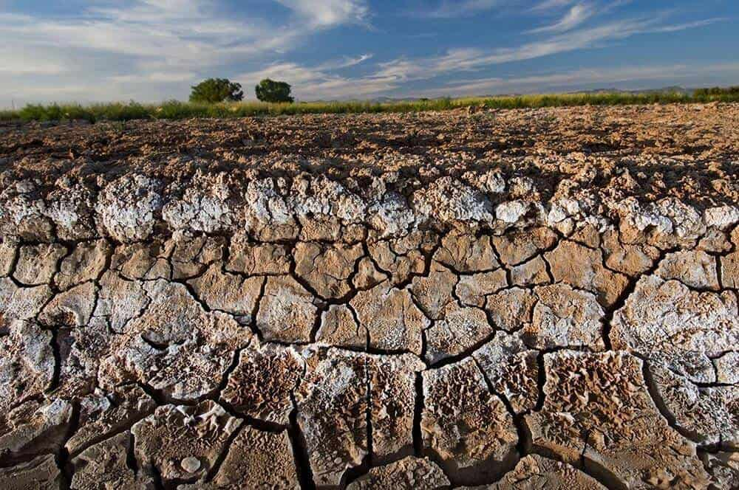

Soil Salinity
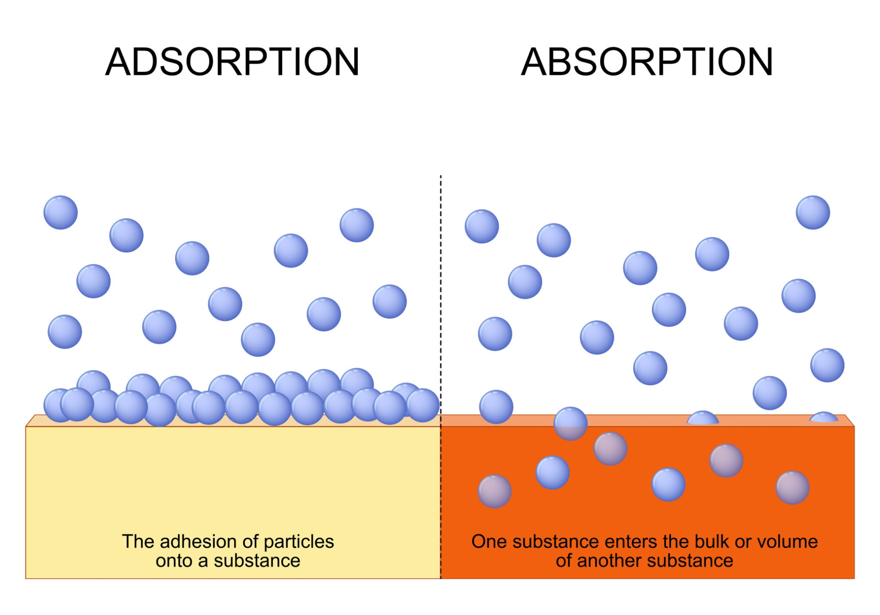

Differentiation Between Adsorption And Absorption
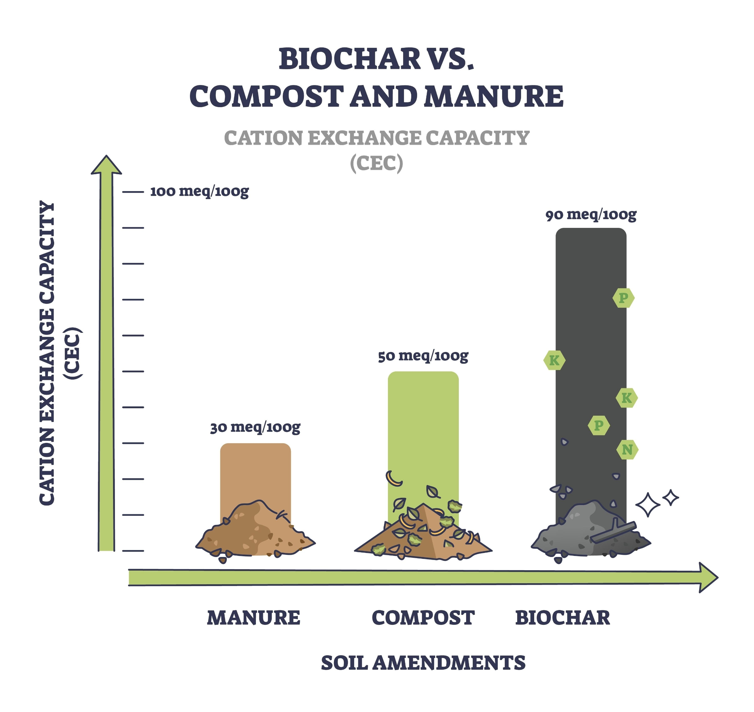
Cation Exchange Capacities of Various Amendments

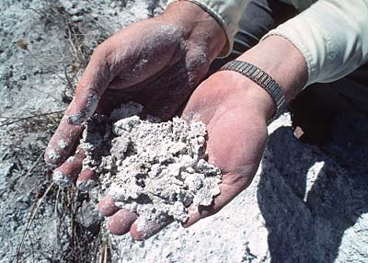

Soil Salinization

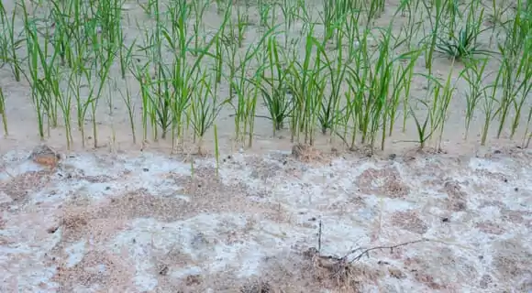

Salts Crusts on the Surface or Saline Soil

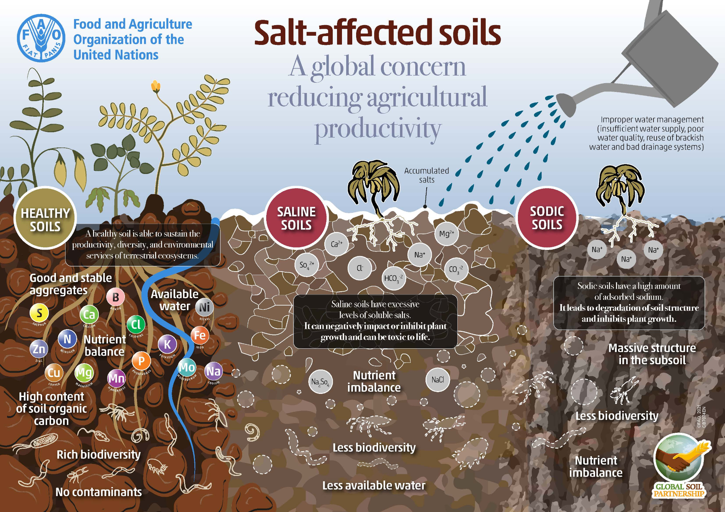

Infographic

Salt Affected Soils A Global Concern Reducing Agricultural Productivity

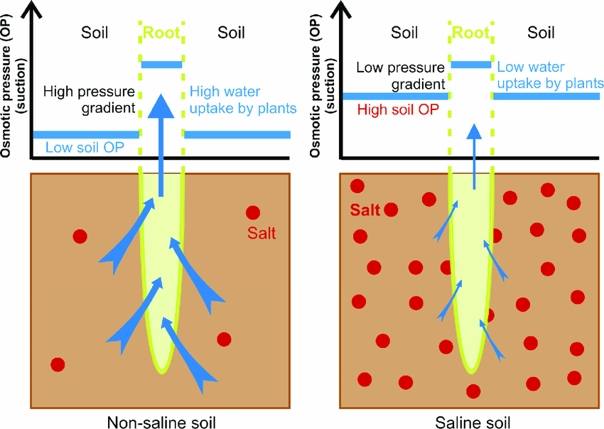

Differentiation of Osmotic Potential in Saline Soils and Non Saline Soils

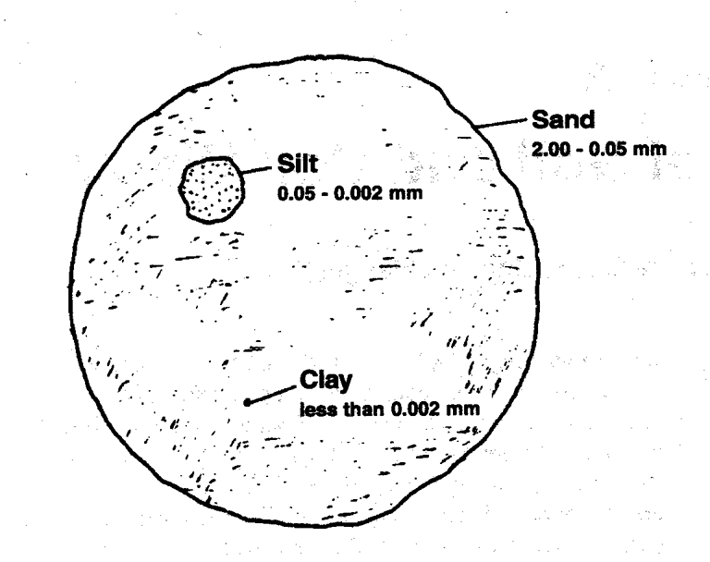

Differentiation of Particles Sizes in Soil Separate i.e. Sand Clay and Silt

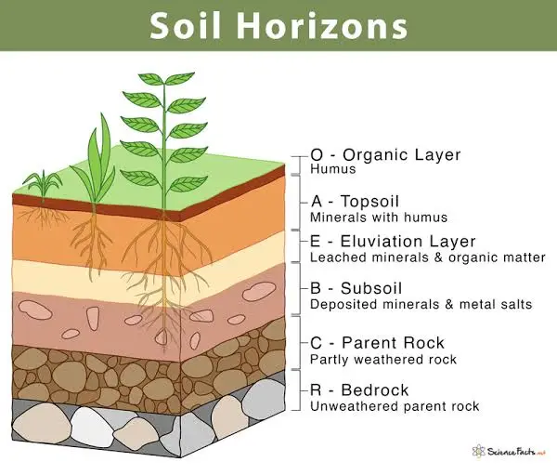

Infographic

Soil Horizons

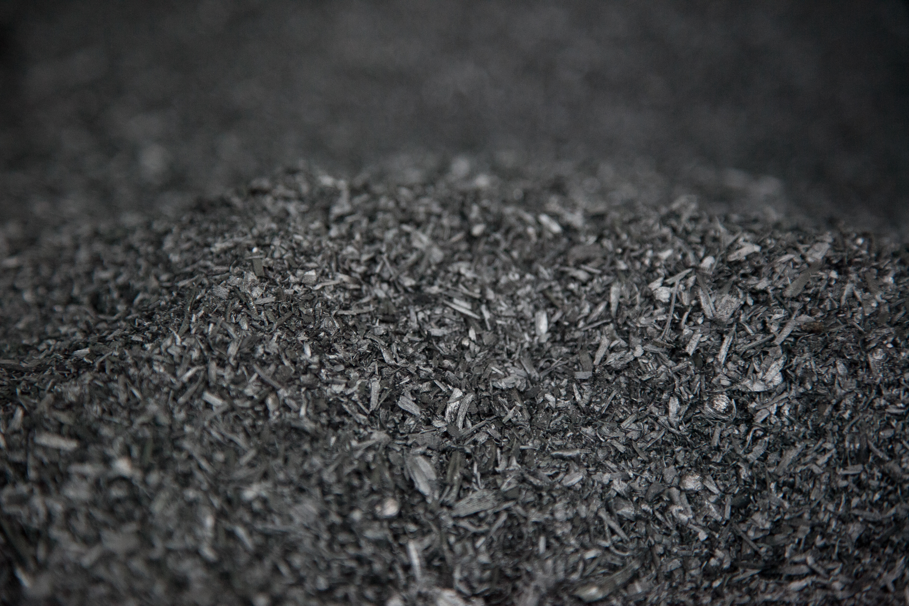

Biochar

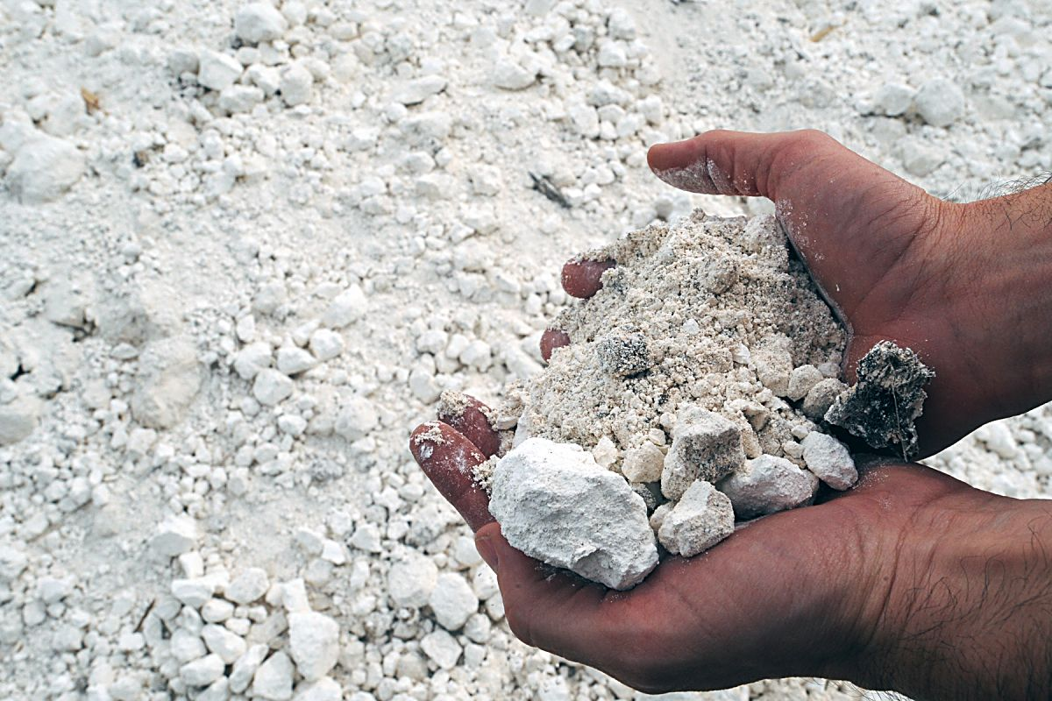

Gypsum

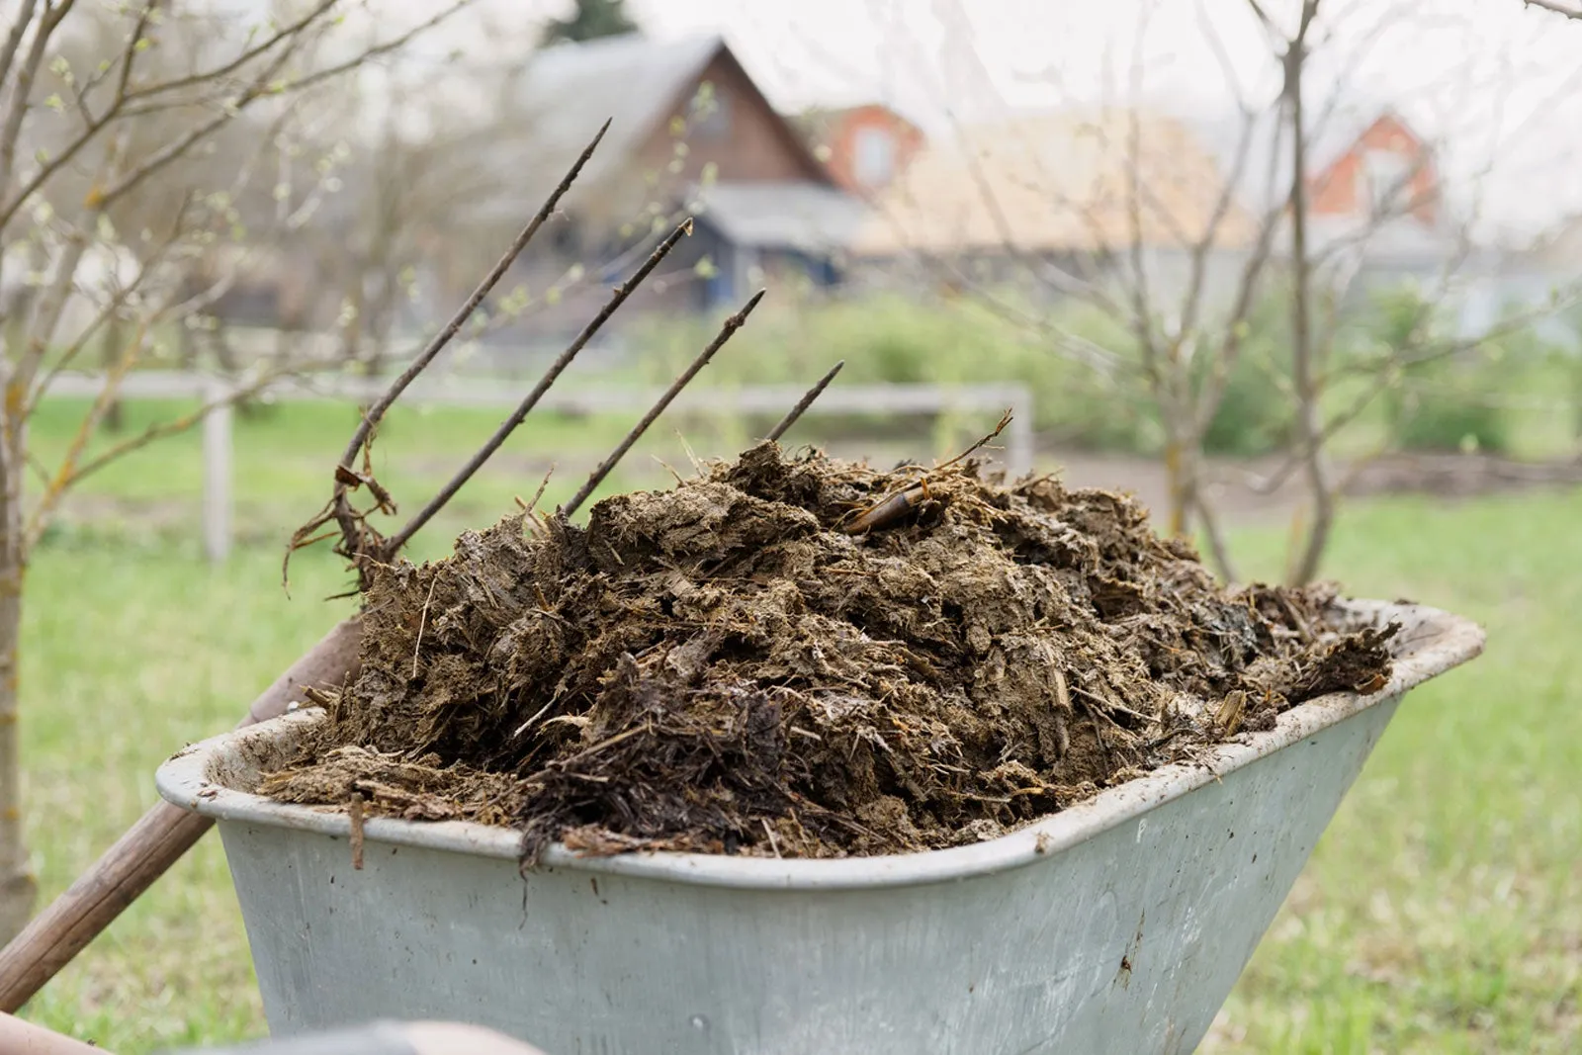

Manure

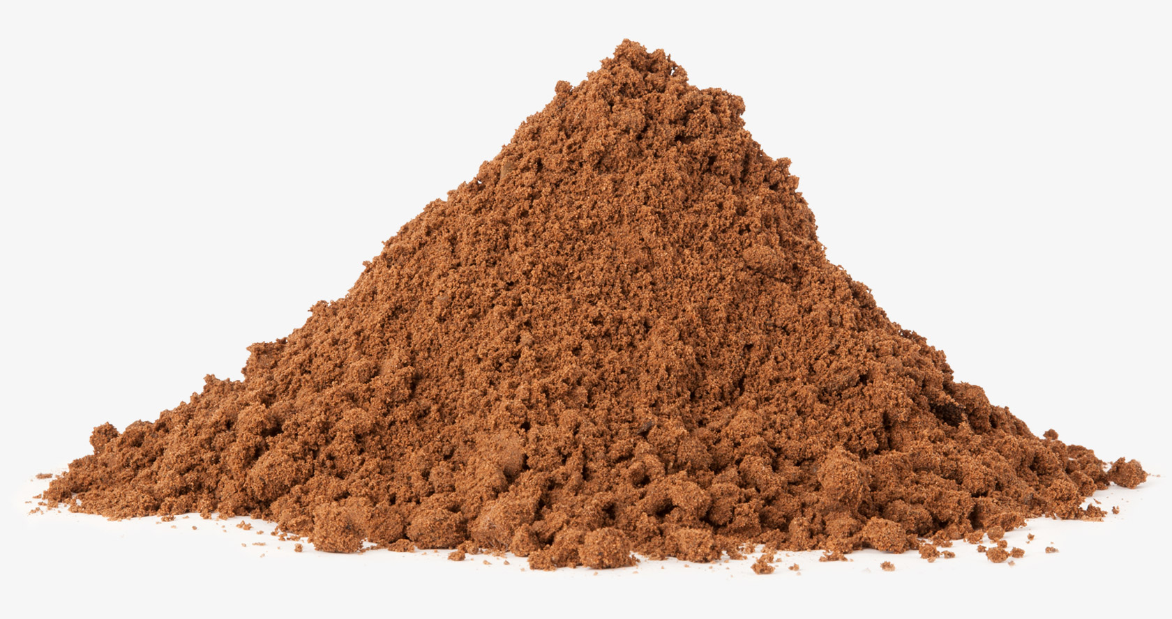

Sand

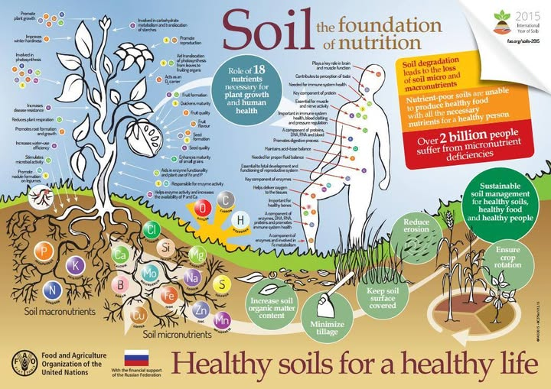

Infographic

Healthy Soils For a Healthy Life

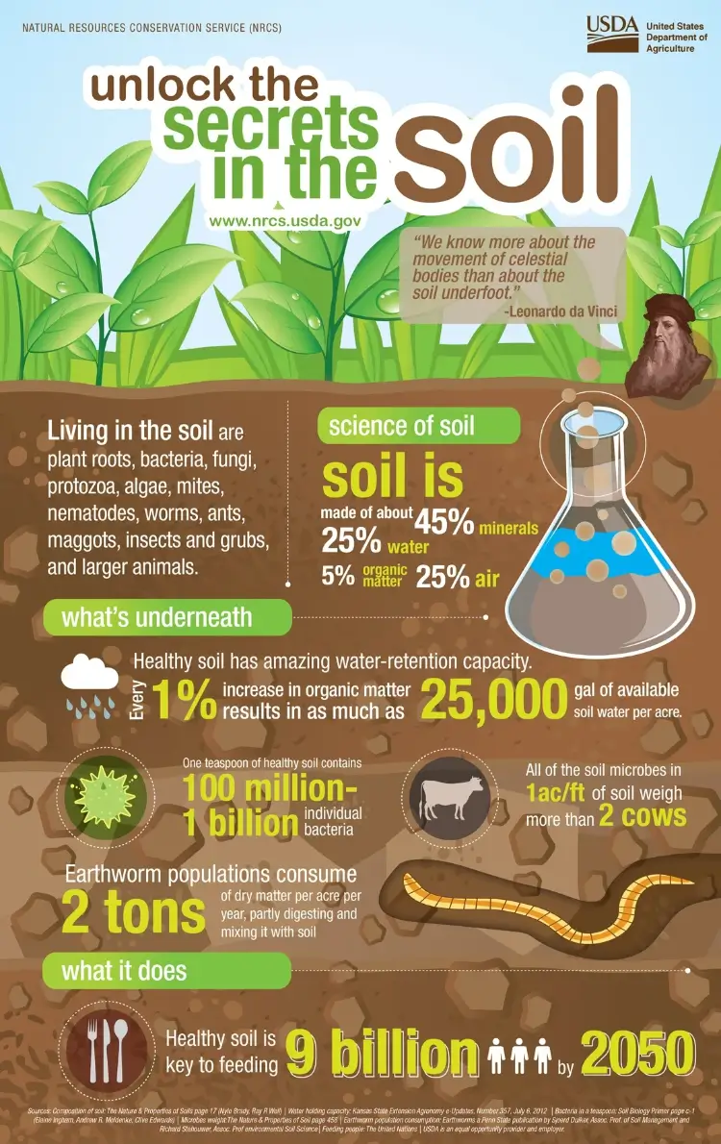

Infographic

Unlock the Secrets in the Soil
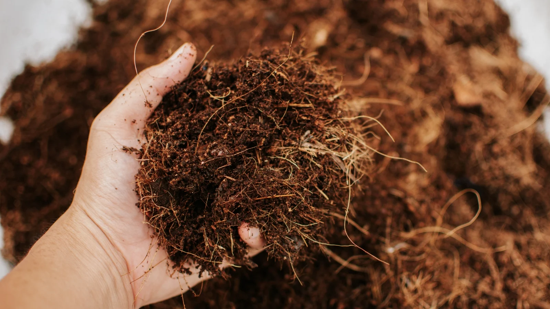

Coconut Coir

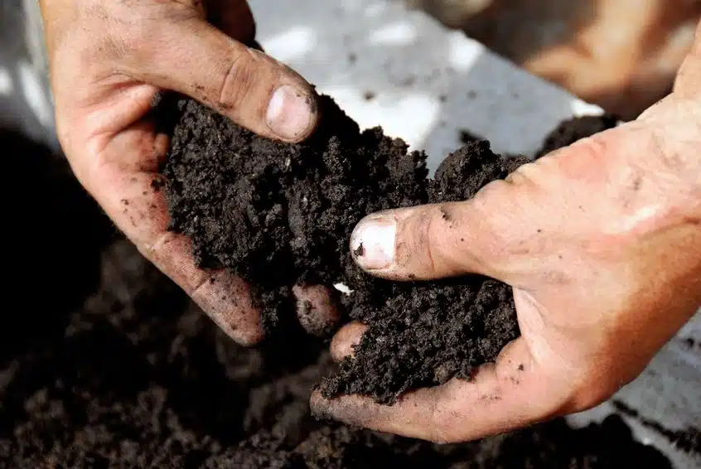

Humus

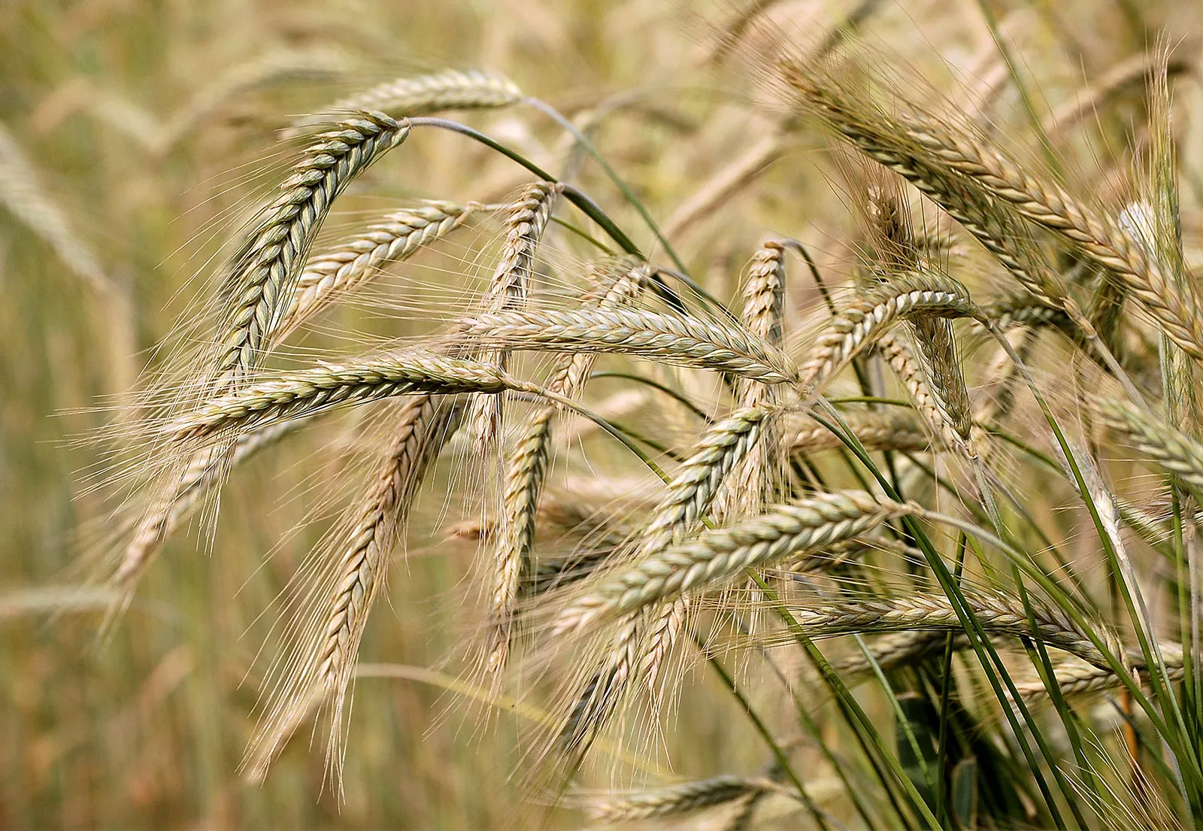

Barley
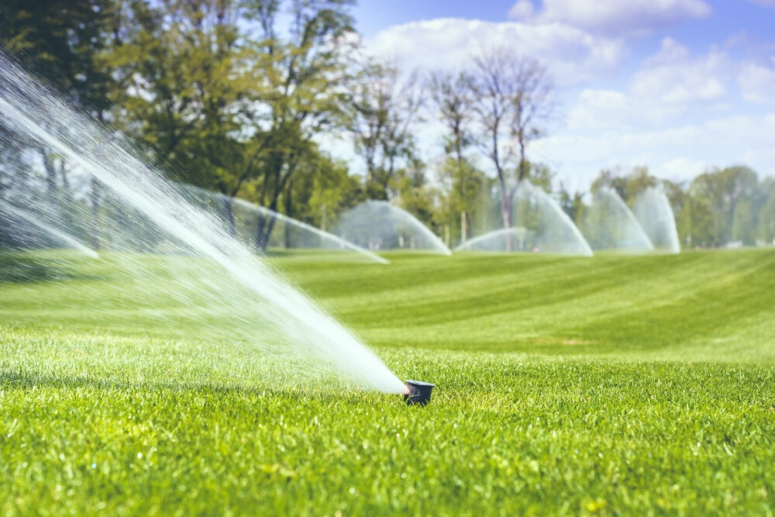

Sprinkler Irrigation
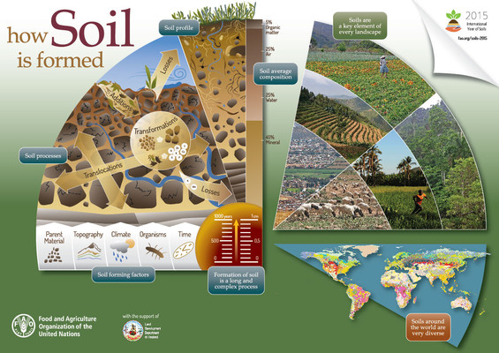

Infographic

How Soil is Formed
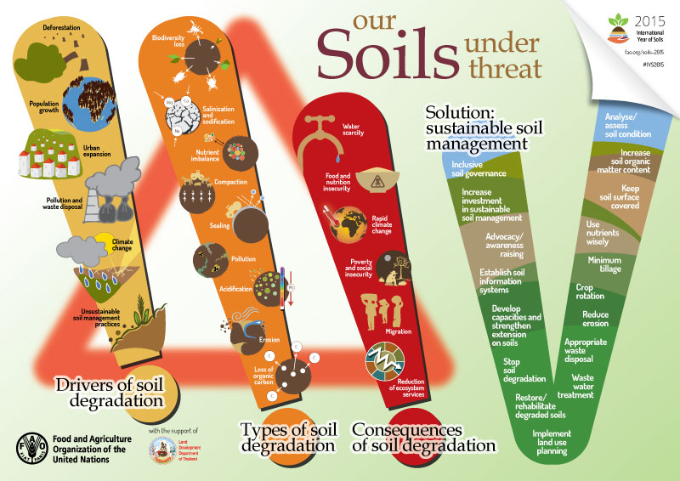

Infographic

Our Soils Under Threat
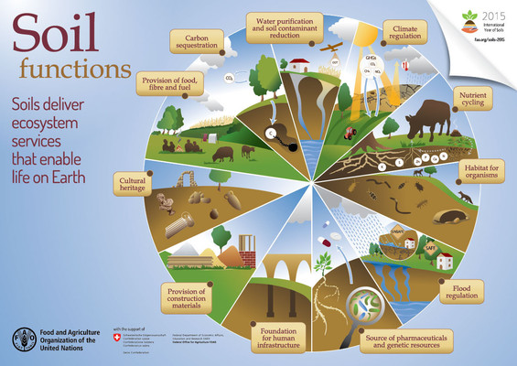

Infographic

Soil Functions
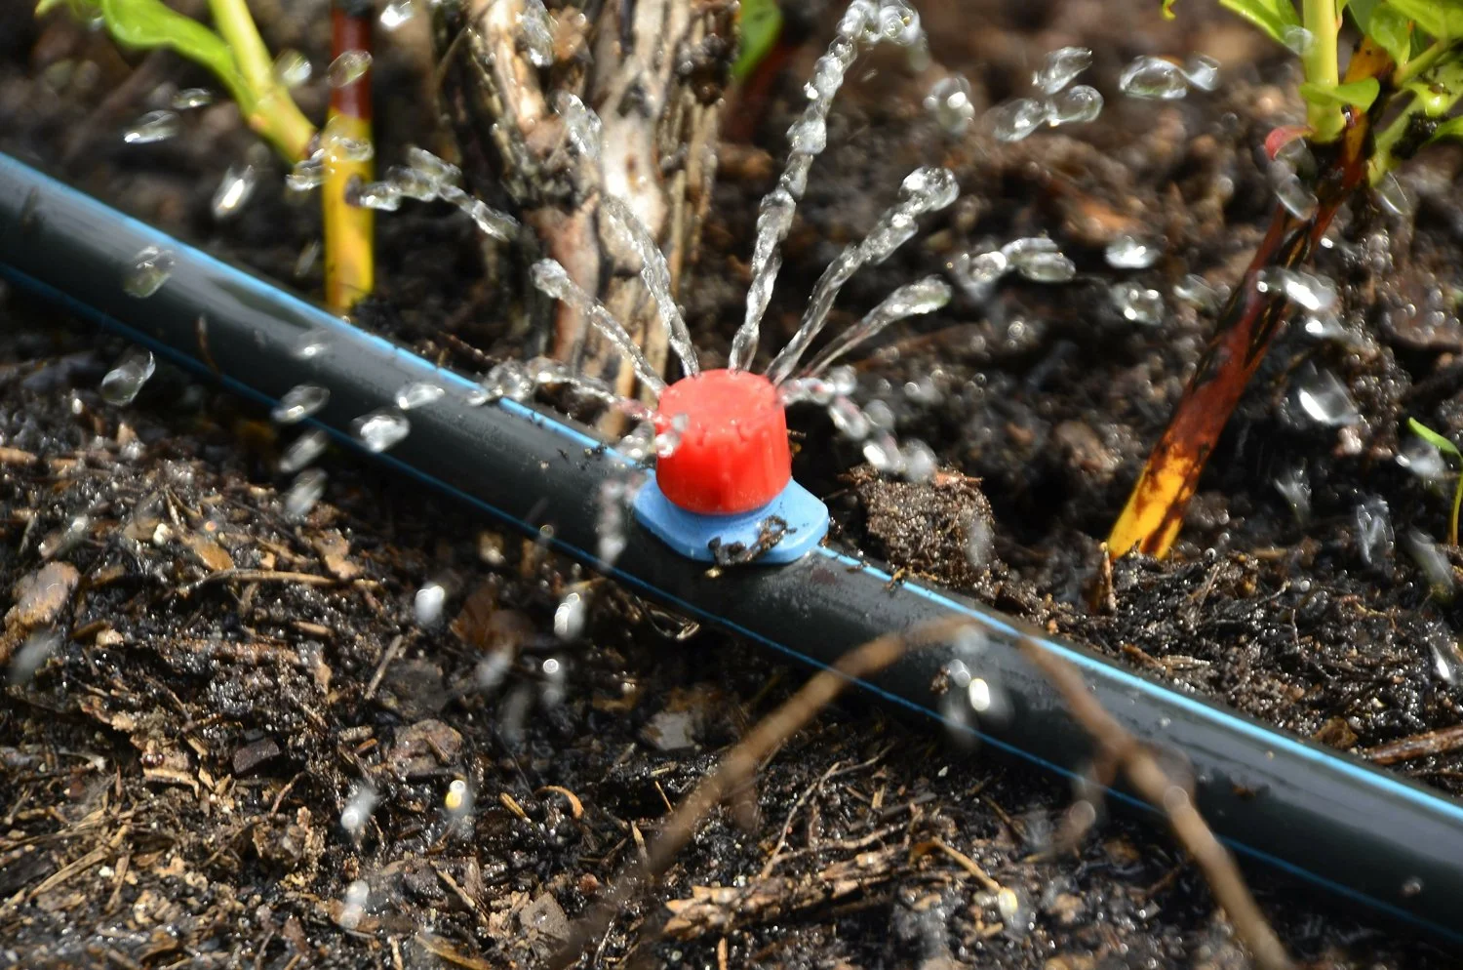

Drip Irrigation

