Focusing on Art

Nora Bekele, Grade 6, Westmount Charter School
Table Of Contents

Acknowledgements - Page 3
Timeline - Page 4
Ideas and Background Research - Page 5
References - Page 6
Question and Purpose - Page 7
Hypothesis - Page 8
Experimental Design - Page 9
Observations - Page 10
Managed Data - Pages 11 & 12
Results/Conclusions - Page 13
Applications & Further Questions - Page 14
Improvement to Experimental Design - Page 15
Back Page

Acknowledgements

I would like to thank my dad for helping me come up with my question & teaching me how to present well, my teacher for announcing it in my class and my friend for telling me about the Logbook, and if she hadn’t told me I would’ve still been oblivious. I am also thankful for the internet, because without it we wouldn’t be able to even do a science fair. I would also like to thank my cousin for being in this experiment even if she lives almost 4 000 km away, and my friends for asking me so much about my experiment that I got tired of it. Thank you!

Timeline

Picked topic - February 7th

Research - February 8 - 10 (get lots of info)

Experiment on the long break - February 11 - 14

Gather data and organize it - February 15 & 16

Create the visual presentation - February 17 & 18

Record the presentation - February 19

Edit and submit science fair - February 20

Ideas & Background Research

Ideas: something about music/writing/art

- Different music affects your mood at different times
- Does art affect your focus on school projects after a certain amount of time?
- Can art make you feel happier?

Final Question: Does art affect your focus/results on school projects/studying after a certain amount of time?

Manipulated Variable - the amount of time that the person is doing the art

Responding Variable - if the test results on mini quizzes will change

Controlled Variables - no background noises, and the same environment

Research:
My project is about art and how frequently you would need to do it to improve your tests, projects or other academic assignments. I chose this because I noticed that some of my classmates get very stressed about tests, so I thought that this experiment’s data could help. I wanted to learn more about how art and mental health correlate, and how it reduces stress.

My manipulated variable is the consistency of the drawing time. I think the more frequently you do it, the better the results will be because I don’t think once would be enough to change it a lot. I’ll measure this by recording the different times and results of the three tests and see the trend that they go in. This will show if frequency is better or not.

My responding variable is the results of the tests, and my friends will send the results back to me. The time will also change and what I’m hoping for is that the time decreases, meaning that it takes a shorter time to finish the quizzes. This will tell me if my hypothesis is wrong or not.

Art is proven to help people with diseases like cancer or dementia, but also people with anxiety or depression. This can support the idea that my experiment will work because tests can bring up anxiety. Art helps anxiety because once you get indulged in the process, time passes very quickly and it distracts you from other things. A report from the Mayo Clinic Study of Aging in 2017 showed that people over 70 that did craft projects instead of reading had a lower risk of getting brain disabilities. It helps you channel out your emotions, relieve stress and also make an art piece out of it too. If you are doing art for recreational uses or therapy, you don’t have to worry about the end result, you just have to enjoy the process.

I think that my hypothesis would be that frequency is better because it helps in lots of things. I’ll use the information about ‘healing with art’ to support my hypothesis, see if my results align, and if it makes a difference, spread the word.

References:

The healing power of art - Harvard Health - July 2017

Mental Health Benefits of Art - RTOR - July 2018

5 ways Art Helps With Mental Health - Science Times - July 2020

Stress Release - Scriba - November 2016

Question & Purpose

Question: How frequently do you have to draw to improve test scores?

Purpose: To see if it lowers anxiety and rises results, so I could use the strategy and tell my classmates about it.

Hypothesis

I think that the longer you do the art, the faster and more accurate the results will be because consistency always helps more than doing it once.

Experimental Design

Materials: A sketchbook or paper, a pencil, eraser, pencil crayons and/or markers, a timer and a computer

Procedure:

- Gather all the materials on a desk or table
- Set a timer for 10 minutes
- Draw
- Turn on the computer
- Click on the designated link for the certain day
- Do the quiz and make sure to time yourself!
- Write down the results for the day
- Repeat steps 1-7
- Open a new Google Sheet document
- Input the data into a table
- Press the graph button and organize it into a graph
- Observe the trend of results and times

Observations

I observed that the different topics made the results very different, and that every person had an average of a certain amount of time. The results revolved around the topic of the quiz more than the actual effect of the drawing, so that’s one thing that altered the data. The sample size I took wasn’t large, so that didn’t provide much data to base off my conclusion off of. The results aligned mostly, but the times were what was different. It depends on how good you are at math too, and if it’s harder, the time will be longer. While doing the experiment, it was also fun, so that’s a thing to add to the benefits of drawing for test improvement.

Managed Data

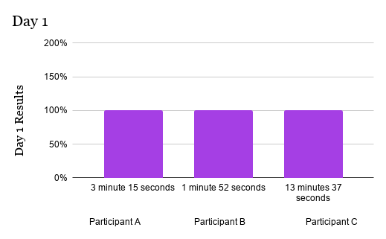
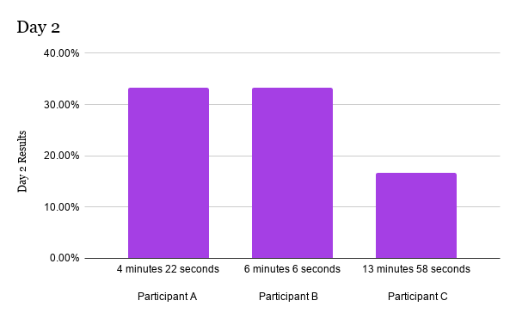
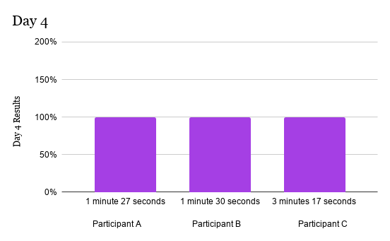

Results/Conclusions

I wanted to find out if and how often you had to draw to improve test scores, and I chose it to see if it could improve your results and also lower stress. Based on my research, I guessed that the results would improve the longer you do it, because my research showed that it does help, and it helps anxiety. My experiment showed that the more drawing and practice you have, the better you do. It also showed that different people have much different times, because everyone takes more or less time on math questions. My hypothesis was therefore correct. I believe this was because all the research I did supported this idea.

Applications & Further Questions

I think that this experiment was useful because now I can tell my family and friends about it, if a big test is coming up. Anxiety is a big part of test-taking, so I wanted to find a way to help - even just a little bit. I wonder how many people know that this can help, and if they did, they wouldn’t be so stressed out anymore. Also, how much would the data change if the sample size increased a lot? What would be the central tendencies?

Improvements to Experimental Design

I think I should’ve used a bigger sample size to get more accurate results, and that the topic of the test should’ve been the same. I could also get some different kind of people, like people with different abilities and advantages to see how they would alter the results. A bigger sample size would’ve given more range, and the topic would have measured the results better.

