Title: Best Breathing Technique for Stamina
Name Lakshansathya Sathyanarayanan
Grade: 9

Dates: | Progress
November 27, 2025 | We checked if our basic project information was done today. Since mine wasn’t done, I worked on it for a little bit.
January 8, 2025 | We did a logbook check today to check how much work we’ve done. Our teacher told me that I have to get to work so I don’t cram anything near the deadline.
January 16, 2025 | Today I did some research before actually formulating a hypothesis and conducting the experiment.  There are many types of runners, such as sprint runners, mid distance runners, etc. I’ll be focusing on marathon runners, as they require the most stamina to complete their run.  Most professional marathon runners use a breathing technique called diaphragmatic breathing, also known as belly breathing. This technique emphasises inhaling through your nose and exhaling through your mouth.  Bibliography:  Diaphragmatic Breathing for GI patients (no date) Diaphragmatic Breathing for GI Patients | University of Michigan Health. Available at: https://www.uofmhealth.org/conditions-treatments/digestive-and-liver-health/diaphragmatic-breathing-gi-patients#:~:text=Inhale%20through%20your%20nose%20for,mouth%20for%20about%206%20seconds (Accessed: 16 January 2025).  What are the Top Endurance Sports? (2023a) STYRKR. Available at: https://styrkr.com/en-ca/blogs/training-and-nutrition-hub/endurance-sports (Accessed: 16 January 2025).  Professional, C.C. medical (2024b) Blood oxygen level: What it is & how to increase it, Cleveland Clinic. Available at: https://my.clevelandclinic.org/health/diagnostics/22447-blood-oxygen-level (Accessed: 17 March 2025).
January 19, 2025 | I will formulate a hypothesis, list all the materials I’ll be needing, create a procedure to run my experiment, and figure out all the variables there’ll be.  Hypothesis:  If you breathe by inhaling through your nose and exhaling through your mouth, you will be able to run for longer due to an increase in stamina because the technique allows you to breathe more deeply than others.  Materials Needed:  - Stopwatch  - At Least 1 person  - Something to record data on (paper, phone, etc)  - Measuring tape  - 4 brightly colored objects to mark spots  Procedure:  - Go to an open area that is preferably long in length (A football field is great)  - Start at one end of the space and place your bright marker where you’ll begin your run  - Walk in a straight line to the other side of the space and place your other bright marker where you’ll turn around if you make it to the end  - Measure the distance between the 2 markers (Use measuring tape to measure until it’s max limit, place a marker on the spot it ends, measure with measuring tape again until max limit, place another marker and remove the first one, repeat until end, add up total length and round to nearest whole number, remove the markers you used in this step)  - Begin your first run while holding 1 marker and keep going until you can’t breathe using the technique  - Remember how many times you went the total length of the space as you run  - Drop your marker if you can't breathe using that breathing technique anymore  - Repeat step 4 but only go up until the newly placed marker  - Multiply the number you remembered in step 6 by the total length of the space, then add the number you got in step 8  - Record data on a safe space  - Rest until you feel recovered and normal again  - Repeat steps 5-11 again 2 more times using the same breathing technique  - Repeat steps 5-12 again 3 times using the other 3 breathing techniques  Variables:  - Controlled: Length of running space, Same gear worn  - Manipulated: Breathing techniques  - Responding: Total distance ran
January 29, 2025 | We had a mandatory science fair meeting today to just discuss what forms are due and how much work we’ve completed so far.
March 8, 2025 | I conducted my tests today due to the weather being nice.  Results:  Length of Field: About 96 meters  Nose then Mouth: 751 m - 821 m - 847 m  Nose then Nose: 416 m - 408 m - 472 m  Mouth then Nose: 621 m - 702 m - 654 m  Mouth then Mouth: 1017 m - 978 m - 1094 m
March 12, 2025 | I had a meeting with the rest of the people who are doing science fair. We talked about what we need on our trifold and when our forms are due.
March 13, 2025 | Results:  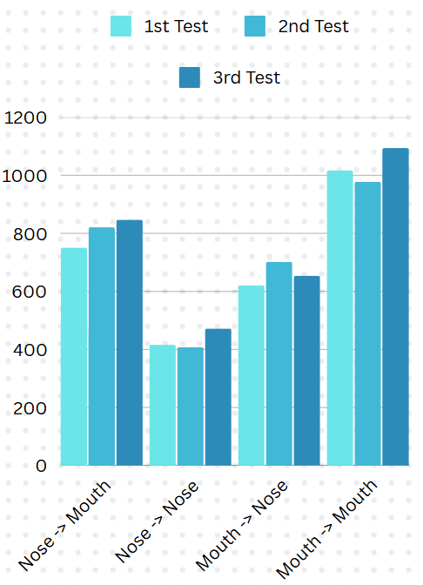
March 15, 2025 | Appliance:  The information obtained from this experiment can be used to prepare for upcoming races where you can't train your breathing technique. The reason for this is because, although inhaling and exhaling through your mouth isn't the most efficient way to breathe on paper, it is the most effective after actually testing myself. Using this information, I can breathe in and out through my mouth whenever I'm racing anyone or running somewhere instead of trying to breathe in a way professional runners do.  Conclusion:  In conclusion, using my mouth to inhale and exhale helped me run and travel a further distance without messing up my breathing technique or just getting tired. My hypothesis only accounted for professionals who trained many years to nearly, if not completely, perfect a breathing technique. To the average person like me, who doesn’t train their breathing, results may differ compared to professionals.

