Charts for Trifold:

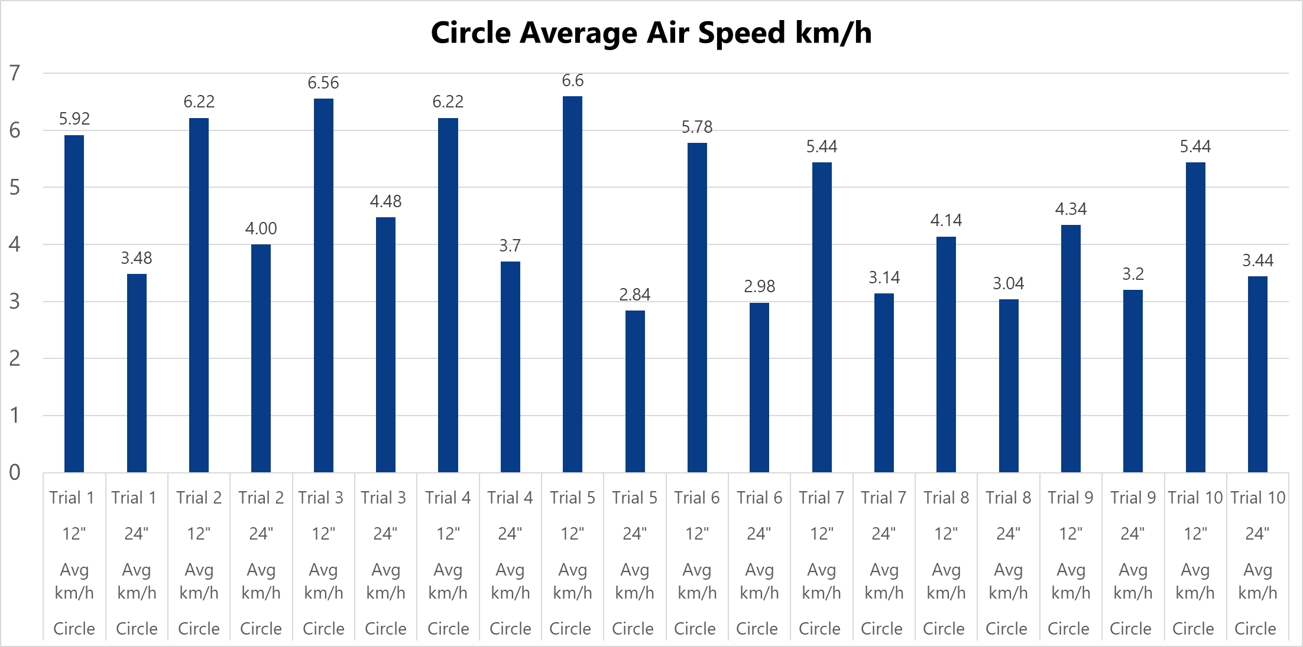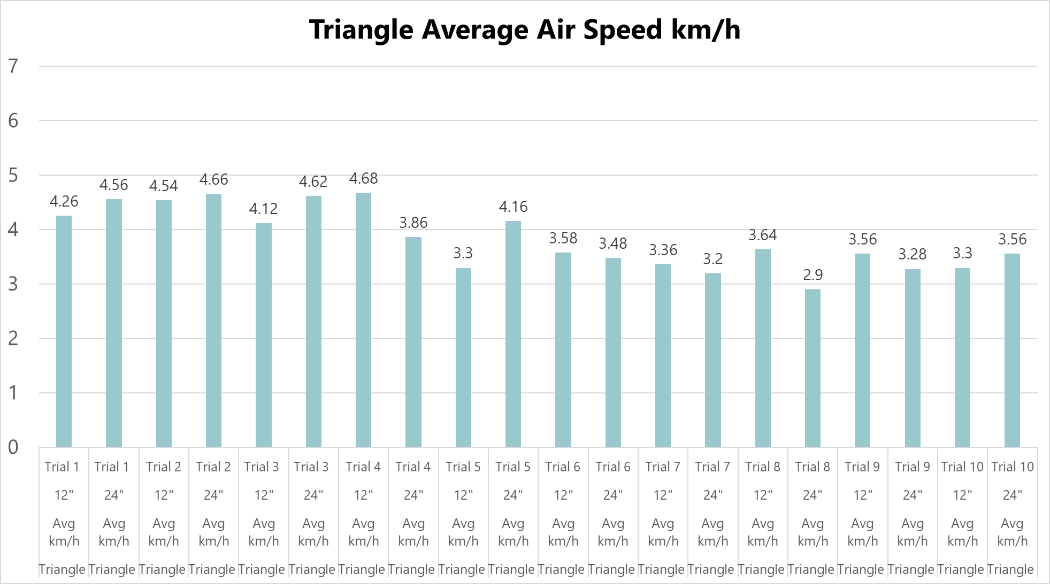
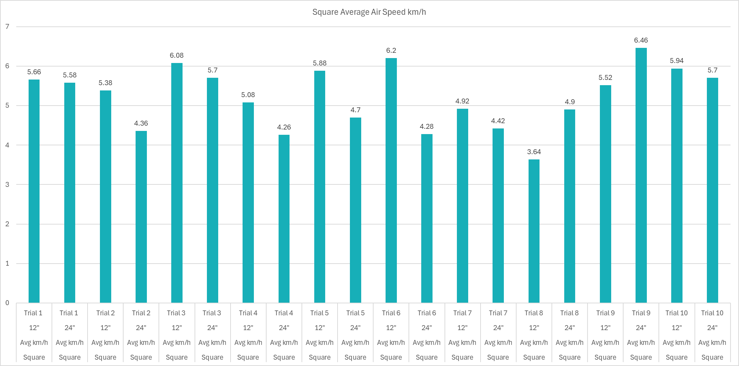

Air Cannon Trial Photos
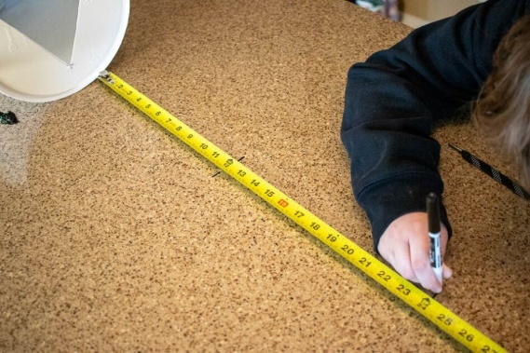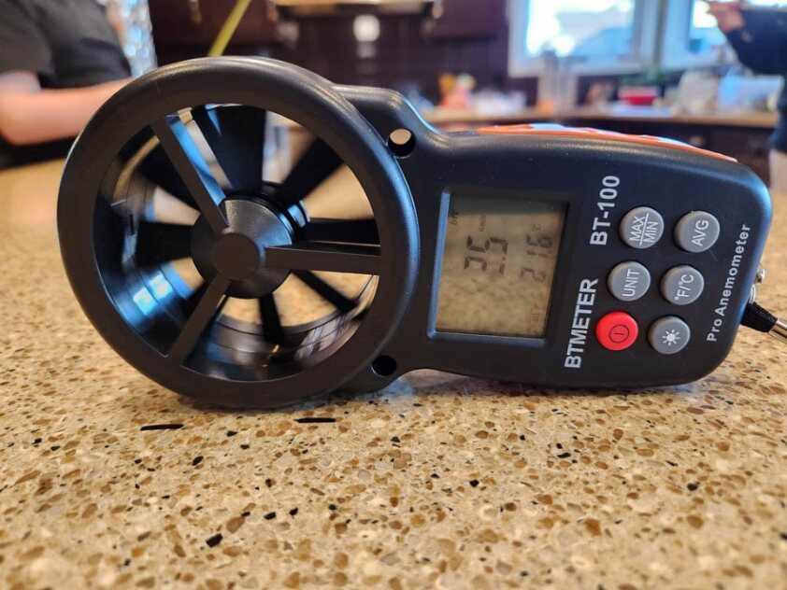
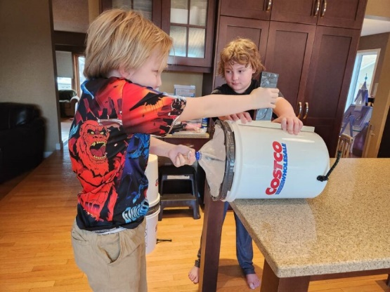
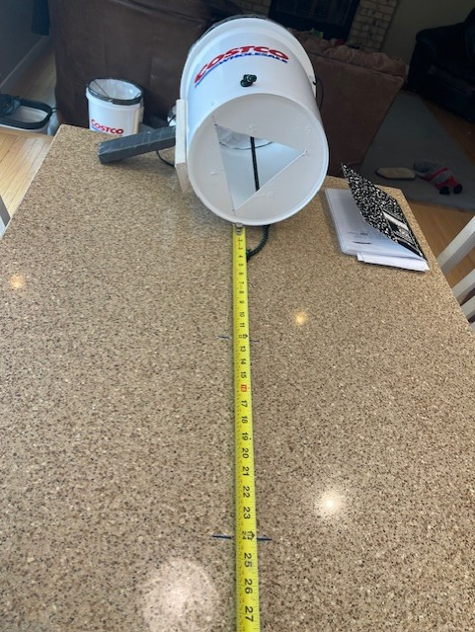

Cannons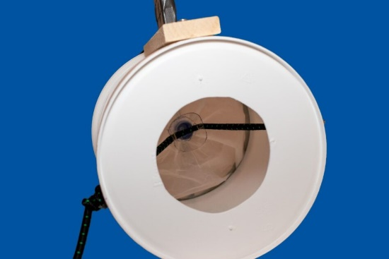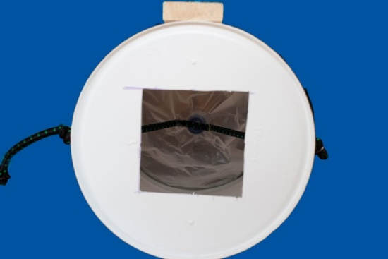
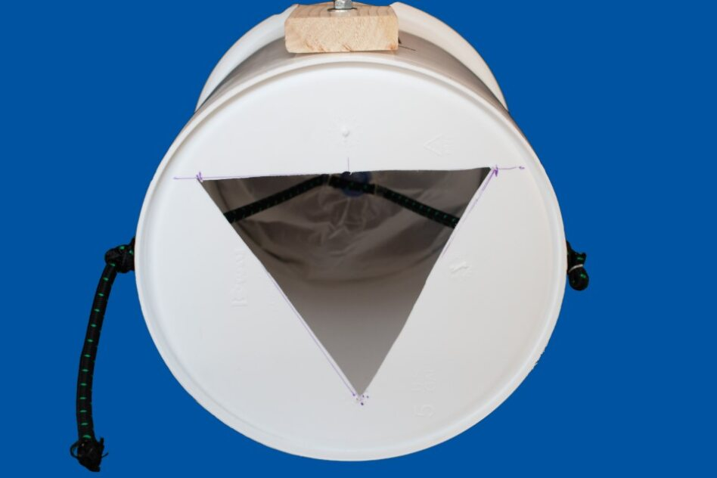

Data:
Shape | km/h | Measured Distance | Trial # | km/h
Circle | km/h | 12" | Trial 1 | 5.7
Circle | km/h | 12" | Trial 1 | 4.6
Circle | km/h | 12" | Trial 1 | 6.4
Circle | km/h | 12" | Trial 1 | 5.7
Circle | km/h | 12" | Trial 1 | 7.2
Circle | Avg km/h | 12" | Trial 1 | 5.92
Circle | km/h | 24" | Trial 1 | 2.8
Circle | km/h | 24" | Trial 1 | 3.2
Circle | km/h | 24" | Trial 1 | 3.6
Circle | km/h | 24" | Trial 1 | 3.9
Circle | km/h | 24" | Trial 1 | 3.9
Circle | Avg km/h | 24" | Trial 1 | 3.48
Square | km/h | 12" | Trial 1 | 5.4
Square | km/h | 12" | Trial 1 | 5.4
Square | km/h | 12" | Trial 1 | 5.4
Square | km/h | 12" | Trial 1 | 6.4
Square | km/h | 12" | Trial 1 | 5.7
Square | Avg km/h | 12" | Trial 1 | 5.66
Square | km/h | 24" | Trial 1 | 6.4
Square | km/h | 24" | Trial 1 | 6.1
Square | km/h | 24" | Trial 1 | 4.6
Square | km/h | 24" | Trial 1 | 5.4
Square | km/h | 24" | Trial 1 | 5.4
Square | Avg km/h | 24" | Trial 1 | 5.58
Triangle | km/h | 12" | Trial 1 | 3.9
Triangle | km/h | 12" | Trial 1 | 4.6
Triangle | km/h | 12" | Trial 1 | 4.3
Triangle | km/h | 12" | Trial 1 | 3.9
Triangle | km/h | 12" | Trial 1 | 4.6
Triangle | Avg km/h | 12" | Trial 1 | 4.26
Triangle | km/h | 24" | Trial 1 | 3.6
Triangle | km/h | 24" | Trial 1 | 4.6
Triangle | km/h | 24" | Trial 1 | 4.6
Triangle | km/h | 24" | Trial 1 | 4.6
Triangle | km/h | 24" | Trial 1 | 5.4
Triangle | Avg km/h | 24" | Trial 1 | 4.56
Circle | km/h | 12" | Trial 2 | 6.1
Circle | km/h | 12" | Trial 2 | 5.7
Circle | km/h | 12" | Trial 2 | 6.4
Circle | km/h | 12" | Trial 2 | 6.1
Circle | km/h | 12" | Trial 2 | 6.8
Circle | Avg km/h | 12" | Trial 2 | 6.22
Circle | km/h | 24" | Trial 2 | 3.6
Circle | km/h | 24" | Trial 2 | 3.9
Circle | km/h | 24" | Trial 2 | 3.6
Circle | km/h | 24" | Trial 2 | 4.3
Circle | km/h | 24" | Trial 2 | 4.6
Circle | Avg km/h | 24" | Trial 2 | 4.00
Square | km/h | 12" | Trial 2 | 5
Square | km/h | 12" | Trial 2 | 5.4
Square | km/h | 12" | Trial 2 | 5
Square | km/h | 12" | Trial 2 | 5.4
Square | km/h | 12" | Trial 2 | 6.1
Square | Avg km/h | 12" | Trial 2 | 5.38
Square | km/h | 24" | Trial 2 | 3.9
Square | km/h | 24" | Trial 2 | 3.6
Square | km/h | 24" | Trial 2 | 3.6
Square | km/h | 24" | Trial 2 | 5.7
Square | km/h | 24" | Trial 2 | 5
Square | Avg km/h | 24" | Trial 2 | 4.36
Triangle | km/h | 12" | Trial 2 | 4.6
Triangle | km/h | 12" | Trial 2 | 4.6
Triangle | km/h | 12" | Trial 2 | 4.3
Triangle | km/h | 12" | Trial 2 | 4.6
Triangle | km/h | 12" | Trial 2 | 4.6
Triangle | Avg km/h | 12" | Trial 2 | 4.54
Triangle | km/h | 24" | Trial 2 | 5.4
Triangle | km/h | 24" | Trial 2 | 4.3
Triangle | km/h | 24" | Trial 2 | 5.4
Triangle | km/h | 24" | Trial 2 | 4.3
Triangle | km/h | 24" | Trial 2 | 3.9
Triangle | Avg km/h | 24" | Trial 2 | 4.66
Circle | km/h | 12" | Trial 3 | 6.4
Circle | km/h | 12" | Trial 3 | 6.1
Circle | km/h | 12" | Trial 3 | 6.8
Circle | km/h | 12" | Trial 3 | 6.4
Circle | km/h | 12" | Trial 3 | 7.1
Circle | Avg km/h | 12" | Trial 3 | 6.56
Circle | km/h | 24" | Trial 3 | 4.6
Circle | km/h | 24" | Trial 3 | 3.9
Circle | km/h | 24" | Trial 3 | 5
Circle | km/h | 24" | Trial 3 | 4.3
Circle | km/h | 24" | Trial 3 | 4.6
Circle | Avg km/h | 24" | Trial 3 | 4.48
Square | km/h | 12" | Trial 3 | 5.4
Square | km/h | 12" | Trial 3 | 6.4
Square | km/h | 12" | Trial 3 | 5.7
Square | km/h | 12" | Trial 3 | 6.8
Square | km/h | 12" | Trial 3 | 6.1
Square | Avg km/h | 12" | Trial 3 | 6.08
Square | km/h | 24" | Trial 3 | 4.6
Square | km/h | 24" | Trial 3 | 6.4
Square | km/h | 24" | Trial 3 | 6.8
Square | km/h | 24" | Trial 3 | 5
Square | km/h | 24" | Trial 3 | 5.7
Square | Avg km/h | 24" | Trial 3 | 5.7
Triangle | km/h | 12" | Trial 3 | 3.9
Triangle | km/h | 12" | Trial 3 | 4.6
Triangle | km/h | 12" | Trial 3 | 5
Triangle | km/h | 12" | Trial 3 | 3.2
Triangle | km/h | 12" | Trial 3 | 3.9
Triangle | Avg km/h | 12" | Trial 3 | 4.12
Triangle | km/h | 24" | Trial 3 | 4.6
Triangle | km/h | 24" | Trial 3 | 4.6
Triangle | km/h | 24" | Trial 3 | 5
Triangle | km/h | 24" | Trial 3 | 4.6
Triangle | km/h | 24" | Trial 3 | 4.3
Triangle | Avg km/h | 24" | Trial 3 | 4.62
Circle | km/h | 12" | Trial 4 | 5
Circle | km/h | 12" | Trial 4 | 7.2
Circle | km/h | 12" | Trial 4 | 5.7
Circle | km/h | 12" | Trial 4 | 6.4
Circle | km/h | 12" | Trial 4 | 6.8
Circle | Avg km/h | 12" | Trial 4 | 6.22
Circle | km/h | 24" | Trial 4 | 3.6
Circle | km/h | 24" | Trial 4 | 3.9
Circle | km/h | 24" | Trial 4 | 3.2
Circle | km/h | 24" | Trial 4 | 3.9
Circle | km/h | 24" | Trial 4 | 3.9
Circle | Avg km/h | 24" | Trial 4 | 3.7
Square | km/h | 12" | Trial 4 | 4.3
Square | km/h | 12" | Trial 4 | 5.4
Square | km/h | 12" | Trial 4 | 6.1
Square | km/h | 12" | Trial 4 | 5
Square | km/h | 12" | Trial 4 | 4.6
Square | Avg km/h | 12" | Trial 4 | 5.08
Square | km/h | 24" | Trial 4 | 4.3
Square | km/h | 24" | Trial 4 | 4.3
Square | km/h | 24" | Trial 4 | 3.4
Square | km/h | 24" | Trial 4 | 5
Square | km/h | 24" | Trial 4 | 4.3
Square | Avg km/h | 24" | Trial 4 | 4.26
Triangle | km/h | 12" | Trial 4 | 5
Triangle | km/h | 12" | Trial 4 | 4.6
Triangle | km/h | 12" | Trial 4 | 4.6
Triangle | km/h | 12" | Trial 4 | 4.6
Triangle | km/h | 12" | Trial 4 | 4.6
Triangle | Avg km/h | 12" | Trial 4 | 4.68
Triangle | km/h | 24" | Trial 4 | 3.6
Triangle | km/h | 24" | Trial 4 | 4.3
Triangle | km/h | 24" | Trial 4 | 3.9
Triangle | km/h | 24" | Trial 4 | 3.9
Triangle | km/h | 24" | Trial 4 | 3.6
Triangle | Avg km/h | 24" | Trial 4 | 3.86
Circle | km/h | 12" | Trial 5 | 5.7
Circle | km/h | 12" | Trial 5 | 7.2
Circle | km/h | 12" | Trial 5 | 7.5
Circle | km/h | 12" | Trial 5 | 5.4
Circle | km/h | 12" | Trial 5 | 7.2
Circle | Avg km/h | 12" | Trial 5 | 6.6
Circle | km/h | 24" | Trial 5 | 3.2
Circle | km/h | 24" | Trial 5 | 2.8
Circle | km/h | 24" | Trial 5 | 2.5
Circle | km/h | 24" | Trial 5 | 3.2
Circle | km/h | 24" | Trial 5 | 2.5
Circle | Avg km/h | 24" | Trial 5 | 2.84
Square | km/h | 12" | Trial 5 | 7.2
Square | km/h | 12" | Trial 5 | 5
Square | km/h | 12" | Trial 5 | 5.7
Square | km/h | 12" | Trial 5 | 5.4
Square | km/h | 12" | Trial 5 | 6.1
Square | Avg km/h | 12" | Trial 5 | 5.88
Square | km/h | 24" | Trial 5 | 5
Square | km/h | 24" | Trial 5 | 5
Square | km/h | 24" | Trial 5 | 4.6
Square | km/h | 24" | Trial 5 | 4.3
Square | km/h | 24" | Trial 5 | 4.6
Square | Avg km/h | 24" | Trial 5 | 4.7
Triangle | km/h | 12" | Trial 5 | 3.6
Triangle | km/h | 12" | Trial 5 | 3.2
Triangle | km/h | 12" | Trial 5 | 2.5
Triangle | km/h | 12" | Trial 5 | 3.6
Triangle | km/h | 12" | Trial 5 | 3.6
Triangle | Avg km/h | 12" | Trial 5 | 3.3
Triangle | km/h | 24" | Trial 5 | 4.6
Triangle | km/h | 24" | Trial 5 | 5
Triangle | km/h | 24" | Trial 5 | 3
Triangle | km/h | 24" | Trial 5 | 4.6
Triangle | km/h | 24" | Trial 5 | 3.6
Triangle | Avg km/h | 24" | Trial 5 | 4.16
Circle | km/h | 12" | Trial 6 | 4.6
Circle | km/h | 12" | Trial 6 | 6.4
Circle | km/h | 12" | Trial 6 | 5.4
Circle | km/h | 12" | Trial 6 | 5.7
Circle | km/h | 12" | Trial 6 | 6.8
Circle | Avg km/h | 12" | Trial 6 | 5.78
Circle | km/h | 24" | Trial 6 | 3.6
Circle | km/h | 24" | Trial 6 | 2.5
Circle | km/h | 24" | Trial 6 | 2.8
Circle | km/h | 24" | Trial 6 | 3.2
Circle | km/h | 24" | Trial 6 | 2.8
Circle | Avg km/h | 24" | Trial 6 | 2.98
Square | km/h | 12" | Trial 6 | 5
Square | km/h | 12" | Trial 6 | 6.4
Square | km/h | 12" | Trial 6 | 6.4
Square | km/h | 12" | Trial 6 | 6.8
Square | km/h | 12" | Trial 6 | 6.4
Square | Avg km/h | 12" | Trial 6 | 6.2
Square | km/h | 24" | Trial 6 | 3.9
Square | km/h | 24" | Trial 6 | 4.6
Square | km/h | 24" | Trial 6 | 4.3
Square | km/h | 24" | Trial 6 | 4.3
Square | km/h | 24" | Trial 6 | 4.3
Square | Avg km/h | 24" | Trial 6 | 4.28
Triangle | km/h | 12" | Trial 6 | 2.5
Triangle | km/h | 12" | Trial 6 | 4.3
Triangle | km/h | 12" | Trial 6 | 3.6
Triangle | km/h | 12" | Trial 6 | 3.6
Triangle | km/h | 12" | Trial 6 | 3.9
Triangle | Avg km/h | 12" | Trial 6 | 3.58
Triangle | km/h | 24" | Trial 6 | 3.2
Triangle | km/h | 24" | Trial 6 | 3.1
Triangle | km/h | 24" | Trial 6 | 3.6
Triangle | km/h | 24" | Trial 6 | 3.9
Triangle | km/h | 24" | Trial 6 | 3.6
Triangle | Avg km/h | 24" | Trial 6 | 3.48
Circle | km/h | 12" | Trial 7 | 6.8
Circle | km/h | 12" | Trial 7 | 5
Circle | km/h | 12" | Trial 7 | 5.4
Circle | km/h | 12" | Trial 7 | 5
Circle | km/h | 12" | Trial 7 | 5
Circle | Avg km/h | 12" | Trial 7 | 5.44
Circle | km/h | 24" | Trial 7 | 3.2
Circle | km/h | 24" | Trial 7 | 3.6
Circle | km/h | 24" | Trial 7 | 3.2
Circle | km/h | 24" | Trial 7 | 2.1
Circle | km/h | 24" | Trial 7 | 3.6
Circle | Avg km/h | 24" | Trial 7 | 3.14
Square | km/h | 12" | Trial 7 | 5.4
Square | km/h | 12" | Trial 7 | 4.3
Square | km/h | 12" | Trial 7 | 4.6
Square | km/h | 12" | Trial 7 | 4.6
Square | km/h | 12" | Trial 7 | 5.7
Square | Avg km/h | 12" | Trial 7 | 4.92
Square | km/h | 24" | Trial 7 | 4.3
Square | km/h | 24" | Trial 7 | 4.3
Square | km/h | 24" | Trial 7 | 3.9
Square | km/h | 24" | Trial 7 | 3.9
Square | km/h | 24" | Trial 7 | 5.7
Square | Avg km/h | 24" | Trial 7 | 4.42
Triangle | km/h | 12" | Trial 7 | 3.2
Triangle | km/h | 12" | Trial 7 | 3.6
Triangle | km/h | 12" | Trial 7 | 3.6
Triangle | km/h | 12" | Trial 7 | 2.5
Triangle | km/h | 12" | Trial 7 | 3.9
Triangle | Avg km/h | 12" | Trial 7 | 3.36
Triangle | km/h | 24" | Trial 7 | 2.8
Triangle | km/h | 24" | Trial 7 | 3.2
Triangle | km/h | 24" | Trial 7 | 3.6
Triangle | km/h | 24" | Trial 7 | 2.8
Triangle | km/h | 24" | Trial 7 | 3.6
Triangle | Avg km/h | 24" | Trial 7 | 3.2
Circle | km/h | 12" | Trial 8 | 3.6
Circle | km/h | 12" | Trial 8 | 4.3
Circle | km/h | 12" | Trial 8 | 4.3
Circle | km/h | 12" | Trial 8 | 3.9
Circle | km/h | 12" | Trial 8 | 4.6
Circle | Avg km/h | 12" | Trial 8 | 4.14
Circle | km/h | 24" | Trial 8 | 2.8
Circle | km/h | 24" | Trial 8 | 3.9
Circle | km/h | 24" | Trial 8 | 3.2
Circle | km/h | 24" | Trial 8 | 3.2
Circle | km/h | 24" | Trial 8 | 2.1
Circle | Avg km/h | 24" | Trial 8 | 3.04
Square | km/h | 12" | Trial 8 | 3.6
Square | km/h | 12" | Trial 8 | 4.2
Square | km/h | 12" | Trial 8 | 3.6
Square | km/h | 12" | Trial 8 | 3.2
Square | km/h | 12" | Trial 8 | 3.6
Square | Avg km/h | 12" | Trial 8 | 3.64
Square | km/h | 24" | Trial 8 | 4.3
Square | km/h | 24" | Trial 8 | 5.4
Square | km/h | 24" | Trial 8 | 4.6
Square | km/h | 24" | Trial 8 | 4.6
Square | km/h | 24" | Trial 8 | 5.6
Square | Avg km/h | 24" | Trial 8 | 4.9
Triangle | km/h | 12" | Trial 8 | 3.6
Triangle | km/h | 12" | Trial 8 | 4.2
Triangle | km/h | 12" | Trial 8 | 3.6
Triangle | km/h | 12" | Trial 8 | 3.2
Triangle | km/h | 12" | Trial 8 | 3.6
Triangle | Avg km/h | 12" | Trial 8 | 3.64
Triangle | km/h | 24" | Trial 8 | 3.2
Triangle | km/h | 24" | Trial 8 | 3.2
Triangle | km/h | 24" | Trial 8 | 2.8
Triangle | km/h | 24" | Trial 8 | 2.1
Triangle | km/h | 24" | Trial 8 | 3.2
Triangle | Avg km/h | 24" | Trial 8 | 2.9
Circle | km/h | 12" | Trial 9 | 4.3
Circle | km/h | 12" | Trial 9 | 3.9
Circle | km/h | 12" | Trial 9 | 5.4
Circle | km/h | 12" | Trial 9 | 4.2
Circle | km/h | 12" | Trial 9 | 3.9
Circle | Avg km/h | 12" | Trial 9 | 4.34
Circle | km/h | 24" | Trial 9 | 3.9
Circle | km/h | 24" | Trial 9 | 3.6
Circle | km/h | 24" | Trial 9 | 2.8
Circle | km/h | 24" | Trial 9 | 3.2
Circle | km/h | 24" | Trial 9 | 2.5
Circle | Avg km/h | 24" | Trial 9 | 3.2
Square | km/h | 12" | Trial 9 | 5.7
Square | km/h | 12" | Trial 9 | 5
Square | km/h | 12" | Trial 9 | 6.1
Square | km/h | 12" | Trial 9 | 5.4
Square | km/h | 12" | Trial 9 | 5.4
Square | Avg km/h | 12" | Trial 9 | 5.52
Square | km/h | 24" | Trial 9 | 4.3
Square | km/h | 24" | Trial 9 | 7.2
Square | km/h | 24" | Trial 9 | 7.2
Square | km/h | 24" | Trial 9 | 6.1
Square | km/h | 24" | Trial 9 | 7.5
Square | Avg km/h | 24" | Trial 9 | 6.46
Triangle | km/h | 12" | Trial 9 | 3.2
Triangle | km/h | 12" | Trial 9 | 3.2
Triangle | km/h | 12" | Trial 9 | 3.6
Triangle | km/h | 12" | Trial 9 | 4.6
Triangle | km/h | 12" | Trial 9 | 3.2
Triangle | Avg km/h | 12" | Trial 9 | 3.56
Triangle | km/h | 24" | Trial 9 | 3.6
Triangle | km/h | 24" | Trial 9 | 2.5
Triangle | km/h | 24" | Trial 9 | 3.9
Triangle | km/h | 24" | Trial 9 | 2.8
Triangle | km/h | 24" | Trial 9 | 3.6
Triangle | Avg km/h | 24" | Trial 9 | 3.28
Circle | km/h | 12" | Trial 10 | 5.4
Circle | km/h | 12" | Trial 10 | 5.7
Circle | km/h | 12" | Trial 10 | 6.1
Circle | km/h | 12" | Trial 10 | 5
Circle | km/h | 12" | Trial 10 | 5
Circle | Avg km/h | 12" | Trial 10 | 5.44
Circle | km/h | 24" | Trial 10 | 4.3
Circle | km/h | 24" | Trial 10 | 3.6
Circle | km/h | 24" | Trial 10 | 2.5
Circle | km/h | 24" | Trial 10 | 3.2
Circle | km/h | 24" | Trial 10 | 3.6
Circle | Avg km/h | 24" | Trial 10 | 3.44
Square | km/h | 12" | Trial 10 | 6.4
Square | km/h | 12" | Trial 10 | 5.4
Square | km/h | 12" | Trial 10 | 5.4
Square | km/h | 12" | Trial 10 | 6.1
Square | km/h | 12" | Trial 10 | 6.4
Square | Avg km/h | 12" | Trial 10 | 5.94
Square | km/h | 24" | Trial 10 | 6.4
Square | km/h | 24" | Trial 10 | 5
Square | km/h | 24" | Trial 10 | 4.6
Square | km/h | 24" | Trial 10 | 6.1
Square | km/h | 24" | Trial 10 | 6.4
Square | Avg km/h | 24" | Trial 10 | 5.7
Triangle | km/h | 12" | Trial 10 | 2.5
Triangle | km/h | 12" | Trial 10 | 3.6
Triangle | km/h | 12" | Trial 10 | 3.2
Triangle | km/h | 12" | Trial 10 | 3.6
Triangle | km/h | 12" | Trial 10 | 3.6
Triangle | Avg km/h | 12" | Trial 10 | 3.3
Triangle | km/h | 24" | Trial 10 | 3.6
Triangle | km/h | 24" | Trial 10 | 3.2
Triangle | km/h | 24" | Trial 10 | 3.9
Triangle | km/h | 24" | Trial 10 | 3.2
Triangle | km/h | 24" | Trial 10 | 3.9
Triangle | Avg km/h | 24" | Trial 10 | 3.56

