How do Self-Driving Cars Respond to Obstacles in their Path
Logbook
By: Mansukh Singh Virdi


Day 1 – 2024 September 29

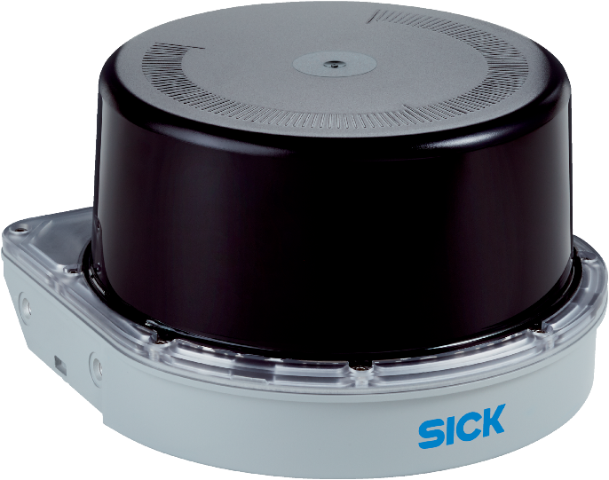
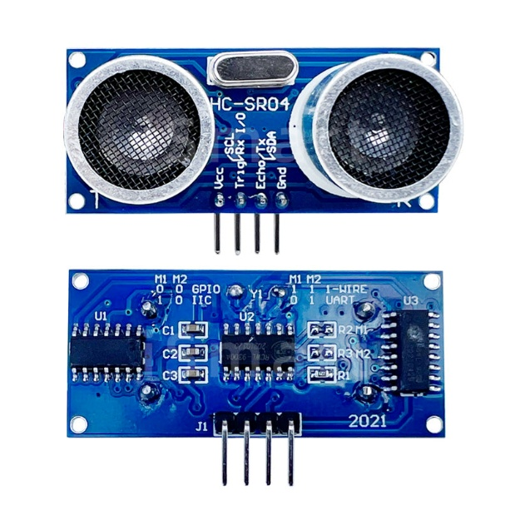
Today I have investigated many possibilities for ways to further advance my line following robot from last year (2023 – 2024). Some possibilities that I have come up with are using an ultra-sonic sensor as shown in figure 1 to allow the robot to stop and reorientation itself in the case of something blocking the path. Another possibility I have come up with is using a lidar sensor such as figure 2 to perform advanced object detection and reorientation. Another possible way to advance this project is by using a grid system where the user can place a dote of where the robot should move to, and the robot will convert the grid into an algorithm where one square corresponds to 1 m.
Figure 2
Figure 1

Day 2 – 2024 October 2

Today I have researched more about my possible options. This has made me understand that Ultra Sonic Sensors does not allow for different objects to be to be detected differently, lidar sensors also have this same problem. My 3rd option has problems as well. This is because with a grid system completely removes the line following, and the grid allows the robot to move anonymously. For these reasons I have learned through my research that a Pixy 2 camera can perform the object to detection and recognition, but it does not record at a high enough frame rate, and it is not widely affordable, these are the same reasons that Husky Lens Camera also does not work. A picture of the Pixy 2 camera can be seen in figure 3 and a Husky Lens Camera can be seen in figure 4.

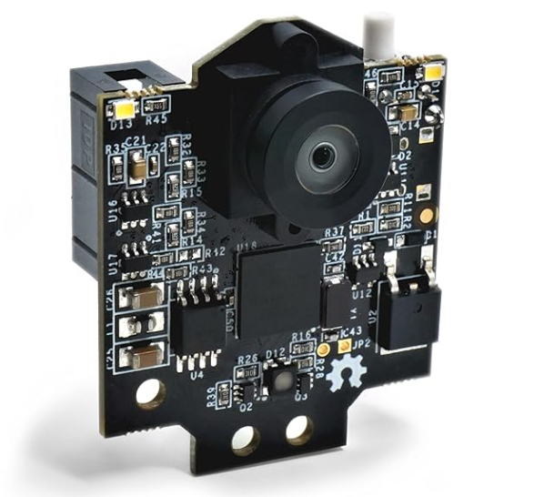
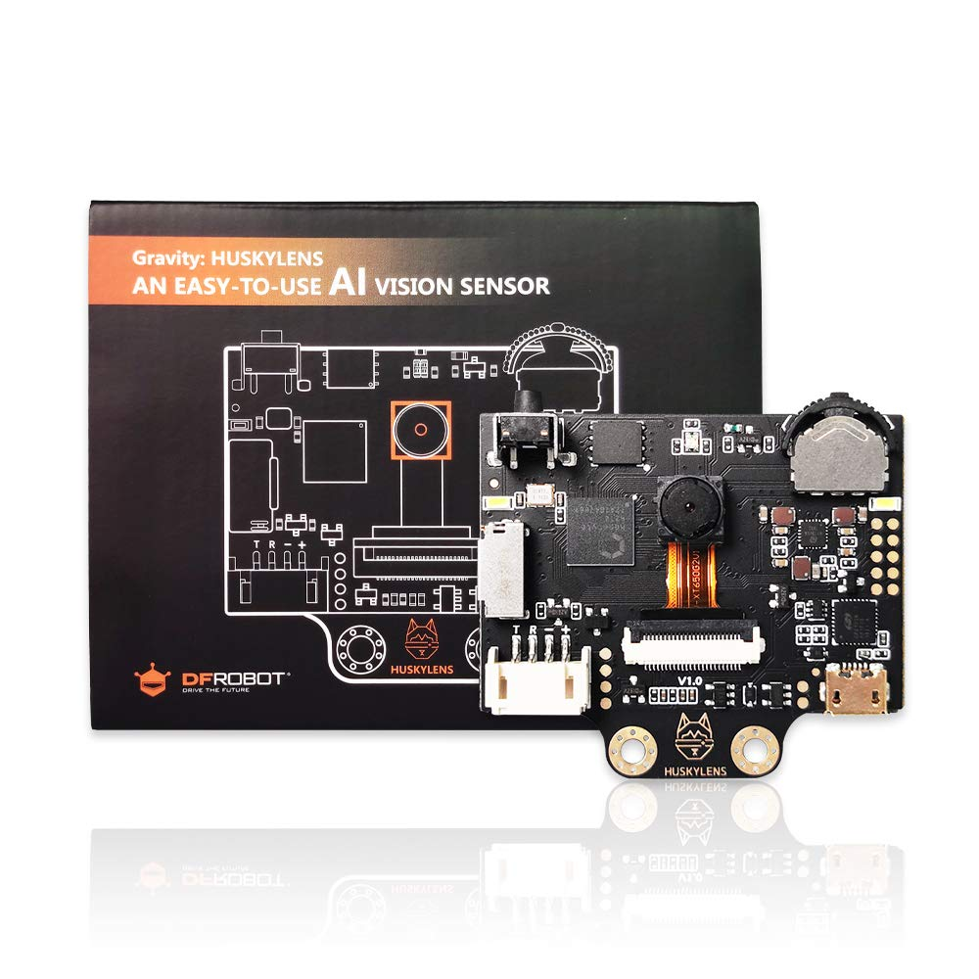
Figure 3
Figure 4

Day 3 – 2024 October 16

Today I have learned that there is a camera called Esp 32 which should work as a more affordable option. I have ordered it for Amazon, and it arrives on the 23rd of October. Figures 5 and 6 are pictures of the camera.

Figure 6
Figure 5
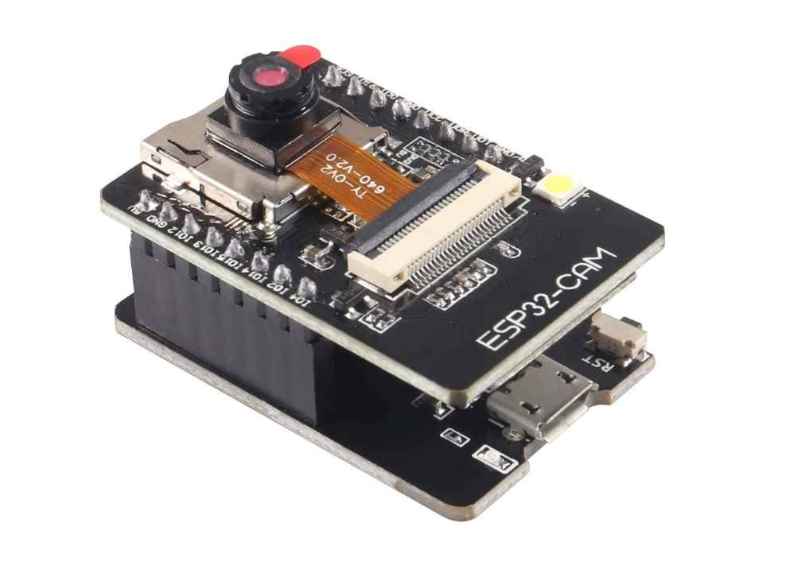
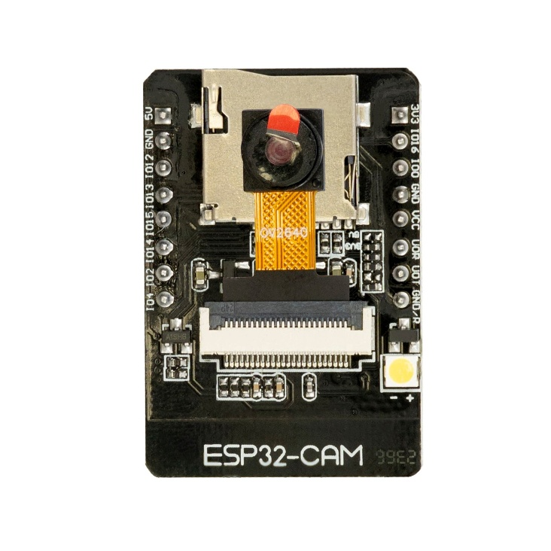

Day 4 – 2024 October 23

Today I received my Esp32, and I have started programming on it. First, I needed to use the Drone Bot Workshop code to get my Esp32 online. This code is in figures 7, 8, and 9. After this the next step was using Edge Impulse to take pictures of my human figure, I had to take a total of 230 pictures of my mini figure. Then Edge Impulse converted those pictures into a code that can be ran on an Arduino Uno R3 the code and be seen on figures 10 – 21.
Figure 8
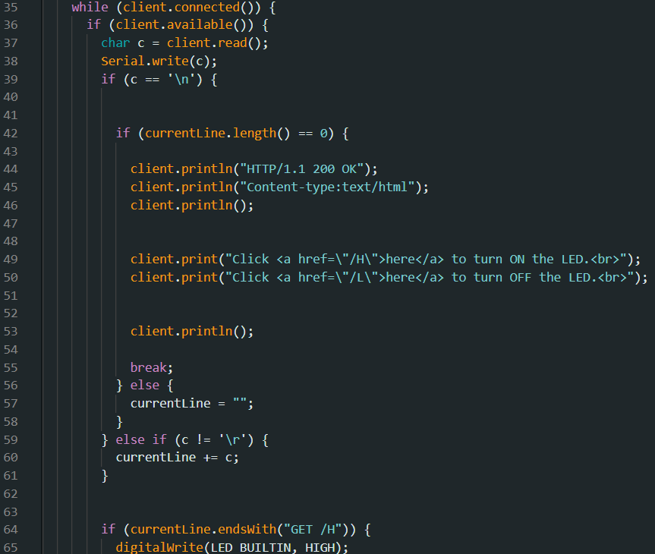
Figure 7
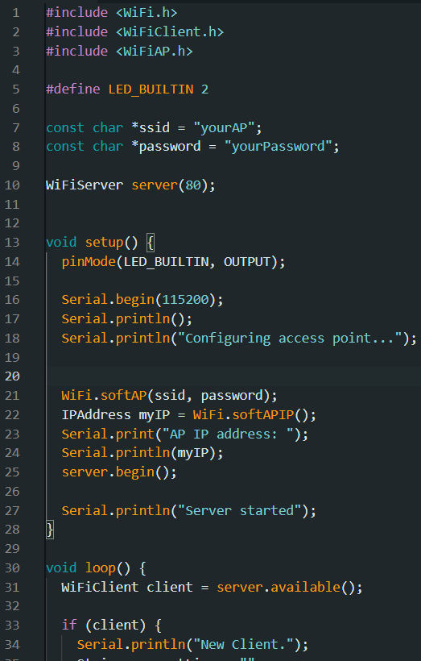

Figure 9
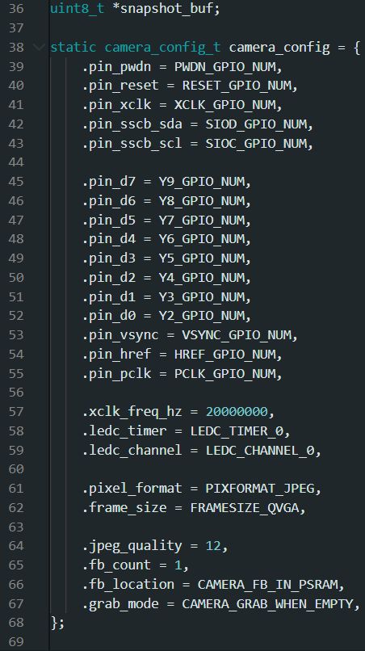
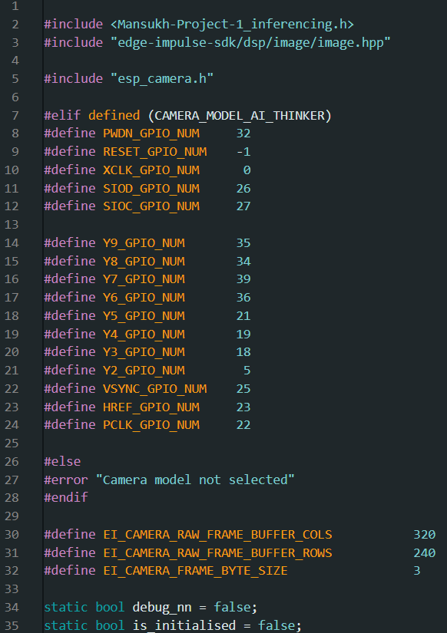
Figure 11
Figure 10

Figure 12
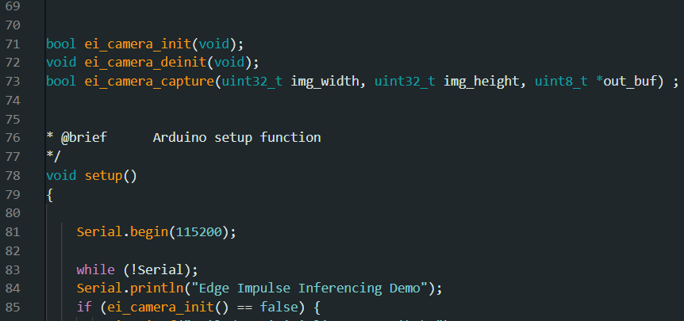

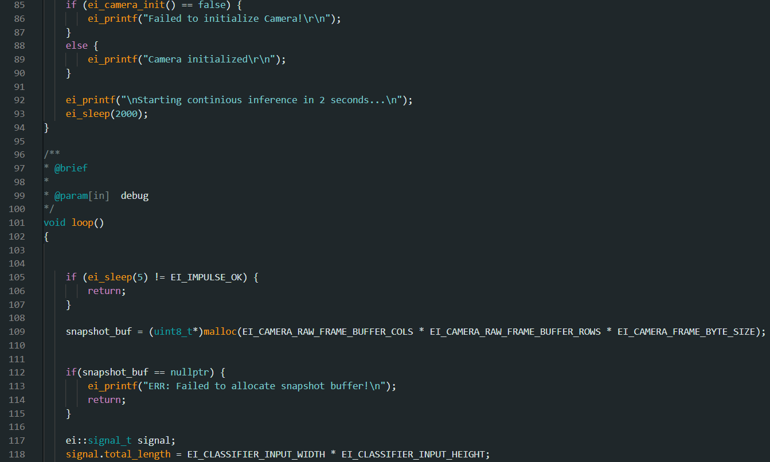
Figure 13

Figure 14
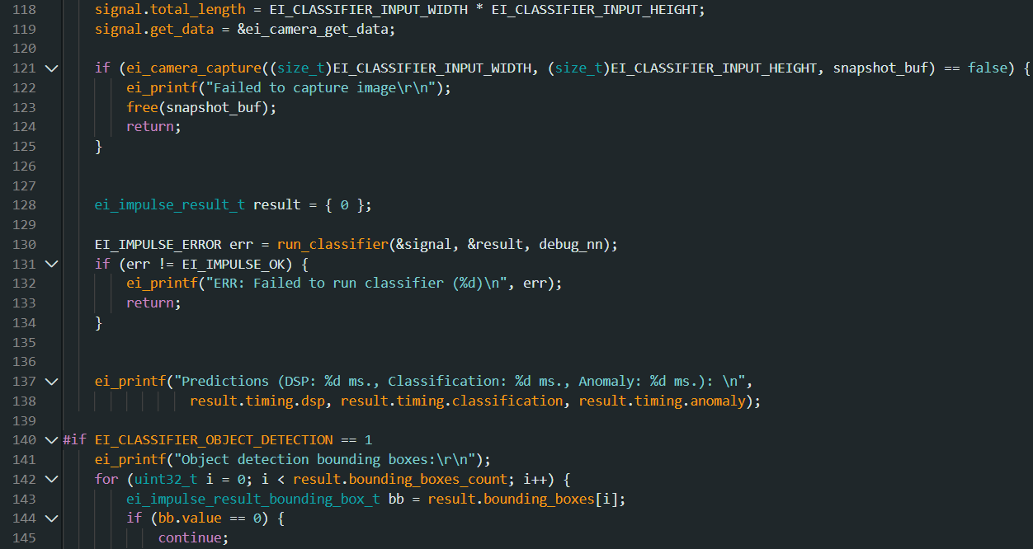

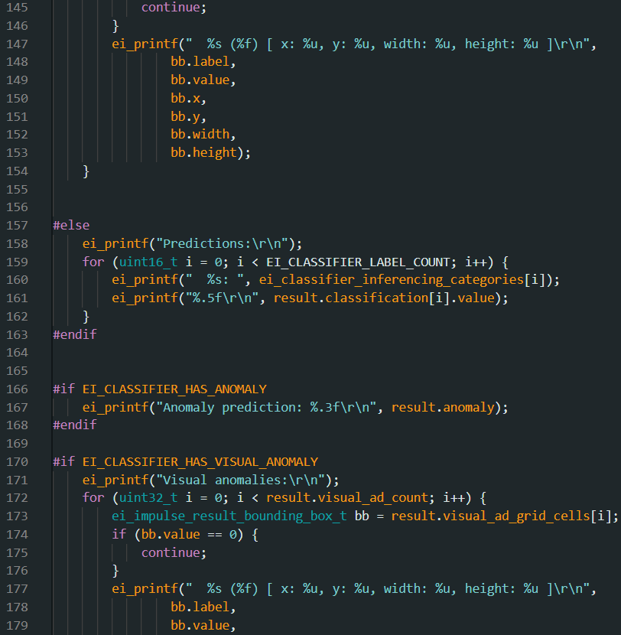
Figure 15
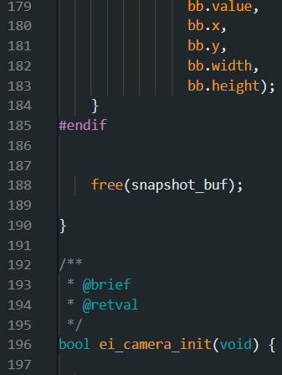
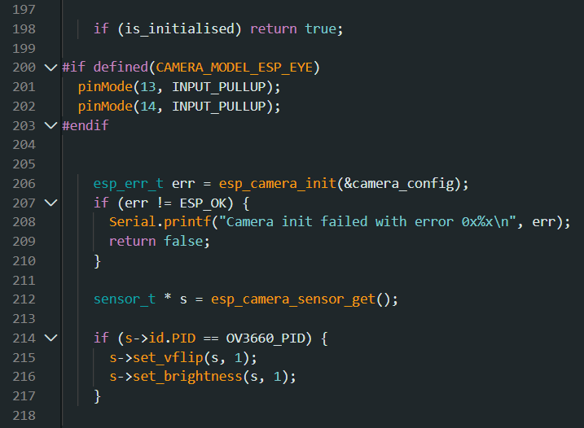
Figure 17
Figure 16
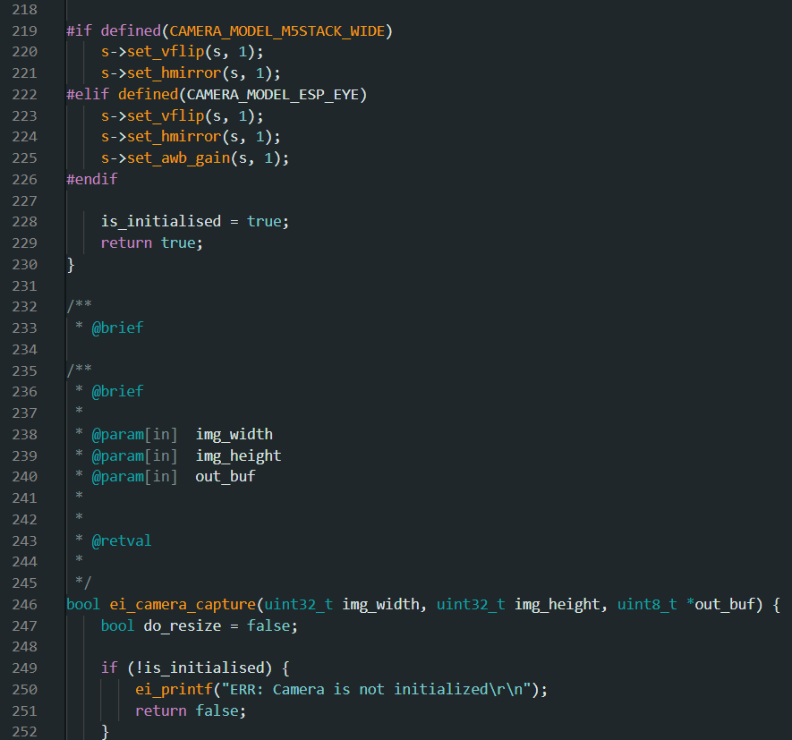
Figure 19
Figure 18
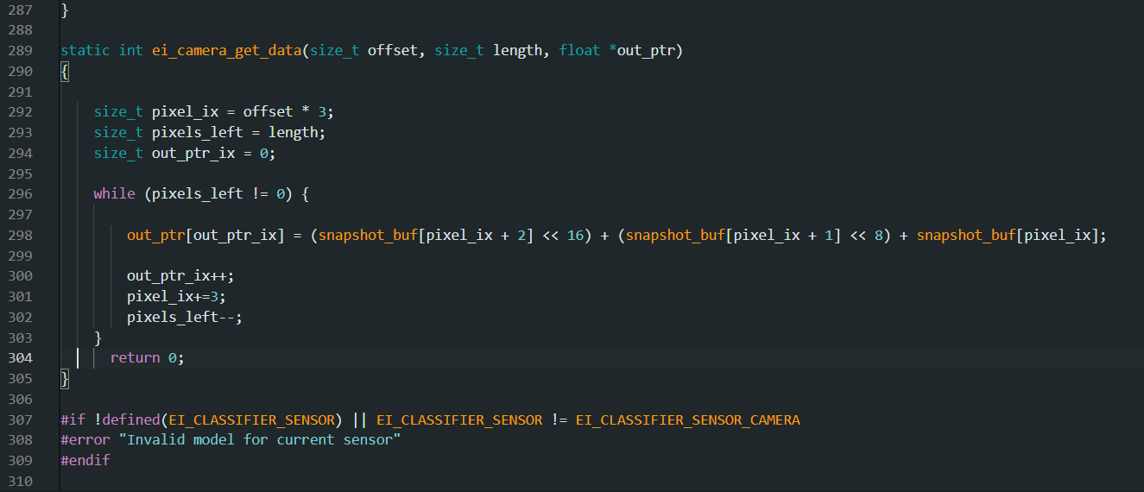
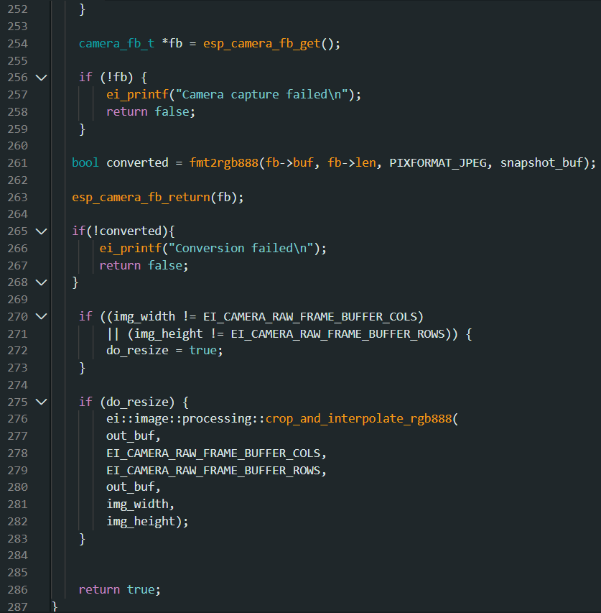
Figure 21
Figure 20
Day 5 - 11 – 2024 October 24 -30

For the past few days, I have tried many different things to make the code work, but it does not upload to Arduino. I have tried taking less picture, buying a special data transfer wire, trying each line, and asking ChatGPT to tell me what each line means and what it does, but it still does not work. So, I have decided to do the face detection in Python 3.11.0 and use the OpenCV library and that may work.
Figure 22


Day 11 - 15 – 2024 November 4- 8

For the past 4 days I have tried using the Esp32 and Python code, but it has a problem creating a web server that the python and Arduino code can run in. This problem is common with Esp32, but it is not working for me. I have tried many things like using manual going into Device Manager and changing the com ports, and how it reads, and even trying to use it as a HTTP server. For these reasons I have switched to using a web cam.

Figure 23
Day 15 - 22 – 2024 November 12 - 19

For the past week I have tried many new Python programs that work with web cams, and I found one reliable one from Arun Ponnusamy who is a computer vision research engineer. The link to his GitHub chat can be found here “https://github.com/arunponnusamy/cvlib/tree/f46a22f8e13bc4b0267b9057fa88de170d41f96a”.
For this code I have installed the following libraries NumPy, OpenCV-python, Requests, Progress Bar, Pillow, TensorFlow, and Keras. This code uses an all-ready created data base of picture, so I do not need to train the face detection software.
Figure 24
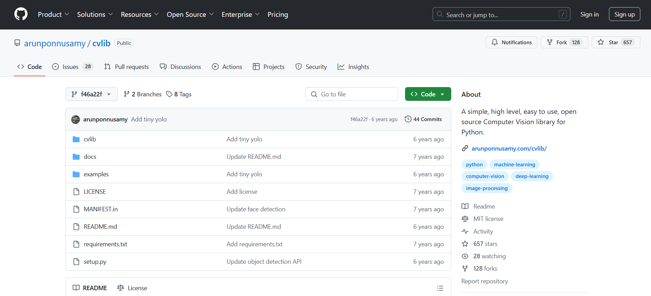

Day 22 - 28 – 2024 November 20 – 26

For the past 6 days I have worked on face detection and have gotten it to run on my web cam. This is very important as now I can work on the serial connection to the Arduino and Python program. In Arduino I have created a code that will stop and start the motors. When a face is detected, the motors stop and when the face is removed the motors restart. For this I have made an Arduino and Python code which can be found in figure 25 - 26 for Arduino and 27 - 28 for Python.
Figure 26
Figure 25
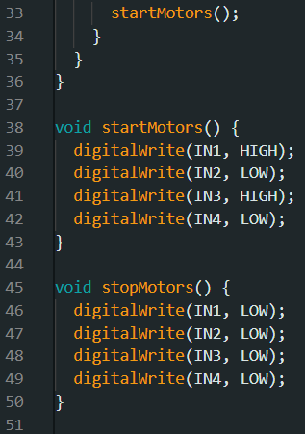
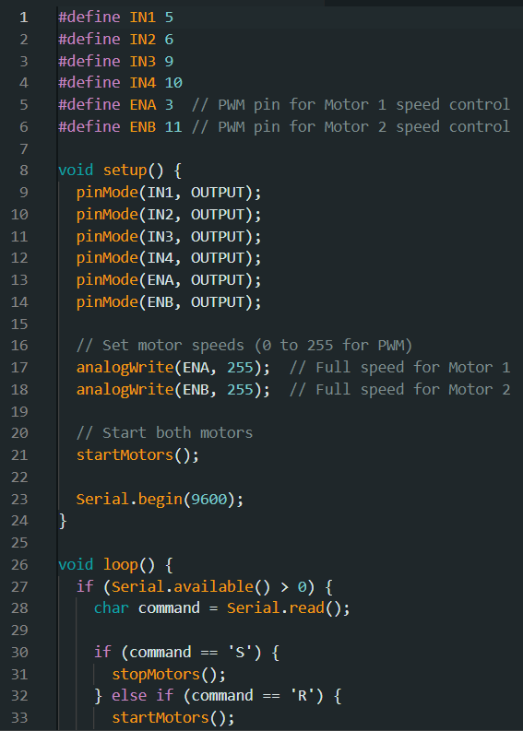

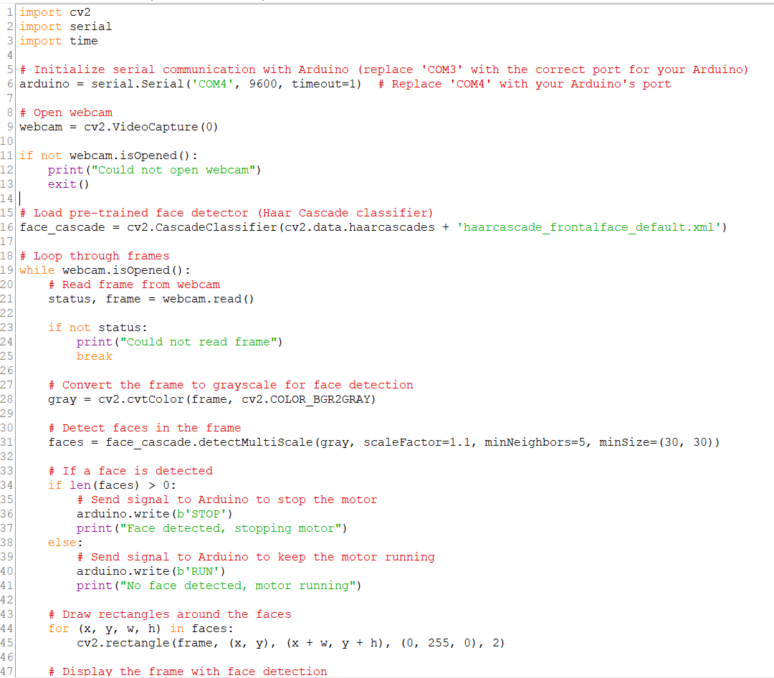
Figure 27

Figure 28
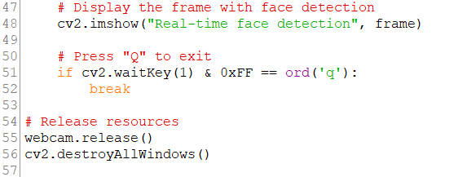

Day 28 - 30 – 2024 November 28 – 30

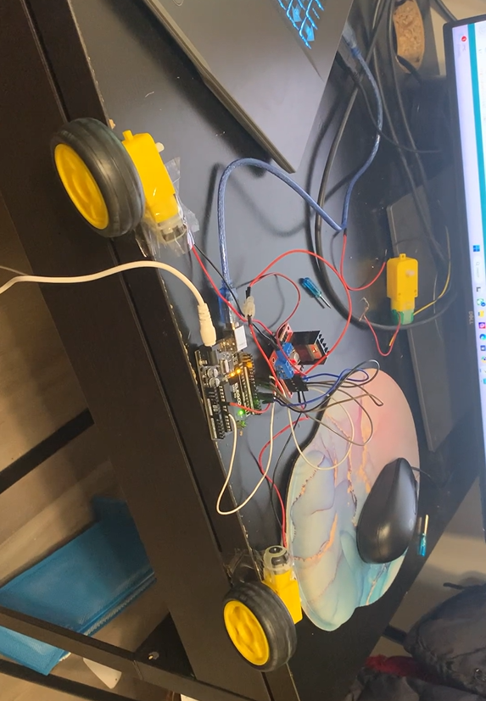
For the past 2 days I have worked on my code and finally gotten my Python and Arduino codes to run together, and it now allows the motors to spin freely when there is no face but when there is a face the motors stop immediately. This now means I can start working on the line following in addition to the face detection that now works. Here is a video of my robot stopping and starting when a face is detected or not, link https://drive.google.com/file/d/1XIgpXCFdXcJYmNE6Hul1gKiwWrq40LSc/view A picture of the temporary motor setup can be seen in figure 29.
Figure 29

Day 30 - 37 – 2024 December 8 – 15

For the past week I have created my robot on a chaise but unfortunately my robot has does not have enough power to pull the cable and all the other components. For this reason, I have decided to make a new robot with 4 motors, a 2-wheel motor step up can be seen in figure 30.
Figure 30

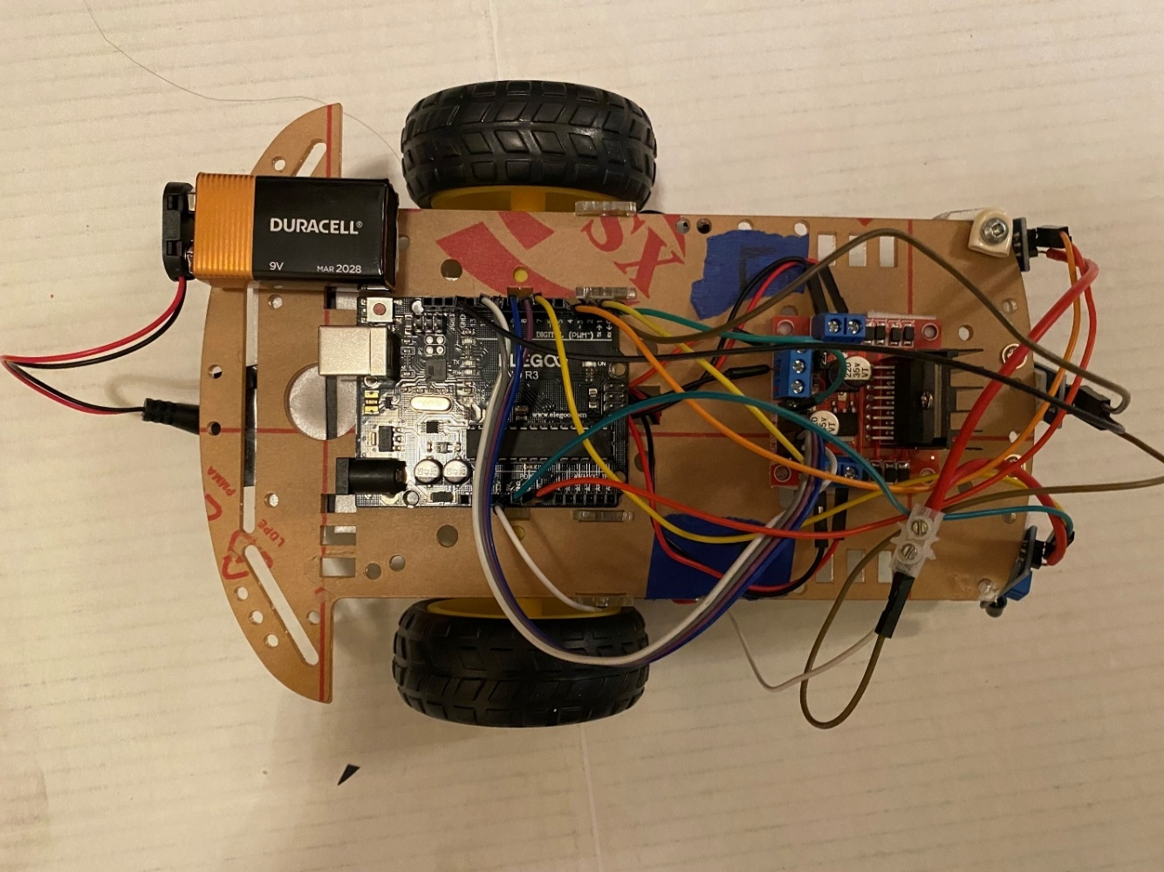

Day 37 – 42 2024 December 15 - 20

I have created a 4-motor design, but that still does not have enough power to pull the cables as the car needs to be plugged in as if it is not the Arduino does not know what it is seeing in front of it. Figures 31 - 38 are below which depicts the 4-motor design.
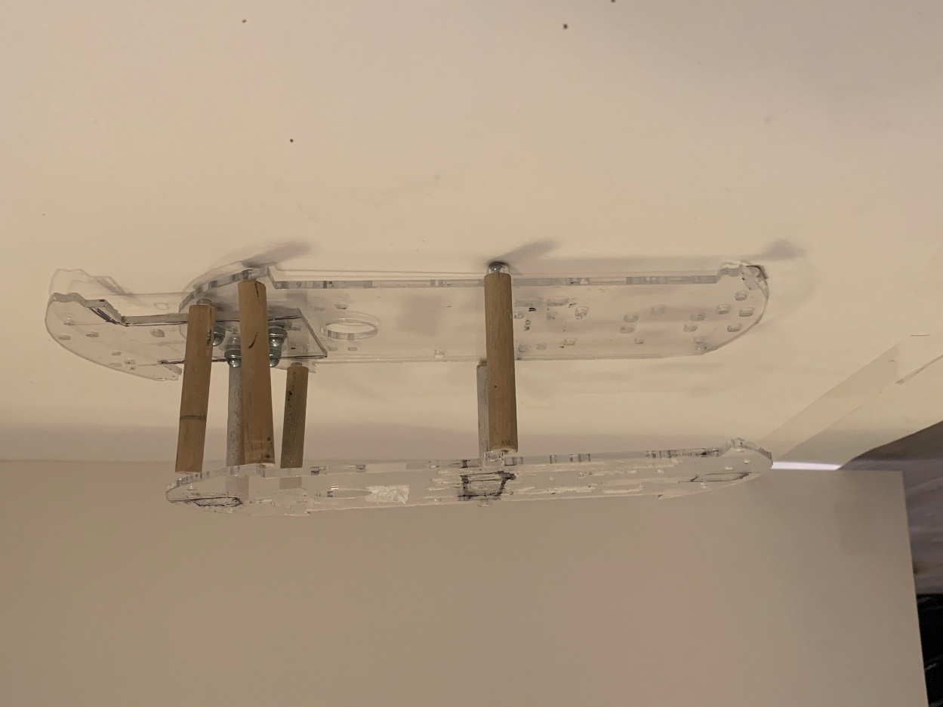
Figure 32
Figure 31
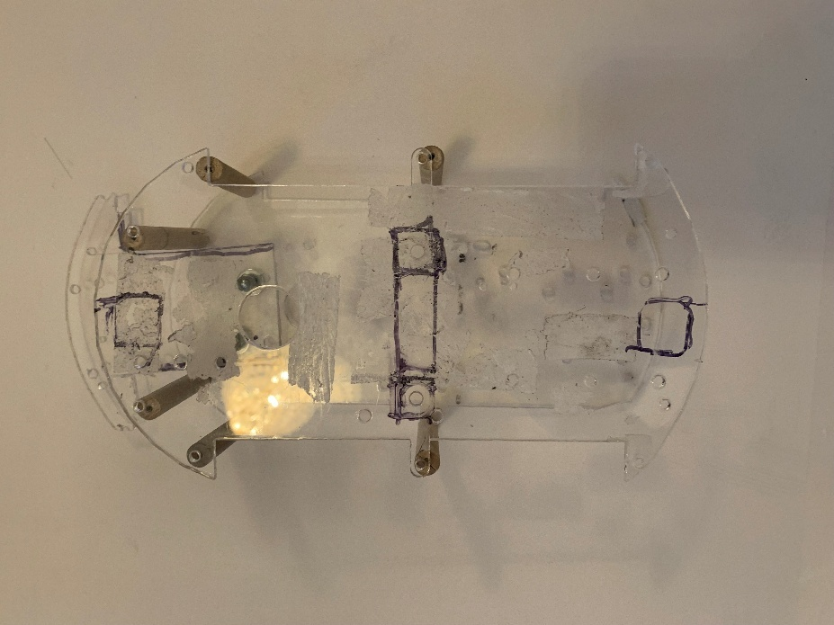

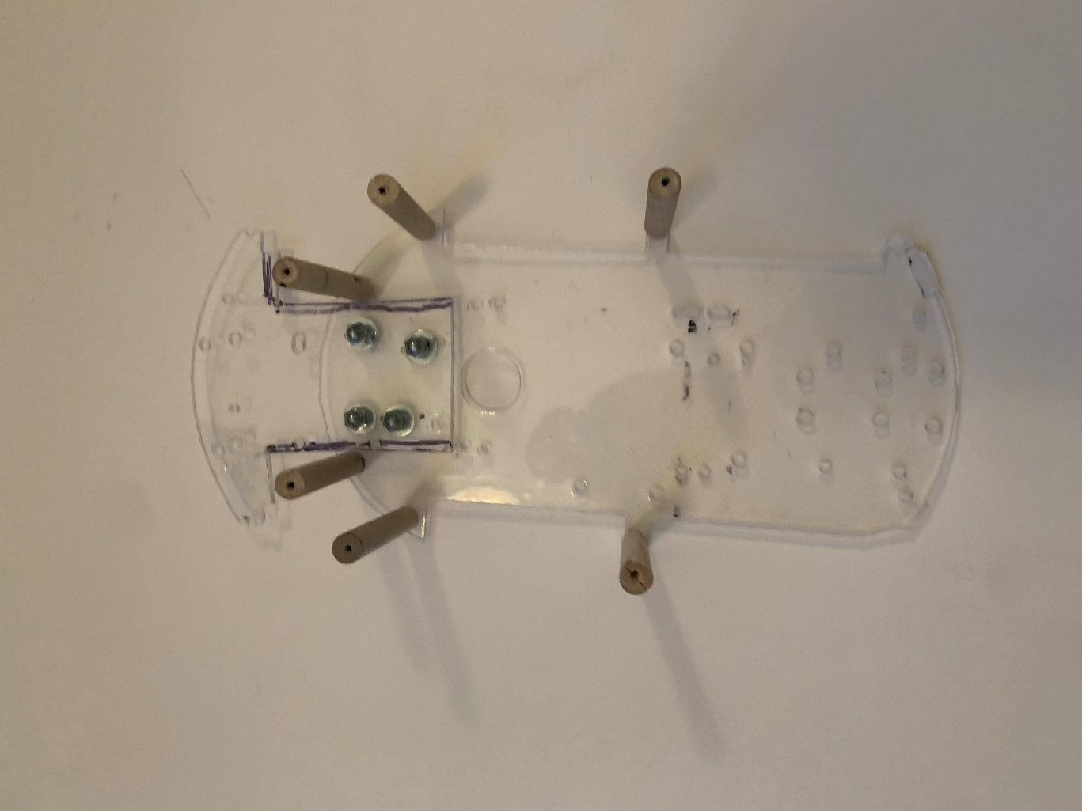
Figure 33

Figure 34
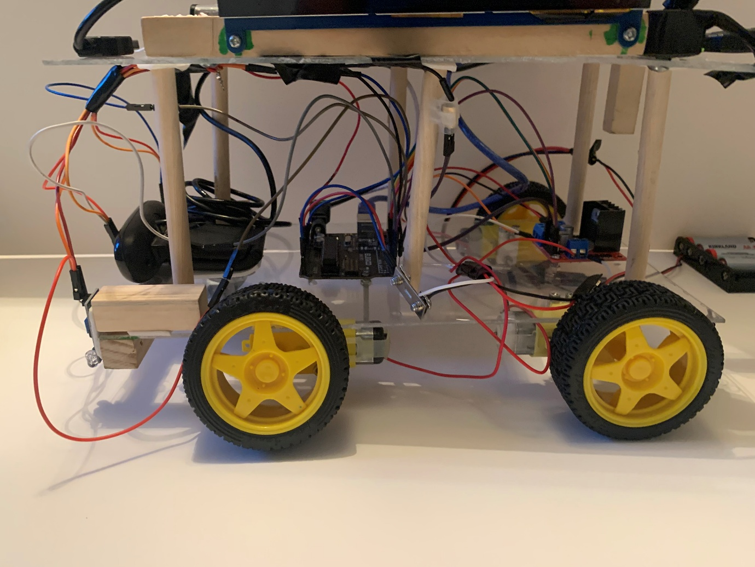

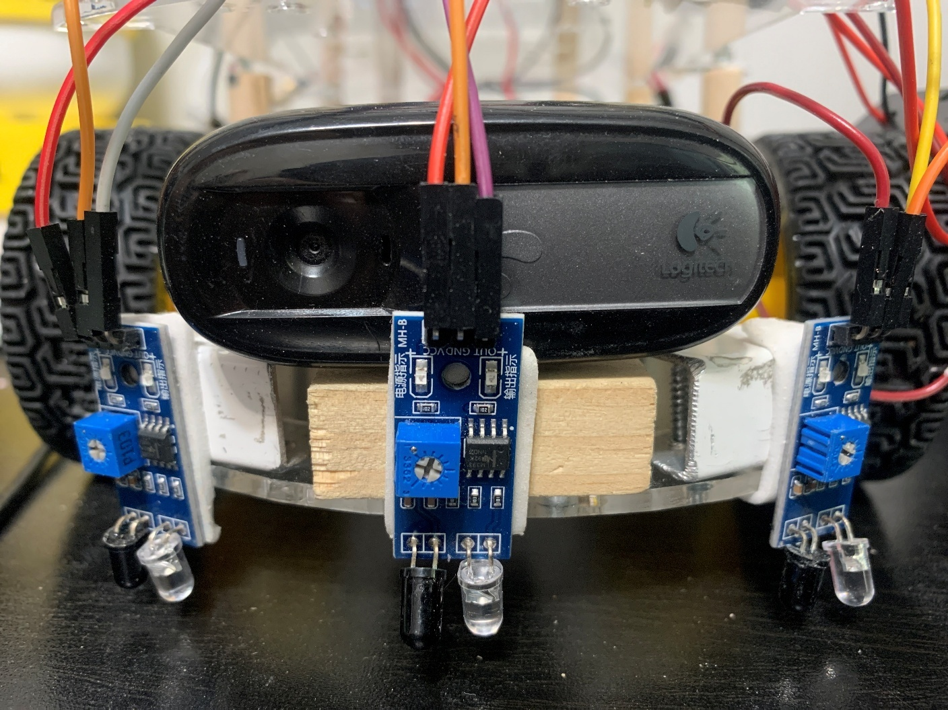
Figure 35

Figure 36
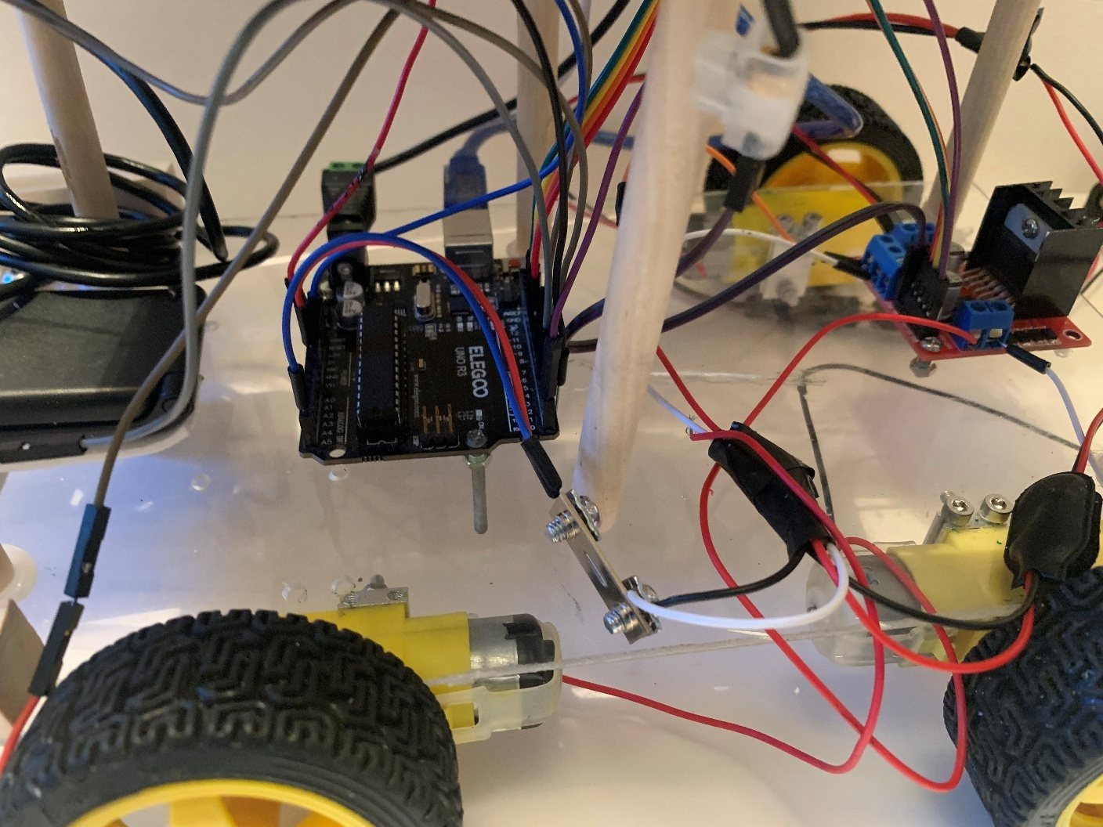

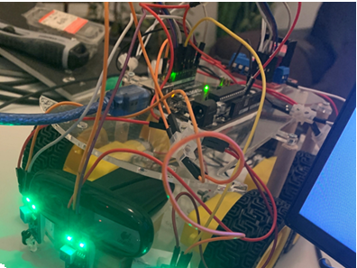
Figure 37

Figure 38
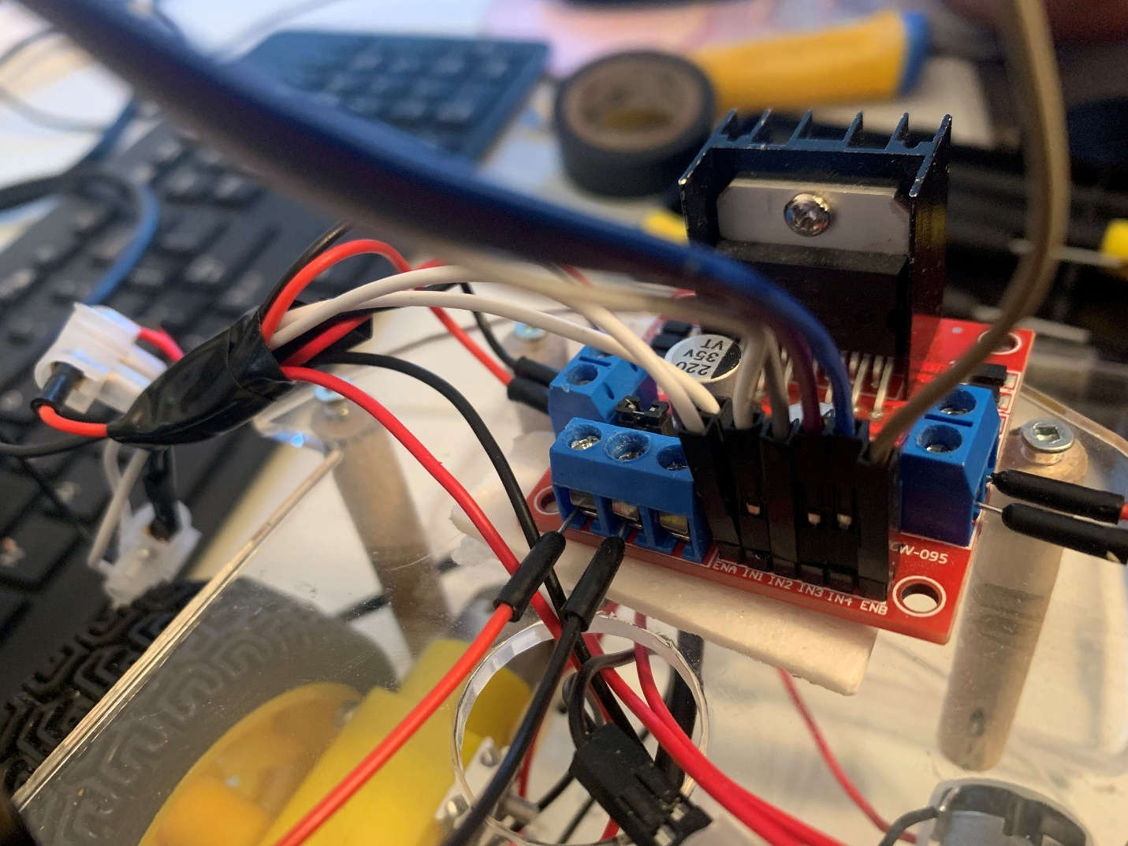

Day 42 - 45 2024 December 20 - 23

I have spent the past 3 days thinking about some possible solutions, and I have come up with 2 main ones, the first being a Raspberry Pi model B and completely removing the wires. The second is providing the L298N motor driver with its own power supply. This will allow the motor driver to have more power as the Arduino can only provide 5 volts, but the reason I did not do this first was that this will not allow the motors to work with pulse width modulation or PWM for short. I have ordered my Raspberry Pi model B, and it should arrive on the 26 of December.
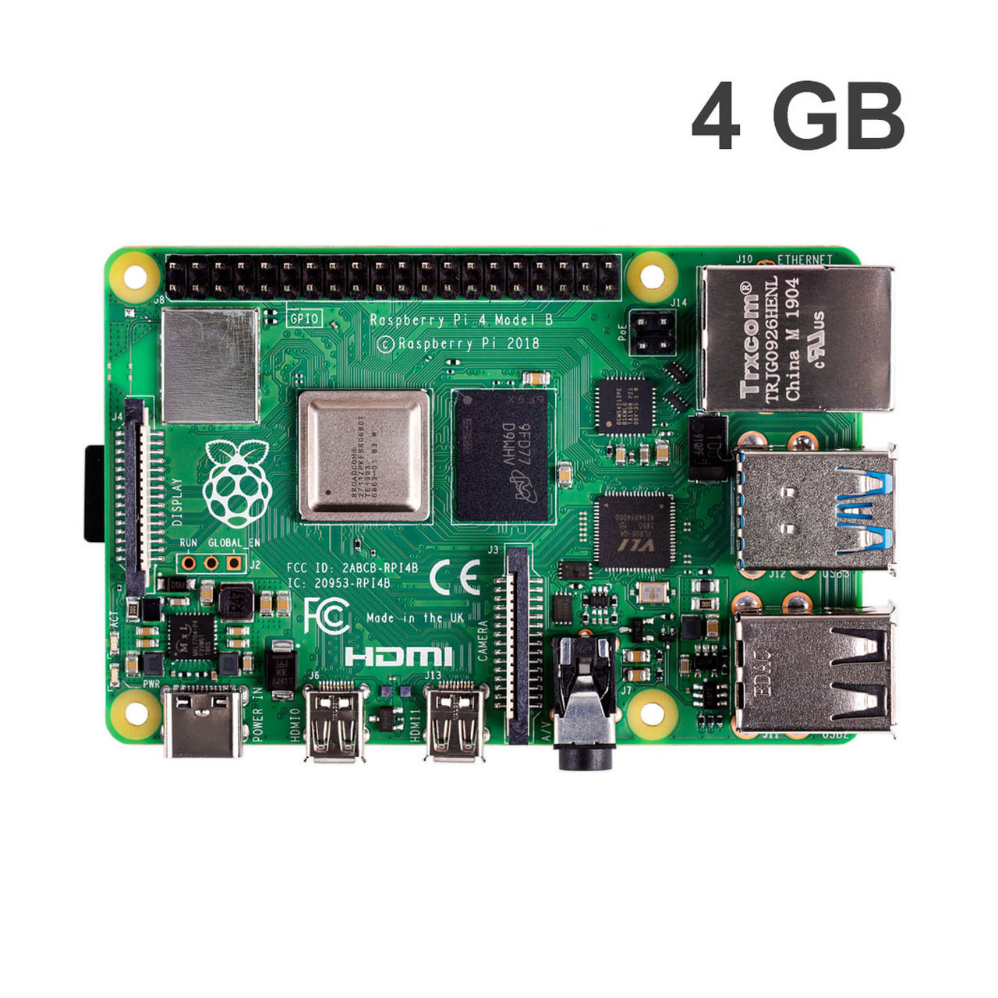
Figure 39

Day 45 - 50 2024 December 26 - 31

I have received my Raspberry Pi model Band have started to install Python and the other library needed for my code, but the Raspberry Pi would not work with OpenCV, and I tried many things to get it work for multiply days until finally on the 31 of December I was able to get it to work. I followed a tutorial for Sam Westby Tech who helped me fix common problems with OpenCV on Raspberry Pi OS here is a link to his video “https://www.youtube.com/watch?v=QzVYnG-WaM4”

Figure 40

Day 50 – 60 2024 January 5 – 15

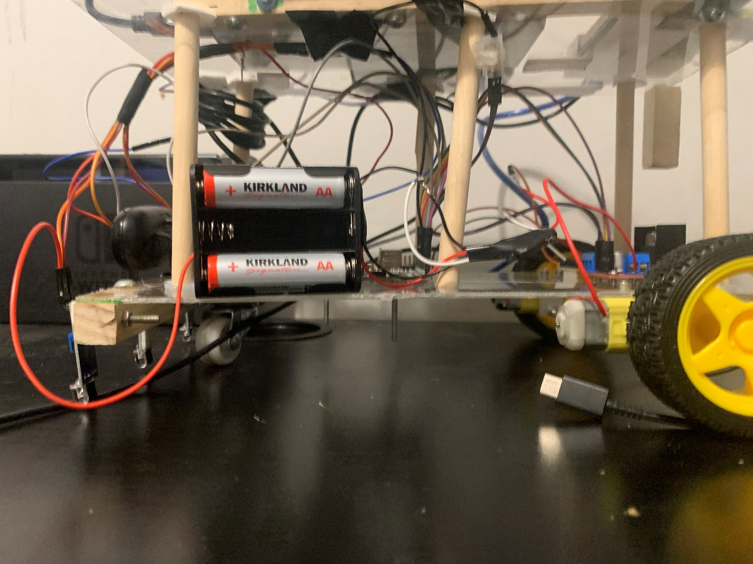
For the past 10 days I have completely remade my robot. I have cut out a new chaise much bigger then the last, put in a monitor to see the live video of the face detection, and have added a separate power supply for all main components including a 6 double AA battery box for the L298N motor driver, a Lipo or Lithium Polymer battery to power the Arduino and a 10k milliamp hour battery pack to power the Raspberry Pi and monitor. This specific battery is needed to power the Raspberry Pi as anything smaller will give a low power waning. Pictures of my car can be seen in figures 41 – 46.
Figure 41

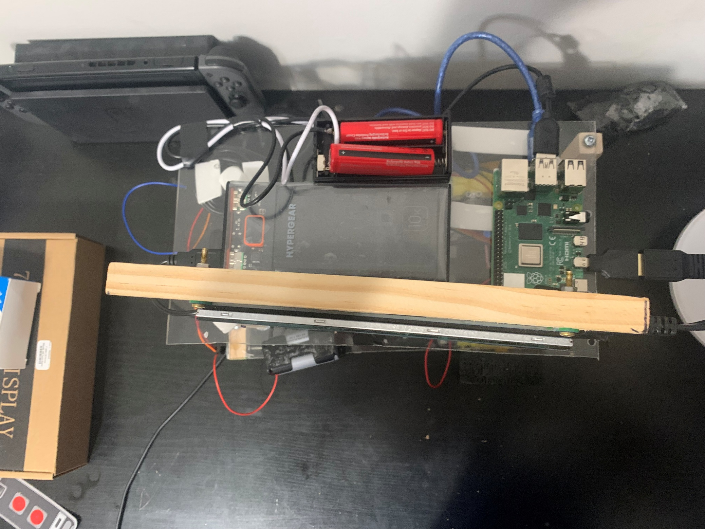
Figure 42

Figure 44
Figure 43

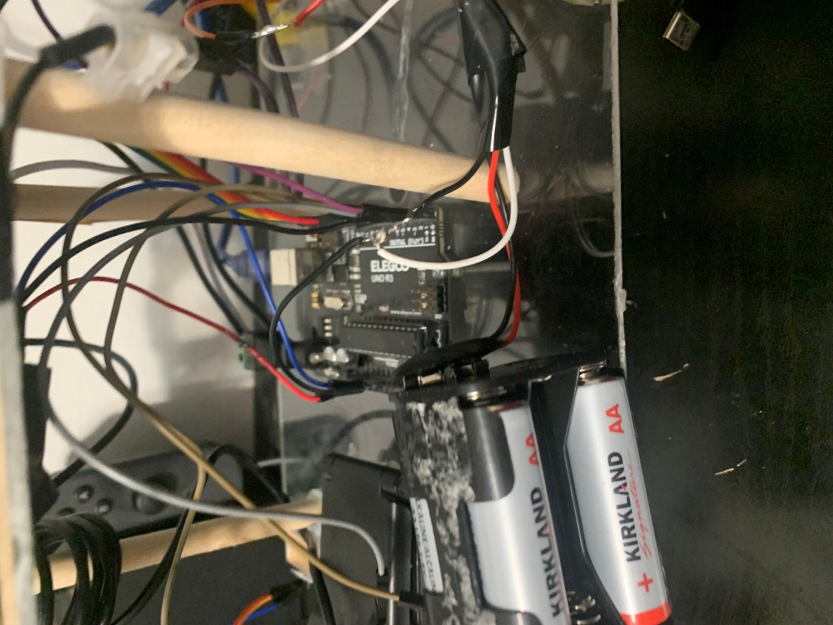
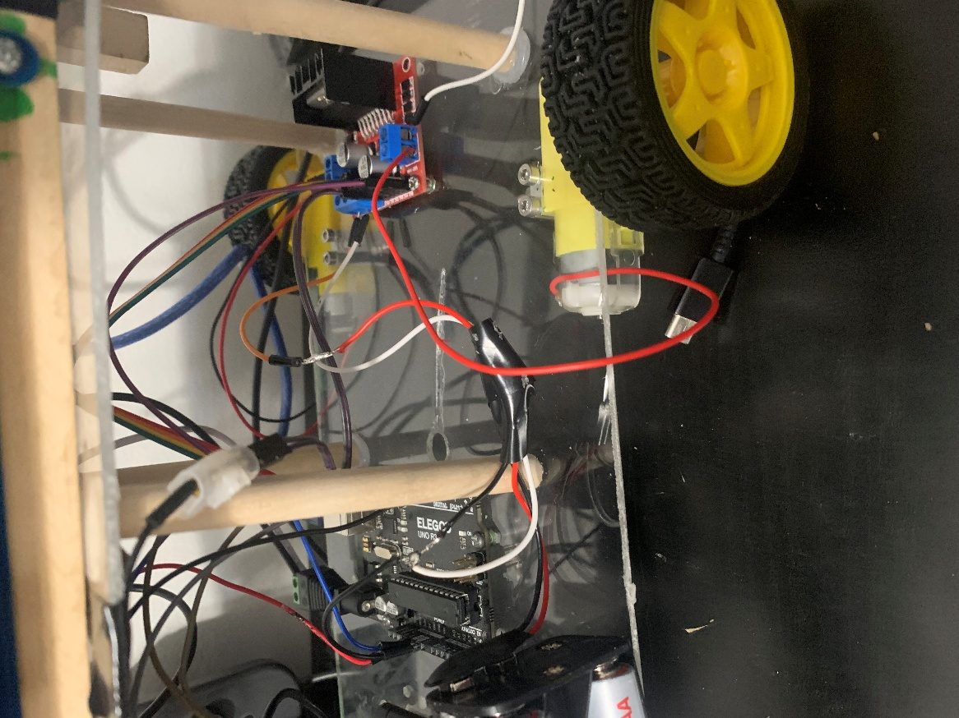

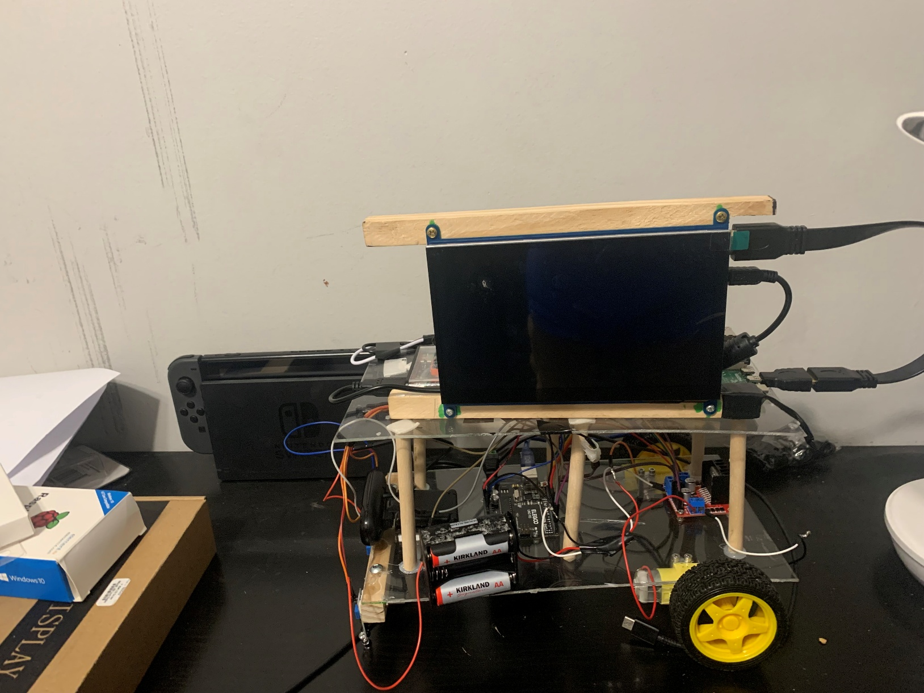
Figure 45

Figure 46
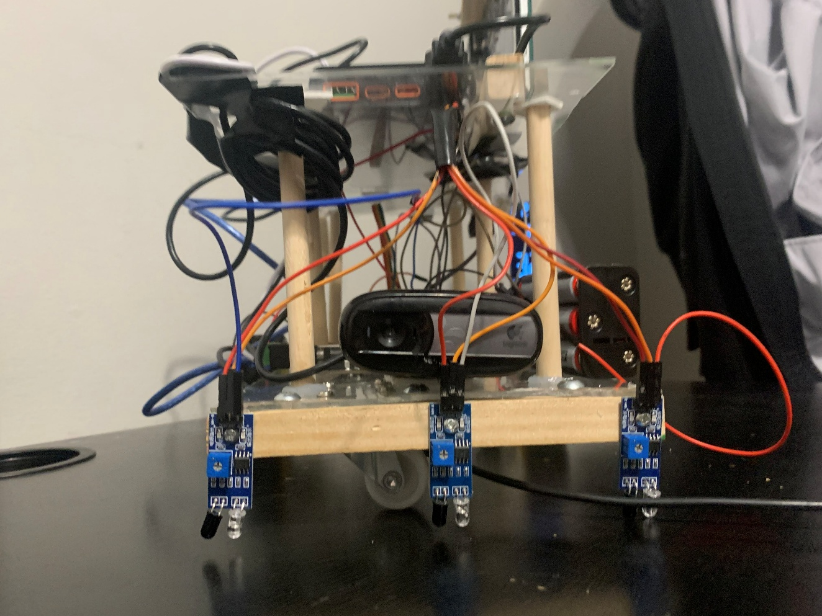

Day 60 - 63 2024 January 15 - 18

For the past few days, I have been trying to fix my robot as it would not stop when a face is detected after many hours and days of research I have learned that the problem was most likely due to my motor driver not being connected to the Arduino to fix this I had to ground the motor driver to Arduino which fixed my problem. But the robot now is too fast to detect the human face. Pictures of the wiring can be seen in figures 47 - 50.
Figure 47
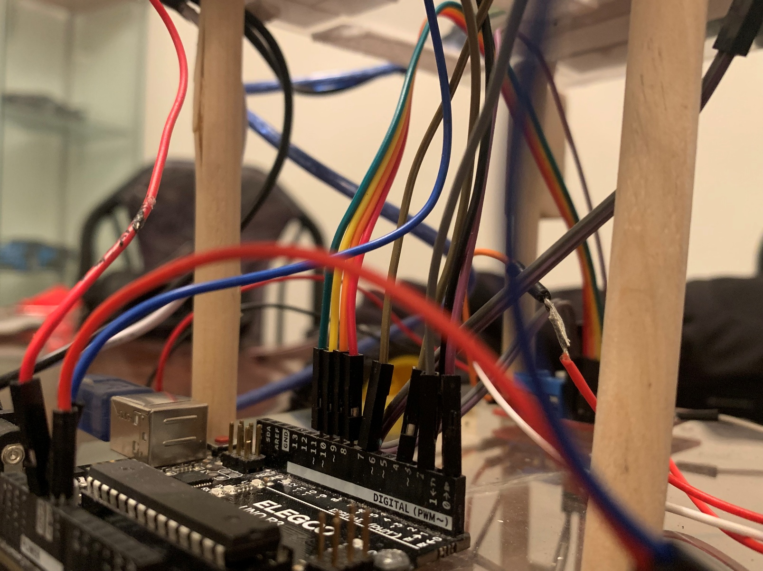

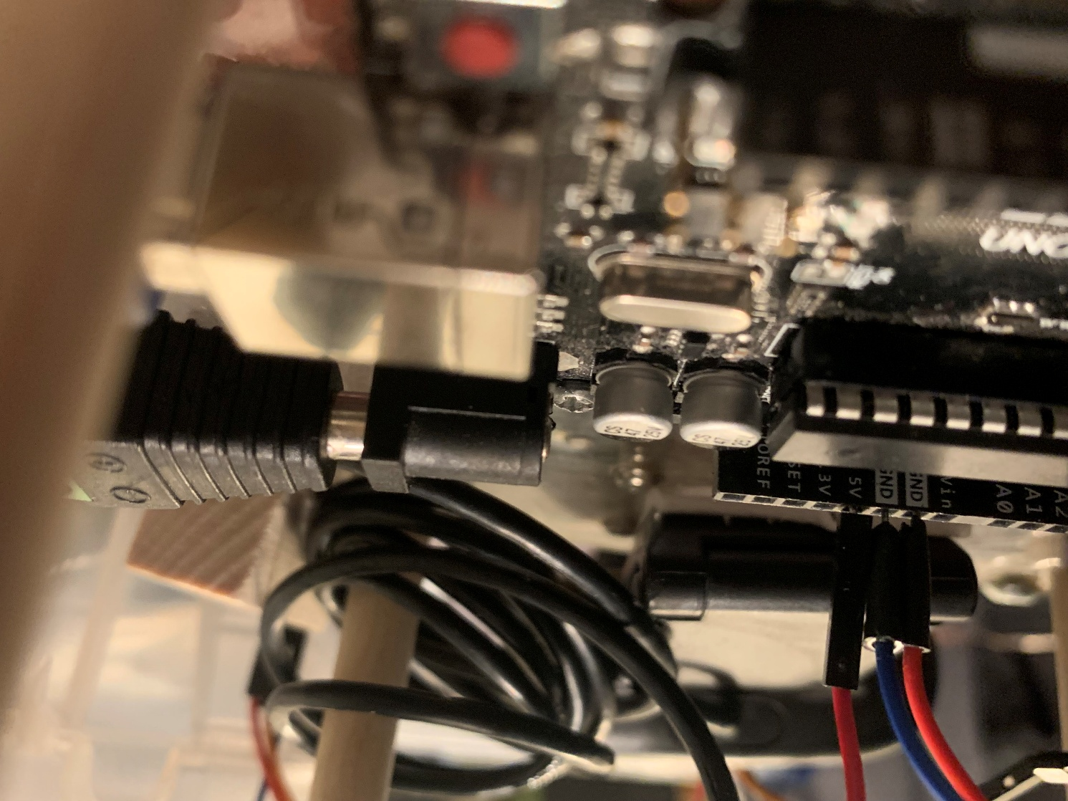
Figure 48

Figure 49
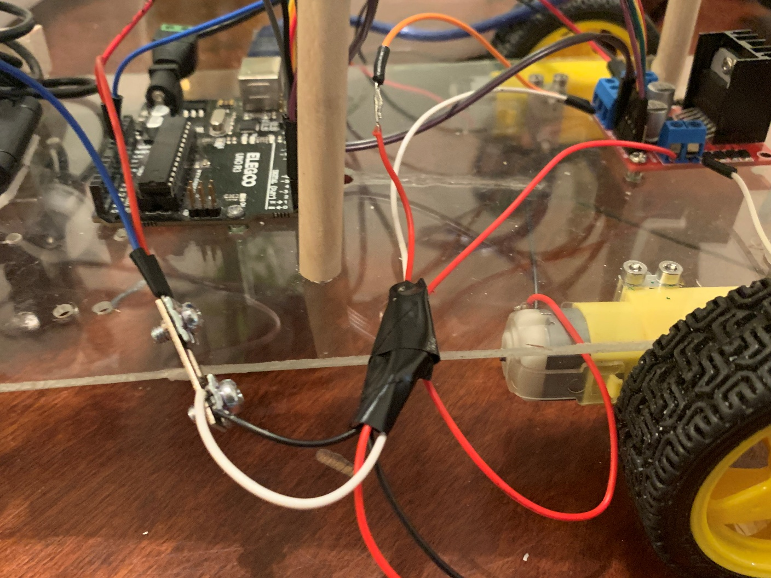

Figure 50
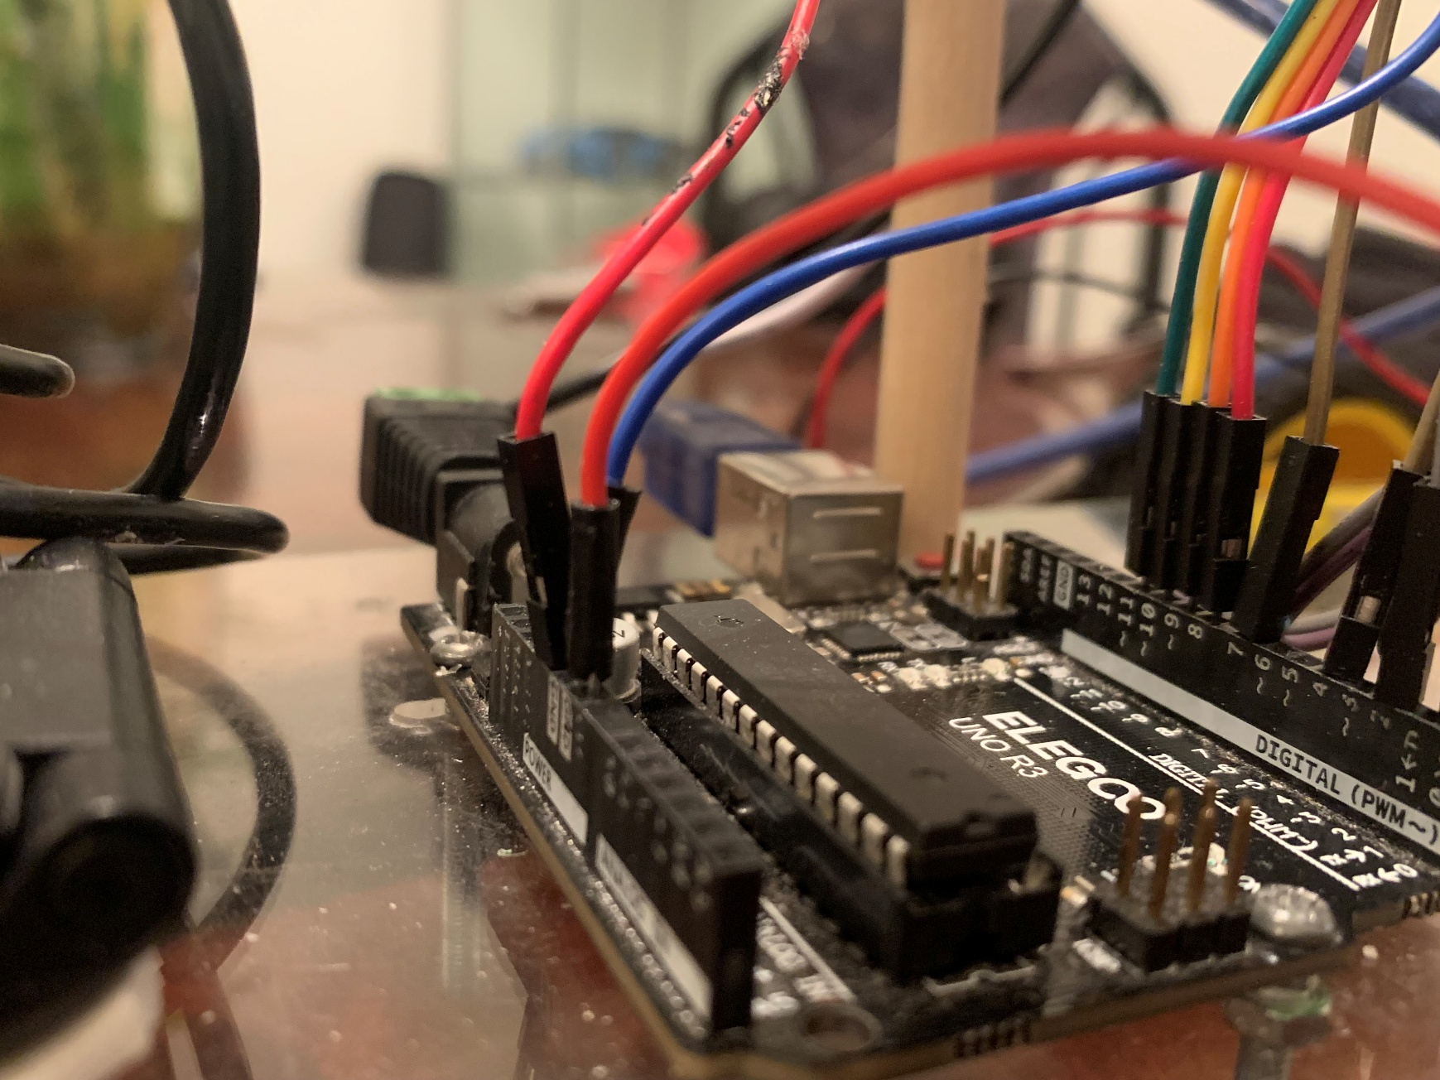

Day 63 - 68 2024 January 18 – 23

For the past few days, I have investigated some options to fix the speed problem for my car and one fix could be switching the previous six battery connector shown in figures 51- 52 to a 5-battery connector like the one shown in figures 53 - 54. Switching to a 5-battery connector has worked and my robot is now finished and works.
Figure 51
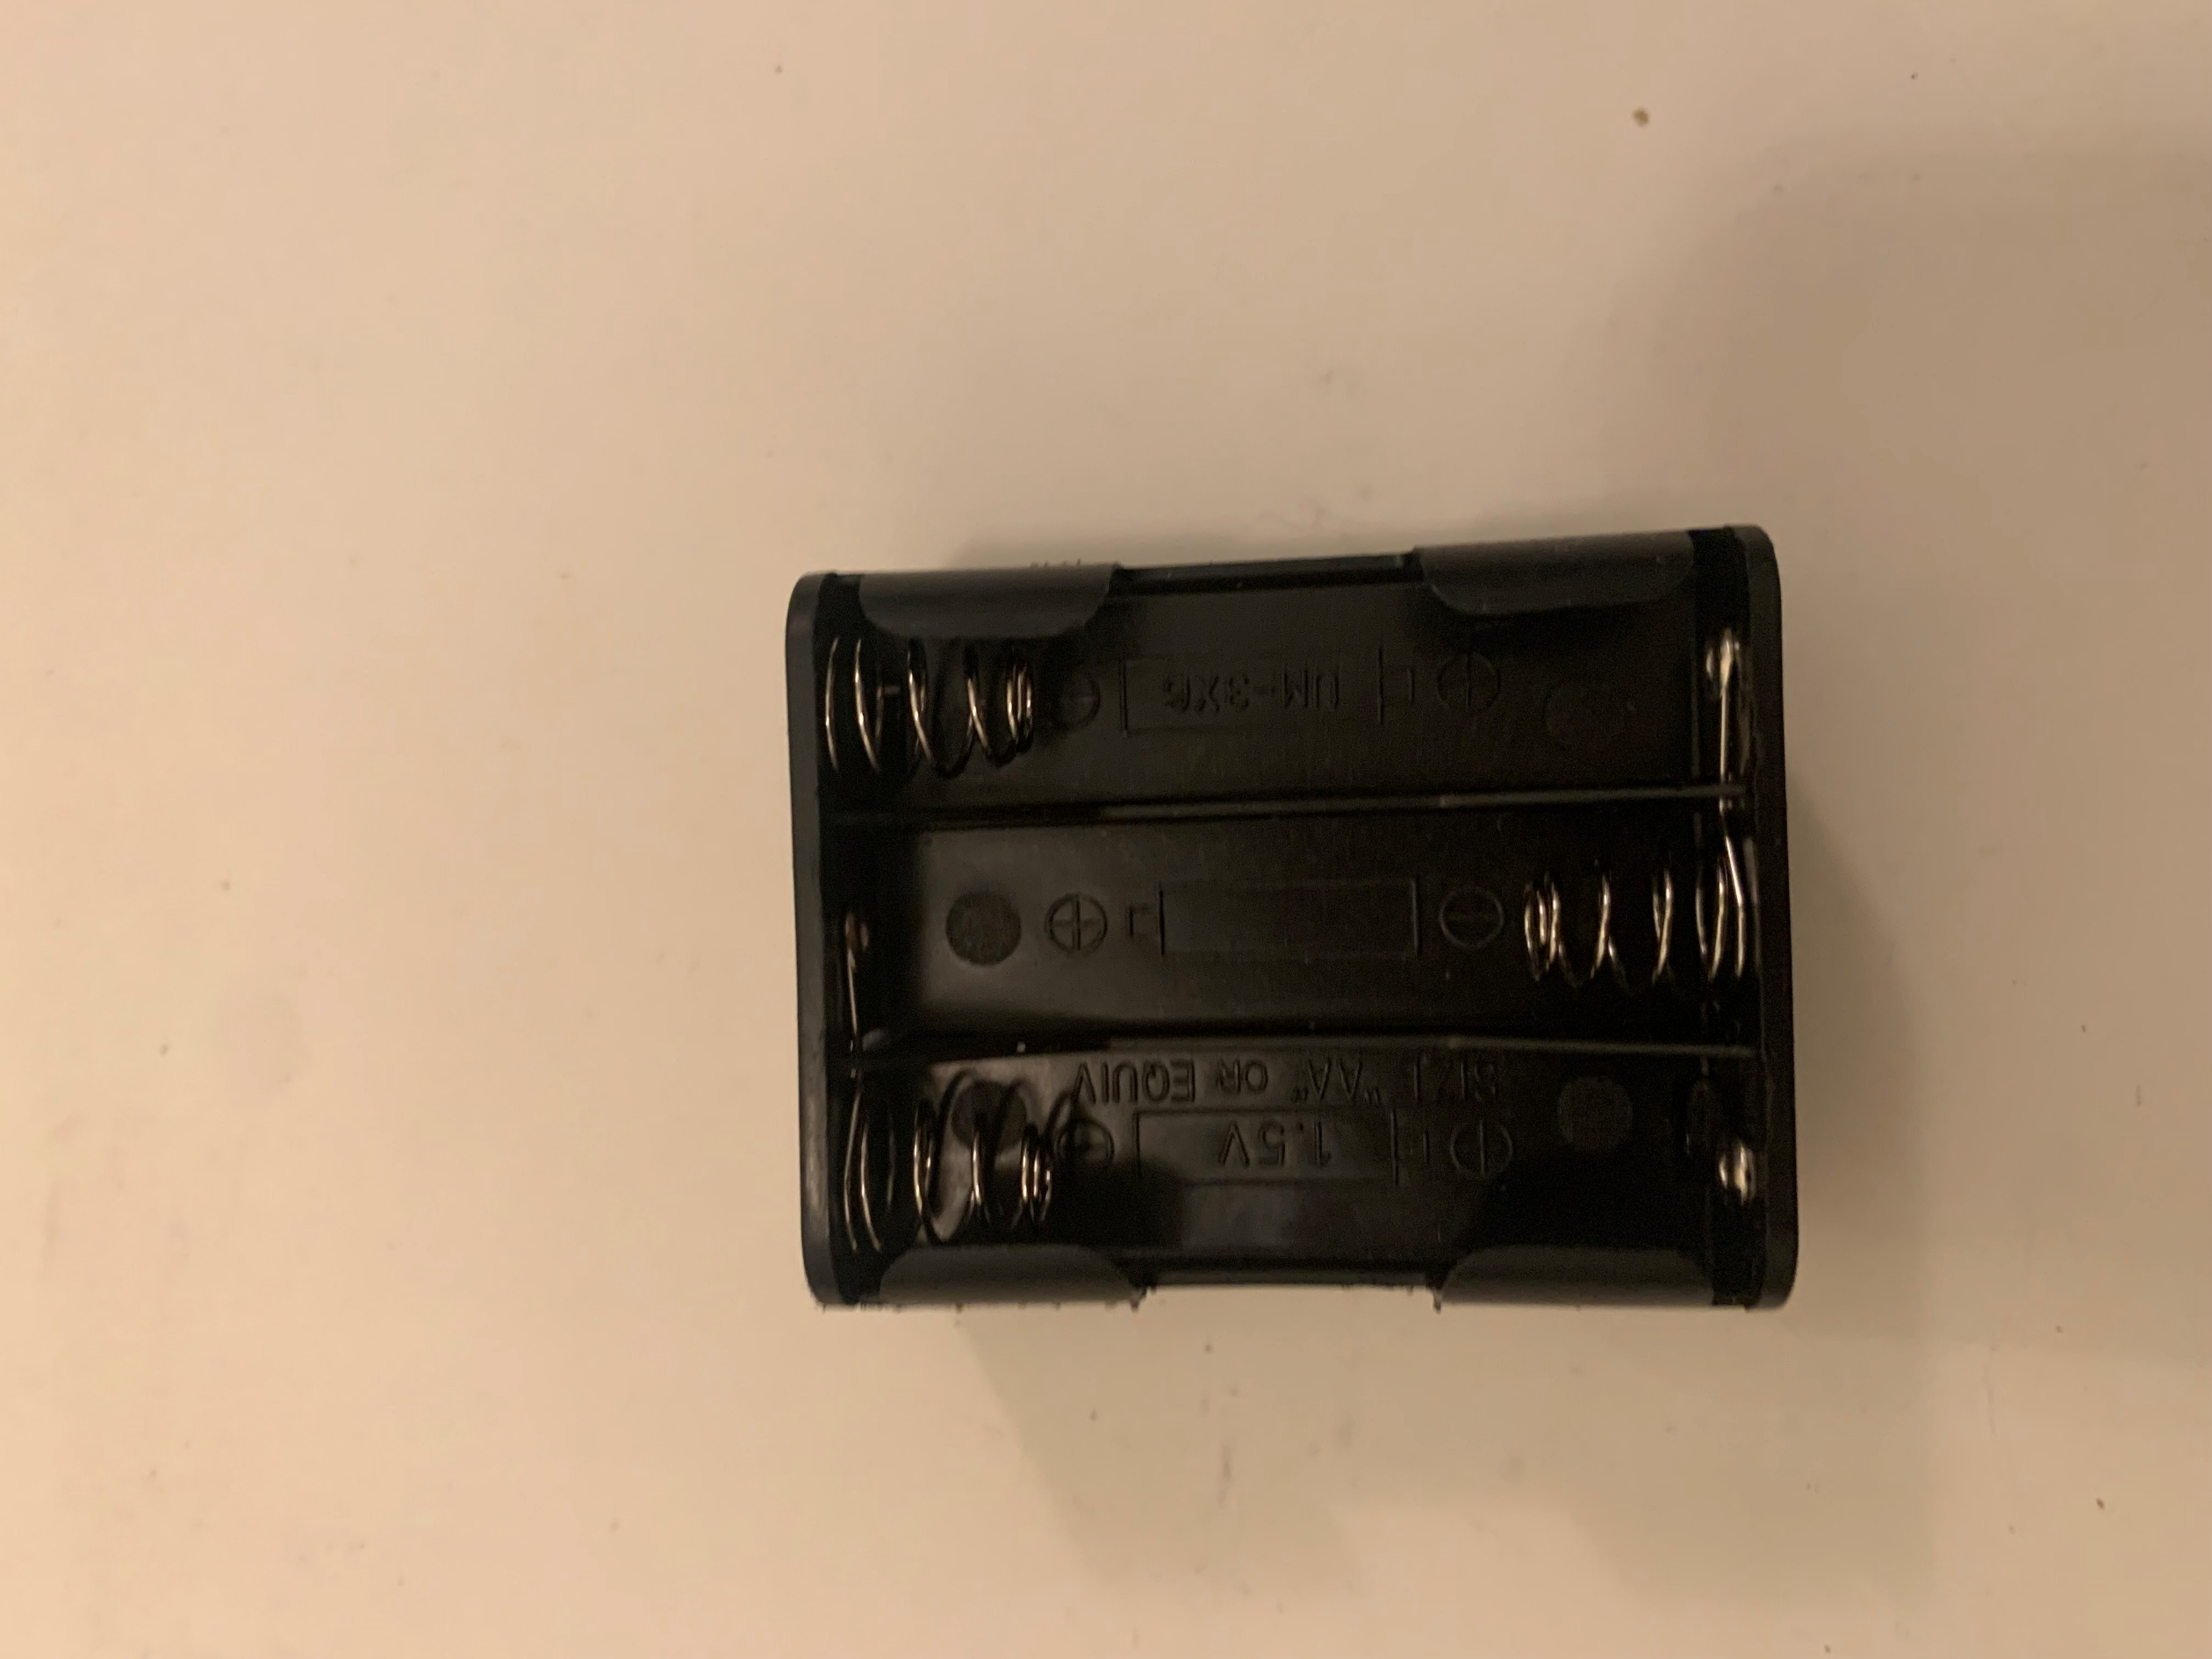

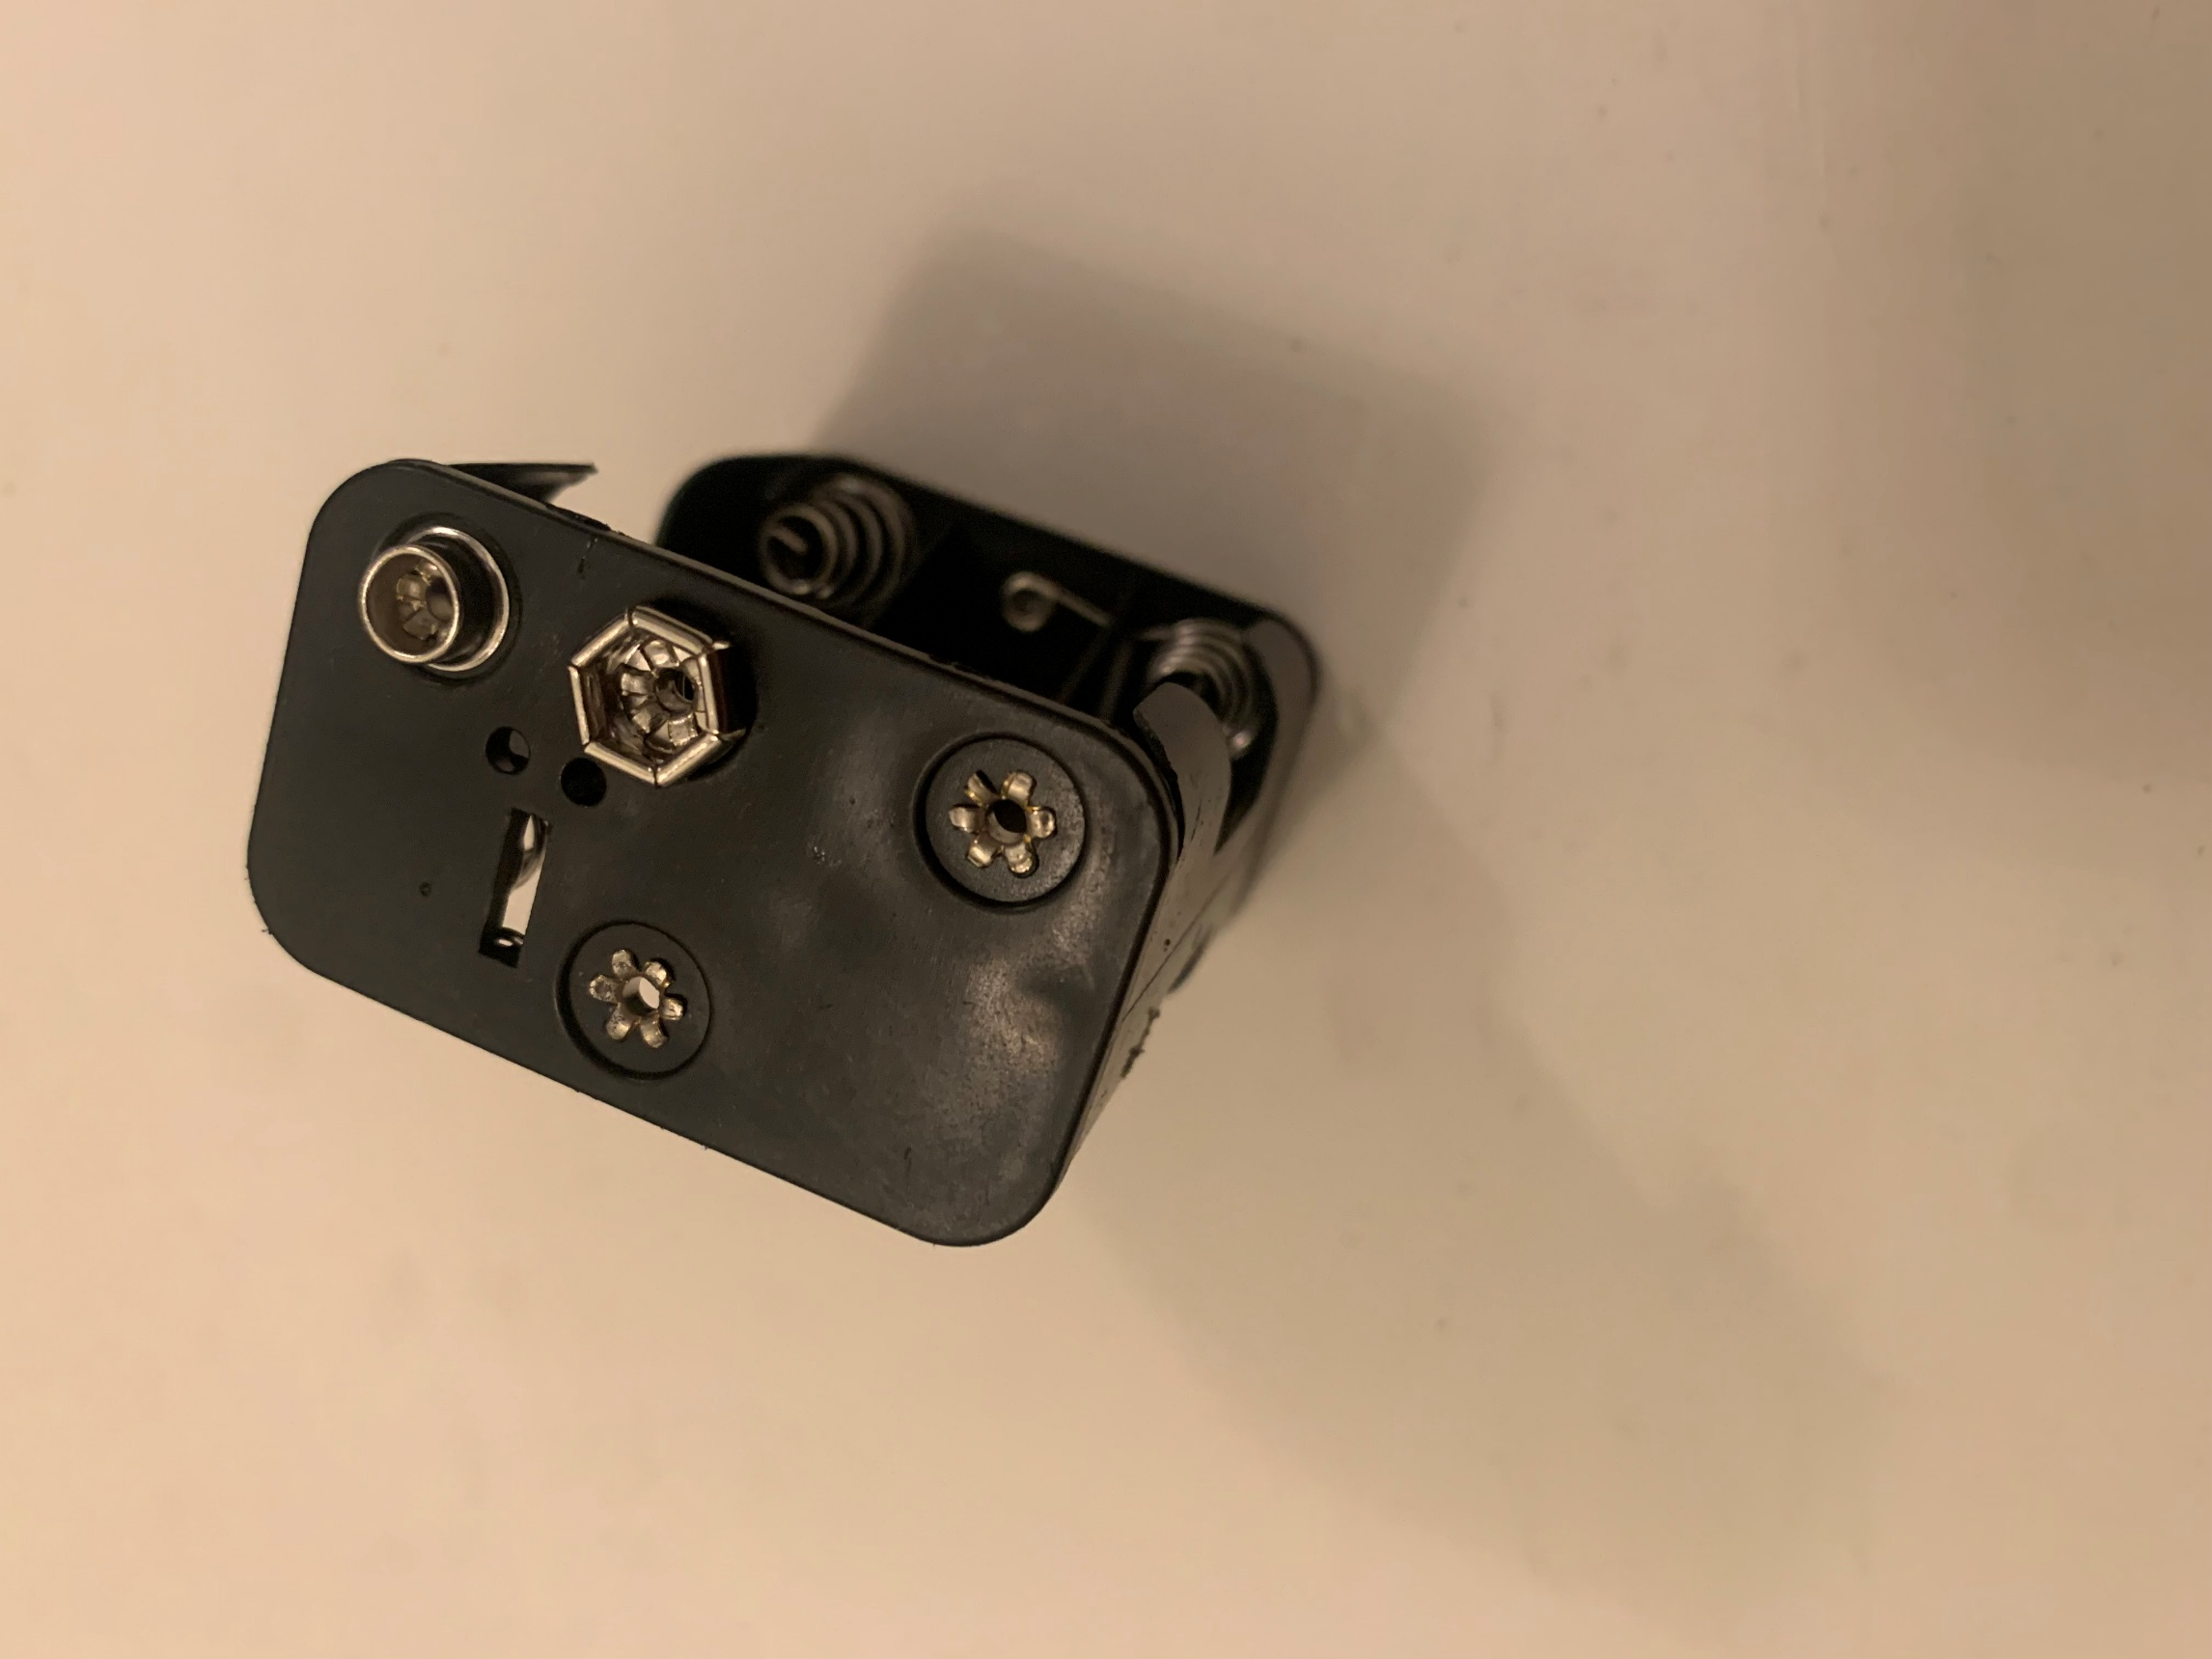
Figure 52

Figure 53
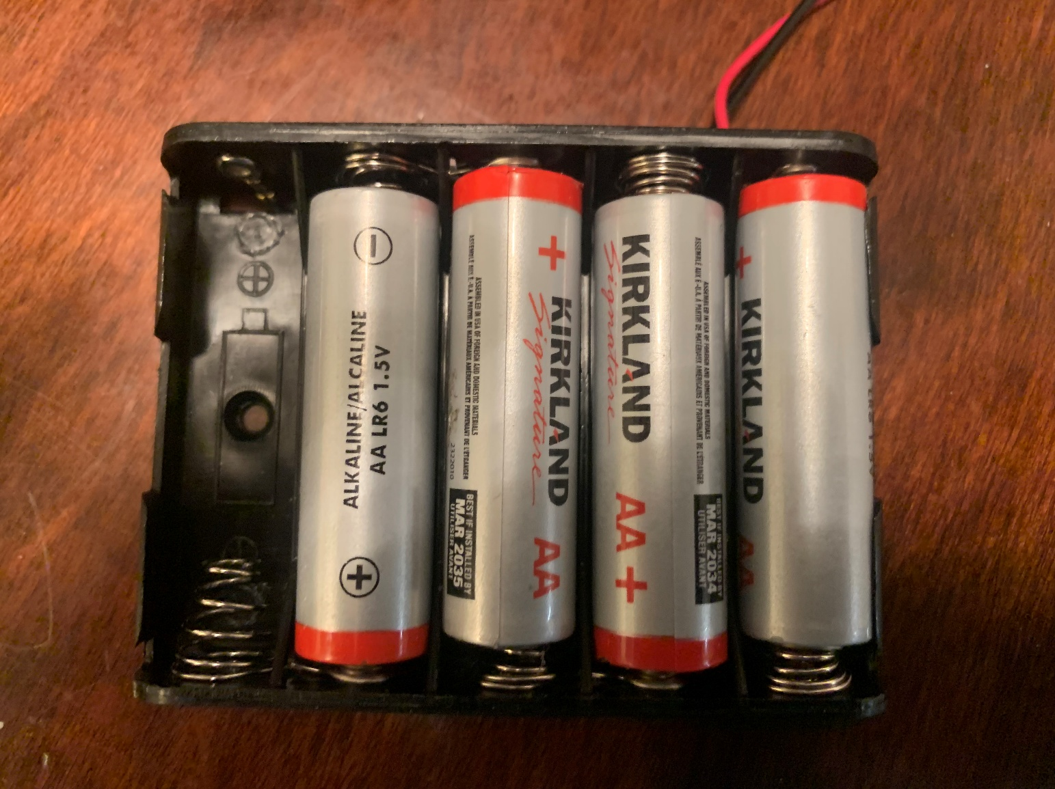

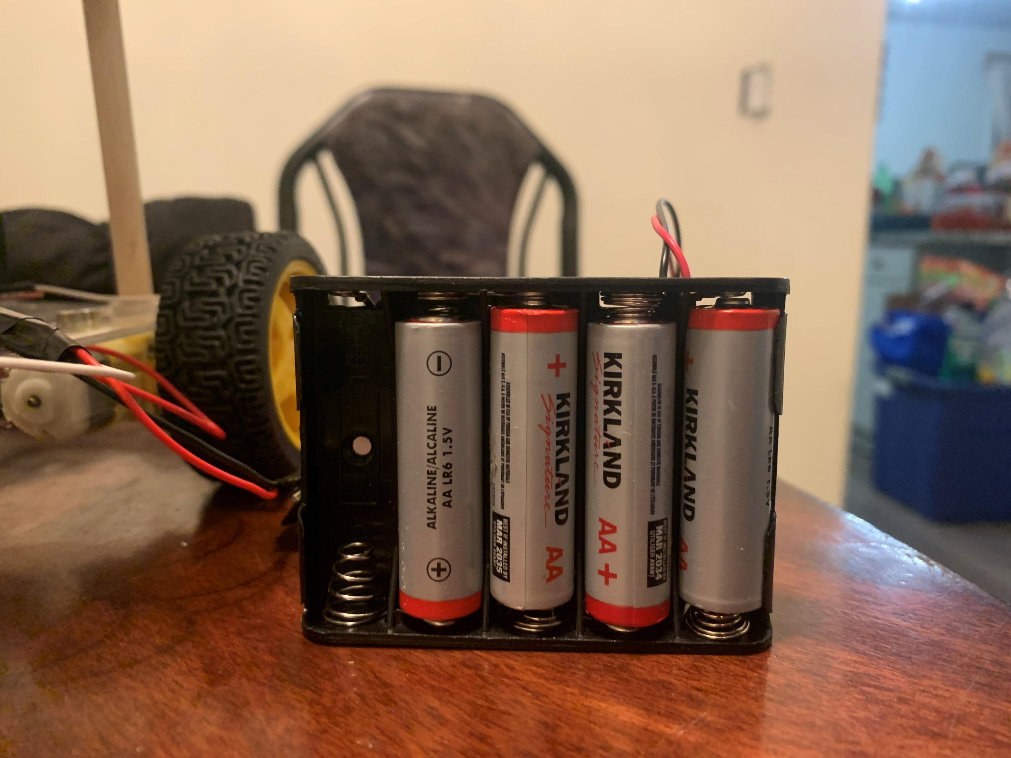
Figure 54

References:

Figure 1 (Ultra-Sonic Senor)
https://haynerobotics.com.au/products/ultrasonic-module-distance-measuring-sensor-hc-sr04

Figure 2 (Lidar Sensor)
https://www.sick.com/ca/en/catalog/products/lidar-and-radar-sensors/lidar-sensors/lms1000/c/g387151

Figure 3 (Pixy2 Smart Vision Sensor)
https://www.amazon.ca/Pixy2-Smart-Vision-Sensor-BeagleBone/dp/B07D1CLYD2

Figure 4 (Husky Lens Camera) https://www.amazon.ca/youyeetoo-HUSKYLENS-Machine-Vision-Sensor/dp/B086GP9PN2

Figure 5 and 6 (Esp32 Camera)
https://dev.to/admantium/esp32-camera-hardware-and-gpio-functions-3i6e

Figure 7 - 9 (Arduino Code)
https://dronebotworkshop.com/

Figure 10 – 21 (Arduino Code)
https://studio.edgeimpulse.com/studio/555095

Figure 22 (OpenCV and Python)
https://opencv.org/blog/opencv-python-is-now-an-official-opencv-project/

Figure 23 (Web Server)
https://www.vecteezy.com/vector-art/21351649-web-server-icon-for-your-website-mobile-presentation-and-logo-design

Figure 24 (GitHub Chat)
https://github.com/arunponnusamy/cvlib/tree/f46a22f8e13bc4b0267b9057fa88de170d41f96a

Figure 25 and 26 (Arduino Stopping Motors Code)
Created By Me

Figure 27 and 28 (Python Stopping Motors Code)
Created By Me

Figure 29 (Picture of working Prototype)
Link to Video Created by Me https://drive.google.com/file/d/1XIgpXCFdXcJYmNE6Hul1gKiwWrq40LSc/view

Figure 30 (Picture of 2-Wheel Motor Step Up)
Created By Me

Figure 31- 38 (Picture of 4-Motor Design)
Created By Me

Figure 39 (Picture of Raspberry Pi model B)
https://www.pishop.ca/product/raspberry-pi-4-model-b-4gb/
Figure 40 (Picture of OpenCV and Raspberry Pi)
https://qengineering.eu/install-opencv-on-raspberry-pi.html

Figure 41 – 46 (Picture of New Robot Car)
Created By Me

Figure 47 - 50 (Picture of The Wiring)
Created By Me

Figure 51- 52 (Picture of Six Battery Connector)
Created By Me

Figure 53 - 54 (Picture of Five Battery Connector)
Created By Me

