Autonomous Car
Logbook
By: Mansukh Singh Virdi


Project Overview and Engineering Objective (2025 – 2026)
This project began in early 2025 with the objective of designing and engineering an autonomous robot capable of following the path given by user/s and reacting to obstacles along the path. The goal was to create an autonomous system that could integrate engineering, electronics, wireless communication, and computer vision detection and understand its surroundings. The robot detected obstacles such as construction cones, responded to school zone signs/ yield zones/ and yellow lights, and navigated toward a defined destination using logical decision-making. From the beginning, the project required multiply different technologies and iterations. The system consisted of an Arduino Uno R3 for motor control info compared with a L298N, a Raspberry Pi for communication and many different sensors, and later, a laptop for better image detection processing. Sensors included an MPU6050 gyroscope for orientation/correction and an HC-SR04 ultrasonic sensor for distance measurement. Each subsystem needed to function independently while remaining synchronized within the robot without delays. The project mainly was built/tested and remade between 2025 and 2026. Early development (from 2023 – 2025) focused primarily on individual aspects of the final robot for example iteration 1 used line following iteration 2 used face detection and these iterations have more detections and better grid-based movement. Development challenges involved computational bottlenecks as the Raspberry Pi did not have enough RAM, CPU, or GPU power and sensor calibration. Later stages of this project optimized many of these issues, but some remain. Testing mainly began in January 2026, where the robot was needing work. This exposed design flaws that were not apparent during short trials. The engineering process quickly shifted from theoretical design assumptions to real-world issues like friction. Throughout this multi-year development process, the primary objective remained constant build a robot capable of intelligent, safe, and efficient autonomous robots and that goal was completed. However, achieving this required many redesigns, extensive calibration testing, and many many long nights.
Day 1 – 2025 September 29

Today I have investigated many possibilities for ways to further advance my face detection robot that I have created last year (2024 – 2025). Some possibilities that I have come up with are using an ultra-sonic sensor as shown in figure 1 to allow the robot to understand its current position and move from there. Another possibility is using a lidar sensor such as figure 2 to perform advanced object detection and reorientation. Another possible way to advance this project is by using a grid system where the user can place a dot of where the robot should move to, and the robot will convert the grid into an algorithm where one square corresponds to 12 cm.
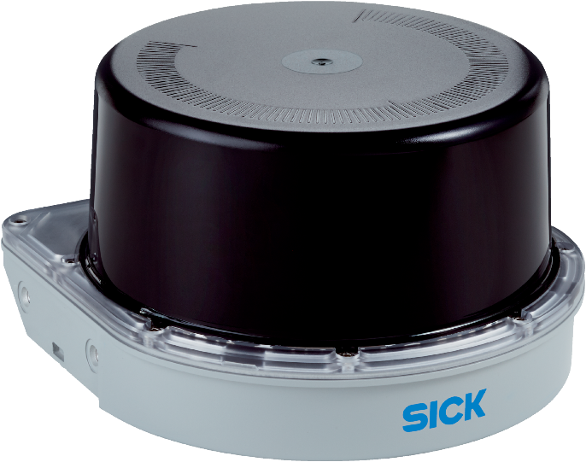
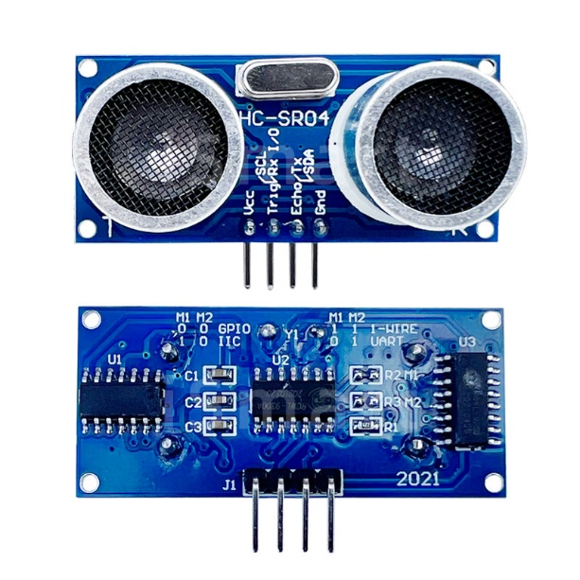
Figure 2
Figure 1
Day 2 – 2025 October 2
Today I have researched more about my possible options. The Ultra Sonic Sensor does not allow different objects to be detected differently but it still can be used for distance calculation, lidar sensors also have this same problem. My 3rd option is possible completely remove the line following, and the grid system would allow the robot to move autonomously with only a current position and detention. I will need find I way to give the user the option to pick from possible options to get to the destination as for example if there was an accident the user can pick a safer path. For these reasons I have learned through my research that a Pixy 2 camera can perform the object to detection and recognition, but it does not record at a high enough frame rate, and it is not widely affordable, these are the same reasons that Husky Lens Camera also does not work. A picture of the Pixy 2 camera can be seen in figure 3 and a Husky Lens Camera can be seen in figure 4.
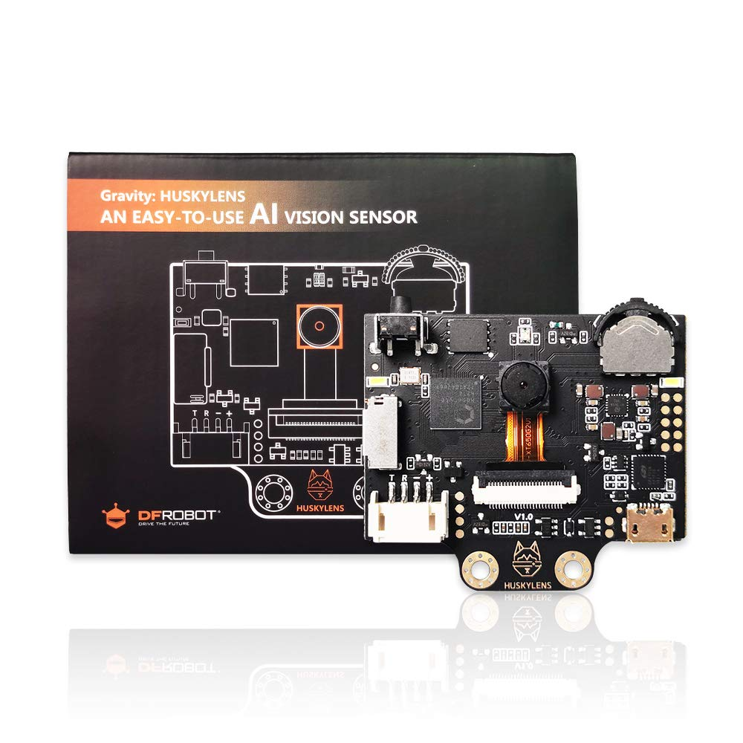
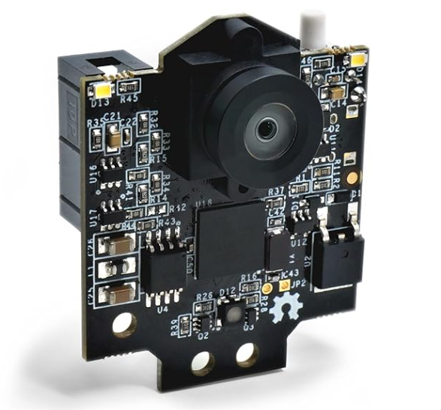
Figure 4
Figure 3

Days 3 - 16 – 2025 October 16 - 29
Today I have investigated development of the robot’s navigation system. The focus of it is to create a grid-based movement system that would allow the robot to follow a predefined path accurately. Designing a grid-based navigation system proved to be considerably more challenging than I first anticipated it to be. The goal was to simulate a real-world road network in which the robot would move along but doing the math to figure out how to draw lines and such using Pygame was very hard. In order to accomplish this, the robot needed to convert path instructions into measurable motor movements using mathematical calculations.
The system needed to perform:
- Exact forward travel distances
- Accurate timing for 90° turns
In figure 5 you can see what I wanted the grid system to look like.
Figure 5

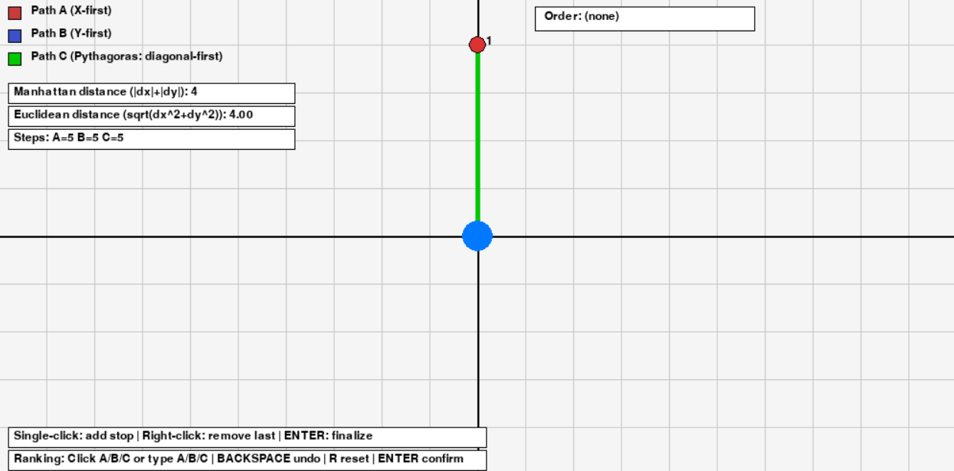

Days 16 - 31 – 2025 November 6 - 21
Each block of the grid is represented by a fixed travel distance in time, and the robot’s movement logic needed to translate those blocks into motor commands. Due to the complexity of this math this system took a lot of time. It involved a lot of testing, debugging, and fixing code and then uploading it on to the Raspberry Pi. Implementing the grid navigation required synchronization between Arduino for motor control, if too late it would time out if too early it would not be inline when the grid finished and skipped commands.
The primary objective of this system was to make the robot move from point A to B and by using coordinates grid from these the detections can be added. This allowed me to start building the robot and testing if it was working with corrodent values. These tests were done on the Raspberry Pi Python (Thonny) and information was sent using the DEV port to the Arduino via USB. The first design was a 4-wheel drive robot that was 2 level design I did this to give me more space and not make the robot base too big. Through tests I have learned that the 4-wheel design is too tall and the width is too short causes the robot to pop wheels. Because motor speed varies depending on battery voltage, traction, and surface type, it was very hard to get perfect 90° turns on simple time-based movement alone. In figure 6 there is an image of the 4-wheel design. Due to the building, testing, and fixing bugs this part took a lot of time.
Figure 6

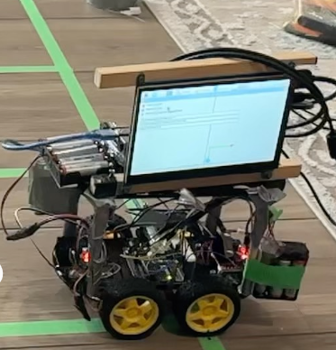

Day 31 - 41 – 2025 November 3 - 13
This week’s focus was centered on resolving one of the most persistent challenges so far of mechanical instability during movement. Although by moving some parts around to add weight the robot has become a little more stable but still when trying to perform precise maneuvers such as 90-degree turns are more like 60° turns.
The instability was primarily related to the height to width ratio of the chassis size. This is because with a taller robot it has a higher center of gravity causing tipping, and wheelies. To fix this I have created a new chassis that is square in shape and only one layer. The robot turns by using tank style turning During testing the robot was stable in moving forward but was very bad at turning. To fix this I have put electric tape on the wheels to try to make the wheels slip more as there is too much friction between the robot and floor the tires cannot turn. This is the reason that tanks use slightly lager trends every few trends giving a pivotal point. To fix it I need to find a solution for too much friction. An image of the tank style turning can be seen in figure 7 and the new robot design can be seen in figure 8.

Figure 8
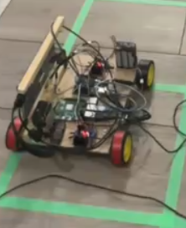
Figure 7
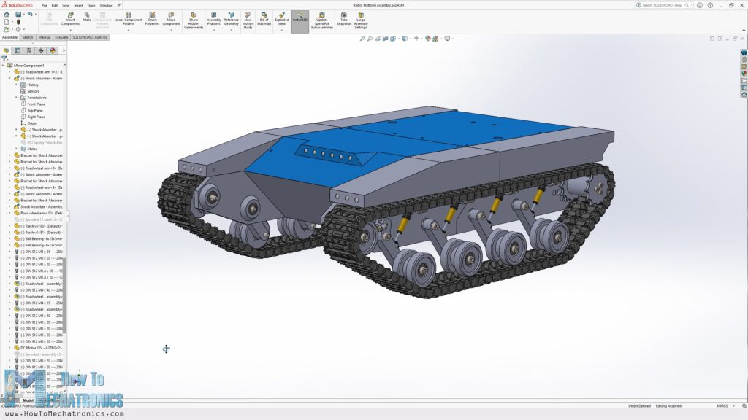

Day 41- 48 – 2025 November 19 – 26
Through my research from previous years of iterations, I've decided to use a caster wheel with two motors in the back and the wheel in the front that is able to move in 360° in all directions and back/forward directions. One main reason I didn't initially start with this design is because it uses only two of the motors dividing the amount of torque and speed we had in half compared to four motor designs. Due to only having two motors the robot needs to be redesigned in a layout to be more evenly waited as even with the small amount of imbalance it will cause a robot to drift to only side. I have finished the programming for the motors and now I need to redesign the frame. The updated Arduino code compared to the original can be seen from figures figure 9' - 17' for 4WD and figure 9 - 17 for 2WD
Figure 9'
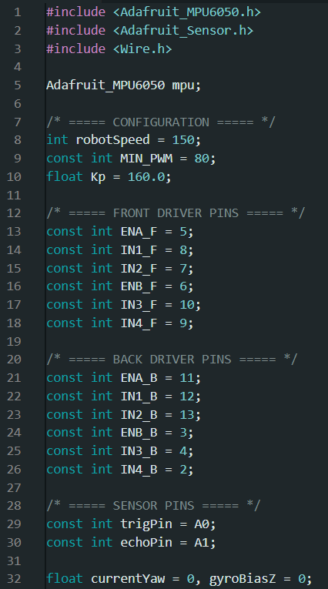
Figure 9
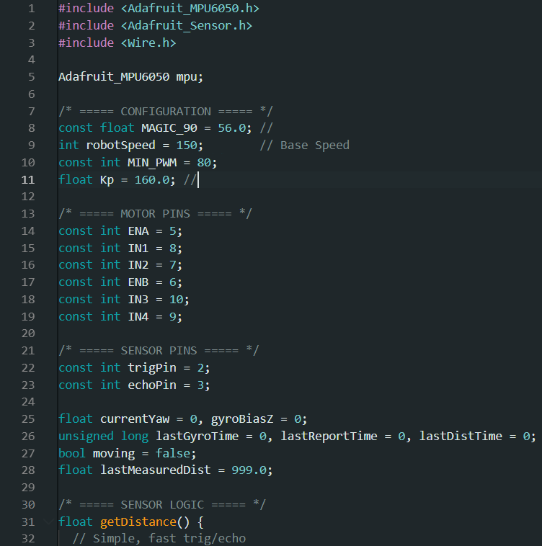

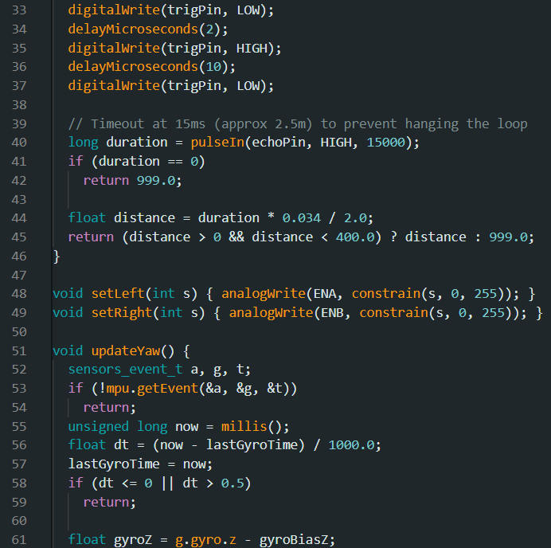
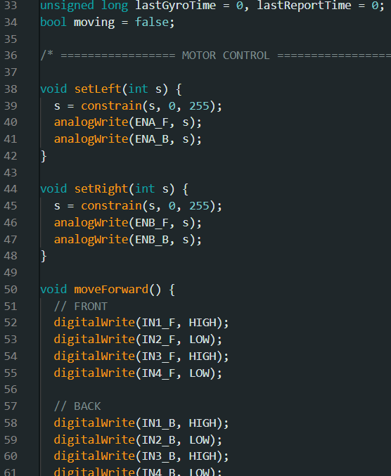
Figure 10'
Figure 10

Figure 11'
Figure 11
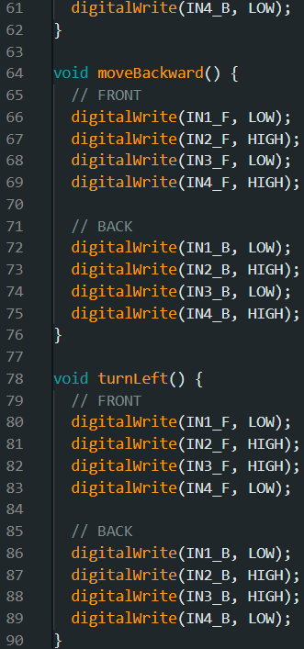
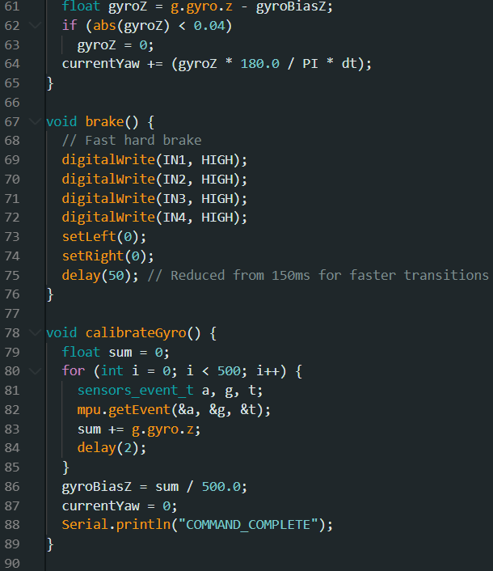

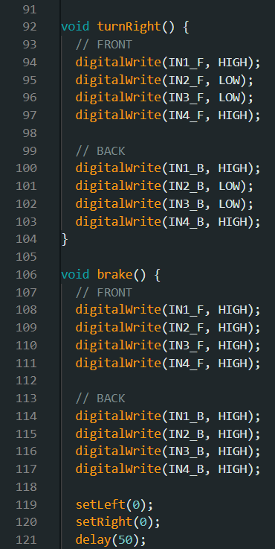
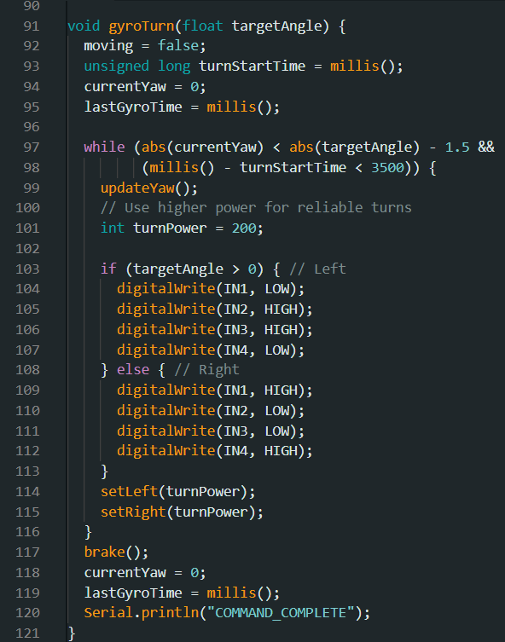
Figure 12'
Figure 12

\

Figure 13'
Figure 13
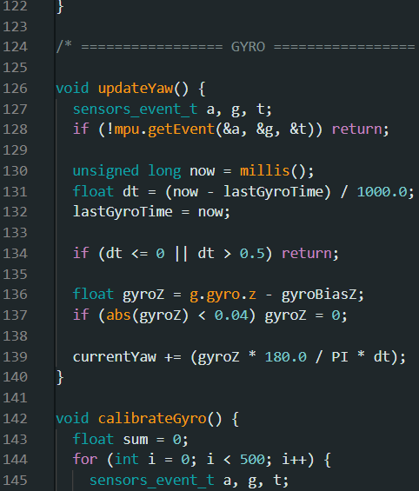
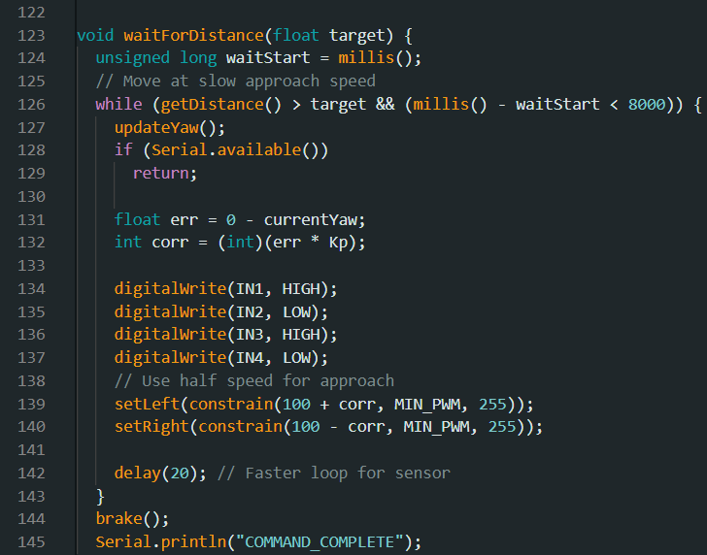

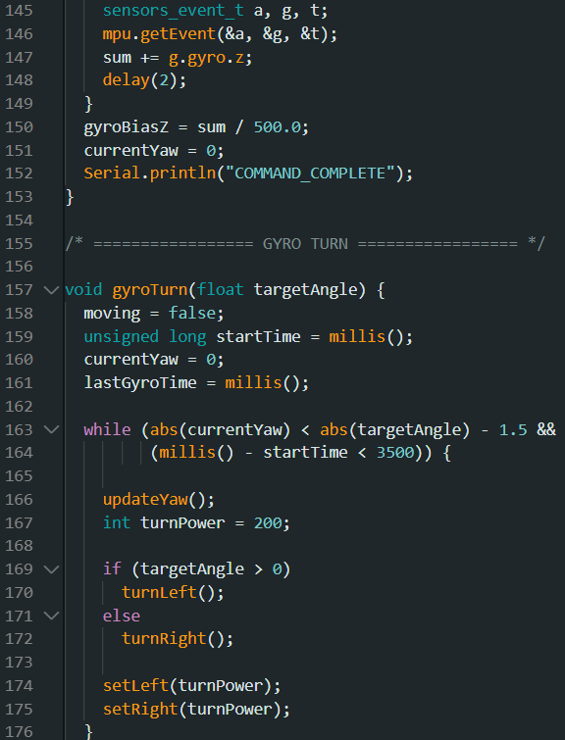
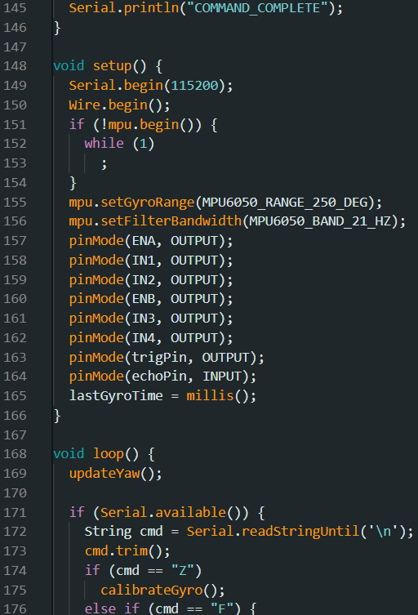
Figure 14'
Figure 14

Figure 15'
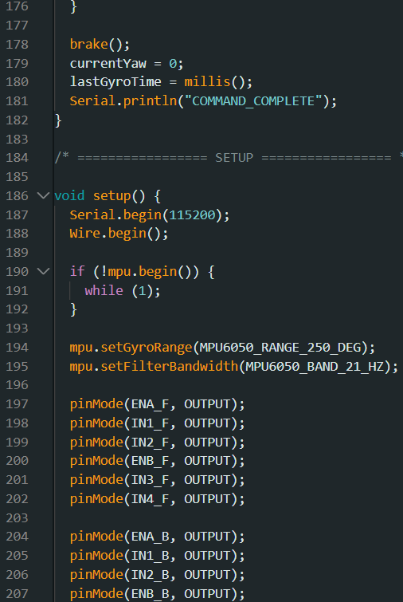

Figure 15

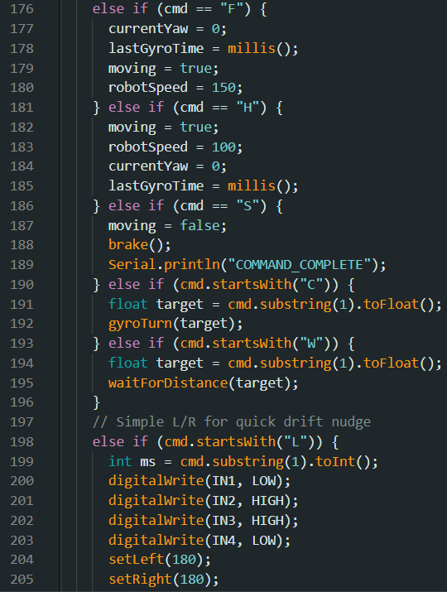

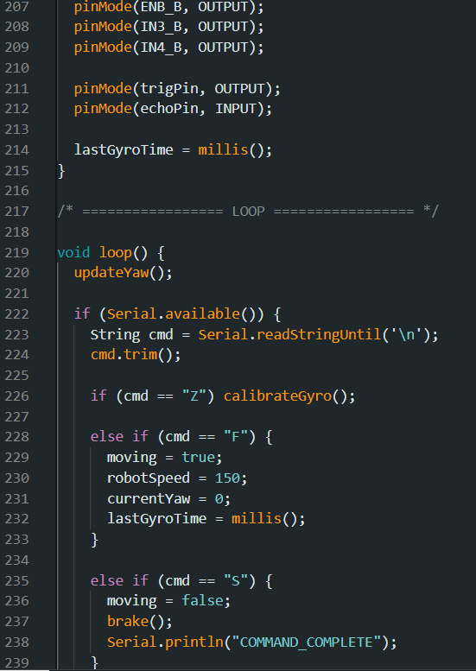
Figure 16'
Figure 16

Figure 17

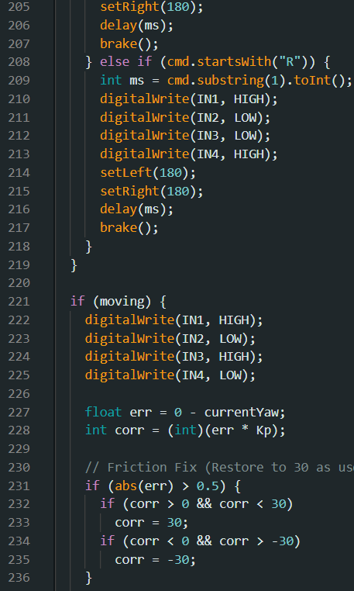

Figure 17'
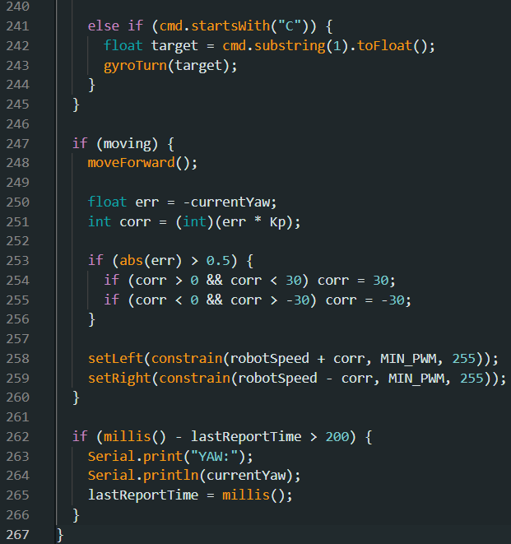

Day 48 – 54 – 2025 November 26 – December 2
I've redesigned the plexiglass chassis to be more rectangular shaped with a caster wheel in the front and two Motors in the back. This allows the robot to turn very easily left to right, but in testing the robot is drifting to one side too much this is because if the caster wheel is even slightly tilted to one side the robot will move towards that side away from the center line with the 4 motor design all four motors were planted in the same direction keeping the robot straight. To fix the drifting issue I've added an MPU650 which connects to the Arduino, this is a gyroscope which will measure the amount of tilt in X, Y, and Z axes. From there the robot can decide what to do, if the robot is tilting to the positive side, it will perform a negative turnback to get back to the centerline. This also applies if robots are drifting in the into the negative side. To program this I had to look at many GitHub projects to learn how it works and how to use it. You can see the GitHub link I used in figure 18.
Figure 18
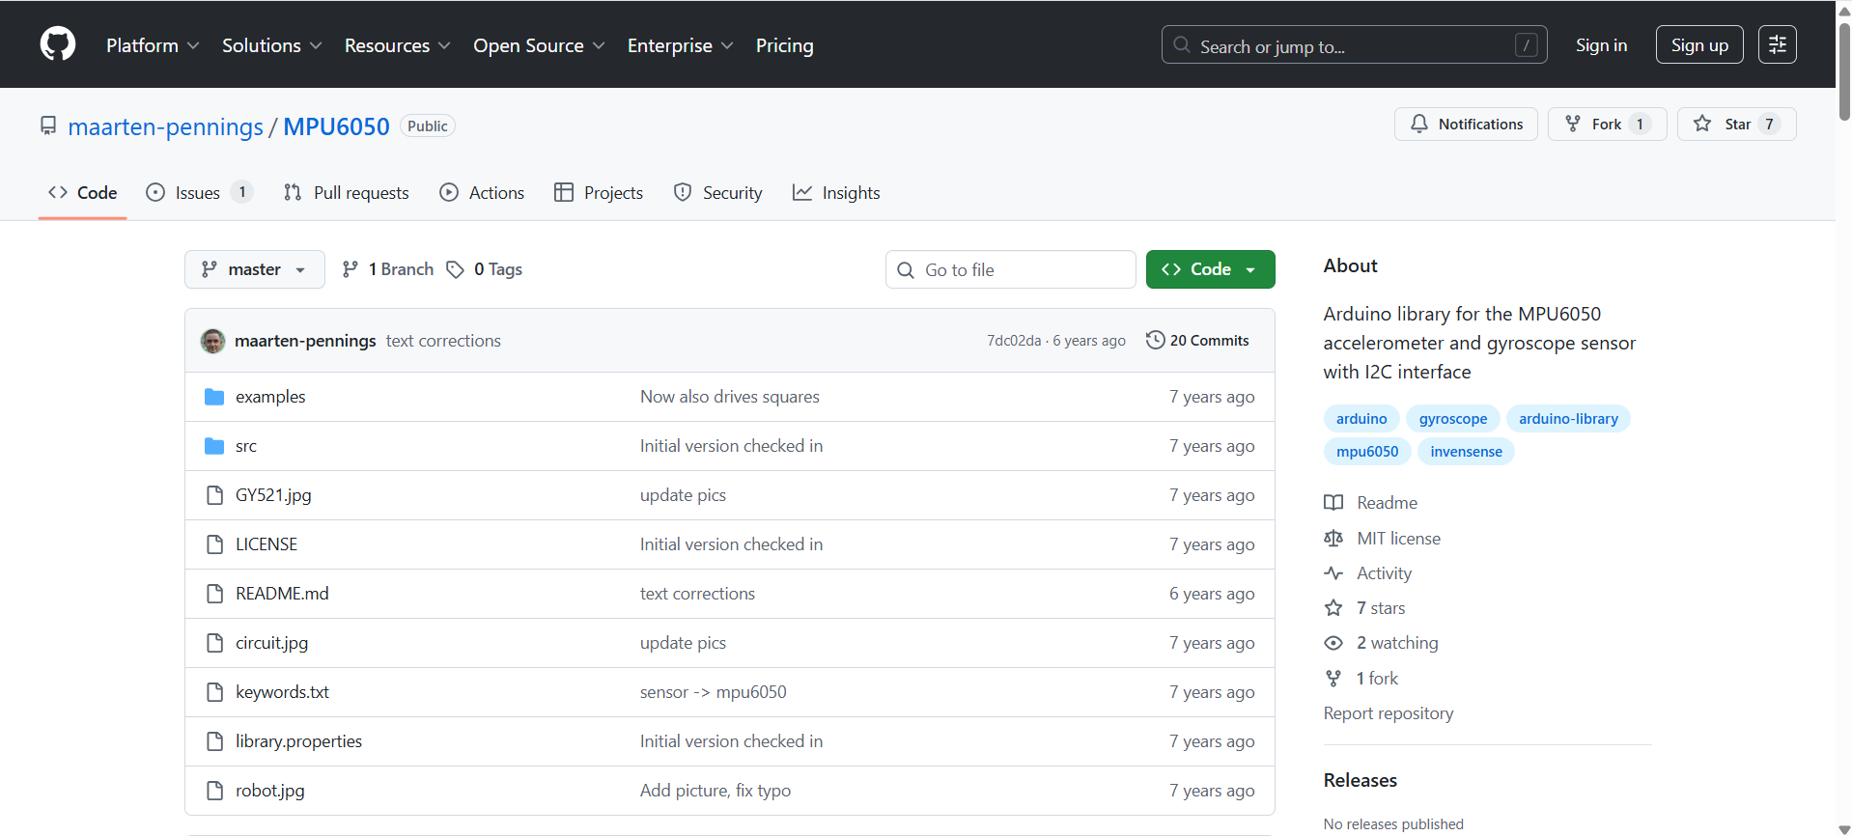

Day 54 - 66 – 2025 December 7 – 20
After looking at many tutorials, I now understand how to use the MPU6050 and the Arduino Uno for drift correction. From here I was able to start the process of the calibration for the turning, now that the robot could go forward for each block, I could adjust the turning as depending on the value it could turn more or turn less. Once the calibrations for the turning were correct and the time per cell, I was able to start working on the detections. The main detection program is called CV2 this is a library that runs on the Raspberry Pi in Thonny. Downloading CV2 live properly on the Raspberry Pi was also extremely difficult this is because it runs Linux, and Linux has many different layers of access in this case I had to figure out how to become admin before I could properly install CV2. Once I could import the CV2 library I was able to start programming the programming was done first on my computer and then using a USB was uploaded to the Raspberry Pi. This was done because the Raspberry Pi does not have a lot of storage space CPU or GPU power. The programming for the detections was also extremely time-consuming. An image of the OpenCV Python Library can be seen in figure 19.
Figure 19


Day 66 – 72 – 2025 December 20 - 26
Once all the detection programming was done and it was sending commands to the Arduino Uno, I was able to start testing the detections. The camera was connected to the Raspberry Pi via a USB this let the entire system be wireless, all running on the Raspberry Pi and Arduino Uno. This did lead to a few issues; this was because the Raspberry Pi does not have a lot of computing power and due to the number of detections it was very taxing on the computer. The camera’s quality suffered extremely, and the detection speed was too slow causing the robot to pass the Stop sign for example before it detected and stopped. Even when the robot was able to detect the stop sign it was very blurry. Due to all these issues I decided to make the detections happen on my computer which had enough CPU and GPU power to perform the detections properly in a good quality, but this brought more concerns about the entire robot would need to be always connected to my computer. To fix this I decided to use a wireless Dev Port between my Windows computer and the Linux Raspberry Pi this was done by using the IP of the computer using ipconfig and digital ports 9000 for video and 5000 to send information to the Raspberry Pi on what to do depending on the detection. An image of how the ipconfig works can be seen in figure 20.
Figure 20
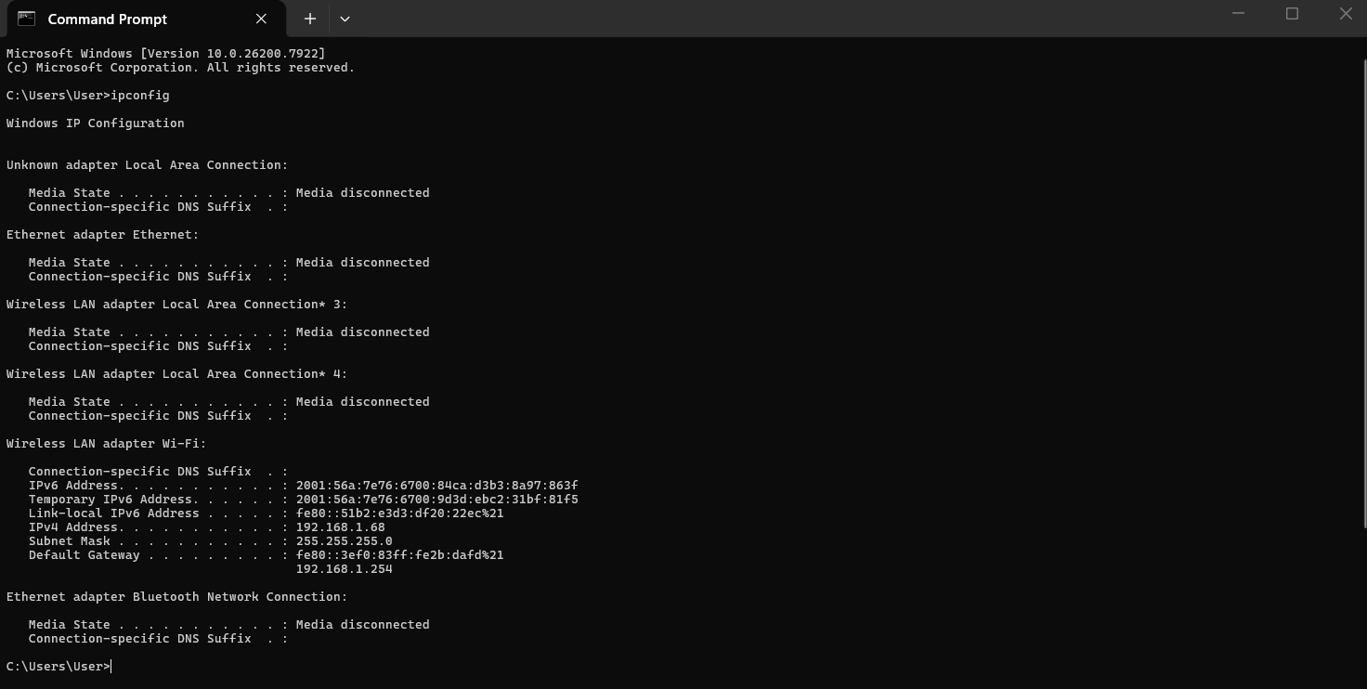

Day 72 - 84 – 2026 January 12 - 24
The robot seems to be working for the detections but there are a few detections where it is having issues one of them is the cone this is because when the cone is detected right now, the robot is performing by bypass maneuver immediately, this leads to the cone getting hit as the robot thinks that it's right in front it. Some ideas I have come up with to fix this are using a lidar sensor or ultrasonic sensor. I used a ultrasonic sensor as it would be working independently but if I was using a lidar sensor it would have to create a 3D map of the entire area and then must scan that map before it knows where it is. This would take even more computing power, and it would also be very heavy, which was a large concern for the robot. Integrating the ultrasonic sensor into the rest of the Arduino program involved changing the Python program that runs on the Raspberry Pi, and the Python program that runs on the computer. Ultrasonic distance sensor uses a transmitter and a receiver to see how far something is in front of it similar to how bats use echolocation. An image of an ultrasonic sensor in use can be seen in figure 21.
Figure 21

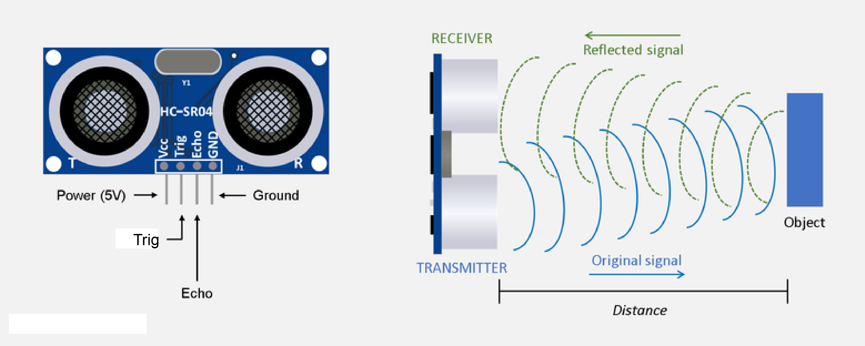

Day 84 - 102 – 2026 January 26 - February 13

The final weeks were spent making the robot look nice by making sure all the cables were properly screwed down and connected making sure that nothing would come out and it all worked together nicely and recording videos and started the presentation portion. On one side of the robot, I had to put extra dead 9-volt batteries, this was because the screen weighed too much and needed a counterbalance to always keep all tires on the ground. Some final pictures showing where everything is located such as the screen the Raspberry Pi the Arduino the L298N motor driver, sensors etc. can be seen below from figures 22 – 31.

Figure 22
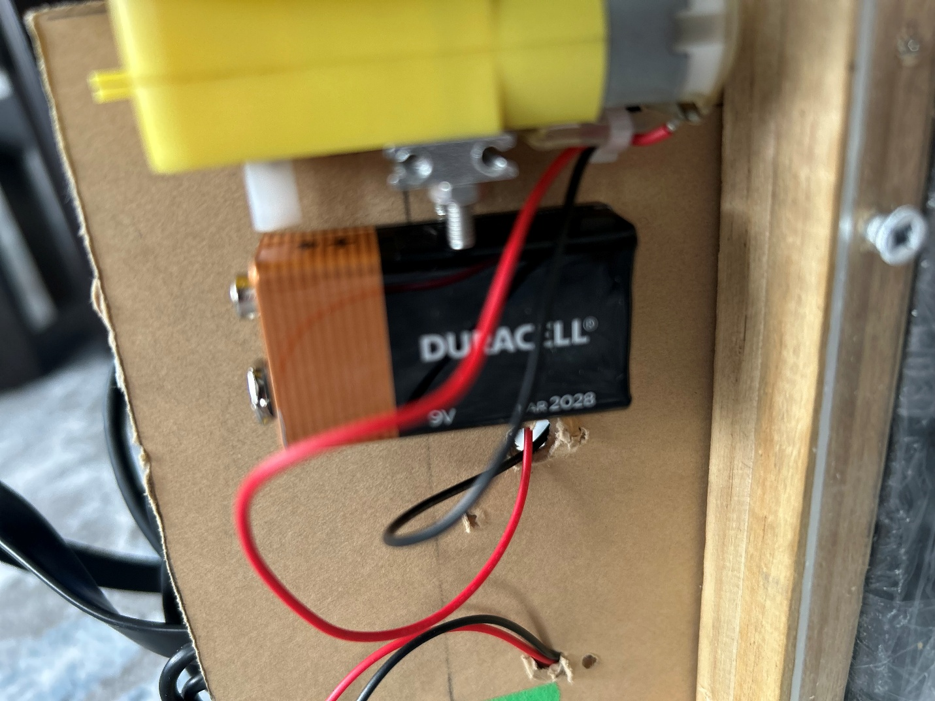

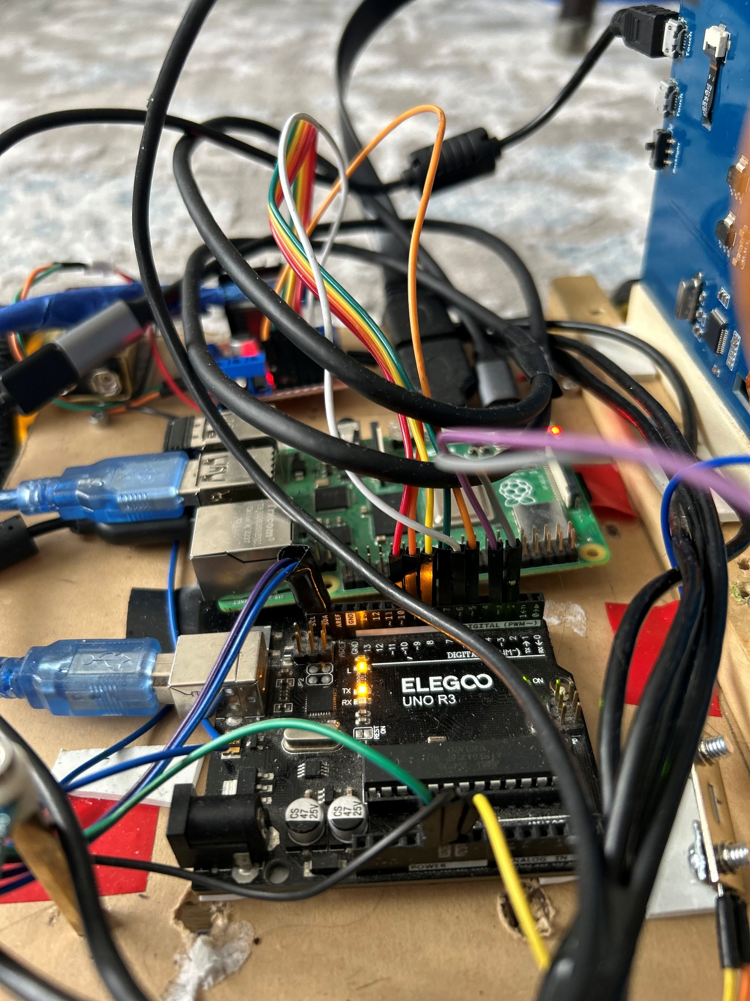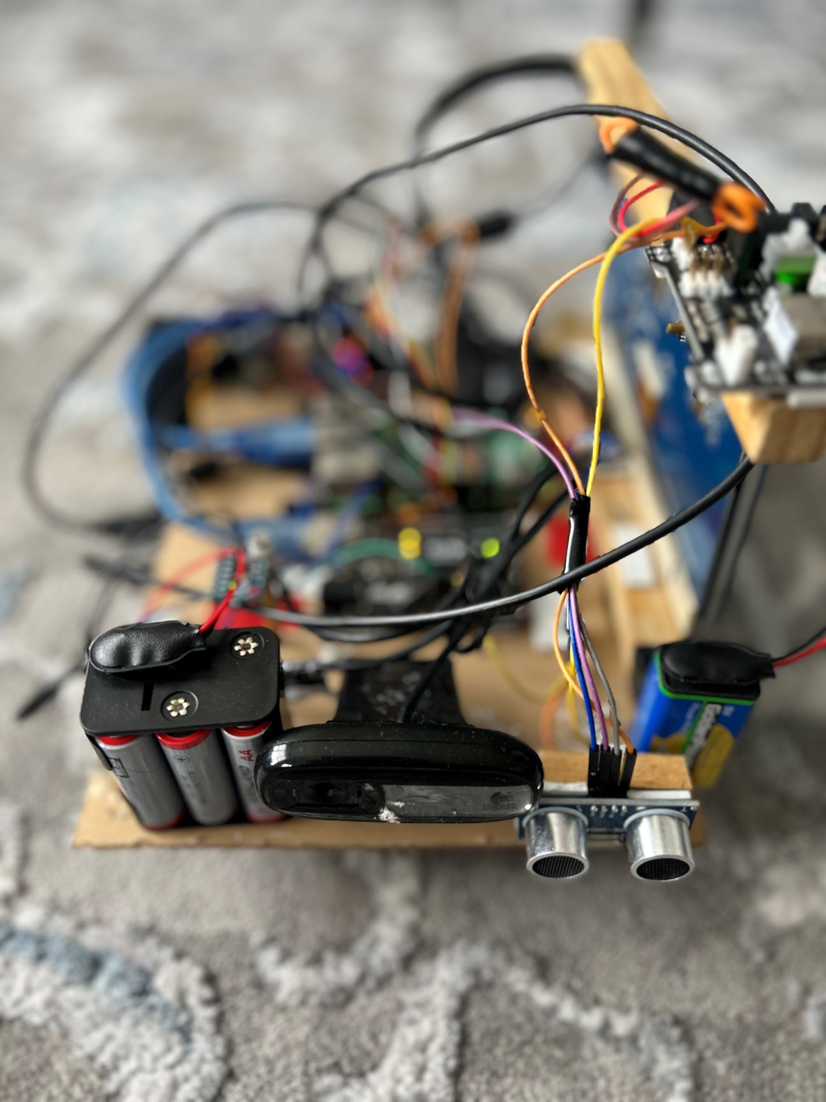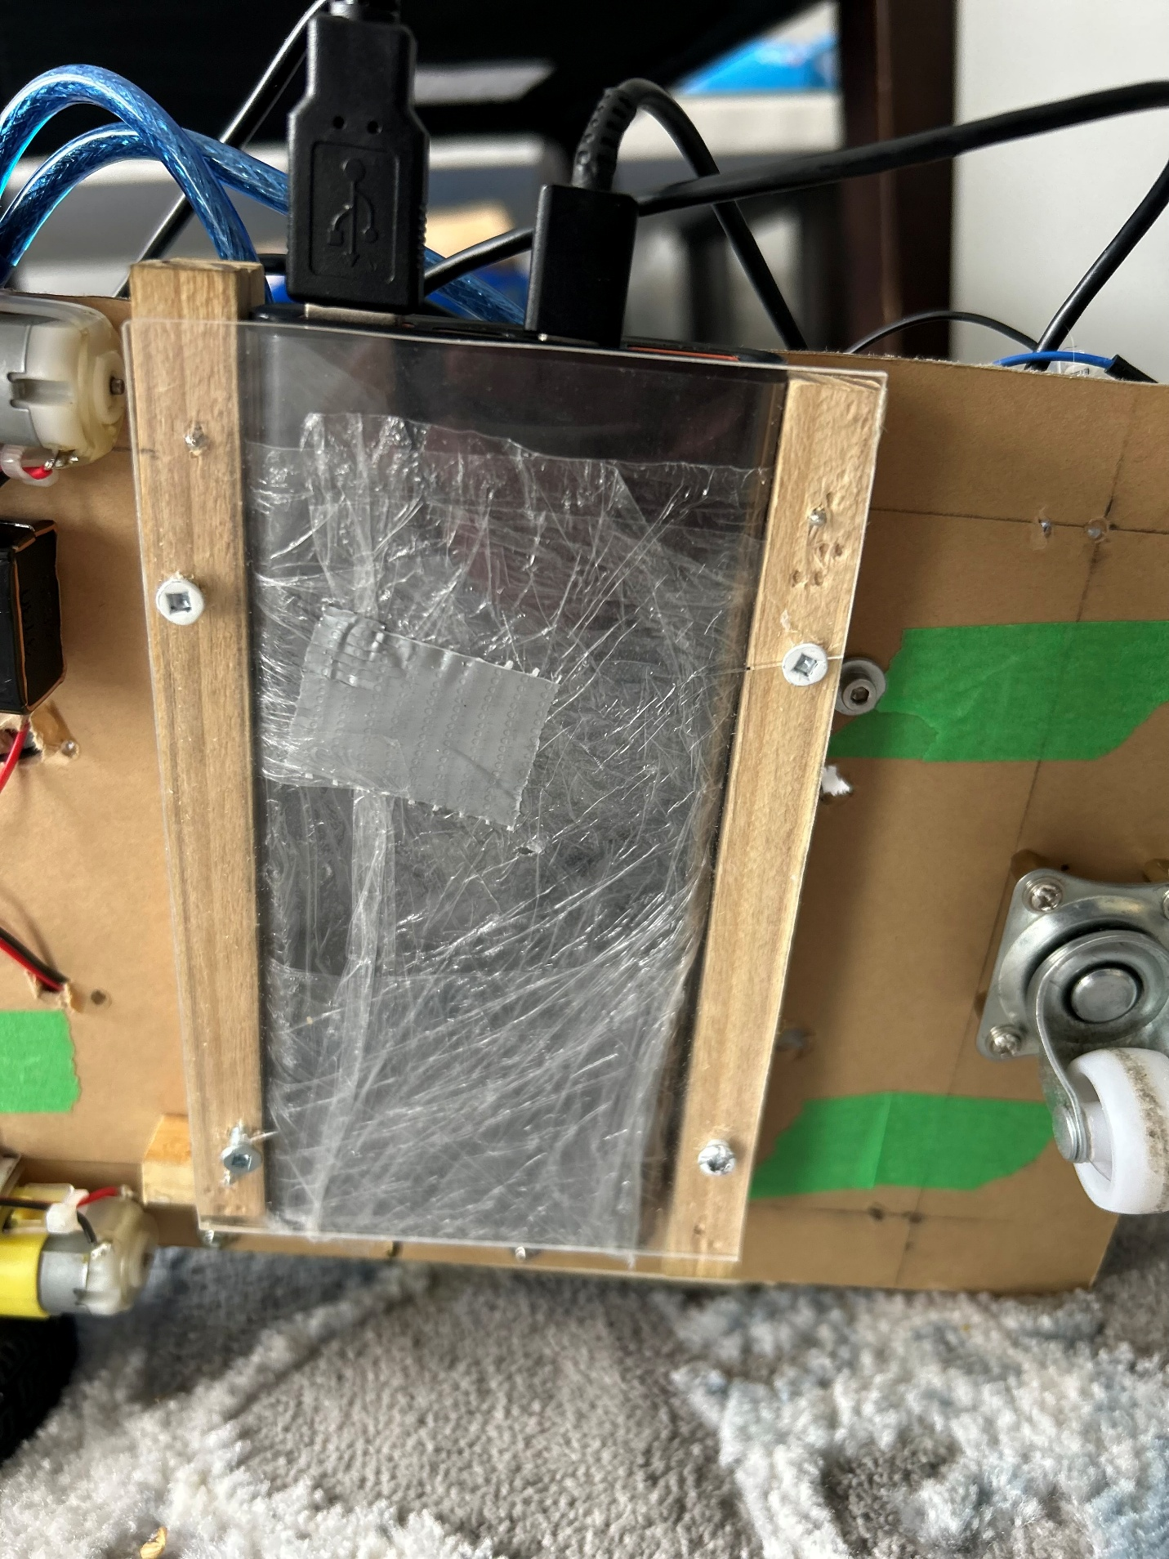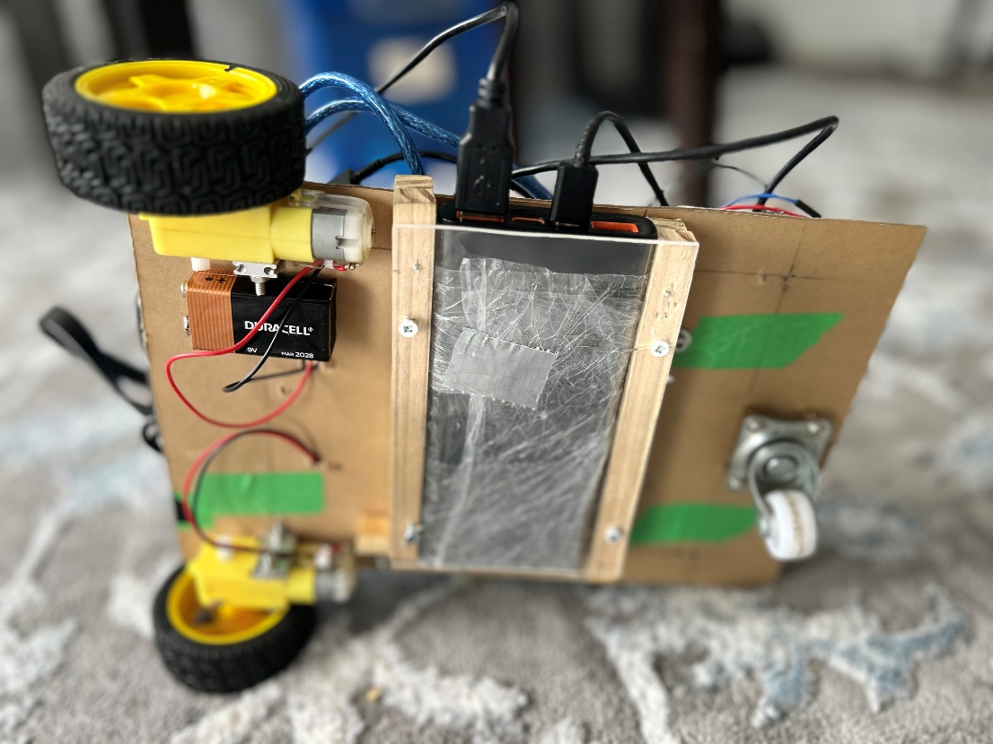
Figure 23
Figure 24
Figure 25
Figure 25
Figure 26
Figure 27
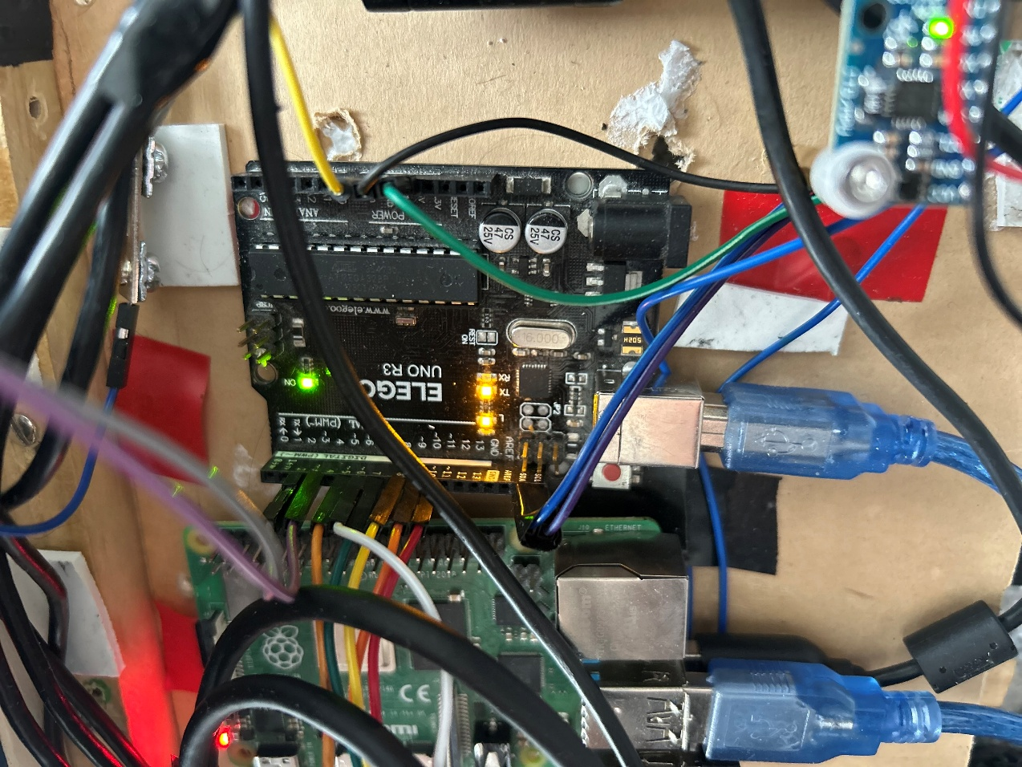

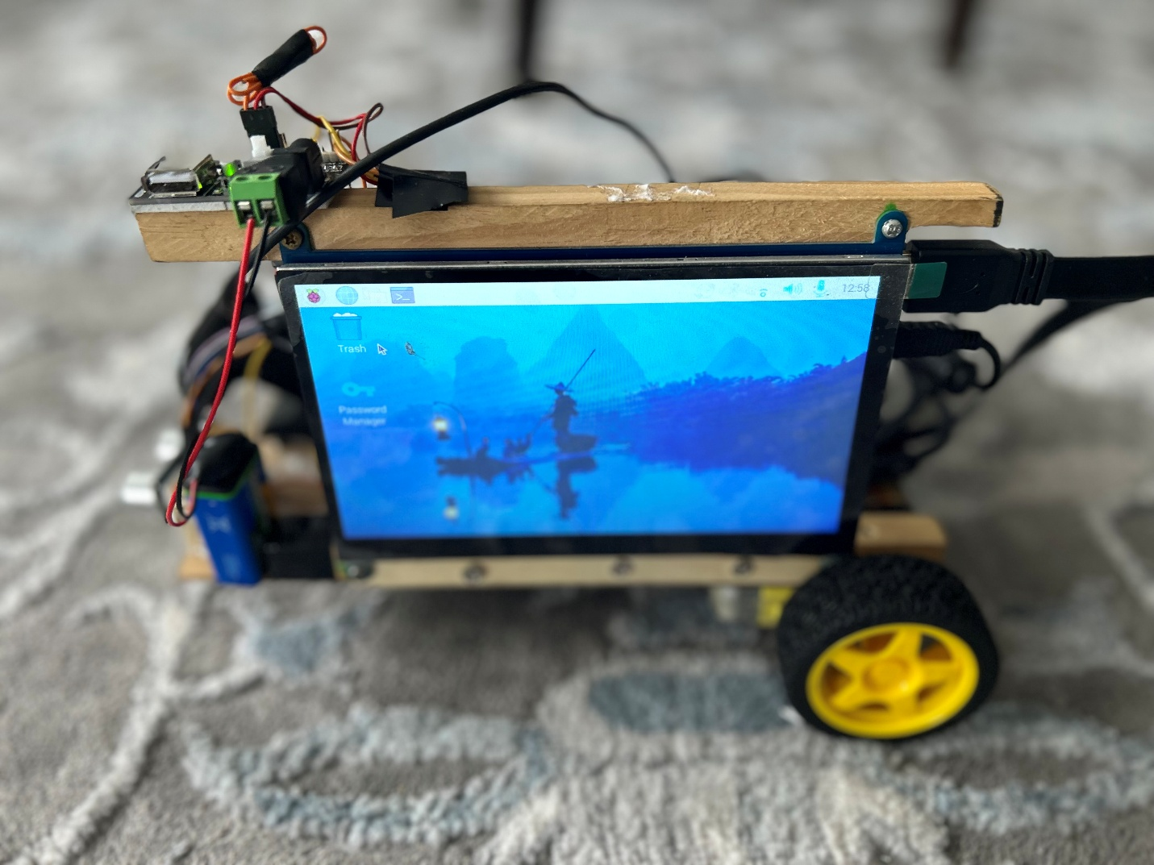
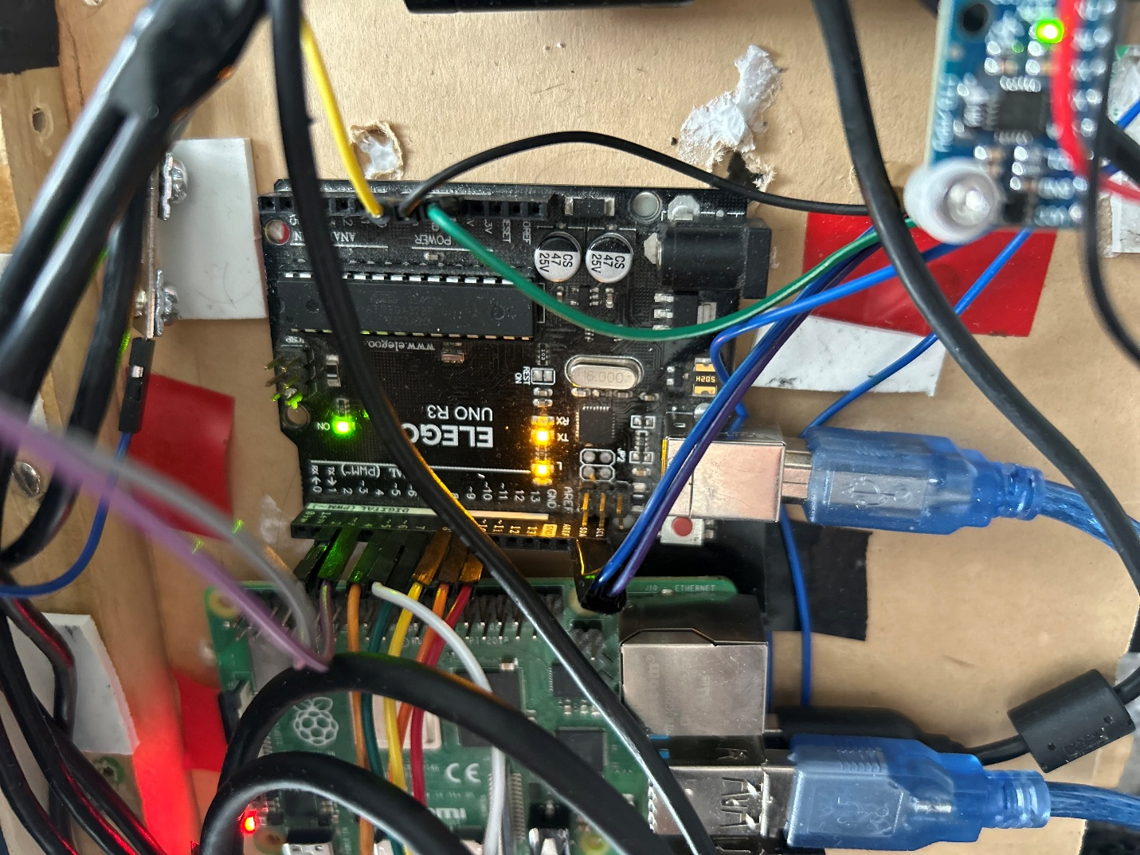
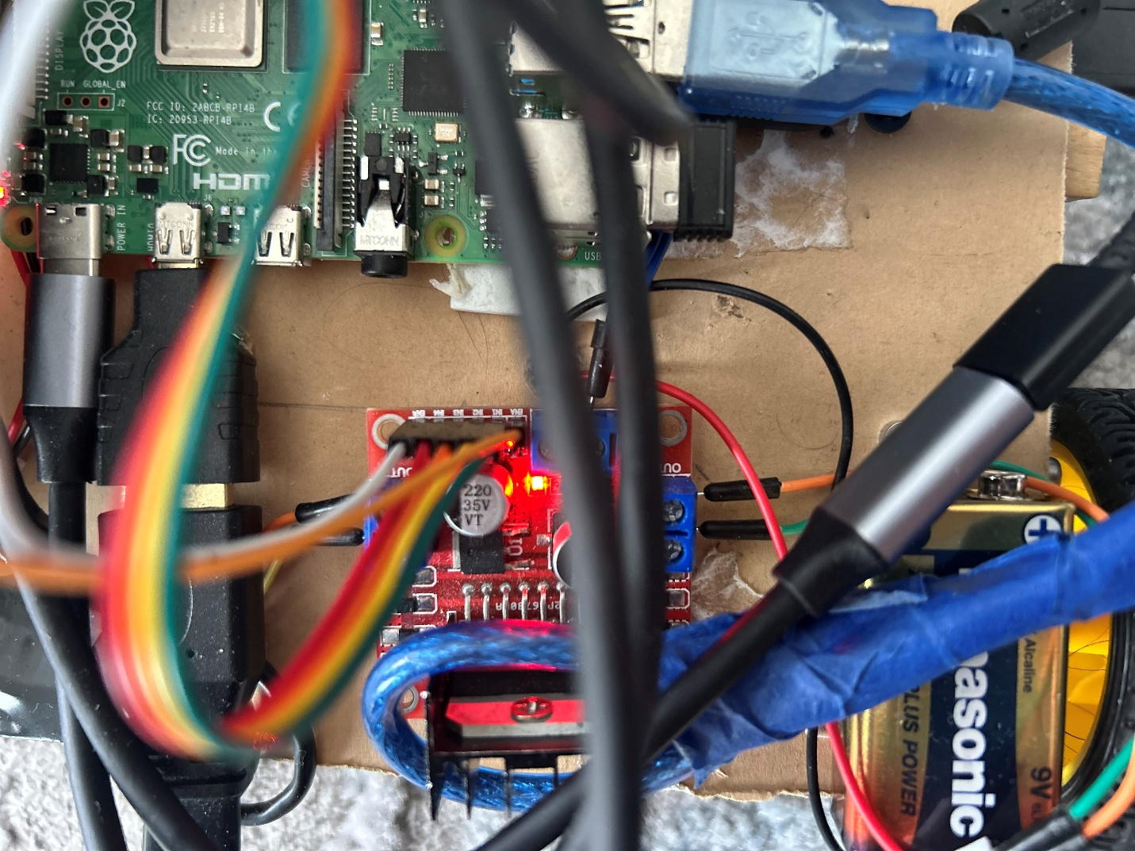
Figure 28
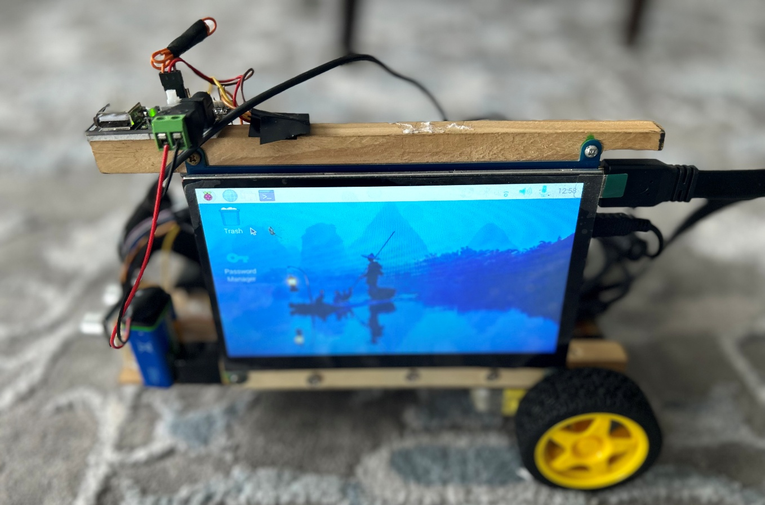
Figure 29

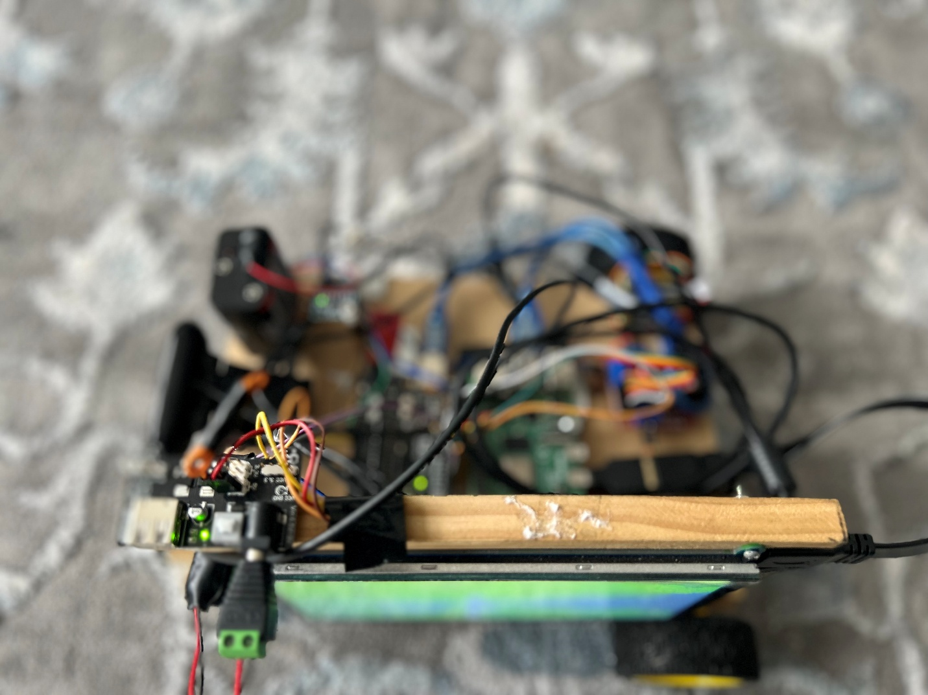
Figure 30

Figure 31
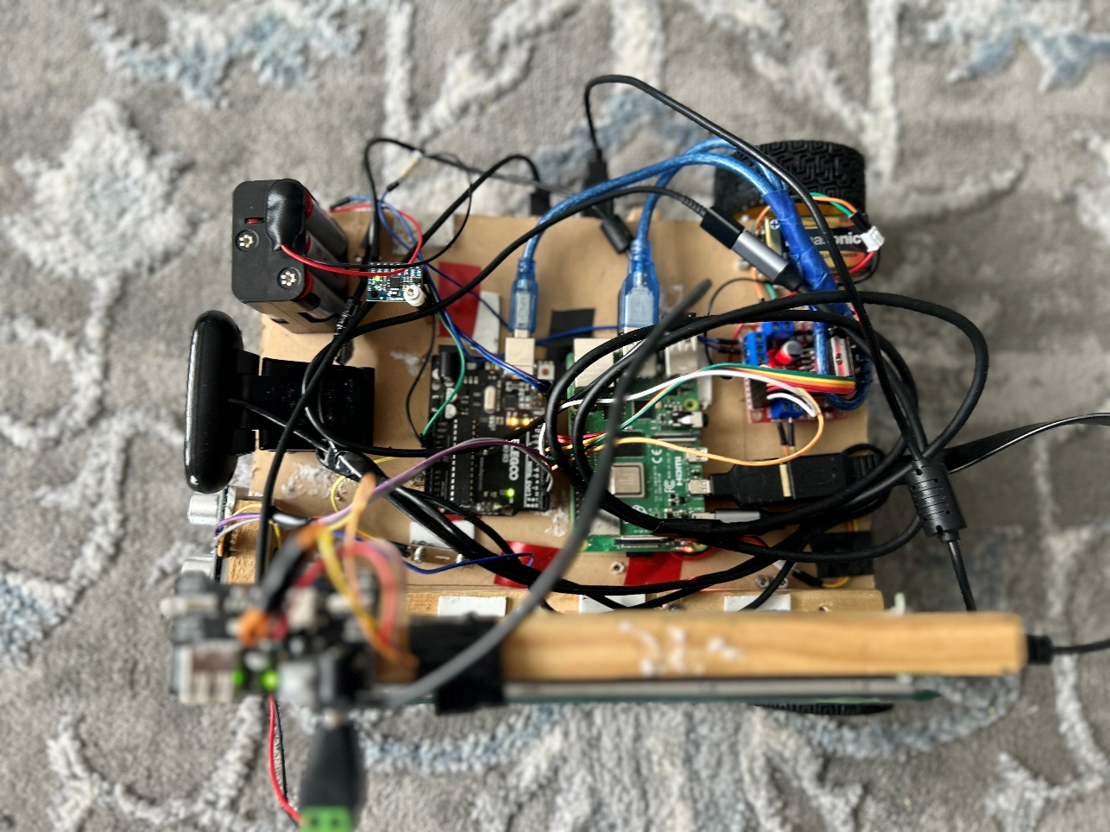

References:

Figure 1 (Ultra-Sonic Senor)
https://haynerobotics.com.au/products/ultrasonic-module-distance-measuring-sensor-hc-sr04

Figure 2 (Lidar Sensor)
https://www.sick.com/ca/en/catalog/products/lidar-and-radar-sensors/lidar-sensors/lms1000/c/g387151

Figure 3 (Pixy2 Smart Vision Sensor)
https://www.amazon.ca/Pixy2-Smart-Vision-Sensor-BeagleBone/dp/B07D1CLYD2

Figure 4 (Husky Lens Camera) https://www.amazon.ca/youyeetoo-HUSKYLENS-Machine-Vision-Sensor/dp/B086GP9PN2

Figure 5 and 6 (Esp32 Camera)
https://dev.to/admantium/esp32-camera-hardware-and-gpio-functions-3i6e

Figure 7 - 9 (Arduino Code)
https://dronebotworkshop.com/

Figure 10 – 21 (Arduino Code)
https://studio.edgeimpulse.com/studio/555095

Figure 22 (OpenCV and Python)
https://opencv.org/blog/opencv-python-is-now-an-official-opencv-project/

Figure 23 (Web Server)
https://www.vecteezy.com/vector-art/21351649-web-server-icon-for-your-website-mobile-presentation-and-logo-design

Figure 24 (GitHub Chat)
https://github.com/arunponnusamy/cvlib/tree/f46a22f8e13bc4b0267b9057fa88de170d41f96a

Figure 25 and 26 (Arduino Stopping Motors Code)
Created By Me

Figure 27 and 28 (Python Stopping Motors Code)
Created By Me

Figure 29 (Picture of working Prototype)
Link to Video Created by Me https://drive.google.com/file/d/1XIgpXCFdXcJYmNE6Hul1gKiwWrq40LSc/view

Figure 30 (Picture of 2-Wheel Motor Step Up)
Created By Me

Figure 31 (Picture of Top Down View of Robot)
Created By Me

