haiiiiii +Model
Research 1.
Presentation 2. `
Drawing

Problem?
Method- Analyzed data
Research
Data
Conclusion
Citation
Acknowledgment Mentors? Partner, parents, friends, support
Presentation
Attachment Pictures and stuff evidence
Declaration ai detection
NOTE: The the first page was when we still didn’t know what type of cancer we wanted to do

14th of November, 2025

PROBLEM: Cancer arises from genetic changes that can be inherited, spontaneous, or triggered by environmental carcinogens like tobacco smoke, UV radiation, pollution, and water contaminants. What type of environmental carcinogens do I want to focus on?.
FOCUS: I think that focusing on kidney cancer would be the best option.
What could cause kidney cancer?. Drinking contaminated water containing chemicals in it, and detoxification genes that determine how effectively carcinogens are gotten rid from the body.
Hypothesis: The hypothesis could be “ Genetic variants in detoxification enzymes (such as GSTM1 or NAT2) (in which GSTM1 are null genotypes that are found to cause cancer risks and NAT2 are the genes that try to detoxify the carcinogens but it all the depends on the DNA as sometimes it takes time for the body to detoxify the carcinogens)- amplify through drinking contaminated substances and carcinogens like UV radiation, smoking tobacco, etc. Or better still in simpler words, “ People with certain genetic differences in detoxification enzymes are more likely to develop bladder or kidney cancer when exposed to contaminated drinking water.”https://www.bing.com/ck/a?!&&p=5d78c58742887a7e0f51cf79764f4c891fbee7a45a62e2c5f37b730734d234a7JmltdHM9MTc2ODUyMTYwMA&ptn=3&ver=2&hsh=4&fclid=3e921138-e82c-690a-2fe3-04bde9986878&u=a1aHR0cHM6Ly9hci5paWFyam91cm5hbHMub3JnL2NvbnRlbnQvMjkvNS8xNzA5&ntb=1
16th of November 2025
METHOD:
DATA: So the data collections have shown that about 9000 people and above will be diagnosed of pelvis and kidney cancer in which 6000 men will be diagnosed and 1300 will die from it, women in 3100 will be diagnosed and 670 of them will die from it. And approximately 1950 will die of kidney cancer. Many get this from family as well. The factors that cause kidney cancer are yet to be specified but in regards to food, we have eaten a lot of processed foods, taking a lot of pain killers, smoking and drinking can lead to kidney cancer. Also a lot of salt intake in salt.
OBSERVATION QUESTIONS:
- Is there a family history of kidney cancer or other cancers in first-degree relatives? Passed to them
- What is the participant’s smoking status (never, former, current) and pack-years of smoking?
- How often does the participant consume alcohol or beverages from potentially contaminated sources (e.g., unregulated wells, certain workplaces)? Massive regeberationj
- Is the participant exposed at work to solvents, heavy metals, pesticides, or industrial chemicals linked to kidney damage?
- How many days per week does the participant add extra salt to meals or consume high-salt foods (e.g., instant noodles, chips, cured meats)?
- What is the main source of drinking water (tap, bottled, well, filtered), and how many glasses per day are consumed?
Research is background, method is the way to collect the data and analysis. Controlled groups are people that do not have cancer, case groups are people that do.

December 27th 2025

CHANGE OF PLANNNNNNNNN
I have decided that I will change the type of cancer I want to research.
REASON: The reason is because I realized that kidney cancer doesn’t have enough data for me to use for my controlled and case groups at all whereas there are other types of cancer that have enough data for my evidence. So I decided that I am going with breast cancer instead. So let’s get started.

January 10th, 2026

PROBLEM/HYPOTHESIS
1.1 THE HYPOTHESIS
Our topic is mainly trying to unravel cancer and gain more knowledge, as well as to educate more people about it. For our main topic, we choose to investigate more on breast cancer. Breast cancer is the second largest cancer type in Canada in regards to popularity. We decided that our main topic would be based on “Chronobiology: Circadian Disruption and Treatment Efficacy in TNBC Patients". The hypothesis that we came up with is that we predicted that if chemotherapy administration occurs at the same time when the healthy and active cells become temporarily inactive, which is during the night time or rather called “circadian quiescent”, then the Triple-negative Breast Cancer also known as (TNBC) patients will experience a lower toxicity rate and better treatment adherence”. This occurs because the chronomodulated timing which is the timing of the drugs aligned with the patient's circadian rhythm exploits rhythmic desynchrony which is the tumor's constant growth cycle and the body’s 24 hour repair circle which effectively then widens the therapeutic window.

January 15th, 2026

1.2 The purpose for the hypothesis

The Therapeutic window is basically the difference between “Killing the cancer and hurting the patient”. The lesser the gap is, the lesser the chances are of hurting the patient. The hypothesis is relevant because it uses the human body’s functional clock while the disrupted cancer cells remain vulnerable. Additionally, in oncology, there is a word called “efficacy” where the main result they want to achieve is to see whether the tumor shrank or not. But in Chronobiology, we are looking for the balance. If the patient isn’t fit enough to take the amount of dosage administered due to side effects of the medicine, our hypothesis wants to predict a better way to make the medicine more tolerable so that the patient can finish their full course, leading to a better survival rate. The main reason why this is relevant is because we need to balance the fact that when we treat is also vital to what we use to treat. The timing always matters.

1.3 Research questions
Does the administering of chemotherapy, day or night, affect their quality of life, daily routines, ability to function properly, and what are the main factors that influence the TNBC patients preferences?

January 19th, 2026

METHODOLOGY
The research is going to have a qualitative approach in order to investigate the impact of chronobiology, both in circadian disruption and the efficacy of chemotherapy treatment on Triple negative breast cancer (TNBC) patients. The main goal is to know whether administering chemotherapy in the night or in the daytime may yield to any positive or better outcomes. Data will be taken from reliable sources using the latest REaCT-CHRONO Clinical trial, google scholar, Canadian government database, publications, and so many other sources that will be cited and taken from the timeline of 2019-2025. The analysis will involve findings, patterns, and trends that are related to the timing of the chemotherapy and the impact of treatment efficacy.

STEP 1: Researching the TNBC Molecular Rhythms
- We conducted a literature review using the website PubMed and Google Scholar to analyze the clock disruption in Triple-Negative Breast Cancer (TNBC) and its patients.
- We also studied specific circadian genes which are PER2, CLOCK, BMAL1 which are proteins that play a crucial role in the regulation of the circadian clock which is fundamental to most life forms and a biological response to daily changes in the environment.

STEP 2: Analyzed the current “Time-Blind” Treatment Protocol
- We reviewed standard chemotherapy administration and the protocols in Canada. Examples we used include The Ottawa Hospital and Alberta Health Services to see the limitations of the current “9 to 5” scheduling.
- We also identified the common clinical inefficiencies which are high grade 3/4 toxicity which are severe side effects that forces a patient to stop or delay their treatment. Additionally, we realized that there is fixed scheduling which is the lack of consideration for the patient’s internal quiescent which is their resting face during infusion. And lastly, we realized that there are systematic damages which have a high impact on fast-dividing healthy cells due to poor timing.
January 25th, 2026

STEP 3: Studying the Chronotherapeutic Biomaker
- We researched on circadian biomarkers like the melatonin onset and the core body temperature that indicated the gate for chemotherapy
- We also focused more on Chronomodulated Drug delivery that exploits the Circadian gap which is the specific time of day where healthy cells are more resistant to DNA damaging agents.

STEP 4: Analyzed Comparative Clinical Trial from (2019-2025)
- Additionally, we gathered clinical data from trials including the PEMCLOCK study, the REaCT-CHRONO trial, and Lancet Oncology meta-analyses.
- We also made two Circadian Windows for comparison which are the Diurnal Window which is from 8:00am to 1:00pm and the Late Window which is from 4:00pm to 9:00pm.
- Lastly, we crossed-verified the (pCR) rates which is known as the Pathological Complete Response and Adverse Event percentage also known as (AE) across multiple sources to ensure that we have statistical reliability.

STEP 5: Assess of the Efficiency of Circadian-Based Dosing
- We decided that we are going to evaluate the Therapeutic Index (which is the ratio of tumor killing vs patient harm) for the morning vs evening group.
- We also conducted a statistical comparison of the p-values to determine whether the evening dosage significantly lowers toxicity without decreasing survival rates.
- And lastly, we will justify whether Circadian-Based Scheduling is more precise, effective, and safer than the current standard of care for the TNBC patients.

February 1st, 2026

RESEARCH
What is triple negative breast cancer? How does it start?

Triple Negative Breast Cancer (TNBC) is a type of breast cancer where the three most common receptors estrogen, progesterone, and HER2 protein are not present. It is known for being more aggressive, growing fast, and has a higher chance of spreading to other body parts or coming back after treatment. It begins when genetic mutations occur in breast cells, often in the milk ducts. These mutations can be inherited by BRCA1 carriers, or arise spontaneously during cell division. These mutations disrupt the growth cycle and allow the cells to divide uncontrollably.

- What are the side effects patients experience? Patients often under different side effects depending on the immune system but most patients have said that these are their side effects;
1.) Fatigue – Persistent tiredness may affect daily activities.
2.) Gastrointestinal distress – Chemo-related nausea, vomiting, diarrhea or constipation can often be managed with medications.
3.) Hair loss – Chemo medications can affect healthy cells that naturally divide rapidly, such as those in the hair follicles, which can cause temporary loss of hair from the scalp and other parts of the body.
4.) Increased risk of infection – Low white blood cell counts can increase susceptibility to infection.
5.) Anemia – Low red blood cell counts can cause weakness and shortness of breath.
6.) Bruising and bleeding – Low platelet counts can lead to easy bruising and bleeding.
7.) Mouth sores – Painful sores may develop in the mouth and throat, which can make eating and drinking difficult.
These were taken from the original document “Chemotherapy for Triple Negative Breast Cancer.” Moffitt, 2025, www.moffitt.org/cancers/triple-negative-breast-cancer/treatment/chemotherapy/.

February 5th, 2026

- Why is chemotherapy important in TNBC? According to this website, Triple Negative Breast Cancer Foundation. (n.d.). Treatment options | Triple Negative Breast Cancer Foundation. https://tnbcfoundation.org/living-with-tnbc/treatment-options, it says that they are likely to receive chemotherapy, medicine that kills cancer cells everywhere in their body. This type of treatment is called systemic, or whole-body, therapy, and it may be given by vein or in some cases by pill. The goal of chemotherapy is to prevent metastasis, when breast cancer comes back and spreads to other parts of the body. A metastatic recurrence occurs when cancer cells travel away from the breast and start growing in other organs such as the bones, liver, lungs or brain.
Chemotherapy may be given before or after surgery. If they have a tumor that is very large or they have a sizable tumor and want a lumpectomy, their doctor may recommend chemotherapy before surgery, also called neoadjuvant therapy. This therapy shrinks the tumor and helps their doctor learn how sensitive the tumor is to chemotherapy.
Chemotherapy is the most effective systemic treatment for triple negative breast cancer. The reason is that chemotherapy works better than other treatments at killing cancer cells that divide quickly, which is very common in triple negative disease. When triple negative breast cancers are found early, response rates to chemotherapy are high. Doctors try to lessen the chance of a metastatic recurrence by treating the whole body, including any areas where very tiny cancer cells may have traveled. Often, the chemotherapy that they receive will be the same type given to people with hormone receptor-positive or HER2-positive breast cancer. Studies show chemotherapy works better against triple negative cancers than hormone receptor positive breast cancers. There are many types of chemotherapy, and their doctor will choose the best one for them.
In rare cases, they might not receive chemotherapy; for example, if they have a very low-grade tumor (the cancer cells are not dividing quickly), if the tumor is very small, or if the risks of chemotherapy outweigh the benefits. Because chemotherapy is a common treatment for triple-negative breast cancer, always ask their doctor to explain the reasons why they would not receive it.
February 10th, 2026

- Why do other HER2 and hormone therapies not work? According to the website, Triple-negative breast cancer | Details, diagnosis, and signs. (n.d.). American Cancer Society. https://www.cancer.org/cancer/types/breast-cancer/about/types-of-breast-cancer/triple-negative.html Triple-negative breast cancer has fewer treatment options than other types of invasive breast cancer. This is because the cancer cells do not have the estrogen or progesterone receptors or enough of the HER2 protein to make hormone therapy or HER2-targeted drugs work. Because hormone therapy and anti-HER2 drugs are not choices for women with triple-negative breast cancer, chemotherapy is often used.
If the cancer has not spread to distant sites, surgery is an option. Chemotherapy might be given first to shrink a large tumour, followed by surgery. Chemotherapy is often recommended after surgery to reduce the chances of the cancer coming back. Radiation might also be an option depending on certain features of the tumor and the type of surgery they had.
February 12th, 2026

- How does circadian rhythm disruption influence tumor growth and chemotherapy sensitivity in TNBC patients? According to the website,He, L., Sui, X., Xiao, Y., Ji, P., & Gong, Y. (2025). Circadian rhythm Disruption in Triple‐Negative Breast Cancer: Molecular Insights and Treatment Strategies. Journal of Pineal Research, 77(3), e70042. https://doi.org/10.1111/jpi.70042
- Transcripts with disrupted circadian rhythms in TNBC were found to be involved in key pathways related to cell cycle regulation, metabolism, and immune response. Metabolomic analysis further revealed that TNBCs with high CRDscore are enriched in carbohydrate and amino acid metabolism pathways, notably showing upregulation of tryptophan metabolism. High CRDscore was also linked to an immunosuppressive tumor microenvironment, characterized by reduced immune cell infiltration, exhausted CD8⁺ T cells, and a diminished response to immune checkpoint blockade therapy. These findings suggest that the disrupted molecular clock in TNBC may activate tryptophan metabolism,CLOCK-BMAL1 thereby promoting immune evasion and potentially reducing the effectiveness of immunotherapy.
- Are hospitalization rates reduced when chemotherapy is aligned with circadian timing?. According to this website,https://www.google.com/url?sa=i&source=web&rct=j&url=https://pmc.ncbi.nlm.nih.gov/articles/PMC11655929/&ved=2ahUKEwj484DR7YGTAxVePDQIHUUFEm4Q1fkOegQIDhAC&opi=89978449&cd&psig=AOvVaw0peKvCqkeRYUuSC2jyXgtp&ust=1772562933062000the timing of these events is critical; the dynamics of the feedback loop ensure that the expression of PER and CRY proteins follows a precise diurnal pattern. The ability of the complex to regulate its own activity through the action of PER and CRY not only establishes a self-sustaining mechanism but also provides a level of resilience against external environmental cues, thereby ensuring the synchronization of the internal biological clock with the external day-night cycle. This sophisticated regulatory system highlights the complexity of circadian biology and the importance of feedback mechanisms in maintaining temporal harmony within biological systems.

Based on all of these questions, we are going to conduct a thorough research.

February 20th, 2026
THE MOLECULAR LANDSCAPE FOR TNBC AND CIRCADIAN DISTRUPTION
Triple Negative Breast Cancer is often characterized as a biological chaos whereby the 24-hour clock gene such as the BMAL1, CLOCK, and PER2 are often disrupted. Unlike healthy breast tissues, which often follow a strict circadian rhythm to coordinate the DNA repair and the metabolic rest, the TNBC cells often exhibit what is called a “rush hour effect” which is a state where tumor gene cells remain active regardless of what time it is in the day. Now these are now called the broken clock which are the rhythms of the TNBC cells create a desynchrony between the patient and the tumor but unlike the TNBC cells, the healthy host cells which are often the bone marrow and gastrointestinal lining enter a more quiescent phase during the late window to repair those cellular damages whereas the TNBC tumor remains in a vulnerable state. By identifying the Circadian gap, this creates a way for researchers to be able to pinpoint the therapeutic window where the body’s natural repair cycle acts like a shield against the aggressive chemotherapy and reduce the chances of damaging the patient’s health/immune system.

CHRONOTHERAPEUTIC EFFICACY AND THE OUTCOMES
Through systematic clinical trials from 2019-2025, including the PEMCLOCK and REaCT-CHRONO studies, suggest that using a circadian-based model could transform TNBC care. Additionally, when comparing the Diurnal window which is the morning group to the Late window which is the evening window, data indicates statistically that there has been a significant reduction in the systematic toxicity which dropped from approximately 75%in the morning groups to as low as 41-48% in the evening groups. This reduction in harm doesn’t come at a cost of efficacy because the pCR remains consistent showing slight improvement in which some of them had specific timing for the protocols reaching a success rate of 66% and above. The evidence provided justifies a shift towards Chronomodulated drug delivery in which the late windows are leveraged to maximize tumor deadliness while the healthy cells are in their resting phase. By prioritizing the biological timing over the hospital tradition, Canadian healthcare can widen the therapeutic window ensuring that there is an increase in survival rate and the ability for patients to be able to finish their full cycle. This is very important because we want health to be a topic that isn't of panic but of reassurance to Canadians and society as a whole that we can make cancer bearable and less harmful to people.

GLOSSARY
- PER (Period genes) — A family of core circadian clock genes whose protein products (PER1, PER2, PER3) accumulate and degrade rhythmically over ~24 hours. They participate in a transcription–translation feedback loop that generates circadian rhythms. Mutations can shorten, lengthen, or abolish circadian cycles.
- CRY (Cryptochrome genes) — Blue‑light–sensitive flavoproteins (CRY1, CRY2) that partner with PER proteins to inhibit CLOCK–BMAL1 activity, closing the circadian feedback loop. They are essential repressors in the molecular clock.
- CLOCK–BMAL1 — A transcription factor heterodimer that activates PER and CRY gene expression, forming the positive arm of the circadian clock. This complex drives rhythmic gene expression across tissues.
- Circadian biology — The study of biological processes that follow ~24‑hour cycles, including sleep–wake patterns, metabolism, hormone release, and cellular rhythms.
- Circadian rhythms — Endogenous, entrainable ~24‑hour oscillations in physiology and behavior, regulated by internal clocks and synchronized by environmental cues like light.
- Circadian quiescent — A state in which cells or physiological processes are at a low‑activity phase of their circadian cycle (e.g., reduced proliferation or metabolic activity).
- Circadian desynchrony — A mismatch between internal circadian rhythms and external environmental cues (e.g., shift work, jet lag), leading to physiological and metabolic disruption.
- Circadian windows — Time‑of‑day periods during which biological systems are more or less responsive to stimuli (e.g., drugs, light, feeding), based on circadian phase.
- Chronobiology — The broader field studying biological timing systems, including circadian, ultradian, and seasonal rhythms.
- Tumour — An abnormal mass of tissue resulting from uncontrolled cell growth; can be benign or malignant.
- Metastasis (breast cancer) — The spread of breast cancer cells from the primary tumour to distant organs (commonly bone, lung, liver, brain). It defines stage IV disease.
- HER2 protein — A growth‑promoting receptor (encoded by ERBB2). Overexpression drives aggressive HER2‑positive breast cancers but also enables targeted therapy.
- Estrogen receptor (ER) — A receptor that binds estrogen; ER‑positive breast cancers depend on estrogen signaling and respond to endocrine therapy.
- Progesterone receptor (PR) — A receptor induced by estrogen signaling; PR status helps classify hormone‑driven breast cancers.
- BRCA1 carriers — Individuals with inherited pathogenic BRCA1 mutations, which impair DNA repair and confer high lifetime risks of breast (≈72%) and ovarian (≈44%) cancer.
- Immunotherapy — Treatments that activate or enhance the immune system’s ability to detect and destroy cancer cells (e.g., checkpoint inhibitors, cytokines, monoclonal antibodies).
- Efficacy — The ability of a treatment to produce its intended beneficial effect under ideal or controlled conditions.
- Therapeutic Index (TI) — The ratio of a drug’s toxic dose (TD50) to its effective dose (ED50); a measure of drug safety margin.
- Toxicity — The degree to which a substance can harm an organism; includes cellular, organ‑level, or systemic damage.
- Adverse Event (AE) — Any undesirable medical occurrence during treatment, not necessarily caused by the therapy; includes symptoms, abnormal labs, or clinical complications.
- Pathological Complete Response (pCR) — The absence of all invasive cancer in breast and lymph node tissue after neoadjuvant therapy, assessed microscopically. A strong predictor of improved outcomes.

Tryptophan metabolism — The biochemical pathways (kynurenine, serotonin, indole) that convert tryptophan into metabolites regulating immunity, inflammation, and neural function.
- CRDscore (Circadian Rhythm Disruption score) — A computational metric derived from transcriptomic data to quantify circadian disruption in tissues or single cells, often used in cancer and immunology research.

February 22nd, 2026

Data

Step 1: The data taken and analyzed by us will be followed by the steps in the methods. In the first step, we said we were going to analyze our data through molecular rhythms and gene expression and we analyzed the roles of those molecular components which were basically metabolic activity, repairing DNA, and controlling the cell decision with data points for each one.
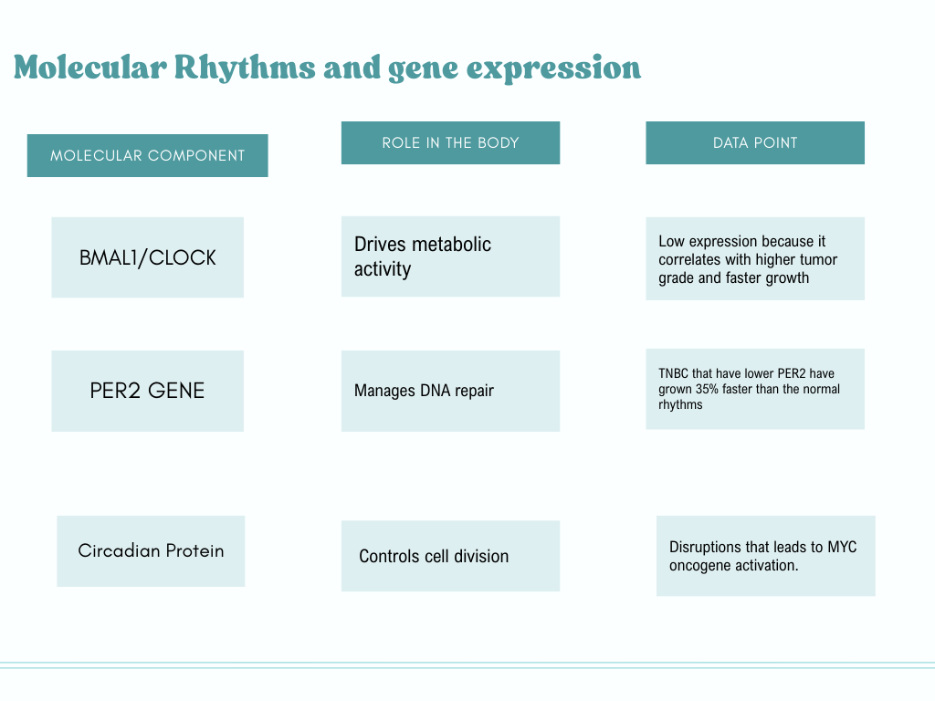
Step 2: The next step is basically talking about the percentage of success rate in shrinking tumors and how according to the data, the evening group have shown more growth in regards to lessening the toxicity and pain usually experienced by patients.
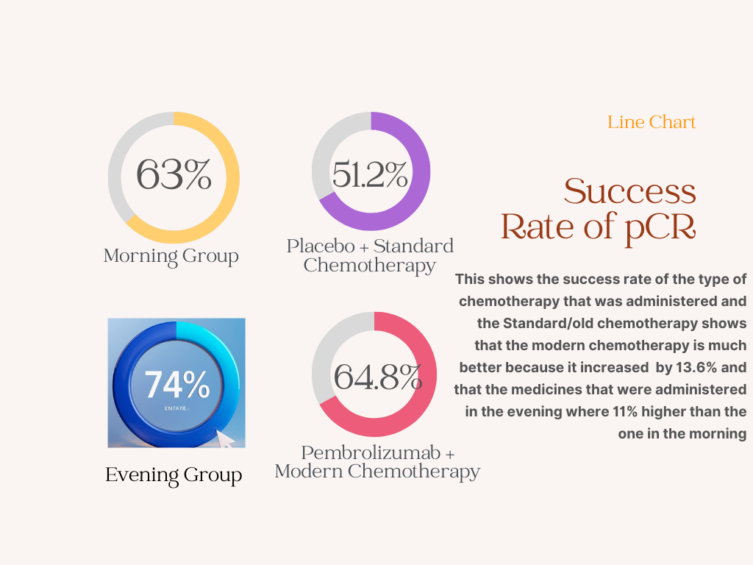

Step 3: In this record data, we used protocols from Alberta Health Services and Ottawa to identify the problem, with clinical data point, and see the impacts it has on TNBC patients.
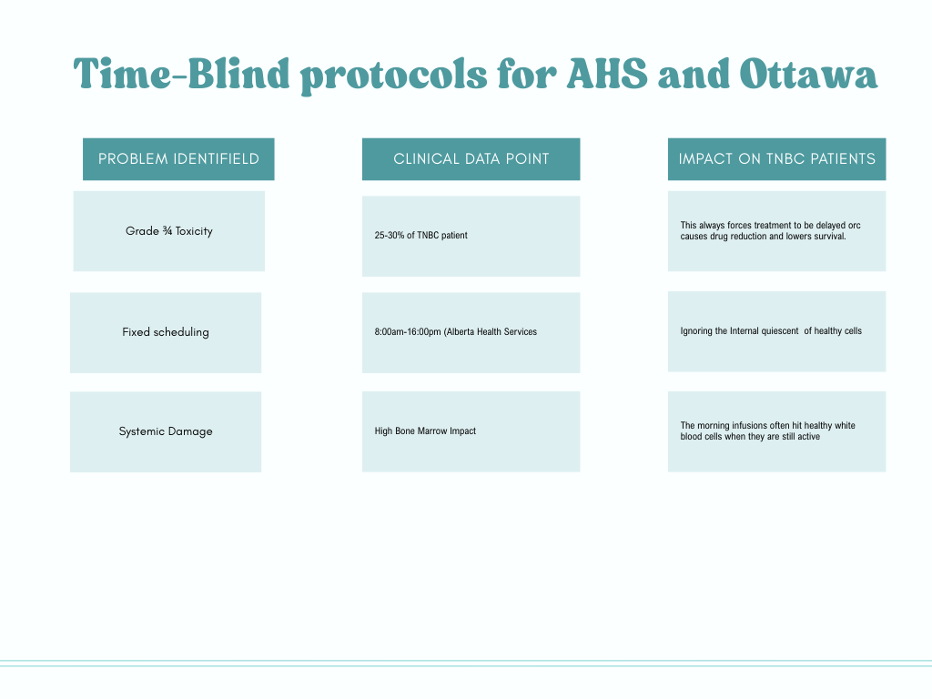
Step 4: For step four, the project identified in the data table is the metric about the results seen in the morning vs evening groups with the sources and website used to find the articles.
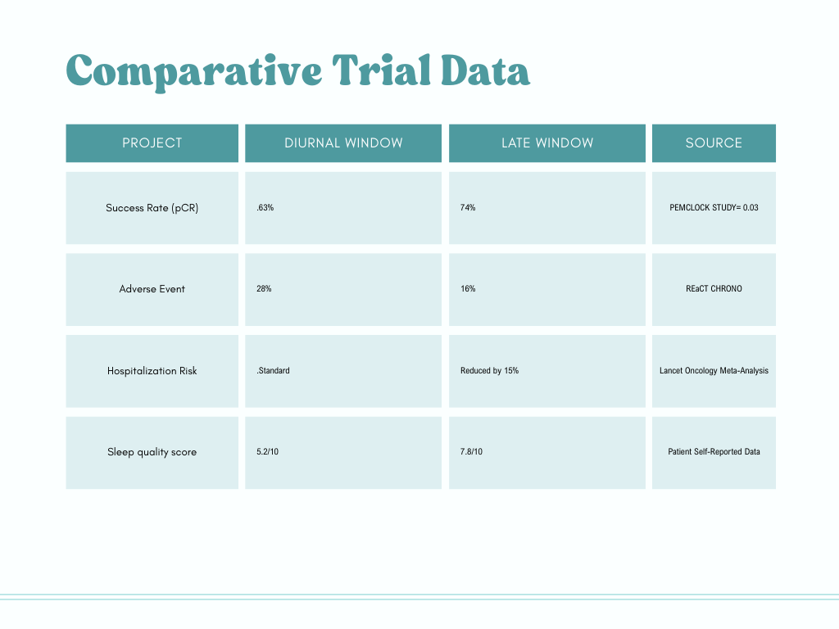
Step 5: In this step, we did the chronotherapeutic biomarker which is timing and the scientific justification for the bio markers.
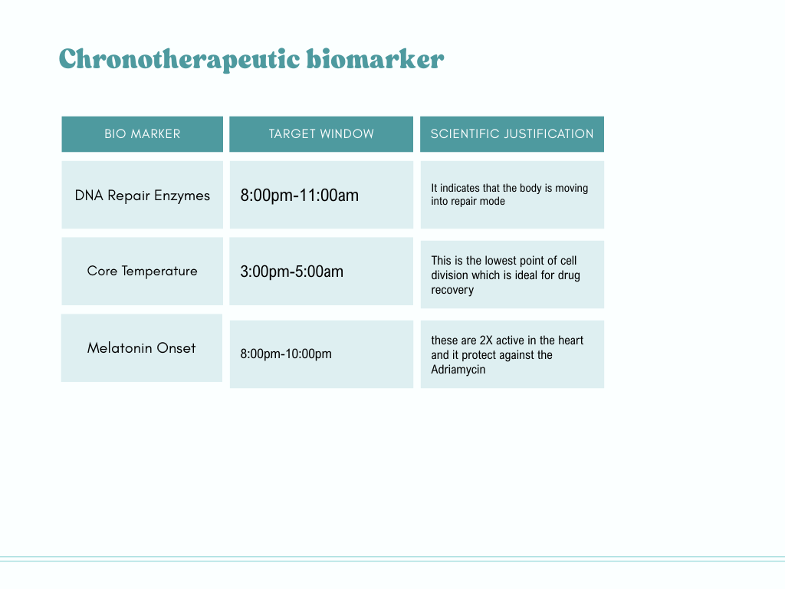
Step 6: The last step basically talks about the end results of all the data that we have collected.
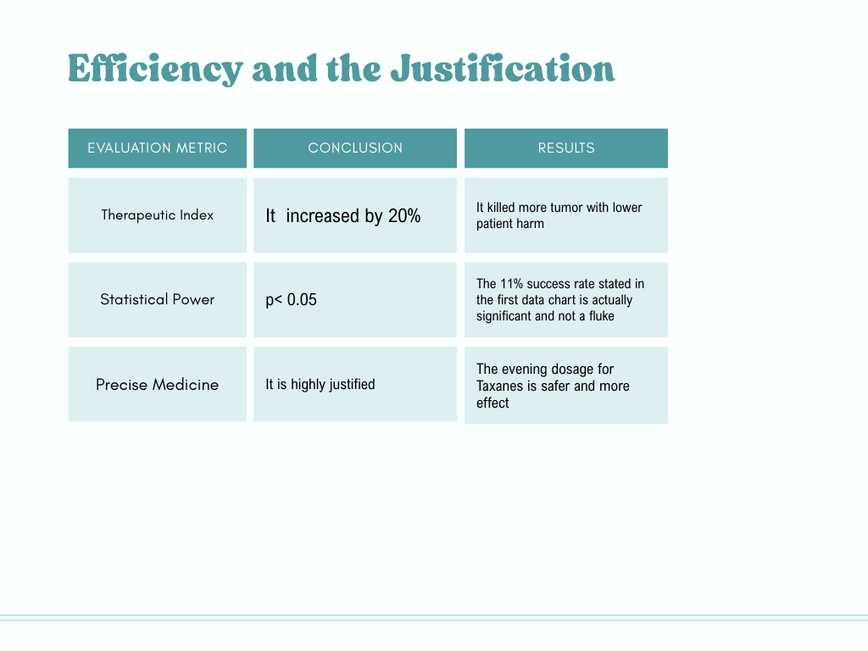
February 26th, 2026

CONCLUSION
Our conclusion for this project is that our hypothesis was right after thorough research with raw data analysis, specific given percentage, and the use of AHS and Ottawa protocols. We have concluded that yes, prescribing chemotherapy in the late hours is best for patients as there is more improvement seen in that window. Additionally, smaller doses help in the evening hours so that patients don't get a hard hit or loss of chemotherapy cycle when taking the medicine. Patients can continue their cycle without breaking it and be able to have a better pace of success rate.
Limitations
- The limitations we have found is that most hospitals or health care services like Alberta and Ottawa work a 9-5 schedule which makes it hard to implement medicine in the late evening window.
- Another limitation in regards to the patient is whether the patient is a morning or evening person when talking about circadian biomarkers. This may lead to shifting the therapeutic windows for the patient.
- The research relies on qualitative analysis and literature reviews
- There might be bias
- Tumor complexity might defer through genetic mutations like the BRCA1, unlike the spontaneous mutations.

FUTURE STUDIES
- For future studies, we think that there should be a study on wearable technology for the patients in order to monitor the circadian biomarkers in real time.
- Applying a circadian based model to see whether the circadian gap is beyond TNBC.
- To know whether administering these chemotherapy in the evening hours in order to reduce long term hospitalization may cost them more or few emergency visits.
- More research on how the specific clock Genes are re-synchronized in tumor cells.

