Yash Jadon Science Fair Logbook

Sept.13

My project question has been approved by Ms. Bretner today and it is “ How can we convert kinetic energy from activities like hiking and running into a clean renewable source of energy to power LED lights and/or flashlights to help people who are hiking or running at night?”

Figured out different sources I can do this from

Title could be: Lighting the Trail: Clean Energy from Every Step

Piezolectric
Steve Mould- Piezoelectricity - why hitting crystals makes electricity
Youtube https://www.youtube.com/watch?v=wcJXA8IqYl8

A piezoelectric crystal like quartz, which is made of silicon and oxygen, is compressed, the atoms in the quartz are also compressing. The oxygen and silicon bond is not quite even, so when you compress it, the negative charged oxygen atoms and positive silicon atoms are pushed to the sides of the crystal


In the first picture, you can see a neutral bond, where the oxygen and silicon atoms are in a neutral bond, where they overlap exactly. However, when compressed, the negatively charged oxygen atoms and positive silicon atoms are pushed to the sides, shown in the picture to the right. When wired, the positive charge will want to pull the negative charge towards it, so if the wires are close enough together, the electricity produces a spark.

Piezoelectricity is a way of producing electricity through mechanical stress
For example, compressing the crystal will produce electricity.
This can be used for a variety of things, like sensors, powering small LED, and even powering large scale electronics if enough power is reached.

Pavegen Tiles
CNBC International Live Youtube Channel
youtube.com/watch?time_continue=2&v=N_Li7gQQLLY&embeds_referring_euri=https%3A%2F%2Fwww.google.com%2Fsearch%3Fq%3Dconverting%2Benergy%2Bfrom%2Bwalking%2Bto%2Belectricit%26oq%3Dconverting%2Benergy%2Bfrom%2Bwalking%2Bto%2Belectricit%26gs_&source_ve_path=Mjg2NjY

These tiles are kind of like pieces of a side walk, but when you step on them, they power vertical electromagnetic generators.

Basically, when you step on the tile, a hidden flywheel underneath spins, and the more people walking on them, the more they spin. The more they spin, the more energy is created.

Sept 26-29
I have decided not to continue with the pavegen tiles, as they are meant to be used by the full weight of the human and not just from arm and leg brace movement.

The wheels will also not create as much energy as the weight of a full human is much more powerful than only movement of limb joints pushing together. The overall wheel design would not fit as well with my design.

Looking at electromagnetic induction as a possible other choice now, and maybe even combine them 2 together.

https://www.electronics-tutorials.ws/electromagnetism/electromagnetic-induction.html
Electronics Tutorials
Electromagnetic Induction

https://www.youtube.com/watch?v=pQp6bmJPU_0
Youtube - Crash Course Physics

Electromagnetic Induction is how magnetism can induce electricity in a circuit. When a wire has a current in it, the wire produces a magnetic field. This magnetic field is quite small, but if you coil the loop of wire, it amplifies it, making an even bigger magnetic field. This field is called magnetic flux, which is basically the magnetic field induced when a current runs through a wire. A change in magnetic flux causes an emf in a loop of wire. Emf means Electromotive Force, which is what causes electrons to move and form a current. So a change in magnetic field, like opening and closing a circuit, can cause the magnetic flux to change, which produces an emf in another closeby wire. When magnetic flux is decreased, the emf increases, and vice versa.

Using this, we know that changing the magnetic field near a wire / loop of wire will induce emf in that wire. That's how magnetic induction works in many products.

Oct - 12-13

Today I will look at different products that use these systems and see how they work in the product to get a sense of how I can use them.

Piezoelectric

https://www.americanpiezo.com/blog/top-uses-of-piezoelectricity-in-everyday-applications/
APC

As
ScienceDirect

In lighters and gas grills, piezo materials, like quartz, are struck with a hammer, which produces a spark strong enough to light a fluid, which then produces a light.

Piezo materials are also able to detect very small disturbances, which make them great for products like medical imaging and high quality sensors.

Piezoelectric materials can also be used for energy harvesting via vibration. This can use compliant mechanisms, which are flexible objects that do not use joints, but use flexible parts. This can help transfer the motion object more smoothly and can make the energy harvesting work more efficiently. With rigid hinges, moving parts can wear out over time. They can not bend, so they don’t absorb the vibrations as smoothly. Stiffness can waste energy instead of using it, which is not as efficient. These devices are also quieter, which works great with my planned brace design. Using CMs are really useful and are almost exactly what I needed for the brace, as it bends, is quiet, and efficient. I will see if I can make it more efficient while testing.

Oct-25

Continuing on with what I was doing previously.

Electromagnetic Induction
This can be used in a variety of applications, which include electric motors, electric generators, induction stoves, transformers, electric guitars, and more. Here is how they work.

Nov 10-11

Another way we can harvest that I found

TRIBOELECTRIC NANOGENERATORS

These are very easy to build with normal items, and also are really good at harvesting energy from motion. When an object comes into contact with another, it transfers electrons, and when they separate, it creates electric potential, or the potential for electricity. These can be used at a small scale or large scale, and I would benefit from using a large scale as it can create more electricity. An example of this is when you rub 2 balloons together, one balloon transfers charge, which leaves the balloons being polar opposites. If the balloons are kept at a distance, this creates electrical potential. As always, the electrons want to create equilibrium, so they try to balance out, but then when touched again they create more These can create high volts but low current, so are pretty good for sensors and other things

Images of ones I found:

https://www.frontiersin.org/journals/mechanical-engineering/articles/10.3389/fmech.2020.576896/full

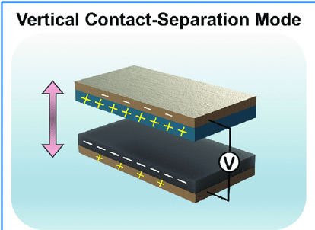

In this image, we can clearly see that there is an electrical potential between the layers. This means electricity can flow.
This is very good for my project as I will be using the fact that people will be moving a lot of their joints while running / hiking, so this is an amazing way to do it

Building more on the electromagnetic induction part, if we want to induce a current with only a magnet. The magnet will have to enter and come out of the coil for maximum efficiency, as a change in magnetic flux is what causes emf.

Nov 12

Prototyping and sketching out ideas.
I have been thinking about a problem with electromagnetic induction. If we want to use it, we would need a way to keep the magnet coming in and out of the coil.

Nov 14

I am using my Dads old knee brace from when he tore his ACL. Images are shown below.

I have also looked around and cannot seem to find any Triboelectric Nanogenerators on the web, so I may have to build it myself..

Dec 2 -5, 2025

Today I have started making a few slides showing my background research and how I have concluded this research can help me with my project.

Dec 6,

Today I talked to Ms. Bretner to check up on my project. She said everything looked good, but I just needed to research the current for my generators. The current will decide how much voltage I would make to actually light up the bulbs, which is what I need

I have also decided to use lower voltage bulbs, as my generators won’t make as much electricity as your day to day batteries, and the purpose of my project is to show the prototype, and how that prototype could actually be used in the real world. I will have to do some testing with the TENG, as it cannot be found in the market since it's relatively new, but I have found some other things online.

Gary Does Solar Youtube Channel

I wanted to find out what really was the difference between current and voltage, and here's the answer

Voltage is basically the pushing force, the force that pushes the electrons through the circuit.

Current is the electrical charge in the circuit, basically the water in the pipe that is being pushed by the pressure.

A normal piezoelectric disk makes high voltage, but low current, only about a few mA
TENG usually produces low current, about a few mA, but if effectively designed can even produce Amps.

Electromagnetic induction seems promising, as it can produce mA to even high current, based on how many loops are there etc. If we can use many loops and use the Faraday’s flashlight example in our own build it could be beneficial

I have approached these problems in different ways. For the piezoelectric one, I thought of trying to use it in the ankle brace, but using it there won’t get the weight I need on the discs, so using it on the inside of a shoe fits better.
Dec 21 - Jan 2

I have been working on creating a material list for whatever I need and making sure I gove it to my Dad to order. I have borrowed some things from my school like breadboards, wires and a multimeter.

Jan 16 - I went to school today and found out I could not borrow the breadboards as the school needed them. Multimeter and alligator clips can be borrowed though.

Jan 23 - Today I am working on converting all my information into slides. I have finished putting all my background research down, and am putting pictures to explain those pictures as well.

Jan 25 - Feb 20 Science fair day

I have bought everything I needed from a store called Solarbotics, which sells alot of electrical components. Using them, I have designed a small electromagnetic induction pen, and a piezoelectric shoe.

For the shoe —-> Piezo discs lined across the bottom sole, and connected together in parallel. The 2 output wires are then fed to the rectifier, where it then is fed to a capacitor, and finally to the led

For the pen, I bought copper wire, wrapped it around the pen, and put 4 magnets inside the pen. Then I connected the ends of the wire straight to a multimeter, as this pen was just a test to see if I could generate electricity. However, then came a problem. When I bought the copper wire, it turned out to not be insulated, causing a problem.

The wire needs to be insulated, as if it's not, the wires that overlap will just short circuit, creating no electricity at all. Since I made this prototype late, I needed a fix fast, and that fix was using the jumper wires I had bought. Since I had bought way more jumper wires than I would ever use, I just connected all of them together, creating sort of a loop of coil. This was giving me 2 mA, which I was expecting as the magnets were not very strong, and the design was small as it was in a pen. Although, it did generate, helping me visualize how this could work on a larger scale.

Piezo shoe outputs

At first with 2 discs, the output was around 5 - 10 mA, however, after adding 6 more, in parallel, the output was averaging 40 mA, and sometimes going to 60. Here is a chart to show how it is outputted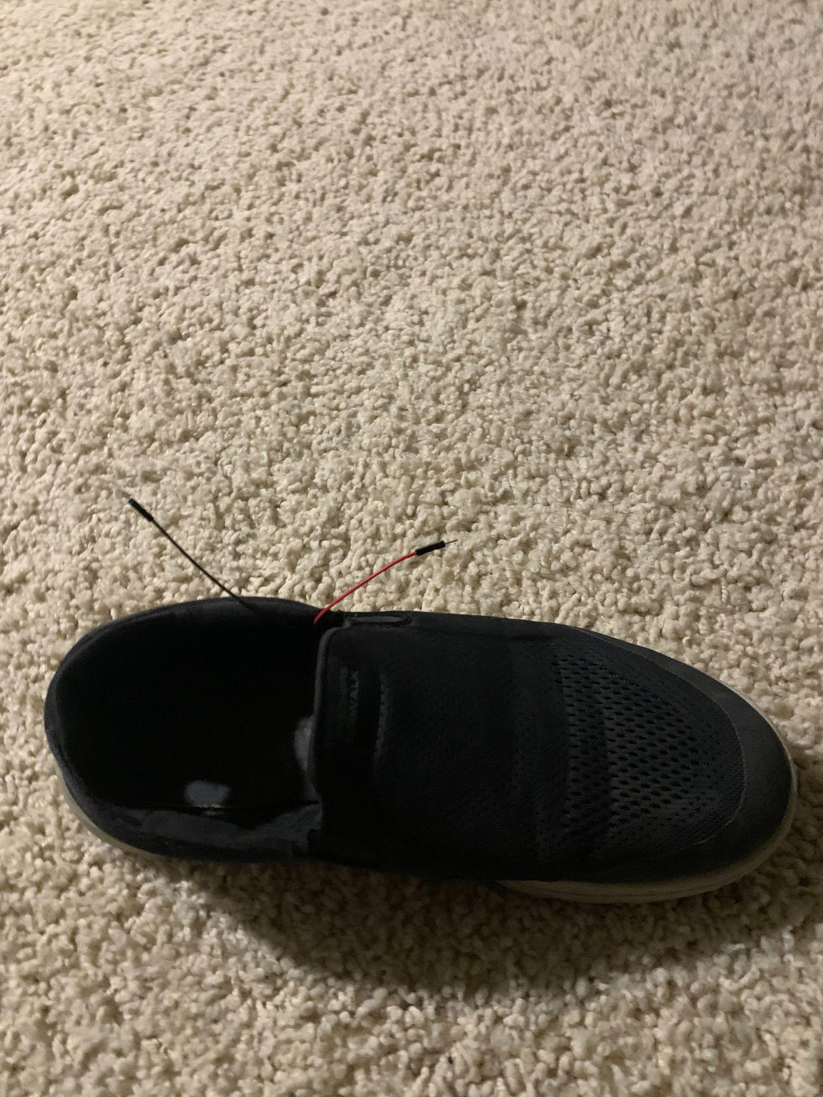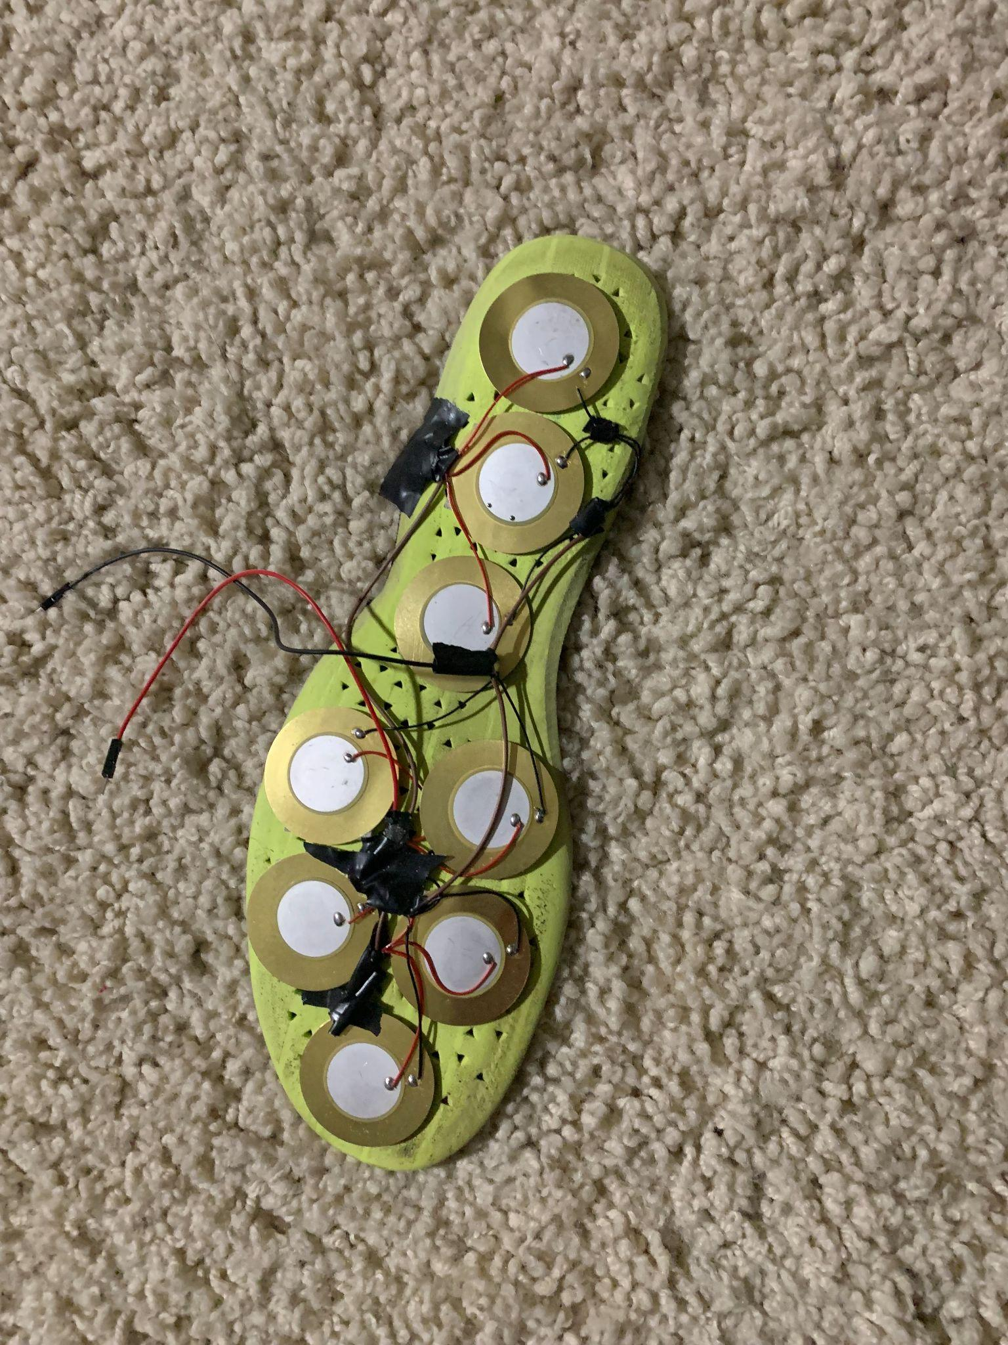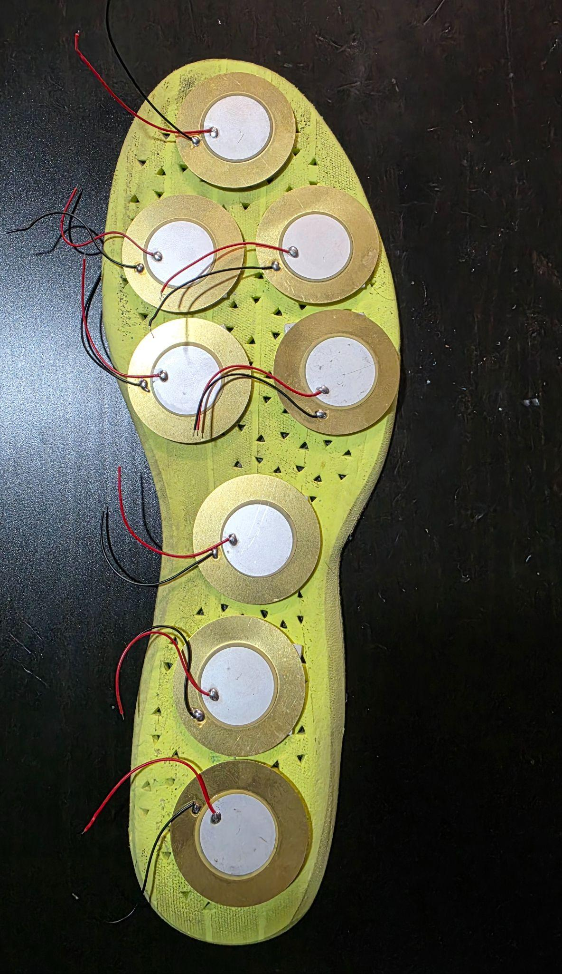.

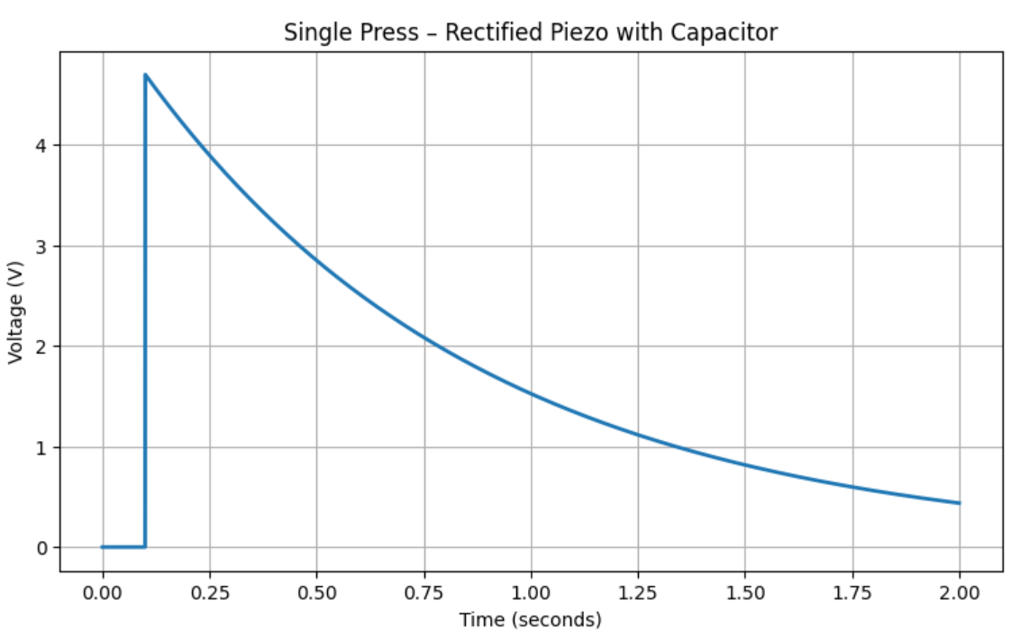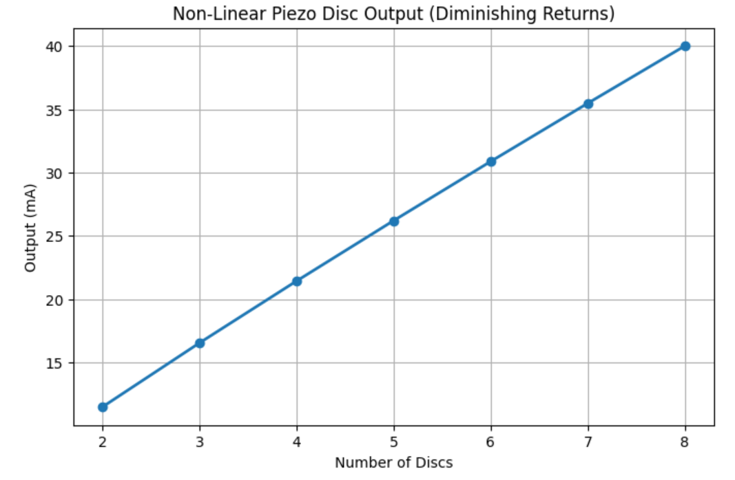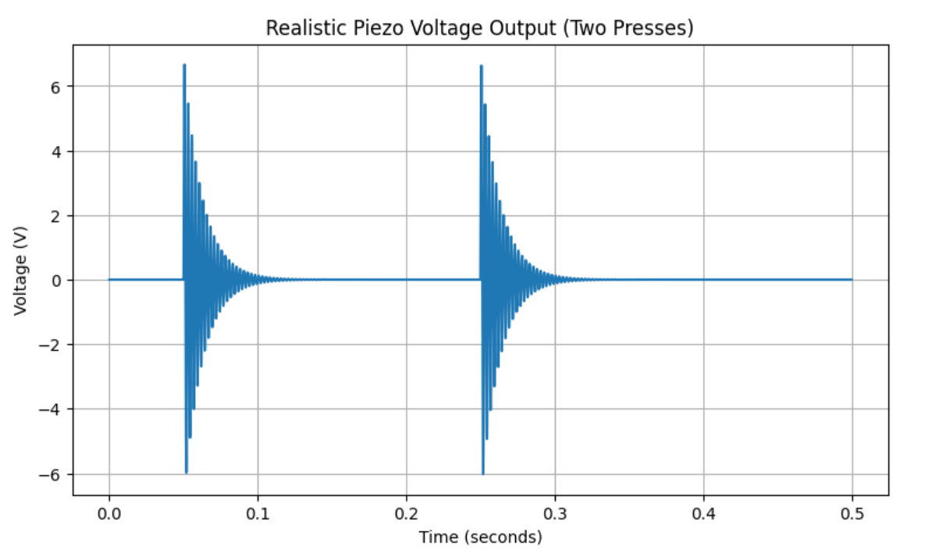

Prototype designs ideas I had made previously

