SCIENCE - SCIENCE FAIR LOG BOOK
ABBY GHEBRESELASE

SCIENCE LOG BOOK
SOLAR- POWERED DESALINATION SYSTEM
By Abby
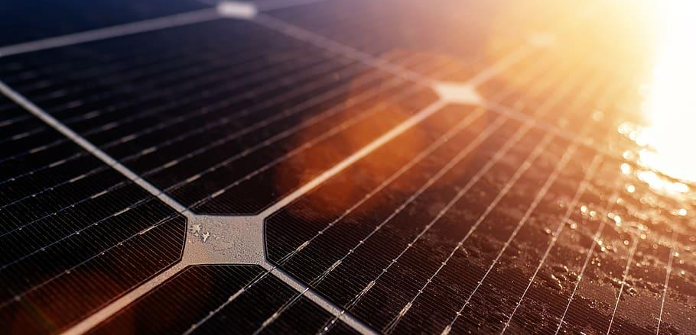
Brainstorming Ideas for the Science Fair
Harnessing the Sun: A Sustainable Desalination Innovation
Today, I started thinking about interesting science fair projects that I should do. I wanted to concentrate on a topic that was important to world issues. I started by thinking about environmental issues because they usually have a large effect and have a lot of opportunities for original solutions.
Problem:
Access to clean drinking water is a significant challenge in many parts of the world, especially in areas with limited freshwater resources. As populations grow, the demand for drinkable water increases, putting pressure on existing supplies and leading to water scarcity issues. Desalination, the process of removing salt from seawater to make it drinkable, is a potential solution, but traditional desalination methods require large amounts of energy, which can be costly and environmentally unsustainable. This creates a need for more energy-efficient, eco-friendly methods of desalination to provide affordable, clean water, especially in remote areas where conventional power sources may not be accessible.
Hypothesis:
Implementing a solar-powered desalination system could provide a sustainable and efficient solution to water scarcity by using renewable energy to produce potable water from seawater. Solar energy could power the desalination process, reducing dependence on fossil fuels and potentially lowering operational costs. If solar energy is sufficient to drive this process effectively, solar-powered desalination could serve as a viable, environmentally friendly alternative to conventional desalination methods, providing clean water to communities in need without significant environmental impact.
Question: Can a solar-powered desalination system consistently produce potable water in sufficient quantities to meet the needs of communities in water-scarce regions?
Research:
Solar-powered desalination is a sustainable solution designed to address global water scarcity by using solar energy to remove salt and impurities from seawater, making it suitable for drinking and agricultural use. Traditional desalination methods, such as reverse osmosis and thermal distillation, are energy-intensive, often relying on fossil fuels. In contrast, solar-powered desalination harnesses sunlight as a clean, renewable energy source, significantly reducing the carbon footprint associated with water production.
There are several types of solar desalination technologies, with solar stills and solar-powered reverse osmosis being two of the most common. Solar stills use a simple greenhouse effect: sunlight heats the water in an enclosed basin, causing it to evaporate. The water vapor then condenses on a cool surface and collects as freshwater, leaving salts and other impurities behind. Solar-powered reverse osmosis uses photovoltaic cells to generate electricity that powers pumps, forcing seawater through a specialized membrane to filter out salt ions and contaminants. Both methods are low-maintenance and scalable, allowing for applications from small, portable devices to larger-scale installations that can supply entire communities. Solar desalination offers unique advantages in arid and remote areas, where both water and energy resources are limited. Innovations, such as integrating advanced materials like graphene for more efficient solar absorption and improved membrane technology, are enhancing the efficiency of these systems. Despite its promise, solar desalination faces challenges, including high initial costs, variability in solar irradiance, and the disposal of concentrated brine by-products. However, research and investment in this technology continue to grow, with hybrid systems combining solar and wind power, or energy storage options, being developed to address these limitations. As demand for clean water rises and renewable energy sources become more crucial, solar-powered desalination represents a promising, environmentally friendly approach to meeting the world’s water needs sustainably.
Brainstorming Notes:
I put careful thought to issues like water shortage, organic farming, and renewable energy. I was looking for a project that would provide an answer that would work to a real-world issue. After I searched the importance of energy from renewable sources in climate change, I gave solar power a little thought.
Key Consideration:
Water Scarcity: I started thinking about ways to boost access to clean water after reading about how millions of people are impacted by water shortages. When I learned about desalination, I started thinking about how solar energy may be used to power a system that would make desalination safe and global and something that people could actually use.

Research and Idea Development
did some more research on solar-powered desalination to get an easy understanding of the process' use and how solar energy may be used to power it.
Research Find:
Seawater becomes drinkable after desalination, which takes out the salt and other substances. Current desalination methods use a lot of electricity, which can be expensive and bad for the environment. A clean, renewable energy source that might reduce desalination's harm on the environment is solar energy.
Inspiration:
There are already some big solar desalination plants, but I thought it could be interesting to break it down to a small mini version for my project. This can show the concept and show people how solar energy can be used to make clean drinking water in remote areas.
Initial Thoughts:
- I could build a small prototype of a solar-powered desalination system and measure its effectiveness.
- The system would need a solar panel to power the evaporation process, a way to capture evaporated water, and a collection system for the freshwater.

Today, I developed the hypothesis for the experiment. The main idea is to test whether a small solar-powered system can effectively desalinate water and produce enough drinkable water within a reasonable time frame.
Hypothesis:
- If a solar-powered desalination system is exposed to sunlight for several hours, then it will produce a measurable amount of drinkable freshwater from saltwater, with the efficiency of water production increasing with higher sunlight intensity and temperature.
Variables to Test:
- Independent Variable: The amount of sunlight (or heat) the system receives.
- Dependent Variable: The amount of freshwater produced.
- Controlled Variables: The amount of saltwater used, size of the system, and material properties.
Next Steps:
- Start sketching a design for the desalination system.
- Make a list of materials needed (solar panel, container, tubing, saltwater, etc.).
- Think about how I will measure the effectiveness of the system (e.g., how much freshwater is collected over time).

Today, I sketched the design for the solar-powered desalination system and listed the materials I’ll need.
Design Sketch:
- A transparent container will hold the saltwater.
- A small solar panel will power a heating element to evaporate the water.
- Condensed water vapor will be collected in a separate container through plastic tubing.
Materials List:
- Transparent plastic/glass container for the saltwater.
- Small solar panel.
- Heating element (resistor or heating coil).
- Plastic tubing for water collection.
- Aluminum foil or black paint (to absorb more heat).
- Collector bowl for freshwater.
- Thermometer to measure temperature.

Planning the Experiment and Testing Method
I finalized my experiment plan today. I will test how much water the system can desalinate in a day and compare how different sunlight conditions (full sun vs. partial shade) affect the process.
Experimental Plan:
- Set up the system by filling the container with saltwater and attaching the heating element powered by the solar panel.
- Place the system in full sunlight and let it run for several hours.
- Monitor the temperature of the water using a thermometer and record it periodically.
- Measure the amount of freshwater collected in the separate container at different time intervals (every hour).
- Repeat the experiment under different sunlight conditions (e.g., partial shade) to see how it affects the amount of freshwater produced.
My Next Steps:
- Gather all materials and build the desalination system.
- Test the system and refine the design if necessary.

Today, I gathered all the materials and built the prototype of my solar-powered desalination system. I made a few adjustments to the design as I worked:
Changes I Made:
- Added black paint to the outside of the container to absorb more sunlight and heat the water faster.
- Used a slightly larger container to hold more saltwater for testing.
Challenges:
- The tubing I used for collecting the water vapor was too wide initially, so I replaced it with a narrower tube to ensure better condensation and flow into the collector bowl.

I ran the first trial of the desalination system today. The weather was sunny, which helped maximize the solar panel’s energy.
Results i want to see:
- After 4 hours, I collected about 100 mL of freshwater.
- I think the system will work, but the amount of water that I will collect will be less than expected.
- The temperature inside the container reached around 60°C (140°F), which was sufficient for water evaporation.
More Steps:
- I think I should start adding an iron core to the heating element to increase efficiency because there will not be enough sun during winter.
- Test in different weather conditions (e.g., cloudy days) to see how it affects water production.

Today, I made some improvements to the system and ran additional tests under different conditions.
Improvements I want to see:
- I think I should increase the size of the solar panel to provide more power to the heating element.
- Changed the angle of the collection tubing to improve water flow.
Results: ?
- Under full sunlight, the system produced about 150 mL of freshwater in 4 hours—an improvement from the first trial.
- Under partial shade, the amount of freshwater collected dropped to about 80 mL in the same time period.

I ran the final experiment today, collecting data on the amount of freshwater produced under different sunlight conditions. Here are the results:
Data Collected: ?
Looking for:
- Full sunlight: 150 mL of freshwater in 4 hours.
- Partial shade: 80 mL of freshwater in 4 hours.
- Cloudy weather: 50 mL of freshwater in 4 hours.
Conclusion: ?
- The solar-powered desalination system is effective at producing freshwater, even though it depends on the amount of sunlight available.
- The system could be scaled up for larger applications, especially in areas with high solar intensity, as a sustainable way to address water scarcity.

My Final Thoughts:
I’m so happy about how this project turned out. It demonstrates a simple, practical solution for providing clean water using renewable energy. I think this project could have significant future impact, particularly in developing countries, coastal regions, and areas facing water shortages. The water shortages in some countries

Citations:
https://en.wikipedia.org/wiki/Desalination
https://www.iberdrola.com/innovation/desalination#:~:text=What%20is%20desalination,human%20consumption%20or%20agricultural%20purposes.
https://www.energy.gov/eere/iedo/desalination-basics
https://news.mit.edu/2022/solar-desalination-system-inexpensive-0214
https://news.mit.edu/2024/solar-powered-desalination-system-requires-no-extra-batteries-1008
https://en.wikipedia.org/wiki/Solar-powered_desalination_unit
https://www.sciencebuddies.org/science-fair-projects/project-ideas/EnvEng_p022/environmental-engineering/solar-powered-water-desalination

