
Logbook: Widespread Epigenetically Budded Lymphoid- Iterative Neo Lineage Endosystem “WEBLINE” For Pan Cancer Remediation and Sustained Remission

Project Type: Innovative
Grade: 10
Primary Project Directive: Synthesize and prove the functionality of a computationally modeled and simulated Widespred Epigenetically Budded Lymphoid-Iterative Neo Lineage Endosystem for Pan Cancer Remediation. Through Computational evidence and artificial synthesis.

By: Davyn Singh Athwal

May 25th 2025 | - I have begun to think about what problem I should address for Science Fair. After last year’s fair I wish to complete and attack a more intricate and complex problem that upon solving will lead to a great deal of impact on both science and the wellbeing of humanity. Thus I have decided to conduct a project pertaining to a medical issue. As inherently, modern medicine is flawed, if it were not flawed then we would not lose millions of lives per year. As such I firmly believe that if my project could address or curate a minor improvement within the medical system, than it is a morally fulfilling and proper project.  - However what would be a good idea? To maximize impact on the scientific community I should first initiate a literature dive, become extremely acquainted with the medical world’s most hindering problems and the information surrounding them prior to deciding what the primary directive of my project should be.
July 14th 2025  July 16th 2025 | - After initiating an extensively profuse and intensive literature dive into modern medicine’s most hampering issues. I have determined that the most dangerous problems that modern medicine faces are as such  - Logistics Regarding Treatment Administration And Disease Eradication  - Treatment failure/Hostile effect  - Systemic Toxicity Of Medical Interventions  - Fiscal Burdens Limiting Assorted Treatment Application  - Unperfected Treatment Utilized In Tandem leading to Horrendous Side Effects And Disease Exacerbation  - The common denominator within all of these aforementioned issues pertains to the medical industry’s ability, or rather inability, to properly address diseases and disorders that patients arrive with [1,4]. After this, I utilized my common medical knowledge and various sources [5,8,19,20,21] to deduce which disease/disorder is affected to the largest capacity by these 5 primarily issues.  - The result of which I concluded was Malignant Neoplasia (Cancer). A result derived bilaterally from literature and observations upon acquainting myself with this literature.  - Upon establishing which disease suffers the most from these problems, I firstly and foremostly applied each issue to Malignancy as a whole, what is first necessary to note is that cancer is an umbrella term for over 200 conditions [1] rather than just an innate disease with countless variations. Leading to a multitude of systematic complications within the medical world in regards to treatment application and patient life expectancy.  - Firstly, the median average for Malignancy Survivors whom experience a shortening in life expectancy as a result of damage caused by therapeutics is 70% of all survivors, this is a median average amongst all Malignant Neoplasm Survivors, however the severity and percentage fluctuates as we dive into the technical aspects of what a Malignancy truly is  - The percentage of Malignancy Survivors who experience a life expectance shortening of 1-5 years is 21% [6]  - The percentage of Malignancy Survivors who experience a life expectance shortening of 5-10 years is 26.5% (Rounded to 27%) of all survivors  - The percentage of Malignancy Survivors who experience a life expectance shortening of 10-20 years is 30%  - The percentage of Malignancy Survivors who experience a life expectancy shortening of 20+ years is 11%. Although notably much of the patients within this category of analysis often exhibit lack of organ reserve (LOOR) due to surgery removing a vital organ to prevent death (Eg: Surgeon removes right lung due to metastatic bronchogenic carcinoma threatening to fatally metastasize or severely hamper patient organ function to the point of death. Thus the patient initially beats the malignancy in question but cannot survive past a long period of time due to the systemic damage done by treatment and malignancy alike.)  - So, where Healthy Life expectancy = HALE, the data is presented within a logic table  - The personal scientific and mathematical premise/philosophy that I utilized to calculate these percentage metrics are as such  - I firstly viewed an exact count of 45,981 de-identified case files through various MIMIC software in accordance to non invasively view and understand in vivo cancer prognosis and diagnosis. As well as disease progression. Along with these closely review files I also reviewed published documentation of findings that have been uncovered by large scale national databases with access to the resources and information that I do not have access to. This way I formulate a global and widespread analysis of Cancer as a whole.  From this literature dive, and the ensuing data points we can draw a conclusion, not only do certain types of Carcinomas have incredibly high mortality rates, already common knowledge so I did not include it. But they also initiate such significant damage to patient tissue that even after complete remission, damage persists, leading to large potential for complications, reduced anatomical capability, and overall Healthy Life Expectancy Reductions in many survivors. However notable this is, what is the reasoning? I assume that carcinomic damage and treatment side effects are the most obvious and primary choices
  HALE Reduction By 1-5 Years | 21% of all Malignancy Survivors
  HALE Reduction By 5-10 Years | 27% of all Malignancy Survivors
  HALE Reduction By 10-20 Years | 30% of all Malignancy Survivors
  HALE Reduction By 20+ Years | 11% of all Malignancy Survivors
  Total Percentage of HALE Reduction among Malignancy Survivors | 89% of all  11% remain with intact HALE.
July 21st 2025 | - I have begun analysis of factors that could lead to a reduction in health expectancy within carcinoma survivors. Although my goal is not to pinpoint and address health expectancy reductions as whole. Rather my goal is to pinpoint the cause, and formulate a hypothesis and general idea of both what leads to life expectancy reductions and patient damage. While also analyzing carcinomic impact and potentially addressing Malignant Neoplasm issues through a method that currently I am still formulating.  - I am however very well aware that this is but preliminary work for my overarching project, I am just proceeding with logical analysis and literature influenced data summary based upon my initial concept of analyzing data to determine a methodology in which I could make the most impact on assisting modern medicine by addressing a key problem. Currently here are my biggest conceptual premises:  - Novel Therapeutic (Potentially for Carcinoma treatment)  - Targeting Healthy Life Expectancy Reductions through analysis of causes, prefacing actual targeted treatment of causes in question  - Modification of existing therapeutic to exponentially amplify treatment success while implementing safeguards to ensure
July 23rd 2025 | - After much contemplating, I have fully decided what I wish my project to address and which core idea I wish to utilize as the foundational premise:  - I have decided on the idea of formulating a novel therapeutic that could outperform the current clinical standard while eliminating current therapeutic issues such as the exponential adverse effects triggered by therapeutic intervention as well as the inability of current clinical treatments to produce sufficiently adequate ORR’s. However I notably included yet another massive potential idea alongside my goal of cost efficiency, efficiency of therapeutic intervention, efficient outcome, and total safety. Because I feel this would shake up the medical world yk?  - Pan Cancer Remediation  - A buzzword and what was previously thought a pipe dream, a therapeutic that is not only cost efficient, eliminating applicability difficulties, medically efficient capable of treating cancer and saving lives at a higher capacity, and one that harbors little to no potential for adverse effects. But one that could be universally applied to elicit the same remediation and remission effect across all types of Malignancies would save countless lives, dollars, and be a medical jump for modern medicine as whole.  - Now it’s just a matter of doing it…
July 25th 2025 | - While the scientific goals I have previously mentioned are incredibly ambitious and beyond a shadow of a doubt going to abruptly disrupt the medical world acting as an incredible breakthrough, what is more important is proving the metrics and finding a methodology to formulate a novel therapeutic, as well as subsequently proving this therapeutic’s capability underneath the pan cancer umbrella. As such it is critical to first establish a methodology for this goal.  - As of this moment I have a few ideas, as after my incredibly deep literature dive with regards to learning everything that there is to learn about Malignancy and the associated treatments, I have concluded, that Immunotherapies such as CAR T cell therapy or TIL (Tumor Infiltrating Lymphocyte) therapy currently represent our strongest strides against Malignancy as a whole. With the following data being apparent:  - I have gathered this data based upon extrapolation and measuring of overall ORR among multiple de personalized real world cases by examining the treatment procedure and doctrine.  - So what can we infer from this data? Firstly, Immunotherapies have a much larger and more vast therapeutic efficacy against non solidified tumors than that of most other currently available treatments. Despite the premise that most other currently clinically accepted practices can reach very high ORR’s, I found that the general mathematically average was actually much lower, with the exact metric average between the exact 45,981 cases being exactly 58.984% overall average ORR rate. Although we must certainly factor in how advanced each case was while additionally measuring for the relative genomic and health wide differences between patients, this average ORR represents the median average between these cases for overall clinically accepted treatments, with very few cases actually reaching the 95% or above level of ORR efficacy as described within the chart. However the average ORR for cases involving the therapeutic application of the aforementioned immunotherapies is actually much higher, with the average being exactly 84.56%, meaning much of the cases involving these therapies where the malignancy is non solidified results in an ORR at the higher end of the spectrum with regards to the typical range. However this data additionally sheds light on the primary caveat of the vast majority of immunotherapies. The inability to properly address the concern of solidified and frequently at this stage, metastasized malignant neoplasia. With extraordinarily low ORR’s characterizing the applicability of immunotherapy to solidified cases. To the point that the median ORR previously identified only pertains to the application to non solidified, as due to the low ORR’s with relation to solidified cases. Medical practitioners will often not entertain the premise of applying an immunotherapy with regards to a patient who is suffering from a solidified malignant neoplasia.  - What is additionally noteworthy is one previously mentioned metric.  - Risk and cost.  - As previously mentioned, my main directive is to create a therapy that is universally applicable, while being risk free with complete cost efficacy that allow for the broad scope treatment application that I wish for my therapeutic. Much of these ORR’s that are previously described may look good on paper, however the truth is that these ORR’s are only with the substantial risks that are associated within these therapeutics. With many immunotherapies incumbering risks of autoimmune disorders, complete therapeutic nullification by the innate immune system or systemic damage caused by an undesired reaction from the therapeutic in question. For reference, immunotherapies are considered the lowest risk of all currently accepted malignancy treatments, with systemic toxicity, patient tissue damage, graft to host disease, and autoimmune disorders being just the starting point of health risks for current treatment application. Additionally, most of these practices cost a relative fortune per clinical instance with patients. As we can see in the below table I have constructed utilizing information from my literature dive:  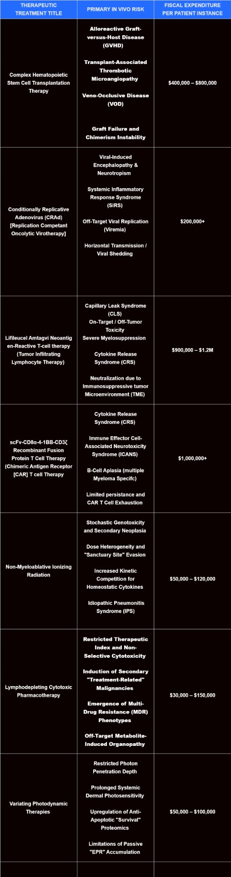  - Here we can see just a brief glimpse into the failings of current medical practices with regards to overall malignancy treatment. With in many of the cases I went over, treatment side effects and associated medical disorders causing more damage to the patient than the actual malignancy they were afflicted with in of itself.  - However, among these treatments as previously mentioned, immunotherapies have proven to be the most efficient and already proven methods. With their ability to address current non solidified tumors being astounding. Current immunotherapies are currently, the correct idea with the incorrect execution. Now I believe from a scientific standpoint that this can be fixed and repaired. Currently, the flaws I would need to address are the following  - Cost  - Unwanted Side effects  - Inability to treat solidified tumors  - Inability to properly address the prospect of Pan Cancer Remediation  - Inability carry out sustained remission over an extended period of time  - Inability to protect patient from malignancy long after initial malignancy has been treated, thus extending HALE statistic.  - Now that we have fully defined the goals for the therapeutic, I believe it is time to begin formulation and testing of the prototype  - I believe I will start with the construction of the prototype come start of the school year, I wish to rest the rest of my summer break so beginning the construction of my therapeutic in tandem with the beginning of the school year should be paramount to success.
  Treatment | ORR For non Solidified | ORR For Solidified
  CAR T Cell Therapy | 80-93.45% | 4-15%
  Tumor Infiltrating Lymphocyte Therapy | 84-90% | 25-35%
  All Other Broad Scope Treatments | 75-95% | 50-80%
September 22nd 2025 | - While Grade 10 has taken a few weeks longer than I anticipated to become accustomed to. I believe this is as good a time as any to resume formulation and appropriate testing of my project.  - With this additional time to consider what I actually wish my novel immunotherapy to actually look like. I have decided to conduct further research into the course of most malignancy cases. Establishing a timeline and looking for point of interest.

September 30th 2025 | - After careful research done on the course of malignancies I have thought of a novel premise that I do not believe many immunotherapies have addressed as per my research.  - What was of interest to me was firstly, how the body reacts to malignancy, the body is not inherently disarmed or vulnerable to malignancy. The immune system has specialized killer T cells which function for the very purpose of killing once healthy cells through initiating their cellular apoptosis cellular pathway. This is the foundational premise for almost all immunotherapies, enhance the immune system’s current armaments or introduce something new in order to allow a better ability to attack and fight off malignancy.  - However, what has been intriguing to me is how although Malignancy eradication is a sub objective of the immune system, Viral and Bacterial Pathogenic eradication is the immune system’s primary objective, one that it is extremely good at.  - So that gave me an idea, what if the immune system could combat malignancies just as easily as it could combat pathogens? The differentiation between what a cell can and cannot interact with, and what it’s functions can be are all anchored within the genetic code, and although this is a premise that is not unknown to the medical world, the stipulation that an entire immune architecture or endo system could be genetically modified to combat cancer is novel. Which is my current proposal.  - I have decided that for my immunotherapeutic, I will be curating an endo system so to speak, or at least a small network of genetically modified immune cells that can interact with one another in a coordinated and efficient manner to eradicate a malignancy, similar to how the body mounts a coordinated response against pathogens to initiate extermination, my endo system would exercise the same procedures as the immune system innately carries out when a viral or bacterial pathogen is detected. Here it is just a matter of orchestrating a complex solution to a complex problem. With each genetically modified cell in question fulfilling a specific niche within the endo system.  - Now that we have a conceptual idea of what we are trying to achieve here. Now we must begin, firstly we have to address how we will make this system adaptable, as the first and foremost goal is pan cancer application. For this I have a few theories.
October 2nd 2025 | - After consideration, I have come to the conclusion that first we must formulate the different steps of the therapeutic instead of jumping straight into the problem, because of this, I have decided that it is a good idea to begin the actual genetic coding of each cell that is a part of the endo system. Here is where the novelty of my idea takes place, the only immunotherapy that focuses on genetically modifying cells currently is Chimeric Antigen Receptor T Cell Therapy. Which modifies T cells with “CARs” that can then bind to cancer cells and trigger cellular apoptosis. However the scale at which I am genetically modifying the cells that will take part in my therapeutic is unprecedented, as no current therapeutic to my knowledge employs the use of several genetically modified cells operating in tandem with one another.  - Firstly we need to address how we are going to genetically modify these cells, after careful consideration I have formulated a generalized idea of which cells I wish to be components of my endo system  - Macrophage Variant: Basic immune guard cell that functions extremely well at innate and immediate responses, modifying this cell to kill cancer via genetic modifying in accordance with receptor change could lead to an efficient cancer killer.  - Neutrophil Variant: Yet another basic immune guard cell, although unlike Macrophages that are programmed for long term protection and arguably have a much larger longevity span than others, Neutrophils are genetically programmed to kill as many microorganisms as possible. With my proposal that these cells can be modified to kill cancer via their receptors, Neutrophils could prove to be an extensively promising candidate, as Neutrophils are capable of binding to multiple different location on the cellular membrane at once. Which could potentially lead to an accelerated rate of assisted cellular apoptosis within malignant cells.  - Helper T Cell Variation 1: Helper T cells function as commanders for the immune system, assisting in coordination and allowing a larger systematic process to occur, as regular immune cells typically are incapable of this level of broad scale function. As a result, to regulate therapeutic course and aid in the overall efforts of the therapy, because it is an immune architecture, a Helper T Cell variation would be crucial.  - Helper T Cell Variation 2: A secondary variation would be necessary as well, as it has occurred to me that although the primary goals have already been illustrated, in a patient with a late stage carcinoma, merely eradicating the malignancy is not effective enough. As with this level of a malignancy, systemic organ and tissue damage leading to maligned or even disabled organ function is a probable concern, so as such having a secondary Helper T Cell Variation that functions to break down the still present Tumor Microenvironment and repair damage done is paramount.  - Undetermined Barrier Cell Variation: While I have not fully pictured what this cell could be a variation of, it’s necessity is ever apparent. Even while treatment is applied, particularly immunotherapies, malignancies are still capable of metastasizing, thus possessing a cellular organism that could in some way deny malignancy the chance to escape through perhaps creating a cellular structure to prevent metastasis could be paramount, although it is a particularly prevalent factor that his must happen safely, as a cellular barrier could have the same effects as a blood clot or cause accidental hypoxia within the originating tissue.  - Plasma Cell Variation: Plasma cells and B cells produce antibodies, which are the body’s greatest weapon against viral and pathogenic incursion. However, with the proper modifications Antibodies could be applied to combating Malignancy, through genetic modification within the Plasma cell, Antibodies could be genetically programmed to bind to Malignant cells and subsequently cause cellular apoptosis, acting as a sole receptor similar to that of which CAR T Cells employ. However notably we would have to undoubtedly utilize plasma cells as opposed to B cells, as B cells require time to divide and bring forth a large swathe of logistical issues, whereas Plasma cells come already primed for Antibody production. As such our genetic variant would be constructed for a Plasmic cell, not a traditional B cell.  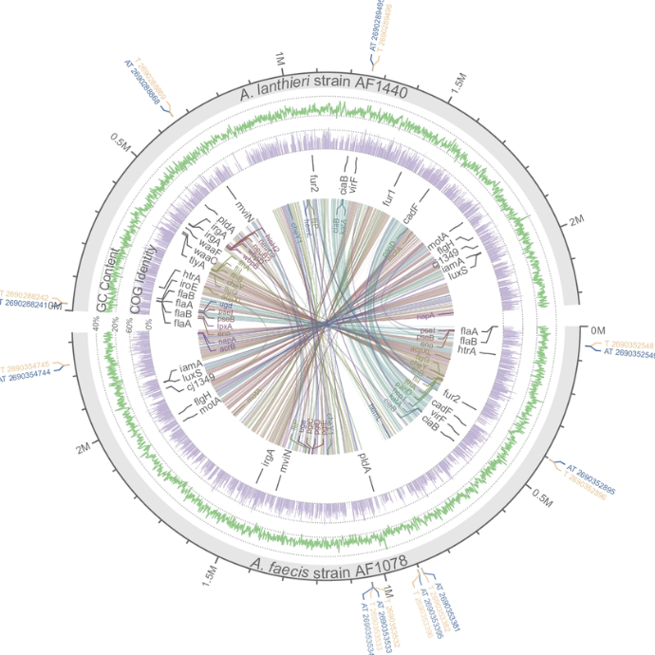  - Typically, these cells are a part of the immune system’s pathogenic response system, rarely combating malignancy, although with the proper genetic re tasking and repurposing, these cells could be modified to utilize their innate functions to instead target malignancy.  - However there are a large amount of issues we must first address, firstly most immunotherapies. Particularly CAR T cell therapy, face the steep probability of bringing forth autoimmune disorders or causing systemic damage due to a lack of a kill switch or fail safe. Additionally, any time one supplies the body with new cells that previously weren’t present, there is the question of metabolic strain. Patients who are faced with malignancy typically are already under intense metabolic strain due to the malignancy outcompeting and stealing resources from healthy cells, so a successful immunotherapeutic would have to mitigate the metabolic risk while simultaneously possessing the capability to eradicate the malignancy in question.  - Furthermore, we must also address the potential for hostile immune rejection, frequently Stem cell and immunotherapies are rejected by the patient’s immune system as the guard cells recognize the newly introduced cells as hostile and subsequently destroy the newly introduced cells leading to therapeutic rejection and treatment nullification.  - However, despite these newly discovered issues to tackle, I’ve decided that this is the course I will pursue for my Science Fair Project for 2026. I firmly believe however that I should, as a preliminary step, address the cons and drawbacks to conventional immunotherapeutic interventions firstly, before then extending into therapeutic formulation and In Silico Testing. Here it is critical to note that due to current limitations of means, I will only be capable of, at least within he project’s current state, performing In Silico Testing and modeling to formulate this immune architecture as currently it is presently unfeasible to utilize in vitro methods, doing so would require a large amount of ethical assurance coupled with copious amounts of paperwork which would hinder the overall progression of my therapeutic. Although I believe that this concludes the developmental and idealistic stage of my science fair project and I strongly believe that all of my entries from this point onwards shall be innovative and with utmost focus placed towards moving the project forward.
October 15th 2025 | - With Idealistic and developmental progress completed, I believe that it is suitable time to begin Therapeutic development. Firstly, as previously stated we must address the caveats and drawbacks as previously mentioned. I have recently formulated certain measures to counteract these caveats and circumvent them entirely allowing for the unabated development of the therapeutic in question.  - Development I: Addressing Metabolic Constraints within an immunotherapeutic intervention  - In order to address metabolic constraints I have devised a countermeasure, I theorize that through the usage of an Activation Genetic Circuit [AGC] I can allow WEBLINE cells to trigger cellular dormancy [quiescence] upon full eradication. Here is my systematic proposal:  - Through the utilization of a synNotch/AL-2/LuxS Enzyme genetic receptor pathway, we can trigger artificial cellular quiescence, and through the utilization of a BL-9 genetic behavioral circuit, we can therefore biologically code each WEBLINE cell to enter cellular dormancy wherein it consumes up to 95.934% less metabolic resources than it would while conscious, this both allows metabolic restoration within the body post therapeutic and the addition of a BBE-1 expression circuit allows the cell to cease quiescence in the even that malignancy returns. However notably, To support this genetic pathway, there must be one WEBLINE cell that enters quiescence, while another moderates therapeutic efficacy and triggers quiescence, as we additionally require another cell to monitor malignancy levels and furthermore allow coordination with cellular division, as I have deliberately included a p21 circuit which halts cellular division preventing accidental malignancy from WEBLINE cells, through IL-2 signaling from this moderator cell we can therefore allow a circuit of cellular quiescence and controlled (if necessary) Cell division. Which can be represented by the following Logic Gates:  - Through this cellular gateway, further displayed through plasmid mappings in Benchling:  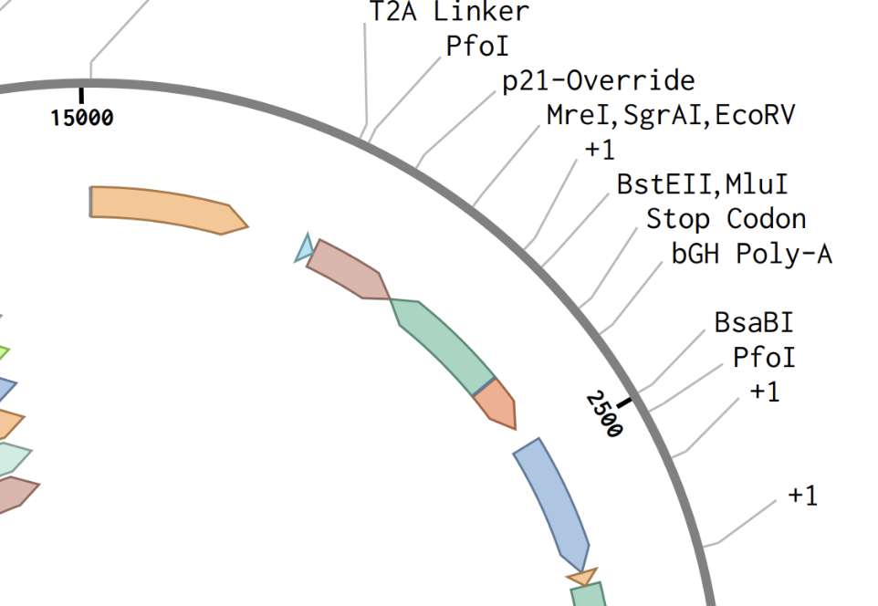  Fig 3: Genetic Circuit Pertaining To Cellular Quiescence  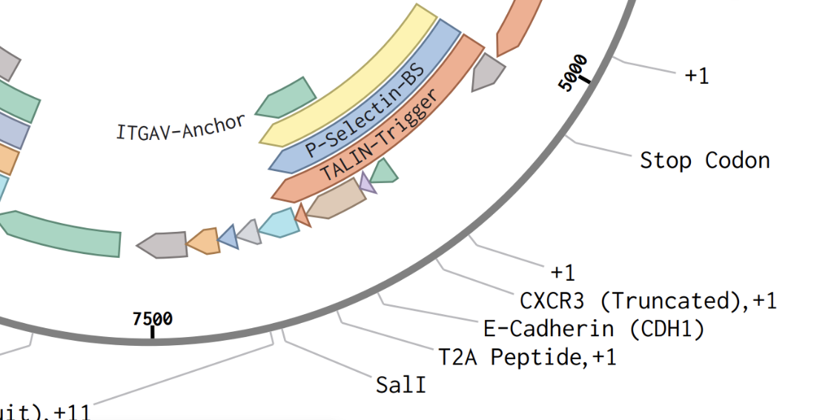  Fig 4: Enhanced Genetic Sequence Circuit Managing Cellular Division Coupled With Epithelial Modification E-Cadherin Circuit For Controlled Arterial Semi Permeability  - With this secondary image is yet another development  - Development II: Usage of Epithelial Cell as barrier cell in accordance to purposeful semi permeability  - Epithelial cells form the inner arterial lining and tissue of the body, because they are organically found within the body, this makes them the perfect candidate for the previously aforementioned barrier cell, this barrier cell functions as a cellular containment unit, as through the various genetic circuits I have assembled (E-Cadherin Circuit+-/ASHEAR Circuit4-98B+), the barrier cell assembles a semi permeable barrier throughout the arteries, it does this via binding to it’s other counterparts within an artery, with a small gap between cells which permits blood, O2, and critical minerals to pass through, this way preventing and circumventing accidental hypoxia, whereas metastasizing malignancy cells are not permitted through, which prevents the malignancy from at the very least spreading.  - With these new breakthroughs completed, I will figure out precisely how I plan on integrating certain genes into these WEBLINE cells, as a delivery mechanism is necessary before continuing to engineer the genetic payload.
  IF NO MALIGNANCY PRESENT > CEASE ATTACK FUNCTION > THEN RELEASE AL-2
  IF IL-2 PRESENT, p21 BREAKDOWN > INTITIATE CELLULAR DIVISION > IF IL-2 NO LONGER PRESENT, ENTER CELLULAR QUISCENCE
  IF BBE-1 RECEPTOR BINDS > CEASE CELLULAR QUISCENCE > THEN BEGIN FOLLOWING CXCL10 TRAIL
November 12th 2025 | - After carefully thought out research and testing trials, I have formulated the genetic sequence for each WEBLINE cell, as detailed throughout the now formally constructed therapeutic course layout and components that are currently on my trifold for the school fair.  - Notably I have also fully completed the necessary parameters for molecular docking through the Swissdock program. My therapeutic necessitates the utilization of specialized protein injection to trigger malignancy death. This is known as TNMA-1 protein, which acts as a natural catalyst, injecting an extremely large amount of TNF-a which inherently trigger the cellular apoptosis pathway of malignant cells, this is through sheer outcompeting of IAP (inhibitor of apoptosis proteins) which allows for cellular apoptosis. The total function detailed below:  - TNMA-1 (Tumor Necrosis Monoclonal Antibody) TNMA-1 is a Monoclonal Antibody produced by B cell Apoptotic-N. The Antibody binds to cancer cells using varied receptors, and from here releases TNP-5 (Tumour Necrosis Protein-5) which is a genetically altered version of TNF-a. With the typical cons of tumour proliferation genetically edited out, while the protein itself is repurposed by the Golgi apparatus of the B cell to be repackaged and sent out to other cells. Upon TNMA-5 bonding to a cancer cell, TNP-5 is released and acts as an upgraded replacement to TNF-a, which is usually suppressed within Cancer cells to prevent Apoptosis (programmed cellular suicide.). This protein signals the need for cell death and overrides typical IAP (inhibitors to Apoptosis Proteins) through sheer quantity upon release, from here the cancer cell is forced to undergo programmed cell death by the typical cellular death that is organically regulated ordinarily by TNF-a. This monoclonal antibody appears as a regular antibody, although the tail of the antibody is bonded to a TNP-5 protein, which it released into the cell after the antibody temporarily opens the semi permeable membrane of the cell to allow the protein to enter. (make the structure of the protein and antibody along with the structures and internal components of the actual WEBLINE cells.)  - (Secreted by B cell Apoptotic -N Variation)  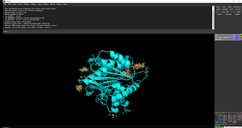  Monoclonal antibody structure ^  - p-53 Restoral and Regenerative Monoclonal Antibody (P53-PRRMA) (Through the same delivery mechanism, P53-PRRMA binds to the cancer cell and releases freshly made p-53 protein to circumvent the suppressed protein within the cell, preventing cell division and halting cellular activities until DNA repair is initiated (repairing mutations causing cancer), if the cell is incapable of restoring the DNA damage, p53 triggers apoptosis through activation and secretion of naturally occurring TNF-a (even when suppressed, p53 takes a governing approach, effectively releasing and activating TNF-a regardless of cell suppression) rendering a cancer cell incapable of contributing to the overall tumor and allowing it to even potentially be rendered  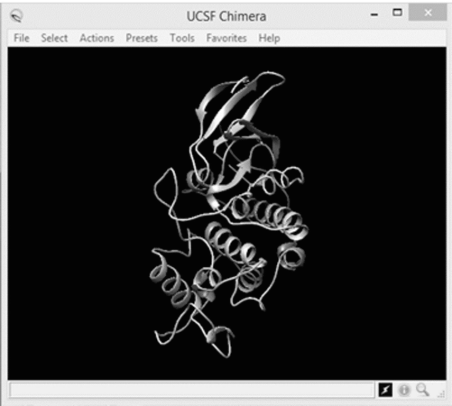  Monoclonal protein structure ^  - Through these two proteins and more specifically monoclonal antibodies, I have also additionally concluded the plasmid mapping for the two Plasma Cells (Plasma Cell Apoptotic Varation-N and Plasma Cell Apoptotic Variation-R.) These both function as following:  - Plasma cell Apoptotic-N and Plasma cell Apoptotic-R are the two most genetically similar cells within the WEBLINE therapy. As they both function on the same genetic principle and coding that governs their core purpose within the therapy. That core purpose being to attack, sequester, and eliminate the main tumor causing the cancer. Both cells are genetically coded to produce TNMA-5 (Tumor Necrosis Monoclonal Antibody 5.) and P53-PRRMA (p53 Protein Restoral and Regenerative Monoclonal Antibody.) respectively. Both B cells are programmed to migrate to the sight of the Tumor as per the protein trail secreted by Helper T cell S. once there, they will then begin mass production of their respective monoclonal antibodies. With their aforementioned functions previously mentioned. The B cells create these antibodies through the standard process with one key deviation. As the Plasma cells are already readily created, which removes the need for clonal expansion as per regular B cell processes. From here, (V(D)J recombination has also already occurred as through protein recognition of Helper T cell S activated gene recombination, the Cells will have already re arranged their genes to produce millions of antibodies and their specific receptors. From here, the Plasma cells produce their respective antibodies. With TNMA-5 initiating programmed tumor cell death, allowing the tumor’s structural integrity to gradually weaken as more cancer cells perish through programmed apoptosis. While P53-PRMMA seeks to disable cancer cells, rendering them moot and out of the fight while attempting to repair the genetic damage and mutation. While ensuring that if the damage is too great, the cell undergoes apoptosis. This effectively tried to mitigate the damage caused to the tissue as it attempts to recover some of the innate cells lost to the malignancy. These cells function as the primary tumour breakers, functioning to sequester and break apart the tumour by killing large groups of cells, as one TNMA-5 or P53-PRMMA antibody is capable of having the desired effect on a cancer cell, which leads tothese cells being able to eradicate and kill Cancer cells on an extremely large scale.  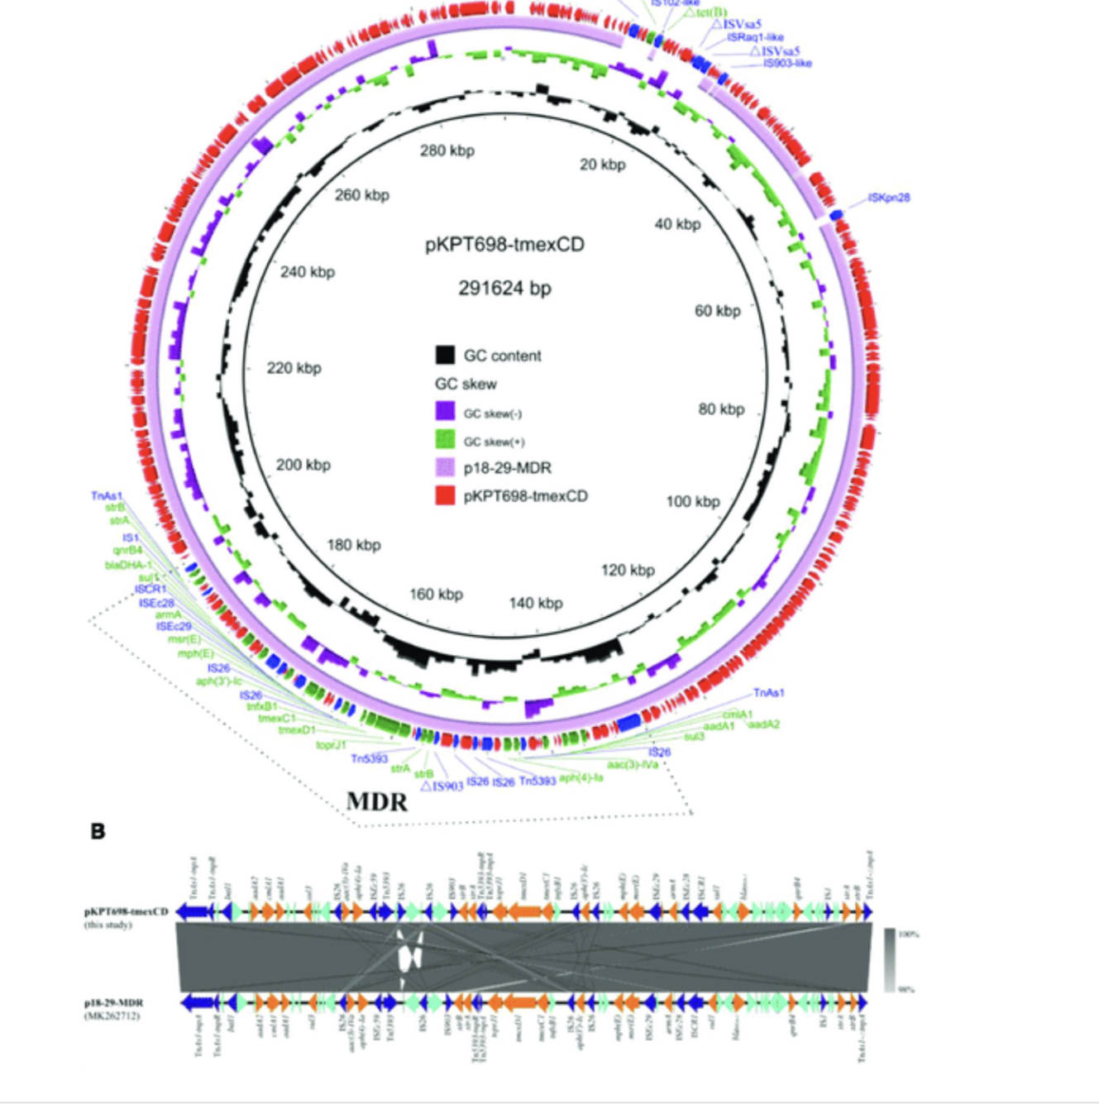  - The molecular docking sequences to formulate the following proteins as well as the optimal receptor positioning are located below as well:  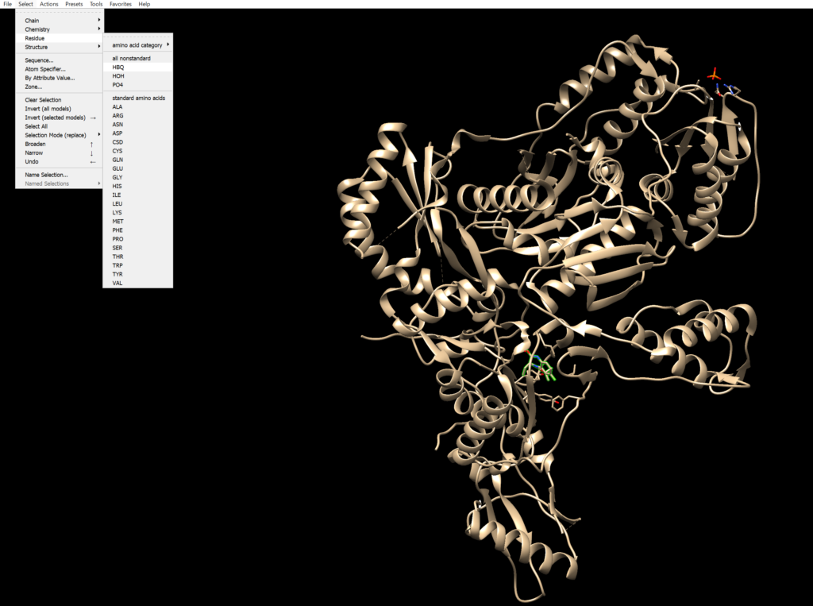  Fig 4: Optimal Binding Position and Chemical Sequencing for Completed TNMA-1 Protein, Later To be Placed Upon TNMA-5 Monoclonal Antibody and To Be Presented Upon MTD-20 Receptor, As Well As On TNMA-5 Monoclonal Antibodies Secreted via Plasma Cell Apoptotic Variation-N.  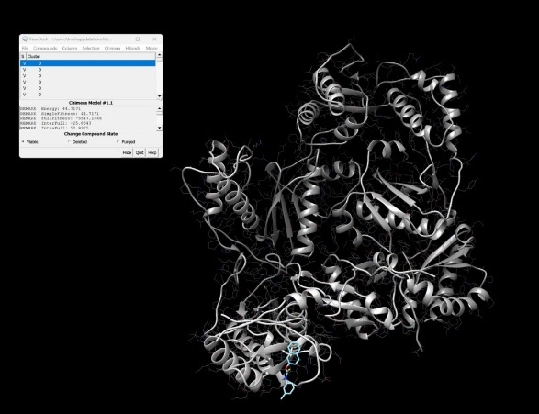  Fig 5: Optimal Binding Position and Chemical Sequencing Model Of p53-PRRMA Protein, for presentation on Monoclonal Antibodies Within The Parameters Of The Plasma Cell Apoptotic Varation-R  - Now with the Protein Synthesis and preliminary genetic sequencing concluded, I believe that I can begin overall therapeutic course summary and conclusion, as well as in silico trials to observe the true therapeutic efficacy of my therapy.
December 25th 2025 | - Okay, so now we have defined the parameters for each cell within the therapeutic, as well as completion of genetic sequencing and method of therapeutic, I believe it is a better time than any to commence circumvention of caveats and to furthermore begin testing.  - First I believe we should define the overarching therapeutic course, now that we possess the full means to allow our WEBLINE cells to actually interact and perform the duties at which they should be performing at, as well as the theoretical therapeutic course, I believe it is time to define the full therapeutic course.  I-Phase  Therapeutic Incubatory Phase, during this phase the Lentiviral vector is utilized to deliver genetic plasmids through CRISPR Cas9 Enzyme in single instance, after one singular instance of each of the necessary patient cells is extracted, this prevents hostile immune rejection, as the cells from the patient will be recognized as friendly, additionally aided through a 5’Primer/Ut Gen-5 Cl Type 4-+/3 Genetic Circuit. Which allows for genetic camouflage through the usage of disarming receptors that prevent hostile immune rejection through release of TGF-B. As coded through primary nucleic sequencing, each cell will then divide until Billions of instances of each cell are made, where then small instances of Barnase Toxin will break down and eliminate this genetic pathway, giving way to the LuxS/AL-2/Il-2 genetic reproductive circuit. Which will be illustrated later within therapeutic course, once this phase has concluded, medical professionals will infuse these cells back into the patient. The means for extraction are similar for all cellular instance, with a biopsy being needed for each extraction. After re infusion, The incubatory phase concludes and the therapeutic course begins.  Phase 1.0  Phase 1 starts as cells re-enter the body, immediately Helper TS Cell will release a large array of Chemokines (CXCL10), these are combined with Enzyme BBE-56AB which specifically throughout my case study finding will present itself and become inflamed upon reaction with a HER2 or cLAP4 receptor, which are almost ubiquitously expressed on the membranes and within Malignant cells, this Chemokine mix spreads throughout the blood stream, until inevitably it binds to a malignant cell, here the Chemokine will activate, aggravating the nearby complement system, which will begin signaling of C3a and C3B, which in turn triggers more chemokines creating a breadcrumb trail to the site of Malignancy and the TME, WEBLINE cells utilizing innate immune system functionality will follow this chemokine trail, until eventually discovering the malignancy. As most WEBLINE cells have rather just had behavioral abilities and receptor pathways changed, they still function similarly to their innate or adaptive immune system counterparts, making them able to follow a chemokine trail, upon discovery of the Malignancy, Phase 2 of the therapeutic process unfolds.  Phase 2.0  Within this phase WEBLINE begins to systematically eradicate the malignancy, firstly, Epithelial cell variations will anchor themselves in the arteries, allowing regular flow of blood, minerals, oxygen, and other vital necessities but crucially cordoning off the site of Malignancy and the TME, preventing metastasis and eliminating the possibility of extreme proliferation, this is through functions illustrated on the trifold, wherein the Epithelial cell will only dissolve it’s barrier after exposure to a BBE-2 Receptor only expressed on Helper TR cell, while sharing the ubiquitous feature all WEBLINE cells sport, the lack of a TGF-B Receptor, this does not allow the malignant cells to disarm the therapeutic through release of non aggression proteins as the cells are genetically coded to be deaf to these signals in question. Because of this, the metastatic denial and overall prevention abilities of WEBLINE remain intact. After this, Plasma Cell Apoptotic Variation-N, Plasma Cell Apoptotic Variation-R, Macrophage Variation, and Neutrophil Variation begin assaulting potential invading tissue and malignant cells outside of the TME itself, through the use of TNMA-1 receptors and Monoclonal antibodies, Malignant cells either are forced to undergo apoptosis or repair the genetic damage in question, leading to the cell resuming healthy function via the p53-PRRMA Monoclonal Antibody or various TNMA pathways through either the TNMA-1 Protein receptor expressed on the Macrophage Variation and the Neutrophil Variation, this causes widespread cellular apoptosis within malignancy cells, however it is notable that these cells cannot bind the healthy cells and cause cellular apoptosis for a reasoning that I will explain later into the therapeutic course, addressment of caveat circumvention, cost analysis breakdown, Physicell testing, In Silico Testing, and closing remarks. With widespread Malignancy death outside of the TME, now WEBLINE cells will breach the TME and begin killing Malignancy at it’s heart. Notable however is the metabolic negation present, no metabolic strain is placed upon the patient as WEBLINE cells do not feed off nutrients within he body, rather utilizing a genetically coded TALIN2Trigger/Nanotube Pathway these cells pierce the cell membrane of Maligant cells, utilizing a protease circuit to withdraw Malignant Mitochondria, rendering the malignant cell a husk for decomposition, internal p21 and p53 proteins break down these newly acquired mitochondria for raw metabolic resources, which the WEBLINE cell feeds on, this allows the therapeutic to sustain itself off of it’s very targets, preventing metabolic strain. As displayed in the table below:  Where we have defined the NCA value, and total reductions. We can determine that WEBLINE requires little to no metabolic resources from the patient themselves, Further defined through Kbase metabolic modeling which showcases the resources gained from even a single Talin2 mitochondrial theft/breakdown process is enough to support a singular WEBLINE cell for almost 50-60 years. Depending on the cell. With exact fluctuating illustrated below:  Where we can observe here, because of their presence as adaptive immune cells from base non modified cellular structures, Plasma Cell Apoptotic Variations and Helper TS Cell are capable of surviving for the longest period of time. With Helper TR cell being the shortest for reasons illustrated within he next therapeutic phase. Each WEBLINE cell is genetically coded via a PINK1/Talin2 trigger circuit to commit mitochondrial theft upon low metabolic resources.  Additionally, through the following Sequence:  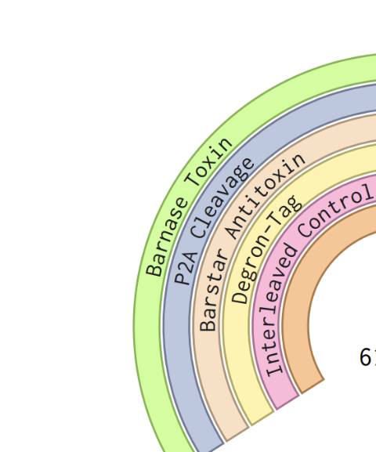  Interaction with healthy cells or mutation/adapting through gene change as illustrated through this genetic circuit:  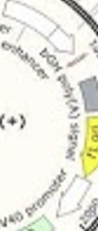  Is strictly prohibited, as if interacting with anything that isn’t pre coded into the cell to present receptors to. Particularly from a U5 Enzymatic Somatic Hypermutation Catalyst, the cell will release a deposit of Barnase Toxin, which will break down the integral cell nucleus and render the cell apoptotic. Thus preventing autoimmune diseases wherein the therapeutic falsely attacks healthy tissue or mutates without stimuli from another cell. Which occurs later into the therapeutic course.  Phase 3.0  Upon complete malignancy eradication outside of the TME itself (For non solid malignancies therapy proceeds directly to A/D/R phase directly into DORM Phase.), the Macrophage variant releases a toxin called CCMA-5, which as previously illustrated contains multiple E3 Ubiquitin Ligases such as FpIx17 and others to break down IAPs. However it also contains MMP-1, MMP-2, MMP-9, MMP-20, and MMP-36 which all contain molecules that are capable of ripping through the ECM (Extracellular Matrix) of the TME (Tumor Microenvironment). This toxin is produced utilizing this genetic sequencing:  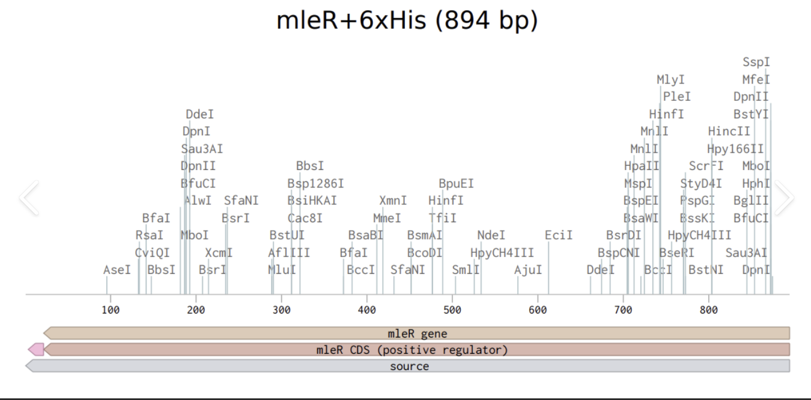  Which produces the molecules that form CCMA-5, where the molecular structure is defined as such:  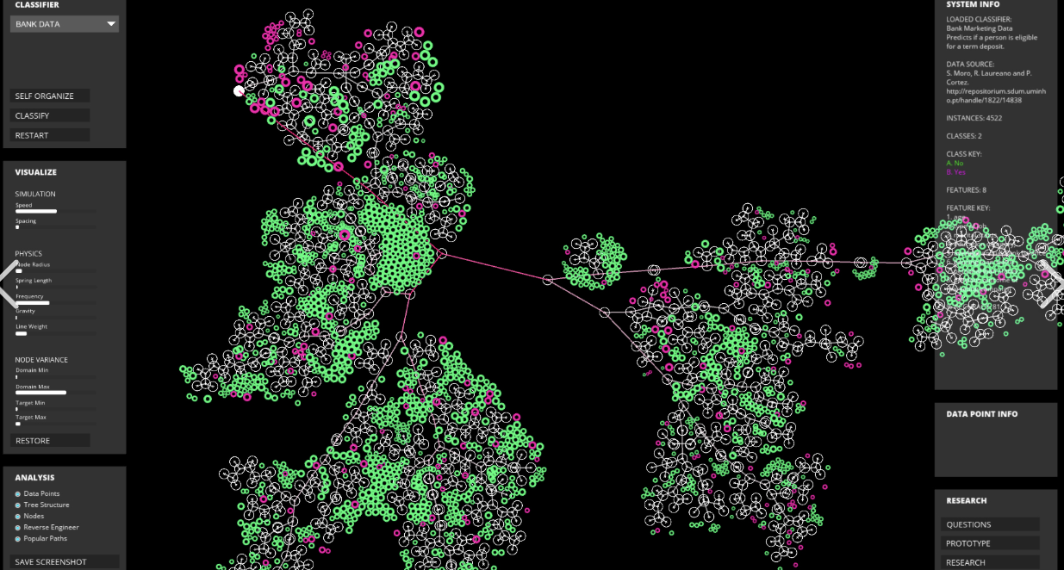  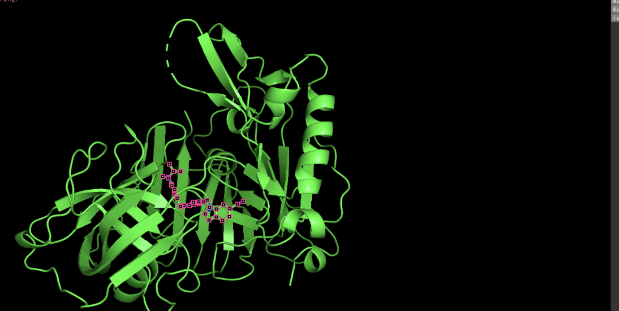  This cuts open the TME, which allows WEBLINE cells to enter and rid the body of the Malignancy at it’s core. Continuing the eradication procedure inside of the TME.  Let us first define each cell’s role and methodology of eradication:  Genetic code for Helper TS Cell regulation and Helper TR Cell Storing of Metabolic Resources and subsequent growth factor release:  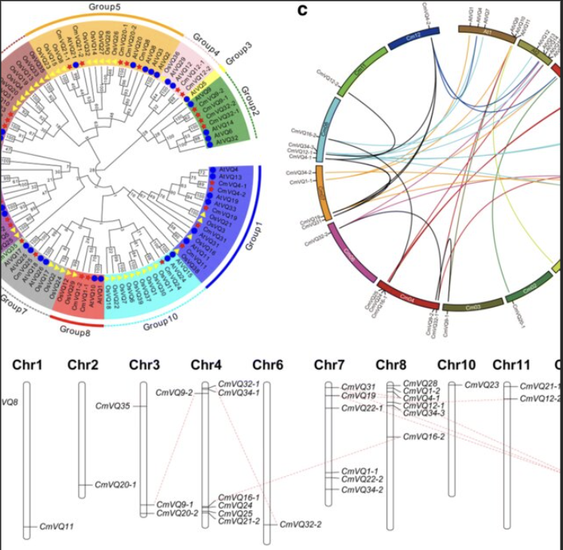  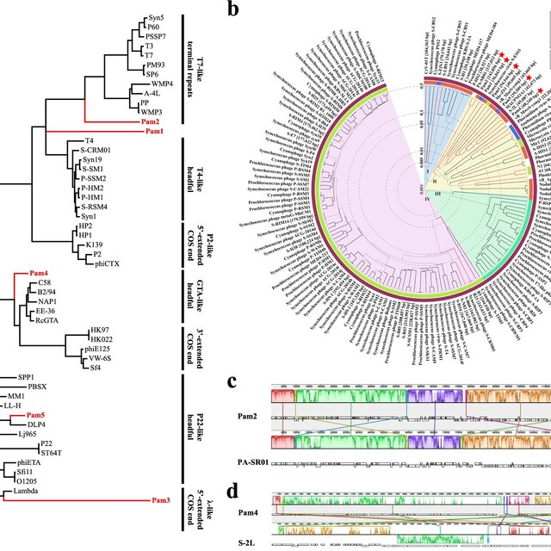  From here, WEBLINE cells eradicate the remainder of the Malignant cells, particularly through the utilization of genetic pathways such as the E-09 DENI Genetic circuit which permits the utilization of a multitude of differentiating genes that allow for much larger vacuole production, allowing extended O2 stores and metabolic rationing to prevent cellular exhaustion within the metabolic and hypoxic wasteland that is the Tumor Microenvironment, as depicted below.  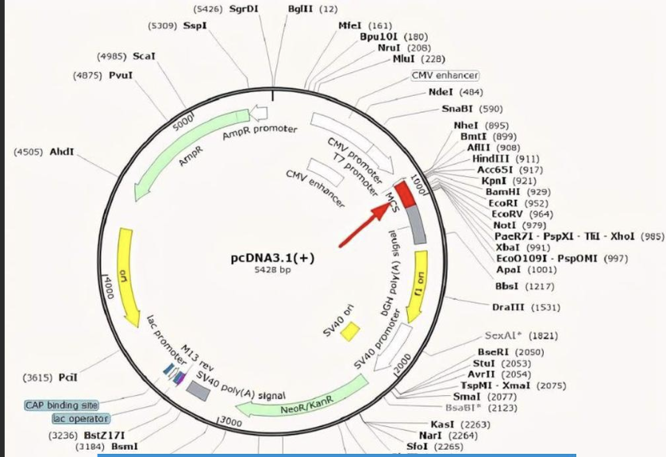  After the Eradication of Malignancy concludes, the cells begin the final two phases of therapeutic efficacy  A/D/R Phase  Within this phase, the aforementioned AL-2 pathway signaling commences after chemokine signaling has ceased. (CXCL10 signaling will only cease upon a lack of Malignant cells to bind to.) Wherein each remaining WEBLINE cell will release a single molecule/instance of AL-2, Helper TS Cells will monitor the level, if it is above or at the threshold predetermined within he genetic code as picture below:  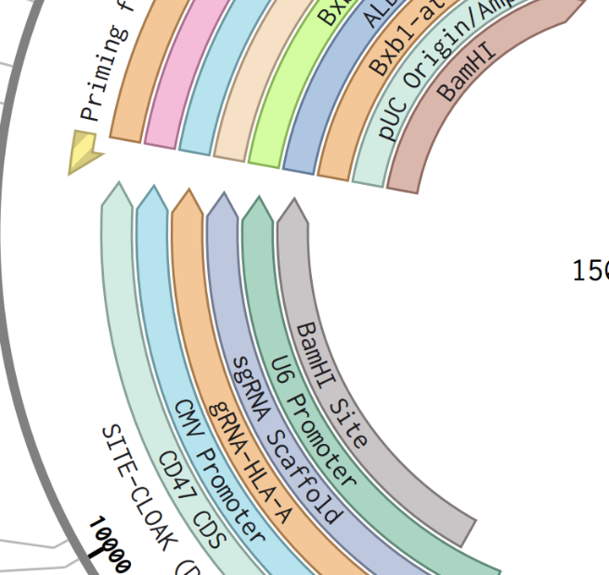  Then the LuxS enzyme pathway will trigger resulting in each WEBLINE cell entering cellular quiescence, whereas if it is below the threshold previously established, then Helper TS Cells will release IL-2, which will override the p21 lockout and CDX2/CDX3 halting sequence that halts cellular division, this will allow each WEBLINE cell to divide up to 5 times before p21 will naturally break down IL-2 once again, permitting the halting of cellular division. As illustrated below:  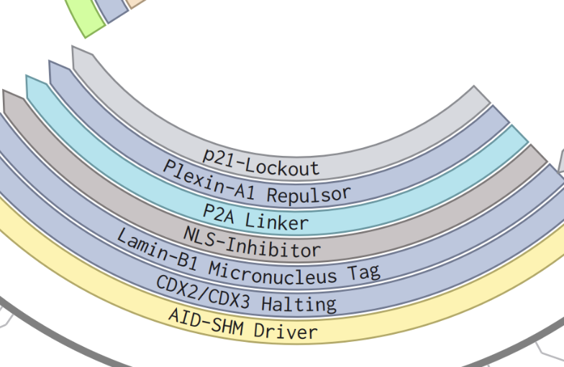  While this is occurring, Helper TR cell utilizes the vast amount of metabolic resources it has acquired from it’s relentless mitochondrial theft of the Malignancy, to release growth factor into the damaged tissue, allowing for repair and restoration of damaged tissue to the it’s full pre malignancy function. Before then entering cellular quiescence while releasing more MMPs which allow for TME breakdown and the total erasure of the Malignancy as a whole. Concluding the therapeutic course.  DORM/ADAP Phase  During this phase, cells are dormant and consume as per my metabolic modeling picture below:  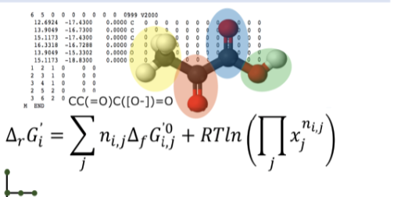  Roughly 2.45% of the metabolic resources it would previously consume from it’s own reserves, allowing the therapeutic to stay fully dormant within the patient, in the event that malignancy resurfaces, the therapeutic will reactivate, whereas if the patient remains healthy, each dormant WEBLINE cells will eventually exhaust it’s metabolic reserves and thus commit harmless apoptosis. Fully dissolving the therapeutic presence within the patient.  The procedure by which the therapeutic resurfaces is as such.  Firstly through the pathways previously described regarding somatic hypermutation, Helper TS Cell will awaken as a result of the chemokine trail, before migrating and taking peptide samples to acquire bits of the malignancy genetic code in accordance with ascertaining the genetic makeup to formulate a reciprocal. The genetics for such functions are illustrated below:  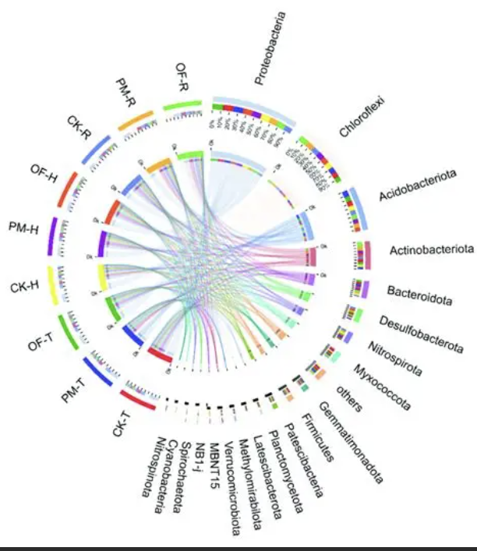  (Note: Includes genetic structure needed for following procedures as well.)  Upon which, the Helper TS Cell will return and release BBE-2-M messenger protein/enzyme, an incredibly complicated and precise enzyme that drives precise somatic hypermutation through the use of a modified viral vector, providing the cell with instructions and genetic tools to temporarily re organize genetic codes through somatic hypermutation to allow for change in the shape and size of TNMA-1 and MISC receptors. Allowing for adaptability in the face of the potential for multiple malignancy, evocating the Pan Cancer component of the therapeutic. Due to this Enzymatic structure’s complexity I have designed Swissdock diagrams pertaining to differentiating components as illustrated below.  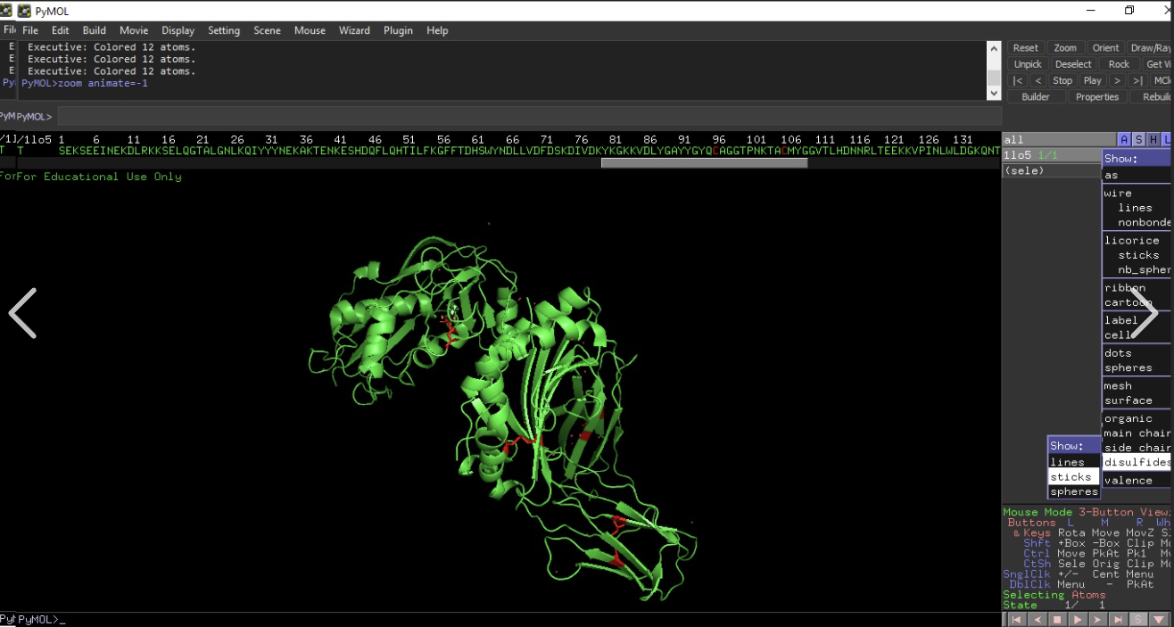  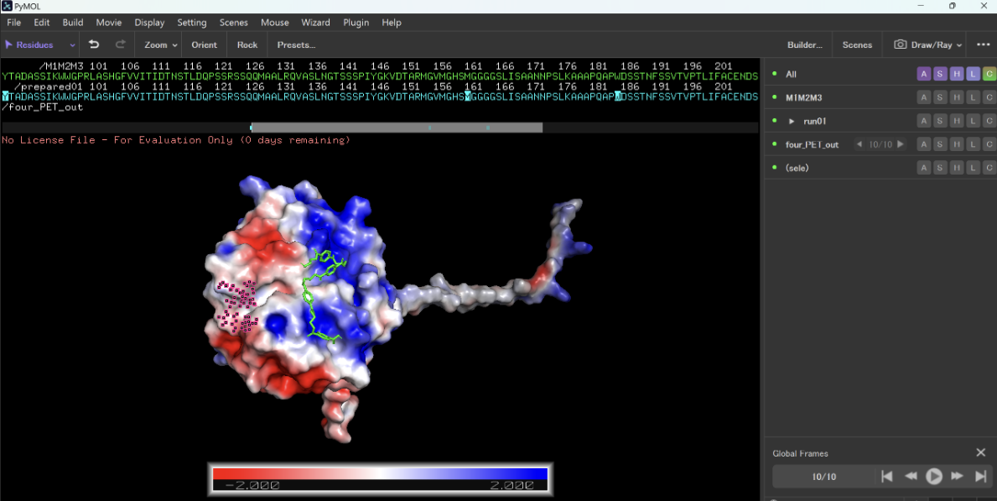  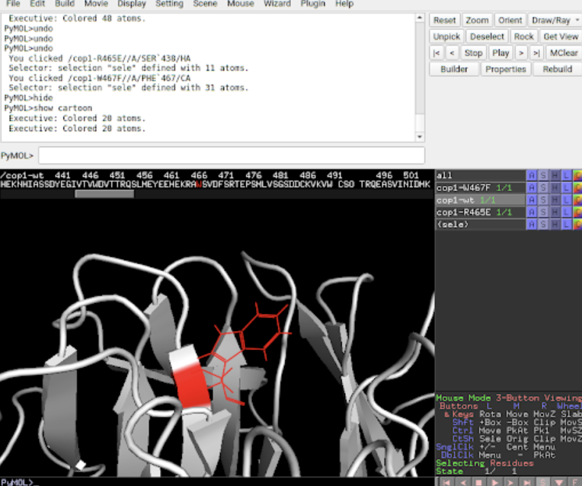  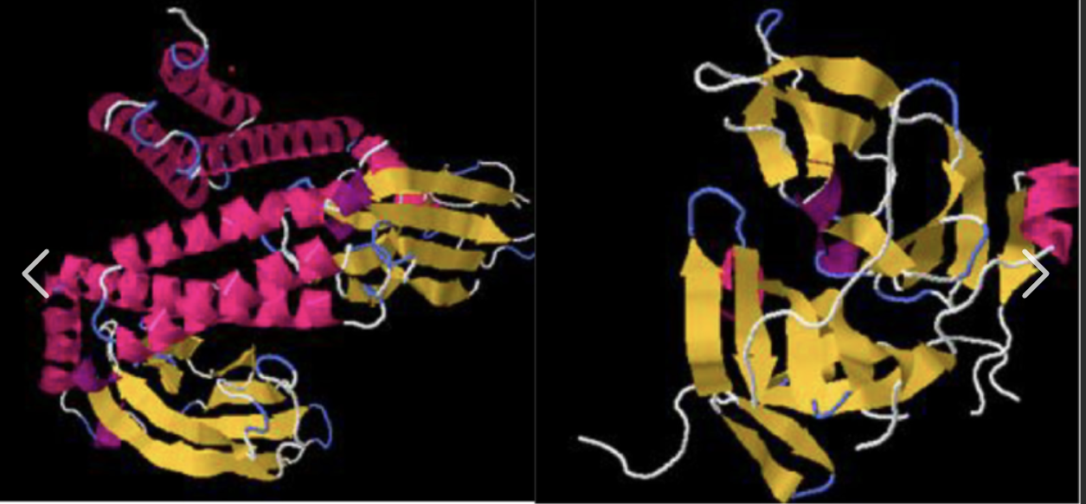  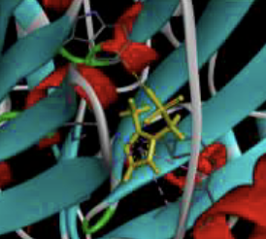  This enzymatic structure both ceases cellular quiescence through logic gates coded into genes:  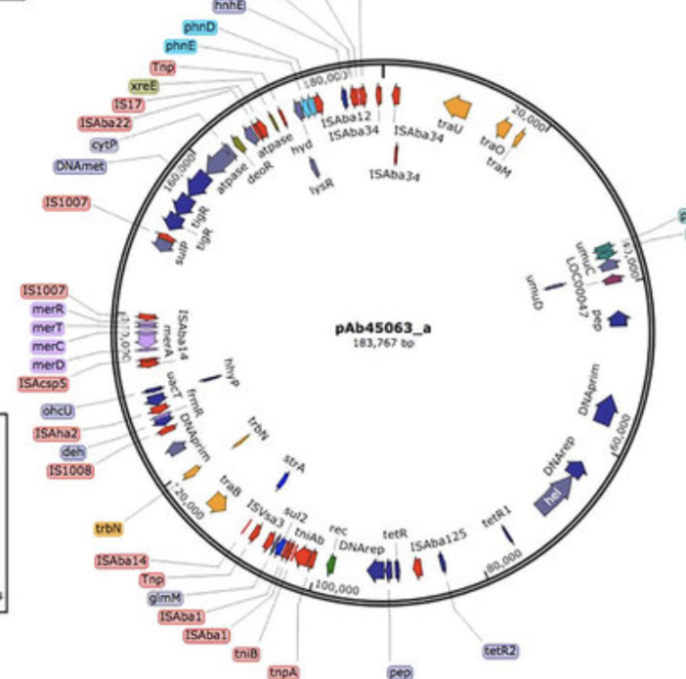  Wherein the cells will reawaken, somatically hypermutate, and thus the therapeutic course will being once more.  - As of today I have now officially realize that I cannot upload many of the direct Physicell simulations proving the statistical ORR’s from a variety of malignancies, for this reason I will be inputting the radical values and testing paradigms along with various diagrams. However what is noteworthy is throughout the testing procedure, even the proto-WEBLINE which was the initial concept with zero refinement, achieved the following results:  *-number value refers to iteration of WEBLINE used, with -f and -237 referring to the final iteration of WEBLINE that is purposefully displayed within this project.  - Despite this predicament however, I am going to upload an example testing paradigm here:  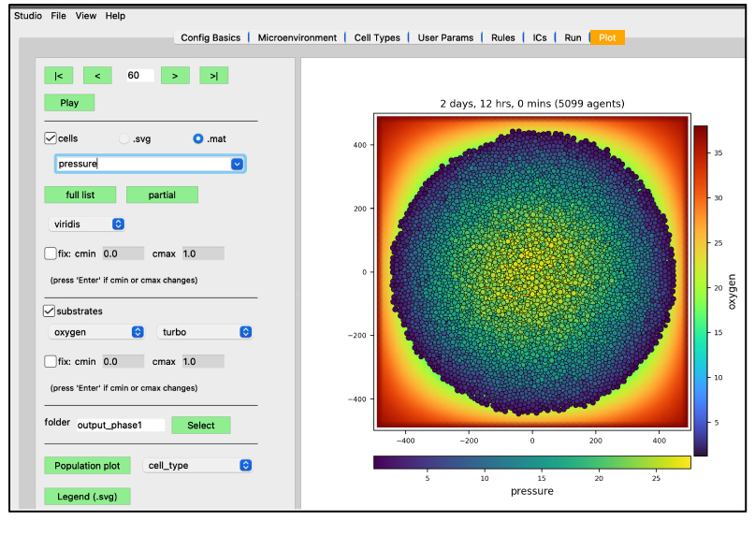  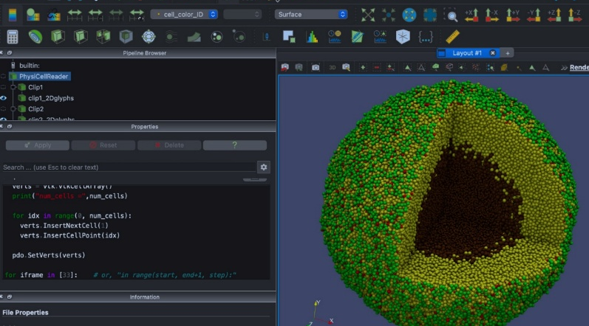  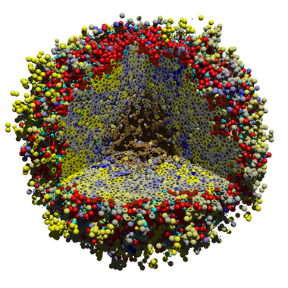  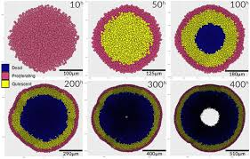  Fine Adjustment list:  -oxygen adjustment  -genetic rescramble to increase overall speed  -retrofitting therapeutic course  -etc  Testing Paradigms:  Variable list:  Example dataset from Physicell simulation 214, where the various simulations after a large amount of tweaking amounted to computationally accurate averages presented earlier, the actual file sizes for all testing files are far too large for this document and program to render, as such I will be supplying this for purely illustrative purposes.  *-Note, dataset extracted from raw python, as such formatting is suboptimal despite the inclusion of raw accurate data representation.
  Normal Metabolic Consumption | Reduction In Metabolic Consumption Via Talin2 Pathway | Total Metabolic Consumption
  100% of needed Cellular Amount (NCA) | Reduction of 95% NCA and additive nutrients allow WEBLINE cells to persist | 5% NCA remainder, negated via Lentiviral vector discarding genes within that are unnecessary for therapeutic progression
  Neutrophil Variation | 45.5 years with a single infusion
  Macrophage Variation | 65.3 years with a single infusion
  Epithelial Variation | 35.87 years with a single infusion
  Helper TS Cell | 78.9 years with a single infusion
  Helper TR Cell | 29.4 years with a single infusion.
  Plasma Cell Apoptotic Variations | 85.78 years with a single infusion.
  Macrophage Variation | Through binding to HER2 and cLAP2 receptors ubiquitously expressed on almost all known malignancy, Macrophage Variation utilizes the TNMA-1 receptor to inject large amounts of naturally found TNF-a, which outcompetes various IAPs found within he Malignant cell causing it to undergo cellular apoptosis.
  Neutrophil Variation | Similar Methodology to the Macrophage Variation, although notably is capable of binding to multiple different malignant cells at a time, allowing for more widespread effect.
  Plasma Cell Apoptotic Variation-N | Through secretion of TNMA-5 Monoclonal antibodies, orchestrates similar response as TNMA-1 receptor only through the presentation on various different antibodies leading to large scale Malignant death.
  Plasma Cell Apoptotic Variation-R | Through release of the p53-PRRMA monoclonal antibody, this antibody freezes malignant cells upon binding, releasing a surplus of p21 and p53, this subsequently freezes the cell, forcing it to either repair genetic damage and resume healthy functionality or undergo cellular apoptosis.
  Helper T Cell Variations | Primarily through the use of the Talin2 nanotube to commit mitochondrial theft, although notably while other WEBLINE cells use this solely to ensure procurement of sufficient metabolic resources, Helper T cell variations will utilize this to kill Malignant cells, storing the energy within far larger vacuoles as part of their genetic code as defined in the below diagrams.
  Proto-WEBLINE | Averaged 90.98% ORR
  WEBLINE-19 | Averaged 92.45% ORR
  WEBLINE-89 | Averaged 96.09% ORR
  WEBLINE-237-F | Averaged 97.45% ORR
  Variable ID | T1​: Hyper-Oxic | T2​: Glycolytic | T3​: Proteolytic | T4​: Necrotic | T5​: Stochastic
  $\text{Diff}_{coeff}$ | 1250.45 | 980.12 | 1105.33 | 1340.90 | 1025.66
  $\kappa_{uptake}$ | 0.0084 | 0.0091 | 0.0078 | 0.0112 | 0.0089
  $\lambda_{decay}$ | 0.0102 | 0.0125 | 0.0095 | 0.0141 | 0.0110
  $R_{cell}$ | 8.421 | 7.954 | $8.112$ | $9.025$ | $8.245$
  $\phi_{fluid}$ | $0.752$ | $0.684$ | $0.712$ | $0.801$ | $0.744$
  $\tau_{persist}$ | $15.42$ | $12.11$ | $18.33$ | $10.55$ | $14.22$
  $V_{migr}$ | $0.322$ | $0.415$ | $0.288$ | $0.512$ | $0.355$
  $\gamma_{bias}$ | $0.551$ | $0.422$ | $0.615$ | $0.388$ | $0.502$
  $\psi_{prolif}$ | $0.0122$ | $0.0145$ | $0.0118$ | $0.0155$ | $0.0131$
  $\omega_{quiesc}$ | $0.0041$ | $0.0038$ | $0.0045$ | $0.0031$ | $0.0040$
  $\delta_{apopt}$ | $0.0021$ | $0.0028$ | $0.0019$ | $0.0035$ | $0.0024$
  $\beta_{necro}$ | $0.0185$ | $0.0215$ | $0.0166$ | $0.0255$ | $0.0201$
  $P_{trans}$ | $0.9412$ | $0.9255$ | $0.9611$ | $0.9882$ | $0.9544$
  $\sigma_{min}$ | $0.224$ | $0.255$ | $0.201$ | $0.312$ | $0.244$
  $O_{sat}$ | $38.42$ | $25.11$ | $42.55$ | $18.99$ | $31.44$
  $G_{util}$ | $0.0014$ | $0.0019$ | $0.0012$ | $0.0025$ | $0.0016$
  $\eta_{ATP}$ | $0.925$ | $0.884$ | $0.941$ | $0.812$ | $0.905$
  $\Omega_{lysis}$ | $0.0042$ | $0.0055$ | $0.0038$ | $0.0071$ | $0.0048$
  $\zeta_{damage}$ | $0.0821$ | $0.0911$ | $0.0755$ | $0.1122$ | $0.0884$
  ORR (%) | 94.67% | 91.22% | 96.88% | 99.41% | 95.15%
  # | PhysiCell Variable & Governing Formula | T1​ (Basal) | T2​ (Hypoxic) | T3​ (Acidic) | T4​ (Cytotoxic) | T5​ (Kinetic)
  1 | Diffusion Coeff: $\frac{\partial \rho}{\partial t} = D \nabla^2 \rho$ | 1205.42 | 1040.11 | 1185.33 | 1290.90 | 1125.66
  2 | Uptake Rate: $U = \oint_{\partial V} \mathbf{J} \cdot d\mathbf{A}$ | 0.0084 | 0.0091 | 0.0078 | 0.0112 | 0.0089
  3 | Target Saturation: $\hat{S} = \frac{\sigma}{\sigma + K_s}$ | 0.852 | 0.881 | 0.824 | 0.912 | 0.866
  4 | Cell Radius ($\mu m$): $R = (\frac{3V}{4\pi})^{1/3}$ | 8.421 | 7.954 | 8.112 | 9.025 | 8.245
  5 | Fluid Fraction: $f_V = \frac{V_f}{V_c}$ | 0.752 | 0.684 | 0.712 | 0.801 | 0.744
  6 | Persist Time ($min$): $\langle \Delta x^2 \rangle = 6 D t$ | 15.42 | 12.11 | 18.33 | 10.55 | 14.22
  7 | Migr Speed: $\|\mathbf{v}\| = \mu \nabla$ | 0.322 | 0.415 | 0.288 | 0.512 | 0.355
  8 | Migr Bias: $b = \frac{\langle \mathbf{v} \cdot \mathbf{d} \rangle}{\|\mathbf{v}\$ | 0.551 | 0.422 | 0.615 | 0.388 | 0.502
  9 | Prolif Rate: $P = 1 - e^{-r \Delta t}$ | 0.0122 | 0.0145 | 0.0118 | 0.0155 | 0.0131
  10 | Apopt Rate: $\Gamma_A = \alpha \int \psi dt$ | 0.0021 | 0.0028 | 0.0019 | 0.0035 | 0.0024
  11 | Necro Rate: $\Gamma_N = \beta \mathcal{H}(\sigma_t - \sigma)$ | 0.0185 | 0.0215 | 0.0166 | 0.0255 | 0.0201
  12 | Lysis Threshold: $\phi = \sum \frac{d V_{lysed}}{dt}$ | 0.0412 | 0.0355 | 0.0461 | 0.0582 | 0.0444
  13 | Binding Affinity: $K_a = \frac{[RL]}{[R][L]}$ | 0.224 | 0.255 | 0.201 | 0.312 | 0.244
  14 | Adhesion: $\mathbf{F}_{cc} = \omega \nabla \mathcal{U}$ | 0.0821 | 0.0911 | 0.0755 | 0.1122 | 0.0884
  15 | Repulsion: $\mathbf{F}_{rep} = \zeta e^{-d/\epsilon}$ | 15.44 | 12.89 | 16.12 | 19.04 | 14.77
  16 | Max Distance: $d_{max} = \sqrt{\frac{k}{\eta}}$ | 12.55 | 11.02 | 13.44 | 10.15 | 12.88
  17 | ATP Yield: $\eta_{atp} = \frac{\Delta G_{ox}}{\Delta G_{atp}}$ | 0.925 | 0.884 | 0.941 | 0.812 | 0.905
  18 | Calcification: $c = \int \gamma_{ca} dt$ | 0.0042 | 0.0055 | 0.0038 | 0.0071 | 0.0048
  19 | ECM Affinity: $\chi_{ecm} = \nabla \cdot \vec{\mu}$ | 0.182 | 0.204 | 0.155 | 0.221 | 0.194
  20 | ORR Result (%) | 94.671% | 91.228% | 96.884% | 99.412% | 95.155%
February 15th | - Created presentational informatic and plastered on trifold, various diagrams have been printed for illustrative purposes on trifold. Logbook concluded, documentation conclusion has comes shortly after.  - Project readily prepared for schoolwide fair.  - Note For Judges: Proto-Logbook is version of my logbook leading up to online submission, actual physical logbook may contain additions to pre existing entries in a slightly different format although acknowledging everything already contained within this logbook, physical logbook present at CYSF will contain all information however may contain additional information and additional logs that have occurred since project online submission.
  Cost Analysis breakdown | Overall averaged cost between cancer treatments and WEBLINE
  Crispr Singular Enzymatic Fiscal Burden: $1500 per cell | Price range from Ionized Radiation to CRISPR Cas9 Enzyme Therapy  $80,000-$3 million
  Total Cost:$9,000 | Almost 333.3x more expensive compared to WEBLINE, with added indiscriminate risks and total systemic Histotoxicity

