Project Icarus Logbook

Student: Ayden Popescu
School Year: 2025-2026

Topics:

More Efficient Jet Engine
Quiet Sonic Booms
More Efficient Fuselage Shapes

Cargo Glider

I chose the cargo glider because I found it to be the most interesting and something that hasn't been done before. I also saw that the other options I thought about didn't work or couldn’t be done in a reasonable timeframe and also be made in real life. Most of these ideas came to mind since I like aerospace and wanted to do something related to that. I also wanted to help the world in general, so a cargo glider was a great way of doing that.

Timetable:
- First two weeks will be research, design, and perfecting it
- Second two weeks will be the time I will simulate and calculate if it can work
- The final two weeks before submission will be full flight tests

Testable Question / Purpose:
- A small 3D-Printed and foam glider, Icarus, will be used to determine if it can carry a 1 kg payload in a city environment with a stall speed below 35 km/h and a glide ratio of at least 10:1, at a lower cost and noise level than a typical powered delivery drone.

Hypothesis:
If a glider is used instead of a full powered drone, then it should lower noise pollution and reduce the cost to transport packages because it will primarily utilize aerodynamic lift and gravity instead of continuous motor thrust.

Background Research:
- Researched how gliders generate lift and why wing loads and glide ratios are important, also researched the Clark Y airfoil, which gives good lift and low speeds and is also easy to cut out of foam.
- Researched typical materials used in RC aircraft, such as foam, balsa, carbon fibre tubes, and 3D printed PLA.
- Compared gliders to delivery drones which are noisy, power-hungry, and expensive to operate.

Materials:
- CAD and software, Fusion 360 for modeling, eufyMake + eufyMake M5 for 3D printing.
- PLA / PLA+ for the filament
- Structure would be made out of XPS or similar foam sheets for the wings and tail, 15 mm OD (Outer Diameter) carbon fiber spars, 2x 10mm OD carbon tail booms.
- MG90S servo for the cargo door, ailerons, elevator, and rudder.
- Glue, epoxy, hot glue, tape, sandpaper, hobby knife, ruler, and calipers.

Manipulated Variables:
- Mass of the aircraft (Total mass, and wing geometry, by changing the span and thickness of the wing to improve wing loading), this will affect overall performance of the glider.

Responding Variables:
- Glide Ratio (Distance / Height)
- Stall speed
- Range from 100m in altitude
- Estimated cost per flight hour, measured and recorded during testing phase

Controlled Variables:
- Airfoil type (Clark Y)
- General Layout (High aspect ratio wing with a twin boom tail)
- Tail configuration (Horizontal stabilizer between booms, two vertical fins)
- Test altitude for glide tests (100m), this is in order to ensure consistent results and minimize external factors.

Procedure / Method:
- Research the background of gliders, wing loading, airfoils, and delivery drones
- Design requirements, including a 1 kg payload, ~1.9m wingspan, low stall speed, and glide ratio greater than 10:1
- Design the 3D Printed Fuselage and payload bay (hollow shell) in Fusion 360 with areas to screw in both bay pieces as they are too big for one printer in one go.
- Design the servo-actuated rear cargo door at the back of the payload bay
- Design the foam wing using a Clark Y airfoil, polyhedral tips (wing tips tilted upwards for passive roll stability), and a 15 mm carbon fiber spar running through it.
- Design the twin-boom tail (carbon booms, horizontal stabilizer, two vertical stabilizers)
- Use volume and density calculations to estimate the mass of the aircraft, then the wing loading, stall speed, and glide ratio.
- 3D print the fuselage sections, and assemble with screws and links
- Install the carbon tubes on the body
- Cut and shape foam wings and tail, then install it on the carbon tubes
- Install the electronics, servos, and linkages, balance the CG / CM (Center of Gravity or Center of Mass)
- Conduct low altitude glide tests, then higher test flights, record distance, time, and behaviour.
- Compare the actual test data to the calculations and update the conclusions.

Short Description:
- Project Icarus is my 2025-26 science fair entry for the CYSF (Calgary Youth Science Fair)
- Objective: Build a small glider that can carry a 1 kg payload anywhere in the city and deliver it.
- The design is scalable so it can be enlarged to carry more payload over a greater distance.
- Icarus v1 will carry a 1 kg package, will be remotely piloted with a camera, and may later get an automated flight plan on a PCB or flight controller.

December 22nd 2025:
- Researched best materials for Icarus Glider
- Came up with using PLA / PLA+ by 3d printing the main fuselage, will weigh in at around half a kilogram. The wings will be made of foam, and the spar (wing support) will be made of carbon fiber tubes (Costs somewhere around $15)
- Finished most of the fuselage of Icarus v1
- One of two things that needs to be finished is the connection between the door and the servo
- The second thing is the split body and connection between the two, the body will be 3D printed out of PLA and it is too big to print in one go so it will be printed in halves with 2 links to secure the two sections.
- 40-60% Infill (How much plastic is actually on the inside of the walls)

December 23rd 2025
- I found a 3d model of the Servo to import and I had an issue when I wanted to connect it to the door. I couldn't use a normal straight piece since when opening it would collide with the rest of the fuselage. So I decided on making an L shaped tab. Now connecting it to the servo is hard since I need to connect it to a specific motor “horn” and there aren't many places to connect it to. I still did it since there are many small holes so it turned out fine.
- Completed the wings
- Decided on a Polyhedral (2 / 3 of the way going out of the wing the wing tilts up by a few degrees), this helps as when rolled to right for example, the right tilted wingtip produces more lift than the left tilted wingtip causing it to automatically stabilize. Perfect for a glider where high winds can cause it to roll.
- Started working on the tail section
- I’m going to have a twin-boom system, with an elevator for pitch in the middle. Then one vertical stabilizer on each boom.
- I decided to switch the nose cone to a better one
- Previously I had a half circle for the nose which pushes air around in all directions
- I changed it to a flat top nose with a 35 degree angle from the front top of the nose cone to the bottom back of the nose. This will push any oncoming air downwards and help the glider stay in the air longer.
- After calculating how well it’d fly I found out that it will not fly very well with a 1.9M wingspan. Therefore I have decided to make the wings thicker and have a longer wingspan. Most gliders have a lift per square meter of 2. My glider had a lift per square meter of 5, which is terrible, to improve this I will do what I said before, increase width and wingspan.

December 26th 2025

- The previous 3 days haven’t seen any work due to Christmas and being too busy to work on it.
- Started work on the Horizontal Stabilizer and Tail
- I started on the section where the tail and Horizontal Stabilizer started, it's pretty basic but I just need to make it taper down near the ends and I’ll have a horizontal stabilizer.

December 27th 2025

- Fully finished Icarus v1
- I finished the vertical stabilizer and horizontal stabilizer
- I added areas to screw in both pieces of the cargo bay, this is needed because it is too big to print in one go.
- Estimated total mass at about ~ 3.5 kg
- Estimated wing loading at ~ 8 kg/m²
- Estimated stall speed at about 34 km/h
- Best glide speed at about 43 km/h
- Estimated glide ratio is about 10:1 -> for every 100 meters in the air it can glide 1 km
- Estimated build cost to be around 235 dollars
- Estimated operating cost to be about 8.50 dollars every flight hour

January 5th 2026
- After waiting for the materials to arrive I finally got to building it, I shaped the wings, tail, and started printing the body. I also made sure that all the ordered parts were of the correct size.
- After shaping the wings into the Clark Y airfoil I sanded it down then carved the hole for where the carbon fiber spar will go through.
- Checked to make sure the carbon fiber spar fits, seems to be just perfect.

January 6th 2026
- The main body finally finished being printed, I assembled it with screws and stress-tested it.
- After that I put the cargo bay on along with the servo, then tested the opening and closing which worked perfectly.
- Finally I put in the electronics and got the wires set up for when the wings will fit onto it.

January 7th 2026
- I carved the ailerons, elevators, and rudders properly then hooked up the motors to them.
- Once that was done I fit them onto the carbon fiber spars and hooked them up to the wires.
- Then I finally did some quick tests to make sure all the controls were working properly and none were failing or broken.

January 9th 2026
- I went to the nearest open and clear area for me where I then ran and threw it into the air where the glider then climbed a bit and started its glide.
- On its descent I could feel that it wanted to pitch up with its nose, this is good and bad since we want it to stay in the air but not pitch up too much and stall
- After that I fully tested all the control systems and the passive roll stability with the polyhedral wing tips.
- Then I landed it and went home as it was cold outside and didn't want to freeze up any of the control systems.

January 11th 2026
- The final flight of Icarus was conducted to gather more information about the glide slope, glide speed, and stall speed.
- I also learned that the two screws were sufficient but decided to glue on another screw connecter onto the top of it for extra strength just in case as it did start bending a bit on landing.
- After that I did another flight where I found the best glide speed, and did a rough calculation of its glide slope where I found that it did better than my estimated 10:1 and it actually had a 12:1 glide slope.
- Tried to do one last flight and the wind picked up, blowing the glider away. I tried searching for it but could not find it. Aside from that simple cargo bay, the wings seemed to have been blown off. I learned that friction-fitting them wouldn’t work too well anymore. Luckily the electronics were recovered
- I ordered more parts to build a second prototype and I am now waiting for them to arrive.

January 14th 2026
- Completed the presentation
- I picked a fitting theme where it had a blueprint and was based around the Aerospace field
- I then added the hypothesis, made the framework of the slides and double-checked the requirements
- I finally added the full text into each slide, along with making a few graphics for the logbook and slideshow to show the information in a nice way.
- Finally got the new parts but haven’t had time to build it due to me needing to work on a bunch of stuff for school and for stuff outside of school.

January 19th 2026
- I recorded the video but was too busy to edit it so I had raw footage of it.
- The video is 11.5 minutes long but will edit it to be shorter so I can fit in clips of me making the glider in Fusion 360

January 24th
- Edited the video late at night so it wasn’t perfect
- I had lots of editing mistakes and general horrible transitions between two things.

January 25th 2026
- Touched up the video so the transitions and mistakes I made were corrected and well done
- Submitted it (I was busy in the past and could not submit it earlier than the final day)
- Finally finished the project with a working glider and

Data:
- 3D printed components weigh 1.5 kg, this is pretty average for 3D printed aircraft
- Foam Wings weight around 350 grams, making them a good choice for us
- Tail section weights 120 grams and they are relatively easy to install and lightweight
- Carbon Fiber, the rods weigh about 100 grams, providing a good balance between weight and strength
- Servos weigh about 70 grams, this is pretty average for servo weight
- Electronics (Control circuits and battery) weigh about 450 grams, these are essential for flight so this cannot be reduced or changed
- Screws, hinges, tape, adhesive, connectors all weigh a total of 60 grams, these are also necessary for the drone’s assembly and maintenance
- Cargo can be changed but max cargo weight is 1 kg, this is a significant addition so it needed to be placed directly on the CG / CM of the glider.

Results:
- Wings experience 7.9 kg/m² in flight on an average day
- Stall speed was found to be around 35 km/h, this can change based on weight and weather
- Best glide speed was tested and was seen to be about 43 km/h
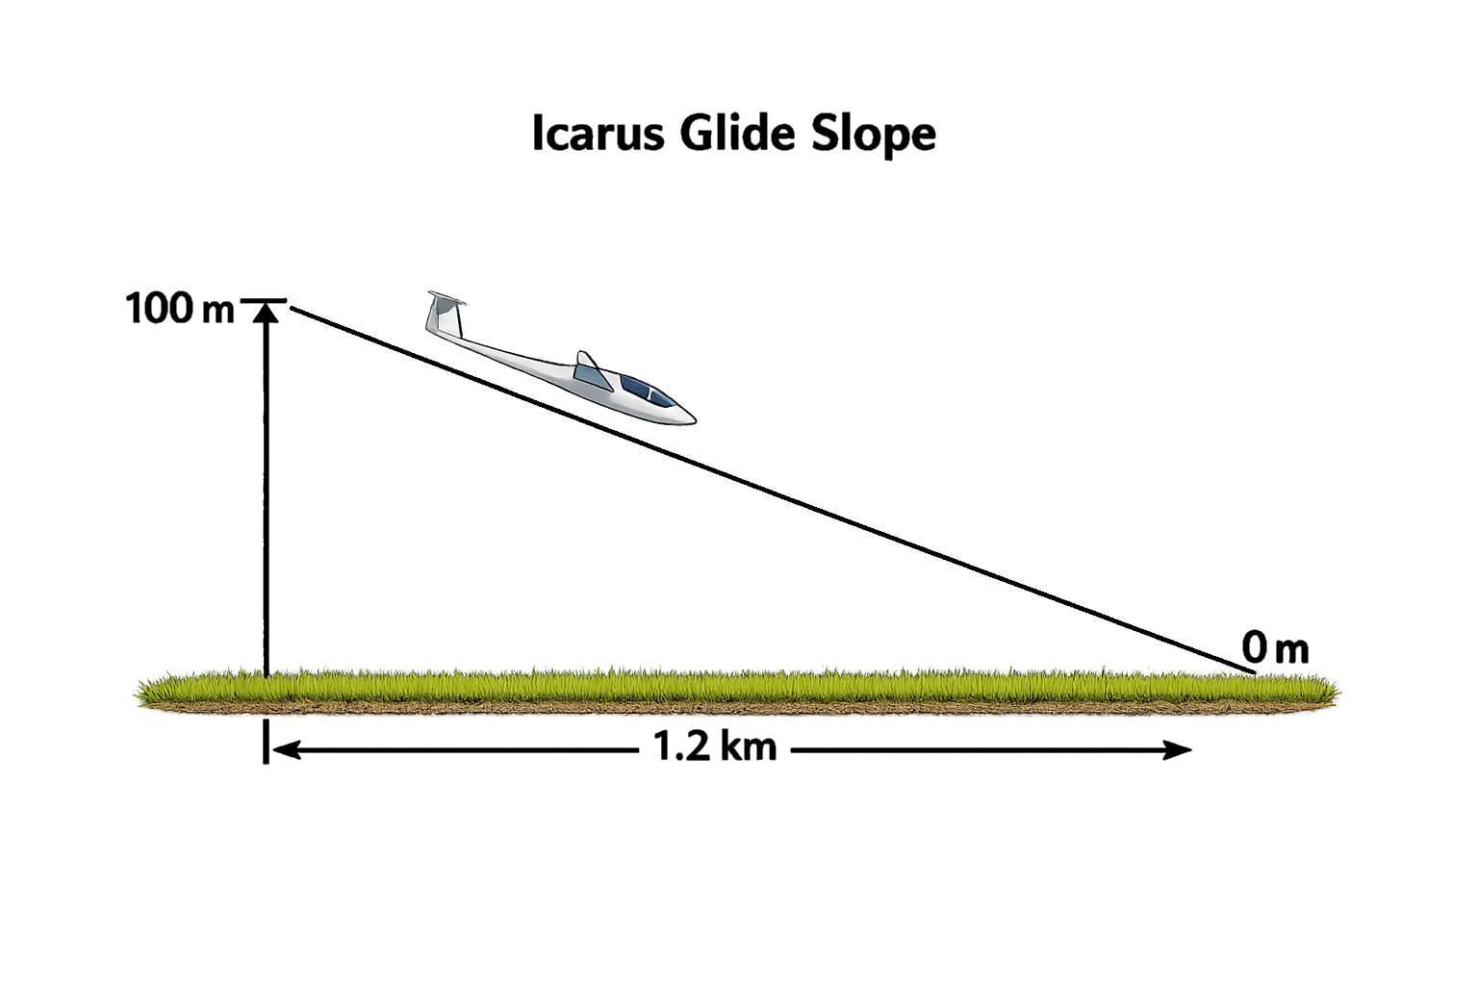
- The glide ratio tested was found to be a 12:1 glide ratio, aka. for every 100 meters in altitude it will travel 1.2 km

- Build cost was around 235 dollars depending on manufacturer and source of the parts
- Cost per 15 minute flight is about $2

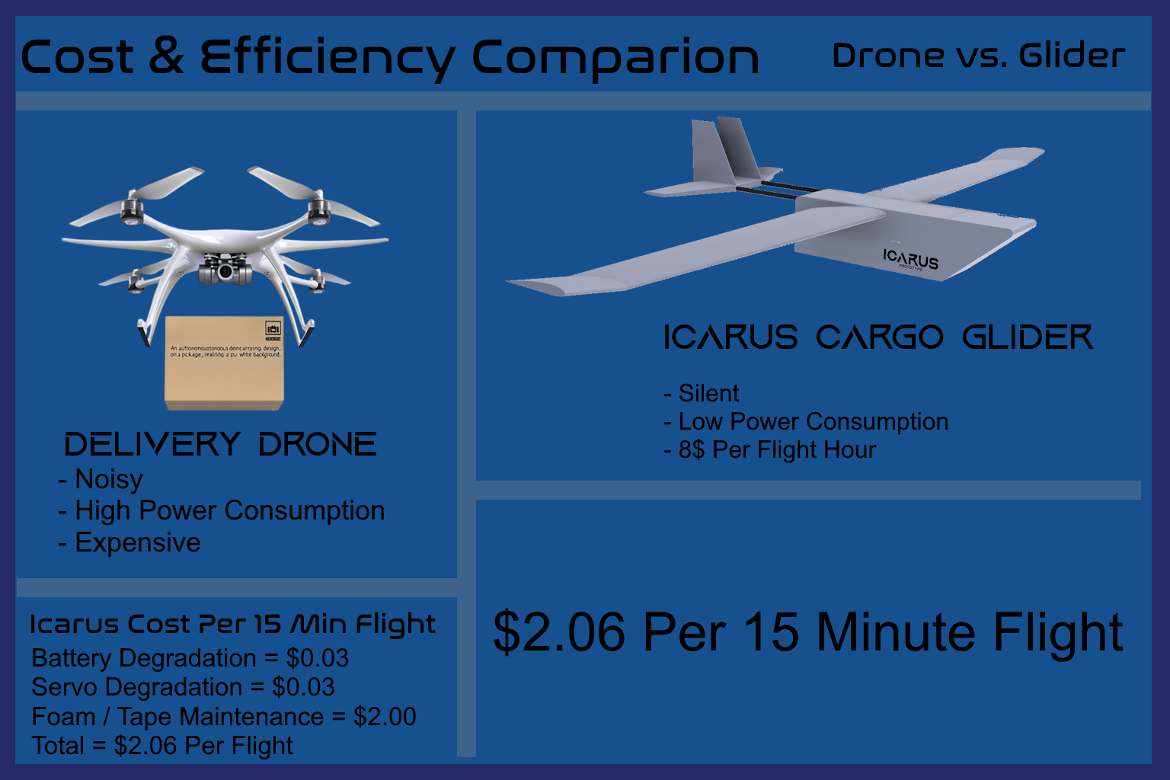

Conclusions:

In conclusion, my hypothesis was indeed answered and I did prove that it can successfully fly and deliver packages throughout a city and even to remote locations if ever needed. The glide ratio makes it perfect for delivery across long distances, making it arguably better for between city or to remote location cargo deliveries. The cost makes it quite cheap to assemble and really cheap to fly compared to delivery drones.
Recommendations / Applications:
- In future use I could put more electronics on to gather more data
- I could also improve the nose cone shape as it did cause a few stalls due to the air constantly pushing it up.
- For cheaper operating costs an autopilot can and should be used instead of a human pilot remotely operating it, this is safer and cheaper.

Resources:

https://www.cstsales.com
https://www.flitetest.com
https://www.flitetest.com
https://www.rcuniverse.com/forum/rc-gliders-sailplanes-slope-soaring-112/1182277-choosing-airfoil-payload-glider.html
https://www.flitetest.com/articles/designing-smooth-symmetrical-airfoil-wings
https://www.fmshobby.com/blogs/news/rc-wing-design-guide

