My yogurt project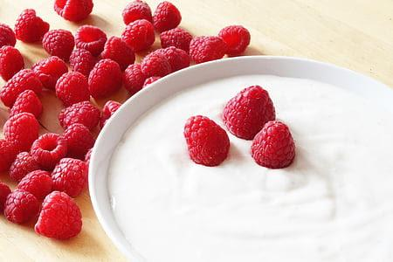

Why am I doing this?
- I want to see if you can make yogurt at home with store bought yogurt.
  - Can you make yogurt from flavored yogurt?
  - Can you make yogurt from yogurt drinks?
- How can you make yogurt in colder climates?
- Are store bought yogurt healthy (active cultures), flavorful and tasty?
- To have a better understanding of yogurt.

Yogurt Ingredients (Plain)

- Activia 3%
Ingredients:
- Skim milk
- Ultrafiltered skim milk
- Cream
- Active probiotic culture (Bifidobacterium lactis CNCM 1-2494

- Astro 3%
Ingredients:
- Skim milk
- Cream
- Skim milk powder
- Active bacterial cultures

- Khaas Dahi 3%
Ingredients:
- Milk ingredients (skim milk, cream and/or whole milk),
- Milk protein concentrate,
- Whey protein concentrate,
- Active bacterial culture.

- Liberte Greek

Ingredients:
- Skim milk
- Cream
- Milk protein
- Bacterial cultures

Yogurt Ingredients(Flavored)

- Activia strawberry 2.2%
Ingredients:
- Skim milk
- Ultrafiltered milk
- Sugar
- Cream
- Water
- Strawberries
- Modified corn starch
- Gelatin
- Pectin
- Active probiotic culture (Bifidobacterium lactis CNCM I-2494) and active bacterial cultures
- Natural flavour
- Black carrot juice (for colour)
- Malic acid
- Sodium citrate
- Vitamin D3
- Calcium lactate
- Annatto (for colour)
Made with vitamin D fortified skim milk

- Astro strawberry (whole)
Ingredients:
- Skim milk
- Cream
- Sugar
- Skim milk powder
- Natural flavour
- Agar
- Vegetable juice extract
- Active bacterial cultures

- YOP strawberry 1%
Ingredients:
- Partly skimmed milk (milk, vitamin D3)
- Water
- Sugar
- Milk protein
- Natural flavour
- Bacterial culture

Question:
What are the common ingredients in commercially manufactured yogurt?

What experiments am I going to do?

- Using store-bought yogurt culture can I make homemade yogurt?
- Using yogurt drinks, can I make homemade yogurt?
- Trying different techniques to make yogurt in colder climates

Flavors and Tests! |  | Liberte Greek Plain  3% | Astro Plain 3% | Homemade culture | Astro Strawberry  Whole | Activia Plain 3%
Consistency/texture
How long did it take?
Did it work?
Taste
\Smell

Control: My Mom’s HOmemade yogurt

I am testing the YOp Strawberry 1% yogurt drink and seeing if it can also make yogurt.

Flavors and Tests | Yop Strawberry 1%
Consistency
How long did it take?
Did it work?
Control: My Mom’s Homemade yogurt.

To answer my last question I am going to list different things that can help make the yogurt in a humid and warm climate.
- Instant pot
- Oven with light on
- Insulated cooler

Appliances and Tests | Instant pot | Oven w/ light on | Thermos | Insulated cooler with hot water
Did it work?
Consistency
How long did it take?

Control: My Mom’s Homemade yogurt.!

To do the testing of each of these experiments I will need

- All of the yogurts
- The Appliances
- Cups
- thermometer

