August 8, 2023

I have decided to do this project after learning that most of the wildland firefighters who are currently fighting off fires do not have the proper Personal Protective Equipment (PPE) they need. Firstly, many of these firefighters do not have proper respiratory equipment to help protect them from the excess amounts of smoke, particulate matter, volatile organic compounds, etc, found in the air when trying to extinguish wildfires. This is very dangerous as these firefighters have a pretty high chance of being diagnosed with many illnesses due to the overexposure of these pollutants. Secondly, the surrounding environment in which the wildland firefighters are working is pretty hot (due to the flames from fires).

Resources (Sources I Read):

- https://www.cbc.ca/news/canada/wildfire-fighters-smoke-protection-1.6897879

- https://www.cbc.ca/news/canada/saskatchewan/firefighters-cancer-risk-1.6794114#:~:text=%22A%20lot%20of%20the%20firefighters,various%20chemical%20and%20hazardous%20substances.

August 9, 2023

Today, I tried to find a solution to the problem of wildland firefighters working in such hot conditions, and not having a way to cool down. I conducted some research and learned about thermoelectric cooling, as well as the Seebeck and Peltier effects. I started thinking of a way I could apply thermoelectric cooling to maybe make a backpack that had a thermoelectric Peltier cooler (inside the backpack) which was powered by a flexible solar panel, solar controller, and battery which was on the backpack. The Peltier is connected to a water pump which will help pump coolant through pipes underneath the firefighter's (PPE) equipment. The pipes should have contact with the person’s skin. The pipes will have connectors as well. When the coolant in the pipes touches the person’s body this will result in them feeling a bit cooler than before. The idea of having a water pump and coolant was inspired by using biomimicry. I have also tried finding some equipment and resources I could use. I also read an article about wearable thermoelectric generators for human clothing applications. I spent the majority of my day doing this today. Tomorrow, I plan to focus on maybe researching more about the idea of having a Powered Air Purifying Respiratory System (PAPR) to help protect wildland firefighters' respiratory systems. I think that I should be able to connect the (PAPR) somehow to the backpack as well. I also read a news article about firefighters and better protection from cancer. I will also try to make a more detailed plan for this backpack idea later this week.

Resources I Used Today:

- https://en.wikipedia.org/wiki/Thermoelectric_effect#Peltier_effect

- Seebeck & Peltier Effect - How Thermocouples & Peltier Cells work? - YouTube

- https://ieeexplore.ieee.org/abstract/document/6627034

- Thermoelectric Peltier TEC1-12706 Cooler Kit - ProtoSupplies

- Peltier Thermo-Electric Cooler Module+Heatsink Assembly - 12V 5A : ID 1335 : $34.95 : Adafruit Industries, Unique & fun DIY electronics and kits

- 12V Micro Mini Pump Submersible Water Pump Aquarium Fish Pond with filter : Amazon.ca: Pet Supplies

- Heatsink Extruded Aluminum TO-220 Kit (5-Pack) - ProtoSupplies

- BME280 I2C Pressure Humidity Temperature Sensor Module - ProtoSupplies

- Thermistor Temperature Sensor Module - ProtoSupplies

- Microsoft Word - Canadian Firefighter Injury and Fatality Claims Analysis.docx

- The C-word: firefighters push for better cancer protection | CBC News

August 10, 2023

Today, I practiced working on Shapr3d to help develop my skills in 3d modeling to help me prototype a (PAPR) in the future. I also found a couple of people who made videos on making their own PAPR in a cost-effective way. One of those videos had a link attached to 3d modeled parts of the PAPR. Today was mainly focused on getting used to 3d modeling and working with the Shapr3d user interface.

Resources:

- https://www.shapr3d.com/

- !!NEW!! DIY Powered Air Purifying Respirator (PAPR) for Grinding and welding - YouTube

- DIY PAPR (Personal Air Purifying Respirator) Mask, Works Awesome! Low Cost Option - YouTube

- Thing files for PAPR Personal Air Powered Respirator DIY by Just_Josh_rfpom - Thingiverse
- [BS dent] DIY Powered air-purifying respirator (PAPR) - YouTube

August 11, 2023

Today, I want to explain a bit more about the design of the cooling system as I hadn’t mentioned this earlier. First off, I am not planning on using the water pump in my project. I am exploring many options such as CPU coolers as well. Both air and liquid CPU coolers work by absorbing heat from the CPU and distributing it away from the hardware. For this project, it may be used for keeping the person cool (using liquid cooling). I also believe that whether I use a water pump, CPU cooler, etc these mechanisms should be no more than 12 volts because if more than 12 volts is required a battery will be needed.

Resources:

- https://www.intel.com/content/www/us/en/gaming/resources/cpu-cooler-liquid-cooling-vs-air-cooling.html#:~:text=Both%20air%20and%20liquid%20CPU,it%20away%20from%20the%20hardware.

August 12, 2023

Today, I looked at a temperature module/controller. If I incorporate a temperature module into the design, this will allow the user to adjust the coolant circulation temperature making the person feel colder (or warmer if too cold) depending on their personal preferences. I also looked at a 12-volt peltier air conditioning unit. I will use the Peltier for cooling down the coolant resulting in the cooling of the internal surface of the suit. I was also planning on wrapping the pipes in some kind of reflective material to help insulate and contain the coldness of the coolant. However, I figured that the wildland firefighters' actual outfits should be thick enough to insulate the coldness of the coolant.

Resources:

- https://www.aliexpress.com/item/1005005915113419.html?spm=a2g0o.productlist.main.1.4c5e3a82aiHFcv&algo_pvid=7d69345b-5b08-416b-9e60-de19ea9cd383&algo_exp_id=7d69345b-5b08-416b-9e60-de19ea9cd383-0&pdp_npi=4%40dis%21CAD%2156.50%2128.25%21%21%21297.35%21%21%402101f49c16918911023671551e4c63%2112000034832152679%21sea%21CA%210%21A&curPageLogUid=1fVRtsQgJQM2

- https://protosupplies.com/product/thermoelectric-peltier-tec1-12706-cooler-kit/
- https://protosupplies.com/product/xh-w1219-temperature-controller-module/

August 13, 2023

Today, I looked at an article about what it kind of is like working as a wildland firefighter. The author talked about the working conditions. The information will help make the cooling device system more efficient. I also found a shop/brand which makes “wearable AC apparel”. I looked specifically at the “PELTIER® SHORT-SLEEVED AIR-CONDITIONED REFRIGERATED CLOTHING”
shirt (linked below). I scanned through it and planned to look more in detail later.

Resources:

- https://the5ftfirefighter.com/what-to-expect

- https://peltiernyc.com/products/solaki-short-sleeved-air-conditioned-refrigerated-clothing-cool-vest-occupational-health-safety-productspersonal-protective-equipment-protective-workwear-safety-apparel-coveralls

August 14, 2023

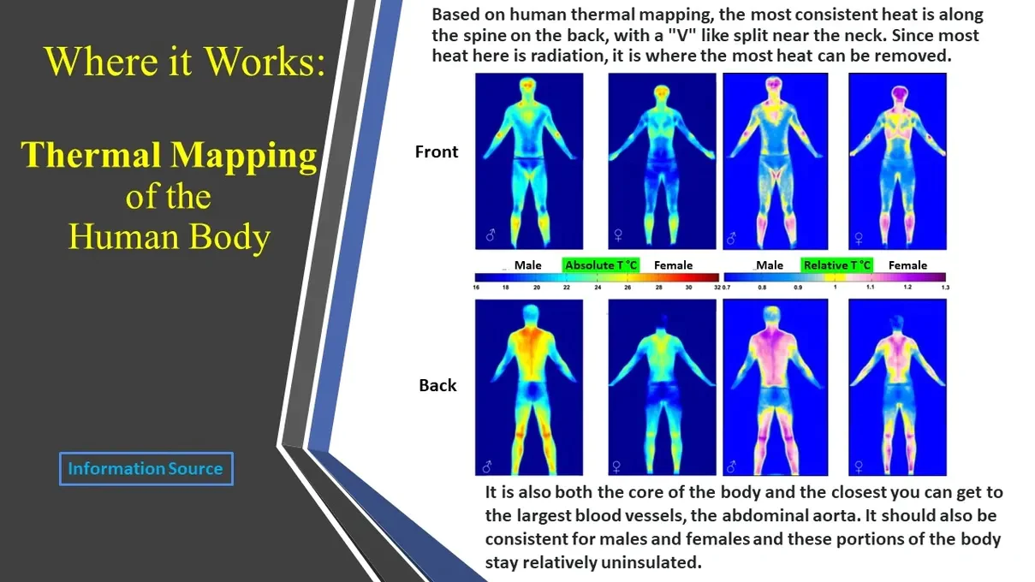
Today I looked at the shirt mentioned from yesterday which was air conditioned. In the description photos listed on the ad, there was an image of a thermal map of a person’s body. It had a caption on the image saying:

I will have to look at multiple trusted sources to confirm if this information is true. If so, I will use information like this to help me with the placement of the cooling device/suit’s pipes where they will have skin contact. This will optimize the device's efficiency by targeting the most heated areas in the human body.

August 15, 2023

So, I forgot to include this diagram as well from the air conditioned short sleeve shirt from yesterday:

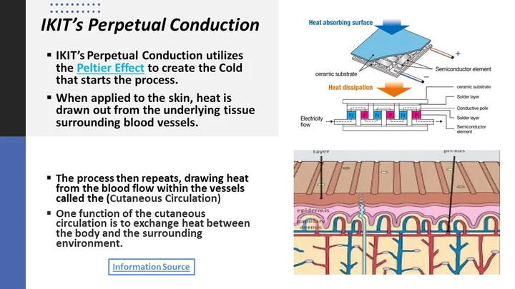

This diagram is about the IKIT Perpetual Conduction. Now, I'm not sure about what this conduction is and if it's accurate because when I searched “IKIT Perpetual Conduction '' nothing showed up relevant except for this image.

August 17, 2023

Today, I read an article about cold and warm sensitivities. In this article, it states that
“Cool and warm sensitivities are seen to vary widely by body part. The foot, lower leg, and upper chest are much less sensitive than average; in comparison, the cheek, neck, back, and seat area are 2–3 times as sensitive to both cooling and warming stimuli.”

I have also read about how the human body regulates heat. Another article about thermoregulation in human bodies states that “In thermoregulation, body heat is generated mostly in the deep organs, especially the liver, brain, and heart, and contraction of skeletal muscles.” I can say that from this information the cooling pipes in my device should be placed on the upper body. Specifically on the back, heart, and liver. I will do more research to determine where I should place the cooling pipes in an even more accurate and appropriate manner.

References:

- https://www.sciencedirect.com/science/article/abs/pii/S0360132319306456#:~:text=Cool%20and%20warm%20sensitivities%20are,both%20cooling%20and%20warming%20stimuli.

- https://www.rush.edu/news/how-body-regulates-heat

- https://www.vedantu.com/question-answer/does-the-human-body-generate-heat-class-8-physics-cbse-5ff2a82846b76d623b35a884

August 23, 2023

Today, I am starting to think about which pipe would be the best to use as these wildfire firefighters will be moving a lot while working. Which pipe would be the most efficient and flexible?

August 26, 2023

https://customthermoelectric.com/

September 22, 2023
DECIDED TO CHANGE TOPIC

Isolated chamber for firefighters or people, which include portable air purification

flexible transparent material (plastic).

Cooling blanket

October 27
Watched a video about tent design and looked at making trekking poles
November 1, 2023

Tent poles for pop-up tents are not visible, they are probably sewn into the tent itself. Pop-up tents use flexible tent poles. Look at tent ventilation

November 2, 2023
Should ask real wildland firefighters about the struggles they have at base camp, and with tents. + Ask about experience, and how it can be improved.
Instead of making a tent from scratch maybe I could modify a store-bought tent. Tyvek would be a great fabric for the tent because it would block out particulate matter from entering the tent. However, it can trap moisture. + can also be a little delicate. For the cooling blanket, I am planning on using the Peltier module system. Could use flexible transparent material to keep particulate matter out.

November 3, 2023

Lightweight material like the material being used for parachuting?
To test the tent I would need two monitors and a room that will fit the tent.

Maybe pop-up tents wouldn't be the best tent for this because they wouldn't be durable. Use guy ropes and pegs. Tent material also could be reflective (insert link about NASA prototyping structures). Polyester 400 material with reflective layering?

November 12, 223

Nov 29, 2023

`Today, I created a net for the tent (a-line shaped). I was experimenting with it and decided that even though a line-shaped tent was pretty common to use, I started to think about how the shape of that tent might not be space-efficient when it was time to pack it up. This was a problem, and I decided to brainstorm ideas on how I could fix that. Then, I remembered some time ago, my family and I went to Ikea and bought foldable recycling bins. These recycling bins were waterproof material and had no structure until I folded them up, and added in their support inserts (which were plastic flat rods). It had only taken just less than 2 minutes to have set up. Based on that information, maybe the tent design I would like to make could be based on this. I will have to add a few design elements and make the tent air-proof, but I believe that this could become a pretty decent tent design (if made correctly). This also solved my problem about keeping the tent space efficient, because when the users are done using the tent they can just take out the supports of the tent, and fold it down into a small square.

Insert net photos
Insert ikea recycling bin photos

December 9, 2023
Today, I thought about incorporating an electrostatic precipitator to help remove particles in the air by using electrical energy to charge the particles positively or negatively. The only issue with actually doing this was that this system required high voltage (around 10,000 volts CONFIRMATION REQUIRED) to work. This would be an issue, because one, where would I supply the electricity from, and second, it wasn’t safe at all to use due to the high voltage. I thought about creating a closed ESP (Electrostatic Precipitator) system, but unfortunately working with a high-voltage was dangerous since it wouldn't be practical, and later today, I also learned that ESPs could produce some ozone, which was a problem I wanted to avoid. So, in the end, I had to get rid of the entire ESP idea, but I am happy that I had gotten to learn more about such an interesting device. I also worked on my tent design and added some helpful features such as an inclined roof so any precipitation that fell onto the tent, could automatically slide down which would prevent the roof from caving into itself.

Dec 15, 2023
Today, I worked on thinking mainly about the tent design. I wanted to have the tent include a flexible solar panel, to help generate some electricity, however finding a flexible solar panel was expensive. Also, building a life-size tent wasn’t displayable (and I wanted the whole idea to be displayable to give viewers a more in-depth look), so instead of having the whole tent, I decided to have a smaller version that could still function, but for now this would be a concept. I also decided that the tent material would be transparent for viewing the inside system more in someone's field of view, without struggling to look inside at the air purification system.
Dec 23, 2023
Today, I explored different ways I could build and set up the tent in a fast and efficient manner. So far, I have looked at different tent net shapes. However, more research is needed to help make a good decision on the tent structure.
- Tent net
- Tent built

December 25, 2023
For the air purifier layout, I decided to improve the layout of the air purifier I built last year. In last year’s air purifier, when polluted air passed through only one air inlet (which was located at the bottom), it passed through some prefilter (which filtered out larger particle sizes), then through a box of activated charcoal and lava rocks (helped adsorb any existing volatile organic compounds and scents), and lastly through two hepa filters which both had a 99.5 percent filter efficiency in removing the smaller polluted particles which were left. The new layout (for this project) will work like this; Polluted air passes through 4 air inlets that are all prefilters (which are located at the sides of the air purifier), then through activated charcoal (which was surrounded by 4 hepa filters forming a cube without a top or bottom), the air then passes through the 4 hepa filters, and then goes out of the air outlet. Instead of using a 110-volt fan, I am still thinking about what kind of fan to use for the best airflow, but for now, I have decided to use multiple PC fans. The new design allows for more polluted air to be imputed into the air purifier, and it would be much faster than the previous design.
-PVC pipe greenhouse
- new air purification system layout
-

December 26, 2023
I focused on the tent structure today and learned about how people use PVC pipes and connectors to help construct a greenhouse. I thought that maybe I could somehow use PVC pipes for the tent structure because they are easy, and straightforward to use. PVC pipes are also very strong, which would make the tent structure reliable. I had also briefly thought about maybe changing the air purifier exterior into a cylinder, and then having polluted air pass through holes around the exterior, into the prefilter, then into the activated charcoal, and lastly through hepa filters cut into a circular shape. However, as I thought more about this, I just decided to not do this because it may not be portable, and I would have to cut the hepa filters (or buy them). The filter size would also be limited due to the circular shape, which won’t allow for much air to be purified at one time.

Dec 27, 2023
Today, I worked on 3d modeling my air purification device design using shapr 3D.

Jan 1, 2024
- Decided to use wet scrubber
I was thinking a bit about adding a wet scrubber

Jan 5, 2024
Today, I thought about how I could improve the design of the air purification system. I decided to add a pipe where the air outlet of the wet scrubber was connected by a pipe to a hole at the bottom of the air purifier. This way, the wet scrubber increases the efficiency of the air purifier because, one, the wet scrubber (which is aimed to remove specific chemicals in the air) will not only get rid of the chemicals commonly found in the atmosphere in situations like this (polycyclic aromatic hydrocarbons, Volatile organic compounds, etc) it will also help get rid of particulate matter. So, this will prevent the hepa filters from wearing out quickly. Second, the wet scrubber will specifically dissolve the polycylic aromatic hydrocarbons, which is something that cannot be done with the air purifier in this design because ein the air purifiers design, it uses activated charcoal which is a non specific adsorber. In the wet scrubber, the liquids I plan to use are water and oil. I chose water because some chemicals and particulate matter will be dissolved in water. On the other hand, after doing some research I decided to use oil because though some PAH’s can be soluble in water, some can also be dissolved in lipids such as oil.

Jan 14, 2024
- Use cyclodextrin solid to remove pahs from the air

Jan 22, 2024
- Decided to not continue with the cyclodextrin idea

Jan 23, 2024
Today I finalized the design for the air purifier on Shapr 3d.

Feb 28, 2024
- 3d layout of how much materials are needed.

Feb 29, 2024
Went to IKEA and bought four starkvind hepa filters for 14.99$ each.

Mar 1, 2024
Worked on Word to write parts of the information required on the CYSF platform

Mar 3, 2024
Today I went to Canadian Tire, Princess Auto, and Home Depot to gather materials for the air purifier. I got aluminum tape (3.49$), waterproof tape (2.51$), clear tarp tape (7.99$), glue gun (14.99), and Hot glue gun sticks (10.99).

Mar 6, 2024
Today I glued the hepa filters together to create a cube/box, and plan on creating the activated charcoal and prefilter boxes which will attach to the sides of the filters tomorrow.

Mar 7, 2024
Today I worked on making the frame for activated charcoal boxes/prefilter. I used white and blackboards (7 in total for a price of 12.5$). We measured and then cut out the pieces to fit with the hepa filters. Then, we created a cut-out where the hepa filter was and filed in the gap with fine metal mesh to add support and prevent the activated charcoal from clogging the hepa filters.

Mar 8, 2024, finished that frame
Glued the prefilter and activated charcoal boxes to the hepa filters. I also sealed the gaps in the boxes using hot glue and silicon cocking.

Mar 9, 2024
Today I bought more materials needed such as a fan for 23.99$ and a large 8-½ x 6W x 5-1/5H ft paint shelter (which will act as the tent for this project after a few modifications) for 49.99$. I chose this “tent” because it was the perfect size, inexpensive, and will be easy to modify. I also bought a 9” pre-filter for 19.99$, and a water dispenser for 19.99 $ for making the wet scrubber.
To test if the tent is airproof put tent material on top of a vacuum that throws air out (outward air flow) and place an anemometer on the other side to see if the air penetrates the surface. If it does, modify it to make it airproof.

Mar 10, 2024

Today I bought 2x foam weatherstrips one for 9.99$ and the other for 4.99$, and 2x clear silicone cocking for 14$. With the help of my dad, we cut the top parts of the box which were sticking out to make it level with the hepa filters using scissors, a mini hacksaw, and a sharp blade.

