Log Book 2026
Agastya Meghlan, Grade 9, Fairview School
Manipulating Hydrogel Release (MHR)

December 27, 2025

What are hydrogels?

- Spheres made of cross-linked polymer
- Usually hold liquids or some other sort of fluid substance
- Have pores which release the fluid inside of the hydrogel (contained substance)
- Similar consistency to jelly
- Retain 99% of their weight in water
- Hydrophilic (has a tendency to mix/dissolve in water)
- Usually made by creating a covalent bond between water and polymer atoms for a stronger and more durable hydrogel
- Can be used to deliver medicine over a long term
- Very easily manipulated to change the amount of time it takes to release all of the contained substance

December 28, 2025

How to manipulate hydrogels
- Scientists are studying how hydrogels can be manipulated in order to change the amount of time and the location at which the controlled substance is released
- Scientists have a theory that the pH level of different body parts can have an effect on the rate at which the contained substance is released.
  - This is because a difference in pH tends to make the hydrogel swell or shrink, and sometimes the covalent bonds between the polymer atoms are reactive to more acidic environments, causing them to weakening and making the hydrogel shrink and even burst.

- The concentration of a binding agent or thickening agent in the original mixture used to create the hydrogel also has a correlation to pore size, which has a correlation to the maximum amount of contained substance which can be released at any given time. This is because the hydrogel becomes more dense and more solid, so there is less space between the atoms. This leads to a smaller pore size, which means a lower output of contained substance.

December 29, 2025

Experiment Details

Materials:

- Gelatin Powder (dad)
- Distilled Water (home)
- Vinegar (sobeyes)
- Baking Soda (home)
- Blue Food Dye (sobeyes)
- Graduated cylinder or some sort of measuring tool (measuring cup from home)
- Glass cups (identical) (home)
- Syringe or Pipette (amazon)
- Spoon or stirring stick (home)
- Spherical molds (amazon)
- ImageJ (computer software)
- White paper (dollarama)
- Weighing scale (home)

Procedure:

Testing effect of ph levels of conditions on drug release rate

- Heat 90mL of distilled water until it is slightly warm
- Add 10g of gelatin powder to the water and stir until the solution is clear
- Pour the gelatin solution into a mold to create 12 identically sized spheres
- Allow the gelatin to set for 2 hours at room temperature
- Remove the gelatin spheres from the mold
- Using a syringe or pipette, fill the sphere with 5ml of blue food dye
- Allow the hydrogels to sit for 10 minutes
- Fill four glasses with the following solutions:
  - Vinegar for an acidic environment
  - Diluted vinegar for a slightly acidic environment (1 part vinegar for 4 parts water)
  - Distilled water for a neutral environment
  - Baking soda for a basic environment (1 gram baking soda for 100mL water)
- Measure the ph level of each solution and record it
- Place one hydrogel into each solution and immediately start a stopwatch
  - Ensure there is constant lighting, and the device used to take pictures remains stable and in the same location throughout the experiment
- Take photographs at 0,5,10,15,20,25,30, and 35 minutes into the stopwatch
- After 35 minutes, remove each hydrogel from its solution. Repeat steps 8-11 twice more for a total of 3 trials.

Testing effect of gelatin concentration of hydrogels on drug release rate

- Prepare the following 3 solutions
  - 5% gelatin: 5g of gelatin powder and 95mL of warm water
  - 10% gelatin: 10g of gelatin powder and 90mL of warm water
  - 15% gelatin: 15g of gelatin powder and 85mL of warm water
- Stir each solution until it is clear
- Pour each solution into identical spherical molds to create 9 hydrogels of each ph level.
- Allow the hydrogels to set for 2 hours
- Remove the hydrogels from the molds, and inject them with 5mL of blue food dye. Allow the hydrogels to rest for 10 minutes
- Prepare 3 glasses of 100mL distilled water
- Place one hydrogel into each glass and start the stopwatch
- Photograph each hydrogel at 0,5,10,15,20,25,30, and 35 minutes after starting the stopwatch.
  - Remember to keep lighting and camera position constant
- After 35 minutes, remove the hydrogels from their glasses.
- Repeat steps 5-9 twice more to complete 3 trials.

January 6, 2026

How do hydrogels work?
- Diffusion is the process by which molecules move from an area of high concentration to an area of low concentration due to random thermal motion, known as Brownian motion.
- The rate of diffusion is described by diffusivity, which represents how easily a solute can move through a medium rather than its speed.
- In hydrogels, diffusion occurs as the solute travels through a water-filled polymer network.
- The structure of the hydrogel influences diffusion by controlling pore size and resistance to movement.
- Increasing gelatin concentration increases polymer density and reduces pore size, which restricts molecular motion and lowers the effective diffusion rate.
- According to Fick’s First Law, diffusion rate depends on both the concentration gradient and the diffusion coefficient of the medium.
  - Changes in hydrogel structure or environmental pH can alter this coefficient, allowing diffusion rate to be controlled while maintaining hydrogel stability.

How to make the judges care

Say something like this
  - Hydrogels are an up and coming technology in the medical field. They are an innovative way to administer long term medicine to patients, and have the potential to treat cancer. By studying how we can manipulate and control the release of drugs via hydrogels, we can further our understanding on how hydrogels can be used in the future.
  - As I said before, hydrogels are an up and coming breakthrough. This research that I have conducted can help grow more awareness for hydrogels and help guide more research and education on hydrogels and how they work. In the foreseeable future, hydrogels will be used as a primary form of medication for long term diseases and lengthy, low-dosage medication. By studying the different variables which can affect the release we can learn how to prevent and take advantage of these variables in order to individualize and specialize hydrogels from treatment to treatment, and from person to person.

January 7, 2026

Sources of Error
- Small inconsistencies in the shape and size of the hydrogel
- Small inconsistencies in the measuring of the contained fluids
- Small inconsistencies in the ratio of acidity or basicness in the environmental fluid

January 15, 2026

Began first experiment: pH test 1

- I decided to go for a an hour rather than 35 minutes because I feel like 35 minutes isn’t enough time to make a meaningful observation

5 Minutes
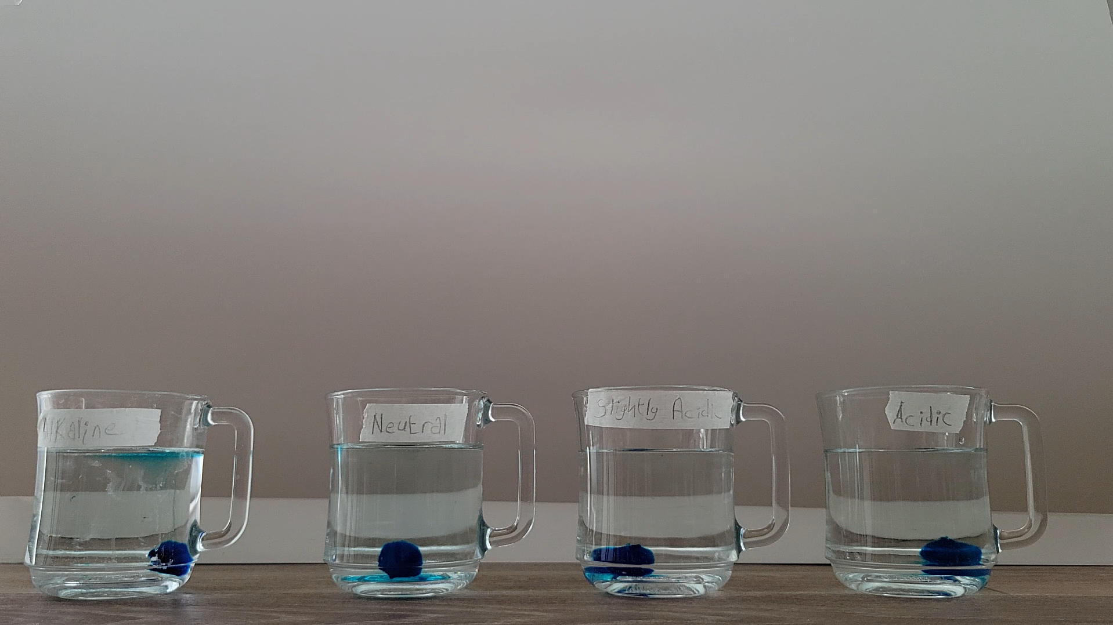

15 Minutes
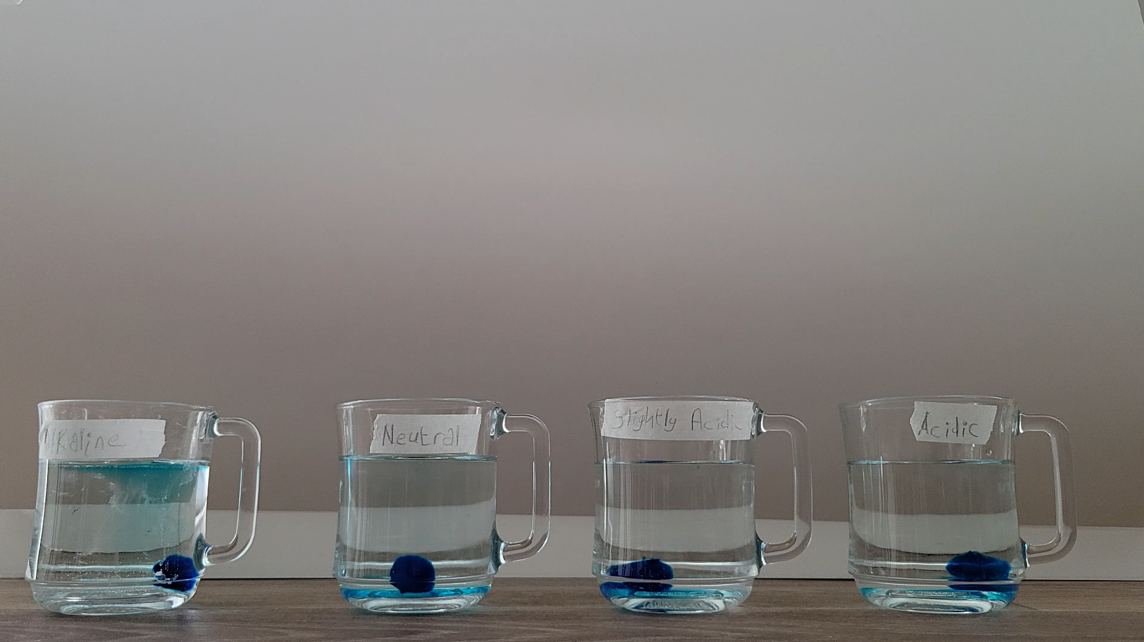

30 Minutes
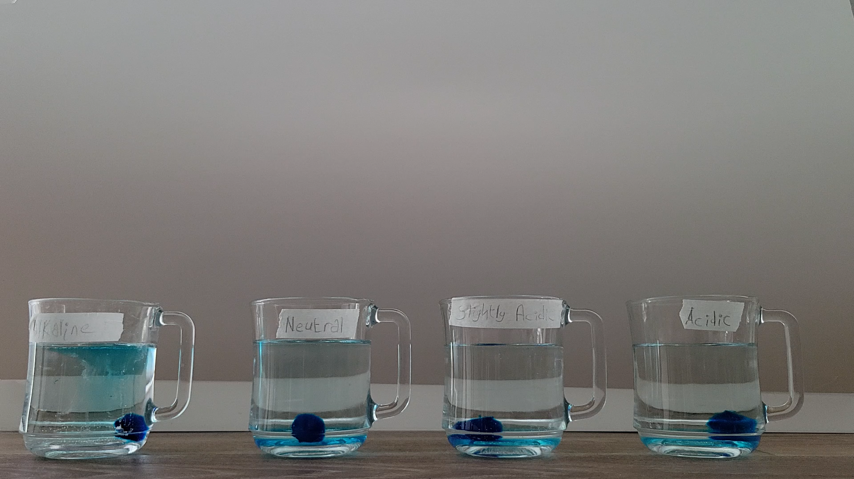

60 Minutes
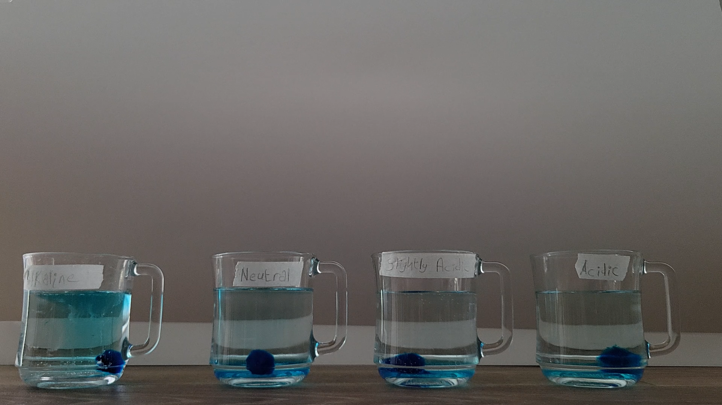

January 16, 2026

pH test 2

5 Minutes
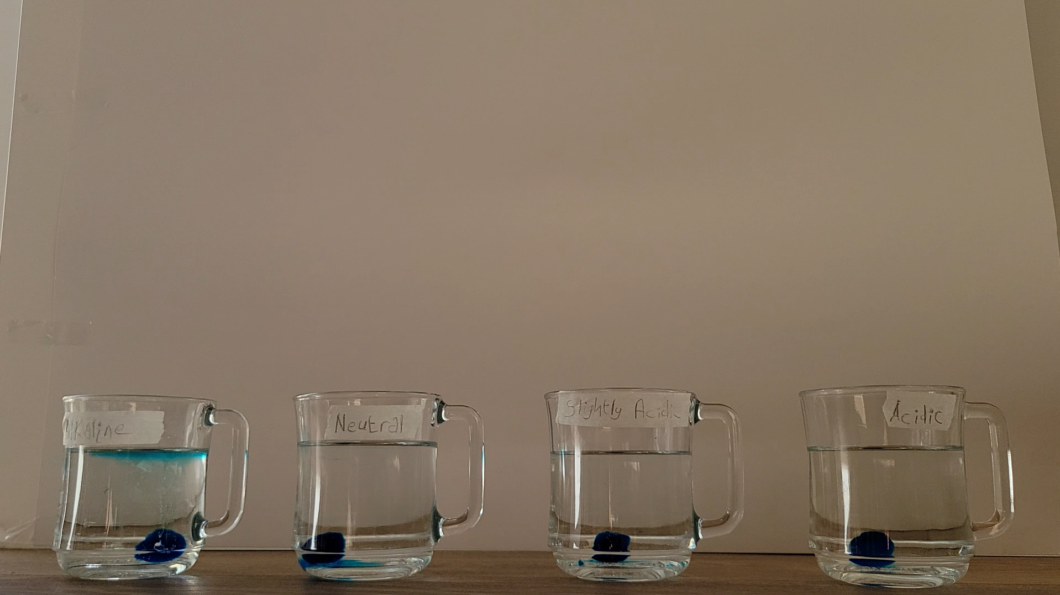

15 Minutes
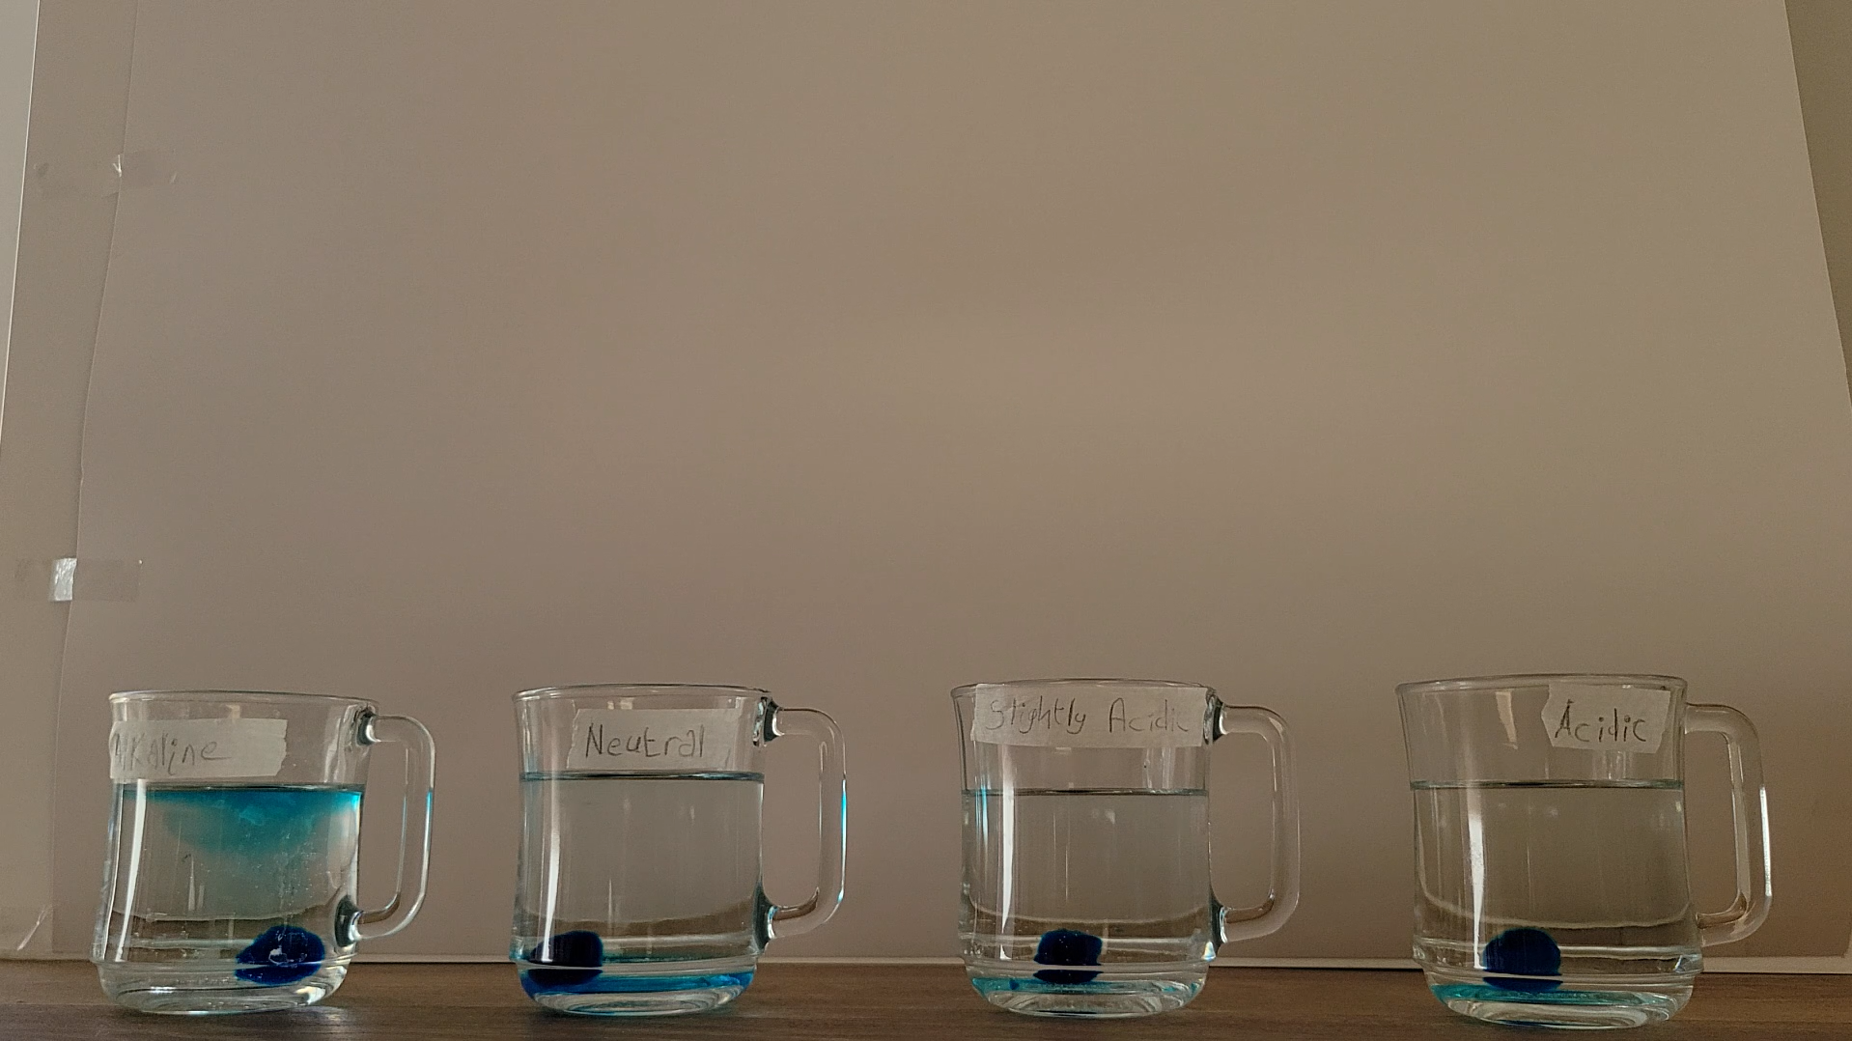

30 Minutes
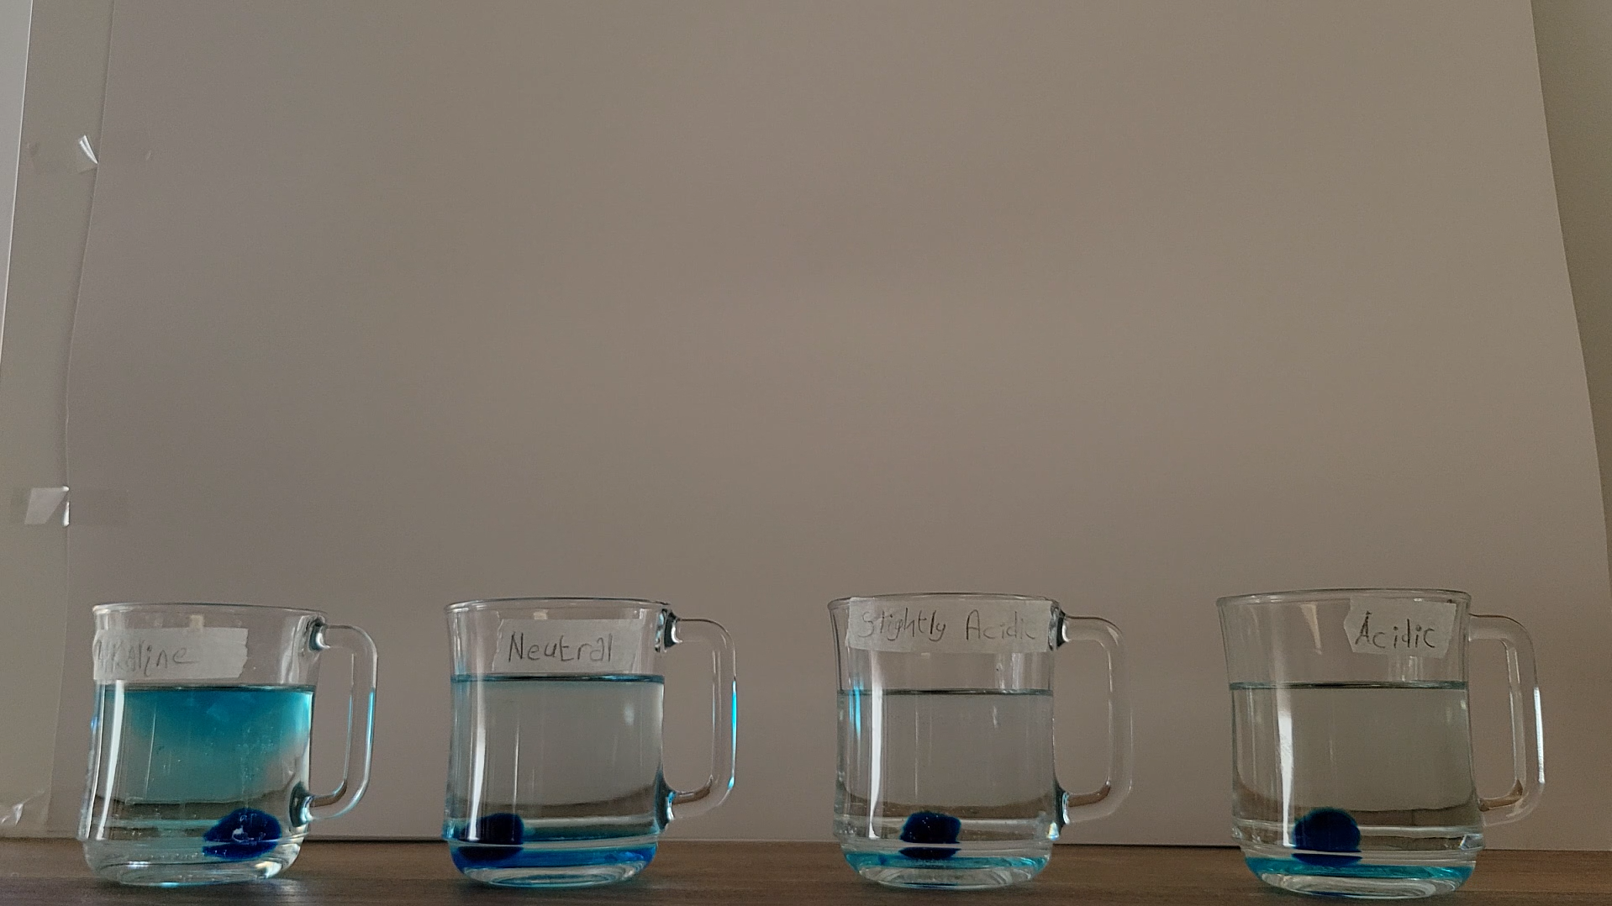

60 Minutes
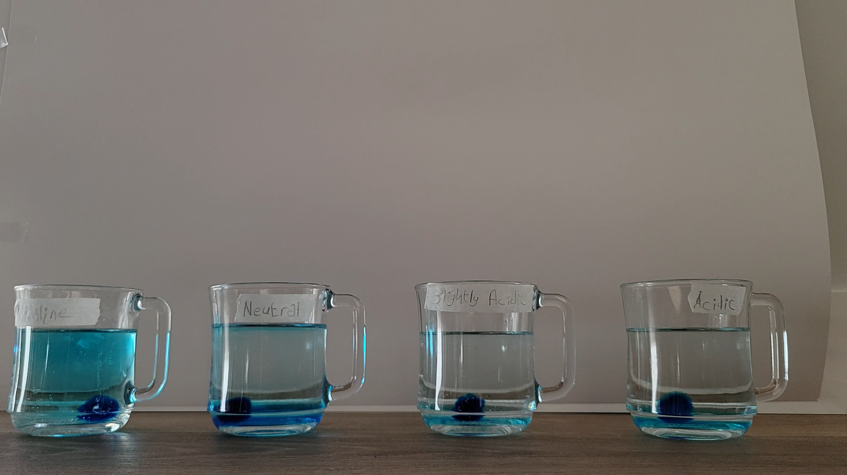

January 18, 2026

pH test 3

5 Minutes
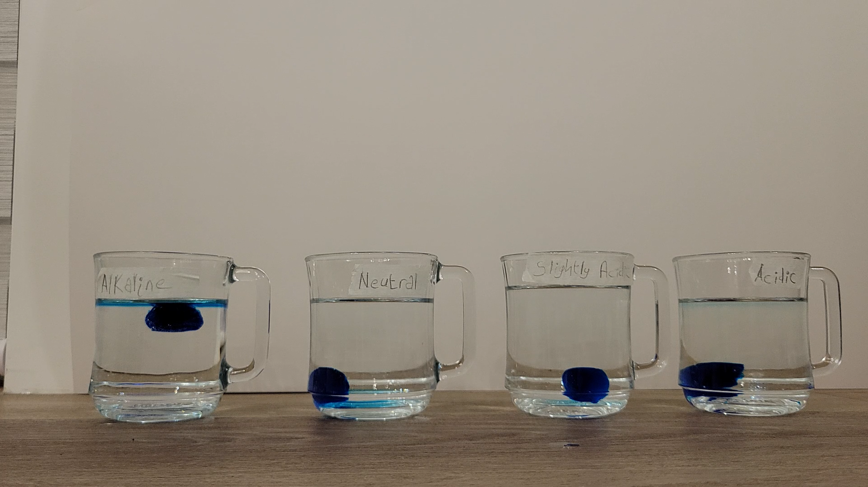

15 Minutes
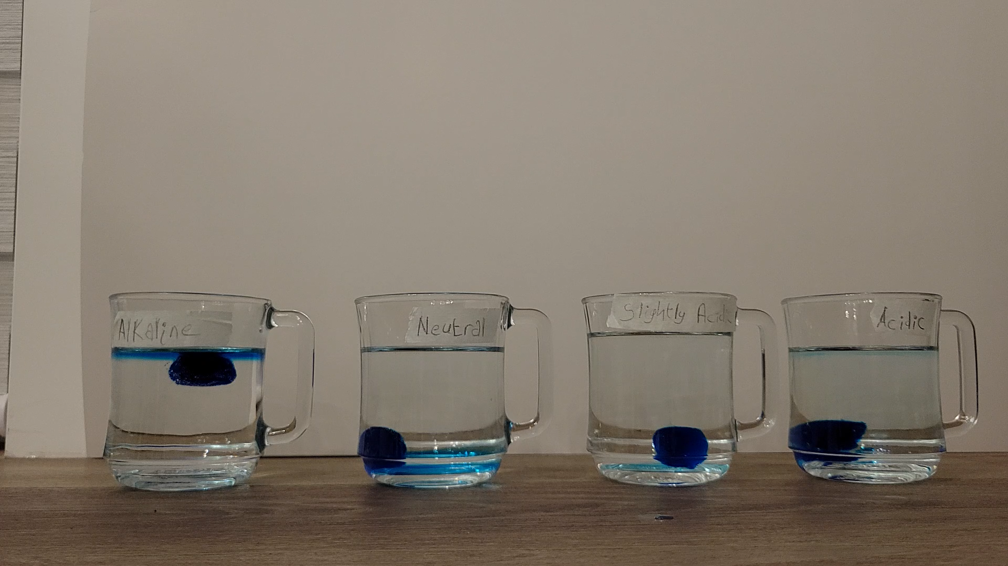

30 Minutes
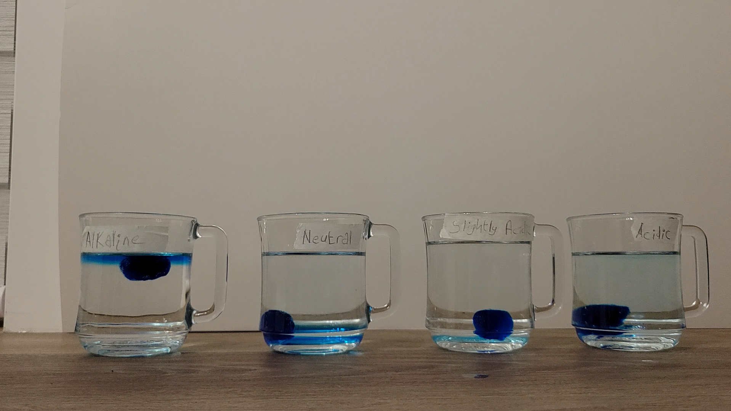

60 Minutes
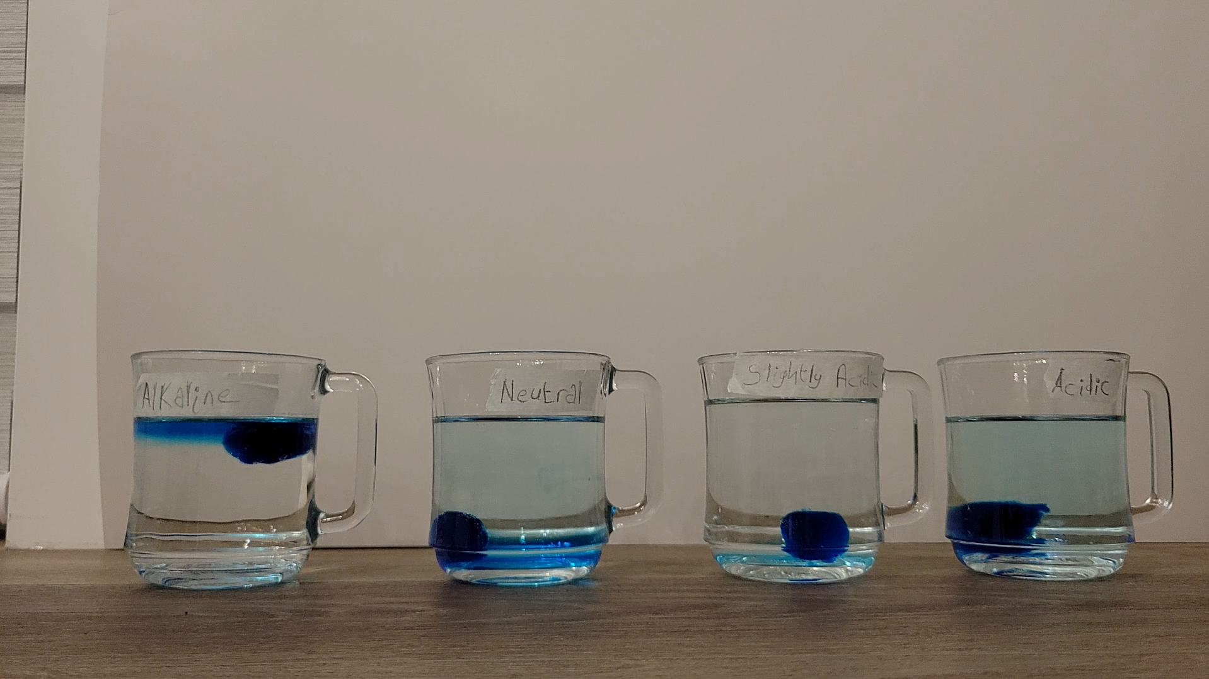

January 19, 2026

Concentration test 1

5 Minutes
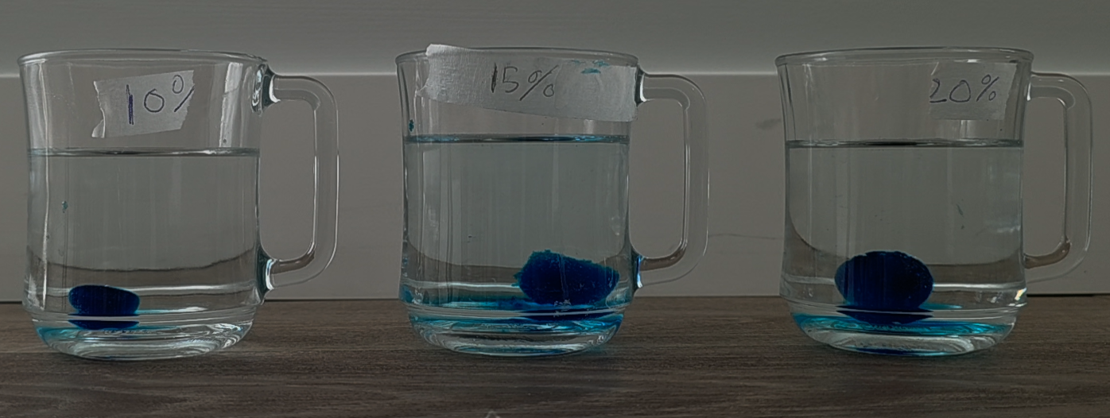

15 Minutes
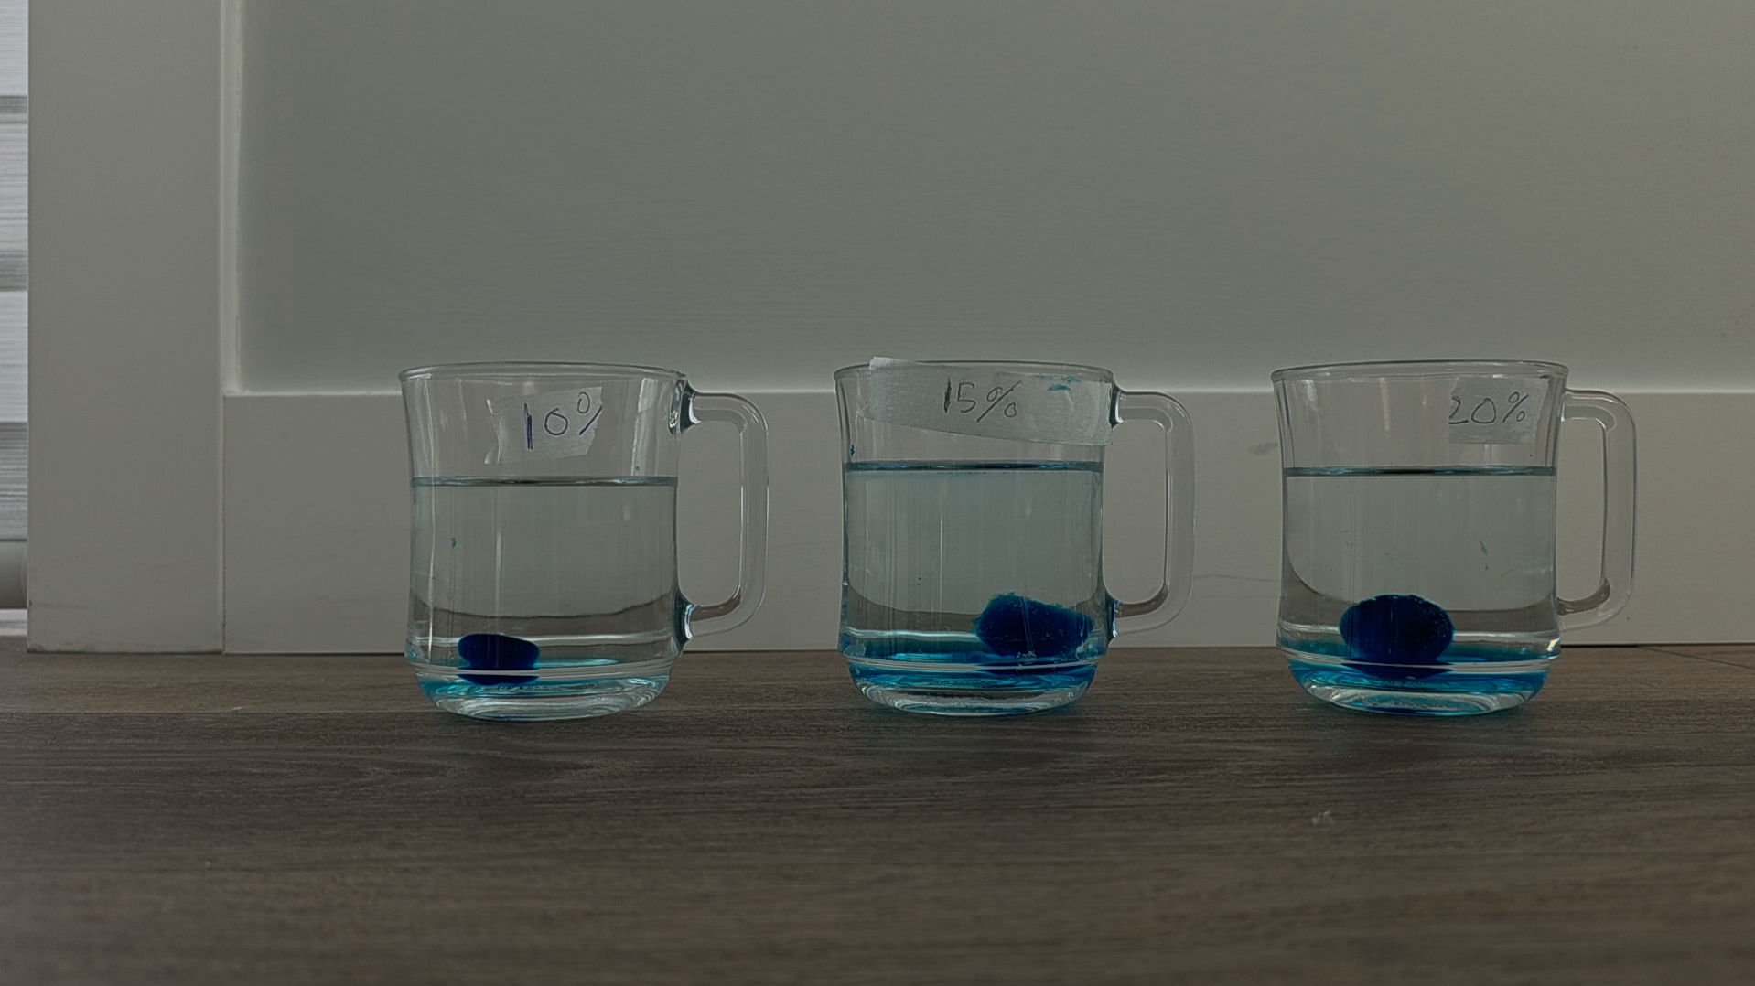

30 Minutes
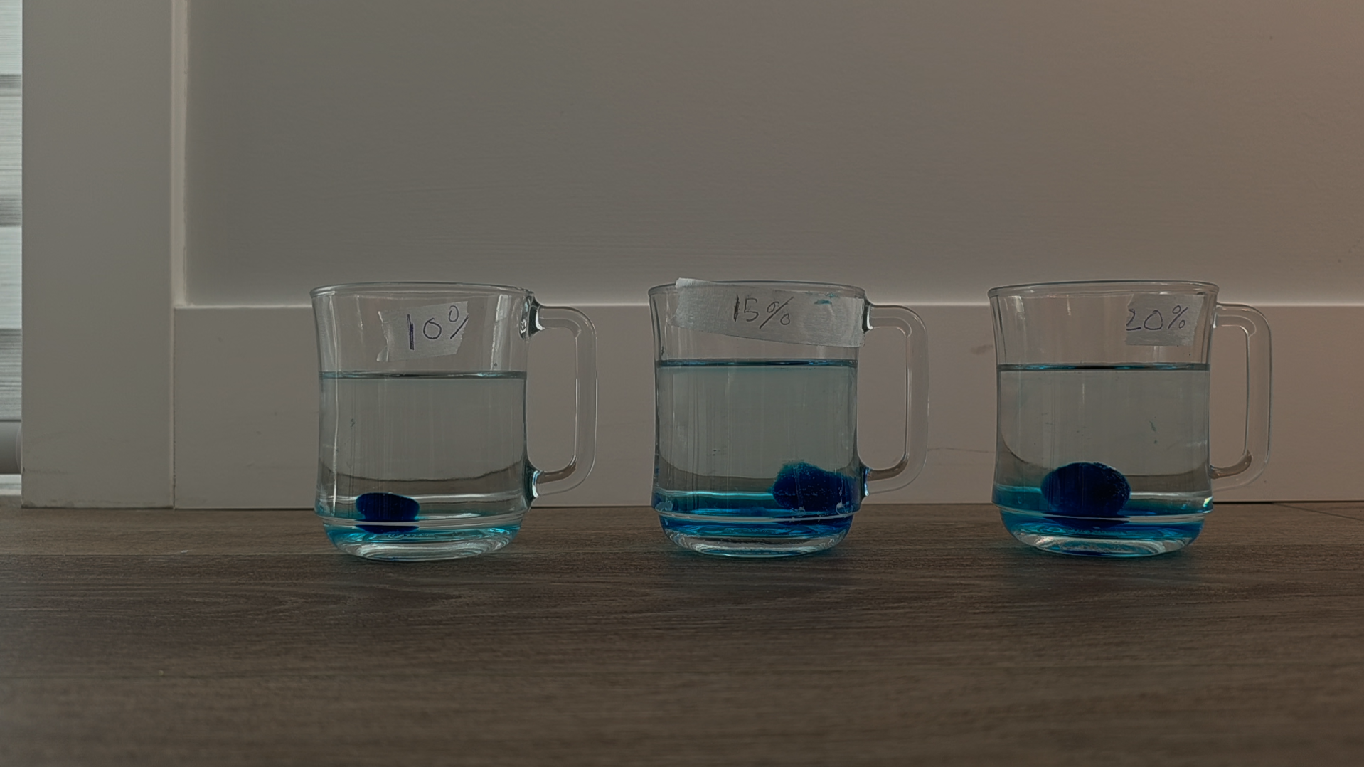

60 Minutes
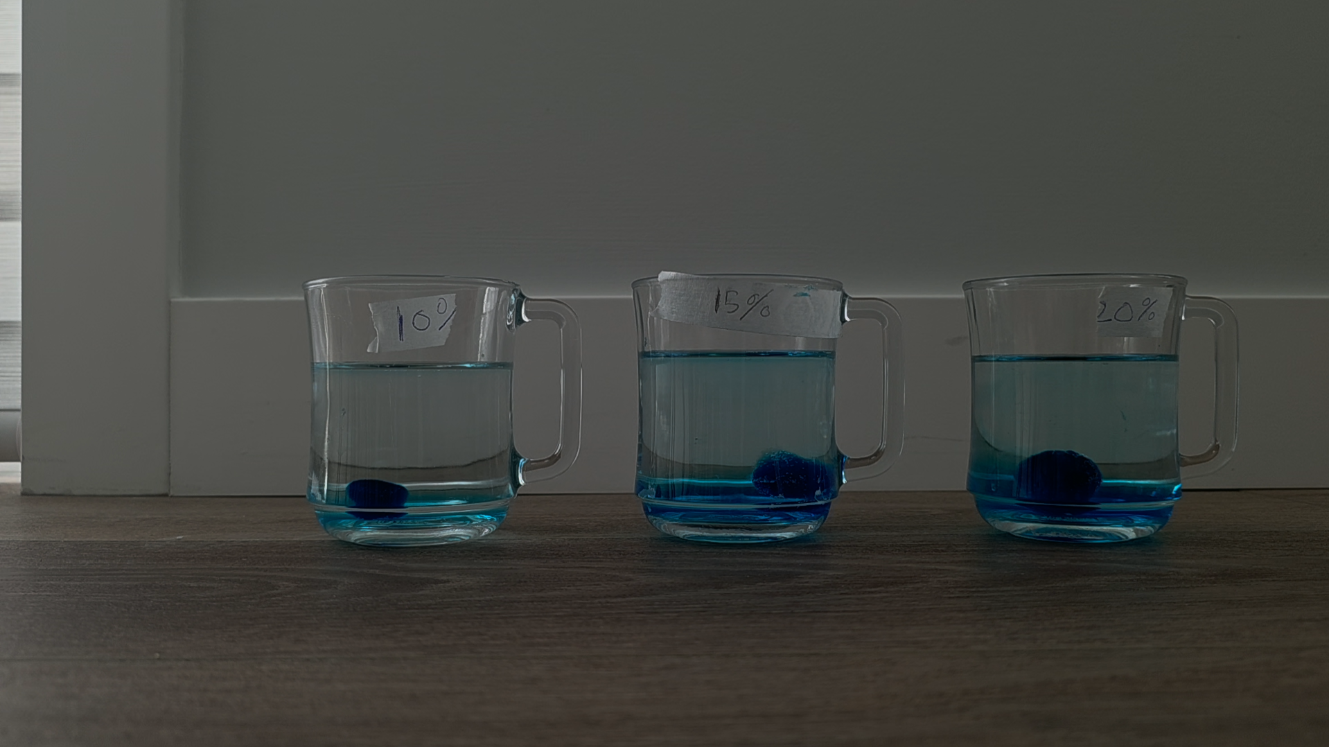

Measured and organized results for pH

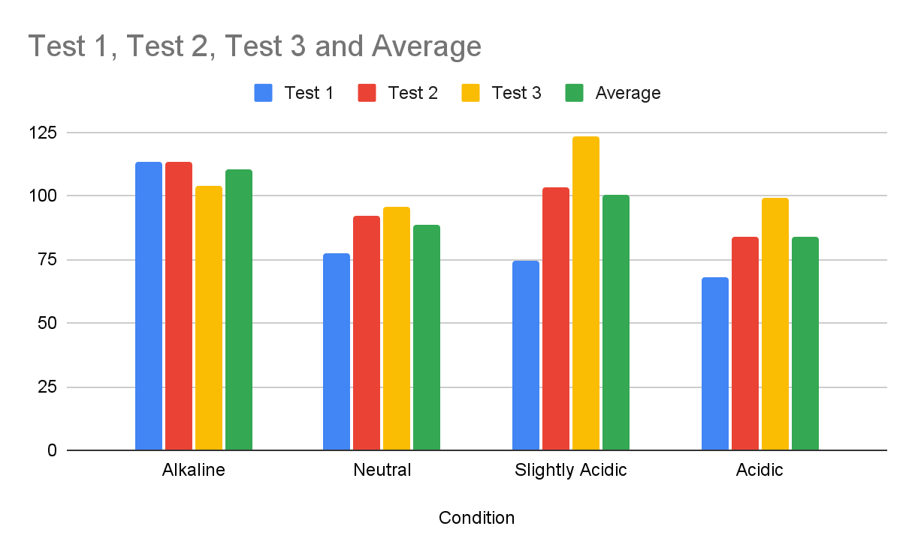
Full Results Sheet

January 20, 2026

Concentration test 2

5 Minutes
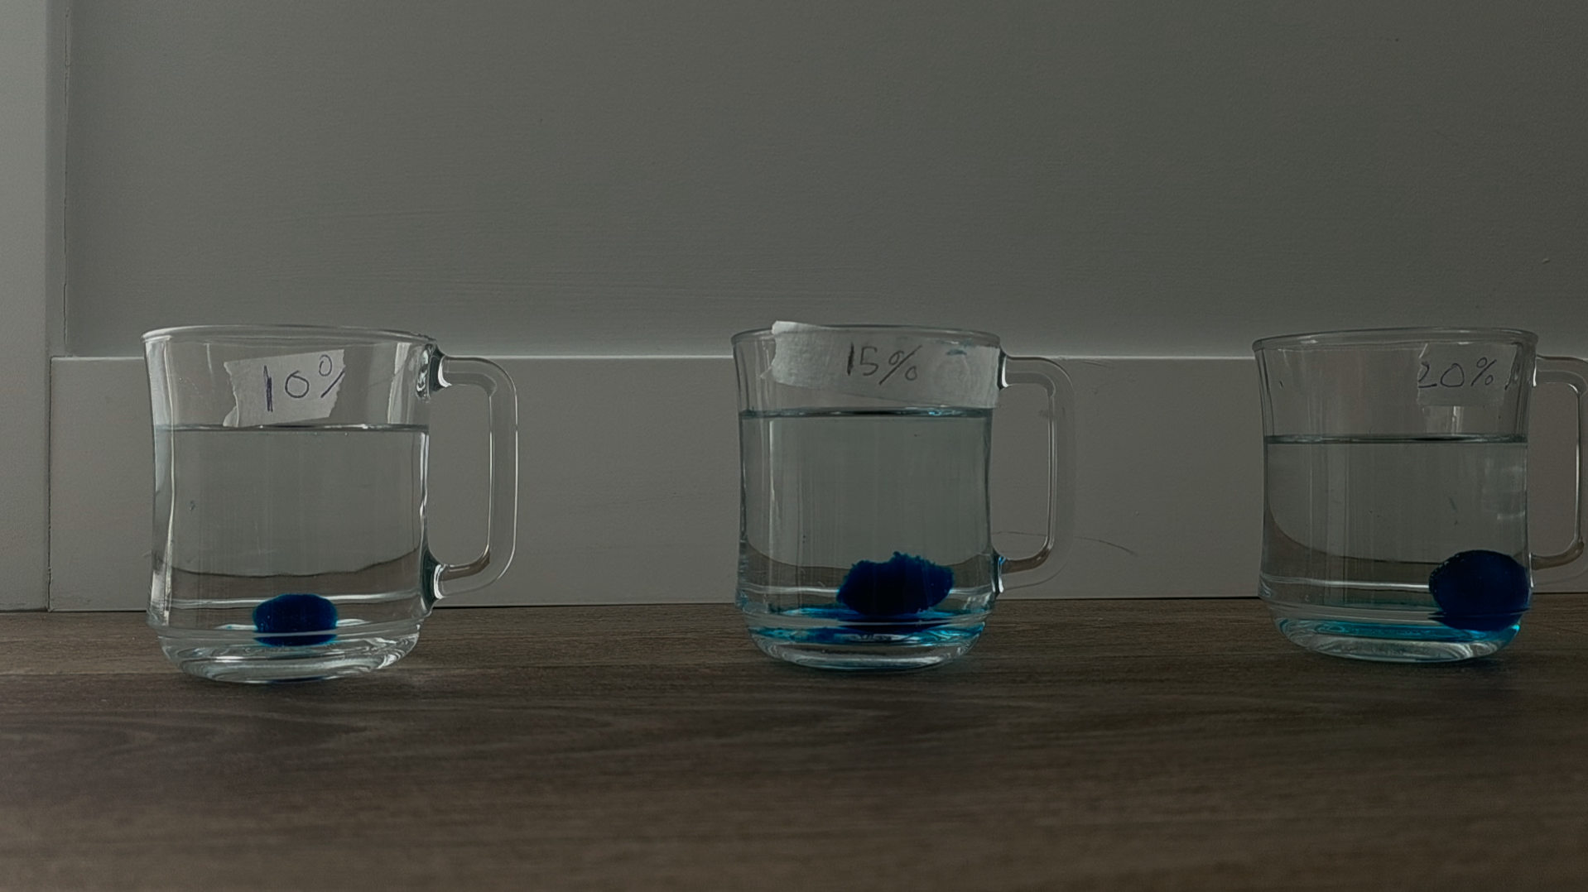

15 Minutes
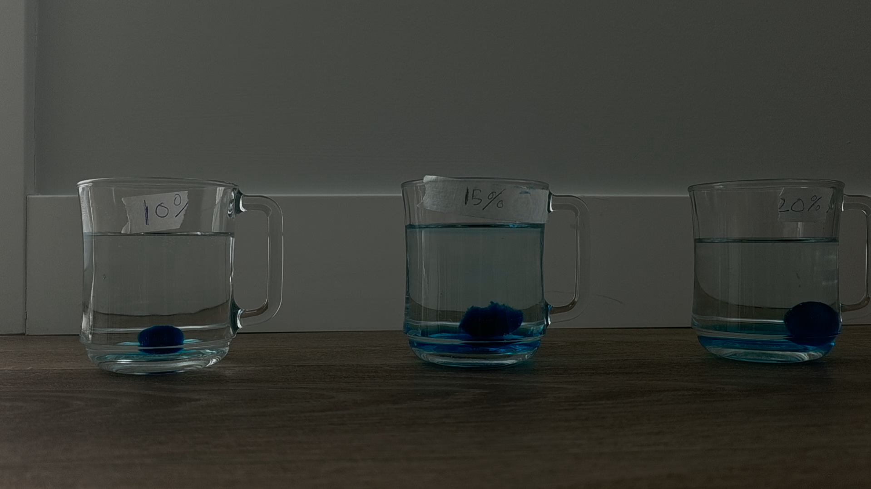

30 Minutes
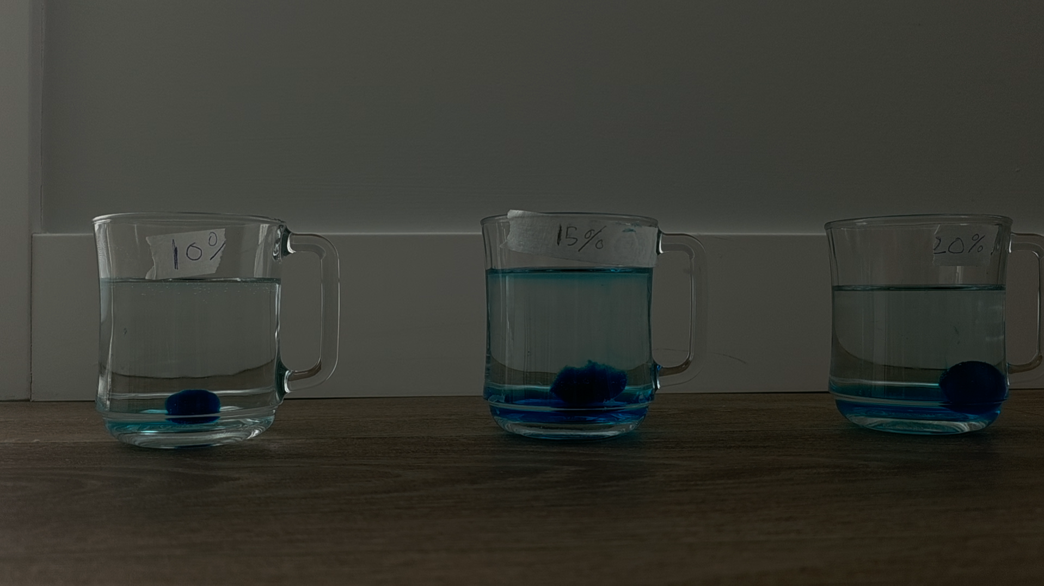

60 Minutes
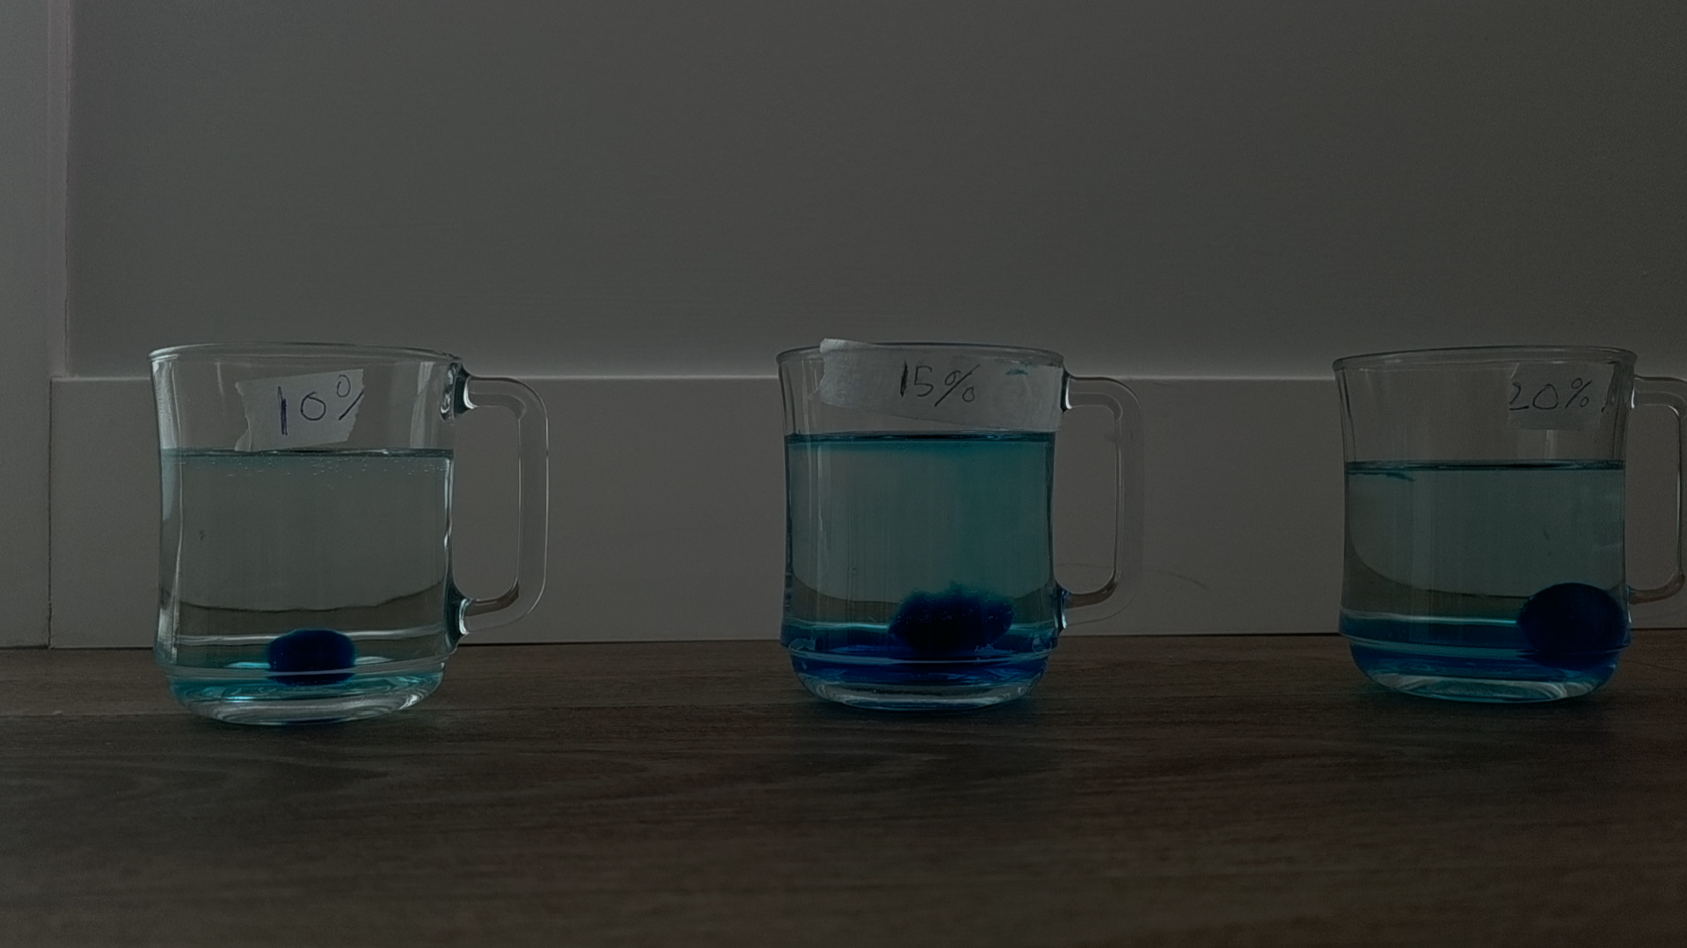

January 21, 2026

Concentration test 3

5 Minutes
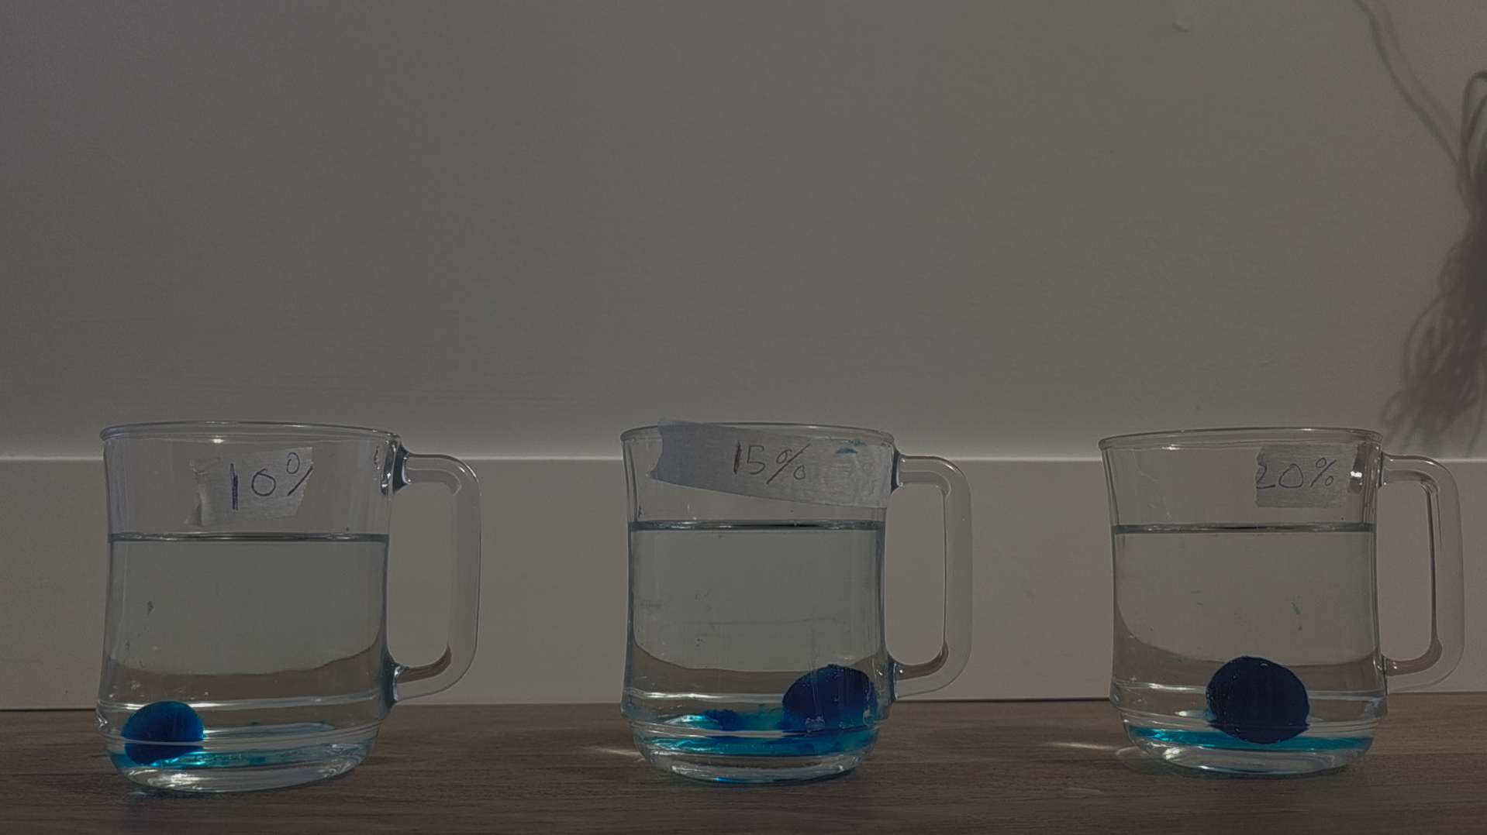

15 Minutes
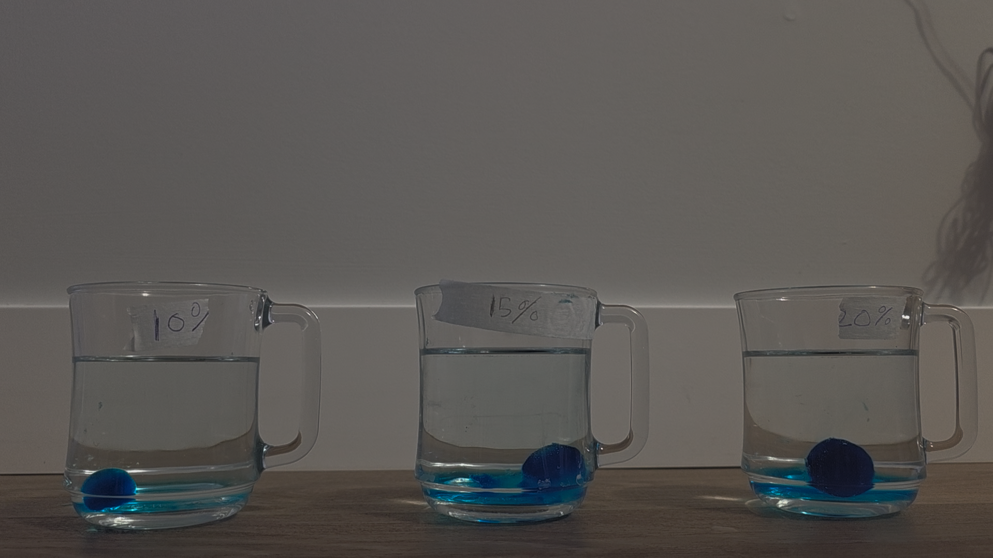

30 Minutes
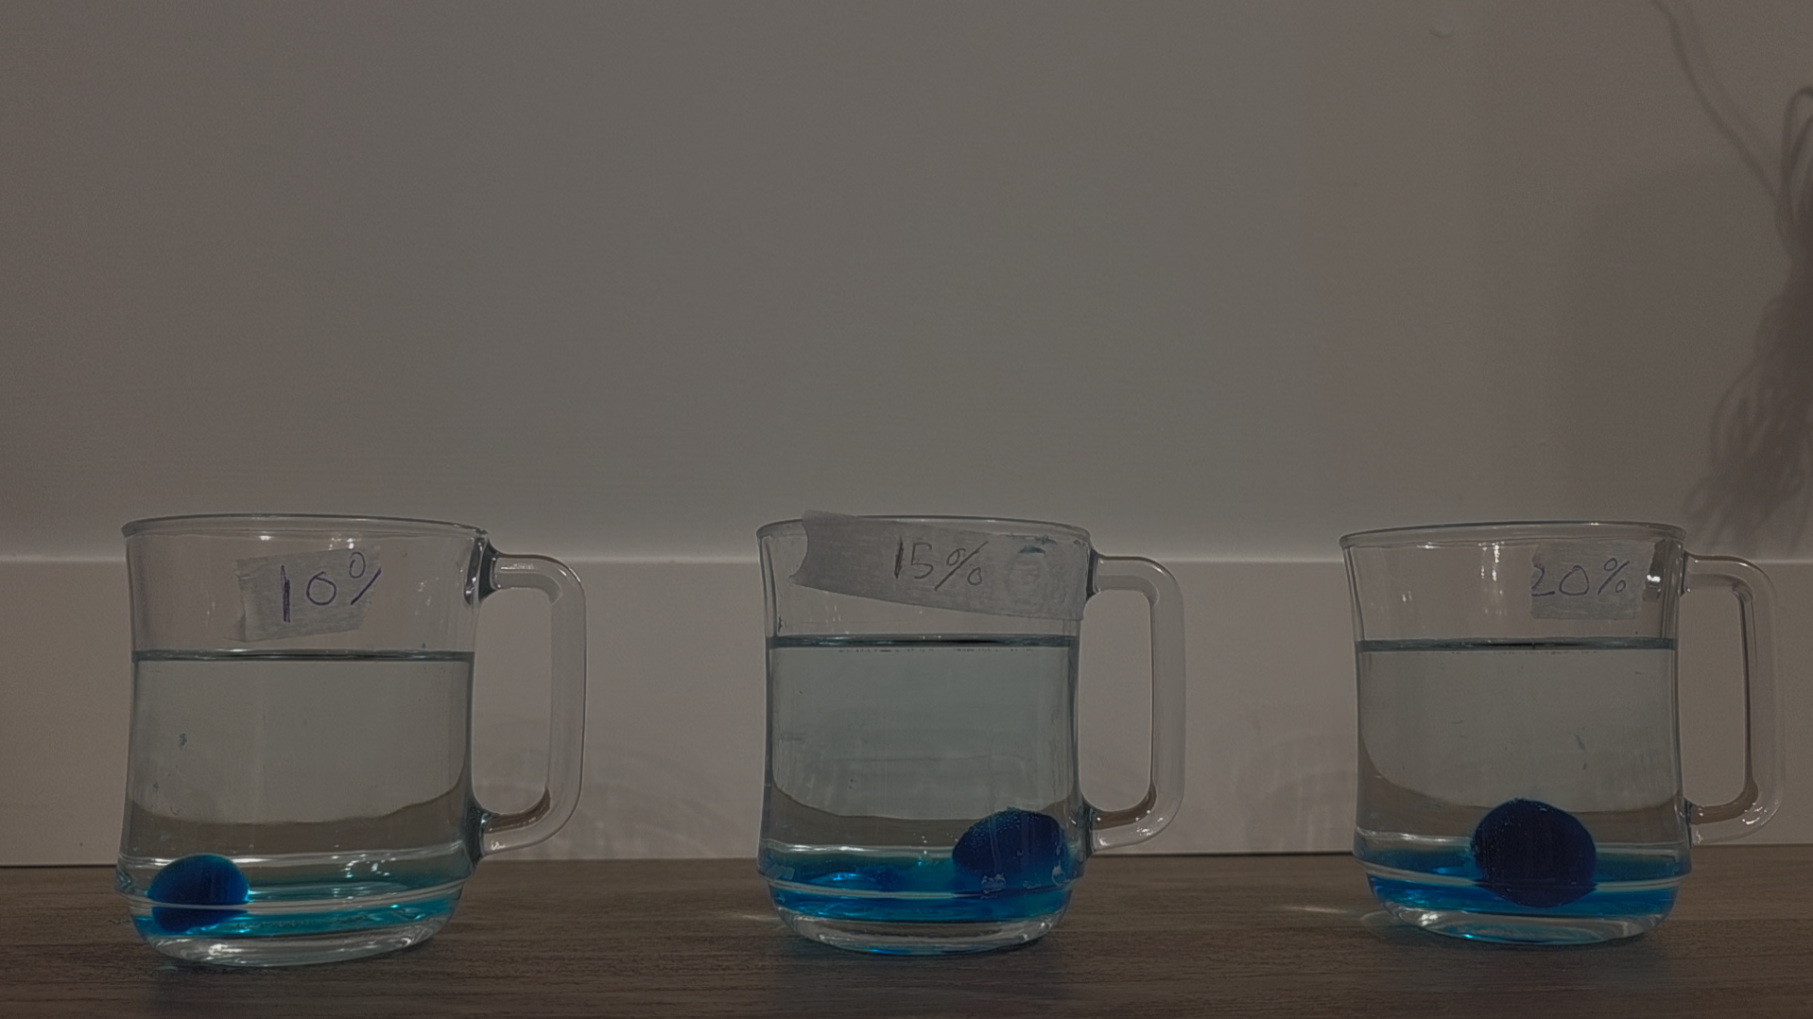

60 Minutes
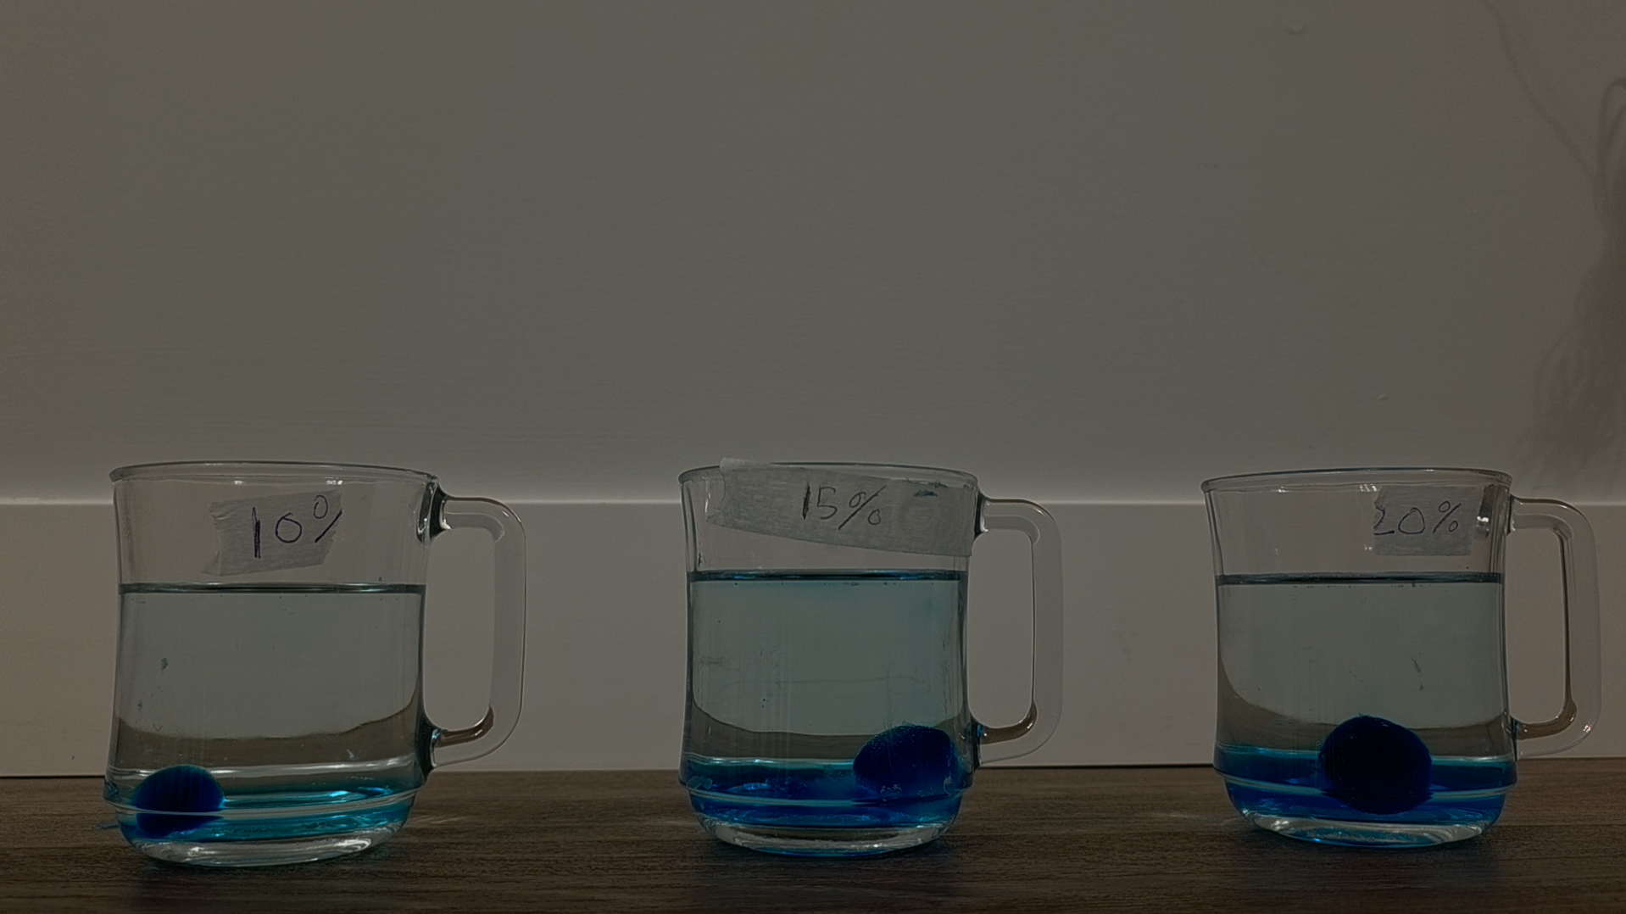

Slideshow
Results

Works Cited
pH Sensitive Hydrogels in Drug Delivery: Brief History, Properties, Swelling, and Release Mechanism, Material Selection and Applications, https://pmc.ncbi.nlm.nih.gov/articles/PMC6432076/. Accessed 24 January 2026.
bock, n. Hydrogels as Drug Delivery Systems: A Review of Current Characterization and Evaluation Techniques, https://pmc.ncbi.nlm.nih.gov/articles/PMC7762425/. Accessed 24 January 2026.
“Diffusivity.” Hydrogel Design, https://hydrogeldesign.org/diffusivity/. Accessed 2 January 2026.
Erikci, Saliha, and Joachim Spatz. “Kinetic and Mechanistic Release Studies on Hyaluronan Hydrogels for Their Potential Use as a pH-Responsive Drug Delivery Device.” MDPI, 12 November 2024, https://www.mdpi.com/2310-2861/10/11/731? Accessed 24 January 2026.
Goforth, Cynthia. “Fick's First Law of Diffusion | Equation & Example - Lesson.” Study.com, https://study.com/learn/lesson/ficks-first-law-equation-examples.html. Accessed 2 January 2026.
Patel, Megha. “pH stimuli-responsive hydrogels from non-cellulosic biopolymers for drug delivery.” Frontiers, 11 September 2023, https://www.frontiersin.org/journals/bioengineering-and-biotechnology/articles/10.3389/fbioe.2023.1270364/full? Accessed 24 January 2026.
“pH in the Human Body.” News-Medical.Net, https://www.news-medical.net/health/pH-in-the-Human-Body.aspx. Accessed 2 January 2026.
Rizwan, Muhammad. “pH Sensitive Hydrogels in Drug Delivery: Brief History, Properties, Swelling, and Release Mechanism, Material Selection and Applications.” MDPI, https://www.mdpi.com/2073-4360/9/4/137? Accessed 24 January 2026.
torchilin, v. “Hydrogels and Their Applications in Targeted Drug Delivery.” PubMed Central, 8 February 2019, https://pmc.ncbi.nlm.nih.gov/articles/PMC6384686/. Accessed 24 January 2026.
“Understanding the Key Properties of Gelatin for Optimal Manufacturing Applications.” Funningpu, Funningpu, 12 October 2024, https://www.fnp-gelatin.com/news/understanding-the-key-properties-of-gelatin-for-optimal-manufacturing-applications.html#:~:text=The%20isoelectric%20point%20of%20gelatin,gelatin%20for%20particular%20applications%E2%80%8B. Accessed 6 January 2026.
Varshosaz, J., and M. Falamarzian. “Drug diffusion mechanism through pH-sensitive hydrophobic/polyelectrolyte hydrogel membranes.” 2001, https://www.sciencedirect.com/science/article/abs/pii/S0939641101001266#:~:text=This%20hydrogel%20is%20quite%20hydrated,of%20the%20solutes%20%5B3%5D. Accessed 28 December 2025.
Yanagida, Toshio, and Akihiko Ishijima. “Brownian Movement.” Science Direct, Science Direct, 2025, https://www.sciencedirect.com/topics/physics-and-astronomy/brownian-movement#:~:text=In%20subject%20area:%20Physics%20and,How%20useful%20is%20this%20definition? Accessed 2 January 2026.

