Log book
Usman Arain Grade 6 T - OBK

- October 30: After giving it countless thoughts, I decided what my project would be about. Hydration is very important for the body and it affects people every day. So I decided to work on the topic of hydration.

Nov 10, 2025
- I decided to make my project about hydration and the effect it has on factors such as the skin and heart. Although hydration affects almost every organ of the body, I decided to focus on two vital organs where immediately affect is visible.

Nov 15 2025

- I decided to do some literature searches about my subject. I read through the multiple articles I found related to my title. Most of the literature was searched through Medline (PubMed) database which is one of the biggest research articles database on medical related research.

- After searching for articles that were related, I read through them and then cited those articles to my project.

Nov 19 2025
- I gave it some thought, and I decided the most fitting approach to this topic would be an intervention study.

- I discovered a device that can measure hydration, and purchased the device.

- I initially found 2 devices: the first one was a scale and the second one was a device that checks skin hydration. I decided to buy the skin hydration device and used it in my project.

Dec 02 2025 - Dec 15 2025

- I considered several possible study methods for this project but finally decided to use a before and after experimental study design for this project, using the skin hydration device and other measurements as part of the experiment.

Jan 10, 2026
- I thought about a number of possible research questions, but none really stood out or were that good. After researching articles related to my topic, I realized that all the experiments done were all long term (>1hour). So I decided to see what kind of effect an experiment would have in under 1 hour (short-term). So that's what I decided to do. So I decided to do a moderate physical activity such as brisk walk as an intervention to measure hydration before and after. The research question I came up with “How does short-term (<30 mins) physical activity impact hydration on the skin and heart?
- My hypothesis was “As little as 20 minutes physical activity significantly changes the amount of hydration in the skin and heart.”

Jan 15, 2026

- I researched other possible ways to check hydration levels. I found a few other ways to check hydration levels such as respiratory rate, saliva tests, and much more.

- I decided for this project I will use skin hydration testing, respiratory rate and heart rate to check hydration levels.
- 20 mins uninterrupted moderate indoor physical activity (brisk walk) at room temperature over 3 days. No eating or drinking (such as water sips) was allowed during the period of intervention. The same intervention was used for all study participants.

- During every record, I set a 20 min timer for the intervention of brisk walk (moderate level physical activity). I always used the skin hydration machine on the same spot for every participant. To check the respiration rate, I counted chest and abdominal movement per min. The same person was always checking the respiration rate. The heart rate was measured by a digital monitor.

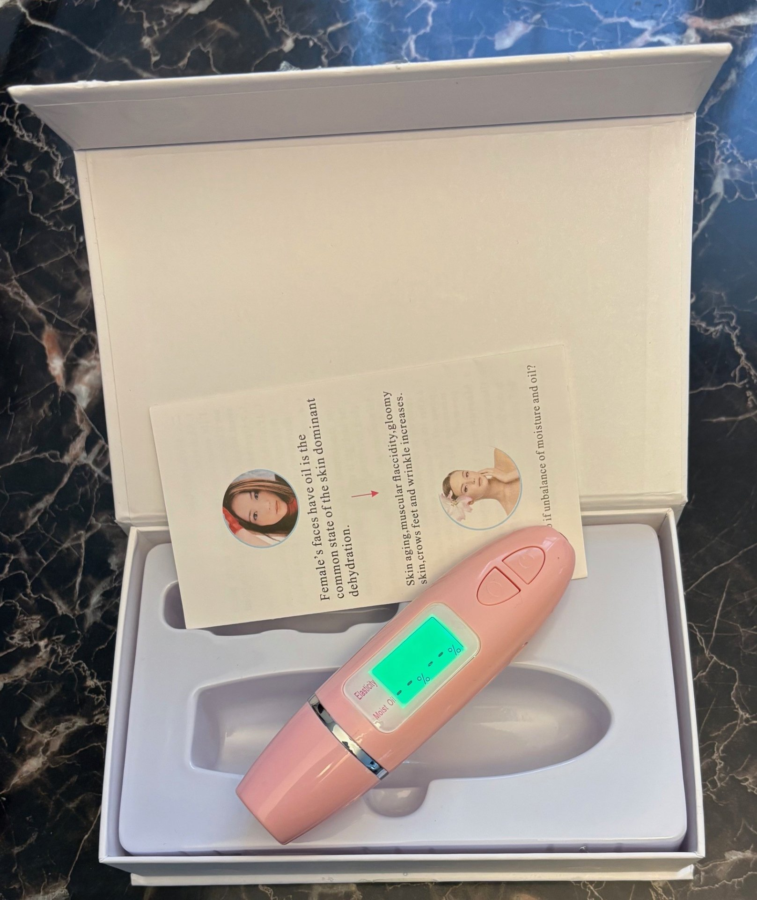

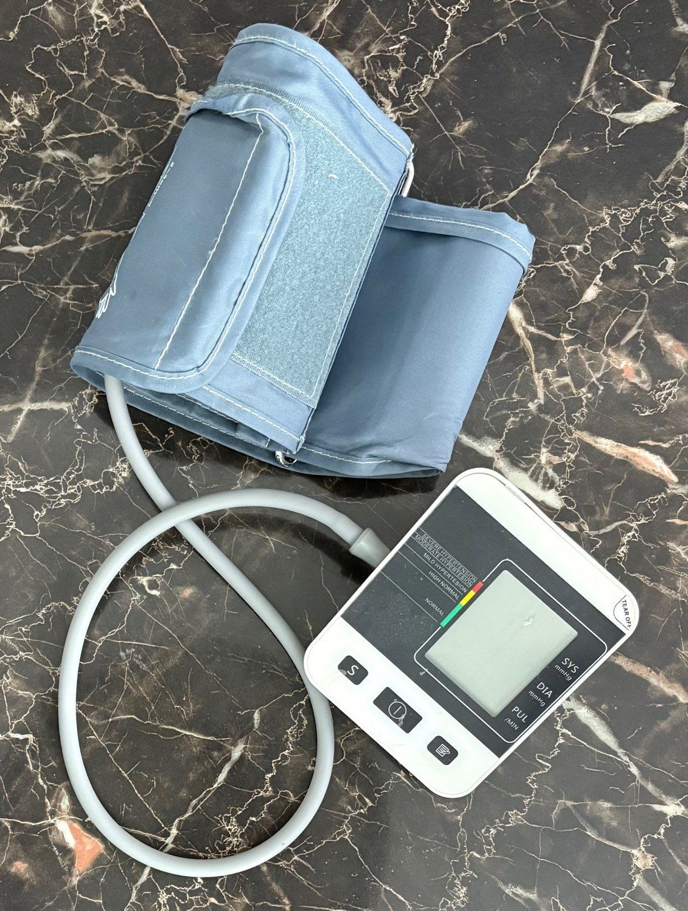
Jan 21, 2026

- To select participants, I decided to use all 4 of my family members (including myself).

- Participants voluntarily agreed to participate in my study.

- I measured and provided complete details of my study participants in the result section including age group, weight, height and gender. I feel this was important so the readers can understand who my research participants are.

Feb 01, 2026

- I looked at the data for analysis purposes by taking the averages for all the before readings, and the average for after the interventions to compare the difference in measurements.

- I also looked at the data by age groups and gender. 75% are male, and 25% female. 50% were adults and 50% were children (<13 years).

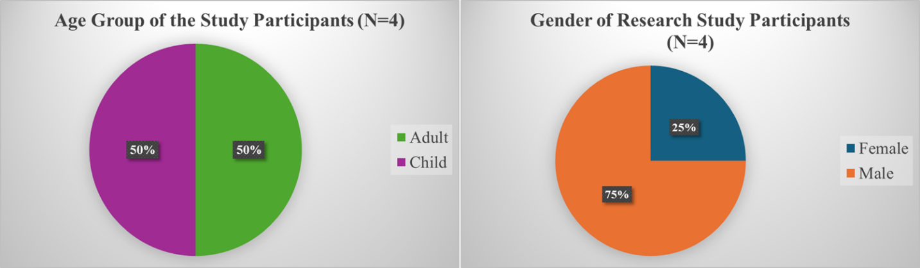

- The most interesting findings came up when I split the data and analyzed by age and gender. Children data showed more impact on heart rate and less on skin hydration while adult data showed more impact on skin hydration and less on heart rate. Gender did not show any variations splitting the data into male and female participants.

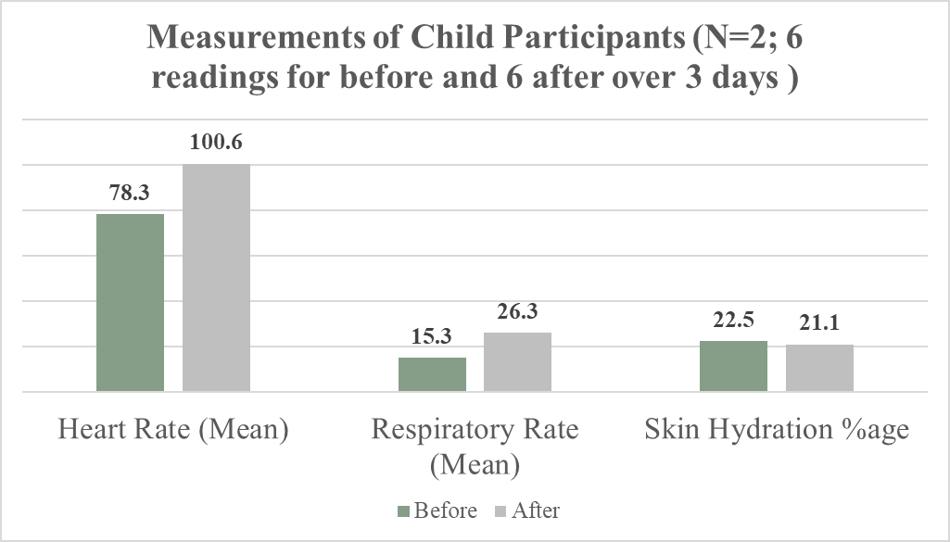

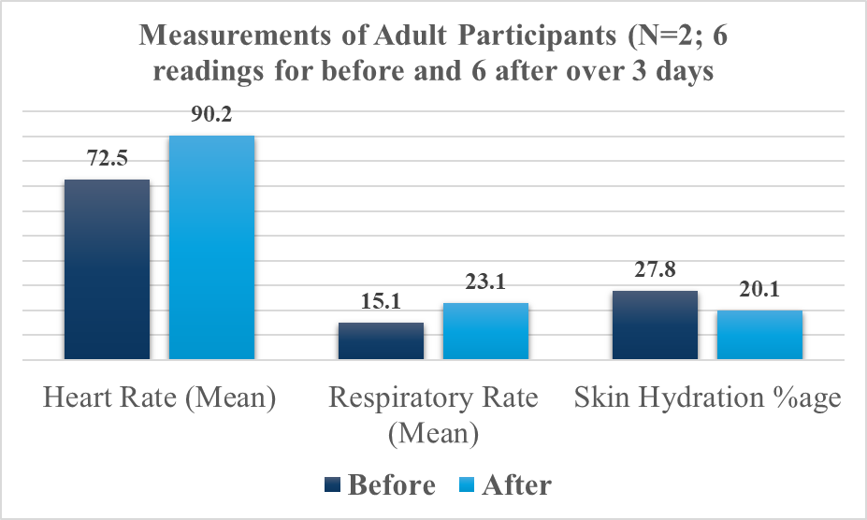

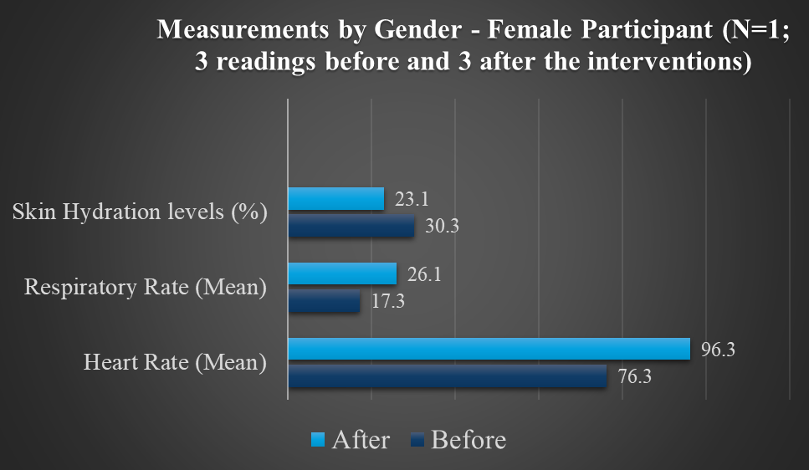

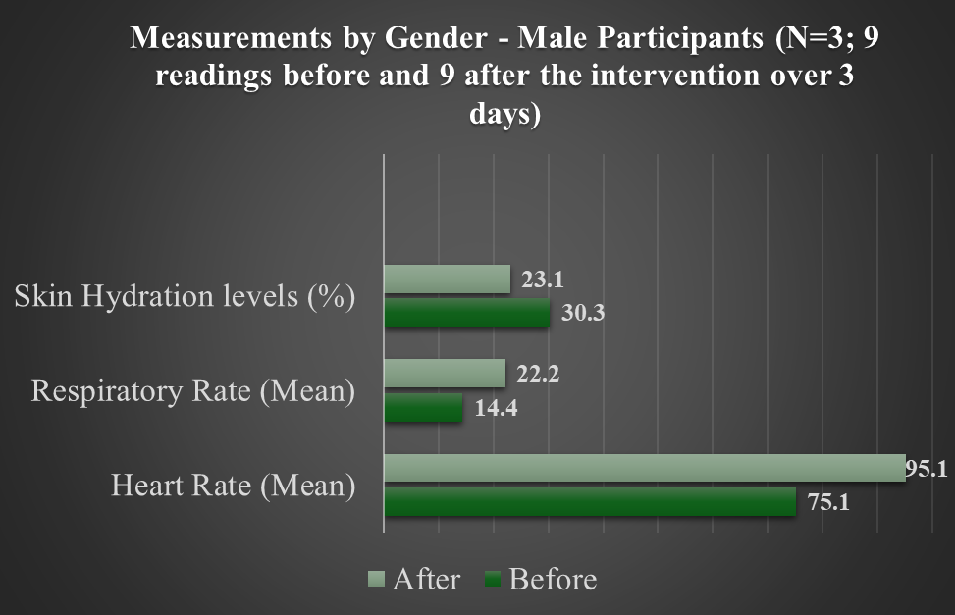

Feb 10, 2026

- Considering all the data and readings from the experiment, I have come to this conclusion that even the short-term mild to moderate physical impact on the hydration status of the body.
- This is particularly important for areas like Calgary where air humidity is less and dehydration often lead to health issues such as migraine.
Challenges
- Finding out the right measuring tools for the hydration status of things like the skin was challenging.

- I had to do literature searches to find out what are the possible ways to measure the current hydration status.

- I included myself as a study participant, which was hard to remain objective. However, using the standard processes and measuring tools ensured to keep my personal bias away from the results.

- It was challenging to not add my personal experience because I sometimes don't drink enough water and feel tired.

- The overall timeline was slightly challenging as I had to do background literature searches, develop study processes/methodology, and conduct an experimental study during a short period of time.

- The other challenge was to present the information from articles in a concise summary without adding too much detail. To develop an introduction, I did literature searches and found several articles, so it was challenging to present them in a concise summary.

Informed Consent

EXERCISE DEHYDRATION STUDY
WRITTEN CONSENT TO PARTICIPATE IN RESEARCH

Thank you for taking the time to speak with me today. I am Usman Arain and I am conducting a before-after intervention study. I am the person who is organizing this study.

You were identified as a possible participant in this study because you fulfilled the criteria of participating in the intervention of moderate physical activity. You do daily exercises, which makes it easier to participate. You were asked about your ability to do moderate exercise for 20 minutes and, at the end, indicated that you were interested in participating.
Your participation in this before-after intervention is voluntary.
The purpose of this research study is to learn more about dehydration, and the impact it gives on the body after moderate exercise.

If you agree to participate I will ask you to participate in moderate exercise (brisk walk) for about 20 minutes. The exercise will be within your ability. The questions will be about your exercise ability and your overall satisfaction with your vitals being measured will be taken into account.

Participation will take a total of about 20 minutes. There will be 3 measurements: heart rate, respiration rate and skin hydration/oil.

If you want to stop the research at any time because you are tired or don’t want to participate any more, please let me know and we will stop the research. If you wish to withdraw before, please let me know.

All identifying information will be confidential and will be permanently deleted after the study. The research data will be securely stored. Only I will have access to these files. Once the research is complete, you cannot withdraw as it is too late because the study has been concluded and recorded.

Participating in this will benefit many people as you will be assisting the research and you will be of my appreciation for doing this study.

You may ask me with any questions or concerns about the research or your participation in this study.

If you have any questions concerning your rights as a participant in this research, please ask me.
Do you have any questions or would like any additional details?

In no way does your agreement to take part in this study waive your legal rights nor release the investigators or involved institutions from their legal and professional responsibilities.

Do you agree to participate in this study?

[If yes, begin the study.]
[If no, thank the participant for his/her time.]

_____________

(signature here)

Date:___________________

Pilot Testing of Digital Hydration Measuring Device
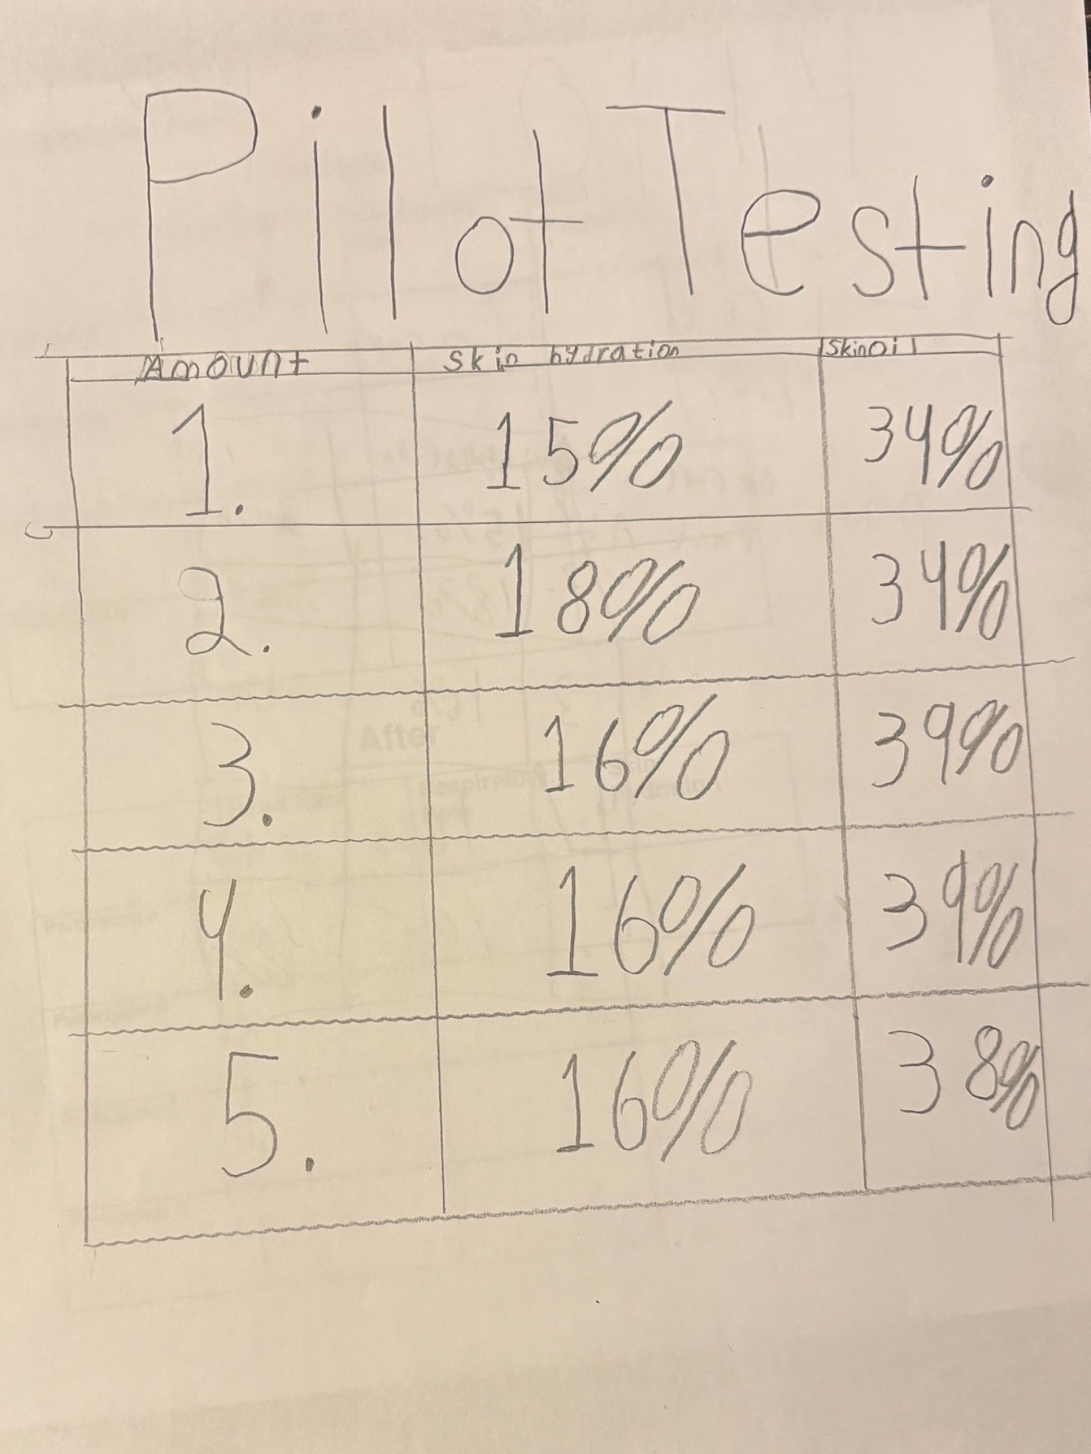

Data Collection Sheets for over three days measurements of the study participants
