LOG BOOK
Alyssa Kim

The effect of vitamin c on the oxidation process

Logbook:
October 16th
I will be choosing my topic for science fair today, so far I am choosing between the effect of different masks on bacteria, and the effect of vitamin c on the oxidation process.
October 29th:
I have chosen to do the vitamin c on the oxidation process and I am finding experiments that are similar to my procedures. I have found a procedure where apples are used for the oxidation process, I will use this and vary the amount of vitamin C to check the effect.
November 13th:
My objective is to find the medical effects of vitamin c to determine the importance of vitamin C. This will help me identify the importance of my experiment, I will also research oxidation in the human body.
December 11th
My objective today was to find the standard of vitamin c given to critically ill patients to determine the amounts of vitamin I would test on the apples. I would use the excessive amount of vitamin c recommended and the ideal amount recommended.
December 12th
My objective was to find the different amounts vitamin c and other vitamin c options such as orange juice for the final portion
December 30th
My objective was to start the first steps of mty experiment, I cutted up the apples and put them in the cups to wait for the 24 hrs result.
Jan 1st
I took the pictures of the 24 hrs result of the apples, there was not a huge difference in the vitamin c results. The other one started to show brown spots and streaks.
Jan 2nd
I took the pictures of the 48 hrs results and even in the vitamin c ones there were brown spots while they all started to rot.
Jan 3rd
This is the final time I take pictures of r72hrs. There are brown spots for everyone
Jan 7th
I have been starting on making my graph of the brown spots following 24hrs, 48hrs, and 72hrs.
Jan 14th
I am planning on transferring my observations onto my digital version of my logbook.
Jan 15th
I continue to create my graph of the browning of my apples, I add the surface together and add that to my graph.
Jan 20th
I will be writing up my analysis and starting the conclusion part of my experiment later on. I have finished the graph for my observations and there have been very noticeable differences between the vitamin C coated apples, and sealed apples.
Jan 24th
I am planning on finishing all of my presentation and getting started on script. I will just have to add my pictures and add in my text.
Jan 28th
I finished my presentation and I will review and present to my teachers and parents to receive feedback and strengthen my presentation.
Feb 5th
I have found out that I have been chosen for CYSF so I will start finetuning my presentation.
Feb 8th
I started the second round of my experiments after receiving feedback and 24 hours started at 7:22 room temperature 20degress Celsius.
Feb 9th
I will be taking pictures and recording the 24hour result of my experiment.
Feb 10th
I will further research the effects of lipid oxidation and other oxidation processes in the human body. I will also later be recording and taking pictures of the 48hours of my experiment
Feb 11th
Today will be the final recording of my data at 72hours.
Feb 12th
I started creating my graph based on my second experiments results and I finished my script.
Feb 15th
I put finishing touches on my logbook and rehearsed my script for my presentation in front of family members and friends.
March 1st
I am finishing up my website for cysf and filming my video to present.

Lab Report

Testable Question:
How does the amount of vitamin c affect the oxidation process?

Hypothesis:
If an apple is put in water with a large amount of vitamin c then the oxidation process will be prevented, because the amount of water and size of water are the same the results will not be affected by it.
Variables:
Controlled variable: Apple and water amount, vitamin C tablet brand, room temperatures
Manipulated variable: Vitamin C
Responding variable: amount of apple oxidized.
Materials:
- 9 cups
- 9 apple slice
- 200ml of orange juice
- 1,200ml of pure water
- Labels
- Sealing Wrap
- 4 vitamin c tablets

Procedure:
- Cut an apple into approximately the equal size and the same weight
- Fill 6 cups each with 200 ml of pure water
- Put in one cup 200ml of orange juice
- In each 5 cups that have 200 ml of pure water put in 60mg, 120mg, 180mg, 240mg, and 300 mg of vitamin C each
- While waiting for the tablets to dissolve put in two cups each that have no liquid an apple slice each
- Put in the leftover cups each one apple slice, the orange juice and water cup
- Label each cup with what liquid is containing it.
- Seal each cup except for one cup that has no liquid and only an apple slice.
9. Take observations at 24, 48, and 72hrs

Observations:

First Trial
24hrs
- Apple in Orange Juice
  - 5 brown spots
  - Has white spots around the sides
  - Hard
- Non-sealed Apple
  - 9 brown spots
  - Dry and crusty
  - Shriveling
- Sealed Apple
  - 5 cm of brown spots covered apple
  - Dry
  - 3cm long brown stripe
- Apple in 60mg of Vitamin C
  - No brown spot
  - Mushy
- Apple in 120mg of Vitamin C
  - No brown spots or lines
  - No color change
- Apple in 180mg of Vitamin C
  - No brown parts
  - Slight pink hue
- Apple in 240mg of Vitamin C
  - No brown spots
  - Pink hue is evident
- Apple in 300mg of Vitamin C
  - Pink Hue is most evident
  - No browning
- Apple in water
  - Mushy
  - Brown splotches that cover 13 cm of the apples
48hrs
- Apple in Orange Juice
  - 8cm brown spots
  - More strong then water filled apples
- Sealed Apple
  - 20cm brown long streaks
  - 5cm new brown spots
  - Shriveling
  - Crust had formed and is dry
- Non-sealed Apple
  - 54 brown coverage
  - Dry and crusty
  - Shriveling
- Water Apple
  - 5cm brown spots
  - 9 cm brown splotch
  - White translucent edge
- Apple in 60mg in Vitamin C
  - Pink hue
  - 18 cm browning coverage of apple
- Apple 120mg of Vitamin C
  - 12cm browned coverage
  - Pink hue
- Apple in 180mg of Vitamin C
  - Pink hue
  - 4cm browned coverage
- Apple in 240mg of Vitamin C
  - 2 cm browned coverage
  - Mushy
  - Pink hue
  - White translucent edge
- Apple in 300mg of Vitamin C
  - No browning
  - Mushy
  - Pink hue
72hrs
- Apple in Orange Juice
  - Brown spots that are 1 cm each
  - Parts of Apple are falling apart
- Non-sealed Apple
  - 100 cm of brown spot coverage
  - 100% coverage of browning
  - Size has decreased
  - Signs of rotting
  - Dry and crusty
- Sealed Apple
  - 120cm brown spot coverage
  - 100% brown spot coverage
  - Dry and crusty
  - A slight smaller size compared o start
- Water apple
  - 120cm new brown spot coverage
  - Mushy
- Apple in 60mg of Vitamin C
  - 8 more 1 cm brown spots
- Apple in 120mg of Vitamin C
  - 2cm brown streaks
  - 2cm brown spot
- Apple in 180kmg of Vitamin C
  - 3 cm brown streak
- Apple in 240mg of Vitamin C
  - 2cm brown spot
- Apple in 300mg of Vitamin C
  - No brown spots
- Every trial and control sample had molding occuring

Second Trial

24hrs
- Apple
  - 2cm brown spot
  - A total of 2cm brown streaks
  - 3cm coverage of brown splotches
  - Slight crust

- Sealed Apple
  - 7 brown spots that cover a total of 1cm
  - 5cm coverage of brown splotches
  - Dry and a crust

- Water apple
  - Rotting edge
  - Total of 7cm brown splotch
  - 2cm brown streaks in total
  - 1cm brown spot
  - Mushy

- 60mg of VC
  - White rotting edge
  - Mushy
  - No color change

- 120mg of VC
  - White translucent edge (sign of rotting)
  - Light pink hue but not evident

- 180pmg of VC
  - White translucent edge
  - No color change
  - Pink hue can also be seen on the surface

- 240mg of VC
  - White translucent edge
  - Pink hue covers all areas
  - Color turns slightly orange from the pink hue and original color of apple clashing

- 300mg of VC
  - White translucent edge
  - Pink hue
  - All surface have turned a shade of orange which is not a sign of oxidation

- Orange juice
  - No rotting edge
  - 2cm brown splotch
  - Brown streaks that add up to 3cm
  - A total of 2cm of brown spots.
48hrs
- Apple
  - 15cm total of brown splotches
  - A total of 5cm of brown streaks
  - 5cm brown spot total coverage

- Seaed apple
  - 6cm brown spot total coverage
  - A total of 7cm for brown splotch coverage
  - 2cm brown streaks in total

- Water apple
  - White translucent edge
  - 11cm brown splotches in total
  - A total of 4brown spots
  - 4cm brown streaks

- 60mg VC
  - White translucent edge
  - Slight pink hue which seems to be only under the surface
  - 9cm brown splotches in total
  - A total of 3cm of brown spots

- 120mg VC
  - White translucent edge
  - Pink hue
  - 4cm brown splotches in total
  - 2cm total of brown spots
  - 3cm brown streaks in total

- 180mg VC
  - Pink hue
  - White translucent edge
  - 2cm brown spot

- Vitamin C 240mg
  - No signs of oxidation
  - No difference spotted from 24hour observations

- Vitamin C 300mg
  - No signs of oxidation
  - No differences

- Orange juice
2 2cm brown splotches and a 2cm brown streak
72hrs
- Apple
  - Shriveled up
  - 100% oxidized/90cm

- Sealed
  - 100%oxidized/110cm
  - Crusty and dry

- Water:
  - Different stages of browning were seen in different areas
  - 100% oxidized/110cm
  - No a lot of rotting seen
  - Water turned yellow but were

- 60mg VC:
  - 4cm brown splotch
  - 1cm spot
  - Little spots and specks of rotting
  - White translucent edge
  - Pink hue

- 120mg VC
  - White hues showing around the apple
  - 4cm brown spots
  - 2cm brown streaks
  - 3cm brown patches
  - Pink hue

- 180mg VC
  - 3cm brown splotches
  - 1cm brown spots
  - White splotches
  - Pink hue

- 240mg VC
  - 1cm brown spots
  - White splotches
  - No other appranct changes
  - Pink hue

- 300mg VC
  - No oxidation seen
  - Pink hue
  - White splotches around the apple slices

- Orange Juice
  - 2cm brown splotches
  - 2cm brown spots
  - Multiple rotting spots seen on one side

Analysis
There were sharp increases of oxidation between 48hours and 72 hours, the highest increase was seen in three trials that became oxidized 100%. A trend was spotted between the vitamin C water as every trial had no signs of oxidation in the first 24 hours. An outlier spotted was in the orange juice which did not follow this trend even when it contained vitamin< c like the rest which could show that orange juice is not an adequate source for vitamin C. There was only a 5mg difference of vitamin C amount between the 60mg of vitamin C tablet. This revealed that orange juice was not a viable source of antioxidants as it had been advertised on the bottle. The trend revealed that the minimum amount of 60mg of vitamin C still had a positive effect on oxidation but any amount underneath it would not be beneficial. Whie an error could have been the rotting could have been mistaken as rotting or the other way around but those parts were peeled and the surface underneath was counted as browning if there were the signs. FOr my second experiment I saw the same observation that there was a sharp- increase of oxidation between 48hours and 72 hours. The highest increases were once again seen in the non-sealed , sealed, and water apple that at my final observation became oxidized a 100%. The trends spotted in my second experiment were between the vitamin C water in which every tria in the first 24 hours had no signs of oxidation but an outlier was spotted amongst this trend. The outlier was in the orange juice which contained 55mg of vitamin C but had 7cm of oxidation seen in the first 24hours. This was more oxidation seen compared to my first experiment which had 5cm of oxidation seen. THis was repeatedly shown in my experiments so this shows that orange juice is not an adequate source of vitamin C as it has been advertised as. While this trend also reveals the minimum amount of 60mg of vitamin C is effective as health websites are informing individuals of. An error in my second experiment would have been that there was a temperature difference from the first experiment and the second one and the ortting that was spotted. The outside temperature at the first experiment was around -15 celsius but at the time of the second one it was -30 celsius so this could have altered the results but it could have helped the rotting because not many signs of rotting were seen. While there wasn’t much rotting spotted I compared the areas to other apples and examined whether it was a sign of oxidation or rotting which was still not as precise. Though the rotting was at a minimum rate because there was less confusion when measuring and determining which parts of my apple were oxidized. Overall this experiment has very similar results except for the slight differences between the oxidized amount. While in the first experiment the highest oxidation was seen in the non-seale apple because it did not shrivel up opposed to my second experiment where it did shrivel up so less oxidation was measured. The orange juice also had higher oxidation seen in the first 24hrs in the second experiment than my first, but in the end the first experiment nearly had 2times the second experiment’s oxidized amount. THis was a big difference so this could have been a result of the temperature difference or there could have been a slightly higher amount of vitamin C then calculated from the bottle. There were slight differences from the amount oxidized between trials compared between both of my experiments but other than the other changes stated above they held similar results. . The vitamin C worked to an extent and even while the orange juice was not as effective compared to the tablets they had a better effect overall compared to the control sample which was oxidized to a 100% at 72 hours.
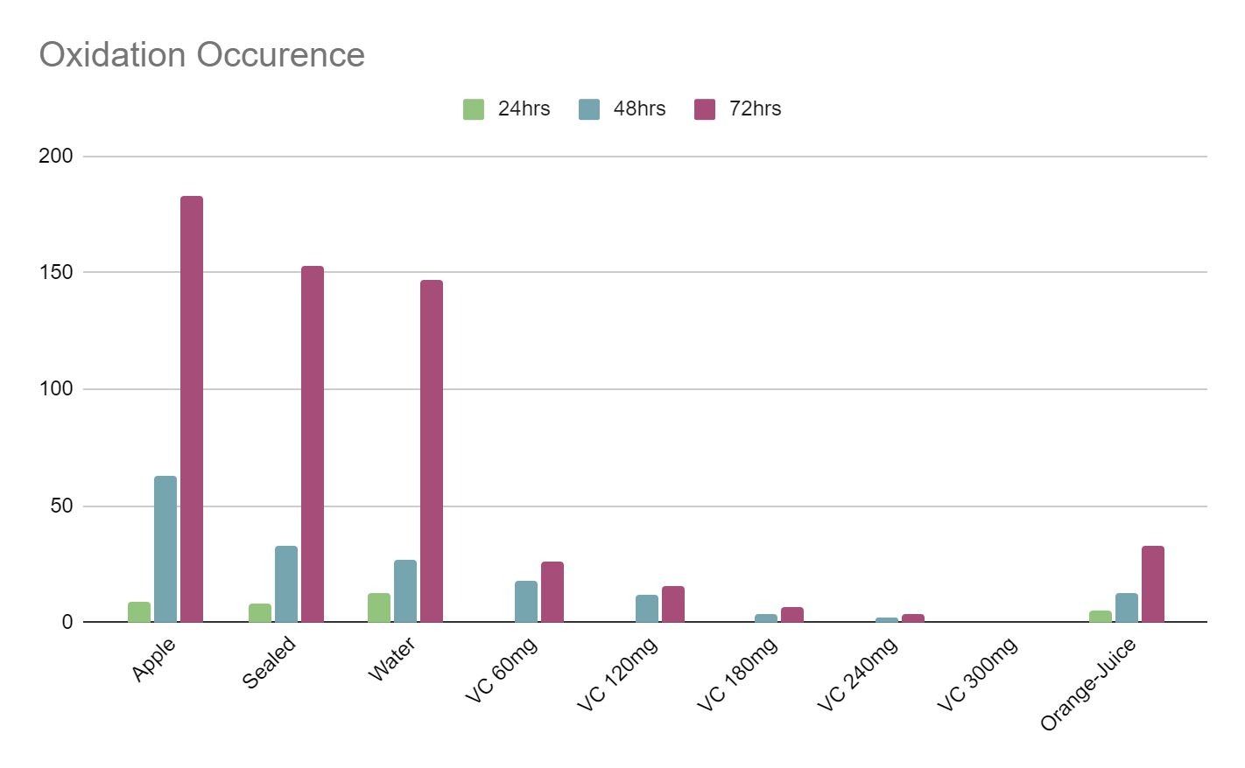
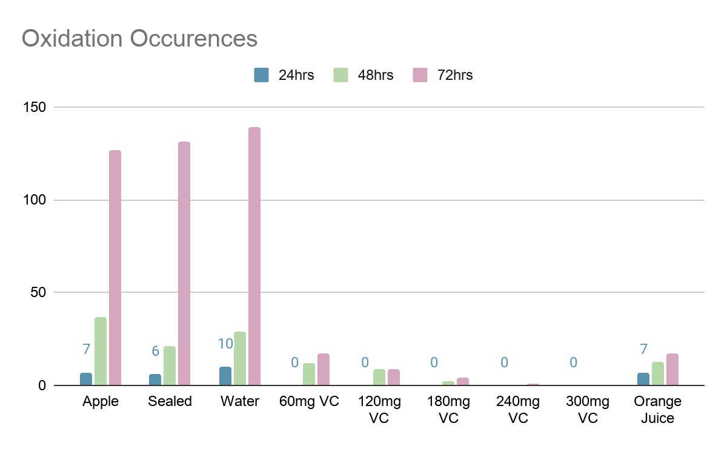

Conclusion
In conclusion my hypothesis was true for both of my experiments because as there was a higher concentration of vitamin C had a slower oxidation rate seen when the 300mg of vitamin C prevented any signs of oxidation from occurring, even the lowest amount of vitamin C in the orange juice which showed an outlier still only had 33cm of oxidation seen in total. The control sample also showed the differences between vitamin C located apples because the control sample eventually became oxidized 100% while the vitamin C prevented most of the oxidation process. My second experiment held a similar result because as the amount of vitamin C concentration decreased more oxidation was spotted. This was seen when 300mg of vitamin C showed no signs of oxidation and remained similar to the start of the experiment and the lowest amount of vitamin C 55mg which was in the orange juice showed signs of oxidation in the first 24 hours. This also revealed how oric acid is helpful as a food colour preserver and perceive the colour for long periods of time if used in high concentrations. VitaminC can be seen as an effective source of antioxidants and this information can help prevent others from getting medical conditions that have oxidation in the process.

Extension
Future Area for Study:
- Oxidation can be seen in humans in a form of lipid oxidation and oxidative stress
- Lipid oxidation: Free radicals taking electrons from lipids which cause cell damage antioxidants such as vitamin C are
- effective against this
- Oxidative stress: Imbalance between production and accumulation of ROS in cells and tissues, the effects can also be
- countered with antioxidants though not as effective compared to lipid oxidation results
- Studying these areas could help spread knowledge about the importance of antioxidant
- Applications to Real World
- Antioxidants are effective against many oxidation processes that cause many medical problems in the body
- While it also does prevent the browning of apples in the everyday life this experiment shows the effectiveness against certain
medical diseases too
- I would research more about the over exaggeration of the antioxidants in certain foods and drinks and how new foods such as new diet foods could be seen as antioxidants

Background research:
- Oxidation
  - Oxidation in apples is a chemical process. When the apple is cut, oxygen is introduced to the injured plant tissues. Once oxygen is present, the polyphenol oxidase enzymes in the chloroplasts rapidly oxidize phenolic compounds that are present in apple tissues to o-quinones. The O-quinoces produce the brown color by reacting to form the compounds with amino acids or proteins.
  - Apples have different levels of original enzyme amount so they will oxidize at different rates
  - Level of PPO differs by apple so for the experiment the same apple must be used.
- Vitamin C
  - Vitamin c can also be called boric acid, and it is a good source for food colour preserving,
  - Without Vitamin C there could be a development of scurvy, scurvy is caused if vitamin c is no longer in your body 3 months because our own bodies can not create more.

  - Colour is one of the easiest ways to see if oxidation has worked.
- When the apple is cut they are exposed to oxygen and free radicals released from the apple.
- When an apple undergoes the processThis is when the apple undergoes the oxidation process eventually turning it brown. Enzymes in the apple oxidise phenolic compounds after oxygen goes into the injured plant tissue, tuning the apple tissues to form melanin.
- This is a very simple way to look at oxidation because I do not have proper equipment for more bigger experiments. I had to try it on a smaller sample. Oxidation is also in human bodies, it causes many diseases such as cancer.
- Vitamin C prevents genetic mutation seen in this study https://www.jbc.org/content/277/19/16895.short
- Vitamin c is also more frequent in smokers, low incomes, people with advanced cancer. With vitamin c deficiencies you have less chance of surviving it
- Critically ill patients have low plasma levels of vitamin c, 60mg is sufficient for most adults.
- Standard enteral provides 100-200mg of vitamin c to critically ill patients. It is insufficient to meet the needs of patients, and they need at least 2-3g of vitamin c respectively, which is insufficient to meet the needs of critically ill patients.
- 1g or more vitamin C can have consequences for many people, the consequences include diarrhea, nausea, vomiting, heartburn, abdominal cramps, headache, insomnia.
- Oxidation is a normal reaction in the body
- Oxidative stress is when there is an imbalance between free-radicals and antioxidants in the body, leading to diabetes atherosclerosis, hardening of blood vessels, inflammatory conditions, high blood pressure, heart disease, neurodegenerative diseases, and cancer.
- Oxidation in apples is called by a chemical process and it can not
- The vitamin C in orange juice can degrade if stored in clear packaging which allows the sunlight to degrade it or contained in a polyethylene or polystyrene package which allows in oxygen also degrading the vitamin C

Past experiments:
- There is a significant difference in color between apples that have been in the vitamin c water, and the ones that have not.
- The apple that is the control sample is mushy and starts rot.
- Reveals that the vitamin c has a good guarantee in protecting something from the oxidation process.
- Apples were dipped into ascorbic acid such as vitamin c solutions, like orange juice, lemon water and others.
- Experiment Description:
- Apple is placed into a glass of plain water as the control sample, another is put in a glass with water that has a full vitamin c tablet.
- There will be different amounts of vitamin c in each glass except the controlled version.
- After 24 hours I will examine, then 48 hours, then 72. Hours.
- I will check to see how far one amount of vitamin c can protect a piece of apple from the oxidation process.
- There was at least 200-300mg of vitamin c for the standard enteral in critically ill patients but it seems as if you need 2-3g. So I will test 200 mg, 300mg, 2g, 3g.

Source
- This presentation template was supplied by Slidesgo, icons by Flaticon, and infographics & images by Freepik
- Abasolo, C. (2019, January 25). Methods to determine oxidative stability. Retrieved from https://www.btsa.com/en/methods-to-determine-oxidative-stability/
- Al-Shahrani, M. M. (2013). Measurement of Antioxidant Activity in Selected Food Products and Nutraceuticals. Journal of Nutrition & Food Sciences, 03(03). doi:10.4172/2155-9600.1000205
- Antioxidants and apples: An experiment. (n.d.). Retrieved from https://www.futurelearn.com/info/courses/everyday-chemistry/0/steps/22334
- Ball, D. W., & Key, J. A. (2014, September 16). Oxidation-Reduction Reactions. Retrieved from https://opentextbc.ca/introductorychemistry/chapter/oxidation-reduction-reactions-3/
- Berdahl, D., Nahas, R., & Barren, J. (2014, March 27). Synthetic and natural antioxidant additives in food stabilization: Current applications and future research. Retrieved from https://www.sciencedirect.com/science/article/pii/B9781845696481500125
- Boyer, J., & Liu, R. H. (2004, May 12). Apple phytochemicals and their health benefits. Retrieved from https://www.ncbi.nlm.nih.gov/pmc/articles/PMC442131/#:~:text=In the laboratory, apples have,of which are strong antioxidants.
- Carty, J. L., Bevan, R., Waller, H., Mistry, N., Cooke, M., Lunec, J., & Griffiths, H. R. (2002, May 25). The Effects of Vitamin C Supplementation on Protein Oxidation in Healthy Volunteers. Retrieved from https://www.sciencedirect.com/science/article/abs/pii/S0006291X00930146
- Padayatty, S. J., & Levine, M. J. (2016, April 14). Vitamin C: The known and the unknown and Goldilocks. Retrieved from https://www.ncbi.nlm.nih.gov/pmc/articles/PMC4959991/
- Padayatty, S. J., Katz, A., Wang, Y., P., Eck, J., O., . . . Levine, M. (2013, June 19). Vitamin C as an Antioxidant: Evaluation of Its Role in Disease Prevention. Retrieved from https://www.tandfonline.com/doi/abs/10.1080/07315724.2003.10719272
- Pehlivan, F. E. (2017, August 02). Vitamin C: An Antioxidant Agent. Retrieved from https://www.intechopen.com/books/vitamin-c/vitamin-c-an-antioxidant-agent
- Vitamins at physiological levels cause oxidation to the DNA nucleoside deoxyguanosine and to DNA—alone or in synergism with metals. (2012, March 30). Retrieved from https://academic.oup.com/mutage/article/27/4/511/1118664

