LOGBOOK
January 24, 2026
Name of project:
Youth Mental Health, Smoking, and Heart Disease
Research question:
Youth, mental health, and smoking: What role do they play in triggering heart disease?
What role does youth, mental health, and smoking play in triggering heart disease?
how mental health and smoking in youth can increase the risk of heart disease.
Hypothesis
If youth experience poor mental health (such as high stress or depression), then they will have a higher risk of developing heart disease, because poor mental health often leads to smoking as a coping mechanism, which physically damages blood vessels and increases heart strain.
January 25, 2026
Research study
Life sciences
My project is about how mental health and smoking in youth can increase the risk of heart disease. It aims to show how mental health and smoking can affect heart health.

January 26 2026
The purpose of this project is to examine how mental health issues and smoking in youth may increase the risk of heart disease. The goal is to raise awareness about these risks and their impact on heart health.
This project is a research study that explores how mental health challenges and smoking in youth may contribute to an increased risk of heart disease. Information will be gathered from scientific articles, health organization websites, and published reports. The study involves analyzing existing data only.

February 9, 2026
Why is smoking addictive?
When a person smokes, nicotine can reach their brain in 10 seconds. First, nicotine may improve mood, concentration, decrease anger and stress, relax muscles and lose appetite. Nicotine leads to changes in the brain which can further lead to nicotine withdrawal symptoms when the nicotine intake decreases. Smoking temporarily can reduce these withdrawal symptoms which makes smoking a habit. This cycle is how most smokers become addicted.
Smoking and mental health
Teenagers with depression are twice as likely to smoke than teenagers without depression. Nicotine develops the release of the chemical dopamine in the brain. Dopamine triggers positive feelings which are often found to be low in people with depression who may use smoking to increase dopamine in their mind. However smoking encourages the brain to switch off its mechanism for dopamine so in the long term their dopamine decreases which makes them want to smoke more. People with depression can find it difficult to quit smoking and have major withdrawal symptoms.
A study at Matilda Centre at the University of Sydney explored this connection and researchers conducted a large scale survey involving more than 5000 students. The survey collected information on vape use and several metal health indicators including depression, stress, anxiety and overall well being. The study found that those who reported severe depressive symptoms were over twice as likely to have tried vapes, compared to those reporting no depressive symptoms. Data showed overall higher vape use among those with poorer mental health, including severe depressive symptoms, moderate and high stress, and low wellbeing.
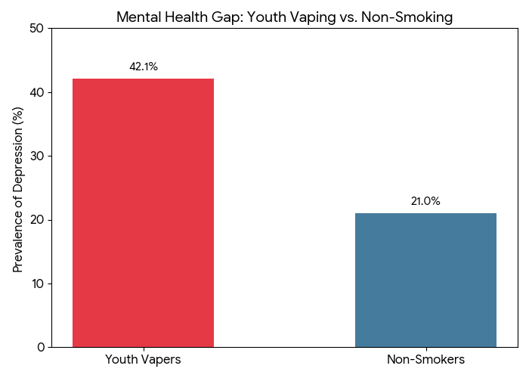
How does smoking and mental health directly affect the rate of heart disease ?
Smoking is a major risk factor for heart disease. The chemicals that smokers inhale can damage their heart and blood vessels. Any amount of smoking can cause damage to the heart and blood vessels. Other heart disease risk factors such as unhealthy blood cholesterol levels, high blood pressure, and overweight or obesity smoking can raise the risk of heart disease even more. The chemicals in cigarettes scratch the inside of your blood vessels. This makes them rough, so gunk (Atherosclerosis) (fat and cholesterol) gets stuck to the sides more easily. Smoking makes your blood thicker and stickier. Sticky blood (Endothelial Dysfunction) causes "clogs," which can lead to a heart attack. When you smoke, your blood carries less oxygen. Your heart has to beat much faster and work harder just to keep you moving. High stress or sadness can cause "inflammation" inside your body. This is like having swelling that hurts your arteries over time. Often, when people feel down or stressed, they might stop exercising, eat junk food, or sleep poorly. All of these choices make the heart weaker. These two things often go together. Someone might feel stressed (Mental Health), so they smoke a cigarette to relax (Smoking). The cigarette actually raises their heart rate and blood pressure, making the body more stressed than it was before.
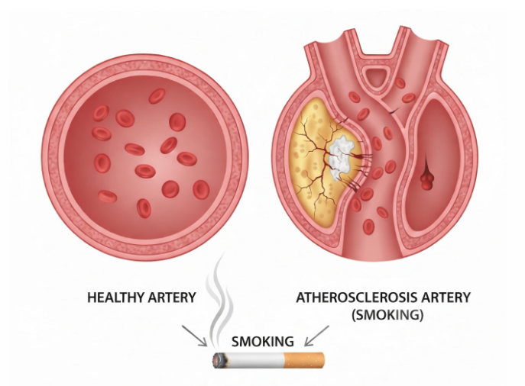

Independent variable: Mental health conditions and smoking/vaping usage.
- Mental Health Status (levels of depression, stress, or anxiety).
- Smoking/Vaping Habits (frequency of use or presence of nicotine).
Dependent variable: The level of risk or physical damage to the heart.
- Risk of Heart Disease (heart rate, blood pressure, inflammation, and arterial damage).
Controlled factors : The age group (youth) and the types of data sources used.
- Age group (youth/teenagers)
- Data sources
- cardiovascular system (the heart and blood vessels)
Statistics
- Heart Damage in Youth: A 2024 study published in the Journal of the American College of Cardiology (JACC) found that smoking from childhood (age 10) through young adulthood is associated with a 33% to 52% higher chance of early structural heart damage. (Smoking From Childhood Associated With Greater Risk of Cardiac Damage - American College of Cardiology.)
- The Mental Health Connection: According to 2024 CDC data, 42.1% of youth who use e-cigarettes report moderate-to-severe symptoms of depression and anxiety, compared to only 21% of those who don’t smoke
(E-Cigarette Use and Symptoms of Depression and Anxiety Among US Middle and High School Students.)
- Over 50% of youth who currently vape say they do it specifically because they are "feeling anxious, stressed, or depressed."
(E-Cigarette Use and Symptoms of Depression and Anxiety Among US Middle and High School Students)

factor | Average heart rate BPM (Beat per minute) | Why?
Resting no smoker | 60–80 BPM | The heart is relaxed and efficient.
Resting smoker | 65–85 BPM | Nicotine is a stimulant that forces the heart to beat faster even when sitting still.
Stressed and smoking | 90–110+ BPM | Stress releases adrenaline, and smoking releases nicotine. Together, they force the heart to work at "exercise levels" while the person is just sitting down.

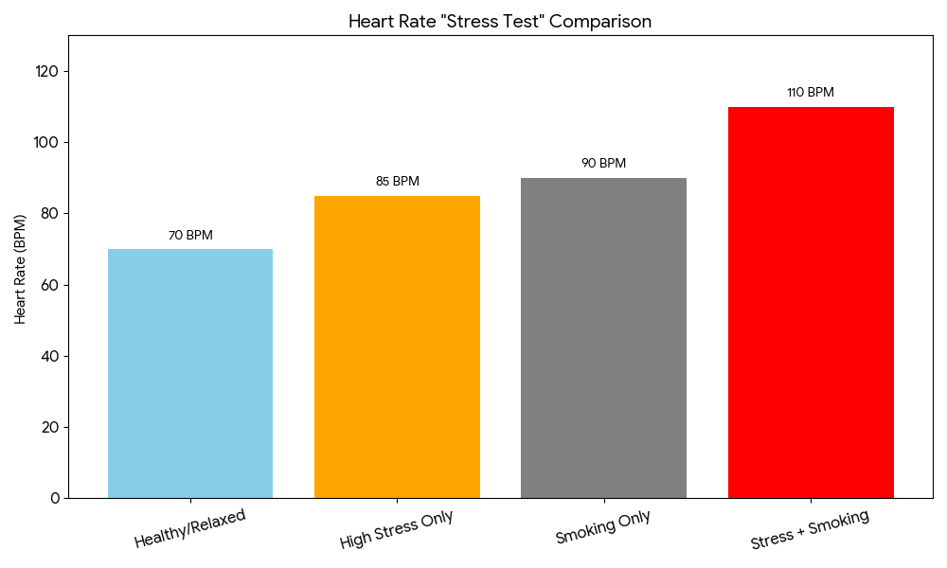

February 12, 2026
What happens to a young person's heart and blood vessels if they quit smoking or manage their stress early?
Quitting smoking is one of the most important actions people can take to improve their health.

Minutes after quitting smoking: | Heart rate drops
24 hours after quitting smoking | Nicotine levels in blood drop to 0
Several days after quitting smoking | The carbon monoxide in blood drops to that of someone who doesn't smoke.
1-12 months after quitting smoking | Coughing and shortness of breath decrease
1-2 years after quitting smoking | Risk of heart attack drops sharply
3-6 years after quitting smoking | Added risk of coronary heart disease drop by half
5-10 years after quitting smoking | Added risk of cancers of the mouth, throat and voice box drops by half. Added risk of stroke decreases.
10 years after quitting smoking | Risk of cancers of esophagus, kidney, and bladder decreases.
10-15 years after quitting smoking | Added risk of lung cancer drops by half
15 years after quitting smoking | The risk of coronary heart disease drops to close to that of someone who doesn't smoke.
20 years after quitting smoking | Risk of cancers of the mouth, throat, voicebox, and pancreas drops to close to that of someone who doesn't smoke. added risk of cervical cancer drops by about half.

February 16, 2026
How quickly can the heart recover after quitting smoking and reducing stress?
Once a teenager quits smoking and manage their stress levels their bodies will start repairing:
20 minutes: In 20 minutes their heart rate and blood pressure will drop back to normal levels
12 hours: in 12 hours carbon monoxide levels in blood drop to normal which allows more oxygen to be able to reach the heart.
2 weeks to 3 months: the circulation improves meaning that the heart doesn't need to pump as hard to move blood.
1 year: The extra risk of coronary heart disease is cut by 50%
15 years: the risk of a heart disease is nearly the same as someone who never smoked.
Mental health: when a person exercises or practices deep breathing rather than smoking, that lowers their cortisol levels. Cortisol is the stress hormone which makes blood vessels tight.

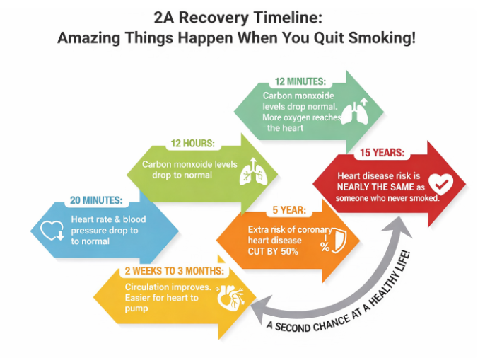
Feb 17 2026
Why does smoking for mental health actually make mental health worse in the long run?
mental health + smoking is much more dangerous for the heart than one of those things alone.
Risk comparison table:
condition | Heart stress level | Why?
healthy/relaxed | 60-80 BPM | Blood vessels are wide and clear
High stress only | 80-90 BPM | Adrenaline forces the heart to pump faster
Smoking only | 85-95 BPM | Nicotine shrinks blood vessels and adds gunk.
stress+smoking | 100+ BPM | Stress shrinks blood vessels while smoking makes the blood sticky

After reviewing data from the CDC and the American Heart Association I have found that youth mental health and smoking are linked in a bad cycle. My research shows that around 42% of youth vapers have depression. This is a problem because depression leads to smoking, and smoking leads to Endothelial Dysfunction (sticky blood). When you add high stress (which causes inflammation), the heart has to work at exercise levels even when the person is resting. This explains why smokers from childhood have a 33% higher chance of heart damage.

Why does smoking for mental health actually make mental health worse in the long run? And why is it so hard for youth to quit?
Nicotine molecules are shaped like a natural brain chemical called dopamine and because they look the same they can unlock the receptors (sense organs in the brain). That triggers a massive flood of dopamine the the brain realizes there is too much dopamine so it starts shutting down the sense organ in order to stay balanced. This process is called down regulation. Nicotine is a stimulant so within seconds after inhaling it the heart rate increases by 10-20 BPM. The brain senses the heart racing and understands it as anxiety even though the person is relaxing. Their fight or flight system is being turned on. At the age of youth the brain does something called synaptic pruning which is basically the brain's way of trimming unused connections so important ones can grow. If youth use nicotine while their brian is pruning the brain builds permanent “roads” for addiction.for the prefrontal cortex which is the part where the brain says stop is not fully formed yet the addiction is built without it being stopped.
The cycle:
- (normal) Brain is calm
- (first use) massive dopamine (very high)
- (withdrawal) the brain feels low and anxious
- (maintenance/habit) the smoker goes back to level 1
- The “solution” (smoking) became a problem which is the source of stress
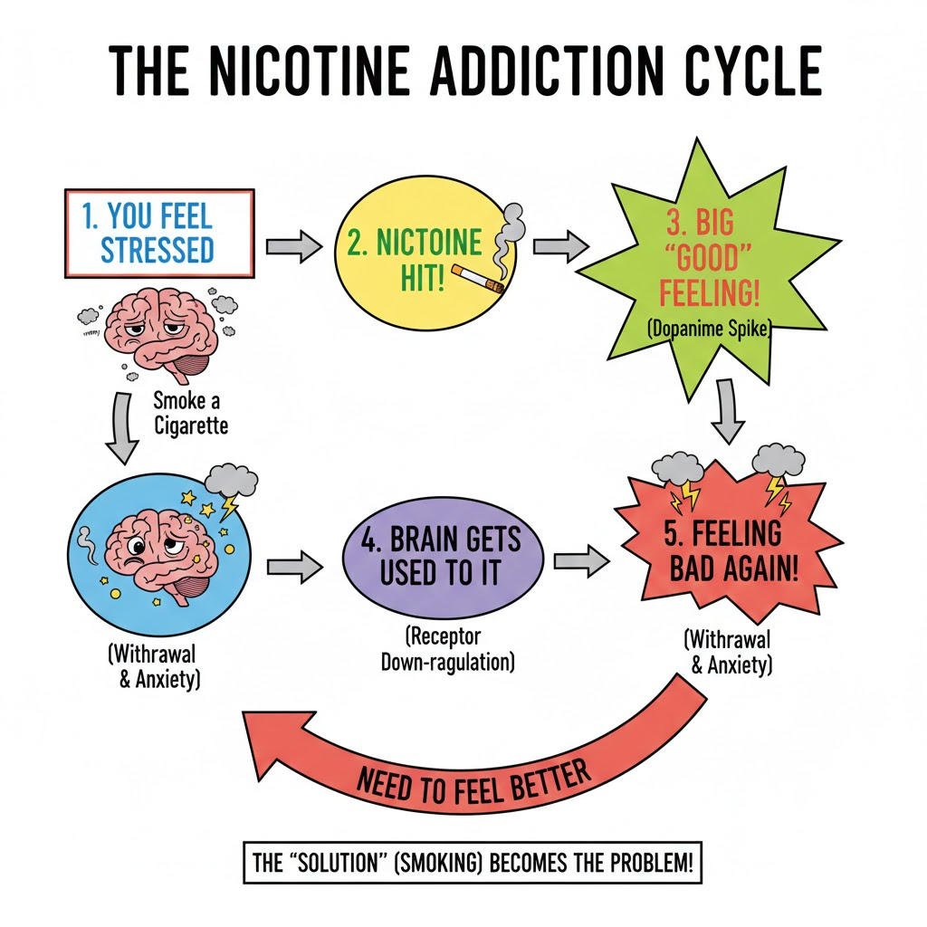

February 18 2026
Youth vs senior
Because of neuroplasticity in youths heart and brian can be easily addicted to damage. Their heart rate can be 100+ BPM (from stress and smoking) is much more dangerous for a growing heart than an adult heart because it can cause early structural damage.
Now because of that neuroplasticity at a young age the recovery is faster so if youth quit now their risk of a heart disease can drop by 50% in just one year.
If mental health is being treated like stress and anxiety at first that may prevent smoking in the first place which protects the heart.
Feb 21 2026
This data table shows the mental health struggles for youth who use nicotine. This confirms my hypothesis that these two factors are connected. However, that does not mean that smoking causes depression.
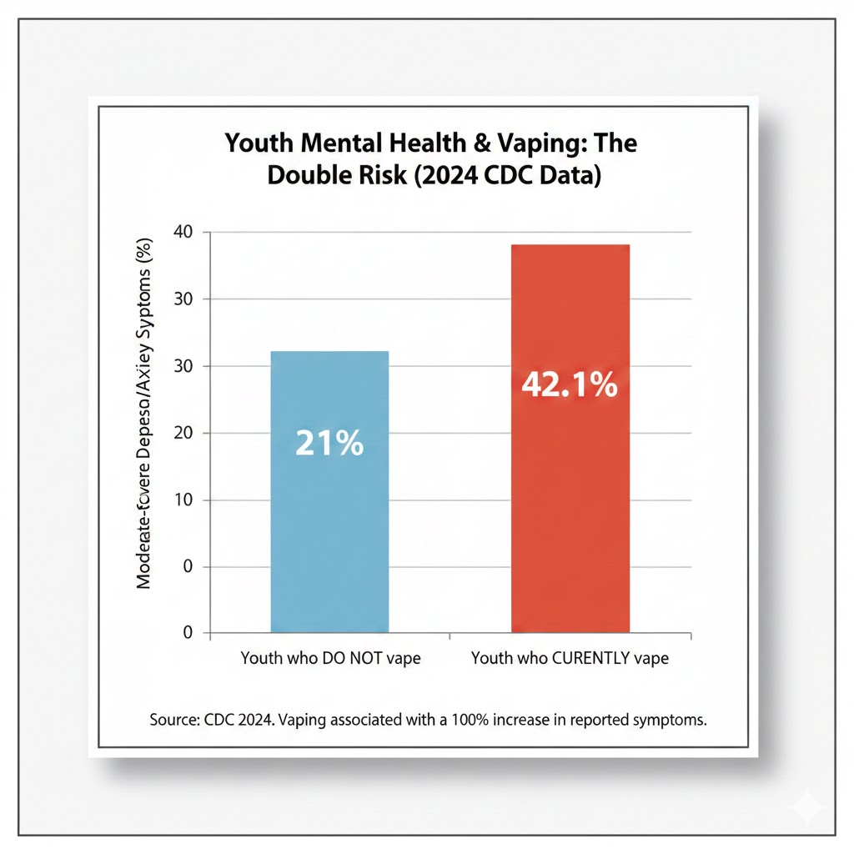

Summary of my findings
My research proves that mental health and smoking work together to damage the heart much faster than either one alone. I found that youth often use nicotine to deal with stress, but this creates a dangerous cycle where the brain actually becomes more anxious during withdrawal. My hypothesis was correct: the combination of high stress (which causes inflammation) and nicotine (which shrinks blood vessels) forces a young person's heart to work at "exercise levels" even when they are resting. This explains why smoking starting in youth leads to much higher rates of heart disease later in life.

February 22 2026
conclusion
The purpose of this study was to determine how youth mental health and smoking interact to increase the risk of heart disease. After analyzing data from the CDC, the American Heart Association, and the Matilda Centre, my hypothesis was supported.
I found that mental health and nicotine use create a hot mess for the cardiovascular system:
- The Loop: Youth with depression or high stress are twice as likely to use nicotine as a coping mechanism to increase dopamine. However, through down-regulation, the brain loses its ability to feel pleasure naturally, leading to a cycle of withdrawal-produced anxiety.
- Physical Strain: While a healthy resting heart rate is 60–80 BPM, the combination of nicotine and stress forces the youth heart to work at 100+ BPM. This essentially puts the heart under "exercise-level" strain while the body is at rest.
- Structural Damage: Because youth are in a stage of synaptic pruning and high neuroplasticity, these habits become built in more easily than in adults, leading to a 33% to 52% higher chance of early structural heart damage (Atherosclerosis).
In summary, mental health issues don't just lead to smoking; they multiply the physical damage smoking does to the heart.

Vocabulary:
- Neuroplasticity: The brain's ability to change and adapt.
- Homeostasis: The body's attempt to keep everything balanced.
- Withdrawal-Induced Anxiety: Stress caused specifically by the lack of a drug.
- Atherosclerosis: The buildup of fats, cholesterol, and other substances (often called "gunk") in and on the artery walls, which can restrict blood flow.
- Endothelial Dysfunction: A condition where the inner lining of the blood vessels (the endothelium) doesn't function normally, often becoming "sticky" and making it harder for vessels to dilate.
- Coronary Heart Disease (CHD): A disease where the main blood vessels supplying the heart are damaged or blocked.
- Inflammation: The body’s immune response to irritants (like cigarette chemicals or high stress); chronic inflammation can damage arteries over time.
- Cortisol: Known as the "stress hormone," it is released during tension and can cause blood vessels to tighten and blood pressure to rise.
- Adrenaline: A hormone that increases heart rate and blood pressure in response to stress (the "fight or flight" response).
- BPM (Beats Per Minute): The standard unit of measurement for heart rate.
- Dopamine: A chemical messenger (neurotransmitter) in the brain associated with feelings of pleasure and reward.
- Nicotine Withdrawal: The physical and mental symptoms (like irritability or anxiety) that occur when a person stops using nicotine.
- Synaptic Pruning: The process where the brain "trims" unused connections. Using nicotine during this phase in youth can "hardwire" addiction into the brain's structure.
- Down-Regulation: The brain’s way of reducing the number of receptors for a chemical (like dopamine) because it is being overstimulated by a drug.
- Prefrontal Cortex: The part of the brain responsible for decision-making and impulse control; it is not fully developed in youth.
- Coping Mechanism: A strategy or behavior used to manage stress or difficult emotions (in this case, smoking).
- independent Variable: The factor you change or look at as the cause (e.g., Mental Health status and Smoking habits).
- Dependent Variable: The factor that changes as a result (e.g., the level of heart damage or heart rate).
- Controlled Factors: The elements that stay the same to ensure a fair comparison (e.g., the age group of "youth").
- Homeostasis: The state of steady internal physical and chemical conditions maintained by living systems.
References (QR code)
- Smoking and mental health
- Vaping teens twice as likely to have mental health issues | Tonic Media Network
- How Smoking Affects the Heart and Blood Vessels | NHLBI, NIH
- About Heart Disease and Mental Health
- Smoking Health Risks | Smokefree
- Smoking From Childhood Associated With Greater Risk of Cardiac Damage - American College of Cardiology.
- E-Cigarette Use and Symptoms of Depression and Anxiety Among US Middle and High School Students.
- E-Cigarette Use and Symptoms of Depression and Anxiety Among US Middle and High School Students
- Cigarette Smoking and Atherosclerotic Cardiovascular Disease.
- https://www.cdc.gov/tobacco/about/benefits-of-quitting.html
- Quit smoking for your heart - Fraser Health
- Timeline after quitting smoking
- https://www.psychiatry.org/search-results?searchText=smoking
- https://nida.nih.gov/search/smoking?sort=_score&language=en

