January 5th-12th
-Starting brainstorming ideas for our experiment, and the task we want our participants to do
-Started researching
January 12th- 16 - Small research on topic

January/Friday 16 2026 :
-Showed presentation to class to recruit participants
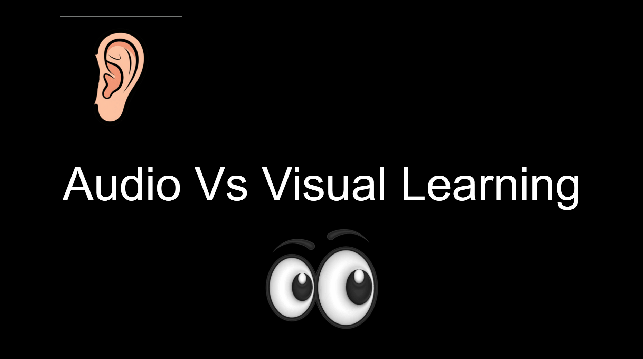
https://docs.google.com/presentation/d/1yJe438IqJC_7-fuBB1Knp9QvODk0rkwNNdujfcFyfZI/edit?slide=id.p#slide=id.p

January/Saturday 17 2026:
-Released survey to class to recruit participants

January/Tuesday 20 2026:
-Put down our different variables
Manipulated:
Audio or video file
Responding:
- Amount of time it takes to complete the task
- Quality of the finished product
Controlled:
Video watched by participants, origami paper
January/Wednesday 21 2026: Formed Hypothesis, “If kids and adults learning is affected during development stages of life, then primarily visual learners will better learn how to do instruction-based tasks (such as folding a paper crane), because”
Still need to work on because statement backed up with extra research

January/Saturday 24 2026: Reading articles on audio and visual learning such as “https://onlineteaching.umich.edu/articles/the-myth-of-learning-styles/”

February/Monday 1 2026: Made script for videos for participants, then made video, Audio - removed visual, Visual - removed audio, Control - original

February/Wednesday 4 and February/Thursday 5 and February/Friday 6 and February/Monday 9 2026: Marking time and quality 0-3 KIDS
Control:
1st: 15:04 quality: 3, only 1 minor error on tail.
2nd: 17:30 quality 2.5, 1 major rip, but folded correctly.
3rd: 17:29 quality 2, 1 major error many minor errors
Visual:
1st: 14:24 quality 2, 1 major error, and small minor errors, but looks like a crane
2nd: 9:11 quality 3, no errors.
3rd: 8:30 quality 3, no errors.
Audio:
1st: 18:00, quality 0, Gave up.
2nd: 18:00, quality 0, Gave up.
3rd: 12:00, quality 0, Gave up.

February/Monday 9 2026: Marking time and quality 0-3 ADULTS
Control:
1st: 9:03 quality 2, looks like a crane, but middle is incorrect
2nd: 10:13 quality 3, minor error on heads
3rd: 12:50 quality 2.5, minor errors on tail and head forming body shape
Visual:
1st: 12:49 quality 3, Perfectly folded
2nd: 20:23 quality 3 perfectly folded
3rd: 24:00 quality 0, did not complete
Audio:
1st: 27:14 quality 0
2nd: 11:22 quality 0
3rd: 3:05 quality 0

