Calgary Youth Science Fair - Log Book

# **Project Title:** Built to Last? How Water Affects Building Materials

## ***START DATE - Jan 27, 2025***

## **Monday, January 27, 2025**

* Figuring out what the project will be
* Trying to test the water resistance of different materials
  + Building materials (wood, brick, concrete, plastic)
  + Trying to understand the relation between material type and durability
  + How there are so many natural disasters like wildfires, flooding, tsunamis, etc; and what building materials would be best to combat those (purpose of experiment)
* Figure out how to test water-resistance
  + Aquarium
  + Bathtub
  + Bucket of water
  + Just put water on them
* Variables:
  + Manipulated: the building material being tested
  + Responding: the quantitative and qualitative analysis of the material (add more detail)
  + Controlled: time of water exposure, size/shape, amount of material being tested, amount of water, temperature of water (need a thermometer??)
* Responding variable / Results
  + Using qualitative observations (e.g., cracks, swelling, bigger than before so like size), temperature (feels hot/cold)
  + Using five senses? (not all though)
    - Taste = no
    - Touch = yes
    - Sight = yes
    - Smell = ?
    - Hear - no
  + Possible methods for quantitative (see how numbers will be incorporated because of quantitative analysis)
    - **Weighing** material before and after to test water absorption
    - Hydrophobic vs. hydrophilic
    - Add another category of objects with and without water sealant or resistance or whatever and compared those
* Materials (to be considered) - at least 5??
  + **Brick**, **concrete**, **wood**, **plastic**, glass, vinyl

## **Tuesday, January 28, 2025**

* Start prepping presentation and do research on how:
  + Chemical composition of materials may help with water resistance
  + Shape and size of material may also have an effect
* Hypothesis: If… then… because
  + Effect of polarity… “like dissolves like”
  + Concrete is stronger, if not the strongest of all materials considering strength required to break by hand
* **Note to self: for tripod display, make the background a house with concrete grounding, brick walls, wooden porch, plastic something and MAYBE glass windows?? (find materials ASAP - home depot?)
* For actual experiment, do multiple trials (prob 3) and if possible bring sample or materials to do a demonstration

## **Wednesday, January 29, 2025**

* Made clarifications on requirements for experiment process
* Close to finalizing forms required (feb 7)
* More details coming soon
* Opened up portal online and looked at other projects

## **Thursday, January 30, 2025**

* Notes about project benefits and risks were made
* Finalized building materials list
  + Includes wood, brick, concrete, and plastic
* Will do background research in coming days
  + Take not of experiments done similar to this
  + Find different brands of brick (or other material) and see differences and how that may affect results
  + use/find generic brand of building materials to test
* Materials needed:
  + Brick
  + Concrete
  + Plastic
  + Wood
  + Scale
  + Water
  + Thermometer
  + Towel
  + Large bucket
* Question? What is the essential question/problem?
* Get tri fold/backboard to start making design and fill out online
* Diagram of tub of water - equal sized samples and how many litres of water??

## **Friday, January 31, 2025 - Sunday, February 2, 2025**

* Looking into different brands of building materials
* Lots of in-head planning
* Next steps:
  + Research at least TWO different brands of each building material and compare
    - Look at lifespan, location (where it is used to determine how weather/climate may affect its performance), weight + size
  + Research different natural disasters involving water (tsunami, flood, hurricane, etc) - maybe 3-4 if easy to find?
  + Find out how builders/construction workers determine whether a certain material is suitable and maybe talk to one???
  + Buy materials and keep track of costs as well as compare prices to build entire building like a house
  + Tie into how if materials are kinda expensive, finding the best one is most recommended as it will save/not waste $$$ and be most sustainable
  + After gathering results, see which is best and then which one is most sustainable and compare those two

## **Monday, February 3, 2025**

* Looked into places to buy and cost of building materials
  + Also created spreadsheet to represent the item, quantity, and cost of ALL materials that will be used for project
  + Will make graphs/charts to convey more info
* Study the different factors this has an impact on
  + Economic (price of building materials is expensive especially considering the current state of Canada, but on a broader range, there’s no reason to pay so much for something for it to be damaged even if it is unforeseen/natural disaster)
  + Health (when wood gets wet, it can begin to create mold due to cellular activity, the mold can spread throughout a building and risk pest infestations and more)

## **Tuesday, February 4, 2025**

* Something about how when I’m done the experiment and have found out which material is best, will I compare it to other types of that material and ways to implement it in the real world

## **Wednesday, February 5, 2025**

* What did I do today?
  + Insert links/references that may be used for research on building materials
  + Made possible formatting for presentation online (10 minutes max!)
  + Watched videos that included tips on successful project
* Research
  + Looked at different types of brick and concrete
    - Will add more detail later on
* Experimental method
  + Hypothesis: **If** regular/common building materials such as B, C, W, P, are submerged in water for 16? Hours, **then** there will be the least/greatest damage from water exposure to [build material], **because** [porosity, appearance]
  + Observations table ** when will I be checking for 16 hours - 4 hour intervals
* Will need to upload/update logbook onto google docs to match what is already there - can look at version history for dates
* Trifold information (video shows it will be really big)
* Diagram for possible set up
  + Talk about real life application with architecture, environmental sustainability, how construction workers choose materials

## **Saturday, February 8, 2025 - Sunday, February 9, 2025**

* Began piecing together virtual presentation
* Did research on various floods (should try to do one hurricane and one tsunami)
  + Calgary flood → 1929 & 2013
  + China flood → 1931
  + Will keep Calgary 2013 (very big infrastructure impact)
* Made hypothesis (to be refined), organized variables and partial procedure
* Need to follow presentation guidelines and hopefully keep under 10 minutes
  + Details on google docs
* Should I continue using a notebook since most research is on PC (google docs)??

## **Saturday, February 15, 2025**

* List of things I need to buy
  + Digital scale (2 kg capacity, 0.1 g precision)
  + Water container (deep plastic bin - 30×30×15 cm - 5-7 L of H2O)
  + Measuring cup / beaker (for water measurement)
  + Timer / stopwatch (for 16 hours) - can use phone
  + 3 of → brick, concrete, wood, and plastic samples (10cm×10cm×3cm)
  + Gloves (have) → towel (big to clean / dry)
  + Plastic bags / containers (for storage after)
  + pH strips? Test chemical reactions?

**Table of Materials**

| M3 | **Item** | **Cost ($)** | **Where** |
| --- | --- | --- | --- |
| yes | Scale | 30-60; 16.49 | Walmart, staples, Canadian tire |
| yes | Plastic bin | 10-20; 2.75 | Walmart, dollarama, Canadian tire |
| yes | Measuring cup | 5-15 | Dollarama, walmart (water bottle) |
| yes | Timer / stopwatch | 5-20 | Walmart, dollarama, use phone |
| ~~no~~ yes | Brick sample | 2-5 | Home Depot, RONA |
| no | Concrete sample | 5-10 | Home Depot |
| no | Wood sample | 2-5 | Home Depot, RONA |
| no | Plastic sample | 5-10 | Home Depot, craft stores |
| yes | Notebook & pen | 2-5 | Dollarama, staples |
| yes | Gloves & towel | 5-15; 4.94 | Walmart, canadian tire |
| n/a | ~~Saw~~ | ~~15 - 40~~ | ~~Home Depot, RONA~~ |
| n/a | ~~Angle grinder~~ | ~~50 - 150~~ | ~~Home Depot, RONA~~ |

**most items are at home - see spreadsheet later

Where to go?

* Walmart
* Dollarama
* Canadian tire
* HOME DEPOT (or RONA)
* Ask for cutting services if needed
* Trifold too!!

## **End of February 2025 (last 2 weeks)**

* Connected with building materials stores/companies
  + Home Depot - didn’t have :(
  + BURNCO → headquarters then emailed Sales Rep (need to follow up)
  + Bought some of other required items on list
* Spoke with science fair coordinator (for “further research”)
  + Suggestion on also studying impact of water on roads (not just buildings) especially with asphalt and trying to find an alternative that has a longer lifespan but isn’t too costly
    - Concrete has long lifetime but it is much more expensive
  + Also to find materials, I can go to a place where construction is shopping and ask for “roof sidings” or something like that
* Deadline is coming up FAST and there is still lots of work to do…
* To-Do list:
  + Make notes/specific case study on Calgary 2013 flood (interview maybe Mom & Dad / ask for opinions and experience)
    - Will have to come up with questions - NOPE!
  + Decide which material is most cost effective and which is most sustainable and which is most common (compare)
  + Start compiling all research in Word document (look at examples)
  + Create presentation AND practice (Record)
    - Do this on March 12 (hopefully!!)
  + Get trifold to start printing info and getting ready for actual fair
    - Ask what info this includes
      * Experiment “stuff” - procedure, hypothesis, data, observations, analysis, further studies

## 

## **Tuesday, March 4, 2025**

* Work on info for digital presentation
* Hypothesis:
  + If building materials are submerged, then brick will absorb least amount of H2O and remain most durable after explore, while wood will absorb most H2O and have greatest deterioration
  + Reasoning for each material based on porosity, durability, and water absorption
  + Brick should prove to be best material for areas prone to floods
  + **CONTINGENCY PLAN**
    - If I can’t obtain ALL 4 materials, I’ll test still and compare results with existing research
* Research:
  + Done on PC with google docs so maybe print??

***Log book continues on PC - notebook will still have information***

## **Thursday, March 6, 2025**

* Research on each of the building materials finalized
* Looked over the case study for Calgary flood of 2013
* Preparation of interview questions underway
* Still don’t have materials :( - idk what i’m gonna do…

## **Friday, March 7, 2025**

* Began inputting all my research and information into online portal for fair
* Finalized research and citations to be used
* Received the concrete blocks I will be using 😀 (BIG THANK YOU TO BURNCO)
* Deciding which information is necessary and then will later need to cut down for presentation video AND actual in-person @ Olympic Oval (April)
* Updated/finished variables, research, hypothesis and procedure

## 

## **Saturday, March 8, 2025**

* Bought brick sample (RONA) and wood sample (Home Depot)
  + Now need is plastic - will likely do testing without it and make notes of the fact that I wanted to do it initially
* Set-up for trial number one and organization
* Had to remove information about plastic (too bad…)

## **Sunday, March 9, 2025**

* Reworded/rewrote procedure
* Made observations table (see below)
* Updated other sections like research, variables, and hypothesis to match with what I’m doing now
* Contacted trifold company in Calgary - will set up an appointment for trifold in coming weeks OR go to Staples and see if there’s one that fits within the dimensions
  + Got the trifold (IT’s VERY BIG)
* First trial underway - had very slightly over 4 litres (like 4 litres and a small glass cup so I don’t think that matters too much)
  + Made notes of what happened, biggest thing is wood floating which will definitely impact results as water is not fully covering all sides but we’ll see
* Started to work on presentation and finalizing what information I’ll put: (possibly)
  + Introduce project (problem, hypothesis, and purpose)
  + Explain method (materials, procedure, and testing process)
  + Showing observations and results
  + Conclusion (what I learned, real-life application, and improvements/sources of error)

| ***Time Elapsed*** | | *0 hours (Start)* | *4 hours* | *8 hours* | *12 hours* | *16 hours (End)* |
| --- | --- | --- | --- | --- | --- | --- |
| **Brick** | *Softening* |  |  |  |  |  |
| *Discoloration* |  |  |  |  |  |
| *Damage* |  |  |  |  |  |
| **Concrete** | *Softening* |  |  |  |  |  |
| *Discoloration* |  |  |  |  |  |
| *Damage* |  |  |  |  |  |
| **Wood** | *Softening* |  |  |  |  |  |
| *Discoloration* |  |  |  |  |  |
| *Damage* |  |  |  |  |  |

***Description on the physical appearance of materials is in notebook***

## **Wednesday, March 12, 2025**

* Worked on my presentation script and the things I want to include
* Initially wanted to end the first trial, however there didn’t seem to be much happening so I let it sit for longer
* Also decided the table that I wanted to use would no longer be accurate or even good especially considering the duration that I left the samples under water
* Made some other descriptive notes on what I could see and took LOTS of pictures

## **Thursday, March 13, 2025**

* The day that I took out the samples (VERY early in the morning)
* After this, they had been in the water for **3 days, 14 hours, and 30 minutes. (3.6042 days)**
  + From March 9, 2025 (9:30 AM) to March 13, 2025 (12:00 AM)
  + [Mar 9 to Mar 13](https://www.calculator.net/time-duration-calculator.html?today=03%2F09%2F2025&starthour2=9&startmin2=30&startsec2=0&startunit2=a&ageat=03%2F13%2F2025&endhour2=12&endmin2=00&endsec2=0&endunit2=a&ctype=2&x=Calculate#twodates)
* I noticed that there was significant changes that matched with my hypothesis, especially with the wood
* Took some videos as well to highlight each part of the material samples
* Later this day, I decided to start the second trial, taking some photos of the materials before submersion
* With this trial, decided to put crosses (X) on the flat side of each of the samples to see if that would also affect the results

## **Saturday, March 15, 2025**

* Took some photos of the state of the samples
* Also didn’t see much change so I decided to let them stay for a little longer

## **Tuesday, March 18, 2025**

* Very early this morning, and somewhat of Monday night, I took some last minute photos of the materials and decided to take them out
  + Especially cause I thought I saw mold growing on the wood which really scared me, but eventually saw that it was just how the water reacted to it making the area white and shiny
* The concrete and brick samples showed similar results except the brick did seem to have a little more water damage whether that was because of the “X” I put or because of the time it was submerged
* These samples had been in the water for **4 days, and 6 hours (4.25 days)**
  + March 13, 2025 (6:00 PM) to March 18, 2025 (12:00 AM)
  + [Mar 13 to Mar 18](https://www.calculator.net/time-duration-calculator.html?today=03%2F13%2F2025&starthour2=6&startmin2=0&startsec2=0&startunit2=p&ageat=03%2F18%2F2025&endhour2=12&endmin2=00&endsec2=0&endunit2=a&ctype=2&x=Calculate#twodates)
* I also put in the last of the samples for the third trial today
  + The brick sample is like double the size of the other ones which will definitely impact results, AND the time I’m leaving for submersion is much shorter than the others so we’ll see…
* Worked on other parts of the project and continuing to put in descriptions
* Started building the final report of all the information that I gathered, especially ones that won’t be on the CYSF online platform or in the video presentation

## 

## **Wednesday, March 19, 2025**

* Last trial complete 🎉😀
  + Was in water for less than a day - **23 hours, and 50 minutes** **(0.9931 days)**
  + March 18, 2025 (12:30 AM) and March 19, 2025 (12:20 AM)
  + [Mar 18 to Mar 19](https://www.calculator.net/time-duration-calculator.html?today=03%2F18%2F2025&starthour2=12&startmin2=30&startsec2=0&startunit2=a&ageat=03%2F19%2F2025&endhour2=12&endmin2=20&endsec2=0&endunit2=a&ctype=2&x=Calculate#twodates)
* Had to really work hard and get the video done and presentation complete
* Finishing up any loose ends
* Need to send my presentation and other files to science fair coordinator (Mr. Nayak) so that they can get checked out and approved before deadline: Mar 21, 2025
* I’m worried…
* Later today:
  + I realized I need to update my entire procedure because i like didn’t follow it… whoops
  + Hopefully that won’t take too long
  + Continued to build up my final report and worked on small sections to ease the stress
  + I’ll have to work harder eventually though
* Added everything to my online CYSF platform
* Will record the video really quick…
* Have to add as many pictures as possible which also means I have to go through all of them but hopefully that is quick
* Finished attaching all links ;-;
* Record video now-

## 

## ***END DATE - Mar 20, 2025***

Reflection: This **ENTIRE** project took me: **52 days!** Nearly 2 months of planning, researching, and doing a science fair project I had not even been thinking about before. Wow! I’m glad this part is done with, now for the trifold. Yay!

# 

# **Photos (many more)**

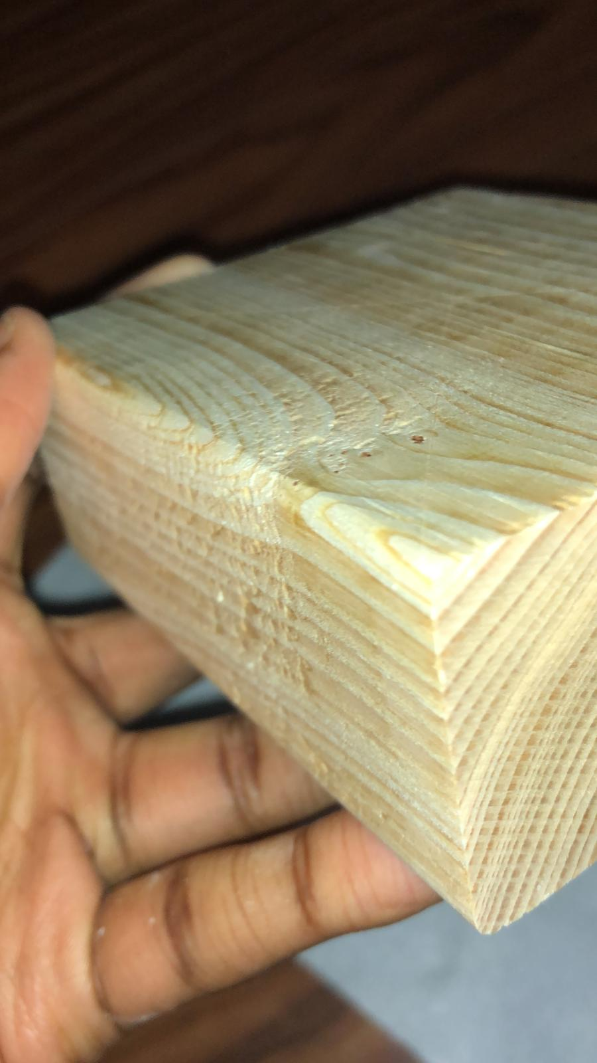

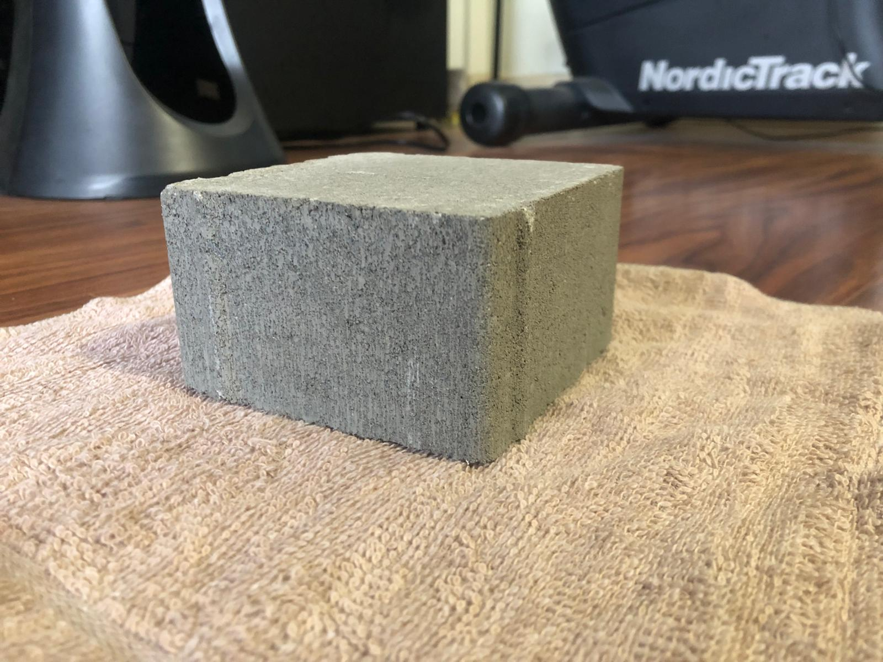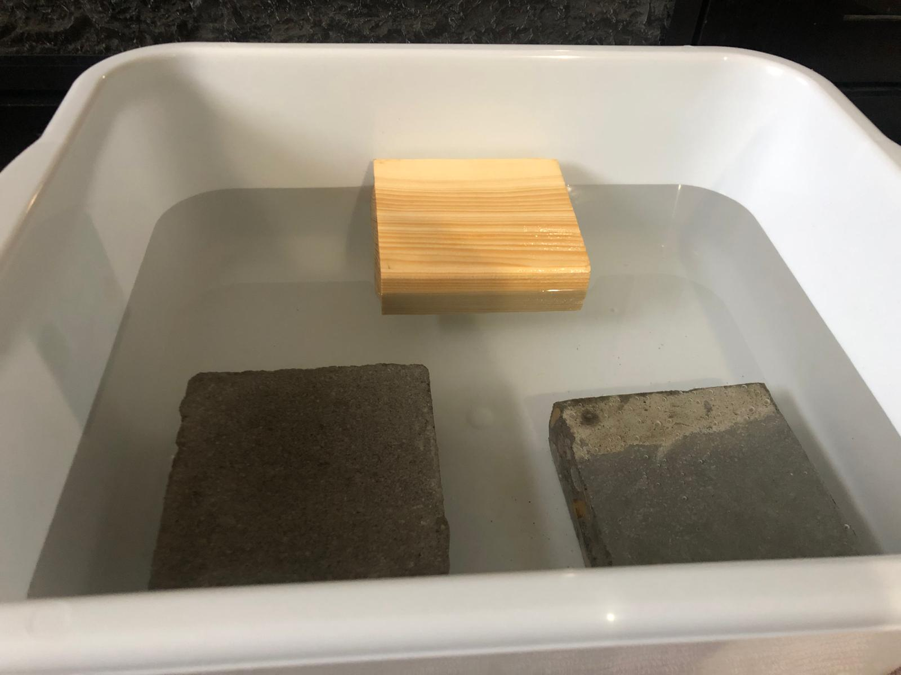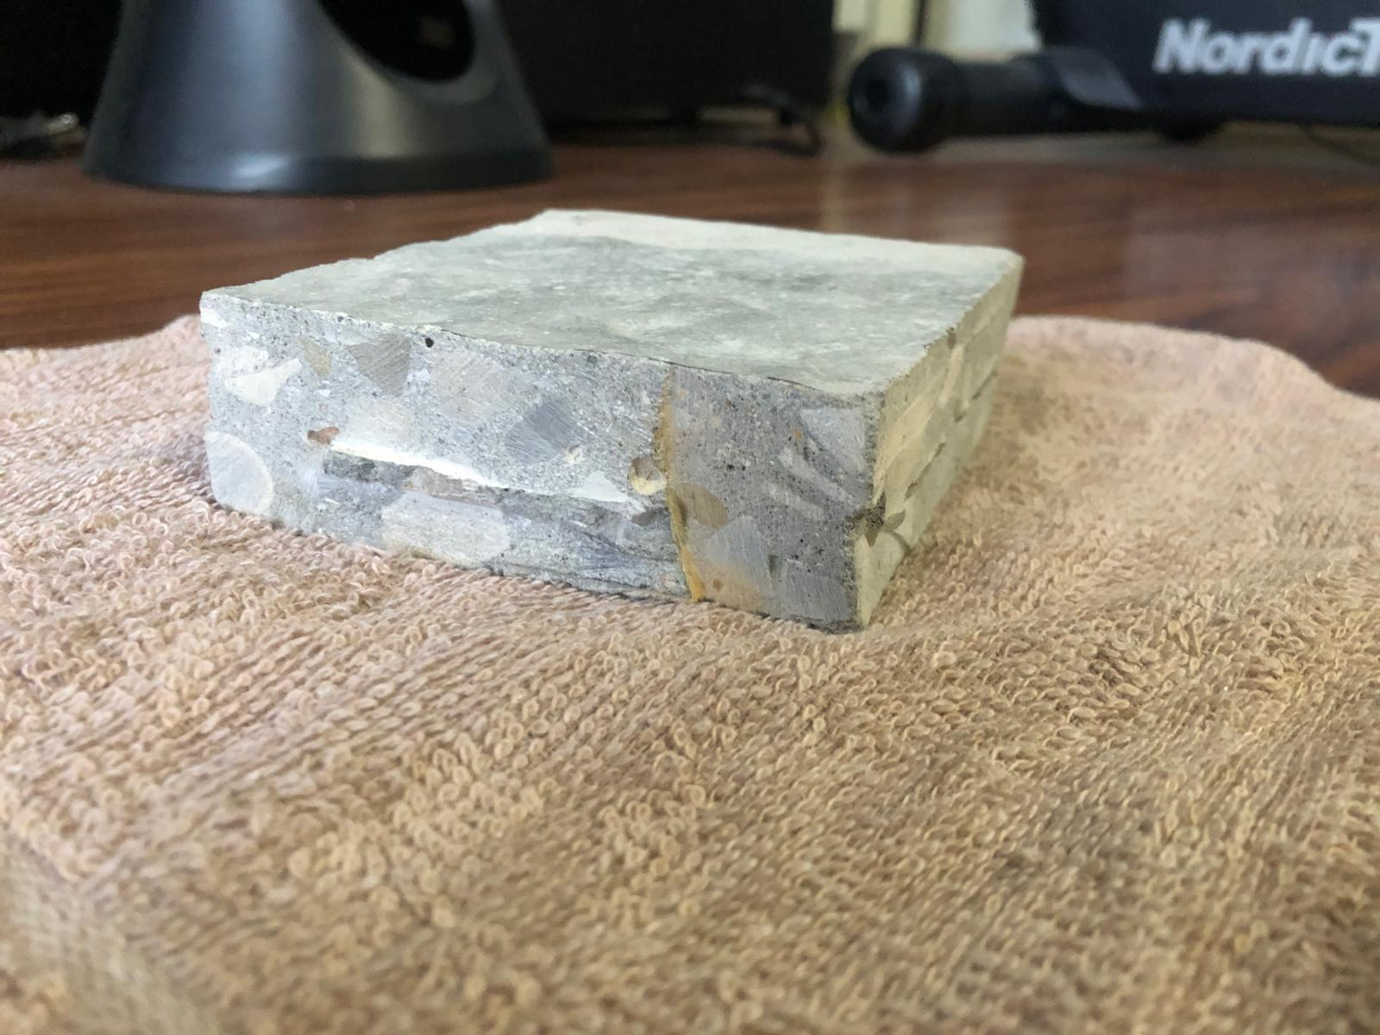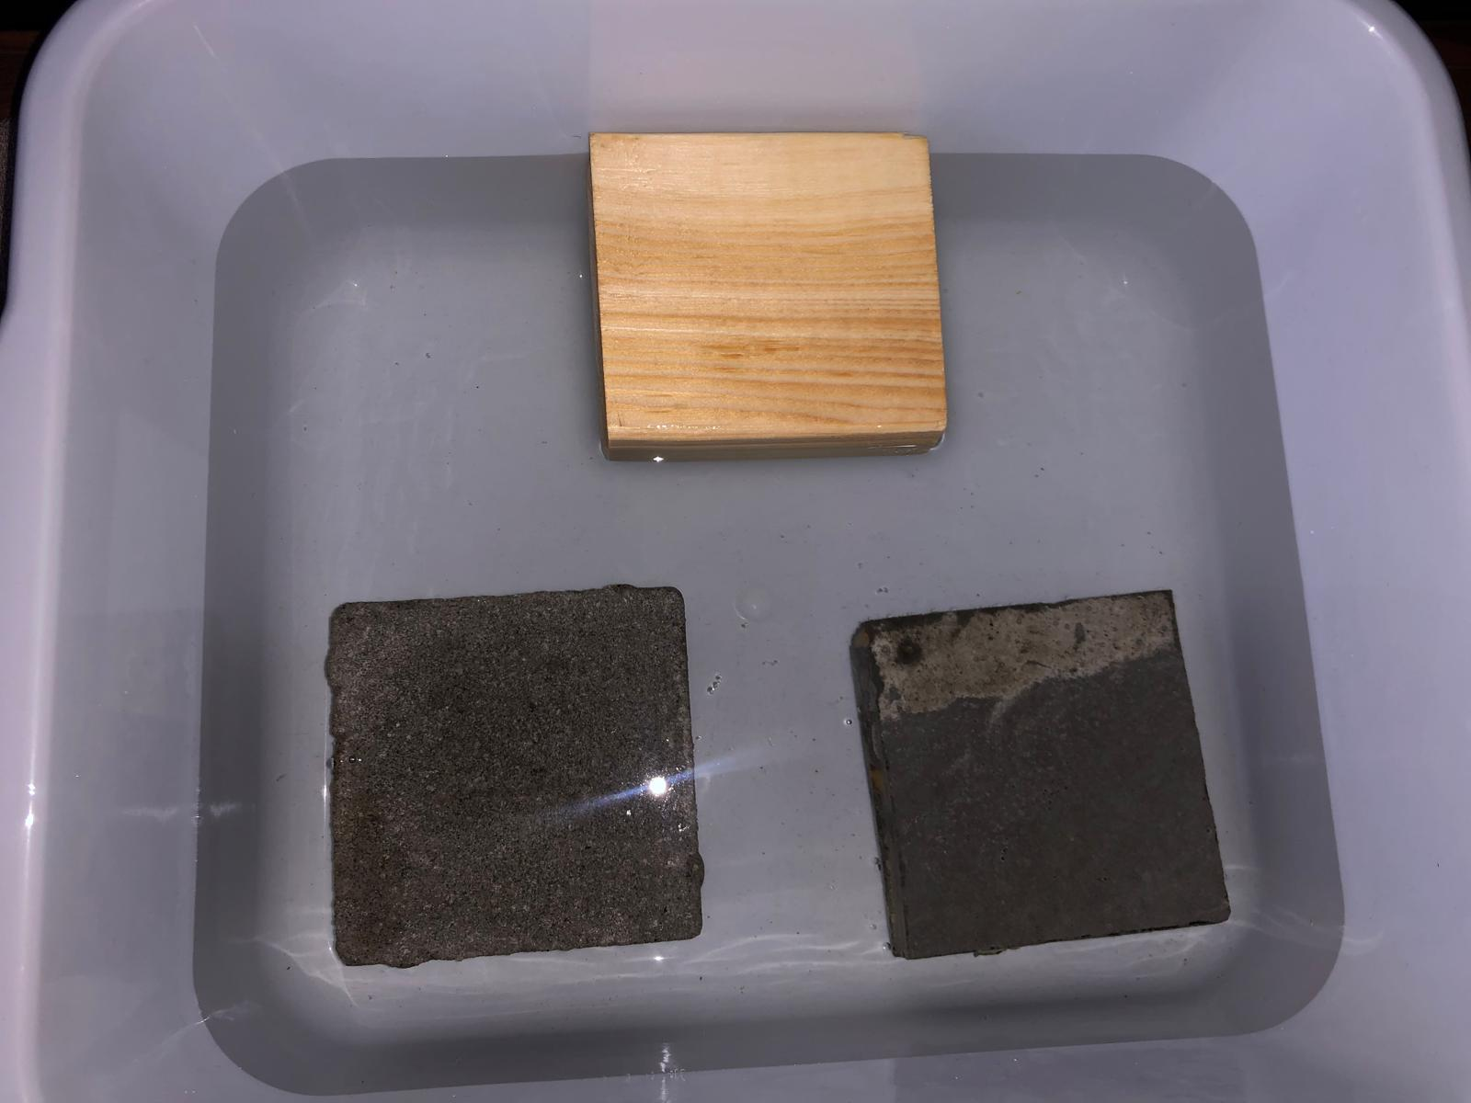

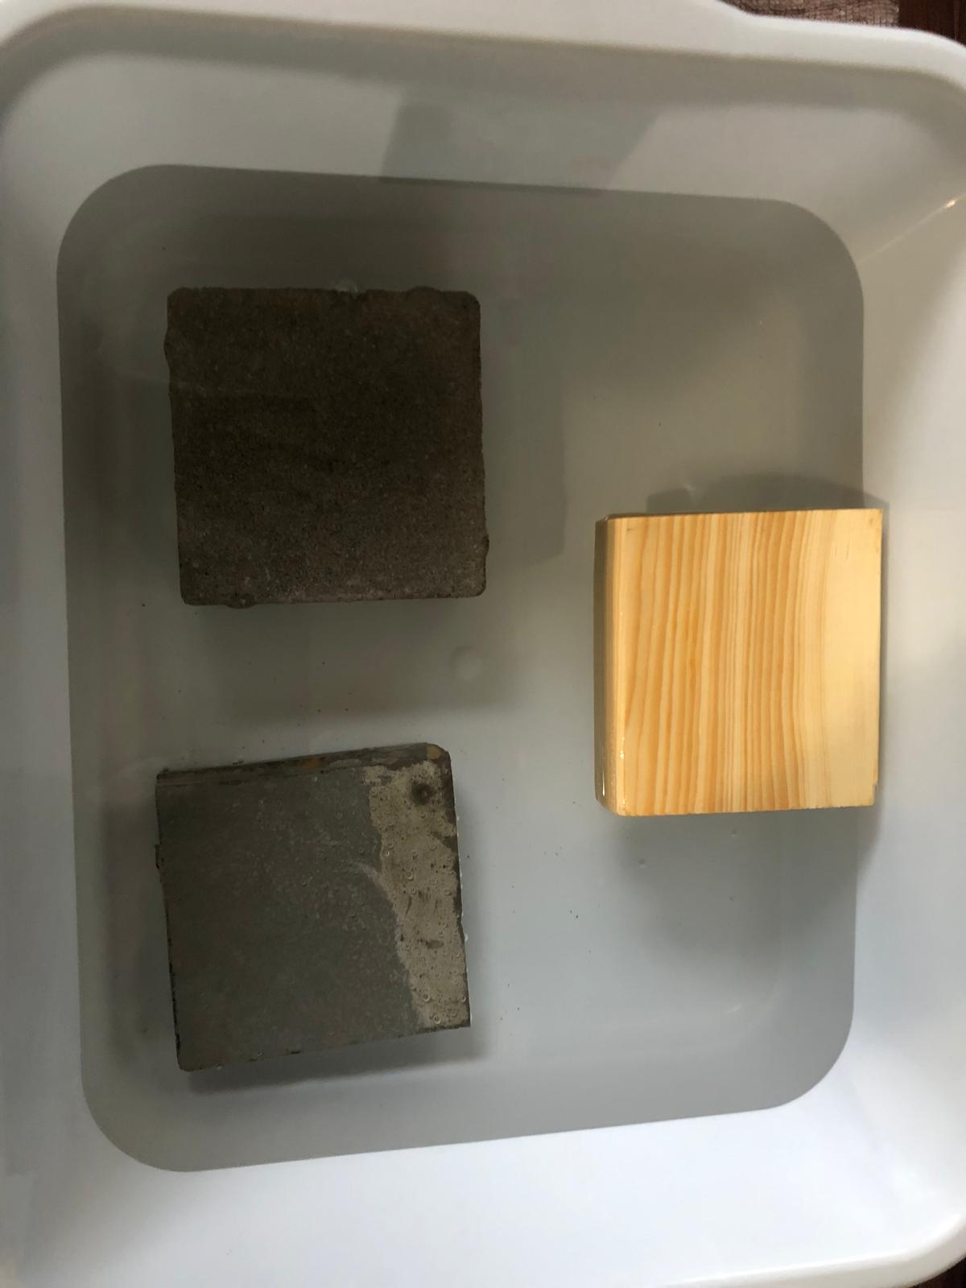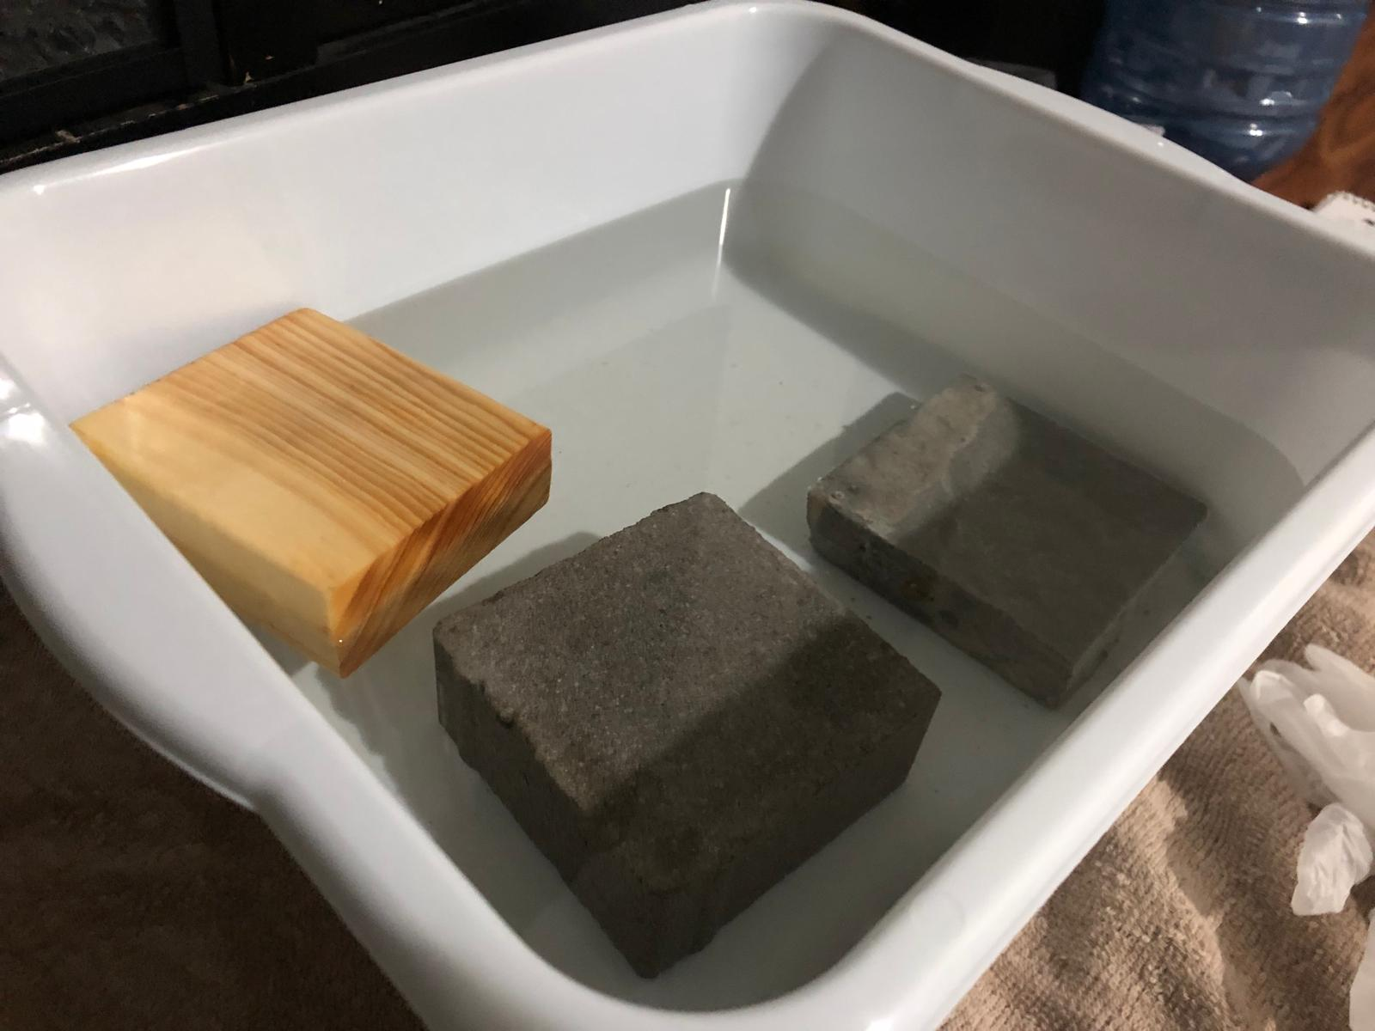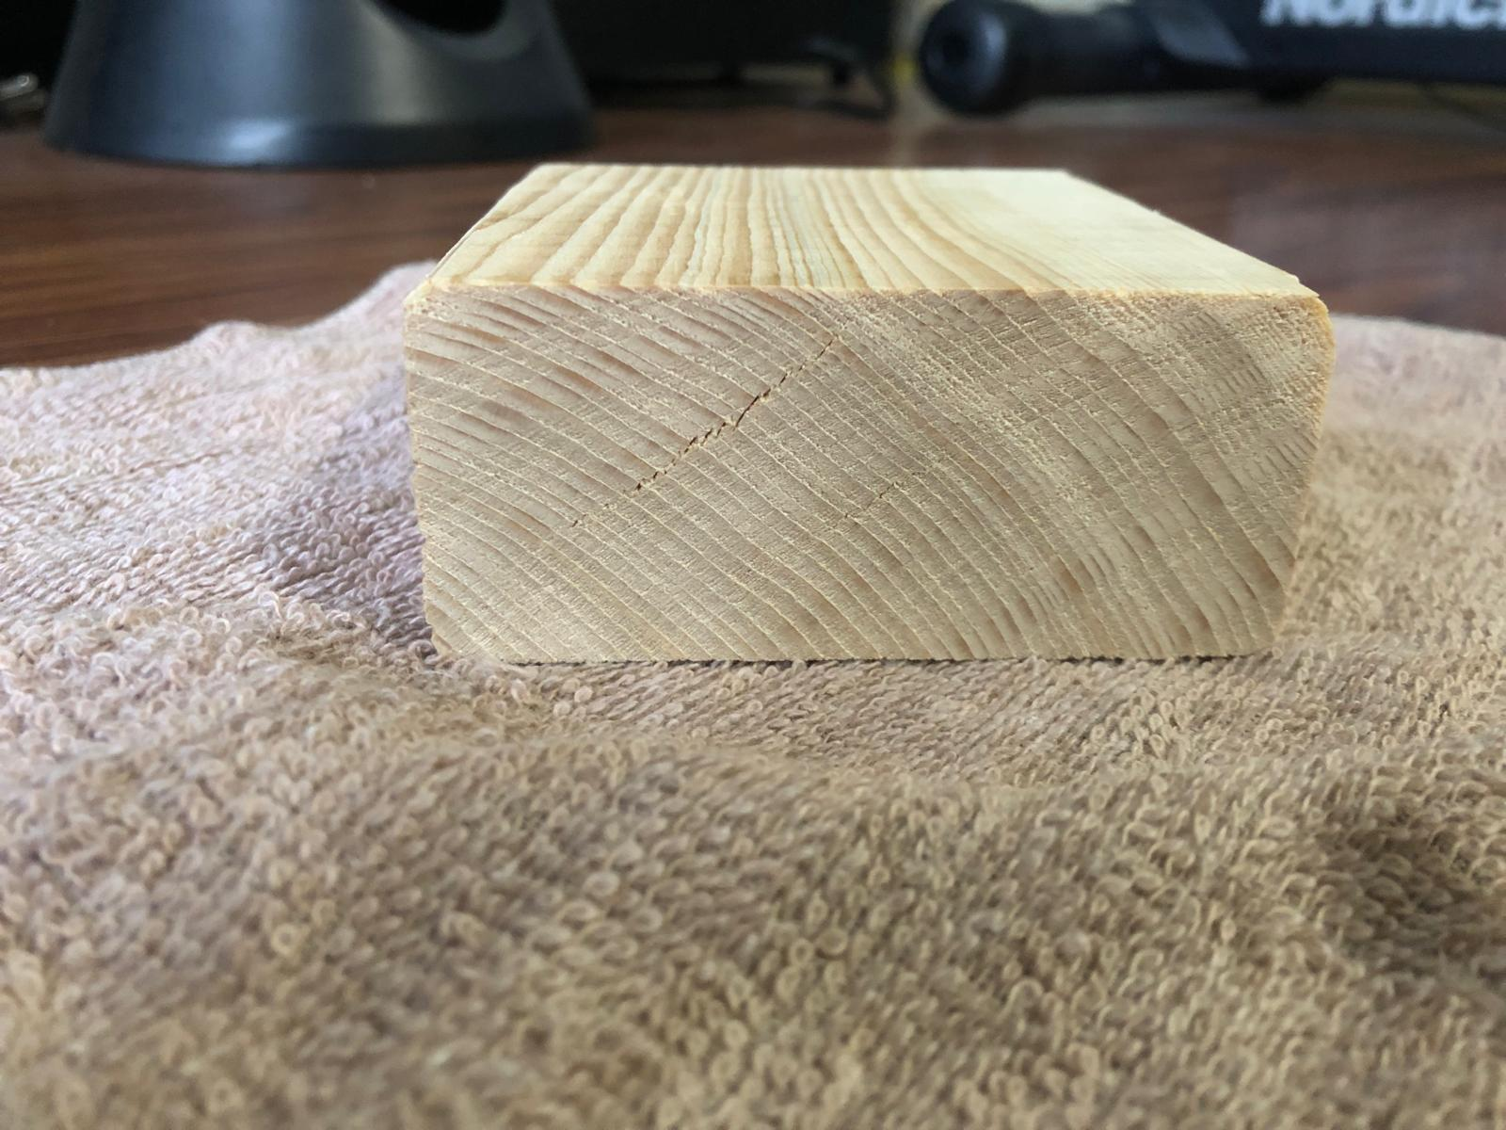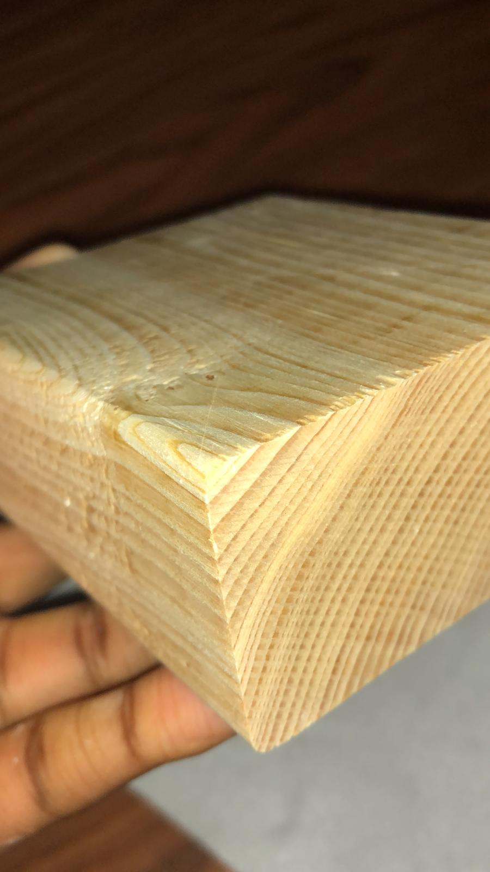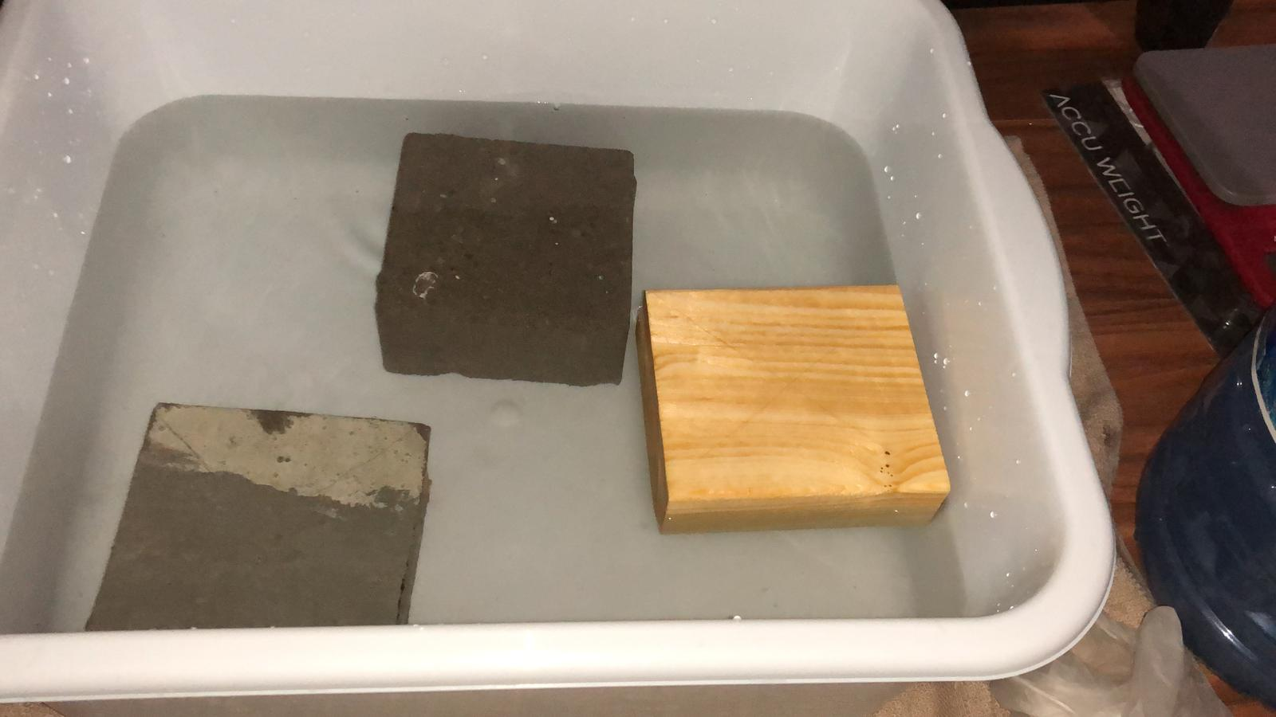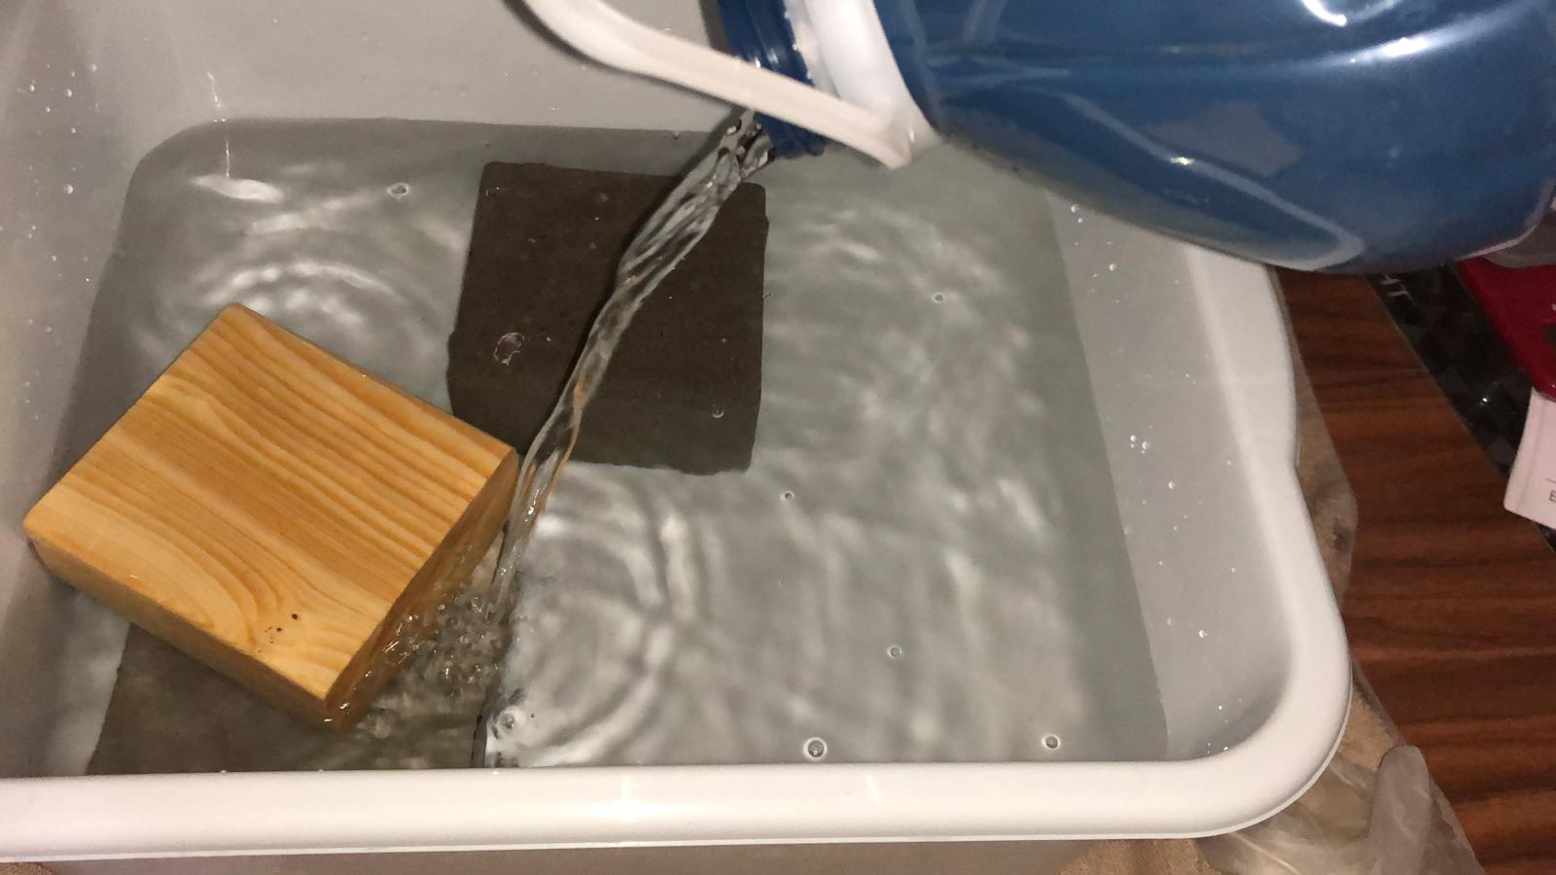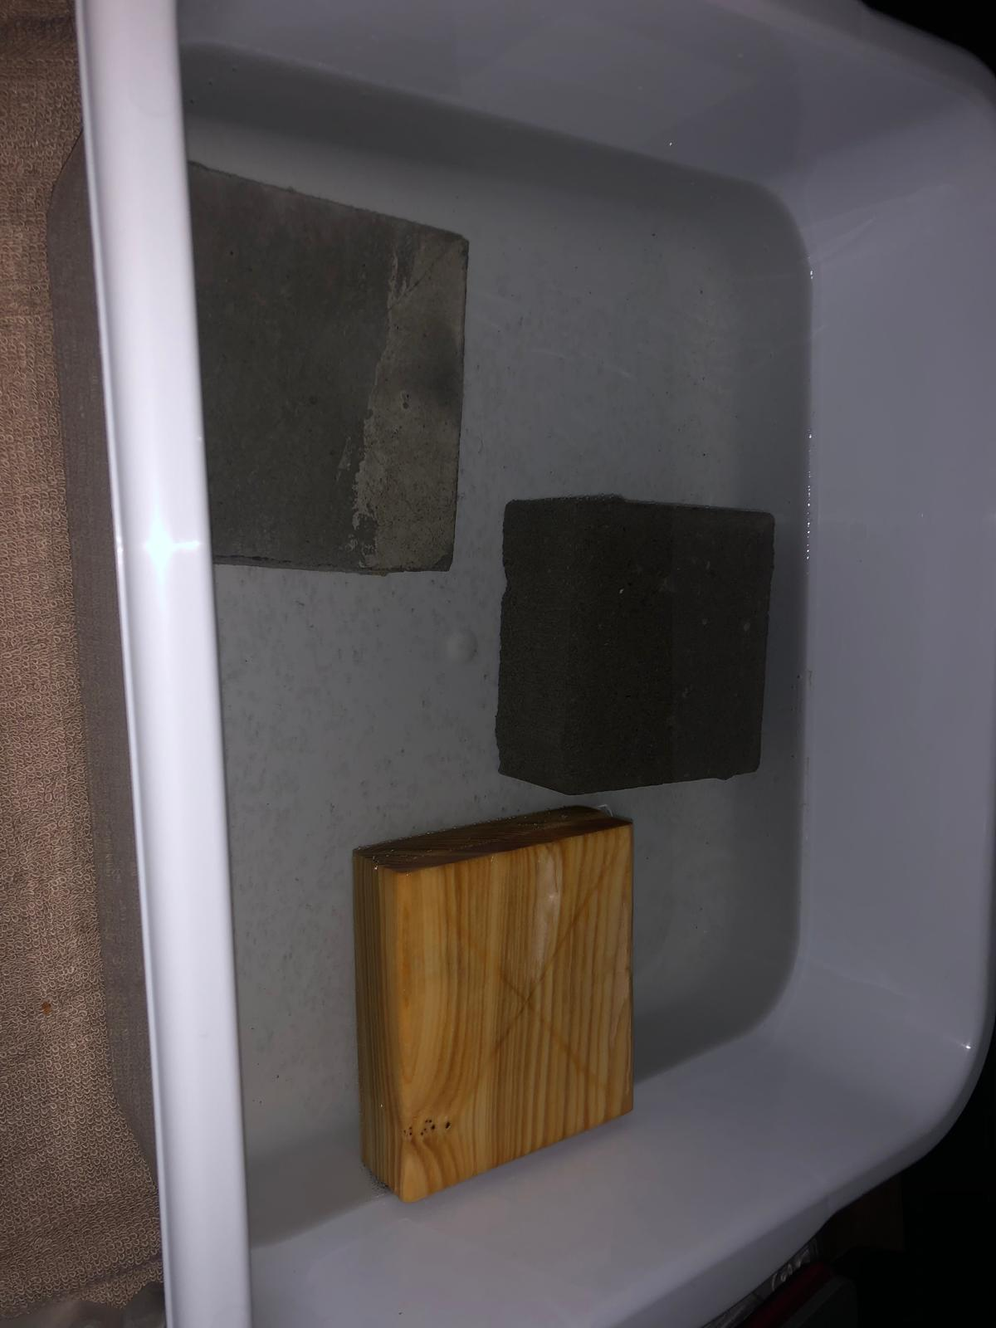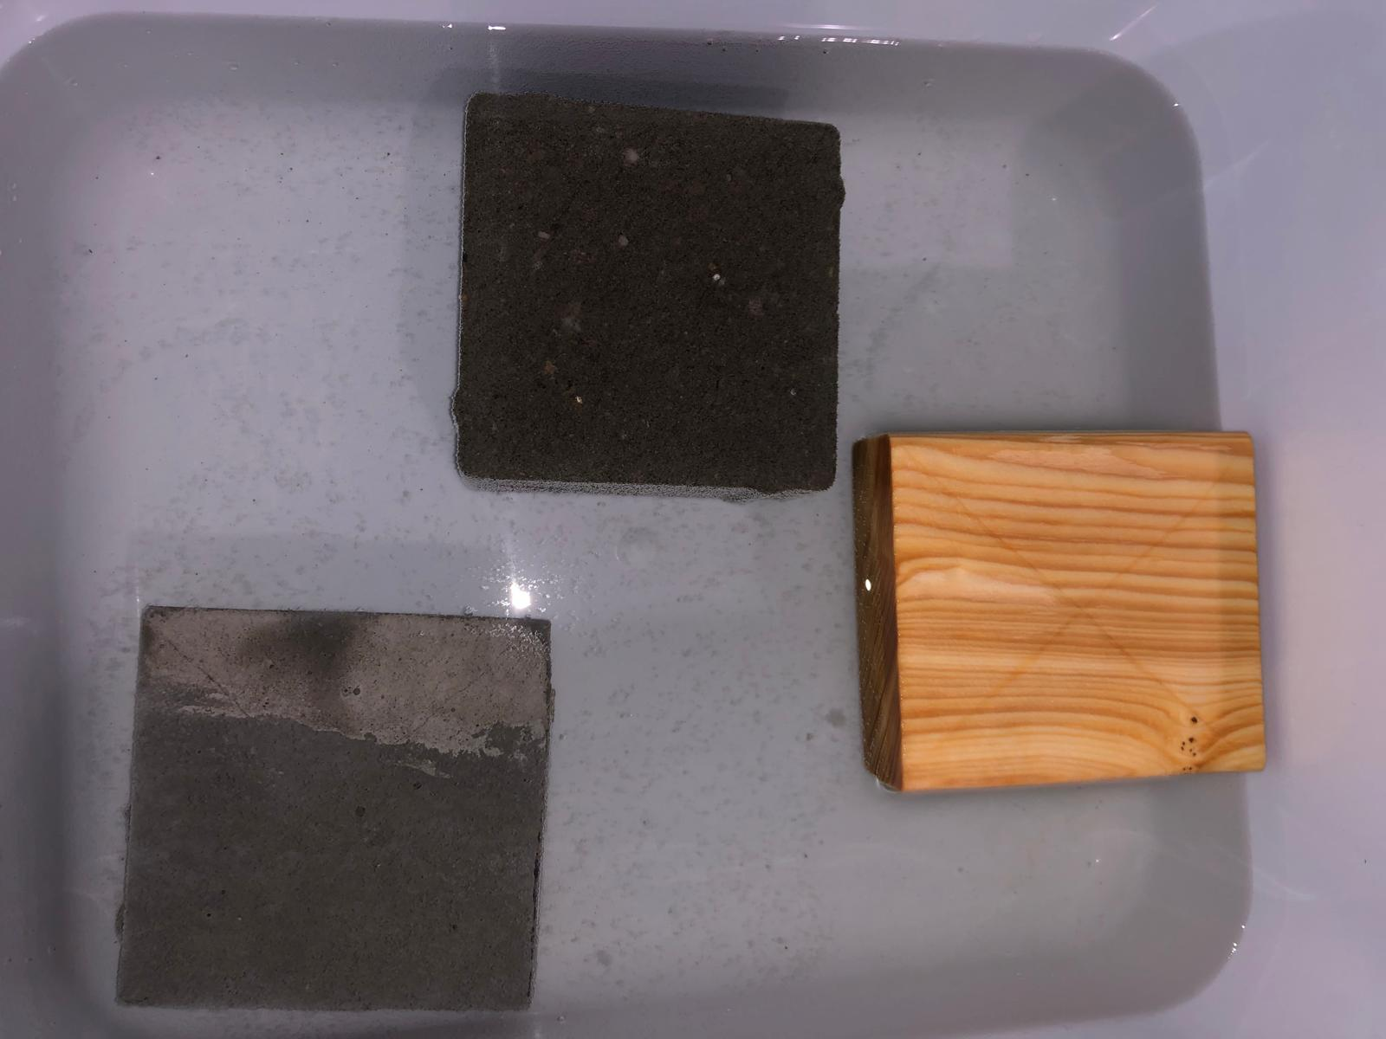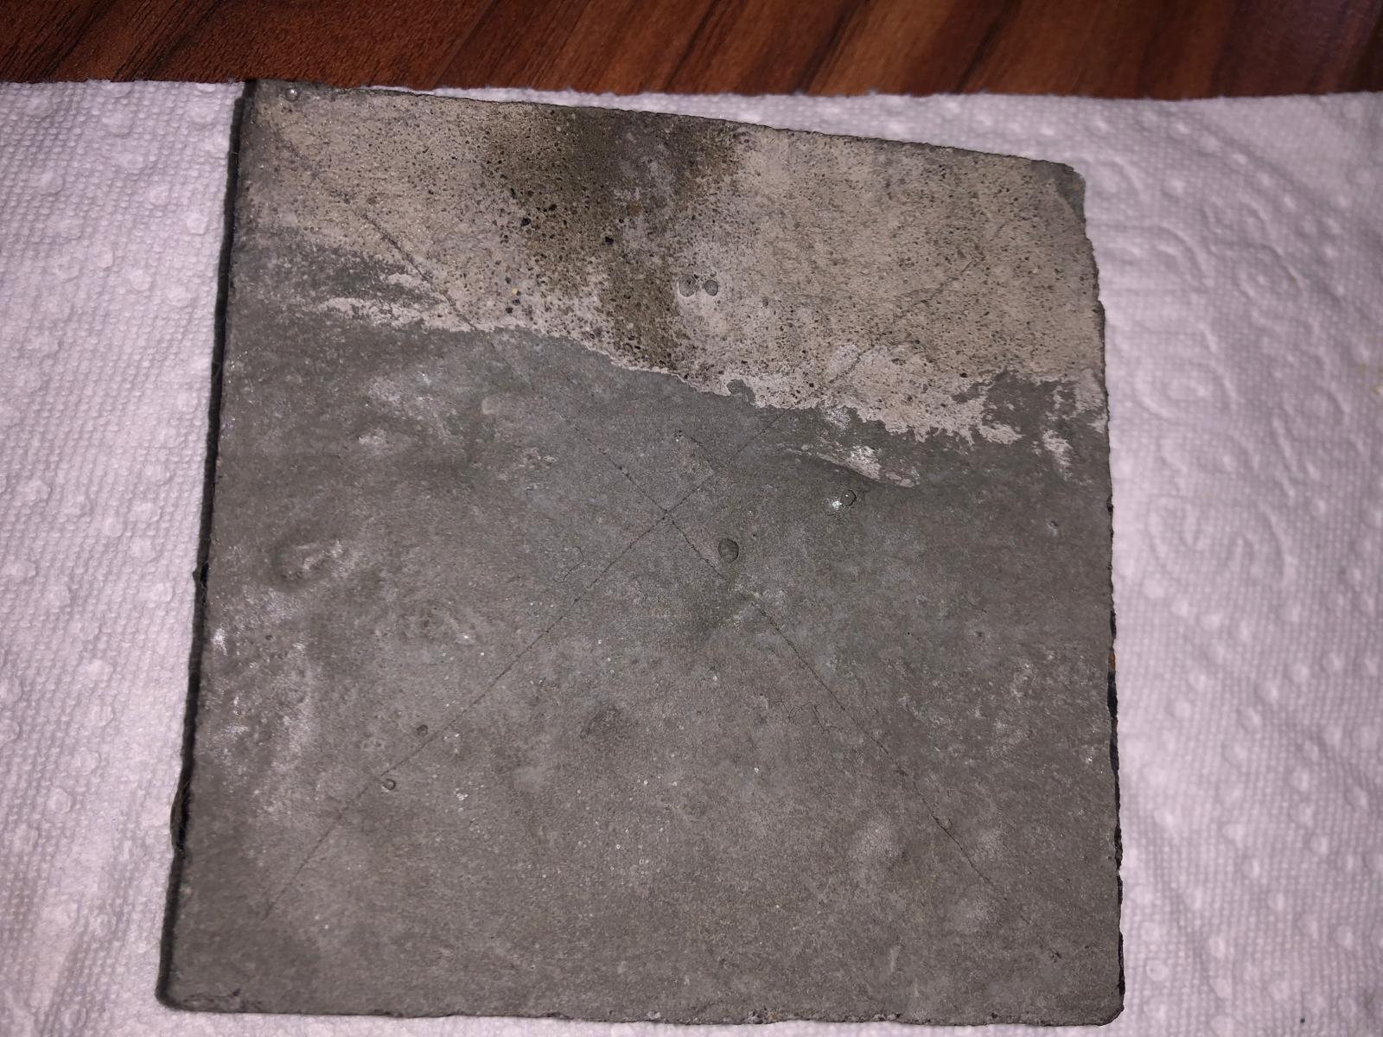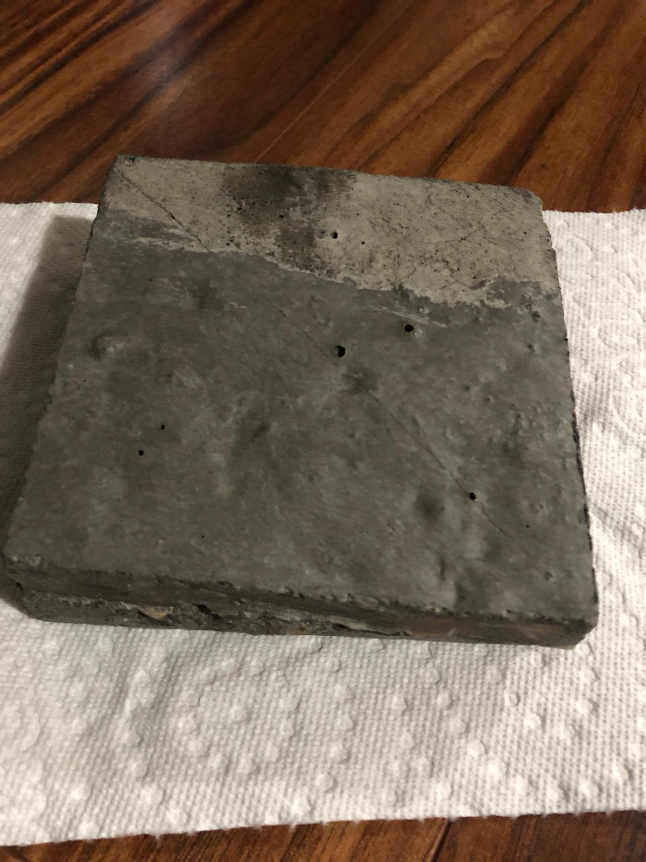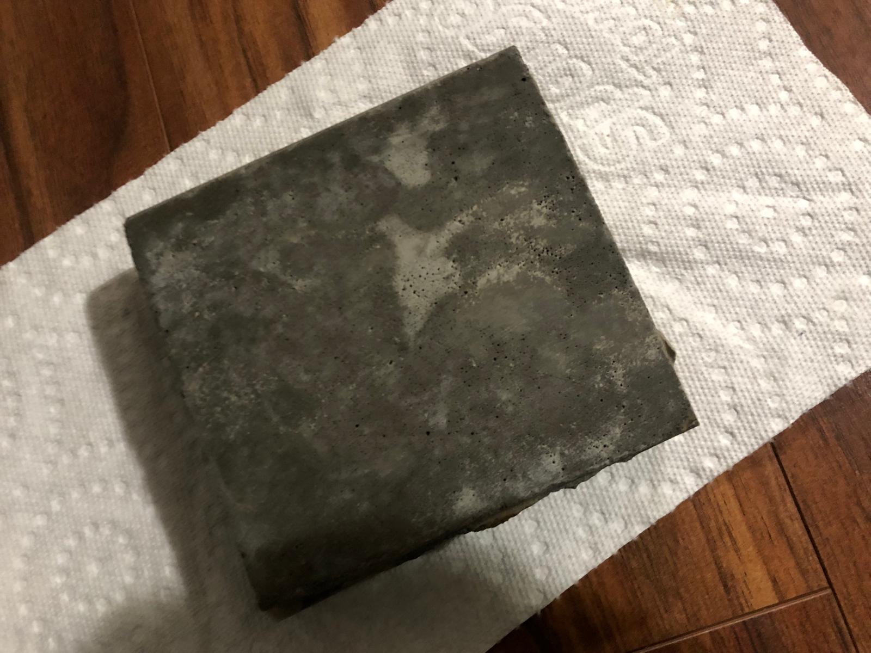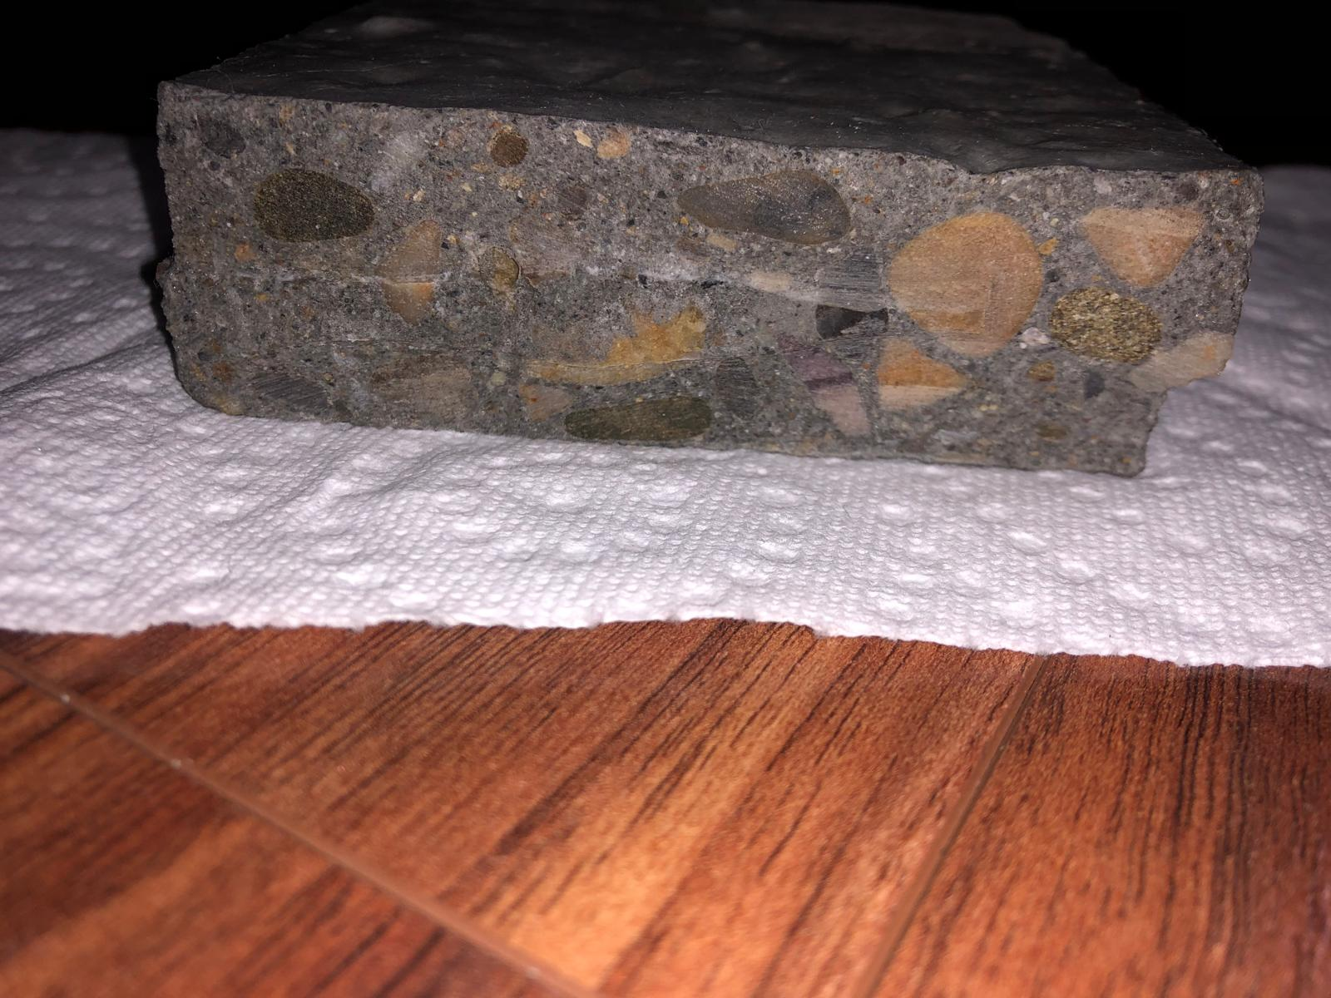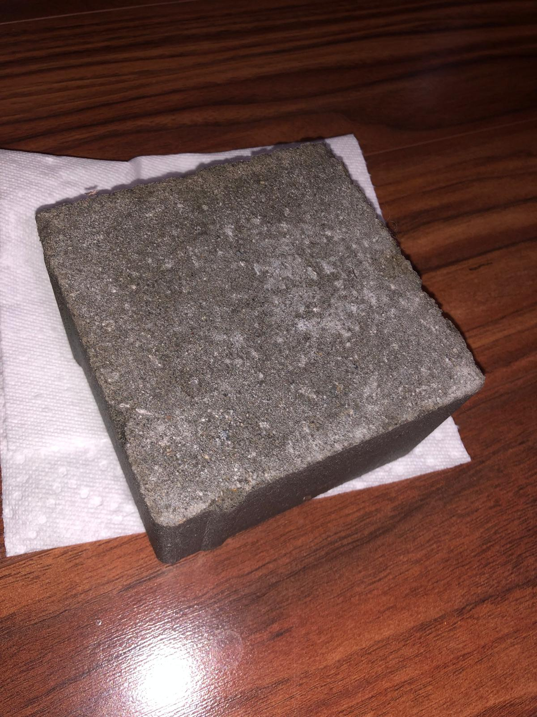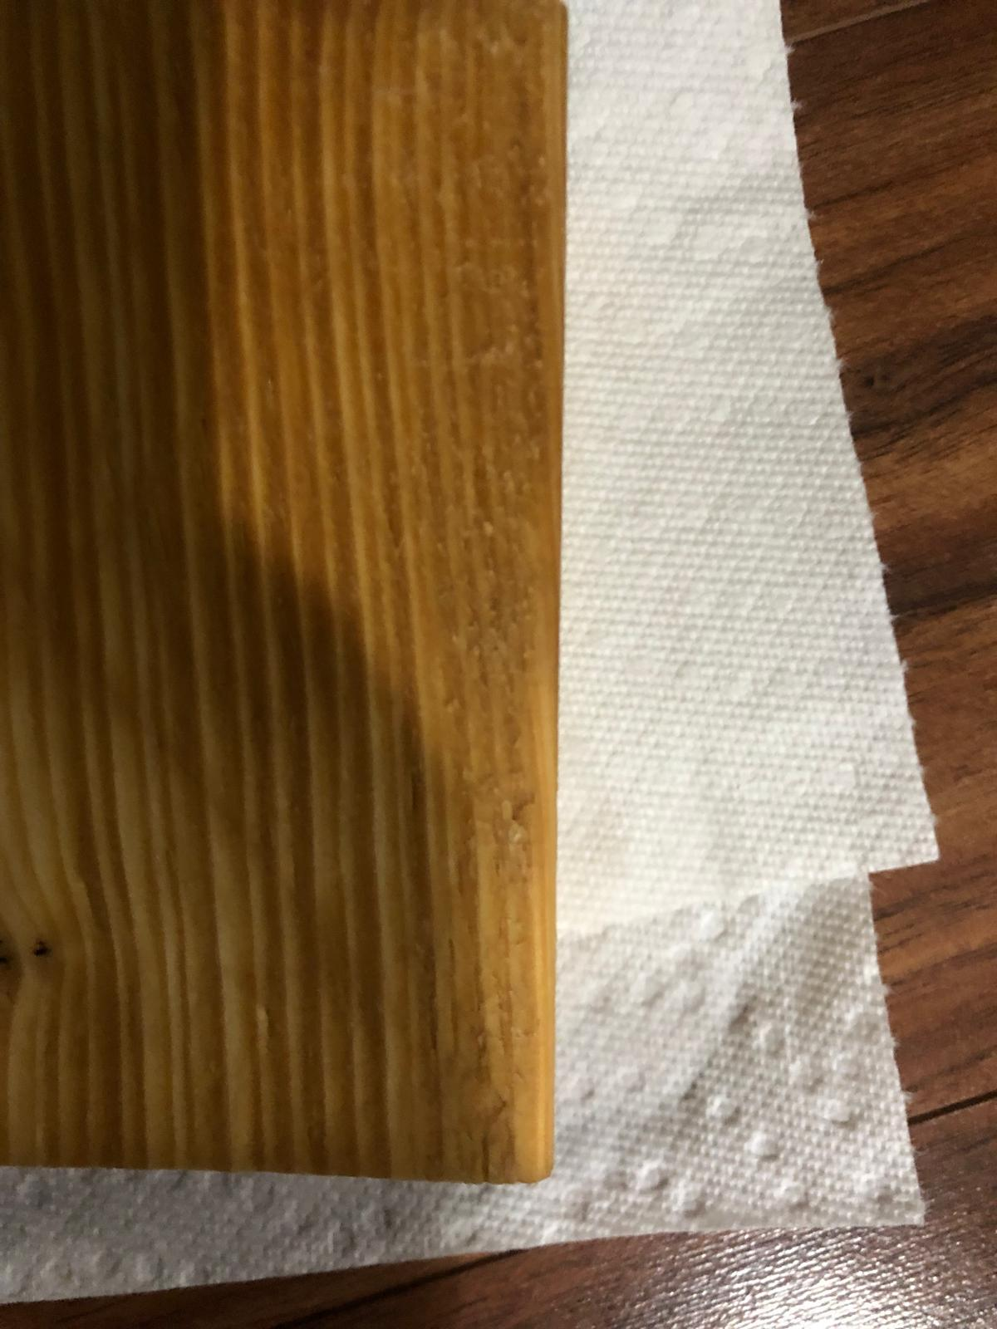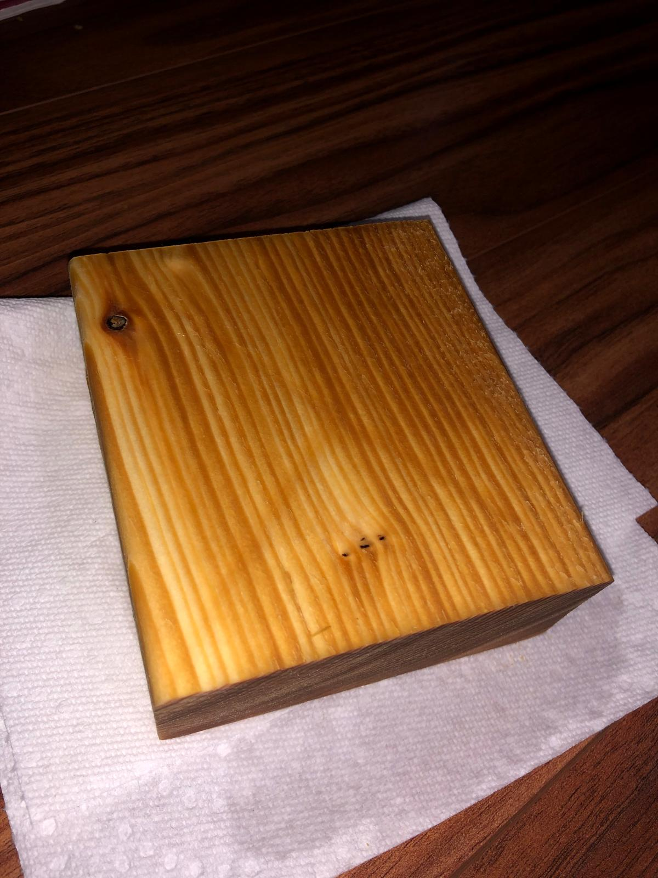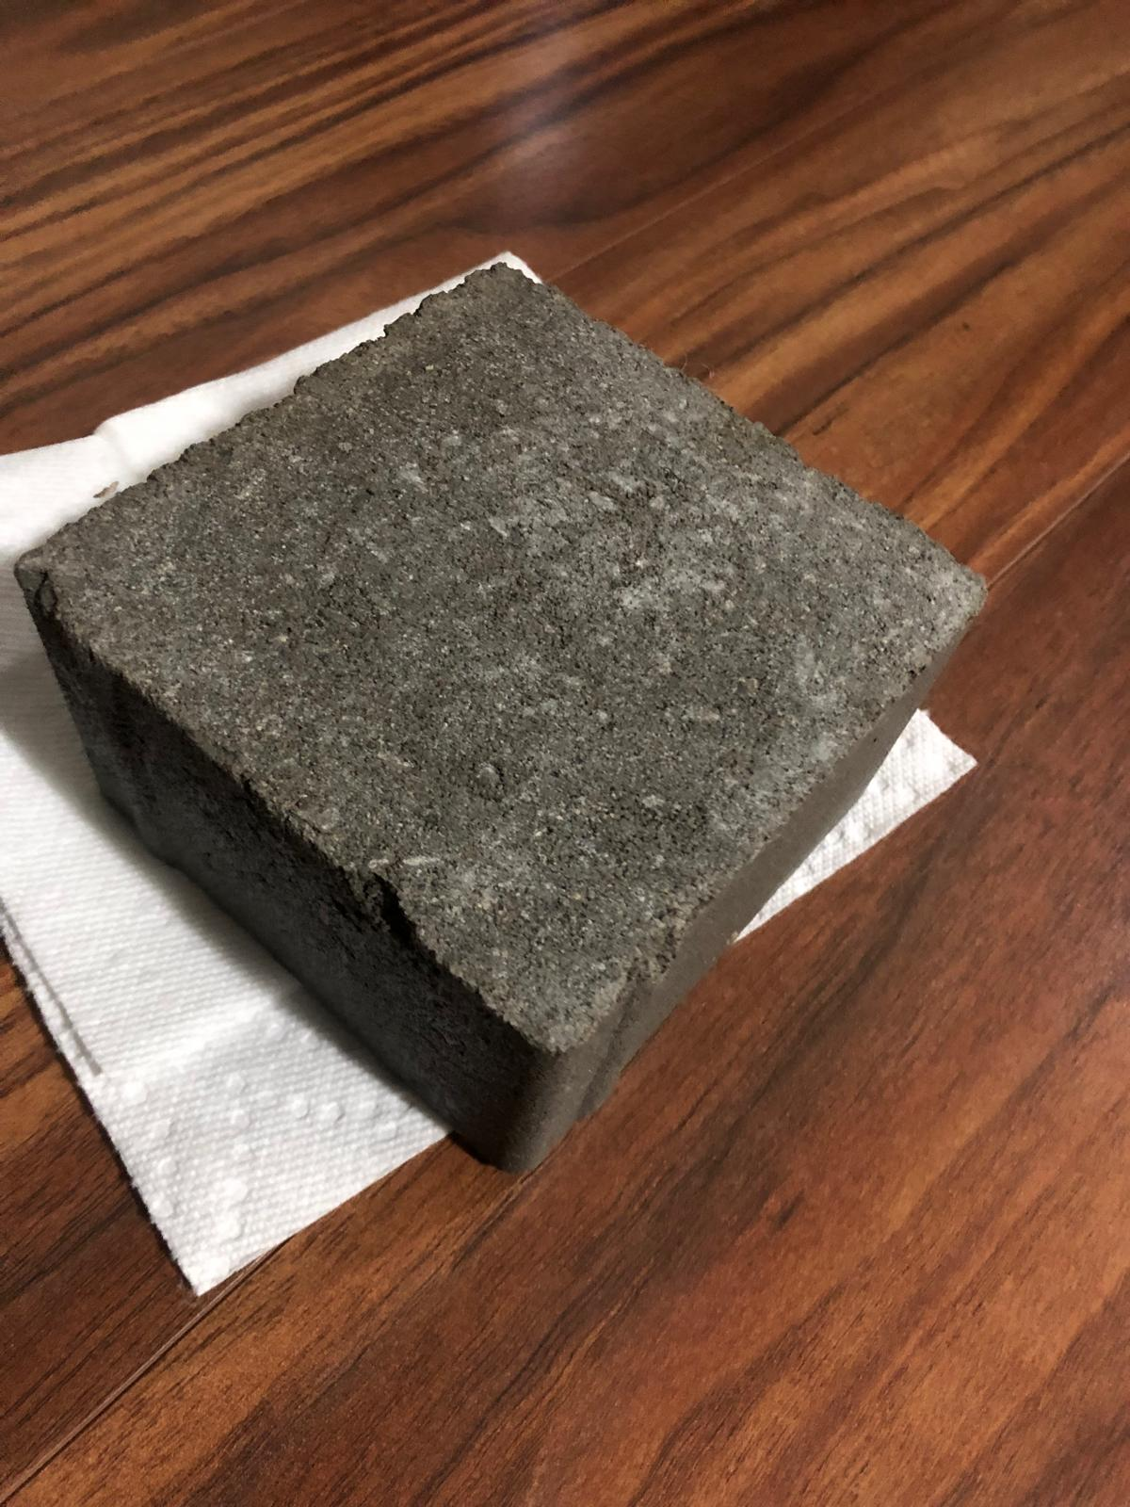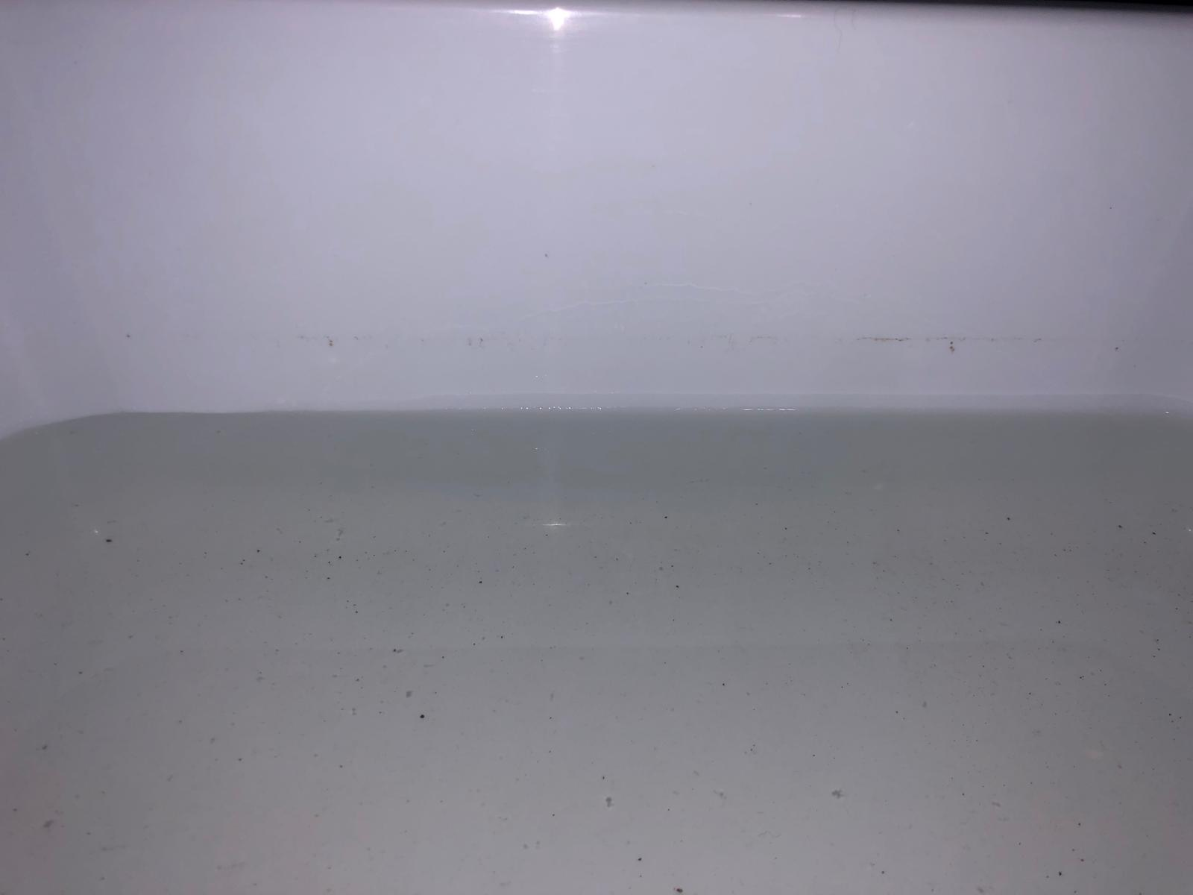

**Photo of the water level going down I think**

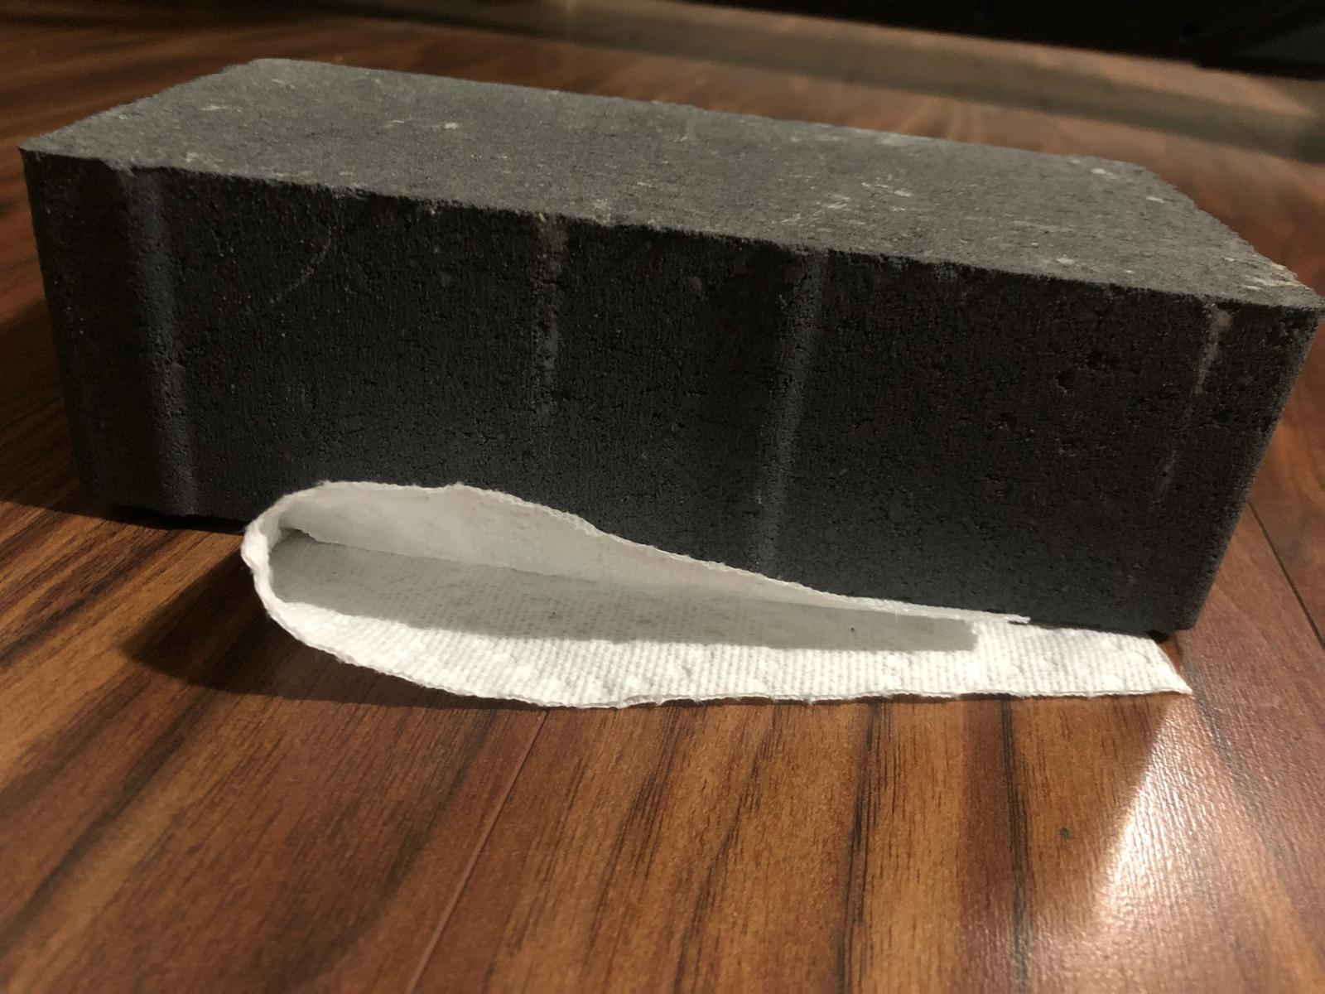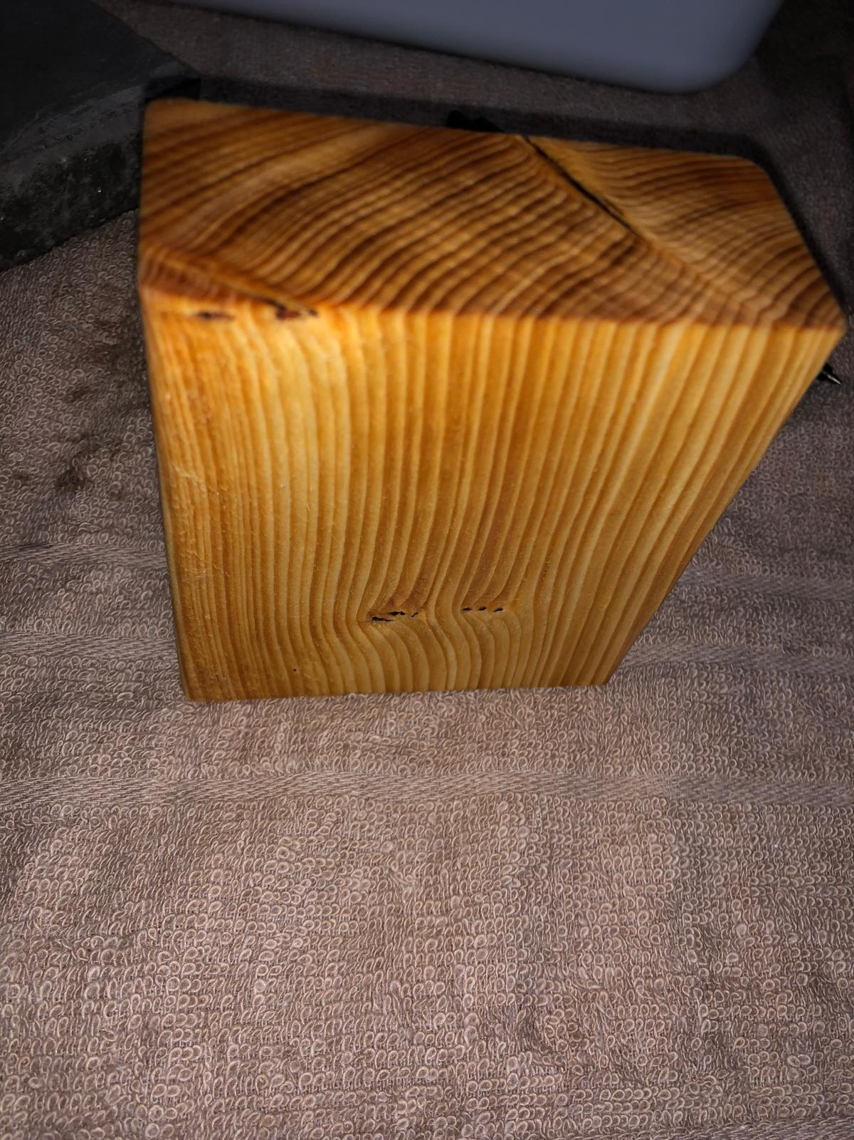

**Deep cut in wood**

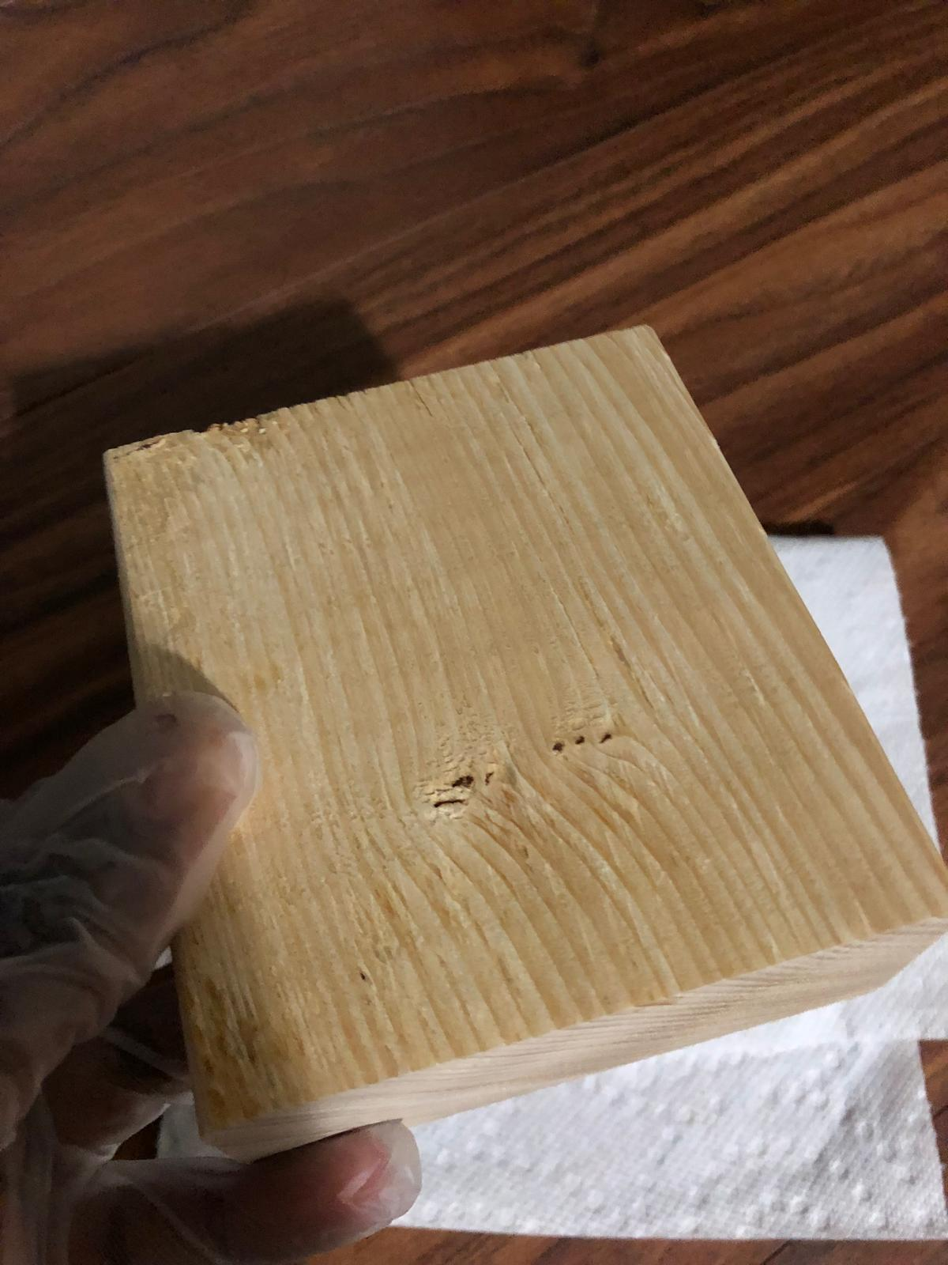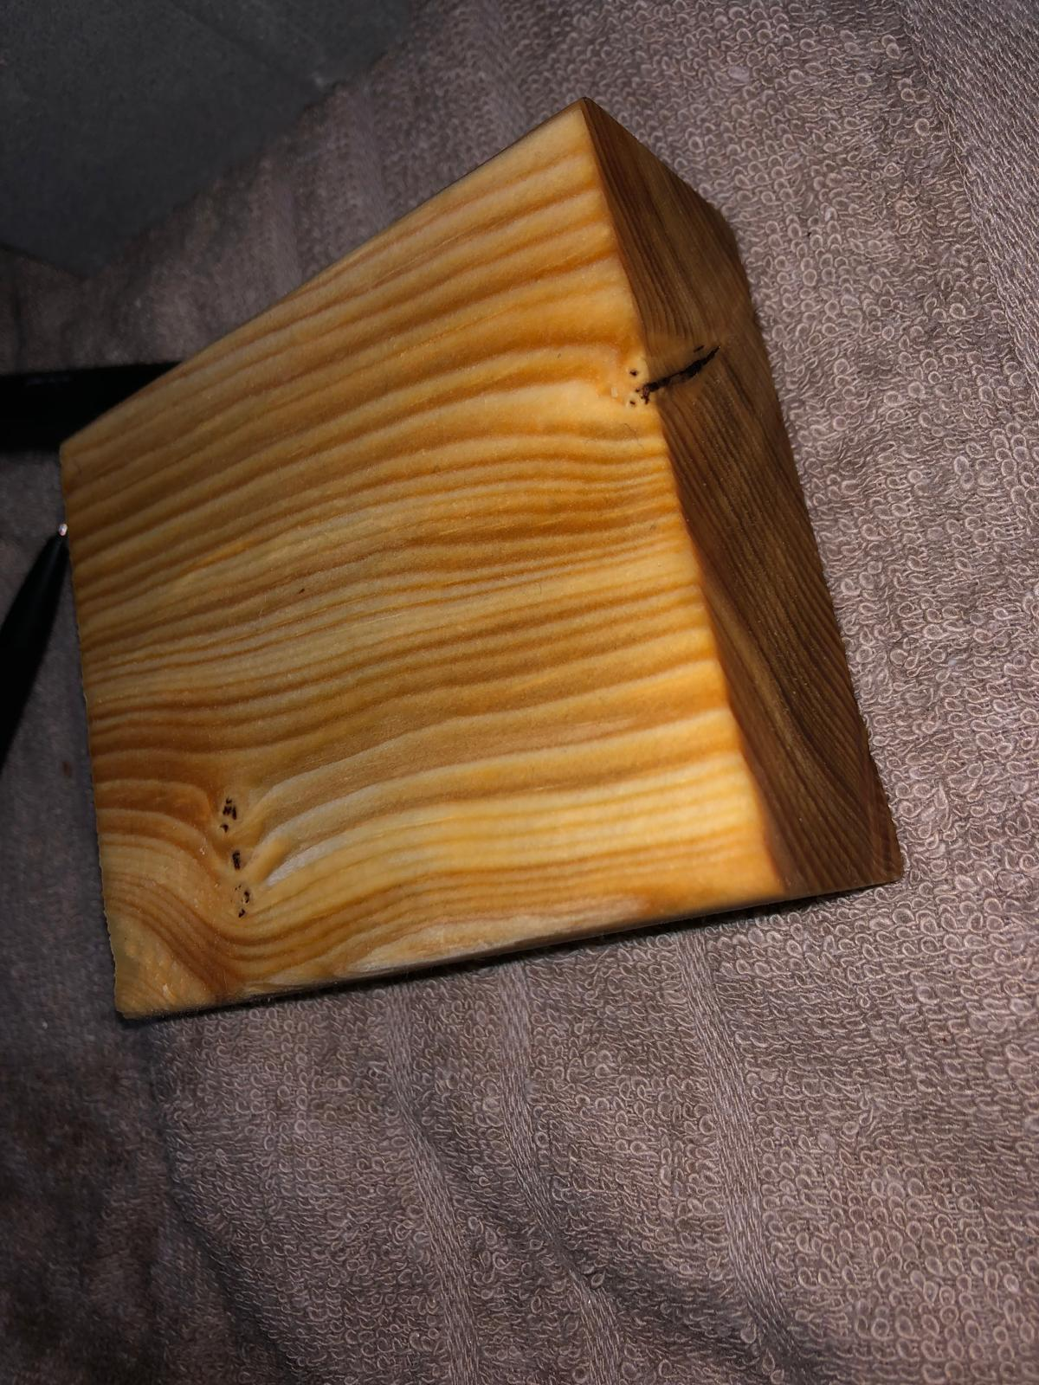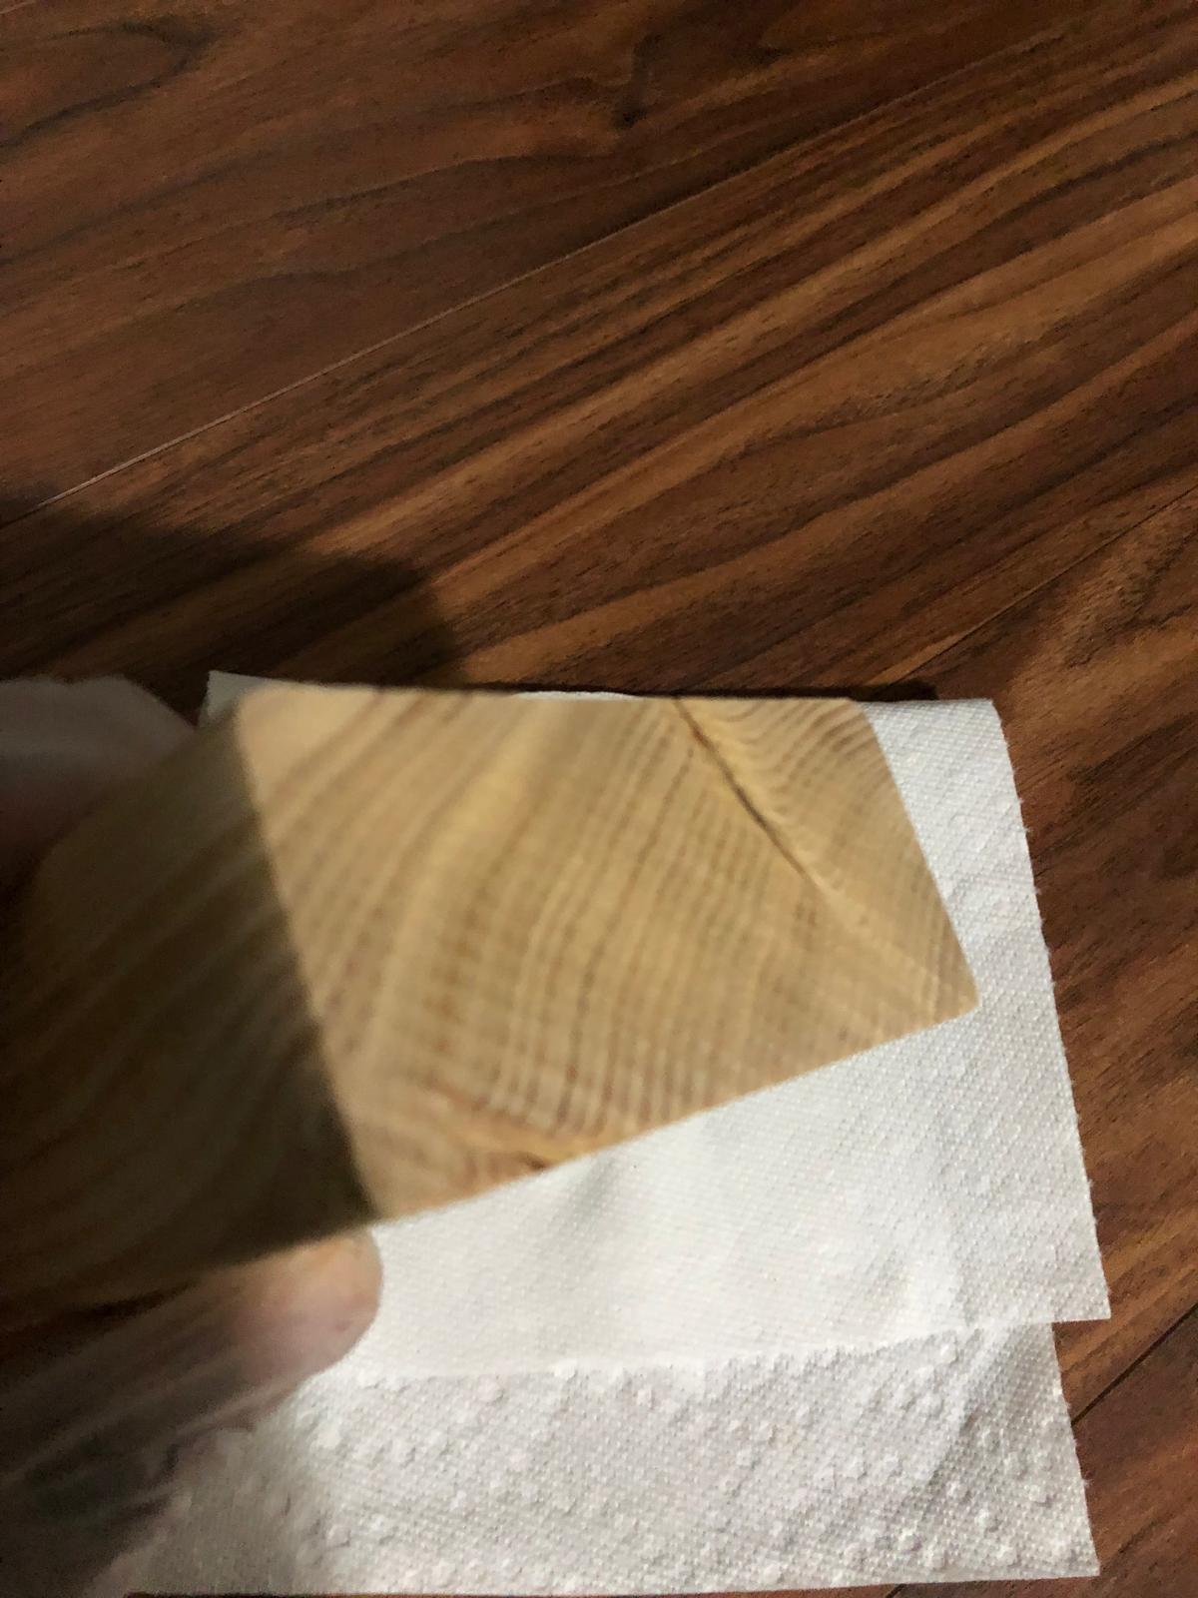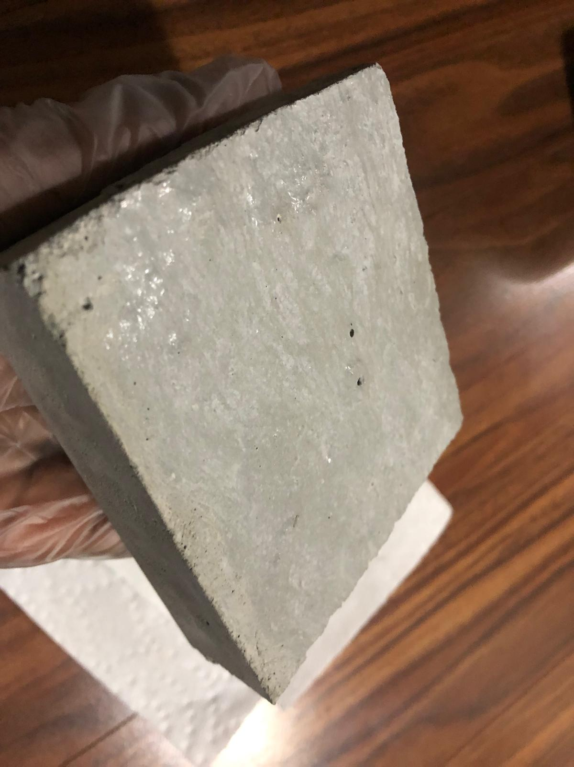

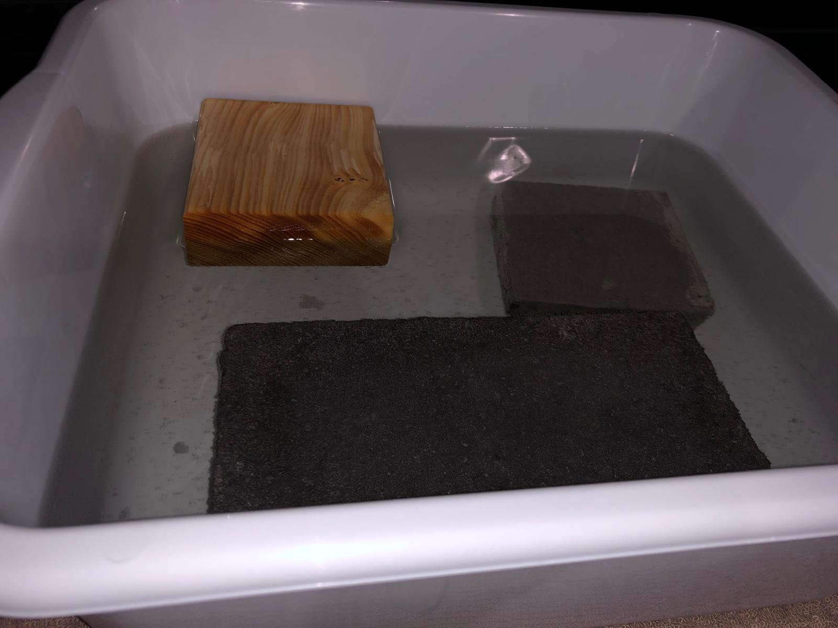

**Dirty water**

