Which household liquid causes metal to corrode the fastest?

On December 21st 2025, I started my science fair project. This was my second one because my first choice was too simple.

I made some pretty straight forward questions

Hypothesis:
I think that the products I'm going to use will corrode because, for corrosion to happen, my nail that I’m going to use will lose electrons. But I also think that it’s not going to work because the nail I will use will probably not be accurate.

Questions:
What does corrode mean?
What are the possible causes of corrosion?
How can corrosion impact household activities?
What are the benefits of corrosion in general?

Then I stated the problem
Problem:
In many households, people would likely grasp acidic liquids such as vinegar and soda. Vinegar is a chemical that can break down material. For example, when using vinegar, it can aggressively reduce the productive layer of a pot, pan, or cooking utensils such as spatulas. Soda is an acidic liquid which can cause metals such as aluminum to dissolve. This can cause a weakening tool making it less efficient for future uses. Aluminum is commonly used for pots and pans.
The same day, i decided to put some of my background knowledge.

Background knowledge
Aluminum is a metal that is used for pans and pots for cooking and our daily uses. Though it might sound toxic, it isn't at all. Aluminum is a very reactive metal but it remains stable because of its thin aluminum oxide layer. Aluminum does not rust, only corrodes. Rust is iron oxide and aluminum does not contain aluminum oxide which shows that it does not rust.

On december 28 2025, I answered one of my questions
What does corrode mean?
Corrode is a scientific term used to describe destroying or damaging metals through a chemical action. Corrode has 2 meanings:
- Destroy or damage through chemical action
- Destroy or weaken something moderately.

What are the main causes of corrosion?
The main causes of corrosion are:
Electrochemical (also can be defined as redox): oxidation: Metal atoms LOSE electrons, causes to form ions

Reduction: other substances or oxygen GAINS those electrons and forms oxide (similarly to rust).

Environmental factors:
Moisture and humidity: water typically acts like an electrolyte which speeds up the oxidation process.

Salts and chloride: Salt water and marine air significantly increase the corrosion rates. Causes of Corrosion
I did this during the past 2 weeks of winter break. (December 30, 2025)

How can corrosion impact household equipment?
Corrosion can have a huge impact on household equipment causing failure regarding functions, deterioration, and health hazards.

Failures in tools that have been corroded can easily prevent fixtures. For example, if your dishwasher has been corroded (internal) can lead to significant damage such as leaks.

Deterioration (mainly revolving around aesthetics) can leave and show an unpleasant stain and other sights such as flaking, and overall show a very unpleasant appearance in the house or property.

Health hazards contribute to corrosion because, if you were to drink water, unaware that your pipe is slowly corroding, you can potentially drink water with a terrible metallic taste and if it gets bad, it can be a serious health hazard.

What are the benefits of corrosion prevention?
The benefits of corrosion prevention are:

Reduced maintenance costs: preventing corrosion can prevent high costs repairment that would be needed for highly valued tools.

Increased efficiency: when an item is not corroded, it can be more efficient.

Increased reliability: without corrosion occurring, fixing malfunctioning objects would be way more easier than a tool that is corroded and hard to work with.

On January 5 2026, I will be taking a look at some experimental videos that I can do.
I watched a video that gave me an idea on how to set it up because I didn't have the materials to actually recreate it.

On January 31st, I did my experiment and now I have to wait for it to rust. But before that, I listed out the manipulated variable, independent variable, and the controlled variable. I also talked about my experiment. Then I listed the materials that you need for the experiment.

On the days of February 1st, 2nd, and 3rd, I finished my experiment.
But before that, I wrote my procedure.

Procedure:
First get 2 clear glasses. Second, put the screwdriving nail in the glass. Lastly, put table salt water into one glass and vinegar in the other one. When you are satisfied with the amount of liquid in each cup, wait for 3 days for a result.

Here are my observations:

Observations:
Day 1:
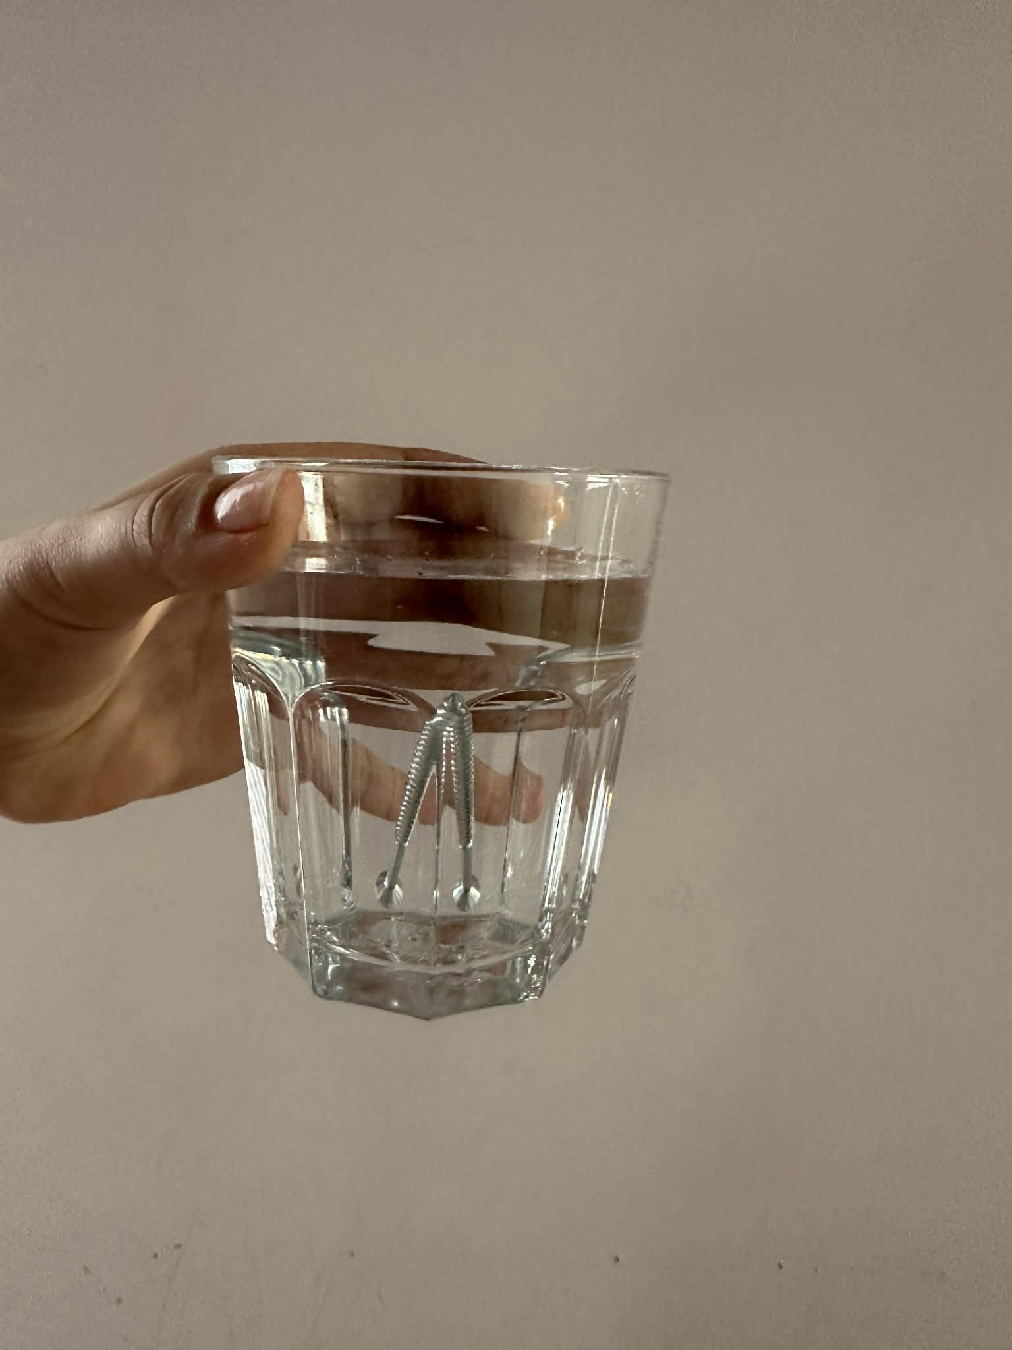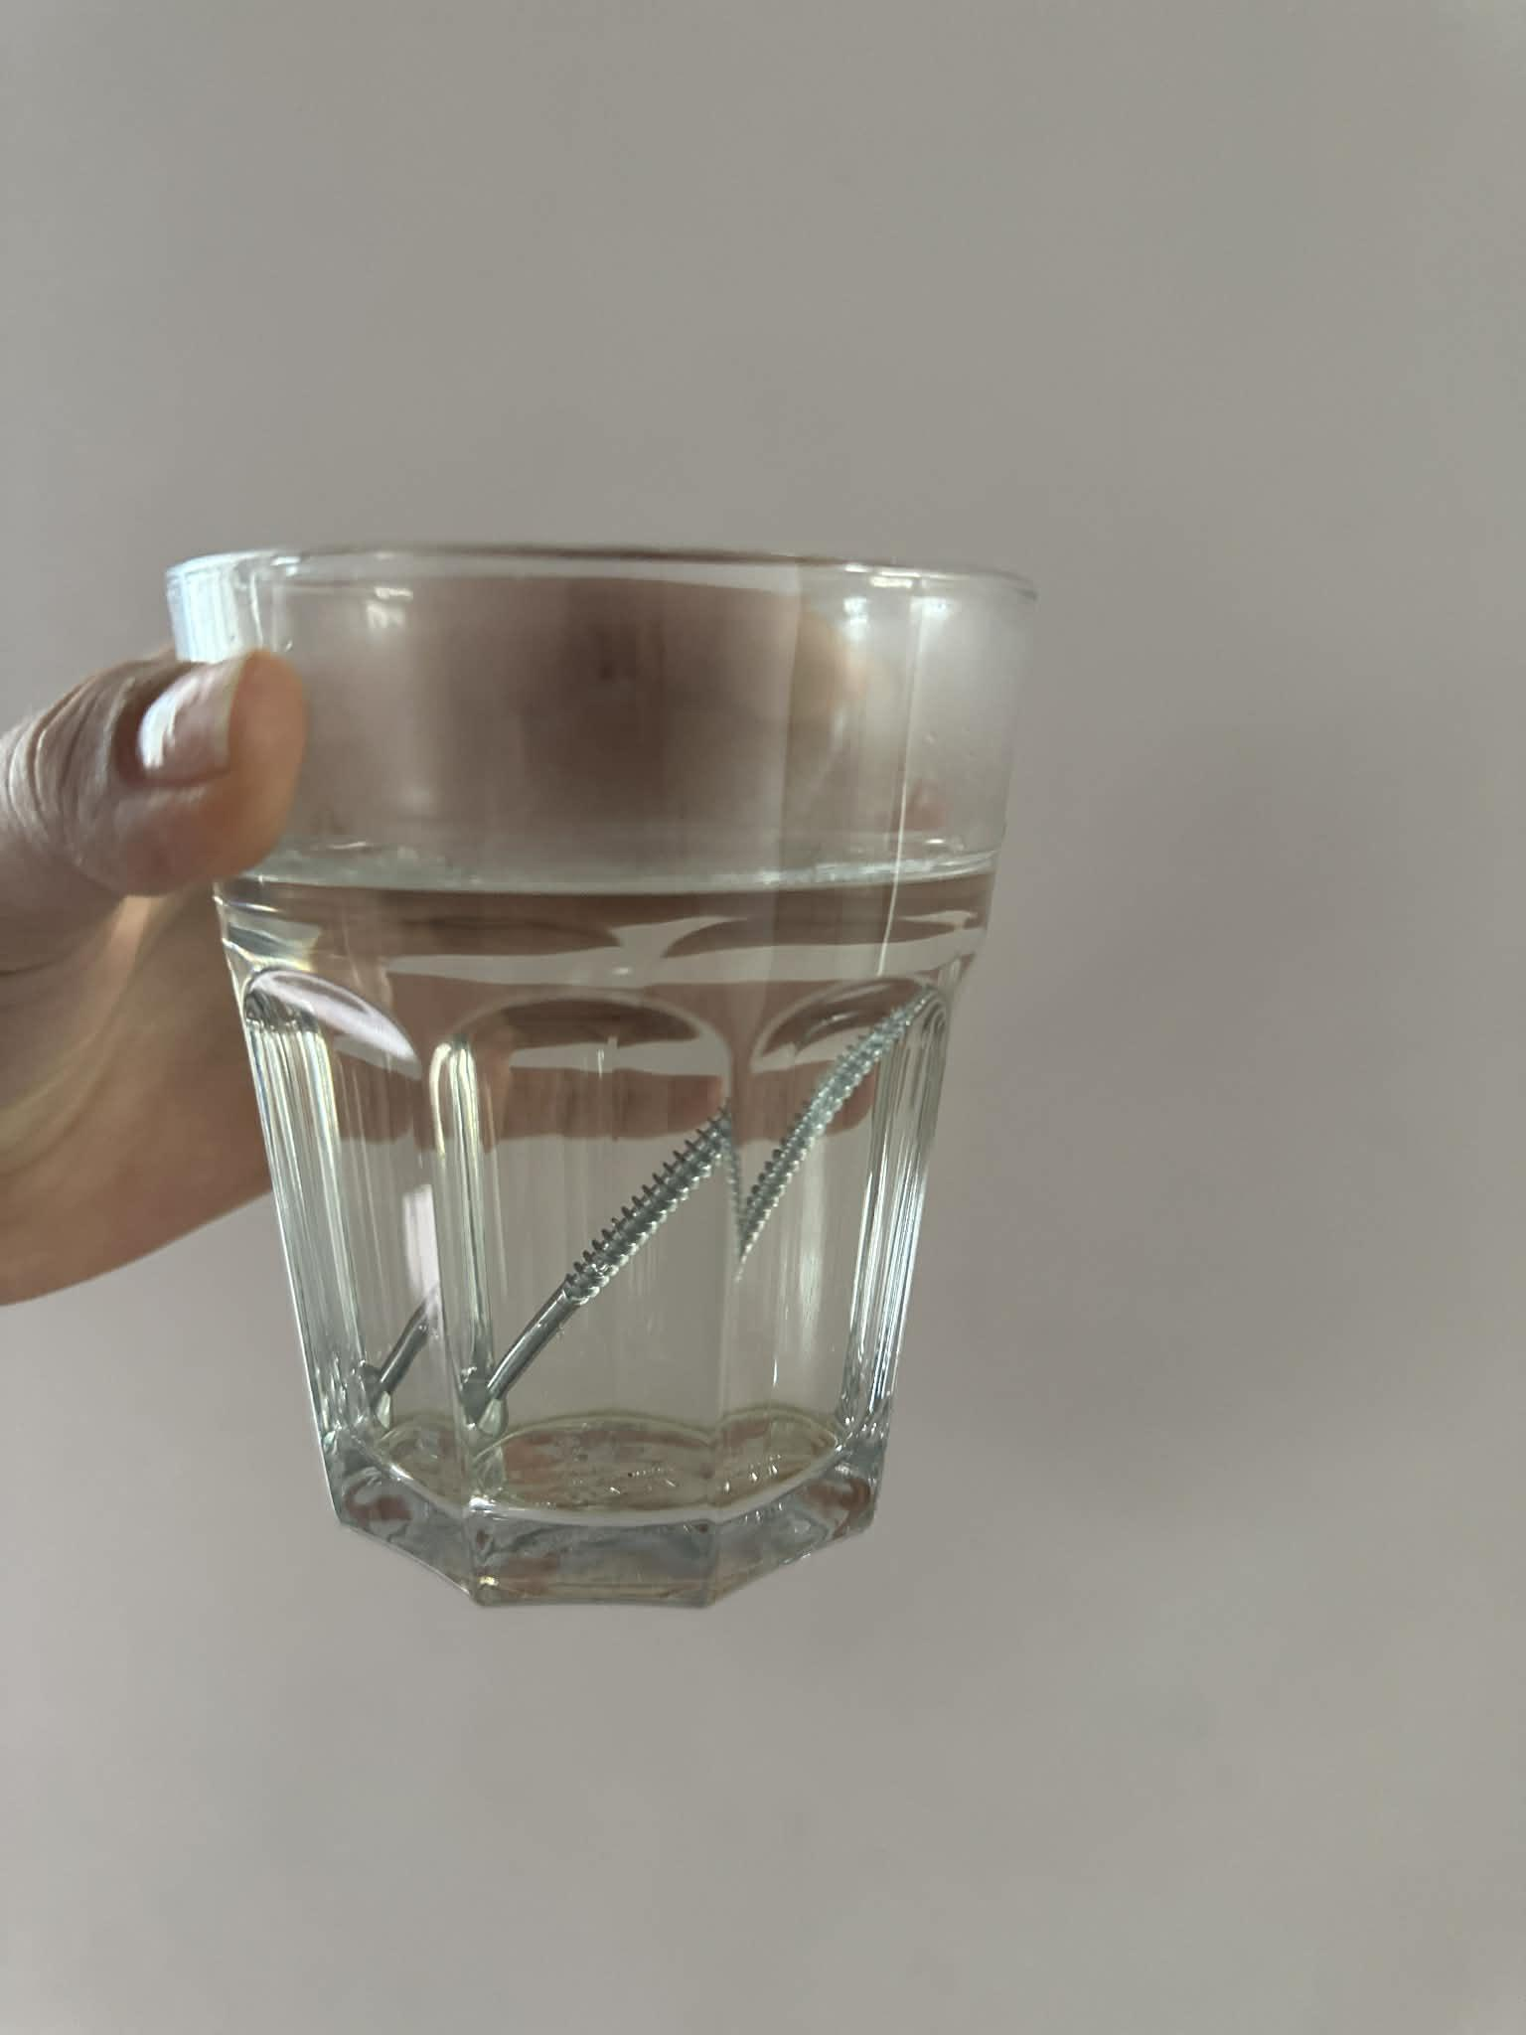
This one is vinegar this one is salt water
So far, I haven't noticed any corrosion.

Day 2
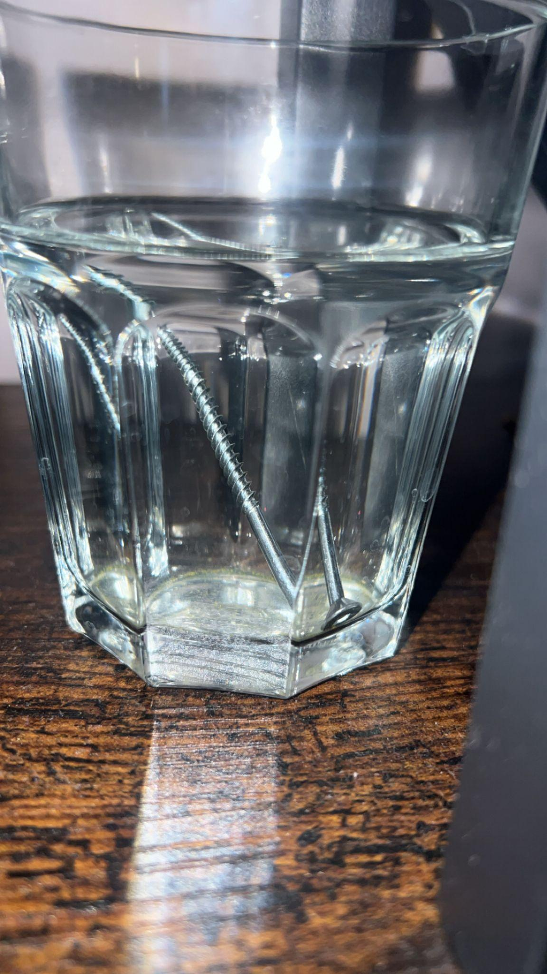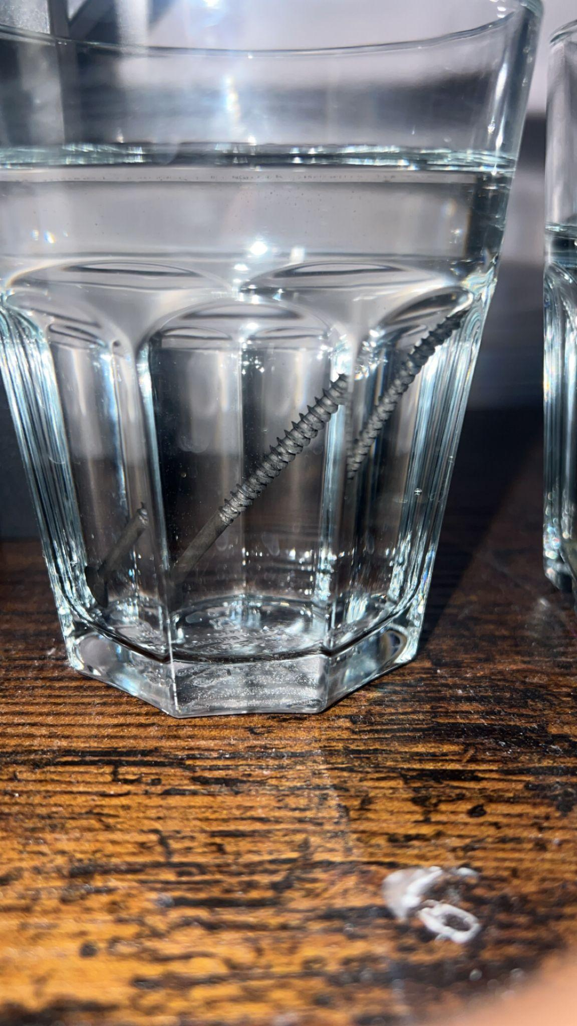
Table salt water vinegar

I noticed that the vinegar had completely corroded the nail but the table salt water didn't even affect the nail at all.

Day 3 (last day)
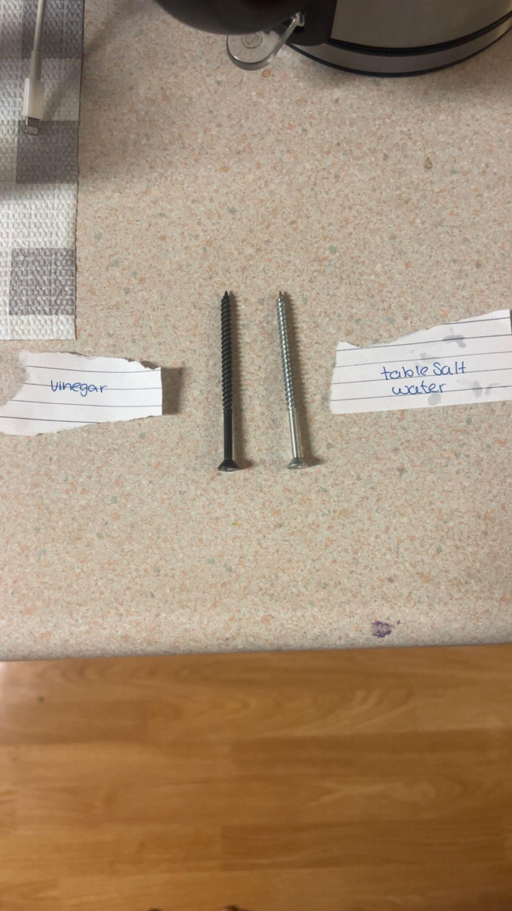 I finished my experiment and found out that the nail in vinegar had completely corroded and I realized that the table salt water didn't even corrode.

After weighing each nail, i decided to start my analysis.
Analysis:
From what I observed, I realized that the nail in the vinegar increased its weight. Both of the nails started at 0.08kgs but as the days progressed, the nail in the vinegar became 0.09 kgs on day 2 and then 0.01kgs on day 3.
I created my graph on paper.

Lastly, I created my conclusion.
Conclusion:
Overall, I would say that my hypothesis was somewhat correct. I say this because, in my hypothesis, I stated that it will happen because it will lose electrons. But I also stated that it may not happen because the material in the nail was “not like household utensils.”

