Implementation and Evaluation of Alternative User Interfaces For Game Control to Improve Application Accessibility
——-—-—-—-—-—-—-—-—-—-—-—-—-—-—-—-—-—-—-—-—-—-—-—-—-—-—-

Marie-Elise Cernelev
2024-2025
Applied Science Project Logbook

DAILY NOTES

Monday, August 19, 2024:
- Wrote a draft proposal about the project that I want to do:
INTRODUCTION:Touch can be unreliable and tedious in virtual reality (VR) due to a lack of visual cues. This makes it challenging to gauge distances and spatial relationships between objects. These issues can be especially difficult for those with motor or visual impairments. While VR’s current implementation is limited, it provides a platform that can be easily adjusted for those who need custom features. Voice commands, movement controls, eye tracking, and sign language are all alternatives to touch that can be implemented quickly and affordably within VR. Individuals suffering from Parkinson's disease, which causes tremors and spasms, could use speech commands to perform tasks that they were not able to before; for example, in virtual reality, ‘typing’ through voice. Non-speaking autistic people who have difficulty with motor skills could also play video games by using sign language or eye and head movement. Those with physical disabilities, to the extent that they are unable to move their limbs, could control a game by using speech, and even those who do not prefer playing video games with, for example, a controller could use other senses. In this experiment, the listed alternatives to touch will be tested to evaluate the efficacy of alternative VR control methods to enhance the user experience for those with disability.
METHODS:Three types of games will be tested: Connect 4, Checkers, and Street Racing. All levels consist of three different control methods; speech, eye and head movement, and sign language. By using machine learning and artificial intelligence to understand and track the movement of one's eyes, head, and body as well as speech recognition training, the person would be able to command the object to make desired movements. A survey will be collected on what method is preferred, by ranking most popular to least. The data will be categorized by age and preference. The collection of data from different age groups will determine the preferred method of control over touch and in which scenario they are preferred.
SIGNIFICANCE:The purpose of this experiment is to determine what alternative different age groups prefer over touch. With an understanding of what senses/ options are preferred, virtual reality and computer games, movies, etc. can become more accessible for those who are unable to use touch. Further understanding of alternative control methods could improve human-computer interactions for disability groups.

Tuesday, August 20, 2024:
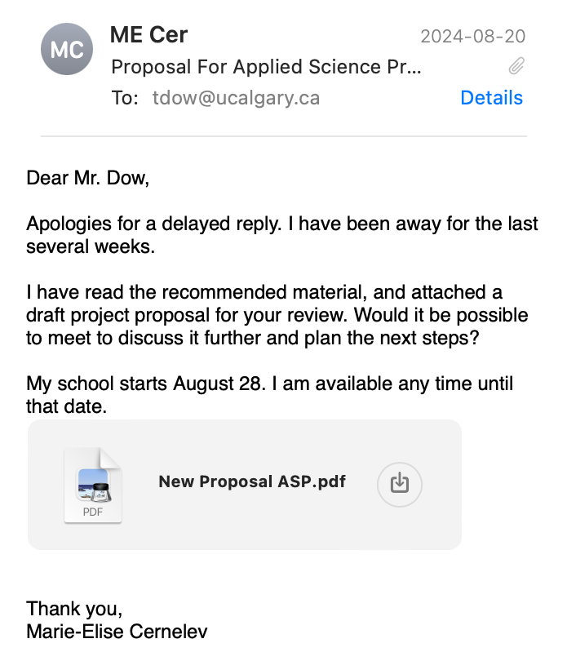
I sent an email to Mr. Dow about the draft proposal and my idea for the project.

Friday, August 23, 2024:
Meeting with Mr.Dow today. Notes taken during the meeting:
- Idea is really well planned but make sure to make clear in the introduction that it is a computer game and will not be done in VR.
- The stretch goal is the racing game.
- Send out data after each game is finished.
- Form can contain age group and gender.
- Set up weekly meetings with me (will do this in a later meeting thinking every Friday 4:30).

Monday August 26, 2024:
Learning about pygame in order to design interfaces for interactive games. Finished: background, connect 4 img, app logo, started voice commands with coin(ran into errors + computer takes long time to load game).

Picture of App LOGO (what will appear when opening the app or website):
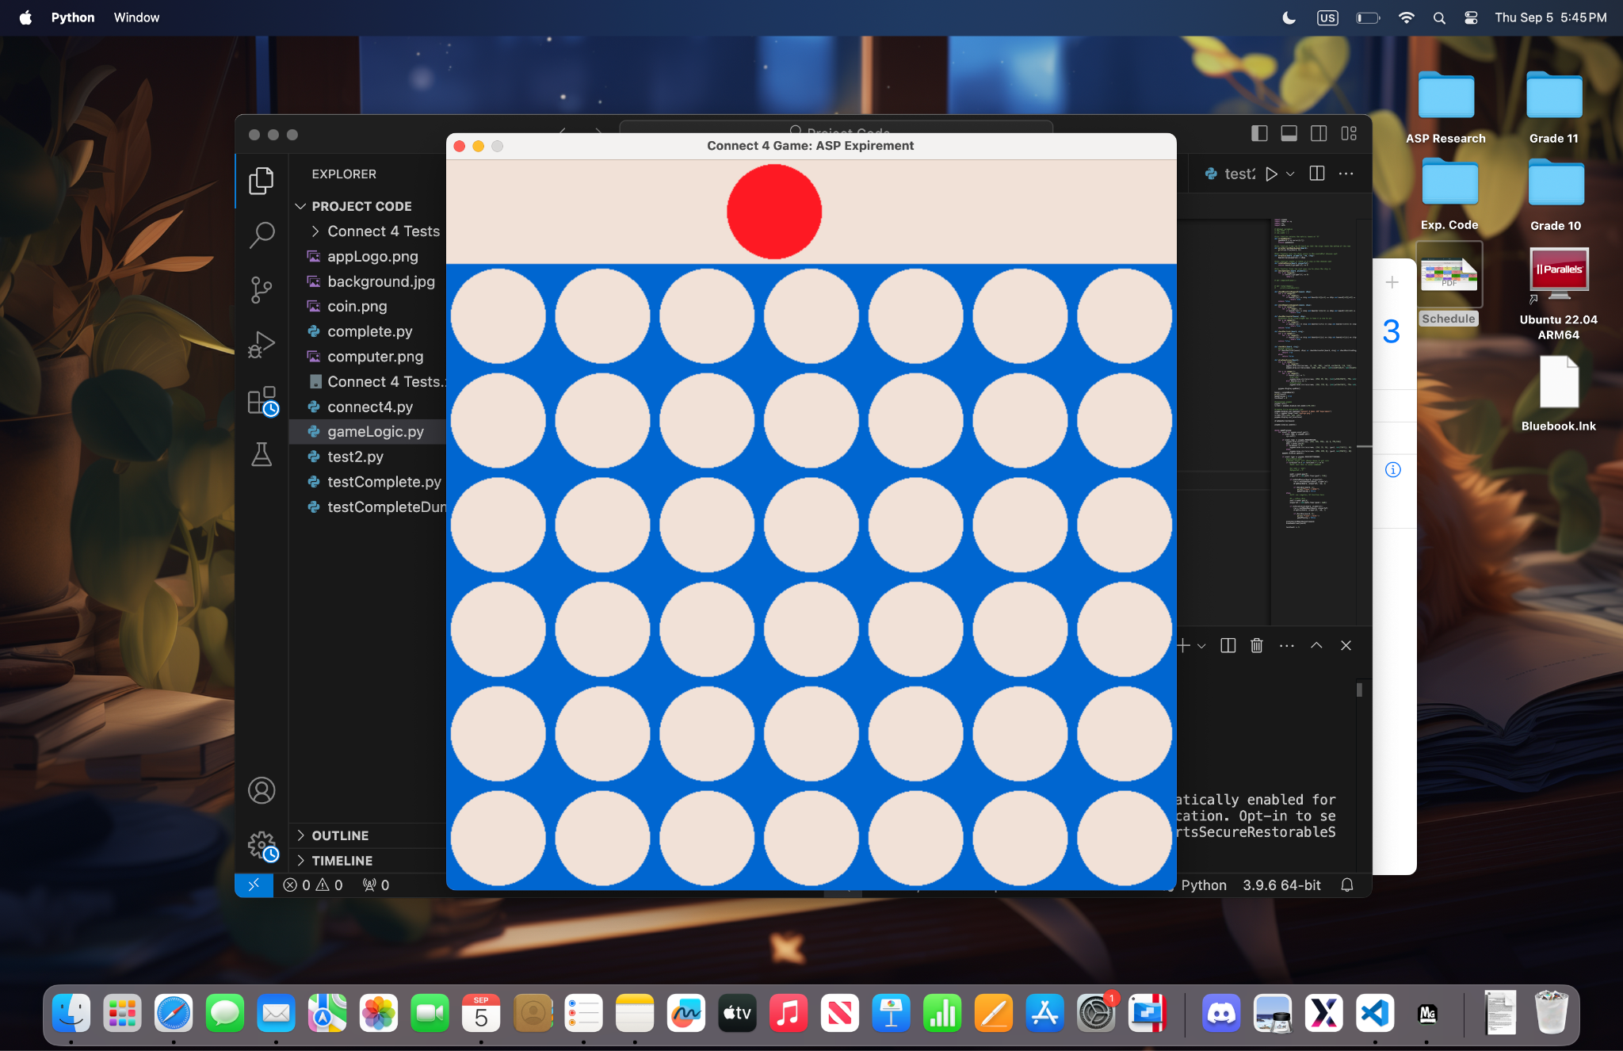
- Red dot is player 1 and the yellow dot is player 2.
- Created the layout using pygame.
- The dot on the top WILL become movable with voice commands.
- When the red button on top left pressed = exit the game.

Tuesday August 27, 2024:
Continued working on voice commands in connect 4 and started on making connect 4 game work with mouse (two players). Finished: all 1-7 commands, game dynamics works and automatically exits when one wins (will fix next time), and layout.
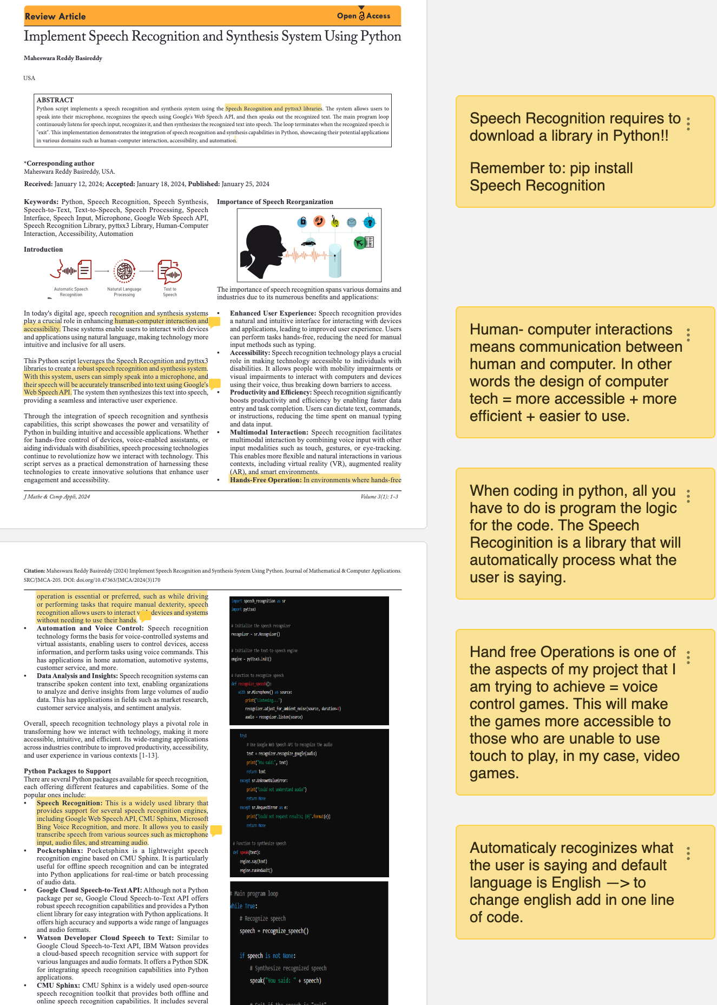
Website where I learned about voice recognition: ¹ https://www.researchgate.net/publication/381780125_Implement_Speech_Recognition_and_Synthesis_System_Using_Python
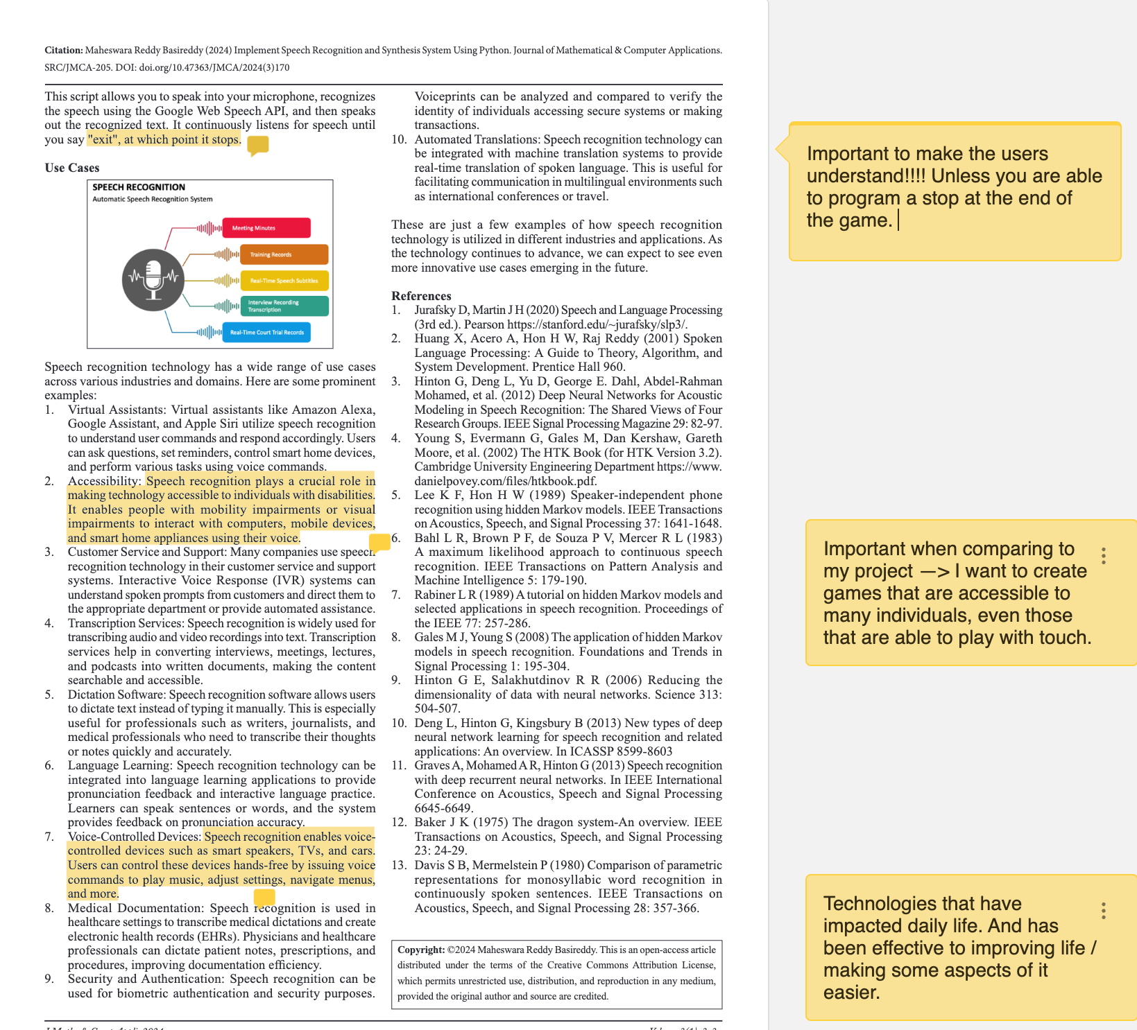

- GOAL: continue working on voice commands (make saying 1-7 movement work)

Wednesday, August 28, 2024:
Continued working on voice commands. Began to add a “drop” command where, even if the user makes a mistake choosing a column number, the coin position is not confirmed until “drop” is said. Finished: all 1-7 commands on top of screen. Errors: drop does not work and the program takes too long to load.
- GOAL:add moving coin on specified column on top of screen.

Tuesday, September 3, 2024:
Had class today and these are notes of what Dr. Garcia said:
- Email your mentor this week and notify them that you have received your schedule.
- You can organize your work and daily notes and schedule in notion or google docs.
  - BE SPECIFIC!!! ADD DETAILS AND IMAGES AND SKETCHES!!
- Assignment #1: Research proposal
  - Will be posted on GC and should be finished mid- October
  - Remember variables for experimental projects
- Google Scholar used to find websites / experiments + Paperpile will be given later
- GOAL: email mentor tomorrow

Wednesday, September 4, 2024:
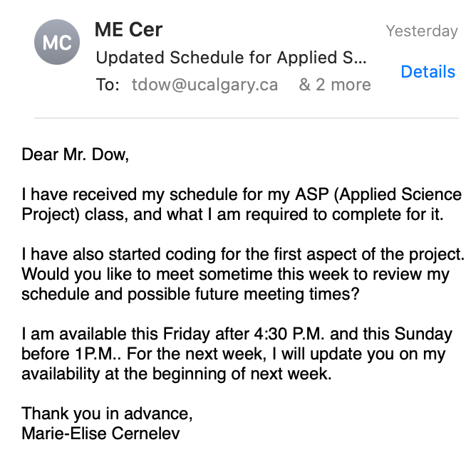
I emailed my mentor:

Friday, September 6, 2024:
Notes during ASP class and Individual Meeting:
- No meetings during midterms + on GC schedule for meetings
  - During midterms → HAVE to work on ASP + DON’T put on hold
- Ethics → Use of humans + form asks for gender + age → email Dr. Garcia
  - ETHICS MOST IMPORTANT IN EXPERIMENT
  - Neurodevelopmental disorders
RESEARCH PROPOSAL:
- Introduction:
  - HCI + Neuro. Disorders + Computer games + goals (studying ___ will help understand ____ ) → research question
- Methods:
  - NO VARIABLES
  - How these games are produced in python (as much detail as possible)
  - Type of data analysis doing with forms → how set up platforms and forms and how you going to access the data
  - Maybe statistical analysis + standard deviation + Can you see a difference from the preferred games → is there a difference
  - How do I present the games → development of models (technology going to use), then testing (no bias when presenting) → how you set up testing + conclusions (significant differences + how to extract data and methods)
  - Creating models of computer games + extract information from it
- Significance:
  - Convince no one has done the way you're doing it + better method + different angle + what the results contribute to the field of study + why critical?
TASK PLANNING:
- Long Range: Months for research, programming, and testing + research proposal
- Close Range: how long each component will take to complete + how to break down all the components
Science Fair → Mid to end March + HAVE TO SHOW SOME DATA
- Very LAST month: February HAVE preliminary data
  - HAVE READY BY DECEMBER BREAK
- How would you deal with multiple uses + playing games → skewing data.
- Forms → which game playing + age + gender

MENTOR MEETING NOTES AND QUESTIONS:
Mentor Meeting:
NOTES:
- Meeting—> Friday 4:30P.M.
- Research Topics —> HCI + Game design accessibilities + alternative modes of interaction (gesture tracking) + VR reactive —> eye and hand moving tracking + VR Games
- Winter —> traveling
- Forms —> google forms and send + results saved in gmail + anonymized (different results) + Play game once —> supervising or lock out
  - Google form or honor system
  - Questions: Consent for video and microphone + image may appear in publication + can anonymize by blurring faces + Name + Age group + Gender +Occupation+ Familiarity with games + Done with eye tracking of head + Experience Questions (Which ones you found easier + most preferred)
    - Consent Form
- Code: checking documentation of library to run of GPU instead of CPU
  - GPU good at doing much of stuff simultaneously + research more libraries
- Missing from last one proposal —> list of must have and list of like to haves
  - Features
- Libraries Face Recognition —> Vuvoria + will email me libraries
QUESTIONS:
  - Meeting:
    - Every Friday 4:30P.M.
  - Research:
    - Human - computer interactions
    - Neurological Disorders
    - Computer games that were made accessible
    - WHAT OTHER FORMS OF RESEARCH SHOULD I DO?
    - If you have any research papers that would help with my project, would you mind sending them to me?
  - How should I present these games? Should I make a website that people can access through a link or an app…?
  - Code:
    - How do I make the code run faster using speech recognition?
    - Do you know of methods in python using camera to track eye and head movement —> any known libraries?
      - I haven’t researched this aspect yet.
  - Science Fair
    - Recommended to have preliminary data by December break so that people can play the games during December and February.
      - I need enough data to make people understand why my project is significant and what the data actually proves.
    - Be ready for school science fair which is typically mid March.
      - I need to have enough data by then to prove a certain point + I have to take into consideration the time to make poster and gather data + standard deviation
  - Forms:
    - Collecting data on forms.
    - What should I put on the form?
      - Age groups, gender, how many times they are playing the game?
        - How do I make it so they don’t play the game more than once
      - How do I make sure that the form data isn’t skewed?
- GOAL: ask mentor questions written in notes.
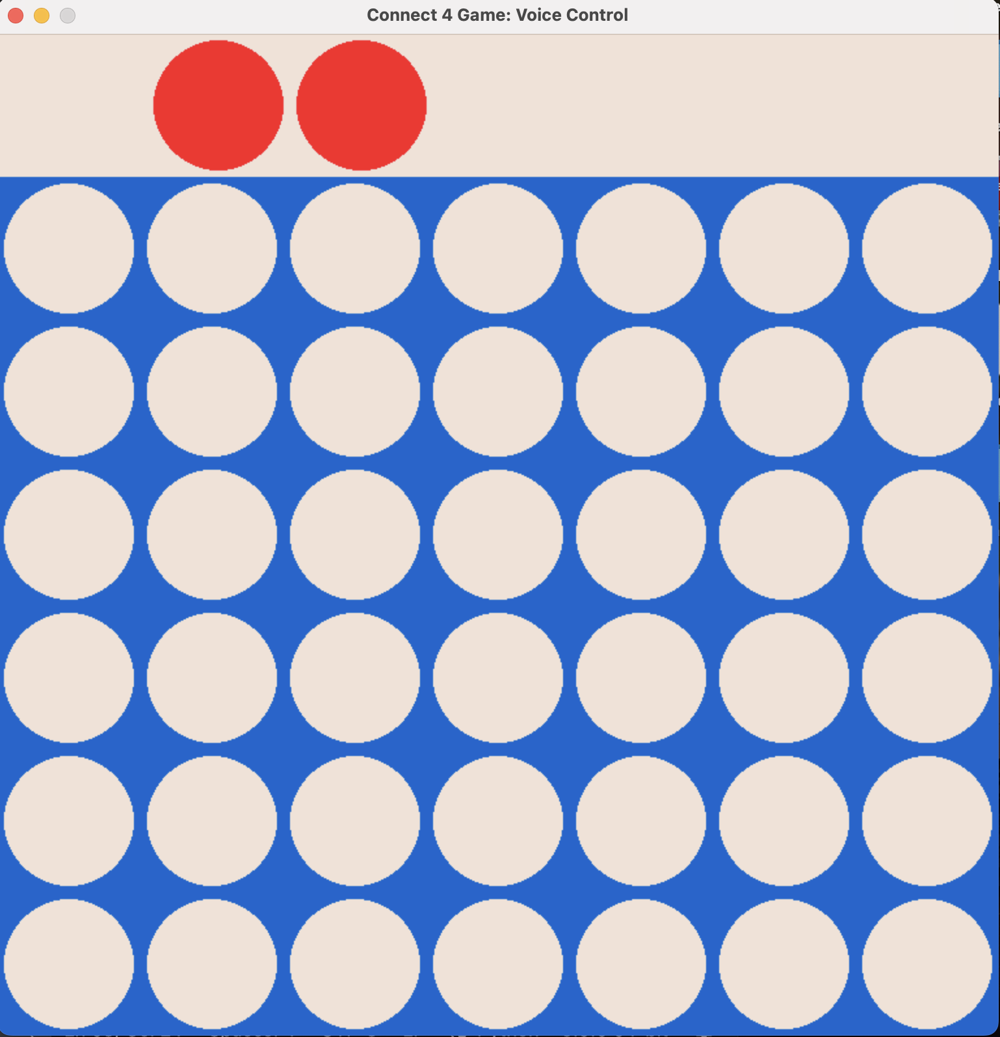

Saturday, September 7, 2024:
I found an error in my code today. Whenever the user says a number, and then another number, two dots are drawn. During the next few days, figure out how to fix this error so that only one dot is drawn and redrawn.
I found and searched for paper revolving around these topics (I only found them, and they will be annotated during the next 3 weeks if I do not finish in 2 weeks + review if relevant):
- Human-Computer Interactions:
  - https://books.google.ca/books?hl=en&lr=&id=0ZRlAwAAQBAJ&oi=fnd&pg=PP1&dq=what+is+Human+Computer+Interaction&ots=-k8Hrkmwhd&sig=ajapsbPP-Cpm_282DkyoLxIa5XQ#v=onepage&q=what%20is%20Human%20Computer%20Interaction&f=false
  - https://snoopedu.com/app/uploads/2022/03/Reading1_HCI.pdf
  - https://link.springer.com/article/10.1007/s00779-005-0055-2
  - https://www.igi-global.com/gateway/chapter/53927 ( NEED ACCESS TO)
  - https://academic.oup.com/iwc/article-abstract/19/2/180/694686?redirectedFrom=fulltext (NEED ACCESS TO)
    - https://www.researchgate.net/publication/222314463_Video_game_values_Human-computer_interaction_and_games (Same website as the one from above but this sign in may work for my mentor?)
- Neurological Disorders:
  - Did not have time today to find articles about this topic. Will find some articles tomorrow and during the next two weeks..
- Accessible Computer Games / VR(Games):
  - https://link.springer.com/chapter/10.1007/978-3-642-23774-4_4
  - https://tcf.pages.tcnj.edu/files/2013/12/kelSmith_virtual_worlds_disabilities_032409.pdf
  - https://journals.sagepub.com/doi/10.1177/1555412020971500
  - https://link.springer.com/article/10.1007/s10209-019-00679-6
  - https://www.sciencedirect.com/science/article/abs/pii/S1071581919300801?via%3Dihub
  - https://www.mdpi.com/2071-1050/12/22/9584
  - https://link.springer.com/chapter/10.1007/978-3-642-23774-4_4
- Alternative Modes of Interaction:
  - https://link.springer.com/chapter/10.1007/978-3-319-91250-9_31

Sunday, September 8, 2024:
I annotated my functions, explaining what each function does and why it is relevant to this code (I have 21 functions divided up into classes, which are essentially different files for different functions and data. Each class has a job (env.py = connect 4 logic functions, listenlogic.py = microphone and speech recognition, main.py = playing game (calls the other classes).). I fixed the error where there were multiple circles drawn when someone said another column by drawing a rectangle (same colour of the background) before the chip, so that it would cover the past chip (function is called clear_selection). Whenever a player wins the game, I wrote Player 1 or 2 wins on the top of the game board.
Notes on my Significance:
- Making video games more accessible to those with neurological disorders
  - Nowadays many people rely on using touch, for instance, using a keyboard requires someone to type by hand, etc.
- By experimenting what other alternatives people prefer to touch, we can further understand what can be integrated into future video games, websites, an, long term, VR games/ tools.
  - In VR, right now, people are using touch to ,for example, type in Virtual Reality or to grab/ touch something ; however, we could improve user interaction and HCI by integrating more than one sense.
    - Therefore it is important to understand the different ways of tracking.
      - Using eye tracking could shift the VR screen while playing a game making the user interface more playable and interactive.
  - Understanding how different people with different neurological disorder/ capabilities/ abilities can control or utilize tools that they would not have been able to use before
    - Prepare tools, games, equipment to be accessible for all.
- GOAL: fix drawing circle error
- GOAL: add player 1 /2 wins text

Tuesday, September 10, 2024:
ASP CLASS TODAY: reading “Use of Virtual World Among People With Disabilities” paper
- Notes are on paperpile: https://paperpile.com/shared/sgmiP8bJ6Ty~jJYnZrvgn7Q

Thursday, September 12, 2024:
ASP CLASS: reading “Future Design of Accessibility in Games: Design Vocabulary” paper
- Notes on paperpile: https://paperpile.com/shared/s4O8MK_IiTXiH6jpcSYzMYg
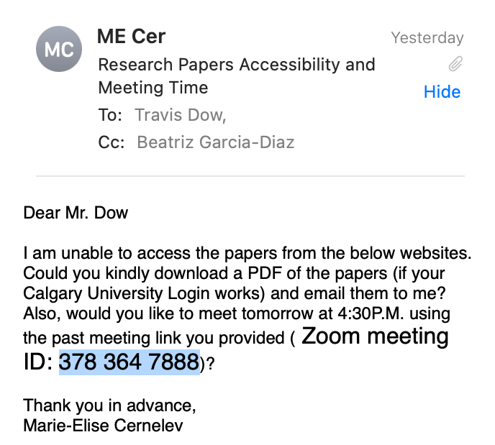
I sent an email to my mentor:
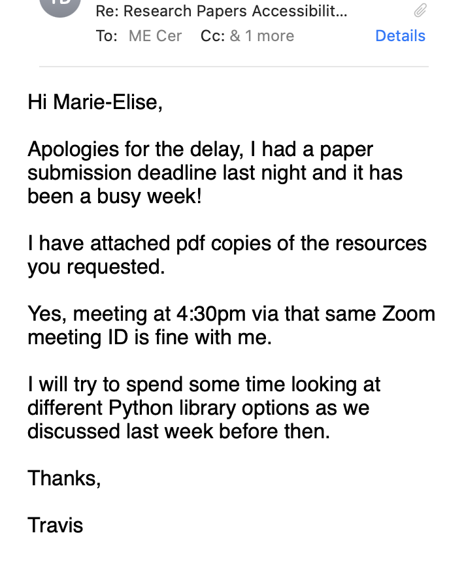
Mr. Dow replied:
- GOAL: finish reading paper
GOAL FOR TOMORROW: add microphone on top right corner of game to signify when to speak or not.

Friday, September 13, 2024:
MENTOR MEETING NOTES AND QUESTIONS (10 min meeting):
- Quick checkup meeting where I showed him what I am currently working on and what my future plans are
  - I told him how I will be integrating the microphone colours to signify whether the microphone is capturing what you are saying and text to declare to the user whether they should repeat phrase.
    - He likes my ideas and tells me to continue working on them + email him if I have any questions or need help with code.
- Mr. Dow recommends having the chip fall down → seeing the chip fall down increases HCI + user interaction.
- He is looking at python libraries —> Real Time Speech to Text if I need for speech recognition.
- Hand tracking libraries (also looked into) —> Open CV (computer vision) + built in support for hand tracking library
  - He recommends using
- Eyes gaze tracking —> may be hard due to not seeing pupil
  - Some libraries need users to stay still in order to only track pupils.
- Multithreading —> woven in how operating system tracking with CPU + a lot of things is transmitting to CPU
  - Liked how I was using classes and threading for my program.

Saturday, September 14, 2024:
- I finished making notes on the past journal I was reading on Thursday: https://paperpile.com/shared/s4O8MK_IiTXiH6jpcSYzMYg
- I started reading another article (“Designing Accessibility: Evaluating the state of accessibility design in video games”) and begane to take notes (first 4 pages):
  - https://paperpile.com/shared/ssS~R5oyMS7uviFinXturrA
- Began formatting the research proposal and created a title: Making Interactions With Computer Softwares More Accessible By Understanding The Correlation of The Preferred Alternatives to Touch and Age
  - Added the proposal I wrote for Mr. Dow into the rough draft of proposal

Sunday, September 15, 2024:
- Added to the significance of the research proposal:
SIGNIFICANCE: The purpose of this experiment is to determine what alternative different age groups prefer over touch. With an understanding of what senses and options are preferred, computer softwares, which could include virtual reality, computer games, movies, etc., can become more accessible for those who are unable to use touch. Further understanding of alternative control methods could improve human-computer interactions for disability groups, creating a more accessible and inclusive environment. By experimenting what other alternatives people prefer to touch, we can further understand what can be integrated into future video games, websites, VR games/ tools, and softwares. This research further adds input into how different people with different neurological disorders; hence, a range of capabilities and abilities, can control or utilize tools that they would not have been able to use before, arranging tools, games, equipment to be accessible for all.

- Added one of the long term goals in objectives:
  - Having individuals with neurological disorders completing difficult tasks, such as driving, is the ideal outcome of this experiment; however, the more realistic outcome is a small step to a greater understanding of how to create accessible platforms.

- Brainstorming Question paragraph:
  - What is the correlation between people's preferred alternatives to touch and their age? By answering this question, we can understand what correlation should be integrated into computer softwares to make them more accessible.

Monday, September 16, 2024:
ASP CLASS notes:
- Want most recent papers + look for a REVIEW paper, although some non-review papers are informational/ specific
- Search SPECIFICALLY on NCBI or google scholar
- Go to PubMed in NCBI and search for paper by title (if no attachment)
  - Allows you to access pdf
- Seperate the papers into folders
- Support claim by providing a source (insert citation from paperpile by searching author or keyword of paper)
- Decide what type of style you want to use for your research paper (Dr. Garcia recommends using the style from the papers you are reading)
  - AMA for biomedical, APA for science, IEEE for engineering, Chicago for social sciences (DIFFERENT CITATIONS FOR EACH)
  - Owl Perdu has all information with research styles https://owl.purdue.edu/owl/research_and_citation/resources.html
    - You can reference author in text → citation with numbers after the name (AMA)
    - Even not referring to author → cite the number of paper
- RESEARCH PROPOSAL:
  - Determine if it is a study (no variables or hypothesis), experiment (variables and hypothesis), or innovation (no variables or hypothesis)
  - You need a Research Question(s) → AS NARROW AS POSSIBLE / goals
    - GOALS ARE LIKE TASKS THAT HAVE TO BE ACCOMPLISHED IN ORDER TO ANSWER QUESTION
      - Goals may not always be achieved
        - Long term Goals: could be things you want to accomplish after you finish short term goals, the two parts of your study, long term in sense that it is years after, WHAT YOU WILL BE CONTRIBUTING TO THE FIELD OF STUDY (ex. A better understanding of …)
  - Introduction: more reading about = more successful in project overall
    - Goal of leading to the research question
    - Last paragraph: why is your study in this → controversy or lack of research in the area.
      - USER THEREFORE, this study will ___ or THAT’S WHY
  - Be effective and succinct!!
- KEY ELEMENTS: have an introduction that grabs attention of people (ex. Initial statement, fact)
  - First sentence = people understand what this paper is about
- APRIL + MAY: UNDERSTAND FULLY THE METHODS
  - Understand how methods help answer the research question (ex. Why you are using microscope for counting cells)
    - Enough of the methods have to be understood to know how it helps answer questions.
- Everything will be submitted on Turnitin.com
- If you have an outline + not comfortable with it = talk to Dr. Garcia + Mr. Dow
- GO TO MEETING PREPARED!
What I did today:
- I emailed Mr. Dow to send me a pdf of the article: “How common are common neurological disorders”
- Edited what the last 2 paragraphs of the research proposals could be (red = add data + research):
  - Although there have been relevant data and ___ in the field of human computer interaction and the accessibility of computer softwares for those with disabilities affecting their ___ skills, there has not been enough action in these fields to have drastically impacted the computer softwares to be fully accessible for these individuals in modern day. Therefore, in this experiment, the listed alternatives to touch: speech recognition, eye and head movement tracking, and sign language tracking- will be tested to evaluate the efficacy of alternative control methods to enhance the user experience in computer softwares for those with disabilities.

Wednesday, September 18, 2024:
ASP Individual Meeting Notes:
- Have daily notes for preparation for meetings.
- ETHICS!!
- Outline for Introduction show Mr.Dow.
- Clear view of 20th to end of October.
  - Task calendar with plan for research proposal.
Plan For Meeting on Friday:
- Show my google form and ask him if he can send me an email of his ethics form he used.
  - I will email him my form and ethics by next week before the next meeting.
    - ask if he thinks this is sufficient data collection for my experiment.
- Show Mr. Dow what I have so far for my research proposal.
  - Show him my outline + what he recommends
    - Should I add something more in my introduction + switch the order?
- What citations should I use ( IEEE, Chicago, APA, AMA)?
- Ask if my research question is specific enough: What is the correlation between people's preferred alternatives to touch- speech recognition, eye and head movement tracking, and sign language tracking- and their age group?
- METHODS: what would my methods be?
- What should my three goals be?
  - Short term, talked like last time: the games
  - Long term: …
  - GOALS ARE LIKE TASKS THAT HAVE TO BE ACCOMPLISHED IN ORDER TO ANSWER QUESTION!
- Should I have variables in this experiment?
- Reading paper (first two pages): https://paperpile.com/shared/sl6CPo83qQs2rHNBzu7cl~Q
- Sent a checkup email:
Hi Mr. Dow,
For your convenience, here is the zoom code for tomorrow's meeting: 378 364 7888. Looking forward to our discussion tomorrow.
Cheers,
Marie-Elise Cernelev

Friday, September 20, 2024:
- Finished reading paper from last class (annotated data from each neurological data):
  - https://paperpile.com/shared/svHwSL3~eTxmcobRatIUWpA
  - This paper contains just data from how many people, estimated, have certain neurological disorders.
- Meeting with Mr. Dow today
MENTOR MEETING NOTES AND QUESTIONS (35 min meeting):
Mr. Dow sent papers + add .zip at the end AND he sent me the ethics forms he used
TYPE OF PROJECT:
- Would my project be experimental or innovative?
  - Would I have a hypothesis and variables or not?
    - Potential Variables = different type of alternative, preferred method, same game
ANSWER: experiment —> name people will be in the thing
ETHICS/ GOOGLE FORM:
- Are these questions specific enough but also appropriate so that I do not offend or make the user feel uncomfortable?
  - Sufficient amount of data collected?
- Am I allowed to have the people sign off on the study online —> form of the website?
- Can you please send me your ethics form that you use for your experiments?
ANSWER: he is sending me his ethics + thinks that my google form is very well done + recommended that the last question was multichoice
RESEARCH PROPOSAL:
- Can you review my research proposal outline/ skeleton format?
  - Is there anything that I should change? Does the order make sense? What do you recommend?
- Is my research question specific enough? Should I reframe/ word it?
ANSWER: research question is very well written + recommends writing null hypothesis and alternative hypotheses + likes my format for introduction: for computer software section: examples of computer software designs that are accessible and the techniques they used + Add HCI explanation afterwards + talk about the alternative types to touch and add a brief overview about that.
NEUROLOGICAL:
- Should I be looking at a specific neurological disorder and making computer softwares accessible to them or should I look at it in a broader sense?
  - There was an article that mentioned that it is important not only to look at the specific neurological disorders but ALSO the broader sense in the way that anyone should be able to access them.
ANSWER: recommends not to go too specific in neurological disorders because then it is expected that you have access to people with those disorders
CITATIONS:
- What citations should I use (IEEE, Chicago, APA, AMA)?
ANSWER: you can use IEEE, AMA, ACM —> whatever you are comfortable with and what is used in papers you read
METHODS:
- What could be my possible methods?
- What should my three goals be?
  - We were talking about finishing the games and having people completing the surveys/ games.
ANSWER: methods: anyone should be able to read it + replicate it + should have rational + why you did what you did, goals: finish game by this date, have x number of participants by x date + specific game data collected by x date.
CODING:
- Tried to use python but all the libraries are really slow BUT I found out that there are Java and Javascript files that run more efficiently and faster. So I may use those.
- May not use face tracking + may use tactile instead.

Saturday, September 21, 2024:
- Found another neurological paper that predicts how many people will have neurological disorder/ brain disorders by 2050.
  - https://paperpile.com/shared/sE5Qc88I1TOOLers1LarZBA
- Gave permission to Paperpile to format my citations.
  - Figured out how to use AMA (no link + format alphabetically).
- Wrote some of the neurological part of the introduction:
It is projected that in the year 2050, 4.9 billion people in the world will have neurological disorders.² These disorders can include Alzheimers, autism spectrum disorders(ASD), cerebral palsy(CP), tourette syndrome, and migraines.³ Although there is a wide variety and range of brain disorders, it is not this paper’s main idea. With roughly a 22% increase in brain disorder cases from 2021 to 2050, it is vital to ensure that these people are able to access any and all platforms available.² Specifically, making computer softwares more accessible for individuals that are diagnosed with neurological disorders. Neurological disorders could cause mobility disabilities, such as motor tics and a restriction of movement (i.e., Tourette syndrome), as well as verbal disabilities, where it is difficult for an individual to formulate words (i,e., non speaking autistic people). As a result, it is difficult for these individuals to complete tasks on computer softwares, such as playing games or accessing an app, when one is unable to use touch. Even though some neurodivergent individuals may have full range of their movement abilities, some may have difficulty ___. Everything in modern day requires an extensive use of mobility. For example, in order to play a video game, one must be able to use a mouse, laptop, or video game controller. In order to drive a car, one must have a fast reaction time and be able to control the car’s movement smoothly. Reaction time, mobility and verbal abilities, and ___ are factors that play a role in how accessible a computer software is.

Sunday, September 22, 2024:
- Thought about research proposal and experiment while reviewing outline for research proposal: If I am not able to get people with neurological disorders to participate in my experiment, should I still include some research about people with neurological disorders → could make inference from data collected?

Tuesday, September 24, 2024:
ASP CLASS:
- Thinking about sample size and how many neurodivergent individuals must be included in the project to make some sort of conclusion about the accessibility and user interface of computer softwares.
  - Talked to some people that have access to neurodivergent individuals (ADHD, OSD, autism, etc.)
    - Must check if they will be willing to do this experiment.
- Reading “Making Softwares Accessible” paper:
- Talked with Dr. Garcia about the ethics from and type of project:
  - Recommends to change to innovative if the scientific method is not completed perfectly or followed to the T.
  - Ethics: send as soon as possible to Mr. Dow + U of C can send you a number for the approved ethics form and send that to Calgary Science Fair Committee.
  - Methodologies: code aspect = explain in depth, but not too specific, about the functions used, libraries, etc. that other developers can create without copying the exact function. EXPLAIN LOGIC.
- Questions for Mr.Dow:
  - Do you have access to neurodivergent individuals that could participate in this experiment?
      - Ex. OSD, ADHD, autism, Parkinson’s disease, dyslexia, Tourette syndrome, etc.
    - I was thinking that because my whole project revolves around the idea of making computer softwares more accessible for individuals that are neurodivergent, if I do not have at least some people that are neurodivergent, this project will not be as meaningful.
- Edited Research Proposal:
VARIABLES
The manipulated variable is the different alternatives to touch used: speech recognition, hand movement, head/ eye tracking movement. The responding variable in this experiment is the individual's alternative to touch preference. The controlled variables are the type of game the individual is playing (Connect 4 or Checkers), ______.
HYPOTHESES
Null Hypothesis: Individuals with different neurological disorders and neuro will have the same alternative to touch preference.
Alternate Hypothesis: I suspect that neurodivergent individuals that have severe mobility disabilities would prefer the speech recognition alternative rather than the alternatives that require movement due to the individuals difficulty of smoothly controlling their movements. Those that are neurotypical and have full mobility access will prefer ___

OBJECTIVES
- Long term goal: street racing game, making difficult tasks (like driving) easier / accessible + what should be integrated into computer softwares in the future + specific date game is done + have enough participants by ____ ,etc.
- Short term: to know which method is preferred + correlation with age

The short term goals are to complete programming the games: Connect 4 and Checkers before December. The long term goals include understanding what alternative to touch neurotypical and neurodivergent individuals, collecting enough participants and data by mid-Feburary for both games, and what alternatives should be integrated into computer softwares in roughly, five to ten years. A stretch goal includes programming a Street Racing Game to additionally understand the correlation between the level of difficulty of the game, age, whether neurodivergent, and how successful the individuals are playing the game. Having individuals with neurological disorders completing difficult tasks, such as driving, is the ideal outcome of this experiment; however, the more realistic outcome is a small step to a greater understanding of how to create more accessible platforms.

Wednesday, September 25, 2024:
- Edited draft form for data collection before someone plays a game:
  - This form is anonymous. The data collected will be used for data collection and drawing conclusions for a research paper, and will not be used for other purposes. During the speech recognition aspect of the game, the responses will be recorded for statistical analysis. It is anonymous. During the gesture tracking portion of the game, video will be used to track movement of an individual's hand. Microphone and camera will be used.
    - https://docs.google.com/forms/d/17pAGYHI0WZCyHoC1GGqGcMI0skDKTR8PcUzOklgHsfc/edit
      - This form will appear on the website before the user plays the game.
      - A form will be collected afterwards about their experience and their preferred method.
- Created a draft form for end data collection, after someone plays the game:
  - From a scale of 1-10, rate your pleasure with the game. 1 being this game is the worst, 5 being it was not bad but wasn't perfect, and 10 being I love this game.
  - What method of interaction did you prefer the most
    - Speech Recognition (speaking)
    - Gesture Tracking (hand controlling game movements)
    - Head and Eye Tracking (using head movements to control the game)
  - Would you play this game again?
    - Yes
    - No
    - Maybe (would play if there are no other games)
  - From a scale of 1-10, how would you rate your satisfaction of playing this game with Speech Recognition? 1 being I would never play using speech recognition, 5 being I would play using speech sometimes, and 10 being I would always play using speech.
  - From a scale of 1-10, how would you rate your satisfaction of playing this game with Gesture Tracking (using hands to control game)? 1 being I would never play using gestures, 5 being I would play using gestures sometimes, and 10 being I would always play using gestures.
  - From a scale of 1-10, how would you rate your satisfaction of playing this game with Head Tracking (head movement controls game)? 1 being I would never play using head movement, 5 being I would play using head movement sometimes, and 10 being I would always play using head movement.
  - Would you play this game with multiple users (ex. your family, friends, siblings, etc.)
    - Yes
    - No
    - Maybe
  - Did you find anything annoying, difficult, or frustrating while you were playing the game? Please specify what was the issue and how you would have liked that issue to be improved.

- Thoughts about research proposal and what is important to mention:
INCREASE COMPLEXITY OF INTERACTION + VARYING METHODS OF INTERACTION WITH OBJECTS AND THE METHOD IS FOCUSING ON VISUALS, ABILITY TO VERBALIZE AND TO SPECIFIC ACTIONS, AND ABILITY TO USE HANDS
ADULTS WITH DISABILITIES ARE LIKE KIDS = MORE DIFFICULT TO CONTROL EMOTIONS AND EVERYTHING ELSE

WHAT AFFECTS THE EXPERIMENT
- Method of interaction
- Complexity of game/ interaction
- Age group
- Environment (home, school (earning points or not), alone, group of friends, etc.)
  - TV, computer
- Social Aspect: game playing with computer or with friends?
  - Ex. kids don’t like handing phone back and forth
    - Voice could be preferred
  - Is this a test, game, or operating dangerous equipment?
CONTROL:
- Number of times a person plays a game with METHOD OF CONTROL
- Complexity of game
- Which game they play
CAN’T CONTROL:
- Age (set up experiment with certain age groups)
  - Critical element
- Gender
- Disabilities (neurodivergent or neurotypical)
- Social (extrovert, introvert → do you like social games, have you played this game before, etc.)

MEASURE:
- How long it took them to play the game (statistics → different methods will have different learning codes and adaptations).
- Every time someone interacts, we can measure the difficulty
  - Measuring how fast someone is learning (in first, second, and third game)
    - Problem: maybe they got unlucky
- How quickly the system starts understanding them
  - Same algorithm is used all the time.
    - How long they respond + did the system fail to recognize what they said multiple times.
      - Ex. system doesn't understand what they say repeatedly
      - RECORD EVERY WORD THEY SAY!! FIGURE OUT IF
- Restart game, if game failed, and if they rage quitted.
FIND OUT IN AFTER FORM:
- Did you like the game?
- Was the game interaction easy?
- How would you rate the game?
- How would you rate these different interactions in this game?
- Would you play this game again?
- Would you want to play this game with multiple users?

Thursday, September 26, 2024:
- Possible questions for Mr. Dow tomorrow:
  - Do you have access to neurodivergent individuals that could participate in this experiment?
    - Ex. OSD, ADHD, autism, Parkinson’s disease, dyslexia, Tourette syndrome, etc.
  - Should I have multiple alternate hypotheses or only one null and one alternate.
  - Should I CC Dr. Kristhnamurthy on the emails I send you?
  - Is it ok if I use your format for the ethics form you sent me? I used some of the phrasing that was used.
    - Would you be able to, once I am done the ethics form, send it to the University of Calgary Conjoint Faculties Research Ethics Board so that I can get the number of approval
      - Ex. Yours was REB21-0731
- Edited Objectives:
  - The short term goals are to complete programming the games: Connect 4 and Checkers before December. The long term goals include understanding what alternative to touch neurotypical and neurodivergent individuals, collecting enough participants and data by mid-Feburary for both games, and what alternatives should be integrated into computer softwares in roughly, five to ten years. A stretch goal includes programming a Street Racing Game to additionally understand the correlation between the level of difficulty of the game, age, whether the individual is neurodivergent, how successful the individuals are playing the game, as well as additional information, such as if they are a social person, if they have played this game, and their level of satisfaction with each alternative. Having neurotypical individuals and those with neurological disorders completing difficult tasks, such as driving, easier than now is the ideal outcome of this experiment; however, the more realistic outcome is a small step to a greater understanding of how to create more accessible platforms for all.
- Dr Garcia NOTES: after writing the research proposal, there will be an oral presentation in class of the proposal roughly during the first week of November.
- First draft of the Ethics Form (will review on weekend and send to Mr. Dow and Dr. Garcia around Wednesday- Friday next week)

Name of Researcher & Email:

Marie-Elise Cernelev, me.cer114@gmail.com

Mentor: Mr. Travis Dow, tdow@ucalgary.ca, Dr. Diwakar Kristhnamurthy: dkrishna@ucalgary.ca

Course Instructor: Dr. Beatriz Garcia-Diaz, bgarcia-diaz@webberacademy.ca

Title of Project: Making Interactions With Computer Softwares More Accessible By Understanding The Correlation of The Preferred Alternatives to Touch and Age

———————————————————————————————————————
This consent form is the only part of the process of informed consent. If you would like more details revolving around project information, feel free to ask. Please take the time to read this carefully and to understand any accompanying information.

Participation is completely voluntary, anonymous, and confidential.

Purpose of the Study
The purpose of this experiment is to determine what alternative different age groups prefer over touch, with an additional understanding under which scenario it is preferred. With an understanding of what senses and options are preferred, computer softwares, which could include virtual reality, computer games, movies, etc., can become more accessible for those who are unable to use touch, and those who can. The conclusions could be used to understand when certain senses are preferred and under what circumstances, further improving the conception of enhanced user interface (human computer interaction), and more accessible softwares.
What Will I Be Asked To Do?
If you volunteer to participate in this study, the researcher will ask you to do the following:

You will play games: Connect 4 and Checkers using a website that will be provided for you. You will have to play each game three times per alternative interaction. Meaning that for each interaction: speech recognition, head tracking, gesture tracking- you will be required to play each section three times. This helps to further understand your progress in these games.

Additionally, you will be asked to complete the following questionnaire before and after playing Connect 4 and Checkers. These questionnaires will be completed before you play the game, as well as after you complete playing the game (considered finished when you complete all three alternative interactions).

For this study, it is important to note that microphone and video camera will be used and will need to be consented on the website in order for you to play the games. During the speech recognition aspect of the game, the phrases that the microphone captures, will be used for additional data collection. This will remain anonymous. During the head and gesture tracking aspects, a video camera will be used; however, data will not be saved or collected from your camera use (i.e., camera recordings will not be saved).

You are free to choose not to participate in the study. You have a right to have all of your questions answered before deciding whether to take part.

What Type of Personal Information Will Be Collected?
Before you begin to play the games, there will be a form we ask you to fill out online. Biological gender, age group, experience in fields, times you have played a certain game before, if you enjoyed playing the game, if you consider yourself as a social pearson (including your opinion if you consider yourself as an extrovert or introvert), if you are diagnosed as a neurodivergent individual and your diagnoses, and if you consider yourself as having a disability and what disability you believe you have will be data collected before the “gaming” process.
After you play the games, there will be a form we ask you to complete online as well. Rating your pleasure with the game, satisfaction of playing the game with the different interactive alternatives, and if you would play this game again, your method of interaction you preferred, if you would play this game with multiple users, and additional comments will be asked.
In addition, the speech that was converted to text during the speech recognition aspect of the game, will be used for statistical analysis: whether the program understood what your commands were and could also help us understand why your satisfaction rates are what they are.
Data from how you adapt to the game alternative and
When you participate in the study, your surveys, questionnaires and other data collected from the study will not be identifiable. This will ensure that personal identifying information is not present in the data or study. The anonymous data collected from these forms and games will be used for statistical analysis and conclusion for the final research paper.

Are There Risks If I Participate?
There are no risks if you participate in this study.
What Happens to the Data I Provide?
Data collected from the study will not contain personally identifying information. The information from the study will be used to draw conclusions regarding accessibility of computer softwares in a research paper.

Conclusions will be presented at my school Science Fair, and possibly student conferences.

Consent
This consent form will appear in the form of a checkbox on the website. Please check the box to give consent to your participation in this study. You should feel free to ask for clarification or information throughout your participation.

———————————————————————————————————————

Questions and Concerns
If you have any questions or concerns revolving around your participation in this study, please feel free to contact: me.cer114@gmail.com

Friday, September 27, 2024:
- Finished the neurological aspect of introduction in research paper:
It is projected that in the year 2050, 4.9 billion people in the world will have neurological disorders.² These disorders can include Alzheimers, autism spectrum disorders(ASD), cerebral palsy(CP), tourette syndrome, and migraines.³ Although there is a wide variety and range of brain disorders, it is not this paper’s main idea. With roughly a 22% increase in brain disorder cases from 2021 to 2050, it is vital to ensure that these people are able to access any and all platforms available.² Specifically, making computer softwares more accessible for individuals that are diagnosed with neurological disorders. Accessibility, in this certain scenario, is defined as the, “ability of [a] product and environment to be used by [a variety of] people.”⁴ Neurological disorders could cause mobility disabilities, such as motor tics and a restriction of movement (i.e., Tourette syndrome), as well as verbal disabilities, where it is difficult for an individual to formulate words (i,e., non speaking autistic people). As a result, it is difficult for these individuals to complete tasks on computer softwares, such as playing games or accessing an app, when one is unable to use touch. Even though some neurodivergent individuals may have full range of their movement abilities, some may have difficulty controlling their limbs to complete certain tasks. Everything in modern day requires an extensive use of mobility. For example, in order to play a video game, one must be able to use a mouse, laptop, or a video game controller. In order to drive a car, one must have a fast reaction time and be able to control the car’s movement smoothly. Reaction time, mobility and verbal abilities, and difficulty levels are factors that play a role in how accessible a computer software is. In this experiment, it is important to note that there is not an availability of individuals with neurological disorders; hence, from the data that will be collected from neurotypical individuals, we can hypothesize what alternatives to touch could be integrated within computer softwares, and how these alternatives could potentially assist making the softwares accessible for people with neurological disorders, and improving the user interface. Not only is it vital to make computer softwares accessible for neurodivergent individuals, however, accessible for all. This can be accomplished by understanding the variety of alternatives that can be integrated into computer softwares. Such as, speech recognition, gesture tracking, and head movement tracking.

MENTOR MEETING NOTES(10 min meeting):
- Should I CC Dr. Kristhnamurthy in the emails I send you?
  - Answers: Welcome to but don’t know if he will respond or if it is necessary.
- Do you have access to neurodivergent individuals or even neurotypicals/ people that could participate in this experiment?
    - Ex. OSD, ADHD, autism, Parkinson’s disease, dyslexia, Tourette syndrome, etc.
      - Answers: Potentially yes + work with community of non-speaking autistic people (in Calgary and further abroad) + in all of North America + for neurotypical people = university campus —> put up a flyer and physiology courses usually “force” undergraduate students to take part of studies
- Should I have multiple alternate hypotheses or only one null and one alternate.
  - Answers: Fine with multiple BUT structured as binary hypotheses (yes or no style)
- Is it ok if I use your format for the ethics form you sent me? I used some of the phrasing that was used.
  - Good that you are using the format + will look over when you send me next week.
    - Would you be able to, once I am done the ethics form, send it to the University of Calgary Conjoint Faculties Research Ethics Board so that I can get the number of approval
      - Answers: Don’t know answer to. Talk to Dr. Kristhnamurthy in that case. Don’t know if it would apply to it cause it is not a research study to the committee.

Sunday, September 29, 2024:
- Reviewed questions to ask before and after the user plays the game (data collection).
  - https://forms.gle/AsoG5ua8jfJhd6zMA (questions for after the game)
  - https://forms.gle/JC7gqr3HNpRCEaMj6 (before game)
- Updated Title of Project: Implementation and Evaluation of Alternative User Interfaces for Game Control to Improve Application Accessibility
- Edited Ethics Form:
———————————————————————————————————————
Name of Researcher & Email:

Marie-Elise Cernelev, me.cer114@gmail.com

Mentors: Mr. Travis Dow, tdow@ucalgary.ca,
Dr. Diwakar Krishnamurthy: dkrishna@ucalgary.ca

Course Instructor: Dr. Beatriz Garcia-Diaz, bgarcia-diaz@webberacademy.ca

Title of Project: Implementation and Evaluation of Alternative User Interfaces for Game Control to Improve Application Accessibility

Making Interactions With Computer Softwares More Accessible By Understanding The Correlation of The Preferred Alternatives to User Type

Understanding correlations in alternative ways of interaction between different type of users and applications

———————————————————————————————————————
This consent form is the only part of the process of informed consent. If you would like more details revolving around project information, feel free to ask. Please take the time to read this carefully and to understand any accompanying information.

Participation is completely voluntary, anonymous, and confidential.

Purpose of the Study
The purpose of this experiment is to determine what alternative different age groups prefer over touch, with an additional understanding under which scenario it is preferred. With an understanding of what senses and options are preferred, computer softwares, which could include virtual reality, computer games, movies, etc., can become more accessible for those who are unable to use touch, and those who can. The conclusions could be used to understand when certain senses are preferred and under what circumstances, further improving the conception of enhanced user interface (human computer interaction), and more accessible softwares.
What Will I Be Asked To Do?
If you volunteer to participate in this study, the researcher will ask you to do the following:

You will play games: Connect 4 and Checkers using a website that will be provided for you. You will have to play each game three times per alternative interaction. Meaning that for each interaction: speech recognition, head tracking, gesture tracking- you will be required to play each section at least three times (optimal five times). This helps to further understand your progress in these games.

Additionally, you will be asked to complete the following questionnaire before and after playing Connect 4 and Checkers. These questionnaires will be completed before you play the game, as well as after you complete playing the game (considered finished when you complete all three alternative interactions).

For this study, it is important to note that microphone and video camera will be used and will need to be consented on the website in order for you to play the games. During the speech recognition aspect of the game, the phrases that the microphone captures, will be used for additional data collection. This will remain anonymous. During the head and gesture tracking aspects, a video camera will be used; however, video data will not be saved or collected from your camera use (i.e., camera recordings will not be saved). The only information recorded during head and gesture tracking alternatives is the position of the controlled cursor, and the user selection on the screen during the game.

You are free to choose not to participate in the study.

What Type of Personal Information Will Be Collected?
Before you begin to play the games, there will be a form we ask you to fill out online. Biological gender, age group, experience in fields and interacting in a game, times you have played a video games before, if you enjoyed playing games, if you had played specific games on a computer, if you consider yourself as a social person (including your opinion if you consider yourself as an extrovert or introvert), what conditions you experience during stressful situations, and which conditions you associate with will be data collected before the “gaming” process.
After you play the games a number of times on each alternative, there will be a form we ask you to complete online as well. Rating your pleasure with the game, satisfaction of playing the game with the different interactive alternatives, and if you would play this game again, your method of interaction you preferred, if you would play this game with multiple users, and additional comments will be asked.
In addition, the speech that was converted to text during the speech recognition aspect of the game, will be used for statistical analysis: whether the program understood what your commands were and could also help us understand why your satisfaction rates are what they are.
When you participate in the study, your surveys, questionnaires and other data collected from the study will not be identifiable. This will ensure that personal identifying information is not present in the data or study. The anonymous data collected from these forms and games will be used for statistical analysis and conclusion for the final research paper.
Are There Risks If I Participate?
There are no risks if you participate in this study.
What Happens to the Information I Provide?
The information collected from the study will only be accessed by my mentors and researchers involved in this study. No hard copies of this data will be kept. A digital copy will be kept, and will only be accessible to the researchers and mentors working on this study. Data collected from the study will not contain personally identifying information. The information from the study will be used to draw conclusions regarding accessibility of computer softwares in a research paper.
You may choose to withdraw your participation before submitting your final/ end survey, or two weeks after survey submission. In this case, all recorded data will be deleted. Please note that you cannot withdraw your data beyond this two week deadline.
The researchers will do their best to make sure that your information is kept confidential. Information about you will be handled as confidentially as possible as previously outline. For your login information, it is important that you use an anonymous name for confidentiality.
Conclusions will be presented at my school Science Fair, and possibly student conferences.

Consent
This consent form will appear in the form of a checkbox on the website. Please check the box to give consent to your participation in this study. You should feel free to ask for clarification or information throughout your participation.

———————————————————————————————————————

Questions and Concerns
If you have any questions or concerns revolving around your participation in this study, please feel free to contact: me.cer114@gmail.com

- Created / edited hypothesis:
Null Hypothesis: Individuals, neurotypical and neurodivergent, will have the same alternative to touch preference.
Alternate Hypothesis: I suspect that neurodivergent individuals that have severe mobility disabilities would prefer the speech recognition alternative rather than the alternatives that require movement due to the individuals difficulty of smoothly controlling their movements. Vice versa, individuals with speech disabilities will prefer either the head or gesture tracking alternatives as those do not require any use of voice. Those that are neurotypical and have full mobility and verbal access will most likely prefer any alternative, but it depends on the circumstance that the games are played in.
Alternate Hypothesis: Individuals that fall into the older age groups will prefer using speech recognition because of its simple use, when compared to head and gesture tracking. While head and gesture tracking require an extensive amount of movement to convey a move in the game, speech could be considered the easier alternative for the older generation as it would not require the individuals to move (ex. they would not need to text or move the mouse).

Monday, September 30, 2024:
ASP CLASS MEETING NOTES:
- Typical errors: not enough information in daily entries (ex. If you read a book or a paper Dr. Garcia expects notes (paperpile link and diagrams))
  - Notes from Class + bullet points of what Dr. Garcia says
  - Mentor Meetings = include homework, what you are going to do, etc.
- Background research can include paperpile links with dates + can add more notes about definitions
- Calendars: each applied ASP class has to be represented in daily notes + on calendar should have a series to task (very specific + accomplished within certain amount of time)
  - Can add tentative dates/ meetings with mentors (move meeting dates)
- READING PAPERS WHEN NOTHING IS BOOKED!!!!
  - More understanding + able to answer questions
- Give yourself due dates + put class due dates in Calendar.
- Every class update notes + make notes very specific + don’t forget dates
  - Give yourself a certain amount of time in each class to complete logbook (will forget what you do)
- Give yourself some deadlines for a research paper.
- Methodologies: do not write procedure in steps (list) but write in paragraph format
  - Code, consent form, variables
- Put question before objectives + hypothesis before methodologies
- Significance is a way of writing conclusions + bring it up in introduction
  - Send to Mentors draft of significance
- Checklist: important to strategize
- Annotated paper (did not finish, will finish today in the evening, BY tomorrow): https://paperpile.com/shared/ssEpl8yfQQ~euoz17RvZQBA
- Edited Logbook in Calendar + background research (added dates + paperpile links that were missing)
- Edited the computer softwares paragraph (mentioning how much of the world population requires or will require some sort of assistance when on computer softwares or completing tasks):
The modern world is growing more digitized. Portable devices, such as computers and smartphones, and high speed internet seems to be growing in popularity around the world. As the popularity of digitalization increases, it is important to consider the population that is using the computer softwares that is made available to all through these devices and the internet. Currently, the world population of Earth is roughly 8 billion in the year of 2024.⁵ Earth’s population is rapidly growing; hence, resulting in more individuals aging. As individuals age, they are growing more susceptible to disabilities that affect their capabilities and abilities.⁴ This could include visual, hearing, movement, and cognitive/ language impairments. With the probability of these impairments increasing as age increases, it is most likely that the use of additional assistance would be needed, no matter the variation or degree of the impairment. As defined by Vanderheiden, the degree of impairments can be addressed as moderate: can still complete tasks with the sense but requires some sort of additional assistance, severe: would need full assistance to complete task, or more severe: would be unable to complete the task without additional assistance from others or platforms (i.e., when an individual has a more severe hearing impairment, they may require an auditory to visual assistance application), impairments.⁴ It is essential to take into consideration the number of individuals, from the population of 8 billion, that are diagnosed or consider themselves to have disabilities, restrictions, or disorders that regulate their abilities to use computer softwares as intentionally designed. For instance, in the United States of America, it is recorded that roughly 11 million people have visual impairments, more than 15 million people have, “some form of hearing impairment,” and 1.9 million people have, “some type of language and learning disability.”⁴
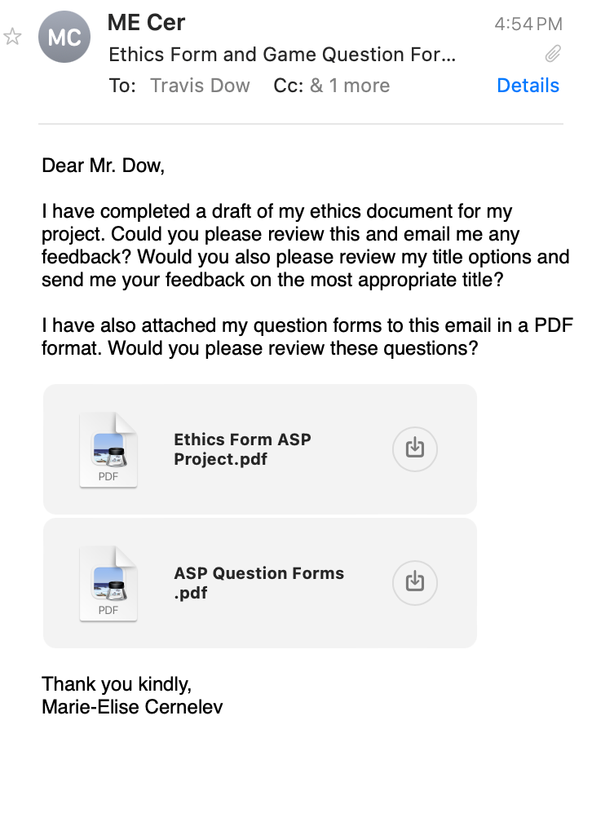
- Sent email to mentor today in the evening:

Tuesday, October 1, 2024:
- Edited more (grammar + information) of the introduction in the proposal:
The modern world is growing more digitized. Portable devices, such as computers and smartphones, and high speed internet seems to be growing in popularity around the world. As the popularity of digitalization increases, it is important to consider the population that is using the computer softwares that is made available to all through these devices and the internet. Currently, the world population of Earth is roughly 8 billion, in the year of 2024.⁵ It is evident that from the year 2023 to 2024, there was a 0.91% increase in the world’s population; hence, Earth’s population is rapidly growing, resulting in more individuals aging.⁵ As individuals age, they are growing more susceptible to disabilities that affect their capabilities and abilities.⁴ This could include visual, hearing, movement, and cognitive/ language impairments. With the probability of these impairments increasing as age increases, it is most likely that the use of additional assistance would be needed, no matter the variation or degree of the impairment. As defined by Vanderheiden, the degree of impairments can be addressed as moderate: can still complete tasks with the sense but requires some sort of additional assistance, severe: would need full assistance to complete task, or more severe: would be unable to complete the task without additional assistance from others or platforms (i.e., when an individual has a more severe hearing impairment, they may require an auditory to visual assistance application), impairments.⁴ Assistance, as mentioned before, can come in multiple forms, including assistive technology, people assistance, and assistance through tools on softwares (i.e., zoom in). The type of assistance that is described in this scenario is defined as, “any item, piece of equipment, software program, or product system that is used to increase, maintain, or improve the functional capabilities of persons with disabilities.”⁶ It is essential to take into consideration the number of individuals, from the population of 8 billion, that are diagnosed or consider themselves to have disabilities, restrictions, or disorders that regulate their abilities to use computer softwares as intentionally designed. For instance, in the United States of America, it is recorded that roughly 11 million people have visual impairments, more than 15 million people have, “some form of hearing impairment,” and 1.9 million people have, “some type of language and learning disability.”⁴ It is hypothesized that if roughly ___ million in people in the United States of America are considered to have disabilities, then roughly ___ in the world have disabilities as well; depicting ____.

Similarly, it is projected that in the year 2050, 4.9 billion people in the world will have neurological disorders.² These disorders can include Alzheimers, autism spectrum disorders(ASD), cerebral palsy(CP), tourette syndrome, and migraines.³ These neurological disorders can be, and will be, in this experiment, considered as conditions or disabilities that an individual associates with . Although there is a wide variety and range of brain disorders, it is not this paper’s main idea. With roughly a 22% increase in disorder cases from 2021 to 2050, it is vital to ensure that these people are able to access any and all platforms available.² Specifically, making computer softwares more accessible for individuals that are diagnosed with these disorders. Accessibility, in this certain scenario, is defined as the, “ability of [a] product and environment to be used by [a variety of] people.”⁴ Neurological disorders could cause mobility limitations, such as motor tics and a restriction of movement (i.e., Tourette syndrome), as well as verbal disabilities, where it is difficult for an individual to formulate words (i,e., non speaking autistic people). As a result, it is difficult for these individuals to complete tasks on computer softwares, such as playing games or accessing an app, when one is unable to use touch. Even though some neurodivergent individuals may have full range of their movement abilities, some may have difficulty controlling their limbs to complete certain tasks. Everything in modern day requires an extensive use of mobility. For example, in order to play a video game, one must be able to use a mouse, laptop, or a video game controller. In order to drive a car, one must have a fast reaction time and be able to control the car’s movement smoothly. Reaction time, mobility and verbal abilities, and difficulty levels are factors that play a role in how accessible a computer software is. In this experiment, it is important to note that there is a possibility that there will not be a large sample size and availability of individuals with neurological disorders; hence, from the data that will be collected from neurotypical individuals, we can hypothesize what alternatives to touch could be integrated within computer softwares, and how these alternatives could potentially assist making the softwares accessible for people with neurological disorders, and improving the user interface. We can further understand if an individual has a certain disability through in the form of a question in the provided survey.

Wednesday, October 2, 2024:
ASP CLASS NOTES (65 min.):
- Tell Author, year, title, or some mix of that for the paper in background research
- September Logbook is practice
- In daily notes add link + notes on paperpile or in background research
  - Own thoughts on it and/or paperpile annotations in background research
- Schedule → ASP class + plans on what to do during that class
- Have to back up information in a research proposal with evidence/ paper.
  - If you are reading stuff from google (ex. Googling terms) + no author = put that next to it
    - Put peer reviewed sites in research proposal
- Dr. Garcia wants to see everything that you are writing + brainstorming
- Mentor communication = mentor can be tough/ difficult in marking you + think about how you will do better/ adhere to the mentors standards
- Know BY THIS WEEK: research question
  - Attached to goals → tasks and future
- Introductions between people will vary BUT all introductions will go from broader aspects from field of studies to narrower aspects that leads to research question
  - Recommended: introduction and Research Question finished by October 4, 2024
- Do not need specific information in depth unless that is what is being studied
  - Do what you think is the best + show to mentors = learn from mistakes and become better
    - Send to mentors roughly October 4-6, 2024.
- Check with mentors!!
  - When in a meeting, ask questions revolving around methodologies, research question, goals, etc….
- Dr.Garcia will be lenient in methodologies (just starting)
- Determine if it is study or experiment.
  - If you are looking for connection of variables + decided by somebody else + the data is already available + want to see effect of this on that than = STUDY
    - Exploring with data that is already available/ there
      - Don’t have to declare variables or hypothesis
- Change order or research proposal: introduction, question, objective, goals, variables, methods, significance
- Significance: WHY IS THIS IMPORTANT? WHY SHOULD BE CONSIDERED THIS?
  - What will this work contribute to the field of studies?
- Ex. If the proposal is due October 15, send the proposal 10 days before.
  - Send to Dr. Garcia anytime, but give her or mentor time.
- In introduction, think if every sentence needs a citation!!
  - Check with Dr. Garcia about the citations/ sources.
- DON’T START WRITING AND FORGETTING TO CITE!!!
- Thought about questions to ask mentor for friday meeting:
  - Were you able to read the documents that I emailed you on Monday?
    - Any recommendations + changes I should make?
  - Is this a good research question (adapted from last shown)?
- Finished reading Computer Software Accessibility Paper: https://paperpile.com/shared/sBf44A0qDSzuORwYsIJxQIw
- Finished reading HCI paper: https://paperpile.com/shared/s6lWEqp~CQE26ElTCW_F3vw
- Found John Hopkins Paper that I took a definition from: https://secwww.jhuapl.edu/techdigest/content/techdigest/pdf/V26-N04/26-04-Gersh.pdf
- Edited Project Proposal: https://docs.google.com/document/d/1IRFmZHyLUH_1aG-IQ5aLOeHOqbhzr-YXPkJuHON0rms/edit?pli=1
The modern world is growing more digitized. Portable devices, such as computers and smartphones, and high speed internet seems to be growing in popularity around the world. As the popularity of digitalization increases, it is important to consider the population that is using the computer softwares that is made available to all through these devices and the internet. Currently, the world population of Earth is roughly 8 billion, in the year of 2024.⁵ It is evident that from the year 2023 to 2024, there was a 0.91% increase in the world’s population; hence, Earth’s population is rapidly growing, resulting in more individuals aging.⁵ As individuals age, they are growing more susceptible to disabilities that affect their capabilities and abilities.⁴ This could include visual, hearing, movement, and cognitive/ language impairments. With the probability of these impairments increasing as age increases, it is most likely that the use of additional assistance would be needed, no matter the variation or degree of the impairment. As defined by Vanderheiden, the degree of impairments can be addressed as moderate: can still complete tasks with the sense but requires some sort of additional assistance, severe: would need full assistance to complete task, or more severe: would be unable to complete the task without additional assistance from others or platforms (i.e., when an individual has a more severe hearing impairment, they may require an auditory to visual assistance application), impairments.⁴ Assistance, as mentioned before, can come in multiple forms, including assistive technology, people assistance, and assistance through tools on softwares (i.e., zoom in). The type of assistance that is described in this scenario is defined as, “any item, piece of equipment, software program, or product system that is used to increase, maintain, or improve the functional capabilities of persons with disabilities.”⁶ It is essential to take into consideration the number of individuals, from the population of 8 billion, that are diagnosed or consider themselves to have disabilities, restrictions, or disorders that regulate their abilities to use computer softwares as intentionally designed. For instance, in the United States of America, it is recorded that roughly 11 million people have visual impairments, more than 15 million people have, “some form of hearing impairment,” and 1.9 million people have, “some type of language and learning disability.”⁴ It is estimated that 1.3 billion people in the world have disabilities in 2023, contributing to roughly 16% of the world’s population, depicting the many people that have difficulty accessing computer softwares.⁷

Similarly, it is projected that in the year 2050, 4.9 billion people in the world will have neurological disorders.² These disorders can include Alzheimers, autism spectrum disorders(ASD), cerebral palsy(CP), tourette syndrome, and migraines.³ These neurological disorders can be, and will be, in this experiment, considered as conditions or disabilities that an individual associates with . Although there is a wide variety and range of brain disorders, it is not this paper’s main idea. With roughly a 22% increase in disorder cases from 2021 to 2050, it is vital to ensure that these people are able to access any and all platforms available.² Specifically, making computer softwares more accessible for individuals that are diagnosed with these disorders. Accessibility, in this certain scenario, is defined as the, “ability of [a] product and environment to be used by [a variety of] people.”⁴ Neurological disorders could cause mobility limitations, such as motor tics and a restriction of movement (i.e., Tourette syndrome), as well as verbal disabilities, where it is difficult for an individual to formulate words (i,e., non speaking autistic people). As a result, it is difficult for these individuals to complete tasks on computer softwares, such as playing games or accessing an app, when one is unable to use touch. Even though some neurodivergent individuals may have full range of their movement abilities, some may have difficulty controlling their limbs to complete certain tasks. Everything in modern day requires an extensive use of mobility. For example, in order to play a video game, one must be able to use a mouse, laptop, or a video game controller. In order to drive a car, one must have a fast reaction time and be able to control the car’s movement smoothly. Reaction time, mobility and verbal abilities, and difficulty levels are factors that play a role in how accessible a computer software is. In this experiment, it is important to note that there is a possibility that there will not be a large sample size and availability of individuals with neurological disorders; hence, from the data that will be collected from neurotypical individuals, we can hypothesize what alternatives to touch could be integrated within computer softwares, and how these alternatives could potentially assist making the softwares accessible for people with neurological disorders, and improving the user interface. We can further understand if an individual has a certain disability in this experiment in the form of a question in the provided survey (it will not ask specifically if they have a disability rather what they experience during stress).

Not only is it vital to make computer softwares accessible for individuals with disabilities, however, accessible for all. This can be accomplished by understanding the variety of alternatives that can be integrated into computer softwares. Such as, speech recognition, gesture tracking, and head movement tracking. Those who have moderate to severe visual impairments, have difficulty in viewing and interpreting what is on the computer software (i.e., an individual that is chronically blind will not be able to navigate through a software).⁴ In this scenario, speech recognition could be integrated into the software.

Thursday, October 3, 2024:
- Added titles and authors in background research.
- Started reading article: https://paperpile.com/shared/sY0PvXmRaR6~5mlVpVC~~1Q
- Found article: https://www.ncbi.nlm.nih.gov/pmc/articles/PMC6257447/
- Found and finished reading papers: “What is computer software” and “What is software?: The Role of Empirical Methods in Answering the Question”
  - https://paperpile.com/shared/swP~Gv0dkQsm6BLnf7O2a~Q and https://www.researchgate.net/publication/367335862_What_is_computer_software
  - I read these papers/ article to understand if I was dealing with computer softwares OR computer software applications (it is specifically people's interaction with computer software applications, as applications refer to apps)
- Edited project proposal introduction section: https://docs.google.com/document/d/1IRFmZHyLUH_1aG-IQ5aLOeHOqbhzr-YXPkJuHON0rms/edit?pli=1#heading=h.rd6ctxyk1yr4
The modern world is growing more digitized. Portable devices, such as computers and smartphones, and high speed internet seems to be growing in popularity around the world. As the popularity of digitalization increases, it is important to consider the population that is using the computer softwares that is made available to all through these devices and the internet. Currently, the world population of Earth is roughly 8 billion, in the year of 2024.⁵ It is evident that from the year 2023 to 2024, there was a 0.91% increase in the world’s population; hence, Earth’s population is rapidly growing, resulting in more individuals aging.⁵ As individuals age, they are growing more susceptible to disabilities that affect their capabilities and abilities.⁴ This could include visual, hearing, movement, and cognitive/ language impairments. With the probability of these impairments increasing as age increases, it is most likely that the use of additional assistance would be needed, no matter the variation or degree of the impairment. As defined by Vanderheiden, the degree of impairments can be addressed as moderate: can still complete tasks with the sense but requires some sort of additional assistance, severe: would need full assistance to complete task, or more severe: would be unable to complete the task without additional assistance from others or platforms (i.e., when an individual has a more severe hearing impairment, they may require an auditory to visual assistance application), impairments.⁴ Assistance, as mentioned before, can come in multiple forms, including assistive technology, people assistance, and assistance through tools on software applications (i.e., zoom in). The type of assistance that is described in this scenario is defined as, “any item, piece of equipment, software program, or product system that is used to increase, maintain, or improve the functional capabilities of persons with disabilities.”⁶ It is essential to take into consideration the number of individuals, from the population of 8 billion, that are diagnosed or consider themselves to have disabilities, restrictions, or disorders that regulate their abilities to use and interact with computer software applications. For instance, in the United States of America, it is recorded that roughly 11 million people have visual impairments, more than 15 million people have, “some form of hearing impairment,” and 1.9 million people have, “some type of language and learning disability.”⁴ It is estimated that 1.3 billion people in the world have disabilities in 2023, contributing to roughly 16% of the world’s population, depicting the many people that have difficulty interacting with computer software applications.⁷ Computer software is a broader terminology used to describe programs that execute tasks and operations on a computer; the term computer software applications is used as it specifically refers to programs that, “perform specific functions for the user” (i.e., apps and games).^{8–10}
Similarly, it is projected that in the year 2050, 4.9 billion people in the world will have neurological disorders.² These disorders can include Alzheimers, autism spectrum disorders(ASD), cerebral palsy(CP), tourette syndrome, and migraines.³ These neurological disorders can be, and will be, in this experiment, considered as conditions or disabilities that an individual associates with . Although there is a wide variety and range of brain disorders, it is not this paper’s main idea. With roughly a 22% increase in disorder cases from 2021 to 2050, it is vital to ensure that these people are able to access any and all platforms available.² Specifically, making computer softwares more accessible for individuals that are diagnosed with these disorders. Accessibility, in this certain scenario, is defined as the, “ability of [a] product and environment to be used by [a variety of] people.”⁴ Neurological disorders could cause mobility limitations, such as motor tics and a restriction of movement (i.e., Tourette syndrome), as well as verbal disabilities, where it is difficult for an individual to formulate words (i,e., non speaking autistic people). As a result, it is difficult for these individuals to complete tasks on computer softwares, such as playing games or accessing an app, when one is unable to use touch. Even though some neurodivergent individuals may have full range of their movement abilities, some may have difficulty controlling their limbs to complete certain tasks. Everything in modern day requires an extensive use of mobility. For example, in order to play a video game, one must be able to use a mouse, laptop, or a video game controller. In order to drive a car, one must have a fast reaction time and be able to control the car’s movement smoothly. Reaction time, mobility and verbal abilities, and difficulty levels are factors that play a role in how accessible a computer software is. In this experiment, it is important to note that there is a possibility that there will not be a large sample size and availability of individuals with neurological disorders; hence, from the data that will be collected from neurotypical individuals, we can hypothesize what alternatives to touch could be integrated within computer softwares, and how these alternatives could potentially assist making the softwares accessible for people with neurological disorders, and improving the user interface. We can further understand if an individual has a certain disability in this experiment in the form of a question in the provided survey (it will not ask specifically if they have a disability rather what they experience during stress).
Not only is it vital to make computer application softwares accessible for individuals with disabilities, however, accessible for all. This can be accomplished by understanding the variety of alternatives that can be integrated into computer softwares. Such as, speech recognition, gesture tracking, and head movement tracking. Those who have moderate to severe visual impairments, have difficulty in viewing and interpreting what is on the computer software application (i.e., an individual that is chronically blind will not be able to navigate through a software).⁴ In this scenario, speech recognition could be integrated into the software, to improve the accessibility for the individual; hence, the blind individual would be able to navigate through the software through speech to text and audio commands and communication.

Friday, October 4, 2024:
ASP CLASS NOTES(35 min):
- Dr. Garcia likes the outline function in google doc.
- She likes the title page in logbook
  - Consists of title of project, logbook
- LAYOUT (order doesn’t matter): logbook title, schedule/ calendar(likes with different tasks as lists), daily notes, Background Research(wants to see in daily work that you worked on paper + date them)
  - PUT TASKS IN CALENDAR + PLAN OUT WHAT TOPICS YOU ARE PLANNING TO READ SPECIFIC DAYS
Questions for Mentor This Meeting:
- EMAIL READING:
  - Did you have a chance to read the ethics form and questions I sent you on Monday?
    - Do you have any recommendations?
- TITLE:
  - For the title: from the three that were provided, what do you think is the best?
    - Recommendations + Changes?
- QUESTION:
  - Is this research question specific enough + well written?
    - Recommendations + Changes?
- Finished Reading “Human-computer interaction in games using computer vision techniques”: https://paperpile.com/shared/sIl9h5egdSFSWLYEJkrZCPg
- Finished Reading: https://paperpile.com/shared/s8ypdlbKZQSq~c1VPADqfGw
  - This article was used for a definition to understand the article named “Video game values: Human-computer interaction and games”
- Started reading “Video game values: Human-computer interaction and games” by Barr P, Noble J, Biddle R: https://paperpile.com/shared/sIccb45K5QxGPxDnNtTJZyw
- Formatted my background research by adding dates as titles.
- Edited my ethics paper and questionnaire: https://docs.google.com/document/d/1G-0BgxhXgQQiBLGS3w6x-SX70FvtnIlCuW_6OTCbNX8/edit (questionnaire) and https://docs.google.com/document/d/1CGlq9KbaLgNeU_1jJ3xAZKzJPiOdUdq5ffV8FA_gSEM/edit (ethics form)
- Edited the project proposal: https://docs.google.com/document/d/1IRFmZHyLUH_1aG-IQ5aLOeHOqbhzr-YXPkJuHON0rms/edit?pli=1
The modern world is growing more digitized.⁸ Portable devices, such as computers and smartphones, and high speed internet seems to be growing in popularity around the world. As the popularity of digitalization increases, it is important to consider the population that is using the computer software applications that are made available to all through these devices and the internet. Currently, the world population of Earth is roughly 8 billion, in the year of 2024.⁵ It is evident that from the year 2023 to 2024, there was a 0.91% increase in the world’s population; hence, Earth’s population is rapidly growing, resulting in more individuals aging.⁵ As individuals age, they are growing more susceptible to disabilities that affect their capabilities and abilities.⁴ This could include visual, hearing, movement, and cognitive/ language impairments. With the probability of these impairments increasing as age increases, it is most likely that the use of additional assistance would be needed, no matter the variation or degree of the impairment. As defined by Vanderheiden, the degree of impairments can be addressed as moderate: can still complete tasks with the sense but requires some sort of additional assistance, severe: would need full assistance to complete task, or more severe: would be unable to complete the task without additional assistance from others or platforms (i.e., when an individual has a more severe hearing impairment, they may require an auditory to visual assistance application), impairments.⁴ Assistance, as mentioned before, can come in multiple forms, including assistive technology, people assistance, and assistance through tools on software applications (i.e., zoom in). The type of assistance that is described in this scenario is defined as, “any item, piece of equipment, software program, or product system that is used to increase, maintain, or improve the functional capabilities of persons with disabilities.”⁶ It is essential to take into consideration the number of individuals, from the population of 8 billion, that are diagnosed or consider themselves to have disabilities, restrictions, or disorders that regulate their abilities to use and interact with computer software applications. For instance, in the United States of America, it is recorded that roughly 11 million people have visual impairments, more than 15 million people have, “some form of hearing impairment,” and 1.9 million people have, “some type of language and learning disability.”⁴ It is estimated that 1.3 billion people in the world have disabilities in 2023, contributing to roughly 16% of the world’s population, depicting the many people that have difficulty interacting with computer software applications.⁷ Computer software is a broader terminology used to describe programs that execute tasks and operations on a computer; the term computer software applications is used as it specifically refers to programs that, “perform specific functions for the user” (i.e., apps and games).^{8–10}
Similarly, it is projected that in the year 2050, 4.9 billion people in the world will have neurological disorders.² These disorders can include Alzheimers, autism spectrum disorders(ASD), cerebral palsy(CP), tourette syndrome, and migraines.³ These neurological disorders can be, and will be, in this experiment, considered as conditions or disabilities that an individual associates with . Although there is a wide variety and range of brain disorders, it is not this paper’s main idea. With roughly a 22% increase in disorder cases from 2021 to 2050, it is vital to ensure that these people are able to access any and all platforms available.² Specifically, making computer softwares more accessible for individuals that are diagnosed with these disorders. Accessibility, in this certain scenario, is defined as the, “ability of [a] product and environment to be used by [a variety of] people.”⁴ Neurological disorders could cause mobility limitations, such as motor tics and a restriction of movement (i.e., Tourette syndrome), as well as verbal disabilities, where it is difficult for an individual to formulate words (i,e., non speaking autistic people). As a result, it is difficult for these individuals to complete tasks on computer softwares, such as playing games or accessing an app, when one is unable to use touch. Even though some neurodivergent individuals may have full range of their movement abilities, some may have difficulty controlling their limbs to complete certain tasks. Everything in modern day requires an extensive use of mobility. For example, in order to play a video game, one must be able to use a mouse, laptop, or a video game controller. In order to drive a car, one must have a fast reaction time and be able to control the car’s movement smoothly. Reaction time, mobility and verbal abilities, and difficulty levels are factors that play a role in how accessible a computer software is. In this experiment, it is important to note that there is a possibility that there will not be a large sample size and availability of individuals with neurological disorders; hence, from the data that will be collected from neurotypical individuals, we can hypothesize what alternatives to touch could be integrated within computer softwares, and how these alternatives could potentially assist making the softwares accessible for people with neurological disorders, and improving the user interface. We can further understand if an individual has a certain disability in this experiment in the form of a question in the provided survey (it will not ask specifically if they have a disability rather what they experience during stress).
Not only is it vital to make computer application softwares accessible for individuals with disabilities, however, accessible for all. This can be accomplished by understanding the variety of alternatives that can be integrated into computer softwares. Such as, speech recognition, gesture tracking, and head movement tracking. Those who have moderate to severe visual impairments, have difficulty in viewing and interpreting what is on the computer software application (i.e., an individual that is chronically blind will not be able to navigate through a software).⁴ In this scenario, speech recognition could be integrated into the software, to improve the accessibility for the individual; hence, the blind individual would be able to navigate through the software through speech to text and audio commands and communication.
It was established, by psychologists, that 80% of communication interaction between individuals involves nonverbal signals, including gesture and head movements, portraying how frequent other types of communication between people are.¹¹ With this understanding, it makes rational sense that other types of interaction could be integrated within computer software applications, tracking gestures, head movements, and even speech. Although it was stated that the majority of communication is non-verbal, 20% of the communication is still verbal; hence, this aspect should still be integrated into the applications. With the tracking of individuals behaviours, emotions, and movements while they use a computer application, applications can become more interactive and entertaining. For example,
Computer software applications are not necessarily built with the level of accessibility that individuals with neurological disabilities need. For instance, touch can be unreliable and tedious in virtual reality (VR) due to a lack of visual cues. This makes it challenging to gauge distances and spatial relationships between objects. These issues can be especially difficult for those with motor or visual impairments. While VR’s current implementation is limited, it provides a platform that can be easily adjusted for those who need custom features¹². Virtual reality could also be used as a rehabilitative process, and with an increased accessibility of VR, individuals could be introduced to new methods of healing (i.e., virtual therapists/ therapeutic benefits).¹² There are many softwares where a greater accessibility range would allow for the individual to experience more opportunities, not only rehabilitative but also for education and amusement. Voice commands, movement controls, eye tracking, and sign language are all alternatives to touch that can be implemented quickly and affordably within VR. Individuals suffering from Parkinson's disease, which causes tremors and spasms, could use speech commands to perform tasks that they were not able to before; for example, in virtual reality, ‘typing’ through voice. Non-speaking autistic people who have difficulty with motor skills could also play video games by using sign language or eye and head movement. Those with physical disabilities, to the extent that they are unable to move their limbs, could control a game by using speech, and even those who do not prefer playing video games with, for example, a controller could use other senses.
Although there has been relevant data and research in the field of human computer interaction and the accessibility of computer software applications for those without and with disabilities affecting their motor and verbal skills, there has not been enough action in these fields to have drastically impacted the computer software applications to be fully accessible for these individuals in modern day. Therefore, in this experiment, the listed alternatives to touch: speech recognition, eye and head movement tracking, and sign language tracking- will be tested to evaluate the efficacy of alternative control methods to enhance the user experience, user interface, and accessibility in computer software applications for those with disabilities and neurotypical individuals.

MENTOR MEETING NOTES(20 min meeting):
EMAIL READING:
- Did you have a chance to read the ethic form and questions I sent you on Monday?
  - Do you have any recommendations?
TITLE:
- For the title: from the three that was provided, what do you think is the best?
  - Recommendations + Changes?
QUESTION:
- Is this research question specific enough + well written?
  - Recommendations + Changes?
  - Want research question more broad + hypothesis more specific + question is too broad + narrow down the conditions
    - Can add sub question —> ex. On average do people enjoy speech recognition over ___?
      - Compare results
Ethics: Title —> chatGPT to ask for titles + he wrote possible title / suggestion + small grammatical issues (highlighted the issues) + explain what alternatives in the first paragraph in ethics form + unclear = highlight (explain what scenario are) + Reword the sentence that says “conclusions” + be more clear for the number of times the user plays the game + you can append the questionnaire to the ethics form + say biological sex instead of gender (in question form) + rephrase field + important you record what they were saying (wrote that paragraph really well) —> determine it it was accurate + “there are no foreseen risks…” + “up to two weeks after …” + make sure that for demographic information —> only asking questions that you need and get everything up front + “Webber Academy 2025 Science Fair”
Questions: do not need prefer not to say in age group question + for a scale, usually making it an odd number (ex. 1-5, 1-7, 1-9) + ask the user to rank the method of interactions they preferred the most + omit the last thing in question 7. + there are not many additional comments —> add more of an open ending question (do not get a lot from that)

Thursday, October 5, 2024:
- Edited introduction in proposal: https://docs.google.com/document/d/1IRFmZHyLUH_1aG-IQ5aLOeHOqbhzr-YXPkJuHON0rms/edit?pli=1
The modern world is growing more digitized.⁸ Portable devices, such as computers and smartphones, and high speed internet seems to be growing in popularity around the world. As the daily use of technology is increasing, it is important to consider the population using computer software applications. Earth’s population is rapidly growing, resulting in more individuals aging.⁵ As individuals age, they are growing more susceptible to disabilities that affect their abilities.⁴ This could include visual, hearing, movement, and cognitive/ language impairments. With the probability of these impairments increasing as age increases, it is most likely that the use of additional assistance would be needed, no matter the variation or degree of the impairment. As defined by Vanderheiden, the degree of impairments can be addressed as moderate impairments: can still complete tasks with the sense but requires some sort of additional assistance, severe impairments: would need full assistance to complete task, or more severe impairments: would be unable to complete the task without additional assistance from others or platforms.⁴ For example, when an individual has a more severe hearing impairment, they may require an auditory to visual assistance application.⁴ Assistance can come in multiple forms, including assistive technology and assistance through tools on software applications (i.e., zoom in). Specifically assistance is defined as, “any item, piece of equipment, software program, or product system that is used to increase, maintain, or improve the functional capabilities of persons with disabilities.”⁶ It is essential to take into consideration the number of individuals, from the population of 8 billion, that are diagnosed or consider themselves to have disabilities, restrictions, or disorders that regulate their abilities to use and interact with computer software applications.⁵ For instance, in the United States of America, it is recorded that roughly 11 million people have visual impairments, more than 15 million people have, “some form of hearing impairment,” and 1.9 million people have, “some type of language and learning disability.”⁴ It is estimated that 1.3 billion people in the world have disabilities in 2023, contributing to roughly 16% of the world’s population, depicting the many people that have difficulty interacting with computer software applications.⁷ Computer software is a broader terminology used to describe programs that execute tasks and operations on a computer; the term computer software applications is used as it specifically refers to programs that, “perform specific functions for the user” (i.e., apps and games).^{8–10}

Similarly, it is projected that in the year 2050, 4.9 billion people in the world will have neurological disorders.² These disorders can include Alzheimers, autism spectrum disorders(ASD), cerebral palsy(CP), tourette syndrome, and migraines.³ These neurological disorders can be, and will be, in this experiment, considered as conditions or disabilities that an individual associates with . Although there is a wide variety and range of brain disorders, it is not this paper’s main idea. With roughly a 22% increase in disorder cases from 2021 to 2050, it is vital to ensure that these people are able to access any and all platforms available.² Specifically, making computer softwares more accessible for individuals that are diagnosed with these disorders. Accessibility, in this certain scenario, is defined as the, “ability of [a] product and environment to be used by [a variety of] people.”⁴ Neurological disorders could cause mobility limitations, such as motor tics and a restriction of movement (i.e., Tourette syndrome), as well as verbal disabilities, where it is difficult for an individual to formulate words (i,e., non speaking autistic people). As a result, it is difficult for these individuals to complete tasks on computer softwares, such as playing games or accessing an app, when one is unable to use touch. Even though some neurodivergent individuals may have full range of their movement abilities, some may have difficulty controlling their limbs to complete certain tasks. Everything in modern day requires an extensive use of mobility. For example, in order to play a video game, one must be able to use a mouse, laptop, or a video game controller. In order to drive a car, one must have a fast reaction time and be able to control the car’s movement smoothly. Reaction time, mobility and verbal abilities, and difficulty levels are factors that play a role in how accessible a computer software is. In this experiment, it is important to note that there is a possibility that there will not be a large sample size and availability of individuals with neurological disorders; hence, from the data that will be collected from neurotypical individuals, we can hypothesize what alternatives to touch could be integrated within computer softwares, and how these alternatives could potentially assist making the softwares accessible for people with neurological disorders, and improving the user interface. We can further understand if an individual has a certain disability in this experiment in the form of a question in the provided survey (it will not ask specifically if they have a disability rather what they experience during stress).

Not only is it vital to make computer application softwares accessible for individuals with disabilities, however, accessible for all. This can be accomplished by understanding the variety of alternatives that can be integrated into computer softwares. Such as, speech recognition, gesture tracking, and head movement tracking. Those who have moderate to severe visual impairments, have difficulty in viewing and interpreting what is on the computer software application (i.e., an individual that is chronically blind will not be able to navigate through a software).⁴ In this scenario, speech recognition could be integrated into the software, to improve the accessibility for the individual; hence, the blind individual would be able to navigate through the software through speech to text and audio commands and communication.

It was established, by psychologists, that 80% of communication interaction between individuals involves nonverbal signals, including gesture and head movements, portraying how frequent other types of communication between people are.¹¹ With this understanding, it makes rational sense that other types of interaction could be integrated within computer software applications, tracking gestures, head movements, and even speech. Although it was stated that the majority of communication is non-verbal, 20% of the communication is still verbal; hence, this aspect should still be integrated into the applications. With the tracking of individuals behaviours, emotions, and movements while they use a computer application, applications can become more interactive and entertaining. For example, when playing interactive games, such as a fighting/ boxing game, the game would be more interactive and the user would, most likely, be more entertained if they imitated fighting in real life.¹¹ These games and applications would use gestures and head movement tracking to improve the user interface and interaction. With more computer software applications using a mix of tracking interactions, including tactile, movement tracking, and speech recognition, the accessibility would not only improve, but the user experience would be enhanced.

Computer software applications are not necessarily built with the level of accessibility that individuals with neurological disabilities need. For instance, touch can be unreliable and tedious in virtual reality (VR) due to a lack of visual cues. This makes it challenging to gauge distances and spatial relationships between objects. These issues can be especially difficult for those with motor or visual impairments. While VR’s current implementation is limited, it provides a platform that can be easily adjusted for those who need custom features¹². Virtual reality could also be used as a rehabilitative process, and with an increased accessibility of VR, individuals could be introduced to new methods of healing (i.e., virtual therapists/ therapeutic benefits).¹² There are many softwares where a greater accessibility range would allow for the individual to experience more opportunities, not only rehabilitative but also for education and amusement. Voice commands, movement controls, eye tracking, and sign language are all alternatives to touch that can be implemented quickly and affordably within VR. Individuals suffering from Parkinson's disease, which causes tremors and spasms, could use speech commands to perform tasks that they were not able to before; for example, in virtual reality, ‘typing’ through voice. Non-speaking autistic people who have difficulty with motor skills could also play video games by using sign language or eye and head movement. Those with physical disabilities, to the extent that they are unable to move their limbs, could control a game by using speech, and even those who do not prefer playing video games with, for example, a controller could use other senses.

Although there has been relevant data and research in the field of human computer interaction and the accessibility of computer software applications for those without and with disabilities affecting their motor and verbal skills, there has not been enough action in these fields to have drastically impacted the computer software applications to be fully accessible for these individuals in modern day. Therefore, in this experiment, the listed alternatives to touch: speech recognition, eye and head movement tracking, and sign language tracking- will be tested to evaluate the efficacy of alternative control methods to enhance the user experience, user interface, and accessibility in computer software applications for those with disabilities and neurotypical individuals.

Sunday, October 6, 2024:
- Rephrased introduction (on alternative document): https://docs.google.com/document/d/1JF41QA8edgFuR5VjD67hiAsfKEV3GPu2g6j4SCNvvrA/edit
​​The modern world is growing more digitized.⁸ Portable devices, such as computers and smartphones, and high speed internet seem to be growing in popularity around the world. As the daily use of technology is increasing, it is important to consider the population using computer software applications. Earth’s population is rapidly growing, resulting in more individuals aging.⁵ As individuals age, they are growing more susceptible to disabilities that affect their abilities.⁴ This could include visual, hearing, movement, and cognitive/ language impairments. With the probability of these impairments increasing as age increases, it is most likely that the use of additional assistance would be needed.⁴ Assistance can come in multiple forms, including assistive technology and assistance through tools on software applications (i.e., zoom in). Specifically, assistance is defined as, “any item, piece of equipment, software program, or product system that is used to increase, maintain, or improve the functional capabilities of persons with disabilities.”⁶ It is essential to take into consideration the number of individuals, from the population of 8 billion, that are diagnosed or consider themselves to have disabilities, restrictions, or disorders that regulate their abilities to use and interact with computer software applications.⁵ For instance, in the United States of America, it is recorded that roughly 11 million people have visual impairments, more than 15 million people have, “some form of hearing impairment,” and 1.9 million people have, “some type of language and learning disability.”⁴ It is estimated that 1.3 billion people in the world have disabilities in 2023, contributing to roughly 16% of the world’s population, depicting the many people that have difficulty interacting with computer software applications.⁷ Computer software is a broader terminology used to describe programs that execute tasks and operations on a computer; the term computer software applications is used as it specifically refers to programs that, “perform specific functions for the user” (i.e., apps and games).^{8–10}

Similarly, it is projected that in the year 2050, 4.9 billion people in the world will have neurological disorders.² These disorders can include Alzheimers, autism spectrum disorders(ASD), cerebral palsy(CP), tourette syndrome, and migraines.³ These neurological disorders can be, and will be, in this experiment, considered as conditions or disabilities that an individual associates with. Although there is a wide variety and range of brain disorders, it is not this paper’s main idea. With roughly a 22% increase in disorder cases from 2021 to 2050, it is vital to ensure that these people are able to access any and all platforms available.² Specifically, making computer software applications more accessible for individuals that are diagnosed with these disorders. Accessibility, in this certain scenario, is defined as the, “ability of [a] product and environment to be used by [a variety of] people.”⁴ Neurological disorders could cause mobility limitations, such as motor tics and a restriction of movement (i.e., Tourette syndrome), as well as verbal disabilities, where it is difficult for an individual to formulate words (i,e., non speaking autistic people). As a result, it is difficult for these individuals to complete tasks on computer software applications, such as playing games or accessing an app, when one is unable to use touch.

Computer software applications are not necessarily built with the level of accessibility that individuals with neurological disabilities need. For instance, touch can be unreliable and tedious in virtual reality (VR) due to a lack of visual cues. This makes it challenging to gauge distances and spatial relationships between objects. These issues can be especially difficult for those with motor or visual impairments. While VR’s current implementation is limited, it provides a platform that can be easily adjusted for those who need custom features¹². Virtual reality could also be used as a rehabilitative process, and with an increased accessibility of VR, individuals could be introduced to new methods of healing (i.e., virtual therapists/ therapeutic benefits).¹² There are many softwares where a greater accessibility range would allow for the individual to experience more opportunities, not only rehabilitative but also for education and amusement. Voice commands, movement controls, eye tracking, and sign language are all alternatives to touch that can be implemented quickly and affordably within VR. Individuals suffering from Parkinson's disease, which causes tremors and spasms, could use speech commands to perform tasks that they were not able to before; for example, in virtual reality, ‘typing’ through voice. Non-speaking autistic people who have difficulty with motor skills could also play video games by using sign language or eye and head movement. Those with physical disabilities, to the extent that they are unable to move their limbs, could control a game by using speech, and even those who do not prefer playing video games with, for example, a controller could use other senses.

Even though some neurodivergent individuals may have full range of their movement abilities, some may have difficulty controlling their limbs to complete certain tasks. Everything in modern day requires an extensive use of mobility. For example, in order to play a video game, one must be able to use a mouse, laptop, or a video game controller. In order to drive a car, one must have a fast reaction time and be able to control the car’s movement smoothly. Reaction time, mobility and verbal abilities, and difficulty levels are factors that play a role in how accessible a computer software application is. In this experiment, it is important to note that there is a possibility that there will not be a large sample size and availability of individuals with neurological disorders; hence, from the data that will be collected from neurotypical individuals, we can hypothesize what alternatives to touch could be integrated within computer software applications, and how these alternatives could potentially assist making the applications accessible for people with neurological disorders, and improving the user interface. We can further understand if an individual has a certain disability in this experiment in the form of a question in the provided survey (it will not ask specifically if they have a disability rather what they experience during stress).

Not only is it vital to make computer application softwares accessible for individuals with disabilities, however, accessible for all. This can be accomplished by understanding the variety of alternatives that can be integrated into computer softwares. Such as, speech recognition, gesture tracking, and head movement tracking. Those who have moderate to severe visual impairments, have difficulty in viewing and interpreting what is on the computer software application (i.e., an individual that is chronically blind will not be able to navigate through a software).⁴ In this scenario, speech recognition could be integrated into the software, to improve the accessibility for the individual. Hence, the blind individual would be able to navigate through the application using speech to text and audio commands as a form of communication.

It was established, by psychologists, that 80% of communication interaction between individuals involves nonverbal signals, including gesture and head movements, portraying how frequent other types of communication between people are.¹¹ With this understanding, it makes rational sense that other types of interaction could be integrated within computer software applications, tracking gestures, head movements, and even speech. Although it was stated that the majority of communication is non-verbal, 20% of the communication is still verbal; therefore, this aspect should still be integrated into the applications. With the tracking of individuals behaviours, emotions, and movements while they use a computer application, applications can become more interactive and entertaining. For example, when playing interactive games, such as a fighting/ boxing game, the game would be more interactive and the user would, most likely, be more entertained if they imitated fighting in real life.¹¹ These games and applications would use gestures and head movement tracking to improve the user interface and interaction. With more computer software applications using a mix of tracking interactions, including tactile, movement tracking, and speech recognition, the accessibility would not only improve, but the user experience would be enhanced.

Although there has been relevant data and research in the field of human computer interaction and the accessibility of computer software applications for those without and with disabilities affecting their motor and verbal skills, there has not been enough action in these fields to have drastically impacted the computer software applications to be fully accessible for these individuals in modern day. Therefore, in this experiment, the listed alternatives to touch: speech recognition, eye and head movement tracking, and sign language tracking- will be tested to evaluate the efficacy of alternative control methods to enhance the user experience, user interface, and accessibility in computer software applications for those with disabilities and neurotypical individuals.

Monday, October 7, 2024:
- Emailed Dr. Garcia for review of ethics and questionnaire forms (will email Dr. Krishnamurthy after given advice):
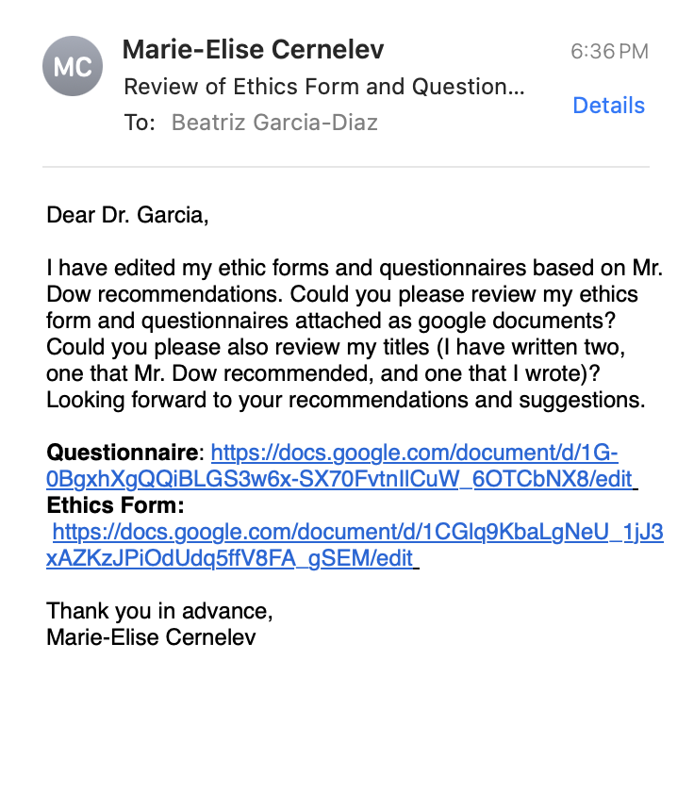

Tuesday, October 8, 2024:
ASP CLASS NOTES (45 min):
- Participate in Senior High Science Fair Meeting:
  - March 11: School Science Fair
    - Make Long Range Plans
- CYSF Online Portal is open
  - Will be invited to the online portal by Dr. Garcia
    - Closes March 28, 2024
- If you get in the top 15 projects and are going to the city science fair, the date is April 10-12.
- Oral Presentations near the end of February.
  - Class assignments will guide you (help with presentation)
- Bring plan proposal with mentor (finished this)
- Set up meeting in google calendar inviting Mr. Dow.
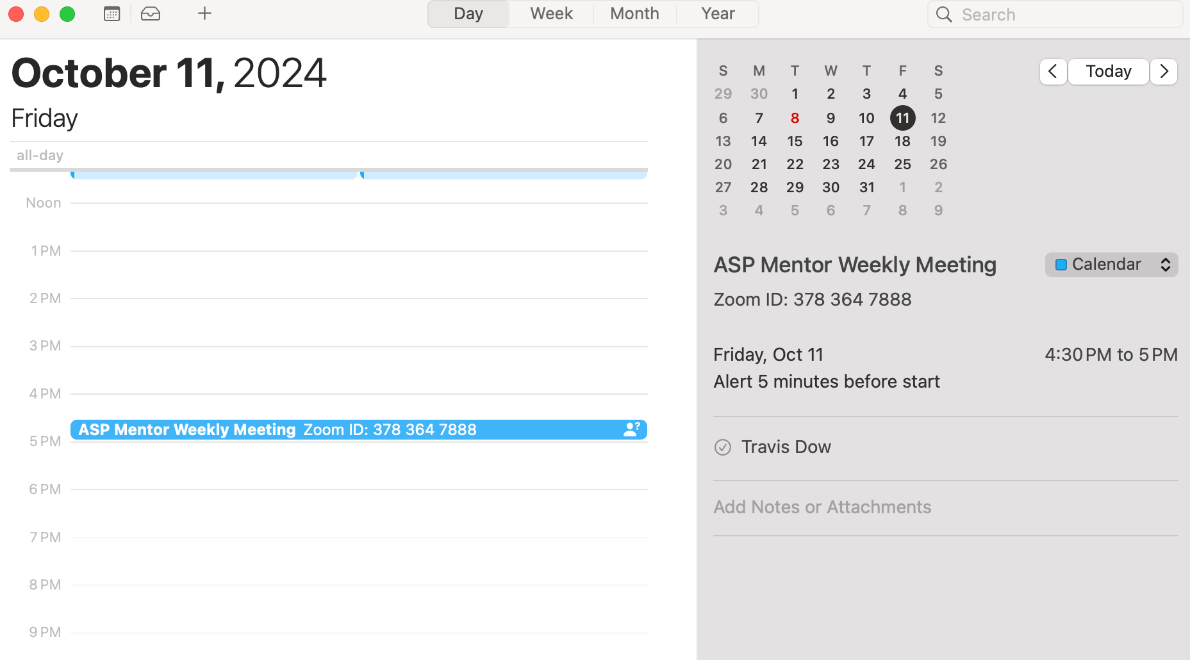
- Reviewed and edited (made it more succinct and to the point and added an HCI brief portion explaining about the relationships between HCI and my experiment) my research proposal introduction: https://docs.google.com/document/d/1V_fguAn0UXb1CeVihHaUIY7Zie-B7DBJ578gDaJSuPY/edit
The modern world is growing more digitized.⁸ Portable devices, such as computers and smartphones, and high speed internet seem to be growing in popularity around the world.⁸ As the daily use of technology is increasing, it is important to consider the population using computer software applications. Earth’s population is rapidly growing, resulting in more individuals aging.⁵ As individuals age, they are growing more susceptible to disabilities that affect their abilities.⁴ This could include visual, hearing, movement, and cognitive/ language impairments. With the probability of these impairments increasing as age increases, it is most likely that the use of additional assistance would be needed.⁴ Assistance can come in multiple forms, including assistive technology and assistance through tools on software applications (i.e., zoom in). Specifically, assistance is defined as, “any item, piece of equipment, software program, or product system that is used to increase, maintain, or improve the functional capabilities of persons with disabilities.”⁶ It is essential to take into consideration the number of individuals, from the population of 8 billion, that are diagnosed or consider themselves to have disabilities, restrictions, or disorders that regulate their abilities to use and interact with computer software applications.⁵ For instance, in the United States of America, it is recorded that roughly 11 million people have visual impairments, more than 15 million people have, “some form of hearing impairment,” and 1.9 million people have, “some type of language and learning disability.”⁴ It is estimated that 1.3 billion people in the world have disabilities in 2023, contributing to roughly 16% of the world’s population, depicting the many people that have difficulty interacting with computer software applications.⁷ Computer software is a broader terminology used to describe programs that execute tasks and operations on a computer; the term computer software applications is used as it specifically refers to programs that, “perform specific functions for the user” (i.e., apps and games).^{8–10}

Similarly, it is projected that in the year 2050, 4.9 billion people in the world will have neurological disorders.² These disorders can include Alzheimers, autism spectrum disorders(ASD), cerebral palsy(CP), tourette syndrome, and migraines.³ These neurological disorders can be, and will be, in this experiment, considered as conditions or disabilities that an individual associates with. Although there is a wide variety and range of brain disorders, it is not the main focus. With roughly a 22% increase in disorder cases from 2021 to 2050, it is vital to ensure that these people are able to access any and all platforms available.² Specifically, making computer software applications more accessible for individuals that are diagnosed with these disorders. Accessibility, in this certain scenario, is defined as the, “ability of [a] product and environment to be used by [a variety of] people.”⁴ Neurological disorders could cause limitations (i.e., mobility limitations, verbal disabilities); as a result, it is difficult for these individuals to complete tasks on computer software applications, such as playing games.

Computer software applications are not necessarily built with the level of accessibility that individuals with neurological disabilities need. For instance, in virtual reality (VR), touch can be unreliable and tedious due to a lack of visual cues, making it challenging to gauge distances and spatial relationships between objects. These issues can be especially difficult for those with motor or visual impairments.¹² There are many software applications where a greater accessibility range for individuals is needed. Voice commands, movement controls, eye tracking, and sign language are alternatives that can be implemented quickly and affordably within applications, such as in the VR example. Individuals suffering from Parkinson's disease, which causes tremors and spasms, could use speech commands to perform tasks that they were not able to before; for example, in virtual reality, ‘typing’ through voice. Non-speaking autistic people who have difficulty with motor skills could also play video games by using sign language or eye and head movement.

Everything in modern day requires an extensive use of mobility. For example, in order to play a video game, one must be able to use a mouse, laptop, or a video game controller. In order to drive a car, one must have a fast reaction time and be able to control the car’s movement smoothly. Reaction time, mobility and verbal abilities, and difficulty levels are factors that play a role in how accessible a computer software application is.

Not only is it vital to make computer application softwares accessible for individuals with disabilities, however, accessible for all. This can be accomplished by understanding the variety of alternatives that can be integrated into computer softwares. Such as, speech recognition, gesture tracking, and head movement tracking. Those who have moderate to severe visual impairments, have difficulty in viewing and interpreting what is on the computer software application (i.e., an individual that is chronically blind will not be able to navigate through a software).⁴ In this scenario, speech recognition could be integrated into the software, to improve the accessibility for the individual. Hence, the blind individual would be able to access the application by using speech to text and audio commands as a form of communication.

It was established, by psychologists, that 80% of communication interaction between individuals involves nonverbal signals, including gesture and head movements, portraying how frequent other types of communication between people are.¹¹ With this understanding, it makes rational sense that other types of interaction could be integrated within computer software applications: tracking gestures, head movements, and even speech. Although it was stated that the majority of communication is non-verbal, 20% of the communication is still verbal; therefore, this aspect should still be integrated into the applications. With the tracking of individuals behaviours, emotions, and movements while they use a computer application, applications can become more interactive and entertaining. For example, when playing interactive games, such as a boxing game, the game would be more interactive and the user would, most likely, be more entertained if they imitated the fighting in real life.¹¹ These games and applications would use gestures and head movement tracking to improve the user interface and interaction. With more computer software applications using a conglomeration of tracking interactions, the accessibility would not only improve, but the user experience would be enhanced.

User experience is associated with the, “evolving concept of usability,” or human-computer interaction (HCI).¹³ As phrased by Carroll, “HCI is about understanding and critically evaluating the interactive technologies people use and experience.”¹³ Terms that are familiarized with HCI are user-friendly and user interface design. From the study of user interaction with the computer software application in this experiment, a better understanding is gained about how to make the application more user-friendly and entertaining for the user.

Although there has been relevant data and research in the field of human computer interaction and the accessibility of computer software applications for those without and with disabilities affecting their motor and verbal skills, there has not been enough action in these fields to have drastically impacted the computer software applications to be fully accessible for these individuals in modern day. Therefore, in this experiment, the listed alternatives to touch: speech recognition, eye and head movement tracking, and sign language tracking- will be tested and implemented in the games, Connect 4 and Checkers, to evaluate the efficacy of alternative control methods. From the data that will be collected in the experiment, we can identify what alternatives to touch could be integrated within computer software applications, and how these alternatives could potentially assist making the applications accessible for those with disabilities and those without. Through this evaluation, we can further understand how to enhance user experience, user interface, and accessibility of computer software applications for all.

Wednesday, October 9, 2024:
- Revised ethics form and questionnaire based on Dr. Garcia recommendations:
https://docs.google.com/document/d/1CGlq9KbaLgNeU_1jJ3xAZKzJPiOdUdq5ffV8FA_gSEM/edit

Thursday, October 10, 2024:
ASP CLASS NOTES:
- Find out with Dr. Kristhnamurthy how long it will take to approve ethics form.
  - University will give code → when apply to CYSF copy and paste the ethics form
- Try to contact Dr. Krishnamurthy and ask about + committee submitting to + how long it would take
- Next thing is presenting the research proposal in class.
  - Start end of October and start of November
- Add screenshot of code/ research
  - Copy and paste code
- Testing code and debugging + there is a way in the logbook to show that the code is working
  - Annotating code + video link and notes on the video
THINK ABOUT HOW TO COLLECT DATA
- Could continue website + people playing games (don’t stop people playing games)
  - How to extract data + differentiate between data that is differentiated and new
    - The date and time when data is collected
- Send a mentor the ideas for each month.
  - Consent will take time + cannot present without ethics approval + don’t have to have games ready
- Confounding variables: effect on
  - Can’t play certain games (type of game influences study)
    - People with experience, no experience, less experience in games
    - Did people like the games or not?
- LONG RANGE PLAN HW FOR NEXT CHECK IN
- Accepted invitation from CYSF portal.
- Edited the ethics form completely based on Dr. Garcia requirements (sending ethics form to Mr. Dow today): https://docs.google.com/document/d/1IP9hpf3fO7R4BICLPqjpF451uVgrqR9DsfuQfLFVtgk/edit
- Wrote draft emails to send to mentors about ethics form (will send immediately after ethics form is completed and edited + approved by Mr. Dow and Dr. Garcia):
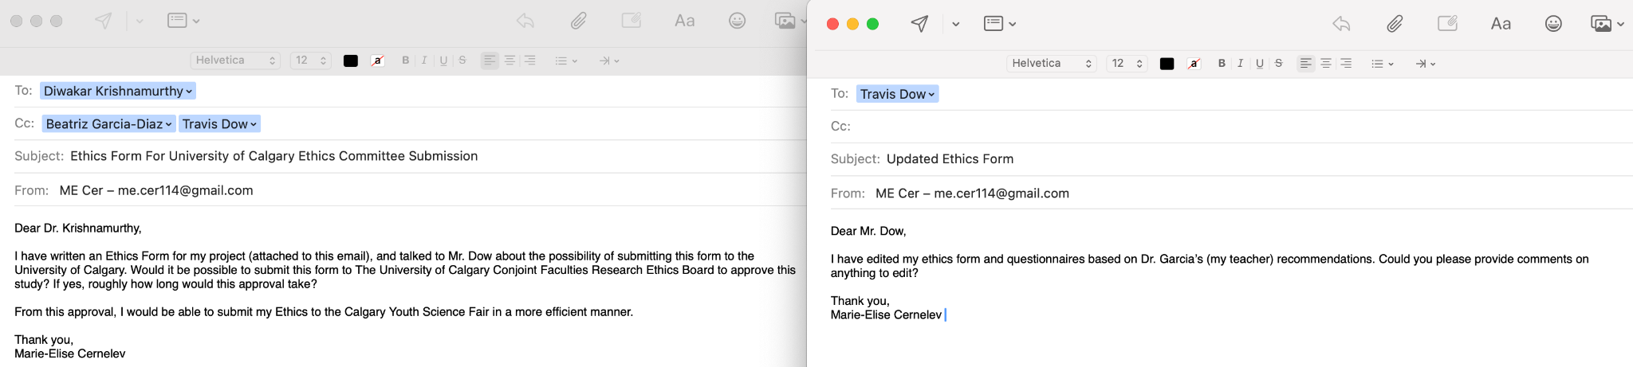

Friday, October 11, 2024:
MENTOR MEETING NOTES(2 min meeting):
ETHICS:
- Roughly how long would it take for the ethics form to get approved?
ANSWER: don’t know, usually quick —> for updates + first viewings not fast, pretty

METHODOLOGIES:
- For methodologies would I add rough outline of the code.
  - Ex. Create a function for ___ .
ANSWER: up to how you want to structure, two separate sections —> system design and actually methodologies + how experiments conducted

Monday, October 14, 2024:
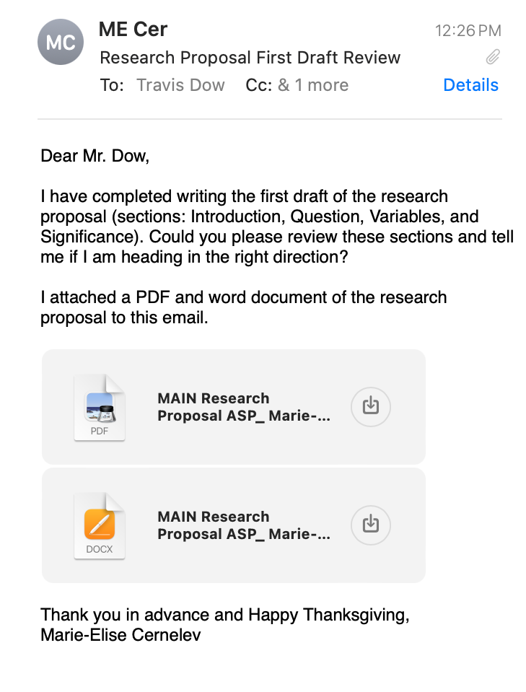
- Reviewed research proposal and asked Mr. Dow to send recommendations on it:
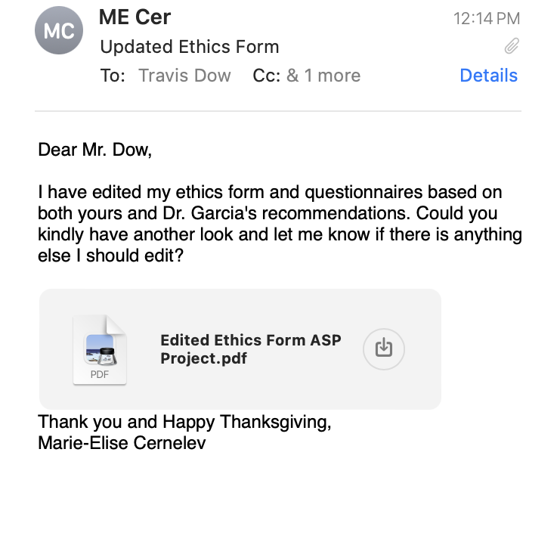
- Sent updated Ethics form to Dr. Dow:
- Rough outline of proposal:
  - Paragraph 1: introducing technology use and accessibility
  - Paragraph 2: statistics for neurological disorders
  - Paragraph 3: Example of integrating alternatives to applications.
  - Paragraph 4: Factors that determine accessibility of applications
  - Paragraph 5: introducing speech, head, gesture alternatives
  - Paragraph 6: significance of alternatives
  - Paragraph 7: HCI explanation
  - Paragraph 8: Significance for making applications accessible for all
- RESEARCH PROPOSAL LINK: https://docs.google.com/document/d/1aDlvRl84ZcuLiKKkhYv_js2GVgFi3pHc0jRukgFWBD4/edit#heading=h.rd6ctxyk1yr4

Tuesday, October 15, 2024:
ASP NOTES (25 min):
- Fill out SH Science Fair Form
- Login to CYSF Portal
- Email Mentors
  - Send research proposal draft
  - Ask Questions
- Oral Presentation DURING FIRST WEEK OF NOVEMBER OR LAST WEEK OF OCTOBER
  - Presenting on November 4, 2024
  - Rubrics are on google classroom
  - 10 minutes presentation and 5 minutes of questions
    - Will receive a mark for the presentation and participation (intelligent questions)
  - 10-15 slides in the presentation (do not put too much information or say irrelevant things around that topic)
- Written Proposal DUE October 31, 2024
  - Hand it in if you have finished early
- For the October logbook, Dr. Garcia will only look at October dates and November Schedule/ calendar.
  - November to complete __ and ____ (clear plan for next month)
- If you want to be more detailed and specific for calendars, look at the rubrics (divide tasks according to things you have to accomplish)
  - Put CYSF portal tasks in your calendar (once a week work on the portal)
- For each of the writing styles, look at the owl Purdue and see how the references look like.
- For CYSF Portal: 1) figure out if you have a study, experiment, or innovation (DEFINE THIS), 2) Ethics: approved? by University ethics committee → mention mentor with phone numbers, emails, and the code (start giving yourself deadlines)
- Edited and finished writing objectives: https://docs.google.com/document/d/1V_fguAn0UXb1CeVihHaUIY7Zie-B7DBJ578gDaJSuPY/edit?pli=1#heading=h.t35jb2q1ptm8
The short term goals are to:
- Implementing alternative methods of interaction/ control: speech recognition, head movement tracking, and gesture tracking before December,
- Complete programming Connect 4 with the methods of control,
- Complete programming Checkers with the methods of control,
- Test the website/ program to ensure the data collection is correct and the code is running smoothly.

The long term goals include understanding what alternative to touch individuals prefer, collecting enough participants and data by mid-Feburary for both games, and what alternatives should be integrated into computer softwares applications in roughly, five to ten years. A stretch goal includes programming a Street Racing Game to additionally understand the correlation between the level of difficulty of the game, age, whether the individual has certain disabilities, how successful the individuals are playing the game, as well as additional information, such as if they are a social person, if they have played this game, and their level of satisfaction with each alternative. Having neurotypical individuals and those with neurological disorders completing difficult tasks, such as driving, in an easier manner than currently, is the ideal outcome of this experiment; however, the more realistic outcome is a small step to a greater understanding of how to create more accessible platforms/ applications for all.

- Sent Mr. Dow a notification/ meeting slot for this Friday’s meeting.
- Edited and added to variables:
The manipulated variable is the different alternatives to touch used: speech recognition, hand movement, head/ eye tracking movement. The responding variable in this experiment is the individual's alternative to touch preference. The controlled variables are the type of game the individual is playing (Connect 4 or Checkers), difficulty and complexity of the game, and the number of times a person plays a game with a certain method of control. Confound variables in this experiment can include whether an individual likes playing Checkers or Connect 4, if the user plays the games without intentions (i.e., clicking random spots just to complete the game; without a goal of winning), whether an individual has disabilities and/ or difficulties during stressful situations, the user’s cognitive abilities and experience playing Connect 4 and Checkers, their age group, biological sex, and if the individual enjoys playing video games.

- Wrote experiment methodology: https://docs.google.com/document/d/1V_fguAn0UXb1CeVihHaUIY7Zie-B7DBJ578gDaJSuPY/edit?pli=1#heading=h.t35jb2q1ptm8
Software Methodology:
…

Experiment Methodology:
After the software is completed, the experiment will then be performed. This will be accomplished from sending the website link to friends, family, and individuals that would like to participate in this experiment. This website link can be sent by others that completed the experiment. A number will be assigned to each person that accesses the game, and the user will be required to write a password to save their progress. Individuals will be required to play each method of interaction at least three times per game (play Connect 4 nine times, and Checkers nine times). The individual can play the games over a span of multiple days; not required to finish all methods in one day. When the user enters the website, there will be a survey that they are required to complete. This survey will allow the researchers to understand the type of individual playing the games. After completing all the methods in Connect 4 and Checkers a final survey will be given. This survey will help the researchers understand the user’s preferences and opinions of the modes of interaction. Individual’s preference of the alternative interactions will be determined by the largest number of individuals that voted for the method in the survey. The average number of users that prefer each method will be ranked.
Three types of games will be tested: Connect 4, Checkers, and Street Racing. All levels consist of three different control methods; speech, eye and head movement, and sign language. By using machine learning and artificial intelligence to understand and track the movement of one's eyes, head, and body as well as speech recognition training, the person would be able to command the object to make desired movements. A survey will be collected on what method is preferred, by ranking most popular to least. The data will be categorized by age and preference. The collection of data from different age groups will determine the preferred method of control over touch and in which scenario they are preferred.

Wednesday, October 16, 2024:
- Questions for Dr. Garcia and Mr. Dow:
  - For the CYSF platform, would my project be classified under life sciences or computer science/ mathematics.
    - My project combines both.
  - What project topics could my project be under?
    - I was thinking about computer science and life sciences… any more?

Thursday, October 17, 2024:
ASP CLASS NOTES (5 min):
- March 11th, 2024 (Tuesday Science Fair School → PAC, poster format, and online platform has to be completed)
- First paragraph: brief description of method, second: if you are using humans/ animal cells or just working with data, third: either you are working directly with the humans (ppl have to approve) + this is a study done at the University of Calgary under this code…
  - This is what my experiment is planning to do, this is the surveys I will
- Wrote the basic project info in CYSF online platform.
- Added my ethics form to the CYSF online platform BUT did not submit to the Ethics CYSF yet.
  - Goal: submit this ethics no later than this Sunday.
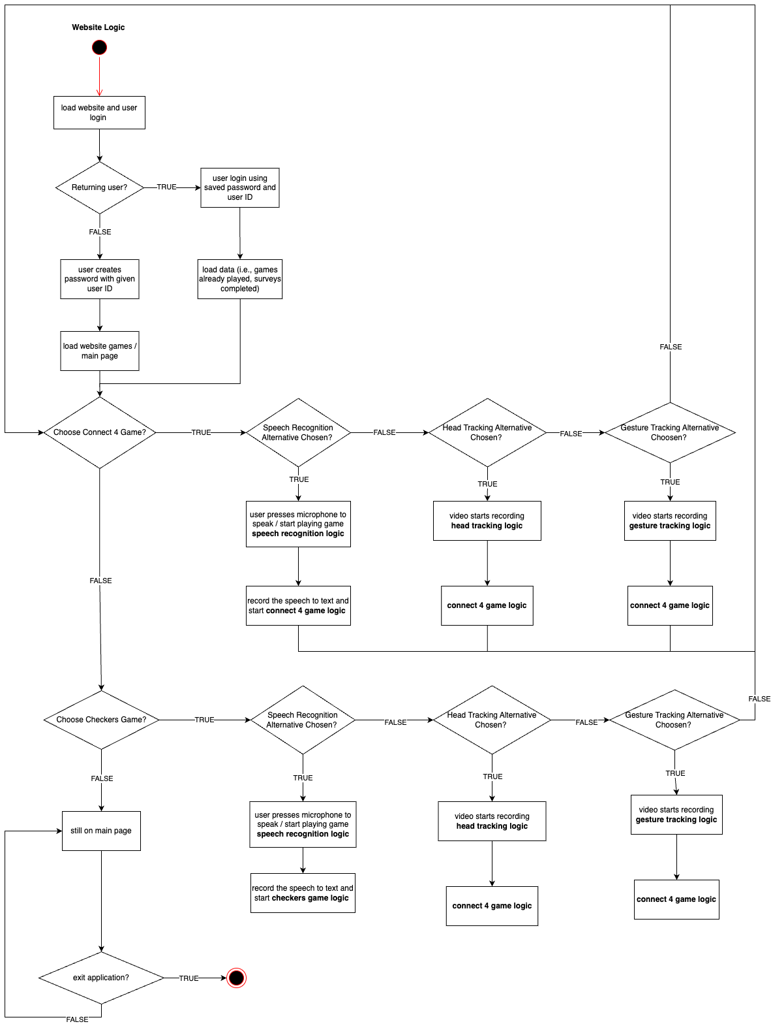
- Worked on Software Methodologies Diagram (main program and connect 4 game logic):

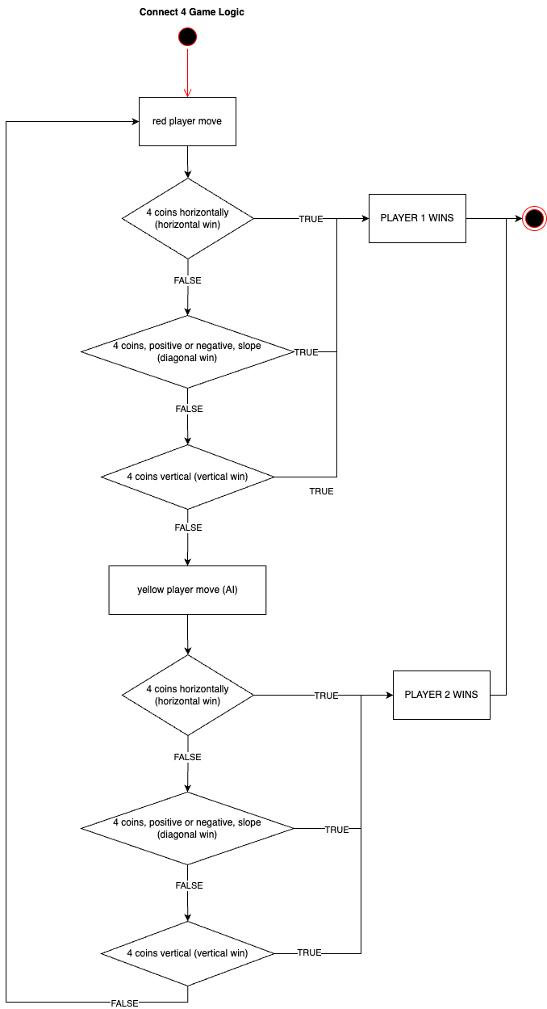

- Questions for Mr. Dow:
ASP FRIDAY:
- What is your department?
- In the CYSF Platform, which categories would I fall under?
- Any additions to the ethics form?
- Any comments/ recommendations on the research proposal?
- Is my project considered low risk or high risk?

Friday, October 18, 2024:
- Dr. Dow emailed me the edits on my ethics form and proposal.
MENTOR MEETING NOTES(40 min meeting):
ASP FRIDAY:
- What is your department?
    - Engineering Electrical and Software department (specialization in software engineering)
- In the CYSF Platform, which categories would I fall under?
    - Filled in on platform
- How was the ethics form?
- Any comments on the research proposal?
- My project is considered low risk or high risk? LOW
ANSWERS:
  - Ethics: in the purpose of the study —> rephrase the first sentence: the purpose of this experiment is to determine if different age groups prefer _____ over touch when playing connect 4 and checkers +
    - Lead with what the groups are.
  - Proposal: wording suggestions + grammatical errors + don’t worry about defining computer softwares + mobility to motor control + RW = rework + can say computer application + write as concise and short (get to the point) + there is a really good term: design for people with disabilities + designing for people without disabilities (improvement across board) + leap in logic for communication interaction (ADD MORE RATIONAL) + for the boxing game check citation —> why reference someone else’s opinion when you could make it your own (I believe…) + last highlight (push the “dialogue” forward —> accessibility) —> given that this is the problem __ this is the way I address it + the question is too broad (what conditions and circumstances are you talking about?) and what type of individuals / characteristics (age groups, etc.) + record correlation + suggests Gantt chart (bar chart with overlapping bars —> organized + understanding what they are doing) + Variables: add confound variables (age, etc.) + for hypothesis: not null or alternative (null is __ and alternative is does not equal __) + methodology (experiment specify how many times to play games, talk if the user would have to
    - GENERAL: CAN BE CONDENSED (SUCCINCT) + combine paragraphs

Sunday, October 20, 2024:
- Edited the sections that Mr. Dow recommended (based on his email):
https://docs.google.com/document/d/1IP9hpf3fO7R4BICLPqjpF451uVgrqR9DsfuQfLFVtgk/edit
- Edited my whole research proposal based on Mr. Dow recommendations:
https://docs.google.com/document/d/1V_fguAn0UXb1CeVihHaUIY7Zie-B7DBJ578gDaJSuPY/edit

Monday, October 21, 2024:
ASP CLASS (1 hour 30 min):
- Content: you will have 10 minutes to present + 5 minutes for questions
  - Display a deep understanding of your project (background research MUST HAVE THE BEST UNDERSTANDING)
  - Be able to convey what your research question is in that context (.. therefore I am studying …)
    - Research question and goals of the research proposal have to be put in certain context
    - THERE IS A NEED FOR THE INVESTIGATION
  - Must have Background Research(3 slides), question(1 slide), goals(1 slides), hypothesis, variables, methodologies,(2-3 slides those three topics) significance (1 slide) (somewhat presented in background research + always giving a reason why → if there is a need for that + how your contribution IMPACTS the field → aim of study contribute to __ field)
    - EMPHASIZE THE SIGNIFICANCE
  - Will look at how to answer the questions from the audience
  - Oral presentation and the research proposal paper are different (same info.).
    - MAIN MESSAGES (10 min)
  - Graphics are crucial (RULE: graphics over text!!!)
    - The graphics has to have QUALITY (must not be blurry)
      - Don’t make it “cutsy”
- Presentation: look at people in the eyes (interactive + engaged) + clear voice + loud + good flow of the presentation (not rigid/ nervous)
- Marks: background context, research question, all components present?, answers to questions, significance, how prepared you are, logical flow, graphics and text, posture/ voice/ pacing
  - Edit yourself (focus on main messages)
- Will be okay if you go a minute over 10 min (it’s ok if you are shorter than 10 min IF everything is clear)
- BioRender: gives templates
  - Add a citation if you take an image/ graph/ etc. (taken from author, year)
- Methodology: form some sort of graphics showing step by step (how to get to answer)
  - Flow diagram
- Goal: SEND ETHICS FORM TODAY TO DR. KRISHNAMURTHY
- I finished the ethics form and emailed Dr. Kristhnamurthy about submitting it to the Ethics Committee at University of Calgary: https://docs.google.com/document/d/1IP9hpf3fO7R4BICLPqjpF451uVgrqR9DsfuQfLFVtgk/edit
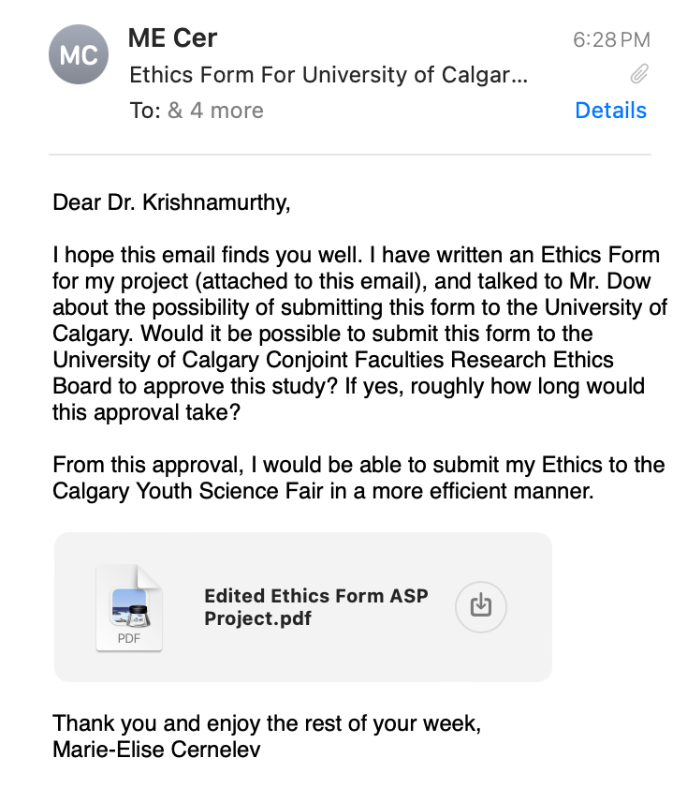

Tuesday, October 22, 2024:
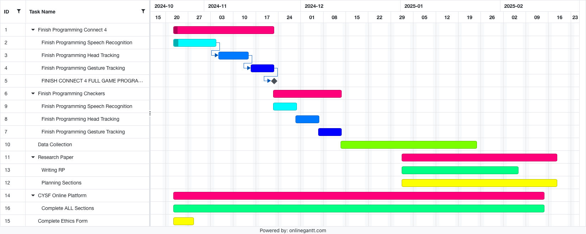
- Finished Long Range plan on Gantt Chart (recommended by Mr. Dow)
- The Gantt Graph → the columns have titles on the left and time spans (seen on the top)
- Added the Graph to the Objectives in the Research Proposal: https://docs.google.com/document/d/1V_fguAn0UXb1CeVihHaUIY7Zie-B7DBJ578gDaJSuPY/edit

Wednesday, October 23, 2024:
ASP NOTES (30 min):
- ETHICS CYSF: title (working), description of project (general terms and brief) + how humans and animals are involved (very precise) + add forms, your participation (in regards to animals and humans), emails and phone numbers of Mentors
  - If your lab has an ethics document that allows those experiments to take place (add the lab ethics code)
  - GET THIS DONE BY END OF OCTOBER
- Research Proposal Methods: make a link between the procedures and how to answer your research question
  - General idea of what is going to happen
    - How do these techniques answer the question
  - METHODS IN FUTURE TENSE (NO PERSONAL PRONOUNS)
    - Plan will be what will do (don’t add could _____)
      - How does that answer your question
- Project Proposal References: paperpile library + in text citations
INDIVIDUAL MEETING (6 min):
- Add plan in calendar in november
  - Oral Presentation + checking of ethics
- Hypothesis that I didn’t use in the project proposal:
  - I suspect that neurodivergent individuals that have severe mobility disabilities would prefer the speech recognition alternative rather than the alternatives that require movement due to the individuals difficulty of smoothly controlling their movements. Vice versa, individuals with speech disabilities will prefer either the head or gesture tracking alternatives as those do not require any use of voice. Those that are neurotypical and have full mobility and verbal access will most likely prefer any alternative, but it depends on the circumstance that the games are played in.
  - Individuals that fall into the older age groups will prefer using speech recognition because of its simple use, when compared to head and gesture tracking. While head and gesture tracking require an extensive amount of movement to convey a move in the game, speech could be considered the easier alternative for the older generation as it would not require the individuals to move extensively (ex. they would not need to text or move the mouse).
- Hypothesis that I used:
  - Null Hypothesis: Older individuals that have difficulty with coordination under stress, will have different alternatives to touch preference as younger individuals with coordination difficulty.
  - Alternate Hypothesis: Older individuals who experience difficulty with coordination will prefer the speech recognition mode of interaction when playing Connect 4 and Checkers. Head and gesture tracking require an extensive amount of movement to convey a move in the game; hence, speech could be considered the easier alternative for the older generation as it would not require the individuals to have perfect coordination or move extensively. Also, younger individuals with coordination difficulty will prefer speech recognition.
- Edited my Research Proposal (ALMOST DONE → FINISH THE MODE OF INTERACTIONS METHODOLOGIES)
  - https://docs.google.com/document/d/1V_fguAn0UXb1CeVihHaUIY7Zie-B7DBJ578gDaJSuPY/edit
- Almost completed methods (the head movement will work for connect 4 but is too complicated for checkers): https://docs.google.com/document/d/1V_fguAn0UXb1CeVihHaUIY7Zie-B7DBJ578gDaJSuPY/edit
Software Methodology:
Website: the website is loaded when the link is activated (i.e., clicked). User will have to login with the saved password and username, and if the user is accessing the website for the first time, a user ID will be generated/ given, and the user will be asked to save a password. After the user has signed into the website, the main page (containing the two game options and three alternative modes of control options) will load. A survey will appear, and the user will be asked to complete the survey before playing the games. The user selects a certain game and mode of interaction. If the user closes the application, then the user has exited the website.
Connect 4: the first player is yellow chip, and the computer player is red chip. After each chip drop, a win will be checked. The wins include horizontal, vertical, and positive and negative diagonal wins (four coins of the same colour). See example below (each colour represents possible wins):

Column Number
1 2 3 4 5 6 7
The chip placement will be checked if it is valid after each “drop”. If it is not valid, the user will have to replace the chip. Invalid moves include adding a chip in an already full column.
Checkers: An eight by eight board will load. The human player/ user will be white coins, and the computer player will be the red coins. A win will be determined by the player who has collected all of the opponents coins. Invalid moves will be checked after each move, and if they are considered invalid, the user will be asked to play their move again. Invalid moves include moving the coin backwards, not moving the coin diagonally, moving the coin more than one space (unless the coin is “eating” the opponent's coin). If the coin is upgraded to a queen, then the only invalid move is not moving the coin diagonally. See example of invalid movements below (green represents correct/ valid movements, yellow represents the user coin’s position, and black represents the opponents coins, red represents the queen coin):

Speech Recognition: will use Google API (application programming interfaces developed by Google). When the microphone button is pressed, the user's words will be displayed and “heard”. If the user says something similar to or 1, 2, 3, 4, 5, 6, 7, the program will register the number and drop the coin (unless an invalid move) when the user says “drop”. If the speech recognition is not compatible with the browser it is using, a message will appear, asking them to use Chrome or Edge. When the game is finished (someone has won), the microphone will stop recording the user’s speech/ commands.
Head Tracking (to be determined if possible/ achievable): will use Google API. Will be similar to gesture tracking; however, it will detect/ track the head. The screen will be divided into three sections. If the user’s head moves to the right, the coin will also move to the right, and vice versa for left movement (in Connect 4). When the user nods, the coin will drop. It may not be possible to create head tracking for checkers, but will be attempted to be implemented. If the implementation is not successful, this mode of interaction may be discarded in checkers.
Connect 4 Diagram:
MOVE LEFT | NOD = DROP | MOVE RIGHT
Gesture Tracking: will use Google API. This will use a video camera and record the movements of someone's index finger and thumb (pinching). The screen is divided into seven equal parts (corresponding to the column numbers). When the user is in a certain part of the screen, the coin will travel with the user’s hand movement. If the user pinches their index finger and thumb, this means that the distance between the two fingers will be smaller than originally started out with. This will be calculated using the Euclidean 3D distance formula. When the user pinches, the coin will drop (connect 4). In checkers, the screen will be divided into four sections. The furthest right will allow the user to move the queen coin back right, and vice versa for the furthest left. The slight right means that the coin will move forward, and vice versa for the slight left. The index finger will be used to swipe to the coin the user wants to move. See diagram below on division of screen for each game:
Connect 4 Diagram:
Left | Pinch = drop | right

Experiment Methodology:
After the software is completed, the experiment will then be performed. This will be accomplished from sending the website link to friends, family, and individuals that would like to participate in this experiment. This website link can be sent by others that completed the experiment. A number will be assigned to each person that accesses the game, and the user will be required to write a password to save their progress. Individuals will be required to play each method of interaction at least three times per game (play Connect 4 nine times, and Checkers nine times). The individual can play the games over a span of multiple days; not required to finish all methods in one day. When the user enters the website, there will be a survey that they are required to complete. This survey will allow the researchers to understand the type of individual playing the games. After completing all the methods in Connect 4 and Checkers a final survey will be given. This survey will help the researchers understand the user’s preferences and opinions of the modes of interaction. Individual’s preference of the alternative interactions will be determined by the largest number of individuals that voted for the method in the survey. The average number of users that prefer each method will be ranked.
Two types of games will be tested: Connect 4, Checkers (Street Racing is a stretch goal, although it is very likely that it will not be programmed). All levels consist of three different control methods; speech, eye and head movement, and sign language. By using machine learning and artificial intelligence to understand and track the movement of one's eyes, head, and body as well as speech recognition training, the person would be able to command the object to make desired movements. A survey will be collected on what method is preferred, by ranking most popular to least. The data will be categorized by age and preference. The collection of data from different age groups will determine the preferred method of control over touch and in which scenario they are preferred.
- Edited the slideshow for the Project Proposal (oral presentation) → powerpoint
  - Title page, in other words… title
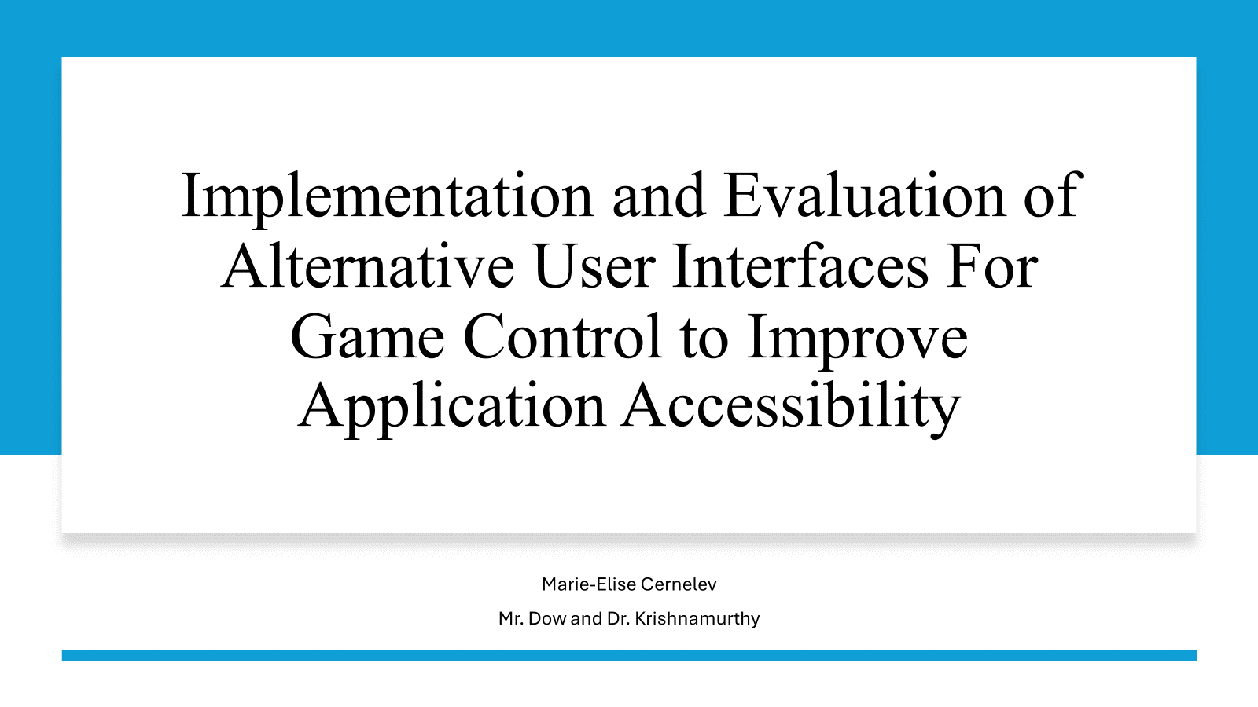
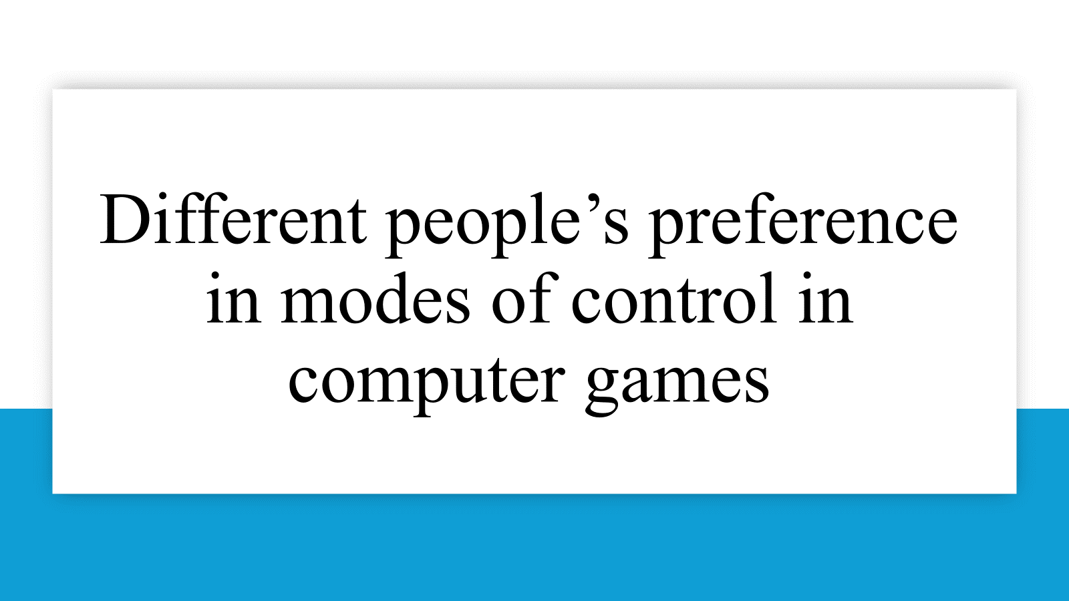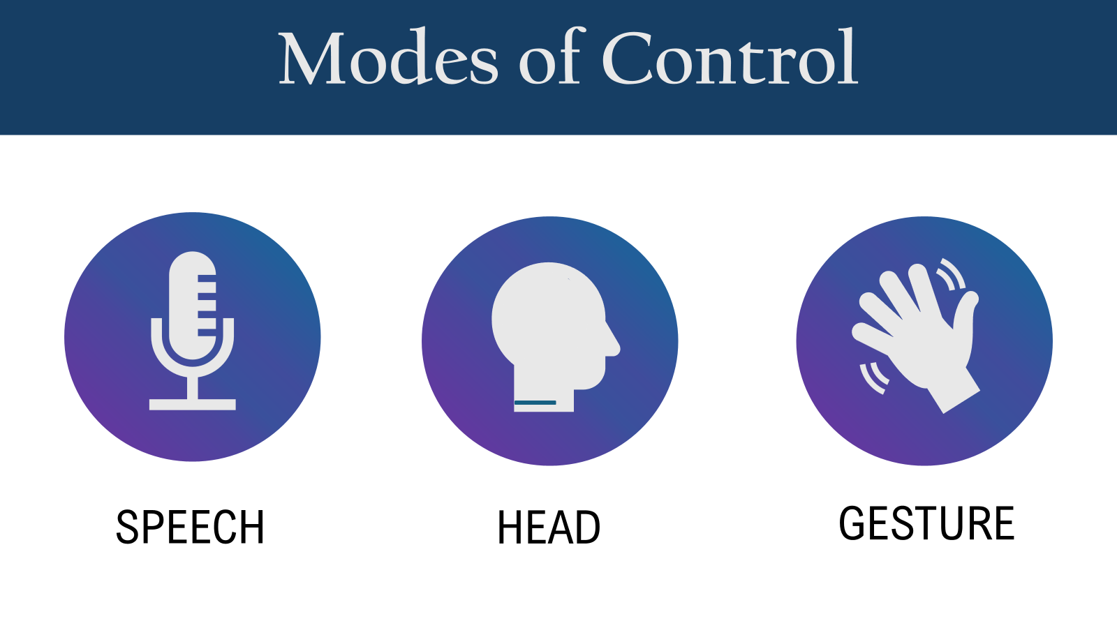

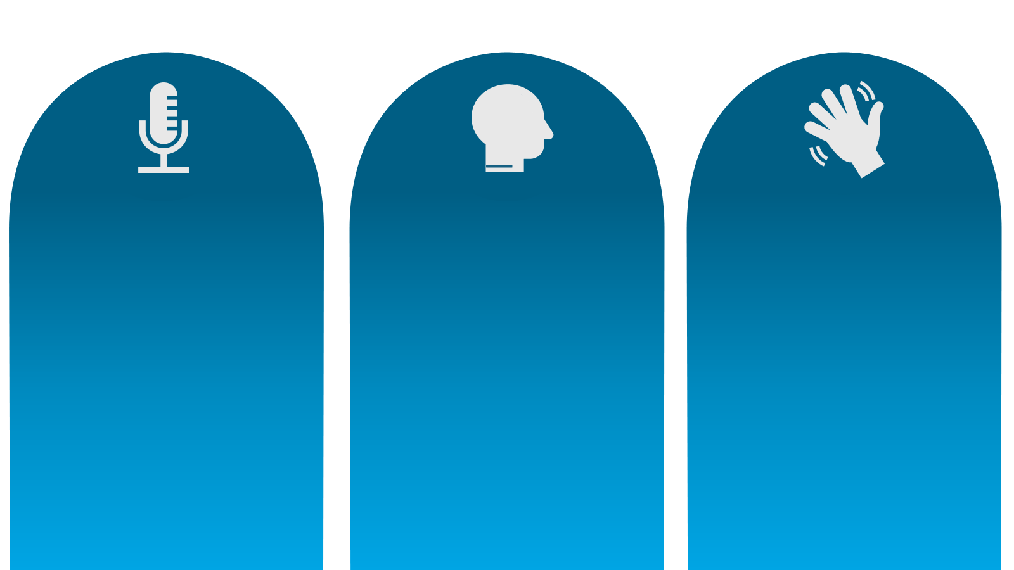
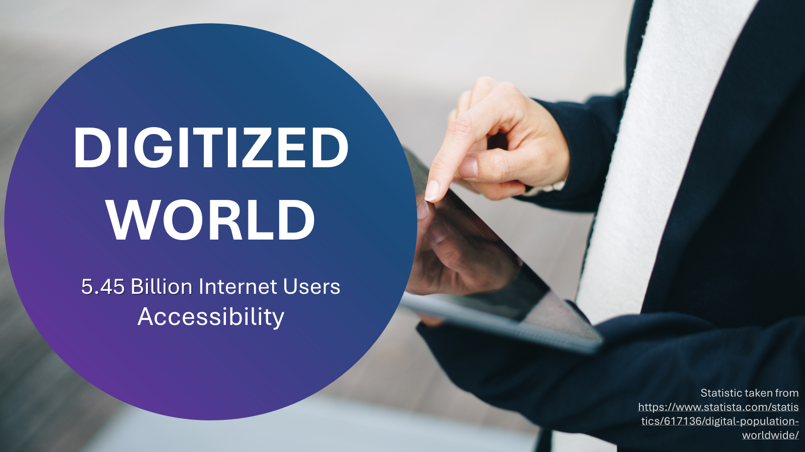
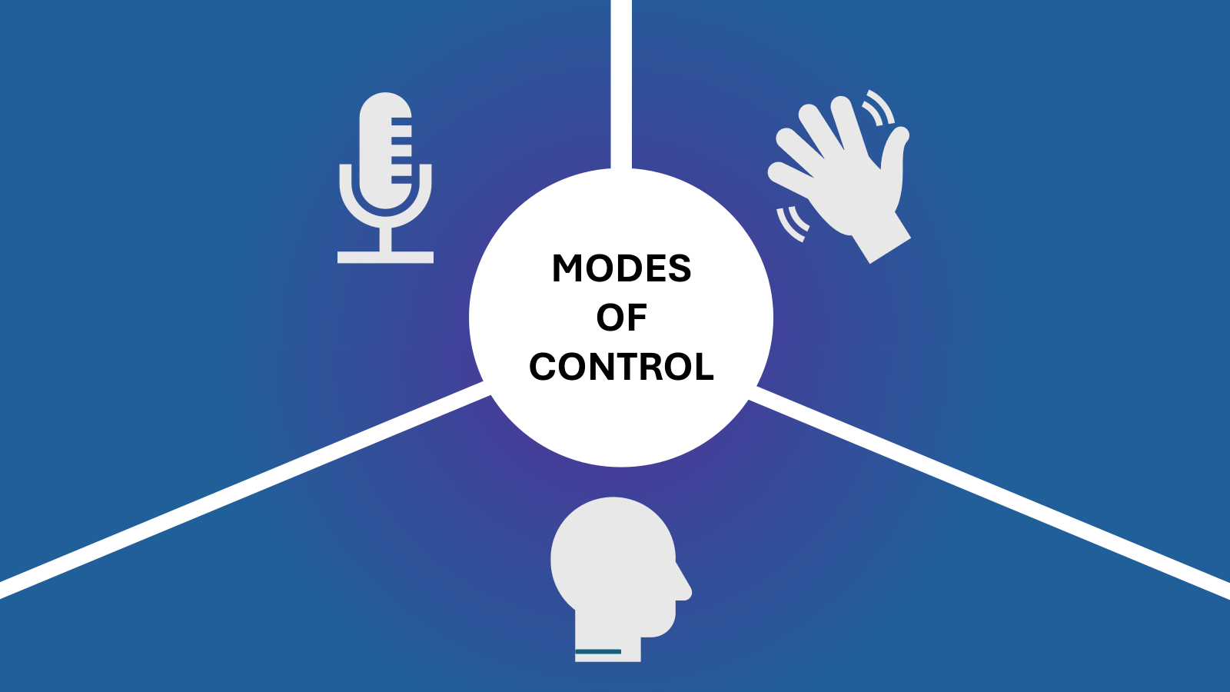

Thursday, October 24, 2024:
- Edited my research proposal (everything is finished/ completed): https://docs.google.com/document/d/1V_fguAn0UXb1CeVihHaUIY7Zie-B7DBJ578gDaJSuPY/edit

Friday, October 25, 2024:
ASP CLASS NOTES (30 min):
- November 6 ORAL PRESENTATION
- Presentations → listening to other people’s presentations + what you like
  - Give minimum number of presentations someone should be at (4)
- Take notes on other people’s presentations
- Font size has to be DOUBLE SIZE and 12 font size
- Research proposal: title page, title, Research proposal, applied science, authors, Student names, mentor names
  - For variables, write the variable names (manipulated, confounding, control, responding) are ….
- Introduction, question, goals, variables, hypothesis, methodology, significance
  - Methodology should NOT be in number form (should be in paragraph form)
- Edited second draft of research proposal and sent to Mr. Dow and Dr. Garcia: https://docs.google.com/document/d/1V_fguAn0UXb1CeVihHaUIY7Zie-B7DBJ578gDaJSuPY/edit
- Finished reading: “Video game values: Human-computer interaction and games” by Barr P, Noble J, Biddle R
  - https://paperpile.com/shared/sUovf_lUeRQCl2jeRdUTXMQ
- Sent an email to Dr. Garica for recommendations on proposal:
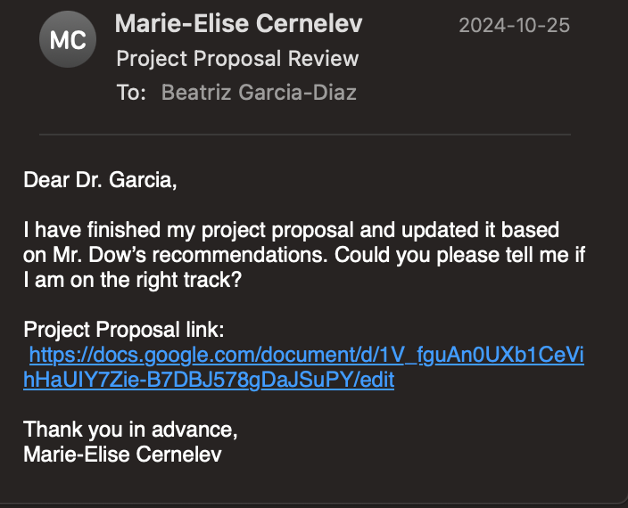
- Sent an email to Mr. Dow (he is unable to meet today):
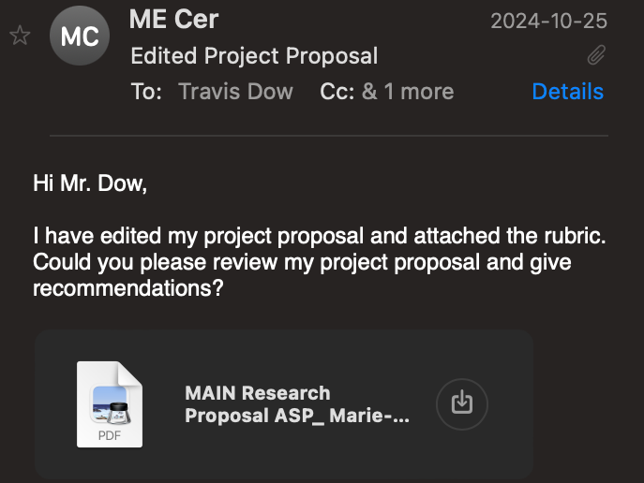
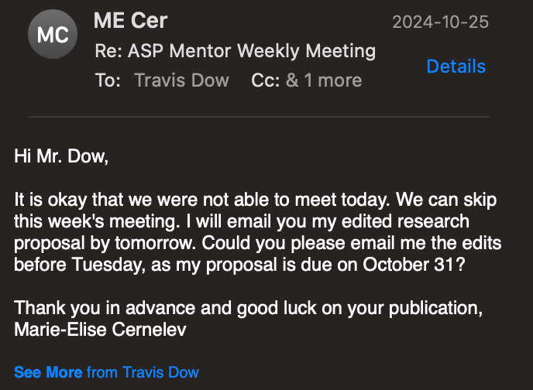

Saturday, October 27, 2024:
- Edited my slideshows for my oral presentation (not in the correct order, but these are the slides that will be showcased in my powerpoint presentation):
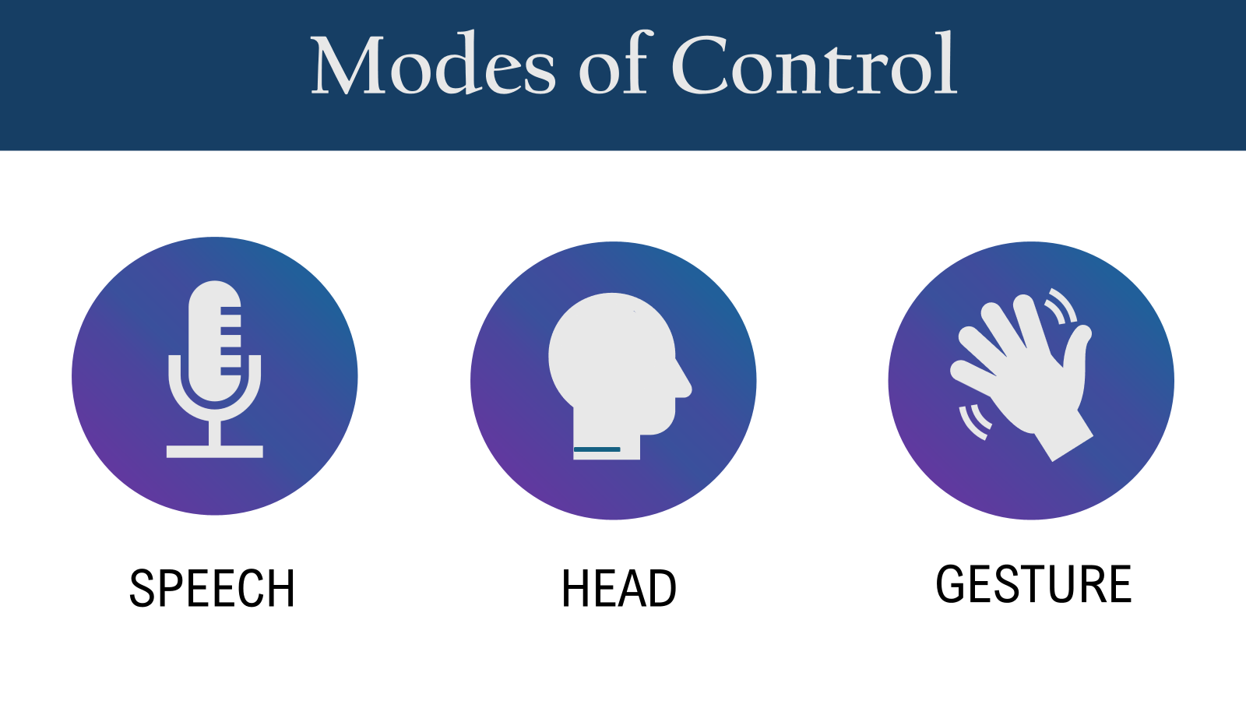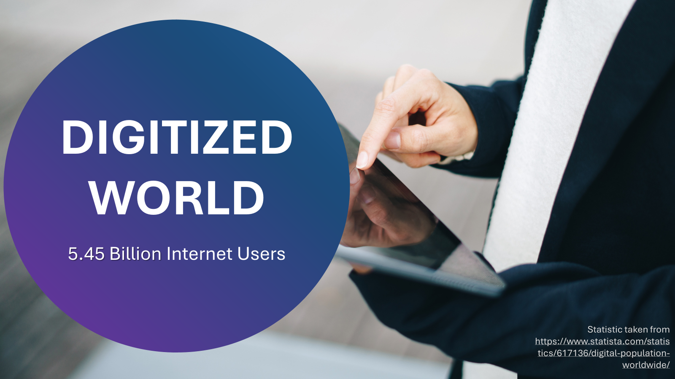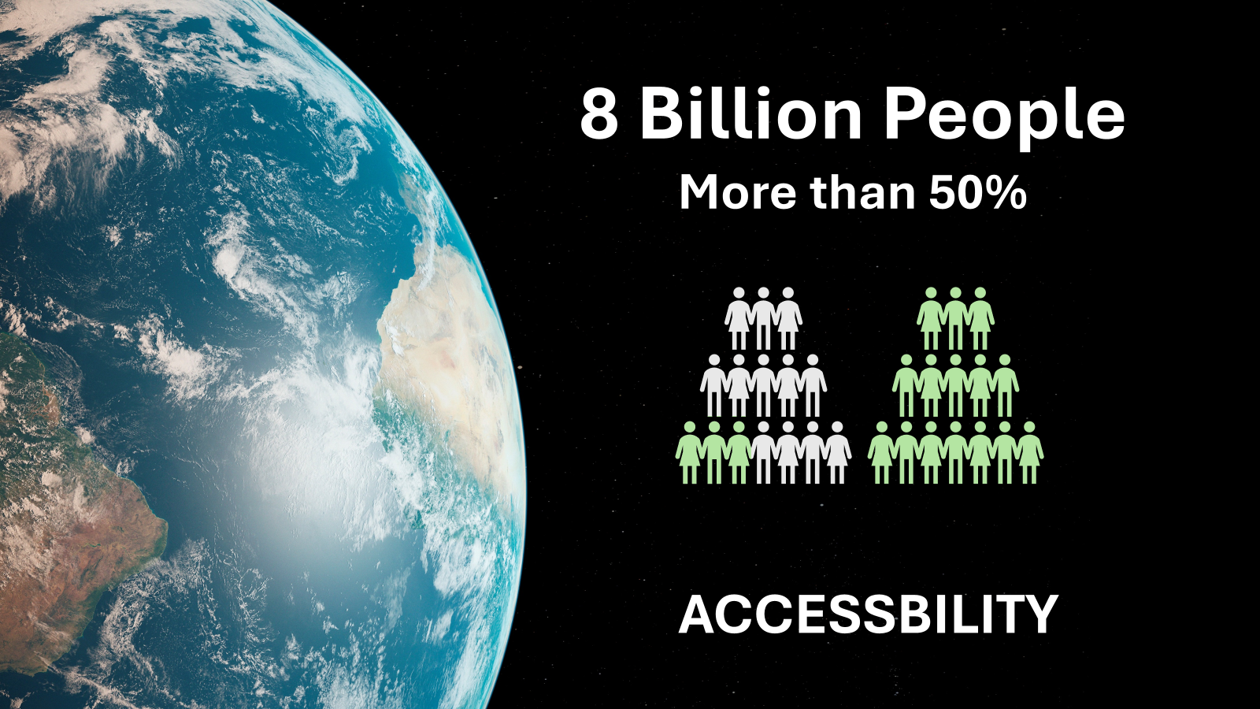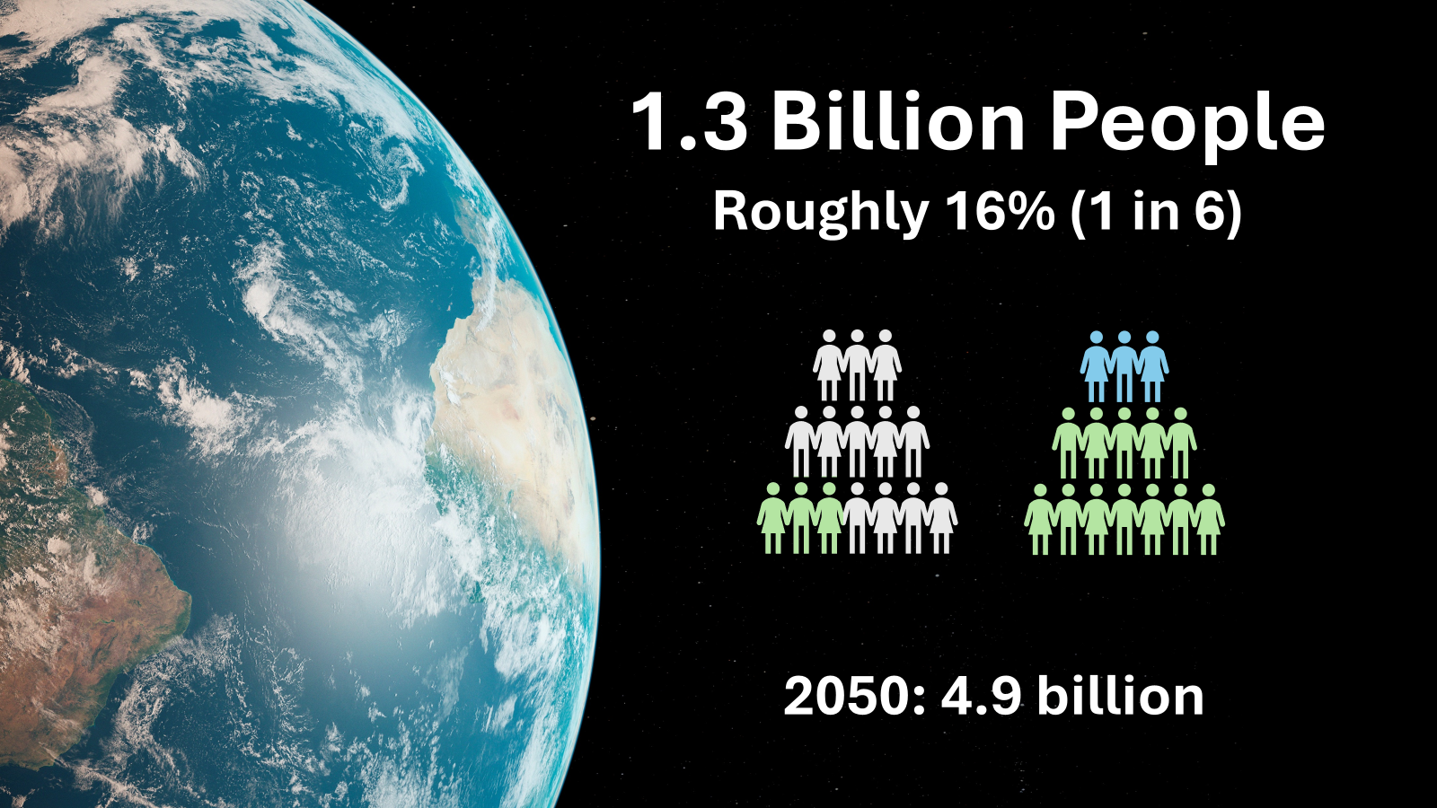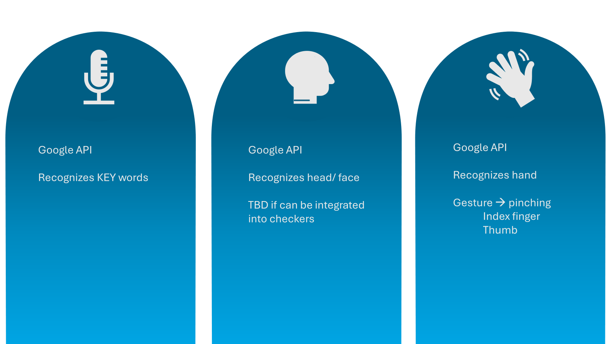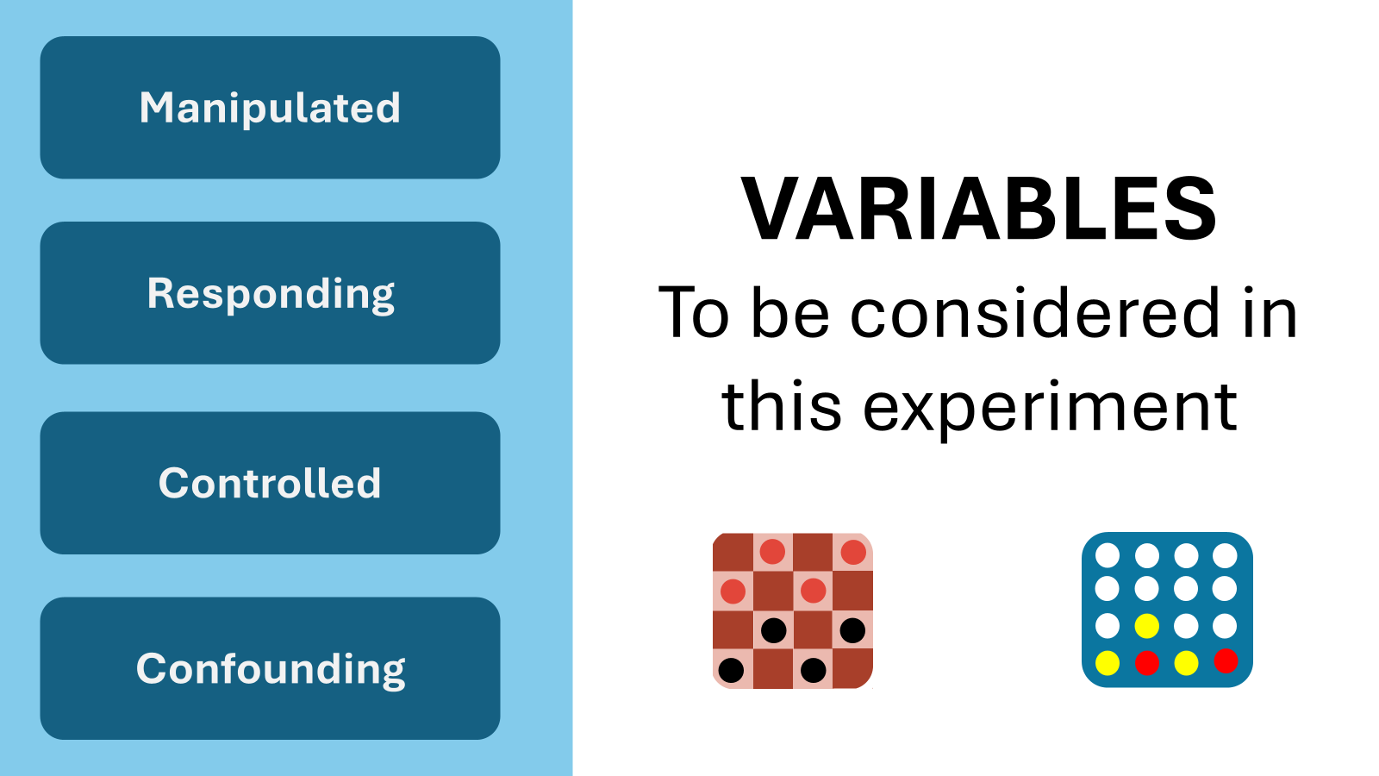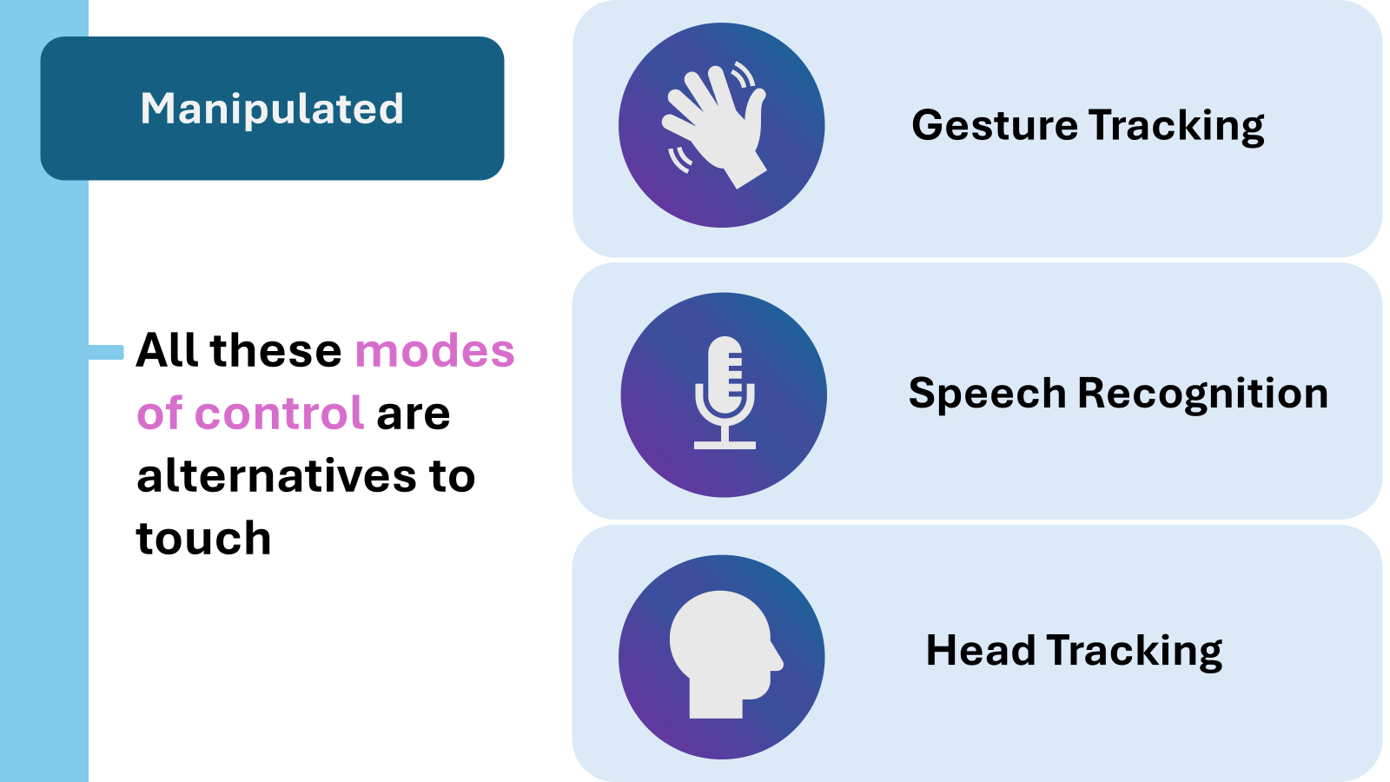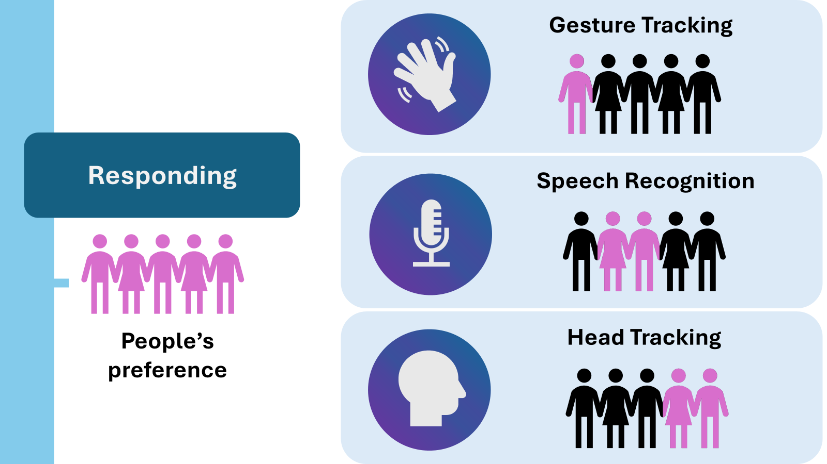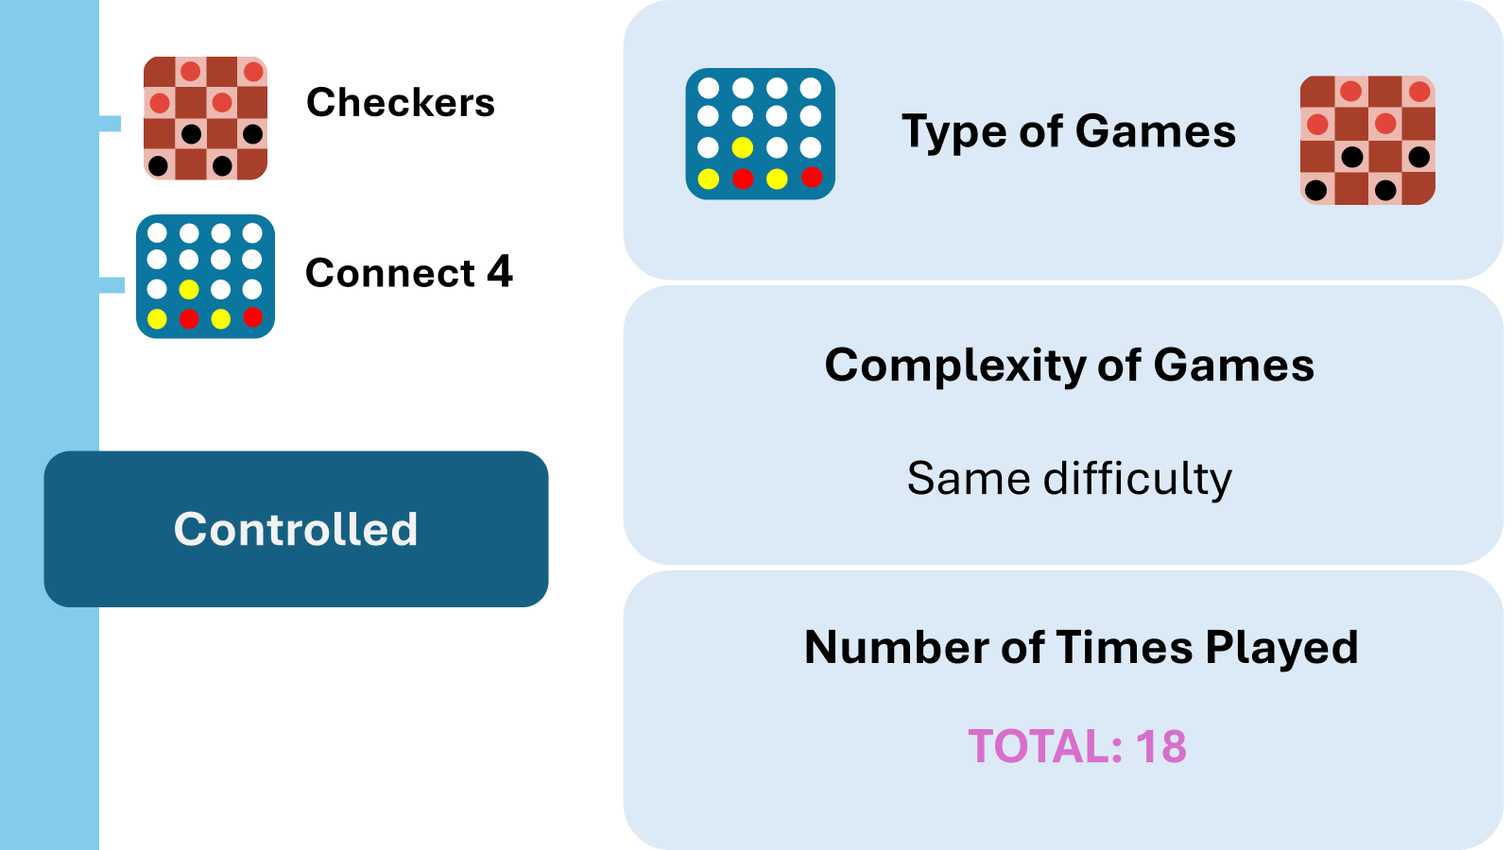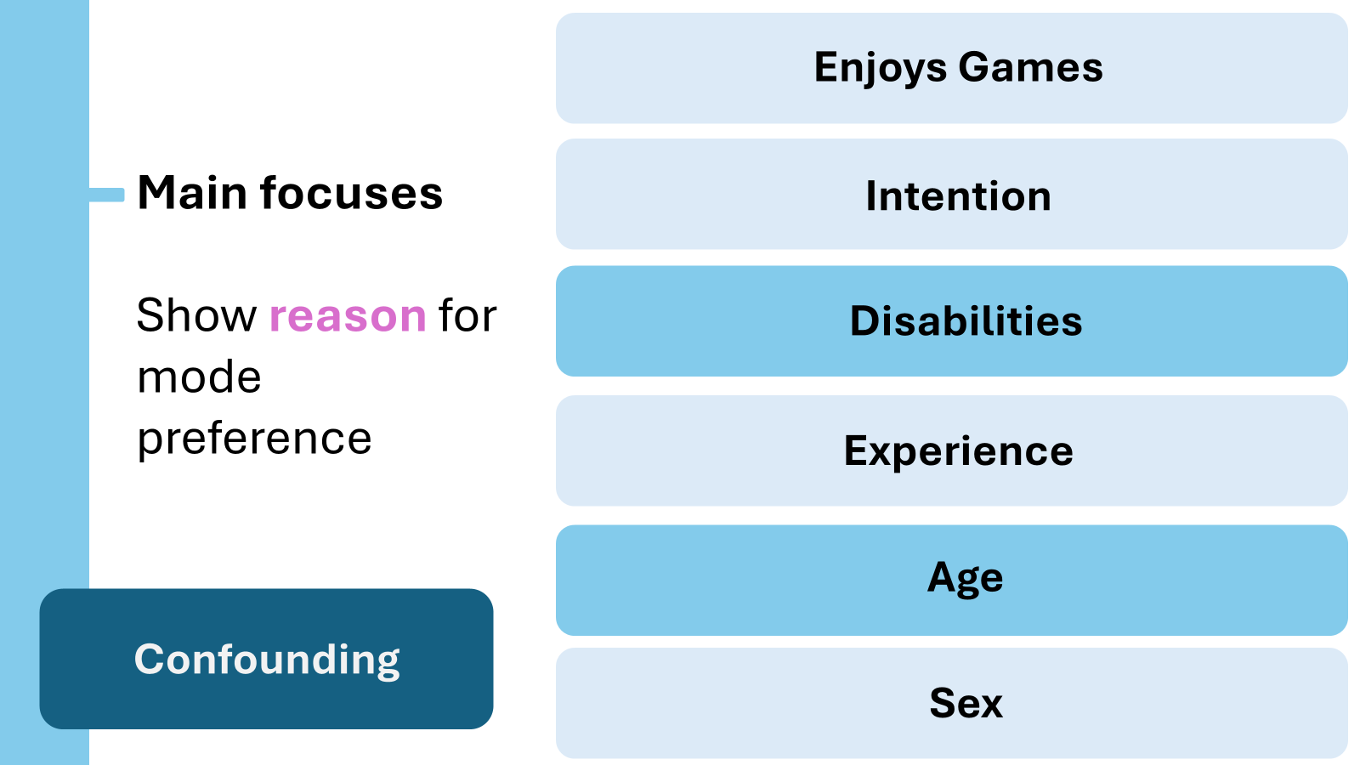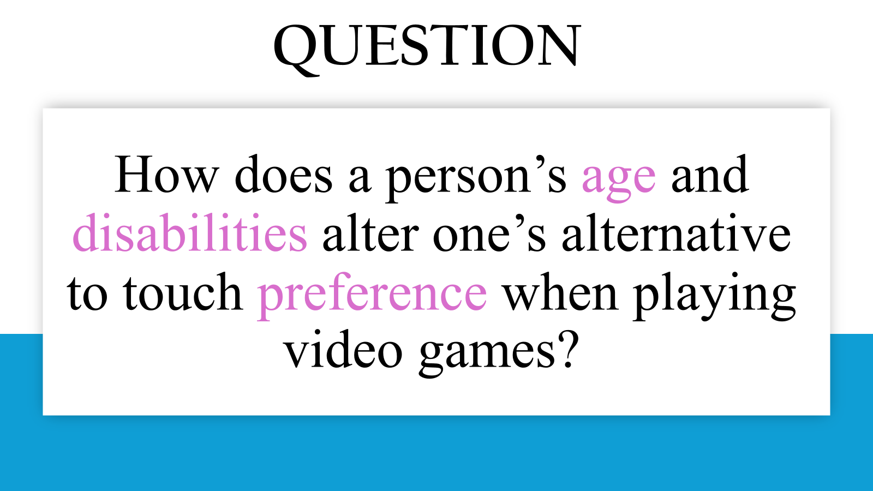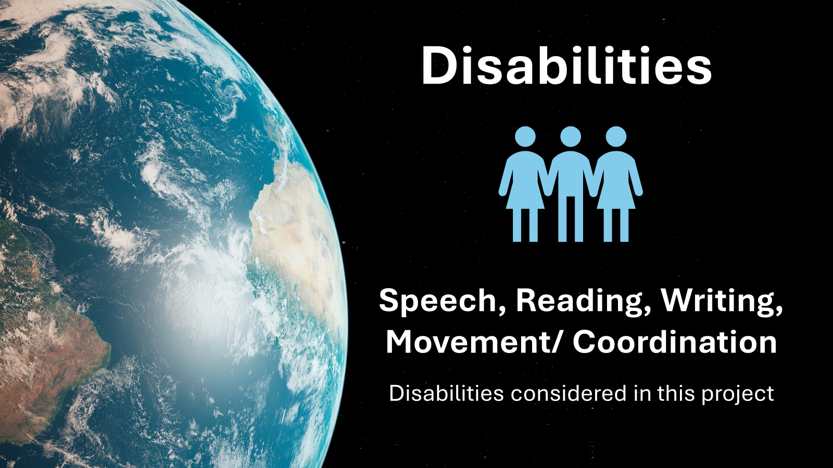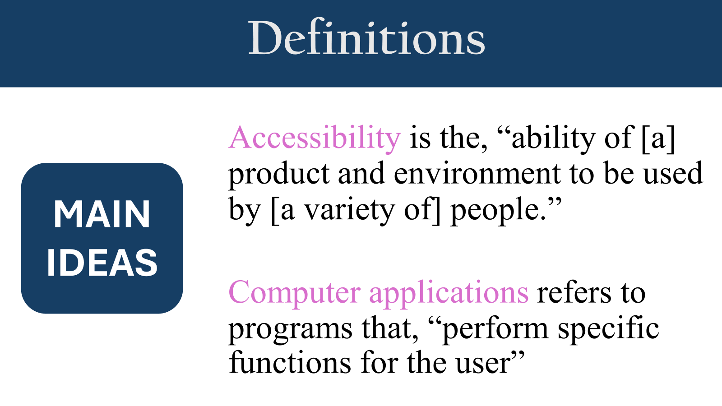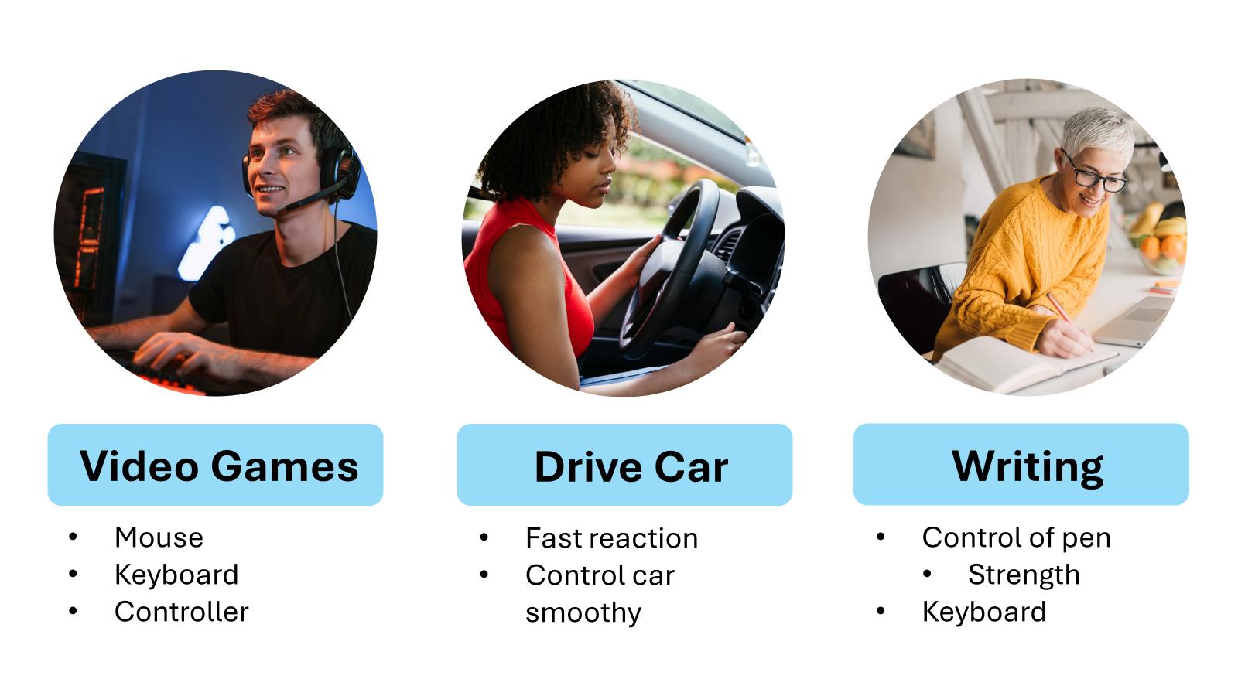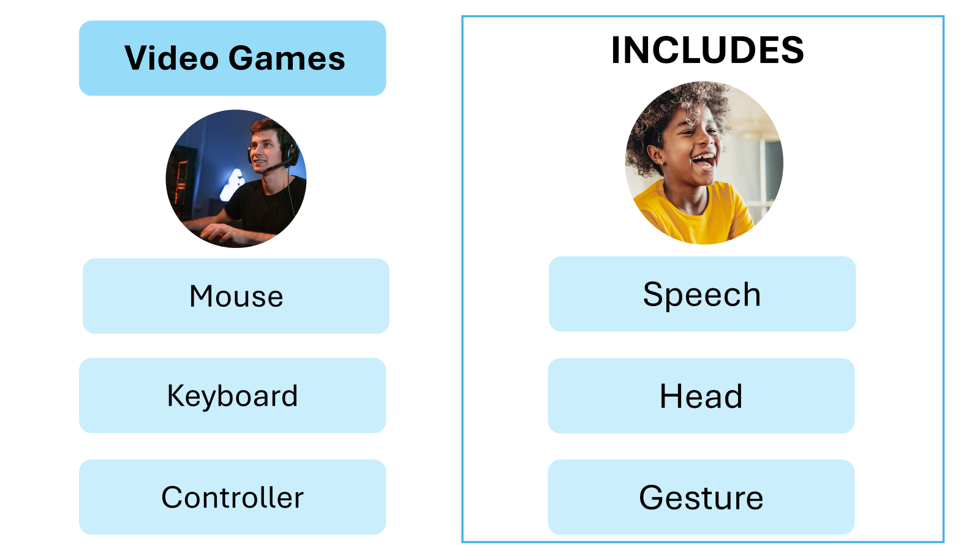

Monday, October 28, 2024:
- Sent emails to Mr. Dow, and Dr. Kristhnamurthy:
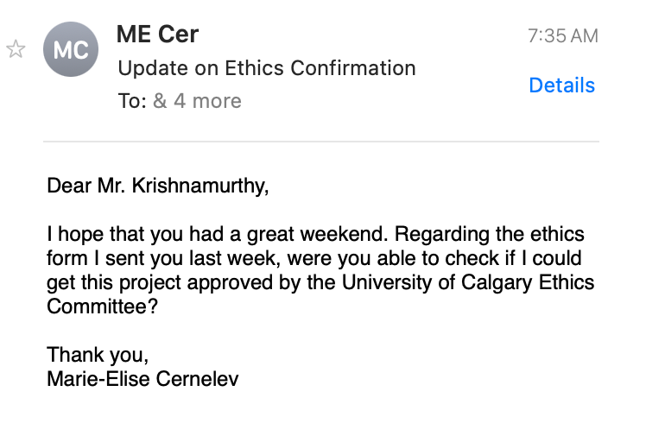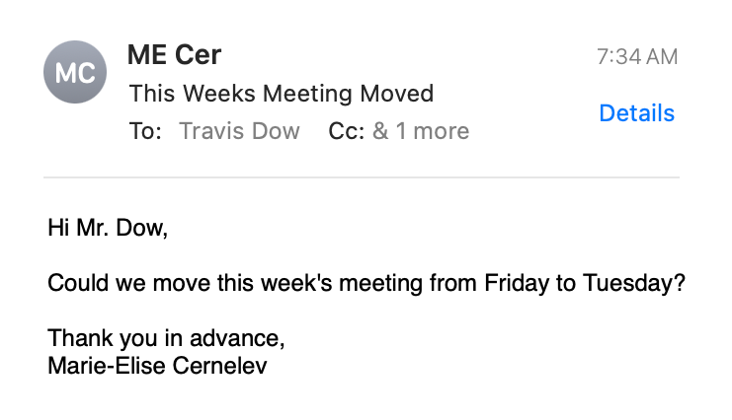

Tuesday, October 29, 2024:
ASP CLASS NOTES (30 min):
- Paperpile: papers that you read and did not put into the research proposal DO NOT cite.
  - Dr. Garcia checks that reference list, all websites, are in introduction/ paper
- You have to check include DOIs or URLs
- When you want to add several citations in one keep adding the citations and then click “add citation”
- This project is supervised by: department of mentors, mentors, phone number, email
MENTOR MEETING NOTES(30 min meeting):
ASP MEETING TUESDAY:
Research Proposal Recommendations (will send document):
- Logical flow edits
- Lines = separate ideas (maybe rearrange order of paragraphs)
- Use ChatGPT to rearrange + make suggestions for logical flow
- Add the definition of computer software as a footnote.
- Question: alternatives = dependent + make more clear
- Confounding variables: make clear that the age group
  - Make clear that the age group is an independent variable
    - Will make the analysis a little harder (isolate the variables)
- Might want to say different demographics variables (age, sex, etc.)
- Can have more than one hypothesis
  - Make the first one about old and young, etc.
- Will not need really big database + it is doable + if you do not need to do the login system do not do it + ALTERNATIVE: disclaimer = you will need __ min to complete (one sitting)
- Checkers —> described board
  - Add in connect 4 about the board
- Speech Recognition: ghost preview (good implementation)
- Make sure you notify the user that the microphone is no longer recording.
- Website: add link, when you accessed information
- MOST IMPORTANT: get variables sorted out + make it more clear (in table + text description)
- Objectives: add timeline

- Edited my research proposal based on Dr Garcia comments + Mr.Dow: https://docs.google.com/document/d/1V_fguAn0UXb1CeVihHaUIY7Zie-B7DBJ578gDaJSuPY/edit?tab=t.0
- Worked on my slideshow:
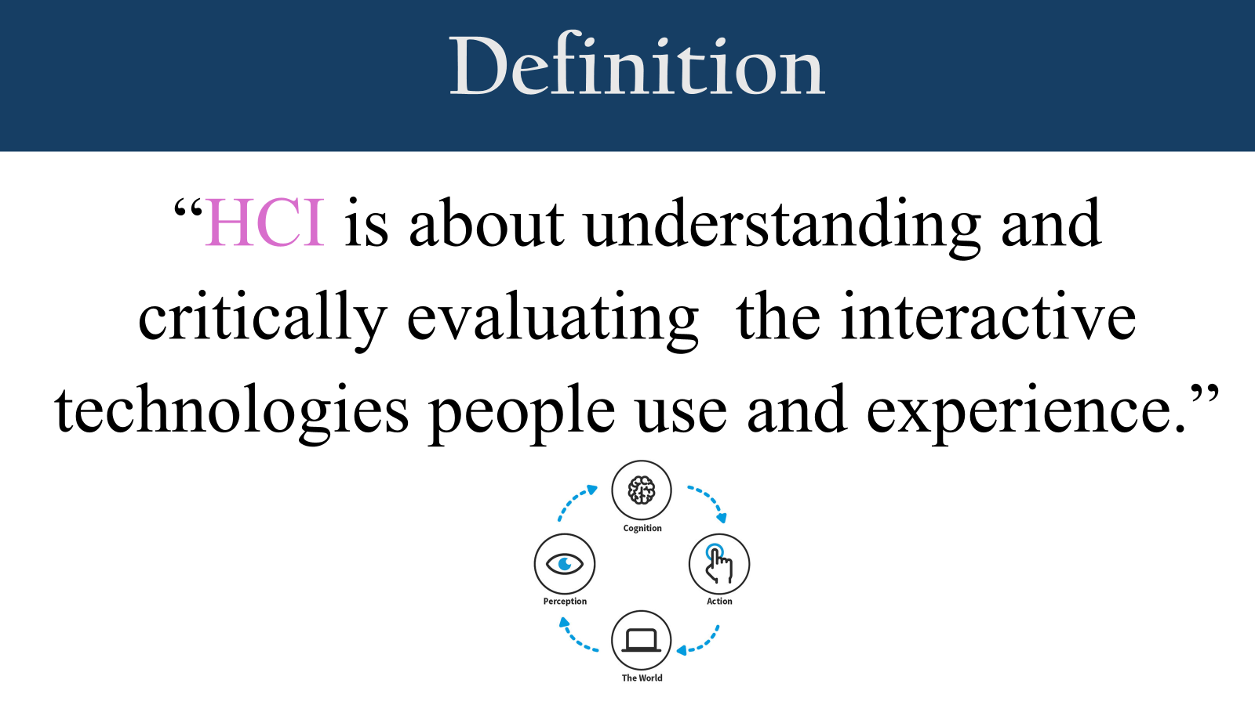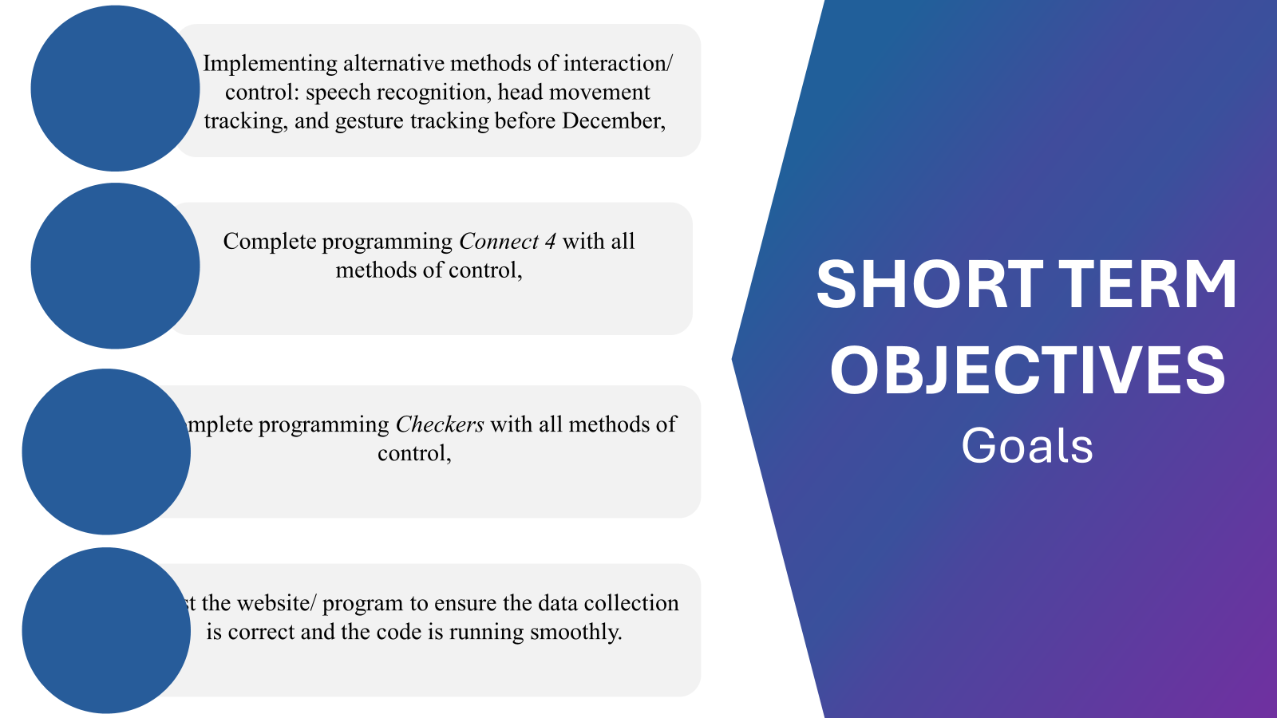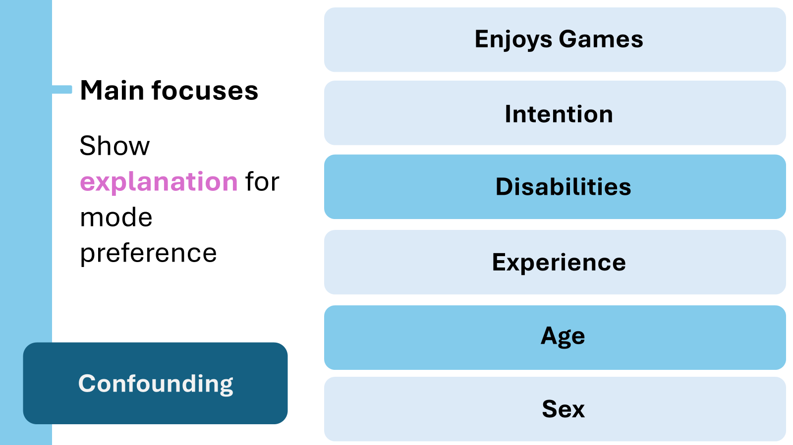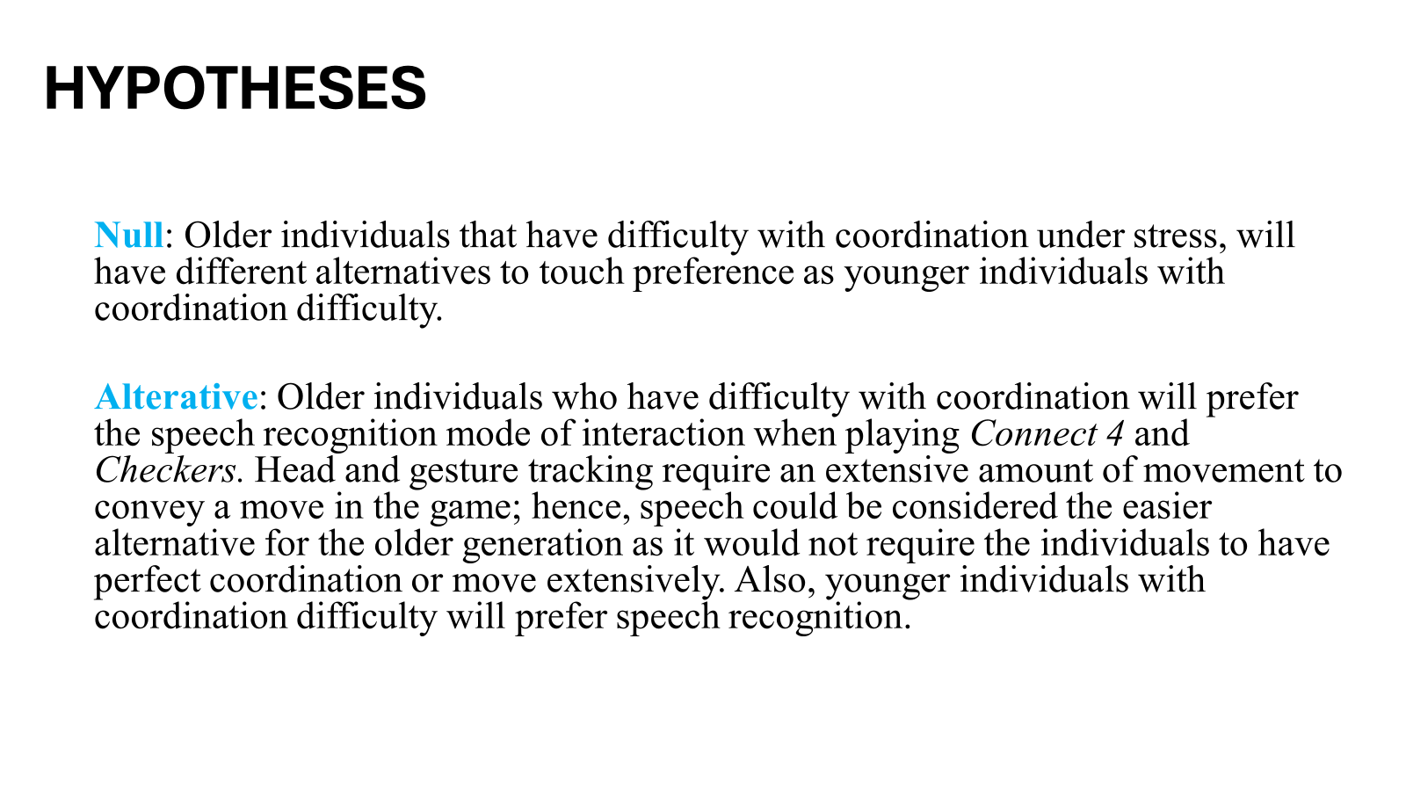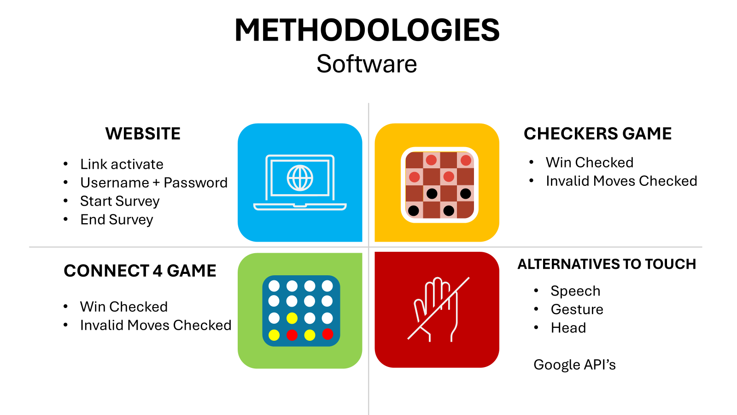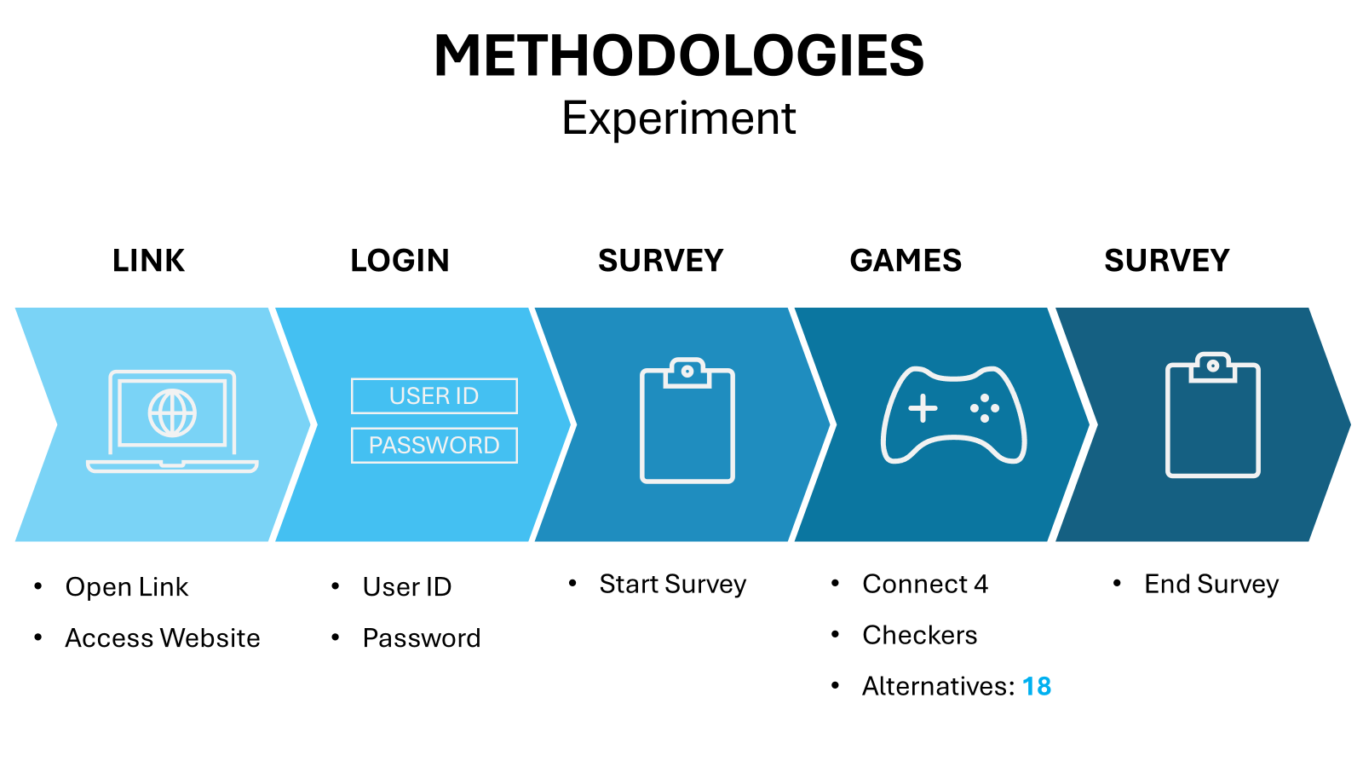
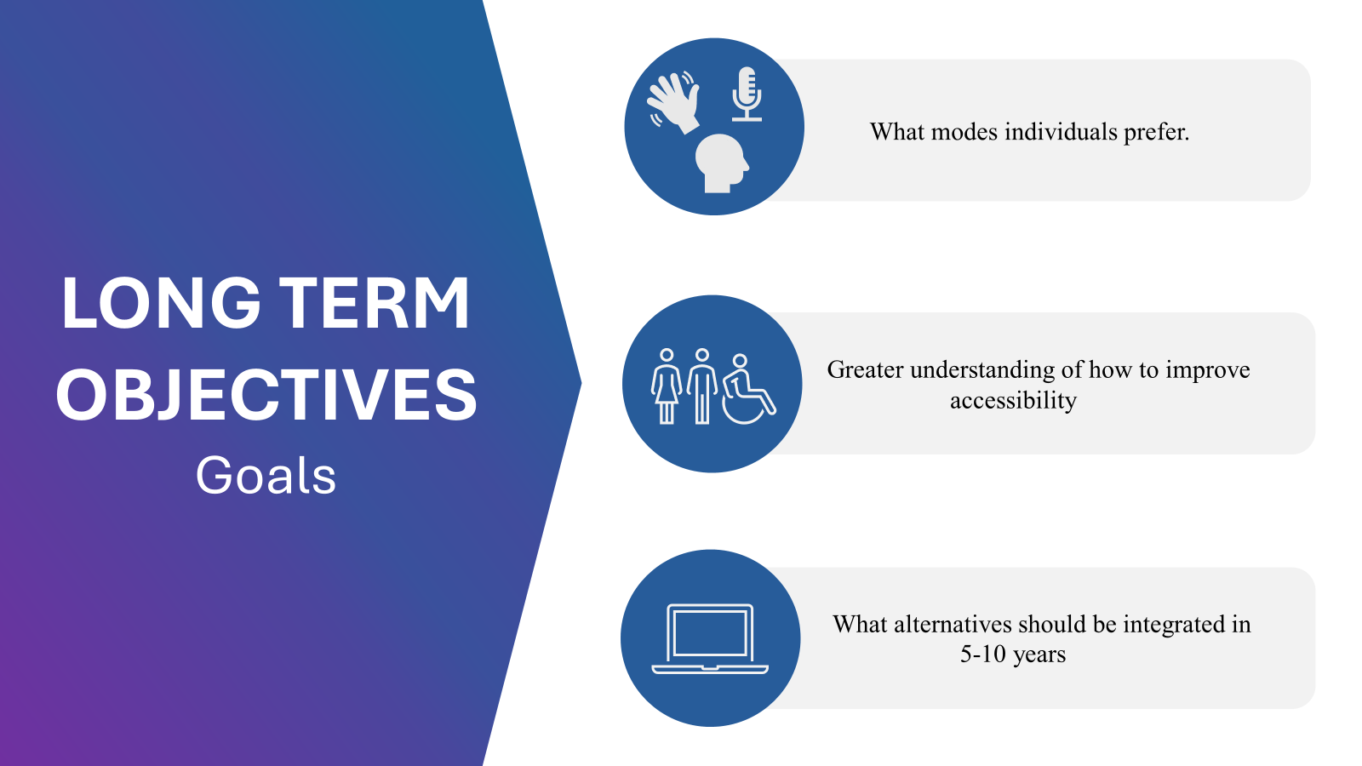

Wednesday, October 30, 2024:
- Reviewed and edited my research proposal: https://docs.google.com/document/d/1V_fguAn0UXb1CeVihHaUIY7Zie-B7DBJ578gDaJSuPY/edit?tab=t.0
  - Sent email to Mr. Dow regarding my references:
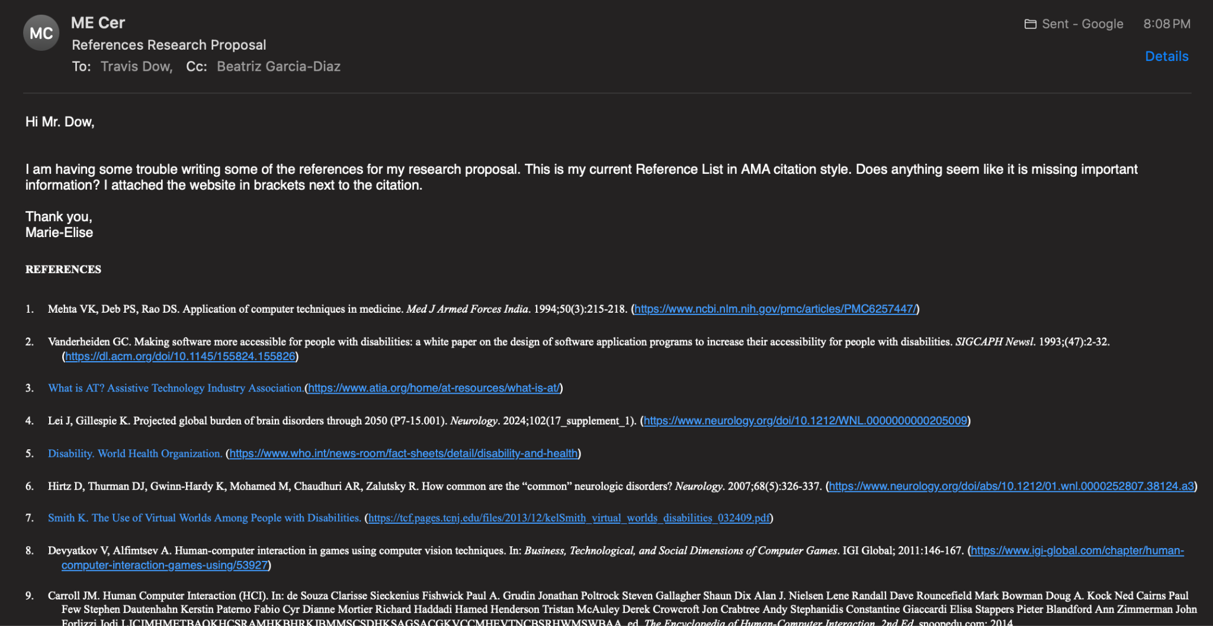
- Coded Connect 4 LOGIC in Javascript (everything is running smoothly, no errors so far):
export const checkWin = (board, player) => {
// Horizontal check
for (let r = 0; r < 6; r++) {
for (let c = 0; c < 4; c++) {
if (board[r][c] === player && board[r][c+1] === player &&
board[r][c+2] === player && board[r][c+3] === player) {
return true;
}
}
}

// Vertical check
for (let r = 0; r < 3; r++) {
for (let c = 0; c < 7; c++) {
if (board[r][c] === player && board[r+1][c] === player &&
board[r+2][c] === player && board[r+3][c] === player) {
return true;
}
}
}

// Diagonal checks
for (let r = 0; r < 3; r++) {
for (let c = 0; c < 4; c++) {
if (board[r][c] === player && board[r+1][c+1] === player &&
board[r+2][c+2] === player && board[r+3][c+3] === player) {
return true;
}
}
}

for (let r = 3; r < 6; r++) {
for (let c = 0; c < 4; c++) {
if (board[r][c] === player && board[r-1][c+1] === player &&
board[r-2][c+2] === player && board[r-3][c+3] === player) {
return true;
}
}
}

return false;
};

export const makeMove = (board, col, player) => {
const newBoard = board.map(row => [...row]);
for (let r = 5; r >= 0; r--) {
if (newBoard[r][col] === 0) {
newBoard[r][col] = player;
return newBoard;
}
}
return null; // Invalid move
};

const findWinningMove = (board, player) => {
for (let col = 0; col < 7; col++) {
const newBoard = makeMove(board, col, player);
if (newBoard && checkWin(newBoard, player)) {
return col;
}
}
return null;
};

const findBlockingMove = (board, player) => {
const opponent = player === 1 ? 2 : 1;
return findWinningMove(board, opponent);
};

const getAvailableColumns = (board) => {
return board[0].reduce((acc, cell, index) => {
if (cell === 0) acc.push(index);
return acc;
}, []);
};

const evaluateBoard = (board, player) => {
let score = 0;
const opponent = player === 1 ? 2 : 1;

// Check horizontal windows
for (let r = 0; r < 6; r++) {
for (let c = 0; c < 4; c++) {
let window = [board[r][c], board[r][c+1], board[r][c+2], board[r][c+3]];
score += evaluateWindow(window, player, opponent);
}
}

// Check vertical windows
for (let r = 0; r < 3; r++) {
for (let c = 0; c < 7; c++) {
let window = [board[r][c], board[r+1][c], board[r+2][c], board[r+3][c]];
score += evaluateWindow(window, player, opponent);
}
}

// Check diagonal windows
for (let r = 0; r < 3; r++) {
for (let c = 0; c < 4; c++) {
let window = [board[r][c], board[r+1][c+1], board[r+2][c+2], board[r+3][c+3]];
score += evaluateWindow(window, player, opponent);
}
}

for (let r = 3; r < 6; r++) {
for (let c = 0; c < 4; c++) {
let window = [board[r][c], board[r-1][c+1], board[r-2][c+2], board[r-3][c+3]];
score += evaluateWindow(window, player, opponent);
}
}

return score;
};

const evaluateWindow = (window, player, opponent) => {
const playerCount = window.filter(cell => cell === player).length;
const opponentCount = window.filter(cell => cell === opponent).length;
const emptyCount = window.filter(cell => cell === 0).length;

if (playerCount === 4) return 100;
if (playerCount === 3 && emptyCount === 1) return 5;
if (playerCount === 2 && emptyCount === 2) return 2;
if (opponentCount === 3 && emptyCount === 1) return -4;
return 0;
};

export const botMove = (board, difficulty = 'medium') => {
const availableCols = getAvailableColumns(board);
if (availableCols.length === 0) return board; // No move possible

let moveCol;

switch (difficulty) {
case 'easy':
moveCol = easyMove(board, availableCols);
break;
case 'medium':
moveCol = mediumMove(board, availableCols);
break;
case 'hard':
moveCol = hardMove(board, availableCols);
break;
default:
throw new Error('Invalid difficulty level');
}

return makeMove(board, moveCol, 2);
};

const easyMove = (board, availableCols) => {
if (Math.random() < 0.4) { // 40% chance of random move
return availableCols[Math.floor(Math.random() * availableCols.length)];
} else {
return findWinningMove(board, 2) ||
findBlockingMove(board, 2) ||
availableCols[Math.floor(Math.random() * availableCols.length)];
}
};

const mediumMove = (board, availableCols) => {
return findWinningMove(board, 2) ||
findBlockingMove(board, 2) ||
findBestMove(board, 2, 3); // Look 3 moves ahead
};

const hardMove = (board, availableCols) => {
return findBestMove(board, 2, 5); // Look 5 moves ahead
};

const findBestMove = (board, player, depth) => {
const availableCols = getAvailableColumns(board);
let bestScore = player === 2 ? -Infinity : Infinity;
let bestMove = availableCols[0];

for (let col of availableCols) {
const newBoard = makeMove(board, col, player);
const score = minimax(newBoard, depth - 1, -Infinity, Infinity, player === 1);

if (player === 2) {
if (score > bestScore) {
bestScore = score;
bestMove = col;
}
} else {
if (score < bestScore) {
bestScore = score;
bestMove = col;
}
}
}

return bestMove;
};
const minimax = (board, depth, alpha, beta, maximizingPlayer) => {
if (depth === 0 || checkWin(board, 1) || checkWin(board, 2)) {
return evaluateBoard(board, 2);
}

const availableCols = getAvailableColumns(board);

if (maximizingPlayer) {
let maxEval = -Infinity;
for (let col of availableCols) {
const newBoard = makeMove(board, col, 2);
const evalScore = minimax(newBoard, depth - 1, alpha, beta, false);
maxEval = Math.max(maxEval, evalScore);
alpha = Math.max(alpha, evalScore);
if (beta <= alpha) break;
}
return maxEval;
} else {
let minEval = Infinity;
for (let col of availableCols) {
const newBoard = makeMove(board, col, 1);
const evalScore = minimax(newBoard, depth - 1, alpha, beta, true);
minEval = Math.min(minEval, evalScore);
beta = Math.min(beta, evalScore);
if (beta <= alpha) break;
}
return minEval;
}
};

Thursday, October 31, 2024:
ASP NOTES (5min):
- Proposal and logbook due today!!
- Oral presentation November 6!
- November 22 at noon marks lock.
- Edited research proposal → references + reviewed the whole proposal: https://docs.google.com/document/d/1V_fguAn0UXb1CeVihHaUIY7Zie-B7DBJ578gDaJSuPY/edit?tab=t.0
- SUBMITTED RESEARCH PROPOSAL
  - References were being weird + help from Dr. Garcia

Friday, November 1, 2024:
- Coded Connect 4 board in CSS and HTML
- import React from 'react';

- const Connect4Board = ({ board, hoverColumn, currentPlayer, onColumnClick }) => {
- return (
- <div className="bg-blue-500 p-6 rounded-lg shadow-lg">
- <div className="flex mb-2">
- {board[0].map((_, colIndex) => (
- <div key={colIndex} className="w-10 h-10 m-0.5 flex items-center justify-center">
- {hoverColumn === colIndex && (
- <div
- className={`w-8 h-8 rounded-full ${
- currentPlayer === 1 ? 'bg-red-500' : 'bg-yellow-500'
- } opacity-50`}
- />
- )}
- </div>
- ))}
- </div>
- {board.map((row, rowIndex) => (
- <div key={rowIndex} className="flex">
- {row.map((cell, colIndex) => (
- <button
- key={colIndex}
- className="w-10 h-10 bg-blue-700 m-0.5 rounded-full flex items-center justify-center focus:outline-none focus:ring-2 focus:ring-white"
- onClick={() => onColumnClick(colIndex)}
- disabled={cell !== 0}
- aria-label={`Column ${colIndex + 1}`}
- >
- {cell !== 0 && (
- <div
- className={`w-8 h-8 rounded-full ${
- cell === 1 ? 'bg-red-500' : 'bg-yellow-500'
- }`}
- aria-label={`${cell === 1 ? 'Red' : 'Yellow'} piece`}
- />
- )}
- </button>
- ))}
- </div>
- ))}
- </div>
- );
- };

- export default Connect4Board;

Saturday, November 2, 2024:
- Worked on the Proposal Slides:

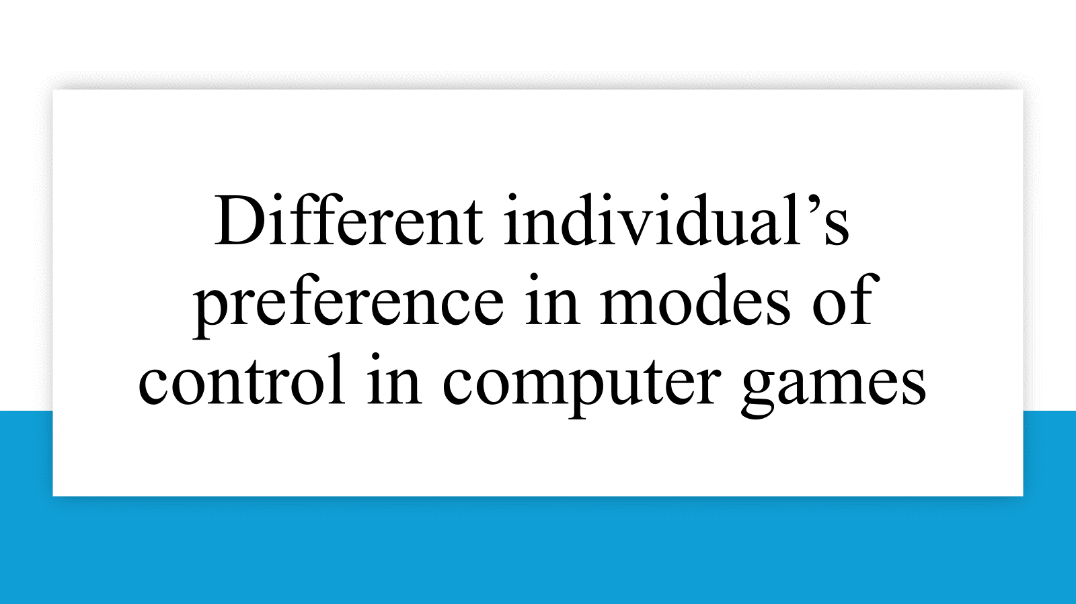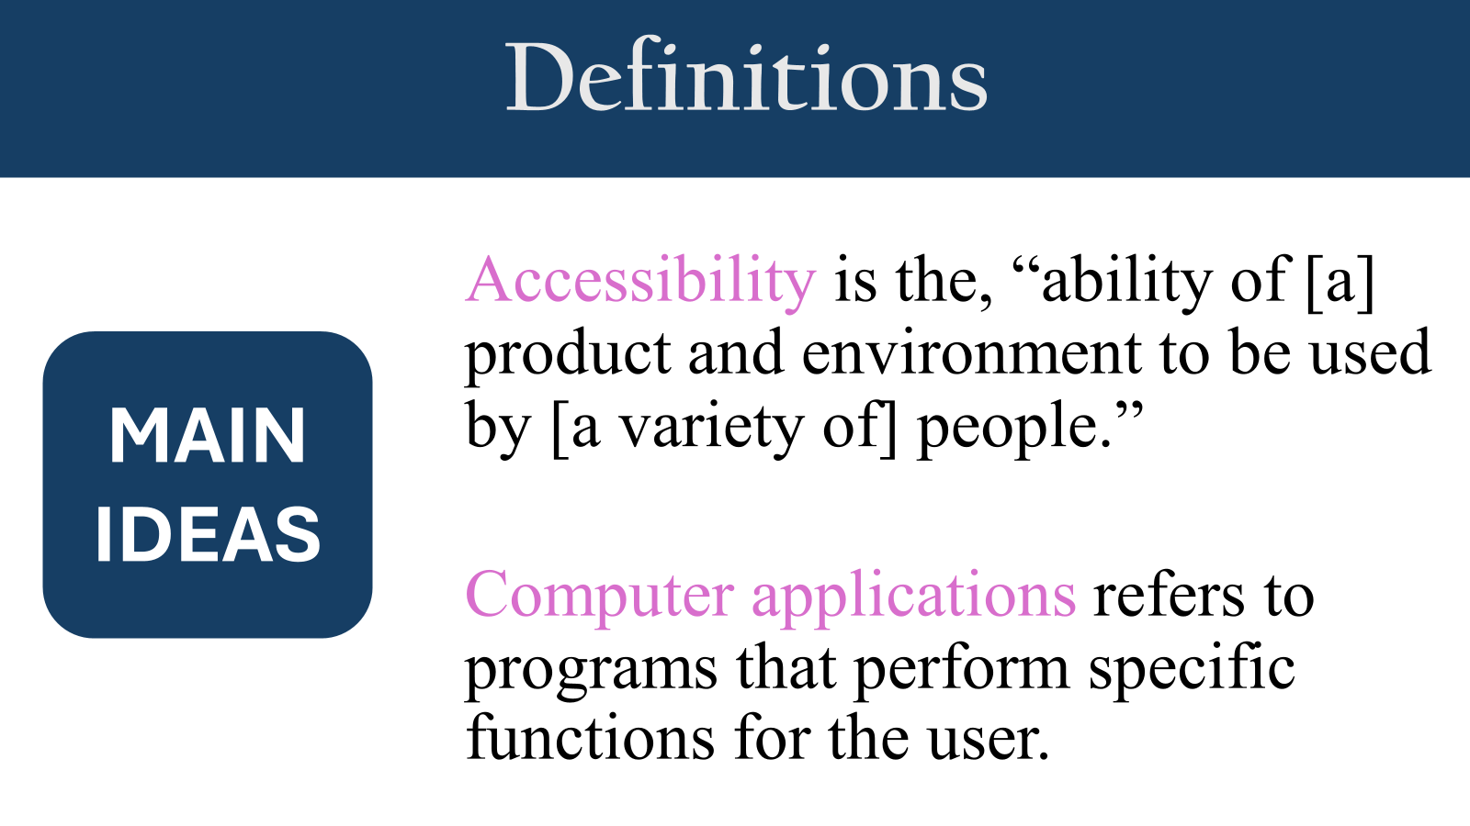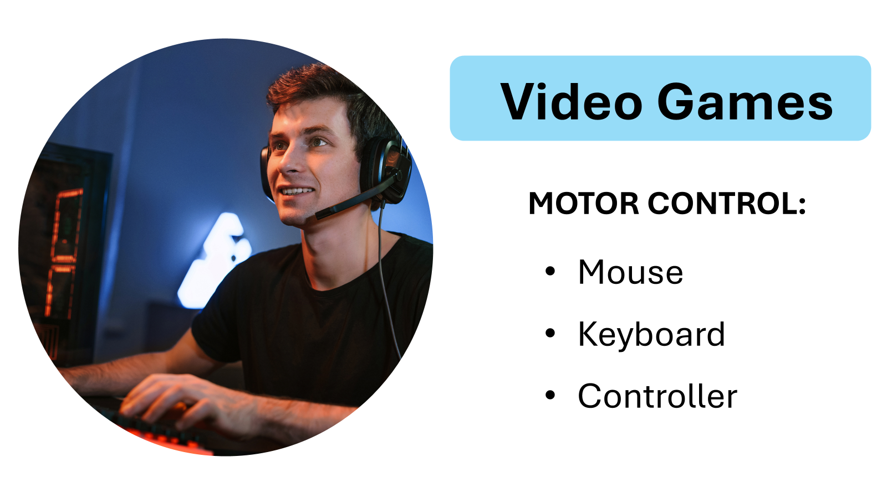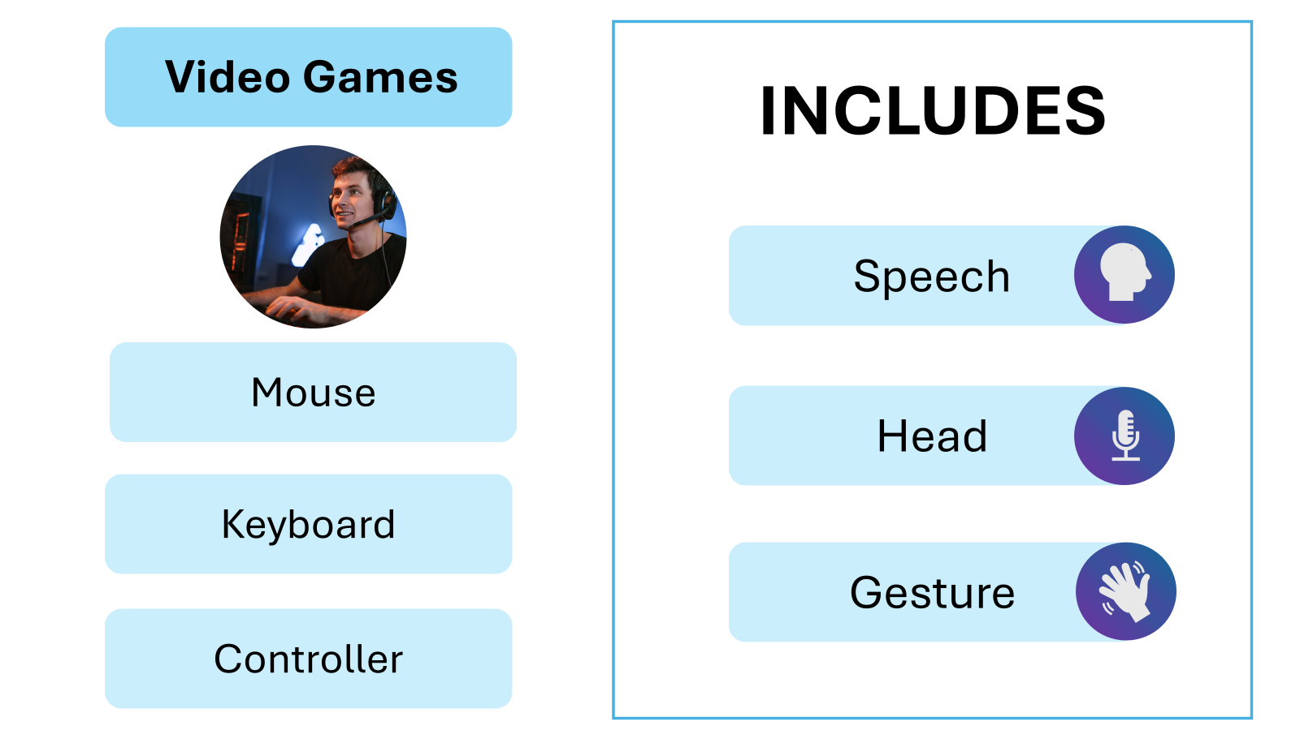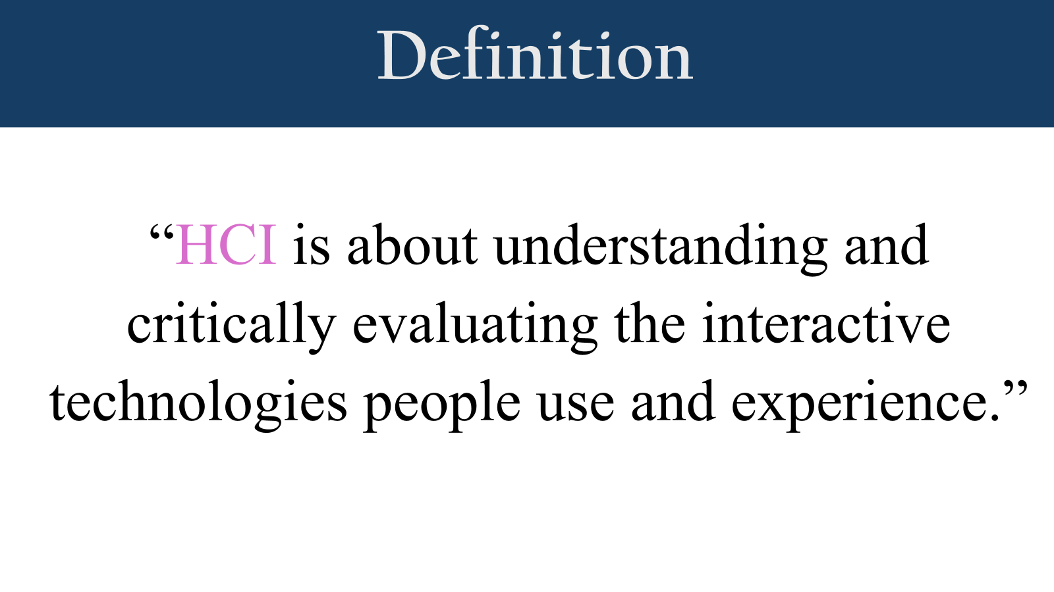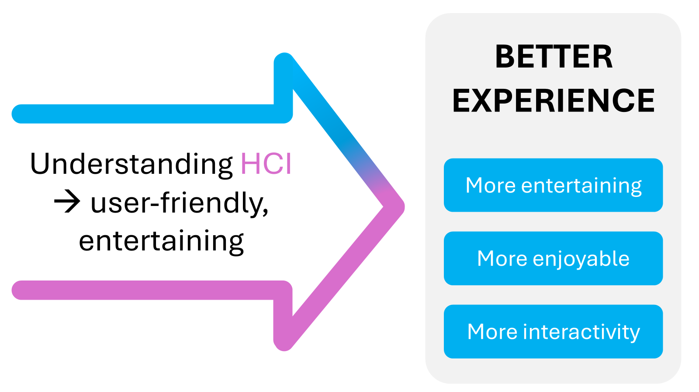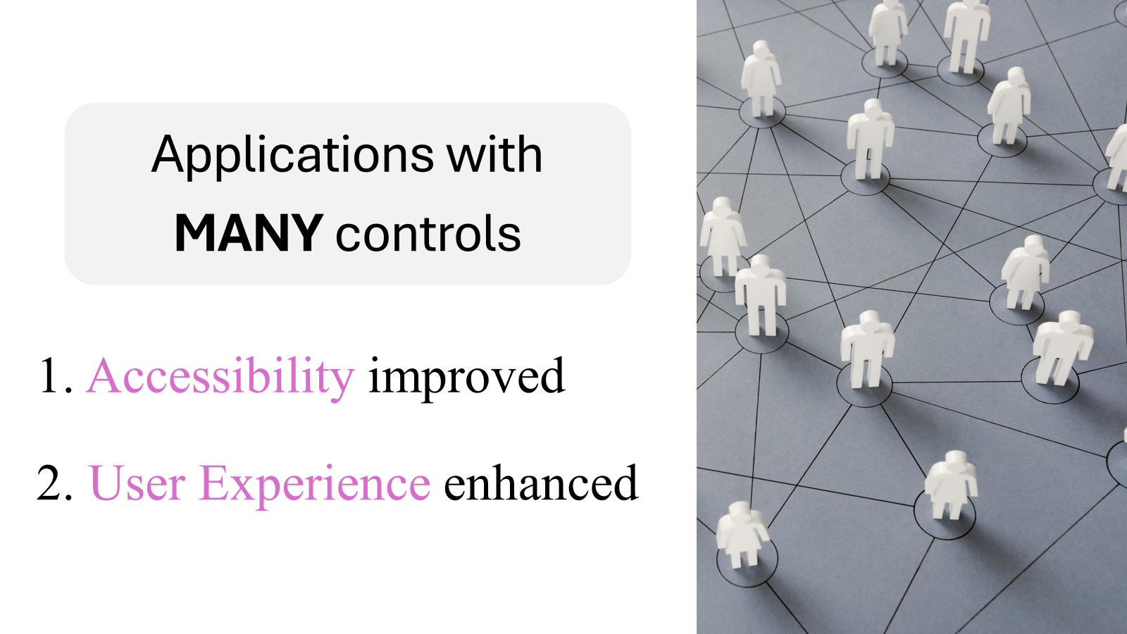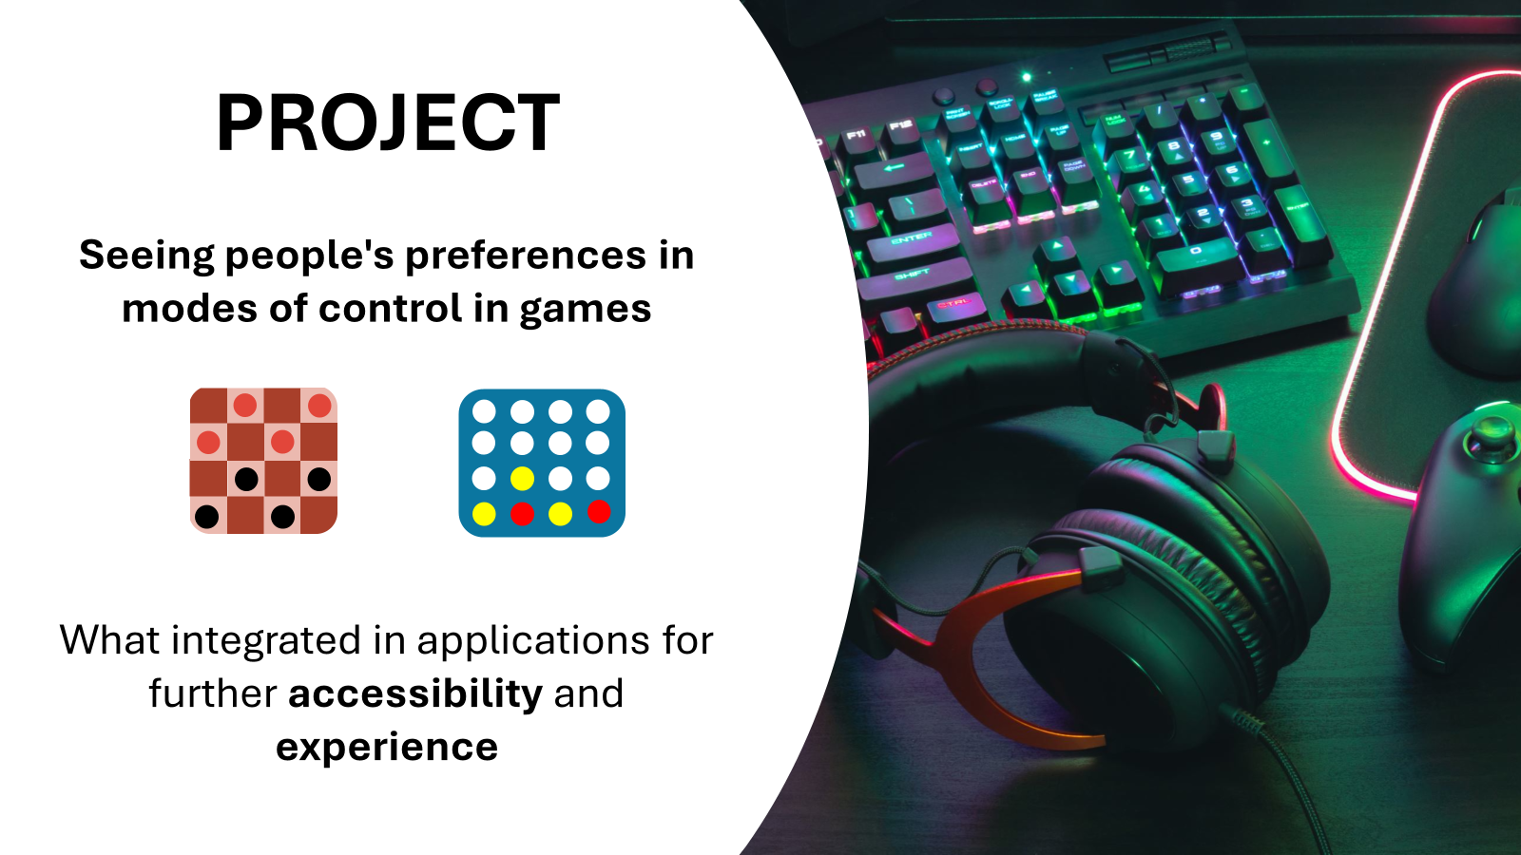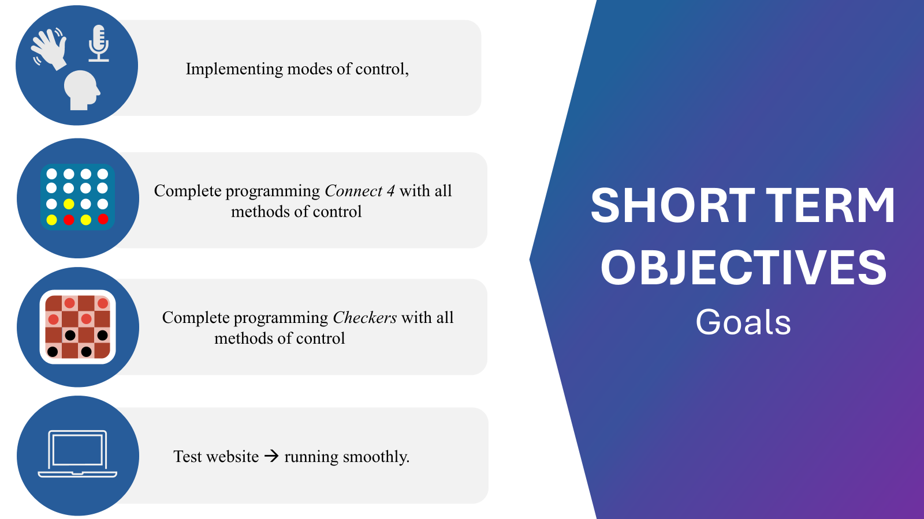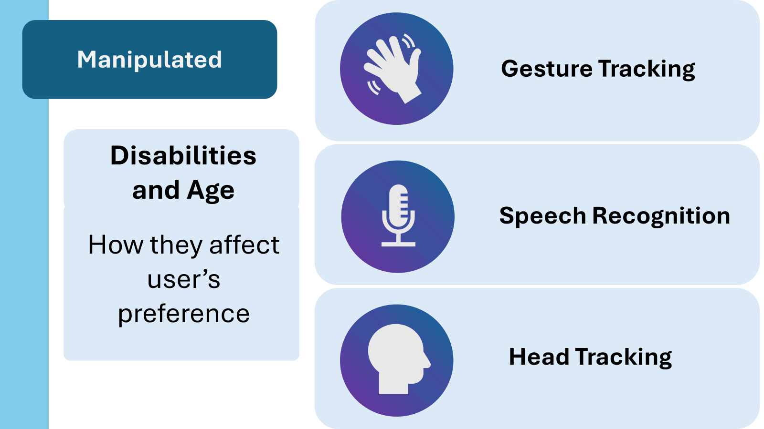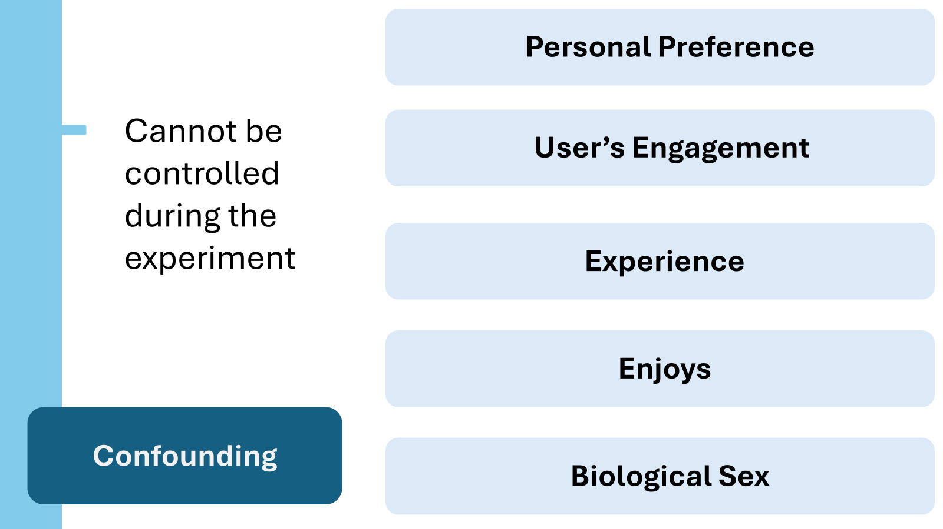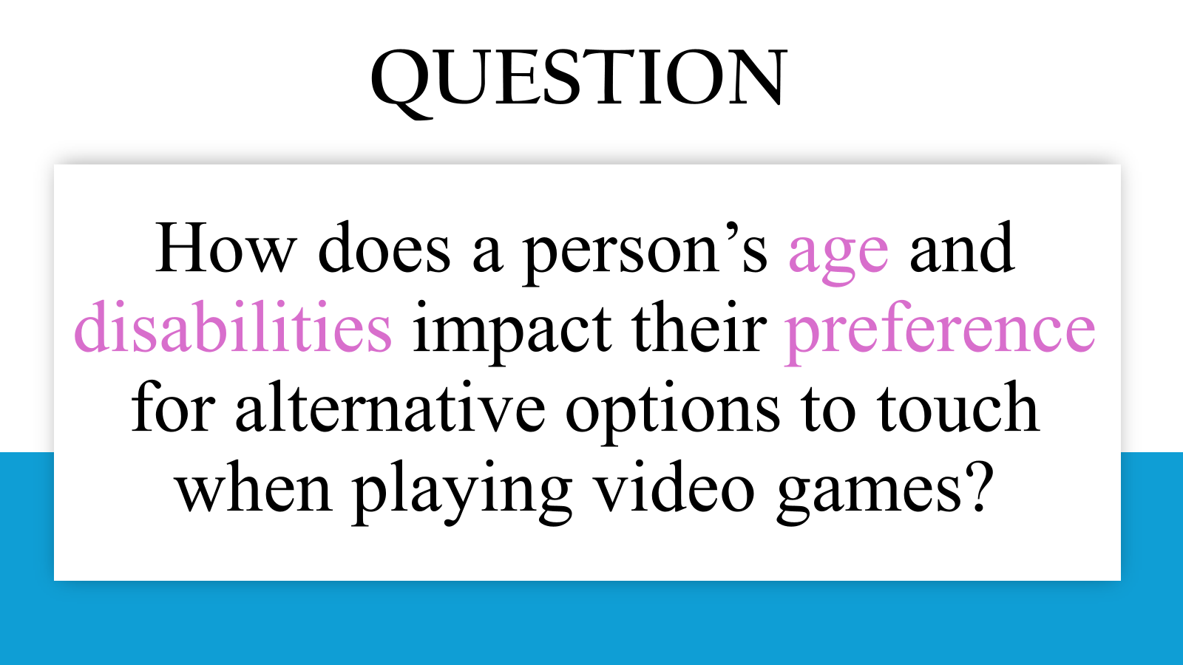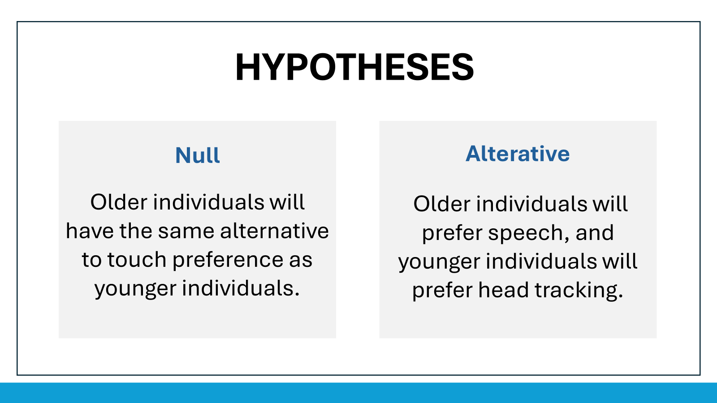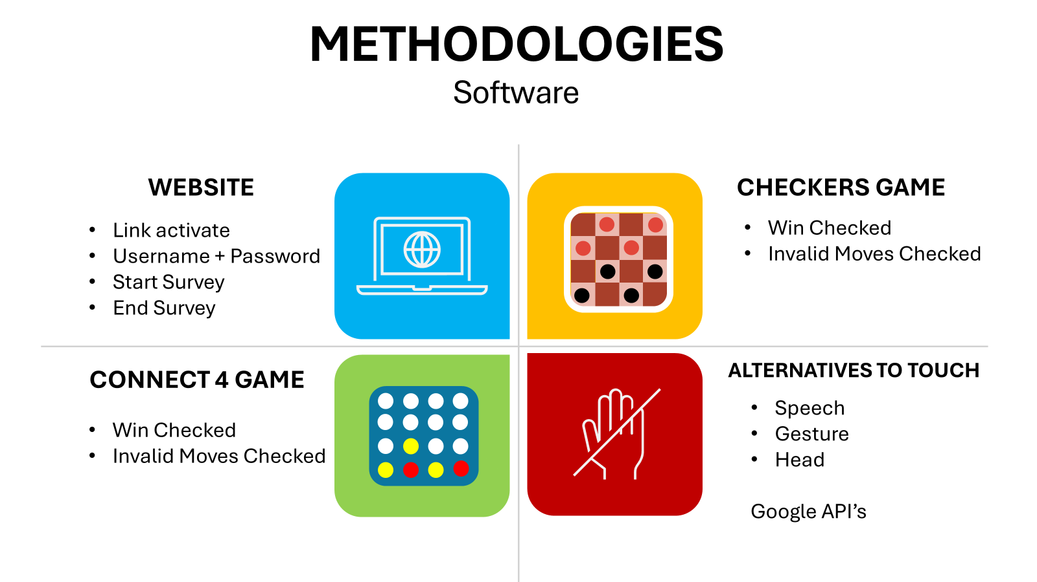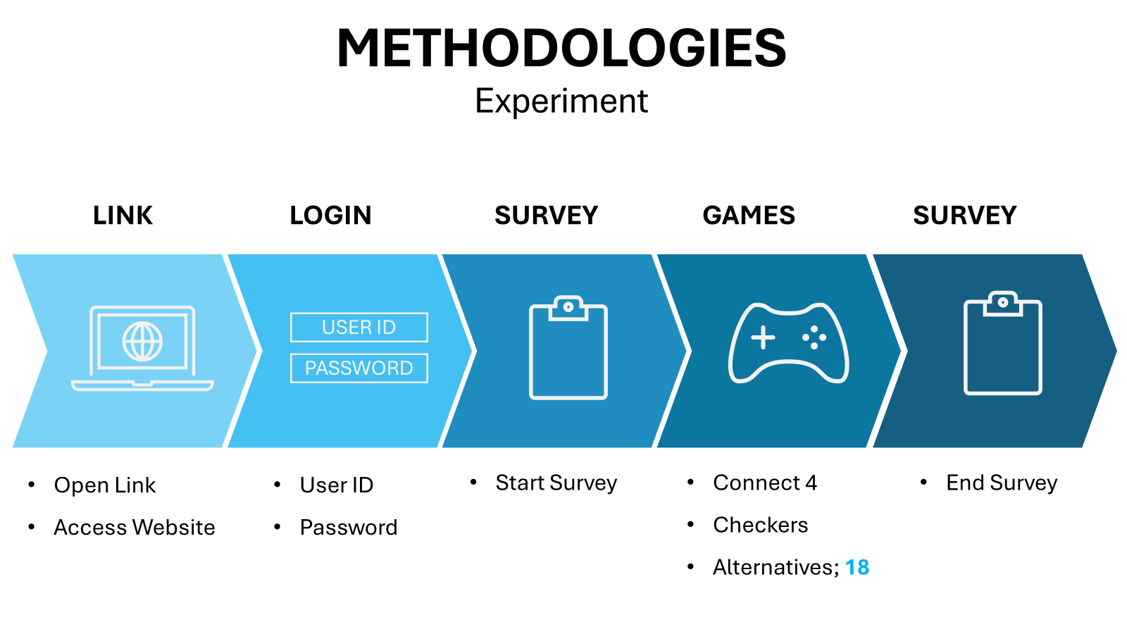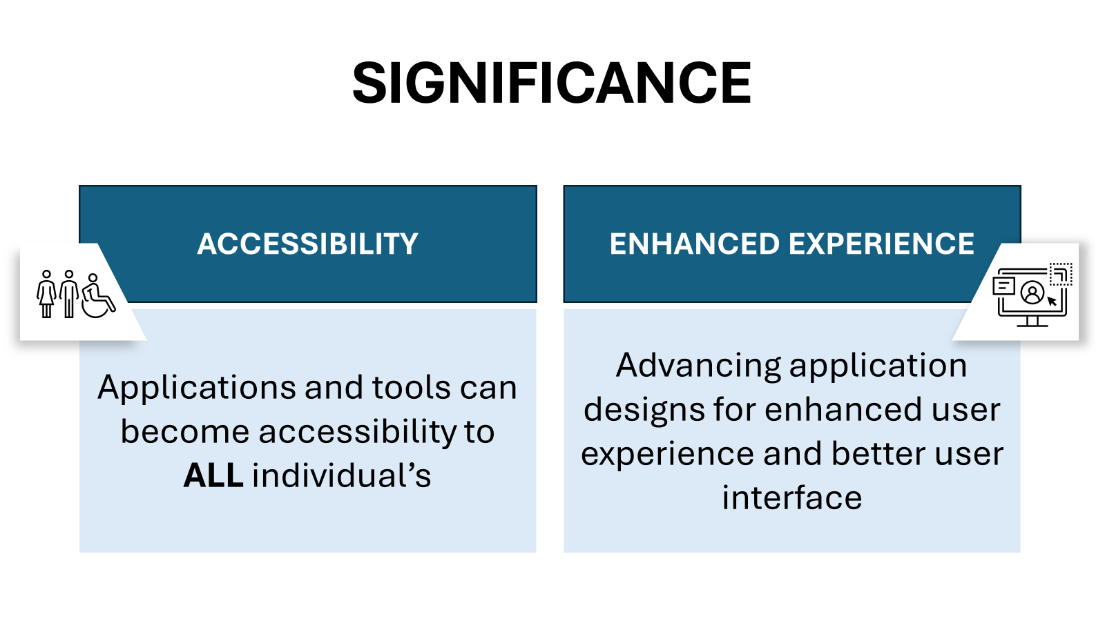Sunday, November 3, 2024:
- Made the slideshow more succinct

Monday, November 4, 2024:
ASP NOTES (25 min):
- Try using Tabs in Google Docs
- Write tentative dates in logbook: reading logbook, CYSF portal, meetings with mentors, oral presentations, emailing mentor
- ETHICS APPROVAL!! On ASP.
- Long Range Plan in meeting with your mentor IN GENERAL TERMS
  - Ex. March 11 POSTER DUE + need a week before to make a poster + experiment, etc.
- Submitted the Ethics form/ approval to CYSF committee.
- FINISHED SLIDESHOW + Practiced Presentation
- 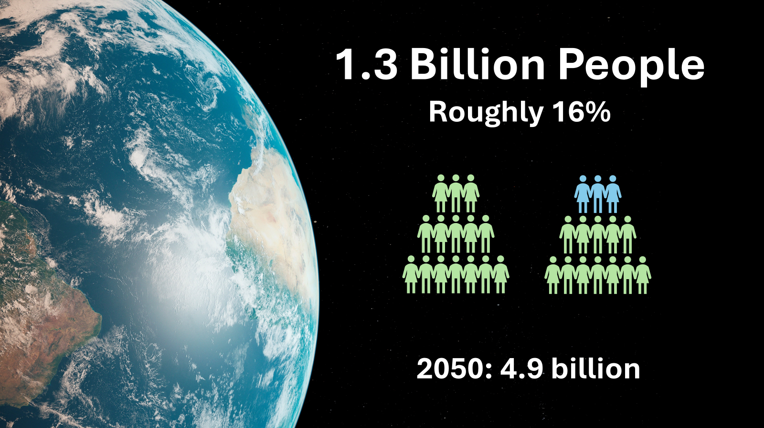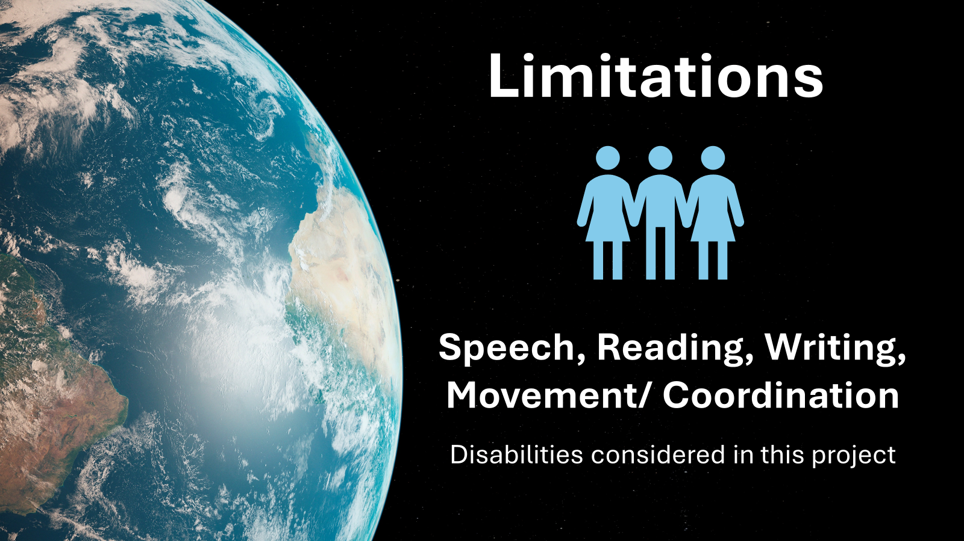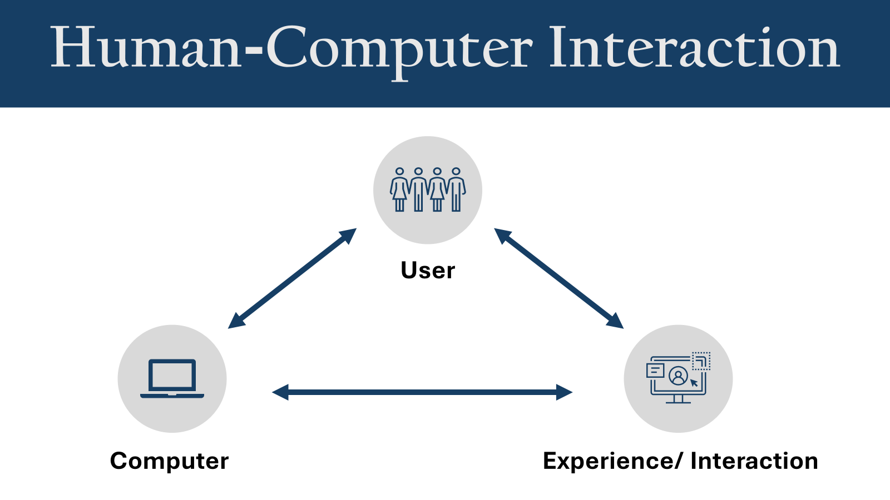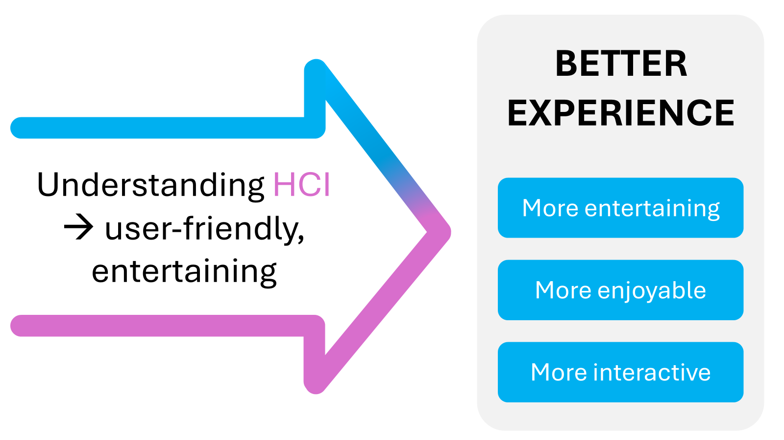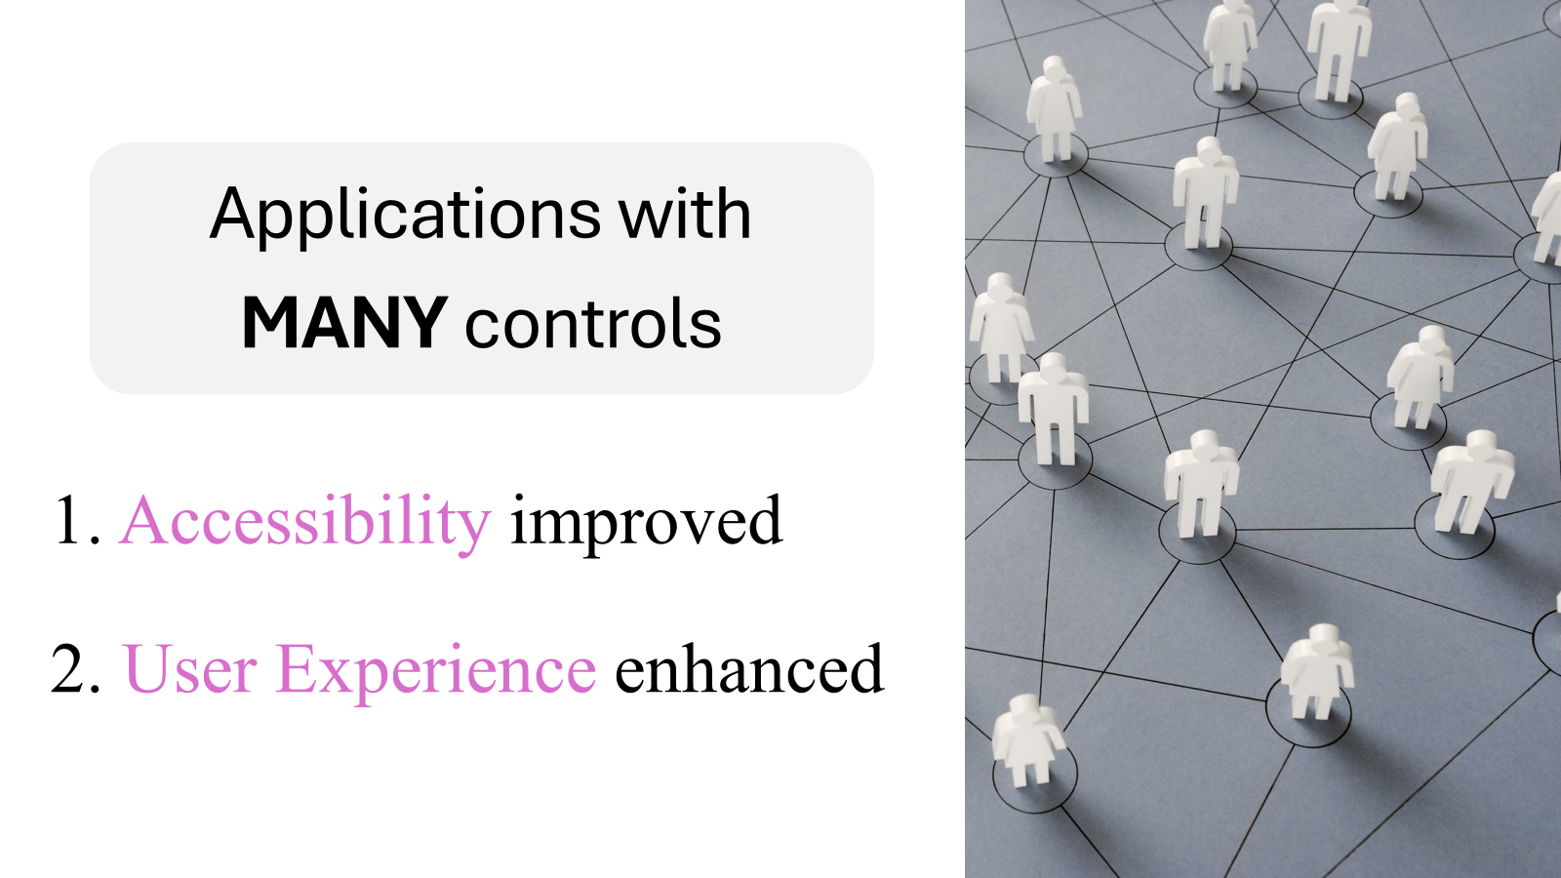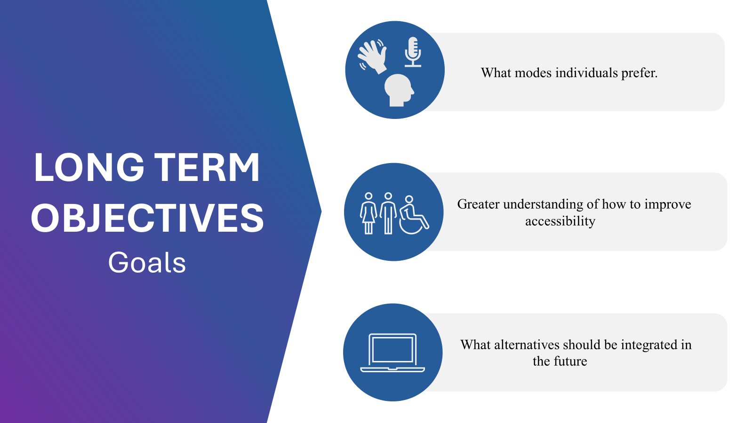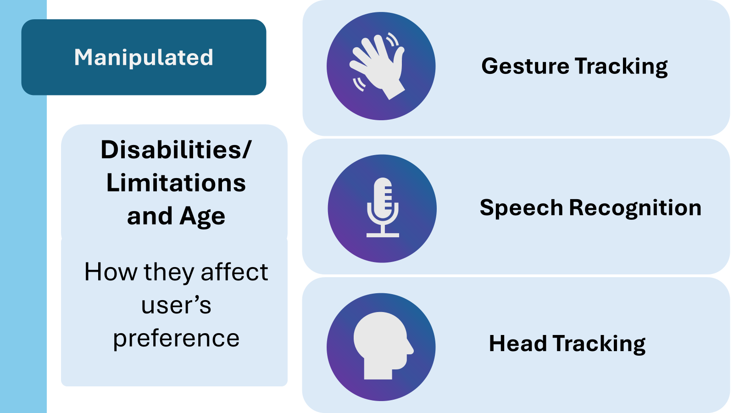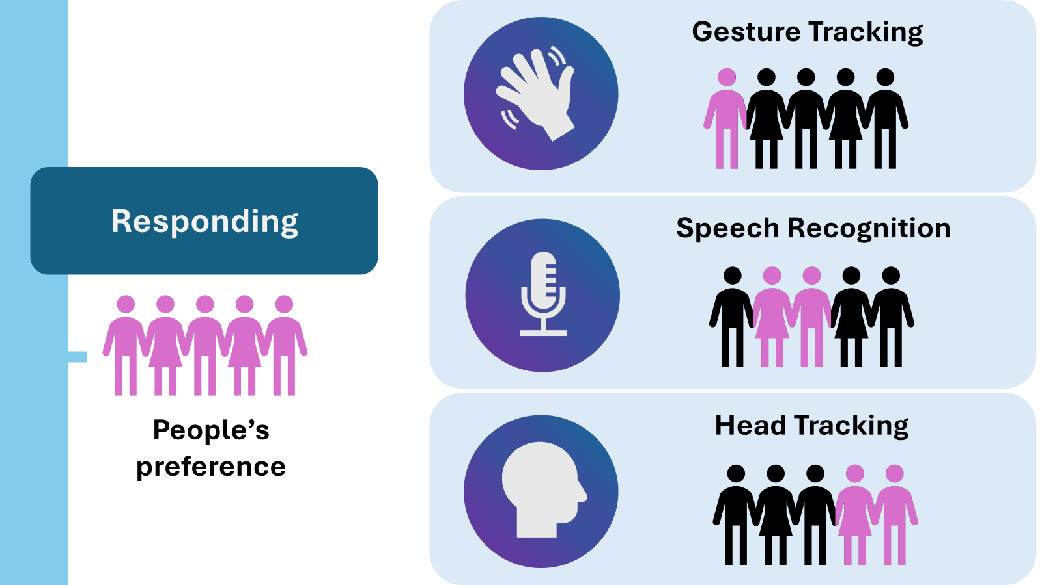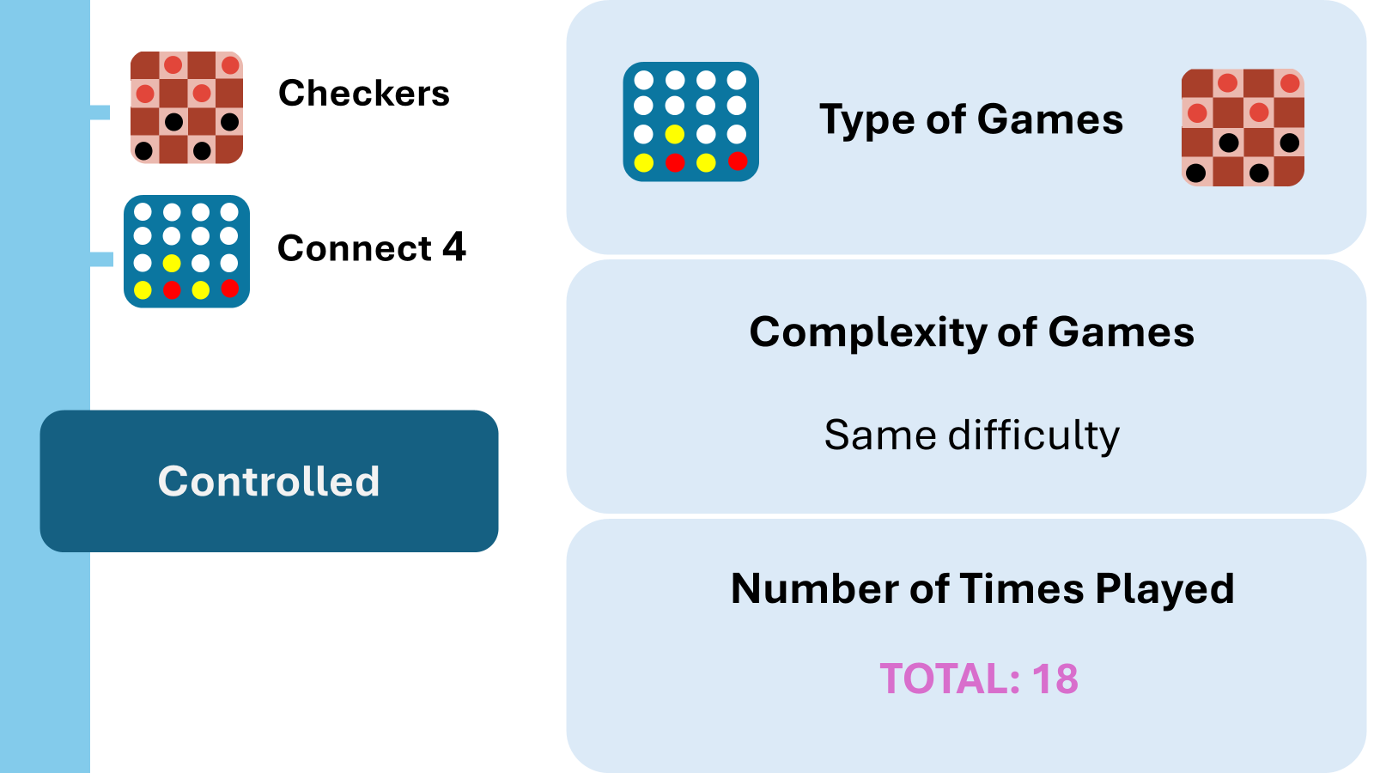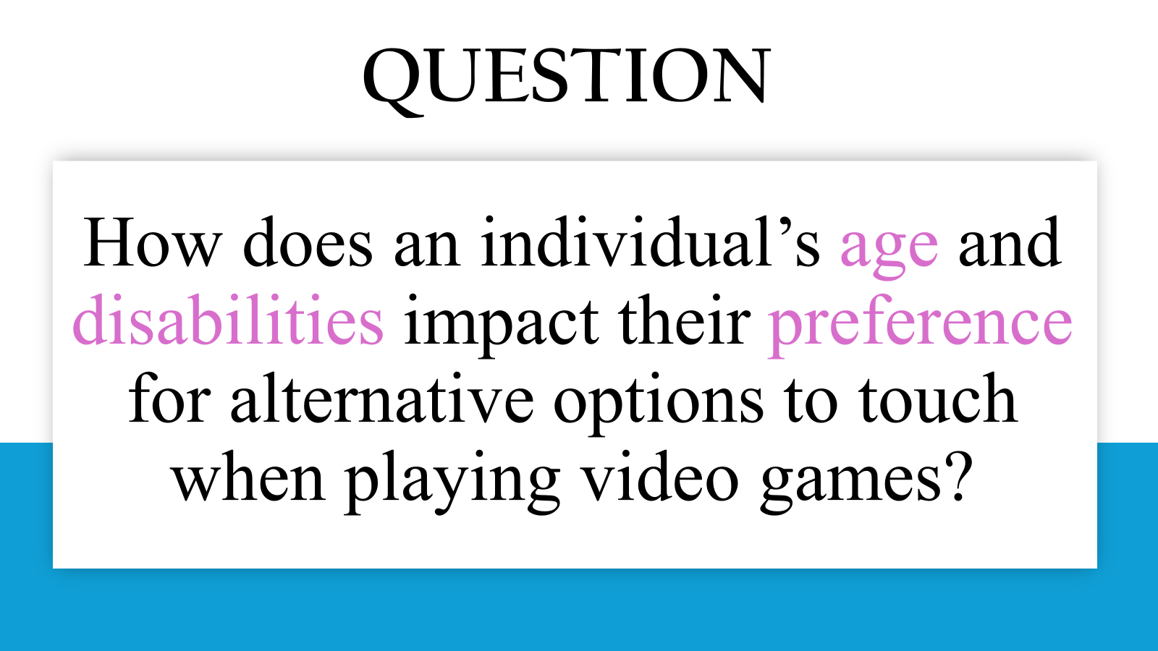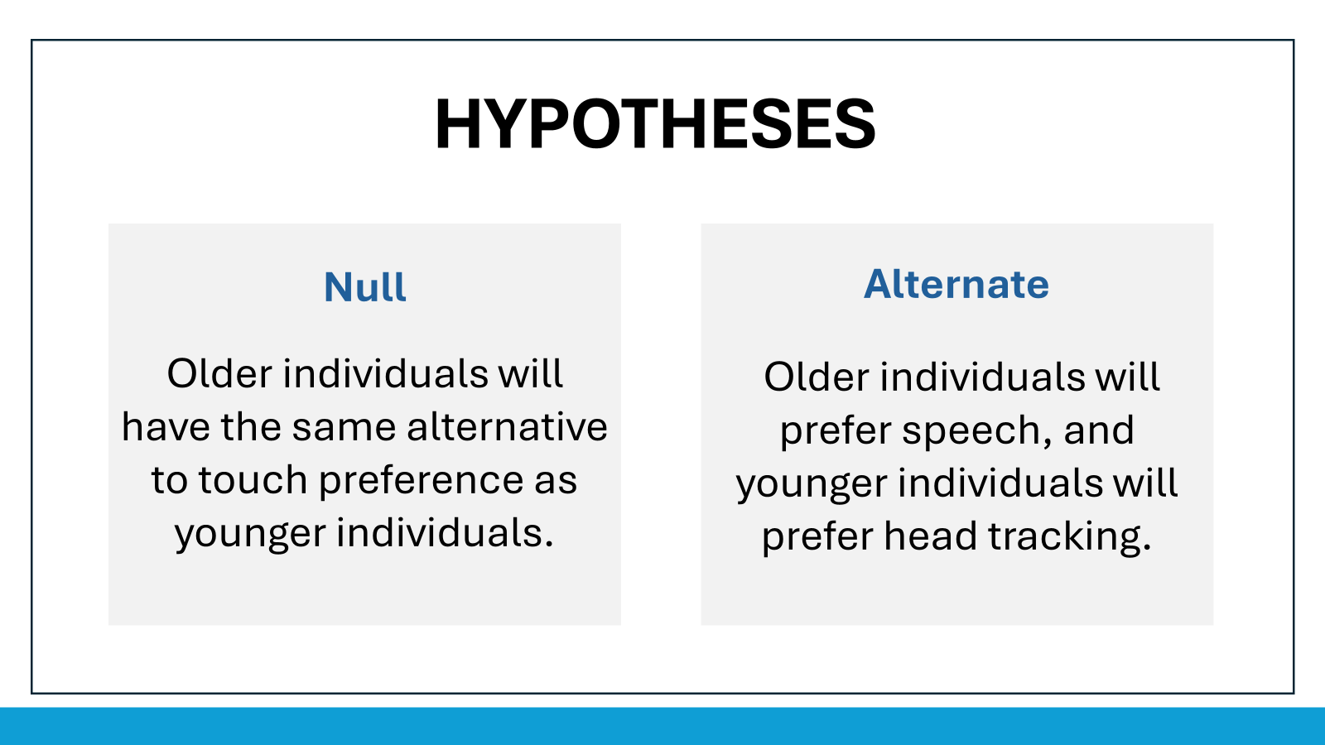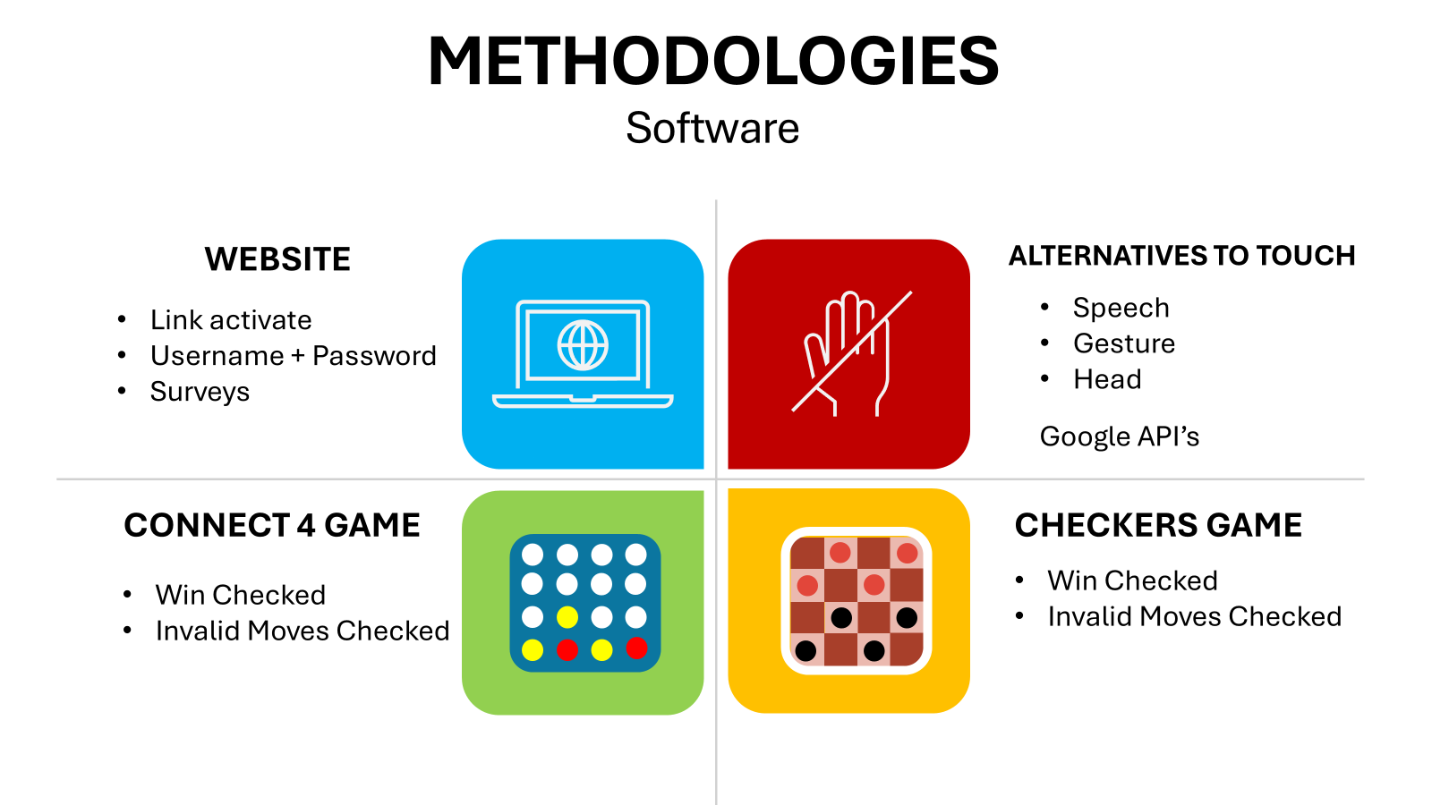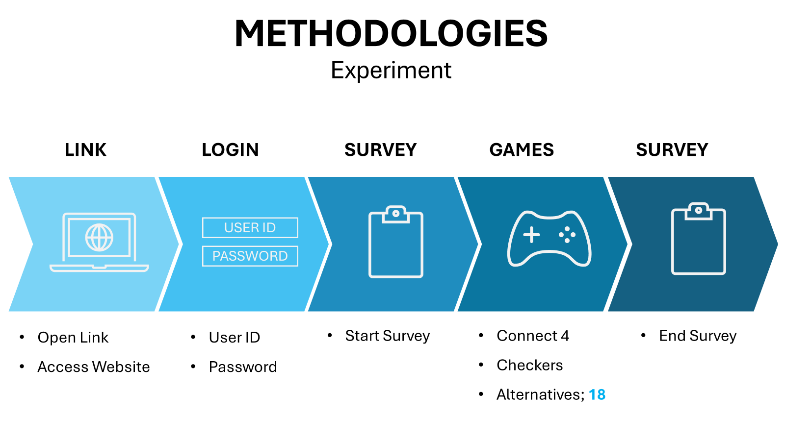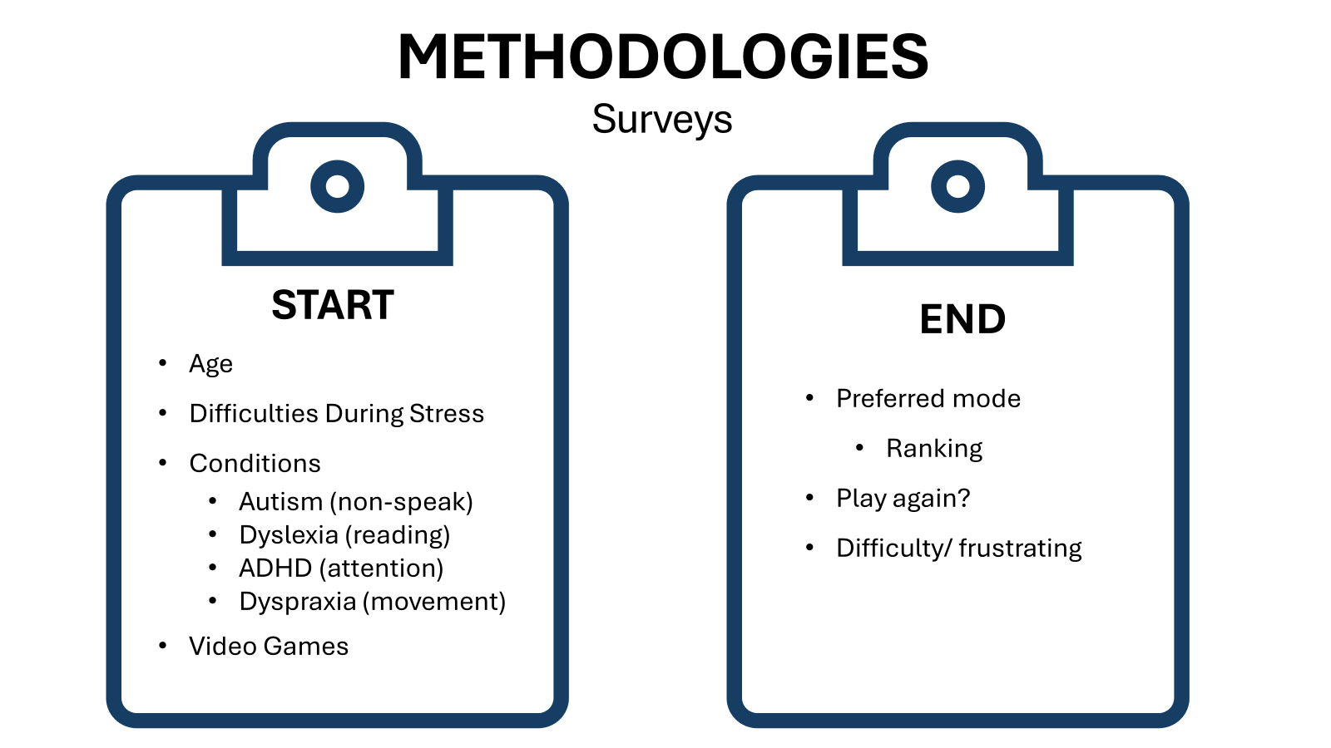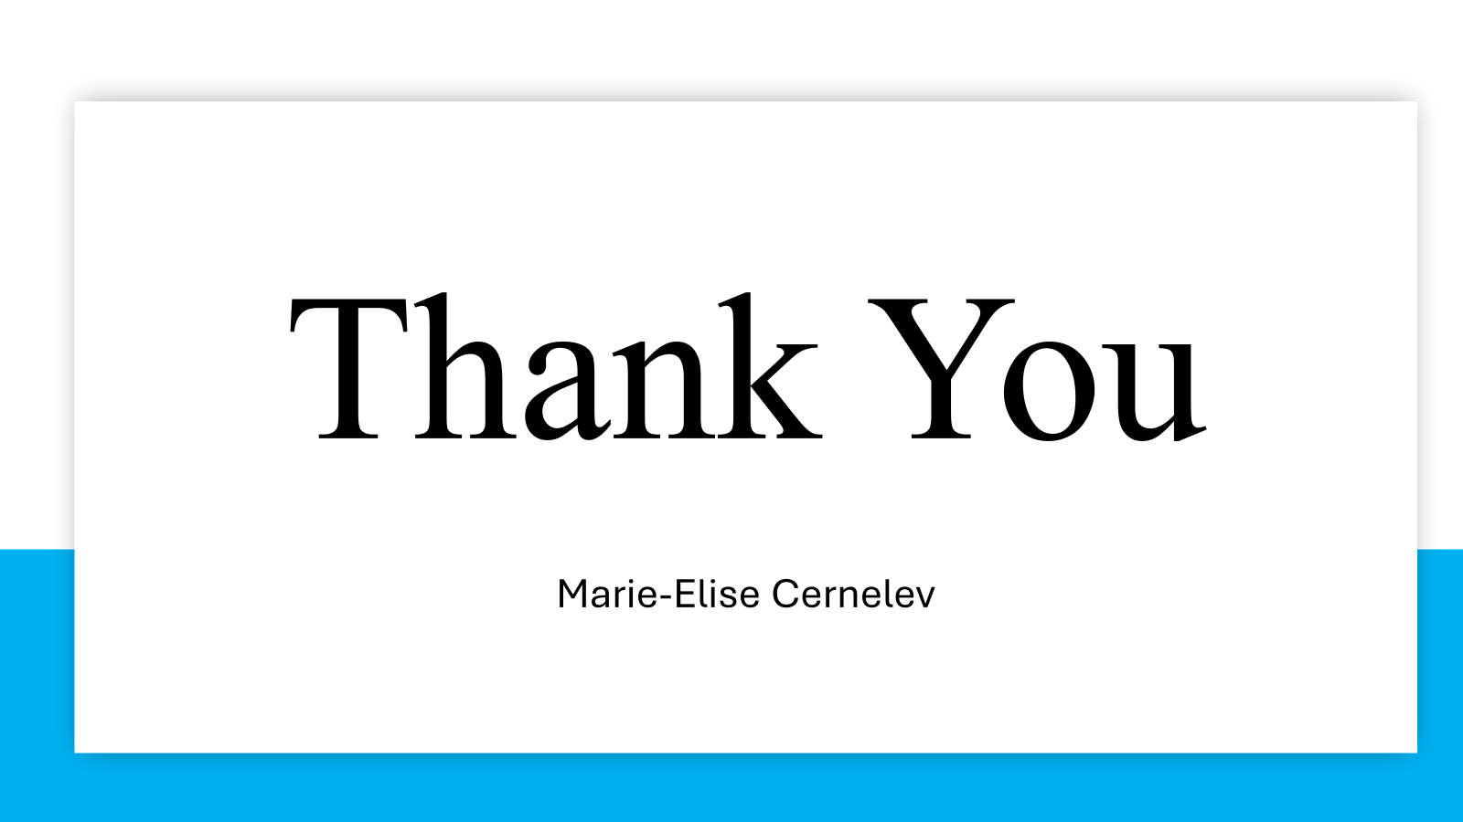

Tuesday, November 5, 2024:
- Rehearsed Presentation and submitted to google classroom

Wednesday, November 6, 2024:
- PUT IN PRESENTATION POINTS + INFORMATION IN SLIDESHOWS (do not have to explain if no time → that is what questions are for)
  - Stronger message for significance → SCIENCE FAIR
    - FUTURE DIRECTIONS
- In February you will have a lot more detail
Eleanor Presentation Notes:
- El Nino is a climate phenomena + natural occurring climate variability
  - Caused by change in air circulation in specific ocean
    - Temperature of water increases = high air pressure
  - Every 2-7 years (lasts for months and even years)
    - Significant events on weather patterns
      - Decrease in rice production = effects on human society
- Human Society Effects:
  - Agriculture, weather anomalies, health
    - These effects can be measured into effects of population and economy
  - REASON: Few have taken account how human society is evolving itself during this process.
    - We more rely on digital industry and finance = weather pattern affect human society
- Compare El Nino from different time periods to examine the impact of human society on how the El Nino event affected up.
- Different dates of El Nino reason: extremely different population size, temperature difference, GDP increases, economy relies on different
- Question: Predict how El Nino will affect human societies.
- Methodology: Create a proxy index + estimate the damage
  - Compare 2 events and their socioeconomic effects by graphs
- Long Term Goal: deeper understanding how extreme weather events affect human societies
  - Help to identity mechanisms to reduce the detrimental impacts of these events
- How Anthropogenic and natural climate affects/ influences future society.

QUESTIONS:
How are you able to predict how El Nino affects the present society by studying El Ninos of the past? Isn’t each El Nino different?
- Each has a similar amplitude and it is classified as extreme El Nino + if it is mild it won't have much impact in society.

What is a proxy index and why is it important for your project?
- Proxy Index is a way to measure the El Nino southern oscillation → coral reefs, for example, are sensitive to these El Nino Events + reconstruction amplitude of El Nino.

- Studied for Math Unit Quiz for rest of period (20 min)

Friday, November 8, 2024:
ASP CLASS NOTES (1 hour 30 min):
Cole Presentation Notes:
- Dementia: mixed → Alzheimer's + vascular dementia (Blood disruptions that result in strokes)
  - Many components = difficult to treat
    - Two Hit Hypothesis: vascular dysfunction + genetic risk factors contribute to dementia
      - Vascular dysfunction are modifiable
      - Genetic Factors = NOT WELL UNDERSTOOD
        - How genes play in dementia
- Project: analyze association b/w genetic risk and vascular dysfunction
- Transient Ischemic Attacks (TIA): associated with four time increase risk in dementia
- CSVD = leads to strokes, TIA’s
  - CSVD (cerebral small vessel disease) sum scores (different markers that impact the brain)
- Look at APOE (risk factor for alzheimer's disease) → three alleles
- Question: Predict cognitive decline and neurodegeneration
  - Relation b/w APOE and 4 allele
- Study conducted: data from U of C + analyzing data regarding APOE and CSVD
- Methodology: statistical analyses + looking at trends + severity of CSVD
- Significance: late-life degenerative disorders are a leading cause of death in developed countries

QUESTIONS:

In your study, what will you be looking for specifically to determine the relationship between the APOE and 4 alleles for predicting cognitive decline?
- APOE and 4 alleles have increased CSVD scores.

Lauren Presentation Notes:
- Finding a mid-step for cancer treatment to improve patient survival, increase patient comfort.
  - Lung cancer MOST COMMON cancer
- Focusing of Stage 3B/C lung cancer
  - 3C largest size of cancer tumors → difficult to treat
- Non-small cell lung cancer: in cells that are inside and outside of organs
  - Focus on the ones that affected the lymph nodes
- Possible Treatments: surgery, radiation therapy, chemotherapy, chemoradiation therapy, targeted cancer medication
  - Immunotherapy: modulate immune system to attack cancerous cells
- Treatment cycle: toxicity and side effects
  - Oncologists are trying to add interventions to limit these side effects
- Study + analyze
- Significance: increased understanding of interventions to treat NSCLC

QUESTIONS:
Are you looking at specific interventions that could be integrated in treatment cycles or are you looking in a broader term?
- Very specific interventions + general lung cancer interventions + see trends and then implement them into cells

Coco Presentation:
- Motor neurons send a signal to muscle fibers + during muscle contractions, electromyography measures this signal
  - During muscle traction, EMG picks up different signals as well
- Most common electrodes used are planar silver wet electrodes
  - Detect signal + have a lot of flaw (extensive skin preparation, skin irritation, motion artifact (EMG signals shift due to during of the gel), reduced signal resolution)
    - Microelectrode arrays (needs that are inserted into patients skin + much higher signal + painless)
    - Wire Bonded MNA’s: mass production, inexpensive, adjustable dimensions
- Ultrasonic ball-bonding technique
- Question: will wire-bonded microneedle arrays be better?
- Controlled variables: input signal wavelength + amplitude
- Significance: MNAs have high quality data vs planar electrodes

QUESTIONS:
How do you make sure that the porcine skin tissue that you are using for your experiment truly imitates skin on a human? Has this been tested in the clinic before?
- As been used in many human skin + closest that could be found / used in experiment

Nina Presentation Notes:
- Psychedelics (type of drug): causes vision distortion
  - Classical: affect serotonin receptors
  - Non-classical
- Serotonin = see things from a different perspective
  - Experiences are very subjective (many factors beyond the drug itself)
- Independent: patient motivations/ expectations
- Dependent: changes in alcohol consumption
- No current research that directly compares motivations + expectations

QUESTIONS:
How will you make sure that the individuals that want to participate in this study do not take any other drugs? Is it based on a trust system?
- Hopefully they tell the truth.
—------------------
- Organized files for programming website

Tuesday, November 12, 2024:
- Index File linked to CSS file and Javascript File (main file is now linked to the file that controls aesthetics and how things look on the website AND javascript code):
<!doctype html>
<html lang="en">
<head>
<meta charset="UTF-8" />
<link rel="icon" type="image/svg+xml" href="/vite.svg" />
<meta name="viewport" content="width=device-width, initial-scale=1.0" />
<title>Vite + React</title>
</head>
<body>
<div id="root"></div>
<script type="module" src="/src/main.jsx"></script>
</body>
</html>

- Started Watching Javascript Video: https://www.google.com/search?q=how+to+code+in+javascript+video&oq=how+to+code+in+javascript+video&gs_lcrp=EgZjaHJvbWUyBggAEEUYOTIICAEQABgWGB4yDQgCEAAYhgMYgAQYigUyDQgDEAAYhgMYgAQYigUyCggEEAAYgAQYogQyCggFEAAYgAQYogQyCggGEAAYgAQYogTSAQg0ODExajBqN6gCALACAA&sourceid=chrome&ie=UTF-8#fpstate=ive&vld=cid:8789b262,vid:8dWL3wF_OMw,st:0

Wednesday, November 13, 2024:
ASP CLASS NOTES (20 min):
- Make sure that you are communicating with your mentor
  - Make a long range plan
- January is coming → DO NOT STOP DOING YOUR WORK
- LISTEN TO DR. GARCIA
  - You need to take important notes that I say
- Paperpile + citations
  - DOUBLE CHECK AND EDIT YOUR CITATIONS
  - Once you have inserted your citation in the spot you wanted, make sure that you FORMAT your citations in paperpile + make sure that your in text citations/ references match and are good.
- ASK QUESTIONS IF YOU HAVE.
- Added to the CYSF portal to the hypothesis, variables, and research section (from research proposal).
- Coded survey data collection in javascript (not finished yet):
import React from 'react';

const EndSurveyPopup = ({ isOpen, isClose}) => {
if (!isOpen) return null;

return(
<div className="fixed inset-0 bg-black bg-opacity-50 flex justify-center items-center z-50">
<div className="bg-white p-6 rounded-lg shadow-xl max-w-md w-full">
<h2 className="text-2xl font-bold mb-4">End Survey Questions</h2>

<section>
<label id="pleasureScale">From a scale of 1-9, rate your pleasure with the games. 1 being these games are the worst, and 9 being I love these games.</label>
<div>
<div id="star">&#9733;</div>
<div id="star">&#9733;</div>
<div id="star">&#9733;</div>
<div id="star">&#9733;</div>
<div id="star">&#9733;</div>
<div id="star">&#9733;</div>
<div id="star">&#9733;</div>
<div id="star">&#9733;</div>
<div id="star">&#9733;</div>
</div>
</section>

<label id="pleasureScale">From a scale of 1-9, rate your pleasure with the games. 1 being these games are the worst, and 9 being I love these games.</label>
<input type="number" id="pleasureScale" min="1" max="9" required placeholder= "Rate Your Pleasure"></input>

<label id="interactionRank">Please rank the method of interactions you prefer the most (from most preferred(1), to least preferred(3)).</label>
<input id="interactionRank" ></input>

<fieldset>
<legend>Would you play this game again?</legend>
<select id="dropdown">
<input type="radio" id="yes" value="yes"><label>Yes</label></input>
<input type="radio" id="no" value="no"><label>No</label></input>
<input type="radio" id="maybe" value="maybe">Maybe (would play if there are no other games)<label>Yes</label></input>
</select>
</fieldset>

<fieldset>
<legend>Did you find anything annoying, difficult, or frustrating while you were playing the game? Select all that apply.</legend>
<div>
<input type="checkbox" id="errors"></input>
<label for="errors">Game crashed (has errors and bugs)</label>
</div>
<input type="checkbox" id="not recognize"></input>
<label for="not recognize">Game didn't recognize my commands</label>
<div>
<input type="checkbox" id="slow"></input>
<label for="slow">Game was slow on processing my commands</label>
</div>
<input type="checkbox" id="confusing"></input>
<label for="confusing">Game was confusing to play</label>
<div>
<input type="checkbox" id="not fun"></input>
<label for="not fun">Game wasn't entertaining</label>
</div>
</fieldset>

<button
onClick={onClose}
className="mt-6 px-4 py-2 bg-blue-500 text-white rounded hover:bg-blue-600 focus:outline-none focus:ring-2 focus:ring-blue-400"
>
Close
</button>
</div>
</div>
)
};

export default EndSurveyPopup;

Thursday, November 14, 2024:
- Programmed end survey popup (have some errors and determined by the red underline/ highlight of the words on my file name → will try to fix tomorrow)
import React from 'react';

const EndSurveyPopup = ({ isOpen, isClose}) => {
if (!isOpen) return null;

return(
<div className="fixed inset-0 bg-black bg-opacity-50 flex justify-center items-center z-50">
<div className="bg-white p-6 rounded-lg shadow-xl max-w-md w-full">
<h2 className="text-2xl font-bold mb-4">End Survey Questions</h2>

<section>
<label id="pleasureScale">From a scale of 1-9, rate your pleasure with the games. 1 being these games are the worst, and 9 being I love these games.</label>
<div>
<div id="star">&#9733;</div>
<div id="star">&#9733;</div>
<div id="star">&#9733;</div>
<div id="star">&#9733;</div>
<div id="star">&#9733;</div>
<div id="star">&#9733;</div>
<div id="star">&#9733;</div>
<div id="star">&#9733;</div>
<div id="star">&#9733;</div>
</div>
</section>

<label id="pleasureScale">From a scale of 1-9, rate your pleasure with the games. 1 being these games are the worst, and 9 being I love these games.</label>
<input type="number" id="pleasureScale" min="1" max="9" required placeholder= "Rate Your Pleasure"></input>

<label id="interactionRank">Please rank the method of interactions you prefer the most (from most preferred(1), to least preferred(3)).</label>
<input id="interactionRank" ></input>

<fieldset>
<legend>Would you play this game again?</legend>
<select id="dropdown">
<input type="radio" id="yes" value="yes"><label>Yes</label></input>
<input type="radio" id="no" value="no"><label>No</label></input>
<input type="radio" id="maybe" value="maybe">Maybe (would play if there are no other games)<label>Yes</label></input>
</select>
</fieldset>

<label id="pleasureScale">From a scale of 1-9, how would you rate your satisfaction of playing this game with Speech Recognition? 1 being I would never play using speech recognition, and 9 being I would always play using speech.</label>
<input type="number" id="pleasureScale" min="1" max="9" required placeholder= "Rate Your Pleasure"></input>

<label id="pleasureScale">From a scale of 1-9, how would you rate your satisfaction of playing this game with Gesture Tracking (using hands to control game)? 1 being I would never play using gestures, and 9 being I would always play using gestures.</label>
<input type="number" id="pleasureScale" min="1" max="9" required placeholder= "Rate Your Pleasure"></input>

<label id="pleasureScale">From a scale of 1-9, how would you rate your satisfaction of playing this game with Head Tracking (head movement controls game)? 1 being I would never play using head movement, and 9 being I would always play using head movement.</label>
<input type="number" id="pleasureScale" min="1" max="9" required placeholder= "Rate Your Pleasure"></input>

<fieldset>
<legend>Did you find anything annoying, difficult, or frustrating while you were playing the game? Select all that apply.</legend>
<div>
<input type="checkbox" id="errors"></input>
<label for="errors">Game crashed (has errors and bugs)</label>
</div>
<input type="checkbox" id="not recognize"></input>
<label for="not recognize">Game didn't recognize my commands</label>
<div>
<input type="checkbox" id="slow"></input>
<label for="slow">Game was slow on processing my commands</label>
</div>
<input type="checkbox" id="confusing"></input>
<label for="confusing">Game was confusing to play</label>
<div>
<input type="checkbox" id="not fun"></input>
<label for="not fun">Game wasn't entertaining</label>
</div>
</fieldset>

<label>Any additional comments?</label>
<input type="text"></input>

<button
onClick={onClose}
className="mt-6 px-4 py-2 bg-blue-500 text-white rounded hover:bg-blue-600 focus:outline-none focus:ring-2 focus:ring-blue-400"
>
Submit
</button>
</div>
</div>
)
};

export default EndSurveyPopup;

Friday, November 15, 2024:
- Programmed Start and End Survey (data collection error → fix that this week):
import React from 'react';

const EndSurveyPopup = ({ isOpen, isClose}) => {
if (!isOpen) return null;

return(
<form id="surveyForm">
<div className="fixed inset-0 bg-black bg-opacity-50 flex justify-center items-center z-50">
<div className="bg-white p-6 rounded-lg shadow-xl max-w-md w-full">
<h2 className="text-2xl font-bold mb-4">End Survey Questions</h2>

<label id="pleasureScale">From a scale of 1-9, rate your pleasure with the games. 1 being these games are the worst, and 9 being I love these games.</label>
<input type="range" id="pleasureScale" min="1" max="9" step="1"></input>

<label id="interactionRank">Please rank the method of interactions you prefer the most (from most preferred(1), to least preferred(3)).</label>
<input id="interactionRank" ></input>

<fieldset>
<legend>Would you play this game again?</legend>
<select id="dropdown">
<input type="radio" id="yes" value="yes"><label>Yes</label></input>
<input type="radio" id="no" value="no"><label>No</label></input>
<input type="radio" id="maybe" value="maybe"><label>Maybe (would play if there are no other games)</label></input>
</select>
</fieldset>

<label id="pleasureScale">From a scale of 1-9, how would you rate your satisfaction of playing this game with Speech Recognition? 1 being I would never play using speech recognition, and 9 being I would always play using speech.</label>
<input type="range" id="pleasureScale" min="1" max="9" step="1"></input>

<label id="pleasureScale">From a scale of 1-9, how would you rate your satisfaction of playing this game with Gesture Tracking (using hands to control game)? 1 being I would never play using gestures, and 9 being I would always play using gestures.</label>
<input type="range" id="pleasureScale" min="1" max="9" step="1"></input>

<label id="pleasureScale">From a scale of 1-9, how would you rate your satisfaction of playing this game with Head Tracking (head movement controls game)? 1 being I would never play using head movement, and 9 being I would always play using head movement.</label>
<input type="range" id="pleasureScale" min="1" max="9" step="1"></input>

<fieldset>
<legend>Did you find anything annoying, difficult, or frustrating while you were playing the game? Select all that apply.</legend>
<div>
<input type="checkbox" id="errors"></input>
<label for="errors">Game crashed (has errors and bugs)</label>
</div>
<input type="checkbox" id="not recognize"></input>
<label for="not recognize">Game didn't recognize my commands</label>
<div>
<input type="checkbox" id="slow"></input>
<label for="slow">Game was slow on processing my commands</label>
</div>
<input type="checkbox" id="confusing"></input>
<label for="confusing">Game was confusing to play</label>
<div>
<input type="checkbox" id="not fun"></input>
<label for="not fun">Game wasn't entertaining</label>
</div>
</fieldset>

<label>Any additional comments?</label>
<input type="text"></input>

<button
onClick={onClose}
type="submit"
className="mt-6 px-4 py-2 bg-blue-500 text-white rounded hover:bg-blue-600 focus:outline-none focus:ring-2 focus:ring-blue-400"
>Submit
</button>

//saved in file named surveyData
document.getElementById('surveyForm').addEventListener('submit' function(surveyData)) {
//this prevent form submission if nothing was inputted
surveyData.preventDefault();
//this line gets data from survey as string
var surveyData = new surveyData(data);
//this formats the data into a string
var dataContent = "data:text/csv;charset=utf-8,";
//puts titles/ fields as array(dictionary)
var sectionTitles = Array.from(surveyData.keys());
//column names
dataContent+= sectionTitles.join(",") + '\n';
//gets the values that were inputted/ selected as array(dictionary)
var sectionValues = Array.from(surveyData.values());
//adds the values that were inputted into the CSV file
dataContent+= sectionValues.join(",") + '\n';

//creates a temporary link for the csv file
var dataLink = document. createElement ('link');
dataLink.href = encodeURI (dataContent);
dataLink.target = '_blank';
//downloads/ puts the data into a csv file
dataLink.download = 'survey_results_asp.csv';
dataLink.click();
};

</div>
</div>
</form>
)
};

export default EndSurveyPopup;

import React from 'react';

const EndSurveyPopup = ({ isOpen, isClose}) => {
if (!isOpen) return null;

return(
<div className="fixed inset-0 bg-black bg-opacity-50 flex justify-center items-center z-50">
<div className="bg-white p-6 rounded-lg shadow-xl max-w-md w-full">
<h2 className="text-2xl font-bold mb-4">Survey Questions</h2>

<fieldset>
<legend>In what age group are you in?</legend>
<select id="dropdown">
<input type="radio" id="11-18" value="11-18"><label>11-18</label></input>
<input type="radio" id="19-35" value="19-35"><label>19-35</label></input>
<input type="radio" id="36-45" value="36-45"><label>36-45</label></input>
<input type="radio" id="46-55" value="46-55"><label>46-55</label></input>
<input type="radio" id="56-64" value="56-64"><label>56-64</label></input>
<input type="radio" id="65+" value="65+"><label>65+</label></input>
</select>
</fieldset>

<fieldset>
<legend>What is your biological sex?</legend>
<select id="dropdown">
<input type="radio" id="Male" value="Male"><label>Male</label></input>
<input type="radio" id="Female" value="Female"><label>Female</label></input>
<input type="radio" id="no say" value="no say"><label>Prefer not to say</label></input>
</select>
</fieldset>

<fieldset>
<legend>Do you consider yourself as an extrovert or an introvert?</legend>
<select id="dropdown">
<input type="radio" id="Extrovert" value="Extrovert"><label>Extrovert</label></input>
<input type="radio" id="Introvert" value="Introvert"><label>Introvert</label></input>
<input type="radio" id="Both" value="Both"><label>Both, depending on the situation</label></input>
<input type="radio" id="Not sure" value="Not sure"><label>Not sure</label></input>
<input type="radio" id="Prefer not to say" value="Prefer not to say"><label>Prefer not to say</label></input>
</select>
</fieldset>

<fieldset>
<legend>Do you consider yourself as a social person (enjoys talking to others and socializing in larger groups)?</legend>
<select id="dropdown">
<input type="radio" id="yes" value="yes"><label>Yes</label></input>
<input type="radio" id="no" value="no"><label>No</label></input>
<input type="radio" id="not sure" value="not sure"><label>Not sure</label></input>
<input type="radio" id="prefer not to say" value="prefer not to say"><label>Prefer not to say</label></input>
</select>
</fieldset>

<fieldset>
<legend>Do you enjoy playing app/video games?</legend>
<select id="dropdown">
<input type="radio" id="yes" value="yes"><label>Yes</label></input>
<input type="radio" id="no" value="no"><label>No</label></input>
<input type="radio" id="sometimes" value="sometimes"><label>Sometimes</label></input>
</select>
</fieldset>

<fieldset>
<legend>How many hours do you play games on a weekly basis?</legend>
<select id="dropdown">
<input type="radio" id="yes" value="yes"><label>I do not play games</label></input>
<input type="radio" id="no" value="no"><label>1-3</label></input>
<input type="radio" id="sometimes" value="sometimes"><label>3-6</label></input>
<input type="radio" id="sometimes" value="sometimes"><label>7-10</label></input>
<input type="radio" id="sometimes" value="sometimes"><label>More than 10</label></input>
</select>
</fieldset>

<fieldset>
<legend>Have you played any of the games below on a computer?</legend>
<div>
<input type="checkbox" id="connect4"></input>
<label for="connect4">Connect 4</label>
</div>
<div>
<input type="checkbox" id="checkers"></input>
<label for="checkers">Checkers</label>
</div>
</fieldset>

<fieldset>
<legend>Select the way you have had experience with, when interacting with a game?</legend>
<div>
<input type="checkbox" id="touch"></input>
<label for="touch">Keyboard, Mouse, or Game controller</label>
</div>
<div>
<input type="checkbox" id="speech"></input>
<label for="speech">Speech Recognition</label>
</div>
<div>
<input type="checkbox" id="camera"></input>
<label for="camera">Camera and Eye Tracking</label>
</div>
<div>
<input type="checkbox" id="camera"></input>
<label for="camera">Camera and Eye Tracking</label>
</div>
<div>
<input type="checkbox" id="none"></input>
<label for="none">None of the Above</label>
</div>
</fieldset>

<fieldset>
<legend>During stressful situations do you experience one or more of the following conditions below?</legend>
<div>
<input type="checkbox" id="anxiety"></input>
<label for="anxiety">Anxiety</label>
</div>
<div>
<input type="checkbox" id="focus"></input>
<label for="focus">Difficulty with focus or attention</label>
</div>
<div>
<input type="checkbox" id="words"></input>
<label for="words">Difficulty with speech</label>
</div>
<div>
<input type="checkbox" id="reading"></input>
<label for="reading">Difficulty with reading</label>
</div>
<div>
<input type="checkbox" id="writing"></input>
<label for="writing">Difficulty with writing</label>
</div>
<div>
<input type="checkbox" id="movement"></input>
<label for="movement">Difficulty with coordination (movements)</label>
</div>
<div>
<input type="checkbox" id="Prefer not to say"></input>
<label for="Prefer not to say">Prefer not to say</label>
</div>
</fieldset>

<fieldset>
<legend>Do you associate with any of the conditions listed below? Select all that apply.</legend>
<select id="dropdown">
<input type="radio" id="asd" value="asd"><label>Autism/Asperger’s/ASD</label></input>
<input type="radio" id="dyslexia" value="dyslexia"><label>Dyslexia</label></input>
<input type="radio" id="dyspraxia" value="dyspraxia"><label>Dyspraxia</label></input>
<input type="radio" id="adhd" value="adhd"><label>ADHD (Attention-deficit/hyperactivity disorder)</label></input>
<input type="radio" id="sometimes" value="sometimes"><label>None of the Above</label></input>
<input type="radio" id="prefer not to say" value="prefer not to say"><label>Prefer not to say</label></input>
</select>
</fieldset>

<button
onClick={onClose}
className="mt-6 px-4 py-2 bg-blue-500 text-white rounded hover:bg-blue-600 focus:outline-none focus:ring-2 focus:ring-blue-400"
>
Submit
</button>

//saved in file named surveyData
document.getElementById('surveyForm').addEventListener('submit' function(surveyData)) {
//this prevent form submission if nothing was inputted
surveyData.preventDefault();
//this line gets data from survey as string
var surveyData = new surveyData(data);
//this formats the data into a string
var dataContent = "data:text/csv;charset=utf-8,";
//puts titles/ fields as array(dictionary)
var sectionTitles = Array.from(surveyData.keys());
//column names
dataContent+= sectionTitles.join(",") + '\n';
//gets the values that were inputted/ selected as array(dictionary)
var sectionValues = Array.from(surveyData.values());
//adds the values that were inputted into the CSV file
dataContent+= sectionValues.join(",") + '\n';

//creates a temporary link for the csv file
var dataLink = document. createElement ('link');
dataLink.href = encodeURI (dataContent);
dataLink.target = '_blank';
//downloads/ puts the data into a csv file
dataLink.download = 'survey_results_asp.csv';
dataLink.click();
};

</div>
</div>
)
};

export default SurveyPopup;

Sunday, November 17, 2024:
- Using tailwind css → https://tailwindcss.com/docs/background-color
- Will solve survey bug AFTER I complete the others game codes
- Connect 4 Board:
import React from 'react';

const Connect4Board = ({ board, hoverColumn, currentPlayer, onColumnClick }) => {
return (
<div className="bg-blue-500 p-6 rounded-lg shadow-lg">
<div className="flex mb-2">
{board[0].map((_, colIndex) => (
<div key={colIndex} className="w-10 h-10 m-0.5 flex items-center justify-center">
{hoverColumn === colIndex && (
<div
className={`w-8 h-8 rounded-full ${
currentPlayer === 1 ? 'bg-red-500' : 'bg-yellow-500'
} opacity-50`}
/>
)}
</div>
))}
</div>
{board.map((row, rowIndex) => (
<div key={rowIndex} className="flex">
{row.map((cell, colIndex) => (
<button
key={colIndex}
className="w-10 h-10 bg-blue-700 m-0.5 rounded-full flex items-center justify-center focus:outline-none focus:ring-2 focus:ring-white"
onClick={() => onColumnClick(colIndex)}
disabled={cell !== 0}
aria-label={`Column ${colIndex + 1}`}
>
{cell !== 0 && (
<div
className={`w-8 h-8 rounded-full ${
cell === 1 ? 'bg-red-500' : 'bg-yellow-500'
}`}
aria-label={`${cell === 1 ? 'Red' : 'Yellow'} piece`}
/>
)}
</button>
))}
</div>
))}
</div>
);
};

export default Connect4Board;

- Connect 4 Logic
export const checkWin = (board, player) => {
// Horizontal check
for (let r = 0; r < 6; r++) {
for (let c = 0; c < 4; c++) {
if (board[r][c] === player && board[r][c+1] === player &&
board[r][c+2] === player && board[r][c+3] === player) {
return true;
}
}
}

// Vertical check
for (let r = 0; r < 3; r++) {
for (let c = 0; c < 7; c++) {
if (board[r][c] === player && board[r+1][c] === player &&
board[r+2][c] === player && board[r+3][c] === player) {
return true;
}
}
}

// Diagonal checks
for (let r = 0; r < 3; r++) {
for (let c = 0; c < 4; c++) {
if (board[r][c] === player && board[r+1][c+1] === player &&
board[r+2][c+2] === player && board[r+3][c+3] === player) {
return true;
}
}
}

for (let r = 3; r < 6; r++) {
for (let c = 0; c < 4; c++) {
if (board[r][c] === player && board[r-1][c+1] === player &&
board[r-2][c+2] === player && board[r-3][c+3] === player) {
return true;
}
}
}

return false;
};

export const makeMove = (board, col, player) => {
const newBoard = board.map(row => [...row]);
for (let r = 5; r >= 0; r--) {
if (newBoard[r][col] === 0) {
newBoard[r][col] = player;
return newBoard;
}
}
return null; // Invalid move
};

const findWinningMove = (board, player) => {
for (let col = 0; col < 7; col++) {
const newBoard = makeMove(board, col, player);
if (newBoard && checkWin(newBoard, player)) {
return col;
}
}
return null;
};

const findBlockingMove = (board, player) => {
const opponent = player === 1 ? 2 : 1;
return findWinningMove(board, opponent);
};

const getAvailableColumns = (board) => {
return board[0].reduce((acc, cell, index) => {
if (cell === 0) acc.push(index);
return acc;
}, []);
};

const evaluateBoard = (board, player) => {
let score = 0;
const opponent = player === 1 ? 2 : 1;

// Check horizontal windows
for (let r = 0; r < 6; r++) {
for (let c = 0; c < 4; c++) {
let window = [board[r][c], board[r][c+1], board[r][c+2], board[r][c+3]];
score += evaluateWindow(window, player, opponent);
}
}

// Check vertical windows
for (let r = 0; r < 3; r++) {
for (let c = 0; c < 7; c++) {
let window = [board[r][c], board[r+1][c], board[r+2][c], board[r+3][c]];
score += evaluateWindow(window, player, opponent);
}
}

// Check diagonal windows
for (let r = 0; r < 3; r++) {
for (let c = 0; c < 4; c++) {
let window = [board[r][c], board[r+1][c+1], board[r+2][c+2], board[r+3][c+3]];
score += evaluateWindow(window, player, opponent);
}
}

for (let r = 3; r < 6; r++) {
for (let c = 0; c < 4; c++) {
let window = [board[r][c], board[r-1][c+1], board[r-2][c+2], board[r-3][c+3]];
score += evaluateWindow(window, player, opponent);
}
}

return score;
};

const evaluateWindow = (window, player, opponent) => {
const playerCount = window.filter(cell => cell === player).length;
const opponentCount = window.filter(cell => cell === opponent).length;
const emptyCount = window.filter(cell => cell === 0).length;

if (playerCount === 4) return 100;
if (playerCount === 3 && emptyCount === 1) return 5;
if (playerCount === 2 && emptyCount === 2) return 2;
if (opponentCount === 3 && emptyCount === 1) return -4;
return 0;
};

export const botMove = (board, difficulty = 'medium') => {
const availableCols = getAvailableColumns(board);
if (availableCols.length === 0) return board; // No move possible

let moveCol;

switch (difficulty) {
case 'easy':
moveCol = easyMove(board, availableCols);
break;
case 'medium':
moveCol = mediumMove(board, availableCols);
break;
case 'hard':
moveCol = hardMove(board, availableCols);
break;
default:
throw new Error('Invalid difficulty level');
}

return makeMove(board, moveCol, 2);
};

const easyMove = (board, availableCols) => {
if (Math.random() < 0.4) { // 40% chance of random move
return availableCols[Math.floor(Math.random() * availableCols.length)];
} else {
return findWinningMove(board, 2) ||
findBlockingMove(board, 2) ||
availableCols[Math.floor(Math.random() * availableCols.length)];
}
};

const mediumMove = (board, availableCols) => {
return findWinningMove(board, 2) ||
findBlockingMove(board, 2) ||
findBestMove(board, 2, 3); // Look 3 moves ahead
};

const hardMove = (board, availableCols) => {
return findBestMove(board, 2, 5); // Look 5 moves ahead
};

const findBestMove = (board, player, depth) => {
const availableCols = getAvailableColumns(board);
let bestScore = player === 2 ? -Infinity : Infinity;
let bestMove = availableCols[0];

for (let col of availableCols) {
const newBoard = makeMove(board, col, player);
const score = minimax(newBoard, depth - 1, -Infinity, Infinity, player === 1);

if (player === 2) {
if (score > bestScore) {
bestScore = score;
bestMove = col;
}
} else {
if (score < bestScore) {
bestScore = score;
bestMove = col;
}
}
}

return bestMove;
};
const minimax = (board, depth, alpha, beta, maximizingPlayer) => {
if (depth === 0 || checkWin(board, 1) || checkWin(board, 2)) {
return evaluateBoard(board, 2);
}

const availableCols = getAvailableColumns(board);

if (maximizingPlayer) {
let maxEval = -Infinity;
for (let col of availableCols) {
const newBoard = makeMove(board, col, 2);
const evalScore = minimax(newBoard, depth - 1, alpha, beta, false);
maxEval = Math.max(maxEval, evalScore);
alpha = Math.max(alpha, evalScore);
if (beta <= alpha) break;
}
return maxEval;
} else {
let minEval = Infinity;
for (let col of availableCols) {
const newBoard = makeMove(board, col, 1);
const evalScore = minimax(newBoard, depth - 1, alpha, beta, true);
minEval = Math.min(minEval, evalScore);
beta = Math.min(beta, evalScore);
if (beta <= alpha) break;
}
return minEval;
}
};

- Connect 4 Game:
//imported modules/ functions
import React, { useState, useCallback, useEffect, useRef } from 'react';
import { useNavigate } from 'react-router-dom';
//Connect4Board is what I coded from other module
import Connect4Board from './Connect4Board';
//Taken from what I coded from other module named Connect4Logic
import { checkWin, makeMove, botMove } from './Connect4Logic';
import { ArrowLeft } from 'lucide-react';
import WinningPopup from '../../components/WinningPopup';

const Connect4Game = ({ Control }) => {
const [board, setBoard] = useState(() => Array(6).fill().map(() => Array(7).fill(0)));
const [currentPlayer, setCurrentPlayer] = useState(1);
const [winner, setWinner] = useState(null);
const [message, setMessage] = useState('Your turn');
const [gameType, setGameType] = useState('connect4');
const [hoverColumn, setHoverColumn] = useState(null);
const [isPlayerTurn, setIsPlayerTurn] = useState(true);
const [showWinningPopup, setShowWinningPopup] = useState(false);
const [difficulty, setDifficulty] = useState('easy');
const [gameScore, setGameScore] = useState(0);
const [timer, setTimer] = useState(0);
const [moveCount, setMoveCount] = useState(0);
const timerRef = useRef(null);
const [gameStats, setGameStats] = useState(() => {
const savedStats = localStorage.getItem('connect4GameStats');
return savedStats ? JSON.parse(savedStats) : {
voice: 0,
motion: 0,
classical: 0
};
});
const navigate = useNavigate();

useEffect(() => {
timerRef.current = setInterval(() => {
setTimer(prevTimer => prevTimer + 1);
}, 1000);

return () => clearInterval(timerRef.current);
}, []);

const handleColumnHover = useCallback((col) => {
if (winner || !isPlayerTurn) return;
setHoverColumn(col);
}, [winner, isPlayerTurn]);

const updateScore = (newBoard, player) => {
const maxScore = 2000;
const winBonus = 1000;
const movePenalty = 0;
const difficultyMultiplier = difficulty === 'easy' ? 1 : difficulty === 'medium' ? 1.2 : 1.5;

let scoreIncrement = 0;
if (checkWin(newBoard, player)) {
if (player === 1) {
scoreIncrement = winBonus;
} else {
// If bot wins, don't change the score
return;
}
} else {
scoreIncrement = player === 1 ? 20 : 0;
}

// Apply move penalty
scoreIncrement -= movePenalty;

// Apply difficulty multiplier
scoreIncrement = Math.round(scoreIncrement * difficultyMultiplier);

// Ensure the score doesn't exceed the maximum or go below 0
const newScore = Math.max(0, Math.min(maxScore, gameScore + scoreIncrement));
setGameScore(newScore);
};

const handleDrop = useCallback((column) => {
if (winner || !isPlayerTurn) return;

const newBoard = makeMove(board, column, currentPlayer);
if (newBoard) {
setBoard(newBoard);
setMoveCount(prevCount => prevCount + 1);
updateScore(newBoard, currentPlayer);
if (checkWin(newBoard, currentPlayer)) {
setWinner(currentPlayer);
setMessage("You win!");
setIsPlayerTurn(false);
setShowWinningPopup(true);
updateGameStats();
} else {
setMessage("Bot's turn");
setIsPlayerTurn(false);
setCurrentPlayer(2);
}
} else {
setMessage("Invalid move. Try another column.");
}
setHoverColumn(null);
}, [board, currentPlayer, winner, isPlayerTurn, difficulty, gameScore, moveCount]);

useEffect(() => {
if (currentPlayer === 2 && !winner) {
const botMoveTimeout = setTimeout(() => {
const botBoard = botMove(board, difficulty);
setBoard(botBoard);
setMoveCount(prevCount => prevCount + 1);
updateScore(botBoard, 2);
if (checkWin(botBoard, 2)) {
setWinner(2);
setMessage("Bot wins!");
setShowWinningPopup(true);
updateGameStats();
} else {
setCurrentPlayer(1);
setMessage("Your turn");
setIsPlayerTurn(true);
}
}, 1000);

return () => clearTimeout(botMoveTimeout);
}
}, [currentPlayer, winner, board, difficulty]);

const updateGameStats = () => {
const controlType = Control.name.toLowerCase().replace('control', '');
setGameStats(prevStats => {
const newStats = {
...prevStats,
[controlType]: prevStats[controlType] + 1
};
localStorage.setItem('connect4GameStats', JSON.stringify(newStats));
return newStats;
});
};

const resetGame = () => {
setBoard(Array(6).fill().map(() => Array(7).fill(0)));
setCurrentPlayer(1);
setWinner(null);
setMessage('Your turn');
setHoverColumn(null);
setIsPlayerTurn(true);
setShowWinningPopup(false);
setTimer(0);
setMoveCount(0);
setGameScore(0);
};

const handleBack = () => {
navigate('/control-selection');
};

const handlePlayAgain = () => {
resetGame();
};

const handleReturnToMain = () => {
navigate('/control-selection');
};

const isClassicalControl = Control && Control.name === 'ClassicalControl';

return (
<div className="flex flex-col items-center justify-center min-h-screen bg-gray-100 p-4 w-screen relative">
<div className="absolute top-4 left-4">
<button
onClick={handleBack}
className="p-2 bg-gray-200 rounded-full hover:bg-gray-300 transition-colors"
aria-label="Back to control method selection"
>
<ArrowLeft size={24} />
</button>
</div>

<h1 className="text-4xl font-bold mb-4">Connect Four</h1>

<div className="flex justify-center items-start space-x-8">
<div className="space-y-4">
<div className="mb-4">
<label htmlFor="difficulty" className="mr-2 font-medium">Difficulty:</label>
<select
id="difficulty"
value={difficulty}
onChange={(e) => setDifficulty(e.target.value)}
className="p-2 rounded border border-gray-300 focus:outline-none focus:ring-2 focus:ring-blue-500"
>
<option value="easy">Easy</option>
<option value="medium">Medium</option>
<option value="hard">Hard</option>
</select>
</div>

{isClassicalControl && (
<Control gameType={gameType} onColumnHover={handleColumnHover} onDrop={handleDrop} isPlayerTurn={isPlayerTurn} />
)}

<Connect4Board
board={board}
hoverColumn={hoverColumn}
currentPlayer={currentPlayer}
/>

{!isClassicalControl && Control && (
<Control gameType={gameType} onColumnHover={handleColumnHover} onDrop={handleDrop} isPlayerTurn={isPlayerTurn} />
)}

<div className="mt-4 text-xl">
{!winner && (
<p>Current player: <span className="font-bold">{currentPlayer === 1 ? 'Red (You)' : 'Yellow (Bot)'}</span></p>
)}
{message && <p className="mt-2">{message}</p>}
</div>
</div>

<div className="bg-white p-6 rounded-lg shadow-md space-y-4">
<h2 className="text-2xl font-semibold mb-4">Game Stats</h2>
<div className="space-y-2">
<p className="text-lg">
Timer: <span className="font-bold">{Math.floor(timer / 60)}:{(timer % 60).toString().padStart(2, '0')}</span>
</p>
<p className="text-lg">
Moves: <span className="font-bold">{moveCount}</span>
</p>
<p className="text-lg">
Score: <span className="font-bold text-2xl text-blue-600">{gameScore}</span>
</p>
</div>
</div>
</div>

<WinningPopup
isOpen={showWinningPopup}
winner={winner}
onPlayAgain={handlePlayAgain}
onReturnToMain={handleReturnToMain}
score={gameScore}
/>
</div>
);
};

export default Connect4Game;

- Checkers Board (WILL BE CONTINUED TO WORK ON! → NOT FINISHED):
import React from 'react';

const CheckerBoard = ({ board, hoverColumn, currentPlayer, onColumnClick }) => {

const labels = ['A', 'B', 'C', 'D', 'E', 'F', 'G', 'H'];
return (
<div className="bg-blue-500 p-6 rounded-lg shadow-lg">
<div class="text-xl text-white font-bold flex space-x-4 space-x-reverse">
<div class="indent-6">1</div>
<div class="indent-10">2</div>
<div class="indent-5">3</div>
<div class="indent-6">4</div>
<div class="indent-6">5</div>
<div class="indent-6">6</div>
<div class="indent-6">7</div>
<div class="indent-5">8</div>
</div>
<div className="flex mb-2">
{/* <p class="text-white font-bold text-xl indent-6 tracking-widest ps-8">1 2 3 4 5 6 7 8</p> */}
{board[0].map((_, colIndex) => (
<div key={colIndex} className="w-10 h-10 m-0.5 flex items-center justify-center">
{hoverColumn === colIndex && (
<div
className={`w-8 h-8 rounded-full ${
currentPlayer === 1 ? 'bg-red-500' : 'bg-black'
} opacity-50`}
/>
)}

</div>
))}
</div>

<div className="flex justify-center text-white indent-2 space-y-4">

<div>
{board.map((row, rowIndex) => (
<div key={rowIndex} className="flex">
{row.map((cell, colIndex) => (
<button
key={colIndex}
className={`w-12 h-12 ${
(rowIndex + colIndex) % 2 === 0 ? 'bg-black' : 'bg-white'
} m-0.5 rounded-none flex items-center justify-center focus:outline-none focus:ring-2 focus:ring-white`}

onClick={() => onColumnClick(colIndex)}
disabled={cell !== 0}
aria-label={`Column ${colIndex + 1}`}
>
{cell !== 0 && (
<div
className={`w-8 h-8 rounded-full ${
cell === 1 ? 'bg-red-500' : 'bg-black'
}`}
aria-label={`${cell === 1 ? 'Red' : 'Black'} piece`}
/>
)}
</button>
))}
</div>

))}
</div>

<div className="flex flex-col items-center">
{labels.map((label, index) => (
<div key={index} className="w-12 h-12 flex items-center justify-center">
<span className="text-lg font-bold">{label}</span>
</div>
))}
</div>
</div>
</div>
);
};

export default CheckerBoard;

- Classical Control:
import React from 'react';

const ClassicalControl = ({gameType, onColumnHover, onDrop }) => {
const handleColumnClick = (columnIndex) => {
onColumnHover(columnIndex);
onDrop(columnIndex); // Pass the columnIndex to onDrop
};

if (gameType == 'connect4'){
return (
<div className="classical-control mt-4">
<div className="flex justify-center space-x-2">
{[0, 1, 2, 3, 4, 5, 6].map((columnIndex) => (
<button
key={columnIndex}
onClick={() => handleColumnClick(columnIndex)}
setHoverColumn
className="w-10 h-10 bg-blue-500 hover:bg-blue-600 text-white font-bold rounded-full focus:outline-none focus:ring-2 focus:ring-blue-400 transition-colors"
aria-label={`Drop in column ${columnIndex + 1}`}
>
{columnIndex + 1}
</button>
))}
</div>
<p className="mt-2 text-sm text-gray-600">
Click on a column number to drop your coin.
</p>
</div>
);
}

//checkers
else{
return (
<div>
<p className="mt-2 text-sm text-gray-600">
Click on a square to place your draught.
</p>
</div>
);

}

}

export default ClassicalControl;

Tuesday, November 18, 2024:
ASP CLASS NOTES (45 min):
- Many of you don’t know your methodology really well (not fully capable of explaining those to a judge → by end of February)
  - Ask these questions to your mentor!!
- Every project had holes in your presentation → REVIEW + KNOW THIS FOR SURE
- The project proposal recommendations need to be fixed for the next papers
  - Take all of Dr. Garcia’s comments seriously
- One Common Error in Research Proposal: references (format citations)
  - AMA has superscripts connected to references by numbers (in order by appearance)
  - ADD DOI AND URL
- You need to do MORE READINGS!!! NEED TO KNOW MORE AND UNDERSTAND MORE INFORMATION!
- DO WORK!!!!! February is coming up fast.
- Oral presentations need to improve → Punch lines
- Communication with your mentors WEEKLY with an actual “big pile of work planned and then delivered” → WILL NOT BE DONE BY TIME IT NEEDS TO BE DONE
- COMMUNICATE WITH YOUR MENTORS AND DR.GARCIA
- Can send emails to mentors
- Voice Control Checkers:
import React, { useState, useEffect, useCallback, useRef } from 'react';

// const = constant value
const VoiceControl = ({ onColumnHover, onDrop, isPlayerTurn }) => {
const [transcript, setTranscript] = useState('');
const [isListening, setIsListening] = useState(false);
const recognitionRef = useRef(null);
const [selectedColumn, setSelectedColumn] = useState(null);
const [isMicrophoneAvailable, setIsMicrophoneAvailable] = useState(true);

const interpretCommand = useCallback((command) => {
//console.log('Interpreting command:', command);

const numberMap = {
// Zero
'zero': 0, 'oh': 0, 'null': 0, 'nought': 0,

// One
'one': 0, 'won': 0, 'juan': 0, 'wun': 0, 'hun': 0,

// Two
'two': 1, 'to': 1, 'too': 1, 'tu': 1, 'tew': 1,

// Three
'three': 2, 'tree': 2, 'free': 2, 'thee': 2, 'tea': 2, "tee":2,

// Four
'four': 3, 'for': 3, 'fore': 3, 'foor': 3,

// Five
'five': 4, 'fife': 4, 'fiev': 4, 'faiv': 4, 'fiv': 4,

// Six
'six': 5, 'sicks': 5, 'sex': 5, 'sics': 5,

// Seven
'seven': 6, 'heaven': 6, 'sven': 6, 'sevin': 6, 'sen': 6,

// Eight
'eight': 7, 'ate': 7, '': 7, 'at': 7, 'aite': 7, 'ite': 7,

//A
//'ah': 0, 'ei':0, 'eigh':0, 'ah':0,
//B
//'bee': 1, 'bea': 1, 'beh': 1,
//C
//'cee': 2, 'see': 2, 'sea':2, 'ceh': 2,
//D
//'dee': 3, 'deh': 3, 'dea': 3, '

// Other potential confusions
'or': 3, 'oar': 3,
'want': 0, 'wont': 0,
'twelfth': 1,
'fourth': 3,
'quarter': 3,
'v': 5,
'octet':7,

// Numerals
'0': 0, '1': 0, '2': 1, '3': 2, '4': 3, '5': 4, '6': 5, '7': 6, '8': 7
};

let newColumn = null;
// for every word check if it includes word in our numberMap
for (const [word, col] of Object.entries(numberMap)) {
if (command.includes(word)) {
// set column
newColumn = col;
break;
}
}

// logging and setting column
if (newColumn !== null) {
// console.log('Column selected:', newColumn);
setSelectedColumn(newColumn);
onColumnHover(newColumn);
}

// if place
if (command.includes('place')) {

// check if player turn, and a column is selected
if (isPlayerTurn && (selectedColumn !== null || newColumn !== null)) {
// if the user did not select a new column it will use previous column
const columnToDrop = newColumn !== null ? newColumn : selectedColumn;

// drop execution
onDrop(columnToDrop);
setSelectedColumn(null);
stopListening();
} else {
console.log('Place command ignored - not player\'s turn or no spot selected');
}
}
}, [onColumnHover, onDrop, isPlayerTurn, selectedColumn]);

const startListening = useCallback(() => {
if (recognitionRef.current) {
recognitionRef.current.start();
setIsListening(true);
}
}, []);

const stopListening = useCallback(() => {
if (recognitionRef.current) {
recognitionRef.current.stop();
setIsListening(false);
}
}, []);

useEffect(() => {

// turn on speech recognition api
if (!('webkitSpeechRecognition' in window)) {
alert('Your browser does not support speech recognition. Please use Chrome or Edge.');
setIsMicrophoneAvailable(false);
return;
}

// starting up listener window
recognitionRef.current = new window.webkitSpeechRecognition();
recognitionRef.current.continuous = true;
recognitionRef.current.interimResults = true;
recognitionRef.current.lang = 'en-US';

recognitionRef.current.onstart = () => {
console.log('Speech recognition started');
setIsListening(true);
};

// getting result text
recognitionRef.current.onresult = (event) => {
const lastResult = event.results[event.results.length - 1];
const text = lastResult[0].transcript.toLowerCase().trim();
setTranscript(text);
if (lastResult.isFinal) {
interpretCommand(text);
}
};

// error check
recognitionRef.current.onerror = (event) => {
console.error('Speech recognition error', event.error);
if (event.error === 'not-allowed') {
setIsMicrophoneAvailable(false);
}
};

// end check
recognitionRef.current.onend = () => {
console.log('Speech recognition ended');
setIsListening(false);
};

return () => {
if (recognitionRef.current) {
recognitionRef.current.stop();
}
};
}, [interpretCommand]);

useEffect(() => {
if (isPlayerTurn && !isListening) {
startListening();
}
}, [isPlayerTurn, isListening, startListening]);

const toggleRecognition = useCallback(() => {
if (isListening) {
stopListening();
} else {
startListening();
}
}, [isListening, startListening, stopListening]);

return (
<div className="voice-control bg-blue-100 p-4 rounded-lg shadow-md mt-4 text-center">
<button
onClick={toggleRecognition}
className={`px-4 py-2 rounded-full font-semibold text-white shadow-md transition duration-300 ease-in-out ${
isListening
? 'bg-red-500 hover:bg-red-600 focus:ring-red-400'
: 'bg-green-500 hover:bg-green-600 focus:ring-green-400'
} focus:outline-none focus:ring-2 focus:ring-opacity-50`}
disabled={!isMicrophoneAvailable}
>
{isListening ? 'Stop' : 'Start'} Voice Recognition
</button>
<p className="mt-2 text-sm text-gray-600">
Recognized Text: <span className="font-medium">{transcript}</span>
</p>
<p className="mt-2 text-sm text-blue-800">
Say a number (1-8) to select a column, and then say a letter (A-H) to select a row. Then say "place" to place your draught or king.
{isPlayerTurn ? " It's your turn." : " Waiting for the bot to play..."}
</p>
<p className="mt-2 text-sm text-gray-600">
Selected Column: {selectedColumn !== null ? selectedColumn + 1 : 'None'}
</p>
<p className="mt-2 text-sm text-gray-600">
Selected Row: {selectedRow !== null ? selectedRow + 1 : 'None'}
</p>
<p className="mt-2 text-sm text-gray-600">
Microphone: {isListening ? 'On' : 'Off'}
</p>
{!isMicrophoneAvailable && (
<p className="mt-2 text-sm text-red-600">
Microphone access is blocked. Please check your browser settings and grant microphone permissions.
</p>
)}
</div>
);
};

export default VoiceControl;
- Checkers Board:
import React from 'react';

const CheckerBoard = ({ board, hoverColumn, currentPlayer, onSquareClick }) => {

const labels = ['A', 'B', 'C', 'D', 'E', 'F', 'G', 'H'];
return (
// Column Numbers
<div className="bg-blue-500 p-6 rounded-lg shadow-lg">
<div className="text-xl text-white font-bold flex space-x-4 space-x-reverse">
<div className="indent-6">1</div>
<div className="indent-10">2</div>
<div className="indent-5">3</div>
<div className="indent-6">4</div>
<div className="indent-6">5</div>
<div className="indent-6">6</div>
<div className="indent-6">7</div>
<div className="indent-5">8</div>
</div>
<div className="flex mb-2">
{/* <p class="text-white font-bold text-xl indent-6 tracking-widest ps-8">1 2 3 4 5 6 7 8</p> */}
{/* Makes the Board and */}
{board[0].map((_, colIndex) => (
<div key={colIndex} className="w-10 h-10 m-0.5 flex items-center justify-center">
{hoverColumn === colIndex && (
<div
className={`w-8 h-8 rounded-full ${
currentPlayer === 1 ? 'bg-red-500' : 'bg-black'
} opacity-50`}
/>
)}

</div>
))}
</div>

{/* The Row Numbers (A, B, C...) */}
<div className="flex justify-center text-white indent-2 space-y-4">

<div>
{board.map((row, rowIndex, column, columnIndex) => (
<div key={rowIndex} className="flex">
{row.map((cell, colIndex) => (
<button
key={colIndex}
className={`w-12 h-12 ${
(rowIndex + colIndex) % 2 === 0 ? 'bg-black' : 'bg-white'
} m-0.5 rounded-none flex items-center justify-center focus:outline-none focus:ring-2 focus:ring-white`}

onClick={() => onSquareClick(rowIndex,colIndex)}
disabled={cell !== 0}
aria-label={`Column ${colIndex + 1}`}
>
{cell !== 0 && (
<div
className={`w-8 h-8 rounded-full ${
cell === 1 ? 'bg-red-500' : 'bg-black'
}`}
aria-label={`${cell === 1 ? 'Red' : 'Black'} piece`}
/>
)}
</button>
))}
</div>

))}
</div>

<div className="flex flex-col items-center">
{labels.map((label, index) => (
// Blue background where the checkers board is held
<div key={index} className="w-12 h-12 flex items-center justify-center">
<span className="text-lg font-bold">{label}</span>
</div>
))}
</div>
</div>
</div>
);
};

export default CheckerBoard;
- Have to code checkers logic and game but I had tests all week so that will be the priority on the weekend.

Thursday, November 21, 2024:
- Helped Eleanor with Google sheets
- Studied for the Math test (IMPORTANT!!)

Sunday, November 24, 2024:
- Continued coding checkers board and game:
export const onSquareClick = (board, player) => {
// finds which spot was clicked on (places draught there)

}

export const makeMove = (board, col, player) => {
const newBoard = board.map(row => [...row]);
for (let r = 5; r >= 0; r--) {
if (newBoard[r][col] === 0) {
newBoard[r][col] = player;
return newBoard;
}
}
return null; // Invalid move
};

const findWinningMove = (board, player) => {
for (let col = 0; col < 7; col++) {
const newBoard = makeMove(board, col, player);
if (newBoard && checkWin(newBoard, player)) {
return col;
}
}
return null;
};

const findBlockingMove = (board, player) => {
const opponent = player === 1 ? 2 : 1;
return findWinningMove(board, opponent);
};

const getAvailableColumns = (board) => {
return board[0].reduce((acc, cell, index) => {
if (cell === 0) acc.push(index);
return acc;
}, []);
};

const evaluateBoard = (board, player) => {
let score = 0;
const opponent = player === 1 ? 2 : 1;

// Check horizontal windows
for (let r = 0; r < 6; r++) {
for (let c = 0; c < 4; c++) {
let window = [board[r][c], board[r][c+1], board[r][c+2], board[r][c+3]];
score += evaluateWindow(window, player, opponent);
}
}

// Check vertical windows
for (let r = 0; r < 3; r++) {
for (let c = 0; c < 7; c++) {
let window = [board[r][c], board[r+1][c], board[r+2][c], board[r+3][c]];
score += evaluateWindow(window, player, opponent);
}
}

// Check diagonal windows
for (let r = 0; r < 3; r++) {
for (let c = 0; c < 4; c++) {
let window = [board[r][c], board[r+1][c+1], board[r+2][c+2], board[r+3][c+3]];
score += evaluateWindow(window, player, opponent);
}
}

for (let r = 3; r < 6; r++) {
for (let c = 0; c < 4; c++) {
let window = [board[r][c], board[r-1][c+1], board[r-2][c+2], board[r-3][c+3]];
score += evaluateWindow(window, player, opponent);
}
}

return score;
};

const evaluateWindow = (window, player, opponent) => {
const playerCount = window.filter(cell => cell === player).length;
const opponentCount = window.filter(cell => cell === opponent).length;
const emptyCount = window.filter(cell => cell === 0).length;

if (playerCount === 4) return 100;
if (playerCount === 3 && emptyCount === 1) return 5;
if (playerCount === 2 && emptyCount === 2) return 2;
if (opponentCount === 3 && emptyCount === 1) return -4;
return 0;
};

export const botMove = (board, difficulty = 'medium') => {
const availableCols = getAvailableColumns(board);
if (availableCols.length === 0) return board; // No move possible

let moveCol;

switch (difficulty) {
case 'easy':
moveCol = easyMove(board, availableCols);
break;
case 'medium':
moveCol = mediumMove(board, availableCols);
break;
case 'hard':
moveCol = hardMove(board, availableCols);
break;
default:
throw new Error('Invalid difficulty level');
}

return makeMove(board, moveCol, 2);
};

const easyMove = (board, availableCols) => {
if (Math.random() < 0.4) { // 40% chance of random move
return availableCols[Math.floor(Math.random() * availableCols.length)];
} else {
return findWinningMove(board, 2) ||
findBlockingMove(board, 2) ||
availableCols[Math.floor(Math.random() * availableCols.length)];
}
};

const mediumMove = (board, availableCols) => {
return findWinningMove(board, 2) ||
findBlockingMove(board, 2) ||
findBestMove(board, 2, 3); // Look 3 moves ahead
};

const hardMove = (board, availableCols) => {
return findBestMove(board, 2, 5); // Look 5 moves ahead
};

const findBestMove = (board, player, depth) => {
const availableCols = getAvailableColumns(board);
let bestScore = player === 2 ? -Infinity : Infinity;
let bestMove = availableCols[0];

for (let col of availableCols) {
const newBoard = makeMove(board, col, player);
const score = minimax(newBoard, depth - 1, -Infinity, Infinity, player === 1);

if (player === 2) {
if (score > bestScore) {
bestScore = score;
bestMove = col;
}
} else {
if (score < bestScore) {
bestScore = score;
bestMove = col;
}
}
}

return bestMove;
};
const minimax = (board, depth, alpha, beta, maximizingPlayer) => {
if (depth === 0 || checkWin(board, 1) || checkWin(board, 2)) {
return evaluateBoard(board, 2);
}

const availableCols = getAvailableColumns(board);

if (maximizingPlayer) {
let maxEval = -Infinity;
for (let col of availableCols) {
const newBoard = makeMove(board, col, 2);
const evalScore = minimax(newBoard, depth - 1, alpha, beta, false);
maxEval = Math.max(maxEval, evalScore);
alpha = Math.max(alpha, evalScore);
if (beta <= alpha) break;
}
return maxEval;
} else {
let minEval = Infinity;
for (let col of availableCols) {
const newBoard = makeMove(board, col, 1);
const evalScore = minimax(newBoard, depth - 1, alpha, beta, true);
minEval = Math.min(minEval, evalScore);
beta = Math.min(beta, evalScore);
if (beta <= alpha) break;
}
return minEval;
}
};

export const viewOptions = (rowIndex, colIndex, board) => {
// Define the options array
const options = [];

// Assuming board is an 8x8 array where:
// 0 = empty, 1 = red piece, 2 = black piece
const piece = board[rowIndex][colIndex];

if (piece === 1) {
// Red piece: moves "downwards" (to higher row indices)
if (rowIndex + 1 < 8) {
if (colIndex - 1 >= 0 && board[rowIndex + 1][colIndex - 1] === 0) {
options.push([rowIndex + 1, colIndex - 1]); // Diagonal left
}
if (colIndex + 1 < 8 && board[rowIndex + 1][colIndex + 1] === 0) {
options.push([rowIndex + 1, colIndex + 1]); // Diagonal right
}
}
} else if (piece === 2) {
// Black piece: moves "upwards" (to lower row indices)
if (rowIndex - 1 >= 0) {
if (colIndex - 1 >= 0 && board[rowIndex - 1][colIndex - 1] === 0) {
options.push([rowIndex - 1, colIndex - 1]); // Diagonal left
}
if (colIndex + 1 < 8 && board[rowIndex - 1][colIndex + 1] === 0) {
options.push([rowIndex - 1, colIndex + 1]); // Diagonal right
}
}
}

console.log(`Options for piece at (${rowIndex}, ${colIndex}):`, options);
return options;
};

Monday, November 25, 2024:
ASP CLASS NOTES:
- January 10-20 = MIDTERMS
  - If you want to meet with mentors, you will have to schedule that on your own time
  - COMMUNICATE WITH MENTORS!
    - Back to class January 21
- Studied a little bit of physics
- Worked on Research Paper ASP: https://docs.google.com/document/d/1-kezICPB2MxYLc4y3_UsT9tY-DksXOnOabYcRZqGSWg/edit?tab=t.0
- Connect 4 Outline:
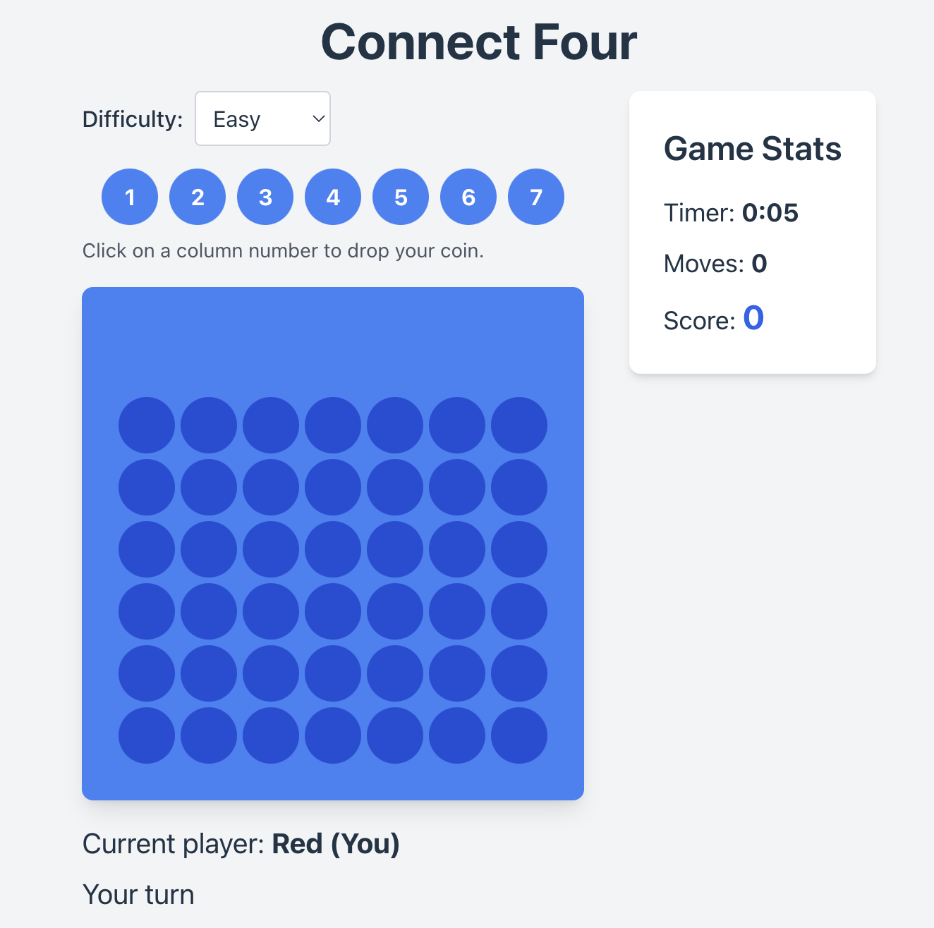
- Website Outline/ Looks:
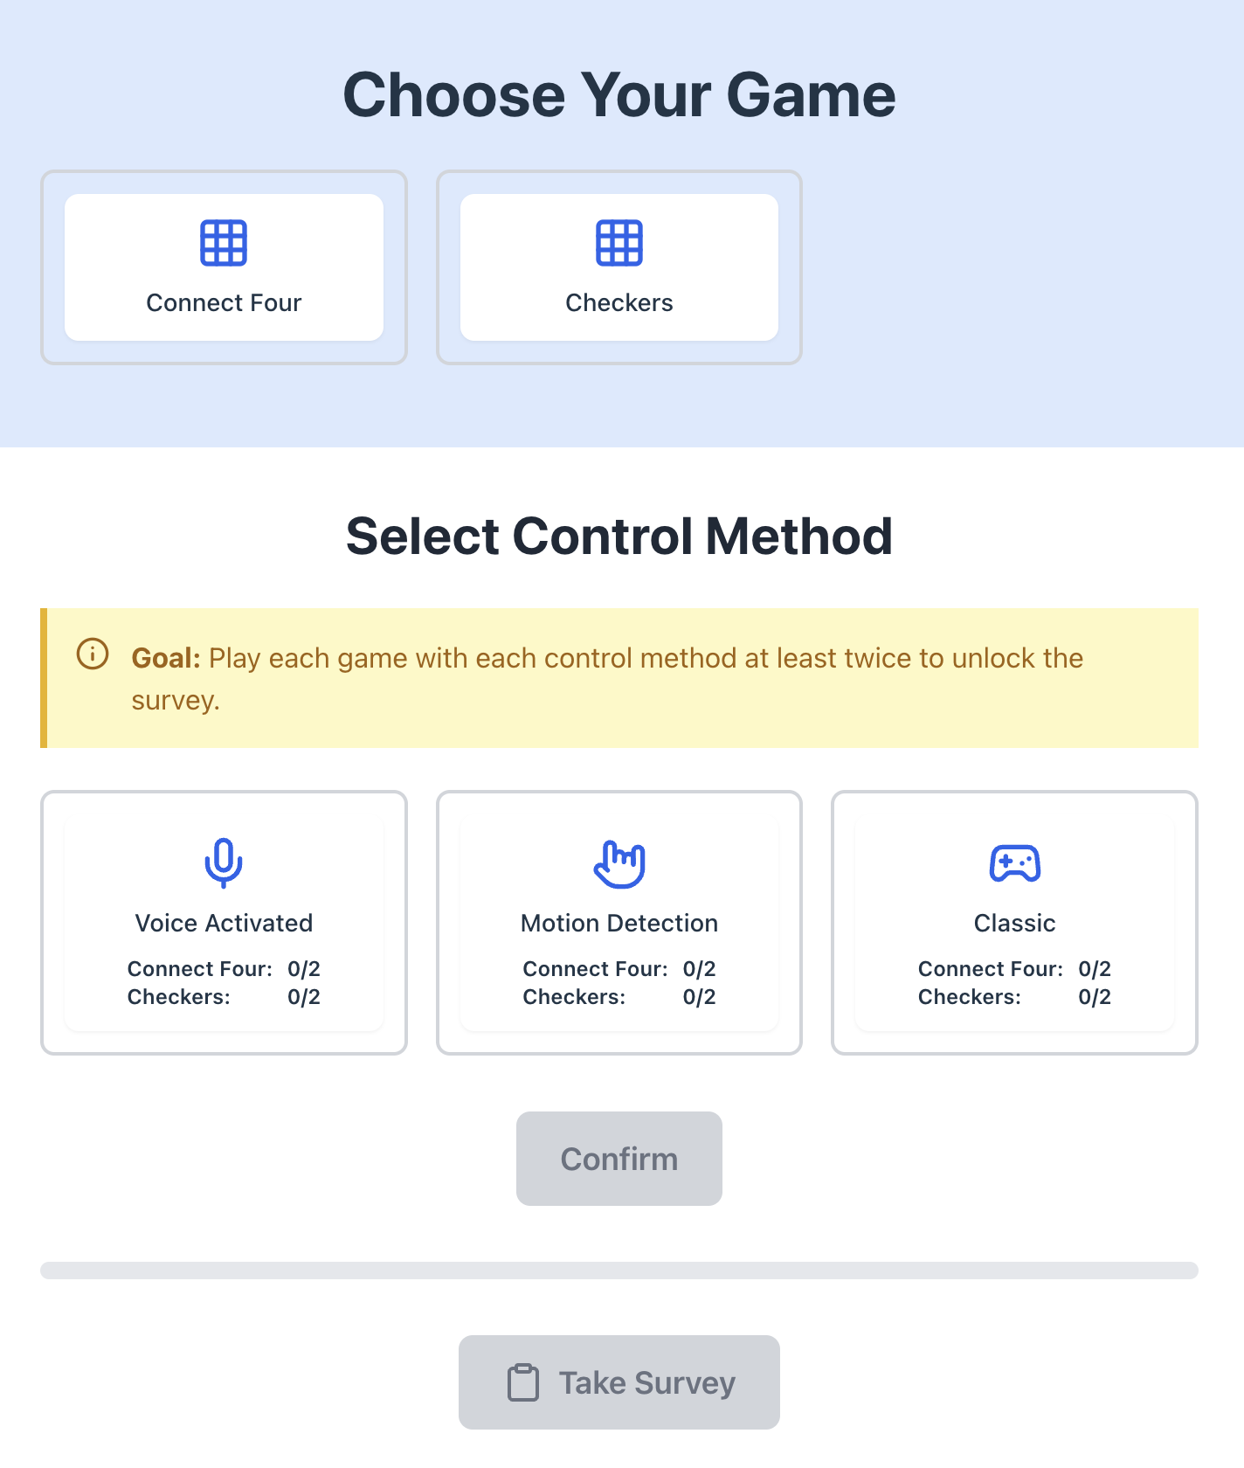
- Checkers Outcome:
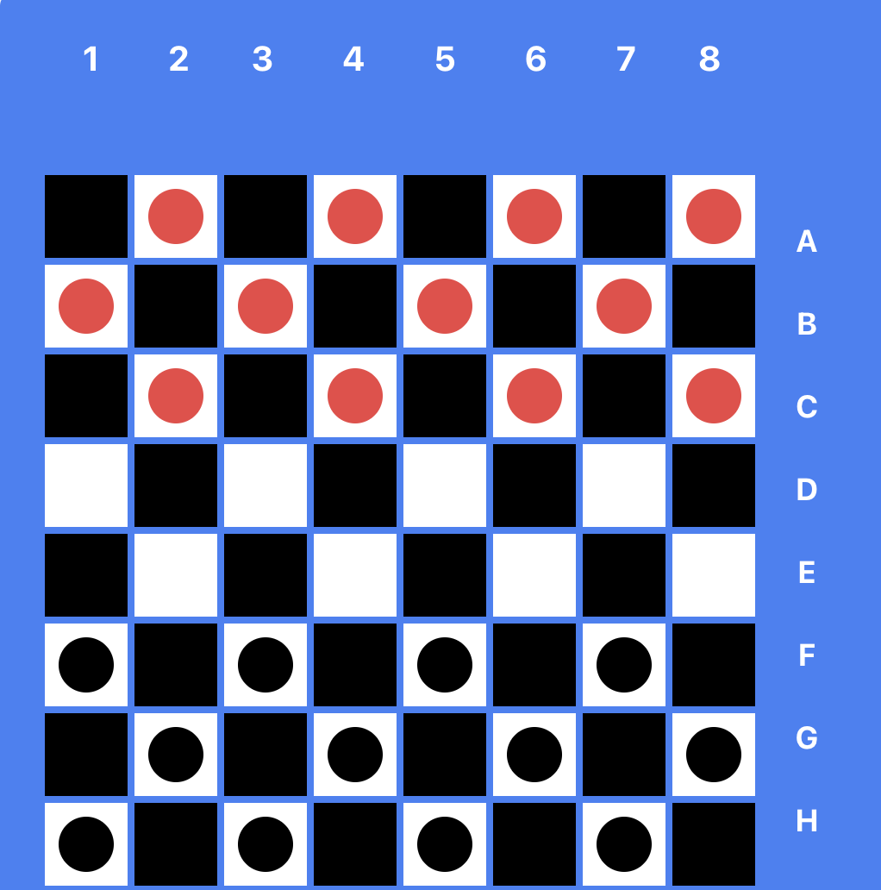

Wednesday, November 27, 2024:
- Code for Checkers outline/ when pressing a draught/square:
- import React, { useEffect } from 'react';

- const CheckerBoard = ({ board, hoverColumn, currentPlayer, onSquareClick, firstRun, onFirstRun }) => {

- const labels = ['A', 'B', 'C', 'D', 'E', 'F', 'G', 'H'];

- return (
- // Column Numbers
- <div className="bg-blue-500 p-6 rounded-lg shadow-lg">
- <div className="text-xl text-white font-bold flex space-x-4 space-x-reverse">
- <div className="indent-6">1</div>
- <div className="indent-10">2</div>
- <div className="indent-5">3</div>
- <div className="indent-6">4</div>
- <div className="indent-6">5</div>
- <div className="indent-6">6</div>
- <div className="indent-6">7</div>
- <div className="indent-5">8</div>
- </div>
- <div className="flex mb-2">
- {/* <p class="text-white font-bold text-xl indent-6 tracking-widest ps-8">1 2 3 4 5 6 7 8</p> */}
- {/* Makes the Board and */}
- {board[0].map((_, colIndex) => (
- <div key={colIndex} className="w-10 h-10 m-0.5 flex items-center justify-center">
- {hoverColumn === colIndex && (
- <div
- className={`w-8 h-8 rounded-full ${
- currentPlayer === 1 ? 'bg-red-500' : 'bg-black'
- } opacity-50`}
- />
- )}

- </div>
- ))}
- </div>

- {/* The Row Numbers (A, B, C...) */}
- <div className="flex justify-center text-white indent-2 space-y-4">

- <div>
- {board.map((row, rowIndex, column, columnIndex) => (
- <div key={rowIndex} className="flex">
- {row.map((_, colIndex) => {
- // Determine piece based on row and column index
- let piece = null;
- if (rowIndex < 3 && (rowIndex + colIndex) % 2 === 1) {
- piece = 'red'; // Red pieces in the first 3 rows

- } else if (rowIndex > 4 && (rowIndex + colIndex) % 2 === 1) {
- piece = 'black'; // Black pieces in the last 3 rows
- }

- return (
- <button
- key={colIndex}
- className={`w-12 h-12 ${
- (rowIndex + colIndex) % 2 === 0 ? 'bg-black' : 'bg-white'
- } m-0.5 rounded-none flex items-center justify-center focus:outline-none focus:ring-2 focus:ring-white`}
- onClick={() => onSquareClick(rowIndex, colIndex)}
- disabled={!piece} // Disable buttons without pieces
- aria-label={`Row ${rowIndex + 1}, Column ${colIndex + 1}`}
- >
- {piece && (
- <div
- className={`w-8 h-8 rounded-full ${
- piece === 'red' ? 'bg-red-500' : 'bg-black'
- }`}
- aria-label={`${piece.charAt(0).toUpperCase() + piece.slice(1)} piece`}
- />
- )}
- </button>
- );
- })}
- </div>

- ))}
- </div>

- <div className="flex flex-col items-center">
- {labels.map((label, index) => (
- // Blue background where the checkers board is held
- <div key={index} className="w-12 h-12 flex items-center justify-center">
- <span className="text-lg font-bold">{label}</span>
- </div>
- ))}
- </div>
- </div>
- </div>
- );
- };

- export default CheckerBoard;

//imported modules/ functions
import React, { useState, useCallback, useEffect, useRef } from 'react';
import { useNavigate } from 'react-router-dom';
//CheckersBoard is what I coded from other module
import CheckerBoard from './CheckerBoard';
//Taken from what I coded from other module named CheckersLogic
import { viewOptions } from './CheckersLogic';
import { ArrowLeft } from 'lucide-react';
import WinningPopup from '../../components/WinningPopup';

const CheckerGame = ({ Control }) => {
const initialBoard = Array(8)
.fill(null)
.map((_, rowIndex) =>
Array(8)
.fill(0)
.map((_, colIndex) => {
if (rowIndex < 3 && (rowIndex + colIndex) % 2 === 1) return 1;
if (rowIndex > 4 && (rowIndex + colIndex) % 2 === 1) return 2;
return 0;
})
);
const [board, setBoard] = useState(initialBoard);

const [currentPlayer, setCurrentPlayer] = useState(1);
const [winner, setWinner] = useState(null);
const [message, setMessage] = useState('Your turn');
const [hoverColumn, setHoverColumn] = useState(null);
const [isPlayerTurn, setIsPlayerTurn] = useState(true);
const [showWinningPopup, setShowWinningPopup] = useState(false);
const [difficulty, setDifficulty] = useState('easy');
const [gameScore, setGameScore] = useState(0);
const [timer, setTimer] = useState(0);
const [moveCount, setMoveCount] = useState(0);
const timerRef = useRef(null);

const [firstRun, setFirstRun] = useState(true);

const [gameStats, setGameStats] = useState(() => {
const savedStats = localStorage.getItem('checkersGameStats');
return savedStats ? JSON.parse(savedStats) : {
voice: 0,
motion: 0,
classical: 0
};
});
const navigate = useNavigate();

useEffect(() => {
timerRef.current = setInterval(() => {
setTimer(prevTimer => prevTimer + 1);
}, 1000);

return () => clearInterval(timerRef.current);
}, []);

const handleColumnHover = useCallback((col) => {
if (winner || !isPlayerTurn) return;
setHoverColumn(col);
}, [winner, isPlayerTurn]);

const updateScore = (newBoard, player) => {
const maxScore = 2000;
const winBonus = 1000;
const movePenalty = 0;
const difficultyMultiplier = difficulty === 'easy' ? 1 : difficulty === 'medium' ? 1.2 : 1.5;

let scoreIncrement = 0;
if (checkWin(newBoard, player)) {
if (player === 1) {
scoreIncrement = winBonus;
} else {
// If bot wins, don't change the score
return;
}
} else {
scoreIncrement = player === 1 ? 20 : 0;
}

// Apply move penalty
scoreIncrement -= movePenalty;

// Apply difficulty multiplier
scoreIncrement = Math.round(scoreIncrement * difficultyMultiplier);

// Ensure the score doesn't exceed the maximum or go below 0
const newScore = Math.max(0, Math.min(maxScore, gameScore + scoreIncrement));
setGameScore(newScore);
};

const onSquareClick = (rowIndex,colIndex) => {
const options = viewOptions(rowIndex,colIndex,board);
highlightOptions(options)
};

const highlightOptions = (options) => {
options.forEach(([row, col]) => {
console.log(`Highlight square at row: ${row}, col: ${col}`);

return(
<div className='m-0.5 rounded-none flex items-center justify-center bg-black'/>
)
});
};

const onFirstRun = () => {
setFirstRun(false)
};

const handlePlace = useCallback((column) => {
if (winner || !isPlayerTurn) return;

const newBoard = makeMove(board, column, row, currentPlayer);
if (newBoard) {
setBoard(newBoard);
setMoveCount(prevCount => prevCount + 1);
updateScore(newBoard, currentPlayer);
if (checkWin(newBoard, currentPlayer)) {
setWinner(currentPlayer);
setMessage("You win!");
setIsPlayerTurn(false);
setShowWinningPopup(true);
updateGameStats();
} else {
setMessage("Bot's turn");
setIsPlayerTurn(false);
setCurrentPlayer(2);
}
} else {
setMessage("Invalid move. Try another column.");
}
setHoverColumn(null);
}, [board, currentPlayer, winner, isPlayerTurn, difficulty, gameScore, moveCount]);

useEffect(() => {
if (currentPlayer === 2 && !winner) {
const botMoveTimeout = setTimeout(() => {
const botBoard = botMove(board, difficulty);
setBoard(botBoard);
setMoveCount(prevCount => prevCount + 1);
updateScore(botBoard, 2);
if (checkWin(botBoard, 2)) {
setWinner(2);
setMessage("Bot wins!");
setShowWinningPopup(true);
updateGameStats();
} else {
setCurrentPlayer(1);
setMessage("Your turn");
setIsPlayerTurn(true);
}
}, 1000);

return () => clearTimeout(botMoveTimeout);
}
}, [currentPlayer, winner, board, difficulty]);

const updateGameStats = () => {
const controlType = Control.name.toLowerCase().replace('control', '');
setGameStats(prevStats => {
const newStats = {
...prevStats,
[controlType]: prevStats[controlType] + 1
};
localStorage.setItem('checkersGameStats', JSON.stringify(newStats));
return newStats;
});
};

const resetGame = () => {
setBoard(initialBoard);
setCurrentPlayer(1);
setWinner(null);
setMessage('Your turn');
setHoverColumn(null);
setIsPlayerTurn(true);
setShowWinningPopup(false);
setTimer(0);
setMoveCount(0);
setGameScore(0);
};

const handleBack = () => {
navigate('/control-selection');
};

const handlePlayAgain = () => {
resetGame();
};

const handleReturnToMain = () => {
navigate('/control-selection');
};

const isClassicalControl = Control && Control.name === 'ClassicalControl';

return (
<div className="flex flex-col items-center justify-center min-h-screen bg-gray-100 p-4 w-screen relative">
<div className="absolute top-4 left-4">
<button
onClick={handleBack}
className="p-2 bg-gray-200 rounded-full hover:bg-gray-300 transition-colors"
aria-label="Back to control method selection"
>
<ArrowLeft size={24} />
</button>
</div>

<h1 className="text-4xl font-bold mb-4">Checkers</h1>

<div className="flex justify-center items-start space-x-8">
<div className="space-y-4">
<div className="mb-4">
<label htmlFor="difficulty" className="mr-2 font-medium">Difficulty:</label>
<select
id="difficulty"
value={difficulty}
onChange={(e) => setDifficulty(e.target.value)}
className="p-2 rounded border border-gray-300 focus:outline-none focus:ring-2 focus:ring-blue-500"
>
<option value="easy">Easy</option>
<option value="medium">Medium</option>
<option value="hard">Hard</option>
</select>
</div>

{isClassicalControl && (
<Control onColumnHover={handleColumnHover} onDrop={handlePlace} isPlayerTurn={isPlayerTurn} />
)}

<CheckerBoard
board={board}
hoverColumn={hoverColumn}
currentPlayer={currentPlayer}
onSquareClick={onSquareClick}
firstRun={firstRun}
onFirstRun={onFirstRun}
/>

{!isClassicalControl && Control && (
<Control onColumnHover={handleColumnHover} onDrop={handlePlace} isPlayerTurn={isPlayerTurn} />
)}

<div className="mt-4 text-xl">
{!winner && (
<p>Current player: <span className="font-bold">{currentPlayer === 1 ? 'Red (You)' : 'Black (Bot)'}</span></p>
)}
{message && <p className="mt-2">{message}</p>}
</div>
</div>

<div className="bg-white p-6 rounded-lg shadow-md space-y-4">
<h2 className="text-2xl font-semibold mb-4">Game Stats</h2>
<div className="space-y-2">
<p className="text-lg">
Timer: <span className="font-bold">{Math.floor(timer / 60)}:{(timer % 60).toString().padStart(2, '0')}</span>
</p>
<p className="text-lg">
Moves: <span className="font-bold">{moveCount}</span>
</p>
<p className="text-lg">
Score: <span className="font-bold text-2xl text-blue-600">{gameScore}</span>
</p>
</div>
</div>
</div>

<WinningPopup
isOpen={showWinningPopup}
winner={winner}
onPlayAgain={handlePlayAgain}
onReturnToMain={handleReturnToMain}
score={gameScore}
/>
</div>
);
};

export default CheckerGame;

export const onSquareClick = (board, player) => {
// finds which spot was clicked on (places draught there)

}

export const makeMove = (board, col, player) => {
const newBoard = board.map(row => [...row]);
for (let r = 5; r >= 0; r--) {
if (newBoard[r][col] === 0) {
newBoard[r][col] = player;
return newBoard;
}
}
return null; // Invalid move
};

const findWinningMove = (board, player) => {
for (let col = 0; col < 7; col++) {
const newBoard = makeMove(board, col, player);
if (newBoard && checkWin(newBoard, player)) {
return col;
}
}
return null;
};

const findBlockingMove = (board, player) => {
const opponent = player === 1 ? 2 : 1;
return findWinningMove(board, opponent);
};

const getAvailableColumns = (board) => {
return board[0].reduce((acc, cell, index) => {
if (cell === 0) acc.push(index);
return acc;
}, []);
};

const evaluateBoard = (board, player) => {
let score = 0;
const opponent = player === 1 ? 2 : 1;

// Check horizontal windows
for (let r = 0; r < 6; r++) {
for (let c = 0; c < 4; c++) {
let window = [board[r][c], board[r][c+1], board[r][c+2], board[r][c+3]];
score += evaluateWindow(window, player, opponent);
}
}

// Check vertical windows
for (let r = 0; r < 3; r++) {
for (let c = 0; c < 7; c++) {
let window = [board[r][c], board[r+1][c], board[r+2][c], board[r+3][c]];
score += evaluateWindow(window, player, opponent);
}
}

// Check diagonal windows
for (let r = 0; r < 3; r++) {
for (let c = 0; c < 4; c++) {
let window = [board[r][c], board[r+1][c+1], board[r+2][c+2], board[r+3][c+3]];
score += evaluateWindow(window, player, opponent);
}
}

for (let r = 3; r < 6; r++) {
for (let c = 0; c < 4; c++) {
let window = [board[r][c], board[r-1][c+1], board[r-2][c+2], board[r-3][c+3]];
score += evaluateWindow(window, player, opponent);
}
}

return score;
};

const evaluateWindow = (window, player, opponent) => {
const playerCount = window.filter(cell => cell === player).length;
const opponentCount = window.filter(cell => cell === opponent).length;
const emptyCount = window.filter(cell => cell === 0).length;

if (playerCount === 4) return 100;
if (playerCount === 3 && emptyCount === 1) return 5;
if (playerCount === 2 && emptyCount === 2) return 2;
if (opponentCount === 3 && emptyCount === 1) return -4;
return 0;
};

export const botMove = (board, difficulty = 'medium') => {
const availableCols = getAvailableColumns(board);
if (availableCols.length === 0) return board; // No move possible

let moveCol;

switch (difficulty) {
case 'easy':
moveCol = easyMove(board, availableCols);
break;
case 'medium':
moveCol = mediumMove(board, availableCols);
break;
case 'hard':
moveCol = hardMove(board, availableCols);
break;
default:
throw new Error('Invalid difficulty level');
}

return makeMove(board, moveCol, 2);
};

const easyMove = (board, availableCols) => {
if (Math.random() < 0.4) { // 40% chance of random move
return availableCols[Math.floor(Math.random() * availableCols.length)];
} else {
return findWinningMove(board, 2) ||
findBlockingMove(board, 2) ||
availableCols[Math.floor(Math.random() * availableCols.length)];
}
};

const mediumMove = (board, availableCols) => {
return findWinningMove(board, 2) ||
findBlockingMove(board, 2) ||
findBestMove(board, 2, 3); // Look 3 moves ahead
};

const hardMove = (board, availableCols) => {
return findBestMove(board, 2, 5); // Look 5 moves ahead
};

const findBestMove = (board, player, depth) => {
const availableCols = getAvailableColumns(board);
let bestScore = player === 2 ? -Infinity : Infinity;
let bestMove = availableCols[0];

for (let col of availableCols) {
const newBoard = makeMove(board, col, player);
const score = minimax(newBoard, depth - 1, -Infinity, Infinity, player === 1);

if (player === 2) {
if (score > bestScore) {
bestScore = score;
bestMove = col;
}
} else {
if (score < bestScore) {
bestScore = score;
bestMove = col;
}
}
}

return bestMove;
};
const minimax = (board, depth, alpha, beta, maximizingPlayer) => {
if (depth === 0 || checkWin(board, 1) || checkWin(board, 2)) {
return evaluateBoard(board, 2);
}

const availableCols = getAvailableColumns(board);

if (maximizingPlayer) {
let maxEval = -Infinity;
for (let col of availableCols) {
const newBoard = makeMove(board, col, 2);
const evalScore = minimax(newBoard, depth - 1, alpha, beta, false);
maxEval = Math.max(maxEval, evalScore);
alpha = Math.max(alpha, evalScore);
if (beta <= alpha) break;
}
return maxEval;
} else {
let minEval = Infinity;
for (let col of availableCols) {
const newBoard = makeMove(board, col, 1);
const evalScore = minimax(newBoard, depth - 1, alpha, beta, true);
minEval = Math.min(minEval, evalScore);
beta = Math.min(beta, evalScore);
if (beta <= alpha) break;
}
return minEval;
}
};

export const viewOptions = (rowIndex, colIndex, board) => {
// Define the options array
const options = [];

// Assuming board is an 8x8 array where:
// 0 = empty, 1 = red piece, 2 = black piece
const piece = board[rowIndex][colIndex];

if (piece === 1) {
// Red piece: moves "downwards" (to higher row indices)
if (rowIndex + 1 < 8) {
if (colIndex - 1 >= 0 && board[rowIndex + 1][colIndex - 1] === 0) {
options.push([rowIndex + 1, colIndex - 1]); // Diagonal left
}
if (colIndex + 1 < 8 && board[rowIndex + 1][colIndex + 1] === 0) {
options.push([rowIndex + 1, colIndex + 1]); // Diagonal right
}
}
} else if (piece === 2) {
// Black piece: moves "upwards" (to lower row indices)
if (rowIndex - 1 >= 0) {
if (colIndex - 1 >= 0 && board[rowIndex - 1][colIndex - 1] === 0) {
options.push([rowIndex - 1, colIndex - 1]); // Diagonal left
}
if (colIndex + 1 < 8 && board[rowIndex - 1][colIndex + 1] === 0) {
options.push([rowIndex - 1, colIndex + 1]); // Diagonal right
}
}
}

console.log(`Options for piece at (${rowIndex}, ${colIndex}):`, options);
return options;
};

- Programming Logic/ Thinking:
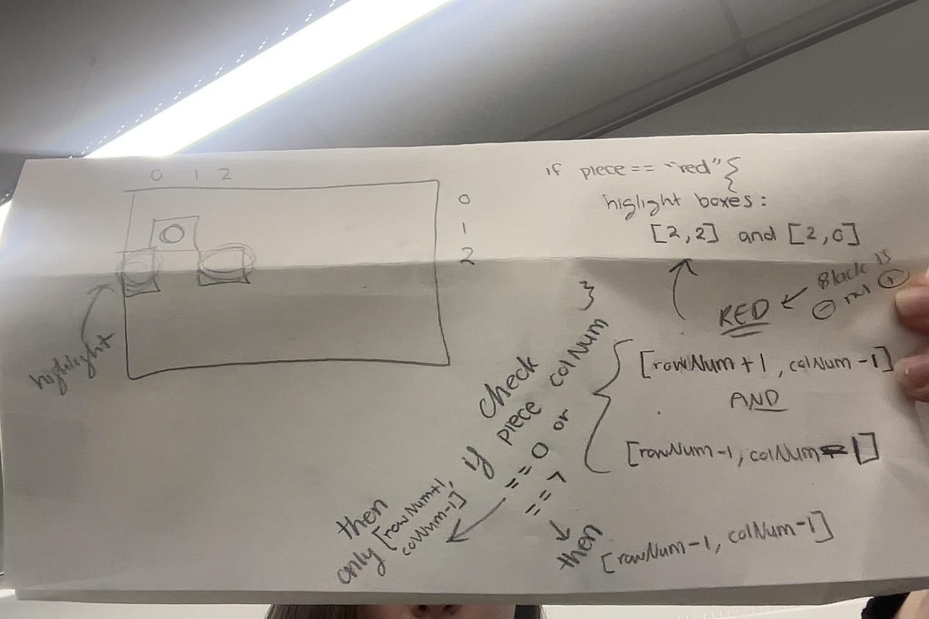

Friday, November 29, 2024:
ASP CLASS:
- Organized Logbook
  - Edited Schedule for December
- Goals updated
- MAIN GOAL:
- Finish programming by end of December
- Edited Research Paper format and content in introduction: https://docs.google.com/document/d/1-kezICPB2MxYLc4y3_UsT9tY-DksXOnOabYcRZqGSWg/edit?tab=t.0#heading=h.f75hj4rcazs7
- Connect 4 Classical Control Code:
import React from 'react';

const ClassicalControl = ({gameType, onColumnHover, onDrop }) => {
const handleColumnClick = (columnIndex) => {
onColumnHover(columnIndex);
onDrop(columnIndex); // Pass the columnIndex to onDrop
};

if (gameType == 'connect4'){
return (
<div classNasme="classical-control mt-4">
<div className="flex justify-center space-x-2">
{[0, 1, 2, 3, 4, 5, 6].map((columnIndex) => (
<button
key={columnIndex}
onClick={() => handleColumnClick(columnIndex)}
setHoverColumn
className="w-10 h-10 bg-blue-500 hover:bg-blue-600 text-white font-bold rounded-full focus:outline-none focus:ring-2 focus:ring-blue-400 transition-colors"
aria-label={`Drop in column ${columnIndex + 1}`}
>
{columnIndex + 1}
</button>
))}
</div>
<p className="mt-2 text-sm text-gray-600">
Click on a column number to drop your coin.
</p>
</div>
);
}

//checkers
else{
return (
<div classNasme="classical-control mt-4">
<div className="flex justify-center space-x-2">
{/* {["A", "B", "C", "D", "E", "F", "G", "H"].map(rowIndex)} */}
{/* {[0, 1, 2, 3, 4, 5, 6, 7].map((columnIndex) => (
<button
key={columnIndex}
onClick={() => onSquareClick(rowIndex,columnIndex)}
setHoverColumn
className="w-10 h-10 bg-blue-500 hover:bg-blue-600 text-white font-bold rounded-full focus:outline-none focus:ring-2 focus:ring-blue-400 transition-colors"
aria-label={`Drop in column ${columnIndex + 1}`}
>
{columnIndex + 1}
</button>
))} */}
</div>
<p className="mt-2 text-sm text-gray-600">
Click on a square to place your draught. A draught outlined in gold is a king.
</p>
</div>
);

}

}

export default ClassicalControl;

- Connect 4 Speech Recognition Code:
import React, { useState, useEffect, useCallback, useRef } from 'react';

// const = constant value
const VoiceControl = ({ onColumnHover, onDrop, isPlayerTurn }) => {
const [transcript, setTranscript] = useState('');
const [isListening, setIsListening] = useState(false);
const recognitionRef = useRef(null);
const [selectedColumn, setSelectedColumn] = useState(null);
const [isMicrophoneAvailable, setIsMicrophoneAvailable] = useState(true);

const interpretCommand = useCallback((command) => {
//console.log('Interpreting command:', command);

const numberMap = {
// Zero
'zero': 0, 'oh': 0, 'null': 0, 'nought': 0,

// One
'one': 0, 'won': 0, 'juan': 0, 'wun': 0, 'hun': 0,

// Two
'two': 1, 'to': 1, 'too': 1, 'tu': 1, 'tew': 1,

// Three
'three': 2, 'tree': 2, 'free': 2, 'thee': 2,

// Four
'four': 3, 'for': 3, 'fore': 3, 'foor': 3,

// Five
'five': 4, 'fife': 4, 'fiev': 4, 'faiv': 4,

// Six
'six': 5, 'sicks': 5, 'sex': 5, 'sics': 5,

// Seven
'seven': 6, 'heaven': 6, 'sven': 6, 'sevin': 6,

// Other potential confusions
'or': 3, 'oar': 3,
'want': 0, 'wont': 0,
'twelfth': 1,
'fourth': 3,
'quarter': 3,
'v': 5,

// Numerals
'0': 0, '1': 0, '2': 1, '3': 2, '4': 3, '5': 4, '6': 5, '7': 6
};

let newColumn = null;
// for every word check if it includes word in our numberMap
for (const [word, col] of Object.entries(numberMap)) {
if (command.includes(word)) {
// set column
newColumn = col;
break;
}
}

// logging and setting column
if (newColumn !== null) {
// console.log('Column selected:', newColumn);
setSelectedColumn(newColumn);
onColumnHover(newColumn);
}

// if drop
if (command.includes('drop' || 'dropped')) {

// check if player turn, and a column is selected
if (isPlayerTurn && (selectedColumn !== null || newColumn !== null)) {
// if the user did not select a new column it will use previous column
const columnToDrop = newColumn !== null ? newColumn : selectedColumn;

// drop execution
onDrop(columnToDrop);
setSelectedColumn(null);
stopListening();
} else {
console.log('Drop command ignored - not player\'s turn or no column selected');
}
}
}, [onColumnHover, onDrop, isPlayerTurn, selectedColumn]);

const startListening = useCallback(() => {
if (recognitionRef.current) {
recognitionRef.current.start();
setIsListening(true);
}
}, []);

const stopListening = useCallback(() => {
if (recognitionRef.current) {
recognitionRef.current.stop();
setIsListening(false);
}
}, []);

useEffect(() => {

// turn on speech recognition api
if (!('webkitSpeechRecognition' in window)) {
alert('Your browser does not support speech recognition. Please use Chrome or Edge.');
setIsMicrophoneAvailable(false);
return;
}

// starting up listener window
recognitionRef.current = new window.webkitSpeechRecognition();
recognitionRef.current.continuous = true;
recognitionRef.current.interimResults = true;
recognitionRef.current.lang = 'en-US';

recognitionRef.current.onstart = () => {
console.log('Speech recognition started');
setIsListening(true);
};

// getting result text
recognitionRef.current.onresult = (event) => {
const lastResult = event.results[event.results.length - 1];
const text = lastResult[0].transcript.toLowerCase().trim();
setTranscript(text);
if (lastResult.isFinal) {
interpretCommand(text);
}
};

// error check
recognitionRef.current.onerror = (event) => {
console.error('Speech recognition error', event.error);
if (event.error === 'not-allowed') {
setIsMicrophoneAvailable(false);
}
};

// end check
recognitionRef.current.onend = () => {
console.log('Speech recognition ended');
setIsListening(false);
};

return () => {
if (recognitionRef.current) {
recognitionRef.current.stop();
}
};
}, [interpretCommand]);

useEffect(() => {
if (isPlayerTurn && !isListening) {
startListening();
}
}, [isPlayerTurn, isListening, startListening]);

const toggleRecognition = useCallback(() => {
if (isListening) {
stopListening();
} else {
startListening();
}
}, [isListening, startListening, stopListening]);

return (
<div className="voice-control bg-blue-100 p-4 rounded-lg shadow-md mt-4 text-center">
<button
onClick={toggleRecognition}
className={`px-4 py-2 rounded-full font-semibold text-white shadow-md transition duration-300 ease-in-out ${
isListening
? 'bg-red-500 hover:bg-red-600 focus:ring-red-400'
: 'bg-green-500 hover:bg-green-600 focus:ring-green-400'
} focus:outline-none focus:ring-2 focus:ring-opacity-50`}
disabled={!isMicrophoneAvailable}
>
{isListening ? 'Stop' : 'Start'} Voice Recognition
</button>
<p className="mt-2 text-sm text-gray-600">
Recognized Text: <span className="font-medium">{transcript}</span>
</p>
<p className="mt-2 text-sm text-blue-800">
Say a number (1-7) to select a column, then say "drop" to place your coin.
{isPlayerTurn ? " It's your turn." : " Waiting for the bot to play..."}
</p>
<p className="mt-2 text-sm text-gray-600">
Selected Column: {selectedColumn !== null ? selectedColumn + 1 : 'None'}
</p>
<p className="mt-2 text-sm text-gray-600">
Microphone: {isListening ? 'On' : 'Off'}
</p>
{!isMicrophoneAvailable && (
<p className="mt-2 text-sm text-red-600">
Microphone access is blocked. Please check your browser settings and grant microphone permissions.
</p>
)}
</div>
);
};

export default VoiceControl;

- Connect 4 Gesture Tracking Code:
import React, { useEffect, useRef, useState, useCallback } from 'react';
// Google APIs
import { Hands } from '@mediapipe/hands';
import * as cam from '@mediapipe/camera_utils';

const MotionControl = ({ onColumnHover, onDrop, isPlayerTurn, gameState }) => {
const videoRef = useRef(null);
const canvasRef = useRef(null);
const lastDropTimeRef = useRef(0);
const [column, setColumn] = useState(null);
const cooldownPeriod = 1000; // 1 second cooldown
const handDetectedRef = useRef(false);

const onResults = useCallback((results) => {

// frame refresh
const canvasCtx = canvasRef.current.getContext('2d');
canvasCtx.save();
canvasCtx.clearRect(0, 0, canvasRef.current.width, canvasRef.current.height);
canvasCtx.drawImage(results.image, 0, 0, canvasRef.current.width, canvasRef.current.height);

// if hand is detected
if (results.multiHandLandmarks && results.multiHandLandmarks.length > 0) {
handDetectedRef.current = true;
// process gestures if it is the players turn
if (isPlayerTurn) {

// track x-coordinate of the index finger
// 0 (leftmost edge of screen) to 1 (rightmost edge of screen)
const landmarks = results.multiHandLandmarks[0];
const tipX = landmarks[8].x;

// this separates the screen in into 7 equal parts
// by taking the fingertip position (0-1) and multiplying it
const newColumn = Math.floor(tipX * 7);

// check if column has changed
if (newColumn !== column) {
setColumn(newColumn);
onColumnHover(newColumn);
}

// check if pinch
const thumbTip = landmarks[4];
const indexTip = landmarks[8];

// calculate finger distances --> Eucilidan Distances (3D)
const distance = Math.sqrt(
Math.pow(thumbTip.x - indexTip.x, 2) +
Math.pow(thumbTip.y - indexTip.y, 2)
);

// adding delay
// get the time of pinch
const currentTime = Date.now();

// check if the time of the last pinch and the current pinch is greater than cooldown
if (distance < 0.1 && currentTime - lastDropTimeRef.current > cooldownPeriod) {
// console.log('MotionControl: Attempting to drop coin in column:', newColumn);
onDrop(newColumn);
lastDropTimeRef.current = currentTime;
}
}
} else {
handDetectedRef.current = false;
}

canvasCtx.restore();
}, [column, onColumnHover, onDrop, isPlayerTurn, cooldownPeriod]);

useEffect(() => {

// hand tracker api
const hands = new Hands({
locateFile: (file) => {
return `https://cdn.jsdelivr.net/npm/@mediapipe/hands/${file}`;
}
});

// settings
hands.setOptions({
maxNumHands: 1,
modelComplexity: 1,
minDetectionConfidence: 0.5,
minTrackingConfidence: 0.5
});

hands.onResults(onResults);

if (videoRef.current) {
const camera = new cam.Camera(videoRef.current, {
onFrame: async () => {
await hands.send({ image: videoRef.current });
},
width: 640,
height: 480
});
camera.start();
}

return () => {
// console.log('MotionControl: Component unmounting');
hands.close();
};
}, [onResults]);

useEffect(() => {
//console.log('MotionControl: isPlayerTurn changed:', isPlayerTurn);
}, [isPlayerTurn]);

return (
<div className="motion-control relative">
<video ref={videoRef} className="input_video hidden"></video>
<canvas ref={canvasRef} className="output_canvas" width="640px" height="480px"></canvas>
<p className="mt-2 text-sm text-blue-800">
Move your hand left and right to select a column. Pinch your thumb and index finger to drop a coin.
{isPlayerTurn ? " It's your turn." : " Waiting for the bot to play..."}
</p>
<p className="mt-2 text-sm text-gray-600">
Hand detected: {handDetectedRef.current ? 'Yes' : 'No'}
</p>
</div>
);
};

export default MotionControl;

Thursday, December 5, 2024:
ASP CLASS NOTES(42 min):
- Next assignment is the Introduction section of the research paper
  - DUE JANUARY 21
    - READ
  - Take core from the background research from project proposal
    - Improve flow and depth (with Dr. Garcia recommendations/ comments)
- A month later methods will be due
  - DUE FEBRUARY 19
  - The methods section has to be very in depth + anyone can copy the procedure
    - All details, equipments, software, statistics have to be referenced
  - TAKE NOTE OF EVERY STEP AND EVERY DETAIL
    - Ex: Membranes were incubated at 37 degrees celsius under continuous shaking using an orbital shaker → the shaker is a tool = MUST WRITE (model, manufacturer, city/country)
  - Technique/ software → excel TM (excel 2021(version)) was utilized to graph.
    - Have to cite libraries in javascript as a SOURCE
      - If method published → the __ was __ as referred by
  - ALWAYS PRESENT PERFECT + NO I/WE/PERSONAL PRONOUNS
    - Mimic methods of papers you have been reading
    - How did they mention the software, the library, how did they source ___
- Start thinking about posters (do you want a trifold or a smaller poster)
- Check in with Dr. Garcia about the presentations + diagrams + anything else if you need help
- The presentation style in class is not the same as in front of the poster
- Introduction with research question and goals.

- Wrote in the Experimental Procedure section of the logbook

Monday, December 9, 2024:
ASP CLASS:
- Worked on Experimental Procedure (Logbook section)
- Studied for biology test

Wednesday, December 11, 2024:
ASP CLASS NOTES(10min):
- Meeting with mentor about december plans / the break
  - Announce date of midterms (January 10-21)
  - Summary of the results and status
    - CHECK IN
  - Next meeting after midterms
- DO NOT LEAVE YOUR MENTORS WITHOUT ANY COMMUNICATION
- Have long range plan for science fair (GIVE YOURSELF TIME TO PROCESS THE INFORMATION AND RESULTS→ UNDERSTAND EVERYTHING)

- Worked on Experimental Procedure/ Methodologies (Logbook section)
- Studied for math and chemistry tests

Friday, December 13, 2024:
ASP CLASS NOTES (26min):
- Worked on Experimental Procedures
  - When you write the figures → no box + on the left of the paper
- Studied for Physics Test

Thursday, December 19, 2024:
ASP CLASS NOTES (35min):
- Chem POGIL

Monday, December 30, 2024:
- Made a google survey: https://docs.google.com/forms/d/1EnvjSHwl1BuN2YTCWxRPnBOZJCbZGjJZkxEaYXbaeLQ/edit
- const handleSurveyOpen = () => {

- window.location.href = 'https://docs.google.com/forms/d/e/1FAIpQLSfTifHQwaAPx-3sFtevV9KAC8lMG6Whkr8_PYKZYI7mNoyQpQ/viewform?usp=header';
- };
- This code: if the user presses the Survey button, they will be redirected to the survey form

Tuesday, December 31, 2024:
- Coded website → behind schedule (post first week of school)
import React from 'react';

const CheckerBoard = ({
board,
onMove,
onPieceSelect,
currentPlayer,
isPlayerTurn,
hoveredCell,
selectedPiece,
possibleMoves,
handlePieceSelect
}) => {
const handleSquareClick = (rowIndex, colIndex) => {
if (!isPlayerTurn) return;

const piece = board[rowIndex][colIndex];

// If clicking a highlighted square (valid move)
if (selectedPiece && possibleMoves.some(([row, col]) => row === rowIndex && col === colIndex)) {
onMove(selectedPiece, [rowIndex, colIndex]); // Use onMove instead of onSquareClick
}
// If clicking a black piece or black queen
else if ((piece === 2 || piece === 4) && isPlayerTurn) {
onPieceSelect([rowIndex, colIndex]);
}
// If clicking anywhere else, clear selection
else {
onPieceSelect(null);
}
};

const isHighlighted = (rowIndex, colIndex) => {
return possibleMoves.some(([row, col]) => row === rowIndex && col === colIndex);
};

const renderPiece = (piece) => {
if (piece === 0) return null;

let pieceClasses = "w-8 h-8 rounded-full flex items-center justify-center ";
if (piece === 1) pieceClasses += "bg-red-500"; // Red piece
else if (piece === 2) pieceClasses += "bg-black"; // Black piece
else if (piece === 3) pieceClasses += "bg-red-500 border-2 border-yellow-400"; // Red queen
else if (piece === 4) pieceClasses += "bg-black border-2 border-yellow-400"; // Black queen

if ((piece === 2 || piece === 4) && isPlayerTurn) {
pieceClasses += " cursor-pointer hover:ring-2 hover:ring-blue-400";
}

return (
<div className={pieceClasses}>
{(piece === 3 || piece === 4) && (
<span className="text-yellow-400 font-bold">♕</span>
)}
</div>
);
};

return (
<div className="bg-blue-500 p-6 rounded-lg shadow-lg">
<div className="text-xl text-white font-bold mb-2 pl-8 flex justify-around px-2">
{[1, 2, 3, 4, 5, 6, 7, 8].map(num => (
<div key={num}>{ num }</div>
))}
</div>
<div className="flex">
<div className="flex flex-col justify-around py-2 pr-4">
{['A', 'B', 'C', 'D', 'E', 'F', 'G', 'H'].map(letter => (
<div key={letter} className="text-white font-bold">{letter}</div>
))}
</div>
<div>
{board.map((row, rowIndex) => (
<div key={rowIndex} className="flex">
{row.map((cell, colIndex) => {
const isSelected = selectedPiece &&
selectedPiece[0] === rowIndex &&
selectedPiece[1] === colIndex;

const isHovered = hoveredCell &&
hoveredCell[0] === rowIndex &&
hoveredCell[1] === colIndex;

return (
<button
key={colIndex}
className={`w-12 h-12
${(rowIndex + colIndex) % 2 === 0 ? 'bg-gray-300' : 'bg-gray-700'}
${isHighlighted(rowIndex, colIndex) ? 'ring-2 ring-yellow-400' : ''}
${isSelected ? 'ring-2 ring-blue-400' : ''}
${isHovered ? 'ring-4 ring-purple-400 ring-opacity-75' : ''}
relative flex items-center justify-center focus:outline-none
transition-all duration-200`}
onClick={() => handleSquareClick(rowIndex, colIndex)}
disabled={!isPlayerTurn}
>
{renderPiece(board[rowIndex][colIndex])}
{isHighlighted(rowIndex, colIndex) && (
<div className="absolute inset-0 bg-yellow-300 opacity-30" />
)}
{isHovered && (
<div className="absolute inset-0 bg-purple-300 opacity-20" />
)}
</button>
);
})}
</div>
))}
</div>
</div>
<div className="mt-4 text-white text-center font-bold">
{isPlayerTurn ? "Your Turn" : "Computer's Turn"}
</div>
</div>
);
};

export default CheckerBoard;

Thursday, January 2, 2025:
- Coded more of checkers for website:
export const onSquareClick = (board, player) => {
// finds which spot was clicked on (places draught there)

}

export const makeMove = (board, col, player) => {
const newBoard = board.map(row => [...row]);
for (let r = 5; r >= 0; r--) {
if (newBoard[r][col] === 0) {
newBoard[r][col] = player;
return newBoard;
}
}
return null; // Invalid move
};

const findWinningMove = (board, player) => {
for (let col = 0; col < 7; col++) {
const newBoard = makeMove(board, col, player);
if (newBoard && checkWin(newBoard, player)) {
return col;
}
}
return null;
};

const findBlockingMove = (board, player) => {
const opponent = player === 1 ? 2 : 1;
return findWinningMove(board, opponent);
};

const getAvailableColumns = (board) => {
return board[0].reduce((acc, cell, index) => {
if (cell === 0) acc.push(index);
return acc;
}, []);
};

const evaluateBoard = (board, player) => {
let score = 0;
const opponent = player === 1 ? 2 : 1;

// Check horizontal windows
for (let r = 0; r < 6; r++) {
for (let c = 0; c < 4; c++) {
let window = [board[r][c], board[r][c+1], board[r][c+2], board[r][c+3]];
score += evaluateWindow(window, player, opponent);
}
}

// Check vertical windows
for (let r = 0; r < 3; r++) {
for (let c = 0; c < 7; c++) {
let window = [board[r][c], board[r+1][c], board[r+2][c], board[r+3][c]];
score += evaluateWindow(window, player, opponent);
}
}

// Check diagonal windows
for (let r = 0; r < 3; r++) {
for (let c = 0; c < 4; c++) {
let window = [board[r][c], board[r+1][c+1], board[r+2][c+2], board[r+3][c+3]];
score += evaluateWindow(window, player, opponent);
}
}

for (let r = 3; r < 6; r++) {
for (let c = 0; c < 4; c++) {
let window = [board[r][c], board[r-1][c+1], board[r-2][c+2], board[r-3][c+3]];
score += evaluateWindow(window, player, opponent);
}
}

return score;
};

const evaluateWindow = (window, player, opponent) => {
const playerCount = window.filter(cell => cell === player).length;
const opponentCount = window.filter(cell => cell === opponent).length;
const emptyCount = window.filter(cell => cell === 0).length;

if (playerCount === 4) return 100;
if (playerCount === 3 && emptyCount === 1) return 5;
if (playerCount === 2 && emptyCount === 2) return 2;
if (opponentCount === 3 && emptyCount === 1) return -4;
return 0;
};

export const botMove = (board, difficulty = 'medium') => {
const availableCols = getAvailableColumns(board);
if (availableCols.length === 0) return board; // No move possible

let moveCol;

switch (difficulty) {
case 'easy':
moveCol = easyMove(board, availableCols);
break;
case 'medium':
moveCol = mediumMove(board, availableCols);
break;
case 'hard':
moveCol = hardMove(board, availableCols);
break;
default:
throw new Error('Invalid difficulty level');
}

return makeMove(board, moveCol, 2);
};

const easyMove = (board, availableCols) => {
if (Math.random() < 0.4) { // 40% chance of random move
return availableCols[Math.floor(Math.random() * availableCols.length)];
} else {
return findWinningMove(board, 2) ||
findBlockingMove(board, 2) ||
availableCols[Math.floor(Math.random() * availableCols.length)];
}
};

const mediumMove = (board, availableCols) => {
return findWinningMove(board, 2) ||
findBlockingMove(board, 2) ||
findBestMove(board, 2, 3); // Look 3 moves ahead
};

const hardMove = (board, availableCols) => {
return findBestMove(board, 2, 5); // Look 5 moves ahead
};

const findBestMove = (board, player, depth) => {
const availableCols = getAvailableColumns(board);
let bestScore = player === 2 ? -Infinity : Infinity;
let bestMove = availableCols[0];

for (let col of availableCols) {
const newBoard = makeMove(board, col, player);
const score = minimax(newBoard, depth - 1, -Infinity, Infinity, player === 1);

if (player === 2) {
if (score > bestScore) {
bestScore = score;
bestMove = col;
}
} else {
if (score < bestScore) {
bestScore = score;
bestMove = col;
}
}
}

return bestMove;
};
const minimax = (board, depth, alpha, beta, maximizingPlayer) => {
if (depth === 0 || checkWin(board, 1) || checkWin(board, 2)) {
return evaluateBoard(board, 2);
}

const availableCols = getAvailableColumns(board);

if (maximizingPlayer) {
let maxEval = -Infinity;
for (let col of availableCols) {
const newBoard = makeMove(board, col, 2);
const evalScore = minimax(newBoard, depth - 1, alpha, beta, false);
maxEval = Math.max(maxEval, evalScore);
alpha = Math.max(alpha, evalScore);
if (beta <= alpha) break;
}
return maxEval;
} else {
let minEval = Infinity;
for (let col of availableCols) {
const newBoard = makeMove(board, col, 1);
const evalScore = minimax(newBoard, depth - 1, alpha, beta, true);
minEval = Math.min(minEval, evalScore);
beta = Math.min(beta, evalScore);
if (beta <= alpha) break;
}
return minEval;
}
};

export const viewOptions = (rowIndex, colIndex, board) => {
// Define the options array
const options = [];

// Assuming board is an 8x8 array where:
// 0 = empty, 1 = red piece, 2 = black piece
const piece = board[rowIndex][colIndex];

if (piece === 1) {
// Red piece: moves "downwards" (to higher row indices)
if (rowIndex + 1 < 8) {
if (colIndex - 1 >= 0 && board[rowIndex + 1][colIndex - 1] === 0) {
options.push([rowIndex + 1, colIndex - 1]); // Diagonal left
}
if (colIndex + 1 < 8 && board[rowIndex + 1][colIndex + 1] === 0) {
options.push([rowIndex + 1, colIndex + 1]); // Diagonal right
}
}
} else if (piece === 2) {
// Black piece: moves "upwards" (to lower row indices)
if (rowIndex - 1 >= 0) {
if (colIndex - 1 >= 0 && board[rowIndex - 1][colIndex - 1] === 0) {
options.push([rowIndex - 1, colIndex - 1]); // Diagonal left
}
if (colIndex + 1 < 8 && board[rowIndex - 1][colIndex + 1] === 0) {
options.push([rowIndex - 1, colIndex + 1]); // Diagonal right
}
}
}

console.log(`Options for piece at (${rowIndex}, ${colIndex}):`, options);
return options;
};

Sunday, January 5, 2024:
- Coded the checkers voice and gesture control
import React, { useEffect, useRef, useCallback } from 'react';
import { Hands } from '@mediapipe/hands';
import * as cam from '@mediapipe/camera_utils';

const CheckersMotionControl = ({
onPieceSelect,
onMovePiece,
isPlayerTurn,
board,
selectedPiece,
possibleMoves,
onHoverUpdate
}) => {
const videoRef = useRef(null);
const canvasRef = useRef(null);
const lastActionTimeRef = useRef(0);
const handDetectedRef = useRef(false);
const hands = useRef(null);
const camera = useRef(null);
const cooldownPeriod = 1000;

// Use refs for callbacks to prevent regeneration
const onPieceSelectRef = useRef(onPieceSelect);
const onMovePieceRef = useRef(onMovePiece);
const onHoverUpdateRef = useRef(onHoverUpdate);
const gameStateRef = useRef({ board, selectedPiece, possibleMoves, isPlayerTurn });

// Update refs when props change
useEffect(() => {
onPieceSelectRef.current = onPieceSelect;
onMovePieceRef.current = onMovePiece;
onHoverUpdateRef.current = onHoverUpdate;
gameStateRef.current = {
board,
selectedPiece,
possibleMoves,
isPlayerTurn
};
}, [onPieceSelect, onMovePiece, onHoverUpdate, board, selectedPiece, possibleMoves, isPlayerTurn]);

const getGridPosition = useCallback((x, y) => {
const row = Math.min(Math.floor(y * 8), 7);
const col = Math.min(Math.floor(x * 8), 7);
return [row, col];
}, []);

const onResults = useCallback((results) => {
if (!canvasRef.current || !gameStateRef.current.isPlayerTurn) {
handDetectedRef.current = false;
onHoverUpdateRef.current(null);
return;
}

const canvasCtx = canvasRef.current.getContext('2d');
if (!canvasCtx) return;

// Draw video frame efficiently
canvasCtx.save();
canvasCtx.clearRect(0, 0, canvasRef.current.width, canvasRef.current.height);
canvasCtx.drawImage(results.image, 0, 0, canvasRef.current.width, canvasRef.current.height);

if (results.multiHandLandmarks?.[0]) {
handDetectedRef.current = true;
const landmarks = results.multiHandLandmarks[0];
const indexTip = landmarks[8];
const thumbTip = landmarks[4];

const [row, col] = getGridPosition(indexTip.x, indexTip.y);
onHoverUpdateRef.current([row, col]);

const distance = Math.sqrt(
Math.pow(thumbTip.x - indexTip.x, 2) +
Math.pow(thumbTip.y - indexTip.y, 2)
);

const currentTime = Date.now();
if (distance < 0.05 && currentTime - lastActionTimeRef.current > cooldownPeriod) {
const state = gameStateRef.current;
lastActionTimeRef.current = currentTime;

if (state.selectedPiece && state.possibleMoves.some(
([moveRow, moveCol]) => moveRow === row && moveCol === col
)) {
onMovePieceRef.current(state.selectedPiece, [row, col], state.possibleMoves);
} else if ([2, 4].includes(state.board[row][col])) {
onPieceSelectRef.current([row, col]);
}
}
} else {
handDetectedRef.current = false;
onHoverUpdateRef.current(null);
}

canvasCtx.restore();
}, [getGridPosition]); // Minimal dependency

useEffect(() => {
// Combined initialization of hands and camera
hands.current = new Hands({
locateFile: (file) => `https://cdn.jsdelivr.net/npm/@mediapipe/hands@0.4.1646424915/${file}`
});

hands.current.setOptions({
maxNumHands: 1,
modelComplexity: 0,
minDetectionConfidence: 0.5,
minTrackingConfidence: 0.5,
selfieMode: true
});

hands.current.onResults(onResults);

if (videoRef.current && !camera.current) {
camera.current = new cam.Camera(videoRef.current, {
onFrame: async () => {
if (hands.current && videoRef.current) {
await hands.current.send({ image: videoRef.current });
}
},
width: 160,
height: 120
});

camera.current.start();
}

return () => {
camera.current?.stop();
hands.current?.close();
};
}, [onResults]);

return (
<div className="motion-control-wrapper">
<div className="motion-control relative">
<video
ref={videoRef}
className="input_video hidden"
playsInline
muted
autoPlay
/>
<canvas
ref={canvasRef}
className="output_canvas w-full h-auto rounded-lg border-2 border-gray-300"
width="320"
height="240"
/>
</div>
<div className="mt-4 space-y-2">
<p className="text-sm text-blue-800">
Move your hand to hover over pieces and squares. Pinch your thumb and index finger to:
{!selectedPiece
? " select a piece"
: " choose where to move the selected piece"}
</p>
<p className="text-sm text-gray-600">
Hand detected: {handDetectedRef.current ? 'Yes' : 'No'}
</p>
{selectedPiece && (
<p className="text-sm text-blue-600">
Selected piece at: Row {selectedPiece[0] + 1}, Column {selectedPiece[1] + 1}
</p>
)}
</div>
</div>
);
};

export default CheckersMotionControl;

import React, { useState, useEffect, useCallback, useRef } from 'react';
import { useAtom } from 'jotai';
import { userDataAtom, usernameAtom } from '../atom/userAtoms';

const CheckersVoiceControl = ({
onPieceSelect,
onMovePiece,
isPlayerTurn,
board,
selectedPiece,
possibleMoves,
onHoverUpdate
}) => {
const [transcript, setTranscript] = useState('');
const [isListening, setIsListening] = useState(false);
const recognitionRef = useRef(null);
const [isMicrophoneAvailable, setIsMicrophoneAvailable] = useState(true);

const [userData, setUserData] = useAtom(userDataAtom);
const [username] = useAtom(usernameAtom);

// Store callbacks in refs to prevent recreation
const onPieceSelectRef = useRef(onPieceSelect);
const onMovePieceRef = useRef(onMovePiece);
const onHoverUpdateRef = useRef(onHoverUpdate);
const selectedPieceRef = useRef(selectedPiece);
const possibleMovesRef = useRef(possibleMoves);
const isPlayerTurnRef = useRef(isPlayerTurn);

// Update refs when props change
useEffect(() => {
onPieceSelectRef.current = onPieceSelect;
onMovePieceRef.current = onMovePiece;
onHoverUpdateRef.current = onHoverUpdate;
selectedPieceRef.current = selectedPiece;
possibleMovesRef.current = possibleMoves;
isPlayerTurnRef.current = isPlayerTurn;
}, [onPieceSelect, onMovePiece, onHoverUpdate, selectedPiece, possibleMoves, isPlayerTurn]);

const collectMove = useCallback((data) => {
const moveData = {
username,
gameType: 'checkers',
timestamp: new Date().toISOString(),
controlType: 'voice',
moveNumber: userData.length + 1,
...data
};

if (transcript && transcript.trim()) {
moveData.spokenCommand = transcript;
}

setUserData(prev => [...prev, moveData]);
return moveData;
}, [username, userData.length, transcript, setUserData]);

// Letter to column mapping (A-H -> 0-7)
const letterMap = {
'a': 0, 'b': 1, 'c': 2, 'd': 3, 'e': 4, 'f': 5, 'g': 6, 'h': 7,
'hey': 7, // Common misrecognition for 'h'
};

// Number to row mapping (1-8 -> 0-7)
const numberMap = {
'one': 0, 'won': 0, 'juan': 0,
'two': 1, 'to': 1, 'too': 1,
'three': 2, 'tree': 2,
'four': 3, 'for': 3,
'five': 4, 'fife': 4,
'six': 5, 'sicks': 5,
'seven': 6, 'heaven': 6,
'eight': 7, 'ate': 7,
'1': 0, '2': 1, '3': 2, '4': 3, '5': 4, '6': 5, '7': 6, '8': 7
};

const interpretCommand = useCallback((command) => {
const words = command.toLowerCase().split(' ');
let row = null;
let col = null;
let isSelectCommand = words.includes('select');
let isMoveCommand = words.includes('move') || words.includes('place') || words.includes('put');

// Look for quadrant-style coordinates (e.g., "F3" or "E2")
for (let i = 0; i < words.length; i++) {
const word = words[i];
if (word.length === 2) {
const letter = word[0];
const number = word[1];

if (letterMap.hasOwnProperty(letter) && numberMap.hasOwnProperty(number)) {
row = letterMap[letter]; // Letter is now row (vertical)
col = numberMap[number]; // Number is now column (horizontal) - 1 for 0-based index
console.log('row: ' + row)
console.log('col: ' + col)
break;
}
}
}

// If no quadrant-style coordinate found, look for separate coordinates
if (row === null || col === null) {
for (let i = 0; i < words.length; i++) {
const word = words[i];
if (letterMap.hasOwnProperty(word)) {
row = letterMap[word]; // Letter determines row
} else if (numberMap.hasOwnProperty(word)) {
col = numberMap[word]; // Number determines column
}
}

// Adjust column to be 0-based (since board displays 1-8)
if (col !== null) {
col = col - 1;
}
}

if (row !== null && col !== null) {
if (!selectedPieceRef.current || isSelectCommand) {
// Select a piece
if ([2, 4].includes(board[row][col])) {
onPieceSelectRef.current([row, col]);
collectMove({
moveType: 'pieceSelect',
position: [row, col]
});
}
} else if (selectedPieceRef.current && isMoveCommand) {
// Move the selected piece
const isValidMove = possibleMovesRef.current.some(
([moveRow, moveCol]) => moveRow === row && moveCol === col
);
if (isValidMove) {
onMovePieceRef.current(selectedPieceRef.current, [row, col], possibleMovesRef.current);
collectMove({
moveType: 'pieceMove',
from: selectedPieceRef.current,
to: [row, col]
});
}
}
}
}, [board, collectMove]);

const startListening = useCallback(() => {
if (recognitionRef.current && !isListening) {
try {
recognitionRef.current.start();
setIsListening(true);
collectMove({
moveType: 'voiceStart',
success: true
});
} catch (error) {
console.error('Error starting recognition:', error);
}
}
}, [isListening, collectMove]);

const stopListening = useCallback(() => {
if (recognitionRef.current && isListening) {
try {
recognitionRef.current.stop();
setIsListening(false);
collectMove({
moveType: 'voiceStop',
success: true
});
} catch (error) {
console.error('Error stopping recognition:', error);
}
}
}, [isListening, collectMove]);

useEffect(() => {
if (!('webkitSpeechRecognition' in window)) {
setIsMicrophoneAvailable(false);
collectMove({
moveType: 'error',
error: 'browserNotSupported'
});
return;
}

const recognition = new window.webkitSpeechRecognition();
recognition.continuous = true;
recognition.interimResults = true;
recognition.lang = 'en-US';

recognition.onstart = () => {
setIsListening(true);
};

recognition.onresult = (event) => {
const lastResult = event.results[event.results.length - 1];
const text = lastResult[0].transcript.toLowerCase().trim();
setTranscript(text);

if (lastResult.isFinal) {
interpretCommand(text);
}
};

recognition.onerror = (event) => {
console.error('Speech recognition error:', event.error);
if (event.error === 'not-allowed') {
setIsMicrophoneAvailable(false);
collectMove({
moveType: 'error',
error: 'microphoneNotAllowed'
});
}
};

recognition.onend = () => {
setIsListening(false);
if (isPlayerTurnRef.current) {
startListening();
}
};

recognitionRef.current = recognition;

return () => {
recognition.stop();
recognitionRef.current = null;
};
}, [interpretCommand, startListening, stopListening, collectMove]);

useEffect(() => {
if (isPlayerTurn && !isListening && isMicrophoneAvailable) {
startListening();
} else if (!isPlayerTurn && isListening) {
stopListening();
}
}, [isPlayerTurn, isListening, isMicrophoneAvailable, startListening, stopListening]);

const toggleRecognition = useCallback(() => {
if (isListening) {
stopListening();
} else {
startListening();
}
}, [isListening, startListening, stopListening]);

return (
<div className="voice-control bg-blue-100 p-4 rounded-lg shadow-md mt-4 text-center">
<button
onClick={toggleRecognition}
className={`px-4 py-2 rounded-full font-semibold text-white shadow-md transition duration-300 ease-in-out ${
isListening
? 'bg-red-500 hover:bg-red-600 focus:ring-red-400'
: 'bg-green-500 hover:bg-green-600 focus:ring-green-400'
} focus:outline-none focus:ring-2 focus:ring-opacity-50`}
disabled={!isMicrophoneAvailable}
>
{isListening ? 'Stop' : 'Start'} Voice Recognition
</button>
<p className="mt-2 text-sm text-gray-600">
Recognized Text: <span className="font-medium">{transcript}</span>
</p>
<p className="mt-2 text-sm text-blue-800">
{!selectedPiece
? "Say 'select' followed by a position (e.g., 'select F3' or 'select F three') to select a piece"
: "Say 'move to' followed by a position (e.g., 'move to E2' or 'move to E two') to move the selected piece"}
{isPlayerTurn ? " It's your turn." : " Waiting for opponent..."}
</p>
<p className="mt-2 text-sm text-gray-600">
Selected Piece: {selectedPiece ? `${String.fromCharCode(65 + selectedPiece[0])}${selectedPiece[1] + 1}` : 'None'}
</p>
<p className="mt-2 text-sm text-gray-600">
Microphone: {isListening ? 'On' : 'Off'}
</p>
{!isMicrophoneAvailable && (
<p className="mt-2 text-sm text-red-600">
Microphone access is blocked. Please check your browser settings and grant microphone permissions.
</p>
)}
</div>
);
};

export default CheckersVoiceControl;

Monday, January 6, 2025:
ASP CLASS (10min):
- Email mentor → happy new year, school resumed today, update, set up next meeting
- Logbooks December + January will be due at the end of January
- After midterms the intro paper is due (will have roughly 4 classes to complete this)
- Emailed mentor with update:
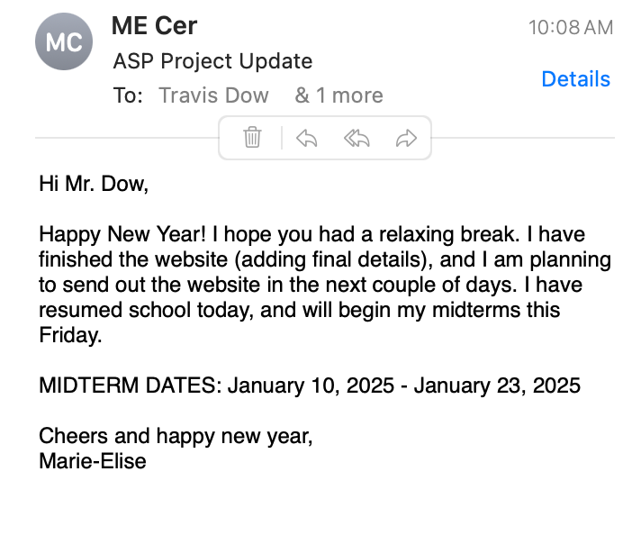

Tuesday, January 7, 2025:
- Made an explanation video (cannot attach video to google doc, has an issue uploading) with audio on how to use the website. Text to speech taken from this website: https://www.narakeet.com/app/text-to-audio/?projectId=8737c987-05a3-4776-a015-326aabc771db
- WEBSITE FINISHED → just have to make link live
- Collecting game data:
import { atom } from 'jotai';

export const gameStatsAtom = atom({});

export const completionStatusAtom = atom((get) => {
const stats = get(gameStatsAtom);
const games = ['connect4', 'checkers'];
const methods = ['voice', 'motion', 'classical'];
return games.every(game =>
methods.every(method =>
(stats[game]?.[method] || 0) >= 2
)
);
});

export const updateGameStats = (gameId, methodId, stats, setStats) => {
const newStats = {
...stats,
[gameId]: {
...(stats[gameId] || {}),
[methodId]: ((stats[gameId]?.[methodId] || 0) + 1)
}
};
localStorage.setItem('gameStats', JSON.stringify(newStats));
setStats(newStats);
return newStats;
};

export const initializeGameStats = () => {
const savedStats = localStorage.getItem('gameStats');
return savedStats ? JSON.parse(savedStats) : {};
};

export const isCombinationComplete = (gameId, methodId, stats) => {
return (stats[gameId]?.[methodId] || 0) >= 2;
};

export const getCompletionPercentage = (stats) => {
const games = ['connect4', 'checkers'];
const methods = ['voice', 'motion', 'classical'];
const totalRequired = games.length * methods.length * 2;
const completed = games.reduce((gameAcc, game) =>
gameAcc + methods.reduce((methodAcc, method) =>
methodAcc + Math.min((stats[game]?.[method] || 0), 2), 0
), 0);

return (completed / totalRequired) * 100;
};

- Added video to website:
import React from 'react';
import { useNavigate } from 'react-router-dom';
import vid from '../assets/tutorialvid.mp4';

const TutorialVideo = () => {
const navigate = useNavigate();

return (
<div className="flex flex-col items-center justify-center w-screen min-h-screen bg-gray-100 p-4">
<div className="max-w-4xl w-full bg-white rounded-lg shadow-lg p-6">
<h1 className="text-2xl font-bold mb-4 text-center">How to Play</h1>
<div className="aspect-w-16 aspect-h-9 mb-4">
<video
className="w-full rounded-lg"
controls
autoPlay
src={vid}
>
Your browser does not support the video tag.
</video>
</div>
<div className="flex justify-between mt-6">
<button
onClick={() => navigate('/control-selection')}
className="bg-gray-500 hover:bg-gray-600 text-white px-6 py-2 rounded-lg transition-colors"
>
Skip Tutorial
</button>
<button
onClick={() => navigate('/control-selection')}
className="bg-blue-500 hover:bg-blue-600 text-white px-6 py-2 rounded-lg transition-colors"
>
Next →
</button>
</div>
</div>
</div>
);
};

export default TutorialVideo;

Wednesday, January 8, 2025:
ASP CLASS:
- Study for physics midterm

Saturday, January 11, 2025:
- Tested website with Eleanor
  - Errors to fix: timer doesn’t work in checkers, motion doesn’t load at all, says you win when you lost in checkers

Sunday, January 12, 2025:
- Errors are fixed
- A new website is loaded using github and vercel
- https://asp-project.vercel.app/

Monday, January 13, 2025:
- Tested website with Eleanor again
- https://asp-project.vercel.app/

Saturday, January 18, 2025:
- Tested website with Eleanor and Audrey → worked + data collection successful
- https://asp-project.vercel.app/

Sunday, January 19, 2025:
- Data collection has started and three responses are in google sheets
- People played website

Tuesday, January 21, 2025:
- Worked on experimental procedures tab on this document

Wednesday, January 22, 2025:
ASP NOTES (65 min):
- Make a plan and be specific about it!!
  - Reconnect with mentors + or meet with them
- PUT IN THE WORK FOR ASP!!!
  - 6 weeks till science fair
- Start entering information on the CYSF platform
  - DUE MARCH 21
- The trifold and poster WILL TAKE TIME
  - Choose between printed poster and traditional trifold
- April 10-12 (if selected for calgary science fair have to miss one day of school)
- Introduction aspects: finish introduction with research questions and goals and hypothesis (end) + variables in methodology
- Feb. 27 WORK WITH WHAT YOU HAVE (back up research with background research)
- Will be judged based on originality + improvements/ changes on project
  - Exploit topic in a way to find a general interest in it
- Conclusions HAVE to be sharp + blunt + clear
- BE ORIGINAL (CREATIVITY) + prove why your project is different from others
WHAT I DID:
- Worked on experimental producers tab on this document
- Worked on Introduction section of research paper

Friday, January 24, 2025:
ASP NOTES (10min):
- Working on experimental procedures on this document
- KEEP MENTOR INFORMED AND CHECK TIMELINE

Sunday, January 26, 2025:
- Received more data → reviewed my google sheets with the data

Monday, January 27, 2025:
- Edited my introduction: https://docs.google.com/document/d/1YFu6KUOIKnySlpiya-4xovmxbnx4JNtqE-EfZ7nDcRQ/edit?tab=t.0

Tuesday, January 28, 2025:
ASP NOTES (6 min):
- Sent an email to my peers to play my website and send to any friends and family of theirs:
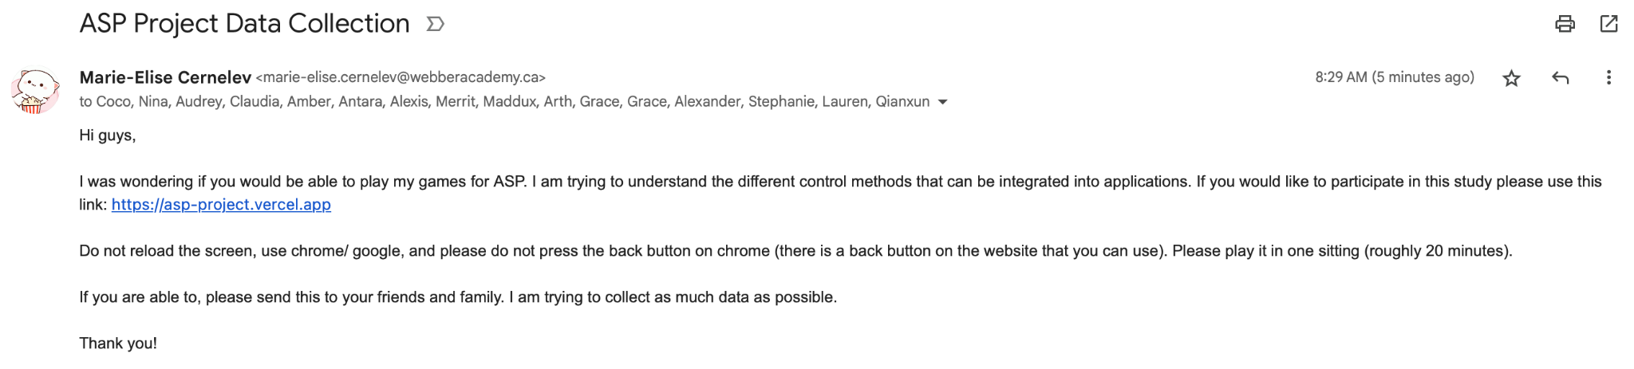
- March 7 is NEXT REPORT CARD (MOST IMPORTANT IN NEXT TERM)
- Working on experimental procedures on this document

Thursday, January 30, 2025:
ASP NOTES (7 min):
- Finished the logbook
- Submitted the introduction and edited based on Dr. Garcia’s comments today: https://docs.google.com/document/d/1YFu6KUOIKnySlpiya-4xovmxbnx4JNtqE-EfZ7nDcRQ/edit?tab=t.0
- Updated CYSF platform with background research
- Wrote some of the acknowledgements on this document

Monday, February 3, 2025:
ASP NOTES (30 min):
- PRESENTATION IS ON FEB 27!!!
  - Will need to get more people to play the game
    - NEED MORE DATA (only 6 ppl so far)
- In the logbook notes or/and data collection write data v
  - ADD DATE!!
- Go to Dr. Garcia if any problems start.
- Planned out my poster (to make sure that I will not procrastinate before the science fair) on canva
  - https://www.canva.com/design/DAGeFPVLnRs/OKZoh_1BMfC3-i-FyM0KXA/edit?utm_content=DAGeFPVLnRs&utm_campaign=designshare&utm_medium=link2&utm_source=sharebutton

Wednesday, February 5, 2025:
ASP NOTES (30 min):
- Continue planning out the poster + where to place the three graphs.
  - Created two possibilities (depending on how many graphs I make)
- Sent email to Mr Dow: Hi Mr. Dow, I hope this email finds you well. I wanted to provide you with another update on my project.The website is finished and I had received seven participants so far. I am fixing a few bugs that the participants found, and I am writing my experimental procedures section for my research paper. Warm regards, Marie-Elise.
- Posters are 4ft by 3ft!!! Make sure that the graphs are not too big but fills the space nicely (Dr. Garcia)
- Real measurements → https://www.canva.com/design/DAGeQEnSXaQ/4UyD-7Sbn4mHrVF1gev9tA/edit?utm_content=DAGeQEnSXaQ&utm_campaign=designshare&utm_medium=link2&utm_source=sharebutton

Friday, February 7, 2025:
ASP NOTES (10 min):
- Must HAVE SPECIFIC
- Plan your schedule to the minute!
- Continued planning the poster → real measurements + emailing people to complete the game: https://www.canva.com/design/DAGeQEnSXaQ/4UyD-7Sbn4mHrVF1gev9tA/edit?utm_content=DAGeQEnSXaQ&utm_campaign=designshare&utm_medium=link2&utm_source=sharebutton
- Wrote my observation for the seven participants in the study so far (in observations section under results/ data collection): https://docs.google.com/spreadsheets/d/1nUhLqaSP8SMOQY8F5O7OhpzGP6nFMWLiwOL6jVXnIFk/edit?gid=1391510971#gid=1391510971
  - Transferred data from google sheets to excel

Sunday, February 9, 2025:
- Emailed people who did not finish the game to complete survey for data collection

Tuesday, February 11, 2025:
- Send game out to more people (and reminded those who signed up to participate before Sunday)
  - Received three more people’s data

Wednesday, February 12, 2025:
- Edited the MAIN poster on canva: https://www.canva.com/design/DAGeQEnSXaQ/4UyD-7Sbn4mHrVF1gev9tA/edit

Thursday, February 13, 2025:
ASP NOTES (45 min):
- CYSF portal has to be finished March 21, 2025
- Has to be sources in methodologies!!!
- Gear your presentation on how original your work is
  - Why is your work not mentor driven. How do you disprove that.
    - In presentation introduce phrases and words how you chose this project with the mentors expertise.
- Use rubrics from city wide science fair
  - See if you have shown that you are original, etc.
- Double check with Dr. Garcia about presentation and writing.
- Observation is data collection → raw data, photos/ images, tables + UNPROCESSED DATA
  - Analysis = final graphs + final tables + explanations
  - Conlcusions = answer your research question!!
    - What factors affected the results + can create new hypothesis?
- Applications: significance of project + how can this knowledge be applied in future studies
- Sources of Error: CYSF love this + you have to find limitations with your study (i.e., the way the data was collected, any confounding variables that affect the results) + has to be really critically analyzed
  - Critical of the work = very good
- There is a section at the bottom in the CYSF portal for references
  - Dont put citations after the background research or after the methods… put all at the end ( could switch to AMA for references but do not have to)
- Acknowledgements: critical for sources of money + acklonwdge university and department, and dont make it long
  - Dr. ___, ___, ___ from U of C/ Webber Academy
- Feburary 27 DEADLINE→ submit logbook + oral presentations (due 11:30 am)
- Feburary 19 DEADLINE for methods!!!
- Posters → Weekend of must have posters finished
- All of the tasks for Feburary (day of the week) → data analysis, methods paper writing, logbook tasks
  - Poster is last priority (after data analysis, methods, logbook, oral presentation)
    - Can start Sunday March 11
- Time management skills!!!!
  - Communication → email Dr. Garcia if you are in trouble!!
- Find similar work like my project → mention in analysis
  - Find peer reviewed sources using Chat GPT how it is used in society (applications)
    - How do they compare to my work
- Added references to procedures paper (will send to Dr. Garcia to review tomorrow)
- Began making the presentation slides for Feburary 27
- Read more background research
  - How speech and gesture tracking is being utilized/ integrated in society
- Methodology written in PAST

Alternative Sources in Society:
- Speech recognitions and gesture tracking are being and are implemented in medicine, education, households = improve daily life
  - https://www.cambridge.org/core/journals/recall/article/abs/review-of-research-on-applications-of-speech-recognition-technology-to-assist-language-learning/5E15DEA15B24F210B095A799708AD00B?utm_source=chatgpt.com
  - https://pmc.ncbi.nlm.nih.gov/articles/PMC10035815/?utm_source=chatgpt.com
  - https://pmc.ncbi.nlm.nih.gov/articles/PMC11054752/?utm_source=chatgpt.com
  - https://pmc.ncbi.nlm.nih.gov/articles/PMC8321080/?utm_source=chatgpt.com
  - https://www.researchgate.net/publication/384185761_Real-Time_Hand_Gesture_Recognition_A_Comprehensive_Review_of_Techniques_Applications_and_Challenges
  - https://academic.oup.com/nsr/article/11/2/nwad298/7452905?utm_source=chatgpt.com&login=false
  - https://pmc.ncbi.nlm.nih.gov/articles/PMC10113989/

Friday, February 14, 2025:
- Collected more data today + categorized per person (see image below_)
  - Each person gets a different google document (ex. See this document: https://docs.google.com/document/d/1Kon0WJ-uW7yxiz-ICFvQrXFEooE-mgzCDqc334Y_9Wg/edit?tab=t.0)
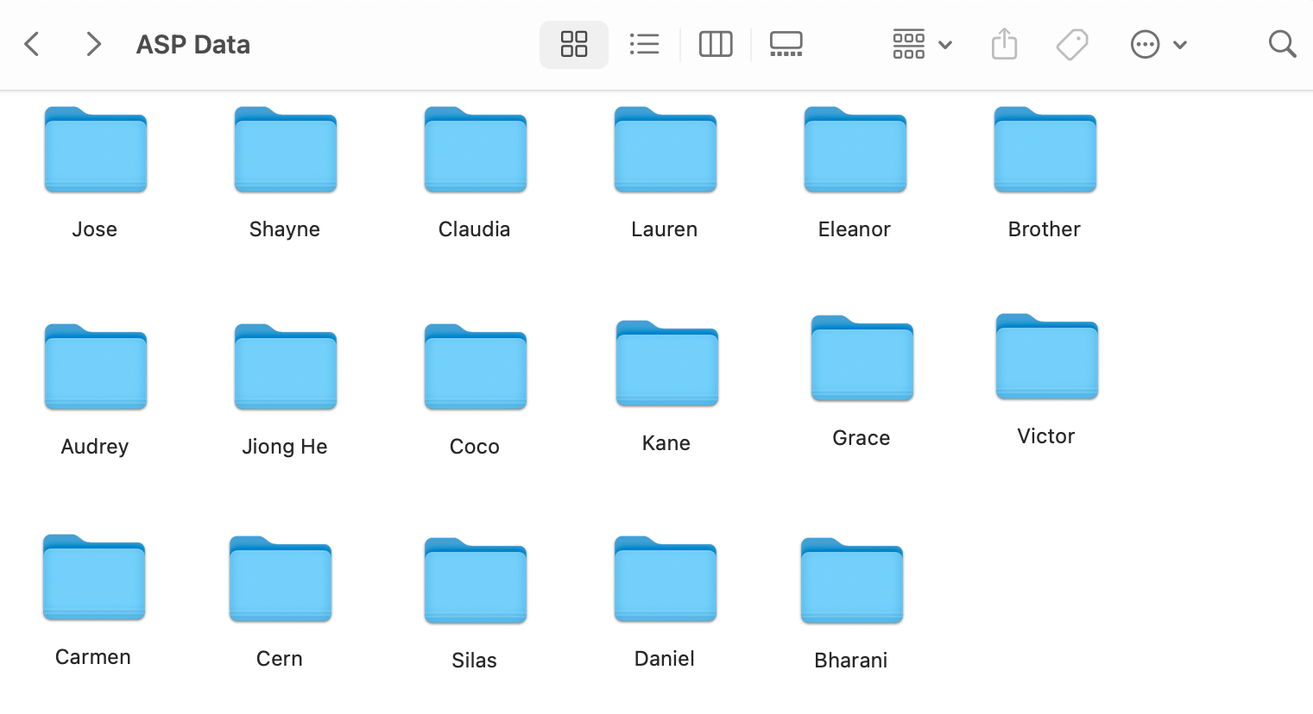
- Some raw graphs of the data collected
  - 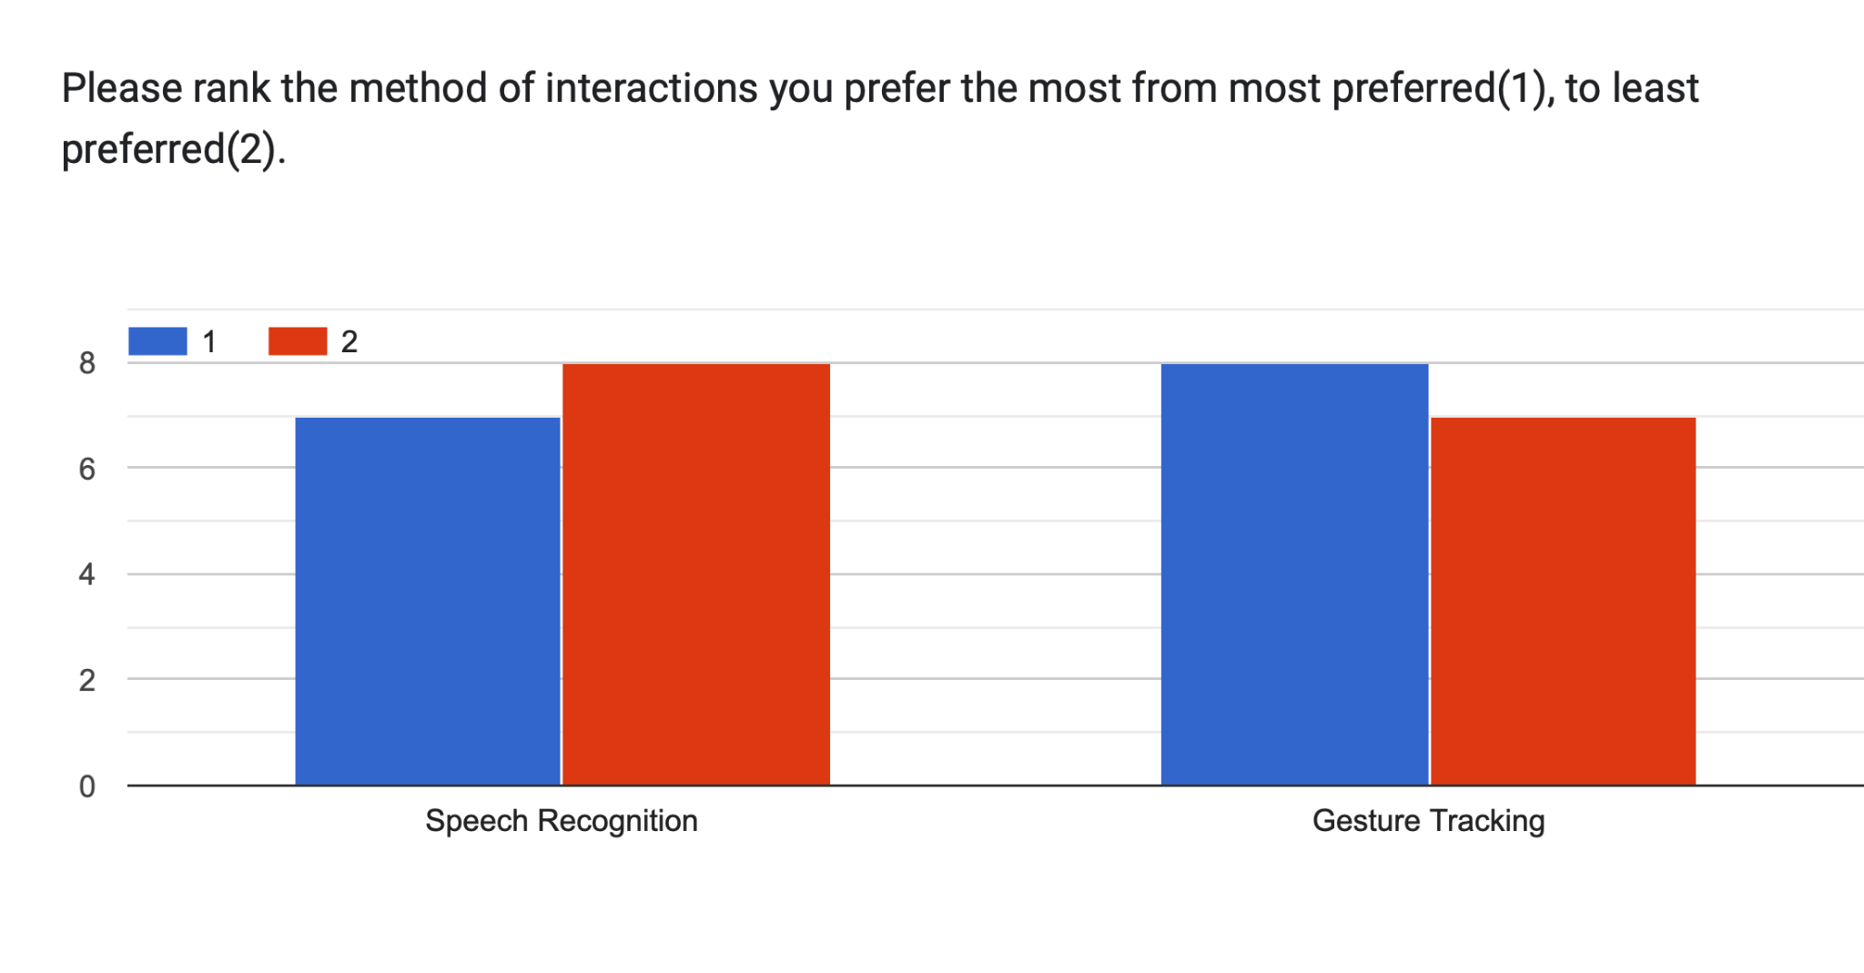
  - 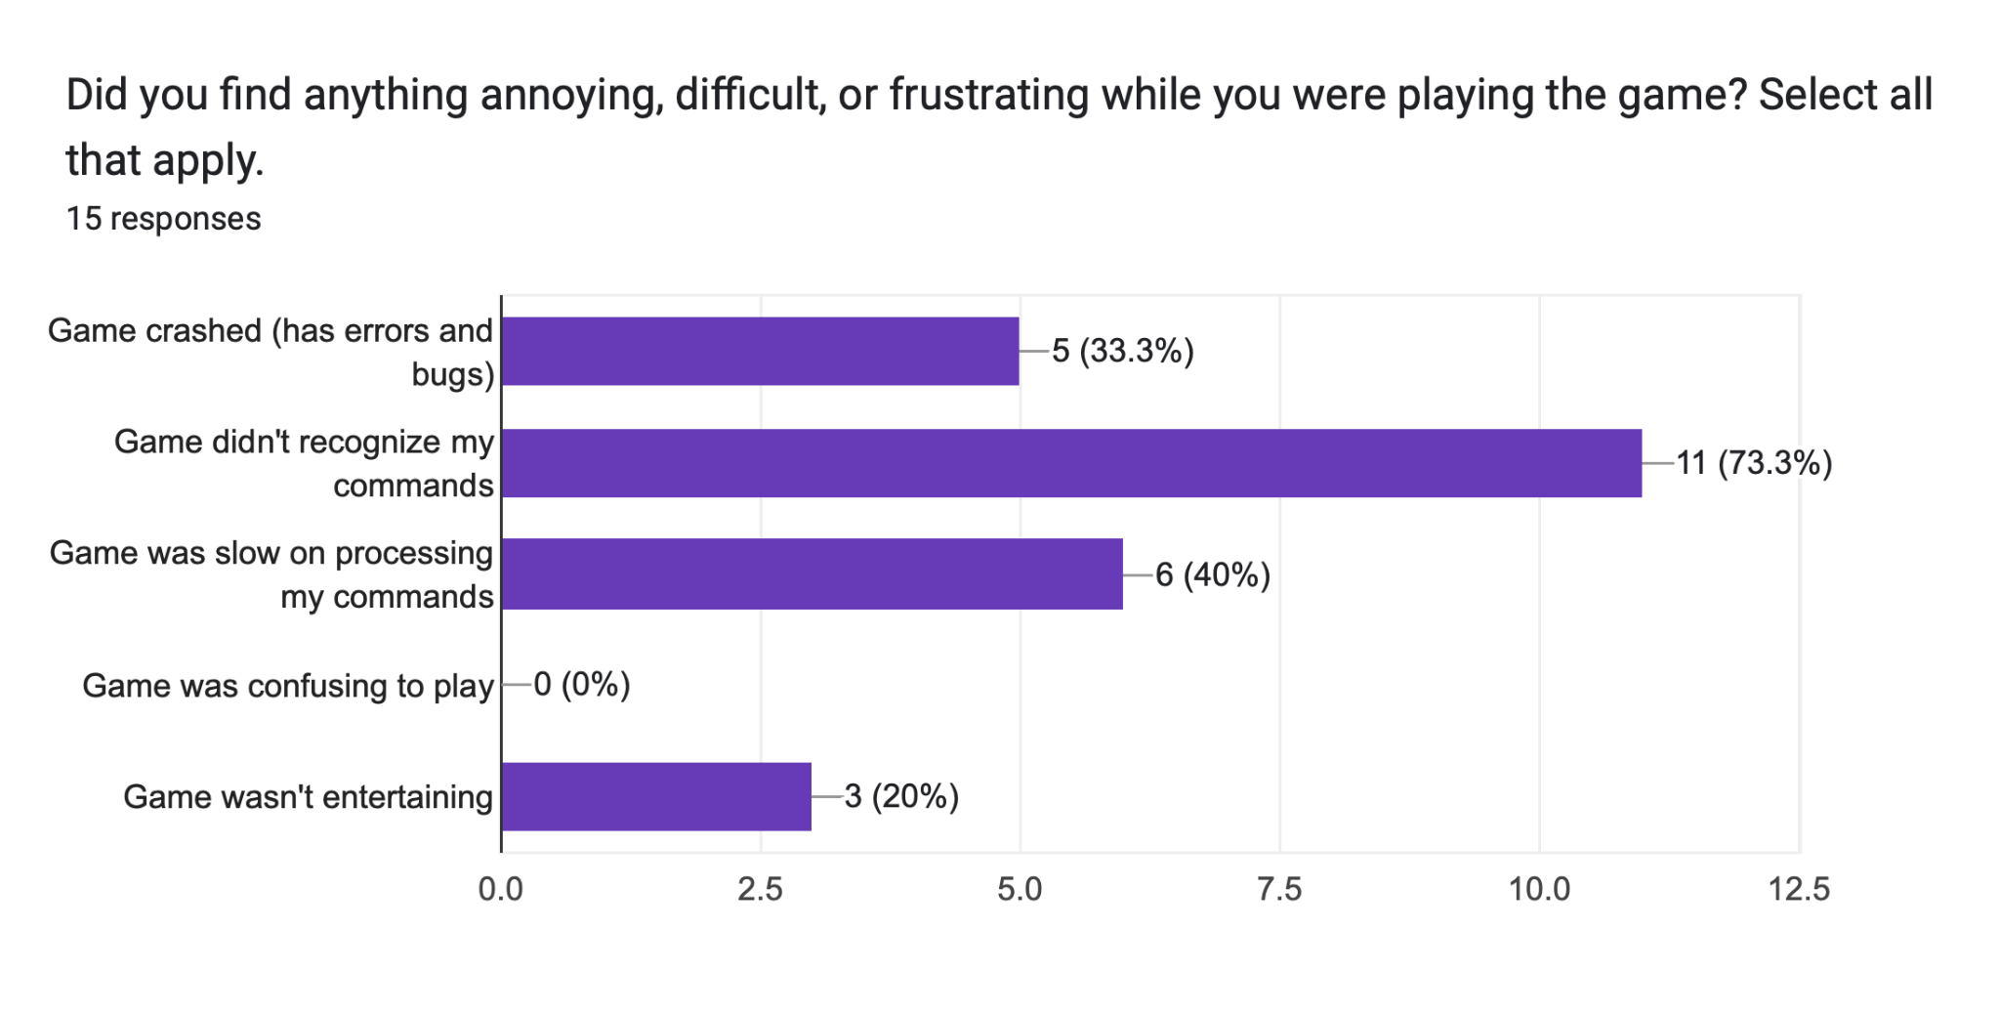
  - 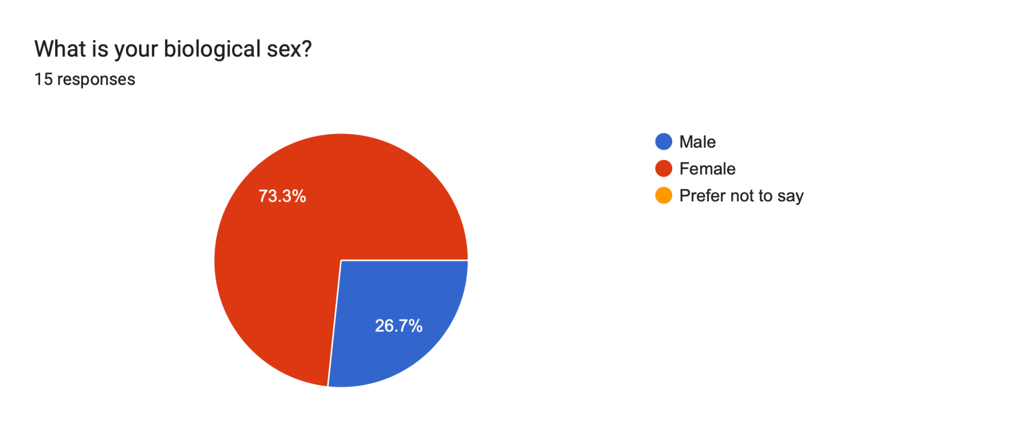
  - 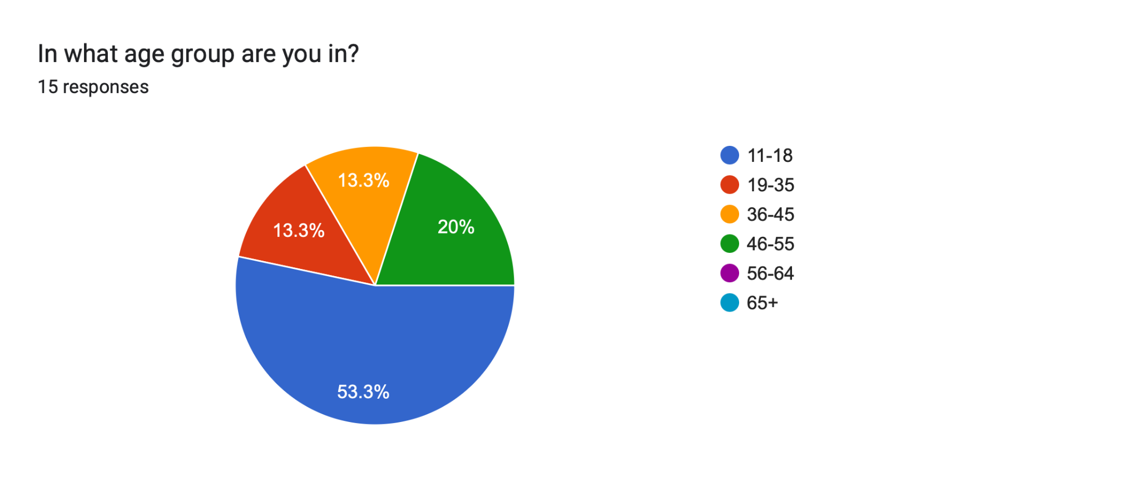
  - 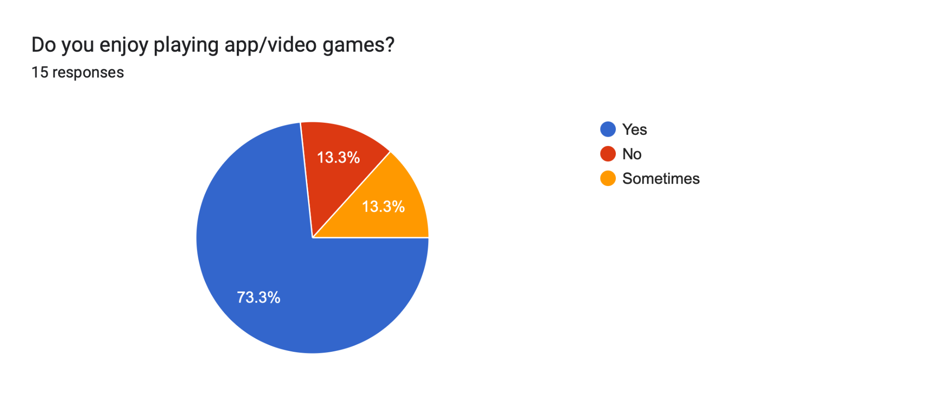

Saturday, February 15, 2025:
- Collected more data today + made PDF documents for each person (18 people so far)
- Edited the procedures paper (grammar, length, etc.)
  - https://docs.google.com/document/d/1zfBp2cIFOXaYvsNukTP18NAhHR92AJnjKD6US3TCU1E/edit?tab=t.0

Monday, February 17, 2025:
- Collected more data today + made PDF documents for each person (same as last day)
  - Have 22 people for data collection so far
- Example data document: https://docs.google.com/document/d/1PiT2zf97TNDetSNrm800f9UYbOThKMUmzmHGXpsWRUE/edit?tab=t.0

Tuesday, February 18, 2025:
- Collected more data today (26 people)
  - https://docs.google.com/spreadsheets/d/1nUhLqaSP8SMOQY8F5O7OhpzGP6nFMWLiwOL6jVXnIFk/edit?gid=1391510971#gid=1391510971
- Edited and reviewed my procedures paper for submission (will submit tomorrow)
  - https://docs.google.com/document/d/1zfBp2cIFOXaYvsNukTP18NAhHR92AJnjKD6US3TCU1E/edit?tab=t.0

Wednesday, February 19, 2025:
ASP NOTES (40 min):
- Send people to review the paper 7 days before or more!
- Results paper due April 14th
  - No raw data in results + only graphs, tables, diagrams
  - Do not describe why!!
    - Do not add with analysis/ conclusions (why results look the way they look)
  - Results section is easiest section
    - Taken into account: FIGURE LEGENDS
      - Figure #: title (underneath the figure image) + after comes te description (very brief)
        - Describe the figure in the paragraph above (in detail)
        - TITLE IS NOT THIS VS THIS
      - If you put in description: data was taken from … , you must add a citation/ source
- Analysis/ Discussion and Conclusions Paper due May 1st
  - Relate it back to the research question and literature
  - Put your results in the context of the current understanding of the field of studies
    - How does data fit into the field
      - Criticize those studies, your study, design issues (your project and others)
  - In conclusions, get back to the research question
  - Reject or accept/ prove research question
  - Significance in final paragraph
- Final Paper due May 30th
  - References need to have DOI’s, links, etc.
- Final review of my procedures paper and submitted today (added references and rewrote logic flow)
  - https://docs.google.com/document/d/1zfBp2cIFOXaYvsNukTP18NAhHR92AJnjKD6US3TCU1E/edit?tab=t.0

Thursday, February 20, 2025:
- Began to analyze data and figure out how to organize graphs
  - Different types of graphs that will be used/ created: Female and Male Statistic on conditions experienced during stressful conditions and alternative to touch + figure out more graphs during ASP class

Friday, February 21, 2025:
ASP NOTES (5 min):
- Results: What would I add to the results paper from my google sheets if it is just raw data? What am I supposed to explain?
  - Do not analyze anything in results! Just → this graph shows…
- Do you need objectives in the slides?
  - Have to say it (doesn’t need to be in slides)
- Do you need significance as a single slide or can you just explain it?
  - Have to talk about it (bring up why are we doing this study)

- Worked on the google sheet :https://docs.google.com/spreadsheets/d/1nUhLqaSP8SMOQY8F5O7OhpzGP6nFMWLiwOL6jVXnIFk/edit?gid=1391510971#gid=1391510971 to make different graphs for conclusions and data
- Created graphs for my raw data and data analysis:
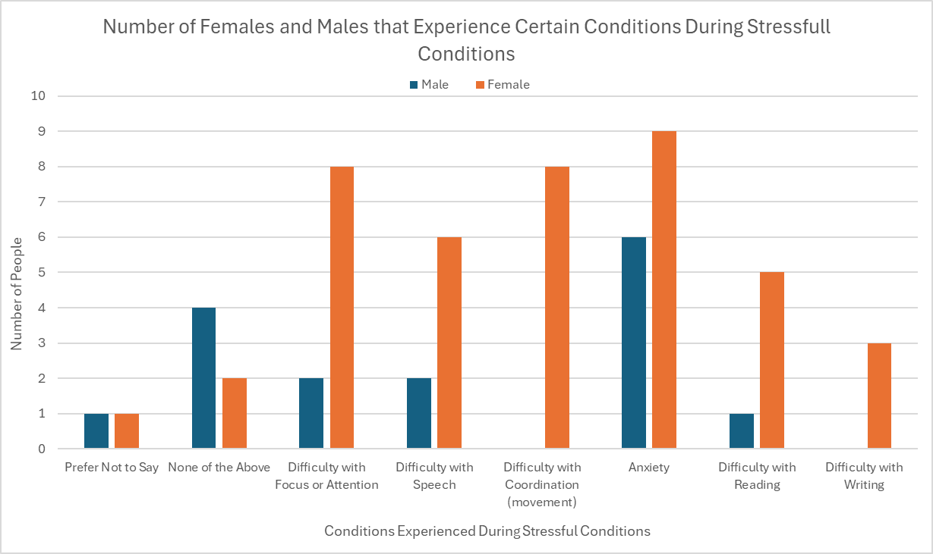
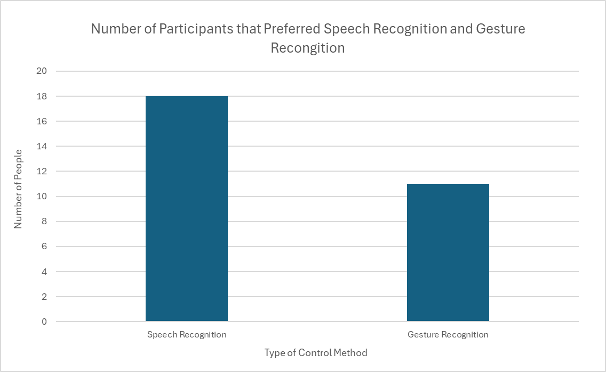
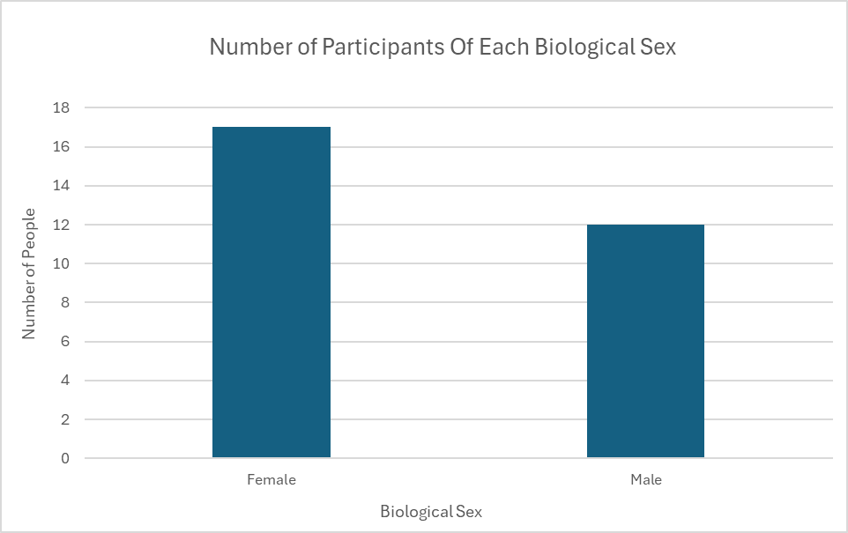
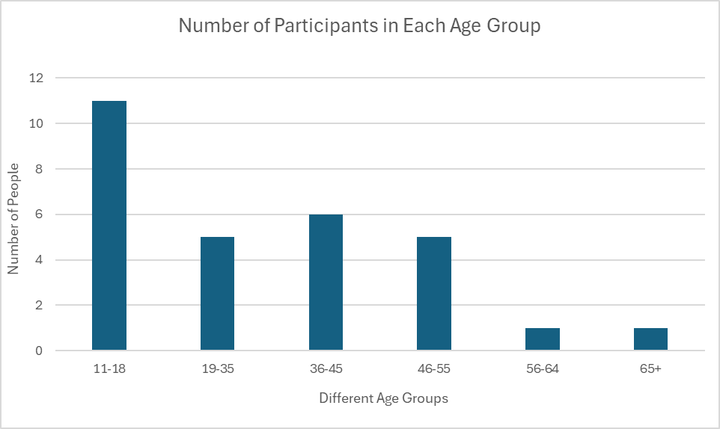
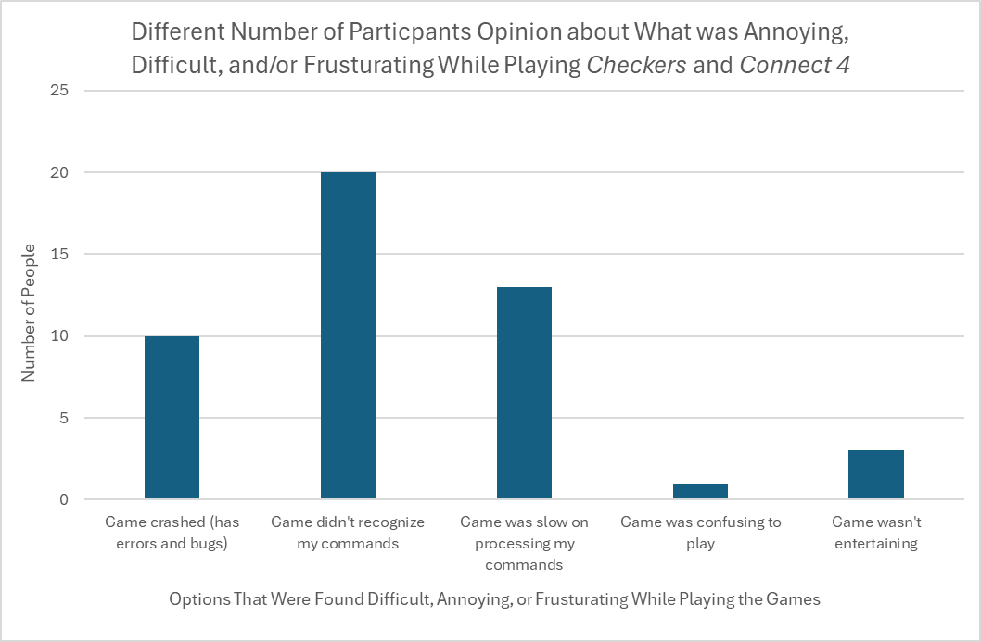

Saturday, February 22, 2025:
VARIABLES:
- The manipulated variables are the different interaction methods: speech recognition and head movement tracking, the individual’s age group and disabilities.
- The responding variable in this experiment is the individual's interaction preference. One’s preference could explain under which scenario certain individuals prefer or are restricted to a certain mode of control.
- The controlled variables are the type of game the individual is playing (Connect 4 or Checkers), difficulty and complexity of the game, and the number of times a person plays a game using a certain method of control.
- The confounding variables in this experiment can include individual’s personal preference of Checkers or Connect 4, if the user’s engagement (i.e., clicking random spots just to complete the game; without a goal of winning), whether an individual has difficulties during stressful situations, the user’s cognitive abilities and experience playing Connect 4 and Checkers, biological sex, and if the individual enjoys playing video games.
- EDITED THE VARIABLES SECTION ON CYSF PLATFORM
HYPOTHESES:
- Null Hypothesis: Older individuals who have difficulty with coordination will have the same alternative to touch preference as younger individuals that experience anxiety under stressful conditions.
- Alternate Hypothesis: Individuals over the age of 45 who have difficulty with coordination will prefer the speech recognition mode of interaction when playing Connect 4 and Checkers. Gesture tracking requires an extensive amount of movement to convey a move in the game; hence, speech could be considered an easier alternative for the older generation as it would not require the individuals to have perfect coordination or move extensively. Younger individuals will prefer the gesture tracking alternative, as it can be interpreted, to younger children, as more interactive.
- EDITED THE HYPOTHESIS SECTION ON CYSF PLATFORM
SLIDES:
- Began making the slides for the oral presentation:
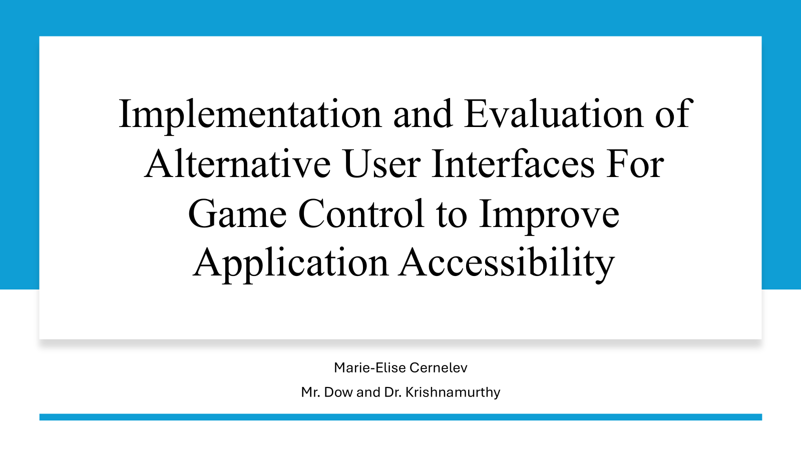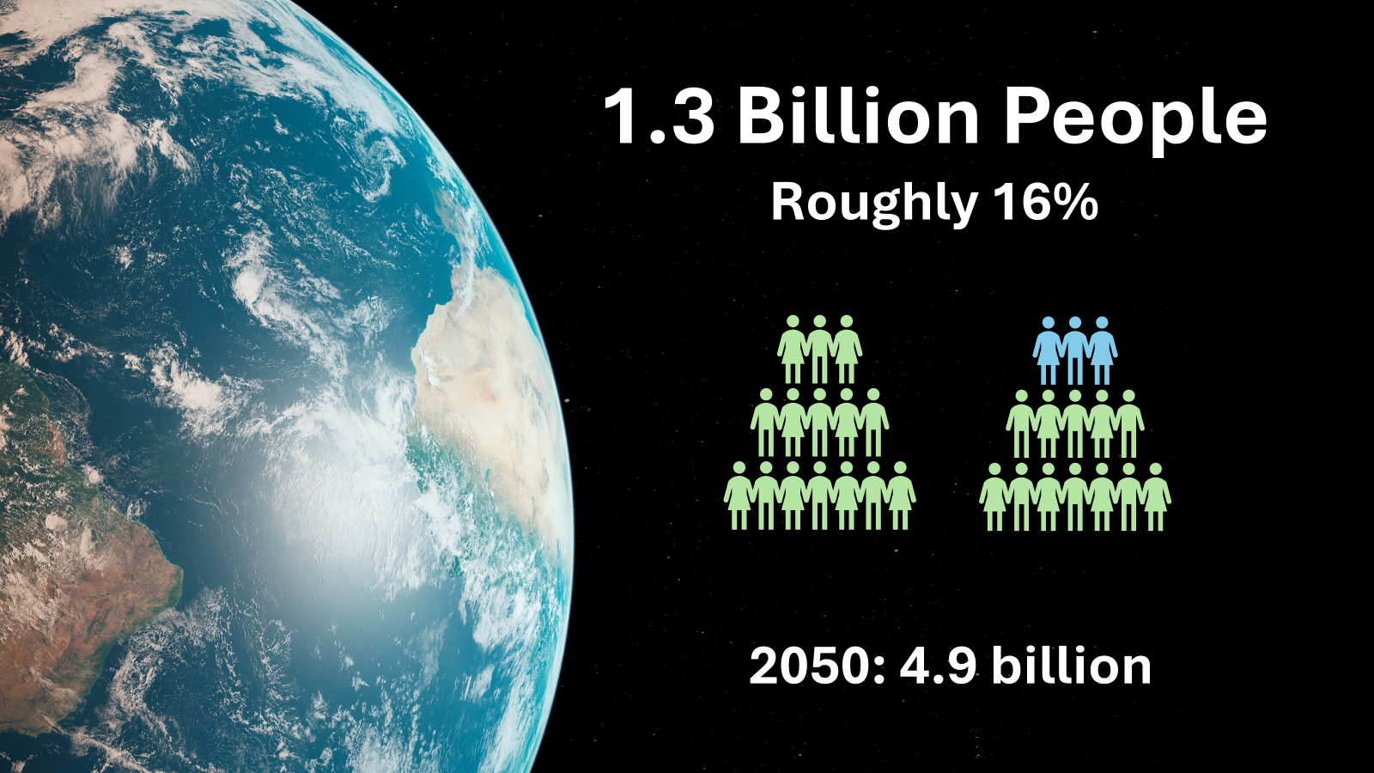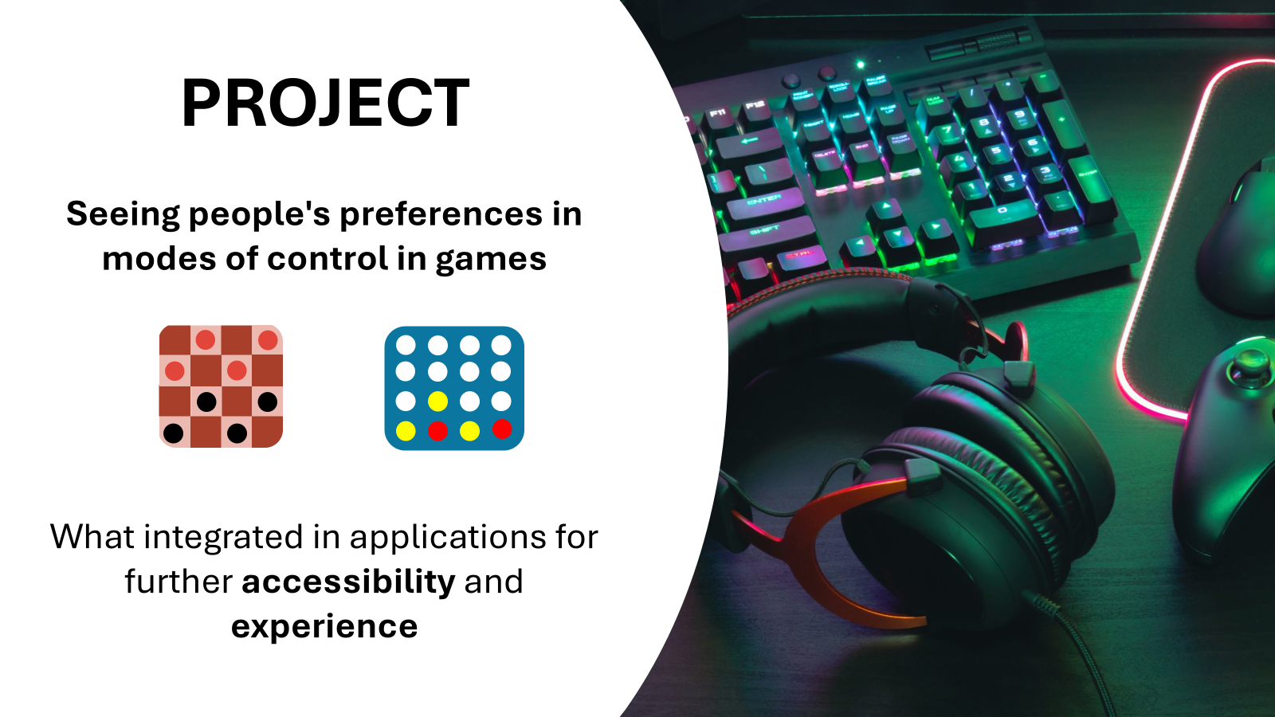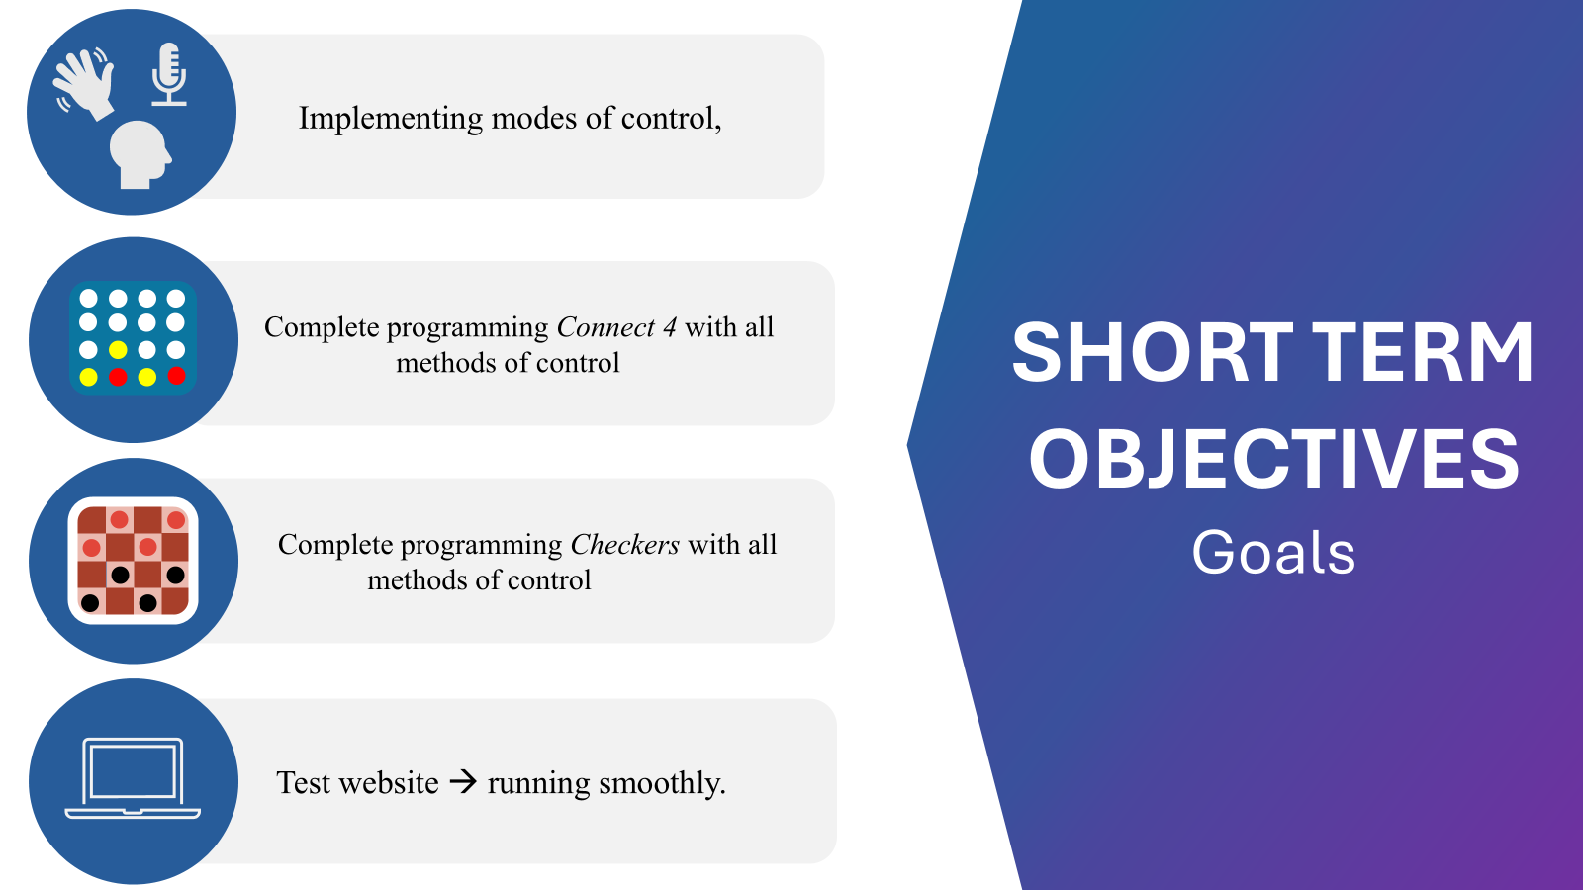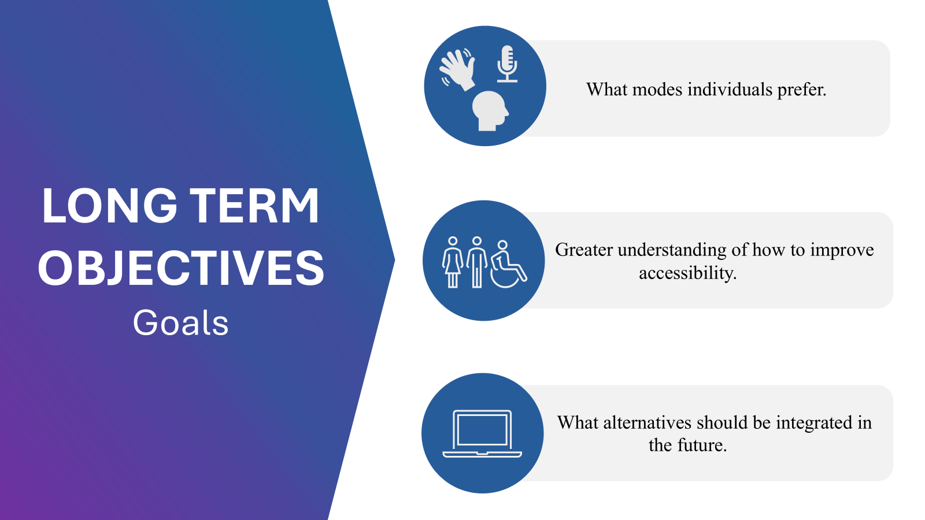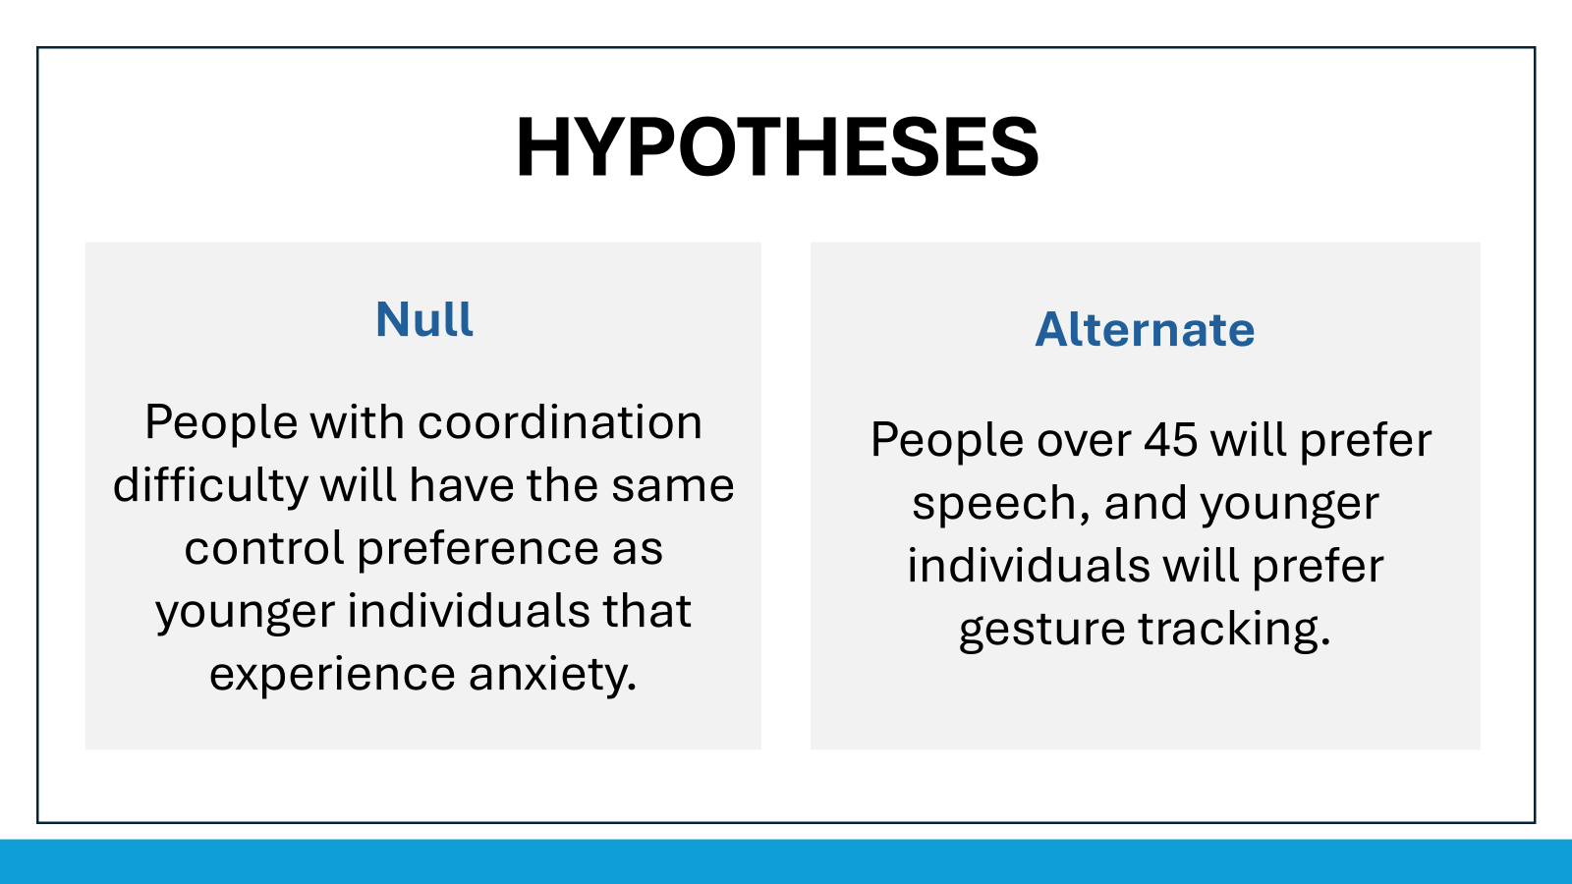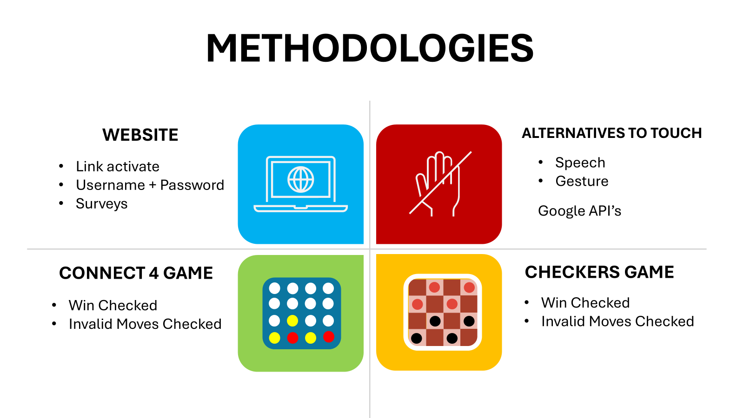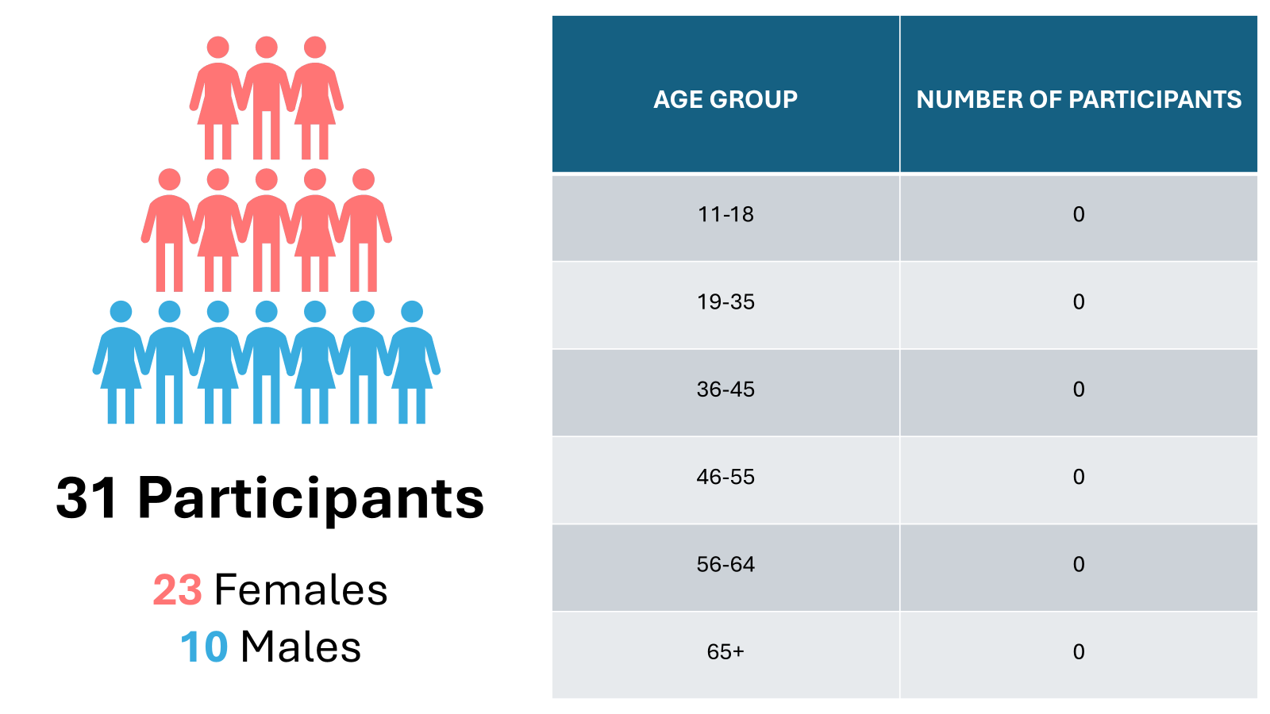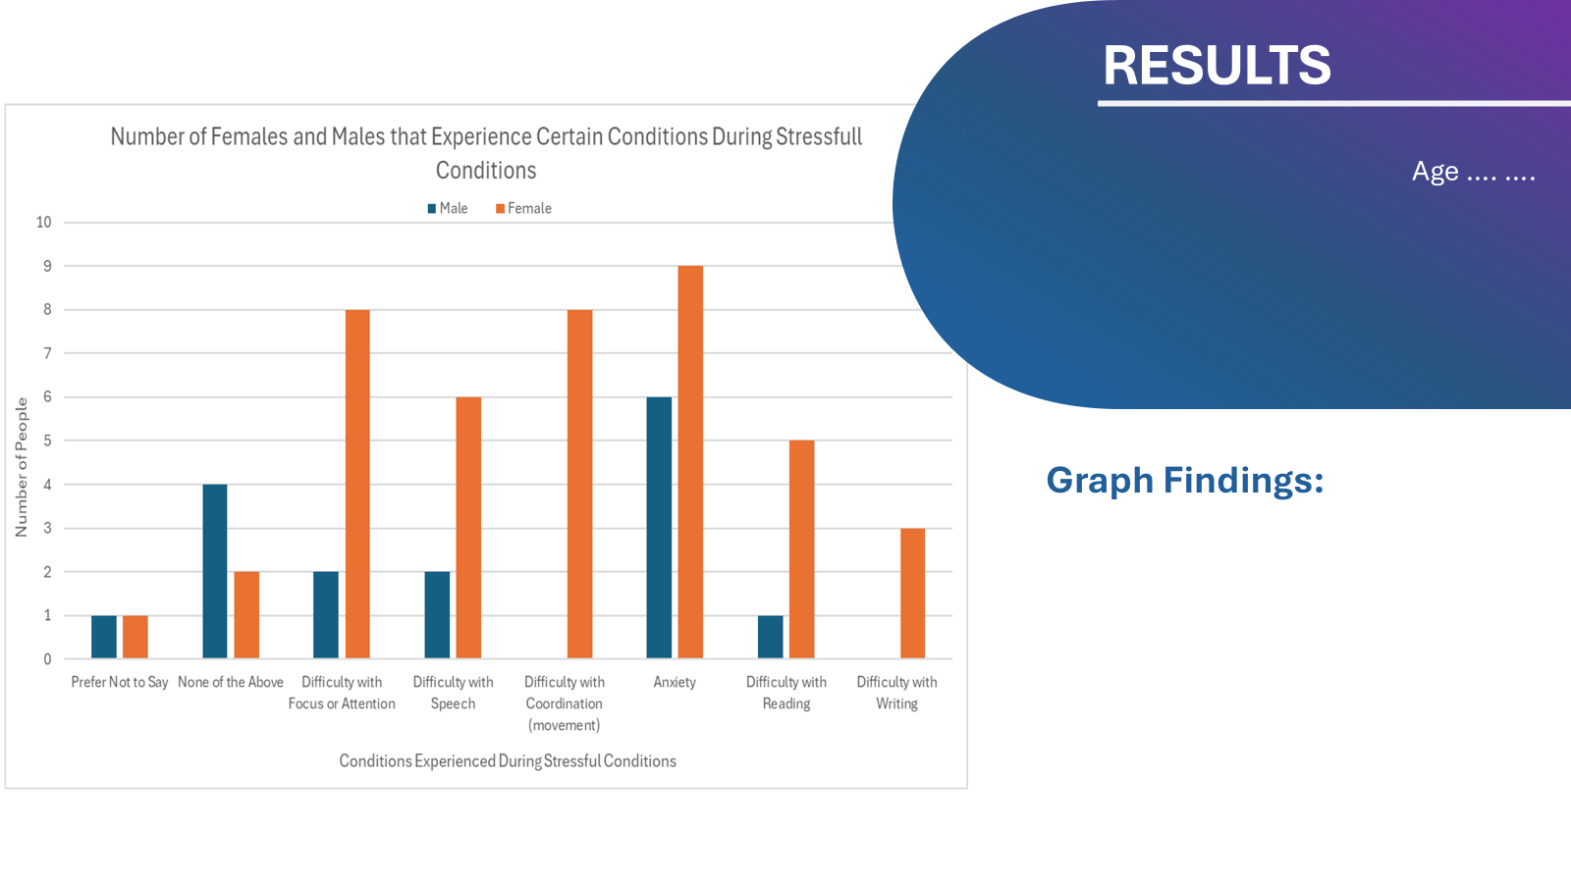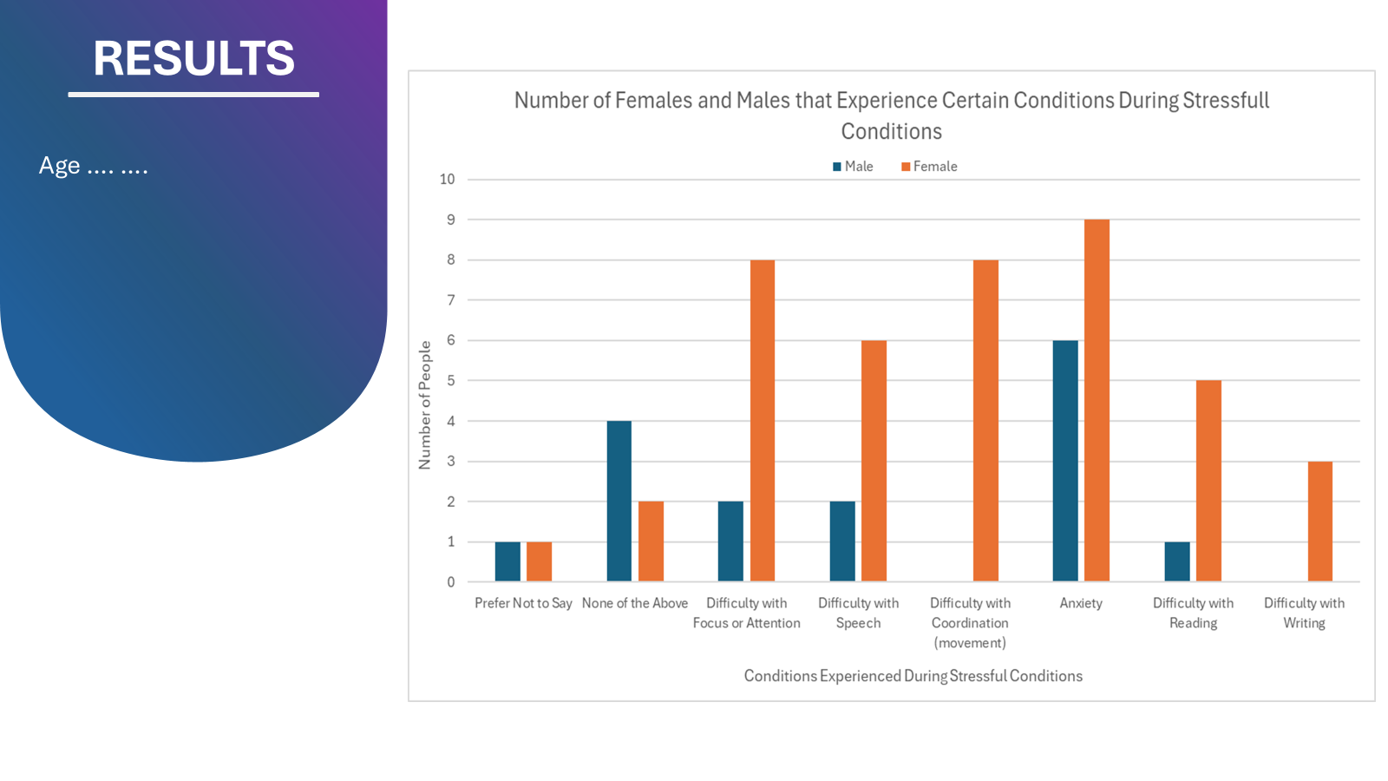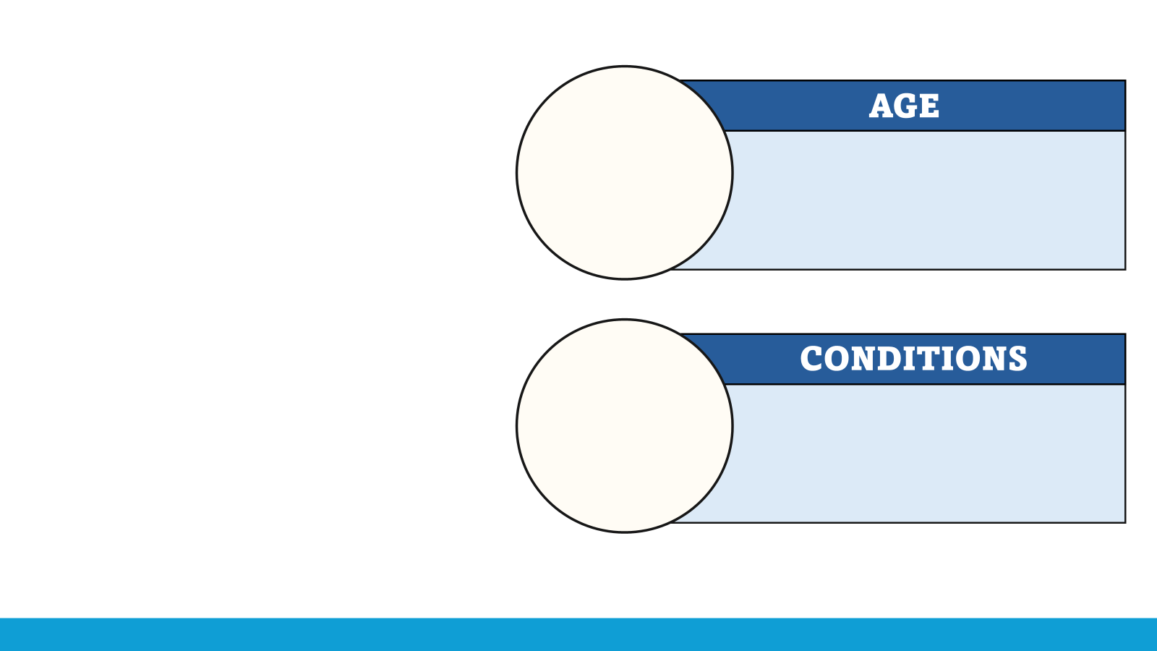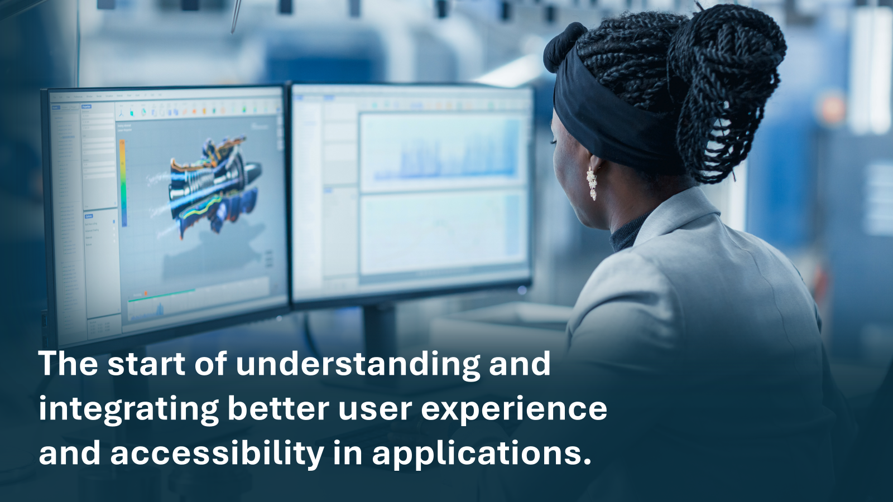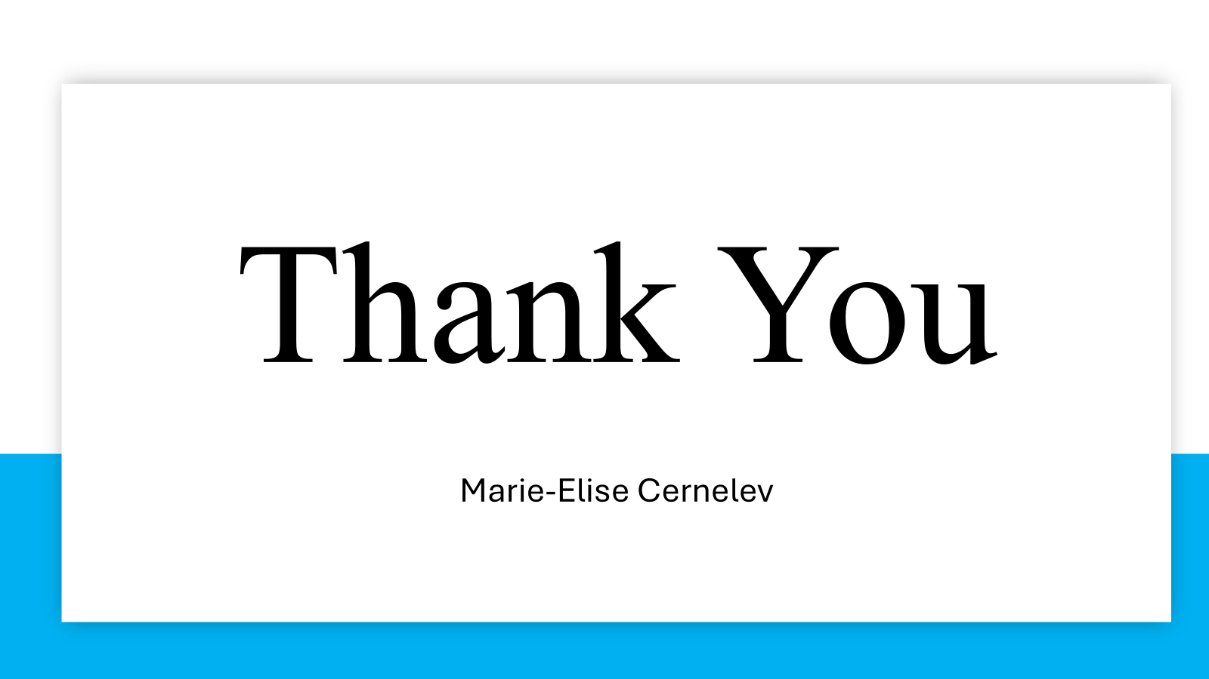

Sunday, February 23, 2025:
- Analyzed data → made more graphs (as seen below) and worked on oral presentation slides
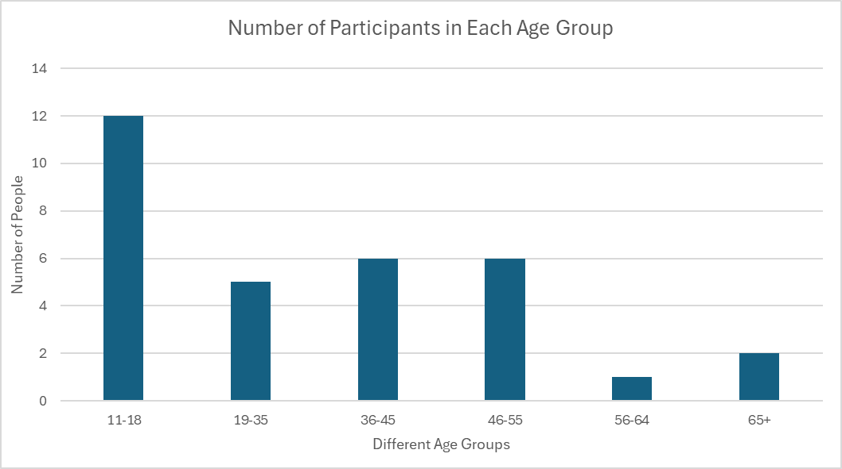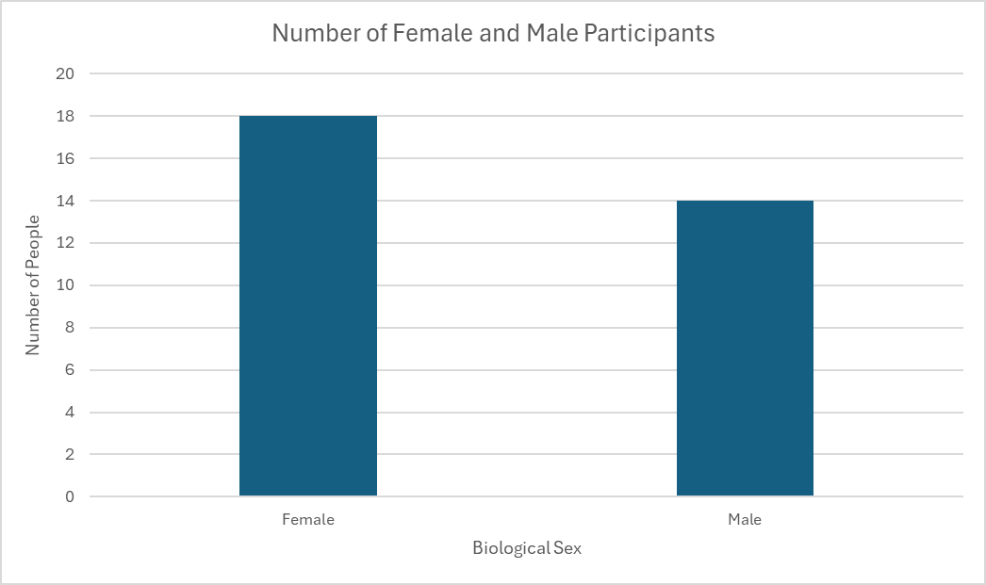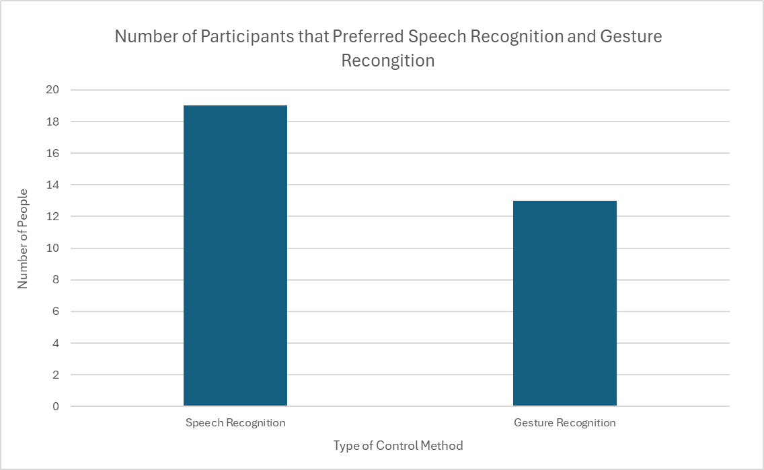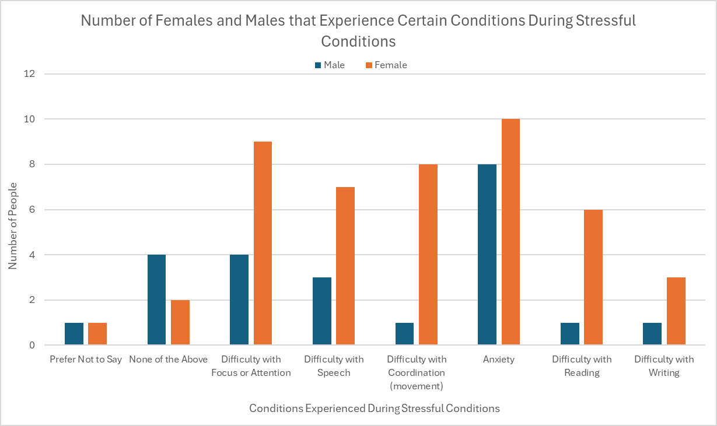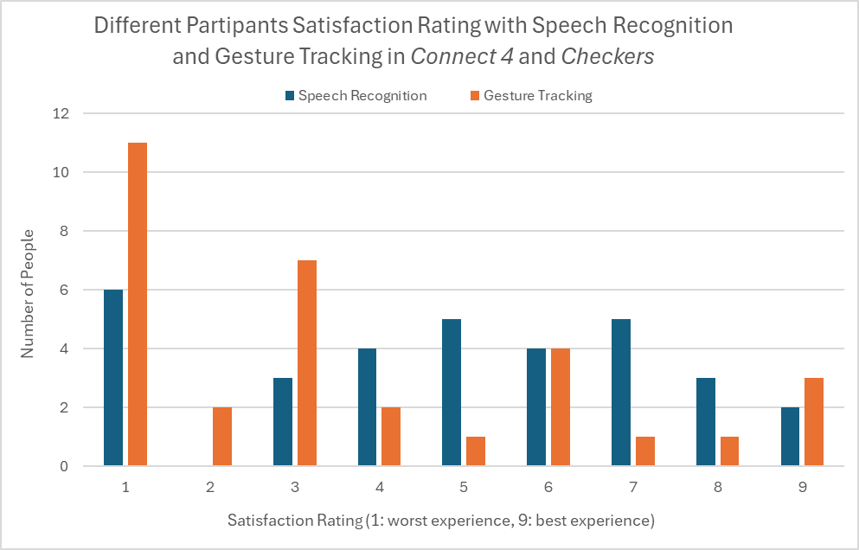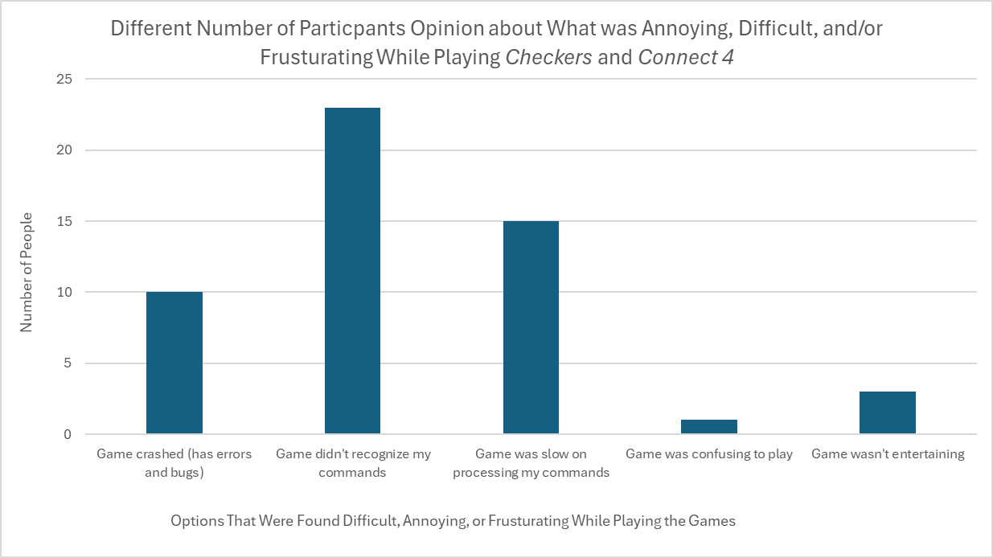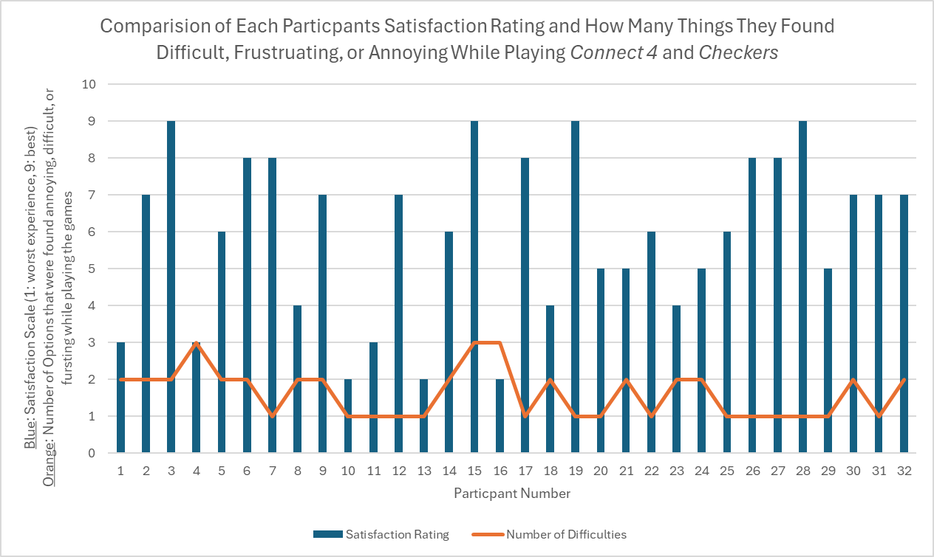
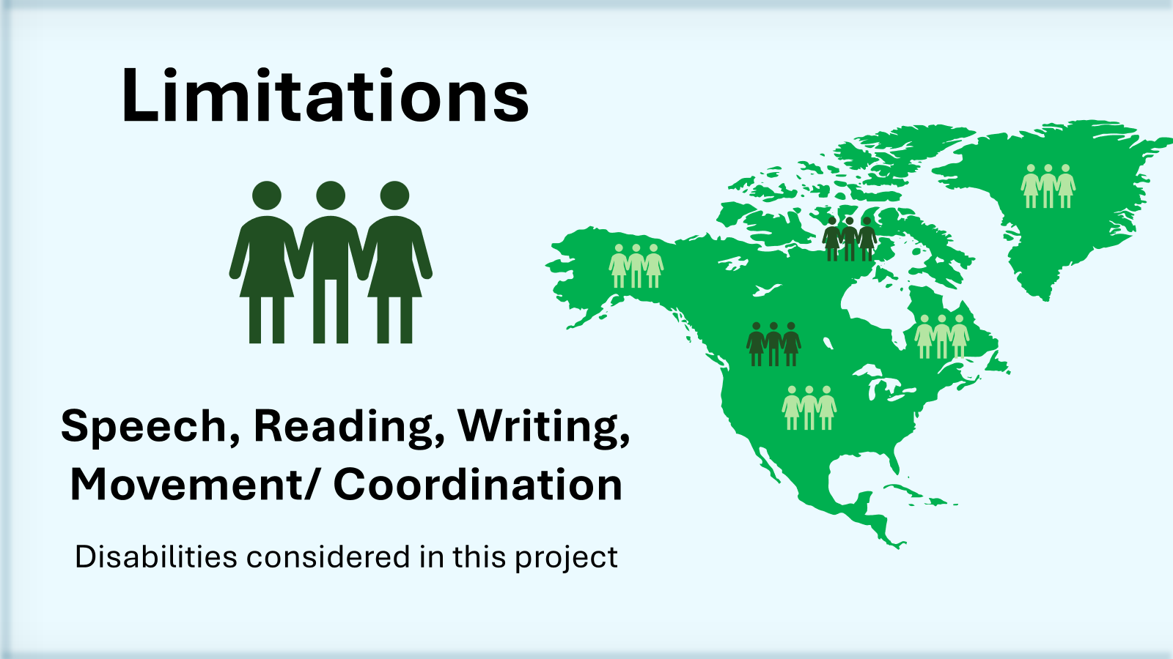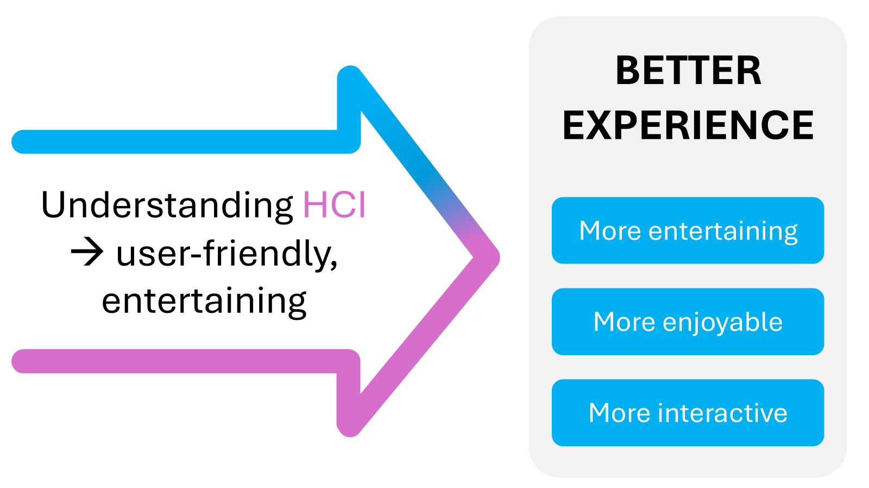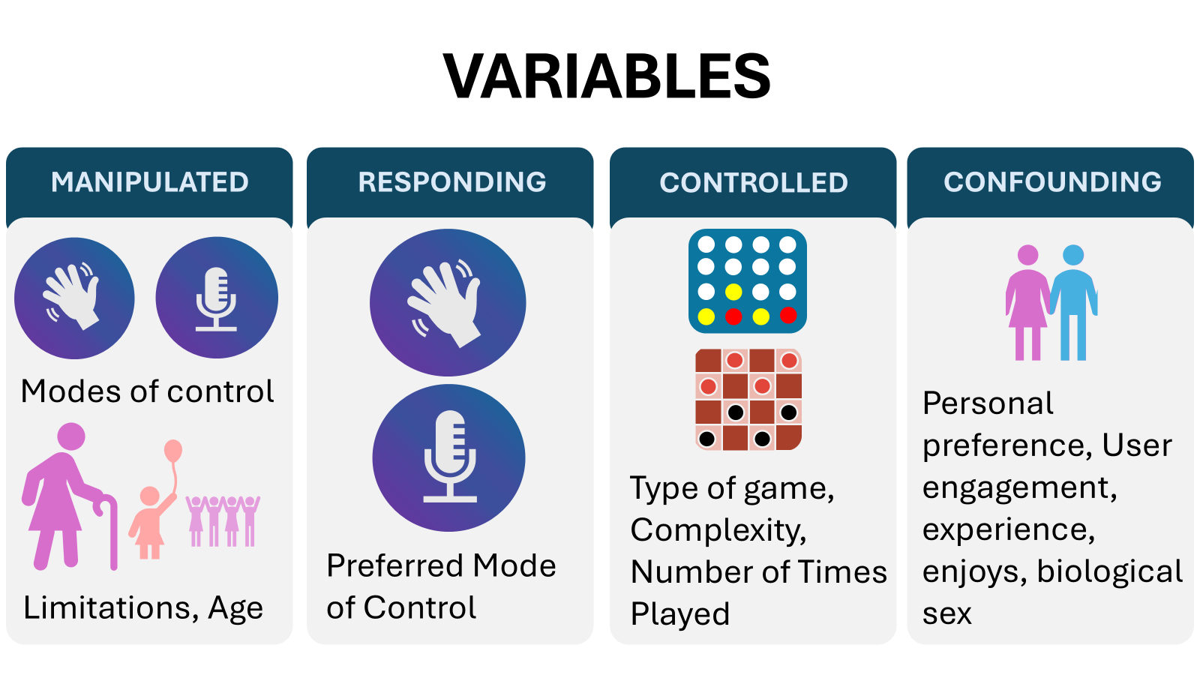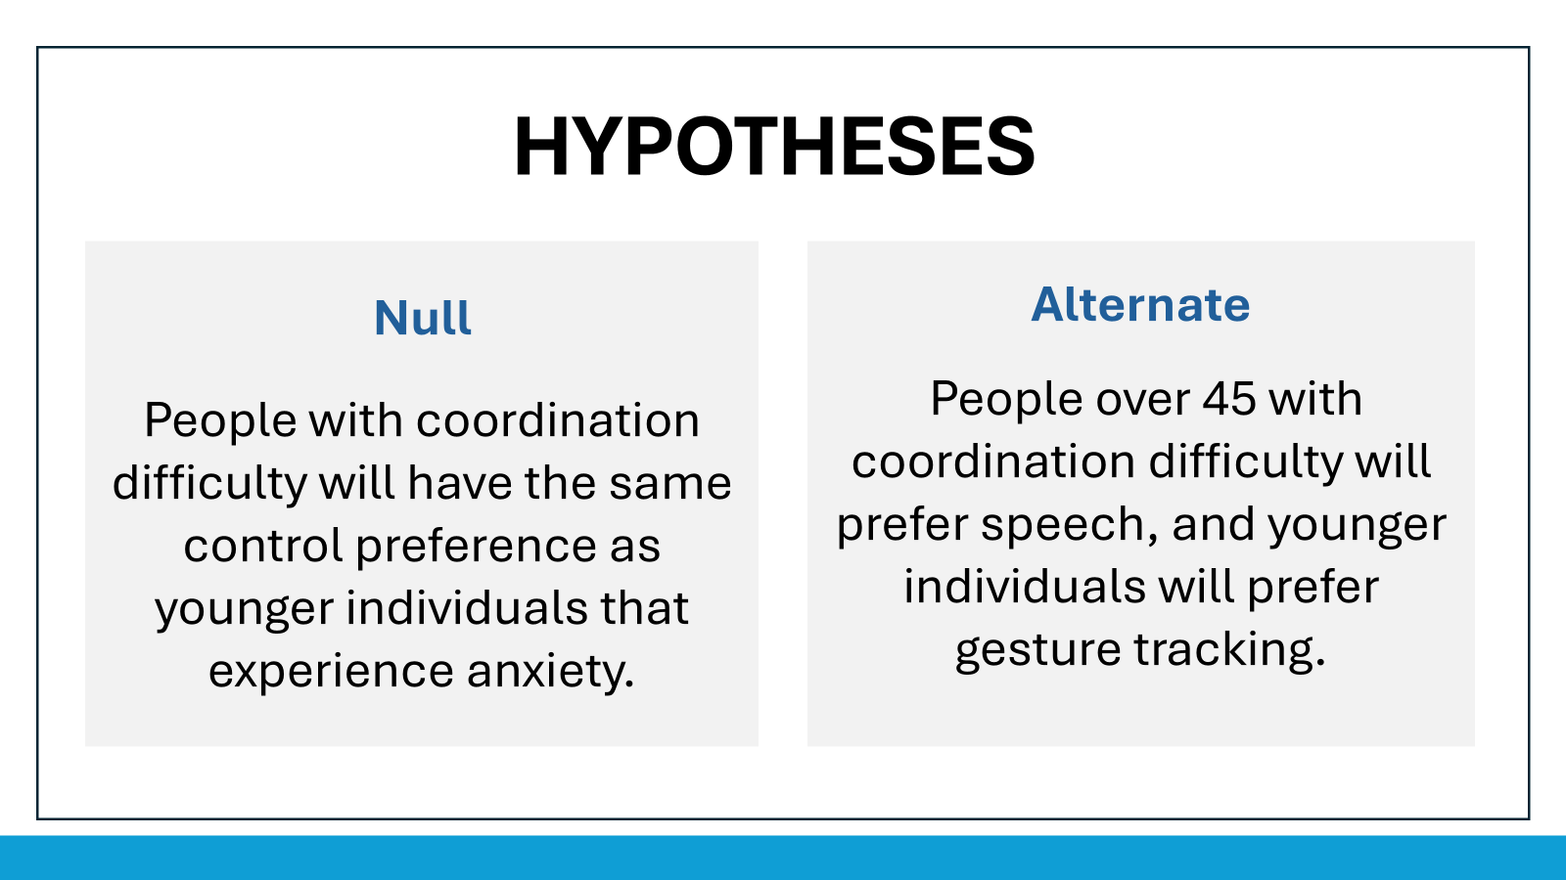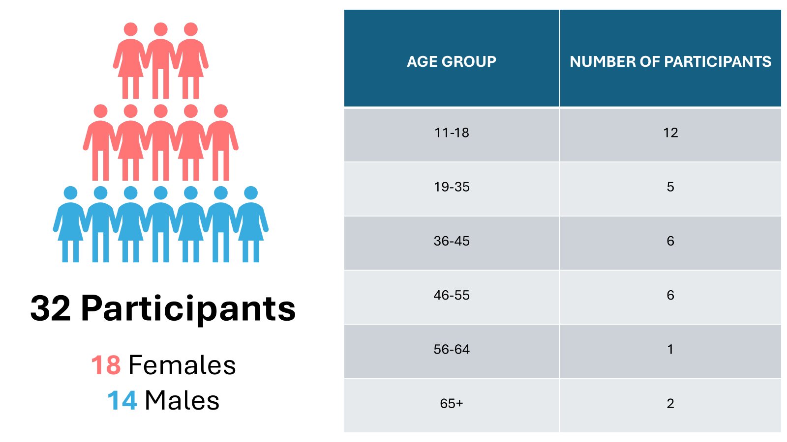

Monday, February 24, 2025:
- More Graphs (relation between age group and mode of interaction):
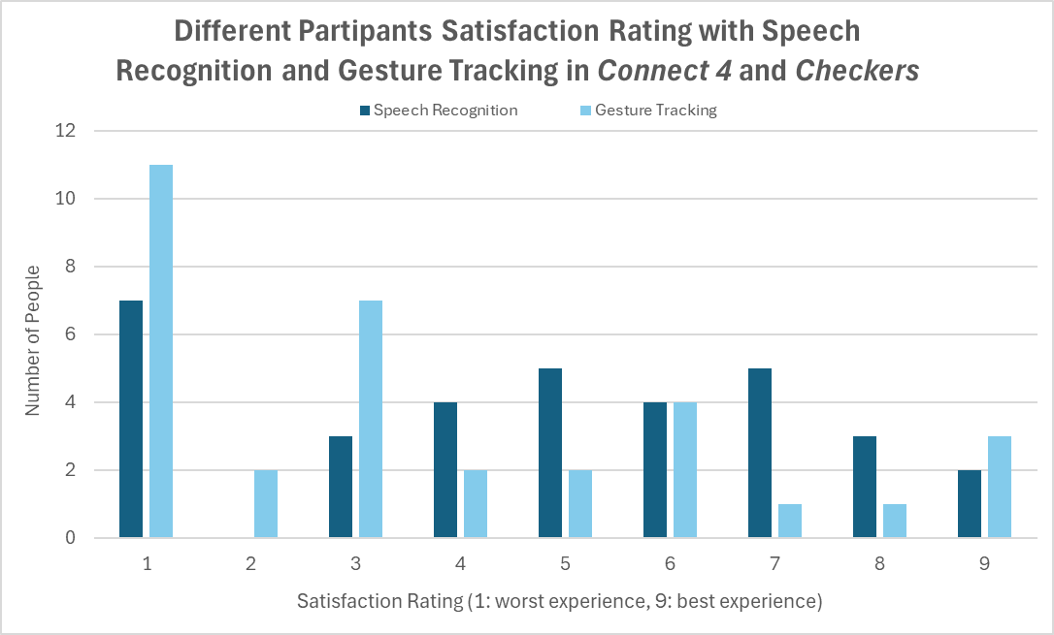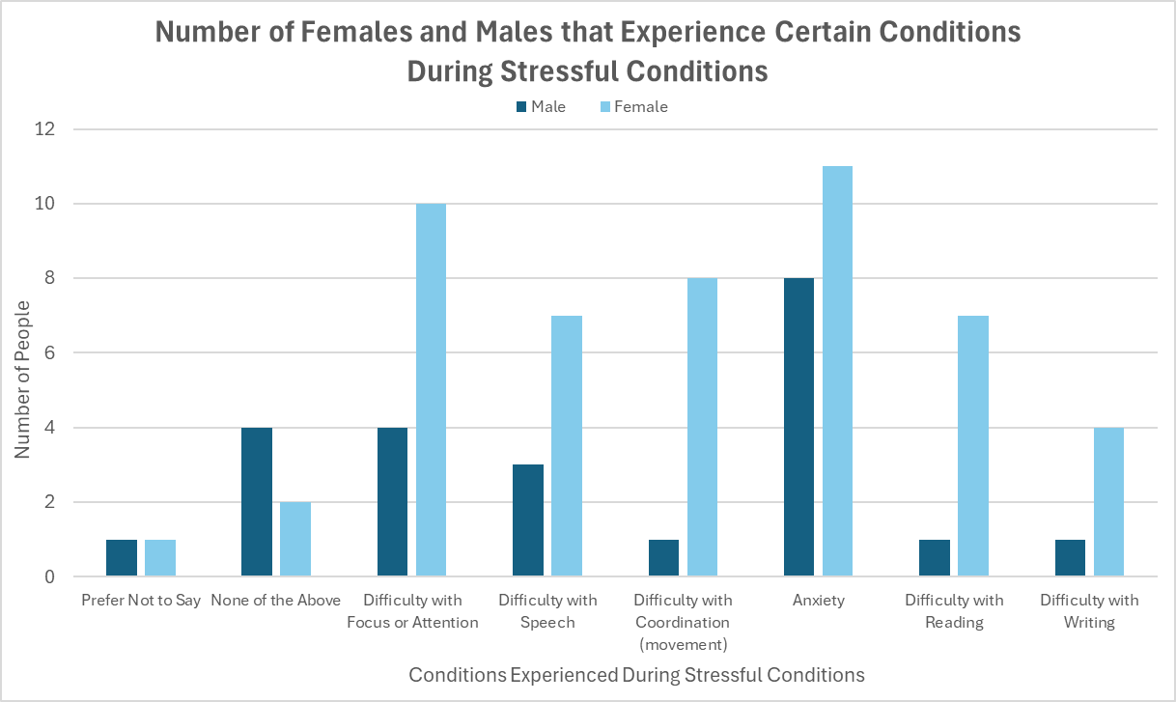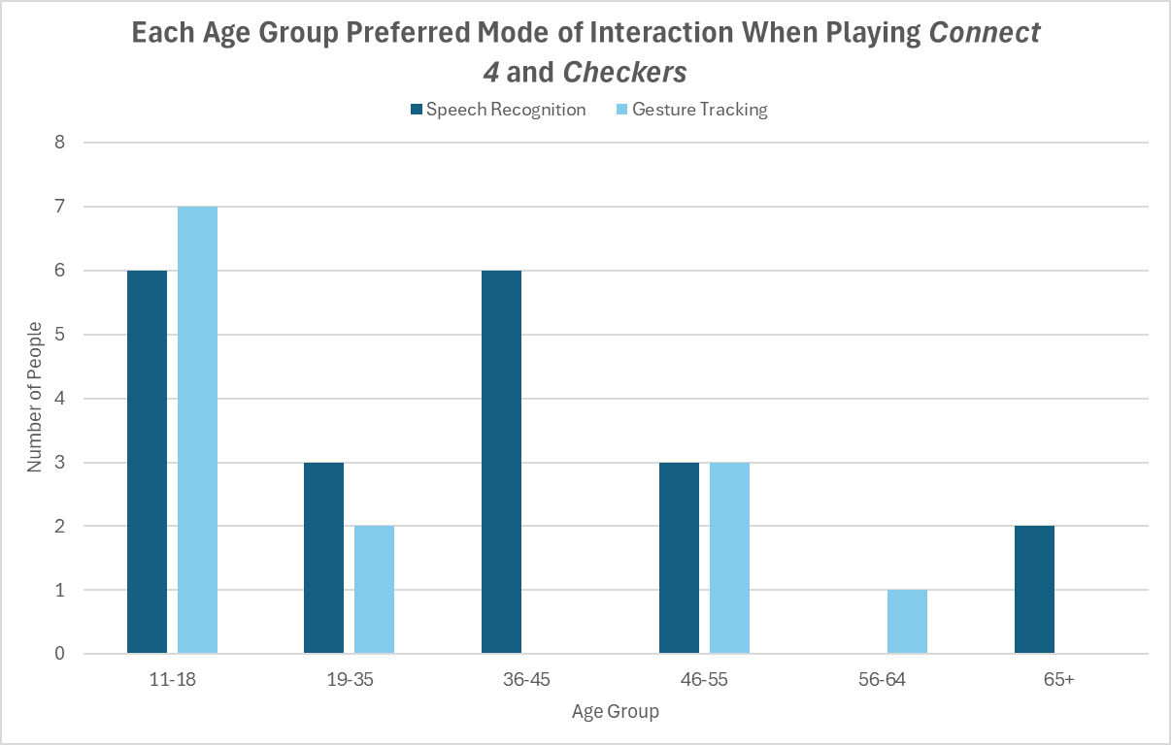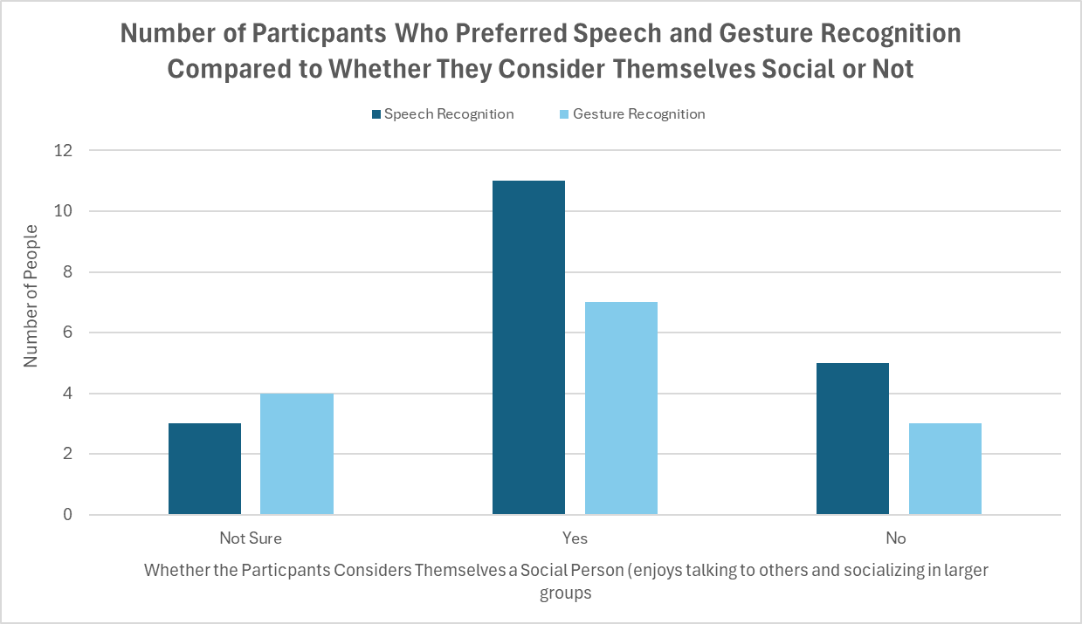

Tuesday, February 25, 2025:
ASP CLASS NOTES (15 min):
- Listened to Merrit and Maddux presentation
  - Question: how many participants did you get and how accurate was your data?
- FEEDBACK FOR PRESENTATIONS: spend more time (more than half) on results, analysis, and conclusion
  - Talk about if it proves or doesn’t prove hypothesis
- Edited the Final Version of Slides for Oral presentation and practiced the oral presentation
- Added the graphs to the raw data section on this google document
- WIll submit Powerpoint slides for oral presentation TOMORROW (day before presentation)

Wednesday, February 26, 2025:
- Edited the graphs with better layout
- Added acknowledgment paragraph from this document of CYSF Platform
- SUBMITTED SLIDES (see slides on google classroom submission)

Thursday, February 27, 2025:
- ASP PRESENTATION IN CLASS
COLE PRESENTATION:
- Disabilities increasing faster than technology advancements
- Immediate cognitive impact that cause people to experience cognitive decline
- Small sample size = statistical errors (not enough power to detect errors)
My question (didn’t get to ask):
- How can this knowledge be integrated into the medicine field?
AMBER PRESENTATION:
- Anesthetics are used to reduce pain and relax muscles
  - But can it cause neurodegeneration?
- More synapses used = stronger it gets
- Analyzed two synapses proteins
- Measuring the length of synapses and energy
  - Dark blue center is the nucleus (able to see the neurons)
    - Markers are working and fluorescents are attacking the right proteins
- Use of anesthetics are unavoidable but can tell about cautions and effects
  - Figure out post- surgery mitigation strategies
My question:
- Do you think age could play a big role in anesthetics?
AUDREY PRESENTATION:
- We don't necessarily have an actual cure or treatment that is effective for e coli O157.
- Contribute to development of working age therapy.
- Nucleospin kit → inspect the DNA
- Whole Genome sequencing is analyzing the whole genome
  - Have to quality check them
- Used heat map to represent her data
Questions:
- Can you provide a quick summary of your overall results and any important trends that were found?
  - No significant difference in defense systems
  - Several distances in Gene presence across isolates
LAUREN PRESENTATION:
- Most fatal kinds of cancer → lung cancer
  - Improve treatment outcomes through simple solutions.
- Stage 3 = infected lymph nodes
- Non-small cell lung cancer (NSCLC)
- Standard treatment for cancer = surgery, chemoradiation or targeted medication (new), intervention, immunotherapy
- Further research the identified intervention
- STUDY = pulled papers from databases about this topic
- Worst intervention = diet recommendations
- Breathing exercises didn’t see large efficacy scores (did not decrease stress/ anxiety).
- Small databases (exclusion of criteria) + large possibility of bias in these studies + lack of uniformity + difficult to identity when results are entirely honest
Questions (not answered):
- How could you take this knowledge from the study to an experimental level?

Monday, March 3, 2025:
ASP NOTES (55 min):
- Poster has to stand alone without you
  - Has to make sense without any explanation + more comprehensive
    - Ex. add definitions + have to understand everything
  - Have to have a flow
  - Graph and the explanation + table and the explanation
- When you talk in slides, you can be formal BUT when in poster you want to show a little informal (not robotic/ memorized rehearsed)
- Make sure that you are interactive with your poster
- Possible print places: vista print, staples
- Don’t confuse conclusion and analysis
  - Analysis: explanation/ discussion of results
  - Conclusions: take home messages + what did you do
- Worked on my poster on canva: https://www.canva.com/design/DAGeQEnSXaQ/4UyD-7Sbn4mHrVF1gev9tA/edit

Wednesday, March 5, 2025:
ASP NOTES (5 min):
- Worked on the science fair speech (rough outline of how I will be talking about my project)
  - https://docs.google.com/document/d/1nqcD1mCjiSCrqNNbDx1woJlrXERevmpebAHSpLMdMnA/edit?tab=t.0

Thursday, March 6, 2025:
- Sent an email to Dr. Garcia and Mr. Dow for recommendations on my poster
- POSTER SENT IN EMAIL:
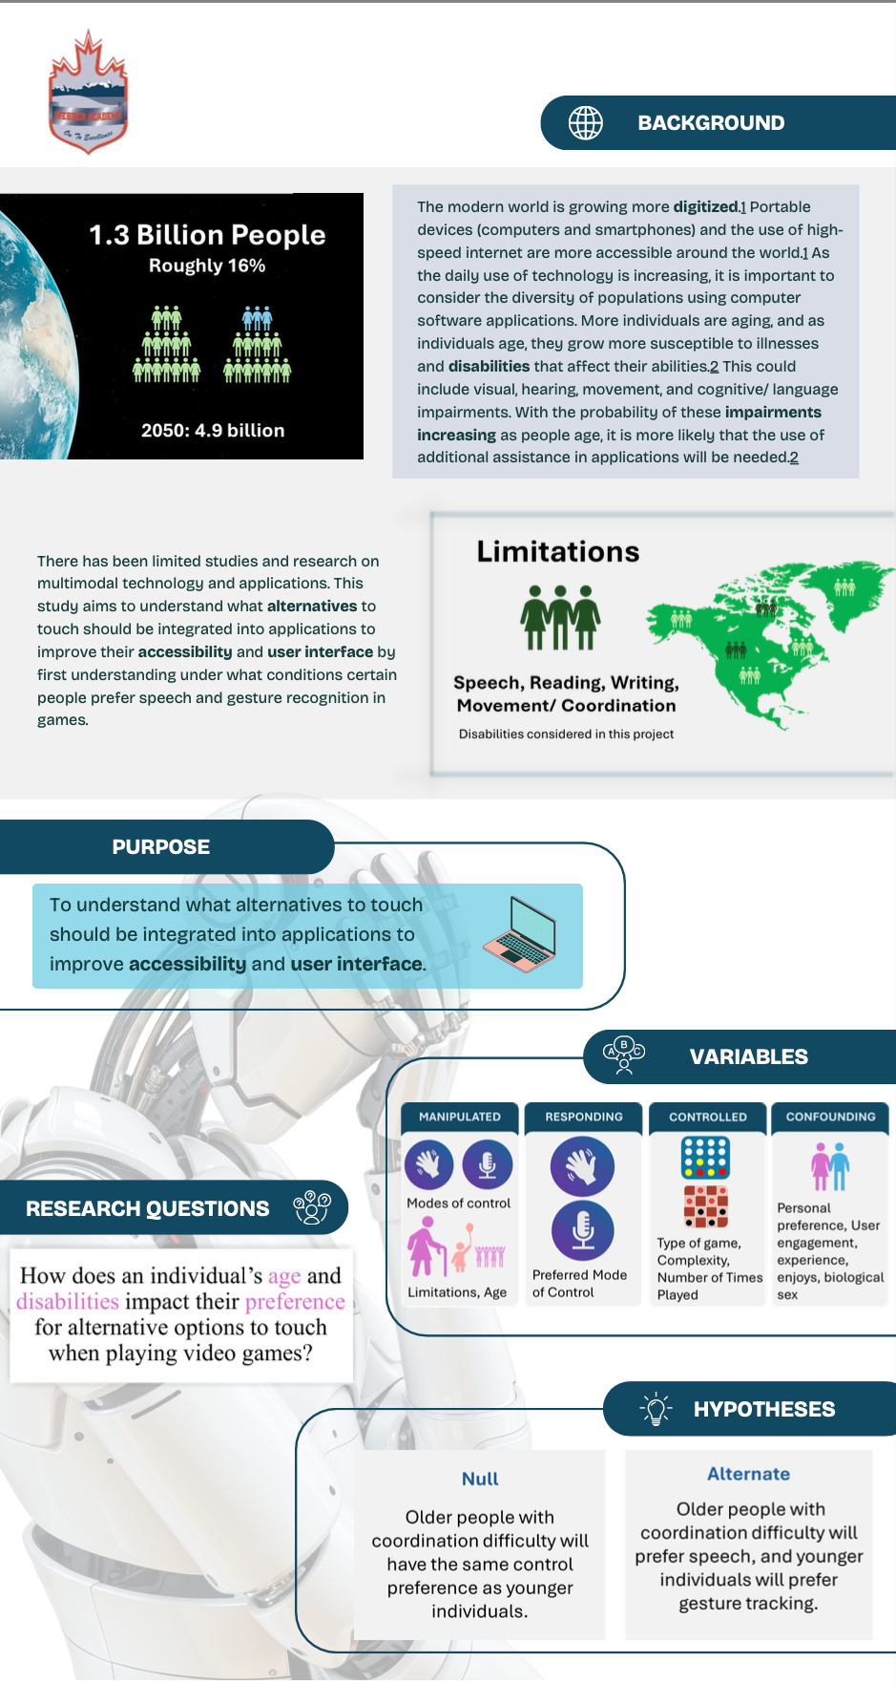

Friday, March 7, 2025:
ASP NOTES:
- Any figure, image, or graph that is NOT OF YOUR OWN MAKING HAVE TO BE CITED
- When presenting you have to say the part that the mentor did and what you did
- Asked Dr. Garcia for recommendations on my poster
  - Bullet point
    - Age and limitations separation
  - Results and Discussion
  - Add departments for acknowledgements
  - Conclusion → it should say what people of ages preferred and what limitations preferred

Tuesday, March 11, 2025:
SCIENCE FAIR DAY

Wednesday, March 12, 2025:
- Completed Acknowledgements, variables, conclusion, background research, citations section on CYSF portal
  - MAKE SURE TO COMPLETE BEFORE SATURDAY (french trip)

Thursday, March 13, 2025:
(ASP CLASS):
- Wrote my English Reading Comprehension test during today’s class

Friday, March 14, 2025:
- Finish the CYSF portal (added all sections + video)

SCHEDULE
Green Highlight = Finished, Yellow = Partially Finished, Red Highlight = Move to another date
Red Word: ASP class

August 2024:
01 | 02 | 03 | 04 | 05 | 06 | 07
08 | 09 | 10 | 11 | 12 | 13 | 14
15 | 16 | 17 | 18 | 19  Wrote a page research proposal for Mr.Dow. | 20  Sent an email to Mr.Dow about my proposal. | 21
22 | 23  Meeting with Mr. Dow (mentor). | 24 | 25 | 26  Study and learn about pygame and speech recognition through youtube videos and papers | 27  Study and learn about pygame and speech recognition through youtube videos and papers | 28  Begin coding connect 4 game using pygame.  ASP CLASS
29 | 30  Begin adding  voice commands to the connect 4 game.  ASP CLASS  (missing class) | 31  Fixing errors.

September 2024:
01 | 02 | 03  Adding drop to 1-7 column voice commands. | 04  Fixing errors.  Sent an email to my mentor about next meeting date.  ASP CLASS | 05  Fixing errors. | 06  Fixing errors + Mentor Meeting  ASP CLASS MEETING | 07  Fixing errors + find research papers + annotate them during the next 2/ 3 weeks.
08  Fixing errors + finding more research papers (but not annotating them yet) + coded | 09  Game should be working using voice commands!!  I fixed an issue. | 10  Fixing errors.  ASP CLASS  Annotated a paper - VR + Disabilities | 11 | 12  Fixing errors + Reading paper  ASP CLASS | 13  Fixing errors + Meeting with Mr.Dow. | 14  Fixing errors. + formatted the research proposal
15  Fixing errors. + Added to the research proposal → significance, objectives, question. | 16  ASP CLASS  Reading neurological papers. | 17  Review notes on neurological paper and make sure you understand. | 18  ASP CLASS MEETING  Reading computer softwares papers. | 19 | 20  Mentor Meeting with Mr. Dow → asked questions regarding research proposal | 21  Write neurological part of research proposal
22  Start thinking about if you will have access to a small sample of people with neurological disorders. | 23 | 24  Learning about video recognition and eye movement tracking.  ASP CLASS  EDIT/ REVIEW + work on objectives, hypothesis, variables in research proposal | 25  Review questions for data collection form BEFORE game + make draft form for data collection answered AFTER game played | 26  ASP CLASS  Write ethics form/ description of project | 27  Meeting with Mr.Dow | 28
29  Complete ethics form + questions that will be used for the experiment | 30  ASP CLASS MEETING  Read computer software paper and integrate it into the computer software paragraph.+ EMAIL ETHICS / QUESTIONS TO MENTORS

October 2024:
01  Continue reading the paper, if not finished on the last day, and edit or add more sentences into the introduction if needed. + Review what is written in the introduction part of the research proposal so far → grammatical check. | 02  ASP CLASS  Read HCI paper, write notes into the paper. | 03  start writing about computer softwares part of introduction + integrate HCI within it | 04  ASP CLASS continue writing about computer softwares + their accessibility (add definition of accessibility and what computer softwares are)  Mentor Meeting | 05  Research about speech recognition in computer softwares → find two or more papers about it. | 06  SEND Start of DRAFT OF PROPOSAL to Dr. Garcia + Mr.Dow. + send draft of form questions +FINISH ETHICS FORM  Research about camera/ gesture tracking in computer softwares → find two or more papers about it. | 07  If edits are given for the proposal and/ or ethics form, edit them. Read the first paper found about speech recognition. EMAIL Dr. Garcia about ethics form
08  ASP CLASS  Read the second paper found about speech recognition, and if time in class read the first paper about camera/ gesture tracking. Make notes. | 09  Finish computer software section in introduction in research paper. | 10  ASP CLASS MEETING  Finish first paper about camera/gesture tracking paper if not finished + finish second paper about camera/gesture tracking paper (make notes). | 11  Add different types of tracking paragraphs in research proposal after the neurological aspect.  Mentor Meeting | 12  Read HCI paper and make notes about it for HCI paragraphs in introduction. | 13  Write HCI paragraph for introduction in research proposal + finish today introduction. | 14  Learn about Javascript video tracking. + SHOULD HAVE most of the DRAFT OF PROPOSAL FINISHED!  Send to Mentor + Garcia.
15  ASP CLASS  Write objectives + edit if objectives written before this date + write variables + add question / edit + review hypotheses | 16  Start planning for methodologies + use information in flowchart already | 17  ASP CLASS  Finish writing a flowchart of code for methodologies + review significance / add more information if not enough | 18  Start coding using video tracking. + review whole research proposal + send to Dr. Garcia, Mr. Dow for review  Mentor Meeting | 19  Code + Edit proposal | 20  Code + Edit proposal | 21  ASP CLASS  SHOULD HAVE PROPOSAL FINISHED!  Send to Mentor + Garcia.
22  Add computer software and neurological disorders on slideshow for presentation. + write presentation for these two sections. | 23  ASP CLASS MEETING  Add different alternatives on slideshow for presentation and HCI. + write presentation for these sections | 24  Add HCI on slideshow if not finished yesterday + add examples of non-accessible computer softwares on presentation. + write presentation for these sections | 25  ASP CLASS  Add objectives on slideshow + Hypothesis + variables + question + methodology + significance | 26’  Review and edit slideshow for presentation + write presentation for these two sections+ send to Mr. Dow for review. | 27  Review presentation + present outloud | 28  Game should be working using head movement commands!! + review presentation/ outloud
29  Begin learning about hand tracking. ASP CLASS  review presentation/ outloud + review code for errors | 30  Learning about hand tracking. | 31  ASP CLASS  Review presentation + continue working on code if there are errors + integrate more aspects on website + FINISH PROPOSAL!!!  Write the presentation.

November, 2024:
01  Catch up on school homework, and finish weekend homework today.  LAST DAY TO SUBMIT PROPOSAL!!!  Write the presentation.  Start finishing reading all papers in your paperpile that you have not read yet  - start and finish reading “Voice games: Investigation into the use of non-speech voice input for making computer games more accessible” | 02  Code the speech recognition alternative for connect 4.  Practice Presentation  Finish reading “TrackMaze: A Comparison of Head-Tracking, Eye-Tracking, and Tilt as Input Methods for Mobile Games: 20th International Conference, HCI International 2018, Las Vegas, NV, USA, July 15–20, 2018, Proceedings, Part III” | 03  Continue coding the speech alternative for connect 4.  Practice Presentation | 04  ASP CLASS MEETING  Practice Presentation | 05  Practice Presentation | 06  PRESENTATION  Speech alternative for connect 4 code finished today.  Eleanor Presentation | 07  Code the gesture alternative for connect 4 (plan out how you will do it with google API).
08  Code the gesture alternative for connect 4 (execute/ implement the plan made yesterday in the gesture alternative)..  Lauren, Cole, Coco Presentation | 09  Code the gesture alternative for connect 4. | 10  Code the gesture alternative for connect 4. | 11  Finish coding the gesture alternative for connect 4. | 12  Code the head alternative for connect 4 (the head alternative will have a similar plan to gesture as it will function around the same function → object changes from hand to head). | 13  Code the head alternative for connect 4. | 14  Finish coding the head alternative for connect 4.
15  Code logic (wins) for checkers | 16  Code logic (invalid moves) for checkers | 17  Create checkers board in CSS and HTML on website (aesthetics) | 18  Code the speech recognition alternative for checkers (each space on the board -> ex. A4). | 19  Continue and finish coding for speech recognition alternative for checkers | 20  code for gesture recognition alternative for checkers | 21  Continue coding for gesture recognition alternative for checkers (pinching fingers)
22  Head alternative WILL NOT WORK in checkers → make sure code runs smoothly +everything works | 23  Fix any errors in code + make sure code runs smoothly +everything works | 24  Continue fixing errors if there are any. | 25  Fixing errors. | 26  Code end survey into the game, and add the data collection platform (TBD) | 27  Continue adding the data collection platform (TBD) | 28  FIX ERRORS!!
29  Fix all aesthetics in website + make sure code runs smoothly with no errors | 30  WEBSITE SHOULD BE RUNNING AND WORKING! + SUBMIT LOGBOOK

December 2024 / 25:
01  Continue coding checkers with keyboard control. | 02  Continue coding checkers with keyboard control. | 03  Continue coding checkers with keyboard control. | 04  Continue coding checkers with keyboard control. + edit introduction part for research paper | 05  Finish coding checkers with keyboard control. + edit introduction part for research paper | 06  Start coding checkers with speech control. | 07  coding checkers with speech control
08  coding checkers with speech control | 09  coding checkers with speech control+ edit introduction part for research paper  TEST (school) | 10  coding checkers with speech control  TESTS (school) | 11  coding checkers with speech control+ edit introduction part for research paper  TESTS (school) | 12  coding checkers with speech control  TESTS (school) | 13  coding checkers with speech control  TEST (school) | 14  Troubleshoot checkers speech control
15  Code checkers with gesture tracking | 16  Code checkers with gesture tracking  TEST (school) | 17  Code checkers with gesture tracking  TEST (school) | 18  Code checkers with gesture tracking+ edit introduction part for research paper  TEST (school) | 19  Code checkers with gesture tracking | 20  Code checkers with gesture tracking | 21  Code checkers with gesture tracking  AWAY FOR WINTER BREAK
22  Code checkers with gesture tracking  AWAY FOR WINTER BREAK | 23  Code checkers with gesture tracking + edit introduction part for research paper  AWAY FOR WINTER BREAK | 24  Code checkers with gesture tracking  AWAY FOR WINTER BREAK | 25  Code checkers with gesture tracking  AWAY FOR WINTER BREAK | 26  Code checkers with gesture tracking + edit introduction part for research paper  AWAY FOR WINTER BREAK | 27  Code checkers with gesture tracking  AWAY FOR WINTER BREAK | 28  Finish gesture tracking control in checkers.  AWAY FOR WINTER BREAK
29  Add survey into the website (google forms link) | 30  TEST WEBSITE + FIX BUGS/ ERRORS | 31  TEST + FIX BUGS/ ERRORS

January 2025:
01  fix/ add finishing touches to website (testing) | 02  fix/ add finishing touches to website (testing) | 03  fix/ add finishing touches to website (finish parts of code that had errors) | 04  fix/ add finishing touches to website | 05  FINISH website | 06  BACK TO SCHOOL | 07  STUDY FOR MIDTERMS
08  STUDY FOR MIDTERMS | 09  STUDY FOR MIDTERMS | 10  PHYSICS MIDTERM  Prepare to send the game out | 11  STUDY FOR MIDTERMS  Test website with friends | 12  STUDY FOR MIDTERMS  Test website with friends | 13  STUDY FOR MIDTERMS | 14  STUDY FOR MIDTERMS  Fix all errors from testing with friends
15  STUDY FOR MIDTERMS  Send out game | 16  STUDY FOR MIDTERMS  data collection | 17  STUDY FOR MIDTERMS  data collection | 18  STUDY FOR MIDTERMS  data collection | 19  STUDY FOR MIDTERMS  SENT GAME TO FRIENDS  data collection | 20  STUDY FOR MIDTERMS  data collection | 21  STUDY FOR MIDTERMS  data collection
22  STUDY FOR MIDTERMS  data collection | 23  STUDY FOR MIDTERMS  data collection | 24  Update CYSF + check data (if have enough)  data collection | 25  data collection | 26  data collection + write experimental procedure | 27  data collection + write experimental procedure | 28  data collection + write experimental procedure + email friends with game link
29  data collection + write experimental procedure + email more people with game link→ waiting for data | 30  data collection + write experimental procedure + submit introduction on turnitin | 31  data collection + write experimental procedure + submit dec/jan logbook

February 2025:
01  data collection + add introduction on CYSF platform | 02  data collection + finish writing experimental procedures | 03  data collection + start analyzing data + edit procedures section  ASP CLASS | 04  data collection + start analyzing data + send procedures paper to dr. garcia for recommendations | 05  data collection  + start analyzing data + edit procedures paper  ASP CLASS | 06  data collection + start analyzing data+ making graphs + read papers on different control methods for applications | 07  data collection + start analyzing data+ making graphs + read papers on different control methods for applications  ASP CLASS
08  data collection + start analyzing data + making graphs + edit the methodologies section for the procedure paper | 09  data collection + edit CYSF platform (with final copy of procedures) + edit the methodologies section for the procedure paper | 10  data collection + read papers on different control methods for applications + email Dr. Garcia and Mr. Dow the methodologies section for the procedure paper | 11  data collection  ASP CLASS | 12  data collection + draw conclusions from data + add the edits from teachers on procedures document | 13  data collection + draw conclusions from data + add the edits from teachers on procedures document  ASP CLASS | 14  data collection + draw conclusions from data + make background research slides for oral presentation + FINISH procedures document
15  data collection + start making the presentation slides for paper and deciding on the layout for the poster + SUBMIT procedures document | 16  data collection + + add graphs and introduction to poster/slides | 17  data collection+ add procedures to poster/ slides  ASP CLASS | 18  data collection  FINISH SLIDES + practice presentation | 19  data collection + PROCEDURE PAPER DUE+  ASP CLASS + practice presentation | 20  data collection + practice presentation with friends (get feedback) | 21  data collection + continue practing the presentation and ask people to ask your sample questions  ASP CLASS
22  data collection + organize the data received in female and male graphs + preferred mode of interaction | 23  data collection + make graphs on conditions experienced during stress and how it affected their preferred choice | 24  data collection + make graphs that combine all aspects from survey to show ultimate → what conditions affected people to choosing a certain mode of control preference | 25  data collection + listen to Maddux and Merritt presentation then work on finishing and practing google slides + having graphs finished (find correlations)  ASP CLASS | 26  data collection +have slides, observations, and analysis finished and understood COMPLETELY | 27  data collection  ORAL PRESENTATION IN  ASP CLASS +submit Feb logbook | 28  data collection + email Mr. Dow with the graphs that you made and ask his opinion + email teachers that science fair is on March 11 and will be missing the full day of classes

March 2025:
01  data collection + add the Mr. Dow edited graphs to the poster and email Dr. Garcia to take the poster on Tuesday | 02  data collection + if there is more data collected, edit the graphs and add to the final copy of the poster + add the Observations to the CYSF platform | 03  Data collection + add the conclusions and analysis texts and icons (DON'T MAKE TOO WORDY) | 04  data collection + send poster layout to Dr. Garcia and Mr.Dow and ask for their opinions | 05  data collection + practice presenting the project and plan out how you are going to be using the poster | 06  data collection + continue practicing the presentation + start writing results (add graphs and tables) | 07  data collection +continue practicing presentation + print the poster for science fair  REPORT CARDS
08  data collection + ROBOTICS BUILD DAY + make the presentation video for CYSF platform + finish the acknowledgement section on CYSF Platform | 09  data collection + write and add the analysis section to the CYSF portal platform (send to Mr. Dow and ask for his opinion) + practice presentation in front of peers and ask for feedback | 10  data collection + PRACTICE PRESENTATION (HAVE TO HAVE IT FOR SURE MEMORIZED BY THIS DAY) + | 11  SCHOOL SCIENCE FAIR ALL DAY | 12  Add text about the figures (graphs and charts that were added before) for results paper | 13  Edit Grammar and wording on results paper and continue writing if not completed days before | 14  Add logbook attachment on CYSF Platform + make sure that all fields are written and completed and edited on CYSF platform
15  TRIP FRENCH | 16  TRIP FRENCH | 17  TRIP FRENCH | 18  TRIP FRENCH | 19  TRIP FRENCH | 20  TRIP FRENCH | 21  TRIP FRENCH + post video on CYSF + FINISH CYSF PORTAL
22  TRIP FRENCH | 23  TRIP FRENCH | 24  TRIP | 25  TRIP | 26  TRIP | 27  TRIP | 28  TRIP
29  TRIP | 30  TRIP | 31  TRIP

April 2025:
01 | 02 | 03 | 04 | 05 | 06 | 07
08 | 09 | 10  CITY SCIENCE FAIR | 11  CITY SCIENCE FAIR | 12  CITY SCIENCE FAIR | 13 | 14
15 | 16 | 17 | 18 | 19 | 20 | 21
22 | 23 | 24 | 25 | 26 | 27 | 28
29 | 30
May 2025:
01 | 02 | 03 | 04 | 05 | 06 | 07
08 | 09 | 10 | 11 | 12 | 13 | 14
15 | 16 | 17 | 18 | 19 | 20 | 21
22 | 23 | 24 | 25 | 26 | 27 | 28
29 | 30 | 31

BACKGROUND RESEARCH
All Notes are on Paperpile Websites

August 27, 2024:
- “Implement Speech Recognition and Synthesis System Using Python” by Maheswara Reddy Basireddy
- https://www.researchgate.net/publication/381780125_Implement_Speech_Recognition_and_Synthesis_System_Using_Python
  - How to use Speech Recognition in Python
  - Annotations: https://paperpile.com/shared/s1sRW6cgdSKG2c2NyZPE9Vw

September 10, 2024:
- “The Use of Virtual Worlds Among People with Disabilities” by Kel Smith
- https://tcf.pages.tcnj.edu/files/2013/12/kelSmith_virtual_worlds_disabilities_032409.pdf
  - Virtual Reality + accessibility for people with disabilities
  - Annotations: https://paperpile.com/shared/sli9KdN9XS8qGIqBq~7w2ow

September 12, 2024:
- “Future design of accessibility in games: A design vocabulary” by Pail Cairns, et. al.
- https://www.sciencedirect.com/science/article/abs/pii/S1071581919300801?via%3Dihub
  - Games accessibility
  - Annotations: https://paperpile.com/shared/sGoQzxjxvTNuQtYC8ZCfz2A

September 20, 2024:
- “How common are common neurological disorders” by D. Hirtz, MD, D. J. Thurman, MD, et. al.
- https://www.neurology.org/doi/10.1212/01.wnl.0000252807.38124.a3
  - Data on number of people with certain neurological conditions
  - Annotations: https://paperpile.com/shared/svHwSL3~eTxmcobRatIUWpA

September 21, 2024:
- “Projected global burden of brain disorders through 2050 (P7-15.001)⁠ ” by Lei J, Gillespie K
- https://paperpile.com/shared/sE5Qc88I1TOOLers1LarZBA
  - Used in sentence about projected number of cases of neurological disorders
  - Paper is not finished; hence, only abstract used/ available

September 30, 2024 - October 2, 2024:
- “Making software more accessible for people with disabilities: a white paper on the design of software application programs to increase their accessibility for people with disabilities” by Vanderheiden GC.
- https://dl.acm.org/doi/10.1145/155824.155826
  - Accessibility of Computer Softwares (helpful information describing different types of impairments + why it is important for people to be able to access softwares)
  - Annotations: https://paperpile.com/shared/sBf44A0qDSzuORwYsIJxQIw

October 2, 2024:
- “Human Computer Interaction” by Carroll. JM
  - Describes about HCI + the continuous evolution of HCI
  - Annotations: https://paperpile.com/shared/s6lWEqp~CQE26ElTCW_F3vw

October 3, 2024:
- “What is software?: The Role of Empirical Methods in Answering the Question” by Osterweil LJ
  - Used this article to gain more knowledge about software: it is a very broad term used to describe programs that essentially execute tasks (can be used in a variety of fields → ex. Computer science + entertainment (ex. Softwares describe programs/videos)) and paper mainly focuses on computer engineering (not my experiments and papers focus)
  - DEFINITION of SOFTWARES: describe programs/videos
  - Link: https://paperpile.com/shared/swP~Gv0dkQsm6BLnf7O2a~Q
- “What is computer software?” by Uddin N
  - NOTES: software application describes the apps and games (what my experiment is focusing on) + also mentions that computer software is broader term (divided into system software and application software)
  - Link: https://paperpile.com/shared/s~SWpj2g6SMqY3lI6Oqchtg
- “APPLICATION OF COMPUTER TECHNIQUES IN MEDICINE” by VK Mehta, et.al.
  - Used for definition of computer software and software applications
  - Definition of computer software: "collection of programs which allow the user to interact with the computer hardware"
  - Definition of Application software: " consists of programs which perform special function for the user such as word processing, data processing, and spreadsheet programs"
  - Annotations: https://paperpile.com/shared/szqBdCBDyTNeKysXJ861G_w

October 3, 2024 - October 4, 2024:
- “Human-computer interaction in games using computer vision techniques” by Devyatkov V, Alfimstev A.
  - Describes about the user of computer vision and the types of models referring to these computer visions in computer games
  - Annotations: https://paperpile.com/shared/sIl9h5egdSFSWLYEJkrZCPg

October 4, 2024:
- “Heuristic Evaluation (HE)” by interaction design foundation
  - Definition: “Heuristic evaluation is a process where experts use rules of thumb to measure the usability of user interfaces in independent walkthroughs and report issues. Evaluators use established heuristics (e.g., Nielsen-Molich’s) and reveal insights that can help design teams enhance product usability from early in development.”
  - Link: https://paperpile.com/shared/s8ypdlbKZQSq~c1VPADqfGw

October 4, 2024 - October 25, 2024:
- “Video game values: Human-computer interaction and games” by Barr P, Noble J, Biddle R
  - Annotations: https://paperpile.com/shared/sUovf_lUeRQCl2jeRdUTXMQ

October 25, 2024:
- “The difference between Dyslexia and Dyspraxia” https://www.lexiconreadingcenter.org/the-difference-between-dyspraxia-and-dyslexia/#:~:text=In%20Conclusion%3A%20The%20Difference%20Between%20Dyslexia%20and%20Dyspraxia&text=Although%20there%20seems%20to%20be,difficulty%20in%20motor%20coordination%20skills.
  - “dyslexia is used to describe a learning difficulty to read write and spell whereas dyspraxia is the term used to describe a difficulty in motor coordination skills.”
- “Dyslexia and dyspraxia” by University of Oxford https://edu.admin.ox.ac.uk/dyslexia-and-dyspraxia#collapse1147946
  - “Dyslexia and dyspraxia are specific learning difficulties or differences. Most people have fairly even cognitive profiles, but the profile for people with specific learning difficulties is a lot more uneven, with strengths in some areas and unexpected weaknesses in others.”

October 30, 2024:
- “Designing for Disability: Evaluating the State of Accessibility Design in Video Games” by Mark Brown and Sky LaRell Anderson.
  - Annotations:https://paperpile.com/shared/sPWAYWFYASBGZxL9Mf63avQ
- “Mining Google Web Services: Building Applications with the Google API” by John P. Mueller.
  - DEFINITION: “API refers to a set of functions that a developer can call on to perform application tasks.”
  - PDF Link: https://books.google.ca/books?hl=en&lr=&id=VvCzHC0Ges4C&oi=fnd&pg=PR10&dq=what+is+a+Google+API+Programming&ots=e0BtV5H5nO&sig=TzRyheSz7dpLwL_rTYB4NuWdR7g#v=onepage&q=what%20is%20a%20Google%20API%20Programming&f=false

January 28, 2025:
- Google Hand API Link: https://github.com/google-ai-edge/mediapipe/blob/master/docs/solutions/hands.md
  - Describes functions and landmark models (i.e., numbered specific parts of the hand)

February 13, 2025:
- “Evaluating the adoption of voice recognition technology for real-time dictation in a rural healthcare system: A retrospective analysis of dragon medical one” https://pmc.ncbi.nlm.nih.gov/articles/PMC10035815/?utm_source=chatgpt.com
  - This study examined if the utilization of voice recognition improves the efficiency of clinical duties (i.e., documentation, medical records).
  - Data showed that the physicians who were more experienced and older did not use voice recognition while those who were younger used it.
    - 72% of people used speech recognition
- “Machine-learned wearable sensors for real-time hand-motion recognition: toward practical applications” https://academic.oup.com/nsr/article/11/2/nwad298/7452905?utm_source=chatgpt.com&login=false
  - The use of machine learning, deep learning, etc. were used to improve accuracy of the gesture tracking/ recognition
  - With the use of wearable light sensors, gesture tracking could become more accurate and utilized for more fields.
    - This study shows that there is research into the accuracy and implementation of gesture tracking using sensors
      - This could be implemented into games and applications (controlling a website with slight hand movements)
- “Voice assistants in private households: a conceptual framework for future research in an interdisciplinary field” https://pmc.ncbi.nlm.nih.gov/articles/PMC10113989/
  - “we witness a rapid adoption rate of VAs in the form of smart speakers such as Amazon Echo, Apple Homepod, and Google Home ”
    - Speech recognition is being used more often especially as seen in households to improve daily life
      - Alexa = notifies of amazon packages + news, etc.
  - “... highlight the fact that more interdisciplinary research is needed and what type of research is needed to advance the development and application of VA in private households and, by implication, inform companies about future business opportunities.”

EXPERIMENTAL PROCEDURES

Website Overview:
The website is coded in react javascript (https://react.dev/) and uses javascript xml (JSX), tailwind CSS for the aesthetics (https://tailwindcss.com/docs/installation). React javascript “reacts” to the user interface (UI) and rerenders and updates the website page. The website was built with assistance from (). This website uses a react router which means that the URL link is in sync with the UI.

Website Login:
Two functions were programmed for the welcome page/ website login; handleDocumentOpen, and handleSubmit. In order to continue to the next page in the website, the user must agree to the terms and read the ethics form. When the user presses on the button to review the consent form, a new window is opened. The handleDocumentOpen function is programmed by the line of code: window.open('https://docs.google.com/document/d/1IP9hpf3fO7R4BICLPqjpF451uVgrqR9DsfuQfLFVtgk/edit?tab=t.0', '_blank');. The link is the ethics document. The handleSubmit function ensures that the user fills in all categories (username, email, consent) by using the alert function to notify the user. When all fields are filled properly, the user will be navigated to the instruction video. The line of code that programs this is: navigate('/tutorial');.

Instruction Video:
The instruction video was built using Mac screen recording and text to speech (https://www.narakeet.com/app/text-to-audio/?projectId=8737c987-05a3-4776-a015-326aabc771db). The aesthetics of the video were programmed using tailwind CSS (https://tailwindcss.com/docs/installation). This video will appear after the user logins, and will have two buttons available (skip and continue). When the user presses either one of the buttons, they will be redirected to the main screen. The line of code used to program this is: onClick={() => navigate('/control-selection')}. The variable, navigate, is the function, useNavigate(). Control-selection guides the user to the file where the main screen is programmed.

Website Choosing Game and Method:
The user will choose the game and control method. Depending on the options the user chose, they will be directed to the appropriate window and file. The progress bar located on the bottom of the website’s screen, is coded by the function enderProgressBar. This function fills the bar based on how many games and control methods the user has completed. The user's progress is determined by the total number of games/methods completed divided by the total number of games/methods required multiplied by 100. The user data will be saved in local storage; however, the users are asked not to reload the screen as the data will not be emailed. Atom is used in this file, imported from Jotai (https://jotai.org/docs/core/use-atom). This allows the programmer to store any value in the atom, and to update it without reading the value from a memory location. In this file, emailjs is imported (https://www.emailjs.com/). When the user presses the button labelled “Take Survey”, the compiled data from the games are emailed to the researcher by using emailjs. The data will include game type (checkers or connect 4), control type (classical, speech, gesture), number of moves, total time, hover count, drop count, hover times, and total hover time. The button will replace the website window with a new window containing the google forms that the user will have to fill out. The link they are redirected to is: https://docs.google.com/forms/d/e/1FAIpQLSfTifHQwaAPx-3sFtevV9KAC8lMG6Whkr8_PYKZYI7mNoyQpQ/viewform?usp=header.

Connect 4 Game Board:
The Connect 4 game board (Figure 1) is styled and designed using tailwind CSS (https://tailwindcss.com/docs/installation). The board is a map that has seven columns and six rows. The colours that are used are different shades of blue (‘bg-blue-500’ and ‘bg-blue-700’). The column numbers in Figure 1 are displayed above the board using the ‘.map’ function, and is styled using tailwind CSS (width 10, height 10, bg-blue-500, text-white, rounded full).

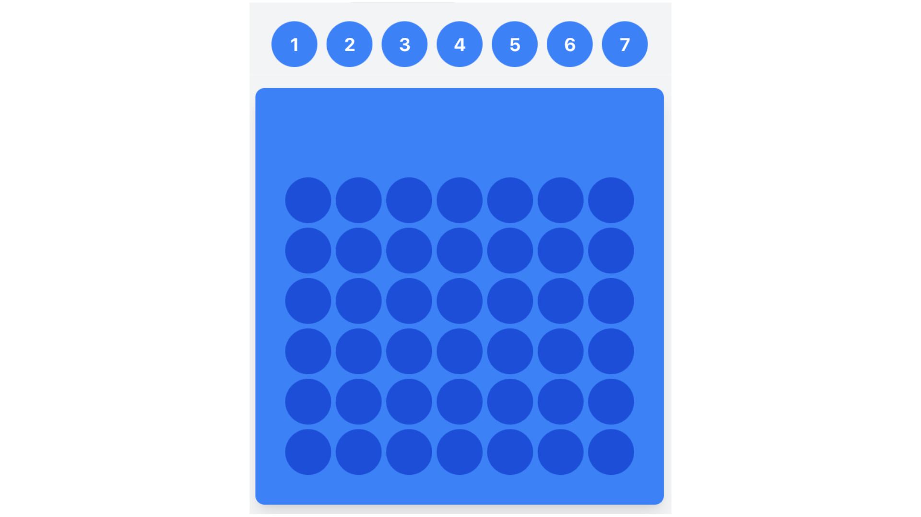
Figure 1: Screenshot of Connect 4 Board from the developed website

Checkers Game Board:
The Checkers game board (Figure 2) was styled and designed using tailwind CSS(https://tailwindcss.com/docs/installation). The board is a map that has eight columns and eight rows. The colours used are red(‘bg-red-500’), black(‘bg-black’), white(‘bg-white’), and blue(‘bg-blue-500’). To determine where the draughts (red and black) are on the board, if statements were used. The red draughts, for the starting board, are restricted to the first three rows, while the black draughts are restricted to the last three rows. If the row index plus column index are not even, then a draught will be placed on that spot. When a user chooses a draught to move, the function, isHighlighted, is called. This function highlights (‘ring-2 ring-yellow-400’) the available positions by calculating the possible, valid moves.

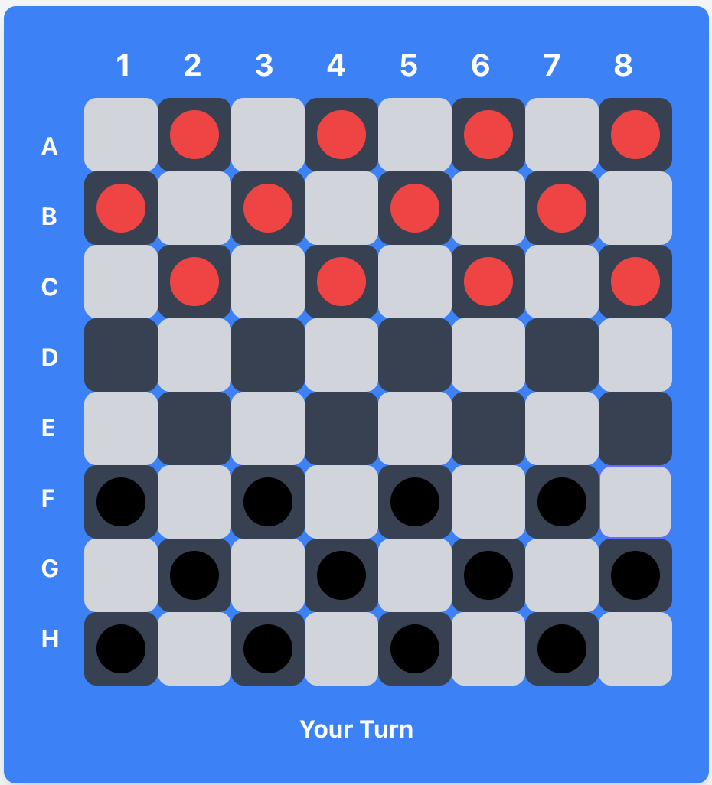
Figure 2: Screenshot of Checkers Board from the developed website.
Row Indexes: ‘A’= 0, ‘B’= 1, ‘C’=2, etc.
Column Indexes: ‘1’ = 0, ‘2’= 1, etc.

Connect 4 Game Logic:
The user will versus a computer player (player 2). The user will always have the first move (player 1). Whenever a player places (drops) a disc into a column, the player number will alternate (player 1 = 1, player 2 =2). This ensures that the colour of the disc always matches the player (red for player 1, yellow for player 2). If the move is invalid, as determined if the player placed a disc in a full column (Figure 3), a message “Invalid Move” will be displayed. The user will have to redo their move. When the move is valid, a new board is generated with the new disc.

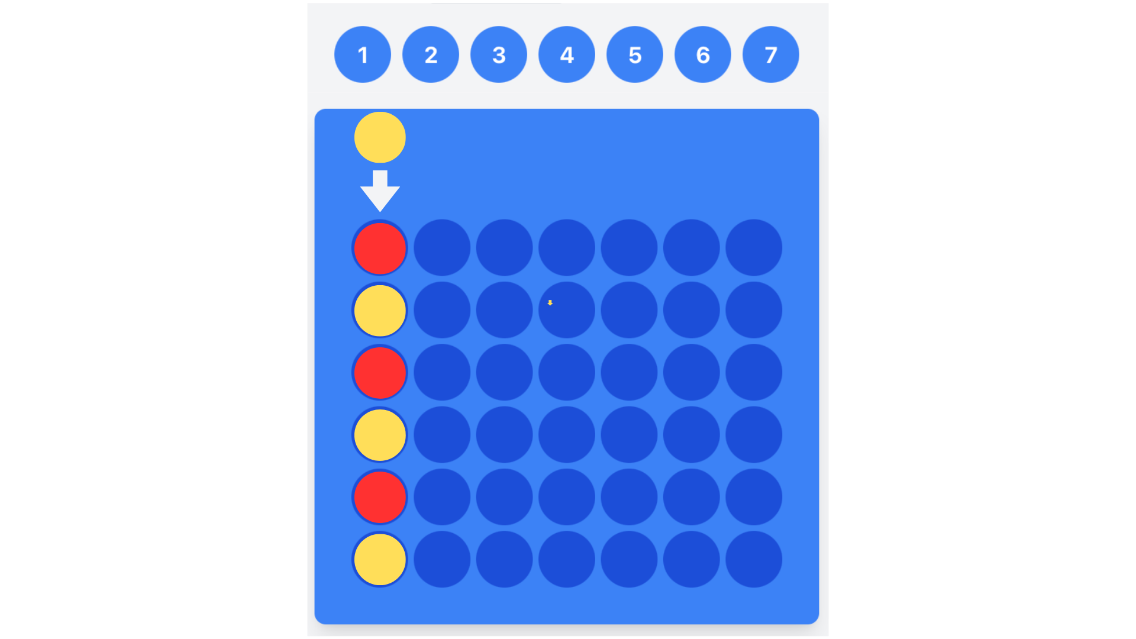
Figure 3: Connect 4 invalid move example on board
Red: Player 1
Yellow: Player 2
Arrow: Player 2 placing the disc in a full column

Whenever the user chooses a column, within range, a check win function is called. This function checks if four same coloured draughts are next to each other in horizontal, vertical, or diagonal placements (Figure 4). If the user has won (as determined by the check win function), then a message, “You Win”, will be displayed. Else, the game will not end and the user will continue to play the game.

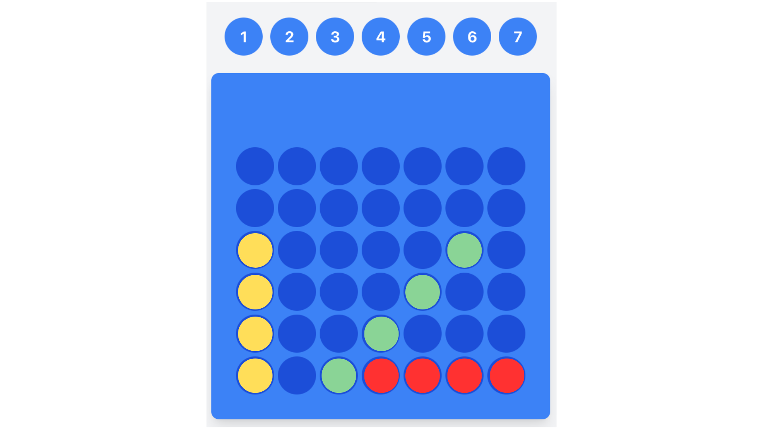
Figure 4: Connect 4 winning positions on board
Yellow: vertical win demonstration
Red: horizontal win demonstration
Green: diagonal win demonstration

Functions that calculate possible moves and wins are used to determine where the computer player will place the disc. The computer player has a 40% chance of playing a random move. This ensures that the game is not too difficult to win, but there are still some challenges. To determine where to place the disc, multiple functions are utilized. One function gets available columns by returning the empty spots on the board. In another function, these empty spots are used as parameters to determine the possible wins by evaluating possible horizontal, vertical, and diagonal win positions (Figure 4). A score/ points feature is also used to motivate the users to play their best. These points are determined by if the user wins (plus 1000 points), and how fast the user chooses a spot. The max score is 2000. The min score is 0.

Speech Recognition for Connect 4:
The speech recognition Google API is used ('webkitSpeechRecognition'). The speech recognition language will be ‘en-US’ (American English). A number map is programmed, which are alternate ways that the speech recognition could recognize the word (Figure 5). If the user says one of the valid column numbers (1-7), a disc will appear above the column. When the user says ‘drop’, then the disc will be placed in that column. The same functions will be utilized as described in Connect 4 Logic, but inputting different parameters into the functions. A microphone button underneath the Connect 4 game will be used for the user to start and stop speech recognition. A function will determine if the speech recognition works on their browser, if not, a popup will alert the user to use Chrome or Edge. When the user is speaking, the speech recognition will transcribe the speech into lowercase text. When the user presses the microphone button again, speech recognition will stop and a popup will alert the user.

const numberMap = {
// Zero
'zero': 0, 'oh': 0, 'null': 0, 'nought': 0,

// One
'one': 0, 'won': 0, 'juan': 0, 'wun': 0, 'hun': 0,

// Two
'two': 1, 'to': 1, 'too': 1, 'tu': 1, 'tew': 1,

// Three
'three': 2, 'tree': 2, 'free': 2, 'thee': 2,

// Four
'four': 3, 'for': 3, 'fore': 3, 'foor': 3,

// Five
'five': 4, 'fife': 4, 'fiev': 4, 'faiv': 4,

// Six
'six': 5, 'sicks': 5, 'sex': 5, 'sics': 5,

// Seven
'seven': 6, 'heaven': 6, 'sven': 6, 'sevin': 6,

// Other potential confusions
'or': 3, 'oar': 3,
'want': 0, 'wont': 0,
'twelfth': 1,
'fourth': 3,
'quarter': 3,
'v': 5,

// Numerals
'0': 0, '1': 0, '2': 1, '3': 2, '4': 3, '5': 4, '6': 5, '7': 6
};

Figure 5: Number map for Connect 4

Speech Recognition for Checkers:
The speech recognition for checkers will be a separate file from speech recognition for connect 4. The speech recognition Google API is used ('webkitSpeechRecognition'). The speech recognition language will be ‘en-US’ (American English). A number map and letter map are programmed, which are alternate ways that the speech recognition could recognize the letter and words (Figure 6). If the microphone is off and available on the user’s browser, the microphone will start listening (processing commands). A collectMove function will gather the data (number of moves, total time it took to play the game, control type = voice, game type = checkers, and username) from the user as they play. Two maps are used because checkers use a standard notation system consisting of letters and numbers. The letters sare converted to numbers to easily determine the row of the map/ matrix. A function, interpretCommand, converts users speech to lowercase text. The first word is the letter (row), and the second word is the number (column). To move a draught, the user will say the draught position and the position they want to move the draught to (i.e., F3 move to E2).

// Letter to column mapping (A-H -> 0-7)
const letterMap = {
'a': 0, 'b': 1, 'c': 2, 'd': 3, 'e': 4, 'f': 5, 'g': 6, 'h': 7,
'hey': 7, // could be misrecognized for h
};

// Number to row mapping (1-8 -> 0-7)
const numberMap = {
'one': 0, 'won': 0, 'juan': 0,
'two': 1, 'to': 1, 'too': 1,
'three': 2, 'tree': 2,
'four': 3, 'for': 3,
'five': 4, 'fife': 4,
'six': 5, 'sicks': 5,
'seven': 6, 'heaven': 6,
'eight': 7, 'ate': 7,
'1': 0, '2': 1, '3': 2, '4': 3, '5': 4, '6': 5, '7': 6, '8': 7

Figure 6: Number map for Checkers

Gesture Tracking for Connect 4:
The Google API used are 2D hand recognition tracking (https://cdn.jsdelivr.net/npm/@mediapipe/hands/hands.js), and camera recognition (https://cdn.jsdelivr.net/npm/@mediapipe/camera_utils/camera_utils.js). When the user moves their hand left or right, it moves in conjugation with the coin. Landmark 4 (thumb tip) and landmark 8 (index finger tip) were utilized so when the user touches their index finger and thumb (act of pinching), the coin will drop in the chosen column (Figure 7). The column is determined by multiplying the landmark[8] in the x component by seven as there are seven columns to choose from in Connect 4). Essentially, the screen is divided into the columns in the Connect 4 game. When a hand is detected, and when it moves left or right, the coin moves accordingly depending on what column number the hand is in. The maximum number of hands to be detected are one, as set by ‘maxNumHands”. The camera quality was decreased so that the website does not crash continuously.
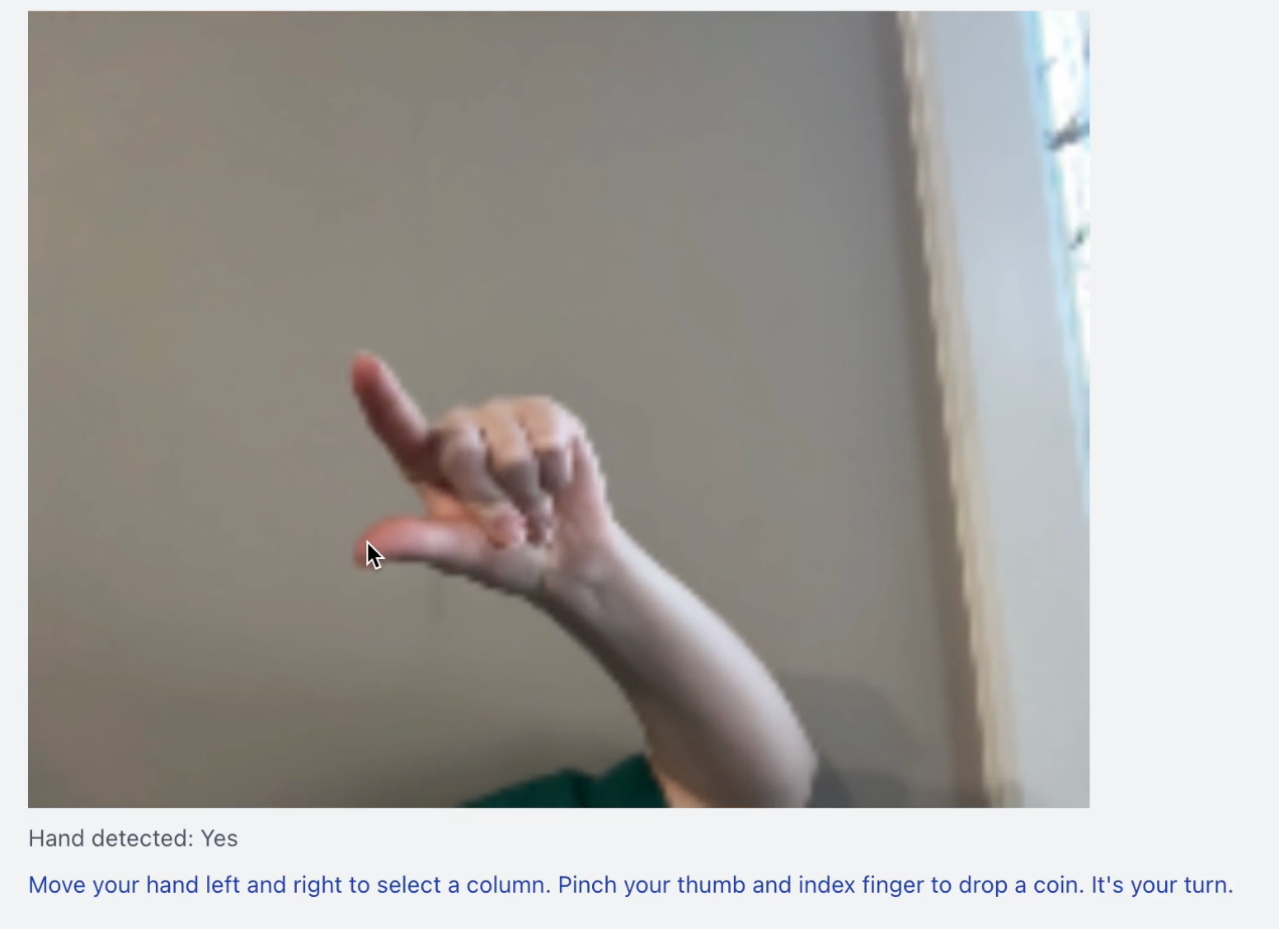
Figure 7: Gesture Tracking Hand Movements (pinching)

Gesture Tracking for Checkers:
The gesture tracking for checkers uses the same API’s, and will be a separate file from gesture tracking for Connect 4. The hand movement to control a draught will be the same as Connect 4 (Figure 7). Function, getGridPosition, returns row and column in an array. Row is calculated by rounding down.

DATA COLLECTION & RESULTS
- Data is collected on a google sheet (from a google form).
  - LINK: https://docs.google.com/spreadsheets/d/1nUhLqaSP8SMOQY8F5O7OhpzGP6nFMWLiwOL6jVXnIFk/edit?gid=1391510971#gid=1391510971

Observations:
February 7, 2025: From the data that I have collected so far (7 participants), there are more females than males that have participated in this study. Those who selected that: Game didn't recognize my commands and Game was slow on processing my commands and Game wasn't entertaining, ranked their user experience lower than those who had selected one or two of the above. Those who checked: game wasn’t entertaining, ultimately choose this option because they do not have interest in Connect 4, Checkers, or both of these games. Also, the glitching in gesture tracking resulted in a lower user experience score. This could mean that in order to improve application HCI, the software should have reduced glitching (if possible none), run smoothly, and adjust based on the user’s interests. This would result in the user staying on the application more and having a more enjoyable experience. From the seven participants, five participants' cameras glitched during gesture tracking. This could have been due to an overload of information and/or the API used. Those whose camera’s glitched preferred speech recognition over gesture tracking, while those who did not experience the glitched camera preferred speech recognition. This shows that whenever the application loads slowly or disrubs someone from their task (in this case, playing the game), one ranks their user experience lower. So far, one participant has identified with ADHD, which means that they are not able to focus on one task. This person preferred gesture tracking, because they would have to repeat the command multiple times in speech recognition. This demonstrates that, so far, when the commands do not work effectively and fast for ADHD individuals, the user loses focus and most likely grows frustrated or distracted from the game. This can be seen from the average moves per game data. In Checkers game voice recognition, the user had eight moves on average, which means that they most likely gave up using voice recognition and quit the game or they started using classical control because they were frustrated. Four participants experienced anxiety during stressful situations (1 male, 3 females). Interestingly, two users preferred speech and the other two preferred gesture. One female user who preferred gesture recognition preferred this option because she does not speak english fluently; it was difficult for her commands to be recognized. The two participants that do not play games preferred the gesture recognition option when playing the games.

February 25, 2025: There were a total of 33 participants, 19 females and 14 males.
There was a nice distribution of participants in all age groups (although there was only one individual in the age group 56-64 and two in 65+). Future improvements and developments of this project would include a greater range of participants in all ages, as well as more participants that experience disabilities or limitations that prevent them from interacting with an application. The six participants with ADHD all preferred the gesture tracking alternative. Individuals with ADHD usually, “require receiving explicit visual or auditory reward … to keep their attention in the video game”14. This proves that something visually entertaining engages people with ADHD while on applications. On average, from the game data, it can be seen that participants with ADHD took a longer time playing the games with speech recognition than gesture recognition.

Raw Data:
- The raw data table from the survey results can be found on the google sheets link: https://docs.google.com/spreadsheets/d/1nUhLqaSP8SMOQY8F5O7OhpzGP6nFMWLiwOL6jVXnIFk/edit?gid=1391510971#gid=1391510971

AGE GROUP | NUMBER OF PARTICIPANTS
11-18 | 13
19-35 | 5
36-45 | 6
46-55 | 6
56-64 | 1
65+ | 2

Number of Participants That Preferred Each Mode of Interaction Chart
SPEECH RECOGNITION | GESTURE TRACKING
19 | 14
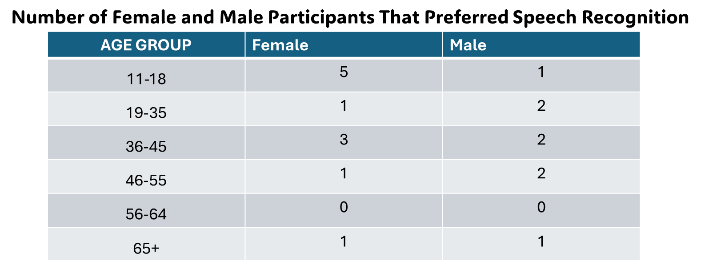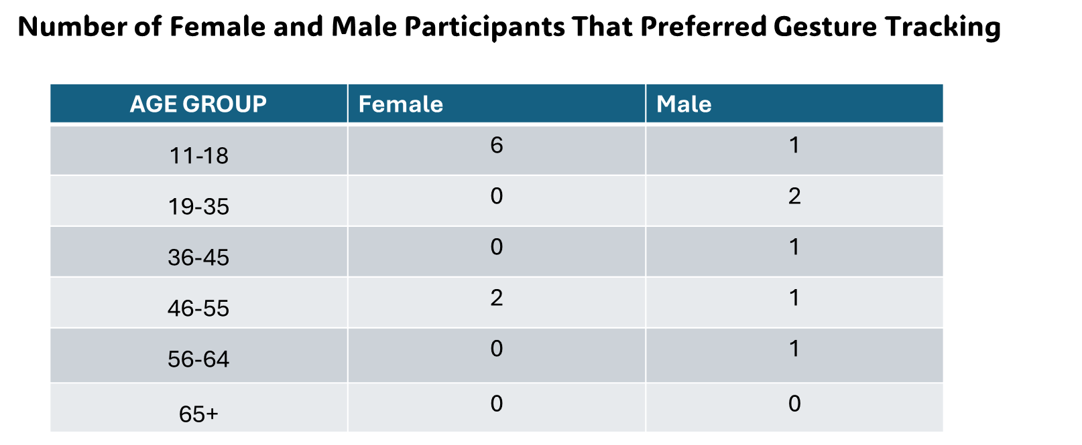
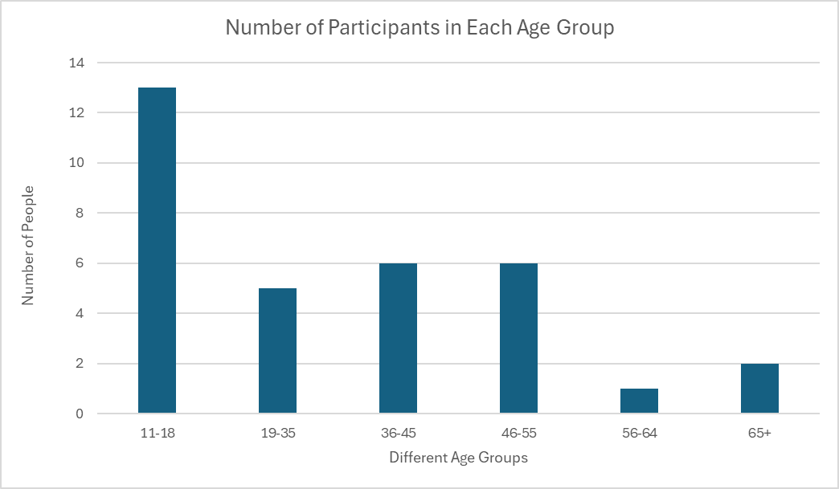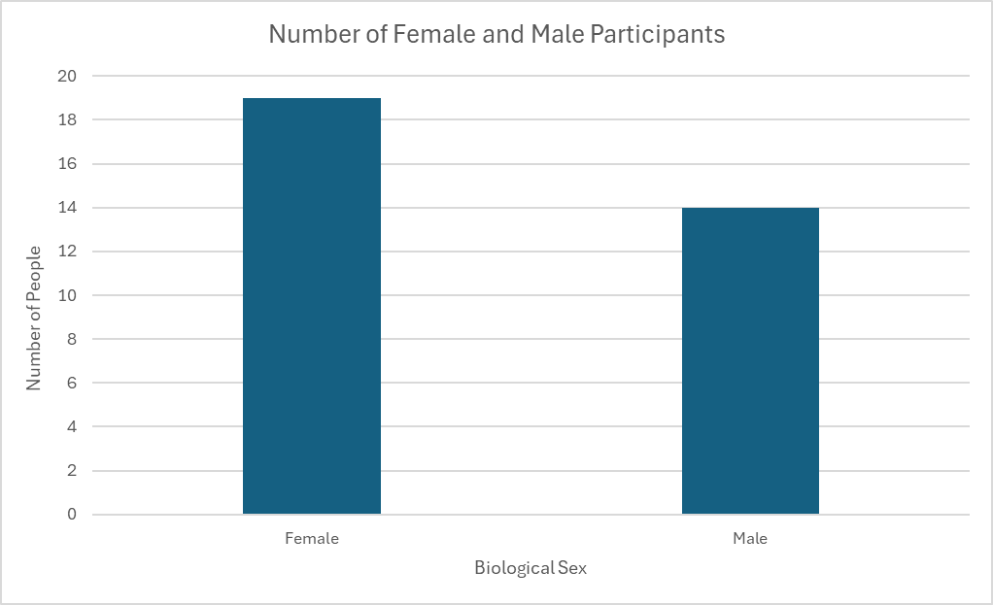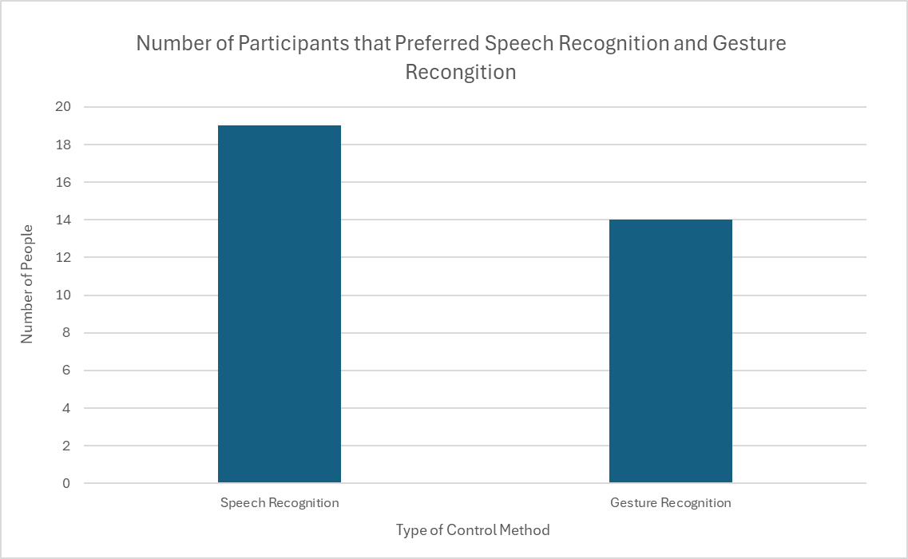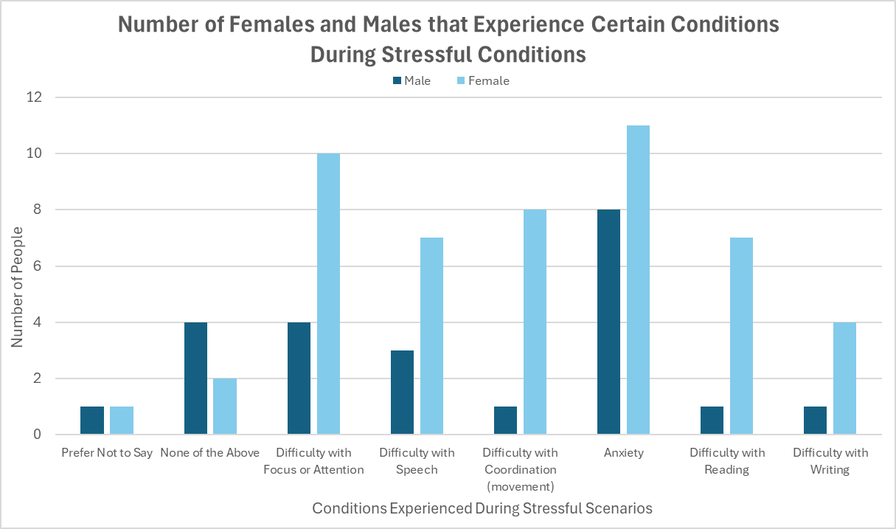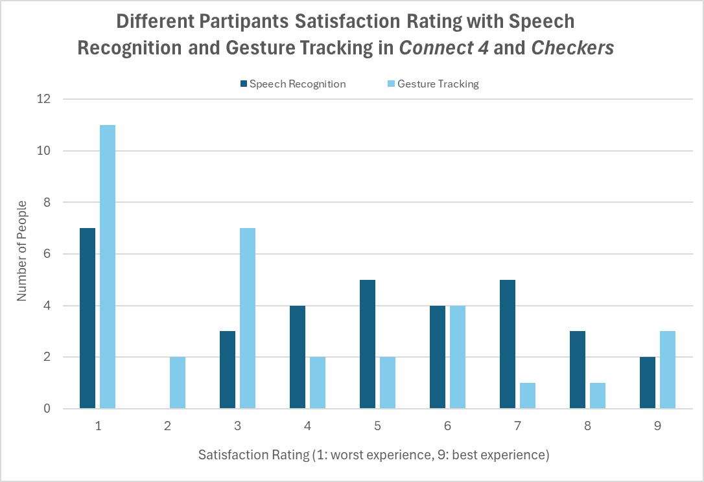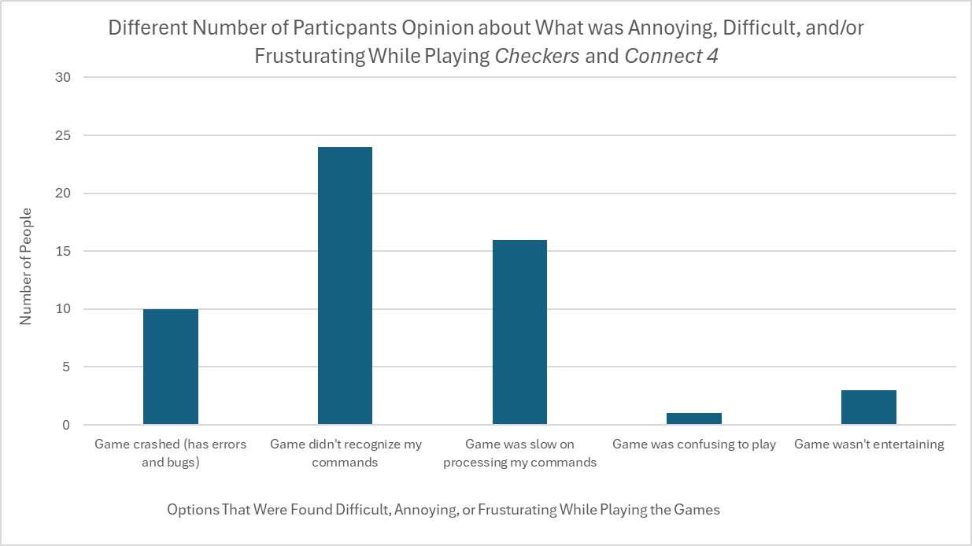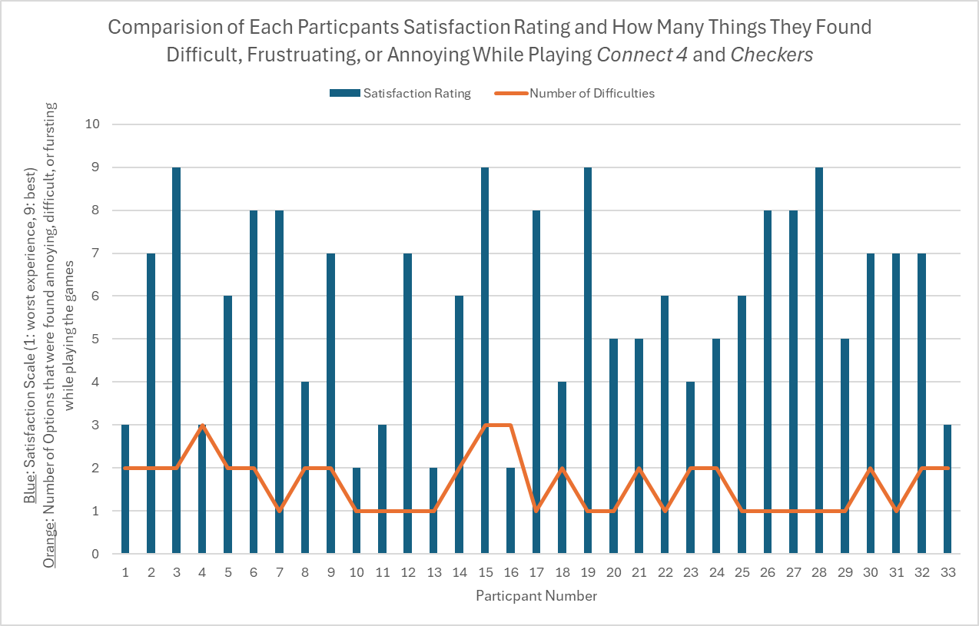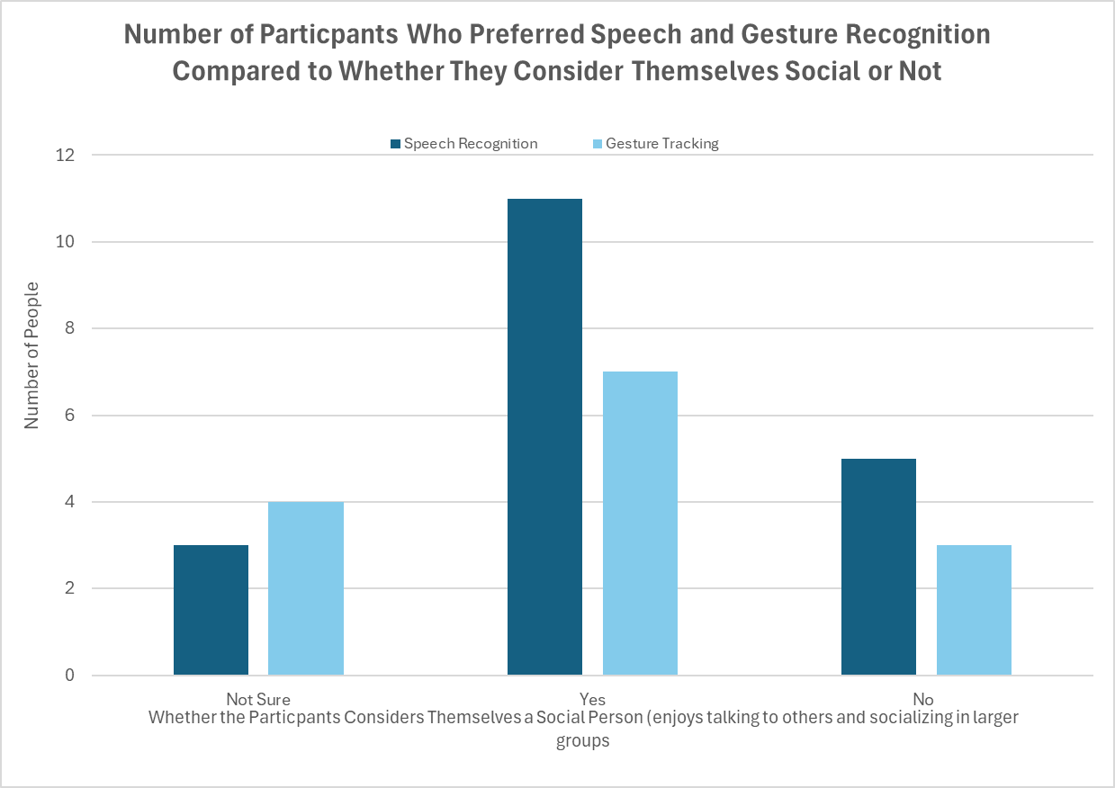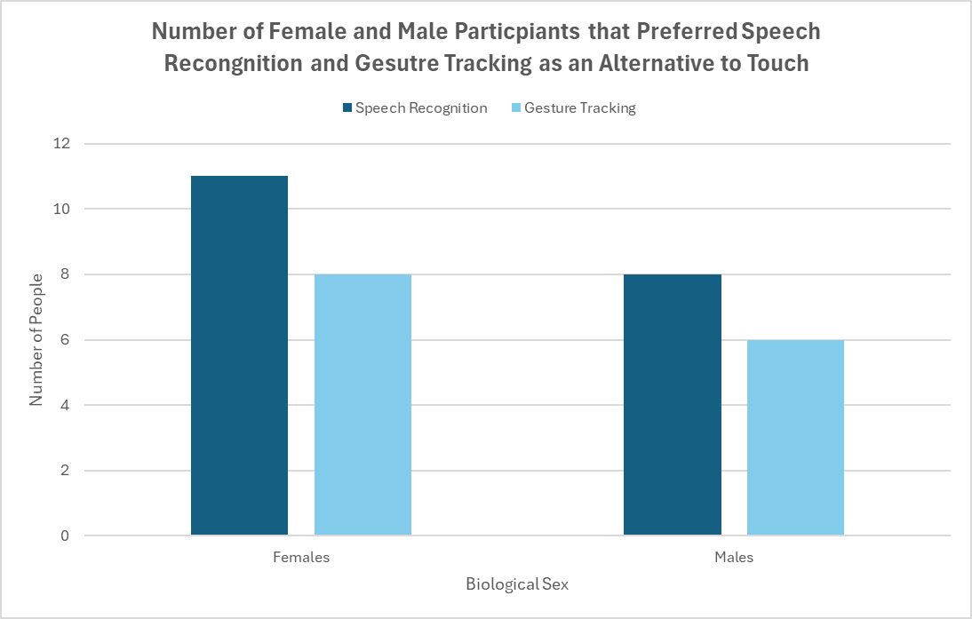

DISCUSSIONS & CONCLUSIONS

ACKNOWLEDGEMENTS
I would like to express my gratitude to my mentor from the University of Calgary: Mr. Travis Dow, and my Applied Science Project professor: Dr. Garcia from Webber Academy. Thank you to my friends and family for their commitment in testing my website and gathering participants in my study. I am sincerely grateful to all of you.

