ASP Logbook

Audrey Lo

# 

**Calendar** **2**

August 2

September 2

October 2

November 3

December 4

January 4

February 5

March 5

April 6

**Daily Work** **8**

August 8

September 8

October 16

November 22

December 26

January 29

February 33

March 39

# 

# Calendar

| August | | | | | | |
| --- | --- | --- | --- | --- | --- | --- |
| Sunday | Monday | Tuesday | Wednesday | Thursday | Friday | Saturday |
| 25 | 26 | 27  Tour Lab  Meet Dr. Niu | 28 | 29 | 30 | 31 |
| September | | | | | | |
| Sunday | Monday | Tuesday | Wednesday | Thursday | Friday | Saturday |
| 1 | 2 | 3  Email Mawra | 4 | 5  Meeting with Mawra 2:20-3:30 (2:00-3:30) | 6  Class  Register for online courses | 7 |
| 8 | 9  Meeting with Mawra 10:30-12:00 (10:00-12:20) | 10  Class ~~- Ind. meeting~~ | 11  Lab Orientation 9:00-12:00  ~~Lab 12:30-3:30?~~ | 12  Class | 13 | 14 |
| 15 | 16  Lab work 8:15-9:15  Class | 17  Lab work 10:30-11:00 | 18  ~~Lab work? 10:30-11:50~~  Class | 19  Lab work 12:00-1:30 | 20  Class  Lab visit | 21 |
| 22 | 23 | 24  Class  Lab work 8:00-9:30  Lab work 3:00-3:30 | 25 | 26  Lab 10:30-11:50  Class | 27  Lab visit? | 28 |
| 29 | 30  Class  September logbook due  Email Dr. Niu about meeting | NOTES:  Highlight goals in purple | | | | |
| October | | | | | | |
| Sunday | Monday | Tuesday | Wednesday | Thursday | Friday | Saturday |
| NOTES:  Goals in purple | | 1 | 2  Class | 3 | 4  Class  Email about dates | 5 |
| 6 | 7 | 8  Class | 9  ~~Finish intro and outline~~  Lab 2:30-3:30 | 10  Class  Lab 8:00-9:00 | 11  Lab 10:30-11:50  Email about dates | 12 |
| 13  ~~Finish articles + citations~~ | 14 | 15  Class | 16 | 17  Class | 18  Email about dates  Lab 2:30-3:30 | 19 |
| 20 | 21  Class  Meeting with Mawra 9:00 | 22 | 23  Class | 24  Finish proposal draft 1 | 25  Class  Email about dates  Lab visit 4:00-  ~~Send proposal draft to Dr. Niu~~ | 26  ~~Finish proposal~~ |
| 27 | 28  Lab visit 2:30-3:30 | 29  Class | 30 | 31  Class  Finish proposal draft 2 (send to Dr. Garcia) |  | |
| November | | | | | | |
| Sunday | Monday | Tuesday | Wednesday | Thursday | Friday | Saturday |
| NOTES:  Goals in purple  Meetings in blue  Due dates in teal  Tasks in red  Try to read one article per class | | | | | 1 | 2 |
| 3 | 4  Class  Meeting with Mawra 12:00  Work on proposal | 5 | 6  Class | 7  Proposal due  Lab visit | 8  Class  Work on presentation (background)  Email Mawra | 9  Work on presentation (methodology) |
| 10  Work on presentation (speech) | 11  Practice presentation | 12  Practice presentation | 13  Class  Oral Pres. | 14  Rework logbook | 15  Class  Revisit logbook  ~~Meeting with Mawra~~  Email Mawra | 16 |
| 17  Finish Ethics Due Care 2A | 18 | 19  Class  ~~Individual Meeting with Dr. Garcia~~ | 20  Finish PADLOC processing  Resubmit Logbooks | 21  Class  Dr. Garcia absent  Read two articles | 22  Email Mawra  Lab visit~~?~~ | 23 |
| 24 | 25  Class  Read 2 articles | 26  Lab visit 10:30-12:00 | 27  Class  review articles | 28 | 29  Class  ~~Read 2 articles~~  Lab visit 12:00-1:30  Logbook check  Email Mawra | 30 |
| December | | | | | | |
| Sunday | Monday | Tuesday | Wednesday | Thursday | Friday | Saturday |
| 1 | 2 | 3  Class  Individual Meeting with Dr. Garcia | 4 | 5  Class  Lab visit 10:10-11:10 | 6  Email Mawra  ~~Lab visit 12-1:30~~ | 7  Review spreadsheets |
| 8  Send Dr. Garcia draft for ethics | 9  Class  Read 2 articles | 10 | 11  Class  Individual Meeting with Dr. Garcia | 12 | 13  Class  ~~Individual Meeting with Dr. Garcia~~  Email Mawra | 14  Submit Ethics 2A |
| 15 | 16 | 17  Class  Read one article | 18 | 19  Class  Read one article | 20  Email Mawra | ~~21~~  Winter Break |
| ~~22~~ | ~~23~~  Read an article | ~~24~~ | ~~25~~ | ~~26~~ | ~~27~~ | ~~28~~ |
| ~~29~~ | ~~30~~ | ~~31~~ | NOTES:  Goals in purple  Meetings in blue  Due dates in teal  Tasks in red  Try to read one article per class | | | |
| January | | | | | | |
| Sunday | Monday | Tuesday | Wednesday | Thursday | Friday | Saturday |
| NOTES:  Goals in purple  Meetings in blue  Due dates in teal  Tasks in red  Try to read one article per class | | | ~~1~~ | ~~2~~ | ~~3~~  Email Mawra | 4 |
| 5 | 6  Class | 7 | 8  Class | 9 | 10  ~~Email Mawra~~  Physics Midterm 11:55-3:50 | 11 |
| 12 | 13  ELA A Midterm | 14  GH A Midterm | 15  ELA B Midterm  Bio Midterm | 16  Chem Midterm | 17  ~~Email Mawra~~  Math Midterm | 18 |
| 19 | 20  GH B Midterm | 21  Read one article  Email Mawra | 22  Class  Read one article  Individual Meeting with Dr. Garcia | 23  Read one article | 24  Class  Email Mawra  Read one article | 25  Read two articles  Retype proposal as introduction |
| 26  Edit introduction and submit to Dr. Garcia for edits | 27  Read an article | 28  Class  Final introduction edits | 29  Read one article | 30  Class  Paper Introduction due  Logbook Check | 31  Email Mawra  Read one article |  |
| February | | | | | | |
| Sunday | Monday | Tuesday | Wednesday | Thursday | Friday | Saturday |
| NOTES:  Goals in purple  Meetings in blue  Due dates in teal  Tasks in red  Try to read one article per day | | | | | | 1  ~~Decide on a poster type~~  ~~Plan initial layout~~ |
| 2  ~~Draft 1 of oral presentation~~ | 3  Class  Individual Meeting with Dr. Garcia | 4 | 5  Class  Virtual Meeting with Mawra | 6 | 7  Lab  Email Mawra | 8  Decide on a poster type  Plan initial layout  Draft 1 of oral presentation |
| 9 | 10 | 11  Class  oral presentation prep | 12 | 13  Class  Individual Meeting with Dr. Garcia | 14  Email Mawra | 15 |
| 16 | 17 | 18 | 19  Class  Paper Procedures due | 20 | 21  Class  Email Mawra  oral presentation prep | 22 |
| 23 | 24  HAND IT IN HARD DEADLINE  Lab | 25  Class  Meeting with Mawra  oral presentation prep | 26 | 27  Class  Oral presentation | 28  Logbook Check  Email Mawra  Lab |  |
| March | | | | | | |
| Sunday | Monday | Tuesday | Wednesday | Thursday | Friday | Saturday |
| NOTES:  Goals in purple  Meetings in blue  Due dates in teal  Tasks in red  Try to read one article per class | | | | | | 1 |
| 2 | 3  Class  Individual Meeting with Dr. Garcia | 4 | 5  Class | 6 | 7  Class | 8 |
| 9 | 10 | 11  Class  School Science Fair | 12 | 13  Class  Individual Meeting with Dr. Garcia | 14 | 15 |
| 16 | 17  Class | 18 | 19  Class | 20 | 21  Class  Paper Results section due | 22 |
| 23 | 24 | 25 | 26 | 27 | 28 | 29 |
| 30 | 31 |  | | | | |
| April | | | | | | |
| Sunday | Monday | Tuesday | Wednesday | Thursday | Friday | Saturday |
|  | | 1 | 2 | 3 | 4 | 5 |
| 6 | 7 | 8  Class  Individual Meeting with Dr. Garcia | 9 | 10  Class  Science Fair (poster and registry) | 11  Science Fair | 12  Science Fair awards ceremony |
| 13 | 14  Class | 15 | 16  Class | 17 | 18  Class | 19 |
| 20 | 21  Class  Individual Meeting with Dr. Garcia | 22 | 23  Class | 24 | 25  Class  Paper Conclusions due | 26 |
| 27 | 28 | 29  Class | 30 | NOTES:  Goals in purple  Meetings in blue  Due dates in teal  Tasks in red  Try to read one article per class | | |

# 

# Daily Work

## **August**

## 16/08/2024

### Individual work

* Dr. Niu emailed about attending workshop for new students (September 11, 9:00-12:00)
  + Highly recommends workshop attendance

## 27/08/2024

### Lab

* Went to the lab for the first time
* Talked to Jenny and Mawra (supervisor)
* discussed Galaxy with Mawra
  + Galaxy (part1)
    - FastQ file
      * process through FastQC
    - FastQC
      * process through FastP
    - FastP
      * process through Shovill
* Met with Dr. Niu
  + Clarified project is about mutations in E. Coli 131 and exposure to phages throughout several generations
* Received link to health safety training courses from Jenny
* Also received files for Galaxy practice

## **September**

## 04/09/2024

### Class

* Dr. Garcia discussed procedures & documentation
  + Logbook
    - 5 - organization/structure
    - 5 - content (full & specific)
    - 5 - calendar/tasks
      * deadlines
      * big+small tasks
      * specific
  + PaperPile
    - citation resource
  + Citations
    - APA or AMA
  + Research Proposal
    - Title
      * Specific as possible
      * concise, informative, descriptive
    - Abstract - optional
      * summary of main research question, rationale, hypothesis, methods
    - Intro
      * background info
        + framework
      * Why is this necessary/relevant?
    - Objectives
    - Variables
      * Independent
      * Dependent
      * Controlled
      * Confounding
    - Questions & Hypothesis - 20
    - Methodology - 10
      * don't have to understand too well but still helpful
    - Significance - 5
      * brief
      * how it will impact field of study
      * larger implications
      * how your research fills a gap
    - References - 3
    - ideally submit MID OCTOBER
  + Next meeting with mentor
    - Project ideas
      * What is my project? - narrow to Research Question
      * Analysis?
      * Come up with own project?
      * Already discussed
    - Meeting Times
      * When should we meet?
    - Research proposal

### Individual Work

* Mawra emailed presentation about DefenseFinder and Galaxy (starting tutorial for use)
  + For reference when needed about Galaxy and DefenseFinder

## 05/09/2024

### Lab

* Discussed scheduling
  + finish Google Calendar schedule
    - send to Mawra
      * CC DR. GARCIA!!!!!
  + inform Dr. Garcia of meeting on Monday
* Received IT email - activated 24 hours later (3:00)
  + register for online courses after school
    - schedule time for those
  + follow the rest of the procedure emailed by Mawra
* Re-clarified Galaxy procedure
  + will re-clarify again on Monday due to lack of time

## 06/09/2024

### Class

* Dr. Garcia - Individual Meeting
* discuss project as a question/sentence topic
* order for outline of lit. for intro
* main topic?

## 09/09/2024

### Lab

* Created IT account
* Registered for required online courses
  + Completed WHMIS 2015 and Laboratory Safety

### Home

* Completed Occupational Health and Safety Orientation

## 10/09/2024

### Lab

* Received lab instructions
  + Materials
    - In Lab
      * Safety materials
      * vials and test tubes
    - Prepare
      * Tryptic soy agar plates (TSA)
      * Tryptic soy agar broth (TSB)
      * lambda diluant
* Discussed antiviral defense systems analysis
  + DefenseFinder
* Ran all of Shovill files through Defense Finder
* Agreed to meet on 12th of September

## 11/09/2024

### Workshop

* Mole calculations
* Types of water
  + Type 3 - RO water
  + Type 1 is best water
* Pipette disassembly?
  + eject ejection system
  + unscrew end
* BSC
  + Clean vs Dirty
    - Clean is sanitised
    - Dirty has dangerous pathogens
  + Procedure
    - When working, keep window at correct height or it gets mad
    - Be careful working around someone working at BSC, could disrupt airflow and get contaminants out of BSC - potential endangerment to others
  + BSC is not fume hood
* Centrifuge
  + Make sure to balance properly or bad things happen
  + smaller centrifuge = more mix

### Individual work

* Emailed Mawra
  + Cancelled for tomorrow (school workload)

## 12/09/2024

### Individual work

* Discussed lab time with Mawra
  + lab meeting at 10:30 tomorrow
  + suggested 2:20 meeting
    - autoclave room closed in afternoon
  + come on Monday instead

## 15/09/2024

### Individual work

* Emailed Mawra about availability tomorrow and remainder of week
  + 8:15 to 9:15 tomorrow
  + Tuesday from 10:30-11:50, Thursday 12-1:30

## 16/09/2024

### Lab

* Discussed procedure for prep and recipes
  + Materials to prep
    - TSA - tryptic soy agar plates
    - TSB - tryptic soy broth
      * 800mL water
      * 24g media
    - bacteria (Avian Pathogenic Escherichia Coli)
    - agarose
    - flask (100mL mTSB)
    - titre box
    - 5mL tips
* General timeline
  + Normal susceptible bacteria
  + Phage exposure
  + Mutant
    - Quantitative Resistance Assay
    - Relative Fitness Assay
    - Antiviral defense system
* Phage propagation
* Bacterial cultures
  + -80 C master colonies
  + streak plates
  + inoculate broth

### Class

* + - Lauren's notes:
      * Paper pile
        + Build library

cite in AMA

* + - * + Citations

AMA - Purdue Owl for guide

* + - * Research Proposal
        + variables+hypothesis

none if study

none if innovation

* + - * + research question

multiple short/long term goals

short

specific as possible

long

can be broad

things to do post-project, what you hope to accomplish

specific as possible

only to outline project/significance

money

* + - * + Intro (lit. review and background)

leads to RQ

ex. cancer leads to treatments leads to why? leads to that's why RQ

should lead to belief that RQ is important

can be multiple paragraphs

* + - * + Methods

why this method? what does xyz method tell you about your question? how understand question through xyz method?

database/dataset analysis, microscopy, setup study, etc.

leads to stats+analysis

fully understood by April/May but not for RP

* + - * Essentially, don't do stupid things that could compromise project and/or project integrity
        + Send drafts to Dr. Garcia
        + can use AI to sum papers

ONLY IF NECESSARY

* + - * + prepare for meetings

questions

work done

* + - * + careful paraphrasing from papers/articles

My notes on what was on the board when I came in:

* + - Narrow down research question & goals
    - question to outline
      * general
    - writing styles
    - Science Fair classroom - mf4vvtj
    - AI
      * DO NOT USE!!!
        + will be using TurnItIn
        + Discuss edits with Dr. Garcia instead of AI
    - No plagiarism
      * + seriously, don't do it.

## 17/09/2024

### Lab

* Inoculated TSB from agar colonies
  + Mawra showed me three and I did the fourth
  + Take loop and plate, take one colony using loop, mix thoroughly into TSB

## 18/09/2024

### Lab

* Cancelled due to autoclave issue
  + come in at 10?

### Class

* Meeting with Dr. Garcia
  + Discussed articles and emailing Dr. Niu

## 20/09/2024

### Lab

* Discussed scheduling for next week
  + email teachers to schedule and account for timing of tests
* working stock prep
  + midlog culture - 0.5-0.6
    - 5ml mTSB + 1ml diluted phage (10^-1) + 10ml bacterial culture
    - vortex + move to 100ml mTSB
    - incubate @37C (190rpm) for 4-6 hours
    - Check lysis - decrease in turbidity
    - if lysis, then centrifuge at 4800xg 7m 30 minutes at 4C
    - filter through filtration unit

### Class

* Meeting with Dr. Garcia
  + Discussed emailing Dr. Niu
  + Articles
    - Research

## 24/09/2024

### Lab

* Morning
  + Re-inoculation of missing culture
* Afternoon
  + took culture out of centrifuge
    - filtered out bacteria (always use negative for pump)
    - serial dilutions for -5 and -6

## 26/09/2024

### Lab

* set phages in agarose for observation
  + heat agarose to melt
  + agarose + phage
  + turn twice
  + pour on petri dish - tilt and spin to evenly coat quickly

### Individual work

* emailed to come tomorrow from 12:00-1:30

## 27/09/2024

### Lab

* Assay unsuccessful (dilution issue)
* practiced micropipetting

## 30/09/2024

### Class

* Emailed Mawra about times this week
  + 2:30 Tuesday (1st), before 9:00 on Wednesday (2nd), 10:30-12:00 Thursday (3rd)
  + Practice times
* Emailed Dr. Niu about project proposal
  + listed accomplished tasks
  + discussion topics
    - research questions
    - goals
    - methodology
    - researched articles
  + potential meeting times
    - after 2:30 on the 1st
    - before 9:00 on the 2nd
    - between 10:30 and 12:00 on the 3rd
    - virtually between 10:00 and 11:30 on the 4th
  + will be meeting at 11:15 on the 3rd at Dr. Niu's office

## **October**

## 01/10/2024

### Lab

* Practiced micropipetting
* Practiced plate streaking

## 02/10/2024

### Lab

* Practice mixing media
  + TSA
    - 600ml
      * Tryptone
      * 9 mg agar
      * 3 mg NaCl
      * 580 ml water

### Meeting with Dr. Garcia

* Discuss with Dr. Niu
  + RP - by end october
    - RQ
      * Concrete tasks & steps
      * Long range idea/plan
    - types of literature
  + Meeting between 15th and 22nd (17 and 20 suggested)
  + 2-3 visits/week
    - need the other half of days to do background research

## 03/10/2024

### Meeting with Dr. Niu

* Mostly discussed scheduling
  + back and forth about how times are scheduled
  + ended with "send time and date on Gmail"
* Change of project
  + genetic changes in E. coli serotype 157
    - mechanisms developed to prevent phage attack
  + bioinformatic focus

### Individual work

* Began notes on *Escherichia coli* ST131, an Intriguing Clonal Group
* Notes in Background Research

## 04/10/2024

### Class

* emailed Dr Niu, Mawra, Dr. Garcia
  + notes on meeting
  + confirmation of current knowledge of new project
  + tasks
    - read articles
    - find more
    - discuss next meeting on either October 16 (1:00-1:30) or October 18 (11:30-1:30
    - Create outline for project proposal
    - send (around) 3 visit dates for each upcoming week every Friday
* Emailed about lab dates
  + Wednesday (9th) after 2:30
  + Thursday (10th) from 8:00 to 9:00
  + Friday (11th) 10:30 to 12:00

## 05/10/2024

### Individual work

* Reply from Dr Niu
  + Objectives
    - To profile anti-phage defense systems from whole genome sequencing (WGS) data of *E. coli* serotype 0157
    - To identify single nucleotide polymorphisms (SNP) from WGS of O157 mutants isolated from 4 phages (T5, T4, T1, rv5)
  + Papers
    - Sent 7 papers to read:
      * Revenge of the phages: defeating bacterial defenses
      * Why antibiotics should not be used to treat Shiga toxin-producing *Escherichia coli* infections
      * Clinical, microbiological and epidemiological aspects of *Escherichia coli* O157 infection
      * Developing Phage Therapy That Overcomes the of Evolution of Bacterial Resistance
      * Genomic, Proteomic and Physiological Characteristics of a T5-like Bacteriophage for Control of Shiga Toxin-Producing *Escherichia coli* O157:H7
      * Efficacy of Individual Bacteriophages Does Not Predict Efficacy of Bacteriophage Cocktails for Control of *Escherichia coli* O157
      * Control of *Escherichia coli* O157 on beef at 37, 22, and 4 °C by T5-, T1-, T4-and O1-like bacteriophages

## 07/10/2024

### Individual work

* Dr. Garcia replied to schedule meeting for Oct. 16, 1:00PM

## 08/10/2024

### Class

* March 11 - Science Fair
  + Make a long-range plan
  + Finish analysis end Feb
    - Oral presentation
  + Poster: 7-10 days
* Mawra replied to email with another paper for info on mutant selection (creation), quantitative resistance assay, relative fitness assay

## 09/10/2024

### Lab

* Mawra sent STEC FASTA files
  + Processed files through DefenseFinder
* Mawra sent notes on proposal document
* Began notes on Resistance Evolution against Phage Combinations Depends on the Timing and Order of Exposure
* Notes in Background Research

### Individual work

* Continued notes on Resistance Evolution against Phage Combinations Depends on the Timing and Order of Exposure

## 10/10/2024

### Lab

* Continued notes on Resistance Evolution against Phage Combinations Depends on the Timing and Order of Exposure
* Formatted proposal (put in headers) and put in objectives

## 11/10/2024

### Individual work

* Emailed Mawra about only coming in on the 18th at 2:30 and not the 16th due to prescheduled meeting on 16th

## 14/10/2024

### Individual work

* Worked on proposal
  + Began writing introduction
  + Started reference section

## 15/10/2024

### Class

* Sent in SH Sci Fair form in Google Classroom
* Worked on project proposal
  + Began formatting citations

## 16/10/2024

### Class

* Create due dates for myself to finish with topics
* Worked on proposal
  + Added to introduction
  + Moved Questions/Hypothesis section below Introduction section
  + Added independent, dependent, controlled, confounding variables

### Meeting with Dr. Niu, Mawra, Dr. Garcia

* Reclarified project
  + Only doing bioinformatic analysis
  + new task assignments
  + only meet with Mawra 1-2 times a week
  + data will be received to process and assay, will not be generated by me

## 17/10/2024

### Class

* sent email to ensure accuracy of meeting interpretation
* worked on logbook formatting

## 18/10/2024

### Lab visit

* Mawra demonstrated PADLOC to me
  + use nucleotide fasta as genome type
  + name as name of file
  + sent PADLOC file
* Sent email for lab dates
  + Monday (21st) at 9AM virtual
  + Friday (25th) to be determined time

## 19/10/2024

### Individual work

* Email did not, in fact, send
  + Actually sent email reconfirming dates

## 21/10/2024

### Class

* Oral Presentation Guildlines:
  + Background Research
  + Research Question ***
  + Goals
    - Short term
    - long term
  + Hypothesis + variables
  + Methodology
  + Significance
    - Need
    - Conclusion & Impact
  + Good quality graphics
    - "graphics over text"
    - include graphs and image of specimen
    - Biorender
* Worked on proposal
  + Questions/Hypothesis section amended to Research Questions section
    - added research question (What would be the genetic modifications and antiviral defense mechanisms that *E. coli* O157 develops in response to exposure to phage attacks that contribute to phage resistance?)
  + Added steps to Methodology

### Meeting with Mawra

* Keep original objectives sent by Dr. Niu in proposal
* Scheduled lab date for 28th

## 23/10/2024

### Class

* Ethics form
  + Working title
  + Describe project
  + "this project works with bacteria and bacteriophages but no animals or humans"
  + supervised by mawra or dr. niu?
    - list department+email(maybe phone)
* Worked on proposal
  + "Bacteriophage" paragraph in introduction

## 25/10/2024

### Class

* Worked on proposal
  + Edited bacteriophage paragraph
  + Added WGS and SNP paragraphs

## 26/10/2024

### Individual work

* Reviewed introduction paragraph
* Sent first draft to Mawra
* Sent email to schedule meeting times
  + Monday (28th) 2:30
  + ~~Friday (1st) 12:30-1:50~~

## 28/10/2024

### Lab

* Mawra sent comments on the proposal introduction draft
  + Edited proposal introduction
  + Reread articles and notes for clarification and edited proposal

## 29/10/2024

### Class

* Oral presentation on the ~~8th~~13th
* Worked on proposal intro

## 31/10/2024

### Class

* Worked on proposal
* Edited logbook

## **November**

## 02/11/2024

### Individual work

* Emailed about meeting times
  + Monday (4th) 11:40-1:50 virtually
  + Thursday (7th) 10:30-12:30
* Mawra replied
  + 4th at 12:00PM and not 11:40
  + finish proposal

## 04/11/2024

### Class

* Do ethics approval
* Do Google Docs tab system reformatting
* calendar info
  + put tentative mentor meetings in calendar
  + put individual meetings with Dr. Garcia in calendar
  + put oral presentation in calendar
* long range plan
* fix logbook

### Meeting with Mawra

* worked on proposal draft
* sent proposal draft to Mawra and Dr. Garcia for first edits

## 06/11/2024

### Class

* Marie-Elise's Presentation
* Eleanor's Presentation
* Worked on proposal edits sent by Dr. Garcia

## 07/11/2024

## Lab

* Mawra helped me work on proposal edits
* Worked on Dr. Garcia's comments
* Sent edited proposal to Dr. Niu

## 08/11/2024

### Class

* Cole's, Lauren's, Coco's, Nina's presentations

## 13/11/2024

### Individual work

* Emailed about meeting times
  + 9:20-9:40 Friday (15th)
* Finish proposal
* PADLOC file completion?

## 13/11/2024

### Class

* Oral presentation
  + Read more articles
  + Go to Dr. Garcia to practice beforehand
* Dr. Niu sent back proposal notes
  + Edit proposal

## 15/11/2024

### Class

* Worked on logbook and reviewed Background Research (formatting)
* PADLOC website not loading?
* Meeting postponed due to scheduling conflicts

## 19/11/2024

### Class

* Dr. Garcia expressed concern over lack of progress
  + Worked on calendar (physically due to lack of laptop)
    - updated

## 21/11/2024

### Class

* Fixed logbook (inputted new calendar dates worked on prior)
* Processed PADLOC files
* Reviewed Background Research

## 22/11/2024

### Lab

* Talked to Mawra about next steps
  + Main job to compile Excel spreadsheet data
  + Should be completed by the next time I go in (Tuesday)

## 25/11/2024

### Class

* Meeting with Dr. Garcia
  + Make sure each time we meet there's progress
  + Discuss plans over winter break with Mawra/Dr. Niu

## 26/11/2024

### Lab

* Finished compiling CSV data
* Introduction to R studio
  + Mawra showed me how to make a heatmap of isolates
  + I would like to do practice with the other CSV files and R studio
  + Created a heatmap of defense systems and isolates
    - M_Lab is control
    - More defense systems = more protected against bacteria

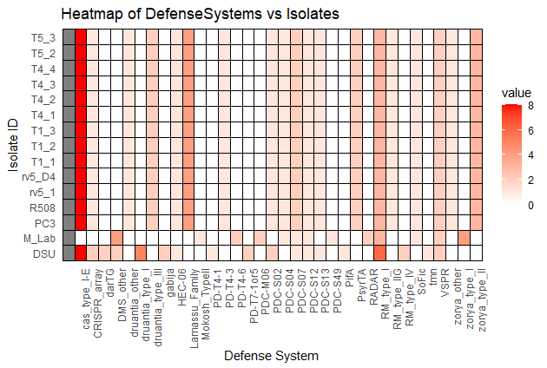

## 27/11/2024

### Class

* Worked on annotations for Phage Diversity and Phylogeny Review
* Edited calendar
* Edited November To Do list

## 29/11/2024

### Lab

* snippy
  + Galaxy
    - Genome from history and build index
    - M_Lab is reference strain
    - single-paired
    - all outputs
* note variant total for each isolate
  + DSU: 0
  + rv5_1: 0
  + rv5_D4: 0
  + T1_1: 0
  + T1_2: 0
  + T1_3: 0
  + T4_1: 0
  + T4_2: 0
  + T4_3: 0
  + T4_4: 0
  + T5_2: 0
  + T5_3: 0
    - all 0s means search in different pathway, otherwise no SNPs found

## **December**

## 05/12/2024

### Lab

* new spreadsheets as assignment
  + compile spreadsheets to be converted to second heatmap

### Class

* STEAL NOTES FROM LAUREN
* mostly individual meetings

## 09/12/2024

### Class

* Do CYSF Ethics 2A
  + Finished
* Work on spreadsheets
* Set reminders to send emails on Friday to Mawra
  + CC Dr. Garcia & Dr. Niu

## 10/12/2024

### Lab

* Finished spreadsheets for heatmap processing
  + Made another heatmap

## 11/12/2024

### Class

* Documentation edits based on logbook check
* Heatmap got deleted so recoded it
* General notes from Dr. Garcia
  + Set up a meeting between now and break
    - winter break work
    - how to catch up when I get back
    - midterm season
  + Set up a meeting for between Jan 6-9
    - summary of winter break work
    - work needed to be done
      * midterm season (Jan 10-21)

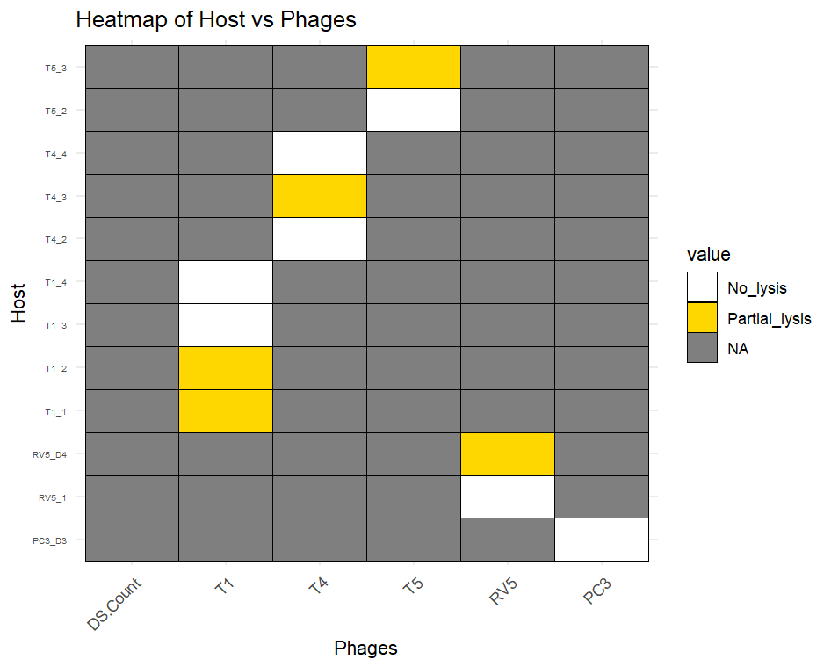

## 12/12/2024

### Lab

* Normal distribution (no)
  + histogram
* abnormal
  + linear regression
    - R studio
  + not working
  + all phages should have resistance - green means no lysis and yellow means partial lysis so update files
  + email Mawra files afterward
* also update original heat map to include new defense systems from defense finder (MazEF, Mok Hok Sok, etc)
* link Excel sheets into document

## 12/12/2024

### Class

* NotebookLM for AI podcasts

## 17/12/2024

### Lab

* Discussed R studio issues
  + used wrong column
    - use DS_Count ~ Resistantphagecount
* New graph sent by Mawra
* Over break, do literature reviews and work on intro

## 18/12/2024

### Lab

* Check in before break
* P1 of project is done
* Presentation
  + Mawra sent her seminar slideshow as example of presentation

## 19/12/2024

### Class

* Went over Mawra's feedback with Dr. Garcia for presentation
  + Make sure graphs are larger
    - or explain well
  + enlarge text
    - concise, condensed info

## **January**

## 06/01/2025

### Class

* General info at start of class
  + expectations
    - email mentors update
      * Happy New Year
      * school resumed
      * midterms period
      * updates
        + done, needed to do
      * set up next meeting
* reading papers

## 20/01/2025

### Individual Work

* Edited Logbook
  + Edited calendar schedule
    - January expectations
    - February due dates (not much)
* Things to ask Dr. Garcia
  + How long would it take her to go over the intro paragraph?
  + Can we make edits to introduction prior to final paper due date?

## 21/01/2025

### To Do

* Work
  + Read and annotate one article
  + ~~Email Mawra~~
    - ~~Next week's lab times~~
    - ~~Any additional work potentially needed to be completed prior to coming back~~

## 22/01/2025

### To Do

* ~~Questions for Dr. Garcia~~
  + ~~How long would it take her to go over the intro paragraph?~~
  + ~~Can we make edits to introduction prior to final paper due date?~~
* Work
  + Read and annotate one article

### Class

* Dr. Garcia
  + Make a specific plan with due dates
    - entering information for each CYSF category
      * Due March 21
  + Science fair
    - 15 spots
    - Approximately 30 applicants total
      * 23 JH
        + about 19 have SH mentors - likely won't drop
      * 19SH
        + 11 are ASP
        + 5 are grade 10s

one is committed

* + - * + 11s

Ronald Li

Sophia Zuykova

* + - * + 12s

Cooper?

* + What if we don't finish?
    - Do your best with the data you have
    - Present what you've got until Feb. 27
      * Collect until Feb. 27
      * Show mastery of knowledge
      * Changes and Improvements
* Work

## 23/01/2025

### To Do

* Work
  + Read and annotate one article

### Science Fair Meeting

* Get stuff done
  + Collect all data
* New information
  + No Cooper

## 24/01/2025

### To Do

* Work
  + Read and annotate one article
  + ~~Email Mawra~~

### Class

* Dr. Garcia reiterated Science Fair meeting contents
* indiv. meeting
  + ask Mawra for weekly goals for the next six weeks
  + present for Dr. Niu and Mawra to correct vocab

## 25/01/2025

### To Do

* Work
  + Read and annotate two articles
  + Retype proposal as introduction
    - Potentially edit to include further information

## 26/01/2025

### To Do

* Work
  + Edit introduction
  + Submit to Dr. Garcia for edits

## 27/01/2025

### To Do

* Work
  + Read and annotate article

## 28/01/2025

### To Do

* Work
  + Final introduction edits

## 29/01/2025

### To Do

* Work
  + Read and annotate one article

### Lab

* Went to lab
  + Spent time revising introduction according to Dr. Garcia's edits
  + Will look for more articles to support evidence

## 30/01/2025

### To Do

* ~~Work~~
  + ~~Email Mawra (with a tone of great urgency) about work~~

### Class

* emailed Mawra

## 31/01/2025

### To Do

* Work
  + Read and annotate one article

## **February**

## 01/02/2025

### To Do

* Report
* Email
* Introduction

### Individual Work

* + Updated heatmap

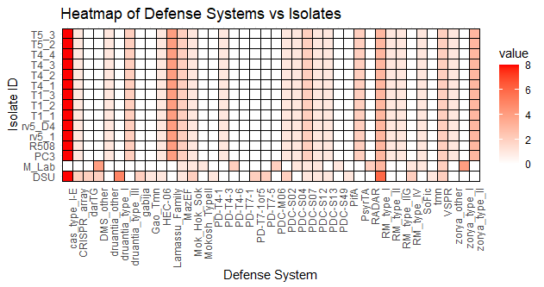

### Class

* Meeting
  + SNP analysis - single mutation/multiple insertions or deletions
  + important genes for phages - main attachment
  + Phages+proteins
  + Genes
    - function
    - check SNPs in genes
  + PROKKA files
    - annotations of genes
    - sort out genes/purpose
    - pipeline
    - genes present, function, location
    - .gff
      * contact number
      * name
      * look up purpose and naming
      * also has function
    - .ffn
      * search for name and then search for number if unavailable
      * coding
      * copy and paste whole sequence with name
      * make a new .txt file and paste
      * add sequence/isolate number (phage (T5_4, etc)
    - genes to look for
      * T5
        + fhuA
        + fepA
        + btuB
        + tonB
      * T1
        + fhuA
        + tonB
      * rv5
        + inner core genes of LPS
      * T4
        + ompC
        + ompF
        + phoE
        + fhuA
    - copy paste all sequences into the same file
    - inner core proteins
      * LPS
    - Roary
      * calculate all genes
      * whole number of genes
      * imported genes integral part of bacteria
      * excel files
        + function
        + number of isolates
        + number of sequences present
        + average sequence per isolate

1 is normal

may be 2 or 3 due to annotations

normal for one isolate in whole genome

* + - * + location
        + whole
      * gene presence in different isolates in final columns
      * trait file
        + file with 0 and 1 with isolates in row and gene in column
      * gene presence absence file
        + compare trade file with gene presence
      * another file
        + gene column
        + annotation column
        + presence of genes which are trait positive (phage resistant)
      * mostly just making the files and the Roary and Scoary output

## 06/02/2025

### To Do

* Work
  + Read and annotate one article

### Individual Work

* Worked on sorting Prokka files

## 07/02/2025

### To Do

* Work
  + Read and annotate one article

### Lab

* Went to lab
* Finished and reconfirmed sorted prokka file format
* commands
  + ls to see folder
  + cd to see contents
  + pwd to see path
* python - main use to sort folders (take gff files into new folder)
  + import os, glob, re
  + prokkafolders - glob.glob('path)
  + for folder in prokkafolders:
    - sample - os.path.basename(folder)
    - fileforroary - glob.glob(folder
  + errors indicated by red text or nonzero numbers
  + do research on glob and re libraries
* linux (ubuntu) - roary
* new csv
  + genes, annotations, noisolates columns
  + graph of isolates with genes affected by genetic changes
* pipeline
  + prokka to roary to scoary
  + research on it

## 12/02/2025

### To Do

* Work
  + Read and annotate one article

### Lab

* Geneious
* run alignment in one
* import
* run variations/snps
* pairwise alignment or multiple alignment
* download
* recheck isolates
  + Mawra tested and they didn't show any issues

## 13/02/2025

### To Do

* Download Geneious
* review .txt gene files

### Class

* Speech notes
  + originality
    - try to prove it
    - prove it's my interest and not mentor-driven
  + USE RUBRICS FROM CYSF TO PROVE
* methodology is written in past tense
* meeting
  + finish work
  + make questions about roary and scoary
  + ask about next week
  + ask about report
  + prep is important
  + conclusions
    - results and effects
  + clear methodology
    - how bioinformatic tools and pipeline answer questions

## 14/02/2025

### To Do

* Download Geneious
* review .txt gene files

### Lab

* bar charts coding
  + import genepresenceabsence csv
  + import libraries ggplot2 ggrepel
  + clean data
  + remove metadata (first 14 cols)
  + convert to matrix
* research
  + dendrogram
  + jaccard distance
  + pca
    - principle
* recheck files AGAIN
  + they're still different and they're not supposed to be
  + why

## 19/02/2025

### To Do

* ~~Fix absence/presence file~~

### Meeting

* Fix(ed) absence/presence file

## 23/02/2025

### To Do

* ~~Finish introduction~~
* Finish methodology

### Individual work

* Worked on papers
  + Finished and submitted introduction
* logbook work
  + edited entries and calendar dates
* background research
  + Interactions of Bacteriophages with Animal and Human Issues in the Light of Phage Therapy
  + Bacteriophages
  + Phage-host interplay: examples from tailed phages and Gram-negative bacterial pathogens
  + Clinical Analysis of Whole Genome Sequencing in Cancer Patients
  + A Simple Practical Guide to Genomic Diagnostics in a Pediatric Setting

## 11/02/2025

### To Do

* Finish poster

### Individual work (facilitated back-and-forth with mentor and supervisor)

* 3 drafts of poster
* draft 1:

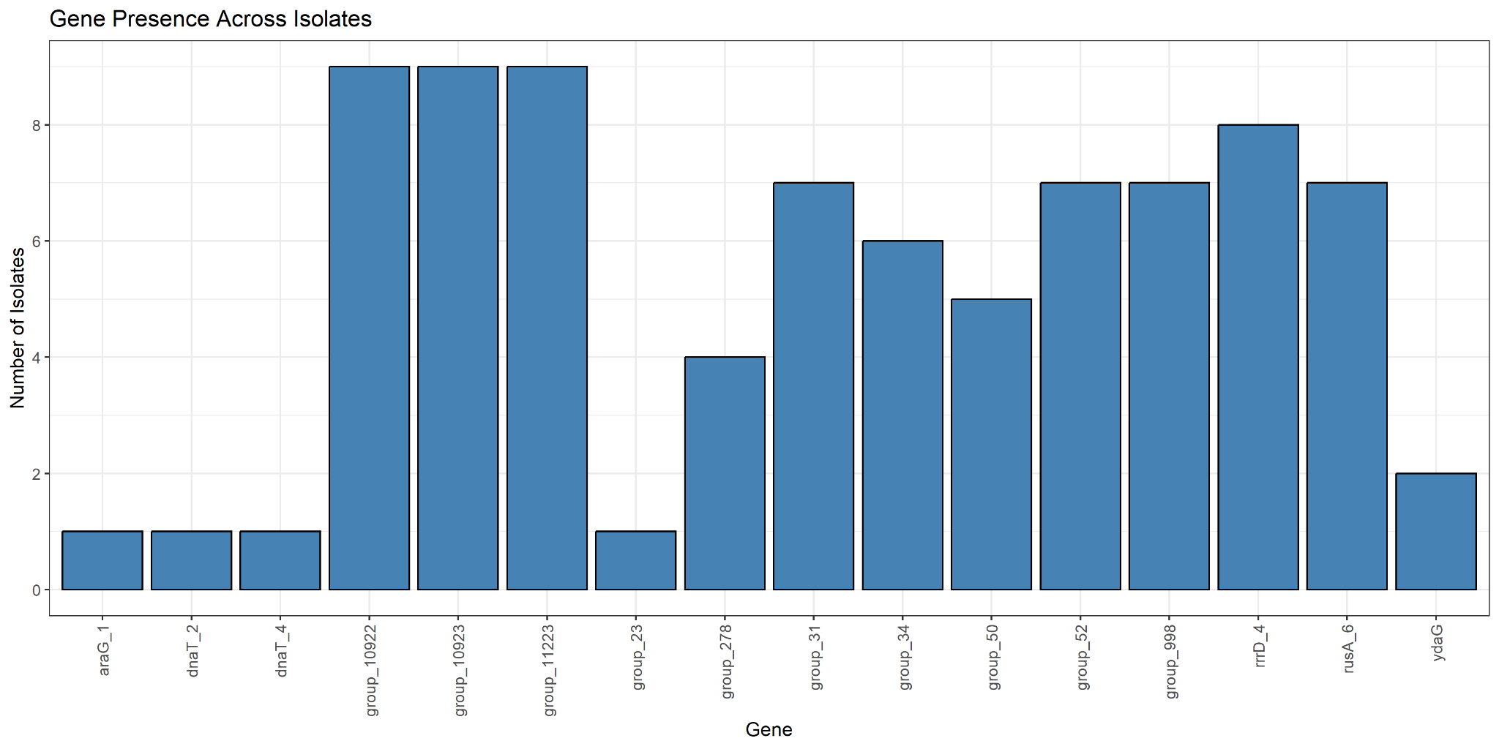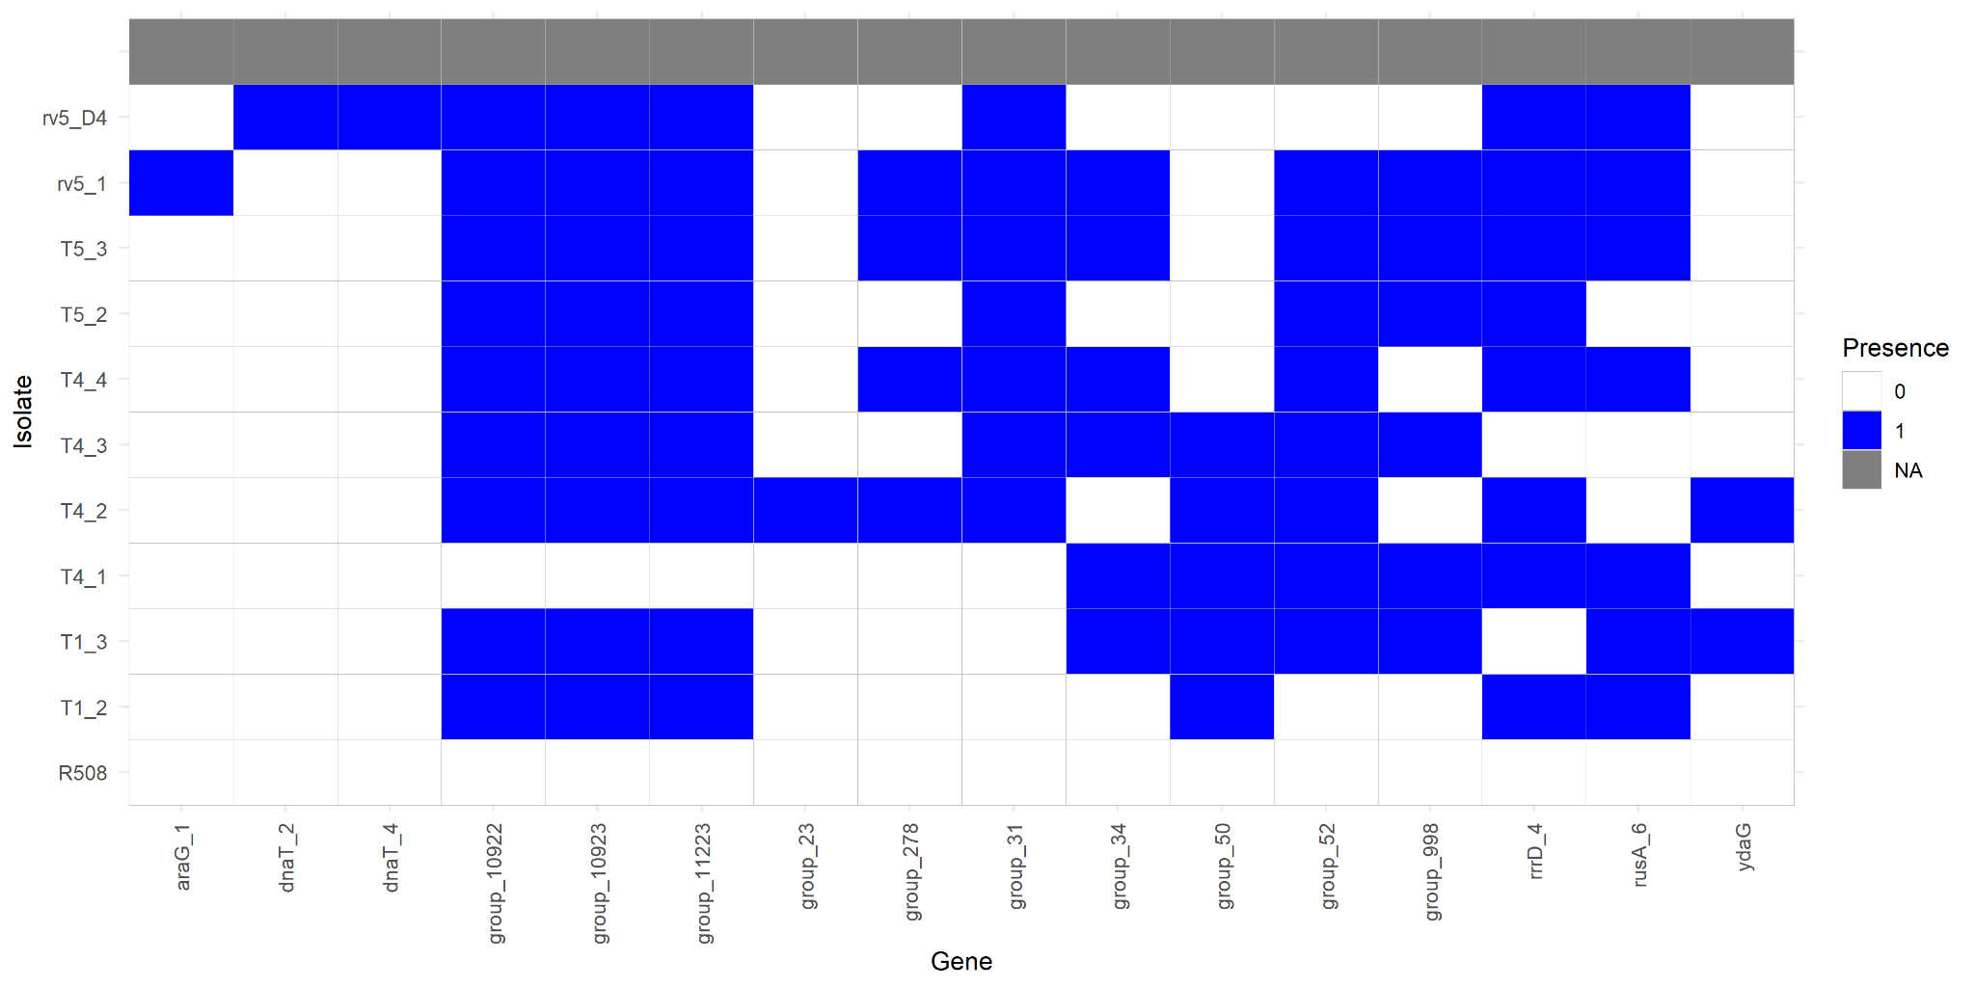

## 28/02/2025

### To Do

* Send email
  + next week's dates (include monday)
  + fix host vs isolates heatmap so it's a line with isolates and lysis
  + fix num of defense systems so it's all 19 (that's the actual number of systems in each)
  + send Mawra updated methodology
  + send Mawra data
  + ask about poster format

### Lab

## **March**

## 01/03/2025

### To Do

* Download Geneious

### Meeting

* Fix absence/presence file

## 03/03/2025

### To Do

* Book a meeting with Ms. Parker to review presentation
* Submit poster format to Dr. Garcia by tomorrow

### Individual work

* Booked meeting with Ms. Parker

## 04/03/2025

### To Do

* Finish poster format to send to Mawra and Dr. Garcia

### Individual work

## 06/03/2025

### To Do

* Finish and print poster

### Individual work

* Poster design
  + draft 1:

## 10/03/2025

### To Do

* Finish and print poster

### Individual work

* Poster design
  + draft 3:
  + draft 4:
* Presentation
  + Sent presentation draft to Mawra for editing
    - Notes on explanation
      * Alternatives in phage cocktail (potential extension of experiment)
      * No significant relationship between resistance and DS but there is an inverse relationship

## 11/03/2025

### To Do

* Finish and print poster

### School Science Fair

* Poster notes:
  + Typo on title of section 2. SNP analysis
    - saved as 1. SNP analysis
  + Graph font needs to be larger
    - sensitivity graph
  + Add limitations and extensions
* Presentation notes:
  + Slight nervousness
    - More rehearsal
    - Work on confidence
    - Read more articles to help with info knowledge
  + Variations on presentation
    - May want to work on a presentation that dives more in depth and one that explains very simply
  + Specific knowledge gaps
    - types of viruses
      * DNA vs RNA viruses
    - methodology
      * research into specifically how each tool works
* Feedback:
* Sum of improvements:

## 17/03/2025

### To Do

* CYSF portal
  + Problem
  + Method
  + Research
  + Data
  + Conclusion
  + Citations
    - Compile all sections with citations and reformat for full citation list
  + Acknowledgement
  + Presentation
  + Attachments
  + ~~Declarations~~

### Class

* Worked on editing background research notes
  + Revenge of the Phages
* Completed Declarations section
* Began combing through past email logs to update logbook and ensure accuracy of recorded information

## 18/03/2025

### To Do

* CYSF portal
  + ~~Problem~~
  + Method
  + ~~Research~~
  + Data
  + ~~Conclusion~~
  + ~~Citations~~
    - ~~Compile all sections with citations and reformat for full citation list~~
  + ~~Acknowledgement~~
  + Presentation
  + Attachments
  + ~~Declarations~~

### Individual work

* Portal
  + Updated Problem, Method, Conclusion, Citations sections with updated formatted citations
  + Added Future Directions to Conclusion section
  + Updated Acknowledgement
  + Data
    - Put majority of visualisation into Data section
    - Requires elaboration
* Methodology
  + Updated to align presentation and portal methodology more precisely
* Poster
  + Updated Conclusions to have conclusions and future directions
  + Fixed font on sensitivity graph
  + Resized & reformatted
* Logbook
  + Continued revising logbook for accuracy
  + Fixed calendar formatting
* Presentation
  + Started slideshow work (mostly transcribing from oral presentations)
* Email
  + Emailed Mawra to ask about methodology edits, oral presentation & slideshow advice & assistance
    - Also mentioned upcoming Spring Break

## 19/03/2025

### To Do

* CYSF portal
  + ~~Method~~
  + Data
  + Presentation
  + ~~Attachments~~

### Class

* 1st priority to finish CYSF portal
* Talked to Dr. Garcia about poster edits
  + Separated Conclusions and Future Directions sections
  + Resized Methodology
  + Resized Introduction
* Worked on logbook
* Mawra emailed back
  + still need to send back slideshow of oral presentation

### Individual work

* Finished oral presentation
* Submitted image to represent project and picture of self
* Mawra emailed back
  + Remember to include DNA extraction in methods
  + Turn WGS/Bioanalysis section into flowchart
  + Provide server link with fastp in methodology
  + edits of poster
  + come in on Friday?
* Sent email about edits and scheduling
  + Sent slideshow and updated poster
  + Will see if Friday availability

## 20/03/2025

### To Do

* CYSF portal
  + Method (link to fastp)
  + Data (elaboration)
  + Presentation (record)
  + Finish logbook edits and records

### Individual work

* Finish presentation

## 20/03/2025

### To Do

* CYSF portal
  + Method (link to fastp)
  + Data (elaboration)
  + Presentation (record)
  + Finish logbook edits and records

### Class

* Worked on logbook and presentation script
* Added Research Question to portal Problem section

### Lab

* Consulted about poster
  + Switch out chevron-style flow chart for box-style
  + Resized poster sections