SCIENCE FAIR LOG BOOK
Important Dates
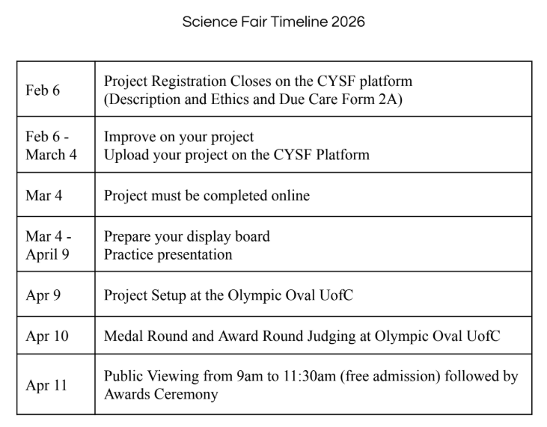

Day 1: Feb, 1, 2026 3:00pm-9:00pm
This is where I started my project about tornadoes. While I was deciding on what I should do for my project I started to brainstorm ideas on what I have always wondered about. One of my things was tornadoes and I have always been interested about it but I never got a chance to really search about it and a lot of people always don’t know about tornadoes. So I picked and started. I found some websites and started to think about a question. Then I started to brainstorm ideas and found the perfect one. Next I started to jot some notes down on the information that I have learned so far. Then I finished everything except the analysis and the conclusion.

Day 2: Feb, 2, 2026 3:30pm-10:30pm
The next day I added more detail to my slides. I also added a nice background. I added some cool fun facts and finished my conclusion and analysis. Then I thought It would be cool if I had a chart comparing Alberta to other regions and seeing the difference of how many tornadoes they have. Then I added a chart about Alberta and the number of tornadoes in the last 5 years. I presented it to my family and they asked me questions then I was ready to go. The next day I presented it to the judges in my school and they liked it, so I got selected to go to the CYSF.

Day 3: Feb, 16, 2026 1:40pm-1:55pm
I made it to the competition so now I am going to add more detail but I was not sure on what to add. So I got some advice from a guy named brother Collin who has won the CYSF 6 times. He told me to make my chart look better, add more detail to my slides so I am going to apply what he said. I am going to get more data and see if I can get a percent.

Day 4: March, 1, 2026 11:30am-12:30am
Now I added more information on climate change and how it might affect tornadoes. Then I realized that because of our pollution we are creating its making tornadoes come more often and making it stronger.

Day 5: March, 2, 2026 4:00pm-8:00pm
The last day to add everything to the CYSF platform so I started to do that. Then I was looking at other people's work, and found some really cool things they talked about. Now I have time to create my trifold and practice how I am going to present.

