Glaciers Logbook Jan 26,2026
World glaciers have been melting at a rapid pace since 2005. The graph shows the trend.

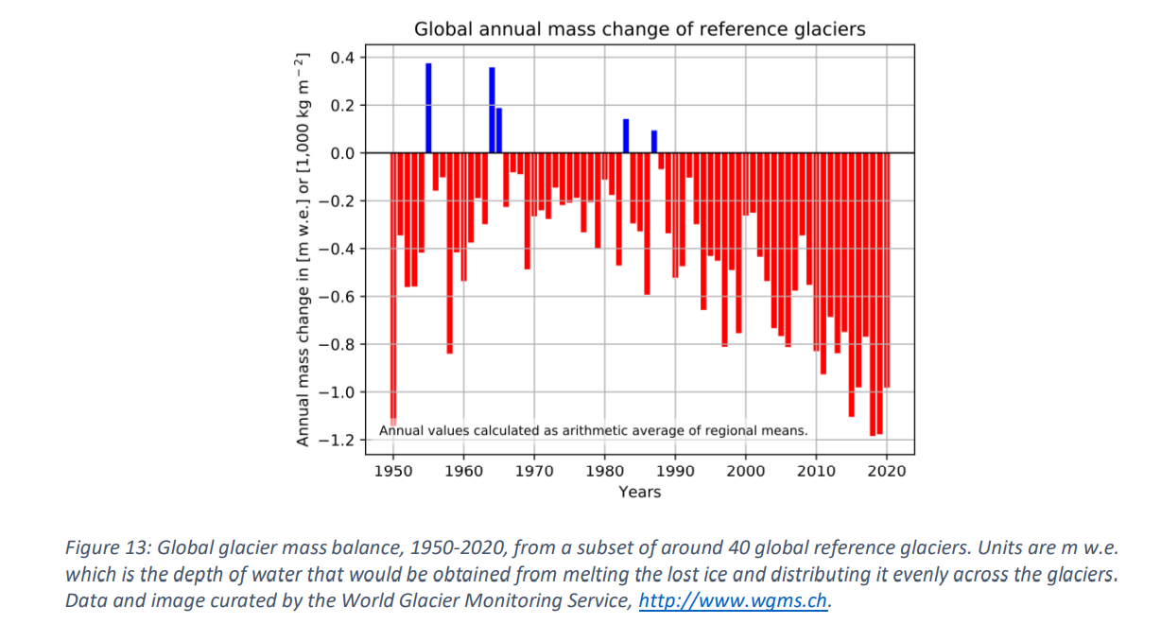

List of all the river basins arising from the Rockies JAN 27 th,2026
in Canada
- Rivers Flowing to the Arctic Ocean
- Athabasca River
- Peace River
  - Parsnip River
    - Misinchinka River
- Finlay River
- Liard River: flows through Yukon, BC and North west territories
  - Muskwa River: flows through Northern British Columbia
  - Kechika River: is a long river in northern British Columbia
  - Gataga River: River on Vancouver iIsland British Columbia
  - Toad River

- Rivers Flowing to the Northwest Pacific Ocean
  - Columbia River Basin
  - Fraser River Basin
- Rivers Flowing to the Gulf of California
  - Colorado River Basin
- Rivers Flowing to Hudson Bay
- Rivers Flowing to the Great Basin

Northwest Pacific Ocean drainage
- Columbia River
  - Kicking Horse River
  - Blaeberry River
  - Bush River
  - Wood River
  - Bitterroot River
  - Kootenay River
    - Elk River
    - Bull River
    - Vermilion River
Fraser River
  - McGregor River
  - Thompson River
Hudson Bay drainage
- South Saskatchewan River
- North Saskatchewan River
- Bow River
- Oldman River
- Red Deer River
102 rivers in total
52 CANDIAN, 50 AMERICAN
Main Canadian rivers
- Athabasca River: Originates in the Columbia Icefield.
- Peace River: One of the few rivers to penetrate the range.
- North Saskatchewan River: Originates in the icefields.
- South Saskatchewan River: Originates in the Eastern Slopes.
- Fraser River: MA majorriver in British Columbia.
- Columbia River: Originates in the Rockies.
- Liard River: Major tributary to the Mackenzie.
- Kootenay River: Flows through the southern Rockies.
Date
MARCH 1st ,2026

Finding out the volume of glacier grafted at my home experiment

Observations table: I figured out the volume of the ice cylinder ( GRAFTED GLACIER EXPERIMENT) with this method
Volume of a cylinder 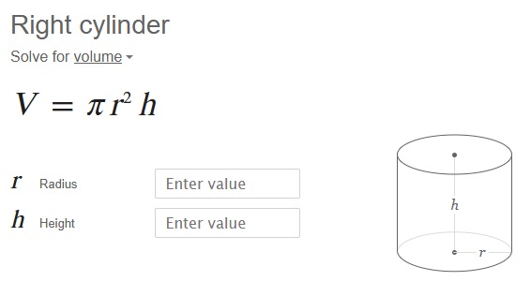

S. No. | Date / Time | Temperature | Volume (cm 3 )
1. | Feb 17, 3 pm | -14 Light snow | 426728.48
2 | Feb 18,4 pm | -23 | 1038485.77
3 | Feb 19, 4 pm | -21 snow flurries | 1038484.29
4 | Feb 21, 4 pm | -16 snow shower a day earlier | 426728.48
5 | Feb 22, 5 pm | -13 | 426063.66
6 | Feb 25, 5:30 pm | 2 | 376989.48
7 | Feb 28 | -14 | 1772249.94
8 | March 1st | 1 | 8482.30

The overall highest total volume is about 7721249.94 on Feb 28.
It shows that the highest was after snowfall and at the lowest temperature, otherwise at a slightly warmer temperature, and the size decreases.

Highest to lowest volume in cm 3
1,772,249.94
1,038,485.77
1,038,484.29
426,728.48
426,728.48
426,063.66
376,989.48


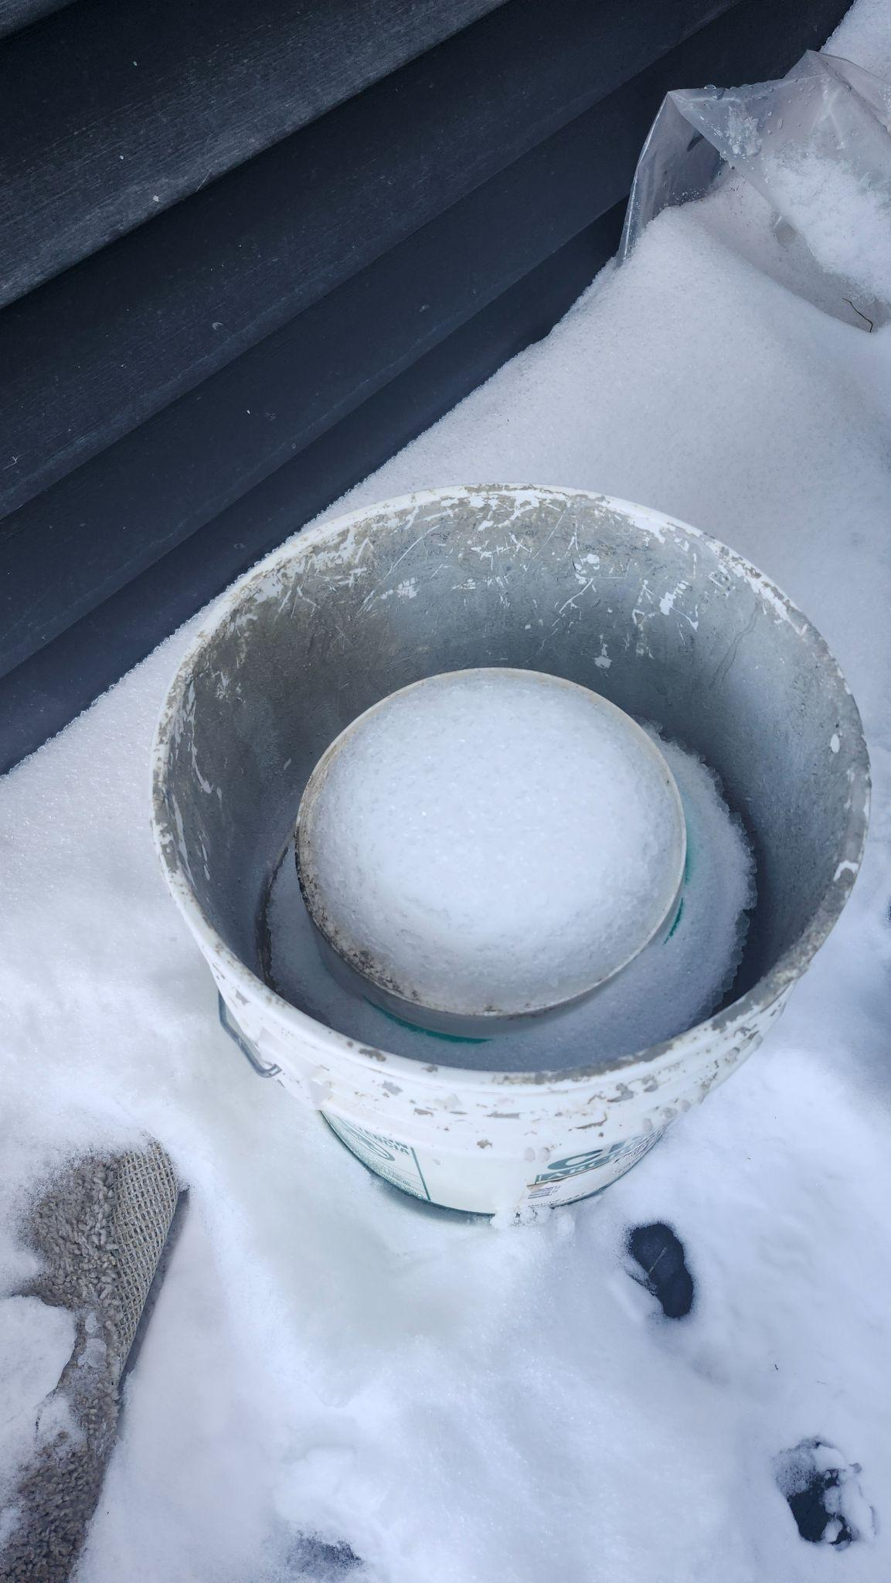

Experiment related to the quality of snow of water in different regions
Details on physical notebook.
