Problem

Did you know, in 2022, over 830 million people are affected by Type 2 diabetes worldwide! And, Type 2 diabetes is mainly caused by an unhealthy lifestyle. If you come to think about it, that is an enormous number, and increases as the years go on. Well, what even is diabetes, and how can we prevent it? That is what my science fair project is all about. Firstly, I will research what Diabetes is, and the biochemistry behind. Secondly, I’ll be researching the medicine, *Ozempic,* and how it works, so we can educate future generations. And lastly, after studying diabetes and ozempic, I’ll conclude how we can prevent diabetes, because if we can inform as many people, then maybe it will make a difference.

Method

In my research Study, I will(in order

* Study and learn what diabetes even is, and the biochemistry behind it
* The different types of diabetes(type 1,2,gestational, prediabetes)
* Prevention methods
* Common Complications(Cardiovascular and neuropathic disease)
* What Ozempic is and how it works
* Semaglutide and GLP-1 Receptor agonists
* The process
* Prior Precautions and knowledge
* Side effects
* Disadvantages of Ozempic

*Research*

Diabetes

First of all, what is diabetes, you may ask. Diabetes is a disease where your blood sugar, or the amount of glucose trapped inside your blood is too high. Too much glucose trapped inside your blood can lead to damaging blood vessels, nerves, and damaging organs. Furthermore, it can even cause heart failure and vision loss.

When the human body intakes carbohydrates, or food, inside of it is glucose(sugar), and the glucose is the body’s main energy source. In order to transport the glucose to all organs and systems of the body, the organ tucked right beneath the stomach is the pancreas, and this major organ produces a hormone called insulin. When there is too much glucose in the bloodstream(or high blood sugar level), the pancreas creates insulin. Insulin helps transport the glucose to all organs of the body, and helps keep blood sugar levels low. However, whenever someone lives an unhealthy lifestyle(only type 2), it can lead to insulin resistance. This means that the body cells don't react to insulin anymore, which leads to an excess amount of blood sugar left in the bloodstream. High levels of glucose(hyperglycemia) inside the bloodstream is known as Diabetes Mellitus, or diabetes.

However, living an unhealthy lifestyle is not the only reason for diabetes. Other types are caused by genetics or family history. There are various types of diabetes.

Type 1 Diabetes

Around 10% of people with diabetes have Type 1 diabetes, and is a chronic condition which can be developed by birth or adolescence. It is a condition where the pancreas makes little to no insulin to transport the glucose. This happens because the body’s immune system(which helps fight against viruses and bacteria) starts attacking and destroying the insulin cells in the pancreas. This is mainly caused by genetics and exposure to certain viruses. Genetics, your family history, geography, and age significantly increase your risk, but Type 1 is mainly found during childhood.

Overtime, type 1 can have severe complications and might even have life threatening symptoms. It can lead to heart and blood vessel disease, nephropathy, neuropathy, eye damage, foot damage, etc. Unfortunately, there is no cure for Type 1 diabetes, but people with Type 1 have to take insulin every day to survive.

Type 2 Diabetes

This is the most common type of diabetes, as over 27 million Americnas suffer from this chronic disease, and around 90% of diabetic patients have Type 2. Also, one in one-fourth of people over the age of 65 have a form of diabetes. Like I mentioned earlier, Type 2 diabetes is a chronic disease, where the body is unable to use insulin properly, which leads to excess amounts of sugar inside the bloodstream, or if the pancreas doesn't create enough insulin.

Symptoms

The main symptoms of diabetes are

* fatigue
* urge to urinate
* Losing weight
* Vision problem(blurred eyes)
* More hunger
* Infections occurring frequently
* Thirst
* Numbness and tingling in arms or feet

Factors that increase your chances of type 2 diabetes

* The main cause is obesity and overweight
* Family history can have a significant influence
* Age(most common over the age of 65)
* Unhealthy lifestyle

Complications

Type 2 can have many major complications including

* Dementia
* nephropathy(kidney damage)
* neuropathy(nerve damage)
* Cardiovascular disease
* Cataracts and glaucoma
* Skin damage

Prevention

Type two can be prevented by just living a healthy lifestyle, eating healthier food, exercising, and losing weight. But some common medications include Insulin injections, metformin(most common), meglitinides, and ozempic(semaglutide)

Prediabetes

Prediabetes occurs when a person has high levels of blood sugar, but not enough to be declared as Type 2 diabetes. Furthermore, people with prediabetes have a higher risk of heart disease in the future, and have a high chance of getting Type 2 diabetes in the future. If you have prediabetes, it is important to take actions immediately and change your dietary restrictions before you get Type 2.

Gestational

Gestational diabetes occurs during pregnancy, but has a high chance of it going away after the baby is born.

Most Common Complications

*Cardiovascular Disease, Heart disease, and Strokes*

Cardiovascular disease is a big term, but it includes heart disease, strokes, and blood vessel disease. Diabetes can affect cardiovascular disease, because high blood sugar levels can damage blood vessels, which disrupts the blood flow to and from the heart. Also, high blood pressure means blood is forced through your arteries harder, and can damage artery walls. Furthermore, bad cholesterol or LDL, can build up in your arteries and clog blood vessels. You can get tests for heart disease through an **electrocardiogram**(measures hearts electrical activity), **and an echocardiogram**(measure how well your heart pumps blood).

Neuropathy

Diabetic related neuropathy is nerve damage caused by high blood sugar. It is caused when the nerves cells don’t have enough access to nutrients and oxygen because blood vessels have been damaged. The 2 most common types of neuropathy are

* Peripheral Neuropathy-This is nerve damage along your spinal cords, and will affect the feet, and legs. Over 50% of people with diabetes have peripheral neuropathy. The symptoms are numbness, pain, and loss of sensation.
* Autonomic neuropathy-This is nerve damage to the autonomic nerves, or the nerves that control your bladder, blood pressure, and heart. The symptoms include: Damage to the digestive system, urinary system, and cardiovascular systems.

You can get tests for diabetic-neuropathy through an diabetic foot exam, EMG(electromyography), and an NCS( nerve conduction studies)

Ozempic

As modern medicine evolves, new inventions and medicines have been able to change our values and beliefs. For example, Metformin is the most commonly prescribed diabetic medication, as it helps improve insulin sensitivity. However, in 2017, a new semaglutide injection by the name of Ozempic, was invented. It wasn’t until 2021 where it became popular as a weight-loss medicine. I will be researching to see if Ozempic is really useful, or if it has bad consequences.

Semaglutide and GLP-1 Receptor Agonists

Firstly, Ozempic is the name of the company, which produces semaglutide injections. These injections are used for treating mainly type 2 diabetes. Semaglutide injections, however, belong to a group of drugs called GLP-1 receptor agonists. GLP-1 receptors are a group of drugs that work by mimicking a hormone (GLP-1). GLP-1 is a hormone that gets released after eating, and regulates blood sugar. But these GLP-1 receptor agonists “pretend” to be the hormone, and help increase insulin and lower blood sugar levels. GLP-1 receptor agonists also reduce Glucagon release. Glucagon is a hormone that counteracts insulin. Unlike insulin, glucagon is a hormone that increases blood sugar levels so that it's not too low.

The process

Firstly, when you eat, your body produces a hormone called GLP-1(glucagon-like peptide 1) when you're full. The GLP-1 receptors in different organs do different things. In the pancreas, GLP-1 receptors promote insulin production and decrease glucagon production. In the stomach, they slow the digestion of the food, making you feel fuller, and resulting in weight-loss. And in the brain, specifically the hypothalamus, there are receptors which reduce your appetite.

Prior Precautions/Knowledge

Ozempic is given to treat type 2 diabetes, but also helps lower the risks of heart attack, stroke, obesity, heart and blood vessels, damage, nerve damage, and kidney damage. However, the doctor should not prescribe Ozempic under specific circumstance, such as

* Allergies
* Ages under 12
* Using Specific medications
* Drug interactions

Ozempic is given on a weekly basis, and is injected through an auto-injector. Everytime time you take a shot, you must take the next shot in a different area. Make sure to use the right dosage amount prescribed by the doctor. The 3 types of dosage are:

1. 0.25mg or 0.50mg prefilled auto injector
2. 1mg prefilled auto injector
3. 2mg prefilled auto injectors

Side effects

Just like all medications, Ozempic can have major and minor side effects

Some commonly known side effects are:

* Nausea
* Constipation
* Diarrhea
* Heartburn
* Vomiting
* Bloating
* Bleaching
* Stomach pain

Some major side effects are

* Breathing problems
* Swollen face, lips, throat
* Rashes and itching
* Join pain
* Fainting and dizziness

These effects may be caused by allergic reaction, and can lead to anaphylaxis.

The disadvantages of Ozempic

Data

Studies show that 42% of America’s population is obese, and it only keeps on increasing. Unfortunately, as Ozempic became more popular, it began to spread across social media, and now people are using Ozempic as a weight-loss medicine. Ozempic is in such demand that there are shortages in many pharmacies, and is the most demanded medication. However, using Ozempic for the sole purpose of weight-loss isn't good at all. The problem is, people aren’t using Ozempic responsibility, and that's an issue. It can lead to:

* Hypoglycemia(low blood sugar)
* Thyroid cancer
* pancreatitis
* Eating disorders
* Nephropathy
* Gastrointestinal issues
* Colon malfunction
* Reduced kidney functioning

Prevention

After learning all about diabetes and Ozempic, you might’ve thought of all the consequences diabetes can have and how it can change the trajectory of your life. So, the best thing we can do now is to prevent getting diabetes. How do you prevent getting diabetes? Well, did you know that 50% of all people with diabetes have obesity!!!!   
Maintaining a healthy lifestyle plays a crucial role in diabetic prevention. Prevention includes

* Being more physically active. People should get at least 30 minutes of aerobic activity per day(walking, swimming, biking) They also recommend doing strength training 2-3 times per week.
* Eat a balanced, healthy diet. Avoid sugary foods and drinks like sodas, pastries, and candy. Make sure to find healthier alternatives, such as diet-soda, water, whole grains, fruits, and vegetables.
* Limit alcohol and smoking
* Maintain a healthy weight.

This bar graph(Created by the National Institute of Health) demonstrates the percentage of young adults developing different complications from Type 1 and 2 diabetes. The graph shows that 47% of people with type 2 diabetes have arterial stiffness, 15.7% from cardiovascular autonomic neuropathy, and 23.6% from hypertension. These 3 have a risk for developing cardiovascular disease

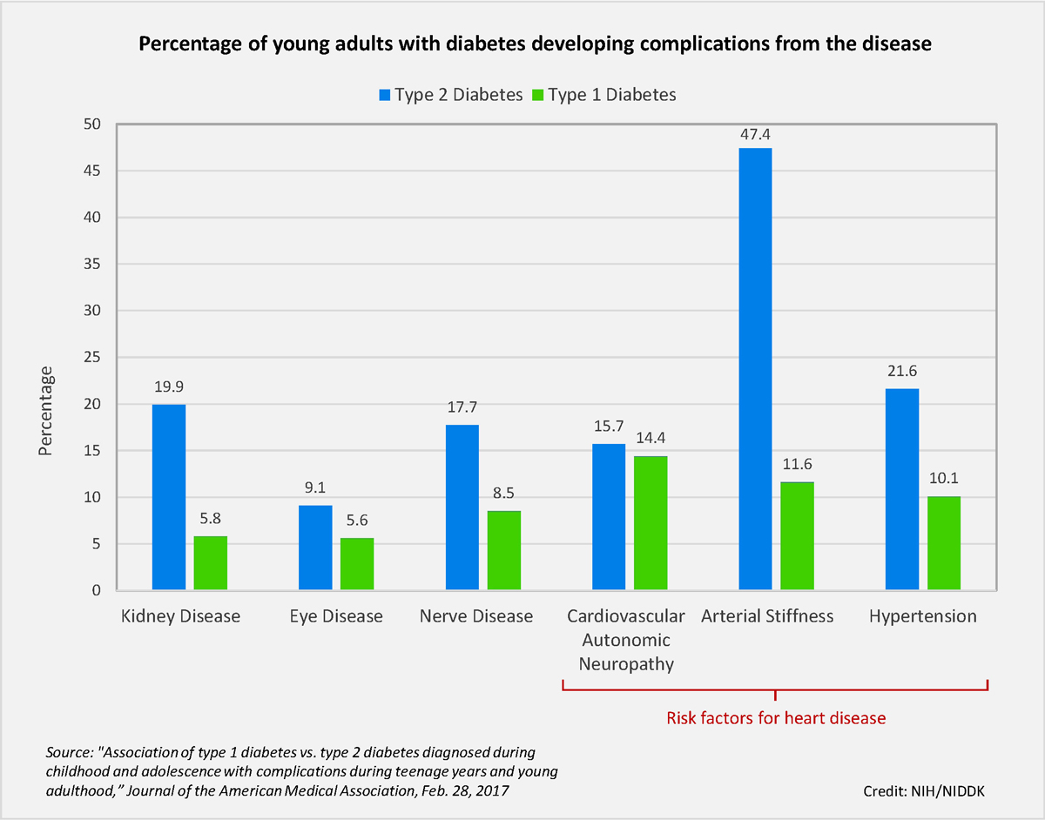

This next line graph(created by Sherwood News) shows the massive demand in Ozempic in the USA from 2018-2023. As you can see, the demand for ozempic has skyrocketed, because Ozempic is known as a weight-loss medicine by the media.

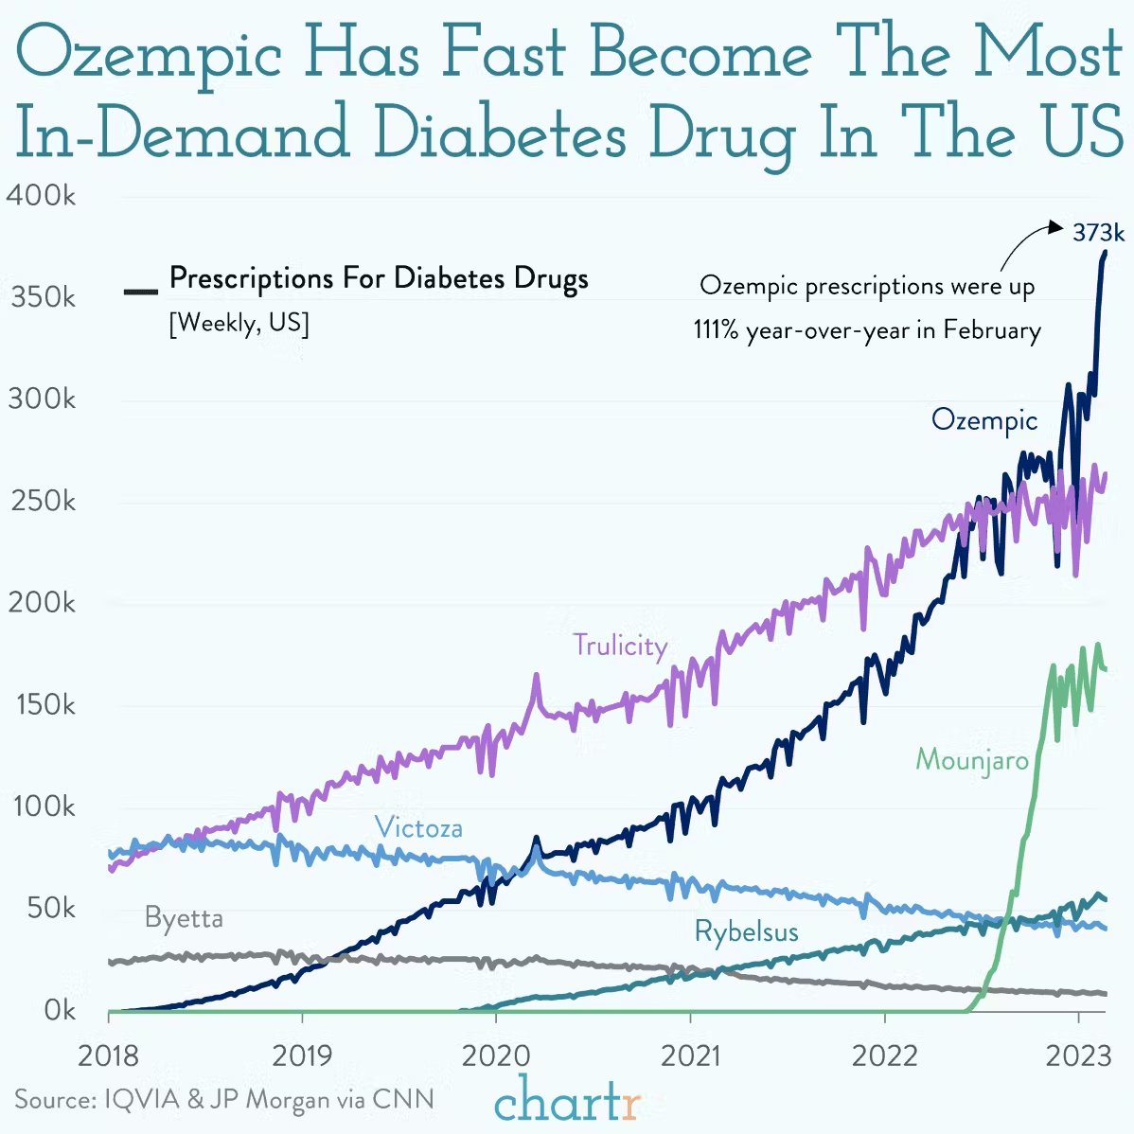

And lastly, this graph(created by ourworldindata.org) shows the annual number of deaths by diabetes, including type one and two. In 2021 alone, over 1.66 million people died from diabetes. People over the age of 70 contributed to nearly 55% of all deaths. Ages 50-59 had around 590,000 deaths, and kids around my age and younger had 2,900 deaths.

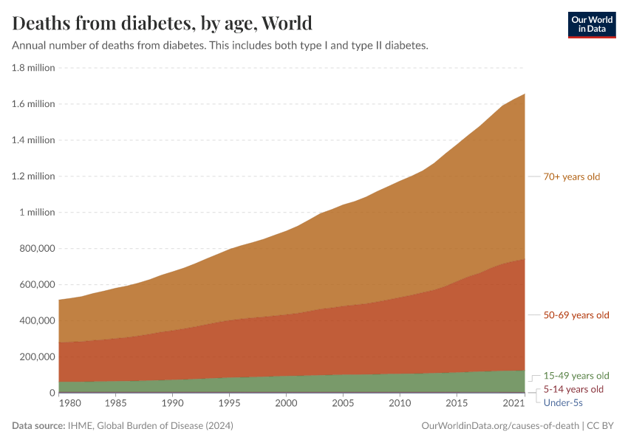

Conclusion

In conclusion, diabetes, especially type 2 diabetes, is a worldwide health challenge that is only increasing as the years go by. As our lifestyles begin to change, our health does too, and can have a significant impact. However, the new and upcoming medicine, Ozempic, is a semaglutide injection which is proven to help insulin regeneration and weight-loss. Although Ozempic might be the new “hero,” we do need to realize that Ozempic can have very major side effects. Diabetes can have scary effects on your health, so it’s best to take precautions now, and make sure you live a healthy lifestyle. In the end, this project was made to educate others about the risks of diabetes.