LOGBOOK:
Research Topic: The taste buds
February 10- Start survey
We walked around our neighborhood and asked people our survey questions: Do you like to eat fish? At what age did you start liking fish? If you like fish, why? If you don’t like fish, why? Have you tried fish a lot? Male/female? What is your age?
February 18- Grade 6 and 8 survey
We asked 2 normal grade 6 and 8 classes the questions shown above. From our results, around 65% of people liked fish and 35% did not. There were 82 total people who answered our questions. We compared the results, and grade 8 like fish more. This is most likely because the 8th graders don’t taste the fish as strongly. Many grade 6 students replied that they didn’t like fish because it tasted very strong. As you age, you do lose taste buds, so you taste things less strongly.
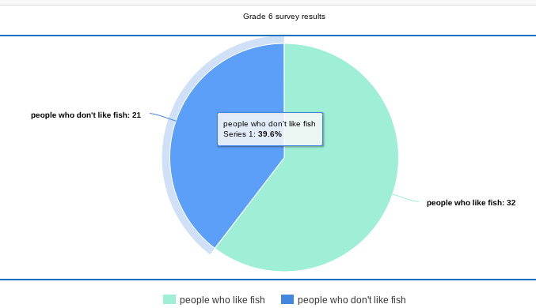

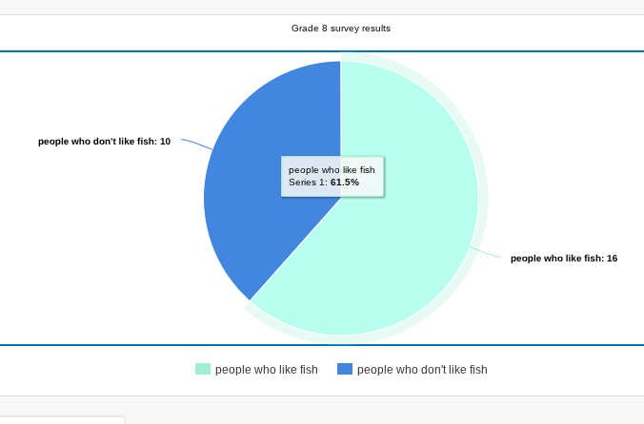
Here is the link for the survey results for 6th and 8th grade

2/21/2026 – 5:04PM to 6:50PM:
As we get older, taste changes because our taste buds get less sensitive, especially after 60. Sweet and salty flavors are the first to fade, so older folks might need a bit more seasoning for the same flavor punch. For an in-person chat, Dr. Kathleen Sitter at the University of Calgary would be a great resource—she's got expertise in sensory research that includes taste.

20 Interview Questions)
Understanding Taste & Aging
- How does the human sense of taste work at a basic level?
- What changes happen to our taste buds as we get older?
- At what age do people usually start noticing changes in their sense of taste?
- Are some taste types—sweet, salty, sour, bitter, umami—more affected by aging than others?
- Is there a difference between how children, adults, and seniors experience flavors?
Research & Scientific Insights
- What kinds of experiments do scientists use to study taste?
- How do researchers measure taste sensitivity in different age groups?
- What are some surprising findings from your work or the field of sensory research?
- Are there common misconceptions people have about taste or taste loss?
- How does culture influence taste preferences across a lifetime?
- What role does memory or storytelling play in how we experience taste?

The Actual Names of the “Taste Bud Structures” on the Tongue
Taste buds sit inside tiny bumps on your tongue called papillae.
There are four types of papillae, but only three contain taste buds.

1. Fungiform Papillae
- Found mostly on the front and sides of the tongue
- Look like tiny red dots
- Contain taste buds

2. Foliate Papillae
- Found on the sides of the tongue, near the back
- Look like small folds or ridges
- Contain taste buds

3. Circumvallate Papillae
- Found at the very back of the tongue in a V-shape
- Large, round bumps
- Contain lots of taste buds (the most per papilla)

4. Filiform Papillae (important!)
- Found all over the tongue
- Look like tiny hair-like structures
- Do NOT contain taste buds
- Used for texture and gripping food

So the real scientific names are:
Fungiform, Foliate, Circumvallate, and Filiform papillae
Only the first three have taste buds.

Which Papillae Decline the Fastest?
Humans have four types of papillae on the tongue:
Papilla Type | Contains Taste Buds? | Location | What Happens With Age?
Fungiform | Yes | Front & sides of tongue | Decline the fastest
Foliate | Yes | Sides, near the back | Decline moderately
Circumvallate | Yes | Back of tongue (V-shape) | Stay stable the longest
Filiform | No taste buds | All over tongue | Do not affect taste

The Papillae That Go Away the Fastest
Fungiform papillae
These are the small, mushroom-shaped bumps on the front of your tongue.
They:
- Contain many taste buds
- Are sensitive to sweet, salty, sour, bitter, and umami
- Decrease in number as early as childhood and adolescence
- Decline faster than the other papillae
This is why:
- Kids often have more intense taste experiences
- Adults may need stronger flavors (more salt, more sugar) to taste the same thing

What About the Others?
Foliate papillae
- Located on the sides of the tongue
- Contain taste buds
- Decline slowly over time
- Still contribute to taste in adults
Circumvallate papillae
- Large bumps at the very back of the tongue
- Contain lots of taste buds
- Stay stable the longest
- Rarely decline significantly
Filiform papillae
- Do not contain taste buds
- Used for texture and gripping food
- Not related to taste loss

1. Filiform Papillae (MOST — no taste buds)
✔ Young: 10,000+
✔ Older: Still around 10,000+
Filiform papillae do NOT decline much with age.
They don’t contain taste buds, so they don’t affect taste loss.

2. Fungiform Papillae (taste buds — decline the fastest)
✔ Young children: 250–400
✔ Adults: 150–300
✔ Older adults (60+): 100–200
These are the first to decline with age.
This is one reason kids taste flavors more strongly.

3. Foliate Papillae (taste buds — moderate decline)
✔ Young: 20–30
✔ Older adults: 10–20
These are the folds on the sides of the tongue.
They shrink slowly over time.

4. Circumvallate Papillae (taste buds — very stable)
✔ Young: 7–12
✔ Older adults: 7–12
These barely change with age.
They contain hundreds to thousands of taste buds each.

How Where You Live Affects How Much You Like Fish
Access and availability
People tend to like foods they grow up eating often.
- Coastal areas (near oceans or lakes):
People eat fish more often because it’s fresh, cheap, and part of daily meals.
- Inland areas (far from water):
Fish may be expensive, less fresh, or not part of regular meals.
Result:
People near water usually like fish more because they eat it more.

Freshness and smell
Where you live affects how fresh the fish is.
- Fresh fish has a mild smell and taste.
- Old fish smells strong and “fishy.”
People who only experience old fish often think they “hate fish,” but really they hate bad fish.

Environmental exposure
If you grow up:
- Fishing
- Near the ocean
- Around seafood markets
- Eating fish at school lunches
…you get used to the smell and taste early.
If you don’t, the flavor can feel “too strong.”

What Each Type of Papilla Looks Like
1. Filiform Papillae (most common)
Appearance:
- Thin
- Pointy
- Hair-like
- Cover almost the entire tongue
How to draw:
- Lots of tiny spikes
- No circles or bumps
- Make them the background texture of the tongue
Important:
These do NOT contain taste buds.

2. Fungiform Papillae
Appearance:
- Small, round bumps
- Mushroom-shaped (“fungi” = mushroom)
- Scattered mostly on the front and sides of the tongue
- Usually pink or red
How to draw:
- Small circles or domes
- Spread out between the filiform papillae
- Label them clearly
These DO contain taste buds.

3. Foliate Papillae
Appearance:
- Leaf-like folds
- Vertical ridges
- Located on the sides of the tongue near the back
How to draw:
- Draw the side of the tongue
- Add several vertical folds or ridges
- They look like “gills” or “pages of a book”
These also contain taste buds.

4. Circumvallate Papillae
Appearance:
- Large, round bumps
- Form a V-shape at the very back of the tongue
- Each one sits inside a circular trench
How to draw:
- Big circles
- Add a ring or “moat” around each one
- Arrange them in a V-pattern

What a Taste Bud Actually Looks Like
A taste bud is not a bump on the tongue.
It is a tiny onion-shaped cluster of 50–100 taste receptor cells inside the papillae.
Here’s what it looks like:
Shape
- Oval or onion-shaped
- About 50–100 micrometers tall (very tiny)
- Looks like a small “garlic bulb” inside the papilla
Parts
A taste bud has three main features:
- Taste pore
  - A tiny opening at the top
  - Where chemicals from food enter
- Taste receptor cells
  - Long, thin cells that look like stretched teardrops
  - These detect sweet, salty, sour, bitter, umami
  - Their tips stick out into the taste pore
- Nerve fibers
  - At the bottom
  - Carry signals to the brain

How Taste Buds Look Inside Each Papilla Type
Even though the papillae look different on the outside, the taste buds inside them all look the same.
Here’s how they sit inside each papilla:
1. Fungiform Papillae
- Taste buds are on the top surface
- Usually 3–5 taste buds per papilla
- Easy to draw: a round bump with a few oval taste buds inside
2. Foliate Papillae
- Taste buds line the sides of the folds
- Many taste buds per fold
- Draw vertical ridges with many oval taste buds along the sides
3. Circumvallate Papillae
- Taste buds are in the walls of the trench
- Hundreds to thousands per papilla
- Draw a big circle with a “moat” and lots of taste buds in the walls
4. Filiform Papillae
- No taste buds
- Only texture
- Draw thin spikes with nothing inside

27 february- Doing survey

