December 1 to 28: Brainstormed idea. Eventually came up with boundary layer tripping methods on airfoils.

December 28 to Jan 10: Researched airfoils, boundary layer detachments, drag, stalls, vortex generators, and golf balls.

January 21: Designed the first version of airfoils.

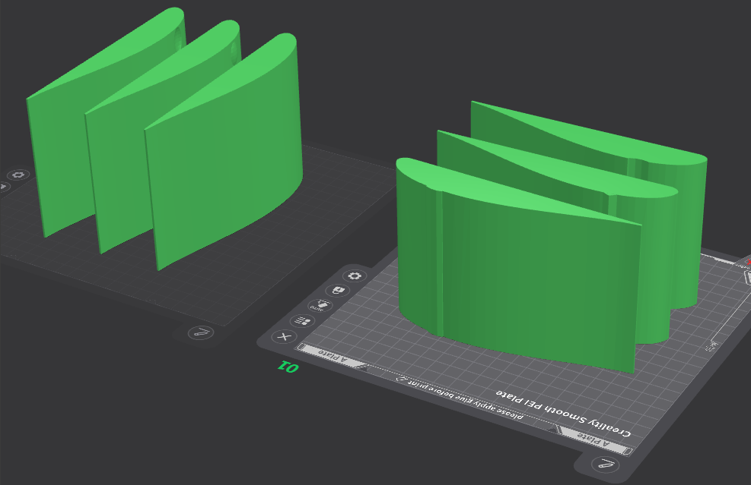

Feb 2: Formulated hypotheses and procedure:

Null Hypothesis: If the airfoils are put through an airstream, then there will be no difference in drag if the airfoils have a positive or negative variation because golf balls use negative bumps, and the Bugatti Bolide uses positive bumps.

Hypothesis (Alternative Hypothesis): If the airfoils are put through an airstream, then the airfoils with bumps will perform better than the rest because the company, Bugatti*,* uses bumps instead of ridges on the roof of their Bugatti Bolide. Since the Bugatti Bolide is the 4th fastest car to exist (according to Luxe Digital), there is lots of work going into the engineering and drag of it.

Hypothesis Conclusion for Best Airfoil: If the airfoils are put through an airstream, then the airfoil with the negative or positive bumps will perform the best because of the same concept in the Bugatti Bolide and as mentioned in the Null Hypothesis, the difference between negative and positive is predicted to be none.

Overall, the airfoils with variations will all perform better than the control because they generate vortices to reduce drag.

Procedure:

1. 3D print airfoils using 15% infill and 4 outer layers.
2. Drill a small hole perpendicular to the airfoil, 4 cm from the left side (bottom up), and 10 cm from the trailing edge.
3. Screw the Newton Meter L-shaped attachment into the airfoil.
4. Make sure the airfoil is exactly parallel to the Newton meter using a ruler.
5. Charge the RC battery.
6. Set newton meter to 0.5 Newtons of downwards force.
7. Align the airfoil 10 cm away from the EDF.
8. Turn off engine safety and initiate full power.
9. Record data.
10. Follow steps 5-7.
11. Align the airfoil 15 cm away from the EDF.
12. Turn off engine safety and initiate full power.
13. Record data.
14. Repeat for more trails/other airfoils.

Feb 2 to Feb 5: 3D printed airfoils.

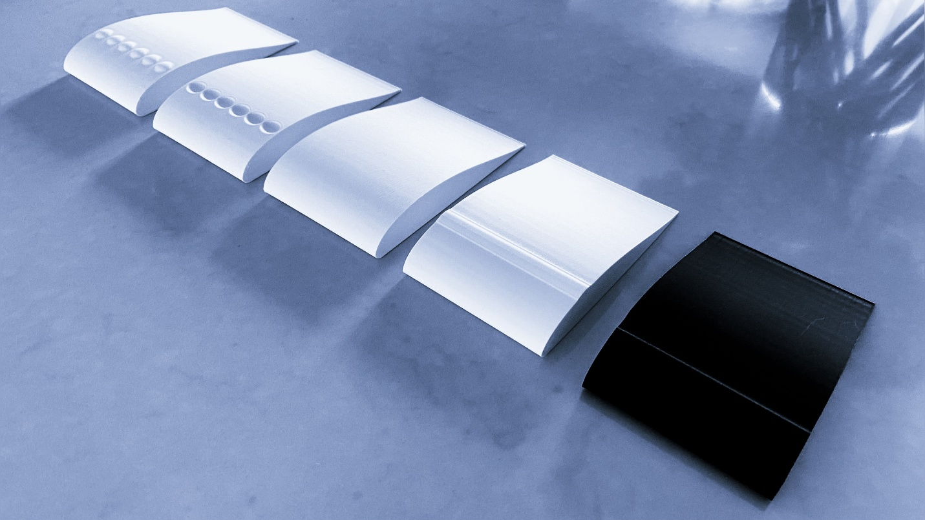

Feb 10: Tested airfoils (version 1).

Feb 11: Started to analyze data and found a source of error. Discarded experimental data.

Feb 20: Designed new airfoils.

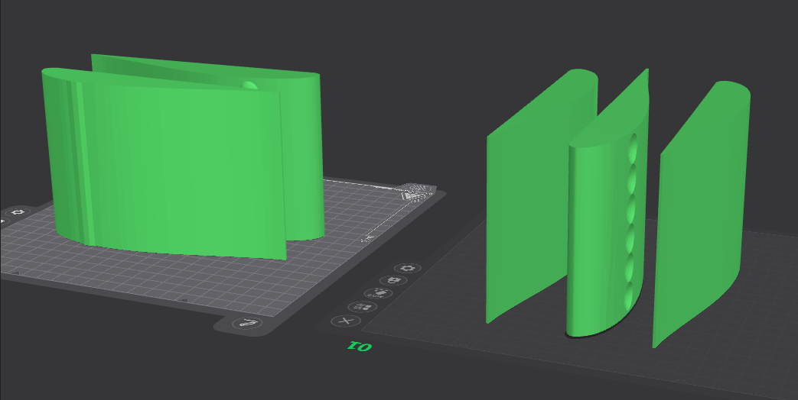

Feb 21-25: 3D printed new airfoils.

Feb 28: Tested airfoils (version 2).

March 1-4: Analyzed data and created graphs.

March 5: Contacted experts.

March 10: Entered information online.