CYSF Logbook 2026

October 6, 2025

Today I was added to our school's science fair online shell. I am still considering what project I am going to do. Last year my project was “Using Biomimicry to Help Improve Structural Stability. Considering I did pretty well on it, I am thinking of maybe continuing it and developing the project further.

October 13, 2025

I have thought about doing other projects as my previous one doesn’t seem to be complex enough for my grade level. Currently I am looking into vehicle protection systems as well as wildlife tracking with artificial intelligence. I am also wondering if I could do a project in the medical field. The only problem is that if I do such a project, I may have trouble executing it and considering the vast number of projects participating in that field, it may be difficult to stand out.

October 20, 2025

I have decided to do a project that is related that falls under the medical field. I am currently exploring certain types of sports injuries and what can be done to support and monitor them. Today our school sent out an email saying that in three weeks, we will have to discuss our project with the coordinator so I have to figure out my project before then.

October 29, 2025

I have decided my project will be related to treating Alzheimer’s disease. After some research, I learned that Alzheimer’s disease a progressive brain disorder that disrupts memory, judgement, thinking skills, and the understanding of information. The disease slowly gets worse, over time, eventually leading to the difficulty performing common tasks. Side effects include mood swings, changes in personality or behavior, asking the same question multiple times etc. It is caused by the clumping of abnormal proteins between cells, which causes disruption of neural electrical signals.

Considering that there was no cure to the disease, I decided to try and make an innovation that uses a brain computer interface(BCI), to try and analyze signals and support the brain during Alzheimer’s. I am still trying to figure out a name for my project and how exactly I can implement it.

The diagram below shows how tangles and clumps called plaques cause cognitive decline and shrinkage of the brain.

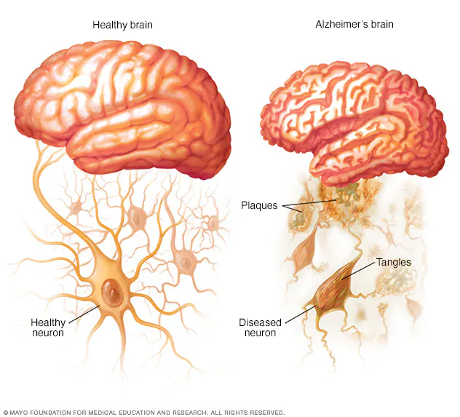

November 1, 2025

Today, our science fair coordinator sent out an email and a form to talk about our project and some of the background research we had done. I completed that and continued doing some research.

November 3, 2025

Today we had a science fair meeting at lunch. The meeting just discussed what would be expected from a science fair and a general timeline of the entire process. I also provided by email to later be added to the CYSF platform.

November 15, 2025

Today I conducted research on my project. I explored the current treatments for Alzheimer's and how effective they are. I realised that having a Brain Computer Interface scan for electroencephalogram(EEG) signals and analyse them was not as easy as I thought. I had named my project the NEUROWATCH, Neuro being an acronym for the Neural Electrical Understand and Response Optimizer but after conducting research I learned that it is almost impossible to collect data on EEG signals from the wrist, like a watch and learned that it rather has to be more like a headband. In addition I explored how exactly my machine would be able to detect eeg signals and be able to differentiate between Alzheimer’s patients and normal eeg activity.

The image below shows how exactly a BCI system works. Usually in a brain computer interface, EEG signals are converted from analog to digital, and then presented in an external device like a computer. In my project I will rather try to make a closed loop system where rather than the output being an external device, signals will be sent back as neural modulation after the interface had processed the information.

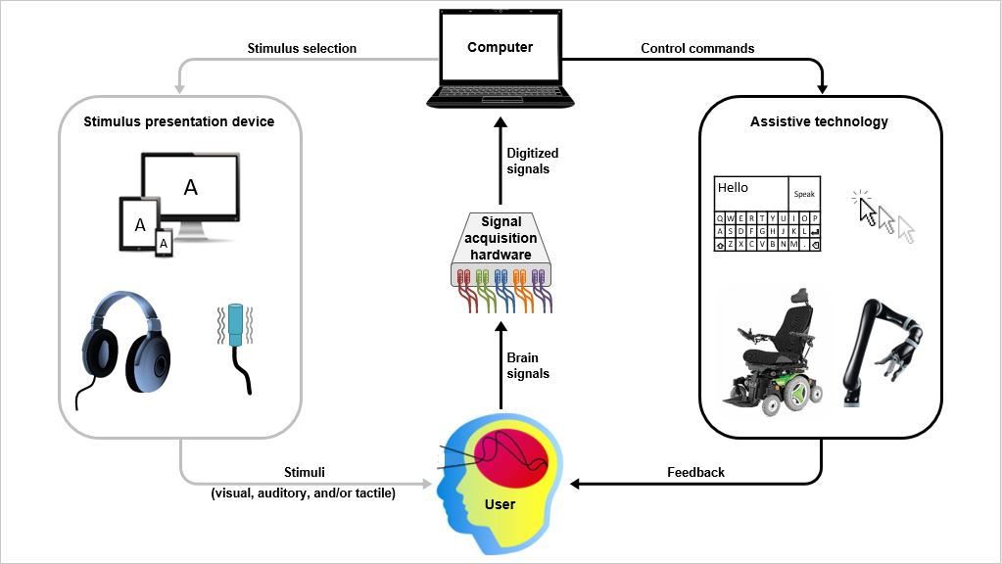

November 16, 2025

I looked into how EEG signals could be analyzed. I found a couple of videos online where people had conducted other BCI experiments. Yet for the purpose of my project, I was quite unsure on how exactly I could categorise each signal based on the task that was trying to be achieved. Considering my lack of knowledge on how exactly EEG signals were read, I decided to first develop my interface based on open source EEG data, which already provided most of the data I needed. Then if I wanted to, I could always switch to real time EEG
signals later.

November 20, 2025

Today I looked into multiple open source EEG platforms including Backyard Brain Spike Recorder, EDF browser, and OpenBCI. I had some difficulty using these platforms due to my inexperience and as well some platforms such as OpenBCI required their actual headset in order for their data to process properly. Others only worked with live eeg input and without an actual headset to scan eeg signals, it was not possible to use those platforms.

November 30, 2025

Today I accepted the invitation email for the CYSF platform and began working on my basic project information.

December 1, 2025

I found a proper open source EEG platform that already had eeg signals for general action pre-loaded. Based on tutorials I found online. I also watched some videos online from EEGUCATION that provided a detailed lesson on reading and understanding EEG signals. I am currently on the second video in a series of ten. In the video I learned the following:

- EEG refers to the recording of the brain’s spontaneous electrical activity over a period of time, as recorded from multiple electrodes placed on the scalp.

-The labeling at the side for each signal are called channels. If the number is odd, the signal corresponds to be received on the left side of the brain while if the number is even it corresponds to the right side of the brain. Letter represents the location of electrodes and the channel FZ-CZ and CZ-PZ records activity from the midline of the brain.

The abbreviations for each electrode placement are:
N: Basion
Fp: Frontal polar
AF: Antero-Frontal(Anterior Frontal)
F: Frontal
FT: Fronto-Temporal
FC: Fronto-Central
T: Temporal
C: Central
TP: Temporo - Parietal
CP: Centro-Parietal
P: Parietal
PO: Parieto - occipital
O:Occipital
I: Inion
Pg:Nasophryngeal
Channel: line of EEG recording
Derivation: arrangement of electrodes

-The platform has interchangeable filters. On average, the filter is usually placed at 70 Hz. The Notch filter removes electrical artifacts and is usually kept at 60 Hz. The sensitivity or gain is usually at 7 uV/mm for the average adult. The higher the time base the more detailed frequencies become with the default time base being at 30mm/s. Lesser waves correlate to lesser activity which can often be a sign of abnormality.

In addition to this I also learned the different artifacts that are created depending on the type of action being exhibited.

December 6, 2025
Today I just experimented with filters of the open source EEG platform, trying to figure out which filter would be the best for a BCI to analyze.

December 11, 2025

Today I watched online tutorials in sampling my EEG data. I decided for my BCI I would use Python as the coding language due to its flexibility as well as how the majority of the BCI projects and lessons online were all completed in Python. I downloaded all my data and kept it under one file. I then began converting all the files under the S001 folder into python files that would then display the EEG graph in Notepad.
December 18, 2025

Today I experimented with the time series analysis and learned how vectors are generated from sampling rates. I also received an email from the safety committee in science fair for my ethics form regarding testing. I replied to this email confirming that human testing was not involved and rather my invention would make a simulation of the interpretation and response based on the EEG signal.

December 22, 2025

I worked on developing threshold-based logic that differentiates neural states as either stable and unstable. This led to a lot of errors as I kept on making mistakes during the analysis.

January 2, 2026

Today I filled out a form regarding when we will present to our coordinator.

January 3, 2026

I finished developing the EEG analysis that categorises signals as stable or unstable. I also made the initial design for the Neurowatch.

January 7, 2026

Today I worked on my presentation for school. I also looked into the materials that would be required to build the NeuroWatch.

January 15, 2026

After conducting research, I ordered materials specifically for the interface itself. This included a raspberry pi 5, a raspberry pico and a pwm driver board. I already had a sensor shield and loads for the output. I also had my school presentation today.

January 23, 2026

I received all my materials and began exploring how I could use them. I also work on the CYSF platform. I have almost finished the problem section and am in the process of writing my method.

February 3, 20256

I have completed the majority of the platform and tested my system with multiple EEG files to see if the results were consistent. Currently there is slight variation within the results.

February 6, 2026

I improved the system by changing the vector time plots and the sampling rate handling. I also added to the CYSF platform.

February 15, 2026

Today I ran the simulation with all the files and everything seems to be working properly. I started watching tutorials on how I can code the electrical response based on the signal interpreted. Based on my research I won't be able to have the interface figure out exactly what tasks are essentially trying to be achieved but rather, it can analyze the EEG data and categorise it based on its neural state. This way my system can initiate an electrical response based on that neural state to help relay information if the neurons are not able to.

February 17, 2026

Today I tested preprocessing steps such as signal normalization and filtering. This was to ensure that large amplitude variations did not affect the NeurWatch’s ability to correctly analyze and interpret EEG patterns. I also had a science fair meeting today where I had to schedule a check in date with my coordinator.

February 22, 2026

Today I worked on my platform and filled out the majority of my information.

February 28, 2026

I worked on the CAD model of the NeuroWatch on fusion 360. I am currently designing a housing for my materials proper slots for electrode placement.

March 3, 2026

Today I had a check-in with my coordinator. I also finished all my work on my platform.

March 4, 2026

I added my logbook as well as all my citations on the platform. I also did some editing and proof reading. From here I need to implement all my parts, finish modeling the housing and make sure the electrical response for the close loop interface works properly.

