Using MEG Coherence Based Hallmarks & Protein Modification in a Treatment for Schizophrenia

Dates of Research
November 1st -7th – Schizophrenia Research
November 15th – November 22nd Hallmark Research
November 28th – December 3rd – Protein Research
December 17th – December 24 – Constructing The treatment
December 28th – January 8th Pictures, Analysis, Conclusion
January 15th – January 29th – Extra Research and Summaries
February – Finalizing the project / Completing the CYSF platform
March 3rd – March 10th – Making Video /Audio

Schizophrenia
Schizophrenia is a mental illness in which chemical imbalances in the brain cause significant changes in thought emotion and behavior.
Causes of Schizophrenia
Specific causes of schizophrenia are unknown, but it is known that the imbalance of neurotransmitters and a combination of genetic, psychological, and environmental factors that can cause this disorder.
- Neurotransmitters
- Dopamine
- Serotonin
- Glutamate
- Norepinephrine
Symptoms
Symptoms are primarily based on how severe the disorder is on the individual’s brain and what stage it has progressed to. The symptoms are:
- Hallucinations
- Delusions
- Depression
- Disorganized/Negative thinking
- Abnormal behavior
- Not being able to express certain emotions
Diagnosis
Current diagnostic tests are:
- Physical examination
- Oral tests and screenings - this includes MRI and CT scanning
- Psychiatric Evaluations
- DCS - diagnostic criteria for schizophrenia
The diagnostic tests will be applied based the type of symptoms the individual is facing. Diagnosis criteria may vary on the type of Schizophrenia symptoms that are showing on the individual.

Current Treatments
Schizophrenia is a condition that can be treated through certain drugs and therapy.
- Electroconvulsive Therapy: ECT scans stimulate electric impulses from the individual’s brain while they are in anaesthesia.
- The types of drugs that are used to treat schizophrenia are antipsychotic, anti-anxiety, and antidepressants.
- The overdose of these drugs can possibly increase neurotransmitters whereas taking a certain amount can reduce the number of chemical imbalances.

Problem
Schizophrenia is a mental disorder that can be treated in its initial stages by psychological therapy or by using antipsychotic medications, but these treatment methods aren’t as effective in the later stages. The question is how we could possibly treat Schizophrenia more effectively in another way.
Thesis
As we know current treatments for Schizophrenia have worked psychologically and are efficient to treat Schizophrenia in its initial stages. Having considered this, the only question was how the worst types of Schizophrenia could be treated more efficiently. If Schizophrenia could be treated using modified proteins and key hallmarks based on surgical principles, then this could be an efficient and very effective treatment for Schizophrenia. Meaning that a Schizophrenic individual would experience less symptoms because this would allow the neurotransmitter levels to be neutralized.

Types of Glial Cells

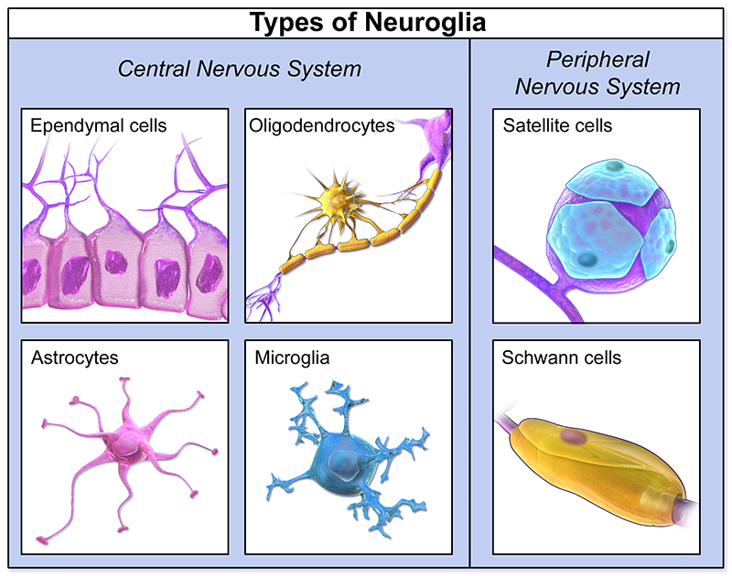

Microglia
- Immune cells for the brain - used when injury or stages of diseases
- Microglia will identify when there has been any disturbance in the communication between parts of the brain and the neurons.
- This cell removes any type of toxicity and dead cells.
- Overall the microglia are the brain's protection cells but don’t always react to any occurrence of abnormal activity.
- Microglia is T - lymphocyte
- Even though they are responsible for the immune response in the brain they cannot always serve this function when going against B - lymphocytes which are toxic cells.
- Microglia react more in progressive neurodegenerative diseases (continuous death of nerve cells) such as Alzheimer’s and other types of Dementia.The cells are also involved in the creation of synapses and neuroplasticity of the brain.

- Macroglia

Astrocytes

- They are the cells that help in the neuron’s working environment.
Involved in the neuroplasticity

- Astrocytes create this working environment by identifying the levels of synaptic transmission and then signaling the oligodendrocytes.

- These cells control the distribution of important ions like potassium and provide metabolic support.

- Astrocytes only have the ability to sense the neurotransmitter levels around the synapse but they do not serve the function to react to this.

Oligodendrocytes

- Provide support to axons that are located in the CNS.

- The oligodendrocytes are the most important cells in the Interbody Cell Transplant for Schizophrenia.

- This neuroglial cell in particular is very self-protected due to its production of a fatty substance called myelin
- Myelin is a sheath that wraps around the axons as an insulation. The myelin sheath’s main function is involved in controlling the speed and quickness of the synaptic activity.

- During Schizophrenia the levels of synaptic transmission increase when oligodendrocytes eventually die and cannot control synaptic transmission.
- The three major glial cells that are going to be used in this treatment are Astrocytes , Oligodendrocytes, Microglia, Ependymal cells.

Other Types of Macroglia

CNS

Ependymal Cells

- Found in the spinal cord and ventricles of the brain.
- Ependymal cells are the key cells involved in the production of CSF with choroid plexus.
- Ependymal cells will be used in this treatment because they are involved in the production of cerebrospinal fluid and the transport system of major ions like proteins and vitamins for the neurons and synaptic support.

Radial Glia

- They are the generating cells for the neurons, oligodendrocytes, and astrocytes.
- Radial glia don’t serve a major function that react to chemical imbalances in the brain but they do help in the formation and development of the cerebral cortex.
- Radial glia do tend to slow down during unstable synaptic transmission and imbalances in neurotransmitter levels.

PNS

Schwann & Satellite Cells

- Schwann cells myelinate neurons in the peripheral nervous system similar to oligodendrocytes. Since the presence of schwann cells is mainly found in the PNS they serve this function in the neurons found in the PNS.

Diagram of Schwann Cell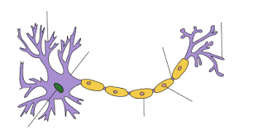

Background Research
MEG Coherence Based Hallmarks

Figure 1 - MEG Coherence

The MEG machine detects neuronal and synaptic activity and it will also detect any changes or patterns in the synapses of neurons and neuronal activity itself.

- Magnetoencephalography machines are used by detecting magnetic fields produced in the brain to make magnetic source images. These magnetic fields are produced by the activity of neurons. MEG machines will measure the neurons in a specific order. This is so there is no interference between position and the signals of the MEG and the neuron.

- The measuring of the neuronal activity can also tell which part of the cortex has high levels of neurotransmitters passing through the synapses of the neurons. MEG machines can also detect CSF movement in the subarachnoid spacing between the skull and brain.

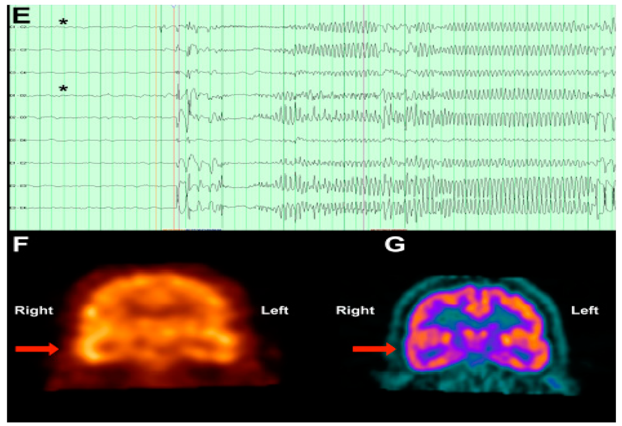

This image shows a magnetoencephalography screening test comparing a brain affected by depression and an average individual's brain.

Figure 2 - Neuroglia ( Hallmark - 1)

- Neuroglia are cells that protect the neurons and serve different functions. The neuroglial cells can be detected by MEG in the subarachnoid spacing. Glial cells like astrocytes and ependymal can be found within the CSF.

- Other neuroglial cells can be found in neural tubes within the spinal cord or the cerebral aqueduct.

Neuroglia is a valid hallmark for Schizophrenia because it serves the function to ultimately protect the neuron. Schizophrenia is an illness in which it involves the overuse of neurotransmitters. The neuroglial cells detect the levels of synaptic transmission by controlling the number of neurotransmitters released at the nerve terminal. Schizophrenia will target glial cells which cause them to lose their ability to control synaptic transmission which leads to the over transmission of neurotransmitters.

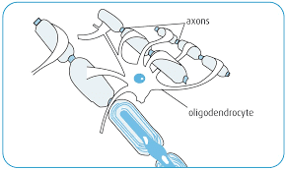

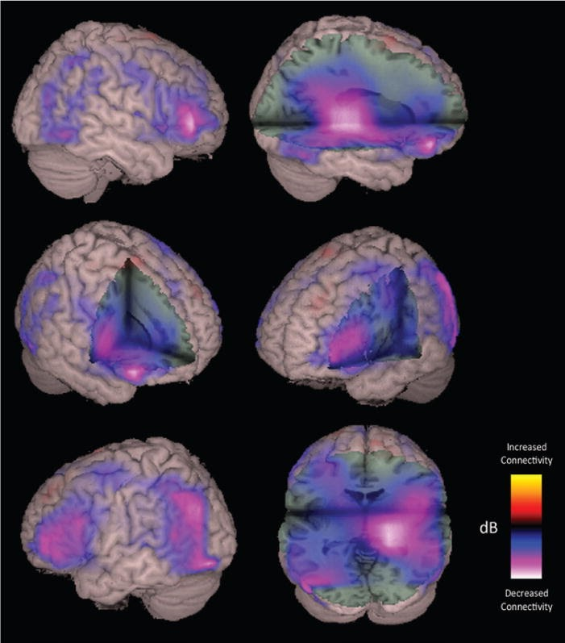

- The differences in the color show the absences in connectivity using MEG. The MEG will detect the synaptic transmission and magnetic fields to detect the speed of neurotransmitters passing between the synapses.
- MEG machines will detect the magnetic fields due to the synaptic transmission between the neurons.
- Not all parts that have decreased connectivity can be targeted with treatment, but they can be treated through antipsychotic medication.

Figure 3 - Cerebrospinal Fluid - (Hallmark - 2)

- Cerebrospinal fluid and Neuroglia can be considered as one of the hallmarks due to CSF containing many different types of Neuroglia. To specifically analyze the neuroglia, it will have to be extracted from the CSF.

- Chemical analysis on the neuroglia will tell how cells react to the synaptic transmission and if they are serving their proper functions or not.

- The chemical analysis will show how efficient or inefficient they are. Depending on the analysis the neuroglia will be transported to the affected region of the brain.

- CSF is a type of hallmark/biomarker that can indicate and help diagnose many other diseases like Alzheimer’s and Brain tumors.

Cerebrospinal Fluid has many important elements in its composition. CSF contains more different types of protein, than blood plasma. Cerebrospinal fluid also contains certain amounts of potassium, glucose, and calcium but in very little amounts. During the formation of CSF, the choroid plexus also adds growth factors of the CSF like iodine, and vitamins B1 and B12.

CSF samples are taken from the thoracic part of the spinal cord which is also known as the spinal tap.

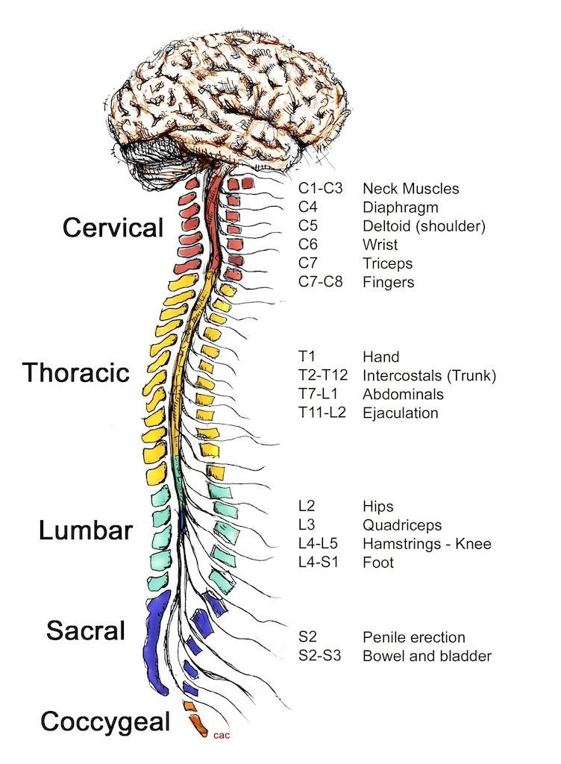

Research
- Vesicular Glutamate Transporter 1 - (protein)
Neurotransmitter release at excitatory synapses highly depends on the glutamate import into synaptic vesicles by VGLUT1. VGLUT1 and VGLUT2 are two of the three vesicular glutamate transporters and these two are very common in adult brains.

- Vesicular inhibitory amino acid transporter - (protein)
This is a protein in humans that is encoded by the SLC32A1 gene and is a specific protein for synaptic vesicles and is responsible for vesicular storage of GABA and glycine. This is key for GABAergic and Glycinergic neurotransmission.

- Vesicular Glutamate Transporter 3 - (protein)
A protein that transports glutamate into synaptic vesicles before it is released into synaptic cleft. This is a protein encoded by the SLC17A8 GENE.

- Sodium dependent phosphate transporter protein 1 - (protein)
This is a protein in humans encoded by the SLC17A1 gene. It is found within the Central Nervous System (CNS).

- Sialin - (protein)
Sialin is a protein encoded into human by the SLC17A5 gene. It is stored as sialic acid in the brain and is found throughout the Central Nervous System (CNS).

- Monocarboxylate transporter - (protein) - (MCT)
MCT's are membrane proteins which are carriers for lactate, pyruvate, and ketone bodies. There are three different types of MCT in the brain. MCT 1 is known to be within endothelial cells, ependymocytes, and astrocytes. MCT 4 is known to be found in all these cells other than astrocytes. MCT 2 is found in neurons for majority of the time.

- Ion transporter - (protein)
This protein is known as a transmembrane protein that moves nutrients (ions) across membranes from a high number of particles to a low number of particles.

- Monoamine neurotransmitter (chemical compound)
They are neuromodulators that have one amino group connected to an aromatic ring through the help of a two-carbon-chain. EX: dopamine and serotonin.

- Excitatory amino acid transporter 1 - (protein)
Also known as Glutamate Aspartate Transporter 1. This protein is also found in the plasma membrane which give it the ability to remove glutamate from the extracellular space.

- Excitatory amino acid transporter 4 - (protein)
This protein is encoded by the SLC1A6 gene. EAAT4 is found in the cerebellum area of the brain. The protein has high capabilities to have dissimilar chemical species to be capable to form chemical bond. The Excitatory amino acids can form these bonds which are L-glutamate and L-aspartate

- Solute carrier family 25 member 22 - (protein)
A protein encoded by the SLC25A22 gene and its responsibilities are to encode mitochondrial glutamate carrier. This protein and the genes associated with this are found in colorectal tumor cells.

Treatment Procedure - Interbody Cell Transplant -
INTERBODY CELL TRANSPLANT DESIGN - FULL PROCEDURE OF TREATMENT

1. Basic principles of craniotomy will be applied from the point of the brain where the ventricles are located to the embryonic precursor in the spinal cord, and the affected region of the brain. (embryonic precursor neutral tube in the spinal cord where the neuroglial cells are located).

2. A Syringe - 8 inches in length will be placed in the subarachnoid space surrounding the brain and the spinal cord. The syringe will take a sample of the CSF. (CSF – Cerebrospinal Fluid) - ( S1 SYRINGE)

3. The CSF and the neuroglia within the CSF will be analyzed to examine their behavior if they are healthy or not.

4. After knowing where there are differences in synaptic transmission and activity in specific regions of the brain through MEG the S2 syringe will be used.

5. The S2 syringe will contain the neuroglial cells and CSF - ( Hallmarks 1 & 2). Which will be transported to the certain affected regions of the brain directly through the incision made in the skull.

6. After this step a fMRI scan will scan the whole brain, specifically the affected regions of the brain.

7. S3 Shunt connecting from the neural tube and ventricles to the affected part of the brain will transport a greater amount of healthy neuroglial cells than the S1 and S2 Syringe tubes. This shunt will be there from the duration of the surgical process. (This procedure will only be there if needed this depends on how worse the illness has progressed over the brain).

8. The modified/phosphorylated proteins – VGULT 1 & 3, SERT, DAT, NET will be transported directly through opening of the skull which leads to the brain. Prior to this procedure there will be chemical analysis performed on each of the modified proteins. Depending on the individual and the health of their brain additional amount of neuroglia and proteins may have to be transported.

9. At last the basic principles of cranial anatomy will end the procedure. Artificial duramater will be used to cover the incision made in the skull and original duramater layer. The titanium screws/plates will be used to attach the drilled piece of the skull back on to the skull.

10. The post fMRI scans and MEG scans on the affected part of the brain and the neurons will show that synaptic transmission has been well balanced. This step will be performed at least 48 hours after the procedure has been completed because it will take time for the results to show

11. The astrocytes (type of neuroglial cell) will start to take away the remains of the dysfunctional and dead glial cells.

OFFICIAL PLAN OF PROTEIN MODIFICATION

Phosphorylation
Phosphorylation changes the structural conformation of protein and causes the protein to be activated or enhance its function. De-phosphorylation is when the protein becomes de-activated. In the process of phosphorylation, a phosphoryl/phosphate group is added to the protein (PO3)/(PO4). Phosphate groups can be found in the human DNA, RNA, and adenosine triphosphate (ATP). The human body in general needs phosphate to help repair bones teeth and help nerves function.
Phosphate Group – PO4
Phosphoryl Group – PO3
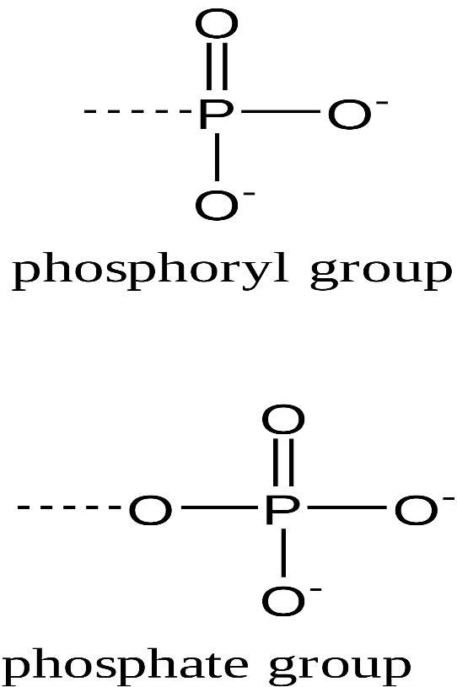

  - Phosphoryl groups are consisting of phosphorus and oxygen. The process of phosphorylation and de-phosphorylation are carried out by certain enzymes.
Importance of Phosphorylation
  - Important for glycolysis
  - It is used for protein interaction
  - Protein degradation
  - Enzyme inhibition
  - Balances homeostasis by regulating energy which is done by chemical reactions.

Protein Phosphorylation
  - Happens when the phosphoryl groups are added to an amino acid structure of a protein.
  - Majority of the time the amino acid being used is known as serine.
  - Phosphorylation can also occur on threosine and tyrosine in eukaryotes.
  - Phosphorylation is a type of post translational modification method.
  - Protein phosphorylation is plays an important role in metabolism and spotting pathways.
Glycolysis
The process where a molecule of glucose is converted into two molecules of pyruvate. Through the help of this process molecules of ATP can be synthesized.
Protein Degradation
When proteins breakdown into smaller polypeptides or amino acids.
Enzyme Inhibition
A certain type of molecule that attaches it self to an enzyme and decreases the activity of the enzyme.
Homeostasis
A type of property in cells, tissues, and organisms that allows the maintenance and balance for certain things to functions properly.
Amino Acid
They are organic compounds and they are also the building blocks of proteins. Amino acids consist of and amino groups and a carboxylic acid group and (R) group which is unique to each amino acid.
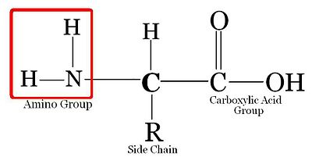
Eukaryotes
Cells of organisms who have their nucleus enclosed within a nuclear envelope.
Prokaryotes
Unicellular organisms that don’t have any organelles or other internal membrane structures. Although they don’t have a nucleus and only have a chromosome located in the nucleoid.

Other Post Translational Modification Methods
Methylation
Protein methylation is another type of posttranslational modification method which involves adding methyl groups to proteins.
Methyl groups can also so be found in certain foods
  - Methyl Groups: R-CH3
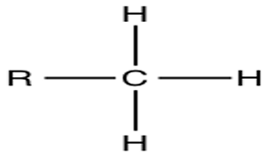
Acetylation
Acetylation is a protein modification method that can happen as co-translational and post-translational modification on proteins. The purpose of acetylation is so that when certain proteins that replicate DNA and fix genetic materials that are damaged are fixed through the process of acetylation. Acetylation also plays a key role in DNA replication and also analyzes the energy that proteins use for duplication.
Acetyl Group
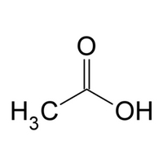
  - acetylation can also drastically change the functions and properties of a proteins.

Glycosylation
A chemical reaction where a carbohydrate (glycosyl donor) is attached to a hydroxyl.
  - Glycosyl Donor: a mono-carbohydrate that will react with an appropriate glycosyl acceptor in order to form a new glycosidic bond.
  - This glycosyl donor will be attached to a hydroxyl.

Glycosyl Donor
(Glucosyl Bromide) Hydroxyl Group
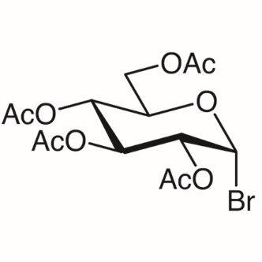 combine 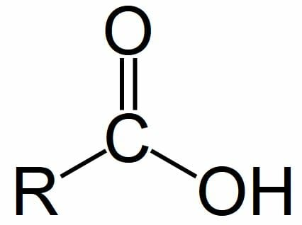

  - There can be many different types of glycosyl donors glucosyl bromide is known as one of them.
  - A hydroxyl group which attaches itself to certain molecules that contain a hydrogen atom and oxygen atom.
  - Glycosylated protein is more flexible and suitable for serving their functions

Ubiquitination
Ubiquitination is an enzymatic posttranslational modification in which a ubiquitin protein is added to a substrate protein. The protein ubiquitin is found in all cellular tissues in humans and can also be found in eukaryotic cells and this protein helps with synthesizing new proteins and destroying of bad and negative proteins.
Destruction of Proteins: Ubiquitin Proteasome System (UPS)
In the degradation of proteins ubiquitin is added to the amino group on the side chain of a lysine residue. Additional proteins of ubiquitin are also added with each other and this forms a multiubiquitin and this process is also known as proteolysis.

Lipidation
Lipidation is a process in which the function of the proteins is enhanced through many different types of lipids and these functions can only be augmented by enhancing their binding affinity to biological membranes.
Proteins can be modified by six different types of lipids which are:
  - Fatty acids
  - Isoprenoids
  - Sterols
  - Phospholipids
  - Lipid derived electrophiles (LDE)
Fatty Acid
It is a carboxylic acid which is made up of a hydrocarbon chain and carboxyl group
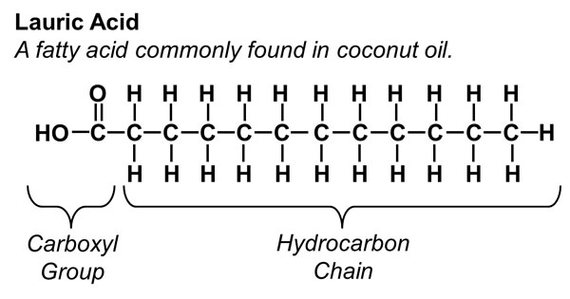

Fatty acids are found in various types of food such as vegetable oil, seeds, nuts, animal fats, and fish oil. Fatty acids are also a very important for the human body diet (omega-3 fatty acids)

Isoprenoids
They are organic compounds made up of two or more units of hydrocarbons and every unit will have 5 carbon atoms arranged in a specific pattern.
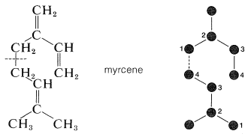

Lipid Derived Electrophiles
Endogenous reactive metabolites that initiate as products of lipid peroxidation when the cells go through a process called oxidative stress. LDE’s have the capability to modify nucleophilic smells/residues in proteins to change or enhance functions and change the physical structure.

Biotinylating
Process in which a biotin is attached to a protein. This protein is very efficient, rapid, accurate, and will not disrupt the function and properties due to its physical size being very small. Biotin interaction can detect ad purify proteins. Overall, the main function of biotin is so it attaches itself to proteins to enhance their functions and abilities.
Biotin
Biotin is a water-soluble vitamin which is included in the vitamin-B group.
Key things biotin is needed for:
  - Helps convert nutrients into energy
  - health of hair
  - Health of skin
  - Health of nails
Biotin does not produce in the body, but the human body’s gut bacteria can produce biotin. The body does not store biotin because it is a water-soluble protein.
  - Biotin is attached to a protein covalently

Biotin Structure
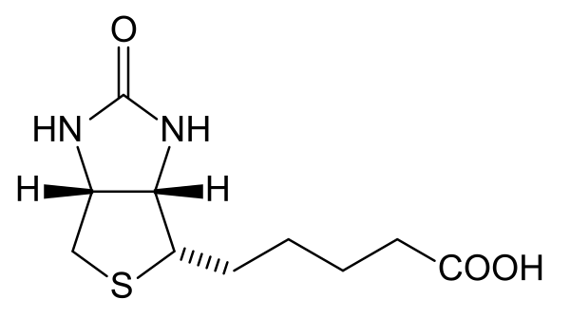

Protein Modification
These protein modification methods are going to be applied on the specific proteins that will be extracted from the different parts of the nervous.
Proteins
  - Vesicular Glutamate Transporter -1 (VGLUT-1)
  - Vesicular Glutamate Transporter -3 (VGLUT-3)
  - Serotonin Transporter (SERT)
  - Dopamine Transporter (DAT)
  - Noradrenaline Transporter (NET)
Post Translational Modification applied on Proteins
The most efficient PTM method is phosphorylation and every protein will be phosphorylated to modify it and enhance its functions. The proteins will be modified and will be used alongside neuroglial cells.

VGLUT-1/3 - Vesicular Glutamate Transporter 1/3
The neurotransmitter glutamate is very important in our synaptic activity. To ensure that synaptic efficiency is balanced, the synaptic vesicles are refiled with glutamate by the VGLUT proteins.
In the process of neurotransmission, the synaptic vesicles are retrieved by endocytosis. When the synaptic vesicles are in the position to be refilled again this is all possible depending on the activity of VGLUT proteins. The transport rate of VGLUT increases at the hippocampal glutamatergic terminal. VGLUT-1 and 2 are most found in adult brains (mature brains). This protein is highly associated with membranes of synaptic vesicles.
When the activity of this protein decreases this allows the brain to be more vulnerable to diseases.
  - The lack of glutamate transmission is what leads to symptoms associate with schizophrenia.
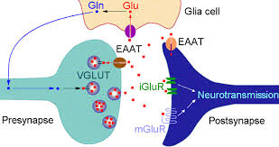

When the modified VGLUT-1/3 will be transported through the neural pathways, they will eventually make way to the neurons beginning the process again.

Phosphorylation on VGLUT-1/3
In basic term phosphorylation would be the process of adding phosphoryl and phosphate groups to a protein to enhance their functions.
  - VGLUT-1 + (PO3 -2) or (PO4 -2)

Enhancement of Proteins
Since these proteins are associated with the certain neurotransmitters, making them phosphorylated will allow them to prevent over neurotransmission alongside with the neuroglia cells. When the neurotransmission is going to be balanced this will allow neural networks and pathways to function properly.
  - With some proteins a sodium dependent transporter may have to be used for this protein to accomplish its task (reaching the neural networks and assisting the neuroglia cells to balance neurotransmission).

Serotonin Transporter Protein
The serotonin transporter protein is also known as sodium dependent serotonin transporter. This protein removes serotonin from the synaptic cleft back into the synaptic boutons causing this to stop the functions of serotonin in areas that are not needed. Overall SERT plays a key role in regulating serotonergic neurotransmission and limiting the amount being used.

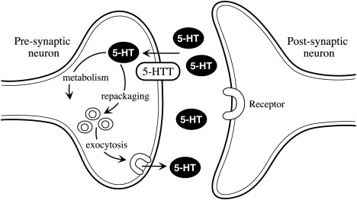
Exocytosis
A certain process in which a bulk of molecules are released. In this process membrane bound secretory vesicles are carried to the cell membrane and the other remaining molecules would be secreted into the extracellular environment
Phosphorylation on Serotonin Transporter
SERT + (PO3-2) or (PO4-2)

Dopamine Transporter Protein
The dopamine transporter also known as dopamine active transporter or DAT is a membrane spanning protein that pumps the neurotransmitter dopamine out of the synaptic cleft back into cystol. The cystol is the place where other transporters isolate dopamine into vesicles for storage and later release. Dopamine controls many functions such as movement, cognition, mood, and the feeling of reward. All of these functions can’t be controlled unless if the DAT manages the amount of use of DAT.
  - The dopamine transporter is a target for several different types of narcotics.

Phosphorylation on Dopamine Transporter
DAT + (PO3-2) or (PO4-2)

Transportation of Neuroglia Cells and Proteins
- The neuroglia cells will be transported directly through the incision/opening made in the skull. This is a a very efficient way of transporting the neuroglia cells and the proteins because they come in direct contact with the brain meaning that they will be effective very fast and efficiently.
- Another possible way of transporting the proteins and neuroglia is through the blood brain barrier (BBB). The BBB is a very risky but also very efficient option for transportation of the neuroglial cells and the proteins and there are several reasons behind this.
- The blood brain barrier serves the function to control nutrients (ions) and cell transfer between the blood and the brain, and vise versa. This is very efficient because the proteins and neuroglia transfer process becomes much more easier when they are transported through the BBB.
- There is a risk factor when it comes to contacting the blood brain barrier. The risk in contacting the blood brian barrier is that it is very much likely to be disturbed then this will cause the immune cells to come in contact with the neurons causing nerve damage. This can further lead to many other injuries and problems in the brain like MS.

Summary - Brief Description
​ This treatment uses the hallmarks that are very efficient and are key in identifying the research of this project which is focused around creating an efficient and novel treatment option for Schizophrenia. The main way in which this treatment will be conducted is through using key hallmarks and modified proteins. Neuroglia cells and cerebrospinal fluid are the two hallmarks that I targeted during research, I was able to figure that both were viable sources that could be used. Having considered that neurotransmission and synaptic activity would need to be balanced by not just the health of the neurons but also many different factors, I decided to target proteins. Targeting proteins was very challenging in terms of understanding their functions, health, and abilities. Knowing that PTM of a protein in the brain can be stopped by imbalance of neurotransmitters, I had to research another way of modifying these proteins. This method was to phosphorylate the proteins through phosphate/phosphoryl groups extracted from the blood and combining them with the proteins. During the process of constructing this treatment, the biggest factor to consider was how it could be designed to be minimally invasive and safe. Acknowledging this, I designed three syringes and shunt tubes which will certainly make this procedure safe and very efficient. Every step in this procedure was studied and analyzed to assure that the risk level is minimized, and the efficiency is maximized.

Conclusion
Schizophrenia is a growing mental disorder around the world and has very severe and devastating symptoms which is noticed by a breakdown between thought, emotion, and behavior. The most debated question around the world is how there can be a more efficient treatment created for Schizophrenia. My thesis stated that if proteins associated with specific neurotransmitters were to be modified and used alongside key hallmarks of Schizophrenia under craniotomy principles, then a significant balance could be spotted in the neurotransmitter levels and synaptic connectivity. With the highly likely and predicted outcomes, the design of the Interbody Cell/Protein Transplant can show a very accomplished and satisfying result if it is ever clinically applied. Having Considered the pros and cons of the Interbody Cell/Protein Transplant, this novel treatment option can be very beneficial to treat Schizophrenia. Overall, I conclude that this treatment design can have impact on our society as another option besides the use of anti-psychotic medication and therapeutic drugs, which can have show lasting negative side effects. This reasearch and treatment innovation is to help treat individuals with Schizophrenia, however, it also seeks raise awareness and provide knowledge of what impact mental illness can have on individuals.

What's Next ?
In society today, we thrive on excellence, perfection, and idealism, individuals tend to forget about their mental health trying to meet certain expectations. Innovating a hypothetical treatment; The Interbody Cell/Protein Treatment, gives me the encouragement to progress my research work and keep learning. Seeing how devastating it can be to see someone go through such events and experience tough symptoms, I thrive to raise more awareness in society, so we understand how dangerous and severe mental illness and its outcomes are if they are not treated. Soon, I look forward to working with more skilled and experienced individuals with quite more knowledge and presenting my ideas to them. I believe that the ideas of this innovative creation are a step in the right direction to discover and learn how to tackle such situations. Overall, the main goal I look forward to achieving is to bring more awareness into our community about what this illness pertains to and creating such innovations which can help others in the future.

Bibliography – Proteins
  - https://en.wikipedia.org/wiki/Dopamine_transporter#:~:text=The%20dopamine%20transporter%20(also%20dopamine,for%20storage%20and%20later%20release.
  - https://pubmed.ncbi.nlm.nih.gov/30273635/
  - https://www.britannica.com/science/norepinephrine
  - https://www.sciencedirect.com/topics/neuroscience/serotonin-transporter
  - https://en.wikipedia.org/wiki/SLC20A1
  - https://www.uniprot.org/uniprot/Q9NRA2
  - https://en.wikipedia.org/wiki/Monocarboxylate_transporter
  - https://en.wikipedia.org/wiki/Ion_transporter#:~:text=From%20Wikipedia%2C%20the%20free%20encyclopedia,homeostasis%2C%20energy%20production%2C%20etc
  - https://www.pnas.org/content/108/38/15810#:~:text=The%20norepinephrine%20or%20noradrenaline%20transporter,neurons%20(2%2C%203).
  - https://en.wikipedia.org/wiki/Urea_transporter#:~:text=A%20urea%20transporter%20is%20a,%2DA%20and%20UT%2DB.&text=Their%20inhibition%20results%20in%20diuresis,collecting%20ducts%20of%20the%20kidney.
  - https://www.ncbi.nlm.nih.gov/pmc/articles/PMC3321928/#:~:text=Monoamine%20transporters%20are%20transmembrane%20proteins,)%20(1%2C%202).
  - https://en.wikipedia.org/wiki/Excitatory_amino_acid_transporter_1
  - https://www.ncbi.nlm.nih.gov/pmc/articles/PMC6888595/
  - https://en.wikipedia.org/wiki/Solute_carrier_family_25_member_22
  - https://en.wikipedia.org/wiki/Calcium-binding_mitochondrial_carrier_protein_Aralar1

Bibliography – Protein Modification Methods
  - https://en.wikipedia.org/wiki/Post-translational_modification
  - https://www.thermofisher.com/ca/en/home/life-science/protein-biology/protein-biology-learning-center/protein-biology-resource-library/pierce-protein-methods/overview-post-translational-modification.html
  - https://www.thoughtco.com/phosphorylation-definition-4140732#:~:text=Phosphorylation%20is%20the%20chemical%20addition,e.g.%2C%20kinases%2C%20phosphotransferases).
  - https://www.ncbi.nlm.nih.gov/pmc/articles/PMC5500920/
  - https://en.wikipedia.org/wiki/Methylation#:~:text=In%20the%20chemical%20sciences%2C%20methylation,group%20replacing%20a%20hydrogen%20atom.
  - https://www.ncbi.nlm.nih.gov/pmc/articles/PMC3521964/#:~:text=DNA%20methylation%20is%20essential%20for%20silencing%20retroviral%20elements%2C%20regulating%20tissue,on%20the%20underlying%20genetic%20sequence.
  - https://www.sciencedirect.com/science/article/pii/S1570963916301169
  - https://www.intechopen.com/books/glycosylation/the-role-of-glycosylation-in-receptor-signaling
  - https://www.medicinenet.com/ubiquitination/definition.htm

Bibiography – Images &
https://www.bioinformatics.org/tutorial/1-3.html
https://www.google.com/search?q=types+of+neuroglia&safe=strict&rlz=1C1GGRV_enCA766CA766&sxsrf=ALeKk02JoZUr-kBb8U_Yxrm_FgYIVWKlKg:1615860258085&source=lnms&tbm=isch&biw=1422&bih=680#imgrc=qcZpQ1j2UnnLCM
https://www.brainhq.com/brain-resources/cool-brain-facts-myths/brain-101/
https://en.wikipedia.org/wiki/Carboxylic_acid
https://www.sciencedirect.com/science/article/pii/S0083672914000223
https://en.wikipedia.org/wiki/Phosphoryl_group
https://sites.google.com/site/honorschemistryonline/6-organic-chemistry/5-functional-groups
https://www.thoughtco.com/ventricular-system-of-the-brain-3901496
https://www.cancer.gov/types/brain/patient/adult-brain-treatment-pdq
https://pixers.de/leinwandbilder/gehirn-scan-x-ray-50992349
https://www.sciencedirect.com/topics/neuroscience/serotonin-transporter
  - https://www.semanticscholar.org/paper/Magnetoencephalography-for-brain-electrophysiology-Baillet/fad7b1a6f26a16c359230579218c32fb32413710/figure/3
  - https://mstrust.org.uk/a-z/glial-cells
  - https://medlineplus.gov/ency/imagepages/9240.htm

