Built to Last? How Water Affects Building Materials

Aliyah A. Yusuff

Calgary Youth Science Fair

Grade 11

April 2025

Built to Last? How Water Affects Building Materials

# Introduction

Flooding is a recurring natural disaster that causes severe damage to buildings and infrastructure. Past floods in Calgary have highlighted how vulnerable structures are to water exposure. Different building materials react differently when exposed to water, affecting their durability and long-term performance. Understanding how materials withstand water can help in making better choices to reduce damage in flood-prone areas.

This experiment tested three common building materials—brick, concrete, and wood—to determine how they respond to water exposure. Initially, plastic was considered as a fourth material, but it was excluded due to challenges in obtaining suitable samples. Research shows that plastic materials, such as PVC and acrylic, are highly water-resistant and do not absorb water like brick, concrete, or wood. While not tested here, future studies could explore the long-term effects of water on plastic materials.

# Purpose

The goal of this experiment was to determine which building material is most resistant to water damage. By observing how brick, concrete, and wood respond to water exposure, this study can provide insight into the best materials for construction in flood-prone areas.

# Hypothesis

If different building materials are submerged in water, then:

* Concrete will absorb the least water.
* Brick will remain the most durable after exposure.
* Wood will absorb the most water and deteriorate the fastest.

This prediction is based on material properties:

* Brick is dense and moderately porous, making it somewhat resistant to water absorption.
* Concrete is durable but porous, meaning it can absorb water over time.
* Wood is highly absorbent and can weaken or rot when exposed to water for long periods.

If the hypothesis is correct, concrete would be the best material for construction in flood-prone areas.

# 

# Variables

**Independent Variable:** Type of building material (brick, concrete, wood).

**Dependent Variable**: Reaction to water exposure, including changes in:

* Warping or shape changes
* Surface texture differences
* Color changes
* Structural integrity

**Controlled Variables:**

* Volume of water used for testing
* Temperature and environment during testing
* Consistent observation criteria
* Position of samples in water

# Materials

* **Building Material Samples:** 3 bricks, 3 concrete samples, 3 wood samples (one per trial)
* **Water:** 4-5 litres per trial
* **Equipment:**
  + Bucket or container for water
  + Timer
  + Measuring cup
  + Towels
  + Gloves and protective clothing
  + Camera or smartphone for documentation

# Procedure

1. Preparation**:** Gather materials and set up a clean workspace.
2. Initial Observations**:** Record characteristics of each sample before submersion.
3. Water Submersion**:** Place samples in water, ensuring full submersion.
4. Observation Period**:** Leave materials submerged for a set duration (e.g., 12 hours).
5. Post-Submersion Analysis**:** Remove samples, dry them, and document changes in shape, texture, and color.
6. Repeat Testing**:** Conduct three trials to ensure consistency.
7. Data Analysis**:** Compare findings across trials to identify trends.

# 

# Observations & Results

Each trial revealed differences in how materials reacted to water exposure.

## Trial 1: Baseline Test

* **Brick:** Developed small cracks and whitening at the edges.
* **Concrete:** Became smoother, lost powdery residue, and formed small holes.
* **Wood:** Absorbed the most water, darkened in color, and softened significantly.

## Trial 2: Surface Roughness Test

* Roughened surfaces absorbed more water, leading to more visible damage in all materials.

## Trial 3: Shortened Submersion Test

* Shorter exposure resulted in less damage, with concrete showing minimal change.

# Analysis

## Material Comparisons

* **Brick:** Absorbed some water but retained structural integrity.
* **Concrete:** Maintained stability but developed minor surface holes.
* **Wood:** Absorbed the most water, becoming weak and deformed.

## Key Trends:

* Rough surfaces absorbed more water.
* Longer exposure led to greater deterioration.
* Whitening on brick and concrete likely resulted from mineral deposits.

# Conclusion

The results supported the hypothesis that different materials respond differently to water exposure. Wood was the least resistant, absorbing large amounts of water and weakening the most. Concrete and brick remained more durable, with concrete showing the least structural damage overall.

**Best Material for Water Resistance:** Concrete, due to its stability after exposure.  
**Worst Material for Water Resistance:** Wood, which deteriorated the most.

This experiment highlights the importance of selecting water-resistant materials for construction, particularly in flood-prone areas. Future research could explore additional materials, different water exposure durations, and long-term durability under real-world conditions.

# Photograph Assortment

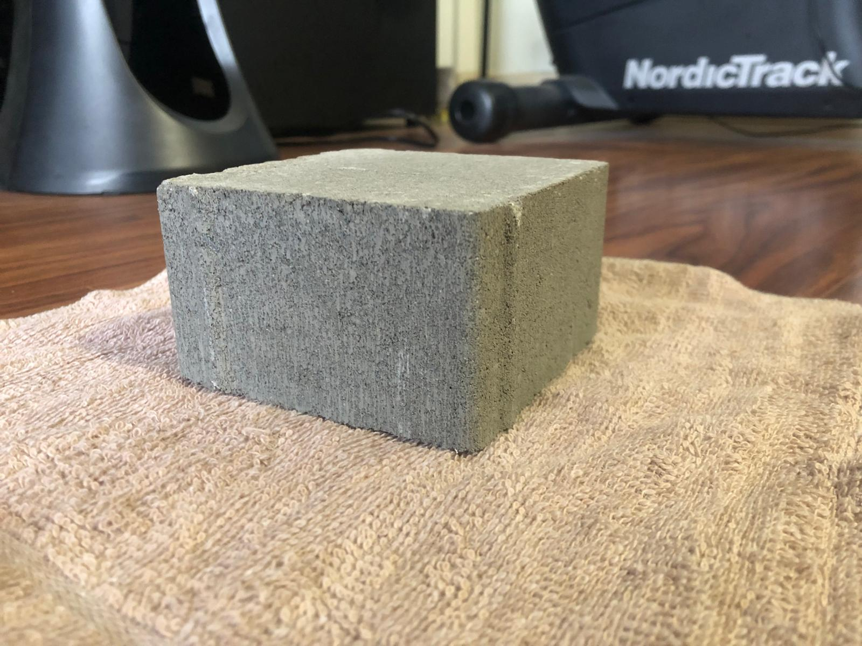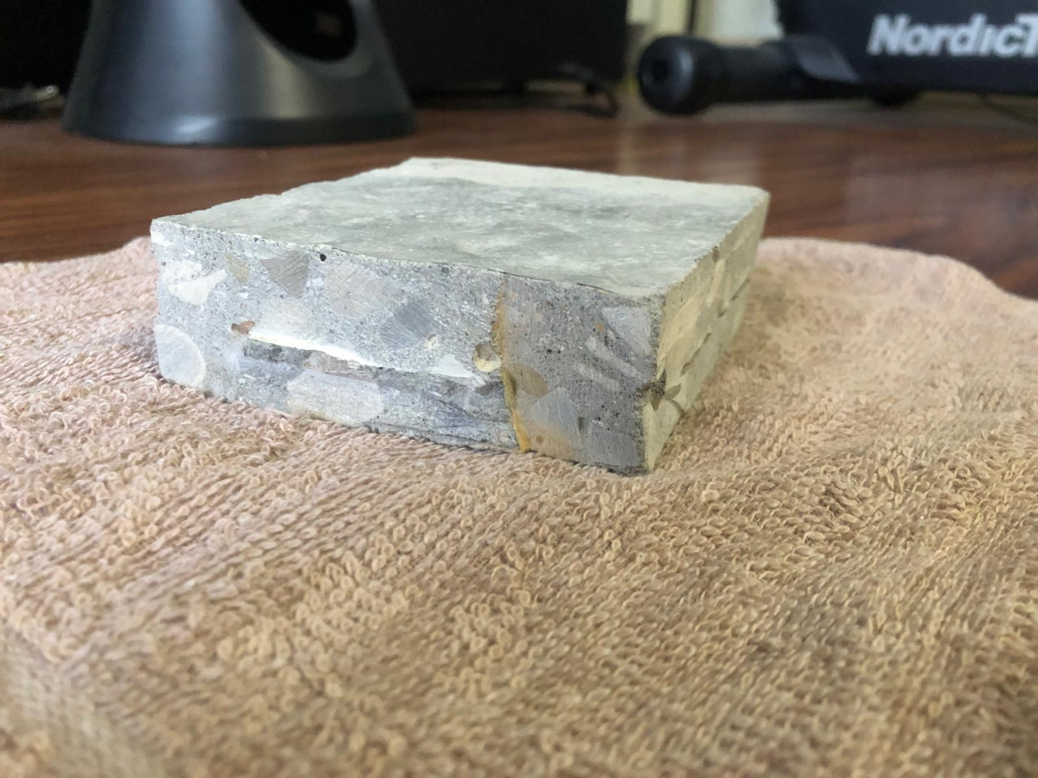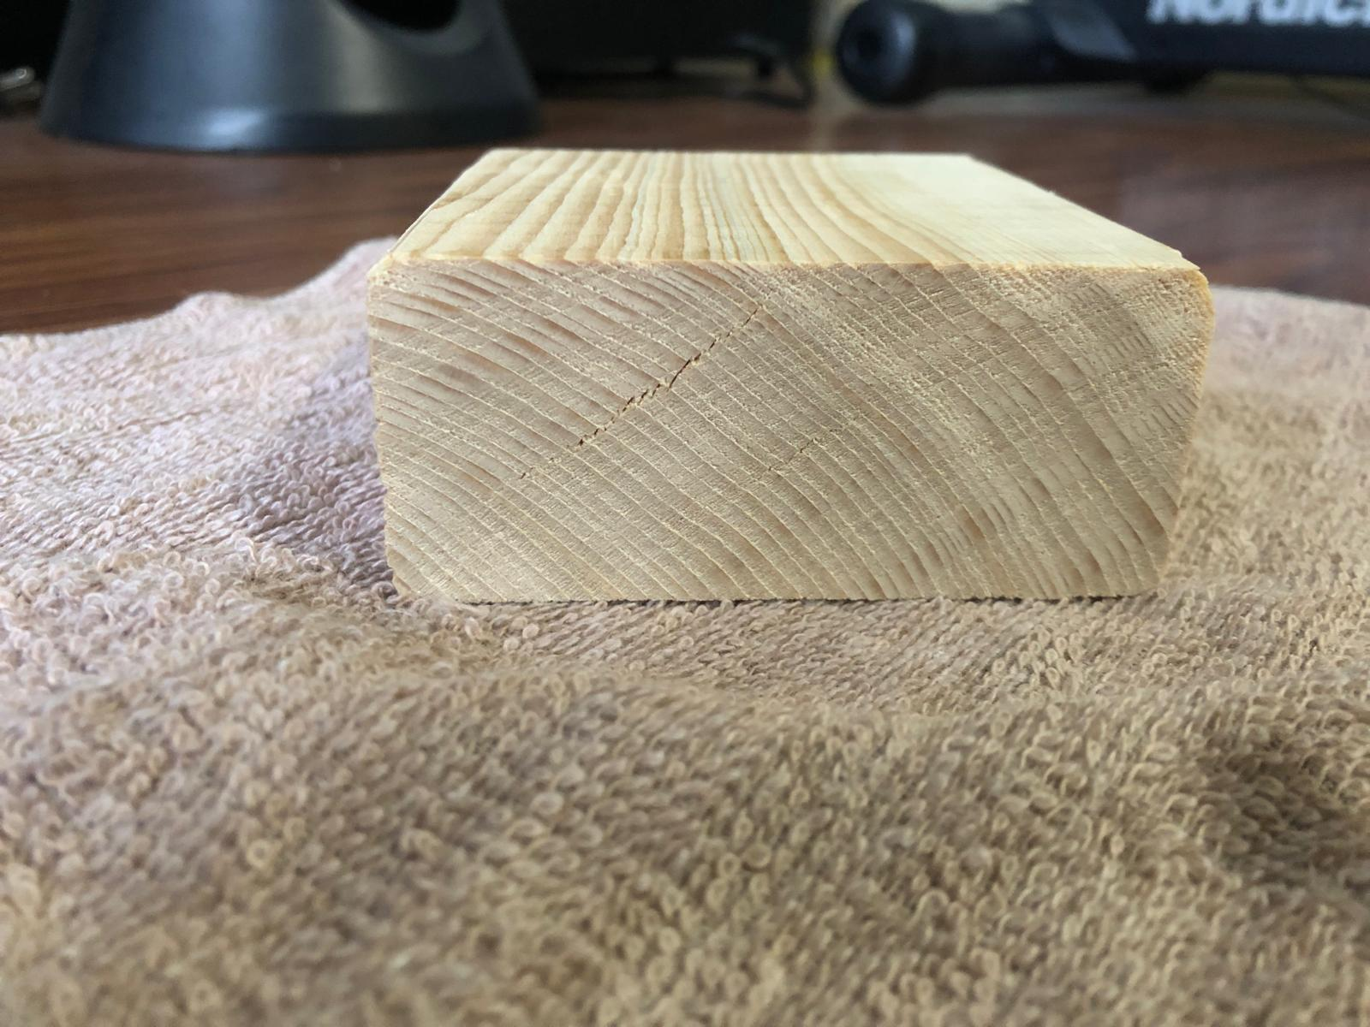

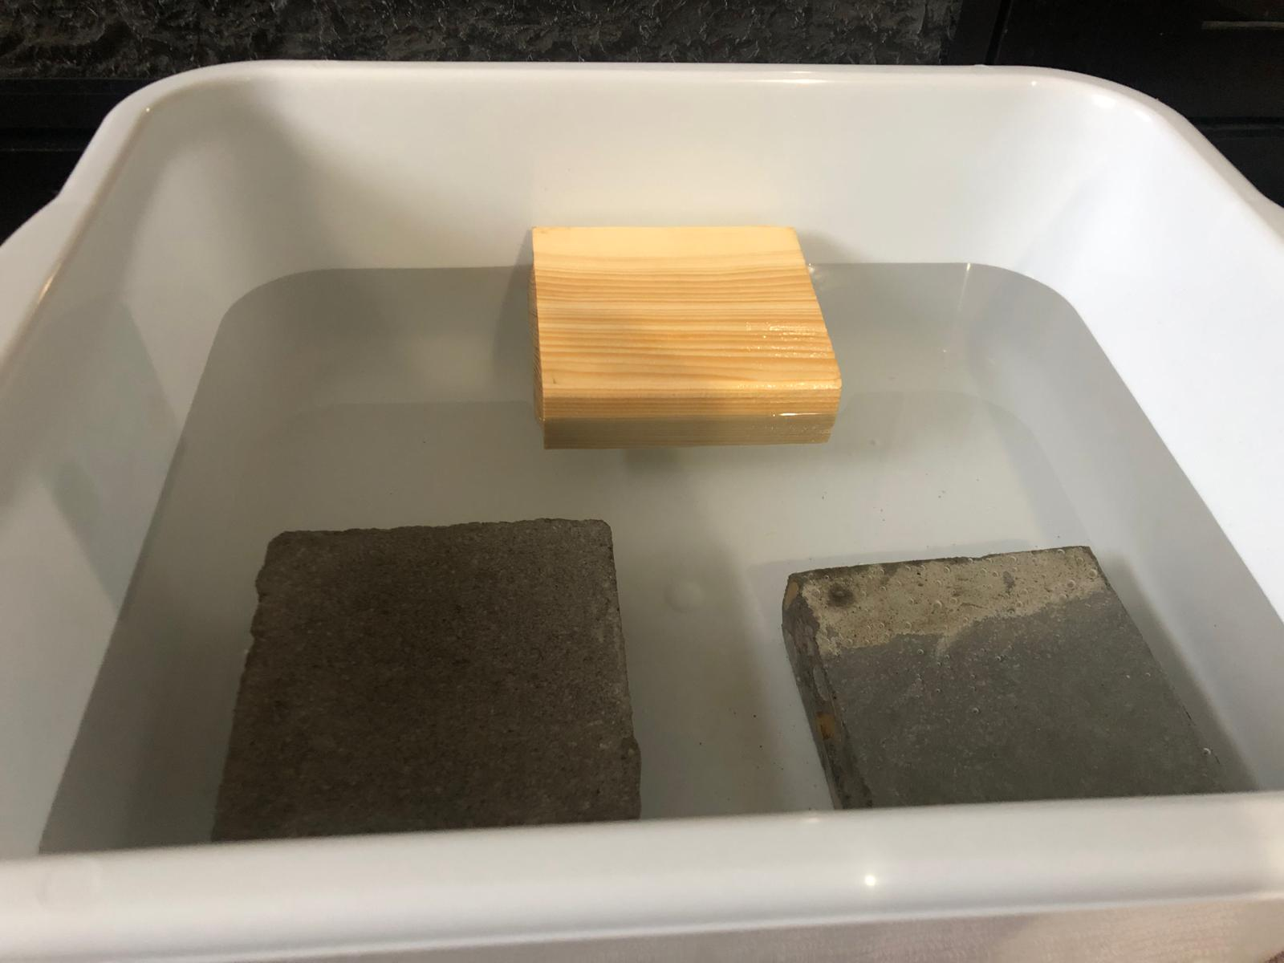

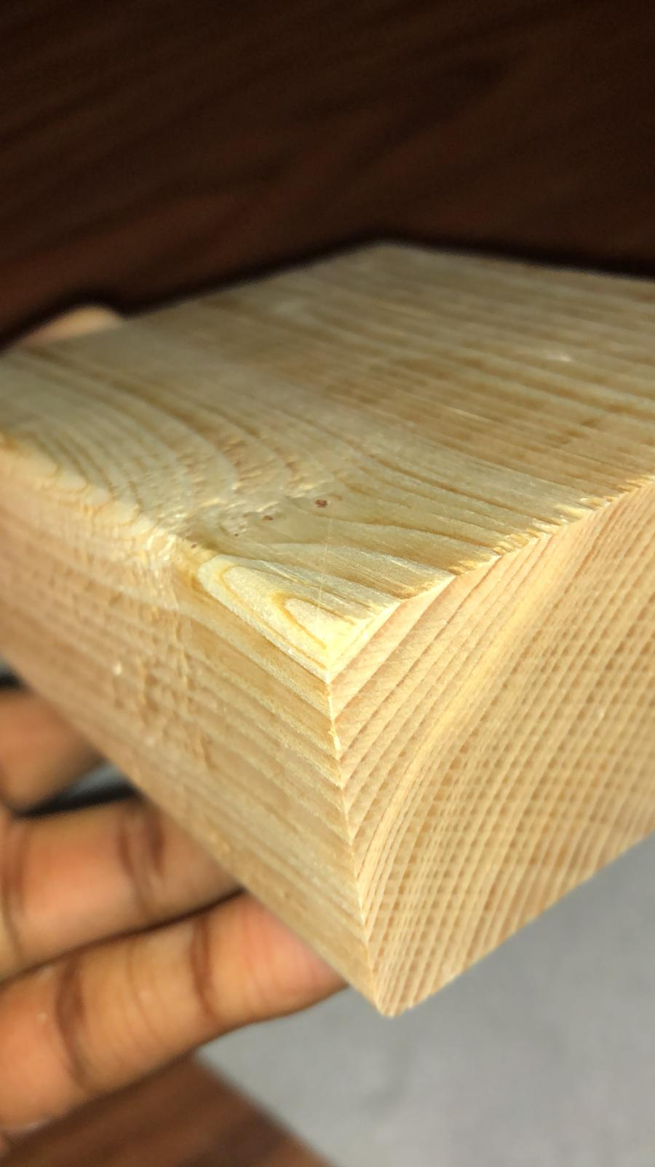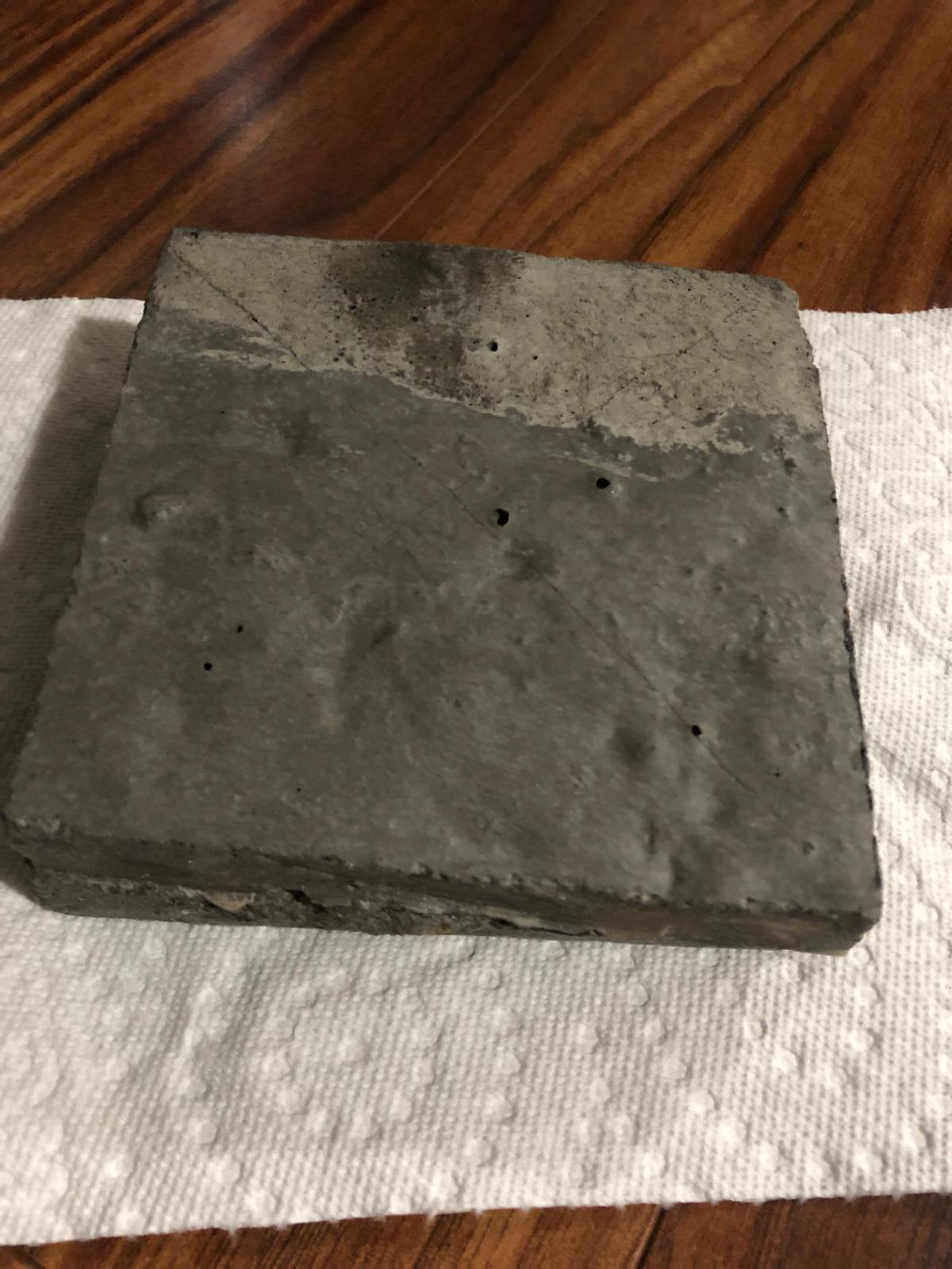

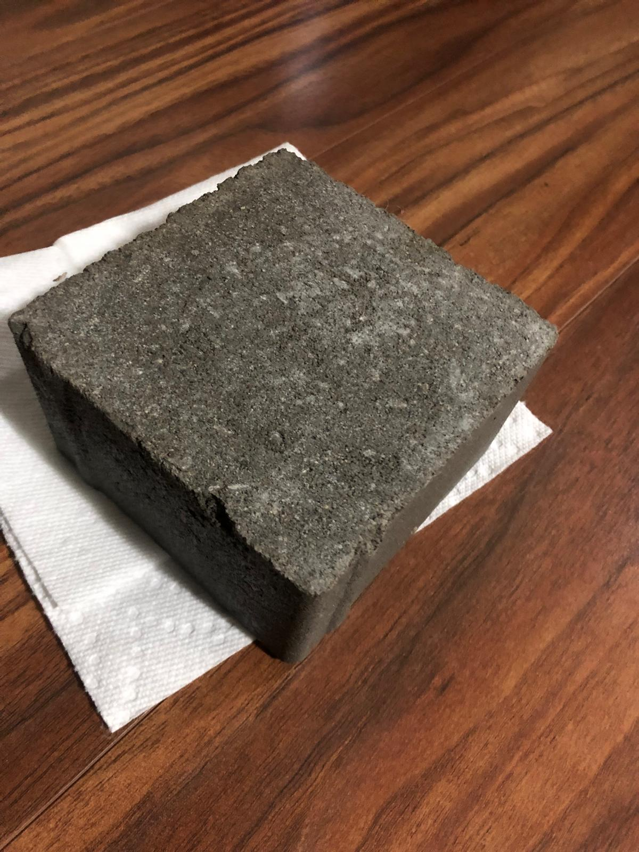

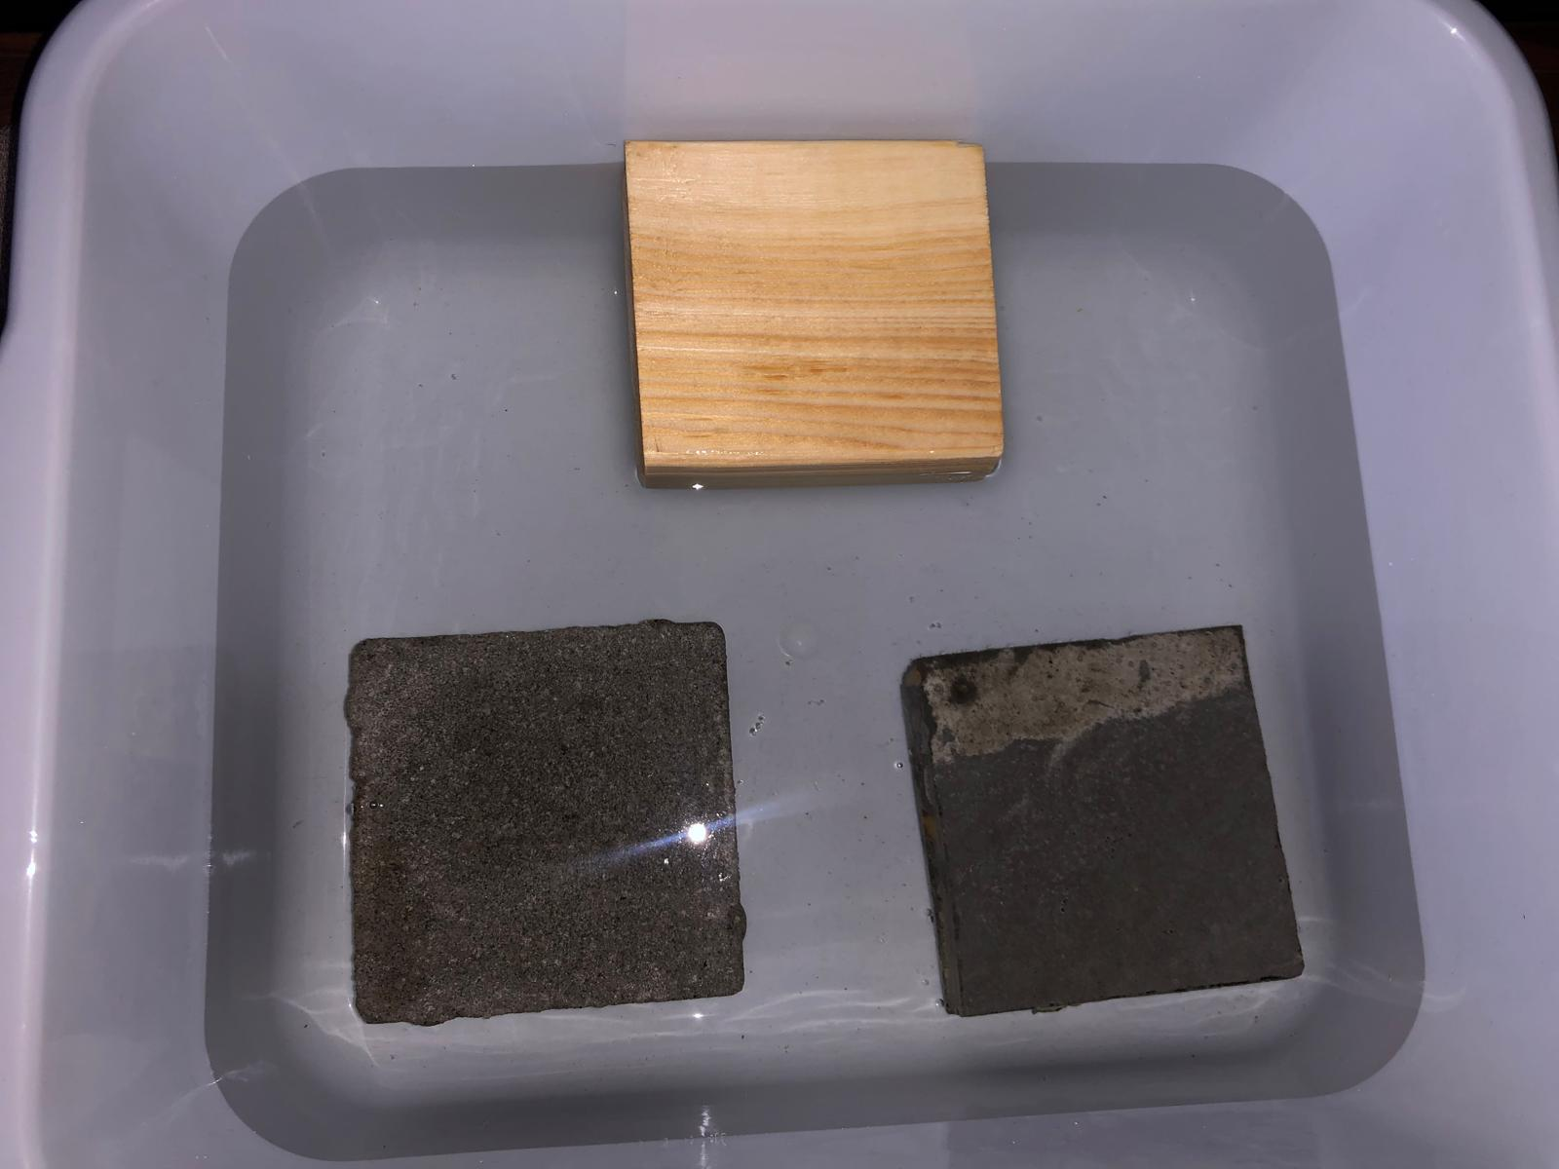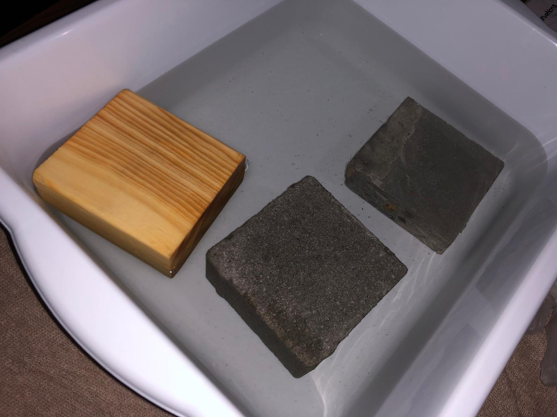

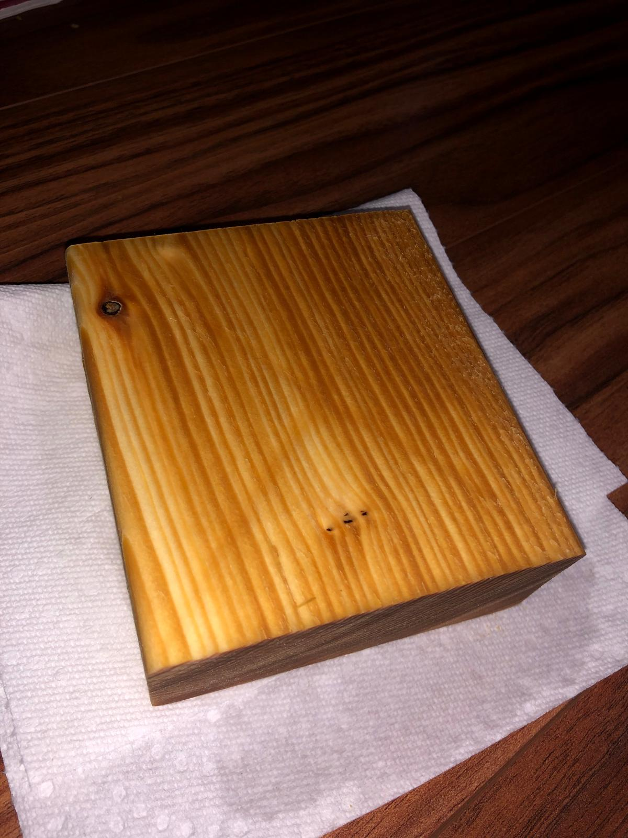

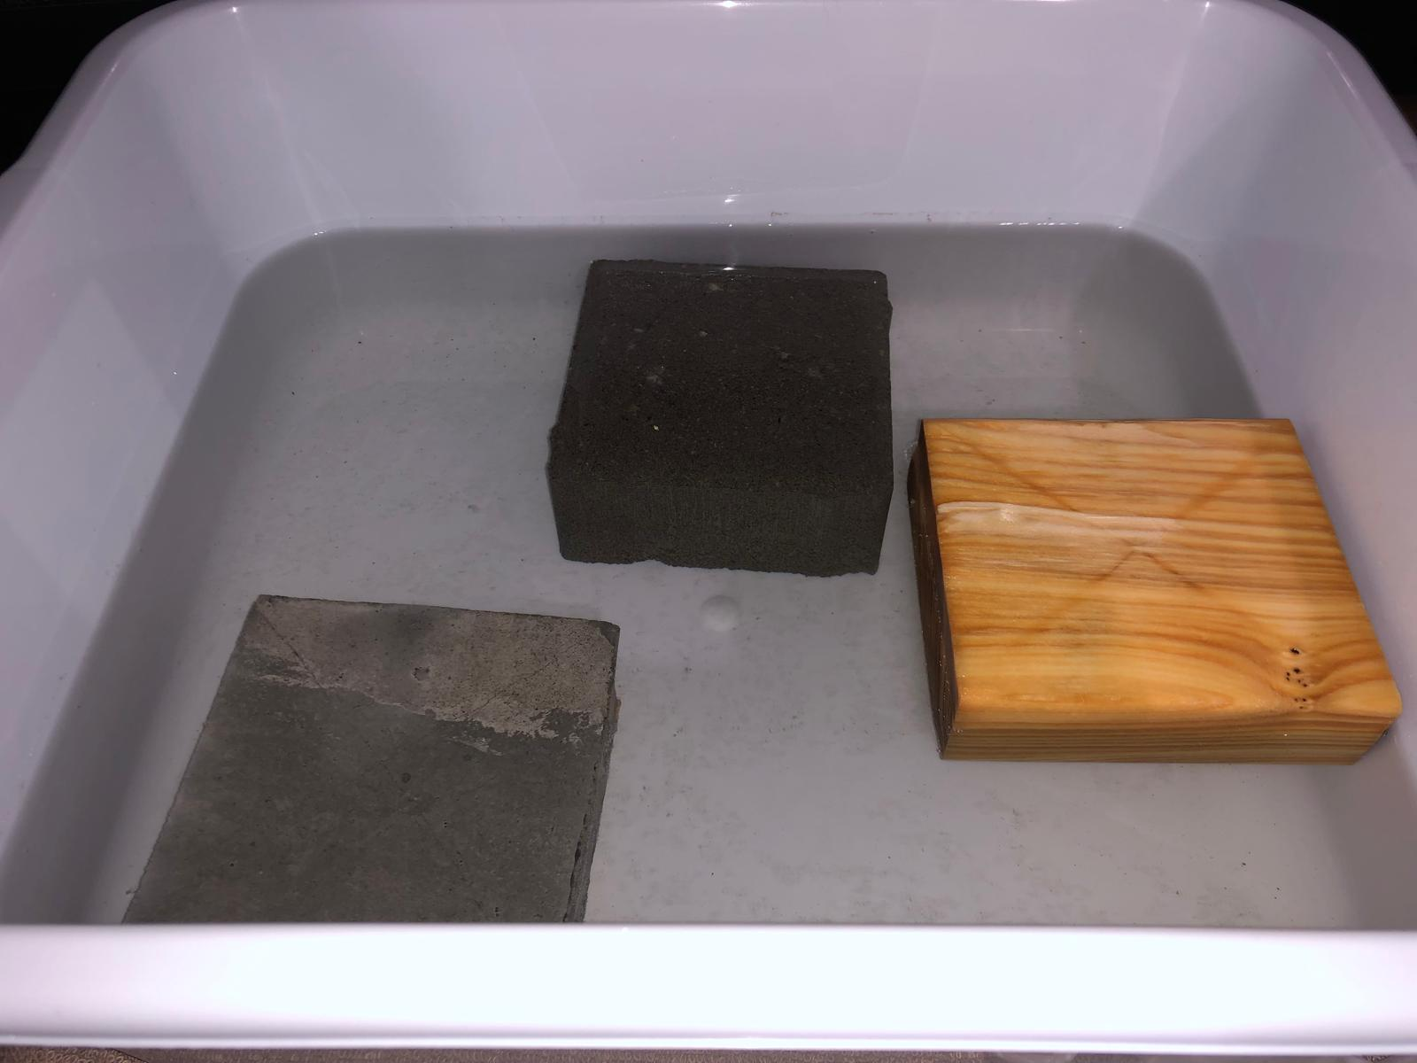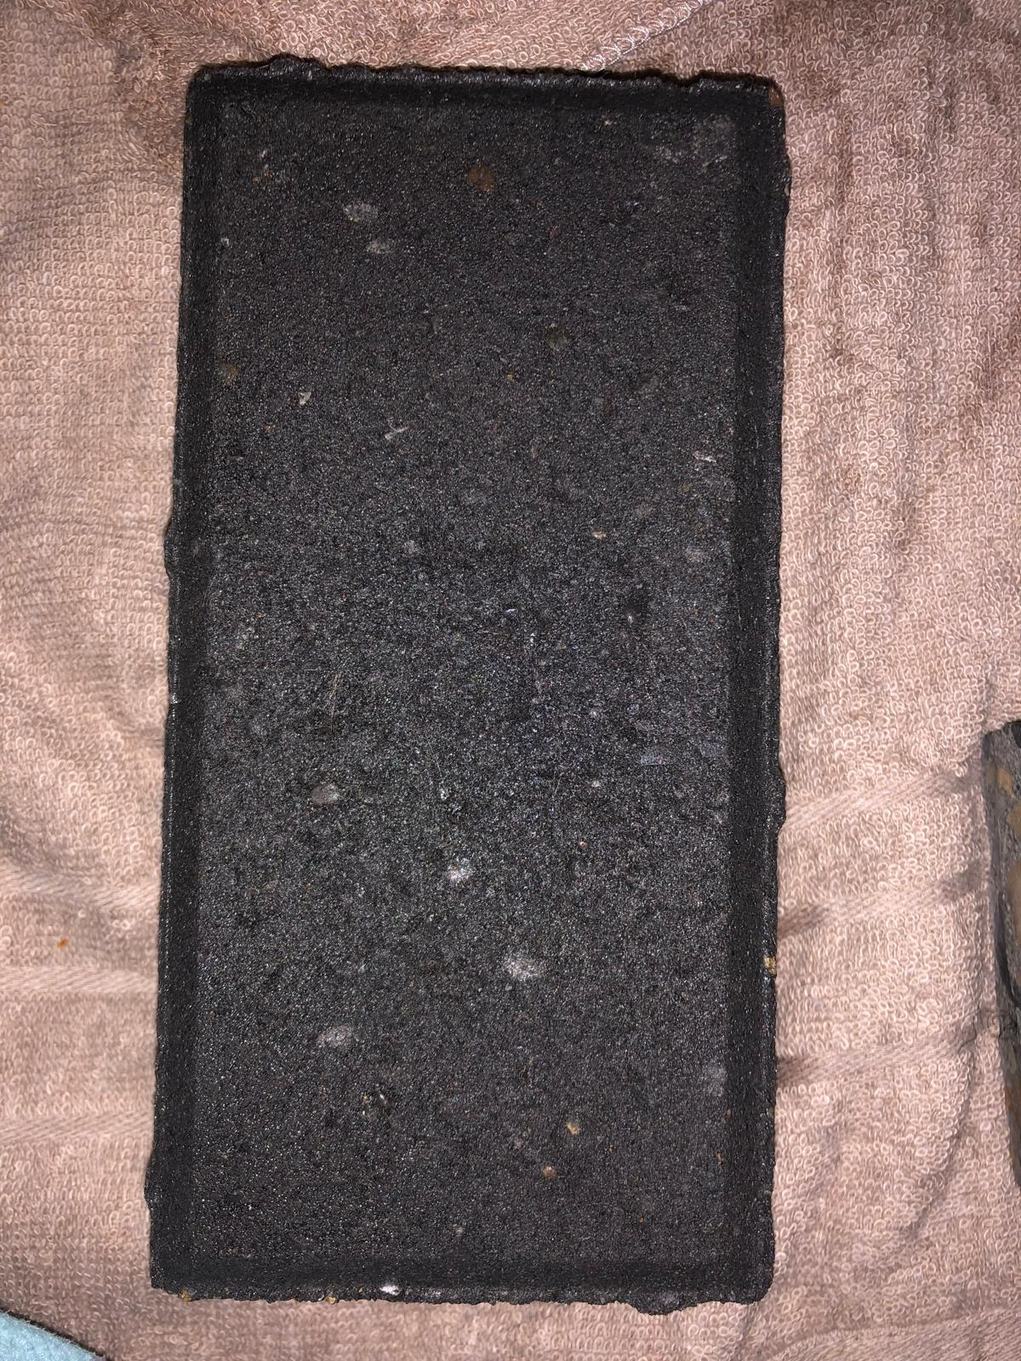

# Citations

Ambegaonkar, R. (2024, December 10). Key Factors for Selecting the Right Building Materials. *Nearby Engineers*. <https://www.ny-engineers.com/blog/factors-to-consider-when-choosing-building-materials>

Bigrou, R. (2024, December 2). *Top Sustainable building materials for Eco-Friendly Construction - Green Building Solutions*. Green Building Solutions. <https://greenbuildingsolutions.org/top-sustainable-building-materials-for-eco-friendly-construction/>

Blackwell, C. (n.d.). *Types of bricks and 15 Interesting uses of brick | Royalmasonry.ca*. <https://royalmasonry.ca/blog/types-of-bricks-and-brick-uses/>

Brey, J. (2009). *New Residential House; Architectural Asphalt Shingle Roof, Vinyl Siding, Gables - stock photo*. [Photograph]. Getty Images. [https://www.gettyimages.ca/detail/photo/new-residential-house-architectural-asphalt-shingle-royalty-free-image/157420126?searchscope](https://www.gettyimages.ca/detail/photo/new-residential-house-architectural-asphalt-shingle-royalty-free-image/157420126?searchscope=image%2Cfilm&adppopup=true)

Calgary Herald. (2024, June 10). *Calgary’s great June flood of 1929*. CalgaryHerald. <https://calgaryherald.com/news/local-news/calgarys-great-june-flood-of-1929>

Caulfield, J. (2022, June 28). How to Cite an Image | Photographs, Figures, Diagrams. Scribbr. Retrieved March 4, 2025, from <https://www.scribbr.com/citing-sources/cite-an-image/>

CBC News. (2013, July 29). Harry Sanders: A quick history of Calgary floods: Worst flood to hit Calgary was in 1879, according to historian Harry Sanders. *CBC*. <https://www.cbc.ca/news/canada/calgary/harry-sanders-a-quick-history-of-calgary-floods-1.1313298>

*Commemorating the 2013 floods*. (n.d.). https://www.calgary.ca. <https://www.calgary.ca/water/flooding/flood-commemoration.html>

CTV News. (2023, June 21). *How Calgary has changed since the 2013 flood* [Video]. YouTube. <https://www.youtube.com/watch?v=MDrnookLl2U>.

Doyle, P. M. (2021). *A pile of wood sitting next to each other*. [Photograph]. Unsplash. <https://unsplash.com/photos/a-pile-of-wood-sitting-next-to-each-other-yVRn-d6JGzo>

*Flood resiliency improvements since 2013*. (n.d.). https://www.calgary.ca. <https://www.calgary.ca/water/flooding/flood-resiliency-improvements.html>

*Flooding in Calgary - Flood of 2013*. (n.d.). https://www.calgary.ca. <https://www.calgary.ca/water/flooding/history-calgary.html>

Green, E. (2024, July 1). *Traditional vs. Sustainable Building Materials: Cost And Performance*. Sigma Earth. <https://sigmaearth.com/traditional-vs-sustainable-building-materials-cost-and-performance/>

Haupt, M. (2020). *Brown and white brick wall.* [Photograph]. Unsplash. <https://unsplash.com/photos/brown-and-white-brick-wall-GN2IqNRlPXs>

Lightbody, L., & Watts, B. (2020, October 1). *Repeatedly flooded properties will continue to cost taxpayers billions of dollars*. The Pew Charitable Trusts. <https://www.pewtrusts.org/en/research-and-analysis/articles/2020/10/01/repeatedly-flooded-properties-will-continue-to-cost-taxpayers-billions-of-dollars>

McCoy, H. (2023, June 15). *On Calgary’s 10-year flood anniversary, businesses are more ready: UCalgary researchers suggest businesses might be more resilient in the post-COVID world if Calgary flooded again*. News. <https://ucalgary.ca/news/calgarys-10-year-flood-anniversary-businesses-are-more-ready>

National Geographic Society. (2024, July 19). *The Many Effects of Flooding*. National Geographic. <https://education.nationalgeographic.org/resource/many-effects-flooding/4th-grade/>

Pinconsult Associates Limited. (2022, July 27). *15 Factors Affecting the Selection of Construction Materials*. LinkedIn. <https://www.linkedin.com/pulse/15-factors-affecting-selection-construction-materials-limited/>

Rider, D. (n.d.). *Choosing the right construction materials can make the difference*. If. . . <https://www.if-insurance.com/large-enterprises/insight/choosing-the-right-construction-materials>

Rm4l. (2024, November 5). *10 Types of building materials: properties, applications, and lifespan*. RM4L. <https://rm4l.com/types-of-building-materials/>

Rodriguez, F. (2025, February 25). *Plastic | Composition, History, Uses, Types, & Facts*. Encyclopedia Britannica. <https://www.britannica.com/science/plastic>

Team, I. (2024, November 4). *Comparing Different Types of Building Materials: Strengths and Weaknesses | illustrarch*. Illustrarch. <https://illustrarch.com/articles/35805-comparing-different-types-of-building-materials.html>

Torres, E. (2014). *Concrete Cubes*. [Photograph]. Flickr. <https://flic.kr/p/k6vV5S>

Trusscore. (2025, February 6). Flood resistant home design. *Trusscore*. <https://trusscore.com/blog/flood-resistant-home-design.html>

*Understanding Types of Bricks & their Properties in Construction | UltraTech*. (n.d.). <https://www.ultratechcement.com/for-homebuilders/home-building-explained-single/descriptive-articles/types-of-bricks-and-its-properties>

Un-Water. (n.d.). *Water and Disasters | UN-Water*. UN-Water. <https://www.unwater.org/water-facts/water-and-disasters>

*What are the best materials to use for a bridge that is both functional and beautiful?* (n.d.). <https://www.linkedin.com/advice/0/what-best-materials-use-bridge-both-functional-obxbe>

*What is Concrete? Types, Composition & Properties | UltraTech*. (n.d.). <https://www.ultratechcement.com/for-homebuilders/home-building-explained-single/descriptive-articles/what-is-concrete-types-composition-properties-and-uses>

Wooduchoose. (n.d.). *What is Wood | Wood Info*. Wooduchoose - the Home of Wood. <https://www.wooduchoose.com/what-is-wood/>

Team, I. (2024, November 5). *Guide to Choosing the Right Building Materials: Sustainability, Cost & Durability Tips | illustrarch*. Illustrarch. <https://illustrarch.com/articles/architectural-sustainability/35803-guide-to-choosing-the-right-building-materials-for-project.html>

Zurowski, M. (2024, June 14). *Nine unforgettable historic flood photos: When rivers rage in southern Alberta*. CalgaryHerald. <https://calgaryherald.com/news/local-news/southern-albertas-flooding-history>

# 

# Acknowledgement

I would like to express my sincere gratitude to Mr. Nayak for his guidance and support throughout the completion of this project. I also thank my parents for assisting with the purchase of materials and sharing their valuable knowledge. A special thanks to my mom for helping with the materials and my dad for the large trifold and transportation. Lastly, I am grateful to Sean Savage and Lance Beairsto at BURNCO for creating the concrete samples specifically for my experiment. Your contributions have been invaluable.