Title

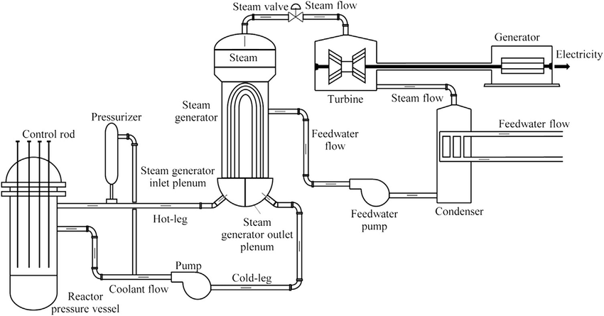

Leveraging GRcop for Integration in Pressurized Water Reactors (PWR)
Applied Science Project
─
Richard Gao

Ben Hewitt

Professor Ahmed Tiamiyu

Calendar

Calendar

NOVEMBER

SUN | MON | TUE | WED | THU | FRI | SAT
 |  |  |  |  |  | 1
2 | 3 | 4 | 5 | 6 | 7 | 8
9 | 10 | 11 | 12 | 13 | 14 | 15
16 | 17 | 18 | 19 | 20 | 21 | 22
23 | 24 | 25 | 26 | 27 | 28 | 29
30

September

SEPTEMBER

MON | TUE | WED | THU | FRI | SAT | SUN
1 | 2 | 3  Scheduled meeting with Ben | 4 | 5  Scheduled meeting with Ben | 6 | 7
8 | 9  Meeting with Dr. Garcia, start “Challenges to deployment… of nuclear reactor systems" | 10 | 11  Paperpile introduction day | 12 | 13 | 14
15  Scheduled meeting with Ben, finish what I need for “Challenges to deployment…” afterwards, then do what work he assigns me | 16 | 17  Watch SRIM video, then work on draft for research proposal | 18 | 19  University day: process data at home before Tuesday | 20 | 21
22  FINISH PROCESSING DATA | 23  Scheduled meeting with Ben on phase diagrams, read “material challenges to nuclear energy” afterwards. See how far I get | 24 | 25  Start writing the economical challenges to nuclear fusion for my research proposal. Finish at least up to advances in fission. Leave the rest for homework. | 26 | 27 | 28
29  Finish writing the economical challenges section, start material challenges, focus on dpa first | 30 | - The introduction of RP will be very long, so I should be spending most of my time in class to work on that.  - Make long term objectives more understandable  - Last thing in introduction should lead to research questions  - Link methodology to research questions  - Significance should be summary of importance in introduction

October

OCTOBER

SUN | MON | TUE | WED | THU | FRI | SAT
 |  |  | 1  Continue writing the material challenges to fission, should be around done. Leave the rest for homework | 2 | 3  Start the transition to my topic in introduction. Highlight potential drawbacks, theoretical calculations. Leave the rest as homework | 4
5 | 6 | 7  Write the research questions and objectives. Should be relatively short. Draft the methodology afterwards and read another (undecided) paper after. | 8 | 9  Write methodology sections: creation of alloy, testing for corrosive resistance, displacement energies, experimental cross sectional value, etc. Write significance at home.  RESEARCH PROPOSAL DRAFT SHOULD BE COMPLETED AT THE END OF THE DAY | 10  Send paper to Dr. Garcia for review | 11
12  Edit with Dr. Garcia’s feedback, send to mentor | 13 | 14  GOING TO UNI FOR TIA CHECKUP | 15 | 16  Edit RP from Dr. Garcia’s edits, write methodology | 17  SEND RP TO BEN | 18
19 | 20  Finalize RP, make final edits with Ben’s comments | 21 | 22  Read papers of material selection to fusion after finishing RP  RP DUE | 23 | 24  AWAY FROM ASP | 25
26 | 27 | 28  Presentations - present then listen to the other ones | 29 | 30  Continue processing and uploading SRIM simulations | 31  Finish all SRIM data for binary Cu-Mo, start processing chromium

November
NOVEMBER

SUN | MON | TUE | WED | THU | FRI | SAT
 |  |  |  |  |  | 1
2 | 3  Read Design and Development of Stable Nanocrystalline  High-Entropy Alloy: Coupling Self-Stabilization and Solute Grain Boundary Segregation Effects, finish methodology, start reading results | 4  Finish reading 3.1 structural analysis at home  Finish chromium SRIM simulations at home | 5  Start reading 3.2: In-situ Annealing of in class  Finish the rest of 3.2 at home  Start reading 3.3: 3.3. Ex-situ annealing | 6  Start discussion at home of XRD results | 7  Finish discussion section of same paper in class | 8  Start reading the abstract and introduction of Design of self-stable nanocrystalline high-entropy alloy
9  Finish abstract and introduction of Design of self-stable nanocrystalline high-entropy alloy | 10  Read and finish the methodology of same paper  Note how grain boundary decoration is used in methodology | 11  Start reading results: 3.1. Microstructural evaluation | 12  Read 3.3 Ex-situ evaluation | 13  Read discussion and conclusion of paper in class, leave the rest for home | 14  Start reading Ball milling process variables optimization for high-entropy alloy development using design of experiment and genetic algorithm  Finish introduction and abstract by today  Start methods | 15
16  Finish methodology, start reading results  Finish 3.1.1 Effect of PCA | 17  Finish 3.2 Experimentally-generated responses  Meeting with Dr. Garcia | 18  Finish the rest of the results, conclusion and summary | 19  Research all types of data XRD can produce  Create vacancy graphs from SRIM simulations | 20 | 21  Start researching on how each property XRD gives responds to thermal neutron irradiation  Finish graph processing for SRIM vacancy simulations | 22
23  DECIDE ON COMPOSITIONAL COMPONENT OF ALLOY TO USE | 24 | 25  Potential milling day  Run detailed calc of chosen alloy composition | 26 | 27  Potential milling day  Review the steps to mill the alloy  Meeting with Dr. Garcia | 28 | 29
30
- Note: I will only start reading another paper if the last one is finished

December
DECEMBER

SUN | MON | TUE | WED | THU | FRI | SAT
 | 1  Learn the William Hall equation | 2 | 3  Read introduction of Stress Corrosion Cracking and Copper Alloy Products  Finish draft of introduction | 4  Read 2.1 cold deformation and 2.2 heat deformation of Stress Corrosion Cracking and Copper Alloy Products | 5  Meeting with Dr. Garcia  Finish the rest of paper: assembly stress and conclusion | 6
7 | 8  DR. GARCIA DRAFT DUE | 9  Read introduction of Modelling the effects of  void swelling on the fracture of metallic materials by  crystal plasticity | 10  Read 2.1 spatial distribution of voids and 2.2 yield function of single porous crystal | 11  Read 2.3 porous crystal plasticity model | 12  Read 3: numerical implementation | 13  Implement Dr. Garcia’s comments to introduction
14 | 15  Meeting with Dr. Garcia  Analyze the ANSYS-GRANTA data sent from Ben  INTRODUCTION DUE  POTENTIAL MILLING DAY | 16  Read 4.1 Parameter calibration, 4.2 effects on overall mechanical property, 4.3 quasi brittle fracture  POTENTIAL MILLING DAY | 17  Read 4.4 effects of inner pressure and conclusion  POTENTIAL MILLING DAY | 18  POTENTIAL MILLING DAY | 19  Look more into XRD data from peer papers  POTENTIAL MILLING DAY | 20
21 | 22  Winter break  POTENTIAL MILLING DAY | 23  Winter break  POTENTIAL MILLING DAY | 24  Winter break  POTENTIAL MILLING DAY | 25  Winter break  POTENTIAL MILLING DAY | 26  Winter break | 27
28  Winter break | 29  Winter break | 30  Winter break | 31  Winter break
- If I can mill the alloy before Ben goes on break (Dec. 24th), then I will need to wait a couple of weeks for the milling to finish.

January
JANUARY

SUN | MON | TUE | WED | THU | FRI | SAT
 |  |  |  | 1  Winter break | 2  Read low temperature embrittlement of “Effect of neutron dose and spectra, He:dpa ratio and Ni and Zn accumulation on irradiation damage of pure copper and PH and DS copper alloys” | 3
4 | 5  Read pure copper responses to high temperature embrittlement | 6  Read DS copper responses to high temperature embrittlement | 7 | 8  Read changes in mechanical properties and conclusion | 9  MIDTERMS | 10
11 | 12  MIDTERMS | 13  MIDTERMS | 14  MIDTERMS | 15  Review the steps of ball milling, learn the specifics of how it works  MIDTERMS | 16  MILLING DAY | 17  Run quick calculation simulations of GRCOP in SRIM
18 | 19  Run detailed calculation simulations of GRCOP in SRIM | 20  Research the properties of GRCOP under normal conditions  Meeting with Dr. Garcia | 21 | 22  Research the properties of GRCOP under irradiated conditions | 23  Research the properties of GRCOP under high temperature conditions | 24
25 | 26  Read introduction of thermophysical properties of AM GRCOP 84 and 42 | 27  Read methodology of properties of GRCOP | 28  Read 3.1 chemistry, 3.2 thermal conductivity, and 3.3 Problem Encountered During Thermal Conductivity Testing  Meeting with Dr. Garcia | 29  Read 3.4, 3.5, and 3.6 (rest of results) in properties of GRCOP | 30  Review XRD equations and extrapolations | 31

February

FEBRUARY

SUN | MON | TUE | WED | THU | FRI | SAT
1 | 2  Read discussion of the thermophysical properties of GRCOP | 3  Read conclusion of thermophysical properties of GRCOP | 4  Review XRD equations, procedure, hall-petch, and plasticity model | 5  XRD DAY  Write XRD section in methodology | 6  Finish methodology, send draft to Dr. Garcia | 7
8 | 9  Read abstract and introduction of “Microstructural size effects in high-strength high-conductivity Cu-Cr-Nb alloys” | 10  Read methodology of “Microstructural size effects in high-strength high-conductivity Cu-Cr-Nb alloys” | 11  Review Dr. Garcia’ comments, send draft to Ben | 12  First draft of poster: finish introduction and methodology flow chart | 13  Add results and discussion into poster | 14  Add conclusion, limitations, future directions, etc. into poster  Send poster to Dr. Garcia
15 | 16  Read all of results of “Microstructural size effects in high-strength high-conductivity Cu-Cr-Nb alloys” | 17 | 18  Final revision of methodology  Edit poster for Dr. Garcia’s advice, set up meeting with mentor for practice, set up meeting with Dr. Garcia for practice | 19  METHODOLOGY DUE  Read discussion, of “Microstructural size effects in high-strength high-conductivity Cu-Cr-Nb alloys” | 20  Meeting with Ben?  Meeting with Dr. Garcia?  Read conclusion of “Microstructural size effects in high-strength high-conductivity Cu-Cr-Nb alloys” | 21
22 | 23  Meeting with Ben?  Meeting with Dr. Garcia?  Review and edit poster according to Ben’s and Dr. Garcia’s feedback | 24  Meeting with Ben?  Meeting with Dr. Garcia?  Rehearse oral presentation | 25  PRINT POSTER  Participate in oral presentations  Go over oral presentation, rehearse final times | 26  Rehearse oral presentation | 27  ORAL PRESENTATION | 28

March

MARCH

SUN | MON | TUE | WED | THU | FRI | SAT
1  Robotics provincials  Final rehearsals for the school CYSF | 2  SCHOOL SCIENCE FAIR  Fill out results, discussion, and remaining categories in CYSF platform | 3  RESULTS COME OUT  Double check all categories have been filled | 4  Inform Ben of results, schedule SEM microscopy if I made cities | 5  Write results: finish draft of the XRD related sections | 6 | 7  Email Ben to give me restricted articles
8 | 9  Read abstract and introduction of “Microstructural size effects in high-strength high-conductivity Cu-Cr-Nb alloys” | 10  Read methodology of “Microstructural size effects in high-strength high-conductivity Cu-Cr-Nb alloys” | 11  Write the SRIM related parts of the results | 12  Write SEM of results | 13 | 14
15 | 16  Read all of results of “Microstructural size effects in high-strength high-conductivity Cu-Cr-Nb alloys”  If I can’t finish, then read on Tuesday | 17  Finish the results section of “Microstructural size effects in high-strength high-conductivity Cu-Cr-Nb alloys” | 18  Revise the results section, send to Dr. Garcia for review | 19  Start rehearsing for the city science fair if I make it | 20  Read discussion of microstructure effects of GRCop | 21  Read conclusion of microstructure effects of GRCop
22 | 23  Review Dr. Garcia’s comments, send to Ben for review | 24  Practice for CYSF city fair, schedule a meeting with Dr. Garcia to go over presentation | 25  Dr. Garcia practice?  Rehearse presentation  Write grain size calculations section of the discussion | 26  Dr. Garcia practice?  Rehearse presentation | 27  Dr. Garcia practice?  Rehearse presentation  Write the significance of microstrain and miller indices of discussion | 28
29  Dr. Garcia practice? | 30  Dr. Garcia practice?  Write about limitations and future directions of the discussion | 31  Dr. Garcia practice?  Review discussion, send to Dr. Garcia for review

Daily Notes

Daily Notes

Date
Tasks To-do |  | Review |  | Notes

Summer

Daily Notes

Summer, 2025
Tasks To-do |  | Review |  | Notes
- Finish MIT Nuclear Engineering introduction course  - Come up with potential ideas  - Find gaps in research or potential problems that need solving in reactors |  | - Introductory meeting with Ben Hewitt, my mentor  - Recommended me to watch MIT 22.01 course  - Finished by mid August  - Met with Mentor after I watched the course  - Told me to come up with a few ideas and meet in 2 weeks  - Met on August 27 to discuss my ideas  - Eventually settled on using copper alloys in nuclear reactors  - Told me to research different properties of copper alloys by August 29th  - Copper zirconium alloy applications  - SRIM is good tool  - Research applications??  - Copper hafnium-zironium?  - Find gaps in research  - NOTES OF ELEMENTAL PROPERTIES: August 28  - Sharp drop in hardness at around 200-400 celsius for Copper-Silver based alloys  - 550 degrees for Copper zirconium  - Hardest was CuCrZr(170 HV)  - https://www.luvata.com/docs/default-source/products/alloy-data-sheets/zirconium-copper_eng.pdf?Status=Master%26sfvrsn=37d261c4_47  - 950-1200 melting point of copper zirconium alloys  - SiC - CuZr alloy is good for nuclear fuel cladding material file:///C:/Users/gaoru/Downloads/Zr-Cu_alloy_filler_metal_for_brazing_SiC_ceramic.pdf  - Cross section of 1 barn for absorption  - Resistant to corrosion  - Using copper hafnium alloys in molten salt reactors to protect from corrosion in pipes and heat exchanger(anything that’s affected by corrosion currently)  - Reactor chamber barrier  - Wires suffer from corrosion  - CuCrZr is more long lasting and less likely to corrosion stress crack, Cu-Hf has a greater cross section for absorption but could crack due to corrosion stress  - Fusing copper zirconium and copper hafnium if possible for reduced costs |  | Decided on general gist of project

September Notes

Daily Notes

August 29, 2025 - Meeting with Ben
Tasks To-do |  | Tasks Completed |  | Notes
- Download SRIM  - Explore table of nuclides, identify potential elements of high or low neutron absorption cross sections |  | - Preliminary research on copper-zirconium and copper-hafnium |  | UoC does not have hafnium powder
 |  |  |  | e
Review
- Here is what we covered in our meeting today:
  - 1. Explored different materials and their cross-sections and stopping ranges
  - 2. Introduced SIRM (you will make a video about it sometime soon)
  - 3. Discussed the conductive properties of copper and its potential application as a coating
- Here is what I will do before our next meeting:
  - 1. Download SIRM and bypass my computer antivirus
  - 2. Explore the table of nuclide contents and look for potential elements of use with high or low neutron absorption cross sections.

August 29, 2025 - ASP
Tasks To-do |  | Tasks Completed |  | Notes
- Status check to Dr. Garcia  - Met mentor?  - Discussed project topics?  - Started reading?  - Established meeting times? |  | NA |  | Log everything you do  First ASP class
 |  |  |  | e
Review
- Time deadlines are very important, self paced course
- Communication is key to success
  - Email attend@webber when out of school, CC teachers
- Respond to emails very quickly(2-3 times a day)
  - Set spare time during the day to check emails
  - Personal emails(already done)
- Adjust to them, not us because they are busier
- IMPORTANT: Send an email to the mentors after a meeting.
  - Send a summary of the meeting, of tasks, deadlines, etc.
- Keep this logbook to keep track of all events in class, with mentors, etc.
  - Organize the notes you take
  - Keep track of lab data
  - Due dates and guidelines for assignments
  - Basically a robotics notebook
- Use a calendar to keep track of tasks
  - Plan for each class of work
  - Give yourself deadlines for tasks in the calendar
- Preparedness
  - Monthly mentor evaluations
    - Punctual?
    - Communication?
    - Progress?
    - Preparedness?
- Get help/ask questions when needing help
- Typical class
  - Come to class and work
  - Meet
    - Status update
  - Or come to Uni
    - Can miss another class to go to uni, arranged with Garcia and Kale, and other teacher
  - Can do other work if necessary
- MARKING
  - Biweekly assessments for communication, schedule, etc.
  - Logbooks monthly contains every bit of information that I’ve done
    - Submit to GC
  - Oral presentations
    - Research proposal
    - Prepare for Science Fair
    - Science Fair presentation
    - Final
  - Written work
    - Research proposal
    - Introduction
    - Procedure
    - Results
    - Analysis
    - Final edited paper

September 3, 2025 - ASP information
Tasks To-do |  | Tasks Completed |  | Notes
- Research proposal due Oct. 16  - Decide on topic |  | NA |  | Research proposal is used to highlight the overview of your project, and establish sigificance
Review
- ASP CLASS INFORMATION:
  - Science fair judging: gold = 100, silver = 95, bronze = 90, HM = 80
  - February presentation marked by Dr. Garcia and Ms. Kale
  - Term 1 marks will be very volatile
  - 3 types of projects: study, experiment, innovation
  - Goal of this month: get a project
  - Narrow your scope of your topic
  - Don’t explore well-researched topics
  - Research proposals can get funding
  - Titles
    - Must be understood by most people and highlights contents of topic
    - Not too many abbreviations
  - Introduction most important part of proposal
  - Objectives
    - Short term goals: achievable in this course
    - Long term goals: could be unachievable, ambitious
  - Methodology should be general and not very detailed
  - Significance: why does the project matter? Use as summary paragraphs to establish why?
  - DUE OCTOBER 16

September 3, 2025 - Work and meeting
Tasks To-do |  | Tasks Completed |  | Notes
- Meet with Ben to discuss  - Complete the spreadsheet |  | - Finish compiling data of neutron absorption cross section |  | Below is data of neutron absorption cross sections of certain isotopes
Review
- Collected isotope cross section values for thermal neutron absorption (see data collection tab)

Here is what we covered today:

1. Went over notable elements with high or low cross sections and talked about a few specific ones
2. Created a spreadsheet to keep track of isotopic behaviours for cross sections, thermal conductivity, yield strength, melting temperature, phase, etc.
3. Talked about the Hume-Rothery rules

Here is what I will do before Friday:

1. Complete the spreadsheet and note the notable elements of the notable elements

Series of power elements at UoC:
1. Zirconia (Zr)
2. Cobalt (Co)
3. Chromium (Cr)
4. Iron (Fe)
5. Tungsten (W)
6. Aluminum (Al)
7. Vandanium (V)
8. Manganese (Mn)
9. Molybdenum (Mo)
10. Tin (Sn)
11. Titanium (Ti)

September 4, 2025
Tasks To-Do |  | Tasks Completed |  | Notes
- Wait to meet with Ben |  | - Finished spreadsheet |  | Ben made another copy of his own in another tab
Review
- Worked on cross sectional averages and filled in all values.
HIGHLIGHTED VALUES ARE OF INTEREST:
- Green is good, red is bad, yellow can be both good and bad:
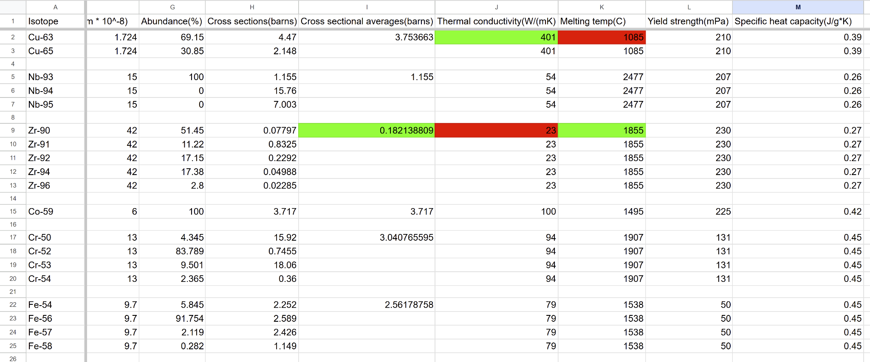
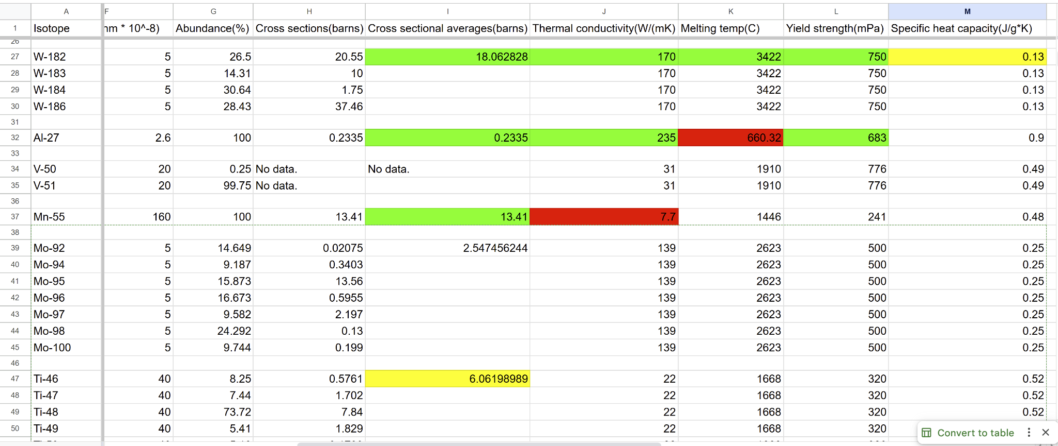
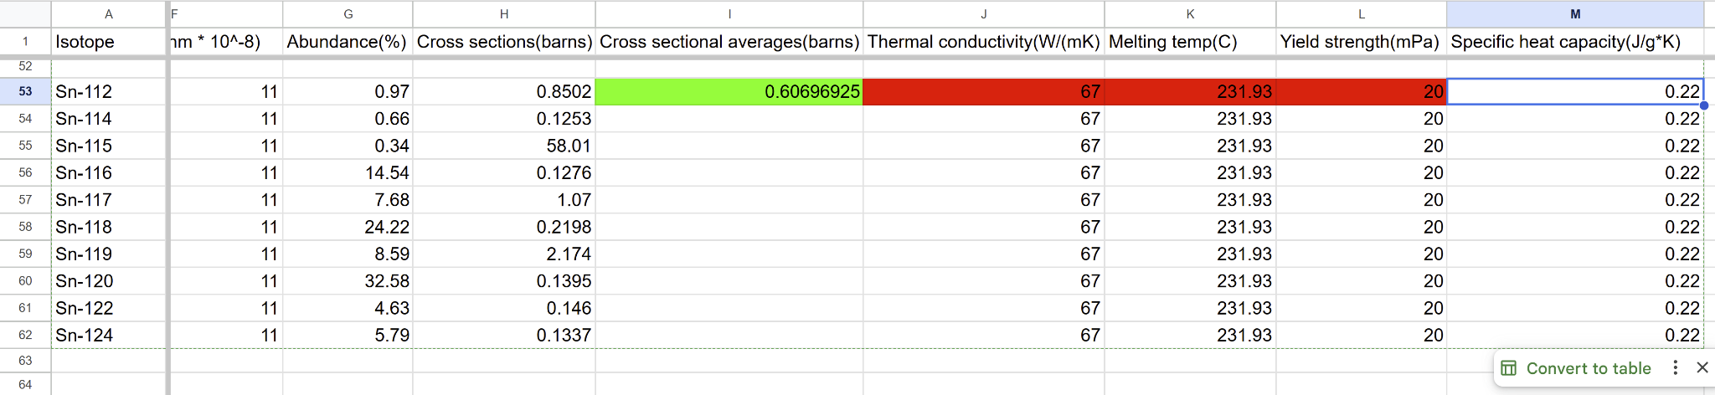

September 5, 2025
Tasks To-Do |  | Tasks Completed |  | Notes
- Start reading papers  - Download SRIM (somehow still haven’t managed to bypass my computer firewall yet) |  | - Spreadsheet of properties |  | ASP class and meeting summary
Review
- Meeting:
- Decided on Tungsten for alloying with copper
- To do next: Download SRIM, read papers (start with “challenges to deployment”)
- The best day to go to UoC before their license expires is on Sept. 19

- Downloaded openEuphoria and SRIM
- Add tasks in calendar
- If not meeting with teachers, should do work
- Research proposal should be due a week before for mentors to edit
- Paper sites for eng: IEEE
- Started reading “challenges to deployment of 21st century nuclear reactor systems”

September 9, 2025
Tasks To-Do |  | Tasks Completed |  | Notes
- Read |  |  |  | Read papers in class
Review
- Continued “challenges to deployment…”
- Installed SRIM

September 11, 2025
1
Tasks To-Do |  | Tasks Completed |  | Notes
- Add 5 sources to paperpile  - Cite in IEEE style |  |  |  | Paperpile installation
Review
- Installed paperpile
  - OWL PURDUE: CITATION STYLE DOCUMENTATION
- Add papers to paperpile library
- Can annotate papers in paperpile, then export to google docs as a pdf
- Citations: APA, AMA IEEE, Chicago, DONT USE MLA
  - IEEE for me
- Add citation on top left, change citation styles in there too
  - ALWAYS SELECT LINKS
- Cannot cite non-peer reviewed sources
  - But can use to learn from
- Citation only works in first tab

September 15, 2025
1
Tasks To-Do |  | Tasks Completed |  | Notes
- Notify teachers of leave of absence on Friday for lab, sign lab permission forms |  | - Paperpile introduction exercise |  | Visiting lab on Friday
Review
- Peer reviewed papers:
  - PUBMED
  - Google scholar
  - Research gates
  - IEEE
  - Ar Xiv
- Met with Dr. Garcia, she jot down some notes
- GOAL for the end of September: Outline and draft the research proposal
- Met with Ben afterwards

Meeting:
Here are the specifies of the visit we covered today for the lab visit on Sept. 19:

1. Will arrive at Suncor mechanical engineering building at around 12:20, wait in main lobby
2. Will end at approximately 4-5 pm, subject to change

I will also experiment with SRIM before our meeting, to see if I could find anything notable.

September 17, 2025
1
Tasks To-Do |  | Tasks Completed |  | Notes
- Experiment more with SRIM |  | - Notify teachers, sign permission forms for lab |  | Visiting lab on Friday
Review
Watched SRIM introduction video today
- Look for displacement values online
- Fast neutrons usually penetrate deeper
- Raster measures the width of damage
- Displacement energy: energy required to knock an atom out of its lattice
- Quick calculation of damage: only follows highest energy paths.
- All cascades: consider all cascades. Use quick calculation first. This method is very slow, and usually needs to run overnight.
- If ions penetrate all the way, increase the width
- Run at least 2000 times, 3k-4k simulations is what is usually used in literature
- If the saved file is saved, open the VACANCY one.
- Set delimiter to SPACE when importing tfo excel
- Make another column with total vacancies from recoil and cascade

Worked on RP outline https://docs.google.com/document/d/1NCuRld8iqTxIPPEB_DeTkyyKU8KioWqx7akRub244h0/edit?usp=sharing

INITIAL TRIM RESULTS:
- Hydrogen has greatest penetrating power
- If energy is very low, then there is no cascade
- Copper tungsten fairs very well, as its penetrating depth is not very deep.
- Sometimes the “neutron” doesn’t scatter the material
- Thermal neutrons usually penetrate for at least 50 nanometers
DISPLACEMENT ENERGIES
- Tunsten: 90
- Copper: 30
- Zirconium: 40

September 19, 2025
1
Tasks To-Do |  | Tasks Completed |  | Notes
- Process data before Ben’s next meeting  - Read papers he gave me |  | - Lab visit and trim results |  | Lab visit
Review
- Here is what we did today:
  - 1. Ben toured me around Suncor in the beginning of the visit
  - 2. Met the lab supervisor Moses, he showed me how to use the software
  - 3. We used the software to make a lot (like twenty or so) of phase graphs to see if an alloy is compatible
    - There was no tungsten in the application
  - 4. Ben gave me 3 papers, each 20 pages to read over the next few days.
    - https://paperpile.com/shared/sbu1EWCrUS1GjqHGD8UixzQ
    - https://paperpile.com/shared/smljSoCX3Qaq096m7ce4y5Q
    - https://paperpile.com/shared/sh9Uy8cOsT_ufwwrZGXSQZw
  - 5. License could expire in October instead?
  - https://drive.google.com/drive/folders/1wslE6yav1SgQr5JABU9BUjYcD-GuS4GP?usp=sharing
- What to do over the next few days:
  - 1. Read the papers
  - 2. Process the phase graphs and decide on 1-2 alloys to use, for either high cross-sectional heat exchangers or low interference material
SEE DATA COLLECTION FOR PHASE DIAGRAMS

September 21, 2025
1
Tasks To-Do |  | Tasks Completed |  | Notes
NA |  | - Phase diagram learning and analysis |  | Phase diagrams
Review
- Learned about phase diagrams (SEE: BACKGROUND RESEARCH)
- Analyzed the phase diagrams
  - Copper molybdenum is realistically the only one that can be alloyed at a wide enough range
  - Only dual phases present, except for copper zirconium
  - Will mainly use copper molybdenum for conductivity properties
- Found copper-tunsten phase diagram (added to folder) https://drive.google.com/drive/folders/1wslE6yav1SgQr5JABU9BUjYcD-GuS4GP?usp=drive_link

List of phase diagrams to rerun or run:
- Al-Zr
- Cu-Mo-Mn
- Cu-Zr

Low cross sectional materials could be used to reduce corrosion and stress corrosion cracking, maybe????

September 23, 2025
1
Tasks To-Do |  | Tasks Completed |  | Notes
- Research the drawbacks of tungsten and molybdenum  - Read his papers |  | - Met with Ben |  | ASP class
Review
- Meeting with Dr. Garcia
  - Introduction should include developments of reactors
  - Methodology highlights the testing methods and procedure used, should relate back to research question
- Meeting summary:
- This is the list of what we discussed today:
- 1. Discussed the phase diagram of copper-tungsten, which should be a double phase based on the molybdenum phase diagram
- 2. Located a potential use for low cross-sectional materials, but most likely not going down that path
- 3. Asked you to rerun the following alloys:
- 4. The license could be expiring in October instead

- 60% Cu, 20% Mo, 20% Mn

- 80% Cu, 10% Mo, 10% Mn

- Zr-Al

- Cu-Zr

- What I will do next:
- 1. Continue reading the papers you sent me (start with “material challenges to nuclear energy”)
- 2. Research the drawbacks/benefits of the potential candidates (W, Mo, maybe Zr)

TUNGSTEN RESEARCH
(See background research)

Read “material challenges to nuclear energy” in class. Finished 2 pages of annotations

September 25, 2025
1
Tasks To-Do |  | Tasks Completed |  | Notes
- Write economical challenges to fission in RP |  | - Researched drawbacks |  | Questions
Review
- RESEARCH PROPOSAL
  - Does not have to be on one topic
  - Still not too general
  - You aren’t forced into 1 topic, 10 research questions of different things are also valid
  - Don't “cure cancer?”
- WORKED ON RP AFTERWARDS - Economical challenges to fission - part of intro

Response to my research for tungsten and molybdenum properties
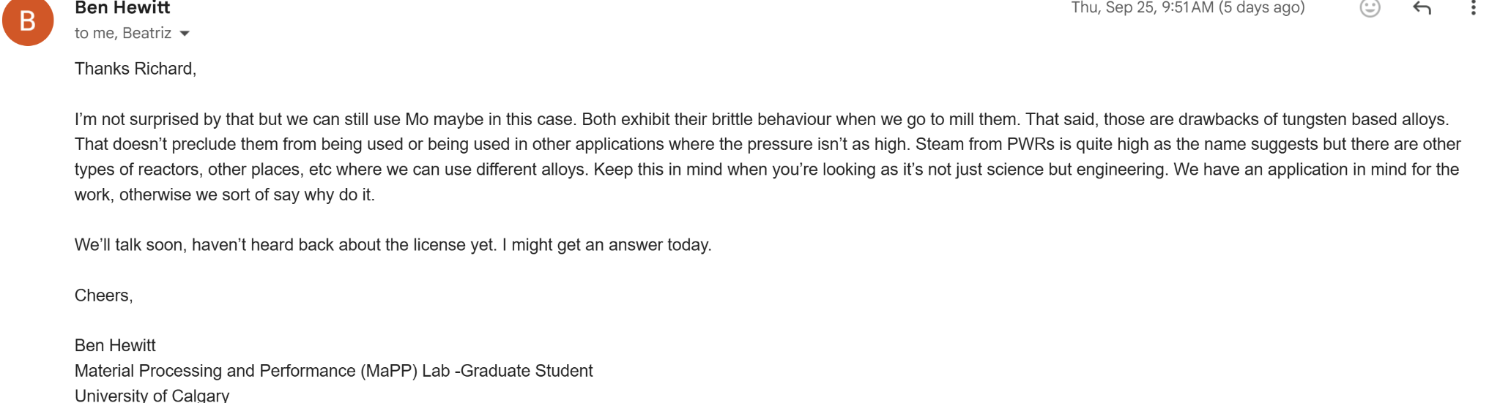

Questions to ask for next meeting:
- Can the brittle properties of tungsten decrease or be negated from the copper based alloy?
  - Tungsten also is not resistant to oxidation at high temperatures
- Does the brittleness of tungsten and molybdenum affect the milling and alloying of the alloy?
- Can we make a cu-w alloy coating to bypass its brittle properties?
- A lot of the materials used in PWRs use stainless steel. Why is that?
- Tungsten in fuel cladding?
- Why does molybdenum work better than tungsten in this case?

September 26, 2025
1
Tasks To-Do |  | Tasks Completed |  | Notes
- Reading all his papers  - Write economical challenges to fission |  | - Question brainstorming |  | Answers
Review
Answers to previous questions:
- Can the brittle properties of tungsten decrease or be negated from the copper based alloy? More copper = less brittleness from the tungsten
  - Tungsten also is not resistant to oxidation at high temperatures Yea, but for thermal reactors, the temperature ranges should be low enough so it's not as susceptible to oxidization. Tungsten is still brittle
- Does the brittleness of tungsten and molybdenum affect the milling and alloying of the alloy? Yes, but we can cold weld it to still make the alloy
- Can we make a cu-w alloy coating to bypass its brittle properties? Yes. We can still use tungsten in the heat exchanger. It does somewhat bypass it. We are mainly using tungsten for its cross section, strength, and shielding capabilities
- A lot of the materials used in PWRs use stainless steel. Why is that? Chromium works really well with iron to prevent some forms of corrosion. However, the trade off is that it is not as resistant to other forms of corrosion. Chromium only works with iron, so in our case, it wouldn’t be useful.

September 29, 2025
1
Tasks To-Do |  | Tasks Completed |  | Notes
- Continue material challenges |  | - Economical challenges to fission |  | Research proposal work
Review
- Logbook rubrics
  - Daily notes
  - Content details
  - Layout and organization
    - Can you find everything very quickly?
  - Calendar
- Oral presentations
  - Total presentations over 3 days
  - Need slides for it
  - Starts 22nd Oct, ends 28th Oct
  - Rubric: /34 individual presentation mark
    - /10 participation mark
      - Participate in at least 4 presentations
      - Can do other work afterwards
      - Not weighted heavily
- WORKED ON RESEARCH PROPOSAL - STARTED MATERIAL CHALLENGES (SEE WRITTEN WORK)

October Notes

Daily Notes

October 1, 2025
Tasks To-do |  | Review |  | Notes
- Finish rest of intro - how to implement tungsten and copper, what properties do they have that we want  - Finish material challenges to nuclear energy |  | - Key findings  - Chromium is great for resistant IASCC  - Ferritic alloys are better than austenitic for IASCC  - Phase diagram license expired…? 🙁  - Copper tungsten is likely going to be susceptible to IGSCC, but could fare better with dpa and IASCC  - Finished writing material challenges to fission  - Completed 1.1 and 1.2 of research proposal: economical and material challenges to fission (see written work)  - Sent to Dr. Garcia to review  Following email was sent to Ben Hewitt:  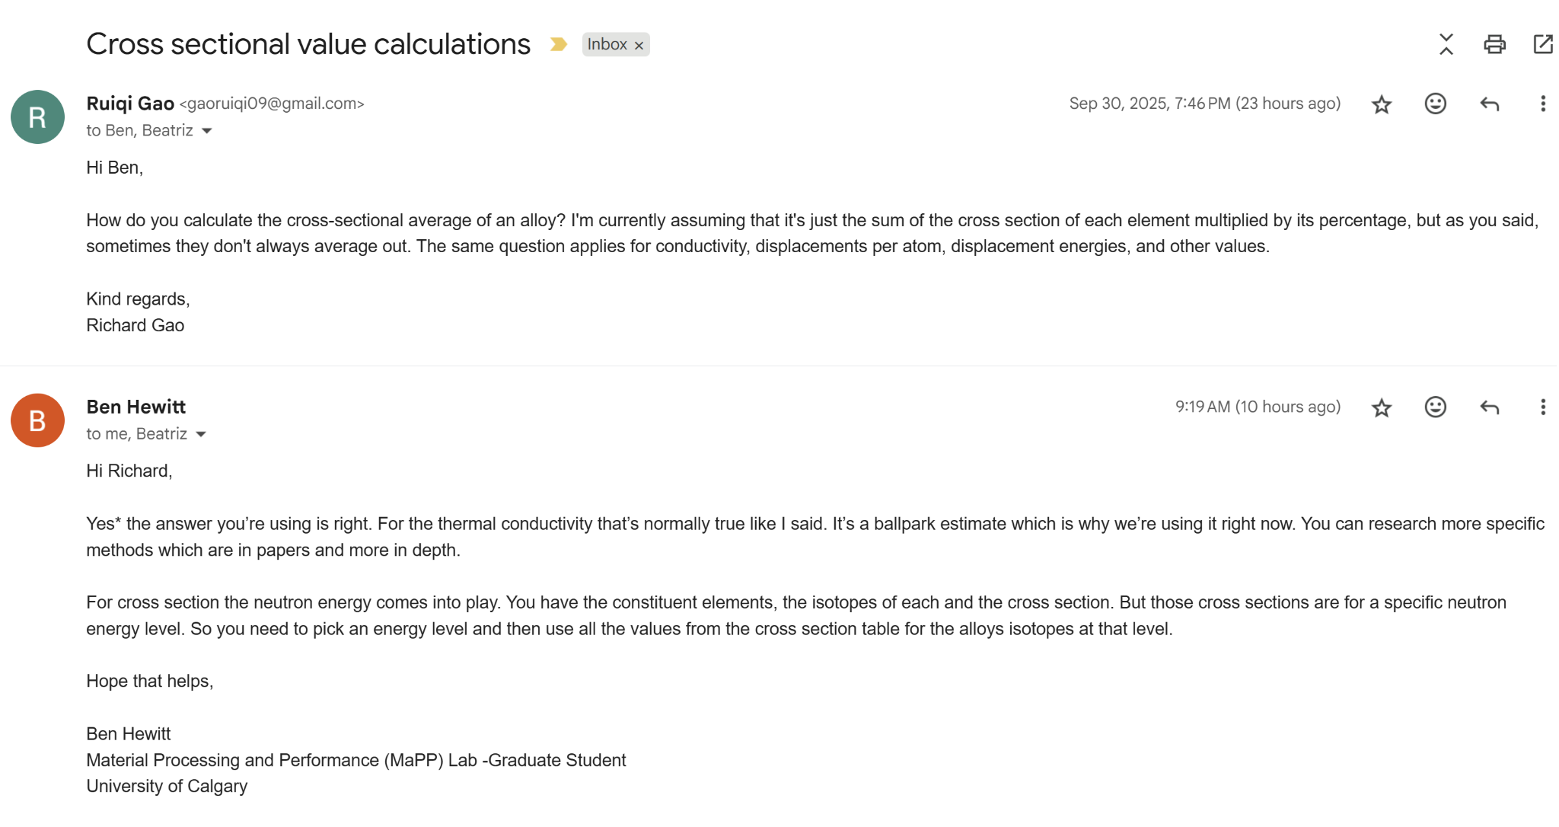 |  | The license for the phase diagram library should expire today

October 2, 2025
Tasks To-do |  | Review |  | Notes
- Finish rest of intro - how to implement tungsten and copper, what properties do they have that we want |  | - Information Ben gave me  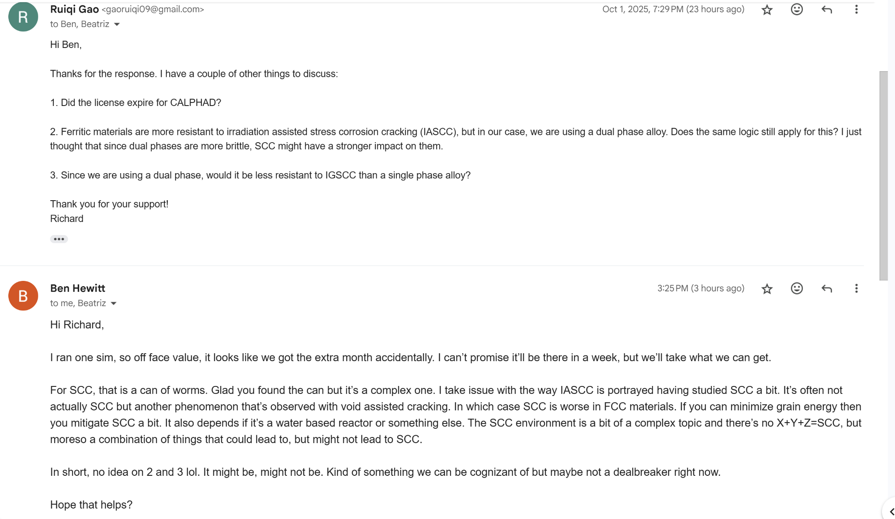  - CALPHAD license is still there 😀  - Check email below for additional information  - FCC is not good for anything other than SCC  - SCC is more volatile than I think  - Asked him to run 70Cu-5Cr-Mo phase diagram after  - Finished material challenges to nuclear energy, all of SCC and onwards (SEE BACKGROUND RESEARCH)  - Watched Charpy Impact Test procedure and what it measures (SEE BACKGROUND RESEARCH) |  | CALPHAD DIDN’T EXPIRE YAYYYYYYYYYYYYYY  Running chromium

October 3, 2025
Tasks To-do |  | Review |  | Notes
- Finish rest of intro - how to implement tungsten and copper, what properties do they have that we want |  | - Added on heat exchanger problems in introduction for RP, started writing about copper and tungsten’s properties that might work better  - SEE RP FOR PROGRESS |  | RP work

October 4-5, 2025
Tasks To-do |  | Review |  | Notes
- Write research questions, objectives |  | - Finished proposing the integration of copper and tungsten in heat exchangers  - Why copper  - Theoretical calculations  - SEE RESEARCH PROPOSAL FOR PROGRESS  The following email was received:  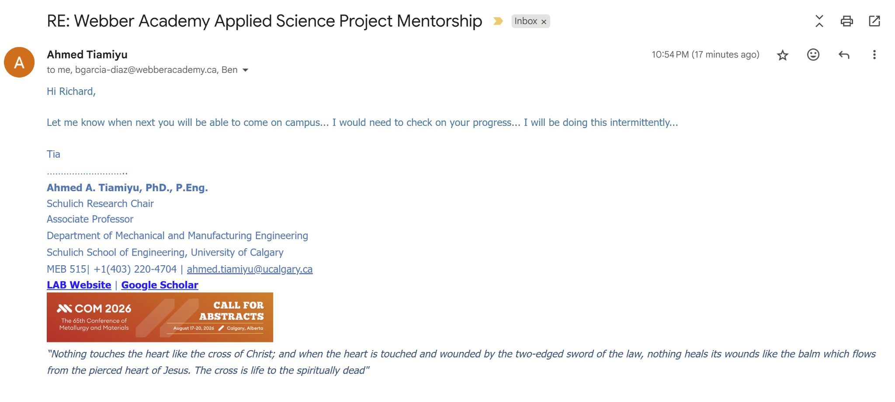  Replied with following:  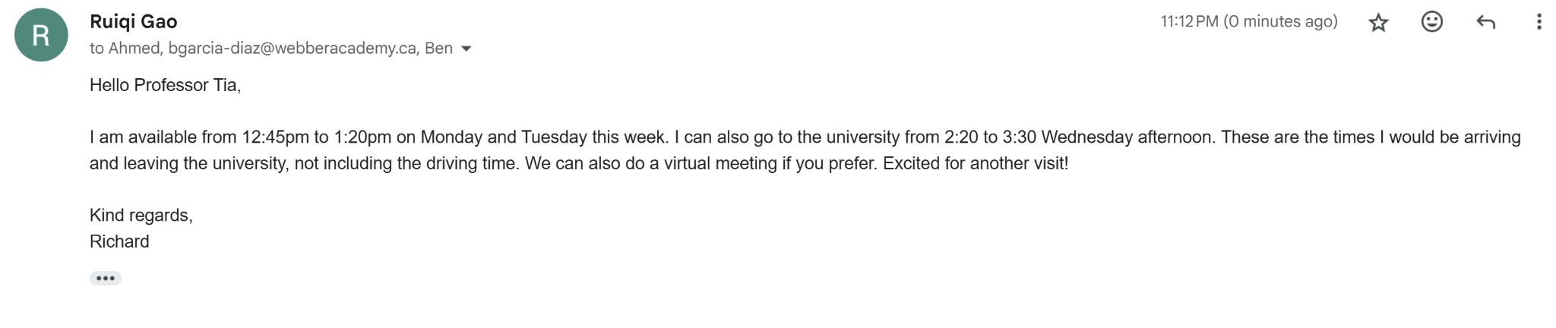 |  | RP work

October 6, 2025
Tasks To-do |  | Review |  | Notes
- Write research questions, objectives |  | Established meeting time with Tia. 12:45 Oct. 13:  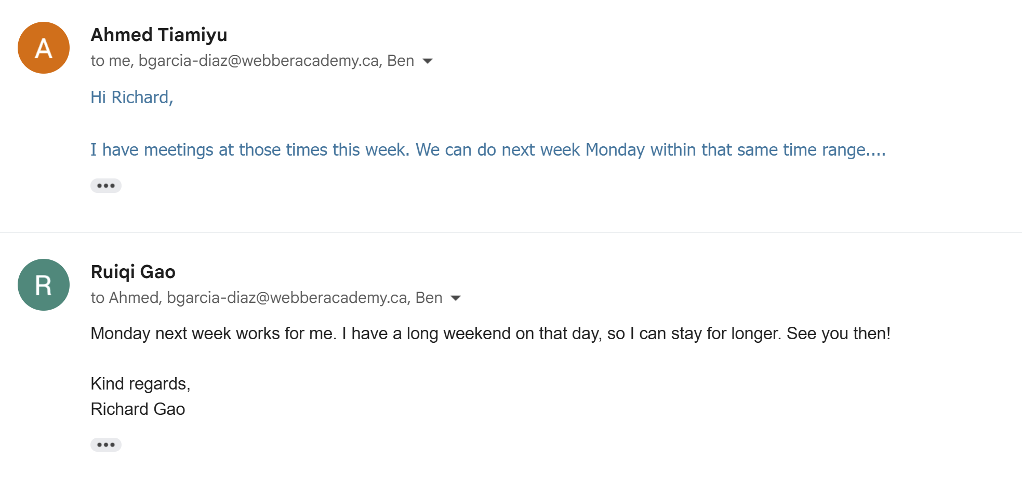  Later changed to Tuesday at 10:45am. Meeting in Suncor, room 515  Requested PDFs of restricted articles from Ben:  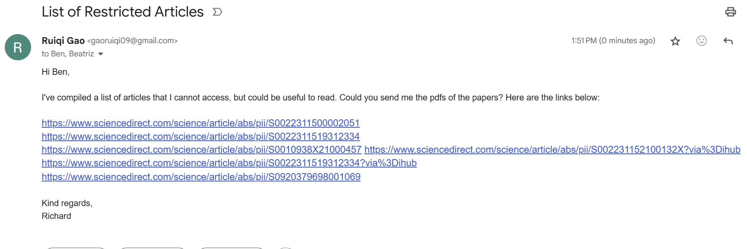  Added neutron absorption cross sectional values of tungsten in the introduction  Obtained 70Cu-25W-5Cr phase diagram. See link below:  https://drive.google.com/drive/folders/1wslE6yav1SgQr5JABU9BUjYcD-GuS4GP?usp=sharing  Asked Ben to set up another meeting, provided him with the ASP times:  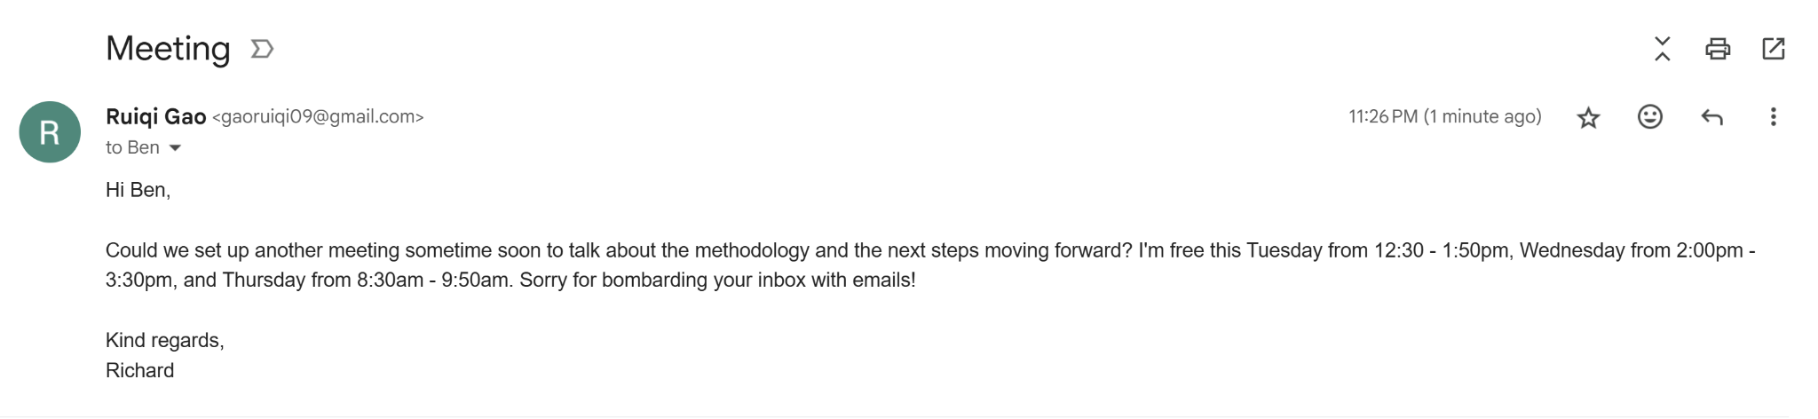 |  | Miscellaneous

October 7, 2025
Tasks To-do |  | Review |  | Notes
- Summarize RP to show to Tia  - Email Dr. Garcia about calendar |  | - Ben responded, rescheduled the meeting after I met with Tia for his advice  - Will send research proposal soon to Ben  - Wrote research questions and objectives in class (see RP)  - Met with Dr. Garcia  - Gave feedback about RP  - Email her to give me feedback about the calendar  - Ben evaluation: I’m focusing too much on the specifics of the project instead of focusing on the bigger picture  - Talking to Tia about the methodology  - After meeting with Tia, meeting virtually with Ben to fill him in  - Could delay RP submission to wait for Ben’s feedback  - Could meet with Ben virtually to get feedback on presentation  - Make RP more understandable for non specialized people  - Make presentation more understandable for non specialized people  - Started opportunities and challenges for materials innovation  - Finished introduction  RP comments: https://drive.google.com/file/d/1YuuaF9CS-YLgLjFS584COPXEpWGFiz9i/view?usp=sharing

October 8, 2025
Tasks To-do |  | Review |  | Notes
- Summarize RP to show to Tia  - Send Dr. Garcia new RP for edits  - Write significance section in RP |  | - Took Dr. Garcia’s comments and implemented them on research proposal (see oct. 7 for comments), see RP for edits  - Could not find any peer reviewed papers for electrical capacity  - Added correlations of previous accidents to the withdrawal of funding  - Removed the figure from my RP because it was too overwhelming  - Copper being a noble metal is common knowledge in nuclear physics - can’t find a peer reviewed source on this  - Continued reading opportunities and challenges… started analyzing the graph data - stopped page 8 |  | Usual RP work and reading

October 9, 2025
Tasks To-do |  | Review |  | Notes
- Summarize RP to show to Tia  - Send Dr. Garcia new RP for edits  - Write significance section in RP |  | - Research proposal extended to Oct. 22  - Oral on Oct. 28  - Added displacement energies of tungsten in introduction  - Slightly modified my research questions  - Finished significance section in RP, includes lifespan extensions and generation IV reactor research  - SENT RP TO DR.GARCIA  - See RP for progress  - Continued opportunities and challenges for materials innovation  - Analyzed dpa correlations with radiation phenomena |  | Usual RP work and reading

October 11-13, 2025
Tasks To-do |  | Review |  | Notes
- Write methodology |  | - Continued Opportunities and challenges to nuclear energy  - Dpas  - Void swelling  - Radiation hardening  - Summarized research proposal for Tia (see Research Proposal in written) - Oct. 13 |  | RP summary and reading

October 14, 2025
Tasks To-do |  | Review |  | Notes
- Write methodology |  | - University visit for Tiamiyu summary:  - I showed him my research proposal, satisfied with my work  - Showed me their paper they are currently working on: grain boundary decoration: forming a ring around the grain so that it can’t swell, causing it to be very resistant to corrosion  - Neutron irradiation testing: there are certain sites with such capabilities, but need to write a proposal for that. Very competitive for time slots, and UoC doesn’t have one. Neutron irradiation is generally bad for human health, so cannot build randomly  - Casting involves alloying at liquid states, milling is for solid powders  - We are using milling, Ben will show me how to use that  - Meeting with Ben tomorrow at 4pm  - Continued opportunities… for nuclear energy  - Mainly thermal creep data, what materials are resistant to it (AFAs, cold welded materials, specific examples) |  | University visit

October 15, 2025
Tasks To-do |  | Review |  | Notes
- Write methodology  - Send Ben the RP |  | Meeting with Ben:  Here is an overview of what we covered today:  1. Finalized methodology: Use X-ray characterization, SRIM simulations, and theoretical research; there are no sources to irradiate the sample  2. We are milling in around a month  3. I'll send the research proposal before this Friday  4. Not using impact test  5. Grain boundary decoration cannot be used in our material because of the dual phase structure  6. Discussed nano-crystalline formations during milling  FINISHED OPPORTUNITIES AND CHALLENGES TO NUCLEAR ENERGY  - Rest of paper focused mainly on LOCA events and fuel cladding improvements  - LOOK AT BACKGROUND RESEARCH |  | Meeting with Ben for next steps

October 16, 2025
Tasks To-do |  | Review |  | Notes
- Write methodology  - Send Ben the RP |  | - Learned about X-ray diffraction  - See background research  - Edited RP based on Dr. Garcia’s comments (https://drive.google.com/file/d/13zDnqDYKBjpaJliAtNuDE4Wk8GuqbjFg/view?usp=drive_link).  - Rewrote research questions completely  - Could send to Dr. Garcia again for review  - Rewrote short term objectives  - Wrote the methodology in research proposal (see written for progress)  - Using CALPHAD to create binary and trinary phase diagrams  - X-ray characterization to determine actual structure and composition of alloy  - SRIM simulations  - Sent research proposal to Ben for edits, also attached the marking rubric |  | Research proposal writing and background research

October 20, 2025
Tasks To-do |  | Review |  | Notes
- Submit research proposal |  | - Ben returned comments in my research proposal:  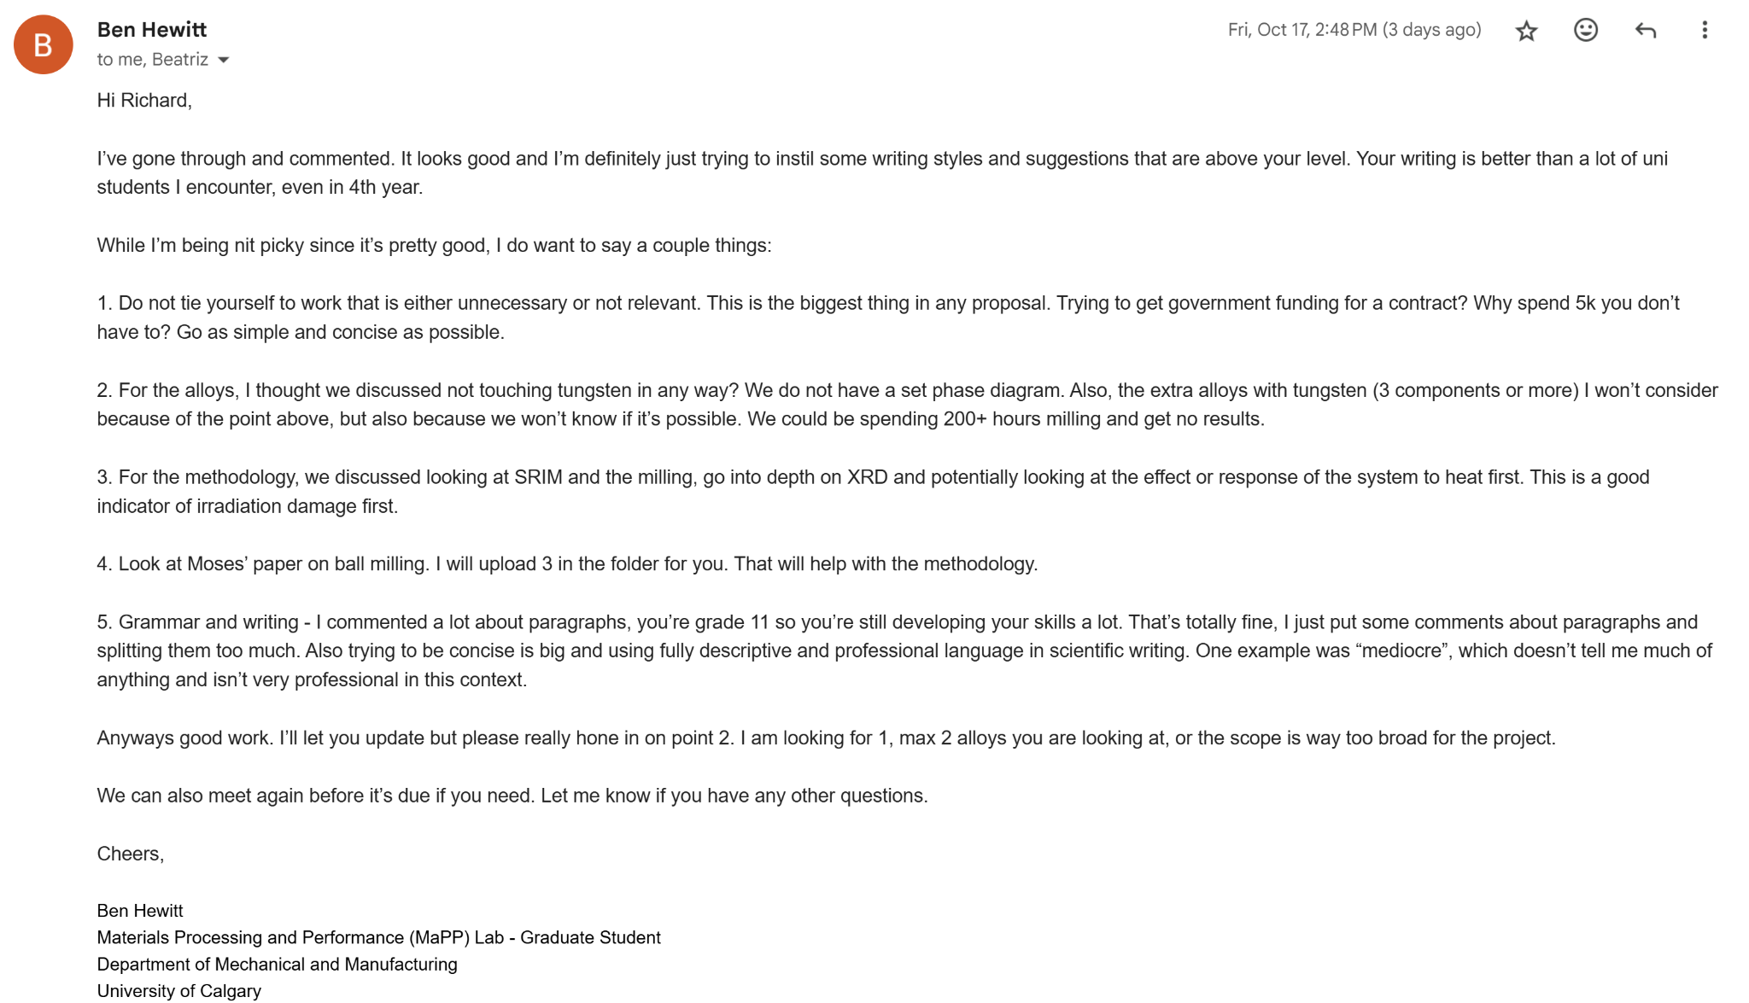  - Edited RP according to his comments (see research proposal for progress)  - Need to join CYSF portal  - Ben uploaded three papers for me  - Ball milling process variables optimization for high-entropy alloy Moses et.al  - Design and Development of Stable Nanocrystalline Moses et al.  - Design of self-stable nanocrystalline high-entropy alloy Moses et al. |  | Research proposal feedback and editing

October 21, 2025
Tasks To-do |  | Review |  | Notes
- Submit research proposal |  | - Continued RP editing according to Ben’s feedback  - Wrote voids and nano-crystalline section  - Removed Cu-W section |  | Research proposal feedback and editing

October 22, 2025
Tasks To-do |  | Review |  | Notes
- Submit research proposal |  | - RESEARCH PROPOSAL DUE  - Joined CYSF portal  - Filled out basic project info and ethic form in CYSF  - Ethics form submitted for review  - Following email sent to Ben:  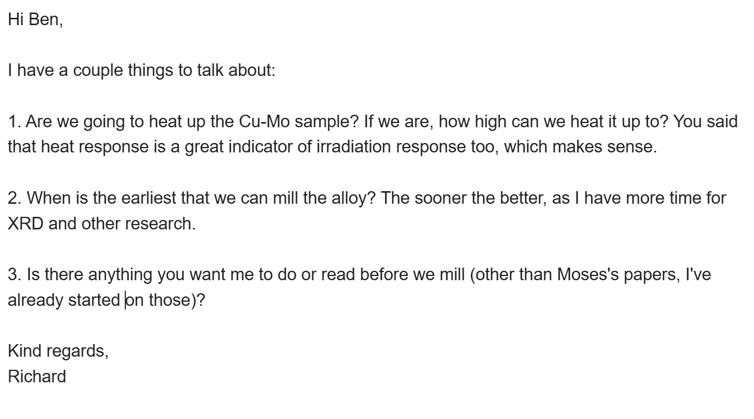  - Ben replied with following email:  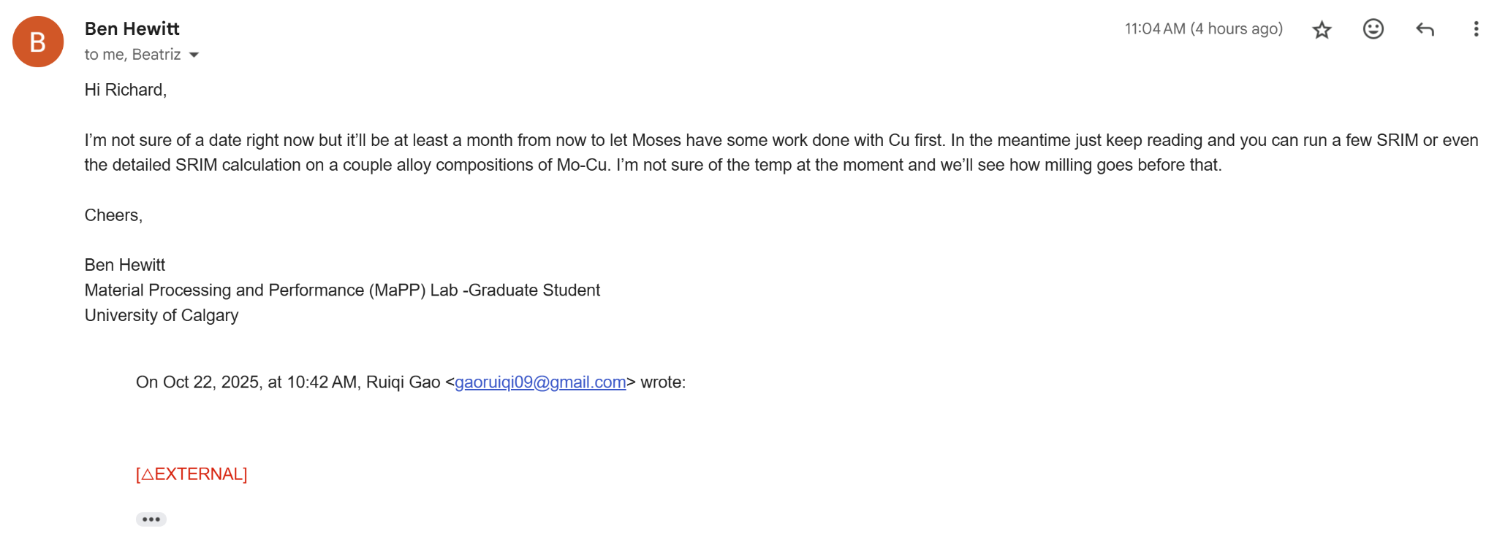  - FINAL EDITS TO RESEARCH PROPOSAL  - Grammar check and sentence structure  - Submitted |  | Research proposal feedback and editing

October 26, 2025
Tasks To-do |  | Review |  | Notes
- Oral presentation |  | - Created oral presentation slides  - Imported template from slidesgo  - See oral work for slides |  | Oral presentation work

October 27, 2025
Tasks To-do |  | Review |  | Notes
- Oral presentation |  | - Met with Dr. Garcia to review my oral presentation  - Key points:  - Need to explicitly state research questions and objectives  - Explain all jargon so that my classmates can understand  - Explain materials degradation  - Get simpler version of reactor diagram  - Highlight the important stuff in each diagram  - See oral presentation for changes |  | Oral presentation and feedback

October 28, 2025
Tasks To-do |  | Review |  | Notes
- Oral presentation |  | - PRESENTED ORAL  - Listened to Emma’s presentation  - 3 types of child abuse  - Physical  - Sexual  - Emotional  - Long term effects on victims  - CYAC for help  - Domestic abuse with child abuse increases effects on victim  - Short term goals  - Extract data  - Compare key characteristics  - Methods  - LUNA database  - Each client assigned a numeric identifier  - Corresponding file created  - Chi-squared test  - Used LUNA local database to solve local problems, database trusts local students to handle their data more than foreign students  - Jessica presentation  - Parts of neuron cell identified  - White matter and grey matter in brain, for different functions  - Multiple sclerosis: chronic autoimmune disease affecting the central nervous system, damaging myelin and grey matter  - Many symptoms  - RQs: what are changes in grey matter in multiple sclerosis that effects  - Review of literature and data analysis combined with own data collecting to analyze  - Looking at 3 main factors: age, gender, demographic |  | Oral presentation and participation

October 28, 2025
Tasks To-do |  | Review |  | Notes
 |  | Sent following email to Ben:  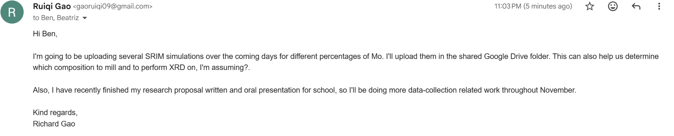  - Started to run SRIM simulations  - Currently running 30% Mo, 70% Cu  - Waiting for results  - Watched video about enthalpy  - SEE BACKGROUND RESEARCH |  | SRIM sims

October 29, 2025
Tasks To-do |  | Review |  | Notes
 |  | - Processed vacancies data in excel  - Uploaded to google drive  - Finished uploading simulation data for 10%, 20%, 30%, 40%, 50% Mo and the other percentages is copper  - No chromium simulations yet  - Data: https://drive.google.com/drive/folders/1UChsZ8ZWtOpc5NcdvSbUFnWMPzgkQCdT?usp=sharing |  | SRIM sims

October 30, 2025
Tasks To-do |  | Review |  | Notes
 |  | - Listened to Justin’s presentation  - Measuring PRPF4B protein levels after gene knockout in iPSCs  - Cerebrospinal fluid has a sweet spot for regulation  - PRPF4B protein regulates cerebrospinal fluid  - CRISPR Cas9 can be used to turn on or off specifically PRPF4B gene  - iPSCs behave similarly to stem cells  - PRPF4B controls CSF levels  - RQ: how can removing the PRPF4B gene affect the protein levels of its corresponding protein?  - Independent variable: knockout chromosome  - Dependent variable: protein levels produced  - Hypothesis: if a PRPF4B allele is knocked out, then the protein levels will stay the same  - Significance: provides treatment for neurodevelopmental disorders  - Andi’s presentation:  - Developing a computer program to distinguish between sarcasm and speech  - Many reasons to use sarcasm  - Sarcastic speech is lower in pitch  - Humans can detect sarcasm, expressed in facial expressions  - Tone of sarcasm is different - prosody is different  - Lengths of emphasised words, pitch of words can be used to detect sarcasm  - AI programs will not detect sarcasm  - 50% decrease in accuracy  - Some neurological disorders can inhibit a human’s ability to detect sarcasm  - Can help improve communication between regular humans and disordered people  - Current AI models don’t measure pitch, contour, etc.  - Current AI models use neural networks, which is a black box: weightings are unknown  - Goals: use logistic regression model to detect sarcasm  - Long term goals: make sarcasm flagging detector |  | Presentation participation

October 30, 2025
Tasks To-do |  | Review |  | Notes
- Oral presentation |  | - Proposed meeting times after weekend to meet up with Ben  - Uploaded 5% chromium sims  - 15%, 25%, 35%, 45% Mo  - Remaining percentage is chromium  - Link to data: https://drive.google.com/drive/folders/1UChsZ8ZWtOpc5NcdvSbUFnWMPzgkQCdT?usp=sharing  - Ben scheduled meeting at 4pm on Monday  - Sent meeting link |  | Oral presentation work

November Notes
Daily Notes

November 2, 2025
Tasks To-do |  | Review |  | Notes
- Finish design and development of NC material |  | - Read abstract and introduction of “Design and Development of Stable Nanocrystalline  High-Entropy Alloy: Coupling Self-Stabilization and Solute Grain Boundary Segregation Effects”  - See background research for annotations |  | Reading

November 3, 2025
Tasks To-do |  | Review |  | Notes
- Finish design and development of NC material |  | List of topics to discuss for Ben’s meeting:  - Can we form stable NC by using thermodynamic approach?  - How to determine best composition?  - Which composition is best to test?  - Should we use chromium?  - Talk about factors that promote GB segregation  - What to do with the sheets of vacancy data?  Continued reading design and development of NC material  - Finished approach/methodology  - See background research for annotations  - Finished 3.1 Microstructural evaluation  MEETING SUMMARY  Here is what we covered today:  1. Copper milling will take a long time because of its softness  2. NC cannot be stabilized due to dual phase and low enthalpy/entropy difference  3. Keep spreadsheets, they will be used later  4. SRIM results showed no significant difference in penetrating power  Here is the work I will do before our next meeting:  1. Determine the composition to use by considering other factors such as cost, availability, difficulty of integration/manufacturing, etc.  2. Explore the phase diagrams to help determine the composition to use |  | Ben meeting and reading

November 4, 2025
Tasks To-do |  | Review |  | Notes
- Finish design and development of NC material  - Decide on composition |  | - Read 3.2 in-situ XRD results of “Design and Development of Stable Nanocrystalline  High-Entropy Alloy: Coupling Self-Stabilization and Solute Grain Boundary Segregation Effects”  - See background research for annotations |  | Reading

November 5, 2025
Tasks To-do |  | Review |  | Notes
- Finish design and development of NC material  - Decide on composition |  | - Must have at least 1 weekly email to mentor  - Progress report  - Meeting notes  - Plan for next week  - Created spreadsheet for calculating the compositional properties  - SEE DATA COLLECTION UNDER DECISION MATRIX AND COMPOSITION PROPERTIES  - Decided on 45Cu-50Mo-5Cr, 70Cu-25Mo-5Cr, 48Cu-52Mo, and 72Cu-28Mo for Ben’s opinion  - Set up meeting with Ben to discuss this  - Hasn’t responded |  | Composition work

November 6, 2025
Tasks To-do |  | Review |  | Notes
- Finish design and development of NC material  - Decide on composition |  | - Met with Ben  - Meeting summary notes:  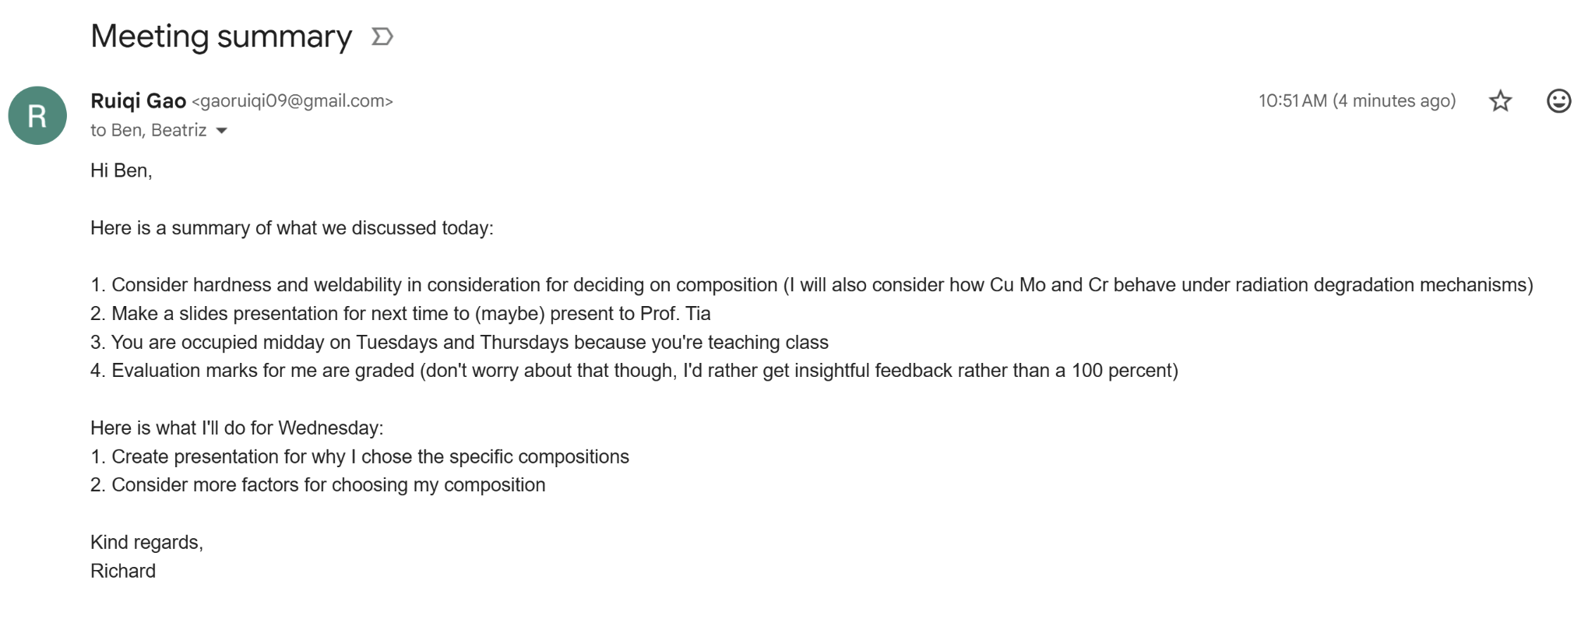  - Read 3.3.1. Effect of Temperature on the Stability of NC-AlCoCrFe with intended segregation of Zr and 3.3.2 Effect of Zr Addition on the Thermal Stability of NC material at 973K annealed for 4h  - Check background research for annotations  - Scheduled meeting with Ben next Wednesday  - Note: put sources of images in slideshow |  | Meeting summary

November 7, 2025
Tasks To-do |  | Review |  | Notes
- Finish design and development of NC material  - Decide on composition |  | - Make a long term plan for each month with mentor of what to do  - Make progress report weekly to mentor  - Mentor eval unweighted in schoolcloud  - Read and finished discussion of design and development of NC material: coupling self stabilization  - See background research for annotations  - Note: mention to Ben that the marks for mentor eval will not be used as the exact grade, “keep doing what you’re doing”  - Filled out availability times on When2Meet for Ben  - Ben scheduled another meeting at 2pm on Friday, Nov. 14 to present to Tia |  | Reading and scheduled meeting

November 11, 2025
Tasks To-do |  | Review |  | Notes
- Finish design and development of NC material  - Decide on composition |  | - Created and finished slideshow for presenting to Ben tomorrow about the best composition to use  - See oral presentation for the slideshow  - Finished discussion, conclusion, and Experimental section of design and development of NC material: coupling self stabilization  - See background research |  | Reading and slideshow work

November 12, 2025
Tasks To-do |  | Review |  | Notes
- Finish design and development of NC material  - Decide on composition |  | - Ben meeting  This is what we went over today:  1. I presented my slideshow on which is the best composition to use  2. Ben gave feedback about what to improve (SEE FOOTNOTES OF SLIDESHOW IN ORAL)  Here is what I'll do before Friday:  1. Implement your feedback to my presentation  2. Research further into if Cr can suppress void swelling |  | Meeting summary

November 13, 2025
Tasks To-do |  | Review |  | Notes
- Finish slideshow  - Create long term plan next meeting with Ben  - Ask Ben if project is experiment or innovation |  | - Started reading “Design of self-stable nanocrystalline high-entropy alloy”  - Finished introduction, methods,  - Implemented slideshow comments stored in footnotes  - Check oral work for the revised slideshow  - Added a decision matrix for determining the most optimal composition  - Check Google Drive for sheet in data collection under decision matrix and composition properties  - CYSF marking rubric  - Problem/objective  - Was your problem clearly stated?  - Was the direction for your project clearly identified?  - Methods  - Logbook must be specific (good right now)  - Methods must be clearly stated and described  - Analysis  - Must include visuals on poster  - Extent to which problem was solved is realized  - Creativity  - Why did I choose this project?  - How creative was it?  - Practical applications identified  - Resourceful use of resources  - Communication  - Oral presentation was clear and logical  - Time limit of presentation was honnored  - Visuals were effective  - Create long term calendar with Ben next meeting (Friday after the presentation)  - Last two weeks of Feb are poster and presentation  - Ask Ben about if project is experiment or innovation |  | Reading and slideshow feedback implementation

November 14, 2025
Tasks To-do |  | Review |  | Notes
- Give ANSIS-GRANT list for Ben to explore  - Modify decision matrix |  | - Ben meeting  This is what we did in our meeting:  1. Presented about the composition we decided to use  2. Explored ANSIS-GRANT and how it can be used to support our decision of using Mo instead of other elements  3. Created long-term calendar of when to be done with the data collection (milling date is still unknown)  4. Talked about how to implement the bucket method in the decision tree to obtain less biased results  5. Implemented Hume Rothery considerations on the decision of alloy, as well as how a PH phase may affect the mechanical properties of the Cu alloy  6. Discussed the potential usage of a ternary alloy for a PH strengthened material  Here is what I will do next:  1. Explore the ANSIS-GRANT software capabilities and give a list of properties for Ben to look into  2. Rework the decision matrix to include less bias and implement the "bucket" method |  | Meeting summary

November 17, 2025
Tasks To-do |  | Review |  | Notes
- Give ANSIS-GRANT list for Ben to explore  - Modify decision matrix |  | - Explored the Ansys Granta Materials Selector features (watched this video: https://www.youtube.com/watch?v=IvvHpN4KyH4)  - Asked Ben to get graphs of the following properties of all powders available at UoC  - Conductivity vs. yield strength (elastic limit)  - Bulk modulus vs. Young's modulus  - Conductivity vs. melting point  - Conductivity vs. fracture toughness (at both room temperature and 570K if the database has that information)  - Solute percentage vs. yield strength of Cu binary alloy  - Solute percentage vs. conductivity of Cu binary alloy  - Solute percentage vs. Bulk modulus of Cu binary alloy  - Solute percentage vs. Young's modulus of Cu binary alloy |  | Ansys Granta

November 17, 2025
Tasks To-do |  | Review |  | Notes
- Modify decision matrix |  | - Read approach, milling of alloy, and in-situ heat treatment of “Design of self-stable nanocrystalline high-entropy alloy”  - See background research |  | Reading

November 19, 2025
Tasks To-do |  | Review |  | Notes
- Modify decision matrix |  | - Ex-situ of 773K and 973K annealed AlCoCrFe HEA, discussion and conclusion of “Design of self-stable nanocrystalline high-entropy alloy”  - See background research  - Redesigned the decision matrix to bucket list  - See data collection for changes under decision matrix and composition properties |  | Reading

November 20, 2025
Tasks To-do |  | Review |  | Notes
 |  | - Learned the Scherrer equation and how to use it  - See background research  - Research proposal feedback was released  - Introduction used for next paper  - Methodology will be used for the skeleton for methodology paper  - Avoid informal language  - Link to RP in written work, comments are also in written work |  | Scherrer equation and research proposal

November 21, 2025
Tasks To-do |  | Review |  | Notes
 |  | - Applied edits from Dr. Garcia’s comments to the research proposal  - See research proposal document in written work  - See research proposal comments in written work  - Science fair presentation  - Video is to highlight challenges of the project and how hard you worked to reach your conclusion  - Take videos of lab visits  - Don’t read off a script  - Don’t rush |  | Research proposal editing and science fair presentation

November 24, 2025
Tasks To-do |  | Review |  | Notes
- Research Cu and Mo response to SCC |  | - Meeting summary with Ben:  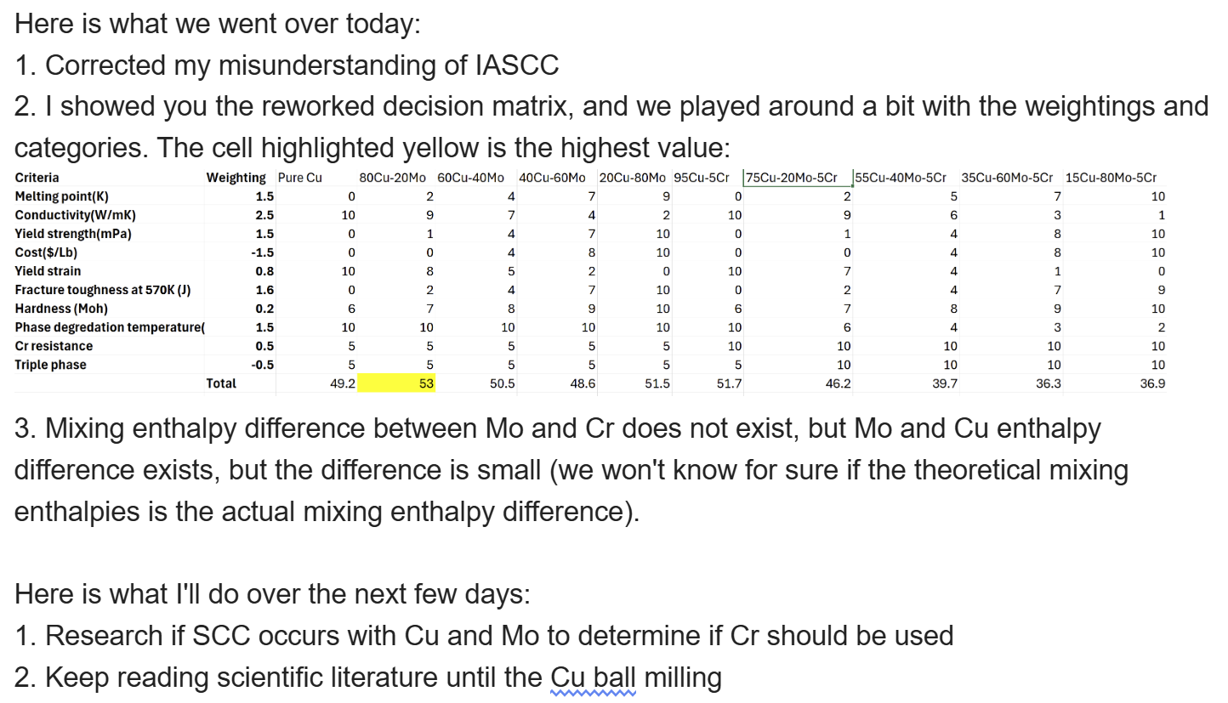 |  | Meeting summary

November 25, 2025
Tasks To-do |  | Review |  | Notes
- Research Cu and Mo response to SCC  - Learn William Hall equation |  | - Read introduction and methodology of “Ball milling process variables optimization for high-entropy alloy development using design of experiment and genetic algorithm”  - See background research |  | Reading

November 26, 2025
Tasks To-do |  | Review |  | Notes
- Research Cu and Mo response to SCC  - Learn William Hall equation |  | Sent following email to Ben:  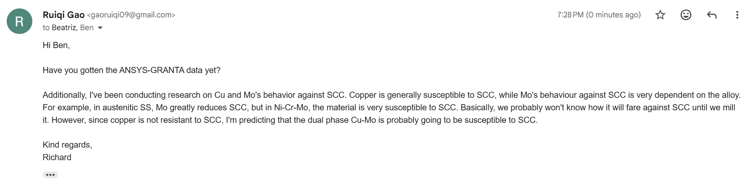  Ben responded with this:  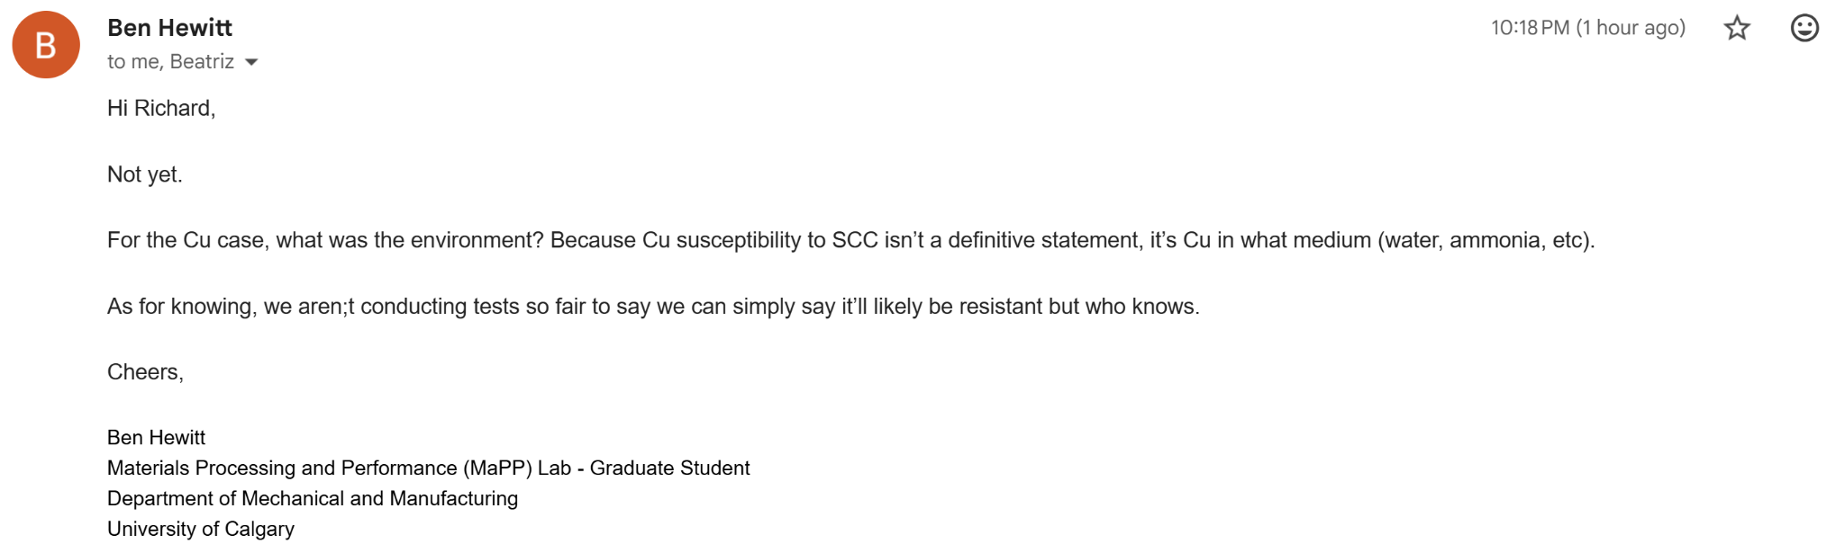  Sent this to him:  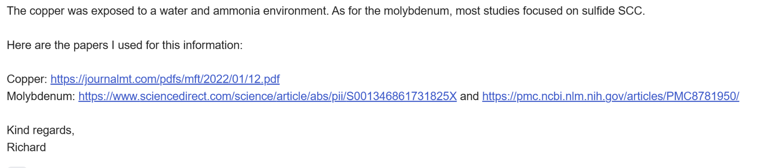 |  | ANSYS GRANTA

November 27, 2025
Tasks To-do |  | Review |  | Notes
- Learn William Hall equation |  | - Finished revising Dr. Garcia’s comments on the research proposal for the introduction  - See written work for both her comments and my revisions  - Read 3.1.1 Experimental determination of optimum PCA type for the onset of solid-solution at 350 rpm in “Ball milling process variables optimization for high-entropy alloy development using design of experiment and genetic algorithm”  - See background research for annotations |  | Reading and ANSYS GRANTA

December Notes
Daily Notes

December 1, 2025
Tasks To-do |  | Review |  | Notes
- Learn William Hall equation |  | - Communicate with mentors of plan during winter break  - Ask mentor during next meeting of the plan for winter break  - Plan for the future:  - 3 weeks until winter break  - Midterms after, probably little time to work on project  - Only 4.5 weeks after that until poster due  - Read and finished Ball milling process variables optimization for high-entropy alloy development using design of experiment and genetic algorithm  - Genetic algorithm  - Signal to noise ratio analysis  - Conclusion and discussion  - SEE BACKGROUND RESEARCH FOR ANNOTATIONS  Email conversation about decision matrix and ANSYS-GRANTA: 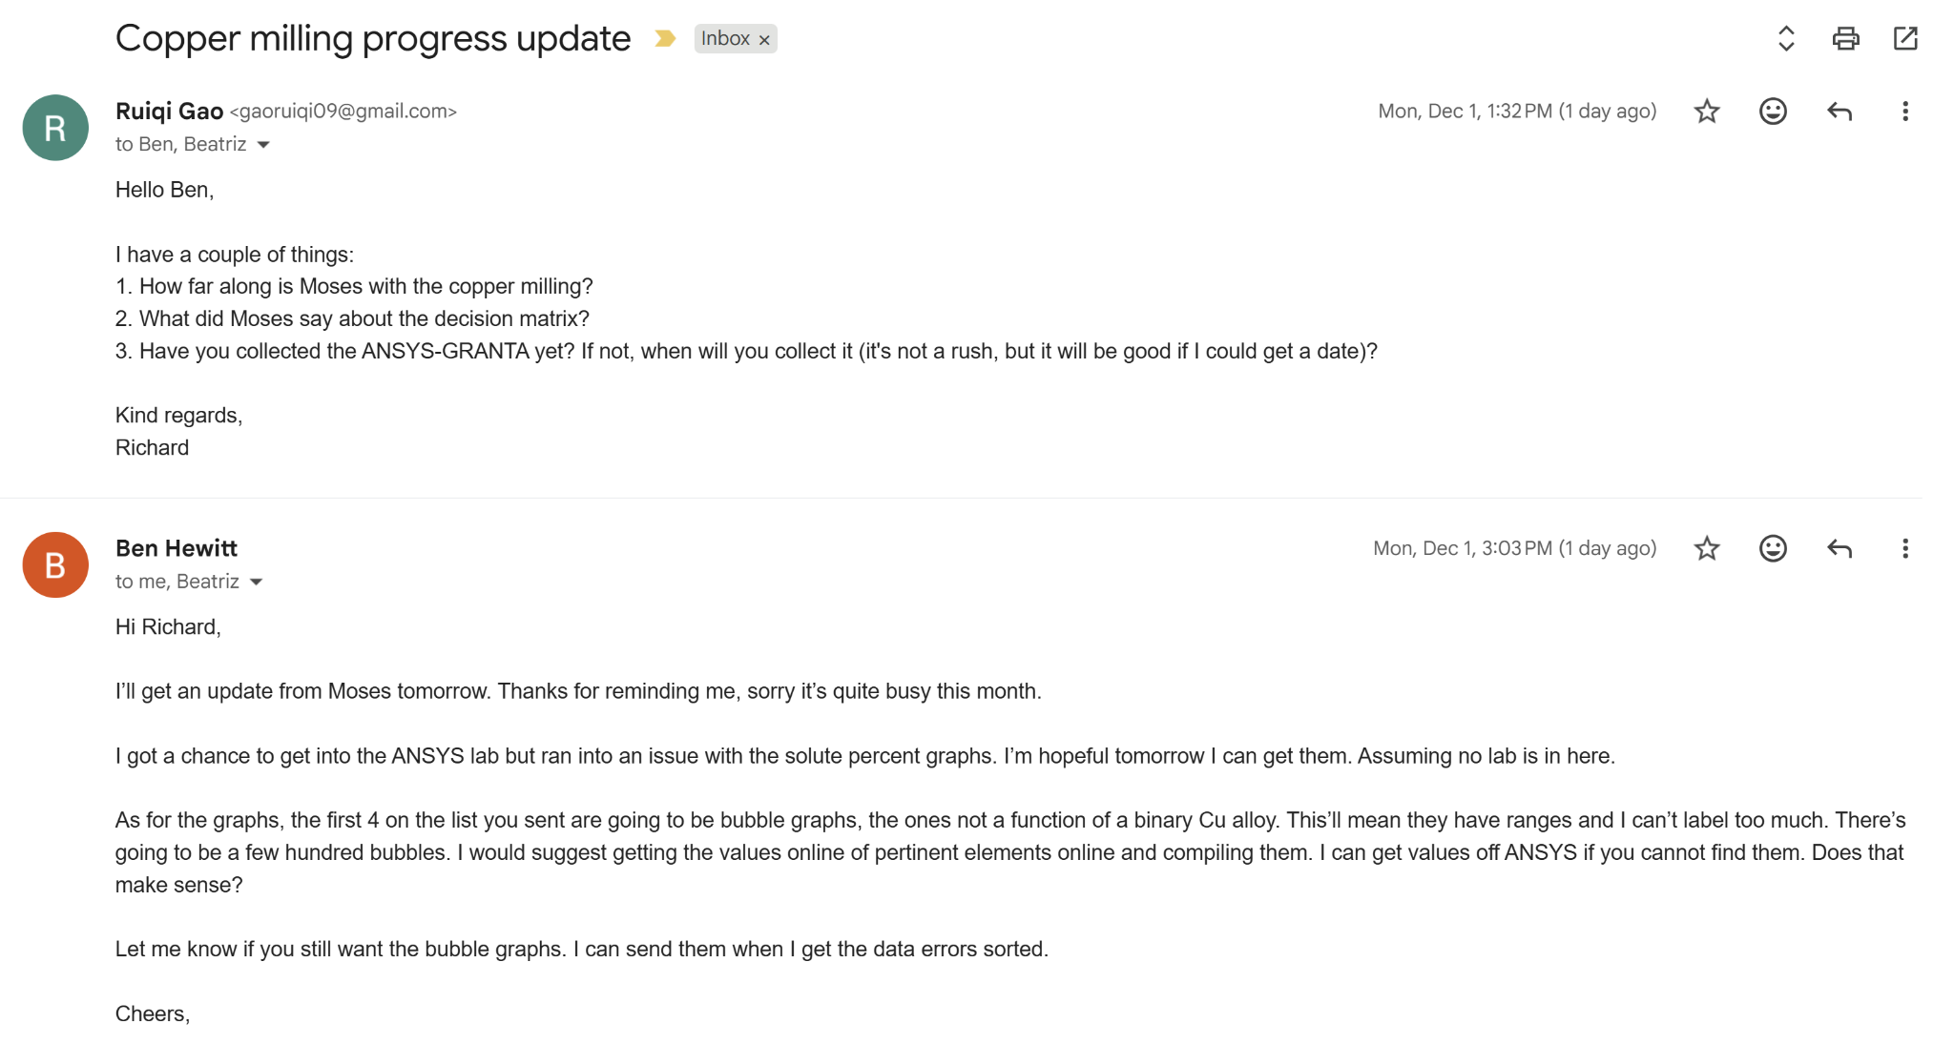 |  | Reading and calendar

December 2, 2025
Tasks To-do |  | Review |  | Notes
- Learn William Hall equation |  | - Ben sent me following email:  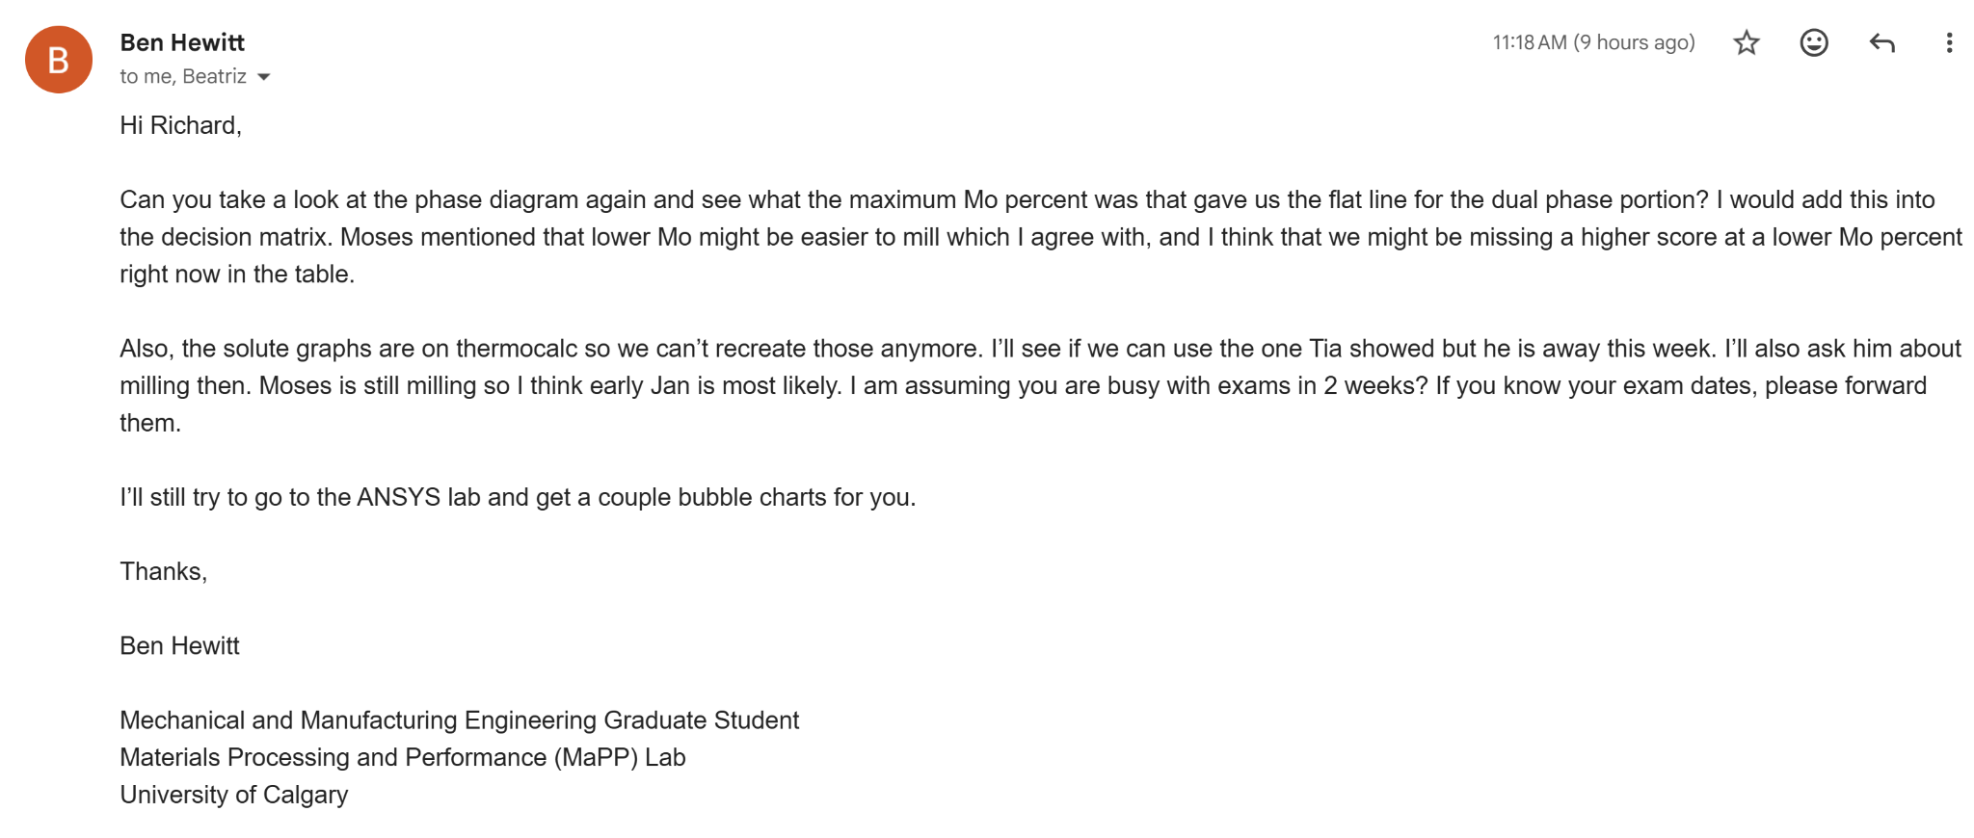  - Added another section in my decision matrix to include the optimal Mo percentage of milling  - 82Cu-18Mo was the highest value  - See data collection tab for the sheets under decision matrix and composition properties |  | Emails and decision matrix

December 3, 2025
Tasks To-do |  | Review |  | Notes
- Learn William Hall equation |  | - Learned the Williamson Hall plot and Bragg’s law  - Check background research for notes  - Added the introduction  - Reworked the ending to include research questions and objectives  - See written work for intro |  | Background research and writing

December 4, 2025
Tasks To-do |  | Review |  | Notes
- Make yield strength graphs |  | - Finished the introduction draft  - Sent to Dr. Garcia to review  - See written for the introduction draft  - Sent email to Ben about what process control agent we are going to use  - Ben gave me the ANSYS GRANTA data  - See data collection tab for data  - Missing yield strength  - Read introduction and 2.1, 2.2: cold stress sources and heat treatment stress sources in “SCC and copper alloy products”  - Check background research |  | Writing, emails, reading

December 5, 2025
Tasks To-do |  | Review |  | Notes
- Make yield strength graphs |  | - Read and finished SCC and copper alloy products  - 2.3 Assembly stress and conclusion  - See background research |  | Reading

December 6, 2025
Tasks To-do |  | Review |  | Notes
- Make yield strength graphs |  | - Used webplotdigitizer to extract young’s modulus, bulk modulus, conductivity, and melting point values of metallic elements from ANSYS graphs Ben gave me  - Searched up online for yield strength values at 550K using matweb.com  - Check data collection for the spreadsheet under ANSYS data |  | Webplotdigitizer

December 7, 2025
Tasks To-do |  | Review |  | Notes
- Make yield strength graphs |  | - Made yield strength vs. conductivity, melting point, young’s modulus, and bulk modulus graphs using excel  - Check data collection for the graphs under ANSYS data  - Emailed Ben about the completed graphs and scheduled meeting  - Scheduled meeting for Tuesday, Dec. 9 12:30pm |  | ANSYS graphs using excel

December 9, 2025
Tasks To-do |  | Review |  | Notes
- Implement Dr. Garcia’s comments  - Think of ways to visualize |  | - Met with Ben  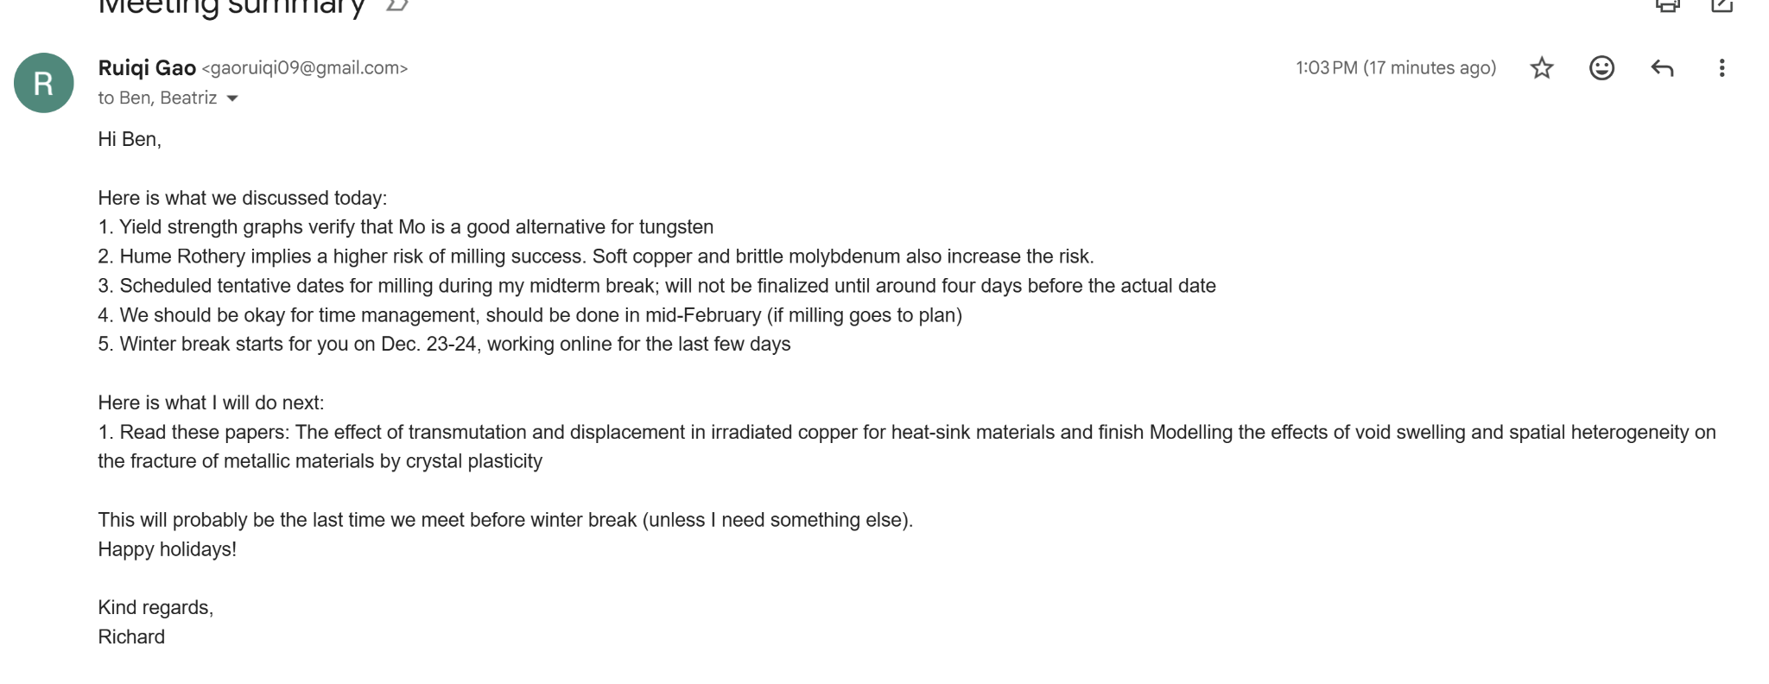  - Dr. Garcia individual meeting  - Gave feedback about introduction link: https://drive.google.com/file/d/1FWH-DeDXx32O7h9D45uZRSlOcvPNUtHj/view?usp=sharing  - Filled her in on my progress  - Gave me another task to do before milling: think of ways to visualize my data for the science fair and think of what content to put in the poster  - Sent another email to Ben:  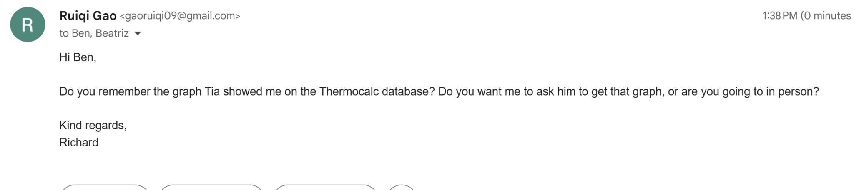  - Updated introduction based on Dr. Garcia’s comments  - See introduction in written work  - Read introduction of Modelling the effects of void swelling and spatial heterogeneity on the fracture of metallic materials by crystal plasticity  - See background research |  | Meetings

December 10, 2025
Tasks To-do |  | Review |  | Notes
 |  | - Read 2.1 spatial distribution of voids and 2.2 yield function of single porous crystal of “Modelling the effects of void swelling and spatial heterogeneity on the fracture of metallic materials by crystal plasticity”  - See background research |  | Reading

December 11, 2025
Tasks To-do |  | Review |  | Notes
 |  | - Read 2.3 porous crystal plasticity model of “Modelling the effects of void swelling and spatial heterogeneity on the fracture of metallic materials by crystal plasticity”  - See background research  - CYSF closes on March 4th  - Added long term objectives to the end of the introduction and did a grammar review of the paper  - See written for changes  - Fixed the ANSYS graph axis titles  - Capitalized the M in MPa and also fixed the formatting of the data labels  - See data collection for graphs |  | Reading and writing

December 11, 2025
Tasks To-do |  | Review |  | Notes
 |  | - Ben got permission to remake the percent solute graphs from Tia using Moses’s data  - Read 3: numerical implementation of “Modelling the effects of void swelling and spatial heterogeneity on the fracture of metallic materials by crystal plasticity”  - See background research |  | Reading

December 15, 2025
Tasks To-do |  | Review |  | Notes
 |  | - Reviewed and did a final edit of the introduction paper  - See written work  - Submitted to turnitin and Google Classroom  - Kasi, Shayaan’s mentor, wants to do milling at the same time |  | Introduction editing

December 16, 2025
Tasks To-do |  | Review |  | Notes
 |  | - Read 4.1 parameter calibration and 4.2 effects of void swelling on overall mechanical properties and 4.3 quasi-brittle fracture of “Modelling the effects of void swelling and spatial heterogeneity on the fracture of metallic materials by crystal plasticity”  - See background research |  | Reading

December 17, 2025
Tasks To-do |  | Review |  | Notes
 |  | - Read 4.4 Effects of inner pressure, conclusion, and appendices of “Modelling the effects of void swelling and spatial heterogeneity on the fracture of metallic materials by crystal plasticity”  - See background research |  | Reading

December 19, 2025
Tasks To-do |  | Review |  | Notes
 |  | - Read introduction of “The effect of transmutation and displacement in irradiated copper for heat-sink materials”  - See background research |  | Reading

December 20, 2025
Tasks To-do |  | Review |  | Notes
 |  | - Read methods and results of “The effect of transmutation and displacement in irradiated copper for heat-sink materials”  - See background research |  | Reading

December 21, 2025
Tasks To-do |  | Review |  | Notes
 |  | - Read discussion and conclusion of “The effect of transmutation and displacement in irradiated copper for heat-sink materials”  - See background research |  | Reading

December 25, 2025
Tasks To-do |  | Review |  | Notes
 |  | - Read abstract and introduction of “Effect of neutron dose and spectra, He:dpa ratio and Ni and Zn accumulation on irradiation damage of pure copper and PH and DS copper alloys”  - See background research |  | Reading

December 27, 2025
Tasks To-do |  | Review |  | Notes
 |  | - Research the density functional theory to calculate mechanical properties of a material  - See background research  - Sent email to Ben  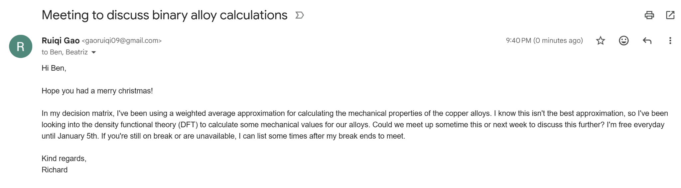  - Finished reading 1.2 thermal conductivity and 2 changes in shape of the alloy during operation of “Effect of neutron dose and spectra, He:dpa ratio and Ni and Zn accumulation on irradiation damage of pure copper and PH and DS copper alloys”  - See background research |  | Reading

December 31, 2025
Tasks To-do |  | Review |  | Notes
 |  | - Set up meeting with Ben for Jan. 2  - Water pipe broke, so milling could be delayed because UoC is restricted from using water during the water restrictions |  | Set up meeting

January Notes

January 2, 2025
Tasks To-do |  | Review |  | Notes
 |  | - Met with Ben  - Meeting summary:  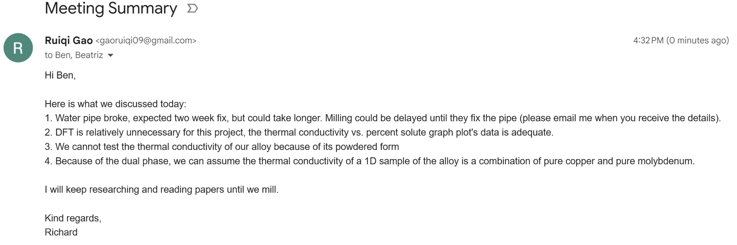  - Read Low temperature radiation embrittlement and high temperature radiation embrittlement of PH copper alloys of the paper “Effect of neutron dose and spectra, He:dpa ratio and Ni and Zn accumulation on irradiation damage of pure copper and PH and DS copper alloys”  - See background research |  | Meeting summary and reading

January 3, 2025
Tasks To-do |  | Review |  | Notes
 |  | - Ben told Dr. Garcia about the water leakage  - Read DS alloys and pure copper’s mechanisms to high temperature radiation embrittlement, and read high temperature embrittlement of “Effect of neutron dose and spectra, He:dpa ratio and Ni and Zn accumulation on irradiation damage of pure copper and PH and DS copper alloys”  - See background research |  | Reading

January 4, 2025
Tasks To-do |  | Review |  | Notes
 |  | - Finished changes in mechanical properties and conclusion “Effect of neutron dose and spectra, He:dpa ratio and Ni and Zn accumulation on irradiation damage of pure copper and PH and DS copper alloys”  - See background research |  | Reading

January 6, 2025
Tasks To-do |  | Review |  | Notes
 |  | - Water pipe will be fixed very soon 😀  - Ben scheduled the milling for Jan. 16 at 8:00am |  | MILLING :D

January 14, 2025
Tasks To-do |  | Review |  | Notes
 |  | - Email from Ben about where to meet  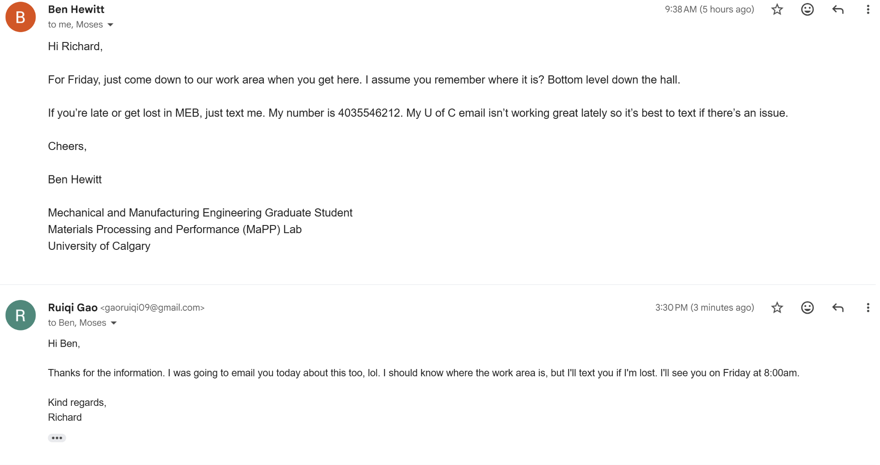  - Researched specific details to ball milling  - See background research |  | MILLING :D

January 16, 2025
Tasks To-do |  | Review |  | Notes
 |  | - Visited UoC for milling  - Some plans were changed (see below)  Summary:  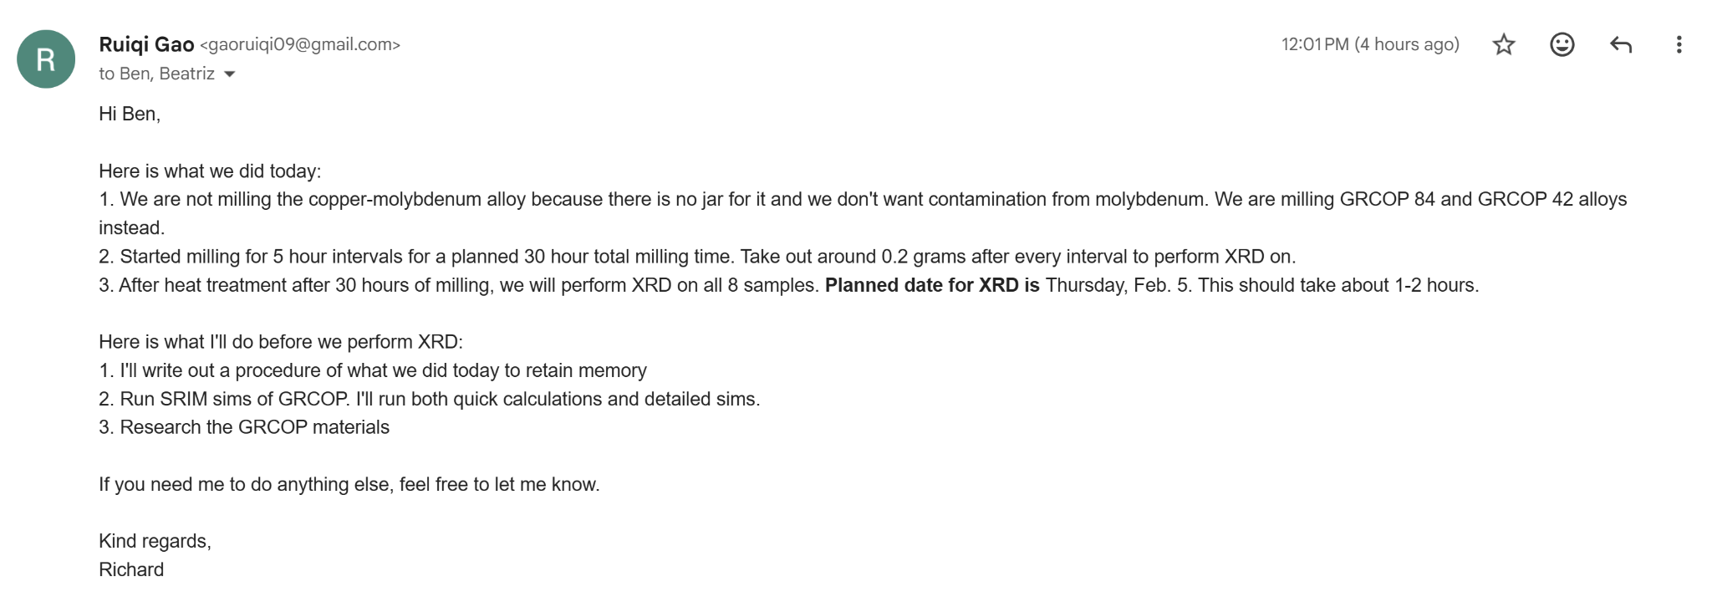  - Wrote down the procedure for the ball milling process in the methodology  - See methodology in written work  - Ran quick calculations of GRCOP 84 and 42 in SRIM, uploaded data onto Google Drive  - See SRIM data in data collection |  | MILLING :D  SRIM simulations

January 18, 2025
Tasks To-do |  | Review |  | Notes
 |  | - Finished detailed calculations for GRCOP 84 and 42  - See SRIM data collection  - Major differences in the two materials  - The peak width of GRCOP 84 is drastically shorter than that of 42  - Penetrating depth is very similar |  | SRIM

January 20, 2025
Tasks To-do |  | Review |  | Notes
- Finish methodology |  | - First ASP class day back from midterms  - Methodology section due on February 19th  - Give Dr. Garcia and Ben long notice time for review  - Oral presentation  - Reduce intro and methodology time  - Emphasize the results and what they mean  - My presentation date: Feb. 27  - Can present with poster or slideshow  - Should schedule a practice presentation with Dr. Garcia  - School science fair  - March 2  - CYSF Portal completed by March 4, including video  - Can use school-provided trifold or a printed poster  - Meeting with Dr. Garcia  - Key point: told me on how to properly syntax the materials used  - Include manufacturer and where they are based in in parentheses  - Include this for the powders I used too  - Edited methods based on her guidelines  - See written work  - Researched about the properties of GRCOP under normal, room temperature conditions  - See background research |  | MILLING :D  SRIM simulations

January 22, 2025
Tasks To-do |  | Review |  | Notes
- Finish methodology |  | - Wrote the SRIM section in the methodology  - See written work  - Wanted to research more about anisotropic displacement behaviors, send Ben the links of two restricted articles:  https://www.sciencedirect.com/science/article/abs/pii/S0022311520311934  https://www.tandfonline.com/doi/abs/10.1080/01418618108235802  - Currently rerunning the SRIM simulations of GRCOP, but using displacement energies of at 550K instead  - Might take a few days to finish |  | SRIM and writing

January 23, 2025
Tasks To-do |  | Review |  | Notes
- Finish methodology |  | - Finished GRCOP 84 SRIM simulations  - Check data collection for results  - Currently running GRCOP 42  - Scheduled XRD procedure date to Feb. 4  - Ben gave me the two pdfs of the restricted papers  - Will read soon |  | SRIM

January 25, 2025
Tasks To-do |  | Review |  | Notes
- Finish methodology |  | - Finished GRCOP 42 SRIM simulations  - Check data collection for results |  | SRIM

January 26, 2025
Tasks To-do |  | Review |  | Notes
- Finish methodology |  | - Ben emailed me about the high temp simulations:  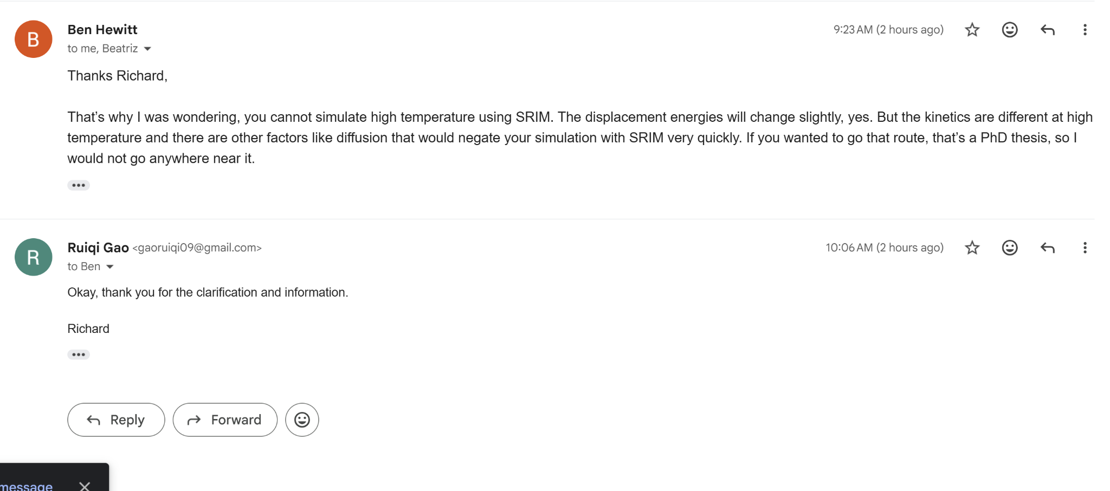  - Methodology paper notes:  - Do not go too basic  - Meant for people in your field of studies to evaluate how you conducted their experiment  - Audience is the experts of the field  - Specific materials and equipment should contain manufacturer and location  - Know the procedure well  - Do not write in point form  - Must write in past tense  - Figures and tables enhance the understanding  - Use of published studies must be cited and provide description  - State the purpose of each procedure  - Search in purdue owl about styles for title, references, etc.  - Process: outline sections, write out everything, list what you don’t know and ask mentors, edit tense, style, tone, etc.  - Can add methods to intro to keep citation numbers in order  - XRD final date is Feb. 5th at 9:00am  - Read abstract and introduction of thermophysics properties of GRCOP 84 and 42  - See background research |  | XRD, SRIM, methodology

January 27, 2025
Tasks To-do |  | Review |  | Notes
- Finish methodology |  | - Read methodology of the thermophysical properties of GRCOP  - See background research |  | Reading

January 28, 2025
Tasks To-do |  | Review |  | Notes
- Talk to Ben about poster  - Finish methodology |  | - Met with Dr. Garcia  - Todo:  - Talk to Ben about poster  - Read 3.1 3.2 and 3.3 of thermophysical properties of GRCOP  - See background research  - Science fair meeting  - Arrive by 8:30am on March 2nd to set up posters/trifolds  - 9:00-11:30: first judging round  - 11:30 - 12:20: lunch  - 12:20 - 3:30pm: judging  - 20 minute judging sessions  - Must be able to access the logbook without wifi  - Must cite AI usage  - Results released March 3rd  - CYSF portal locks March 4th |  | Reading

January 30, 2025
Tasks To-do |  | Review |  | Notes
- Talk to Ben about poster  - Finish methodology |  | - Introduction paper comments and grade released  - Check written for introduction comments  - Edited introduction according to Dr. Garcia’s comments  - Also changed the ending to GRCOP instead of a copper-molybdenum alloy  - See written  - Oral presentation outline  - Introduction should only be a minute(ish)  - Results and discussion should be the bulk of the presentation  - Conclusions show the significance of the work |  | Reading

February notes

February 2, 2025
Tasks To-do |  | Review |  | Notes
 |  | - Ben emailed me to contact Wen, the XRD technician  - Introduced myself and explained the logistics  - Read 3.5 and 3.6, phase identification and thermal expansion of the thermophysical properties of additively manufactured GRCOP 84 and 42  - See background research |  | Emails

February 3, 2025
Tasks To-do |  | Review |  | Notes
 |  | - Created Canva poster template for the science fair poster  - Check oral work  - Read discussion of thermophysical properties of GRCOP  - See background research  - Trifold dimensions: 240cm by 150cm  - Poster dimensions: 122cm by 92cm |  | Poster, reading

February 4, 2025
Tasks To-do |  | Review |  | Notes
 |  | - Read conclusion of thermophysical properties of GRCOP  - See background research |  | Reading

February 5, 2025
Tasks To-do |  | Review |  | Notes
- XRD analysis |  | - Went to XRD at UoC  - Uni visit summary:  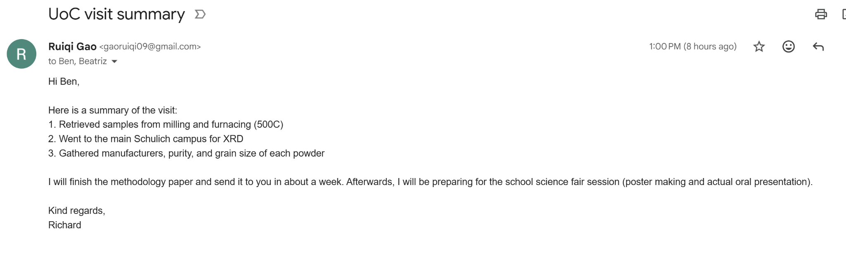  - Finished writing methodology (XRD section)  - Check written work  - Sent to Dr. Garcia to review |  | Uni

February 6, 2025
Tasks To-do |  | Review |  | Notes
- XRD analysis |  | - Dr. Garcia returned the methodology to me  - Link to comments: https://drive.google.com/file/d/10Vhw4S3wER1fge1hV78pfo6ezGPkz3--/view?usp=sharing  - Edited methods according to her feedback  - See written section  - Sent email to Ben to schedule SEM microscopy |  | Methods and SEM

February 8, 2025
Tasks To-do |  | Review |  | Notes
 |  | - We will do SEM microscopy if I make cities  - Edited methodology according to Dr. Garcia’s comments  - See written |  | Methods

February 9, 2025
Tasks To-do |  | Review |  | Notes
 |  | - Researched how to use GSAS II for XRD analysis  - See background research  - Started analyzing the 10h and 20h XRD samples  - See data collection  - Emailed Ben to meet up early next week for data analysis |  | GSAS II

February 11, 2025
Tasks To-do |  | Review |  | Notes
 |  | - Edited methodology to sound more professional and fact-checked all work  - See written  - Sent to Ben for review  - Ben sent comments back already, lol  - See written for comments |  | Writing

February 11-15, 2025
Tasks To-do |  | Review |  | Notes
 |  | - Finished running the GSAS calculations for 10h, 20h, 30h, and heat treated samples  - Calculated grain size, FWHM, interplanar spacing, etc  - See data collection  - What to discuss with mentor:  - Lack of peaks that match the intensity for 30 HR values  - Grain size is in nm?  - Why is the heat treated sample the only one that’s not sloped?  - Does Hall-Petch apply?  - Is grain size supposed to be this small? |  | GSAS XRD ANALYSIS

February 16, 2025
Tasks To-do |  | Review |  | Notes
 |  | - Meeting summary:  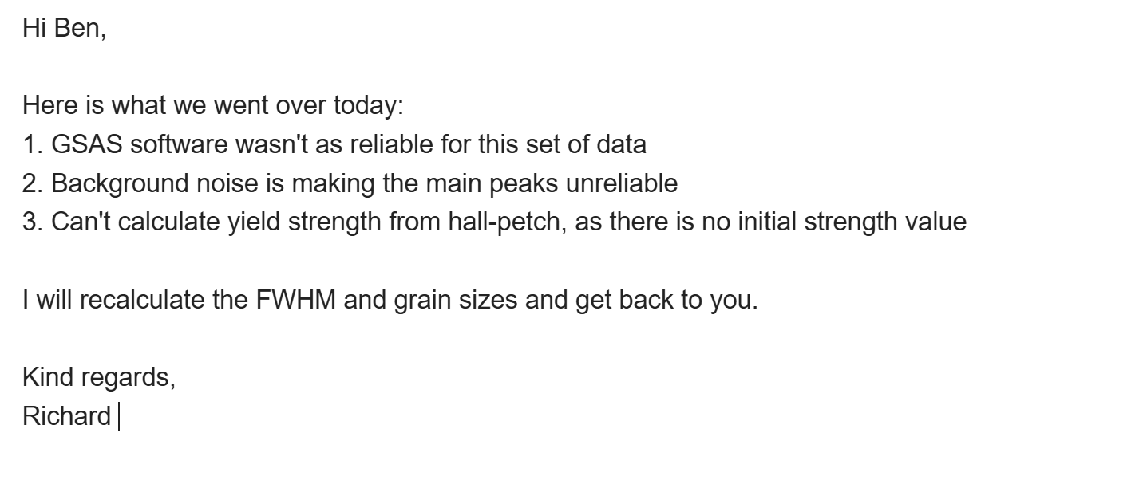 |  | Meeting

February 17, 2025
Tasks To-do |  | Review |  | Notes
 |  | - Edited methodology from Ben’s comments  - See written  - Manually calculated grain sizes for GRCop 84 and 42 at 30h and the heat treated sample  Data: |  | Meeting

February 18, 2025
Tasks To-do |  | Review |  | Notes
 |  | - Finished the methodology flow chart, introduction, and results of the science fair poster  - See oral presentation  - REMEMBER TO DECLARE AI USAGE  - Will continue working on the actual project after the CYSF ends.  - Did (likely) final revision of methodology  - See written |  | Meeting

February 19, 2025
Tasks To-do |  | Review |  | Notes
- Oral presentation and |  | - Must dissuade judges that the work I’ve done is by my mentor  - Must mention which steps were done in lab  - Use the rubric to outline the presentation  - DO NOT say “my mentor said”  - Do not info dump, the best projects are the best at the summary  - Three main things to convince judge:  - This is a hard project for a 16 yr old  - This is a student driven project rather then mentor led  - I am confident while answering questions  - Submitted methodology to Dr. Garcia  - Finished the science fair poster  - Sent to Dr. Garcia and Ben to review  - Scheduled OP practice with Ben, waiting for his response  - See oral work for poster |  | Meeting

February 20, 2025
Tasks To-do |  | Review |  | Notes
 |  | - Scheduled meeting with Ben Wednesday morning |  | Meeting

February 23, 2025
Tasks To-do |  | Review |  | Notes
 |  | - Andi presentation  - Current ML models for sarcasm detection uses complex models that are hard for interpretation and are expensive  - Objective: to develop a logistic regression model to distinguish sarcastic and sincere utterances using local features and characterize sarcasm types  - MUStARD++ dataset  - Manually marked sarcasm type  - 80/20 train test ratio  - Some features were predictors of sarcasm in some models but not others  - Legendre coefficients we not significant  - As speech rate increases, probability of sarcasm decreases  - Biggest increase in performance was model that differentiated between exaggerated sarcasm  - No predictors for monotone sarcasm  - Logistic regression could be used to detect sarcasm  - Datasets contain low signal to noise ratio  - Ronald’s presentation  - Honeybees are integral for the economy and pollination  - Varroa mites feed on bees and decrease lifespan of colony  - Stickyboards can monitor varroa mites  - Data collected using smartphone cameras  - Data augmented to make more applicable  - High mean average precision  - Above 50% overlap counts as success  - Random crop and square symmetry worked best because they are trained in all orientations  - Domain specific augmentations improved accuracy, whereas generic robustness augmentations hurt accuracy because of lack of variety of data  - Dr. Garcia gave me comments for the poster  - Edited the poster for Ben’s and Dr. Garcia’s comments  - See oral  - Probably printing Thursday? |  | Meeting

February 24, 2025
Tasks To-do |  | Review |  | Notes
 |  | - Met with Dr. Garcia in free time to review final poster  - FINAL poster done, downloaded the jpg and will print at staples tomorrow |  | Meeting

February 25, 2025
Tasks To-do |  | Review |  | Notes
 |  | - Shayaan presentation  - Looking at microstructure at varying SiC percentages in Al-SiC  - Metal and ceramic  - Created pellets to mimic blades  - As percentage of SiC increases, the micro-hardness of the composite will increase  - 5, 10, and 15% SiC by mass  - Manually mixed the powder, used cold press to create solid, used AFM to create a 3D topographical map  - Hardness test using nano-intentation  - Highest SiC has least displacement, lowest SiC has highest displacement  - Met with Ben, gave comments about OP  - Pace slower, connect everything, give a line of reasoning for everything  - XRD: you shoot xrays onto the sample, they reflect at certain angles, you measure their intensities  - SRIM analogy: shotgun  - Start off with nuclear reactors are exposed to high temp, high pressure, … nanocrystallines can combat this  - Judges probably aren’t too technical/specialized, so better to explain everything and leave something out than the other way around  - Dr. Garcia’s comments  - Positives: intro, conclusion, analogy  - Improvements: Pace (slow down), establish personal interest, follow CYSF rubric, explain SRIM more, point to table, |  | Meeting

February 26, 2025
Tasks To-do |  | Review |  | Notes
 |  | - Created additional data doc to print  - Also calculated the microstrain and put it on the poster and document  - See oral  - Added the microstrain calculations onto the table and onto the poster  - See science fair documents in oral |  | Meeting

February 27, 2025
Tasks To-do |  | Review |  | Notes
 |  | - Shicheng’s presentation  - Prokaryotic bacteria are becoming more resistant to antibiotics  - Measures need to be taken to ascertain the antiviral defense systems  - Uses Whole Genome Sequencing  - Feeds genetic code into FASTQ File Preprocessor, Unicycler for file conversion  - Abricate tool to find certain genes and uses Prokka and QUAST  - AMR genes aad and aph were detected, tet (h)_3 was also detected  - Presented in ASP class  - Self reflection: mention hall-petch and explain the low grain growth next time and FOLLOW THE CYSF RUBRIC  - Dr. Garcia’s comments after presenting |  | Meeting

March notes

March 2, 2025
Tasks To-do |  | Review |  | Notes
 |  | - Presented in the school science fair  - Overall think I did pretty well, first presentation with Ms. Clouston was a bit rough, others were fine  - Filled out the remaining sections of the CYSF portal, including video, poster, attaching this logbook, etc.  - Recorded the video and uploaded it onto google drive  - Link: https://drive.google.com/file/d/1al6mR6965ve_nv8DZ_pWCdwGJxanFcYK/view?usp=sharing |  | Emails

Data collection
Data collection

Isotope cross sections
Xe-81: 2.665E6(unstable)
N-15: 2.401E-5(Stable)
Gd - 157 - 2.537E5 - Stable, all gadolinium isotopes are relatively high
Sm-149 - slightly lower than gadolinium, but stable
O-16 slightly higher than N-15 - Stable and more abundant
Pb-208: 2.321E-4 - Stable and abundant
Kr-86: 8.782E-4 - stable
Cd-113: 2.072E4 - slightly radioactive
Platinum isotopes around 3.00E3
Zr-94: 4.988E-2 - Zr-96 is lower but radioactive
Co-59: 37.17
Cr-54: 0.36
Cr-52: 0.7455
W-186: 37.46
Al-27: 0.2335
Mn-55: 13.41
Mo-92: 2.075E-2
Tin: 58.01 - 0.09
Ti: 7.8-0.17

Powders available at UoC:
1. Zirconia (Zr)
2. Cobalt (Co)
3. Chromium (Cr)
4. Iron (Fe)
5. Tungsten (W)
6. Aluminum (Al)
7. Vandanium (V)
8. Manganese (Mn)
9. Molybdenum (Mo)
10. Tin (Sn)
11. Titanium (Ti)

Cross section and mechanical properties of powders at UoC:
https://docs.google.com/spreadsheets/d/1IaoqVo6aRMum7UlBpMVFuD6BxdaHSH_33mLkN-HrN30/edit?usp=sharing

Phase diagrams for select alloys
https://drive.google.com/drive/folders/1wslE6yav1SgQr5JABU9BUjYcD-GuS4GP?usp=sharing

SRIM Outputs
https://drive.google.com/drive/folders/1UChsZ8ZWtOpc5NcdvSbUFnWMPzgkQCdT?usp=sharing

Decision matrix, composition properties
https://docs.google.com/spreadsheets/d/17RRZB5HM2pAwGA-dk6nJiYHX6y0sz7YZtN83fNcemXQ/edit?usp=sharing

ANSYS-GRANTA materials selector graphs, including custom made ones
https://drive.google.com/drive/folders/1QOWqPC52YrrN9GcqrEYRzpT8qamkiaX4?usp=sharing

Excel sheet for values obtained using webplotdigitizer: https://docs.google.com/spreadsheets/d/1kFq2JnrkNhpltYh7o-XOeH1XnCdw8fnYGm0AjxllJFg/edit?usp=sharing

X-ray diffraction data, Feb. 9 - 15
https://drive.google.com/drive/folders/1KVSeB_M-CF2wqqdAgrOUEu3axOHUKJpB?usp=sharing

Background Research
Research

Challenges to deployment of twenty-first century nuclear reactor systems - Sue Ion
https://royalsocietypublishing.org/doi/epdf/10.1098/rspa.2016.0815?src=getftr&utm_source=readcube&getft_integrator=readcube
Sept. 9th
- Radiolytic oxidization: Decomposition of molecules by radiation causes the formation of hydroxyl radicals, which react and oxidize important materials, weakening them.
  - Hydroxyl radicals: highly reactive, oxidizing compounds with an unpaired electron that wants to combine with other atoms for stability
- Market economies naturally provide disincentives for nuclear fission development
- Most reactors in use are only generation 2
  - We have made gen-4 reactors
- Reactor plant life is less than 100 years
  - Plant life is proof of performance for investment
- Syncotron radiation: electromagnetic radiation emitted with electrons travel near the speed of light and are forced to bend their path because of magnetic fields.
- Fuel cladding is a relatively new field of research
- Alloy 600, a nickel alloy, is primarily used today for corrosion-resistant heat transfer
  - Problem: still easily susceptible to stress-corrosion cracking(SCC)
  - Alloy 690 is better at handling SCC
    - Used already in pressurized water reactors

- Stress corrosion cracking: when stress in a corrosive environment causes a ductile material to crack and propagate.
  - Requires a crack of at least 100 micrometers
- Accident tolerant fuels(ATFs): New fuel development of which strives to minimize reactor damage during failure
  - Ex. SiC
- Development of Gen-4 reactors is largely hindered because of current technology, which do not allow for new systems to be long lasting and efficient
- Fast reactors problem: is not efficient enough compared to thermal reactors, so there is no incentive to invest on them

PHASE DIAGRAMS (https://www.youtube.com/watch?v=MJoYwtX_zFA)

Sept. 21

- Isomorphous phase diagrams: Continuous solid solution/alloy, that exists for every concentration of the solute
- Binary phase diagram: only 2 elements/components in the phase diagram
- Two variables: temperature and percent composition. Percent composition could be mass percent, mole percent, or the fraction equivalents.
  - Vertical axis (temperature) is subject to change
- Phases of alloys change according to both temperature and composition
- Tie line: boundary from one phase to another in two phase regions. It’s a horizontal line.
- Concentrations: In dual phases, what percent of one phase is present compared to another phase?
- LEVER RULE (https://www.youtube.com/watch?v=_UGVDKlquxo)
  - Separate the tie line into two sections, the dividing point is the composition percent you want to use
  - Subtract the composition of phase 1 with the composition of what we are calculating
  - Divide by the length of the tie line to find concentration of phase 2
  - Do the same process for phase 1 concentration
- Alloy phases
  - Body Centered Cubic (BCC)
  - Face Centered Cubic (FCC)
  - Hexagonal Close Packed (HCP)
  - Body Centered Tetragonal (BCT)
  - Many others
- Dual phase alloys are brittle
  - Triple phases exist, but even worse
- On a phase diagram of alloys, random letters usually represent areas which cannot make the alloy

SRIM - Sept. 17
https://drive.google.com/file/d/1dWUQFHpJRGpkfWaNVRarYMM7Q68ebavZ/view?usp=sharing
- Look for displacement values online
- Fast neutrons usually penetrate deeper
- Raster measures the width of damage
- Displacement energy: energy required to knock an atom out of its lattice
- Quick calculation of damage: only follows highest energy paths.
- All cascades: consider all cascades. Use quick calculation first. This method is very slow, and usually needs to run overnight.
- If ions penetrate all the way, increase the width
- Run at least 2000 times, 3k-4k simulations is what is usually used in literature
- If the saved file is saved, open the VACANCY one.
- Set delimiter to SPACE when importing to excel
- Make another column with total vacancies from recoil and cascade

Tungsten's drawbacks - Sept. 23
- https://www.sciencedirect.com/science/article/abs/pii/S0263436818300659
- Tunsten is brittle at low temperatures (<600K), at the temperature of a PWR, it is still relatively brittle for its uses
- Generally not good for health if directly comes in contact with skin, major consequences of inhaled or swallowed
- At high temperatures, it is not resistant to oxidization (https://www.nature.com/articles/198082b0)
- Expensive and more challenging to manufacture (https://www.researchgate.net/publication/380200097_Progress_and_Challenges_of_Additive_Manufacturing_of_Tungsten_and_Alloys_as_Plasma-Facing_Materials)
- Molybdenum is similar

Materials challenges to nuclear energy - Zinkle SJ et. al - Sept. 23 - Oct. 2
https://drive.google.com/file/d/1offuPLKaAeFDFUf9N-HsGVvhN2IjqGB1/view?usp=sharing

Charpy Impact Test - Oct. 2 (https://www.youtube.com/watch?v=tpGhqQvftAo)
- Charpy impact test is used to measure the fracture toughness of a material
  - Hammer primed, uses gravity
    - The operator has to first calibrate the charpy machine by testing without a material and seeing if friction is accurately accounted for
  - Strikes an object at the bottom, the hammer rises to a height lower than the starting, even without friction. That is the fracture toughness in joules
  - Read the scale telling us the fracture toughness, in joules.
  - Higher fracture toughness energies means more plastic deformation when fracturing (energy must have somewhere to go)
  - The difference in potential energy of the hammer absorbed from the material is the knotch impact energy (symbol: KV)
    - Ferritic materials’ KV is very low below around 0 celsius, but logistically increases above 0 degrees
    - Austenitic materials’ KV is high at all temperatures, even higher than ferritic at high temps.

Opportunities and Challenges for Materials Innovation Nuclear Energy

Steven J. Zinkle

Oct. 7 - 15
https://drive.google.com/file/d/1cCeha87vkel2CXVjVJVmbR1z1PPrFzHm/view?usp=sharing

X-Ray Diffraction

Oct. 16
https://chem.libretexts.org/Courses/Franklin_and_Marshall_College/Introduction_to_Materials_Characterization__CHM_412_Collaborative_Text/Diffraction_Techniques/X-ray_diffraction_(XRD)_basics_and_application
- Technique used to determine the structure and composition of a sample
- X-rays are fired at a material
  - Bounches off surface
  - Most destructively interfere
  - Measured X rays are at a measured angle of 2 theta, all 2 theta x rays constructively interfere
  - Graph of X ray positions can be created, the x axis corresponds to the distance between each atom, the intensity of the peak corresponds to the relative number of atoms spaced in that distance
  - The width of peaks is inversely proportional to the size of the crystal measured

Enthalpy

Oct. 28
https://www.youtube.com/watch?v=SV7U4yAXL5I
- Heat is transfer of energy in molecules
- Work is transfer of energy between objects
- THEY ARE PATHWAY DEPENDENT
- Enthalpy definition:
  - Internal energy of a system
  - It’s a state function
  - Represented by capital H
  - Impossible to measure, so enthalpy change is measured
  - Change in enthalpy is change in heat of a system, assuming pressure is constant

Design and Development of Stable Nanocrystalline

High-Entropy Alloy: Coupling Self-Stabilization and Solute Grain Boundary Segregation Effects

Nov. 2 - 11

https://drive.google.com/file/d/1Pk4QL6xN0PIyGbRUtLQg1FTarA69r-Do/view?usp=sharing

Design of self-stable nanocrystalline high-entropy alloy

Nov. 13 - 19

https://drive.google.com/file/d/1Q4_70ytyf-ISiF8eO9OS2AypRVdiCxnk/view?usp=sharing

Scherrer’s equation

Nov. 20
https://www.youtube.com/watch?v=m8L-B4A75Ec
- Scherrer equation is used to calculate the grain sizes of a material based on the peak intensities and angles obtained from XRD

D = Kλ/(β * cos(θ))

D = Grain size (nm)
K = Scherrer constant that accounts for the structure of the material
λ = XRD Wavelength (nm)
β = FWHM (Full Width at Half Max, measured in radians)
- Basically a value to measure the width of the peak at half of its max intensity
θ = Peak angle (radians)

FWHM can be found with applications like OriginPro, theta is provided as XRD is initially collected, Scherrer constant can be Googled, XRD wavelength is usually 0.1nm, or 1 angstrom.

Average crystalline size can be found by summing all XRD angles.

Ball milling process variables optimization for high-entropy alloy development using design of experiment and genetic algorithm

Nov.25 - Dec. 1

https://drive.google.com/file/d/1c0XlwIHSIprjJ6jZzM6fmhXJjLX_0NTK/view?usp=sharing

XRD relevant equations

Dec. 3

Equation for calculating microstrain (https://www.youtube.com/watch?v=ipX3iUJ5VcU)
- If the crystalline size remains constant as 2θ changes, we can then assume peak broadening is only resultant from microstrain.
  - This simplified equation can then be used:
  - ε = β / (4tanθ)
  - Where ε is the microstrain, β is the FWHM, and θ is the diffraction angle
- If crystalline size does not stay constant, we need to then use a Williamson Hall plot
  - Microstrain FWHM: β = 4εtanθ
  - Crystalline FWHM: β = Kλ/(Dcos(θ))
  - β_{total} = β_{sample} = β_{microstrain} + β_{crystal}
  - Can be rearranged to β_{total}cosθ = ε4sinθ + Kλ/D
  - Linear form
  - Crystalline size can be calculated using y-intercept, Kλ/D
  - Microstrain can be calculated using slope, ε

Bragg’s law (https://www.vedantu.com/physics/braggs-law)
- Formula: nλ = 2dsin(θ)
- Used for calculating crystalline spacing
- Only certain values of theta will result in it producing an integer number of wavelengths
- System of equations can be set up to calculate d
- Limitations
  - Limited to crystalline materials
  - Assuming perfect structure and no deformations
  - Does not account for secondary diffraction
  - X-rays must be monochromatic

Stress Corrosion Cracking and Copper Alloy Products

Dec. 4-5

https://drive.google.com/file/d/1zXt8nYfRzycxxpsSEDU626P5WurrkASb/view?usp=sharing

Modelling the effects of void swelling and spatial heterogeneity on the fracture of metallic materials by crystal plasticity

Dec. 9-17

https://drive.google.com/file/d/1i8Ge4LFqm6qDd8zE6NYzjqdInDz0D8At/view?usp=sharing

The effect of transmutation and displacement in irradiated copper for heat-sink materials

Dec. 19-21

https://drive.google.com/file/d/11BcR95h1LtxhRI3PqhFQV8iJNsNDk5m_/view?usp=sharing

Density Function Theorem

Dec. 27
https://www.youtube.com/watch?v=Ez_Fm4iTUeo
- Schordinger’s equation needs the wave function of the entire system
  - Wave function depends on the positions of all electrons in the system
- Such equation grows exponentially, so practical applications of Schrodinger's equation can only be used for small molecules/systems of matter
- The density function theorem simplifies the wave function to grow only cubically, so it can be used for much bigger systems
  - However, rests on two fundamental assumptions:
    - Ground state energy from Schrodinger's equation is a unique functional of the electron density
    - The electron density that minimizes the energy of the overall functional is the true electron density and is the full solution for the Schrodinger's equation
- Equation is a bit complex to be displayed here and interpreted, so there are usually applications online for using the DFT for a variety of applications

Effect of neutron dose and spectra, He:dpa ratio and Ni and Zn accumulation on irradiation damage of pure copper and PH and DS copper alloys

Dec. 25 - Jan.4

https://drive.google.com/file/d/1YQAmbMIK1rJBm9prgjf44UnhpV4Glx-Z/view?usp=sharing

Milling research

Jan. 14
https://www.youtube.com/watch?v=dPhGVAx31uQ
- Used the PM 300 by Retsch as the example ball mill to research how it works
- There are grinding jars that you can put into the machine, usually there are different sizes of grinding jars
- Put the powders you want to mill together into the same grinding jar, secure tightly in the planetary ball mill
  - There will be sensors to check if the jar is secure enough
- Centrifugal forces will then generate tons of G pressure, when grinds the powders together
  - Each jar has several SS balls which assist in grinding
- You can adjust the RPM and time
- Open the lid after the time is up, and (hopefully) the powders have mixed together to form an alloy

GRCOP in normal conditions

Jan. 20

- https://velo3d.com/wp-content/uploads/2024/04/Velo3D-GRCop-42-Material-Datasheet.pdf
- https://additivemanufacturingllc.com/wp-content/uploads/2023/03/GRCop-42.pdf
  - GRCOP 42 is researched, not much of GRCOP 84 is researched. Two alloys should have the same behaviours because of the 1:2 ratio of Nb to Cr
  - GRCOP 42 possesses extremely high thermal conductivity at room and also high temperatures due to the high composition of copper
  - Also has very high yield and ultimate tensile strengths at room temperature (yield strength is approximately 186mPa), more than 5 times that of pure copper (extreme upgrade for such small additions of other low conductivity materials)
    - Also expected to retain high yield strength at relatively high temperatures
    - Mechanism behind this is because of Cr₂Nb laves that precipitate in GRCOP that harden the material, could be classified as a PH alloy
      - Laves are extremely stable for some reason
  - Because of pure copper matrix, the beneficial properties of copper are still retained while enhancing its strength

Thermophysical properties of additively manufactured (AM) GRCop-42 and GRCop-84

Jan.26 - Feb. 4

https://drive.google.com/file/d/1JSXYqrJdim14YcWnzp0iRmz9T4XM9zsv/view?usp=sharing

GSAS II

Feb. 9
https://www.youtube.com/watch?v=Sqajk6B_U1c
- Import powder data
- There is no parameter file for us, so we can skip the .param file
- Set limits from 0 to 90 (2 theta)
- If there is no background file, manually fit the background data
  - If the fit isn’t good, gradually increase the coefficient number
- Instrument parameters: ka1 and ka2 values are already given, select only Cuka as irradiation source leave everything else blank
- Sample parameters, use Bragg brentano for diffractometer type
- Manually add peaks by clicking on the very top of them
  - Can also auto search
- Vary all for peak refining
- Load index peak list
- Set sample’s crystal structure to FCC and BCC (for us)
- Run indexing
- Use online crystallography databases to identify materials

Restricted articles links
https://www.sciencedirect.com/science/article/abs/pii/S3050475925001836
https://www.sciencedirect.com/science/article/abs/pii/0022407377901613?via%3Dihub

Written

Research proposal
Actual proposal:https://docs.google.com/document/d/1YP7h-2xbTdS4cu_u9Bw7PzPtV5EUTBJHvHnbMP9WrJ8/edit?usp=sharing

Outline: https://docs.google.com/document/d/1NCuRld8iqTxIPPEB_DeTkyyKU8KioWqx7akRub244h0/edit?usp=sharing

Dr. Garcia’s comments: https://docs.google.com/document/d/1_w22b7NjnurkPoWf-61FBDYts4xvNCUOkrReZlxyEV8/edit?usp=sharing

Summary for Tia: https://docs.google.com/document/d/1bdSmrhQW3g_6DIlQLnDNiqTVNPbnrk9RqwscND82x84/edit?usp=sharing

Introduction
Introduction: https://docs.google.com/document/d/1MJmxMT_miB3Oy77KbxZ9bMeX6Ap0yGu_x6IoUTk1XS0/edit?usp=sharing

1st draft for Dr. Garcia: https://docs.google.com/document/d/1yMykfhERcLt48c1Nt74xwAZtM6Sem0vqv1COLPj7TuE/edit?usp=sharing

Introduction feedback:
https://docs.google.com/document/d/1REep3wcbN96Ajx0x4qJEKwx9TXz9y4SrD0aByzF9ayk/edit?usp=sharing

Methodology
Methodology: https://docs.google.com/document/d/1HCCAryDox2FgULTgz419omaYhJdyd_E-ax4qhVz8owI/edit?usp=sharing

Ben comments: https://docs.google.com/document/d/1C2OaSdNvQRwCUyeimDYfx1Kz7qjYOrMO-i8fgiAo5_o/edit?usp=sharing

Oral work

Research proposal presentation
Presentation: https://docs.google.com/presentation/d/1YMV_8TSICxXkSeCvHU2b1lbqBupDONJY06Y_bKwp5_k/edit?usp=sharing

Composition decision
Presentation:
https://docs.google.com/presentation/d/1bDHGY4YmSEYLCzxs_F32CDLh8KL97E4qqrQGoM-M2-Y/edit?usp=sharing

Science Fair
Poster: https://www.canva.com/design/DAHASzhbLvI/sdmLPaRO35RP4vSpkUTOJg/edit?utm_content=DAHASzhbLvI&utm_campaign=designshare&utm_medium=link2&utm_source=sharebutton

Additional data: https://docs.google.com/document/d/1c90qlpCkLYG-1PZ4bCc1tc590_Mi3mtHIh13DxPb3S4/edit?usp=sharing

Google drive documents
Google drive documents: https://drive.google.com/drive/folders/1M7tOwQlTzbRfKBHqnqZMQmk6wpBUm2zG?usp=sharing

