2025 CYSF Science Fair

Idle to Vital

— AI Matrix
- By Abrielle Li
- St. Vincent de Paul School, Calgary, Alberta
- March 14, 2025

https://lodgingmagazine.com/brittain-resorts-hotels-introduces-ai-business-intelligence-tech-matrix/



https://www.whydoai.com/achieving-excellence-in-ai-mastering-the-ai-maturity-matrix/



https://matrixlabourleasing.com/pages/blog-leveraging-ai-and-analytics-in-2024-staffing

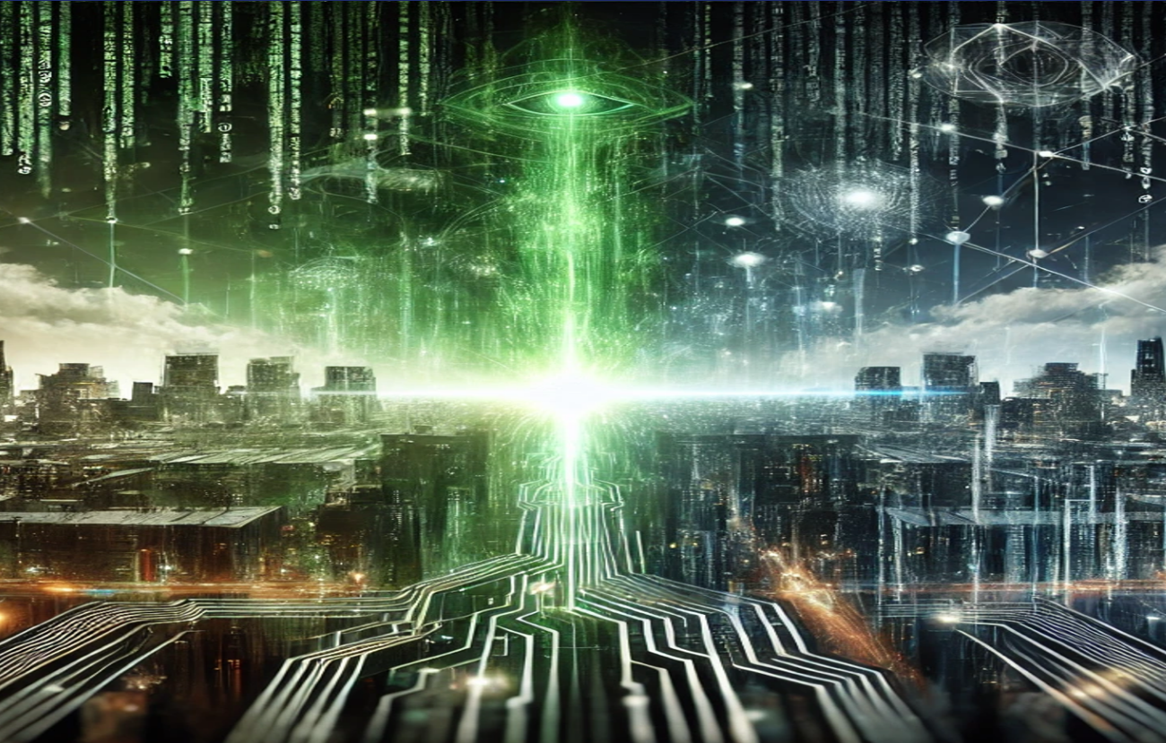

https://skoolofcode.us/blog/the-matrix-and-modern-ai-fiction-vs-reality/

Table of Contents
2025 CYSF Science Fair: 1
AI Matrix 1
---Idle to Vital 1
Project Introduction 8
Question 9
Hypothesis 10
Variables 11
Procedure 12
Materials 13
Observations 14
Conclusion 15
Application 16
Bitcoin Trading Limitations 18
Future Work 19
When Would You Like More Computing Power? 20
Acknowledgements 21
Appendix 1 Electricity Price Prediction for Toronto, London, Houston and California 22
Appendix 2 Electricity Price Prediction Accuracy by the Model 22
Appendix 3 CPU Load% VS. Power Watts Consumed 22
Appendix 4 Electricity Prices Predicted by the Model for Different Cities 26
1. Toronto Canada 26
2. London, UK 27
3. Houston, USA 28
4. California, USA 29
Appendix 5 California Next 24 Hours Mining Schedule and Profits 31
Appendix 6 CPU Stress Test Data and Graph 33
Appendix 7 California and Other Cities Next 24 Hours Mining Schedule and Profits (Compete Mode) 37
Appendix 8 Bitcoin CTF Price Forecasting Model Performance and Auto Trading Graph 41
Appendix 9 Citation and Reference 52
References 52
Appendix 10 Data Source 53
London, UK: 53
Houston, USA: 53
California, USA: 53
Ontario, Canada: 53
Turkey 54
Europe 54
Bitcoin DATA 55
Appendix 11 Science Methods 56
Mining Cost and Revenue Assumptions 57
Assumptions 2 58

Project Introduction

Science Project Idea:

Build a universally accessible web-based platform, or an AI powered app similar to Airbnb, to allow idle computers to get rented out.

This future platform will dynamically and intelligently predict when to buy and sell both electricity and stocks, and when to rent available computers for others to use. Examples of usage include bitcoin mining, picture recognition, weather forecasting, other scientific research simulation, and more. For simplicity, I only focused on one type of computing: bitcoin mining.

Question

Can the platform make a profit using the computing power of idle devices available for rent?

Hypothesis

I think that:

- Such a platform would be viable if the revenue generated exceeds the costs incurred.
- Using the income generated from selling bitcoins can be one source of income for the platform.
- The higher the CPU Usage %, the higher the electricity consumption and cost.
- If we can predict electricity prices within the next 24 hours and use computing power during valleys, we can lower those costs.
- If we can predict bitcoin prices within the next 24 hours, we can sell the mined bitcoins when prices are relatively higher.
- With historical price data, this app can predict the times when electricity will be cheap and turn your outlet on and off at the appropriate times to save and make money, with an adequate accuracy rate.

Variables
Controlled Variables | Manipulated Variables | Responding Variables
Historical Time | Mining schedule (time) | Predicted electricity prices
Historical Prices | Trading schedule (time) | Predicted bitcoin (ETF) prices
Other parameters that could have affected Prices (oil, gas, Solar, wind, water level, weather, holidays, special events, etc.) | The amount of time predicted ahead | Mean square errors and the model accuracy level
Neural Network LSTM Model  Feature Extraction and Hyper Parameter Screening | Training, Validation and Testing Datasets, Training Batch, Epochs | Total Profit

Procedure
- Perform research and write code for the models.
- Use historical data to predict future electricity prices and evaluate the accuracy level of the predictions.
- Simulate computing power consumption by stress testing a computer’s CPU%, GPU%, RAM%, and more compared to the electricity cost.
- Simulate running computing tasks on a computer while testing the voltage, frequency, and current and checking my computer’s CPU Usage.
- Determine the exact timing of the mining schedule using the electricity price predictions and simulate mining bitcoin with the schedule.
- Use an upgraded LSTM model incorporated with a professional financial analyst library to predict bitcoin prices 1 minute into the future.
- Try to make stock trading automatic by assuming that there is $1M to start with and trade the bitcoins when prices are high.
- Simulate stock trading automation to sell bitcoins when prices are high and keep them for later use when prices are not high enough.
- Summarize the information I gathered from my research and experiments and determine if an innovative sharing economy platform like this one can make a profit. I will calculate the profit with the money I can make minus the money lost, the electricity bill, and other potential costs when applicable.

Materials

- Power Meter Plug
- Mastercraft Digital Clamp Multimeter
- Mastercraft 7-Function, 19 Range Pocket Digital Multimeter
- Wion Model 50049 Outdoor Wi-Fi Wireless Plug-In Switch
- Lenovo ThinkCentre M900 I7 SFF Desktop Computer
- TELUS Actiontec T3200 modem
- Intel Core i7-6700
- Intel HD Graphics 530

Observations
During my experiment, I noticed that:

- The power wattage was in the range of 17 W to 91W.
- The electricity wattage power or cost was highly correlated to CPU% and GPU% workload.
- The RAM and Network Card were practically negligible during the stress test.
- From the LSTM Price Prediction experiment, the predicted electricity prices for four out of the five cities I trained the model with each had a high accuracy rate.
- For my experiment using the mining schedule, a decent profit could be made in all the 4 cities that I tested.
- For the Bitcoin Price Prediction model, the statistic showed that it had 54.76% of successful trades.
- From the predicted electricity price tables, if you choose to yield with the grid, it is calculated you could make a profit of $22.807 in a 24-hours span with just one Tesla Model3. If you want to compete with the grid (though it’s not recommended) you could make about $ 34.0162 a day!
- Assuming 10% of the 475,592 Tesla vehicles registered in the State of California deploy my strategy, these Tesla owners can, in total, harvest $1,081,191.8 in a day! If the platform charges a 10% royalty fee, it could make a daily profit of $108,119.18, from one state alone!

Conclusion

It is calculated that such a platform would be profitable because, according to the graphs seen earlier, and my observations, it was predicted that a daily profit of $108,119.18 could be made from one state alone (California in this case) and only using one type of computing (bitcoin mining). Here are some additional things I found out:

- CPU usage is highly related to electricity cost.
- Electricity and bitcoin prices can be predicted satisfactorily with this model in some regions with quality data.
- It’s feasible that users, and especially Tesla owners, could use my app to mine bitcoins during off-peak hours and make a profit when they are sleeping! Profits are larger in regions where price differentials are bigger. (Prices in Canada are lower than in the USA.)

Therefore, my hypothesis is theoretically correct; such a platform would be profitable.

Application

By using this idea, we could:
- Save and make money by adopting this dynamic schedule
- Transform idle devices into vital resources for AI development of the society
- Optimize the electricity grid and unused computer power, helping to minimize carbon footprint
- Provide an alternative solution to the currently centralized cloud services, especially during times of war or other disaster scenarios.

What would happen if we didn’t try and stabilize the electricity grid and optimally use idle devices?

- If we don't use energy wisely, we could waste more energy, spend more money, and hurt the environment.
- The capabilities of devices would be wasted when idle.
- Users would waste the opportunity to make money just by letting others use their computing power while they aren’t using it.

Limitations

- Though my CPU is similar to a Tesla model 3’s CPU, the GPU in our Lenovo M900 is slower than a real Tesla model 3 one, so its performance is not exactly the same as a real tesla’s.
- Our predictions would be better if we had more recent and better-quality data.
- My project only focused on some key factors that affect electricity prices.
- Batteries have a limited life and can only be charged for a limited number of times.
- The trading model wasn’t tested for a long enough period, so it might fail in a more complex market with hidden influences.
- If electricity prices are too volatile, it would be hard to be accurate.
- It's nearly impossible to consistently beat the market by picking stocks or timing trades.
- My model is based on very short-term history data.
- While trading, it is always important to consider the risks of investment
- Training will yield better outcomes if a larger and cleaner dataset is available.
- Proper back testing of these deep learning models is necessary to manage portfolio risks and reduce financial losses

Bitcoin Trading Limitations
- The Bitcoin ETF stock price signal has a lot of volatility. In a practical environment, we would not want to trade excessively on every period’s signal. Use different signal thresholds for entering and exiting positions.
- If taking the trading costs into consideration, too many transactions mean a lot of money goes to transaction fees. Because there are always trading costs involved, we may want to restrict our trading to signals that are stronger than a chosen threshold. We also need a model of trading costs for penalizing excessive trading.
- Competitors or reverse engineering could easily see this strategy, so we may want some asymmetry in our trading strategy
- One can never predict the future with 100% accuracy every time just based on some historical data, so a professional evaluation team would intervene on a timely basis.

Future Work
- Test more types of computing tasks.
- Get more data with better quality to train the models for a longer period.
- Consider the execution delay problem. In practice, we may not be able to trade instantly upon receiving a new signal.
- The model should recognize persistent underperformance or bugs on its own and give warnings to the administrator.
- Get more useful features and the most up to date information.
- Customize the model for each market by adding green energy sources like solar, wind, and hydro for better accuracy.
- Use the Kelly Criterion to make bets on each minute of charging, mining, and trading more efficiently.
- Design a website for users to sign up and promote this vision, mission, and technology.
- Create an app to connect devices, letting users communicate and trade.
- Look for mentorship, investment opportunities and possible support to get this science project upgraded to the next level.
- Refine deep learning models to make them more accurate.
- Automate the entire process with more codes.
- Confirm the money made for the revenue assumption.
- If possible, negotiate a sponsorship from Tesla to conduct real experiments on their electric cars.

When Would You Like More Computing Power?

What things use a lot of computing power?

What things use a lot of computing power?

- Cloud Computing Services, like the many ones we mentioned earlier
- Enterprise Data Centers, massive computer centers used by companies to manage business operations
- Telecommunications and Internet Services, like AT&T, Verizon, and ISPs
- Artificial Intelligence and Machine Learning, like ChatGPT and self-driving cars
- Scientific Research & Simulations, like weather forecasting, space exploration, DNA sequencing, and physics simulations
- Gaming and Entertainment, like Roblox and YouTube
- Cryptocurrency Mining, like mining bitcoin and running blockchain networks
- Cloud and Edge Computing, like smart cameras
- Quantum Computing, which are like supercomputers

Acknowledgements

Thank you to the following people for their support!

- Ms. Ruzycki, my science fair coordinator
- My parents, who helped me with my experiment and trifold
- CYSF! The website had many helpful tips.

Appendix 1 Electricity Price Prediction for Toronto, London, Houston and California

Appendix 2 Electricity Price Prediction Accuracy by the Model

Appendix 3 CPU Load% VS. Power Watts Consumed

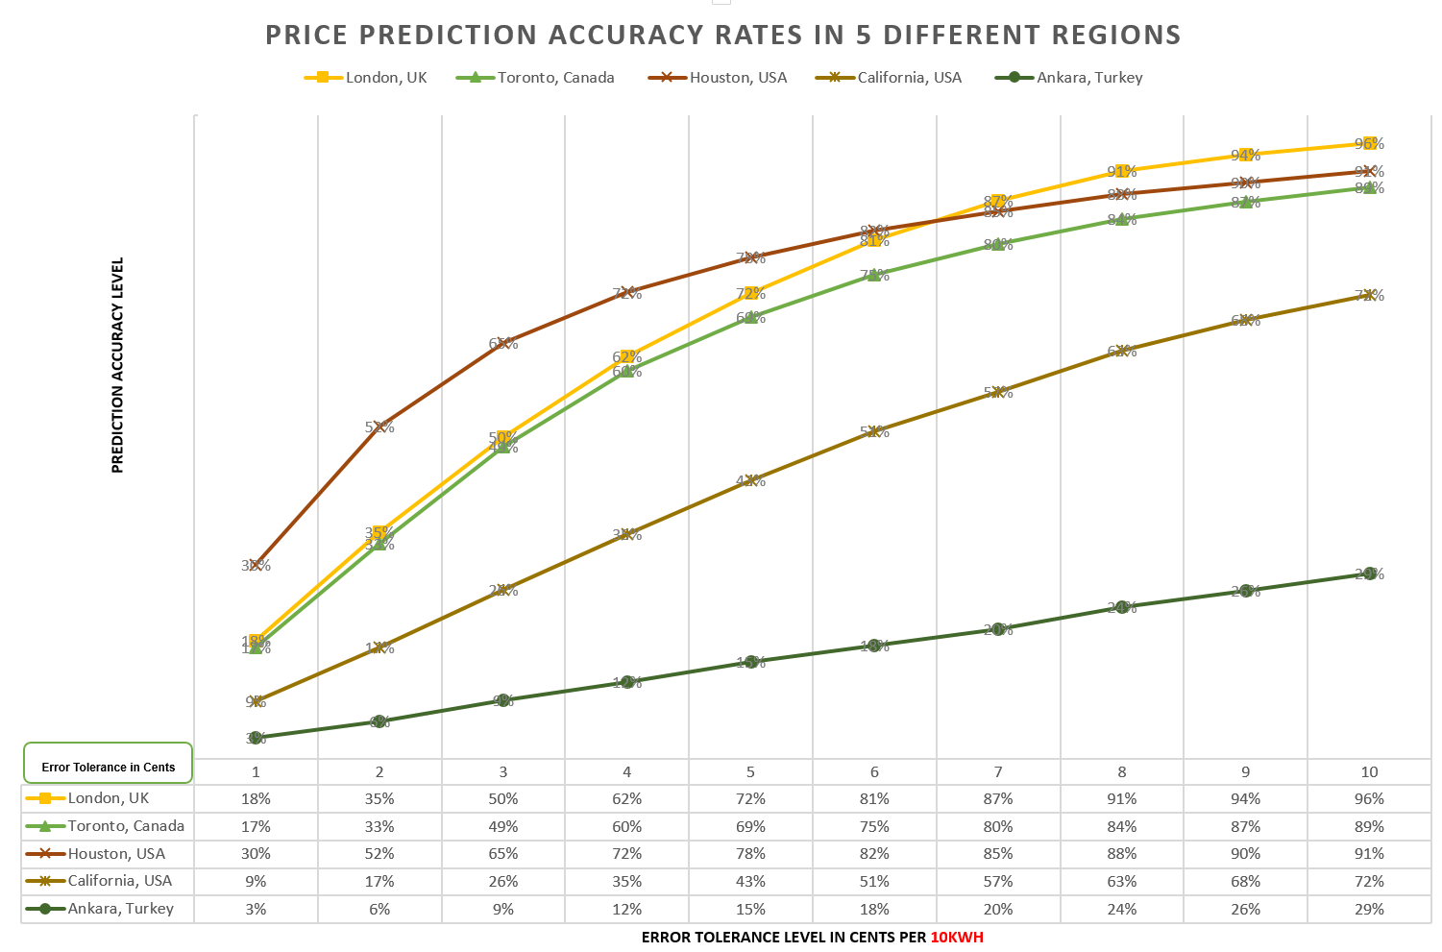

Appendix 4 Electricity Prices Predicted by the Model for Different Cities

Toronto Canada

London, UK

Houston, USA

California, USA
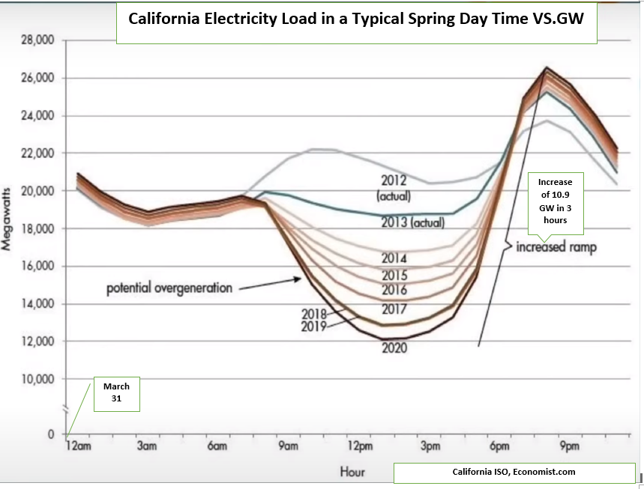

Appendix 5 California Next 24 Hours Mining Schedule and Profits
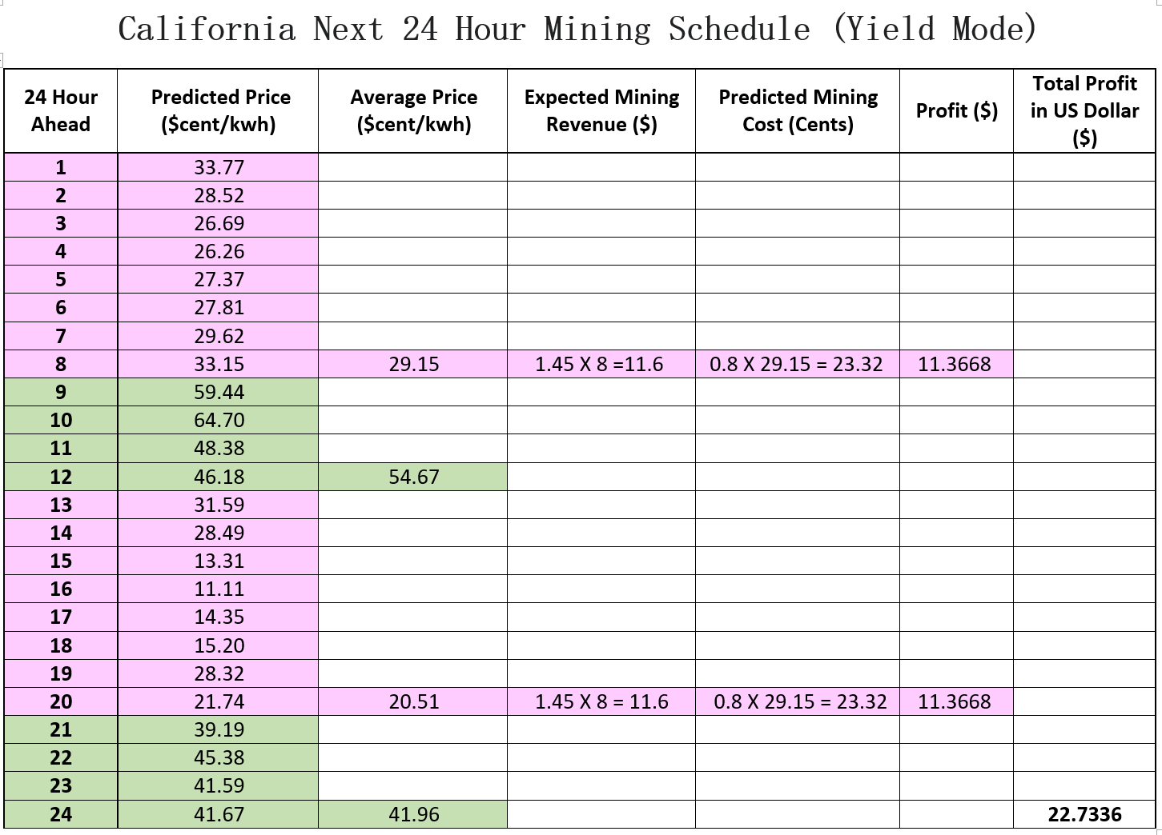
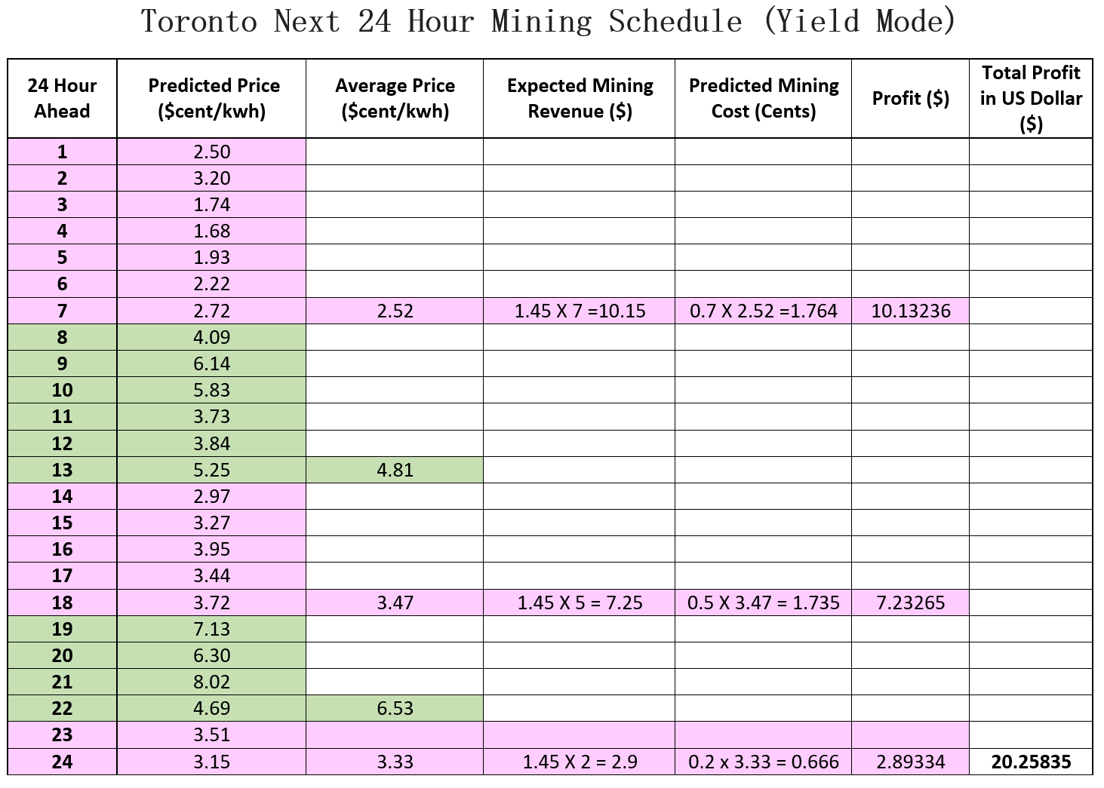

Appendix 6 CPU Stress Test Data and Graph
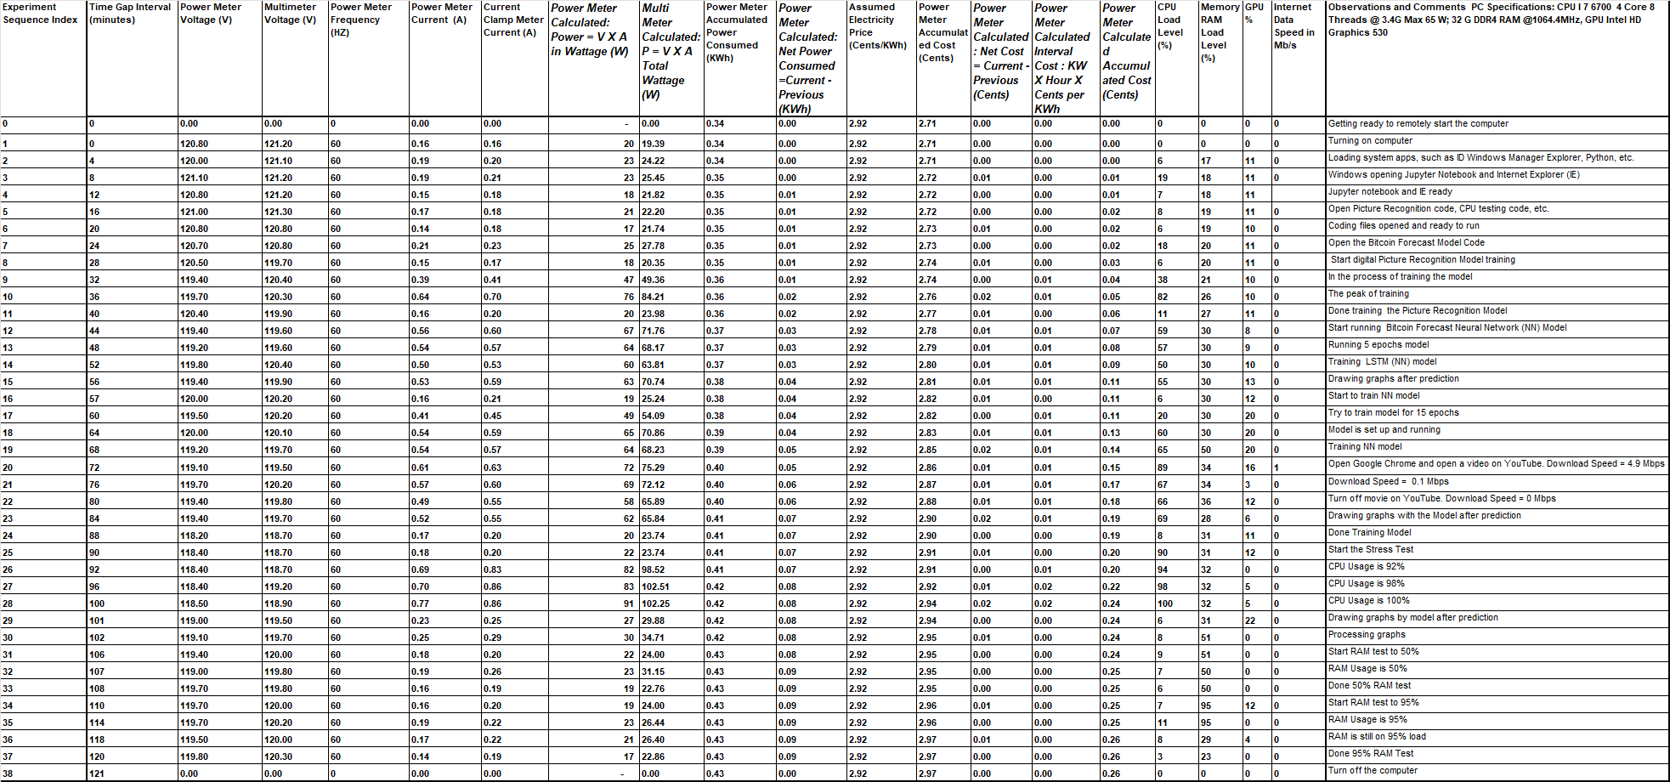
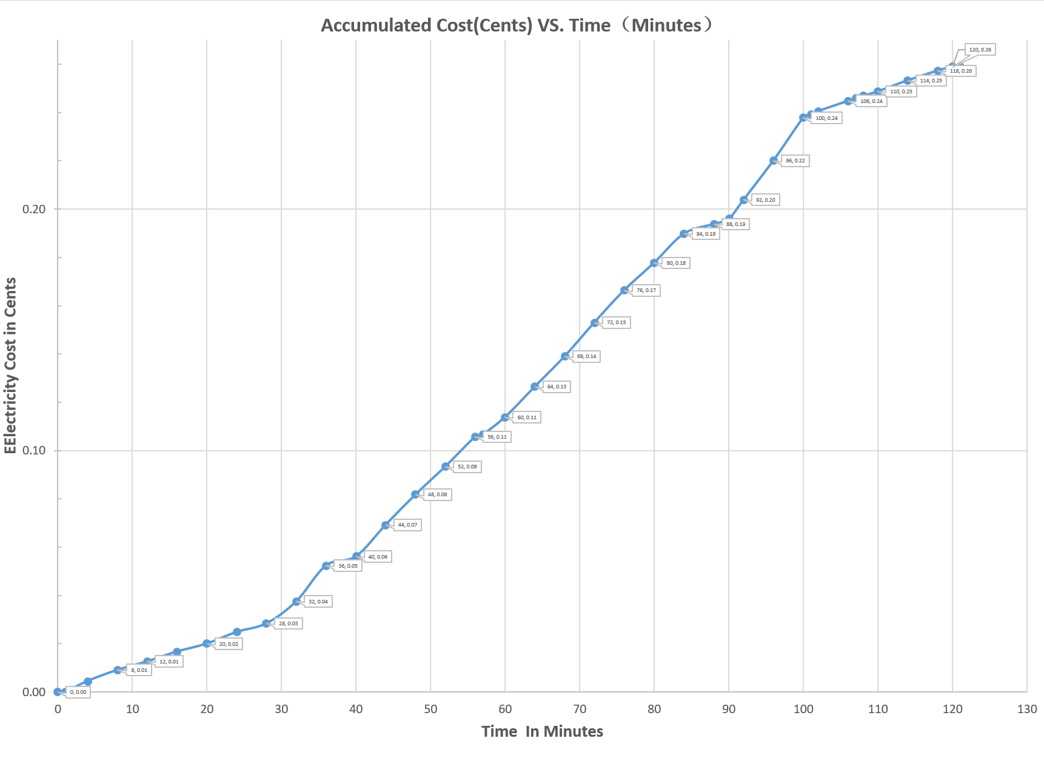
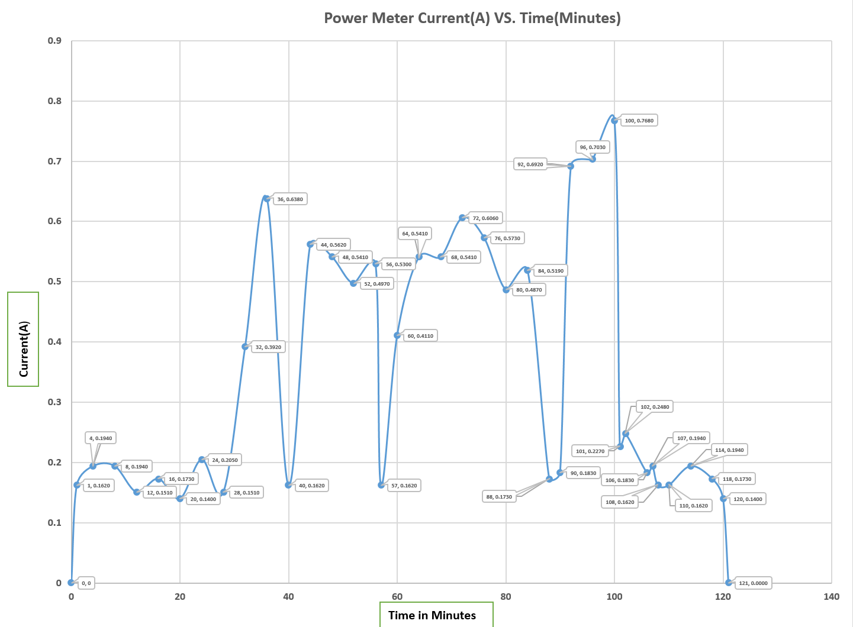
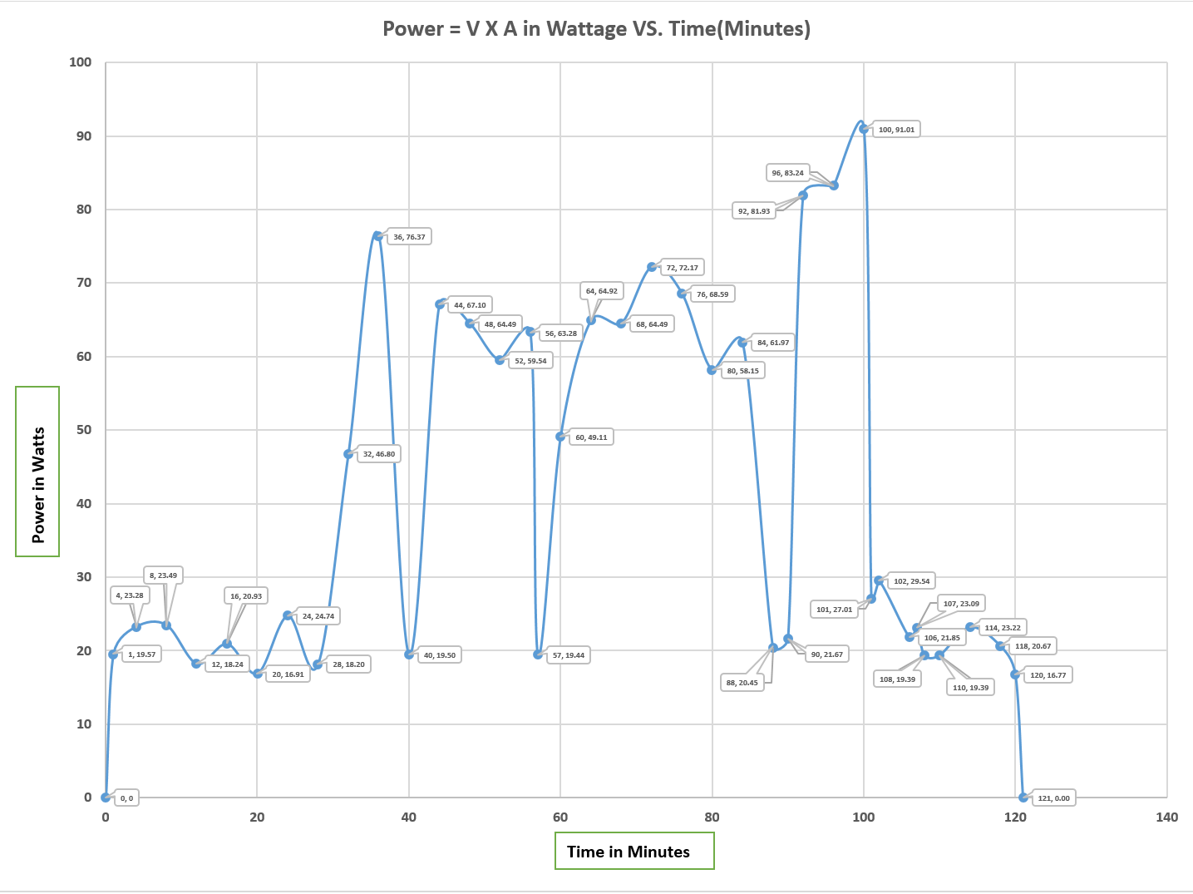

Appendix 7 California and Other Cities Next 24 Hours Mining Schedule and Profits (Compete Mode)
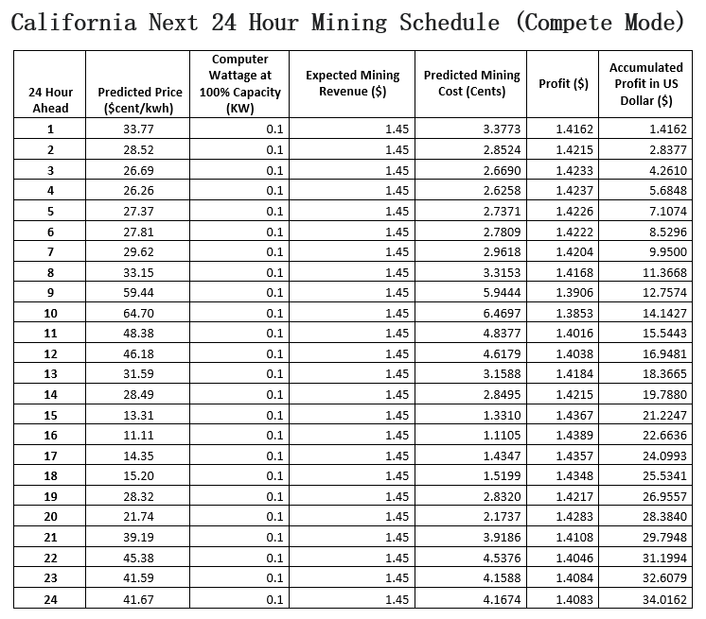
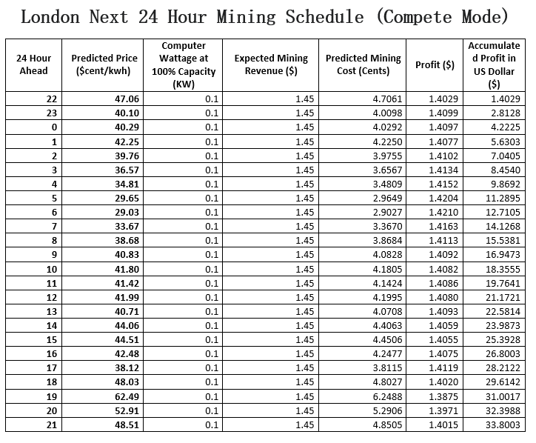
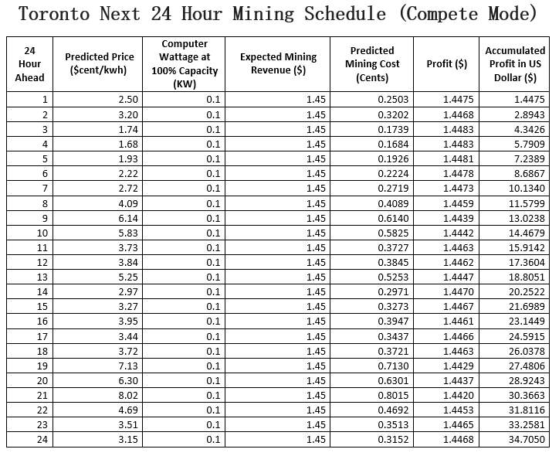
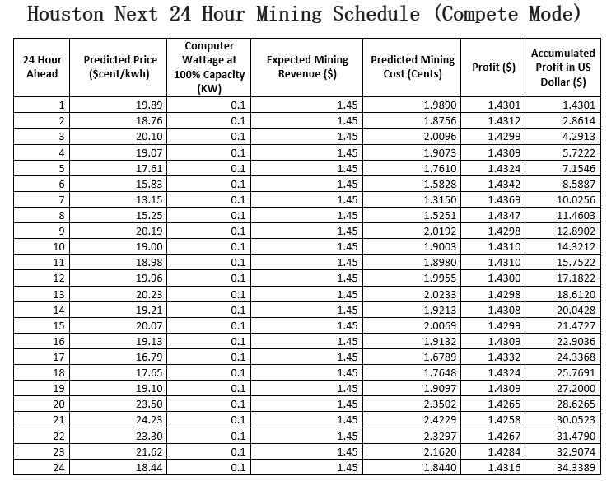

Appendix 8 Bitcoin CTF Price Forecasting Model Performance and Auto Trading Graph

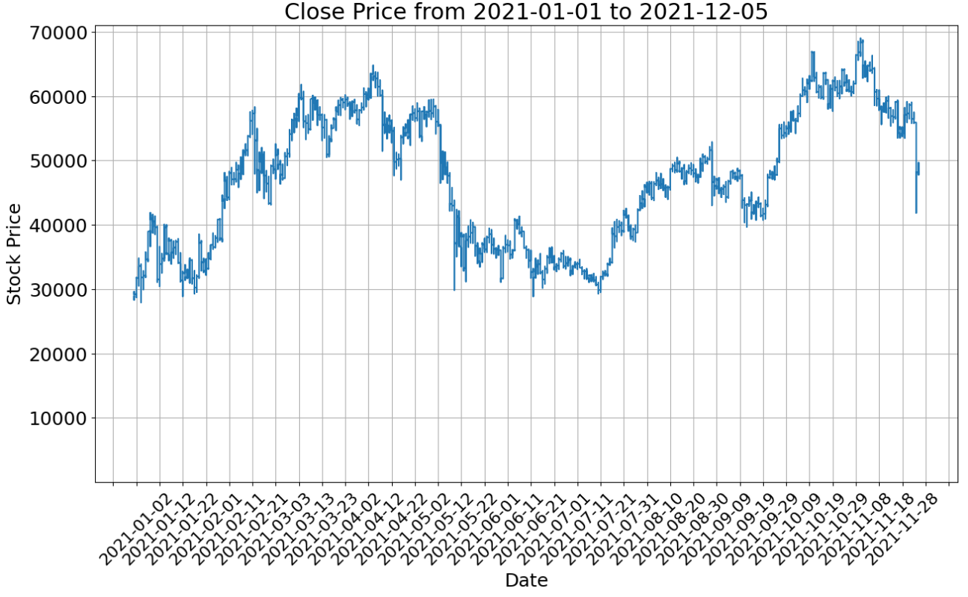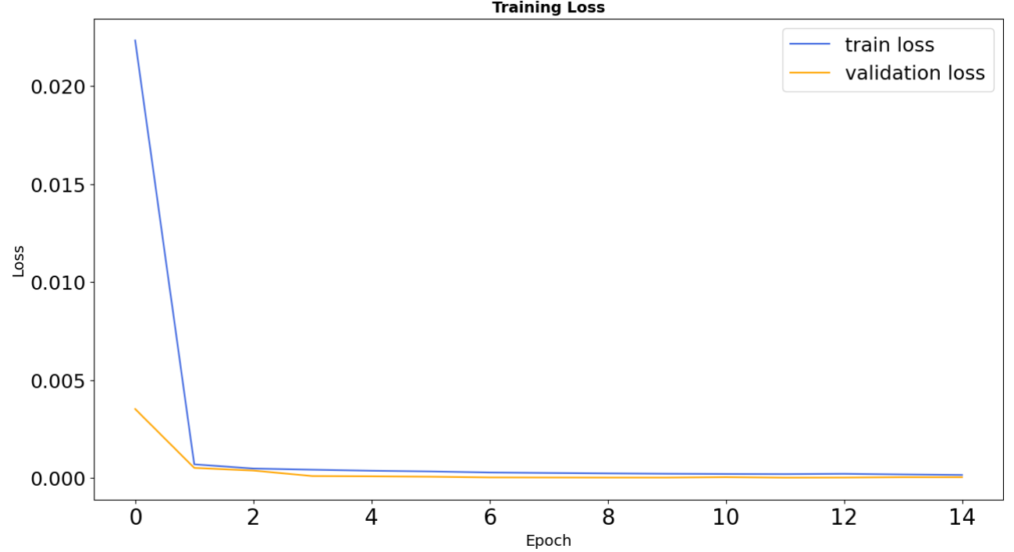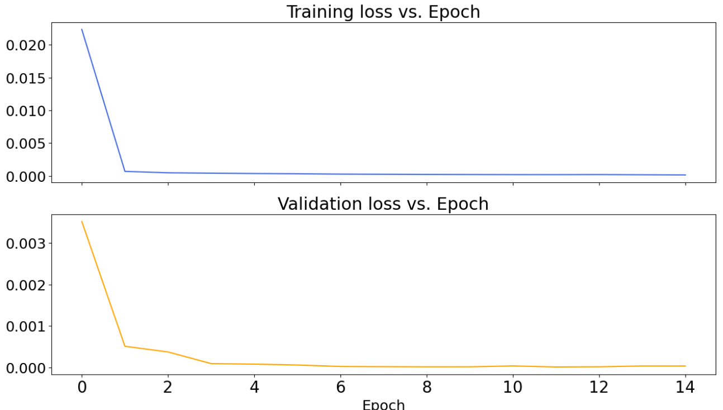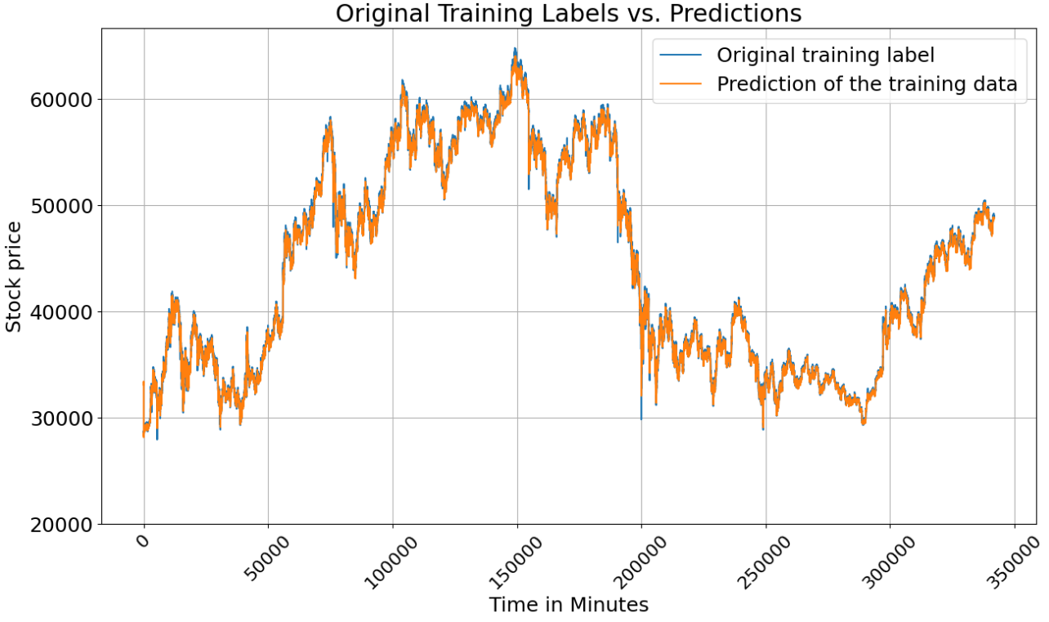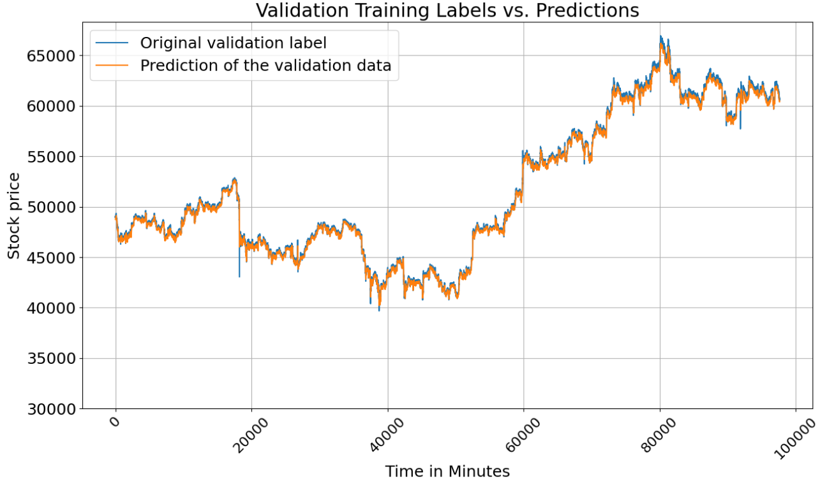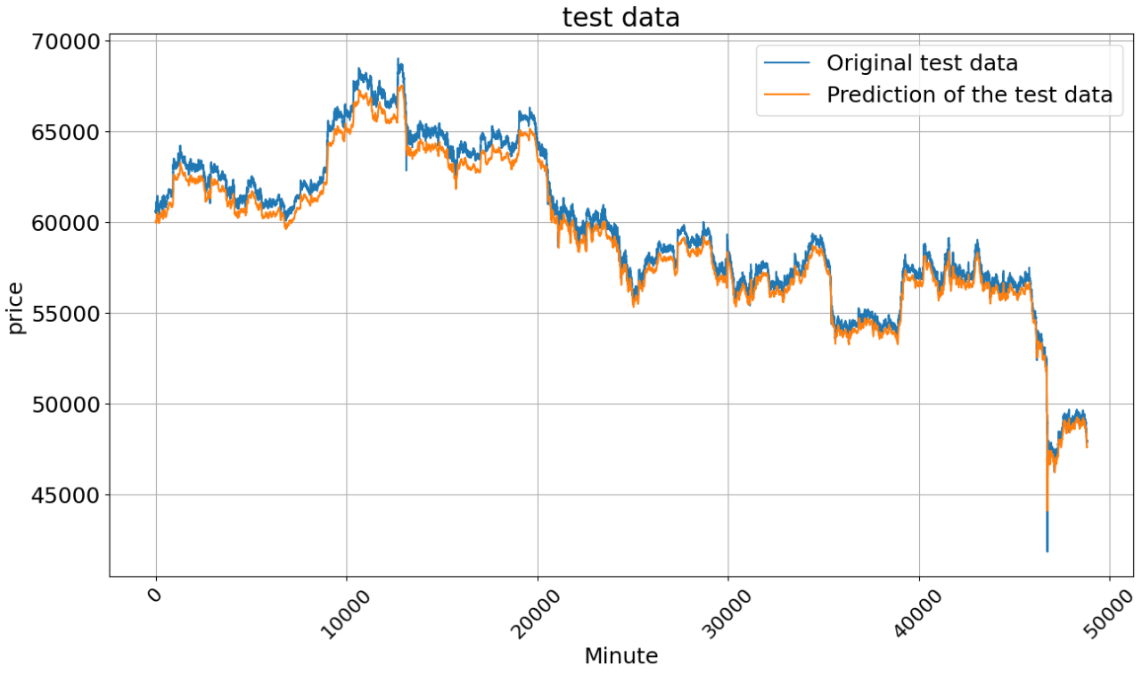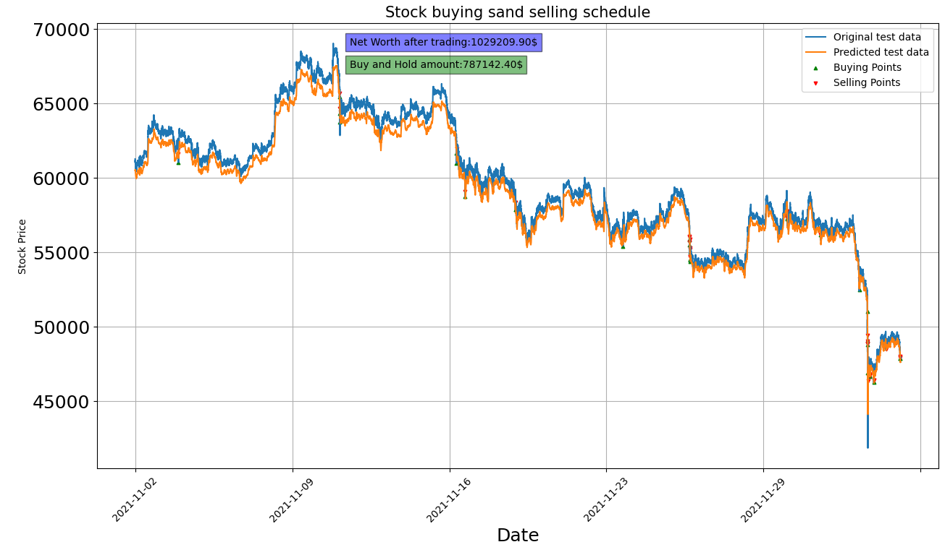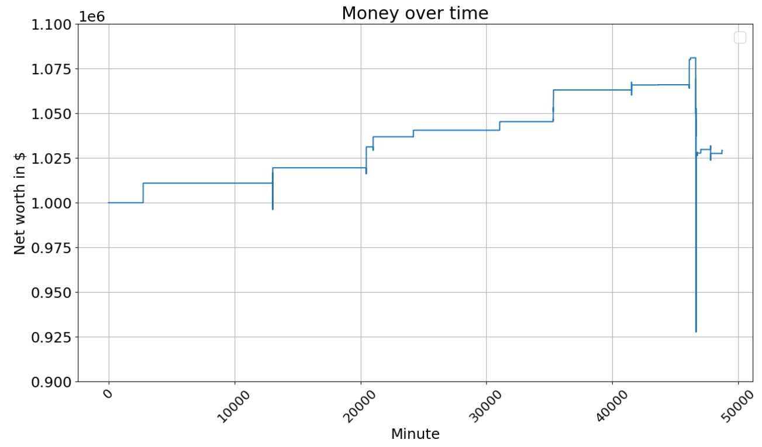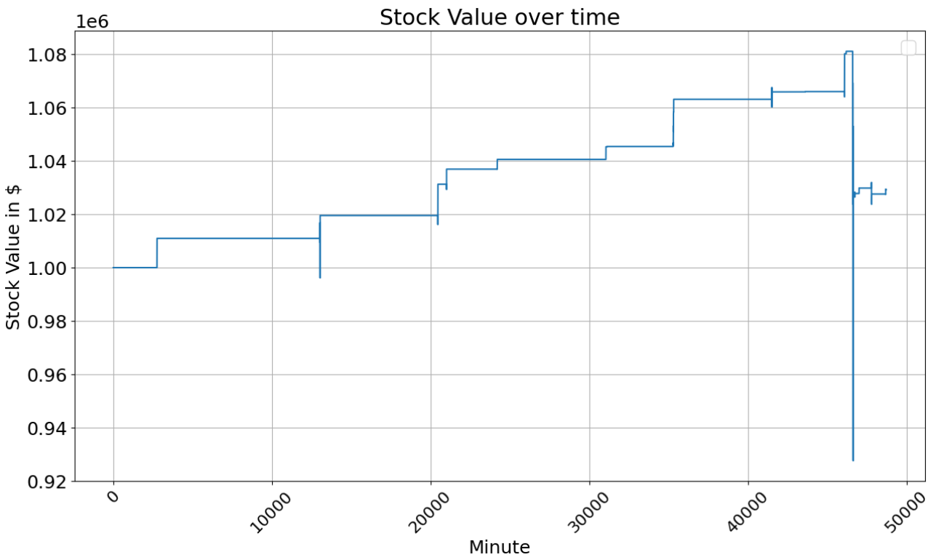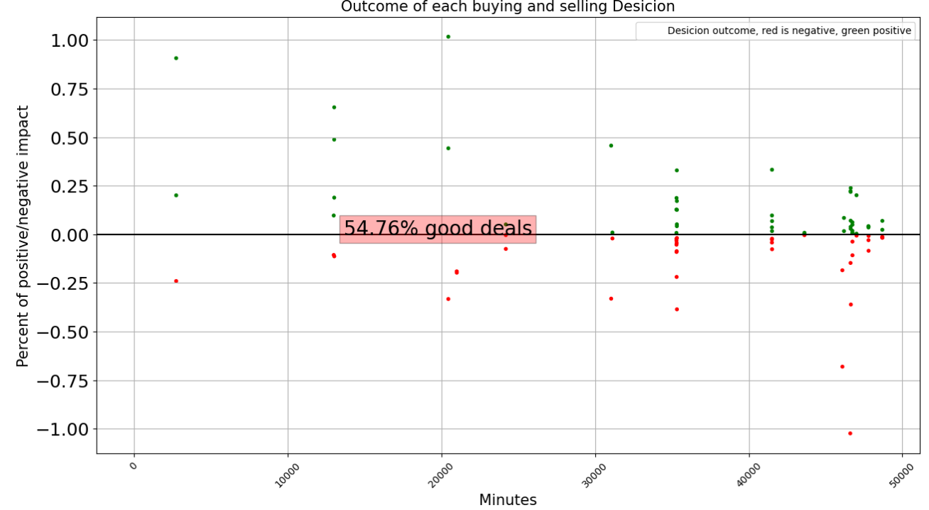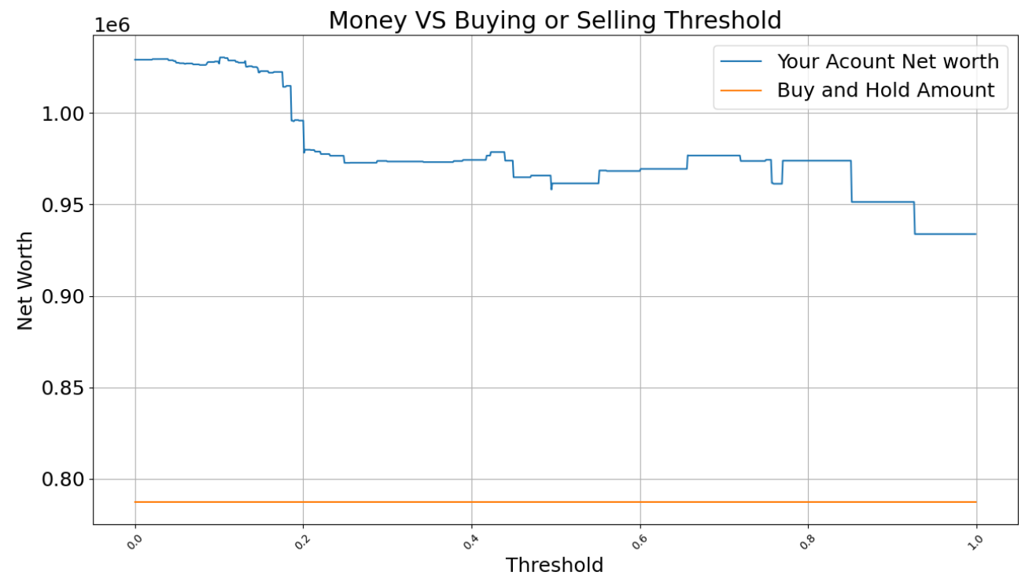

Appendix 9 Citation and Reference

References

- https://github.com/optuna/optuna
- https://github.com/peerchemist/finta
- https://www.kaggle.com/aipeli/btcusdt
- https://web.stanford.edu/class/cs379c/archive/2018/class_messages_listing/content/Artificial_Neural_Network_Technology_Tutorials/OlahLSTM-NEURAL-NETWORK-TUTORIAL-15 by Stanford.
- Sima Siami Namini, Akbar Siami Namin. Forecasting Economics and Financial Time Series: ARIMA vs. LSTM. ArXiv: 1803.06386,2018.
- Bao W, Yue J, Rao Y. A deep learning framework for financial time series using stacked auto encoders and long-short term memory. In PLoS ONE 12(7): e0180944, 2017.
- Aniruddha Dutta, Saket Kumar and Meheli Basu. A Gated Recurrent Unit Approach to Bitcoin Price Prediction. , 2019.
- Bouri, E, Molnár, P, Azzi, G, Roubaud, D. On the hedge and safe haven properties of Bitcoin: Is it really more than a diversifier
- https://www.ceicdata.com/zh-hans/turkey/environmental-environmental-policy-taxes-and-transfers-oecd-member-annual/tr-industry-electricity-price-usd-per-kwh
- Vasudharini Sridharan, Mingjian Tuo and Xingpeng Li, "Wholesale Electricity Price Forecasting using Integrated Long-term Recurrent Convolutional Network Model",https://arxiv.org/abs/2112.13681.

Appendix 10 Data Sources

London, UK:
The project began with the need to collect electricity price data. Hourly electricity prices were collected from Nordpool, which runs several European electricity markets. The years collected were 2013- 2019, with 2018 used as a validation set, and 2019 as the test set.
Hourly Temperature Data was collected using the DarkSky API in 61,000 requests.
Daily commodity price data was collected for various inputs in the production of electricity, namely:
Coal, Natural Gas, Uranium, Oil etc. These extra variables all affect the price of electricity and have predictive power.

Houston, USA:
https://www.ercot.com/mp/data-products/data-product-details?id=NP4-188-CD
https://www.ercot.com/mp/data-products/data-product-details?id=NP4-183-CD
https://www.ercot.com/content/cdr/contours/rtmLmp.html
1. Temperature data for the Houston region – Weather API. Using a python code, collected the temperature data using API call from the server of the website.
2. ERCOT price data: From ercot website, taking real time wholesale electricity price for a specific zone i.e. Houston area for four entire years: 2015-2018. Temporal resolution is an hour.
3. ERCOT load data: From ercot website, historical load data for each weather zone in the ercot region is got. Houston comes in the coast zone.

California, USA:
On OASIS you will find real-time data related to the ISO transmission system and it’s Market, such as system demand forecasts, market prices and market result data such as:
All technical specifications and artifacts for OASIS are available on the ISO Developer site. Self-registration is required to access the site. User name: Abby, need an email and password to login.
To download data without using the OASIS interface, see how to use report URLs to download OASIS data on the ISO Developer site. https://developer.caiso.com/_login/DeveloperLogin.aspx?ReturnUrl=%2f_layouts%2f15%2fAuthenticate.aspx%3fSource%3d%252FArtifacts%252FOASIS%252FReport%252DURLs%252Dfor%252DOASIS%252Edocx&Source=%2FArtifacts%2FOASIS%2FReport%2DURLs%2Dfor%2DOASIS%2Edocx
• Access non-technical OASIS reference documents on: www.caiso.com
https://developer.caiso.com/_login/developersignup.aspx

Ontario, Canada:
In the IESO-administered market, the Hourly Ontario Energy Price (HOEP) is charged to local distribution companies (LDCs), other non-dispatchable loads and paid to self-scheduling generators. Businesses that use more than 250,000 kWh a year pay the hourly price. The HOEP is also the basis for regulated rates charged to residential and small business customers. The HOEP values are reported as $/MWh.
More details can be sourced from:
HOEP and Demand: http://www.ieso.ca/
Weather: https://toronto.weatherstats.ca/
Predict-Electricity-Demand-in-Ontario
The hourly electricity demand in Ontario from the years 2017 to 2020 (https://www.ieso.ca/en/Power-Data/Data-Directory). Other features used for the predictions include time, temperature from https://climate.weather.gc.ca), and holiday information.
https://www.ieso.ca/en/Power-Data/Data-Directory
In the IESO-administered market, the Hourly Ontario Energy Price (HOEP) is charged to local distribution companies (LDCs), other non-dispatchable loads and paid to self-scheduling generators. Businesses that use more than 250,000 kWh a year pay the hourly price. The HOEP is also the basis for regulated rates charged to residential and small business customers. The HOEP values are reported as $/MWh

Price map
http://www.caiso.com/TodaysOutlook/Pages/prices.html
Current and forecasted demand
http://www.caiso.com/TodaysOutlook/Pages/index.html
Supply and renewables
http://www.caiso.com/TodaysOutlook/Pages/supply.html
CA Department of Water Resources
https://cdec.water.ca.gov/dynamicapp/req/CSVDataServlet?Stations=SHA&SensorNums=15&dur_code=H&Start=2016-01-01&End%20=2024-02-29
CA ISO MARKET DATA: Each ISO typically has an API with different limits on how often you can hit it for data, but has a number of dimensions available for data:
Real-time prices (RTM LMP) prices at particular "nodes" for the next period (5 min intervals, down-sampled to hourly)
DA (day ahead) market prices … set once a day for the next 24 hours (hourly)
HASP (hour ahead) prices … 15 minute intervals down-sampled to hourly
Load forecasts … ISO prediction for energy demand in MW at four different projection horizons: 7 days ahead, 2 days ahead, day-ahead (all 3 are hourly), and real-time (15 min freq down-sampled to hourly).
Index of /data/global-hourly/archive/csv
https://www.ncei.noaa.gov/data/global-hourly/archive/csv/

Turkey
Note: Acording to CEIC, Organisation for Economic Co-operation and Development，Turkish electricity market is very volatile, the record high in 2002 is 380 us dollars / MWh, the lowest point is 220 us dollars/MWh. Average price from 1990 to 2020 is about 280 us dollars/MWh.
https://seffaflik.epias.com.tr
https://rp5.ru

Europe
https://transparency.entsoe.eu/dashboard/show, you need to apply for a User name and password to login and download
https://transparency.entsoe.eu/transmission-domain/r2/dayAheadPrices/show?name=&defaultValue=false&viewType=TABLE&areaType=BZN&atch=false&dateTime.dateTime=22.02.2024+00:00|CET|DAY&biddingZone.values=CTY|10Y1001C--00003F!BZN|10Y1001C--000182&resolution.values=PT60M&dateTime.timezone=CET_CEST&dateTime.timezone_input=CET+(UTC+1)+/+CEST+(UTC+2)#
https://www.visualcrossing.com/weather-data-editions
https://rp5.ru/%E5%9F%BA%E8%BE%85%E5%A4%A9%E6%B0%94_
https://www.ercot.com/mp/data-products/data-product-details?id=NP4-188-CD
Note: The Ukraine electricity supply is extremely volatile due to the military conflicts and high energy price. The data source is very limited. Only one set of predicted data for 1 day was downloaded from the website for the charging experiment. The website has predictive capabilities. So this data is not predicted by my model.

https://transparency.entsoe.eu/dashboard/show
Login User name: puppy.johnson.lee@gmail.com
Password: puppy.johnson.lee

Bitcoin DATA

- Bitcoin is the longest running and most well-known cryptocurrency, first released as open source in 2009 by the anonymous Satoshi Nakamoto.
- Bitcoin serves as a decentralized medium of digital exchange, with transactions verified and recorded in a public distributed ledger (the blockchain) without the need for a trusted record keeping authority or central intermediary.
- Transaction blocks contain a SHA-256 cryptographic hash of previous transaction blocks, and are thus "chained" together, serving as an immutable record of all transactions that have ever occurred.
- As with any currency/commodity on the market, bitcoin trading and financial instruments soon followed public adoption of bitcoin and continue to grow.
- Included here is historical bitcoin market data at 1-min intervals for select bitcoin exchanges where trading takes place.
- This dataset provides 1-min BTC and ETH price data, including trade volume, and high, low, and close price. The BTC dataset starts in 2014, and the ETH dataset starts in 2016.
- For more information about this dataset and background on the ETL process, visit this Github repo: https://github.com/Gendo90/Crypto-Historical-Prices

Appendix 11 Science Methods
Price Forecast Coding:
- Python Jupiter notebook, excel sheet
- Data exploration, Data cleaning and loading
- Convert various not a number "Nan" numeric codes to np.nan ,then use df['column'].fillna(method='ffill') to carry forward the last known observation to fill the gaps.
- Min-Max and One Hot Encoding methods.
- Statistics and Data Visualization
- Pandas, Numpy, Keras, Tensorflow, Scikit Learn, data analysis
- Deep Learning (Neural Networks), Machine Learning (LSTM), Predictive Modeling
- Data Treatment
- Bitcoin historical one-minute records from Okex Exchange.
- The time selected is from 2021-01-01 00:00:00 - 2021-12-05 23:59:00 it has about half a million rows (To be exact 488,160 rows in total)
- Used PyTorch to create a model with an LSTM layer which has a dropout layer in addition to a fully connected layer.
- Adopted FinTA in order to have more sophisticated features that are used by traders to try and manually predict stocks' future.
- Divided the rows of data into chronologically ordered train, validation and test
- Split the training data to train, validation and test set at many batches.
- Every epoch, the batches started from a random offset which helped us to learn the connection between different batches along the training.
- Adopted Optuna library to optimize input variables over minimize validation loss.
- The training loss was defined as the Mean Square Error (MSE) between the LSTM's prediction of a minute later and the actual values of closing price next minute.

Mining Cost and Revenue Assumptions

- According to Business Reporter Grace Dean from Company Business Insider, in the year 2022, a Tesla owner called Siraj Raval told CNBC that he had tested his Tesla 2018 Model 3 to mine bitcoin for about 20 hours a day when his car was idle.
- He reported that he could make about 400 to 800 dollars a month (In USD), and that the electricity charging fees were about 30 to 60 a month.
- The Tesla Model 3's Full Self-Driving (FSD) computer normally uses 72W (less than 100W).
- Let’s assume it uses 100 watts (to check the highest electricity cost) for 20 hours a day at full speed for 30 days a month.
- If the electricity price is set at 2.92 cents per kilowatt, the cost of electricity for the month would be
- C = 2.92 cents/1000-watt x 100 watts/1000 x 20 hours x 30 days =175.2 Cents.
- The electricity cost would be less than 2 dollars.
- Let’s assume that, in 2024, a Tesla Model 3 owner could make 400 to 800 dollars a month.

Assumptions 2

- According to finance.yahoo.com/quote/BTC-USD, the lowest bitcoin price in 2024 was $39507.37 (USD) on January 21, 2024. Assuming one could make 400 dollars in January 2024 at that lowest price, how many coins can be mined that month?
- C: fraction of a coin mined that month = 400 ÷ 39507.37 = 0.0101246 coins
- Based on statistics, assuming the same model car computer kept mining bitcoins for the same amount of time each month in 2025, the expected return would be about the same number of coins (using the same platform), which is 0.0101246 coins per month.
- However, in 2025, the price of one bitcoin is now 85862.41 dollars per coin.
- So, incorporating that into the equation, the same car computer could make this much money:
- Money = 0.0101246 Coin per month x 85862.41 dollars per coin = 869.32255 dollars.
- So, with a simple example to show the math and logic:
- In 2025, the same car could make about 870 dollars per month mining 20 hours per day on average.
- As a result, the hourly expected revenue would be:
- Revenue = 870 ÷ 30 ÷ 20 = 1.45 dollars per hour
- So, for simplicity, let’s assume a tesla model 3 could be expected to make 1.45 dollars per hour for an easier calculation demonstration.

Mining Cost and Time Limit

- Tesla Model 3 Car Computer: The Tesla car computer has a power of 72W, and a maximum power of 100 W. It is simulated by a Lenovo M900 I7 CPU Desktop which has a power of 65 W. with an Intel HD 350 GPU at 15W.
- How many coins are left and when does bitcoin end?
Currently, there are around 19.5 million bitcoins in circulation out of a capped supply of 21 million.
- The last bitcoin of the remaining is expected to be mined around 2140.
- So, there are still 115 years to do the job if the job is profitable.
https://crypto.com/bitcoin/how-many-bitcoins-are-there
- The cost of mining will mirror the price of Bitcoin
- Satoshi Nakamoto said: The marginal cost of gold mining tends to stay near the price of gold. I think the case will be the same for Bitcoin. The cost of gold is similar to the cost of labor to mine the gold. The cost of mining is basically how much money to pay for the electricity the computer uses.
- At the moment, how much computer power does it take to mine a bitcoin?
- Roughly 155,000 kWh at the most optimized efficiency.
- Even the most efficient Bitcoin mining operation takes roughly 155,000 kWh to mine one Bitcoin. By comparison, the average US household consumes about 900 kWh per month on Dec 29, 2024. That is 0.58% of bitcoin electricity cost.
- Assume the electricity price is 10 cents / KWh. The cost of mining a coin will be:
Cost = 10 X 155000 = 1550000 cents = 15500 Canadian dollars.
- The bitcoin price today in 2025 is about 120,002.97 Canadian dollars.
The profit will be
Profit = 120002.97 – 15500 = 104502.97
- Assuming renting a computer is free and you only need to pay for the electricity bill.
- Rate of investment = profit / investment = 104502.97 /15500 = 6.742127 = 674.2127%
However, if you pay a lot of money for the computer, the rate will be much less, but still very profitable. The rate of investment will lower as more and more miners come to compete with each other.
- Due to Bitcoin’s difficulty adjustment, the marginal cost of mining one bitcoin will forever approach the value of one bitcoin. This means that, if the price of bitcoin is at $100,000, the price of mining one bitcoin will be close to $100,000. For many individuals, the costs will greatly exceed $100,000, making it unprofitable to mine, but this is different for everyone.
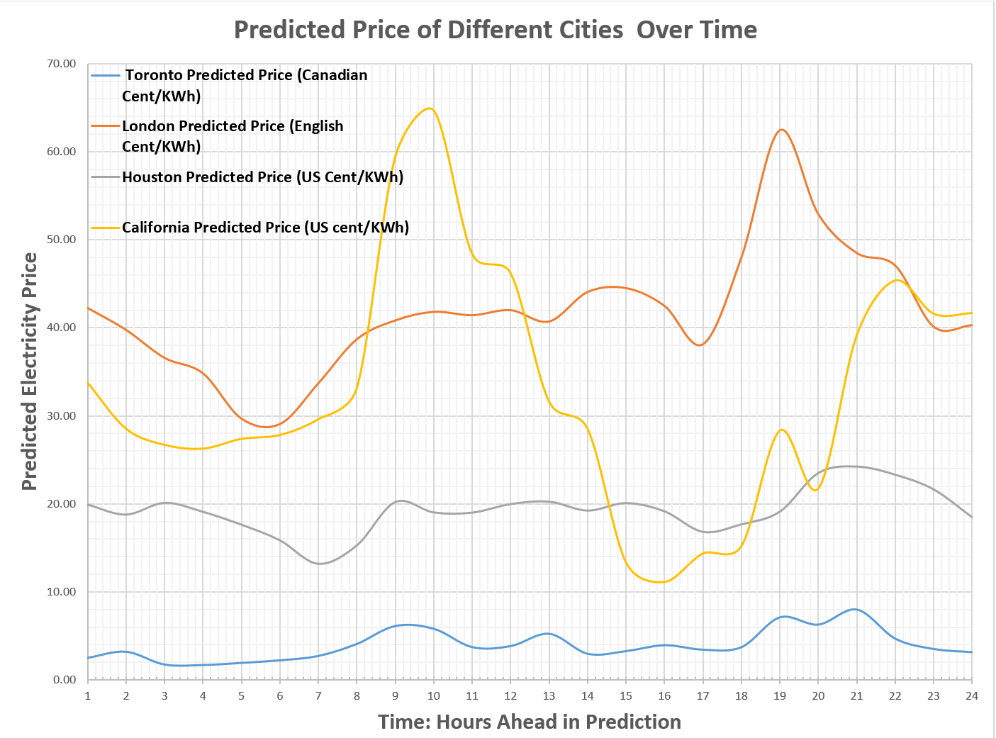

The Accumulated Mining Revenue of 4 Cities For the Next 24 Hours
24 Hour Ahead | Toronto | London | Houston | California
1 | 1.4475 | 1.4475 | 1.4475 | 1.4475
2 | 2.8943 | 4.3418 | 5.7893 | 7.2368
3 | 4.3426 | 8.6843 | 14.4736 | 21.7104
4 | 5.7909 | 14.4752 | 28.9489 | 50.6593
5 | 7.2389 | 21.7142 | 50.6630 | 101.3223
6 | 8.6867 | 30.4009 | 81.0639 | 182.3862
7 | 10.1340 | 40.5349 | 121.5988 | 303.9851
8 | 11.5799 | 52.1148 | 173.7136 | 477.6987
9 | 13.0238 | 65.1386 | 238.8522 | 716.5509
10 | 14.4679 | 79.6065 | 318.4588 | 1035.0097
11 | 15.9142 | 95.5208 | 413.9795 | 1448.9892
12 | 17.3604 | 112.8811 | 526.8607 | 1975.8499
13 | 18.8051 | 131.6863 | 658.5469 | 2634.3968
14 | 20.2522 | 151.9384 | 810.4853 | 3444.8821
15 | 21.6989 | 173.6373 | 984.1226 | 4429.0048
16 | 23.1449 | 196.7822 | 1180.9049 | 5609.9096
17 | 24.5915 | 221.3737 | 1402.2786 | 7012.1883
18 | 26.0378 | 247.4115 | 1649.6901 | 8661.8784
19 | 27.4806 | 274.8922 | 1924.5823 | 10586.4606
20 | 28.9243 | 303.8165 | 2228.3988 | 12814.8594
21 | 30.3663 | 334.1828 | 2562.5816 | 15377.4410
22 | 31.8116 | 365.9945 | 2928.5761 | 18306.0171
23 | 33.2581 | 399.2526 | 3327.8287 | 21633.8457
24 | 34.7050 | 433.9576 | 3761.7862 | 25395.6319

