2025-2026 Science Fair
CropCast: Farming the Future with Machine Learning
Logbook

By Abrielle Li
Grade 8
St. Vincent de Paul

October 21st, 2025

For my CYSF science project this year, I was thinking of doing something to do with crop prediction, because I think it’s really important for ensuring food security, optimizing our resource management, and increasing farmer profits by allowing for better planning and risk mitigation, which is especially crucial as the global population grows.

If we can forecast the amount of crops that will be produced in a specific area by using past data, governments and organizations can better plan to meet food demand, farmers can make more strategic decisions for harvesting and marketing, and we can better anticipate potential issues like crop disease or drought to take preventative measures in advance. This could also optimize resource use and provide data for climate change adaptation strategies.

Using some past crop yield data from AltaML, I can make some code and create an ML (Machine Learning) model to predict future crop yields. I might also compare different models and see how they each perform compared to one another to make things more interesting.

To-Do List:
- Research more about crop prediction
- Research more about different ML (Machine Learning) algorithms (neural network, support vector machine, linear regression, decision tree, etc.)
- Pick KPIs (Key Performance Indicators) to include when training the ML model(s) (water, sunlight, fertilizer usage, pesticides, etc.)

Oct 24th, 2025

Today I researched different ML algorithms and made some notes on each of them. I decided to stick with these three:

- Neural Network (NN) Model
- stacks simple neurons in layers and learns pattern-recognizing weights and biases from data to map inputs to outputs
- Support Vector Machine (SVM) Model
- a supervised machine learning algorithm used for classification and regression tasks
- Linear Regression Model
- assumes there is a line of best fit

Why? Because these are among the most useful, popular, and commonly used algorithms for complex, nonlinear problems like the one in my project (at least, right now in 2025). Therefore, I picked these three to compare their performances and prediction accuracy rates (when predicting future crop yields), because they’re supposed to be among the best. NN models are great for complex problems, SVM models are effective for high-dimensional spaces and small datasets, and Linear Regression models provide clear, understandable results and decisions. I think this is a solid and pretty well-balanced trio, so it’ll be interesting to see how they each perform.

October 27th, 2025

My question for this project is “Can we predict crop yields using historical farming data?”, because that’s basically the whole point of the project: to see if the models can predict future crop yields with a reasonable accuracy rate.

November 7th, 2025

I chose a name for my project - CropCast: Farming the Future with Machine Learning.

Also, here’s some additional research on the incorporation of machine learning in agriculture, and how it offers potential solutions to challenges farmers are facing:

The agricultural landscape is undergoing a profound transformation as machine learning (ML) technologies reshape traditional farming practices. This technological revolution comes at a critical time—according to the Food and Agriculture Organization (FAO), with the global population projected to reach 9.7 billion by 2050, agricultural production must increase by approximately 70% to meet growing demand.

At the same time, farmers face growing challenges, such as:

- Resource constraints: With arable land per person decreasing and water scarcity increasing, farming has to become more efficient.
- Climate change: Unpredictable weather patterns and extreme events make farming more uncertain.
- Labor shortages: Many farming regions face declining rural populations and labor shortages.
- Sustainability demands: Consumers and regulators increasingly expect environmentally sustainable and responsible farming practices.

To address these pressures, agriculture must become more precise, efficient, and predictive.

Machine learning offers potential solutions to these challenges. By analyzing historical farming data, ML models can help farmers optimize water, fertilizer, and pesticide use while maintaining and/or improving yields. This way, instead of reacting to problems, farmers can make proactive, data-driven decisions.

Additionally, a 2022 study published in Nature Sustainability found that farms using ML-guided precision agriculture techniques reduced their environmental footprint by an average of 35% while increasing yields by 10-15% compared to conventional farms of similar size and crop type.

November 11th, 2025

Question: Can we predict crop yields using historical farming data?

Hypothesis: By analyzing past key performance indicator (KPI) farming data, we can accurately predict how much a farm is likely to yield.

Procedure:
- Research about KPIs that affect crop yields, find past yield data, research good ML algorithms
- Collect data
- Explore, clean, and organize data
- Finding meaningful patterns and correlations
- Observe and gather results
- Organize results into tables and graphs
- Conclude info - can we predict future crop yields using past yield data?
- Write application
- List out future Work
- List out limitations

Variables:

Controlled: historical data, data cleaning process,
Manipulated: model features - KPIs (like water, fertilizer, pesticides, sunlight, region/location, temperature, etc.) # We are testing how changes in these values affect yield
Responding: crop yield (yield per hectare)

November 22nd, 2025

I researched more on KPIs, and found information from ScienceDirect.com that summarized many features used in crop prediction. The dataset in this project definitely doesn’t have this many features, but this just demonstrates the wide range of variables that can influence crop yield prediction (these KPIs can be included in the future if this model were to be upgraded).

Climate & Weather Variables:

- Temperature
- Rainfall / Precipitation
- Forecasted rainfall
- Humidity
- Wind speed
- Solar radiation/Shortwave radiation
- Photoperiod
- Degree-days
- Atmospheric pressure
- General climate conditions

Soil Properties:

- Soil type
- Soil maps
- pH value
- Organic carbon
- Cation exchange capacity
- Nitrogen
- Phosphorus
- Potassium
- Calcium
- Magnesium
- Zinc
- Boron
- Sulphur
- Manganese

Crop and Field Information:

- Crop type/crop information
- Area of production
- Fertilization levels
- Irrigation practices
- Time (season/year)

Remote Sensing and Vegetation Indices:
- NDVI (Normalized Difference Vegetation Index)
- EVI (Enhanced Vegetation Index)
- MODIS-EVI
- Leaf Area Index
- Satellite images
- Gamma radiometrics

December 4th, 2025

Today I ran my code (experiment). I used seaborn, a Python data visualization library, to visualize the key features of my data and explore pair relationships. I then analyzed the relationships between the features and made a list of observations based on the heat map seaborn produced.

From the correlation patterns and feature characteristics, we can observe the following:

- Water and fertilizer have strong positive linear relationships with yield.
- Higher water and fertilizer levels generally increase crop yield, and there is no sign of the correlation turning negative (yet).
- Zones 1 and 2 show consistently stable yields, making them good locations for farming.
- Zones 5 and 6 show strong negative correlations with yield.
- These areas are warm and may be better suited for high-value, heat-tolerant crops rather than high-yield staples.
- Farming suitability by zone appears to be:
- Best → Zone 2, Zone 1
- Moderate → Zone 3, Zone 4
- Weaker → Zone 0, Zone 4, Zone 3 (for climate and terrain reasons)
- Zone-specific limitations:
- Zone 0 is too cold.
- Zone 3 is near mountainous terrain, making equipment operation difficult.
- UV shows little correlation with yield.
- Likely because sunlight hours are already far above minimum plant requirements.
- Because light is plentiful + abundant, crops can be planted more densely if water and fertilizer are sufficient and if equipment access is maintained.
- Water strongly influences fertilizer effectiveness, since plants require water to move minerals and nutrients (irrigation).
- Investing in better irrigation could significantly boost yield.
- Slight water restriction during early rooting may improve later wind resistance and crop quality.
- More water is needed during flowering and seeding stages.
- Zones 0, 2, 5, and 4 receive too much water (rain or groundwater), while Zones 1, 3, and 6 may need more water (irrigation).
- Zones 0 and 2 appear to have high-quality soil, so fertilizer costs can be reduced there.
- Zones 5 and 6 likely require more fertilizer, possibly due to sandy soil with low organic matter.
- All pesticides show a slight positive relationship with yield.
- Zones 0, 3, and 6 need less pesticide due to colder climates, higher elevations, or coastal wind/humidity reducing pests.
- Pesticides B and C appear overused, with B showing the strongest correlation to yield.
- Pesticide D shows the weakest correlation among the four, while Pesticide A may need increased use.
- Overuse of chemicals leads to diminishing effectiveness (drug resistance) and long-term soil damage.
- The optimal pesticide usage level appears to be around 4 units.
- Zones 1 and 4 maintain pesticide levels near this amount.
- To reduce drug resistance, rotate pesticide types and consider crop rotation to break pest cycles.
- Pesticide correlation patterns resemble a power-function shape.
- The relationship might follow something like y = (a·x + b)²
  - which suggests that deeper nonlinear analysis may be needed
- If nonlinear features can be transformed into more linear forms, linear regression and similar models will perform better.
- Some features have weaker correlations and may be removed or ranked to improve model efficiency and reduce simulation time.

Heatmap:
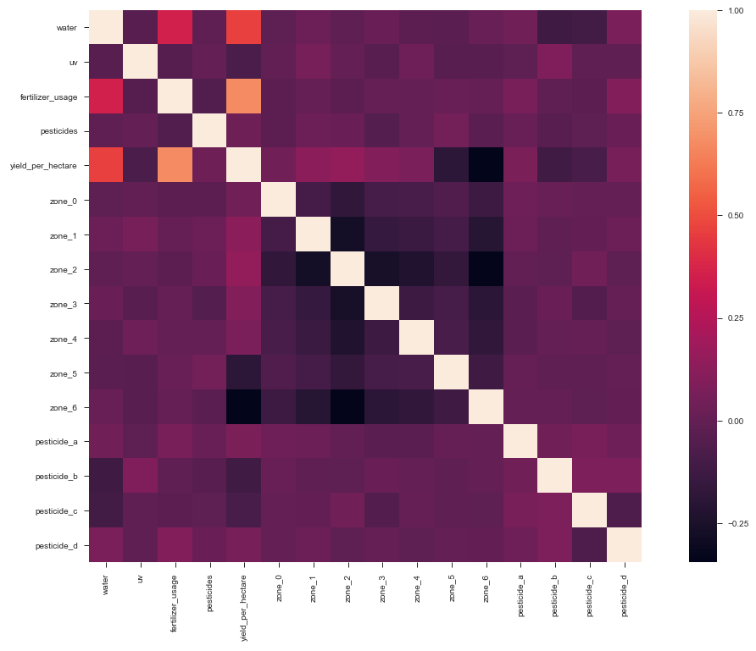
Each of the model’s prediction results:

Neural Network Model:

- Mean Square Error: 0.0059
- Mean Square Error Standard Deviation: 0.0004
- R Squared Value: 0.8605
- Accuracy: 0.9229

NN Model’s Predictions VS. Actual Values:
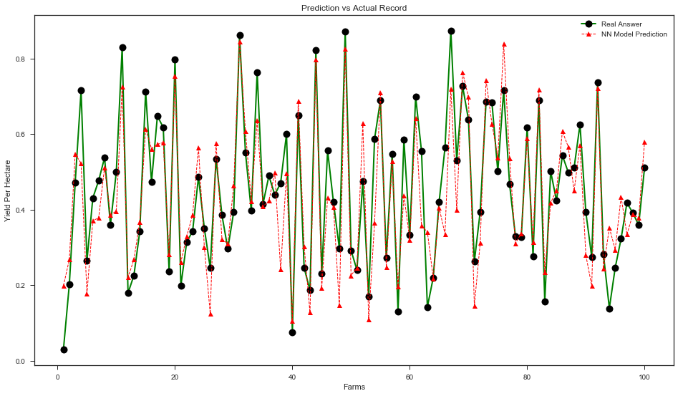

Linear Regression Model:

Mean Square Error: 0.006282
Mean Square Error Standard Deviation: 0.000282
R Squared Value: 0.861385
Accuracy: 0.921

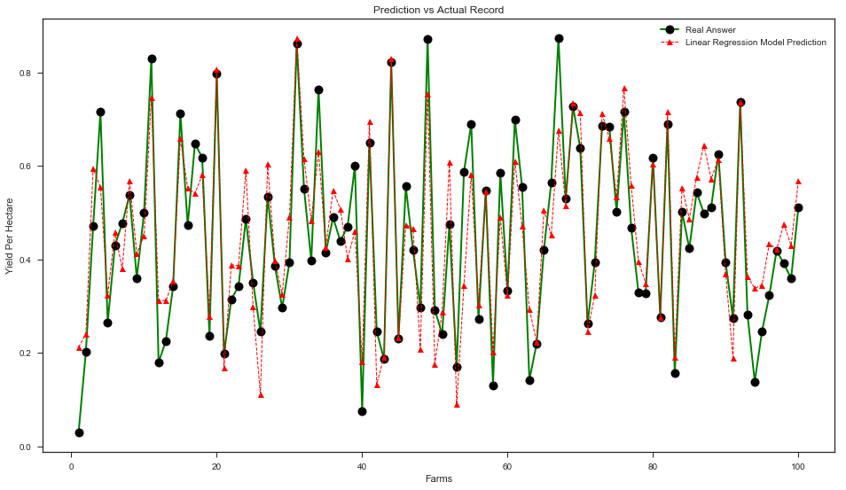

Support Vector Regression (SVR) Model:

- Mean Square Error: 0.007156
- Mean Square Error Standard Deviation: 0.000462
- R Squared Value: 0.841562
- Accuracy: 0.9154

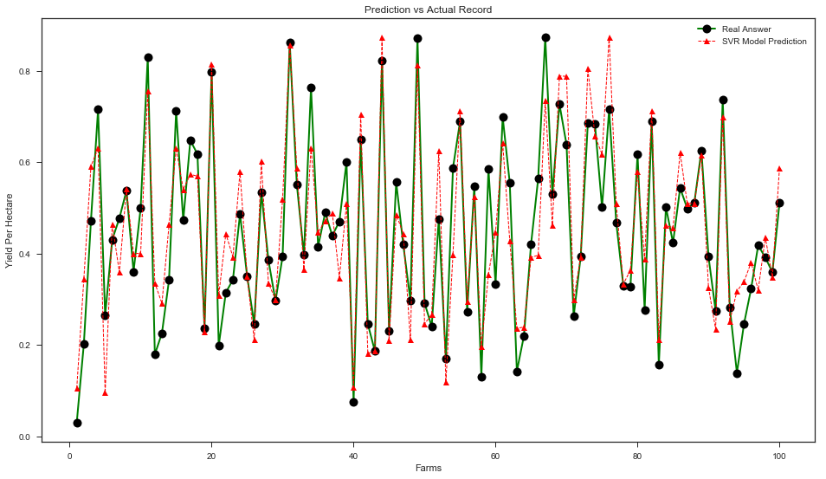

Comparing Model Accuracy:
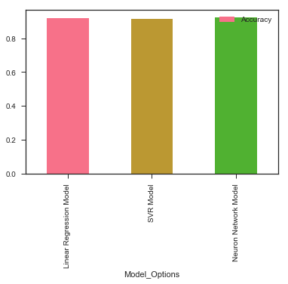
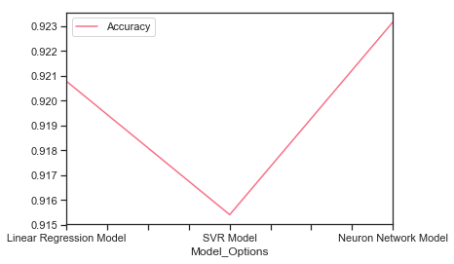

The graph above shows that the NN model was more accurate than the Linear Regression model and the SVR Model.

The Linear Regression model was faster than the SVR model and much faster than the NN model. This is because the NN and SVR models have added complexity in algorithm structure.

All 3 models achieved over 91% in accuracy.

December 29th, 2025

Conclusion:

- Crop yields can be accurately predicted using historical farming data
- By analyzing key performance indicators (KPIs) such as water usage, fertilizer levels, pesticide use, and farming region, machine learning models were able to predict crop yield with over 90% accuracy
- Results showed that water and fertilizer have the strongest impact on crop yield
- Pesticides affect yield only up to a certain point
- The NN (Neural Network) Model had the highest accuracy of 92.29%

January 13th, 2026

Future Work:

- Use more data (this dataset was relatively small, so if we add more, the models’ accuracy would increase)
- Add new variables/features. Examples:
- Weather forecasts
- Soil moisture and nutrient sensors
- Satellite images of crop health
- Crop type and growth stage data
- Improve prediction of profit, not just yield; we could combine crop yield predictions with:
- Market prices
- Costs of fertilizer, water, and pesticides
- Government incentives
- Use live data from sensors and weather stations to allow predictions to update during the growing season
- Fine-tune models

Sources of Error

- Incomplete or Inaccurate Data:
If the historical farming data contains missing values, measurement errors, or incorrect records, the model may learn inaccurate patterns.

- Data Bias:
If most of the data comes from only one region, crop type, or climate condition, the model might not generalize well to other environments.

- Weather Variability:
Unpredictable extreme weather events (droughts, floods, heat waves, etc.) may differ from historical trends, which would reduce the prediction accuracy.

- Overfitting:
The model might perform very well on training data but poorly on new, unseen data if it memorizes patterns instead of learning general trends.

- Limited Variables:
Some important factors may not be included in the dataset, such as:
- Sudden pest outbreaks
- Soil nutrient changes
- Farming technique differences
- Equipment efficiency
Missing variables can reduce prediction accuracy.

- Measurement Differences:
Different farms may record data in different ways (units, timing, or methods), leading to inconsistencies in the dataset.

- Model Assumptions:
ML models assume that future conditions will follow patterns similar to the past. If farming practices or climate conditions change significantly in the future, predictions may become less reliable.

- Human Error:
Errors during data cleaning, coding, or model selection could influence results.

January 26th, 2026

Mrs. Ruzycki gave us some important dates for Science Fair:

- Science Fair: April 9th, 10th, 11th.

- ENTIRE Project + Trifold Due on March 20th.

- All Sections of Online Project Due on March 1st.

February 12th, 2026

Note: Agriculture yield prediction in terms of money is a complicated problem. While this model can predict crop yield with a reasonable accuracy rate, predicting profit is more complex, because farm income doesn’t just depend on how much food is produced. It also depends on market prices, supply and demand, production costs, and government policies.

For example:

- Trade policies between countries can influence farmers’ decisions on what to grow, where to grow, and how much to grow.
- Market prices and futures contracts can affect how much farmers decide to plant.
- Farmers may adjust their investments during the season based on expected outcomes.
February 13th, 2026

In the future, the model could move beyond yield prediction and help farmers maximize profit too. In that case scenario, the model might look something like:

(Investment NPV) = F {[Max (Yield ($) / hectare] + Government Incentives – Min. ∑[$Cost to Feature(x)] – Min. ∑[Optional Cost]}

So, basically, the Investment Net Present Value (NPV) equals:

- The maximum possible revenue from crop yield (in $/hectare)
- Plus any government incentives/subsidies
- Minus the total cost of farming inputs (like fertilizer, water, labor, equipment, etc.)
- Minus any additional optional investments

This way, the model could help farmers find out the highest long-term financial return.

February 27th, 2026

I’m going to download this logbook and upload it onto the CYSF website online as it is right now, as the deadline for the online project is March 1st (according to Mrs. Ruzycki, though apparently the actual deadline is March 4th). However, I’ll continue updating it up until the fair.

