Cytotoxic T-Cell Implantation & Genetic Modification in a Treatment for Lung Carcinoma

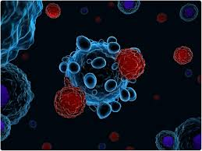

By: Ayush Chalishajar
Fairview School

Timeline
January 15th - January 25th | Fill out application forms
January 26th - February 15th | Finish logbook/research  - Jan 27th - Feb 5th: Lung Cancer information  - Feb 6th to Feb 15th: Treatment creation
February 17th - February 28th | Do CYSF platform
March 1st - March 9th | Create video presentation for CYSF platform
March 10th - March 19th | Final edits/receive feedback for final changes

Problem

Lung Cancer (Lung Carcinoma) can be treated by medications and complicated surgeries or therapy, but they do not always provide positive or satisfactory results. The question remains how can we treat such a lethal disease more efficiently, at a lower cost, and with fewer side effects using external Cytotoxic T-Cells?

Hypothesis
Since T-Cells are a crucial component of our bodies fighting against any disease, I believe that implanting genetically modified Cytotoxic T-Cells (that have already targeted Lung Cancer) into patients will allow the body to fight the disease more efficiently and faster. This is because the modified T-Cells will act as a catalyst. Naturally, our body takes a long time to create antibodies to fight against any disease and by then the severity usually escalates. With external implantation, antibodies can be created faster which will start fighting the disease almost instantly, allowing more efficient treatment. This would result in comparatively less effects on the patient from the disease and potentially lower mortality rates.

Background Research

Lung Cancer
Lung Carcinoma (Lung Cancer) is a cancer that starts in the lungs, resulting in many health complications such as difficulties in breathing and coughing up blood. About 2 million people are diagnosed with this disease yearly and will continue to get diagnosed in the future. When a person has lung cancer, they have abnormal cells that cluster together to form a tumor in the lung. These cancer cells grow without order or control, destroying the healthy lung tissue around them. Lung cancer spreads through the body quickly, resulting in most people with this disease getting cancer in other parts of the body. Current treatments have not shown satisfactory results, as lung cancer still has the highest death rate compared to any other cancer.

Types of Lung Cancer

There are two major types of lung cancer. They are:
- Small cell lung cancer (SCLC)
  - 15% to 20% of all lung cancers are SCLC
  - Smaller and harder to target for treatment
  - More aggressive form of lung cancer; cancer cells tend to grow quickly and travel to other parts of the body, or metastasize, more easily.
  - 2 main subtypes:
    - small cell Carcinoma
    - combined cell Carcinoma
- Non-small cell lung cancer (NSCLC)
  - 80% to 85% of lung cancers are NSCLC.
  - Emanates from lung tissue
  - Easier to treat than SCLC
  - Usually grows and spreads to other parts of the body more slowly than SCLC does
  - 3 main different subtypes:
    - Adenocarcinoma → slow growing
    - Squamous Cell Carcinoma
    - Large Cell Carcinoma

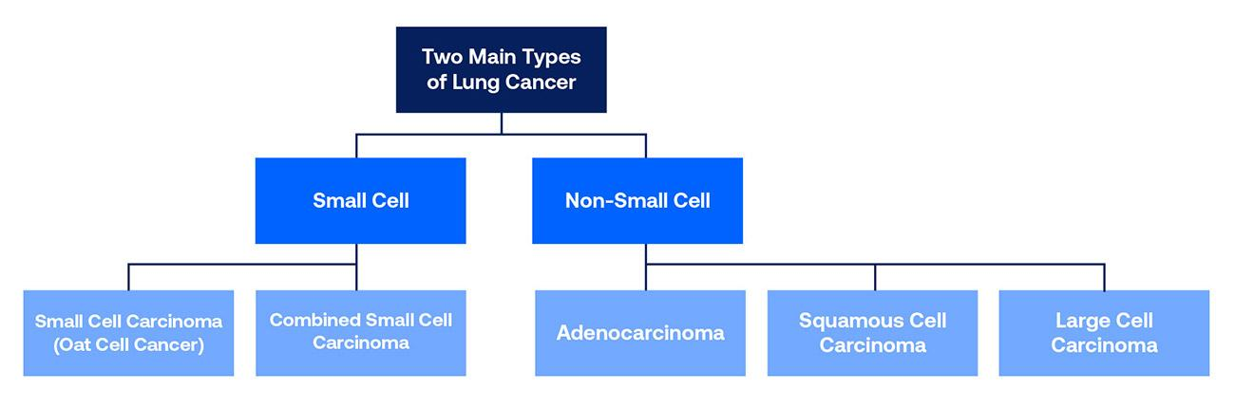

Causes of Lung Carcinoma

Lung cancer can be caused by a lot of things, including:
- Smoking - Tobacco products can increase the risk of lung cancer because tobacco smoke is made up of chemicals, many of which are poisonous.
- Secondhand smoking - Despite being indirect, secondhand smoking can still cause lung cancer because of the inhalation of the smoke.
- Radon - Natural gas produced when uranium, radium and thorium break down inside the ground. It seeps through gaps in homes and buildings, it is the main cause of lung cancer in non-smokers.
- Family history - If your biological parents or sibling has or does have lung cancer, it is likely that it will be passed on to you as well, and the same goes for your offspring.
- Radiation therapy - Survivors of cancer who’ve had radiation therapy, specifically to the chest, have a higher risk of lung cancer.
- Diet - Scientists have noticed that smokers taking beta-carotene supplements have an increased chance of lung cancer, despite beta-carotene having various benefits.
- Other substances - Exposure to asbestos, arsenic, diesel, exhaust, and some forms of silica and chromium can cause lung cancer because they are carcinogens (promotes cancer), these substances can be found in various workplaces.
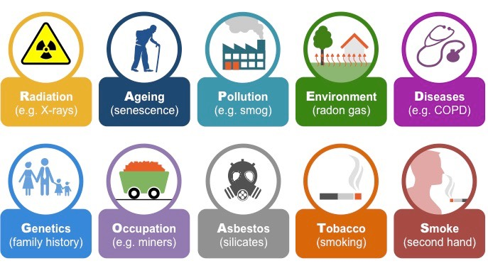

Symptoms of Lung Cancer

Lung Cancer, being such a lethal disease, comes with a lot of symptoms. Some of them include:
- Cough that won't go away
- Losing weight unintentionally and loss of appetite
- Shortness of breath
- Chest and shoulder pain
- Coughing up blood, even a small amount
- Hoarse voice
- Headaches
- Pain in bones
- Lack of energy
- Face and neck swelling

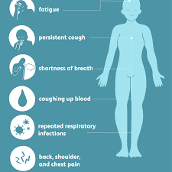

Effects of Lung Cancer on the Body

Although Lung cancer is cancer that begins in the cells of the lungs, it is known to spread to other parts of the body. In the later stages of lung cancer, especially if it spreads to distant areas, it can affect many systems of your body making it harder to treat. This process is called metastasis.
Lung cancer tends to spread to the lymph nodes, bones, brain, liver, and adrenal glands. Initially, it affects only the lungs and respiratory system. Other symptoms vary depending on areas where cancer migrates.
- Respiratory system - cause intense coughing, shortness of breath, nearby tumors, and fluid accumulation around the lungs
- Circulatory/cardiovascular systems - cause blood clots, bleeding arteries, and heart cancer
- Immune/excretory systems - cause lymph node and liver cancer
- Central nervous system - cause headaches, neurological issues, and brain cancer
- Skeletal/muscular systems - cause bone/muscle pain and weakened bones

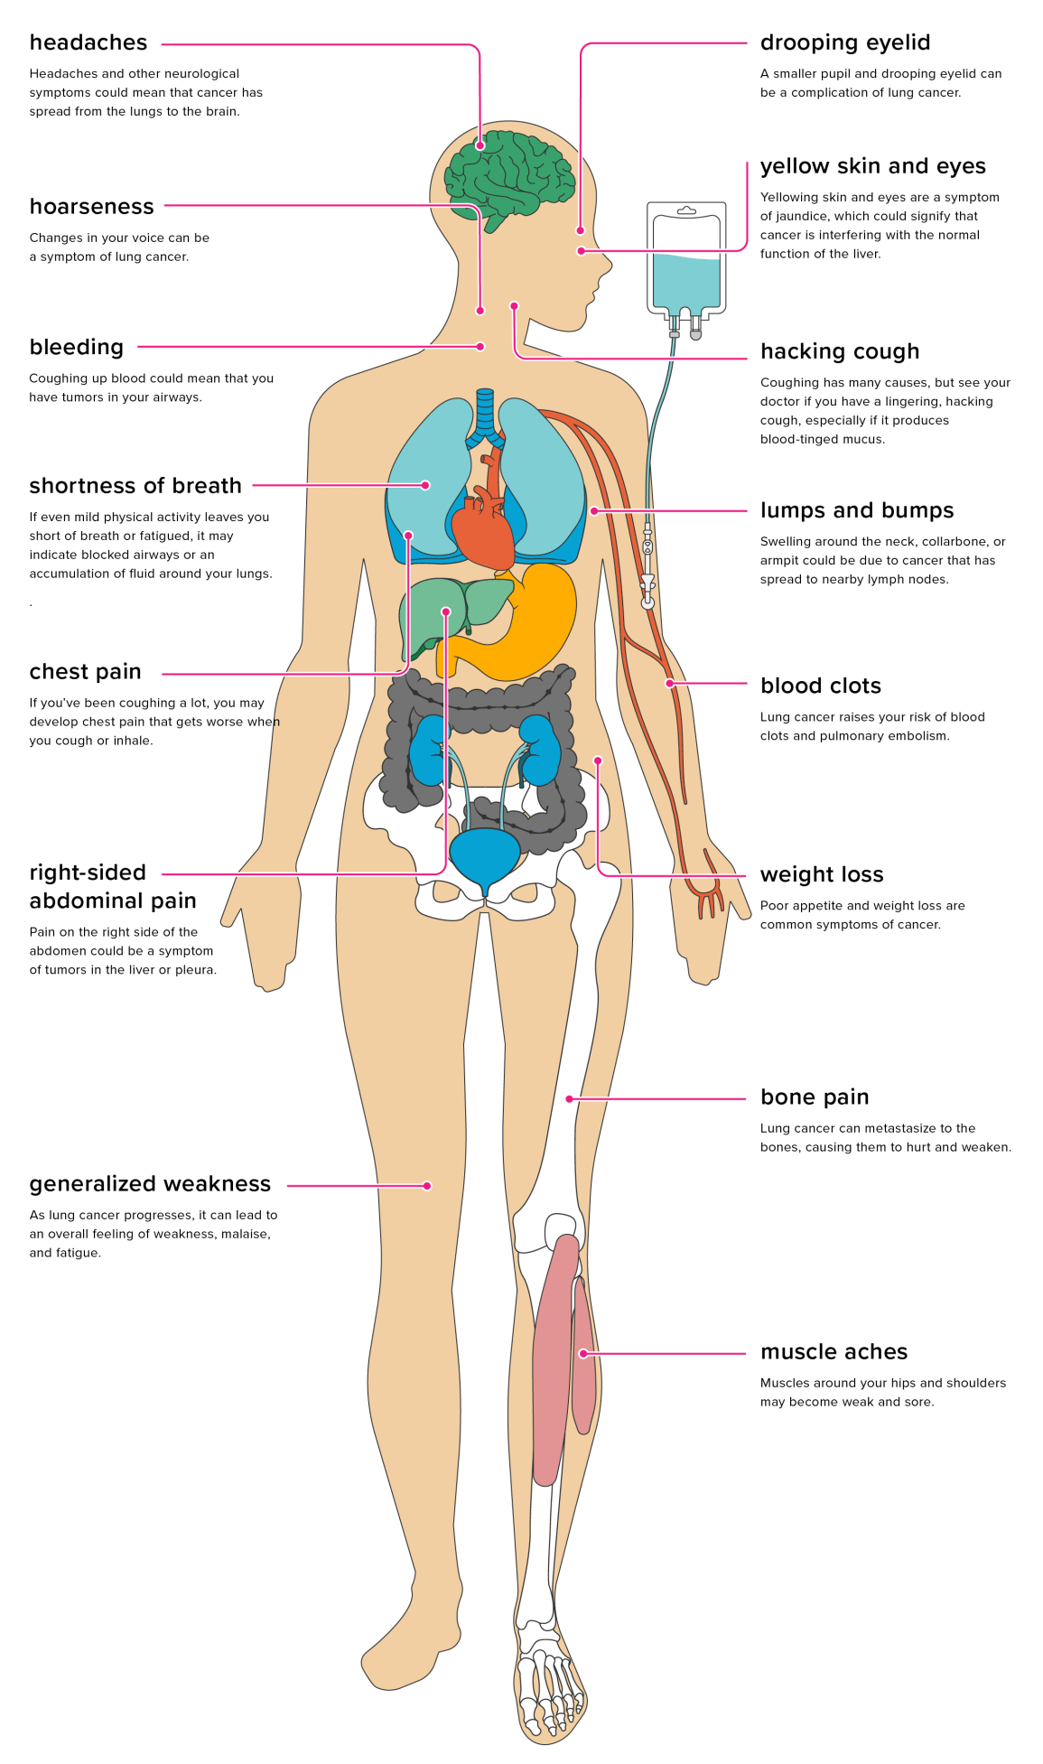

Current Diagnostics

Lung cancer can be detected by several common tests, such as:
- Biopsy - small sample of tissue is taken from the lung/nearby lymph nodes to be examined.
- Chest X-ray - produces clear, detailed images of your lungs.
- CT scan - creates a series of cross-sectional X-ray images of your lungs.
- MRI - uses magnetic-field technology to detect and identify tumors.
- Bronchoscopy - involves the use of a tube with an attached camera and light to view your lungs and other structures.
- Sputum Culture - to analyze the liquid substance produced by your lungs when you cough
- Screening test for Lung Cancer - for patients who have a higher chance of developing lung cancer

Current Treatments

Lung cancer is treated in several ways, depending on the type of lung cancer and how far it has spread. People with Non-small Cell Lung Cancer can be treated with surgery, chemotherapy, radiation therapy, targeted therapy, or a combination of these treatments. People with Small Cell Lung Cancer are usually treated with radiation therapy and chemotherapy.
- Surgery: An operation where doctors cut out cancer tissue.
- Chemotherapy: Use special medicines to shrink or kill cancer. The drugs can be either pills you take, or medicines given in your veins, or sometimes combination of both.
- Radiation therapy: Use high-energy rays to kill cancer.
- Targeted therapy: Use drugs to block the growth and spread of cancer cells. The drugs can be pills you take, or medicines given in your veins.

Why is a new treatment needed?
Although there are already various treatments that are used to treat lung cancer, there are still many issues.
- The survival rate is still lower than any other cancer being only 18.6%. More than half of the people with lung cancer die within one year of being diagnosed.
- Current treatments tend to have many side effects, such as hair loss, weak immune systems, nausea, etc.
- Takes lots of time and money, with no guaranteed efficiency.

Due to these issues, a treatment is needed that will not only be effective but efficient, meaning that it will not take tons of time and money, have fewer side effects, and have a higher success rate.

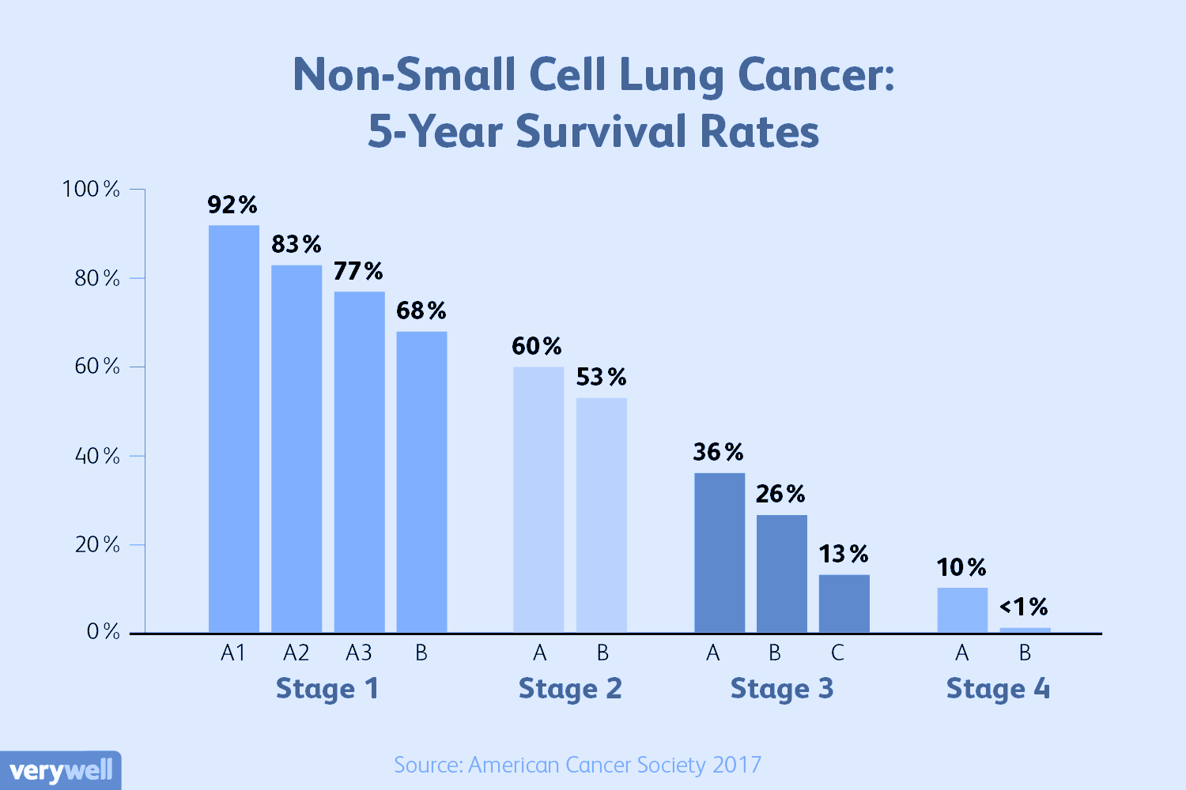

How does our Immune System work?

The immune system is a complex network of cells and proteins that defends the body against infection. When the body senses foreign substances (called antigens), the immune system works to recognize the antigens and try to get rid of them through:
- B lymphocytes are triggered to make antibodies (also called immunoglobulins).
- These proteins lock onto specific antigens.
- After they're made, antibodies usually stay in our bodies in case we have to fight the same germ again.

- Although antibodies can recognize an antigen and lock it onto it, they can't destroy it without help. That's the job of the T-cells. They destroy antigens tagged by antibodies or cells that are infected or somehow changed.
- The immune system keeps a record of every germ (microbe) it has ever defeated so it can recognize and destroy the microbe quickly if it enters the body again.

What are T-Cells?
T-cells are a part of the immune system that focuses on specific foreign particles. Rather than generically attack any antigens, T-cells circulate until they encounter their specific antigen. As such, T-cells play a critical part in immunity to foreign substances. This also means that once T-cells have identified their target, they will flow through your circulatory system until they locate the antigen that they are made to target. T-cells are one of two primary types of lymphocytes—B cells being the second type—that determine the specificity of the immune response to antigens (foreign substances) in the body.

T-cells originate in the bone marrow and mature in the thymus. In the thymus, T-cells multiply and split into helper, regulatory, or cytotoxic T-cells or become memory T-cells. They are then sent to peripheral tissues or circulate in the blood or lymphatic system. Once stimulated by the appropriate antigen, helper T-cells secrete chemical messengers called Cytokines, which stimulate the differentiation of B cells into plasma cells (antibody-producing cells). Regulatory T-cells act to control immune reactions. Cytotoxic T-cells, which are activated by various Cytokines, bind to and kill infected cells and cancer cells.

Because the body contains millions of T and B cells, many of which carry unique receptors, it can respond to virtually any antigen.

Types Of T-Cells

There are 3 main types of T-cells: cytotoxic, helper, and regulatory. Each of them has a different role in the immune response.
- Cytotoxic T-Cells
  - Cytotoxic T-cells kill their target cells, primarily by releasing cytotoxic granules into the cell to be killed. These cells recognize their specific antigen (such as fragments of viruses) when presented by MHC Class I molecules that are present on the surface of all nucleated cells.
  - Cytotoxic T-cells require several signals from other cells to be activated, such as from dendritic cells and T helper cells.
  - Their main function is to kill virally infected cells, but they also kill cells with intracellular bacteria or tumorous cells.
- Helper T-Cells
  - The roles of helper T-cells may include activating other immune cells, releasing cytokines, and helping B-cells to produce antibodies. They help to shape, activate and regulate the adaptive immune response.
- Regulatory T-cells
  - Play a protective role by shutting off the immune response when it is no longer needed. This prevents excessive damage to the normal cells and tissues in the body.
  - Regulatory T-cells suppress the immune response in several ways, including Producing anti-inflammatory cytokines that suppress the immune response, releasing molecules that kill activated immune cells and Changing the way Dendritic cells behave so they can't activate T-cells.
- Memory T-Cells
  - Following an infection, antigen-specific, long-lived memory T-cells are formed. Memory T-cells are important because they can quickly proliferate into large numbers of effector T-cells upon re-exposure to the antigen and have a low threshold for activation.

Cytotoxic T-Cells
Cytotoxic T-cells are the main immunity response our body has against any illness/disease. They are a T lymphocyte (a type of white blood cell) that kills cancer cells, cells that are infected (particularly with viruses), or cells that are damaged in other ways.
- Most cytotoxic T-cells express T-cell receptors (TCRs) that can recognize a specific antigen. An antigen is a molecule capable of stimulating an immune response and is often produced by cancer cells or viruses.
- Antigens inside a cell are bound to class 1 MHC molecules and brought to the surface of the cell by the MHC molecule, where they can be recognized by the T-cell.
- If the TCR is specific for that antigen, it binds to the MHC molecule and the antigen, and the T-cell destroys the cell.

Although the main function of cytotoxic T-cells is to kill virally infected cells, they also kill cells with intracellular bacteria or tumorous cells.

Apheresis

Apheresis is a medical procedure. It involves:
- Removing whole blood from a donor or patient
- Separating the blood into individual components so that one component can be removed
- The remaining blood components are reintroduced back into the bloodstream of the patient or donor.

Apheresis is very useful for creating vaccines and other antibodies against diseases, as it allows us to target very specific components in the blood such as the disease cell itself or antibodies our body has created already.

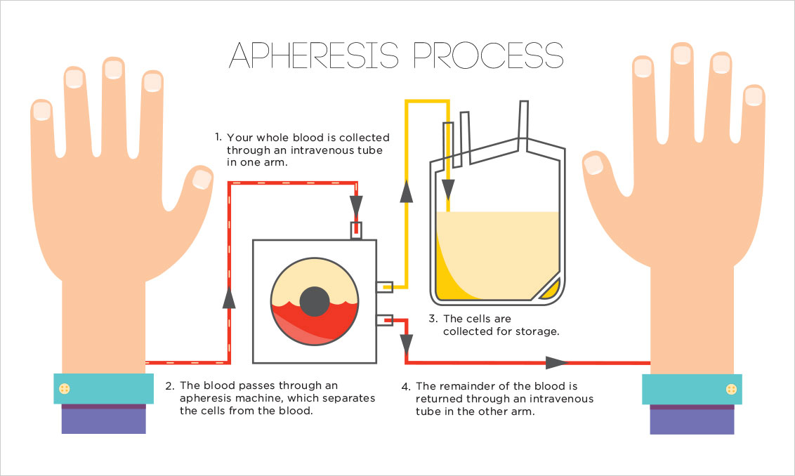

Genetic Modification

In recent years many scientists have started looking into cell-mediated immunity and its possibilities. One of the more prominent focuses is T-Cells. T-cells play a key role in cell-mediated immunity and strategies to genetically modify T-cells either through:
- Altering the specificity of the T-cell receptor (TCR)
- Introducing antibody-like recognition in chimeric antigen receptors (CARs)

These methods have made substantial advances in cell-mediated immunity. One of these advancements is that with these methods, regular T-Cells can be modified to target specific diseases and have a stronger impact in fighting the disease.

Treatment
Cytotoxic T-Cell Therapy (CTT)

Treatment Description
My idea is to create a theoretical treatment (Cytotoxic T-Cell Therapy) for lung cancer (lung carcinoma). This theoretical treatment procedure would use the implantation of genetically modified cytotoxic T-Cells into a battling patient’s immune system, allowing the patient to fight the disease more effectively. These T-Cells would be extracted from the patient using apheresis, and then genetically modified to have TCRs for lung cancer. They would later be implanted into the battling patient’s system. Since the T-cells already have TCRs for lung cancer on them, they will be able to easily recognize and fight the disease. With the help of these “enhanced” T-cells, it will allow the patient to fight the disease more easily compared to other treatments that are known to have side effects, be expensive, and often not be efficient.

- NOTE*: This treatment is completely hypothetical and has never been implanted before.
- NOTE**: This treatment is inspired by the method to use T-cells in vaccine creation.
- NOTE***: This treatment is only to be used in the later stages of lung cancer as other treatments are shown to be efficient in earlier stages.

Procedure
As with any treatment, CTT would have a standard procedure as well. The process would be in the following steps:

- Evaluation: Patients undergo a series of tests and screenings to determine if this procedure is an appropriate option.
- Collection: If deemed appropriate, cytotoxic T-cells are collected from the patient via apheresis. The remaining blood is then returned to the body.
- Engineering: The T-cells are sent to a laboratory where they are genetically modified to have TCR (T-cell receptors) on their surface.
- Multiplication: The genetically modified T-cells are "expanded" by growing cells in the laboratory until there are in millions. This process can take a few weeks. When there are enough T-cells, they are frozen and sent to the hospital or center where the patient is being treated.
- Infusion: Patients are admitted to the hospital and the T-cells are re-infused in a process similar to a blood transfusion. This is a one-time infusion, although patients may remain in the hospital under observation for several weeks to monitor response to treatment, overall condition, and side effects.
- Treatment Process: Over the following weeks, T-cells will circulate through the system and attack tumors, killing the tumor/cancer cells.

Materials/Equipment

This theoretical treatment requires a few materials/equipment including:
- Apheresis machine - for the apheresis process.
- Cytotoxic T-cells - extracted from the patient’s body, most crucial part of treatment
- TCRs - inactive lung cancer viruses will be introduced to the T-cells, resulting in TCRs to be introduced to the surface of these cells.
- Laboratory - where Tc-ells will be introduced to TCRs and be multiplied.
- IV device - using a blood bag containing these modified T-cells, the IV system will help the T-cells enter the body.

Side Effects

As with any treatment, CTT will have some side effects too. Some of them include:
- Cytokine overload - T-cells communicate with each other using chemicals called cytokines. When the body’s immune system goes into overdrive, it can trigger a cycle of releasing lots of these cytokines, which in turn can activate more white blood components. This can cause headaches, respiratory issues, fevers, and even death. In the unlikely event when this occurs, it can be dealt with drugs or therapy which are shown to have a high success rate.
- Tumor lysis - When the T-cells kill the tumor cells, these then break into parts and the leftover can be floating in your bloodstream. If there are too many tumor cells, the body can’t process the waste components, and the blood is “poisoned” (gout). But this can be treated with medication like Allopurinol and Febuxostat (anti-gout medication).
- Flu - Due to the cytokine response, the immune system becomes weakened, resulting in flu symptoms (fever/chills, sniffly nose, achy joints, etc.). This is normal and supports that the treatment is working.

Cost

Knowing the cost is a major factor that affects many people around the world, this treatment needs to be affordable to be feasible to a larger number of people.
- Apheresis costs approximately $3000 including the materials and doctor’s fee
- T-cell modification and multiplying will cost approximately $50,000, depending on the laboratory
- Blood transfusion costs between $500 - $2000
- Checkups and hospital monitoring costs will vary depending on the hospital but can be estimated to cost $20,000 for 2 weeks in the hospital.
In total, the entire process can be estimated to cost $75,000. Although this seems like a large amount, it is a one-time treatment, making it relatively cheaper than its alternatives. This price obviously can vary due to other factors, such as complications, insurance, and hospital charges. The cost will most likely change in the future as technology advances, making T-cell modification cheaper.

Why is it better?
Although this treatment is completely hypothetical, it still shows a lot of promising benefits.
- Cost - Compared to other current treatments for lung cancer (chemotherapy - approx. $12,000 a month), CTT is relatively cheap, being a one-time treatment at a relatively low cost. This means many more people will be able to afford it, creating a feasible treatment option for lung cancer.
- Efficiency - Due to this being a one-time treatment, it is a short process that should theoretically have a very high success rate. This makes it very appealing to cases that are getting treated in the later stages.
- Side Effects - Although CTT has some side effects, it is still a better option than other treatments such as immunotherapy which has more severe side effects.

Pros vs Cons
There are always pros and cons to every medical procedure, including this one.
Pros:
- Not invasive
- Minimal side effects
- Cheap/affordable
- Efficient

Cons:
- Unknown risk factors
- Potential immune system rejection
- Side effects - can escalate
- May have more challenges at trial face

Conclusion
Lung cancer is a highly lethal cancer that has very severe and devastating symptoms and effects, greatly impacting the body and often resulting in death, despite various current treatments. If lung cancer can be treated using Cytotoxic T-cells and genetic modification, this can be a good long-term treatment option. Creating Cytotoxic T-Cell therapy theoretically should show very promising results (if applied) due to the non-invasive approach and minimal side effects. Having considered the pros and cons, the treatment is very beneficial in the long run, having many benefits (low cost, minimal side effects, few materials, efficiency, etc.) with minimal cons. In conclusion, if the concepts of this treatment are applied, it will theoretically show full validity from using apheresis to extract Cytotoxic T-cells, introducing TCRs to these cells and multiplying them in a lab, and then introducing these cells back to the bloodstream.

What’s Next?
Having applied Cytotoxic T-cell therapy to Lung Carcinoma has inspired me to see if this treatment has even more potential than already theorized. Knowing how devastating and damaging it is to a cancer patient and their family to experience such a thing, I thrive to increase awareness on the lethality of cancer and the effect it has on patients. I plan to further look into the topic to introduce more benefits of CTT and how this innovation can be applied, not only in lung cancer but many other diseases in general.

